Unnamed Tropical Cyclone 21U

## 27 June – 1 July 2012

## Joe Courtney, Tropical Cyclone Environmental Prediction Services

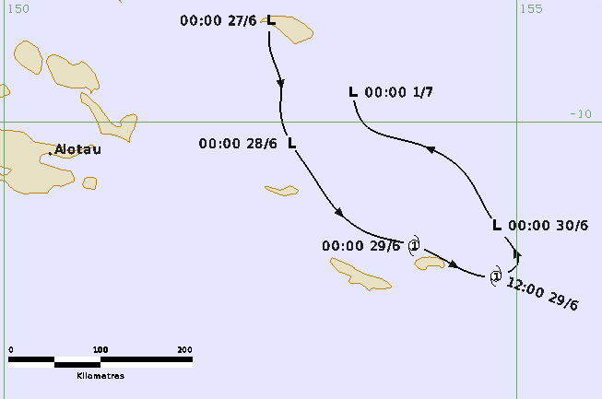

### Revision history

|  |  |  |  |
| --- | --- | --- | --- |
| Date | Version | Authors | Description |
| 22/10/2024 | 1.0 | Joe Courtney | Final draft ready |

### Review status

|  |  |  |  |
| --- | --- | --- | --- |
| Date | Version | Reviewer | Description |
| 23/10/2024 | 1.0 | Linda Paterson | Completed |

### Release history

|  |  |  |  |
| --- | --- | --- | --- |
| Date | Version | Status | Approval |
| 23/10/2024 | 1.0 | Approved for release | Andrew Burton |



Contact details:

Tropical Cyclone Team Lead

Severe Weather Environmental Prediction Services

Bureau of Meteorology

PO Box 1370, West Perth WA 6872

Email: tcwc@bom.gov.au

This work is copyright. Apart from any use as permitted under the Copyright Act 1968, no part may be reproduced without prior written permission from the Bureau of Meteorology. Refer to www.bom.gov.au/other/copyright.shtml for further information. Unless otherwise noted, all images in this document are licensed under the Creative Commons Attribution Australia Licence.

© Commonwealth of Australia 2024

Published by The Bureau of Meteorology

Cover image: Track of Unnamed Tropical Cyclone 21U, 27 June – 1 July 2012. Times in UTC (AEST-10h).

Table of Contents

1. Summary 5

2. Meteorological description 7

2.1. Intensity Analysis 7

2.2. Structure 7

2.3. Motion 7

3. Impact 12

4. Observations 12

4.1. Wind/pressure 12

5. Appendix: List of Abbreviations 13

**List of Figures**

Figure 1. Best track of Unnamed Tropical Cyclone 21U, 27 June - 1 July 2012. 5

Figure 2. Series of visible images at 0600 UTC each day from a. 27 June; b. 28 June; c. 29 June and d. 30 June. 8

Figure 3. SSMIS 91 GHz microwave image at 2154 UTC 28 June, near peak intensity. 9

Figure 4. Visible image at 0001 UTC 29 June, when 21U was near peak intensity. 10

**List of Tables**

Table 1. Best track summary for Unnamed Tropical Cyclone 21U, 27 June - 1 July 2012. 6

1. Summary

An out of season unnamed tropical cyclone formed briefly over the western Solomon Sea. Impacts are unknown but it is likely that heavy rain and strong winds impacted the Rossel and Vanatinai (Tagula and Sudest) Islands in the southeast of the Louisiade Archipelago within Milne Bay Province of Papua New Guinea (PNG).

A tropical low formed on 27 June in the western Solomon Sea near Muyua Island in the far east of PNG. The low drifted to the south then southeast towards the Vanatinai (Tagula and Sudest) and Rossel Islands. Increased deep convection developed particularly in the overnight from 28-29 June to produce a tight band of deep convection about a compact centre. Category 1 tropical cyclone intensity was estimated from early on 29 June until late in the day.

Overnight from 29-30 June the tropical cyclone was affected by wind shear and weakening commenced. The system turned to the northwest. Despite brief increases in deep convection the system then weakened further, dissipating on 1 July.

21U was an example of a small system that both rapidly deepened and then weakened.

The system was not named during operations but has been upgraded to a tropical cyclone upon reanalysis.

The track is shown in Figure 1 and track data are shown in Table 1.



Figure 1. Best track of Unnamed Tropical Cyclone 21U, 27 June - 1 July 2012 (times in UTC, AEST-10).

|  |  |  |  |  |  |  |  |  |  |  |  |  |
| --- | --- | --- | --- | --- | --- | --- | --- | --- | --- | --- | --- | --- |
| Year | Month | Day | Hour UTC | Pos. Lat S | Pos. Long. E | Pos. Acc. nm | Max. wind kn | Max. gust kn | Cent. Press hPa | Rad of gales (NE/SE/SW/NW) nm | Rad of storm (NE/SE/SW/NW) nm | RMW nm |
| 2012 | 6 | 27 | 0000 | 9.0 | 152.6 | 50 | 25 | 45 | 1007 | 0/0/0/0 | 0/0/0/0 | - |
| 2012 | 6 | 27 | 0600 | 9.3 | 152.6 | 50 | 25 | 45 | 1007 | 0/0/0/0 | 0/0/0/0 | - |
| 2012 | 6 | 27 | 1200 | 9.6 | 152.7 | 50 | 25 | 45 | 1005 | 0/0/0/0 | 0/0/0/0 | - |
| 2012 | 6 | 27 | 1800 | 9.9 | 152.7 | 40 | 25 | 45 | 1005 | 0/0/0/0 | 0/0/0/0 | - |
| 2012 | 6 | 28 | 0000 | 10.2 | 152.8 | 40 | 25 | 45 | 1005 | 0/0/0/0 | 0/0/0/0 | - |
| 2012 | 6 | 28 | 0600 | 10.5 | 153.0 | 40 | 25 | 45 | 1004 | 0/0/0/0 | 0/0/0/0 | - |
| 2012 | 6 | 28 | 1200 | 10.8 | 153.2 | 30 | 25 | 45 | 1002 | 0/0/0/0 | 0/0/0/0 | - |
| 2012 | 6 | 28 | 1800 | 11.1 | 153.6 | 30 | 35 | 50 | 998 | 30/30/50/30 | 0/0/0/0 | 10 |
| 2012 | 6 | 29 | 0000 | 11.2 | 154.0 | 25 | 45 | 65 | 994 | 30/40/50/30 | 0/0/0/0 | 8 |
| 2012 | 6 | 29 | 0600 | 11.4 | 154.4 | 25 | 40 | 55 | 996 | 30/40/50/30 | 0/0/0/0 | 10 |
| 2012 | 6 | 29 | 1200 | 11.5 | 154.8 | 25 | 35 | 50 | 999 | 0/40/50/20 | 0/0/0/0 | 10 |
| 2012 | 6 | 29 | 1800 | 11.4 | 155.0 | 25 | 30 | 45 | 1000 | 0/0/0/0 | 0/0/0/0 | - |
| 2012 | 6 | 30 | 0000 | 11.0 | 154.8 | 20 | 30 | 45 | 1002 | 0/0/0/0 | 0/0/0/0 | - |
| 2012 | 6 | 30 | 0600 | 10.5 | 154.5 | 20 | 35* | 50 | 1002 | 0/0/40/0 | 0/0/0/0 | - |
| 2012 | 6 | 30 | 1200 | 10.2 | 154.0 | 25 | 30 | 45 | 1005 | 0/0/0/0 | 0/0/0/0 | - |
| 2012 | 6 | 30 | 1800 | 10.0 | 153.5 | 25 | 25 | 45 | 1006 | 0/0/0/0 | 0/0/0/0 | - |
| 2012 | 7 | 1 | 0000 | 9.7 | 153.4 | 30 | 25 | 45 | 1006 | 0/0/0/0 | 0/0/0/0 | - |

Table 1. Best track summary for Unnamed Tropical Cyclone 21U, 27 June - 1 July 2012.

UTC=AEST-10. * Not at tropical cyclone intensity as gales less than halfway around centre.

1. Meteorological description
   1. Intensity Analysis

An area of thunderstorms consolidated in the western Solomon Sea on 26 and 27 June near Muyua Island in the far east of Papua New Guinea. A circulation was resolved on 27 June which moved to the south southeast with increased deep convection developing in the following overnight period, as shown in the series of daily visible images in Figure 2. An ASCAT pass at 1057 UTC 28 June showed an elongated circulation but proximity to islands and the small scale of the system possibly failed to resolve the true extent of the circulation's development. Subsequently deep convection consolidated considerably and both microwave imagery (SSMI 91H GHz in Figure 3 and visible imagery (MODIS at 0001 UTC 29 June in Figure 4) showed strong curvature of deep convection on a very small scale. Tropical cyclone intensity was estimated from early on 29 June and the peak maximum 10-minute mean wind was estimated at 45 kn (85 km/h) with maximum wind gusts to 65 kn (120 km/h).

Overnight from 29-30 June the circulation was affected by vertical wind shear and the centre separated from the region of deep convection, suggesting that winds weakened below gale-force. Despite brief increases in deep convection the circulation weakened further, dissipating on 1 July.

Subjective Dvorak estimates are consistent with objective ADT values that also peaked at 3.0 between 1800 UTC 29 June and 0130 UTC 30 June. SATCON values were slightly less but not surprisingly microwave-based methods could not resolve the small scale of this system.

21U was an example of a small system that both rapidly deepened and then weakened.

* 1. Structure

Tropical Cyclone 21U was a very small system as shown in the microwave and visible images in Figure 2 and Figure 3. The extent of gales was estimated at 30 nm (55 km) extending to 50 nm (95 km) in the southwest quadrant. The radius of maximum winds was estimated at just 8-10 nm (15-18 km).

* 1. Motion

Initially the low moved slowly to the south then to the southeast through the 29 June. Coincident with weakening the track took an abrupt turn to the northwest as shown in Figure 1.

1. Impact

Impacts are unknown but it is likely that heavy rain and strong winds impacted the Rossel and Vanatinai (Tagula and Sudest) Islands in the southeast of the Louisiade Archipelago within Milne Bay Province of Papua New Guinea.

1. Observations

Nil.

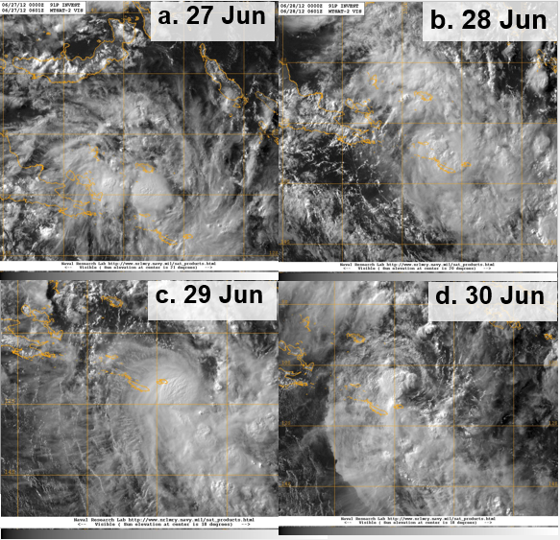

Figure 2. Series of visible images at 0600 UTC each day from a. 27 June; b. 28 June; c. 29 June and d. 30 June.

Images courtesy of NRL: <https://www.nrlmry.navy.mil/TC.html>

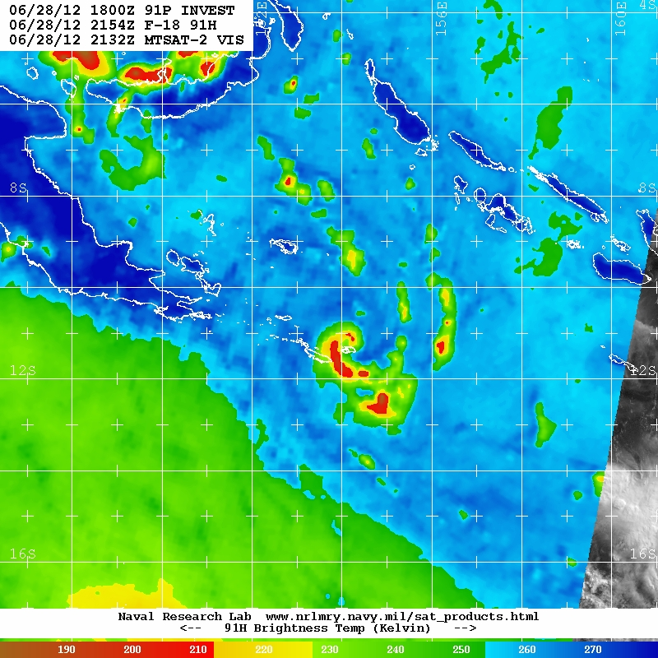

Figure 3. SSMIS 91 GHz (horizontally polarised view) microwave image at 2154 UTC 28 June, near peak intensity.

Image courtesy of NRL: <https://www.nrlmry.navy.mil/TC.html>

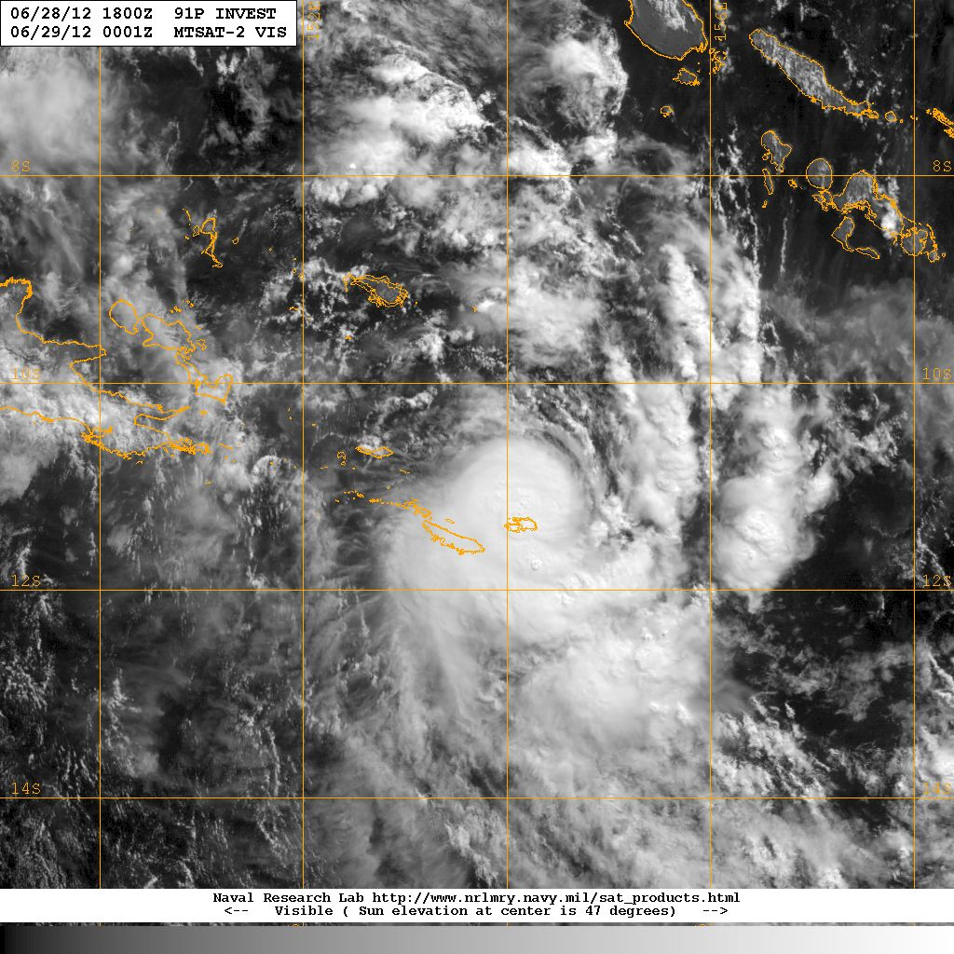

Figure 4. Visible image at 0001 UTC 29 June, when 21U was near peak intensity.

Image courtesy of NRL: <https://www.nrlmry.navy.mil/TC.html>

1. Appendix: List of Abbreviations

|  |  |
| --- | --- |
| Abbreviation | Term |
| ADT | Advanced Dvorak Technique |
| ACST | Australian Central Standard Time |
| AEST | Australian Eastern Standard Time |
| AiDT | AI-enhanced Dvorak Technique |
| AMSR2 | Advanced Microwave Scanning Radiometer |
| AMSU | Advanced Microwave Sounding Unit |
| ASCAT | Advanced Scatterometer |
| ATMS | Advanced Technology Microwave Sounder |
| AWS | automatic weather station |
| AWST | Australian Western Standard Time |
| °C | Celsius |
| CI | Current intensity |
| CIMSS | Cooperative Institute for Meteorological Satellite Studies (USA) |
| CIRA | Cooperative Institute for Research in the Atmosphere (USA) |
| D-MINT | Deep learning - Multispectral Intensity of TCs (formerly known as DMN) |
| D-PRINT | Deep learning - IR Intensity of TCs (formerly known as OPEN-AIIR) |
| EIR | Enhanced InfraRed |
| ERC | eyewall replacement cycle |
| FNMOC | Fleet Numerical Meteorology and Oceanography Centre (USA) |
| FT | Final T-number |
| GCOM | Global Change Observation Mission |
| GHz | Gigahertz |
| GMI | Global Precipitation Measurement Microwave Imager |
| h | hour |
| hPa | hectopascal |
| HSCAT | Hai Yang 2 Scatterometer (HY-2B, HY-2C) |
| km | kilometres |
| km/h | kilometres per hour |
| kn | knot |
| LLCC | LLCC |
| MET | Model Expected T-number |
| METOP | Meteorological Operational Satellite |
| MJO | Madden-Julian Oscillation |
| mm | millimetres |
| MSLP | mean sea level pressure |
| NESDIS | National Environmental Satellite, Data, and Information Service |
| nm | nautical mile |
| NOAA | National Oceanic and Atmospheric Administration |
| NRL | Navy Research Lab (USA) |
| OSCAT | Scatterometer aboard the OceanSat satellite |
| PAT | Pattern T-number |
| RCM | RadarSat Constellation Mission – Synthetic Aperture Radar |
| RH | relative humidity |
| RMW | radius of maximum winds |
| RSMC | Regional Specialised Meteorological Centre |
| SAR | Synthetic Aperture Radar |
| SATC | CIMSS Advanced Dvorak Technique |
| SATCON | Satellite Consensus |
| SEN1 | Sentinel-1A – Synthetic Aperture Radar |
| SMAP | Soil Moisture Active Passive |
| SMOS | Soil Moisture and Ocean Salinity |
| SSMIS | Special Sensor Microwave Imager/Sounder |
| TC | Tropical Cyclone |
| TCWC | Tropical Cyclone Warning Centre |
| UTC | Universal Time Co-ordinated |