Severe Tropical Cyclone Abigail

## 23 February – 8 March 2001

Joe Courtney and Ian Shepherd, Bureau of Meteorology

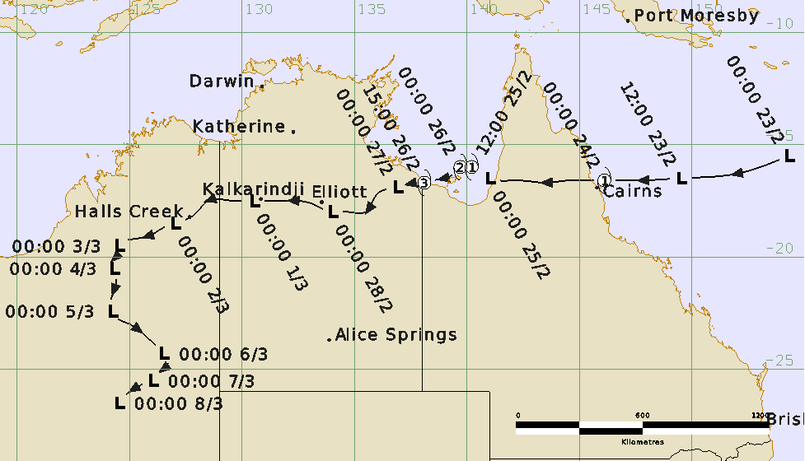

### Revision history

|  |  |  |  |
| --- | --- | --- | --- |
| Date | Version | Author | Description |
| 5/03/2024 | 1.0 | Joe Courtney | Final draft ready |

### Review status

|  |  |  |  |
| --- | --- | --- | --- |
| Date | Version | Reviewer | Description |
| 6/03/2024 | 1.0 | Ian Shepherd | Completed |

### Release history

|  |  |  |  |
| --- | --- | --- | --- |
| Date | Version | Status | Approval |
| 26/03/2023 | 1.0 | Approved for release | Andrew Burton |

Contact details:

Tropical Cyclone Team Lead

Severe Weather Environmental Prediction Services

Bureau of Meteorology

PO Box 1370, West Perth WA 6872

Email: tcwc@bom.gov.au



This work is copyright. Apart from any use as permitted under the Copyright Act 1968, no part may be reproduced without prior written permission from the Bureau of Meteorology. Refer to www.bom.gov.au/other/copyright.shtml for further information. Unless otherwise noted, all images in this document are licensed under the Creative Commons Attribution Australia Licence.

© Commonwealth of Australia 2024

Published by the Bureau of Meteorology

Cover image: Track of Severe Tropical Cyclone Abigail. Time in UTC (AEST-10h).

Table of contents

1. Summary 5

2. Meteorological description 9

2.1. Intensity analysis 9

2.2. Structure 15

2.3. Motion 15

3. Impact 16

3.1 Wind 16

3.2 Heavy rain and flooding 16

4. Observations 17

4.1. Winds 17

4.2. Pressure 17

4.3. Rainfall 17

4.4. Storm Surge 17

5. Appendix: List of abbreviations 19

**List of Figures**

Figure 1. Best Track of Severe Tropical Cyclone Abigail, 23 February to 8 March 2001 (times in UTC, AEST-10h, ACST-9.5h, AWST-8h). 5

Figure 2. Detailed best track of Severe Tropical Cyclone Abigail as it moved from Queensland into the Gulf of Carpentaria and then into the Northern Territory (times in UTC, AEST – 10h, ACST -9.5h). The area of gale-force, storm-force and hurricane-force winds are shown in pink, light red and dark red respectively. 6

Figure 3. GMS-5 Visible image at 2331 UTC 25 February, as Abigail reached category 2 intensity. Image courtesy NRL: https://www.nrlmry.navy.mil/TC.html 10

Figure 4. Special Sensor Microwave Image (SSMI) 85 GHz microwave image at 0849 UTC 26 February, prior to landfall and close to the time that Mornington Is recorded a low pressure of 958.7 hPa. Image courtesy NRL: https://www.nrlmry.navy.mil/TC.html 11

Figure 5. Visible image at 2331 UTC 28 February, showing deep convection near the centre and the surrounding well defined curved bands. Image courtesy NRL: https://www.nrlmry.navy.mil/TC.html 12

Figure 6. Halls Creek radar at 1850 UTC 1 March 2001 showing a well-defined centre east of Halls Creek. Image reproduced from Fig. 4 in Emmanuel, Callaghan and Otto (2008). 13

Figure 7. TRMM 85 GHz microwave image (horizontally polarised) at 1903 UTC 2 March showing strong curvature of deep convection around a well-defined centre. Image reproduced from Fig. 5 in Emmanuel, Callaghan and Otto (2008), original image courtesy NRL: https://www.nrlmry.navy.mil/TC.html 14

Figure 8. Weekly rainfall distribution: 21-28 February 2001. Image: http://www.bom.gov.au/climate/maps/rainfall/?variable=rainfall&map=totals&period=week&region=nat&year=2001&month=02&day=28 18

Figure 9. Weekly rainfall distribution: 1-7 March 2001.Image: http://www.bom.gov.au/climate/maps/rainfall/?variable=rainfall&map=totals&period=week&region=nat&year=2001&month=03&day=07 18

**List of Tables**

Table 1. Best track summary for Severe Tropical Cyclone Abigail, 23 Feb. – 8 March 2001.. 7

1. Summary

Tropical Cyclone Abigail (refer Figure 1 and Figure 2) first crossed the far north Queensland coast before re-intensifying into a severe tropical cyclone in the Gulf of Carpentaria, then produced heavy rain and flooding as it moved over inland Australia.

A complex area of low pressure formed within the monsoon trough in the Coral Sea on 22 February. A tropical low then developed and tracked westward to cross the far north Queensland north of Cairns on 24 February. Just prior to landfall the low rapidly developed to reach tropical cyclone intensity. Little damage was recorded and the system quickly weakened as it moved across Cape York Peninsula.

On 25 February ex-Tropical Cyclone Abigail moved into the southeastern Gulf of Carpentaria and was renamed early on 26 February, northeast of Mornington Island. Abigail rapidly intensified to category 3 intensity passing over Mornington Island before crossing the southern Gulf coast near the NT/Qld border overnight on 26 February. On Mornington Island there was widespread damage to trees with power lines brought down but generally only minor structural damage.

Abigail weakened into a tropical low south of Borroloola but retained strong tropical cloud features as it tracked across the Northern Territory during the next three days along a track close to that followed by TCs Winsome and Wylva earlier in February. Heavy rain produced by ex-Tropical Cyclone Abigail added to flood waters in the Gulf country and Victoria River District, prolonging the pre-existing disruptions to communities and road closures in the region. The low crossed into Western Australia on 1 March and caused further heavy rain across the western desert region before eventually weakening on 8 March.



Figure . Best Track of Severe Tropical Cyclone Abigail, 23 February to 8 March 2001 (times in UTC, AEST-10h, ACST-9.5h, AWST-8h).

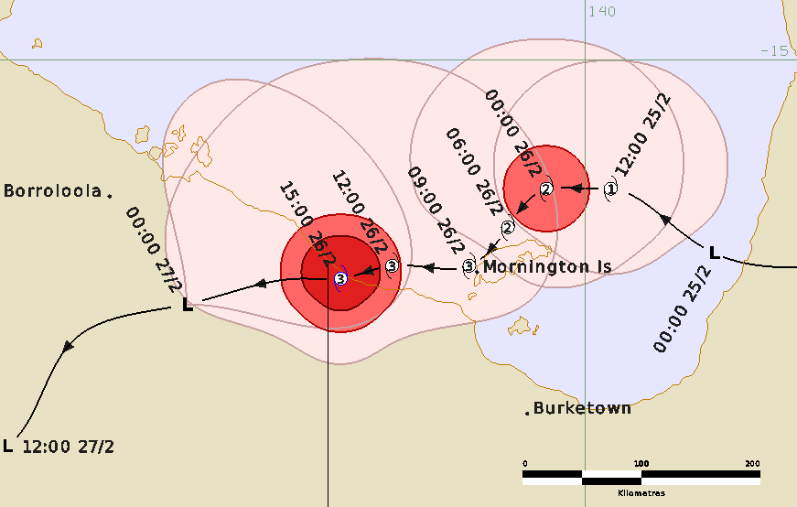

Figure . Detailed best track of Severe Tropical Cyclone Abigail as it moved from Queensland into the Gulf of Carpentaria and then into the Northern Territory (times in UTC, AEST – 10h, ACST -9.5h). The area of gale-force, storm-force and hurricane-force winds are shown in pink, light red and dark red respectively.

Table . Best track summary for Severe Tropical Cyclone Abigail, 23 Feb. – 8 March 2001. Refer to the Australian Tropical Cyclone database for complete listing of parameters to 8 January 2023. UTC=AEST-10h, ACST-9.5h and WST-8h. * Not at tropical cyclone intensity as gales less than halfway around centre.

|  |  |  |  |  |  |  |  |  |  |  |  |  |
| --- | --- | --- | --- | --- | --- | --- | --- | --- | --- | --- | --- | --- |
| Year | Mon | Day | Hour | Pos. | Pos. | Pos. | Max Wind | Max | Cent. | Rad. of gales nm | Rad. of storm nm | RMW |
|  |  |  | UTC | Lat. | Long. | Acc. | 10min | gust | Press. | (NE/SE/ | (NE/SE/ | nm |
|  |  |  |  | S | E | nm | kn | kn | hPa | SW/NW) | SW/NW) |  |
| 2001 | 2 | 23 | 0000 | 15.5 | 154.3 | 40 | 30 | 45 | 998 | 0/0/0/0 | 0/0/0/0 | - |
| 2001 | 2 | 23 | 0600 | 16.3 | 152.0 | 40 | 30 | 45 | 998 | 0/0/0/0 | 0/0/0/0 | - |
| 2001 | 2 | 23 | 1200 | 16.5 | 149.5 | 30 | 30 | 45 | 996 | 0/0/0/0 | 0/0/0/0 | - |
| 2001 | 2 | 23 | 1800 | 16.6 | 147.8 | 25 | 35* | 50 | 992 | 0/0/70/0 | 0/0/0/0 | - |
| 2001 | 2 | 24 | 0000 | 16.6 | 146.1 | 20 | 40 | 55 | 992 | 40/70/20/25 | 0/0/0/0 | 15 |
| 2001 | 2 | 24 | 0200 | 16.6 | 145.5 | 20 | 40 | 55 | 992 | 50/50/20/20 | 0/0/0/0 | 15 |
| 2001 | 2 | 24 | 0600 | 16.6 | 144.5 | 20 | 30 | 45 | 994 | 0/0/0/0 | 0/0/0/0 | - |
| 2001 | 2 | 24 | 1200 | 16.7 | 143.5 | 25 | 20 | 45 | 996 | 0/0/0/0 | 0/0/0/0 | - |
| 2001 | 2 | 24 | 1800 | 16.6 | 142.3 | 25 | 20 | 45 | 996 | 0/0/0/0 | 0/0/0/0 | - |
| 2001 | 2 | 25 | 0000 | 16.5 | 141.0 | 25 | 30 | 45 | 996 | 0/0/0/0 | 0/0/0/0 | - |
| 2001 | 2 | 25 | 0600 | 16.3 | 140.7 | 20 | 30 | 45 | 994 | 0/0/0/0 | 0/0/0/0 | - |
| 2001 | 2 | 25 | 1200 | 16.0 | 140.2 | 20 | 35 | 50 | 994 | 60/40/40/60 | 0/0/0/0 | 20 |
| 2001 | 2 | 25 | 1800 | 16.0 | 140.0 | 20 | 45 | 65 | 990 | 60/40/40/60 | 0/0/0/0 | 20 |
| 2001 | 2 | 26 | 0000 | 16.0 | 139.7 | 20 | 50 | 70 | 986 | 70/50/40/70 | 20/20/20/20 | 20 |
| 2001 | 2 | 26 | 0600 | 16.3 | 139.4 | 20 | 60 | 85 | 975 | 90/50/40/80 | 25/25/20/25 | 20 |
| 2001 | 2 | 26 | 1200 | 16.6 | 138.5 | 20 | 65 | 90 | 970 | 110/50/40/80 | 30/25/25/30 | 15 |
| 2001 | 2 | 26 | 1500 | 16.7 | 138.1 | 20 | 65 | 90 | 972 | 110/40/40/90 | 30/25/25/30 | 15 |
| 2001 | 2 | 26 | 1800 | 16.7 | 137.8 | 20 | 60 | 85 | 975 | 110/40/40/90 | 30/20/20/30 | - |
| 2001 | 2 | 27 | 0000 | 16.9 | 136.9 | 25 | 40* | 55 | 982 | 110/0/0/0 | 0/0/0/0 | - |
| 2001 | 2 | 27 | 0600 | 17.2 | 136.0 | 20 | 30 | 45 | 986 | 0/0/0/0 | 0/0/0/0 | - |
| 2001 | 2 | 27 | 1200 | 18.0 | 135.5 | 25 | 30 | 45 | 988 | 0/0/0/0 | 0/0/0/0 | - |
| 2001 | 2 | 27 | 1800 | 18.0 | 134.7 | 25 | 30 | 45 | 990 | 0/0/0/0 | 0/0/0/0 | - |
| 2001 | 2 | 28 | 0000 | 18.0 | 134.0 | 20 | 30 | 45 | 990 | 0/0/0/0 | 0/0/0/0 | - |
| 2001 | 2 | 28 | 0600 | 17.6 | 133.0 | 20 | 30 | 45 | 988 | 0/0/0/0 | 0/0/0/0 | - |
| 2001 | 2 | 28 | 1200 | 17.5 | 132.2 | 20 | 30 | 45 | 988 | 0/0/0/0 | 0/0/0/0 | - |
| 2001 | 2 | 28 | 1800 | 17.5 | 131.2 | 20 | 30 | 45 | 988 | 0/0/0/0 | 0/0/0/0 | - |
| 2001 | 3 | 1 | 0000 | 17.5 | 130.5 | 20 | 30 | 45 | 990 | 0/0/0/0 | 0/0/0/0 | - |
| 2001 | 3 | 1 | 0600 | 17.5 | 129.5 | 20 | 30 | 45 | 988 | 0/0/0/0 | 0/0/0/0 | - |
| 2001 | 3 | 1 | 1200 | 17.5 | 128.5 | 20 | 30 | 45 | 988 | 0/0/0/0 | 0/0/0/0 | - |
| 2001 | 3 | 1 | 1800 | 18.1 | 127.9 | 20 | 30 | 40 | 988 | 0/0/0/0 | 0/0/0/0 | - |
| 2001 | 3 | 2 | 0000 | 18.5 | 127.0 | 20 | 30 | 45 | 990 | 0/0/0/0 | 0/0/0/0 | - |
| 2001 | 3 | 2 | 0600 | 18.7 | 126.5 | 25 | 25 | 45 | 990 | 0/0/0/0 | 0/0/0/0 | - |
| 2001 | 3 | 2 | 1200 | 19.0 | 126.0 | 25 | 25 | 45 | 992 | 0/0/0/0 | 0/0/0/0 | - |
| 2001 | 3 | 2 | 1800 | 19.2 | 125.2 | 25 | 25 | 45 | 992 | 0/0/0/0 | 0/0/0/0 | - |
| 2001 | 3 | 3 | 0000 | 19.5 | 124.5 | 25 | 25 | 45 | 992 | 0/0/0/0 | 0/0/0/0 | - |
| 2001 | 3 | 3 | 0600 | 19.8 | 124.5 | 25 | 25 | 45 | 990 | 0/0/0/0 | 0/0/0/0 | - |
| 2001 | 3 | 3 | 1200 | 20.0 | 124.4 | 25 | 25 | 45 | 993 | 0/0/0/0 | 0/0/0/0 | - |
| 2001 | 3 | 3 | 1800 | 20.1 | 124.3 | 25 | 25 | 45 | 993 | 0/0/0/0 | 0/0/0/0 | - |
| 2001 | 3 | 4 | 0000 | 20.5 | 124.3 | 20 | 25 | 45 | 994 | 0/0/0/0 | 0/0/0/0 | - |
| 2001 | 3 | 4 | 0600 | 21.0 | 124.4 | 20 | 25 | 45 | 992 | 0/0/0/0 | 0/0/0/0 | - |
| 2001 | 3 | 4 | 1200 | 21.5 | 124.3 | 20 | 20 | 45 | 994 | 0/0/0/0 | 0/0/0/0 | - |
| 2001 | 3 | 4 | 1800 | 22.0 | 124.2 | 25 | 20 | 45 | 993 | 0/0/0/0 | 0/0/0/0 | - |
| 2001 | 3 | 5 | 0000 | 22.4 | 124.2 | 25 | 20 | 45 | 993 | 0/0/0/0 | 0/0/0/0 | - |
| 2001 | 3 | 5 | 0600 | 22.6 | 124.3 | 25 | 20 | 45 | 992 | 0/0/0/0 | 0/0/0/0 | - |
| 2001 | 3 | 5 | 1200 | 23.0 | 125.0 | 25 | 20 | 45 | 995 | 0/0/0/0 | 0/0/0/0 | - |
| 2001 | 3 | 5 | 1800 | 23.7 | 125.9 | 25 | 20 | 45 | 995 | 0/0/0/0 | 0/0/0/0 | - |
| 2001 | 3 | 6 | 0000 | 24.3 | 126.5 | 25 | 20 | 45 | 996 | 0/0/0/0 | 0/0/0/0 | - |
| 2001 | 3 | 6 | 0600 | 24.7 | 126.7 | 25 | 20 | 45 | 994 | 0/0/0/0 | 0/0/0/0 | - |
| 2001 | 3 | 6 | 1200 | 25.0 | 126.5 | 25 | 20 | 45 | 996 | 0/0/0/0 | 0/0/0/0 | - |
| 2001 | 3 | 6 | 1800 | 25.2 | 126.2 | 25 | 20 | 45 | 998 | 0/0/0/0 | 0/0/0/0 | - |
| 2001 | 3 | 7 | 0000 | 25.5 | 126.0 | 25 | 20 | 45 | 1000 | 0/0/0/0 | 0/0/0/0 | - |
| 2001 | 3 | 7 | 0600 | 25.6 | 125.7 | 25 | 20 | 45 | 1000 | 0/0/0/0 | 0/0/0/0 | - |
| 2001 | 3 | 7 | 1200 | 25.7 | 125.5 | 25 | 20 | 45 | 1002 | 0/0/0/0 | 0/0/0/0 | - |
| 2001 | 3 | 7 | 1800 | 26.0 | 125.0 | 25 | 15 | 45 | 1003 | 0/0/0/0 | 0/0/0/0 | - |
| 2001 | 3 | 8 | 0000 | 26.5 | 124.5 | 25 | 15 | 45 | 1004 | 0/0/0/0 | 0/0/0/0 | - |

1. Meteorological description
   1. Intensity analysis

A complex area of low pressure formed within the monsoon trough in the Coral Sea on 22 February. There were two centres of about 1001 hPa: one near 12°S, 157°E and the other near 17.5°S, 154°E. Over the next 24 hours the lows merged and the system tracked westward in an environment of favourable upper divergence, steered by the subtropical ridge to its south. Gales were briefly observed at Flinders Reef south of the centre around 16 UTC 23 February. Shortly before reaching the north Queensland coast, the system exhibited a sudden intensification, and reached tropical cyclone intensity at 0000 UTC on 24 February. Green Island, just off the coast from Cairns reported gales in the southerly flow ahead of the system. Abigail crossed the coast just north of Cairns and weakened below cyclone strength soon after landfall before it started moving across Cape York Peninsula.

On 25 February ex-Tropical Cyclone Abigail moved into the southeastern Gulf of Carpentaria in a region where environmental conditions favoured further development. The system returned to tropical cyclone status early on 26 February, northeast of Mornington Island. Figure 3 is the visible image at 2331 UTC 25 February that shows a developing eye pattern. Figure 4 is an SSMI 85 GHz microwave image at 0849 UTC 26 February that shows an eye signature and Abigail reached its peak intensity of 65 kn (120 km/h) (category 3) intensity. This occurred close to the time that Mornington Is recorded a low pressure of 968.7 hPa. Mornington Island wind gusts peaked at 64 knots (120 km/h) prior to a power outage but the observer estimated that later wind gusts reached 90 kn (164 km/h). The observer also noted the eye of the cyclone passed over around 0930 UTC (1930 AEST) 26 February.

Abigail crossed the southern Gulf coast near the NT/Qld border around 15 UTC 26 February and moved westwards into the McArthur River region. Abigail weakened into a tropical low south of Borroloola but continued to traverse the Northern Territory during the next three days along a track close to that followed by Tropical Cyclones Winsome and Wylva. Abigail remained in a low shear environment and despite being over land, the cloud features retained a tropical cyclone signature for several days. Wave Hill (now Kalkarindji) recorded a pressure of 987.5 hPa at 1700 UTC 28 February. Figure 5 is a visible image at 2331 UTC 28 February showing deep convection near the centre surrounded by well-defined curved bands. Figure 6 is a Halls Creek radar image at 1850 UTC 1 March 2001 showing a well-defined centre east of Halls Creek. Figure 7 is a TRMM microwave image at 1903 UTC 2 March showing strong curvature of deep convection around a well-defined centre. Maximum winds are estimated at 30 kn for this period overland, although it is possible that land gales occurred at different times.

The characteristics of Abigail overland are discussed in detail in 'A Hypothesis for the Redevelopment of Warm-Core Cyclones over Northern Australia' by Emmanuel, Callaghan and Otto (2008). Reference: Emanuel, K., Callaghan, J. and Otto, P. 2008. A Hypothesis for the Redevelopment of Warm-Core Cyclones over Northern Australia. Monthly Weather Review, *Mon. Wea. Rev.* 136. 3863-3872. <https://doi.org/10.1175/2008MWR2409.1>

The circulation weakened on 2 March and eventually dissipated on 6 March over inland Western Australia.

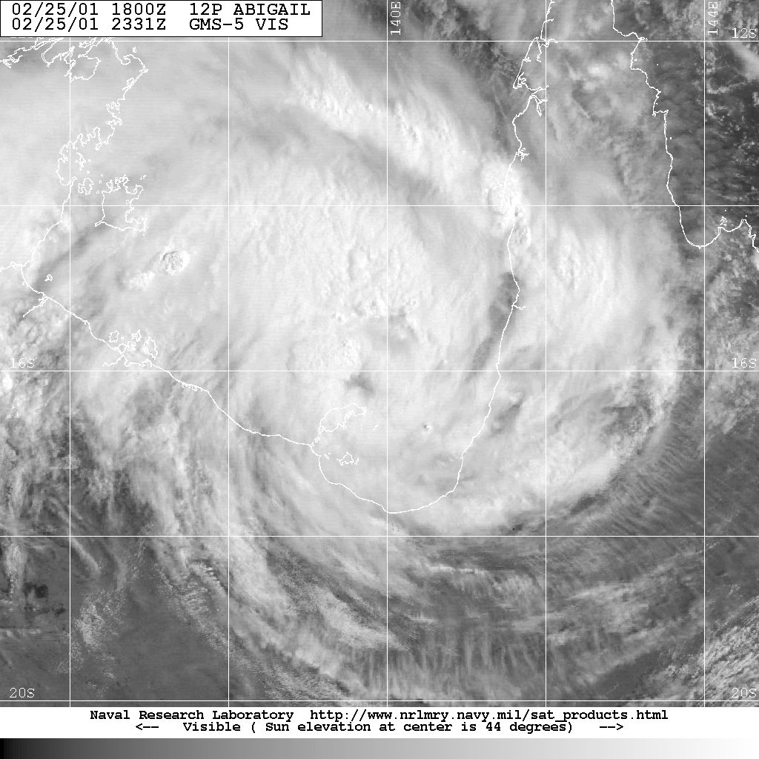

Figure . GMS-5 Visible image at 2331 UTC 25 February, as Abigail reached category 2 intensity. Image courtesy NRL: <https://www.nrlmry.navy.mil/TC.html>

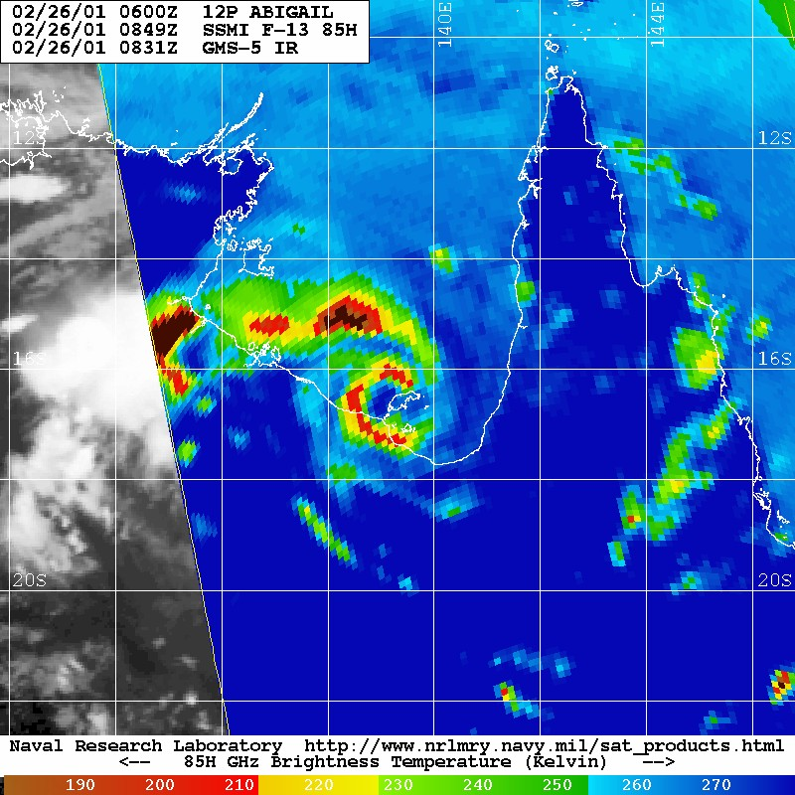

Figure . Special Sensor Microwave Image (SSMI) 85 GHz microwave image at 0849 UTC 26 February, prior to landfall and close to the time that Mornington Is recorded a low pressure of 958.7 hPa. Image courtesy NRL: <https://www.nrlmry.navy.mil/TC.html>

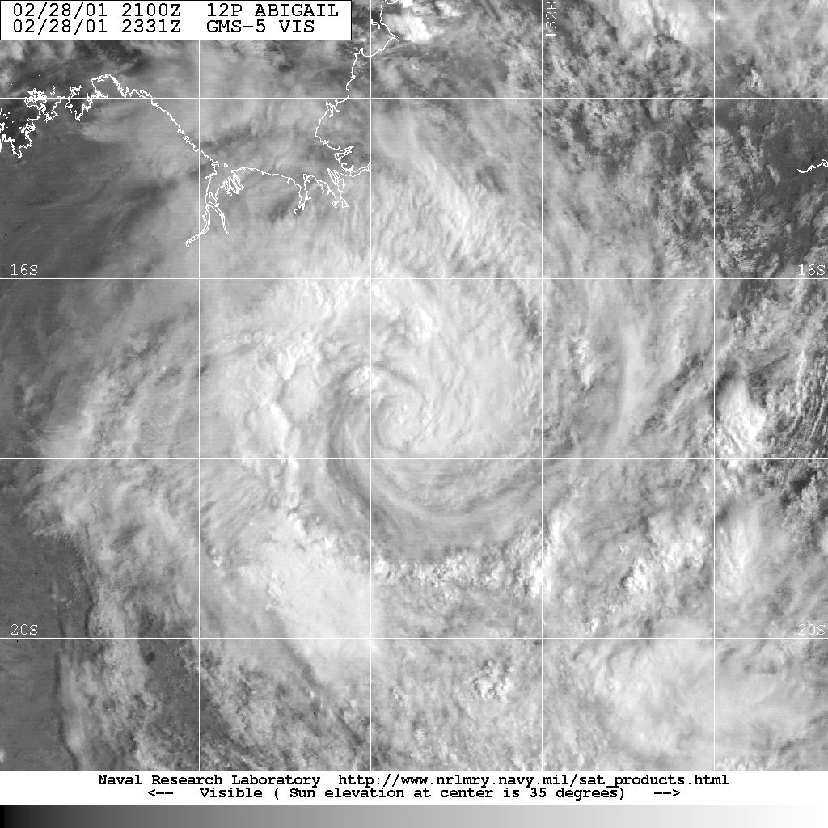

Figure . Visible image at 2331 UTC 28 February, showing deep convection near the centre and the surrounding well defined curved bands. Image courtesy NRL: <https://www.nrlmry.navy.mil/TC.html>

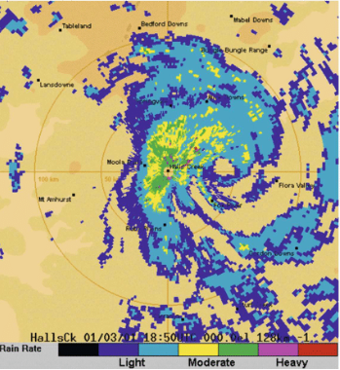

Figure . Halls Creek radar at 1850 UTC 1 March 2001 showing a well-defined centre east of Halls Creek. Image reproduced from Fig. 4 in Emmanuel, Callaghan and Otto (2008).

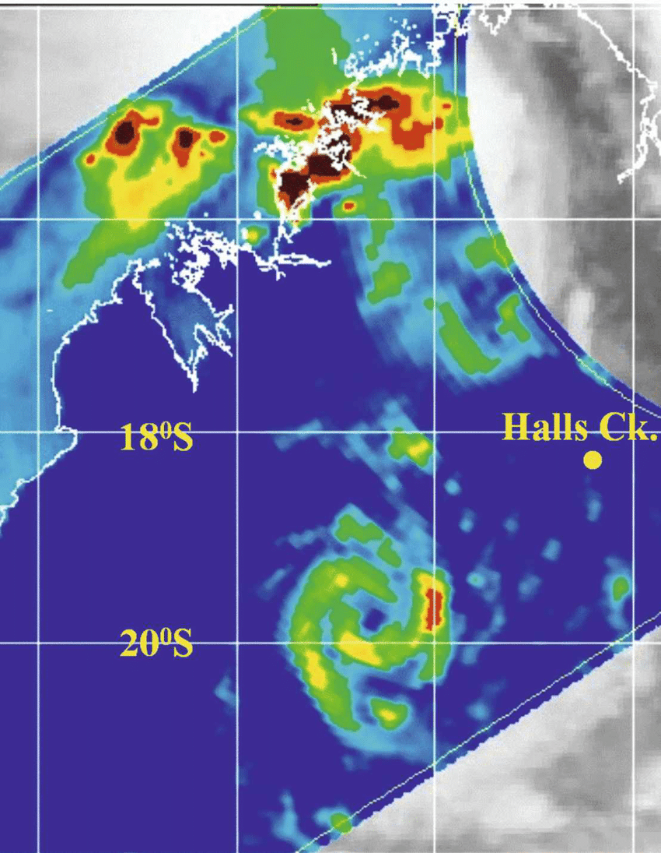

Figure . TRMM 85 GHz microwave image (horizontally polarised) at 1903 UTC 2 March showing strong curvature of deep convection around a well-defined centre. Image reproduced from Fig. 5 in Emmanuel, Callaghan and Otto (2008), original image courtesy NRL: <https://www.nrlmry.navy.mil/TC.html>

* 1. Structure

Gales extended 70 nm (130 km) south of the centre as Abigail neared the Queensland coast assisted by the prevailing trade wind flow and rapid translation speed. By contrast the extent to the north was only estimated at 25 to 50 nm (46-93 km). As Abigail redeveloped in the Gulf of Carpentaria the extent of gales was higher to the north peaking at 110 nm (204 km) northeast of the centre while only estimated at 40 to 50 nm (74-93 km) south of the centre. The radius to maximum winds (RMW) was 15 to 20 nm (28-37 km) as estimated from weather radar and microwave imagery.

* 1. Motion

The developing Coral Sea system moved rapidly westwards under the influence of a strong mid-level ridge to the south. Once over the Gulf of Carpentaria, the ridge weakened and Abigail slowed to less than 10 km/h before tracking west southwest at 15 km/h at landfall. The ridge remained the dominant steering mechanism in following days as the low tracked westwards overland at about 15-20 km/h. On 3 March the track turned to the south over inland Western Australia.

1. Impact

3.1 Wind

There was only minor damage recorded as Abigail crossed the north Queensland coast. There were felled trees at Edge Hill and in the northern suburbs of Cairns.

On Mornington Island there was widespread damage to trees with power lines brought down. One small building was badly damaged however most damage was restricted to roofs and guttering. Reconstruction since TC Warren in 1995 helped to prevent more widespread damage. The eye of the cyclone passed over Mornington Island Township around 1930 AEST 26 February (0930 UTC).

3.2 Heavy rain and flooding

There was only minor flooding recorded as Abigail crossed the north Queensland coast.

The most significant impacts were associated with heavy rain and flooding across the Northern Territory. The rain came following previous heavy rainfall associated with Tropical Cyclones Winsome and Wylva earlier in February that also moved from the Gulf of Carpentaria across the Northern Territory.

Heavy rainfall fell in the Roper-McArthur, Barkly, Katherine, Victoria River and Alice Springs districts. Flood waters around Borroloola and in the Victoria River district continued to isolate many communities, with aircraft food drops required in Borroloola and Yarralin, and evacuations required from various remote stations. The Katherine River rose to 15.5 m on 1 March, inundating low-lying roads and properties, and the Victoria Highway was cut on 3 March near Timber Creek. Heavy rainfall in central WA from the remnants of ex-Tropical Cyclone Abigail flooded the Kiwirrkurra community (WA) requiring the evacuation of 160 residents to Walungurru (Kintore) and Alice Springs. Flood evacuees from the Victoria River District communities of Kalkarindji, Pigeon Hole and Daguragu were able to return from 12 March after repairs to essential services were completed.

1. Observations
   1. Winds

Just prior to Abigail crossing the north Queensland coast, Green Island reported gales between 2300 UTC 23 February and 0000 UTC 24 February (0900-1100 AEST 24 Feb**ruary**)

The maximum wind gust reported from Mornington Island AWS was 64 kn (120 km/h) from the northeast at 1016 UTC (2016 AEST) 26 February. However, a Telstra outage prevented reception of AWS observations during the strongest winds. The observer estimated maximum gusts reaching 90 kn (164 km/h) and also the eye passing over at 0930 UTC (1930 AEST).

* 1. Pressure

Minimum pressure reports:

Green Is. 992.7 hPa 0028 UTC 24 February;

Mornington Island (barograph) 968.5 hPa around 0930 UTC (1930 AEST) 26 February;

Elliott (NT): 992.8 hPa at 05 UTC 28 February;

Wave Hill (NT): 987.5 hPa at 1700 UTC 28 February; and

Halls Creek (WA): 991.8 hPa at 2200 UTC 1 March.

* 1. Rainfall

Heavy rainfall was recorded along the track of Abigail as it tracked across Cape York Peninsula and then the southern Gulf of Carpentaria coast then inland Northern Territory and adjacent Western Australia. Figure 8 and Figure 9 show the weekly rainfall distribution during 21-28 February 2001 and 1 – 7 March 2001 respectively.Highest daily rainfall totals to 9 am local time include:

24 Feb.: Daintree Village 241 mm, Low Isles 228 mm, Topaz 164 mm, Kuranda 149 mm, Cooktown 137 mm, Musgrave 134 mm, Malanda 112 mm;

27 Feb.: Mornington Is 212 mm, Redbank Mind 135.5 mm, Calvert Hills 117 mm, Centre Is 113 mm, Wollogorang 108.2 mm, Westmoreland 104.4 mm;

28 Feb.: Westmoreland 176 mm, Larrimah 155.5 mm, Kingfisher Camp 140.4 mm, Cattle Creek 109 mm, Redbank Mine 104.2 mm;

1 March (NT unless stated): Elliott 111 mm, Wave Hill 90 mm;

2 March - NT: Inverway 143 mm, Bunda 133 mm, Riveren 108 mm, Limbunya 100.2 mm;

WA: Nicholson 108 mm, Moola Bulla 102 mm, Sophie Downs 100 mm;

3 March (WA): Fox River 115 mm, Sophie Downs 108 mm, Kachana 103 mm;

4 March (WA): Cadjebut 153 mm, Larrawa 104.3 mm.

* 1. Storm Surge

The storm surge at Mornington Island was 0.5 m above HAT (predicted high tide 0.8m below HAT). Further east at Karumba there was a 1.2m storm surge. There were no known impacts.

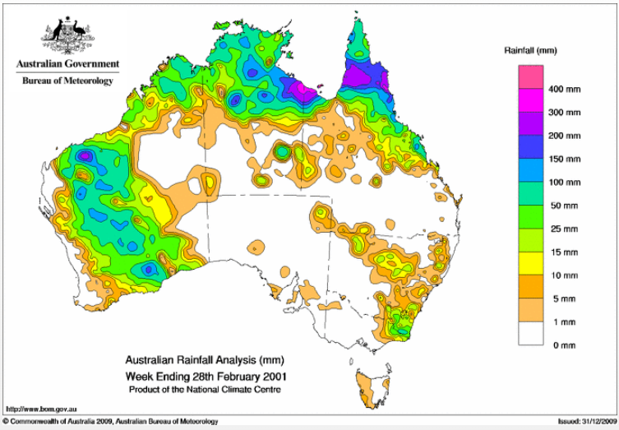

Figure . Weekly rainfall distribution: 21-28 February 2001. Image: <http://www.bom.gov.au/climate/maps/rainfall/?variable=rainfall&map=totals&period=week&region=nat&year=2001&month=02&day=28>

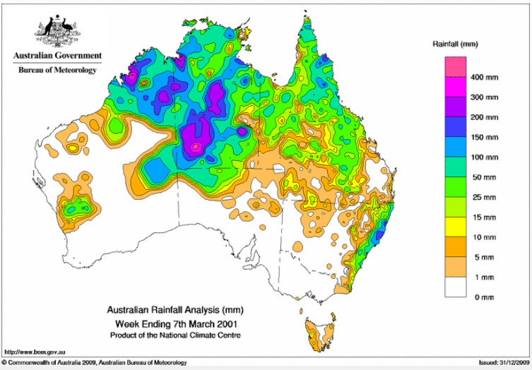

Figure . Weekly rainfall distribution: 1-7 March 2001.Image: <http://www.bom.gov.au/climate/maps/rainfall/?variable=rainfall&map=totals&period=week&region=nat&year=2001&month=03&day=07>

1. Appendix: List of abbreviations

|  |  |
| --- | --- |
| Abbreviation | Term |
| ADT | Advanced Dvorak Technique |
| ACST | Australian Central Standard Time |
| AEST | Australian Eastern Standard Time |
| AMSR2 | Advanced Microwave Scanning Radiometer |
| ASCAT | Advanced Scatterometer |
| ATMS | Advanced Technology Microwave Sounder |
| AWS | automatic weather station |
| AWST | Australian Western Standard Time |
| C | Celsius |
| CI | Current intensity |
| CIMSS | Cooperative Institute for Meteorological Satellite Studies (USA) |
| CIRA | Cooperative Institute for Research in the Atmosphere (USA) |
| EIR | Enhanced InfraRed |
| ERC | eyewall replacement cycle |
| FNMOC | Fleet Numerical Meteorology and Oceanography Centre (USA) |
| FT | Final T-number |
| GCOM | Global Change Observation Mission |
| GHz | Gigahertz |
| GMI | Global Precipitation Measurement Microwave Imager |
| h | hour |
| hPa | hectopascal |
| HSCAT | Hai Yang 2 Scatterometer (HY-2B, HY-2C) |
| km | kilometres |
| km/h | kilometres per hour |
| kn | knot |
| LLCC | LLCC |
| MET | Model Expected T-number |
| METOP | Meteorological Operational Satellite |
| MJO | Madden-Julian Oscillation |
| mm | millimetres |
| MSLP | mean sea level pressure |
| nm | nautical mile |
| NOAA | National Oceanic and Atmospheric Administration |
| NRL | Navy Research Lab (USA) |
| PAT | Pattern T-number |
| RH | relative humidity |
| RMW | radius of maximum winds |
| RSMC | Regional Specialised Meteorological Centre |
| SAR | Synthetic Aperture Radar |
| SATCON | satellite Consensus |
| SMAP | Soil Moisture Active Passive |
| SMOS | Soil Moisture and Ocean Salinity |
| SSMIS | Special Sensor Microwave Imager/Sounder |
| TC | Tropical Cyclone |
| TCWC | Tropical Cyclone Warning Centre |
| UTC | Universal Time Co-ordinated |