Severe Tropical Cyclone Alfred (22U)
21 February – 8 March 2025
Lauren Pattie, James Thompson and Tony Wedd,
Tropical Cyclone Team
Environmental Prediction Services – Severe Weather

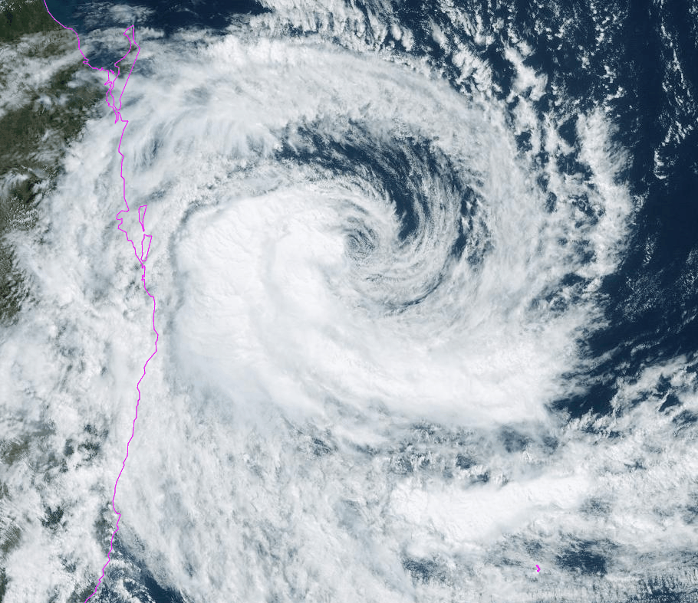

Revision history
Date | Version | Author | Description
30/05/2025 | 1.0 | Lauren Pattie  James Thompson  Tony Wedd | Final draft

Review status
Date | Version | Reviewer | Description
16/06/2025 | 1.0 | David Grant | Completed

Release history
Date | Version | Status | Approval
2/09/2025 | 1.0 | Approved for release | Andrew Burton  Matt Collopy

Contact details:
Tropical Cyclone Team Lead
Severe Weather Environmental Prediction Services
Bureau of Meteorology
PO Box 1370, West Perth WA 6872
Email: tcwc@bom.gov.au

This work is copyright. Apart from any use as permitted under the Copyright Act 1968, no part may be reproduced without prior written permission from the Bureau of Meteorology. Refer to www.bom.gov.au/other/copyright.shtml for further information. Unless otherwise noted, all images in this document are licensed under the Creative Commons Attribution Australia Licence.
© Commonwealth of Australia 2025
Published by the Bureau of Meteorology
Cover image: Satellite image of Severe TC Alfred at 10 am AEST on 5 March 2025, originally processed by the Bureau of Meteorology from the geostationary satellite Himawari-9 operated by the Japan Meteorological Agency.
Contents

1. Summary 8

2. Meteorological description 16

2.1. Intensity analysis 16

2.2. Structure 31

2.3. Motion 40

3. Impact 40

4. Observations 43

4.1. Wind 43

4.2. Pressure 48

4.3. Rainfall 49

4.4. Flooding 53

4.5. Waves 53

4.6. Tides 55

5. Forecast Performance 58

6. References 63

Appendix: List of abbreviations 64

List of Figures
Figure 1 Best track of Severe Tropical Cyclone Alfred 21 February - 9 March 2025 (times in AEST, UTC +10) 9
Figure 2 Best track of Alfred as it approached and moved over southeast Queensland 6-9 March 2025 (times in AEST, UTC+10) 10
Figure 3 Detailed best track of Alfred as it approached and moved over southeast Queensland 6-9 March 2024 (times in AEST, UTC+10). For this period, light pink depicts total extent of gale force (i.e. category 1) winds and red depicts total extent of storm force (i.e category 2) winds. 11
Figure 4: MSLP charts Top Left – 0000 UTC (10am AEST) 21 Feburary 2025. Top Right – 0000 UTC (10am AEST) 24 Feburary 2025. Middle Left – 0000 UTC (10am AEST) 27 Feburary 2025. Middle Right – 0000 UTC (10am AEST) 2 March 2025. Bottom left – 0000 UTC (10am AEST) 5 March 2025. Bottom right – 0000 UTC (10am AEST) 8 March 2025. 19
Figure 5 Real-time Multivariate MJO (RMM) Index diagram depicting a strong MJO, out of the unit circle in the Western Pacific during February 2025. This image is courtesy of BOM and can be accessed from: http://www.bom.gov.au/climate/mjo/#tabs=Monitoring 20
Figure 6 Hovmöller diagram of tropical waves showing the formation of Alfred occurred with a pulse of the MJO (black) and an Equatorial Rossby (ER) wave (red). The image is courtesy of the North Carolina Institute for Climate Studies. https://ncics.org/pub/mjo/archive/2024/2024-12-02/v2/ 21
Figure 7 Scatterometry, ASCAT-B at 1140 UTC 21 February, depicting the elongated centre of a developing Alfred. Image courtesy NRL: https://www.nrlmry.navy.mil/TC.html 22
Figure 8 Scatterometry, ASCAT-B at 2227 UTC 22 February, depicting an elongated centre and gales in three quadrants. Image courtesy NRL: https://www.nrlmry.navy.mil/TC.html 23
Figure 9 Scatterometry, ASCAT-C at 1151 UTC 23 February 2025, storm force winds to the northwest of Alfred's centre. Image courtesy NRL: https://www.nrlmry.navy.mil/TC.html 24
Figure 10 Scatterometry, ASCAT-C at 1049 UTC 26 February 2025 showing hurricane force winds to the north of Alfred's centre. Image courtesy NRL: https://www.nrlmry.navy.mil/TC.html 25
Figure 11 M-PERC (Microwave-based Probability of Eyewall Replacement Cyclone) Hovmöller diagram showing detection of secondary eyewall during 27 February, the primary eyewall eroding, and the secondary eyewall becoming dominant and contracting during 28 February. 26
Figure 12 Microwave image, AMSR2 89 GHz at 1450 UTC 27 February. Shows the last remaining portion of the eroding inner eyewall, surrounded by the much larger second eyewall. Image courtesy NRL: https://www.nrlmry.navy.mil/TC.html 27
Figure 13 Infrared Himawari-9 Satellite Image at 1200 UTC 28 March. At the period of Alfred's peak intensity. Image courtesy NRL: https://www.nrlmry.navy.mil/TC.html and Japan Meteorological Agency (JMA). 28
Figure 14 Scatterometry, ASCAT-C at 1146 UTC 28 February. Shows Alfred at 90 knots intensity, during the period of Alfred's lifetime peak intensity. Image courtesy NRL: https://www.nrlmry.navy.mil/TC.html 29
Figure 15 Scatterometry, ASCAT-C at 2234 UTC 6 March depicting a 45 knot Tropical Cyclone Alfred near the southeast Queensland coast. Image courtesy NRL: https://www.nrlmry.navy.mil/TC.html 30
Figure 16 Scatterometry, SAR at 0807 UTC 23 February, Tropical Cyclone Alfred with gale force winds in all quadrants, and storm force winds in the west. Image courtesy of NOAA's Center for Satellite Applications and Research (STAR): https://www.star.nesdis.noaa.gov/socd/mecb/sar/sarwinds_tropical.php 33
Figure 17 Scatterometry, ASCAT-B at 1129 UTC 3 March, depicting Alfred with a sub-tropical structure, having a large RMW and expanded southern gale radii. Image courtesy NRL: https://www.nrlmry.navy.mil/TC.html 34
Figure 18 Hart & Evans Cyclone Phase Space diagrams. Warm core assessment based on the low-level and upper-level thermal wind. Symmetry based on thermal wind symmetry (B-parameter) and low-level thermal wind. 'C' marks the analysis time. Top Left: USG model base time 3 March 12UTC, shows Alfred moving to a shallow warm core. Top Right: USG model base time 3 March 12UTC, 'C' the analysis is hidden under the zoomed in map of Queensland, but shows an asymmetric system. Bottom Left: USG model base time 4 March 00UTC, shows Alfred with a shallow warm core. Bottom Right: USG model base time 4 March 00UTC, shows an asymmetric Alfred. 35
Figure 19 CIMSS automated phase classification of Alfred. Courtesy of Cooperative Institute for Meteorological Satellite Studies (CIMSS): https://tropic.ssec.wisc.edu/# 36
Figure 20. Sea Surface Temperatures 3 to 9 March, depicting SSTs of 26 to 28C offshore of the southeast Queensland coast along Alfred's track. 37
Figure 21 Scatterometry, ASCAT-C at 1140 UTC shows a symmetric structure. Image courtesy NRL: https://www.nrlmry.navy.mil/TC.html 38
Figure 22 Radiometry, SMAP at 0806 UTC 7 March. Alfred nearing the southeast Queensland coast. Image courtesy NRL: https://www.nrlmry.navy.mil/TC.html 39
Figure 23 Fallen tree over power line at Chinderah in northern NSW (source: Jason O'Brien, AAP). 41
Figure 24 Storm erosion scarp at Mermaid Beach on the Gold Coast (source: Margeret Burin, ABC News). 42
Figure 25 Soybean crops wiped out near Coraki, NSW (source: Kim Honan, ABC Rural). 42
Figure 26 Frederick Reef (200701) mean wind speed and gust observations. 44
Figure 27 Cato Island (200601) mean wind speed and gust observations. 45
Figure 28 Cape Moreton (040043) mean wind speed and gust observations. 45
Figure 29 Redcliffe (040958) mean wind speed and gust observations. 46
Figure 30 Gold Coast Seaway (040764) mean wind speed and gust observations. 46
Figure 31 Cape Byron (058216) mean wind speed and gust observations. 47
Figure 32 Frederick Reef (200701) Mean Sea Level Pressure (MSLP) chart. 48
Figure 33 Cato Island (200601) Mean Sea Level Pressure (MSLP) chart. 48
Figure 34 Cape Moreton (040043) Mean Sea Level Pressure (MSLP) chart. 49
Figure 35 Map of the 7-day rainfall totals across Australia from 3 to 9 March UTC day (4 to 10 March local time day) 2025. 51
Figure 36 Map of the 7-day rainfall totals across southeast Queensland and northeast New South Wales from 3 to 10 March UTC day (4 to 11 March local time day) 2025. 51
Figure 37 Total rainfall accumulation in the 7 days 3-10 March UTC day (4-11 March local day) at Upper Springbrook Alert. 52
Figure 38 Peak rainfall accumulations in the given time periods between 3-10 March UTC day (4-11 March local day) at Hervey Bay Airport. 52
Figure 39 Swell waves at Kirra Point (Coolangatta, Gold Coast) on Tuesday 4 March (source: Swellnet). 54
Figure 40 Water Levels at Ballina Breakwall during March. Shows water levels above HAT with high tides during 6 and 7 March. Data courtesy: New South Wales Government Manly Hydraulics Laboratory. 56
Figure 41 Water Levels at Tweed (inland river entrance) during March. Shows water levels near or just above HAT during high tides between 5 and 10 March. Data courtesy: New South Wales Government Manly Hydraulics Laboratory. 56
Figure 42 Water Levels at Yamba during March. Shows water levels above HAT during high tides between 10 and 12 March. Data courtesy: New South Wales Government Manly Hydraulics Laboratory. 57
Figure 43 Position accuracy figures for Severe Tropical Cyclone Alfred. 59
Figure 44 Intensity accuracy figures for Severe Tropical Cyclone Alfred. 60
Figure 45 First Forecast Track Map issued for the developing 22U. Issued with an analysis time of 0000 UTC (10 am AEST) 22 February. 61
Figure 46 Forecast Track Map accompanying the First Tropical Cyclone Advice issued for Alfred with an analysis at 0000 UTC (10 am AEST) 3 March. 62
Figure 47 Forecast Track Map accompanying first Tropical Cyclone Advice with largest Warning extent issued with analysis time of 0900 UTC (7pm AEST) 4 March. 63
Figure 48 Intensity plot (10-min mean) of objective and subjective guidance. SATCON, SMAP, AIDT, AMSU, SAR-SEN1, ASCAT, SAR-RCM, CIMSS ADT DMINT, DPRINT, Dvorak (subjective estimate), operational analysis (red), post event best track analysis (black), RS2, and SMOS. 67

List of Tables
Table 1 Best track summary for Severe Tropical Cyclone Alfred, 21 February – 8 March 2025. 15
Table 2 Significant wind observations from automatic weather stations (AWS) along the track of Alfred (UTC=AEST-10h and AEDST-11h). 44
Table 3 Observed extreme waves (north to south) for Severe Tropical Cyclone Alfred (source: DETSI and NSW Government Manly Hydraulics Laboratory). 54
Table 4 Observed storm surge (north to south) for Severe Tropical Cyclone Alfred (source: DETSI) 55
Table 5. Verification statistics for Severe Tropical Cyclone Alfred. *Note, verification is performed using the Official Forecast Tracks at the standard times of 00, 06,12 and 18 UTC. 59

- Summary
Severe Tropical Cyclone Alfred (22U) was a long-lived Coral Sea event that had a major impact over southeastern Queensland and northeastern New South Wales including widespread severe coastal erosion, damaging wind gusts causing widespread power outages and some structural damage, and widespread heavy rainfall and associated flooding.
Tropical low 22U formed northeast of Cooktown on 21 February and moved generally eastwards over the following days. Conditions were favourable for development and Tropical Cyclone Alfred was named at 0000 UTC (10 am AEST) 23 February (AEST=UTC+10), while about 320 km northeast of Willis Island. Alfred turned to the south overnight on 24 February and continued to intensify.
While well offshore of the Queensland coast, Alfred was at its lifetime peak intensity of category 4 strength (90 knots, 165 km/h 10-minute mean winds) from 1800 UTC 27 February (4 am AEST 28 February) to 1200 UTC (10 pm AEST) 28 February. From 1 March, conditions became unfavourable and Alfred began to weaken, reaching category 1 intensity by 0000 UTC (10 am AEST) 2 March, while still well east of Rockhampton and moving over Cato Island.
During 2 and 3 March, Alfred was steered to the southeast, intensified again to category 2, and began to interact with the amplifying sub-tropical jet. Sub-tropical transition occurred and Alfred was classified as a sub-tropical cyclone from 0600 UTC (4 pm AEST) 3 March. While Alfred was a sub-tropical cyclone its intensity ranged from 45 to 55 knots (85 to 100 km/h) 10-minute mean winds.
During 4 March Alfred turned abruptly to move westwards towards the Queensland coast. Steering influences were weak, and Alfred displayed slow and sometimes erratic motion as it gradually moved west towards the southeast Queensland coast. Changed environmental conditions during 5 March allowed for renewed tropical development. Alfred was reclassified as a tropical cyclone, category 1, from 1200 UTC (10 pm AEST) 5 March, and intensified to category 2 at 1800 UTC 5 March (4 am AEST 6 March).
Alfred was downgraded to category 1 at 0000 UTC (10 am AEST) 7 March, while about 160 km east of Brisbane. Later that night Alfred approached the Moreton Bay Islands. The motion was slow north-westwards, and Alfred moved across Moreton Island at around 1500 UTC 7 March (1 am AEST 8 March) before being downgraded to a low at 1800 UTC 7 March (4 am AEST 8 March), while near the northern tip of Moreton Island. The low then stalled over the water, just east of Bribie Island, for most of the day, and once again showed sub-tropical characteristics and was reclassified as a sub-tropical cyclone. As a sub-tropical system, Alfred crossed Bribie Island at 1000 UTC (8 pm AEST) 8 March, and moved west onto the mainland at 1100 UTC (9pm AEST) 8 March.
Alfred caused significant damage to southeast Queensland and northeastern New South Wales through damaging wind gusts, heavy rainfall with subsequent flooding impacts and severe coastal erosion of beaches.
Figure 1 shows the best track of Alfred. Figure 2 shows the best track of Alfred zoomed in to southeast Queensland, while Table 1 is a summary of the best track data. Additionally, Figure 3 shows a detailed depiction of the gale force wind extent over southeast Queensland and northeast New South Wales.

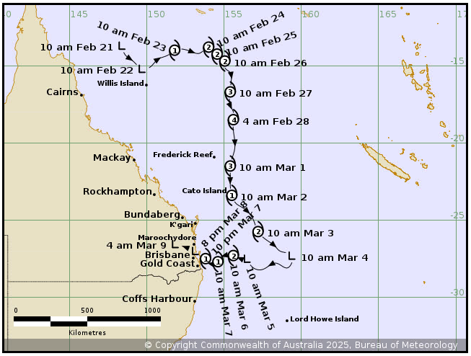
Figure 1 Best track of Severe Tropical Cyclone Alfred 21 February - 9 March 2025 (times in AEST, UTC +10)
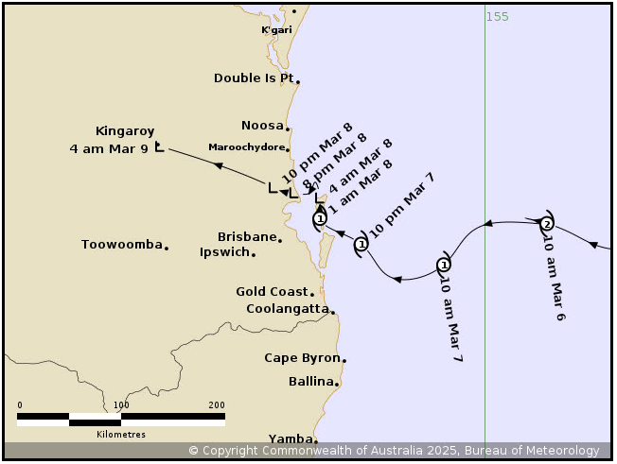
Figure 2 Best track of Alfred as it approached and moved over southeast Queensland 6-9 March 2025 (times in AEST, UTC+10)
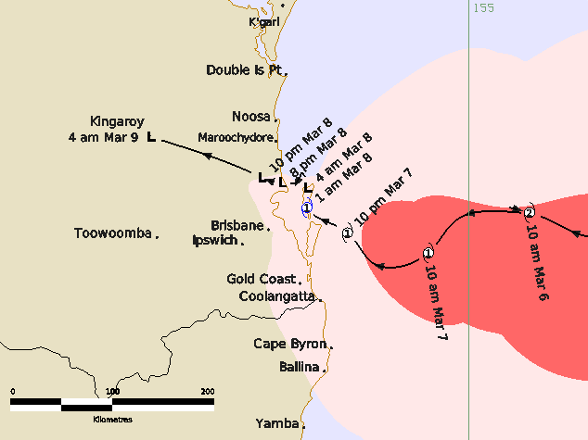
Figure 3 Detailed best track of Alfred as it approached and moved over southeast Queensland 6-9 March 2024 (times in AEST, UTC+10). For this period, light pink depicts total extent of gale force (i.e. category 1) winds and red depicts total extent of storm force (i.e category 2) winds.

Year | Month | Day | Hour  UTC | Pos.  Lat. S | Pos.  Long.E. | Pos.  Acc.  nm | Max Wind10m in kn | Max  Gust  kn | Cent.PresshPa | Rad. of gales  NE/SE/  SW/NW | Rad. of storm  NE/SE/  SW/NW | RMW  nm
2025 | 2 | 21 | 0000 | 13.7 | 148.4 | 35 | 20 | 45 | 1004 | 0/0/0/0 | 0/0/0/0 | -
2025 | 2 | 21 | 0600 | 14.3 | 148.6 | 35 | 30 | 45 | 1001 | 0/0/0/0 | 0/0/0/0 | -
2025 | 2 | 21 | 1200 | 14.7 | 149.1 | 20 | 30 | 45 | 1003 | 0/0/0/0 | 0/0/0/0 | -
2025 | 2 | 21 | 1800 | 15 | 149.4 | 25 | 30 | 45 | 1002 | 0/0/0/0 | 0/0/0/0 | -
2025 | 2 | 22 | 0000 | 15.2 | 149.7 | 30 | 35* | 50 | 1000 | 0/80/70/0 | 0/0/0/0 | -
2025 | 2 | 22 | 0600 | 15.1 | 150.2 | 30 | 40* | 55 | 995 | 0/80/80/0 | 0/0/0/0 | -
2025 | 2 | 22 | 1200 | 14.6 | 150.7 | 40 | 40* | 55 | 997 | 0/90/120/0 | 0/0/0/0 | -
2025 | 2 | 22 | 1800 | 14.3 | 151.4 | 30 | 40* | 55 | 998 | 0/80/80/0 | 0/0/0/0 | -
2025 | 2 | 23 | 0000 | 14 | 151.8 | 20 | 40 | 55 | 997 | 0/60/70/50 | 0/0/0/0 | 30
2025 | 2 | 23 | 0600 | 14.1 | 152.9 | 20 | 45 | 65 | 995 | 35/60/70/50 | 0/0/0/0 | 25
2025 | 2 | 23 | 1200 | 14.2 | 153.4 | 15 | 50 | 70 | 989 | 35/70/60/60 | 0/0/0/30 | 25
2025 | 2 | 23 | 1800 | 14 | 153.7 | 15 | 50 | 70 | 988 | 50/60/60/60 | 0/30/30/30 | 18
2025 | 2 | 24 | 0000 | 13.8 | 154 | 20 | 50 | 70 | 988 | 60/65/75/60 | 0/0/40/40 | 30
2025 | 2 | 24 | 0600 | 13.7 | 154.2 | 15 | 50 | 70 | 988 | 55/55/55/50 | 0/0/0/30 | 20
2025 | 2 | 24 | 1200 | 13.9 | 154.4 | 15 | 50 | 70 | 988 | 50/50/50/40 | 20/0/0/20 | 20
2025 | 2 | 24 | 1800 | 14.05 | 154.5 | 15 | 55 | 75 | 986 | 50/50/50/50 | 20/35/35/20 | 18
2025 | 2 | 25 | 0000 | 14.25 | 154.55 | 12 | 55 | 75 | 984 | 55/50/50/50 | 20/20/20/20 | 17
2025 | 2 | 25 | 0600 | 14.3 | 154.65 | 15 | 55 | 75 | 982 | 60/70/70/60 | 30/30/30/30 | 20
2025 | 2 | 25 | 1200 | 14.35 | 154.9 | 10 | 50 | 70 | 990 | 70/70/90/80 | 0/0/50/50 | 15
2025 | 2 | 25 | 1800 | 14.5 | 154.95 | 10 | 55 | 75 | 982 | 90/90/100/90 | 0/0/50/50 | 20
2025 | 2 | 26 | 0000 | 14.7 | 155.05 | 20 | 55 | 75 | 983 | 80/70/90/70 | 30/30/30/40 | 20
2025 | 2 | 26 | 0600 | 15.2 | 155.1 | 20 | 60 | 85 | 982 | 85/60/100/80 | 35/30/40/40 | 20
2025 | 2 | 26 | 1200 | 15.4 | 155.35 | 15 | 65 | 90 | 977 | 85/80/100/90 | 35/30/45/50 | 20
2025 | 2 | 26 | 1800 | 16.1 | 155.45 | 25 | 70 | 100 | 975 | 100/100/100/100 | 50/45/55/75 | 15
2025 | 2 | 27 | 0000 | 16.7 | 155.4 | 20 | 75 | 105 | 972 | 100/100/100/100 | 50/50/60/60 | 13
2025 | 2 | 27 | 0600 | 17.6 | 155.4 | 15 | 80 | 110 | 967 | 100/110/110/100 | 45/50/60/60 | 10
2025 | 2 | 27 | 1200 | 18 | 155.6 | 15 | 85 | 120 | 961 | 100/110/120/100 | 45/50/60/60 | 25
2025 | 2 | 27 | 1800 | 18.5 | 155.6 | 15 | 90 | 120 | 958 | 100/110/120/100 | 50/60/60/60 | 20
2025 | 2 | 28 | 0000 | 19.2 | 155.6 | 15 | 90 | 120 | 960 | 95/100/130/110 | 55/60/55/50 | 20
2025 | 2 | 28 | 0600 | 20 | 155.7 | 15 | 90 | 120 | 958 | 90/110/130/110 | 60/60/70/60 | 22
2025 | 2 | 28 | 1200 | 20.43 | 155.7 | 15 | 90 | 125 | 954 | 110/110/130/110 | 60/60/70/65 | 22
2025 | 2 | 28 | 1800 | 20.75 | 155.6 | 20 | 80 | 110 | 960 | 110/120/130/110 | 60/60/75/65 | 20
2025 | 3 | 1 | 0000 | 21.5 | 155.4 | 20 | 80 | 110 | 963 | 120/130/130/120 | 60/60/75/75 | 20
2025 | 3 | 1 | 0600 | 21.8 | 155.4 | 20 | 65 | 90 | 971 | 120/160/165/110 | 0/80/85/75 | 40
2025 | 3 | 1 | 1200 | 22.2 | 155.4 | 20 | 60 | 85 | 978 | 120/160/160/110 | 0/70/80/70 | 40
2025 | 3 | 1 | 1800 | 22.75 | 155.4 | 20 | 55 | 75 | 980 | 110/160/150/100 | 0/70/80/0 | 45
2025 | 3 | 2 | 0000 | 23.4 | 155.5 | 15 | 45 | 65 | 983 | 110/160/130/90 | 0/0/0/0 | 50
2025 | 3 | 2 | 0600 | 23.95 | 155.8 | 10 | 50 | 70 | 982 | 120/160/130/90 | 0/0/55/55 | 50
2025 | 3 | 2 | 1200 | 24.2 | 156.2 | 15 | 55 | 75 | 978 | 120/140/130/90 | 0/0/60/60 | 40
2025 | 3 | 2 | 1800 | 25 | 156.9 | 30 | 50 | 70 | 984 | 120/110/150/100 | 0/60/65/0 | 50
2025 | 3 | 3 | 0000 | 25.75 | 157.2 | 15 | 50 | 70 | 985 | 100/85/160/100 | 0/40/40/0 | 30
2025 | 3 | 3 | 0600 | 26.4 | 157.9 | 15 | 50*** | 70 | 983 | 100/160/170/130 | 0/0/60/0 | 50
2025 | 3 | 3 | 1200 | 26.7 | 158.3 | 15 | 50*** | 70 | 982 | 100/210/180/160 | 0/0/70/0 | 60
2025 | 3 | 3 | 1800 | 27 | 158.6 | 15 | 50*** | 70 | 982 | 120/210/180/140 | 0/0/70/80 | 60
2025 | 3 | 4 | 0000 | 27.3 | 159.4 | 10 | 50*** | 70 | 985 | 140/210/180/110 | 0/0/80/80 | 70
2025 | 3 | 4 | 0600 | 28.1 | 159.1 | 10 | 55*** | 75 | 978 | 140/210/200/160 | 0/160/120/90 | 80
2025 | 3 | 4 | 1200 | 27.8 | 158.4 | 8 | 50*** | 70 | 982 | 120/210/210/160 | 0/0/120/0 | 80
2025 | 3 | 4 | 1800 | 28.2 | 157.5 | 15 | 45*** | 65 | 987 | 130/210/220/140 | 0/0/0/0 | 50
2025 | 3 | 5 | 0000 | 27.5 | 156.5 | 10 | 45*** | 65 | 987 | 130/220/180/140 | 0/0/0/0 | 50
2025 | 3 | 5 | 0600 | 27.15 | 156.5 | 4 | 45*** | 65 | 983 | 100/230/200/140 | 0/0/0/0 | 60
2025 | 3 | 5 | 1200 | 27.4 | 156.7 | 10 | 45 | 65 | 985 | 120/140/210/120 | 0/0/0/0 | 40
2025 | 3 | 5 | 1800 | 27.55 | 156.25 | 7 | 50 | 70 | 984 | 80/135/170/80 | 0/90/80/0 | 45
2025 | 3 | 6 | 0000 | 27.3 | 155.6 | 10 | 50 | 70 | 985 | 0/135/140/100 | 0/80/70/0 | 45
2025 | 3 | 6 | 0600 | 27.25 | 155.4 | 12 | 50 | 70 | 979 | 0/150/130/100 | 0/80/70/0 | 45
2025 | 3 | 6 | 1200 | 27.3 | 155.6 | 20 | 50 | 70 | 981 | 70/160/145/100 | 0/0/70/0 | 55
2025 | 3 | 6 | 1800 | 27.3 | 155.05 | 15 | 50 | 70 | 981 | 60/130/110/70 | 0/0/70/0 | 55
2025 | 3 | 7 | 0000 | 27.7 | 154.6 | 12 | 45 | 65 | 989 | 60/100/75/55 | 0/0/0/0 | 35
2025 | 3 | 7 | 0600 | 27.8 | 154.05 | 10 | 45 | 65 | 985 | 70/120/70/40 | 0/0/0/0 | 35
2025 | 3 | 7 | 1200 | 27.5 | 153.8 | 14 | 45 | 65 | 988 | 70/80/50/30 | 0/0/0/0 | 25
2025 | 3 | 7 | 1500 | 27.25 | 153.4 | 10 | 35 | 50 | 990 | 0/45/20/18 | 0/0/0/0 | 15
2025 | 3 | 7 | 1800 | 27.05 | 153.4 | 7 | 35* | 50 | 995 | 0/40/20/0 | 0/0/0/0 | 15
2025 | 3 | 8 | 0000 | 26.9 | 153.35 | 4 | 30 | 45 | 998 | 0/0/0/0 | 0/0/0/0 | -
2025 | 3 | 8 | 0600 | 27 | 153.3 | 6 | 30 | 45 | 1000 | 0/0/0/0 | 0/0/0/0 | -
2025 | 3 | 8 | 1000 | 27 | 153.15 | 5 | 40** | 55 | 1000 | 0/28/14/0 | 0/0/0/0 | -
2025 | 3 | 8 | 1100 | 27 | 153.1 | 5 | 40** | 55 | 1001 | 0/35/18/0 | 0/0/0/0 | -
2025 | 3 | 8 | 1200 | 26.95 | 152.95 | 8 | 40** | 55 | 1003 | 0/20/0/0 | 0/0/0/0 | -
2025 | 3 | 8 | 1800 | 26.55 | 151.85 | 20 | 25 | 45 | 1009 | 0/0/0/0 | 0/0/0/0 | -
Table 1 Best track summary for Severe Tropical Cyclone Alfred, 21 February – 8 March 2025.
UTC=AEST-10h. * Not at tropical cyclone intensity as gales less than halfway around centre. ** Not at tropical cyclone intensity as gales less than halfway around centre and also classified as a sub-tropical cyclone. ***Classified as a sub-tropical cyclone at this time.

- Meteorological description
  - Intensity analysis
A comparison of subjective and objective intensity estimates is shown in Figure 48. Additionally, a table listing abbreviations and acronyms can be found in the appendix.
Tropical Low 22U was first analysed in the northern Coral Sea, about 392 km east northeast of Cooktown, on 21 February 2025. During mid to late February, an active phase of the Madden Julian Oscillation (MJO) was moving through the western Pacific, (Figure 5). The MJO was supported by an Equatorial Rossby (ER) wave as shown in (Figure 6). In addition to the ER wave and the active phase of the MJO, a southeasterly surge from a strong ridge to the south helped create favourable conditions for cyclogenesis (Figure 4).
Once formed, convection became more established near the circulation and a Dvorak T-number of 1.0 was assigned around 1200 UTC 21 February (10 pm AEST). During 21 February, and until the morning of 22 February, the tropical low moved southeast, and closer to Willis Island. The circulation was elongated through 21 February, (Figure 7), though convection steadily developed, and around 24 hours after formation, gales were observed to the south of the system's centre at Willis Island (wind observations page 43). During 22 February, 22U took a more northeast path with quadrant gales persisting. Scatterometry and radiometry (OSCAT 0219 UTC 22 February, AMSR2 0340 UTC 22 February, SMAP 0833 UTC 22 February, SAR 0831 UTC 22 February, all not shown), along with Willis Island observations, showed gales occurring on the southern side of the circulation, with lighter winds to the north.
On 23 February, 22U continued its development while taking a path to the east. Scatterometry during the morning of 23 February (ASCAT-B 2227 UTC 22 February, Figure 8) indicated that gales had extended more than halfway around. Additionally, the associated convection became more organised, giving a Dvorak T-number of 3.0 at 0000 UTC 23 February (10am AEST) (Figure 48). The system was classified as a tropical cyclone at 0000 UTC 23 February (10am AEST) and named Alfred. Alfred continued to intensify, with storm force winds developing in the northwest, as indicated by ASCAT-C 1151 UTC 23 February, Figure 9. At 1200 UTC (10pm AEST) 23 February, Alfred was therefore upgraded to category 2 (50 knot (95 km/h) mean winds).
During 24 and 25 February, Alfred turned and tracked slowly to the southeast while remaining at category 2 intensity. Wind shear analyses showed north to northeasterly wind shear limiting development during this period. This wind shear was countered by a persistent poleward outflow channel and other environmental factors being favourable for development, and during 26 February Alfred developed at just below the average Dvorak rate. Alfred reached category 3 intensity, and became a severe tropical cyclone, at 1200 UTC (10 pm AEST) 26 February. Intensity at this time was based on a 3-hour averaged Dvorak assessment yielding a T-number of 4.5 and scatterometry (ASCAT-C 1049 UTC 26 February, Figure 10, and later SAR 1907 UTC 26 February not shown). Objective intensity estimates during 26 February were generally 5-10 knots higher than this, but the best track intensity was biased towards the mean SAR measurements at 0758 and 1907 UTC, which were consistent with the subjective Dvorak estimate.
Alfred continued to intensify with a small eye briefly emerging during 27 February, before an eyewall replacement cycle occurred. The Hovmöller diagram, (Figure 11), shows the formation of the secondary eyewall during 27 February. This secondary eyewall became dominant from 1200 UTC (10 pm AEST) 27 February. The 89 GHz AMSR2 microwave image at 1453 UTC 27 February (1253 am AEST 28 February) (Figure 12) shows a weak remnant of the primary eyewall, and the much more pronounced outer secondary eyewall. As this secondary eyewall contracted overnight on 27 February, Alfred continued to intensify. Once the new eyewall stabilised on 28 February, Alfred reached category 4 and plateaued at its peak intensity of 90 knots (165 km/h), from 1800 UTC 27 February (4 am AEST 28 February) to 1200 UTC (10 pm AEST) 28 February (Figure 13). Peak intensity was estimated using scatterometry (SAR 1915 UTC 27 February, not shown, ASCAT-C 2317 UTC 27 February, not shown, and ASCAT-C 1146 UTC 28 February, Figure 14), supported by a consensus of the available objective aids. Subjective Dvorak T-numbers were generally slightly lower at 4.5-5.0, although they did peak at 5.5 at 1200 UTC (10 pm AEST) 28 February.
From 1 March, Alfred encountered increasing wind shear from an upper trough to the south and began to quickly weaken, with SAR 1903 UTC 28 February (not shown), suggesting mean maximum winds adjusted to 10-minute mean of 80 knots, and the eye became obscured in satellite imagery. Various scatterometry and radiometer passes (including ASCAT-B 2204 UTC 28 February, and, AMSR2 0344 UTC, SMOS 0718 UTC, SAR 0821UTC, and ASCAT-B 1032 UTC 1 March, not shown), along with subjective Dvorak, confirmed the lowering intensity during 1 March. In general there was good agreement between all intensity estimates that the system was weakening rapidly.
As Alfred continued to track south it began to approach Cato Island. Wind speed observations at Cato Island (Figure 27) had gales commencing from the morning of 1 March and storm force winds occurring in the evening and overnight. On the morning of 2 March, Alfred passed over Cato Island, with winds becoming light and pressure dropping (Figure 27 and Figure 33 respectively). Cato Island observations recorded a minimum pressure of 982.6 hPa as Alfred passed over, Figure 33. Gales returned at Cato Island after Alfred's centre passed over the Island, (Figure 27). ASCAT-C at 2336 UTC 1 March (not shown), confirmed that Alfred had continued to weaken. With this pass as evidence, and supported by Cato Island observations, Alfred was downgraded to a category 1 tropical cyclone, at 0000 UTC (10 am AEST) 2 March.
During 2 March the sub-tropical jet approached Alfred from the southwest and Alfred intensified again to category 2. March 2 was a period of transition as the baroclinic influence of the sub-tropical jet increased, and from 3 March Alfred's intensity plateaued. Alfred was reclassified as a sub-tropical system during 3 March, though it still had an intensity of 50 knots (95 km/h), as evidenced by scatterometry including ASCAT-B at 1129 UTC 3 March, (Figure 17).
Sub-tropical characteristics persisted through 4 March and into 5 March. During this period intensity was initially 50 to 55 knots (95 km/h to 100 km/h), before easing to 45 knots (85 km/h) during 5 March. Various scatterometry and radiometry images were used to assess intensity, with Dvorak and other objective intensity aids not applicable for a sub-tropical cyclone (including SAR 1846 UTC, ASCAT-B 2243 UTC all 3 March, and ASCAT-B 1108 UTC, SAR 0811 UTC, AMSR2 1336 UTC, SAR 1854 UTC, ASCAT-C 2316, all 4 March, all not shown).
At 1200 UTC (10pm AEST) 5 March, Alfred regained tropical characteristics (for more details see section 2.2), and intensified to category 2, 50 knots (95 km/h) at 1800 UTC 5 March (4 am AEST 6 March). Tropical Cyclone Alfred maintained this intensity during 6 March, and continued to move to the west, closer to the southeast Queensland coast. Alfred weakened to category 1, 45 knots (85 km/h) at 0000 UTC 7 March (10 am AEST), with ASCAT-C 2234 UTC 6 March, (Figure 15) showing that storm force winds had ceased. Overnight on 7 March, as Alfred tracked to the northwest, interactions with the Queensland and New South Wales coast, as well as the Moreton Bay Islands, increased, and further weakening was observed. Alfred moved over Moreton Island at 1500 UTC 7 March (1 am AEST 8 March), as a category 1, 35 knot (65 km/h) tropical cyclone. At this time Redcliffe observed a period of gale force winds (Figure 29), as did some of the buoys located in Moreton Bay (wind observations page 43). These observations were used as the basis for the intensity estimate at this time. Observations continued to give good guidance of the intensity, as well as the extent of gales. Shortly after crossing Moreton Island at 1800 UTC 7 March (4 am AEST 8 March), gales were only detected in southern quadrants and Alfred was downgraded to a tropical low.
Further weakening occurred as Alfred stalled between the northern tip of Moreton Island and Bribie Island. By 0000 UTC (10 am AEST) 8 March no gales were recorded with the system. However, at this time the system was reclassified as a sub-tropical system (see section 2.2), and there was a southeasterly surge moving north along the northern New South Wales and southern Queensland coast associated with a strengthening high to the south in the Tasman Sea (Figure 4). Some sites, such as the Gold Coast Seaway, (Figure 30), experienced gales or near gales associated with this surge. The southeasterly surge reached Alfred and gales redeveloped in southern quadrants as Sub-Tropical Cyclone Alfred moved over Bribie Island at 1000 UTC (8 pm AEST) 8 March. Shortly thereafter Alfred moved over the mainland at 1100 UTC (9 pm AEST) 8 March, (Figure 2). Redcliffe observed a peak 10-minute mean wind of 44 knots (81 km/h) at 1130 UTC (9:30 pm AEST) 8 March, and a peak 3-second wind gust of 56 knots (104 km/h) at 1124 UTC (9:24 pm AEST) 8 March (Figure 29).
By the early hours of 9 March, Alfred had moved inland to be located near Kingaroy, and had weakened well below gale intensity. At this time, 1800 UTC 8 March (4am AEST 9 March), it was analysed as having maximum mean winds of 25 knot (45 km/h). Later during 9 March Alfred weakened and dissipated over land.

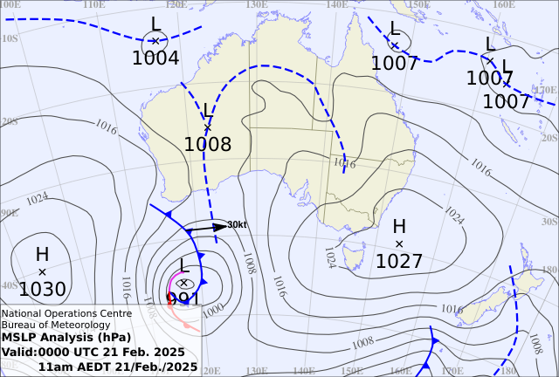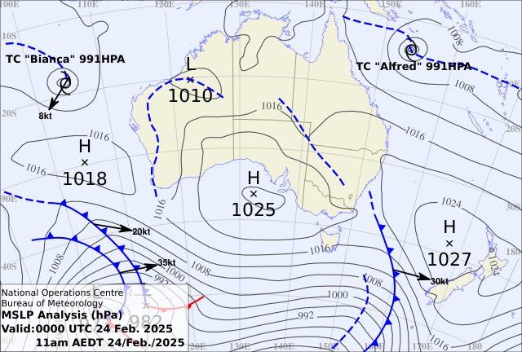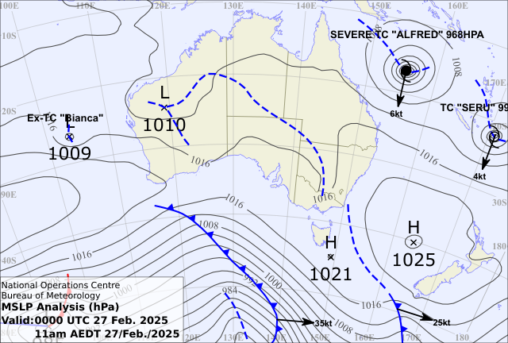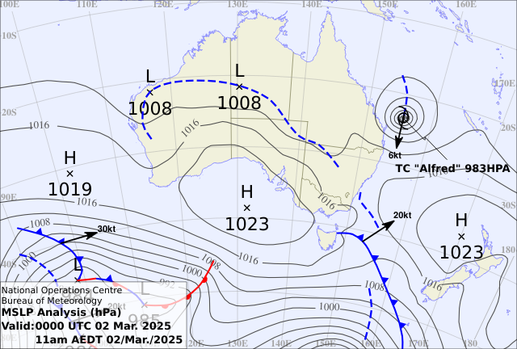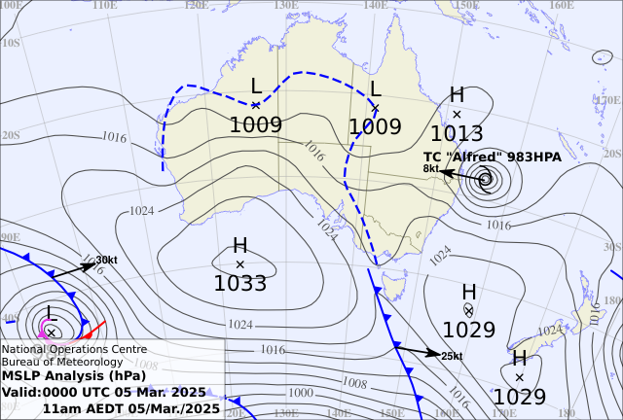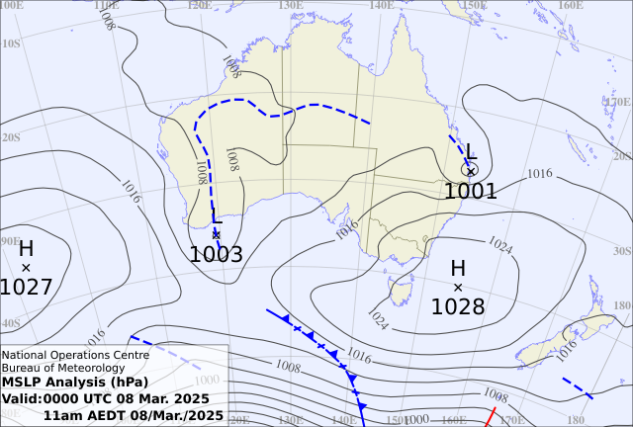
Figure 4: MSLP charts Top Left – 0000 UTC (10am AEST) 21 Feburary 2025. Top Right – 0000 UTC (10am AEST) 24 Feburary 2025. Middle Left – 0000 UTC (10am AEST) 27 Feburary 2025. Middle Right – 0000 UTC (10am AEST) 2 March 2025. Bottom left – 0000 UTC (10am AEST) 5 March 2025. Bottom right – 0000 UTC (10am AEST) 8 March 2025.

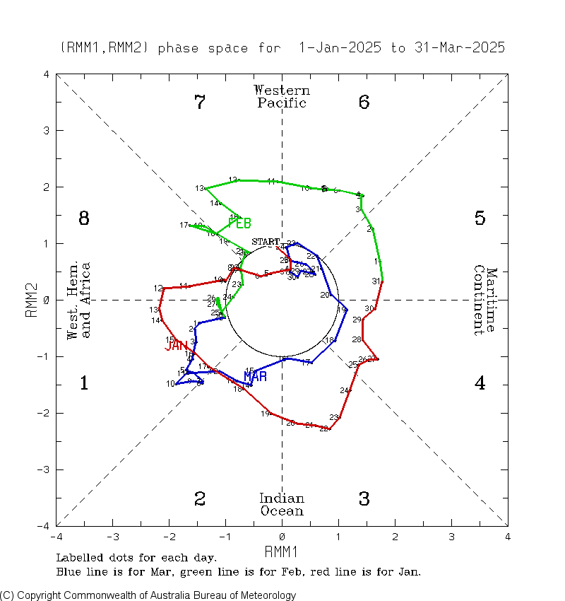
Figure 5 Real-time Multivariate MJO (RMM) Index diagram depicting a strong MJO, out of the unit circle in the Western Pacific during February 2025. This image is courtesy of BOM and can be accessed from: http://www.bom.gov.au/climate/mjo/#tabs=Monitoring
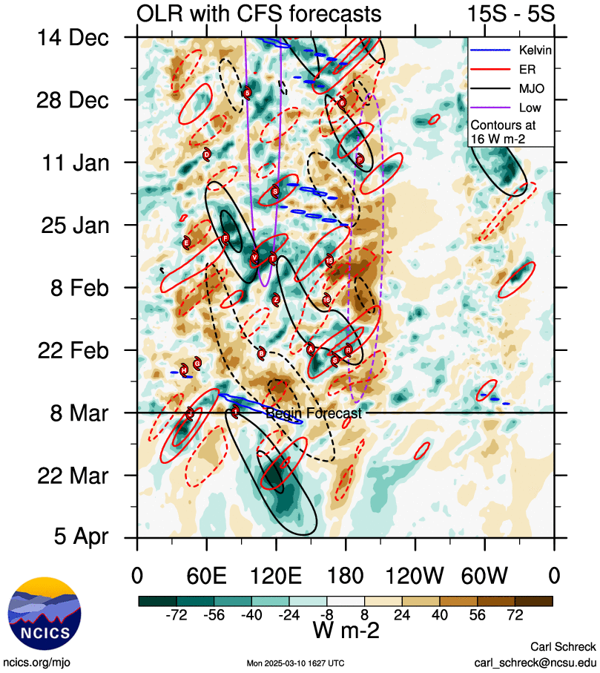
Figure 6 Hovmöller diagram of tropical waves showing the formation of Alfred occurred with a pulse of the MJO (black) and an Equatorial Rossby (ER) wave (red). The image is courtesy of the North Carolina Institute for Climate Studies. https://ncics.org/pub/mjo/archive/2024/2024-12-02/v2/
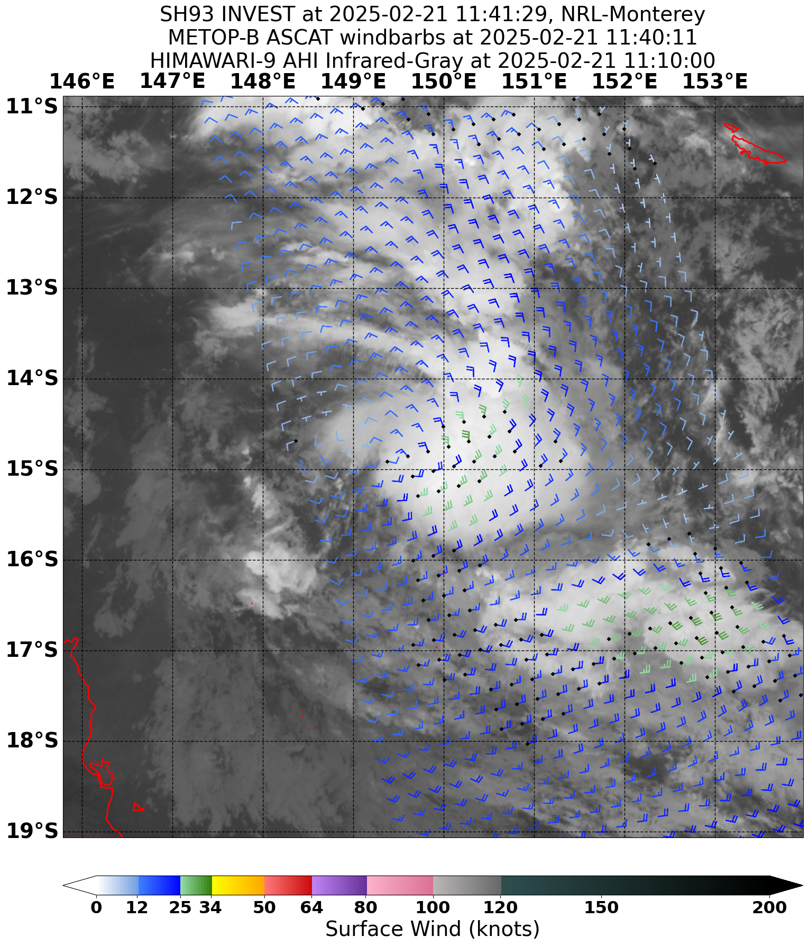
Figure 7 Scatterometry, ASCAT-B at 1140 UTC 21 February, depicting the elongated centre of a developing Alfred. Image courtesy NRL: https://www.nrlmry.navy.mil/TC.html

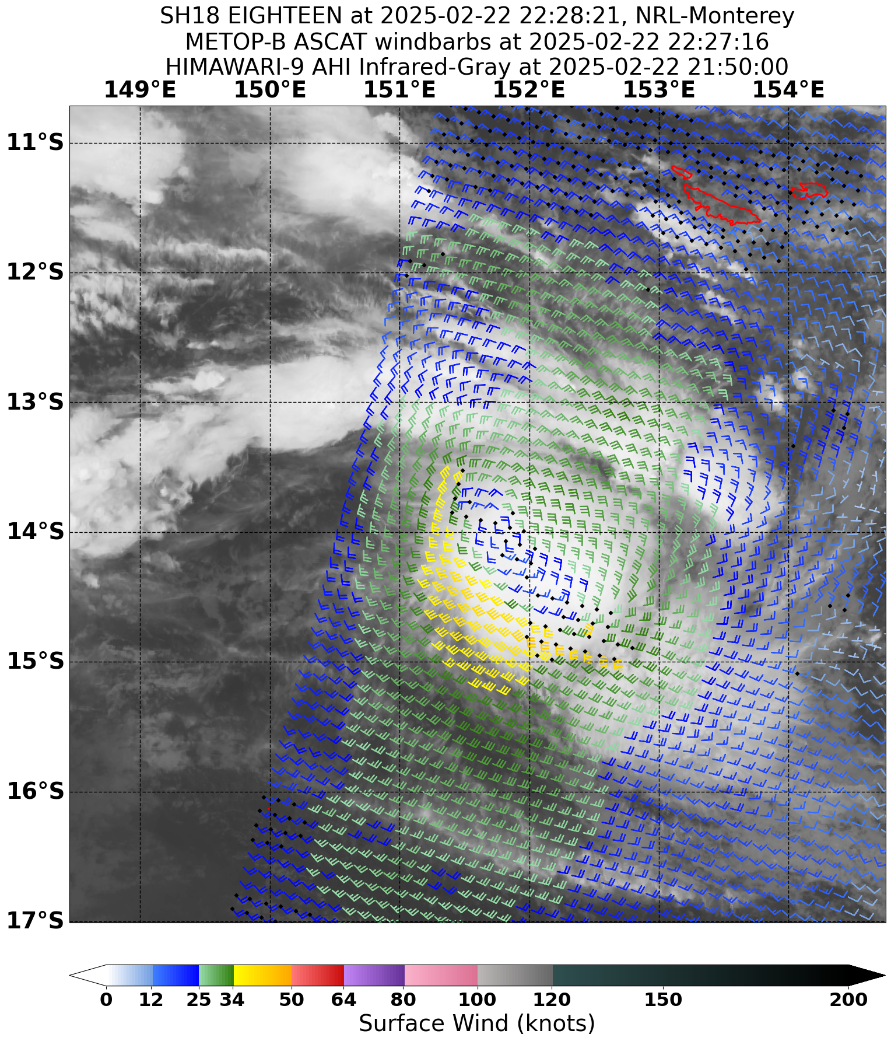
Figure 8 Scatterometry, ASCAT-B at 2227 UTC 22 February, depicting an elongated centre and gales in three quadrants. Image courtesy NRL: https://www.nrlmry.navy.mil/TC.html
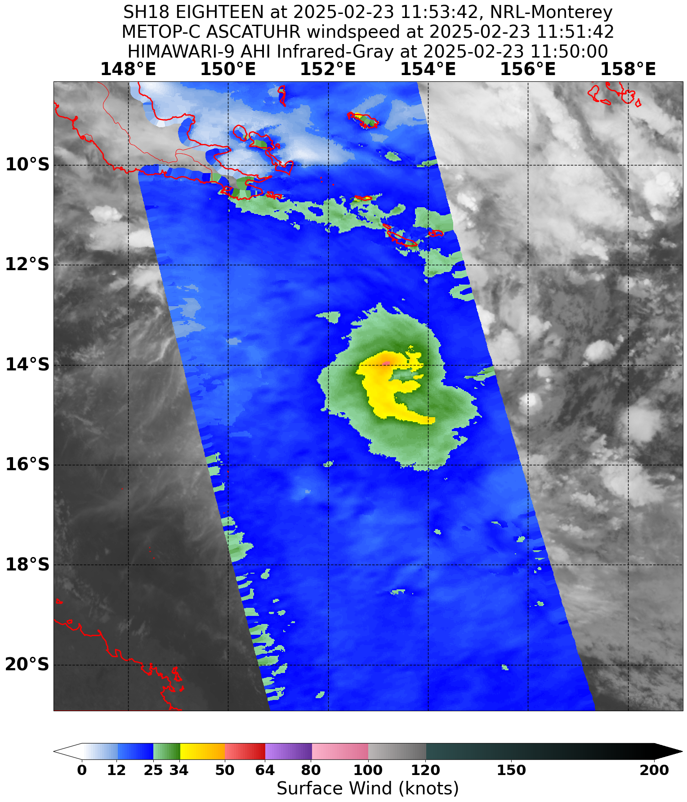
Figure 9 Scatterometry, ASCAT-C at 1151 UTC 23 February 2025, storm force winds to the northwest of Alfred's centre. Image courtesy NRL: https://www.nrlmry.navy.mil/TC.html
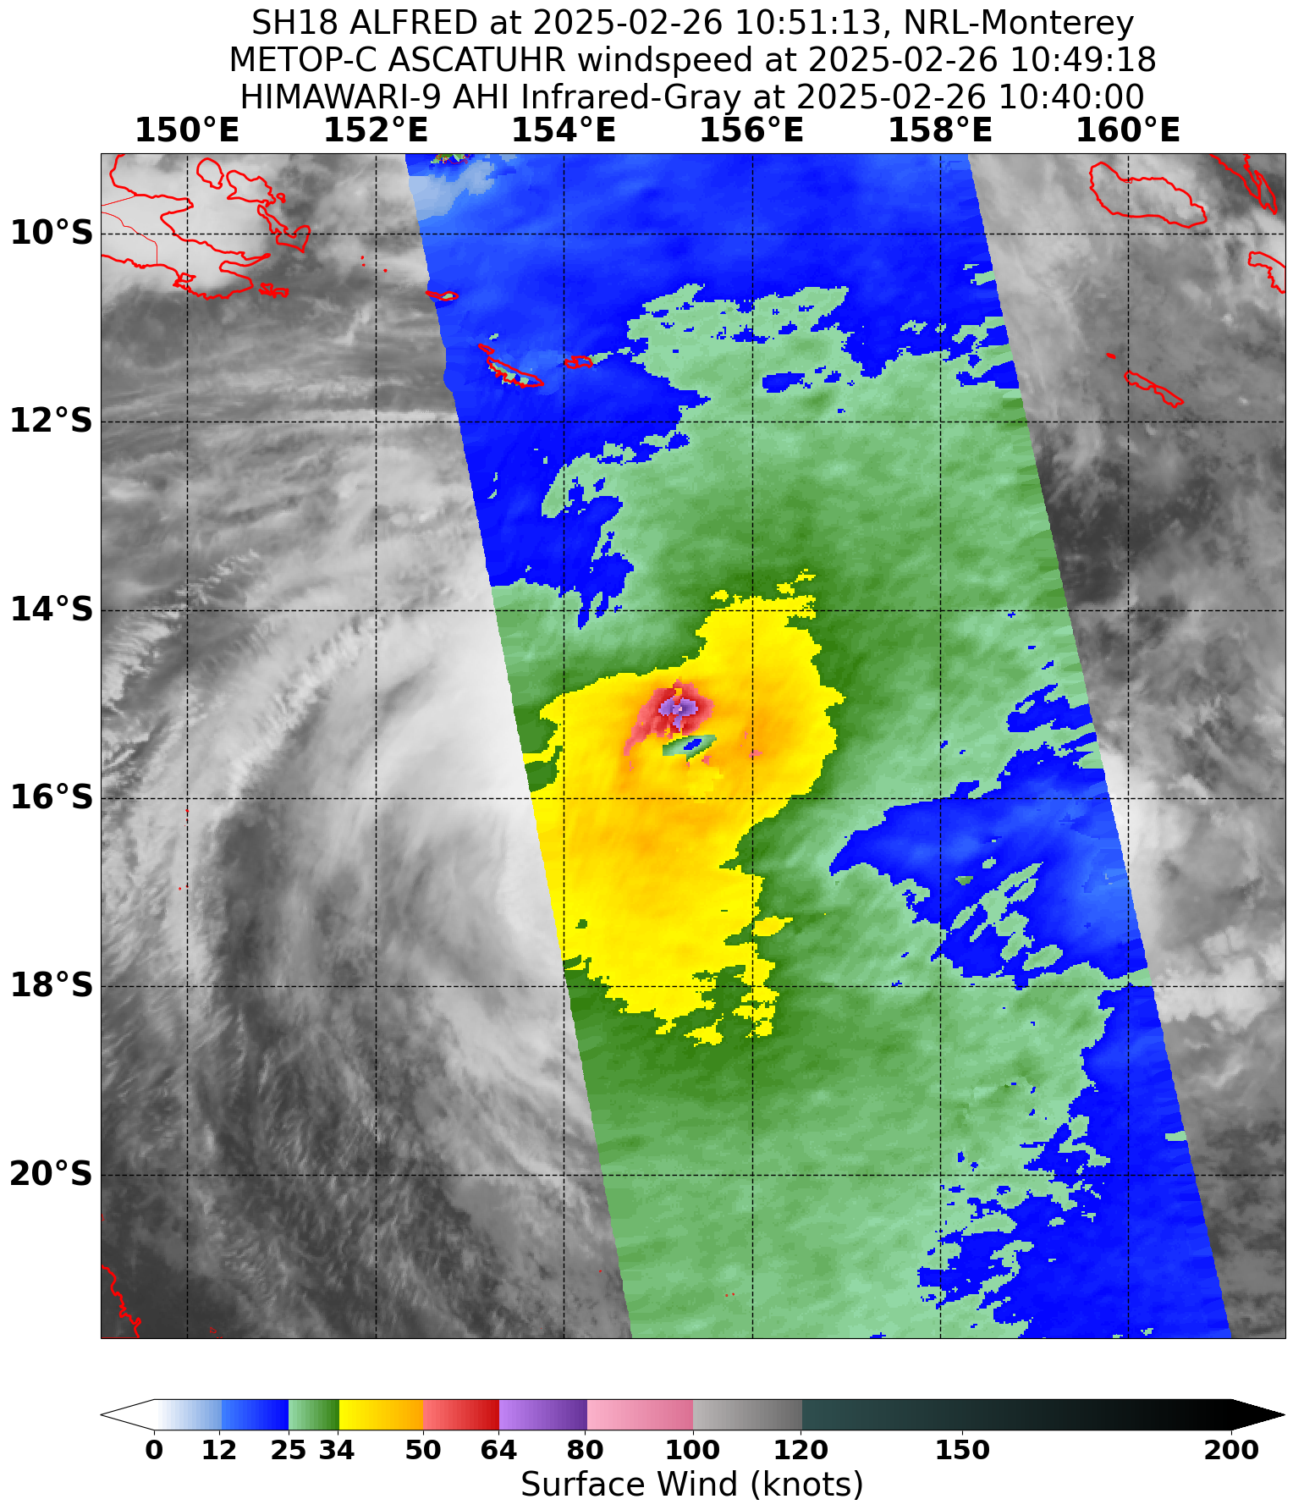
Figure 10 Scatterometry, ASCAT-C at 1049 UTC 26 February 2025 showing hurricane force winds to the north of Alfred's centre. Image courtesy NRL: https://www.nrlmry.navy.mil/TC.html
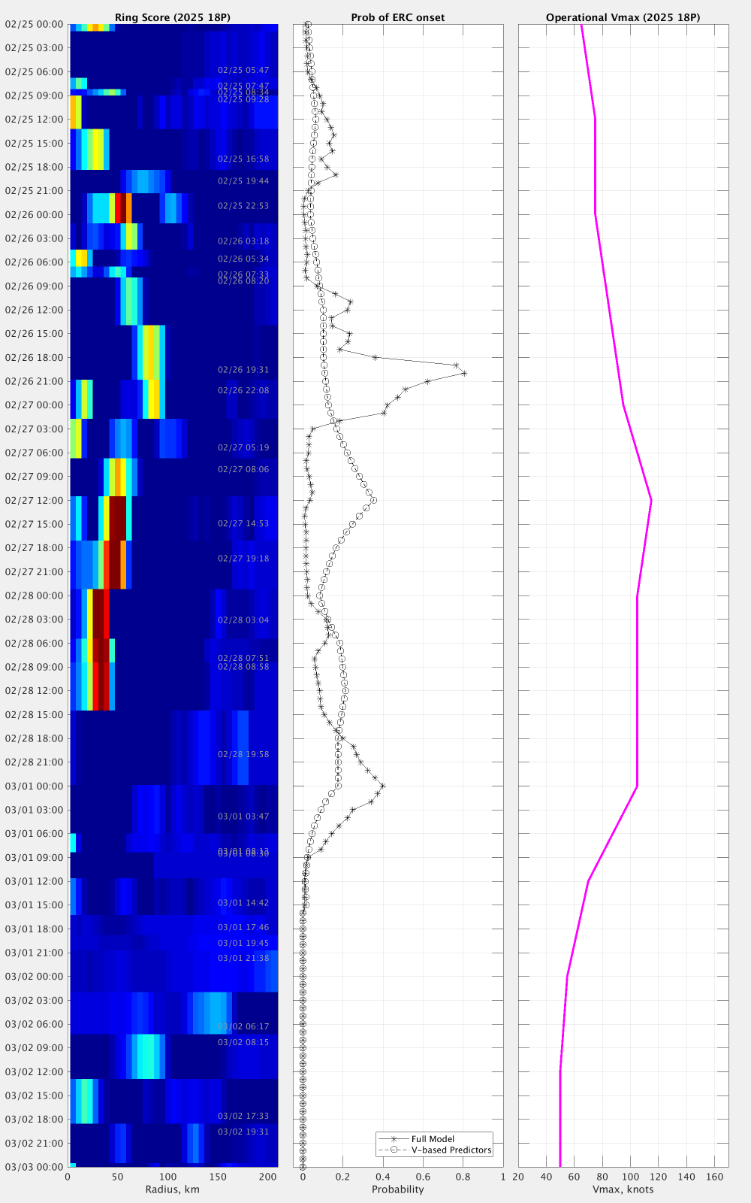
Figure 11 M-PERC (Microwave-based Probability of Eyewall Replacement Cyclone) Hovmöller diagram showing detection of secondary eyewall during 27 February, the primary eyewall eroding, and the secondary eyewall becoming dominant and contracting during 28 February.
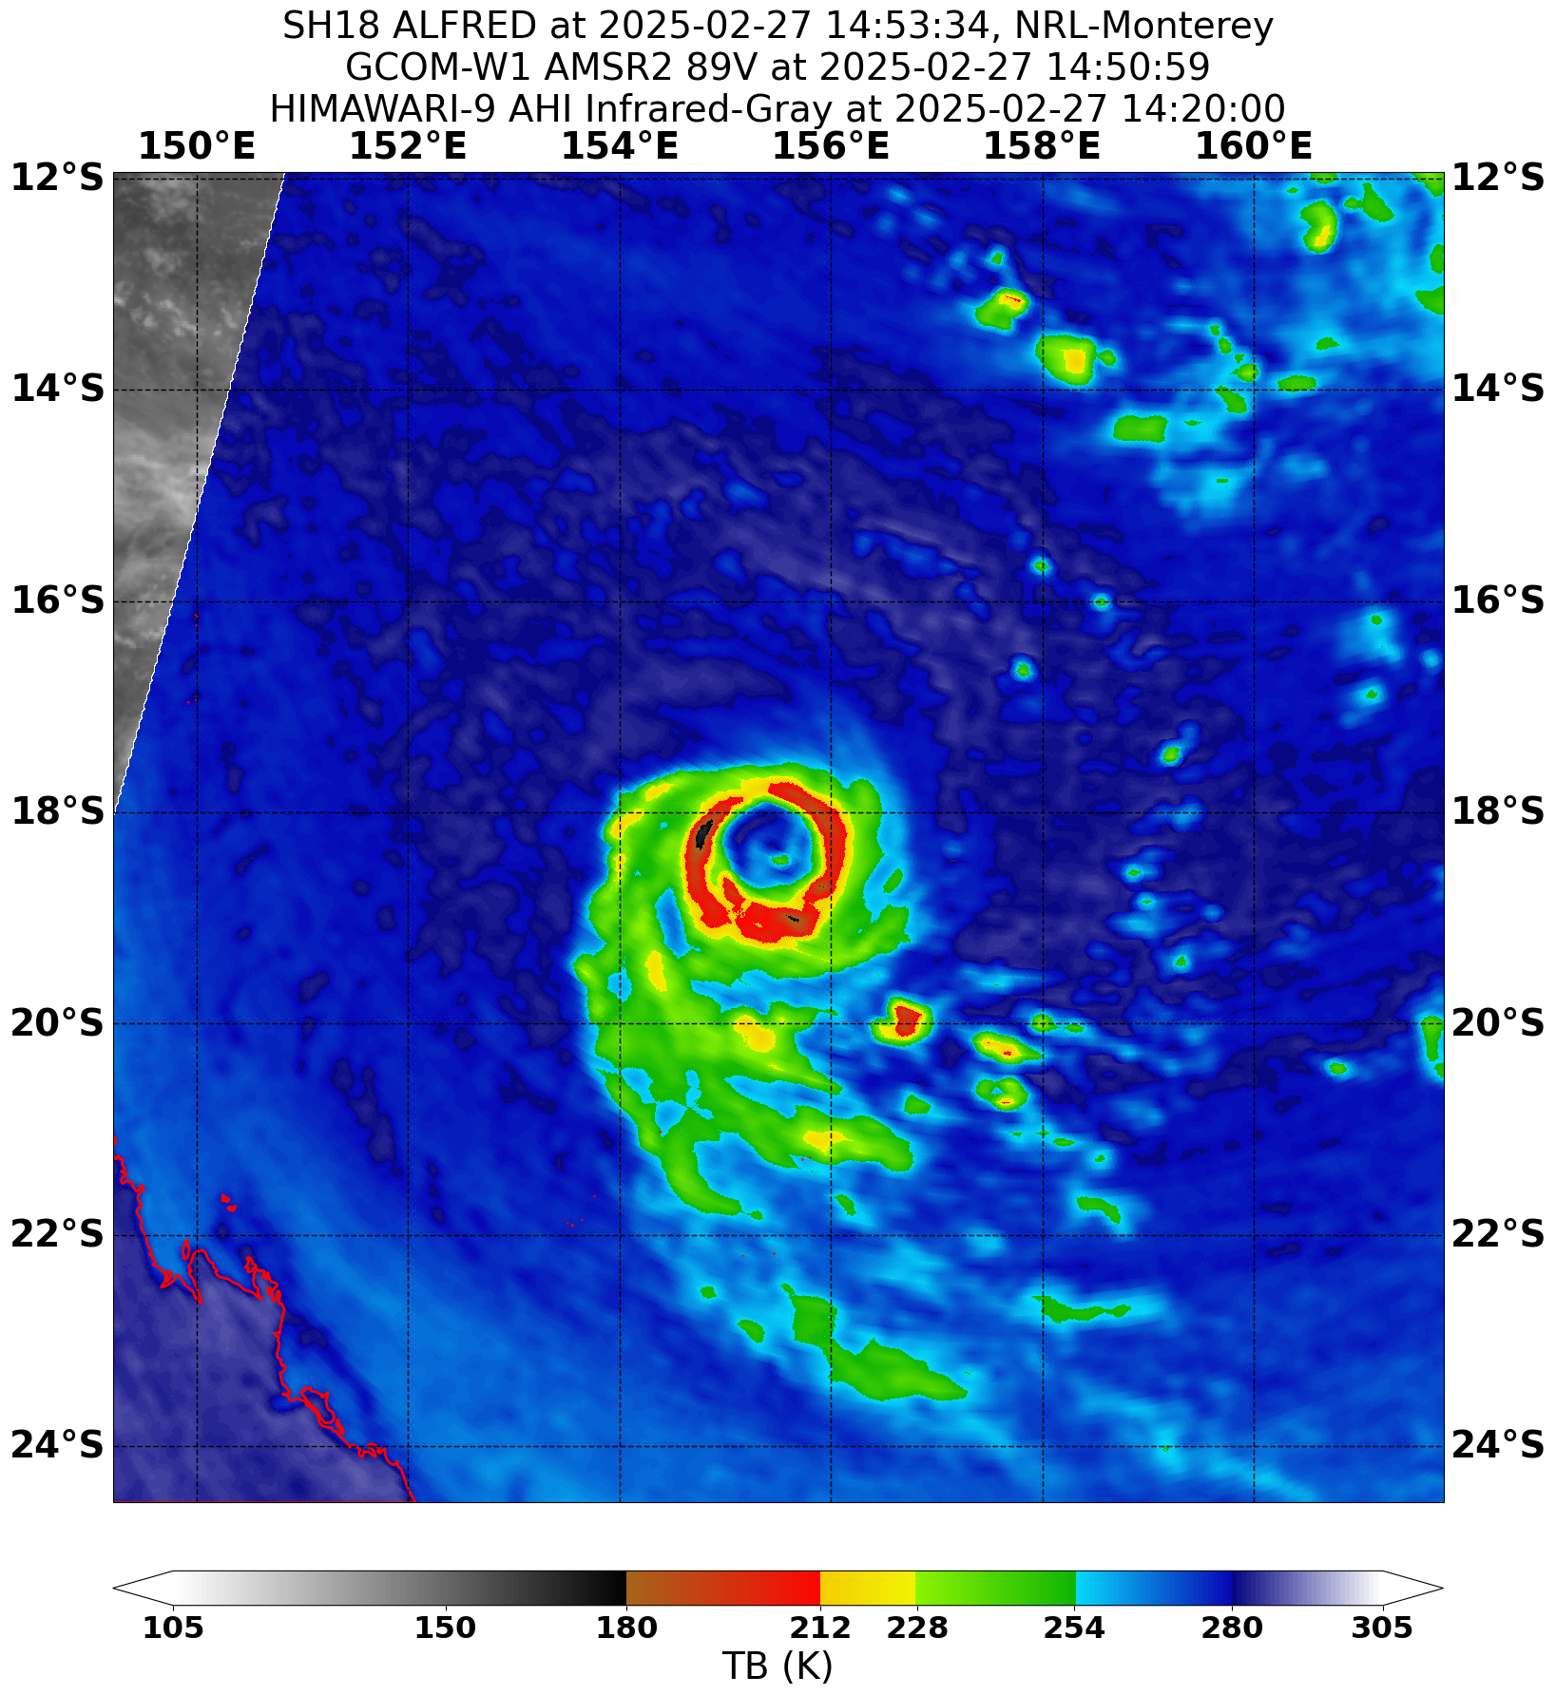
Figure 12 Microwave image, AMSR2 89 GHz at 1450 UTC 27 February. Shows the last remaining portion of the eroding inner eyewall, surrounded by the much larger second eyewall. Image courtesy NRL: https://www.nrlmry.navy.mil/TC.html
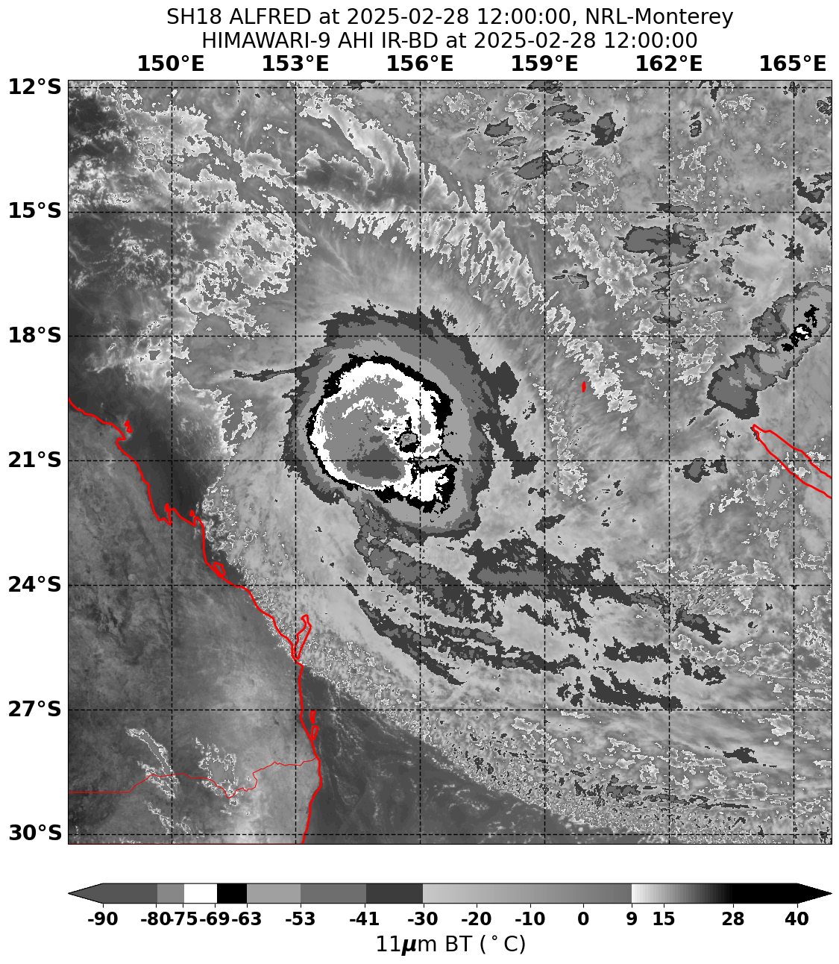
Figure 13 Infrared Himawari-9 Satellite Image at 1200 UTC 28 March. At the period of Alfred's peak intensity. Image courtesy NRL: https://www.nrlmry.navy.mil/TC.html and Japan Meteorological Agency (JMA).
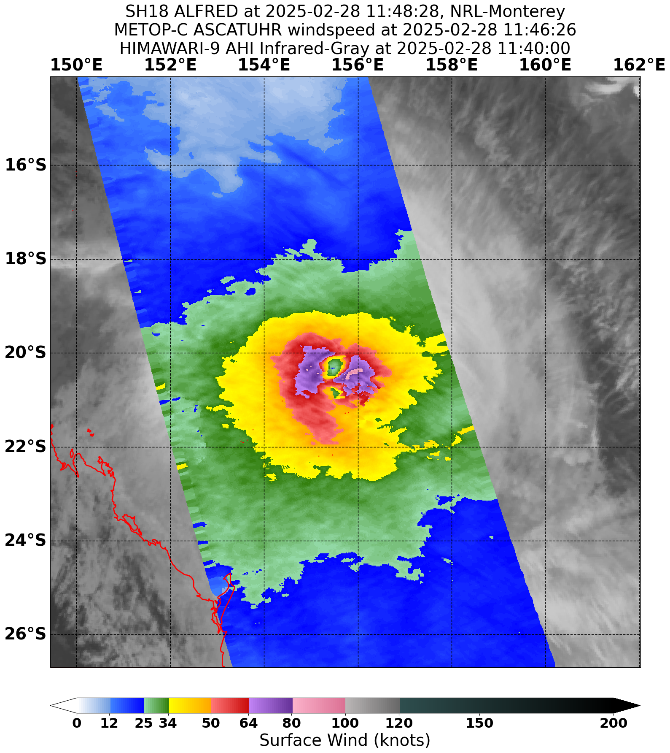
Figure 14 Scatterometry, ASCAT-C at 1146 UTC 28 February. Shows Alfred at 90 knots intensity, during the period of Alfred's lifetime peak intensity. Image courtesy NRL: https://www.nrlmry.navy.mil/TC.html

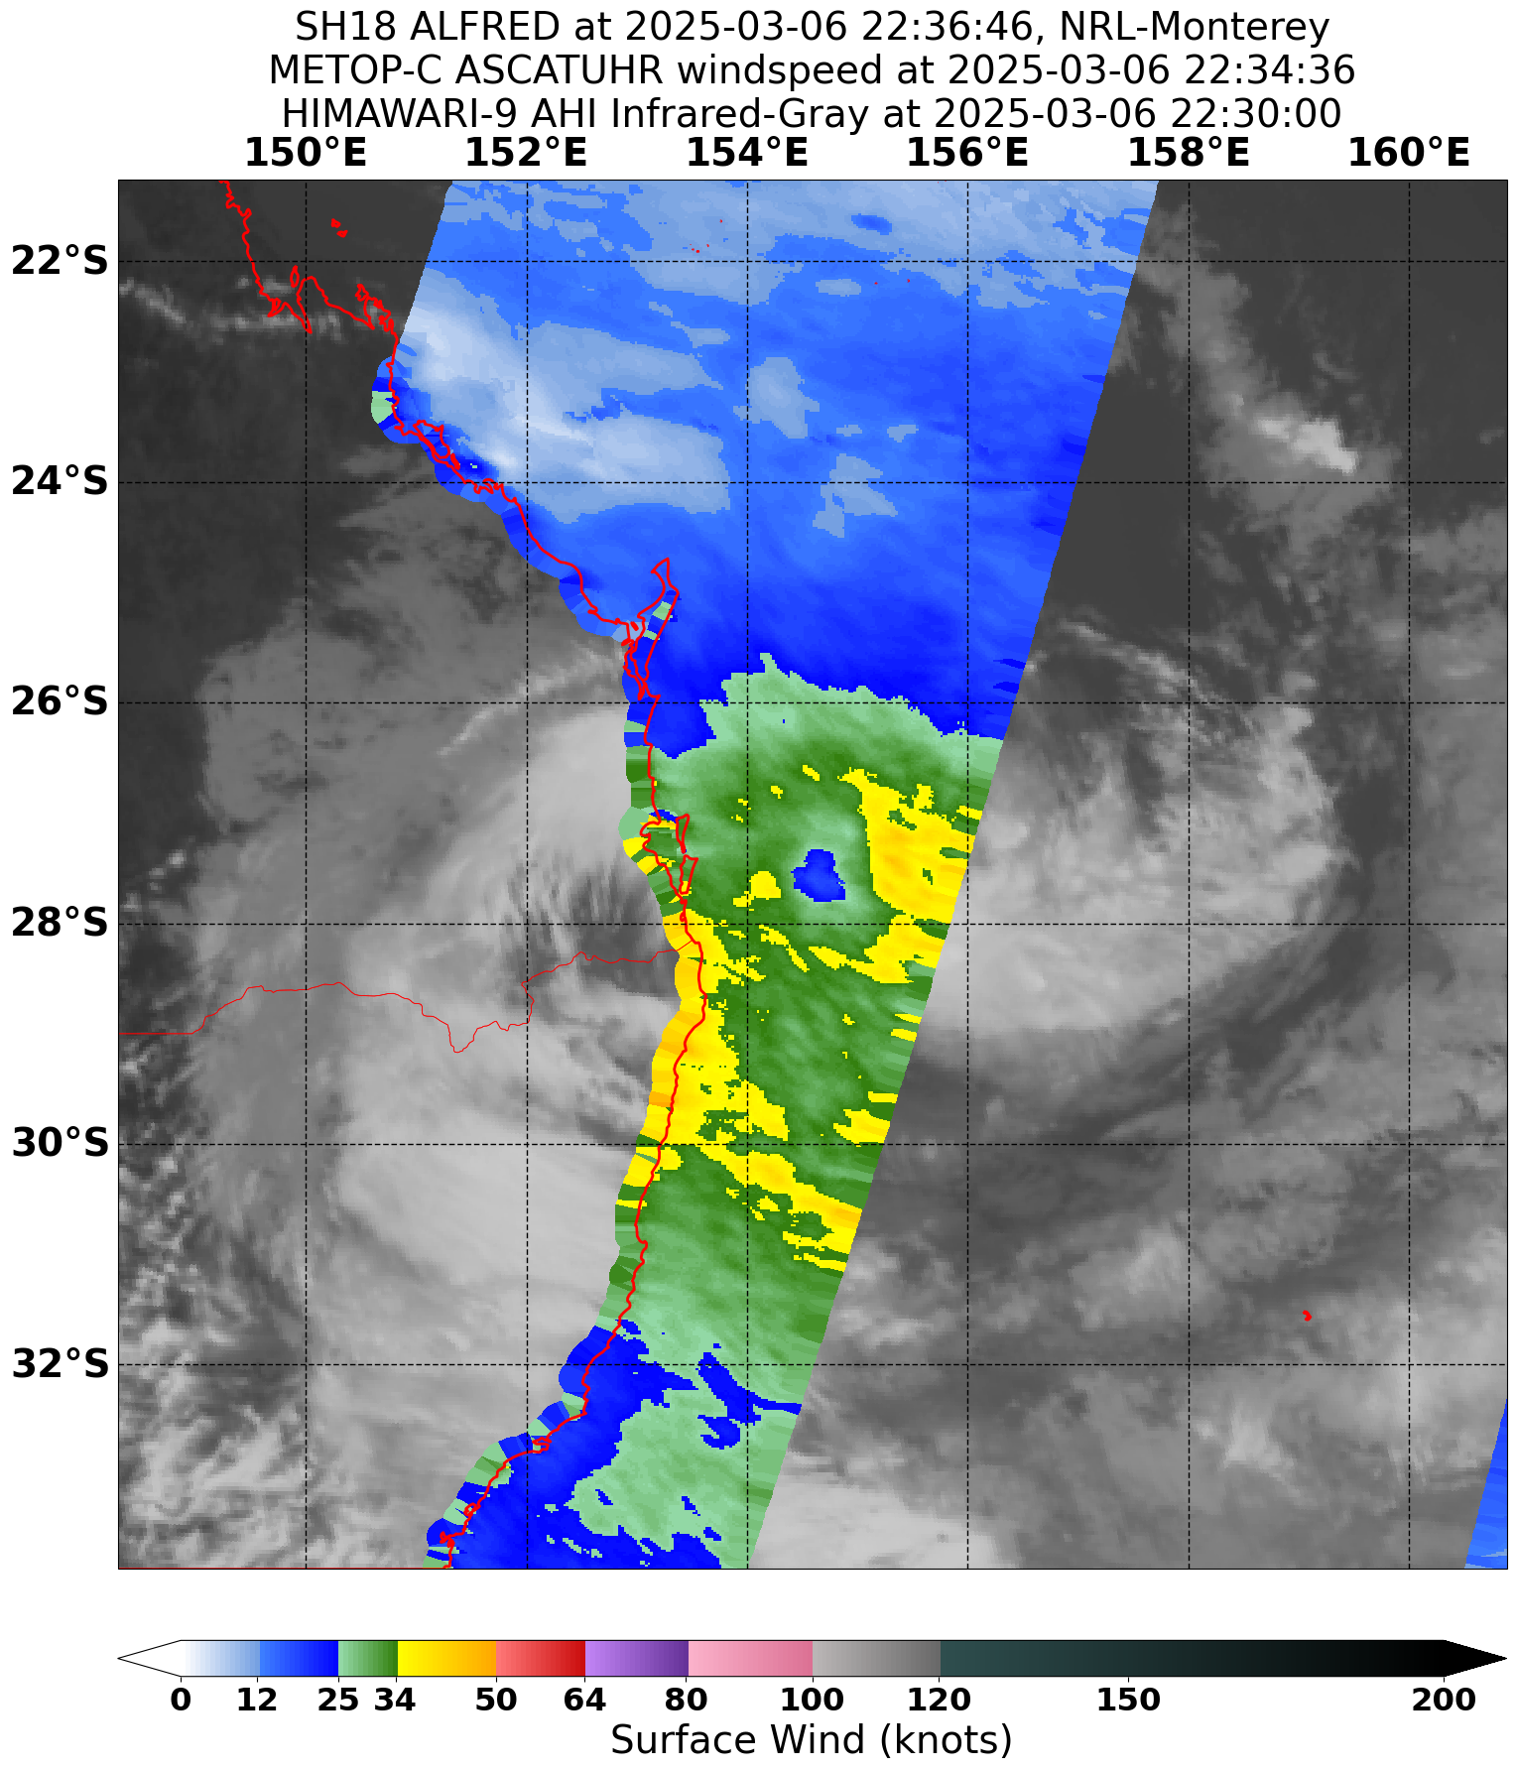
Figure 15 Scatterometry, ASCAT-C at 2234 UTC 6 March depicting a 45 knot Tropical Cyclone Alfred near the southeast Queensland coast. Image courtesy NRL: https://www.nrlmry.navy.mil/TC.html

  - Structure
22U began its life on 21 February as a somewhat elongated circulation, (Figure 7). Gales developed on the southern side from 0000 UTC (10 am AEST) 22 February. At this time, observed gales at Willis Island (wind observations page 43), indicated that the southern quadrant gales extended out to a maximum of 80 nm (148 km). From the morning of 23 February gales slightly contracted (SAR 1939 UTC 22 February, not shown), and gales wrapped around to the northwestern quadrant, with Tropical Cyclone Alfred named at 0000 UTC (10am AEST) 23 March (Figure 8). Scatterometry during 23 February, (SAR 0807 UTC Figure 16, and ASCAT-C 1151 UTC Figure 9, 23 February) indicated that gale force winds had wrapped completely around the system, and storm force winds developed, firstly in the northwest and then into southern quadrants. Around this time, the storm force winds extended to 30-40 nm (56 - 74 km).
During 24 to 26 February, the gale radius saw a gradual expansion, as well as storm force winds in different quadrants as the peak wind region rotated around the system. Alfred continued to intensify as it moved south, and the Radius of Maximum Winds (RMW) contracted to 10 nm (19 km) with the appearance of an eye during 27 February. After an eyewall replacement cycle (See section 2.1 for details), the RMW expanded to 25 nm (46 km) at 1200 UTC (10 pm AEST) 27 February as the secondary eyewall became dominant.
Alfred passed to the east of Frederick Reef during 28 February and into 1 March, with this site recording gales and storm force winds (Figure 32), and along with scatterometry confirmed a gradual expansion of wind radii, to a maximum gale radius of 130 nm (241 km) in the southwest from 0000 UTC (10 am AEST) 28 February.
A series of high-pressure systems (Figure 4) moved across the Tasman Sea during Alfred's lifetime. During 1 March, one such high-pressure system contributed to an expansion of gales in southern quadrants. Then during 2 March, the sub-tropical jet approached from the southwest. This began a period of transition for Alfred. During 2 March and overnight into 3 March, Alfred increased its interactions with the sub-tropical jet, eventually moving underneath it. The RMW fluctuated from 30-50 nm (56 – 93 km), before expanding to 60 nm (111 km) and greater during 3 March. Alfred exhibited a sub-tropical cloud structure, with no deep convection near the centre. Dvorak T-number estimates were difficult to obtain and/or diverged greatly from the actual intensity. Cyclone Phase Space assessments (Figure 18), showed that Alfred was becoming asymmetric and had a shallower warm core. Additionally, the wind structure of Alfred changed, becoming asymmetric, and southern gale radii expanded to 210 nm (389 km) and larger (Figure 17). All of this was evidence that Alfred had undergone sub-tropical transition and at 0600 UTC (4 pm AEST) 3 March, Alfred was reclassified as a sub-tropical cyclone.
The sub-tropical structure persisted during 4 March as Alfred began to be steered to the west. Around this time sea surface temperatures (SSTs) were at their coldest, around 25 to 26 degrees Celsius, (Figure 20). Alfred's structure continued to be asymmetric with southern gales associated with the system extending as far south as near Lord Howe Island overnight on 4 March (wind observations page 43). Cyclone Phase Space assessments showed Alfred had a period where it was asymmetric and had a shallower warm core (Figure 18). The CIMSS automated assessment (Figure 19), suggested some fluctuations in tropical and sub-tropical characteristics, but generally when scrutinised agreed with the collection of evidence indicating Alfred persisting as a sub-tropical cyclone.
By 5 March, Alfred had moved poleward of the sub-tropical jet, though continued to have an asymmetric sub-tropical structure. During 5 March, the high-pressure ridge to the south that was assisting with maintaining a large southern extent of gales, weakened (Figure 4, chart from the morning 5 March shows the weakening high). This assisted with a contraction in gale radii and a more symmetric structure (Figure 21), RMW also contracted. Cyclone Phase Space assessments returned to indicating a deep symmetric warm core (Figure 18). Microwave assessment (AMSU, ATMS and TROPICS, not shown) indicated a warm core was present. SSTs were still marginal for tropical development, but slightly increased as Alfred moved further west. Renewed tropical convection developed near Alfred's centre and there was enough evidence to say that Alfred had undergone tropical transition. Consequently, from 1200 UTC (10 pm AEST) 5 March Alfred was reclassified as a tropical cyclone.
Also during 5 March, gales commenced at the exposed location of Cape Byron (Figure 31), and along with reports of tree damage on some parts of the Gold and Tweed Coasts, indicated that gales were impacting the coastal fringe of northeastern New South Wales and southeast Queensland.
During the morning of 6 March, these gales contracted off the coast for a period, before recommencing later in the day about exposed coastal areas from approximately Cape Byron in New South Wales to the Gold Coast in Queensland, and most of the Moreton Bay Islands (wind observations page 43).
Interactions with the land increased from 7 March, which impacted Alfred's structure. Radiometry, SMAP 0808 UTC, (Figure 22), as well as various other scatterometry showed gales extended south over southeast Queensland and northeast New South Wales waters, though gales for land locations were more intermittent.
As Tropical Cyclone Alfred approached the southeast Queensland coast it moved under another amplifying filament of the sub-tropical jet. Then during 8 March Alfred stalled between the northern tip of Moreton Island and Bribie Island. Alfred's warm core was becoming shallower. A high-pressure system was strengthening in the Tasman Sea (Figure 4), and resulted in a southeasterly surge that moved north along the coast and interacted with Alfred. The renewed baroclinic influence and shallower warm core implied that from 0000 UTC (10am AEST) 8 March Alfred was again reclassified as sub-tropical. Regardless of this classification, at this time the system was below tropical cyclone intensity. Quadrant gales redeveloped, however these were only in the two southern quadrants, and Sub-Tropical Cyclone Alfred moved over Bribie Island and then the mainland.
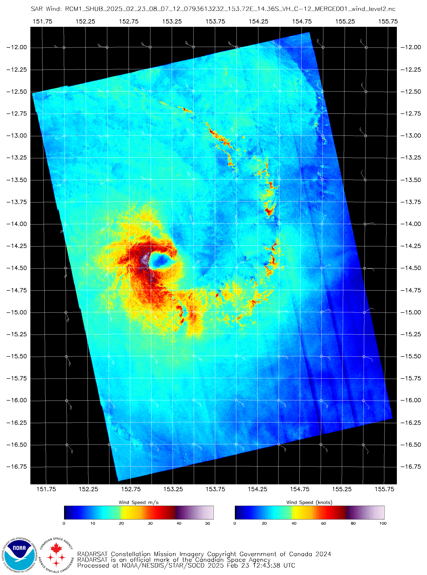
Figure 16 Scatterometry, SAR at 0807 UTC 23 February, Tropical Cyclone Alfred with gale force winds in all quadrants, and storm force winds in the west. Image courtesy of NOAA's Center for Satellite Applications and Research (STAR): https://www.star.nesdis.noaa.gov/socd/mecb/sar/sarwinds_tropical.php

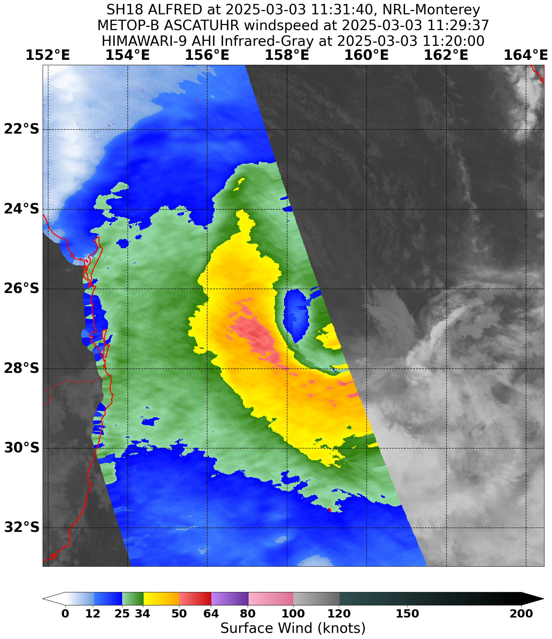
Figure 17 Scatterometry, ASCAT-B at 1129 UTC 3 March, depicting Alfred with a sub-tropical structure, having a large RMW and expanded southern gale radii. Image courtesy NRL: https://www.nrlmry.navy.mil/TC.html
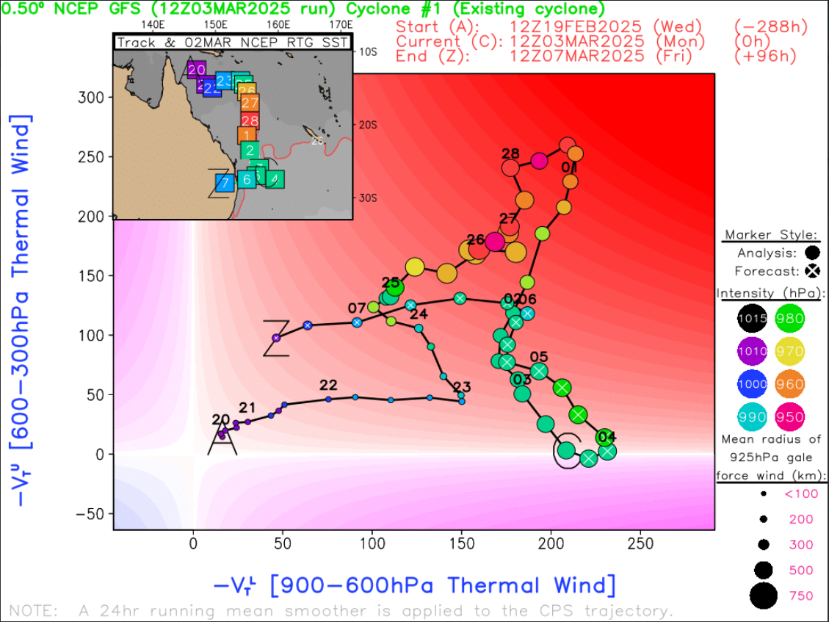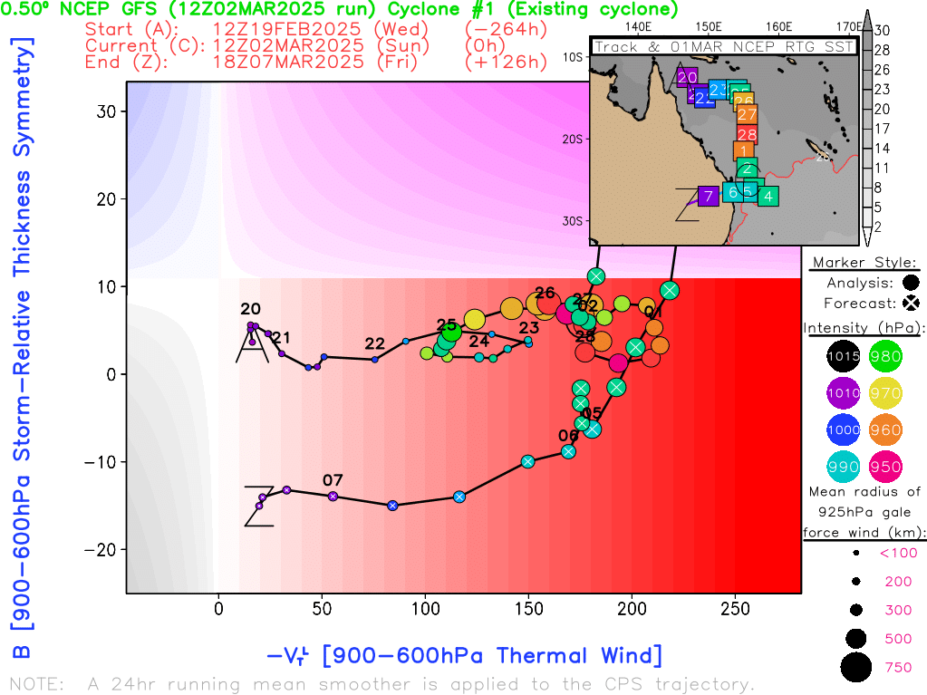
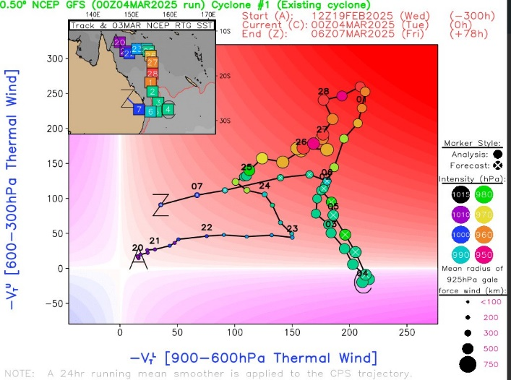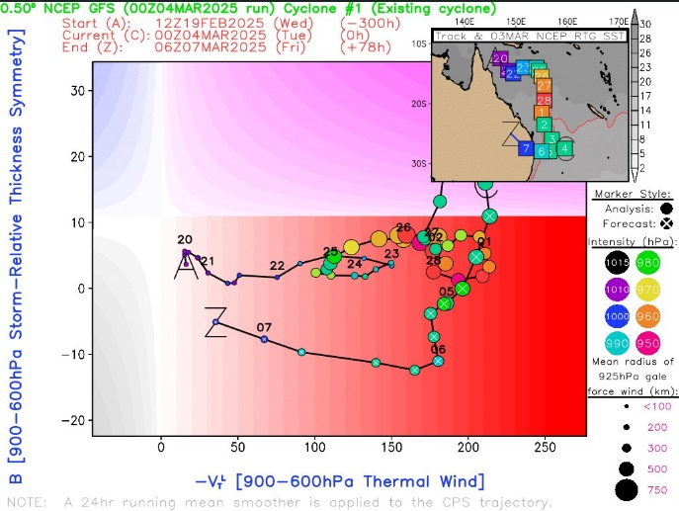
Figure 18 Hart & Evans Cyclone Phase Space diagrams. Warm core assessment based on the low-level and upper-level thermal wind. Symmetry based on thermal wind symmetry (B-parameter) and low-level thermal wind. 'C' marks the analysis time. Top Left: USG model base time 3 March 12UTC, shows Alfred moving to a shallow warm core. Top Right: USG model base time 3 March 12UTC, 'C' the analysis is hidden under the zoomed in map of Queensland, but shows an asymmetric system. Bottom Left: USG model base time 4 March 00UTC, shows Alfred with a shallow warm core. Bottom Right: USG model base time 4 March 00UTC, shows an asymmetric Alfred.

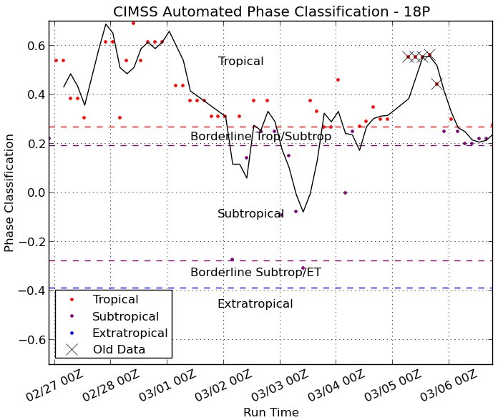
Figure 19 CIMSS automated phase classification of Alfred. Courtesy of Cooperative Institute for Meteorological Satellite Studies (CIMSS): https://tropic.ssec.wisc.edu/#
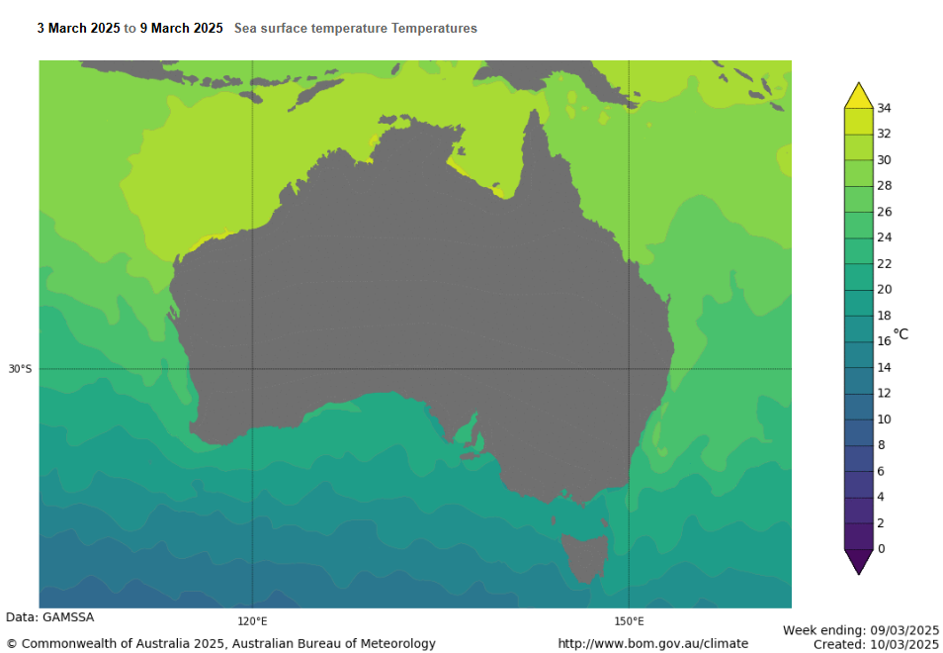
Figure 20. Sea Surface Temperatures 3 to 9 March, depicting SSTs of 26 to 28C offshore of the southeast Queensland coast along Alfred's track.
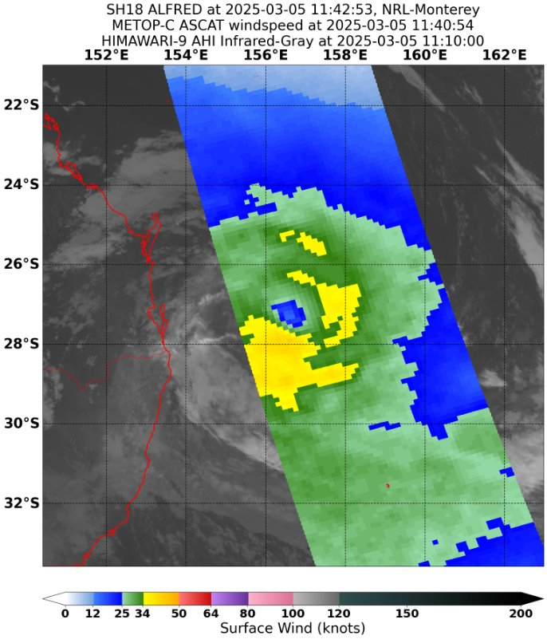
Figure 21 Scatterometry, ASCAT-C at 1140 UTC shows a symmetric structure. Image courtesy NRL: https://www.nrlmry.navy.mil/TC.html

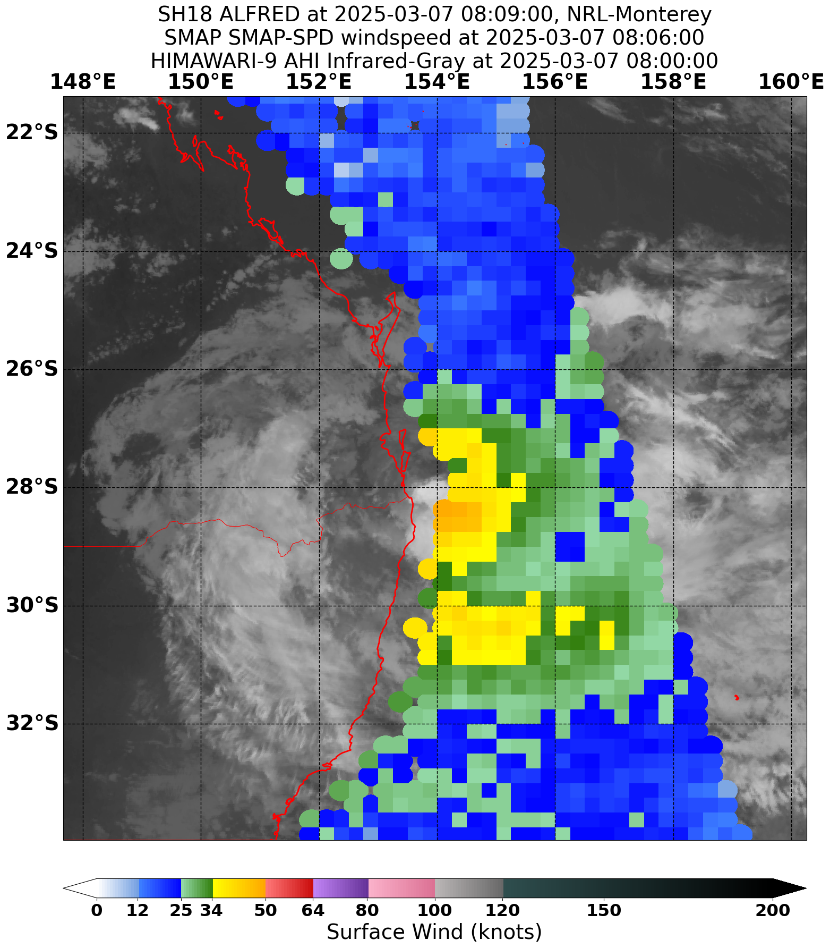
Figure 22 Radiometry, SMAP at 0806 UTC 7 March. Alfred nearing the southeast Queensland coast. Image courtesy NRL: https://www.nrlmry.navy.mil/TC.html

  - Motion
22U was initially (21 – 22 February) steered towards the southeast with influence from an upper trough passing to the south, and enhanced northwest flow to the north of the circulation. Later during 22 February, a low level southeasterly surge arrived giving 22U a push to the northeast. The upper trough continued to influence, with broadly easterly steering continuing during 23 February as Tropical Cyclone Alfred developed.
The upper trough moved away and during 24-26 February, Alfred slowed and turned to the south. A steering ridge extended from the Australian mainland, partially cradling Alfred and halting any further easterly motion. A combination of other steering influences (including the beta effect, an upper trough to the southwest, and another subtropical ridge to the east) contributed to a southwards track during 26 February – 2 March.
During 2-3 March, the sub-tropical jet amplified and became the dominant steering influence, taking Alfred to the southeast. During 4 March the sub-tropical jet moved to the east, and Alfred was steered back to the west by a low to mid-level ridge that strengthened to the south in the wake of the jet.
From 5-9 March, ridging to the south of the system centre continued to steer Alfred generally west. However, the initial high to the south weakened, with light steering occurring during 5 and 6 March. This meant Alfred moved only slowly to the west and had somewhat erratic motion, performing a loop overnight on 5 March and a second loop during 6 March. During 7 March, Alfred continued its westward track, with another mid-level ridge to the south building and being the dominant steering influence. Countering this was a mid-level ridge to the north which balanced the steering somewhat and slowed Alfred's motion. The balanced influences were particularly noticeable during 8 March after Alfred crossed Moreton Island, when it stalled until the ridge to the south strengthened and the associated southeasterly surge met Alfred and pushed it over Bribie Island and the mainland.
- Impact
Severe Tropical Cyclone Alfred caused significant damage in southeast Queensland and northeast NSW. The economic cost of the event was estimated at $1.2 billion by the Australian Government, including damage to roads, infrastructure and agriculture.
More than 300,000 properties and 500,000 customers were without power over southeast Queensland and northeastern New South Wales with many remaining without power for multiple days. Power outages were generally attributed to the windy conditions, including trees or tree branches falling onto power lines.
Beach erosion was a significant impact for Queensland and northern NSW sandy beaches from about Sandy Cape in Queensland to Coffs Harbour in NSW due to the extended duration of high energy waves. For example, the Gold Coast beaches lost about 4,000,000 m³ of sand, leaving escarpments of up to 6 metres high in some dunes during the prolonged erosion event. Additionally, a shoreline recession of 40 metres at Main Beach on North Stradbroke Island (Qld) and 30 metres at Peregian Beach on the Sunshine Coast (Qld) was observed. Some coastal structures were impacted by the erosion and storm waves, including car parks, seawalls and surf lifesaving towers. Footage captured during the event showed water surging onto Currumbin Beach, inundating the surf club and nearly extending onto the nearby Pacific Parade.
Wind damage, power outages and flooding caused significant losses to the agriculture industry. Dairy farmers were not able to refrigerate or transport their product, with Norco estimating a loss of about 375,000 litres of milk. Across the north coast of NSW, crop damage was reported at macadamia and coffee plantations, soybean and cane farms, as well as many others.
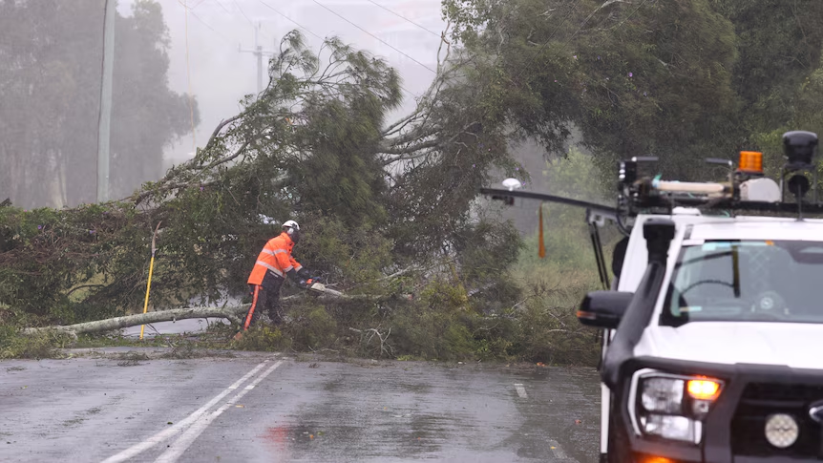
Figure 23 Fallen tree over power line at Chinderah in northern NSW (source: Jason O'Brien, AAP).
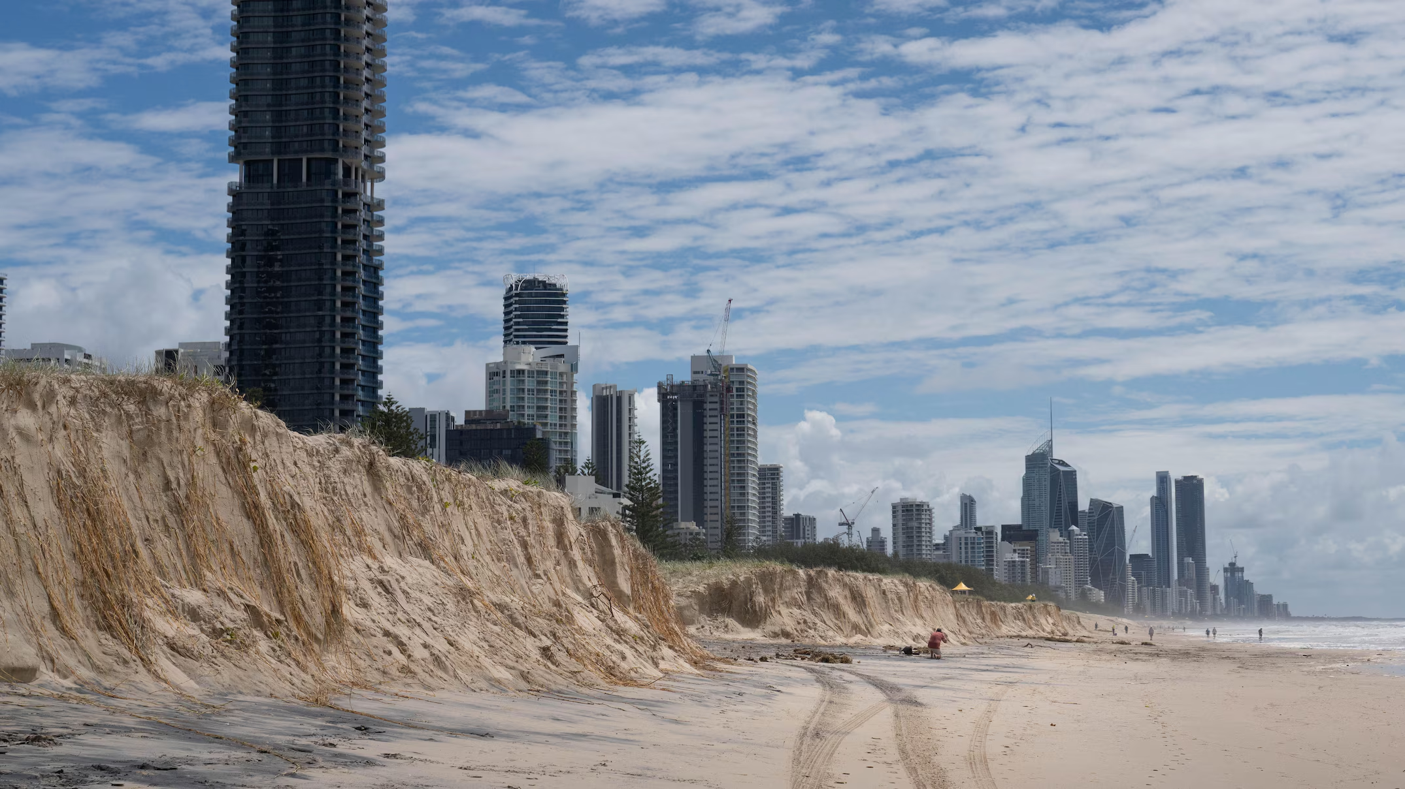
Figure 24 Storm erosion scarp at Mermaid Beach on the Gold Coast (source: Margeret Burin, ABC News).
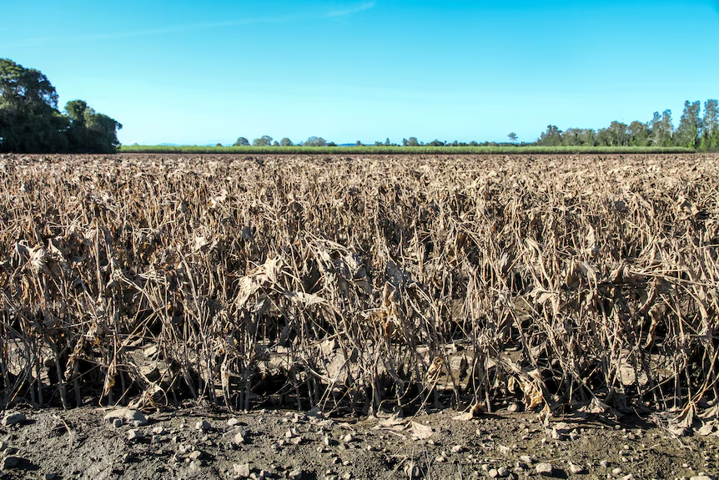
Figure 25 Soybean crops wiped out near Coraki, NSW (source: Kim Honan, ABC Rural).
- Observations
  - Wind
As Alfred tracked south through the Coral Sea, Frederick Reef and Cato Island Automatic Weather Stations (AWSs) recorded storm force winds with maximum wind gusts of 150 km/h on Friday 28 February and 140 km/h on Saturday 1 March. Then, as Alfred approached K'gari, Double Island Point (an exposed observation site at 95 m above mean sea level) recorded gale force winds with a maximum wind gust of 100 km/h on Monday 3 March.
As Alfred tracked towards and over the southeast Queensland coast between Wednesday 5 March and Sunday 9 March, numerous weather stations recorded gale force winds with a maximum wind gust of 120 km/h recorded at Cape Byron AWS on Friday 7 March.
Location | Maximum 10-minute mean wind speed | Time and date of maximum mean wind* | Maximum 3-second wind gust | Time and date of maximum gust
Willis Island | 66 km/h (36 knots) | 0430 UTC, 22/02/25 | 87 km/h (47 knots) | 0408 UTC, 22/02/25
Frederick Reef | 120 km/h (65 knots) | 1530 UTC, 28/02/25 | 150 km/h (81 knots) | 1345 UTC, 28/02/25
Cato Island | 111 km/h (60 knots) | 0600 UTC, 01/03/25 | 140 km/h (76 knots) | 0717 UTC, 01/03/25
Double Island Point | 81 km/h (44 knots) | 1700 UTC, 02/03/25 | 100 km/h (54 knots) | 0448 UTC, 03/03/25
Sunshine Coast Airport | 48 km/h (26 knots) | 0100 UTC, 03/03/25 | 70 km/h (38 knots) | 0202 UTC, 03/03/25
Northwest Beacon (Moreton Bay) | Not available | Not available | 78 km/h (42 knots) | 1512 UTC, 08/03/25
Cape Moreton Lighthouse | 97 km/h (47 knots) | 1452 UTC, 08/03/25 | 109 km/h (59 knots) | 1452 UTC, 08/03/25
Redcliffe | 81 km/h (44 knots) | 1130 UTC, 08/03/25 | 104 km/h (56 knots) | 1124 UTC, 08/03/25
Inner Reciprocal Marker (Moreton Bay) | 68 km/h (37 knots) | 1300 UTC, 07/03/25 | 98 km/h (53 knots) | 1125 UTC, 08/03/25
Brisbane Airport | 64 km/h (35 knots) | 1318 UTC, 07/03/25 | 98 km/h (53 knots) | 1316 UTC, 07/03/25
Toowoomba Airport | 70 km/h (38 knots) | 2109 UTC, 09/03/25 | 98 km/h (53 knots) | 1520 UTC, 08/03/25
Hope Banks (Moreton Bay) | Not available | Not available | 93 km/h (50 knots) | 1028 UTC, 08/03/25
Banana Bank (Moreton Bay) | 64 km/h (35 knots) | 1230 UTC, 7/03/25 | 93 km/h (50 knots) | 1207 UTC, 07/03/25
Gold Coast Seaway | 76 km/h (41 knots) | 1200 UTC, 07/03/25 | 107 km/h (57 knots) | 1146 UTC, 07/03/25
Coolangatta | 59 km/h (32 knots) | 1200 UTC, 07/03/25 | 91 km/h (49 knots) | 1153 UTC, 06/03/25
Cape Byron | 89 km/h (48 knots) | 1900 UTC, 06/03/25 | 120 km/h (64 knots) | 1809 UTC, 06/03/25
Ballina Airport | 59 km/h (32 knots) | 2001 UTC, 06/03/25 | 89 km/h (47 knots) | 1743 UTC, 06/03/25
Evans Head | 68 km/h (37 knots | 2100 UTC, 06/03/25 | 100 km/h (54 knots) | 2111 UTC, 06/03/25
*Where sites recorded the maximum mean wind for a period, the time listed is for the first occasion reaching the stated peak.
Table 2 Significant wind observations from automatic weather stations (AWS) along the track of Alfred (UTC=AEST-10h and AEDST-11h).

A time series from 24 February to 4 March of the wind observations from the nearest Coral Sea reef (Frederick Reef) and island (Cato Island) observation sites are shown below.

Figure 26 Frederick Reef (200701) mean wind speed and gust observations.

Figure 27 Cato Island (200601) mean wind speed and gust observations.

A time series from 1 March to 11 March of the wind observations from southeast Queensland (Cape Moreton, Redcliffe, Gold Coast Seaway) and northeast NSW (Cape Byron) observation sites that experienced significant winds are shown below.

Figure 28 Cape Moreton (040043) mean wind speed and gust observations.

Figure 29 Redcliffe (040958) mean wind speed and gust observations.

Figure 30 Gold Coast Seaway (040764) mean wind speed and gust observations.

Figure 31 Cape Byron (058216) mean wind speed and gust observations.

Additional wind observations for some sites:
Willis Island
Gales recorded at times between 2230 UTC 21 February (8:30 am AEST 22 February) and 0630 UTC (4:30 pm AEST) 22 February, as the developing tropical low passed to the north.
Banana Bank*
Gales were recorded between 1230 UTC (10:30 pm AEST) 7 March and 1400 UTC 7 March (12:00 am AEST 8 March). A second period of gales was recorded between 0730 UTC (5:30 pm AEST) 8 March and 1100 UTC (9:00 pm AEST) 8 March, in the hours prior to ex-Alfred's landfall near Bribie Island.
Inner Reciprocal Marker
Gales were recorded between 1239 UTC (10:39 pm AEST) 7 March and 1600 UTC 7 March (2:00 am AEST 8 March). A second period of intermittent gales was recorded between 0730 UTC (5:30 pm AEST) 8 March and 1530 UTC 8 March (1:30 am AEST 9 March), during the hours around ex-Alfred's landfall near Bribie Island.
Hope Bank*
Gales were recorded at times between 0730 UTC (5:30 pm AEST) 8 March and 1330 UTC (11:30 pm AEST) 8 March, during the hours around ex-Alfred's landfall near Bribie Island.
Lord Howe Is
Intermittent gales were recorded between 0730 UTC (5:30 pm AEST) 4 March and 0423 UTC (2:23 pm AEST) 5 March. This was predominately due to a strong surface pressure gradient between Alfred and a high pressure system in the Tasman Sea.
*Sites at approximately 7m.
  - Pressure
As Alfred tracked south through the Coral Sea, Frederick Reef AWS recorded a minimum mean sea level pressure (MSLP) of 987.8 hectopascals (hPa) at 3:05 and 3:10 am AEST on Saturday 1 March as Alfred passed to its east. On Sunday 2 March, Cato Island AWS recorded a minimum MSLP of 982.6 hPa between 4:00 and 4:36 am AEST as Alfred passed over the island.
Later, as Alfred tracked over Moreton Island and crossed Bribie Island, Cape Moreton AWS recorded a minimum MSLP of 995.6 hPa at 1:59 and 2:05 am AEST on Saturday 8 March.

Figure 32 Frederick Reef (200701) Mean Sea Level Pressure (MSLP) chart.

Figure 33 Cato Island (200601) Mean Sea Level Pressure (MSLP) chart.

Figure 34 Cape Moreton (040043) Mean Sea Level Pressure (MSLP) chart.
  - Rainfall
Tropical Cyclone Alfred brought widespread heavy to intense rainfall from 5 March across south-eastern Queensland and north-eastern New South Wales, both before and after making landfall (Figure 35, Figure 36).
The relatively large size and slow forward speed of Alfred contributed to the extended period of heavy rainfall. Generally, the most widespread and persistent heavy to intense rainfall fell along and south of Alfred's track (Figure 35, Figure 36). A broad swath of rainfall totals above 300 mm was recorded between the mid-north coast in New South Wales and just north of Brisbane, with more localised heavy to intense rainfall above 600 mm about the higher terrain near the Queensland New South Wales border, and the near Dorrigo Plateau, Figure 36. On the north side of Alfred's track, heavy to intense rainfall was less widespread and more confined to shorter periods. However, localised areas experienced much higher short term rainfall intensities in the three-to-six-hour accumulation period than locations further to the south.
Some of the most intense rain rates and highest total rainfall accumulations for the 7 days between 2300 UTC March 3 (9 am AEST March 4) and 2300 UTC 9 March (9 am AEST 10 March) are summarised below.
- Springbrook (Gold Coast, Qld) received the highest totals with 1146.0 mm at Upper Springbrook, Figure 37, and 1048.4 mm at Lower Springbrook.
- Dorrigo (Mid North Coast, NSW), well to the south of Alfred, received some of the heaviest rainfall during the event with 894.0 mm. This heavy rain was due to topographic enhancement and persistent strong onshore flow associated with the pressure gradient between a large high pressure system [1029 hPa] in the southern Tasman Sea and Alfred [987 hPa].
- Elsewhere, 7-day totals exceeding 800 mm were reported at other Gold Coast sites and in New South Wales in the Northern Rivers district.
In the 24 hours to 2300 UTC on 8 March (9 am AEST on 9 March):
- Annual daily records were observed at Hervey Bay and K'gari Eurong with 261.4 mm and 427.3 mm, respectively. This was in the form of a near-stationary band of thunderstorms on the outer periphery of the cyclone's circulation, and featured some high intensity rainfall, including 302.4 mm in 6 hours at Hervey Bay Figure 38.
- March daily record was observed at Mt Glorious Alert with 322.0 mm.
In the 24 hours to 2300 UTC 9 March (9 am AEST 10 March):
- The official Brisbane gauge recorded an annual daily record of 275.2 mm for the current site. This is the highest daily rainfall Brisbane City has recorded, at either the current site or old site, since 26 January 1974 with Tropical Cyclone Wanda, when 314 mm was recorded.
- Nambour recorded an annual highest daily rainfall record with 345.0 mm of which 180 mm fell in 6 hours, while nearby West Woombye recorded 244 mm in 6 hours.
- March daily records were recorded at Archerfield, Eagle Farm and Amberley with 272.6, 244.0 mm and 162.4 mm, respectively.
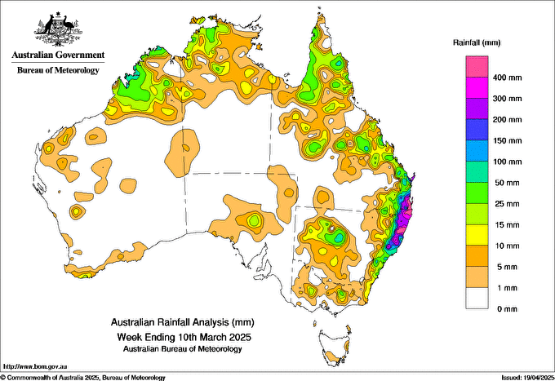
Figure 35 Map of the 7-day rainfall totals across Australia from 3 to 9 March UTC day (4 to 10 March local time day) 2025.
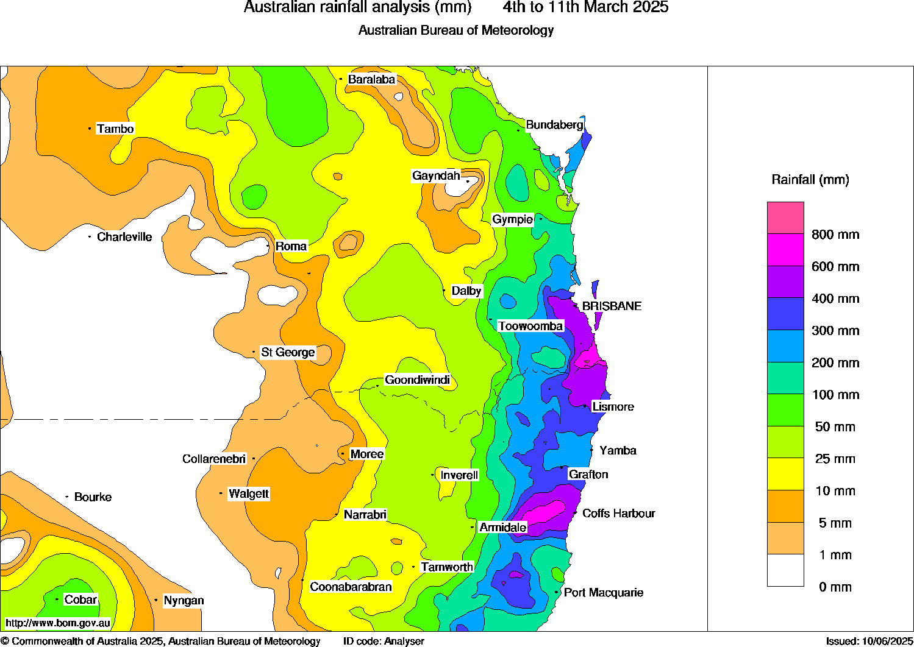
Figure 36 Map of the 7-day rainfall totals across southeast Queensland and northeast New South Wales from 3 to 10 March UTC day (4 to 11 March local time day) 2025.
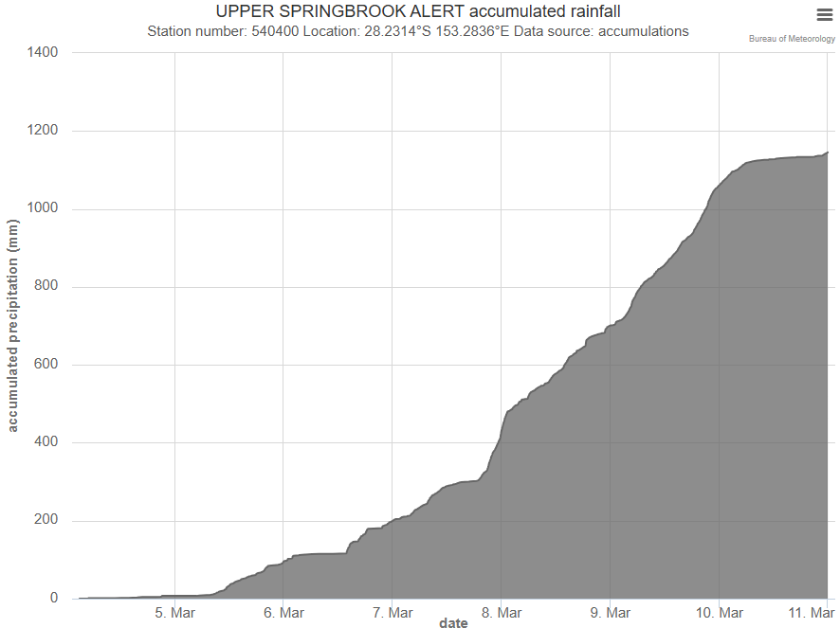
Figure 37 Total rainfall accumulation in the 7 days 3-10 March UTC day (4-11 March local day) at Upper Springbrook Alert.
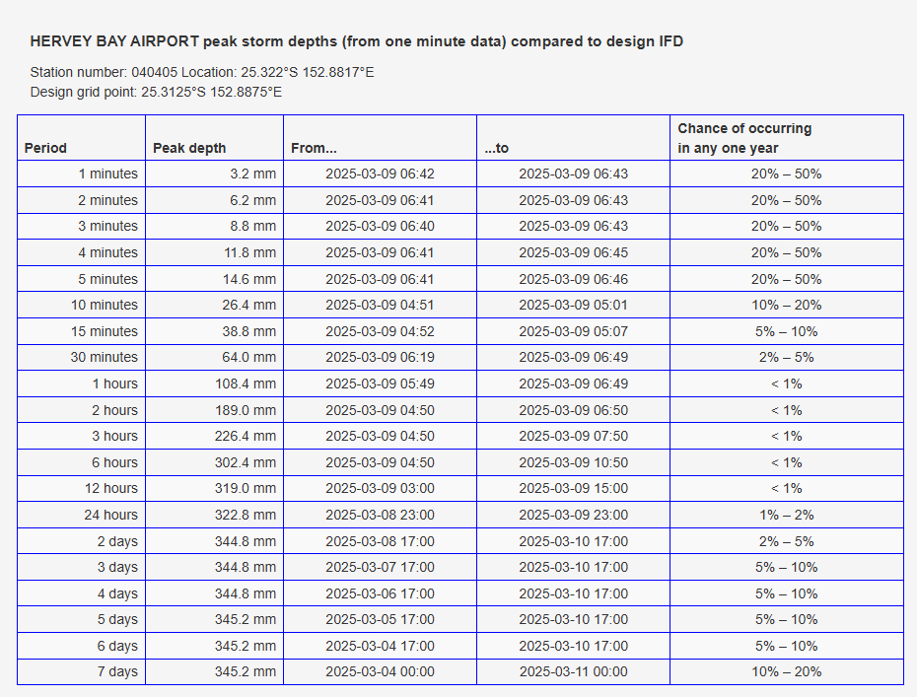
Figure 38 Peak rainfall accumulations in the given time periods between 3-10 March UTC day (4-11 March local day) at Hervey Bay Airport.
  - Flooding
Riverine flooding and flash flooding were recorded in northeastern NSW and the Gold Coast initially. Flooding and flash flooding then extended further north. On 9 March riverine flooding or severe flash flooding occurred from as far north as Hervey Bay (Wide Bay) south to northeastern New South Wales.
Widespread minor to major riverine flooding occurred in northeastern NSW and southeastern QLD. In NSW, major riverine flooding occurred in the Richmond, Clarence and Bellinger Rivers while in QLD, major riverine flooding occurred in the Lockyer, Laidley and Warrill Creeks, and the Bremer, Logan and Albert Rivers. Significant localised flash flooding also occurred in many locations.
  - Waves
Large waves were recorded along the Queensland and NSW coasts, south of about Mackay and north of about Sydney, during the event. The largest wave height was recorded at the Tweed Offshore wave buoy with a maximum wave height of 13.91 metres. The table below shows some of the maximum wave heights and maximum significant wave heights observed along the Queensland and NSW coasts during the event. For the Wide Bay, Caloundra, Palm Beach, Bilinga and Tweed Offshore buoys, these waves were the largest on record. For the Coffs Harbour buoy, Alfred was the 7th largest storm waves on record (since 1976).
This wave event resulted in significant beach erosion, partially due to the longevity of these high energy waves. Large waves were recorded on 28 February due to Alfred's southward track through the Coral Sea as a severe tropical cyclone between 27 February and 1 March. A second swell grew, with some of the largest waves of record, on 5 March as Alfred slowed off southeast Queensland with a large fetch of easterly winds on its southern flank, particularly between 3 and 6 March.
Due to the extreme nature of the waves, wave breaking processes affected some of the wave buoy measurements and larger wave heights may have occurred. In particular, the Byron Bay (Ballina) buoy failed between 1 March and 10 March and the Gold Coast buoy failed on 5 March such that these buoys may have missed recording some of the largest waves during the event. Further details about Queensland wave monitoring data during Alfred can be found on the Department of Environment, Tourism, Science and Innovation (DETSI) fact sheet.
Location | Maximum wave height (m) | Significant wave height (m)
Wide Bay (K'gari) | 9.16 | 5.08
Mooloolaba | 7.82 | 4.30
Caloundra | 7.75 | 3.55
North Moreton Bay (Bribie Island) | 7.14 | 3.87
Brisbane (North Stradbroke Island) | 11.51 | 6.44
Gold Coast | 7.47 | 4.16
Palm Beach | 10.36 | 5.58
Bilinga | 8.32 | 4.87
Tweed Heads | 10.05 | 5.41
Tweed Offshore | 13.91 | 7.58
Byron Bay (Ballina) | - | -
Coffs Harbour | 11.77 | 6.74
Crowdy Head | 11.08 | 5.70
Table 3 Observed extreme waves (north to south) for Severe Tropical Cyclone Alfred (source: DETSI and NSW Government Manly Hydraulics Laboratory).
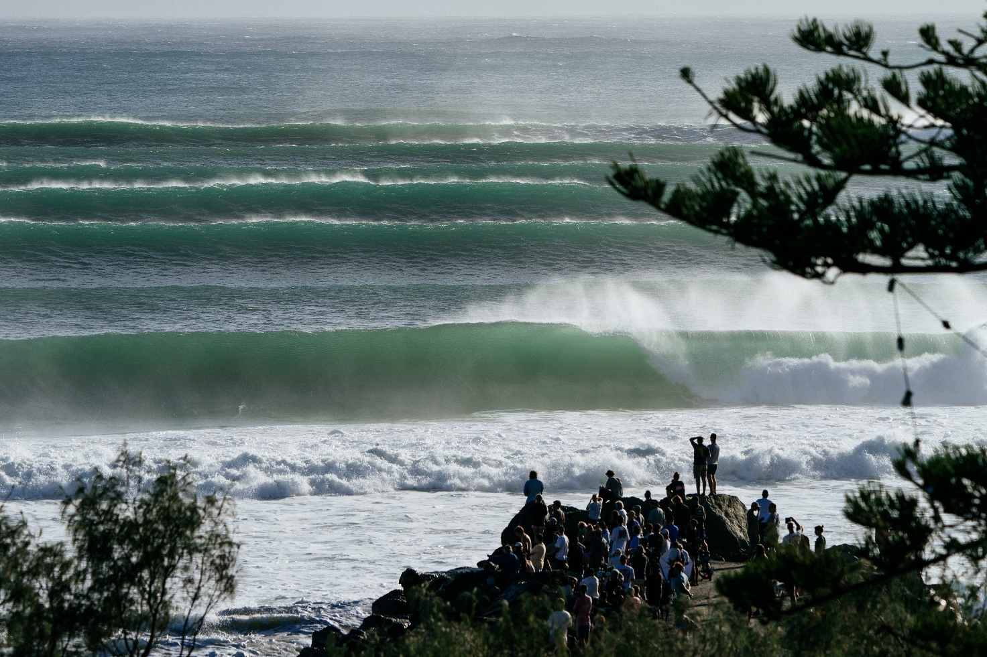
Figure 39 Swell waves at Kirra Point (Coolangatta, Gold Coast) on Tuesday 4 March (source: Swellnet).

  - Tides
Positive tidal anomalies were recorded along the southeast Queensland and northeast NSW coasts during the event. The maximum storm surge was recorded at Maroochydore tide gauge with an anomaly of 0.94 metres, likely due to a combination of storm surge from the ocean and flow from flood waters. The total water level exceeded the Highest Astronomical Tide (HAT) level at Maroochydore, and Shorncliffe, in Queensland, as well as Ballina, Tweed (inside river entrance), and Yamba in New South Wales, (Table 4, Figure 40, Figure 41, Figure 42). The table and graphs below show some of the storm surge values observed during the event. While storm surge heights were high, total sea levels largely remained below the Highest Astronomical Tide (HAT), as it was a period of neap high tides.
Open beaches likely experienced a larger storm surge as they are exposed to larger wave setup, however, there were no water levels recorded on the beaches themselves. Instead, photography from the event showed a large erosion scarp of more than two metres in height for open beaches.
Location | Maximum storm surge (m) | Maximum storm tide (m above HAT)
Maroochydore | 0.94 | 0.12*
Mooloolaba | 0.44 | -0.03
Golden Beach (Caloundra) | 0.53 | -0.03
Donnybrook | 0.55 | -0.05
Tangalooma (Moreton Island) | 0.47 | -0.09
Scarborough Boat Harbour | 0.49 | -0.10
Shorncliffe | 0.70 | 0.02
Brisbane Bar | 0.42 | -0.06
Birkdale | 0.42 | -0.25
Raby Bay | 0.39 | -0.24
Gold Coast (sand bypass jetty) | 0.58 | -0.06
Tweed Heads Sand Bypass Jetty | 0.79 | -0.10
*Maroochydore has combined influence from storm surge and flood waters.
Table 4 Observed storm surge (north to south) for Severe Tropical Cyclone Alfred (source: DETSI)
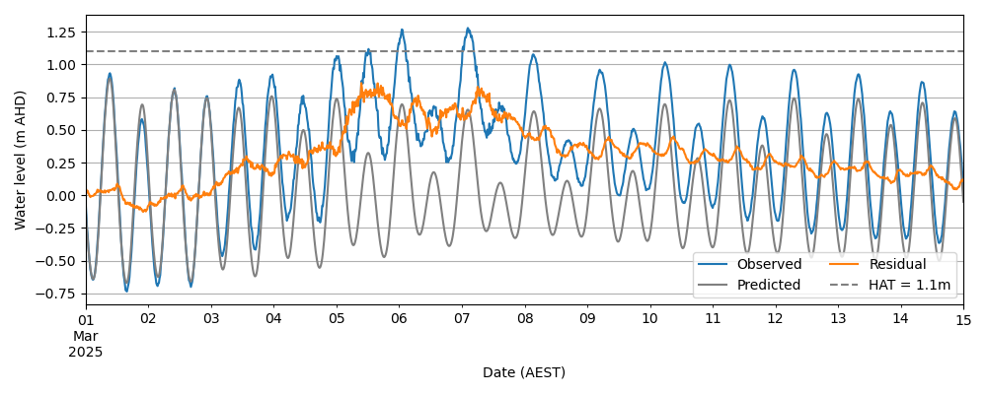
Figure 40 Water Levels at Ballina Breakwall during March. Shows water levels above HAT with high tides during 6 and 7 March. Data courtesy: New South Wales Government Manly Hydraulics Laboratory.
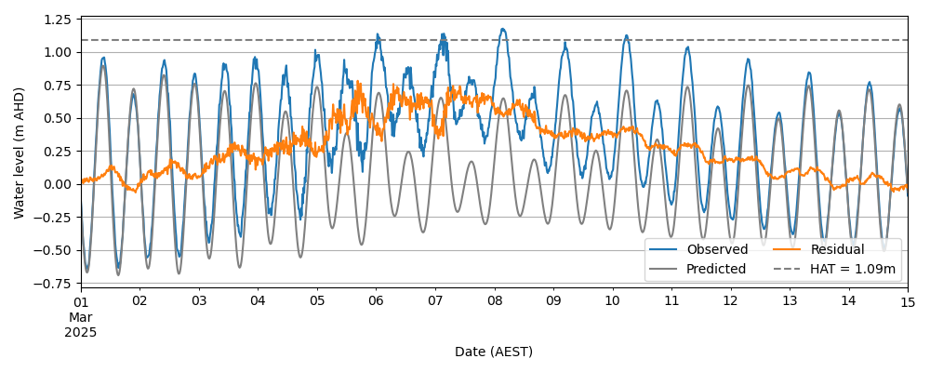
Figure 41 Water Levels at Tweed (inland river entrance) during March. Shows water levels near or just above HAT during high tides between 5 and 10 March. Data courtesy: New South Wales Government Manly Hydraulics Laboratory.
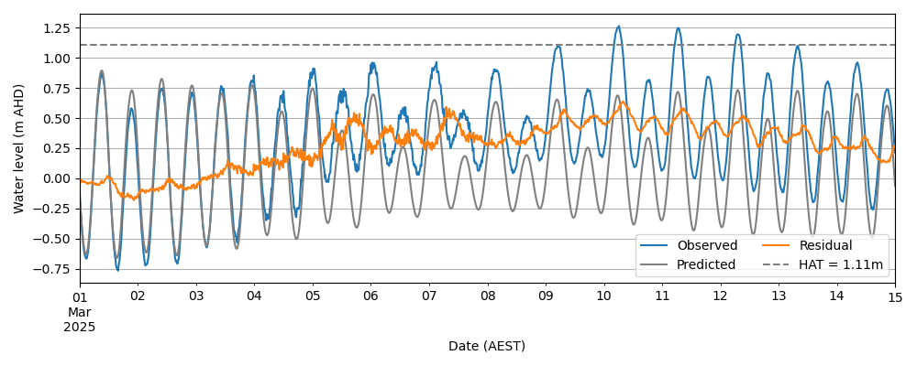
Figure 42 Water Levels at Yamba during March. Shows water levels above HAT during high tides between 10 and 12 March. Data courtesy: New South Wales Government Manly Hydraulics Laboratory.
- Forecast Performance
The accuracy statistics for Severe Tropical Cyclone Alfred are below in Table 5 and shown in Figure 43 and Figure 44. For verification purposes all forecast fixes were included regardless of classification, either tropical or sub-tropical. The forecast track position accuracy was near the 5-year average to a lead time of approximately 72 hours, and for lead times greater than 72 hours was better than the 5-year average. Intensity forecasts were better than the five-year average at all lead times, and notably better for lead times greater than about 24 hours.
The Tropical Cyclone 7 Day Forecast for 22U commenced on 15 February with a Low (5-15%) chance of a tropical cyclone. Ratings were increased to moderate during 18 February and High during 19 February.
Forecast Track Maps were issued between 0000 UTC (10 am AEST) 22 February and 1500 UTC 8 March (1 am AEST 9 March), (Figure 45, Figure 46, Figure 47). Ocean Wind Warnings were issued between 0000 UTC (10 am AEST) 22 March and 2000 UTC 7 March (6 am AEST 8 March). Technical Bulletins were issued between 0000 UTC (10 am AEST) 22 February and 0600 UTC (4pm AEST) 8 March. While Alfred was in the Coral Sea well away from Australian communities, Information Bulletins were issued, between 0000 UTC (10 am AEST) 22 February and 0000 UTC (10 am AEST) 3 March. The first Tropical Cyclone Advice, a Watch for Sandy Cape to Grafton, was issued for 0000 UTC (10 am AEST) 3 March, Figure 46, forecasting Alfred to turn abruptly west and track back towards the Australian mainland coast. This was approximately 54 hours before gales due to Alfred commenced at exposed coastal locations. Tropical Cyclone Advices continued, with the Watch upgraded to a Warning between Double Island Point and Yamba from 0600 UTC (4 pm AEST) 4 March. The Warning was extended south to just north of Grafton later that day, Figure 47. This was approximately 24 hours before gale force winds were initially experienced at some coastal locations. Hourly Tropical Cyclone Advices and Forecast Track Maps were issued from 2300 UTC 6 March (9 am AEST 7 March). Hourly Tropical Cyclone Advices continued until 2000 UTC 7 March (6 am AEST 8 March), after Alfred had moved across Moreton Island and weakened, however, Severe Weather Warnings for Queensland and New South Wales continued for some time after this. Hourly Forecast Track Maps continued until 2100 UTC 7 March (7 am AEST 8 March). In total, 49 Tropical Cyclone Advices were issued for Severe Tropical Cyclone Alfred.

Time | 00 | 06 | 12 | 18 | 24 | 36 | 48 | 72 | 96 | 120
Position accuracy (km) | 15 | 38 | 53 | 67 | 80 | 103 | 127 | 169 | 200 | 223
Intensity accuracy (knots) | 2.9 | 4.1 | 5.8 | 6.5 | 7.0 | 6.8 | 7.1 | 7.2 | 7.3 | 8.9
Sample size | 59 | 59 | 58 | 57 | 56 | 54 | 52 | 47 | 41 | 37
Table 5. Verification statistics for Severe Tropical Cyclone Alfred. *Note, verification is performed using the Official Forecast Tracks at the standard times of 00, 06,12 and 18 UTC.
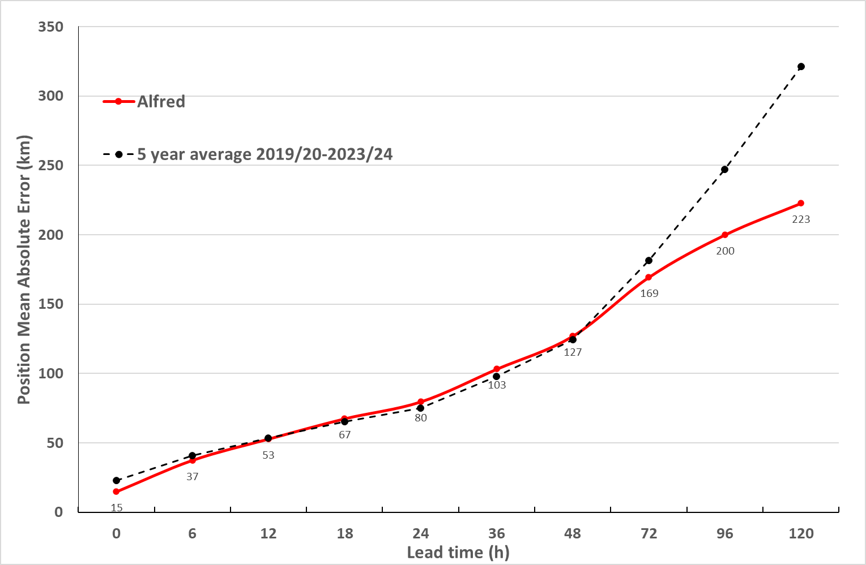
Figure 43 Position accuracy figures for Severe Tropical Cyclone Alfred.
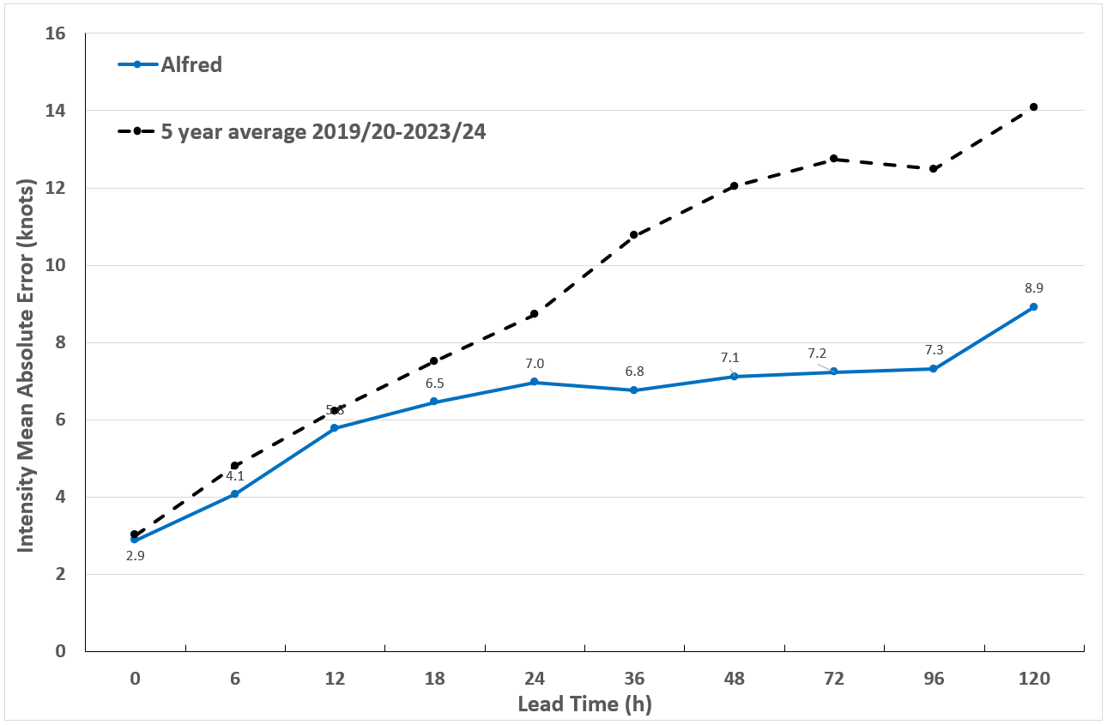
Figure 44 Intensity accuracy figures for Severe Tropical Cyclone Alfred.

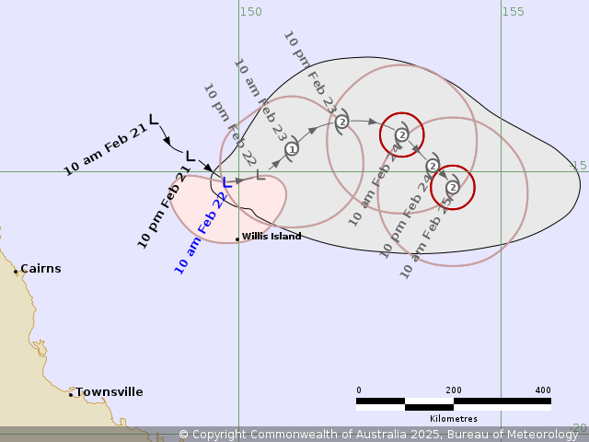
Figure 45 First Forecast Track Map issued for the developing 22U. Issued with an analysis time of 0000 UTC (10 am AEST) 22 February.
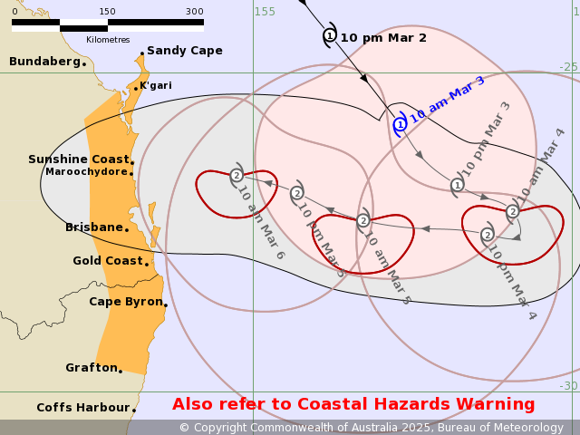
Figure 46 Forecast Track Map accompanying the First Tropical Cyclone Advice issued for Alfred with an analysis at 0000 UTC (10 am AEST) 3 March.
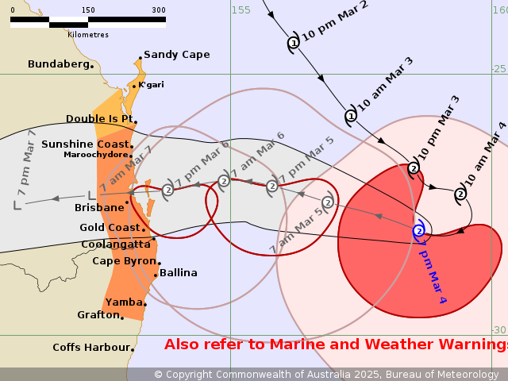
Figure 47 Forecast Track Map accompanying first Tropical Cyclone Advice with largest Warning extent issued with analysis time of 0900 UTC (7pm AEST) 4 March.

- References
- Cooperative Institute for Meteorological Satellite Studies, products from: https://tropic.ssec.wisc.edu/#
- Department of Environment, Tourism, Science and Innovation (DETSI) Tropical Cyclone Alfred fact sheet at: https://www.publications.qld.gov.au/dataset/tropical-cyclone-alfred-storm-surge-and-wave-data-fact-sheet
- Hart and Evans phase space analysis and forecast from: http://moe.met.fsu.edu/cyclonephase/
- Kimberly Wood, Wataru Yanase, Jack Beven, Suzana J. Camargo, Joseph B. Courtney, Chris Fogarty, Junya Fukuda, Naoko Kitabatake, Matthew Kucas, Ron McTaggart-Cowan, Michelle Simões Reboita, Jacopo Riboldi, 2023, Phase transitions between tropical, subtropical, and extratropical cyclones: A review from IWTC-10, Tropical Cyclone Research and Review, Volume 12, Issue 4, Pages 294-308.
- Synthetic Aperture Radar (SAR) based tropical wind products were generated and provided through the STAR Water Surface Conditions Science Team’s tropical cyclone winds program. See the following webpage (https://www.star.nesdis.noaa.gov/socd/mecb/sar/sarwinds_tropical.php) for more information.
- U.S Naval Research Laboratory images at: https://science.nrlmry.navy.mil/geoips/tcweb/active/

Appendix: List of abbreviations
Abbreviation | Term
ADT | Advanced Dvorak Technique
ACST | Australian Central Standard Time
AEST | Australian Eastern Standard Time
AiDT | AI-enhanced Dvorak Technique
AMSR2 | Advanced Microwave Scanning Radiometer
AMSU | Advanced Microwave Sounding Unit
ASCAT | Advanced Scatterometer
ATMS | Advanced Technology Microwave Sounder
AWS | automatic weather station
AWST | Australian Western Standard Time
°C | Celsius
CI | Current intensity
CIMSS | Cooperative Institute for Meteorological Satellite Studies (USA)
CIRA | Cooperative Institute for Research in the Atmosphere (USA)
DETSI | Department of Environment, Tourism, Science and Innovation
D-MINT | Deep learning - Multispectral Intensity of TCs (formerly known as DMN)
D-PRINT | Deep learning - IR Intensity of TCs (formerly known as OPEN-AIIR)
EIR | Enhanced InfraRed
ERC | eyewall replacement cycle
FNMOC | Fleet Numerical Meteorology and Oceanography Centre (USA)
FT | Final T-number
GCOM | Global Change Observation Mission
GHz | Gigahertz
GMI | Global Precipitation Measurement Microwave Imager
h | hour
HAT | Highest Astronomical Tide
hPa | hectopascal
HSCAT | Hai Yang 2 Scatterometer (HY-2B, HY-2C)
km | kilometres
km/h | kilometres per hour
kn | knot
LLCC | LLCC
MET | Model Expected T-number
METOP | Meteorological Operational Satellite
MJO | Madden-Julian Oscillation
mm | millimetres
MSLP | mean sea level pressure
NESDIS | National Environmental Satellite, Data, and Information Service
nm | nautical mile
NOAA | National Oceanic and Atmospheric Administration
NRL | Navy Research Lab (USA)
OPEN-AiiR | Ordered Pattern Encoding AI Infrared
PAT | Pattern T-number
RCM | RadarSat Constellation Mission – Synthetic Aperture Radar
RH | relative humidity
RMW | radius of maximum winds
RSMC | Regional Specialised Meteorological Centre
SAR | Synthetic Aperture Radar
SATC | CIMSS Advanced Dvorak Technique
SATCON | Satellite Consensus
SEN1 | Sentinel-1A – Synthetic Aperture Radar
SMAP | Soil Moisture Active Passive
SMOS | Soil Moisture and Ocean Salinity
SSMIS | Special Sensor Microwave Imager/Sounder
TC | Tropical Cyclone
TCWC | Tropical Cyclone Warning Centre
UTC | Universal Time Co-ordinated

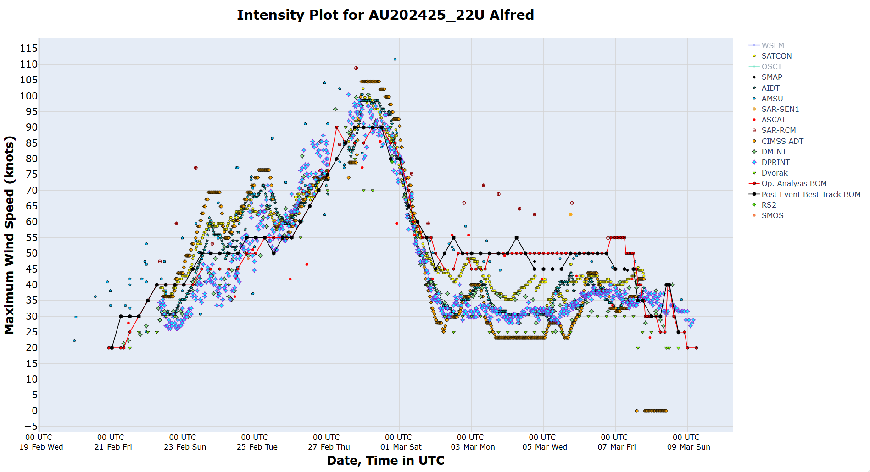
Figure 48 Intensity plot (10-min mean) of objective and subjective guidance. SATCON, SMAP, AIDT, AMSU, SAR-SEN1, ASCAT, SAR-RCM, CIMSS ADT DMINT, DPRINT, Dvorak (subjective estimate), operational analysis (red), post event best track analysis (black), RS2, and SMOS.

Microwave assessment of Alfred's warm core courtesy of CIMSS found at: tropic.ssec.wisc.edu/real-time/tropics/archive/2025/202518P/202518P.html, and https://tropic.ssec.wisc.edu/real-time/atms/archive/2025/202518P.html, and https://tropic.ssec.wisc.edu/real-time/amsu/archive/2025/202518P.html
Alfred met the definition of a tropical cyclone: A warm-cored, non-frontal low pressure system of synoptic scale, developing over warm waters, having organised convection and a (10-minute mean) wind speed of at least 34 knots (63 km/h), extending more than halfway around near the centre and persisting for at least 6 hours
Cost estimates from 2025 to 2026 budget at https://ministers.treasury.gov.au/ministers/jim-chalmers-2022/speeches/2025-26-budget-speech-parliament-house-canberra.
Erosion estimates are from the Gold Coast City Council at https://www.goldcoast.qld.gov.au/Services/Projects-works/Beaches-restoration-program-Cyclone-Alfred.
Agriculture impact estimates from the ABC at https://www.abc.net.au/news/2025-03-17/cyclone-alfred-cost-to-nsw-agriculture-17-million-and-rising/105059484.
Stated pressures are the mean sea level pressure at 0000 UTC (10 am AEST, 11 am AEDT) on 5 March 2025.
The 6-hour total is larger than the daily record rainfall at Hervey Bay because the latter is for the standard 9am-9am AEST period, while the 6-hour period of intense rainfall occurred either side of 9am on 9 March.
Current observations for "Brisbane City" are taken from the current Brisbane site (40913), which opened December 1999. Rainfall is compared across the current and former site Brisbane Regional Office (40214) which ran from 1841 to 1994 with complete daily rainfall from 1869.
A digitised report on Tropical Cyclone Wanda is found at: http://www.bom.gov.au/cyclone/history/wanda1974.shtml#:~:text=Summary,during%20the%20previous%20few%20days.
Record period. Wide Bay – 5 years, Caloundra – 12 years, Palm Beach – 8 years, Bilinga – 4 years, Tweed Offshore – 5 years.
Department of Environment, Tourism, Science and Innovation (DETSI) Tropical Cyclone Alfred fact sheet at: https://www.publications.qld.gov.au/dataset/tropical-cyclone-alfred-storm-surge-and-wave-data-fact-sheet

