Severe Tropical Cyclone Anggrek

12 – 25 January 2024

Craig Earl-Spurr
Tropical Cyclone Environmental Prediction Services

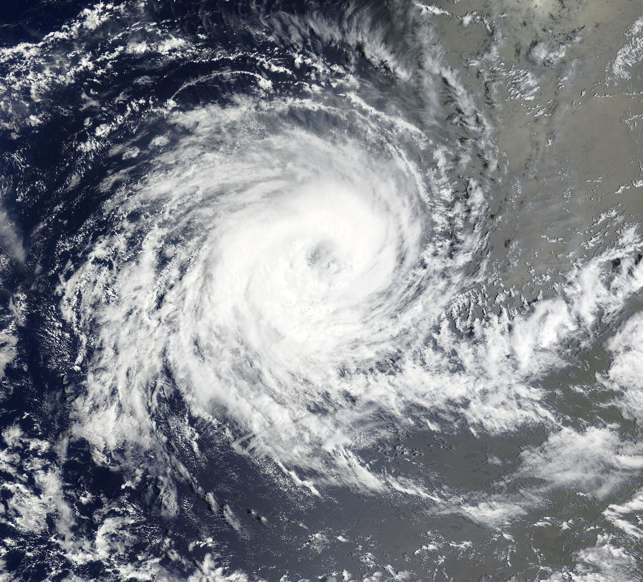
Revision history
Date | Version | Author | Description
7/03/2024 | 1.0 | Craig Earl-Spurr | Final draft ready

Review status
Date | Version | Reviewer | Description
14/04/2024 | 1.0 | Adam Conroy | Completed

Release history
Date | Version | Status | Approval
28/03/2024 | 1.0 | Approved for release | Andrew Burton

Contact details:
Tropical Cyclone Team Lead
Severe Weather Environmental Prediction Services
Bureau of Meteorology
PO Box 1370, West Perth WA 6872
Email: tcwc@bom.gov.au

This work is copyright. Apart from any use as permitted under the Copyright Act 1968, no part may be reproduced without prior written permission from the Bureau of Meteorology. Refer to www.bom.gov.au/other/copyright.shtml for further information. Unless otherwise noted, all images in this document are licensed under the Creative Commons Attribution Australia Licence.
© Commonwealth of Australia 2023
Published by the Bureau of Meteorology
Cover image: MODIS True Color satellite image of Anggrek in the Indian Ocean. Courtesy NASA Worldview

Contents

1. Summary 4

2. Meteorological description 8

2.1. Intensity analysis 8

2.2. Structure 15

2.3. Motion 15

3. Impact 16

4. Observations 16

5. Forecast Performance 17

6. Appendix: List of abbreviations 20

List of Figures
Figure 1 Best track of Severe Tropical Cyclone Anggrek. 5
Figure 2 Intensity plot of objective and subjective guidance. 9
Figure 3 ASCAT-B scatterometer pass at 1544 UTC 15 January. 10
Figure 4 89GHz GPM microwave pass at 2319 UTC 19 January 11
Figure 5 SAR imagery from RCM pass at 2332 UTC 20 January. 12
Figure 6 Himawari-9 colour enhanced infrared satellite imagery from 1800 UTC 21 January 13
Figure 7 Himawari-9 colour enhanced infrared satellite imagery from 0600 UTC 24 January 14
Figure 8 Position accuracy figures for Severe Tropical Cyclone Anggrek. 18
Figure 9 Intensity accuracy figures for Severe Tropical Cyclone Anggrek. 19

List of Tables
Table 1 Best track summary for Severe Tropical Cyclone Anggrek, 12 – 25 January 2024..............6
Table 2 Verification statistics for Severe Tropical Cyclone Anggrek………………………………….17

- Summary
Severe Tropical Cyclone Anggrek was an Indian Ocean cyclone that over a two-week period strengthened and weakened multiple times to the west of the Cocos (Keeling) Islands.
A tropical low formed to the northwest of the Cocos (Keeling) Islands on 12 January near the boundary between the Australian and TCWC Jakarta Area's of Responsibility. It gradually intensified over the following days, reaching tropical cyclone strength on 15 January in the TCWC Jakarta Area of Responsibility and was named Anggrek.
Anggrek proceeded to move steadily south while remaining at or near category 1 intensity. It entered the Australian Area of Responsibility on January 17 and passed to the west of the Cocos (Keeling) Islands. On 18 January it started moving much slower and to the west while intensifying further. Anggrek reached category 2 intensity on 19 January, but then weakened back to a tropical low on 22 January.
Anggrek then started moving due south before moving southwest and strengthening back into a tropical cyclone on 23 January. It intensified rapidly on 24 January into a category 3 tropical cyclone, reaching a peak intensity that night and maintaining its intensity as it moved into RSMC La Reunion Area of Responsibility the following day.
There were no impacts to any island or coastal communities.

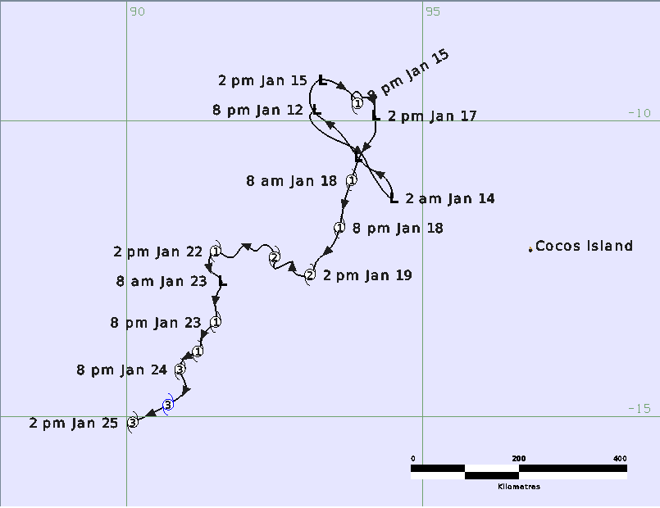
Figure 1 Best track of Severe Tropical Cyclone Anggrek (times in AWST, UTC +8).

Table 1 Best track summary for Severe Tropical Cyclone Anggrek, 12 – 25 January 2024.
UTC=AWST-8h. * Not at tropical cyclone intensity as gales less than halfway around centre.
Year | Month | Day | Hour  UTC | Pos. Lat.  S | Pos. Long.  E | Pos. Acc.  nm | Max Wind 10min  kn | Max gust  kn | Cent. Press.  hPa | Rad. of gales  nm  (NE/SE/SW/NW) | Rad. of storm  nm  (NE/SE/SW/NW) | RMW  nm
2024 | 1 | 12 | 1200 | 9.8 | 93.2 | 60 | 15 | 40 | 1006 | 0/0/0/0 | 0/0/0/0 | -
2024 | 1 | 12 | 1800 | 9.9 | 93.1 | 60 | 15 | 40 | 1006 | 0/0/0/0 | 0/0/0/0 | -
2024 | 1 | 13 | 0000 | 10.1 | 93.2 | 60 | 15 | 40 | 1006 | 0/0/0/0 | 0/0/0/0 | -
2024 | 1 | 13 | 0600 | 10.6 | 94.0 | 60 | 20 | 45 | 1005 | 0/0/0/0 | 0/0/0/0 | -
2024 | 1 | 13 | 1200 | 10.8 | 94.1 | 60 | 25 | 45 | 1004 | 0/0/0/0 | 0/0/0/0 | -
2024 | 1 | 13 | 1800 | 11.3 | 94.5 | 60 | 25 | 45 | 1005 | 0/0/0/0 | 0/0/0/0 | -
2024 | 1 | 14 | 0000 | 11.0 | 94.4 | 60 | 30 | 45 | 1002 | 0/0/0/0 | 0/0/0/0 | -
2024 | 1 | 14 | 0600 | 10.8 | 94.1 | 20 | 30 | 45 | 1002 | 0/0/0/0 | 0/0/0/0 | -
2024 | 1 | 14 | 1200 | 10.6 | 93.9 | 30 | 30 | 45 | 1002 | 0/0/0/0 | 0/0/0/0 | -
2024 | 1 | 14 | 1800 | 10.1 | 93.5 | 30 | 30 | 45 | 1003 | 0/0/0/0 | 0/0/0/0 | -
2024 | 1 | 15 | 0000 | 9.7 | 93.1 | 20 | 30 | 45 | 1003 | 0/0/0/0 | 0/0/0/0 | -
2024 | 1 | 15 | 0600 | 9.3 | 93.3 | 30 | 35* | 50 | 1000 | 60/0/0/70 | 0/0/0/0 | -
2024 | 1 | 15 | 1200 | 9.7 | 93.9 | 30 | 40 | 55 | 1000 | 60/30/30/70 | 0/0/0/0 | 25
2024 | 1 | 15 | 1800 | 9.6 | 93.8 | 30 | 40 | 55 | 996 | 60/30/30/60 | 0/0/0/0 | 25
2024 | 1 | 16 | 0000 | 9.5 | 93.9 | 30 | 40 | 55 | 994 | 60/40/30/0 | 0/0/0/0 | 20
2024 | 1 | 16 | 0600 | 9.5 | 93.9 | 30 | 40 | 55 | 993 | 60/40/30/60 | 0/0/0/0 | 20
2024 | 1 | 16 | 1200 | 9.6 | 94.0 | 20 | 40 | 55 | 994 | 60/40/40/60 | 0/0/0/0 | 20
2024 | 1 | 16 | 1800 | 9.6 | 94.0 | 20 | 40 | 55 | 993 | 60/0/40/60 | 0/0/0/0 | 20
2024 | 1 | 17 | 0000 | 9.6 | 94.1 | 15 | 35 | 50 | 997 | 50/0/40/60 | 0/0/0/0 | 25
2024 | 1 | 17 | 0600 | 9.9 | 94.2 | 30 | 30 | 45 | 1000 | 0/0/0/0 | 0/0/0/0 | -
2024 | 1 | 17 | 1200 | 10.2 | 94.2 | 20 | 35 | 50 | 997 | 50/50/0/50 | 0/0/0/0 | 25
2024 | 1 | 17 | 1800 | 10.5 | 94.0 | 30 | 35 | 50 | 998 | 50/50/0/50 | 0/0/0/0 | 30
2024 | 1 | 18 | 0000 | 11.0 | 93.8 | 10 | 35 | 50 | 1000 | 50/50/0/50 | 0/0/0/0 | 30
2024 | 1 | 18 | 0600 | 11.3 | 93.7 | 30 | 35 | 50 | 999 | 50/60/0/60 | 0/0/0/0 | 35
2024 | 1 | 18 | 1200 | 11.8 | 93.6 | 15 | 40 | 55 | 997 | 60/70/70/60 | 0/0/0/0 | 35
2024 | 1 | 18 | 1800 | 12.2 | 93.4 | 15 | 45 | 65 | 994 | 60/60/70/70 | 0/0/0/0 | 30
2024 | 1 | 19 | 0000 | 12.4 | 93.2 | 20 | 45 | 65 | 993 | 80/60/70/80 | 0/0/0/0 | 30
2024 | 1 | 19 | 0600 | 12.6 | 93.1 | 20 | 50 | 70 | 990 | 70/60/60/60 | 50/0/0/0 | 25
2024 | 1 | 19 | 1200 | 12.5 | 92.8 | 20 | 50 | 70 | 990 | 70/80/70/60 | 40/40/40/0 | 20
2024 | 1 | 19 | 1800 | 12.4 | 92.8 | 20 | 50 | 70 | 989 | 70/80/70/70 | 40/40/40/0 | 20
2024 | 1 | 20 | 0000 | 12.4 | 92.8 | 15 | 60 | 85 | 981 | 80/80/80/80 | 50/50/40/40 | 15
2024 | 1 | 20 | 0600 | 12.5 | 92.5 | 20 | 60 | 85 | 983 | 70/70/60/70 | 40/40/40/30 | 15
2024 | 1 | 20 | 1200 | 12.3 | 92.5 | 15 | 60 | 85 | 983 | 60/60/60/60 | 30/40/40/30 | 15
2024 | 1 | 20 | 1800 | 12.1 | 92.3 | 30 | 60 | 85 | 983 | 60/60/60/60 | 40/40/40/30 | 15
2024 | 1 | 21 | 0000 | 12.2 | 92.2 | 20 | 55 | 75 | 986 | 60/60/60/60 | 40/40/30/30 | 15
2024 | 1 | 21 | 0600 | 12.1 | 92.0 | 20 | 50 | 70 | 990 | 50/50/50/50 | 30/30/30/30 | 20
2024 | 1 | 21 | 1200 | 12.3 | 91.8 | 20 | 40 | 55 | 996 | 60/40/50/60 | 0/0/0/0 | 20
2024 | 1 | 21 | 1800 | 12.3 | 91.7 | 20 | 35 | 50 | 999 | 70/40/50/60 | 0/0/0/0 | 25
2024 | 1 | 22 | 0000 | 12.3 | 91.7 | 15 | 35 | 50 | 998 | 60/40/50/60 | 0/0/0/0 | 25
2024 | 1 | 22 | 0600 | 12.2 | 91.5 | 30 | 35 | 50 | 999 | 50/40/50/50 | 0/0/0/0 | 25
2024 | 1 | 22 | 1200 | 12.5 | 91.4 | 30 | 35* | 50 | 999 | 0/50/50/0 | 0/0/0/0 | -
2024 | 1 | 22 | 1800 | 12.6 | 91.5 | 30 | 35* | 50 | 1001 | 0/50/50/0 | 0/0/0/0 | -
2024 | 1 | 23 | 0000 | 12.7 | 91.6 | 20 | 35* | 50 | 1001 | 50/40/0/0 | 0/0/0/0 | -
2024 | 1 | 23 | 0600 | 13.0 | 91.5 | 20 | 40* | 55 | 999 | 50/50/0/0 | 0/0/0/0 | -
2024 | 1 | 23 | 1200 | 13.4 | 91.5 | 15 | 40 | 55 | 999 | 50/60/60/0 | 0/0/0/0 | 20
2024 | 1 | 23 | 1800 | 13.6 | 91.3 | 20 | 40 | 55 | 998 | 50/60/60/0 | 0/0/0/0 | 20
2024 | 1 | 24 | 0000 | 13.9 | 91.2 | 15 | 40 | 55 | 999 | 50/70/70/50 | 0/0/0/0 | 20
2024 | 1 | 24 | 0600 | 14.0 | 91.0 | 15 | 50 | 70 | 992 | 60/70/70/60 | 0/0/40/40 | 20
2024 | 1 | 24 | 1200 | 14.2 | 90.9 | 15 | 70 | 100 | 977 | 60/60/60/60 | 40/40/30/30 | 15
2024 | 1 | 24 | 1800 | 14.5 | 91.0 | 15 | 75 | 105 | 973 | 60/70/70/60 | 40/40/40/40 | 15
2024 | 1 | 25 | 0000 | 14.8 | 90.7 | 20 | 75 | 105 | 974 | 60/70/70/60 | 40/40/40/40 | 15
2024 | 1 | 25 | 0600 | 15.1 | 90.1 | 15 | 70 | 100 | 979 | 50/80/80/60 | 30/50/50/30 | 15

- Meteorological description
  - Intensity analysis
A strong Madden-Julian Oscillation moving through the Indian Ocean assisted in the development of an elongated circulation to the northwest of the Cocos (Keeling) Islands on 12 January. Assisted by a Kelvin Wave on 13 January persistent convection developed, the circulation consolidated, and a Data-T (DT) of 1.0 was assigned. This was soon followed by a significant increase in deep convection and the intensity was estimated at 40 kn (75 km/h) on 15 January based on scatterometry passes (refer to Figure 3) and supported by Dvorak analysis.
After maintaining an intensity of 40 kn (75 km/h) on 16 January, Anggrek weakened again under the influence of dry air with the intensity weakening to 30 kn (55 km/h) on 17 January. This was accompanied by a relative absence of deep convection but was short lived as Anggrek began to intensify once more.
Between 18 and 20 January intensity increased from 35 kn to 60 kn (65 km/h to 110 km/h), despite persistent moderate to strong wind shear of about 20-25 kn (35-45 km/h). During this period there was a large divergence in intensity estimates between objective aids (refer to Figure 2). ADT estimates included a microwave adjustment, due to a GMI pass on 19 January that showed an eye within the deep convection in the 89 GHz frequency (refer to Figure 4). At the time of peak intensity on 20 January, the highest estimates came from ADT and reached 84.8 kn (~155 km/h) 1-minute mean (78.9 kn (~145 km/h) 10-minute mean) contrasting with D-PRINT being as low as 48 kn (~90 km/h) 1-minute mean (44.6 kn (~85 km/h) 10-minute mean) during the same period. Multiple SAR passes also supported the higher intensity estimates (refer to Figure 5). Operational intensity estimates peaked at 50 kn (95 km/h), based in part on Dvorak estimates using the commonly applied curved band or shear patterns. Post-event the peak intensity was increased to 60 kn (110 km/h) which represents a consensus in the spread of objective guidance and is supported by the choice post-event to base Dvorak analysis on the infrequently used embedded centre pattern.
Even as vertical wind shear reduced on 21 January, so too did deep convection (refer to Figure 6), due to the influence of dry air. Accordingly, intensity decreased back to 35 kn (65 km/h) where it stayed for 36 hours. Dvorak analysis also dropped to as low as 2.5 early on 23 January.
The vertical wind shear dropped even further on 23 January to be below 10 kn (20 km/h). An accompanied increase in deep convection allowed Anggrek to overcome the dry air in its local environment and it began to intensify once more. On 24 January it underwent a period of rapid intensification, strengthening 35 kn (65 km/h) in 18 hours as a clear eye developed on satellite imagery (refer to Figure 7). Dvorak analysis increased to a FT of 4.5 and Anggrek reached its peak intensity within the Australian region of 75 kn (140 km/h) shortly before it moved into the RSMC La Reunion Area of Responsibility on 25 January.

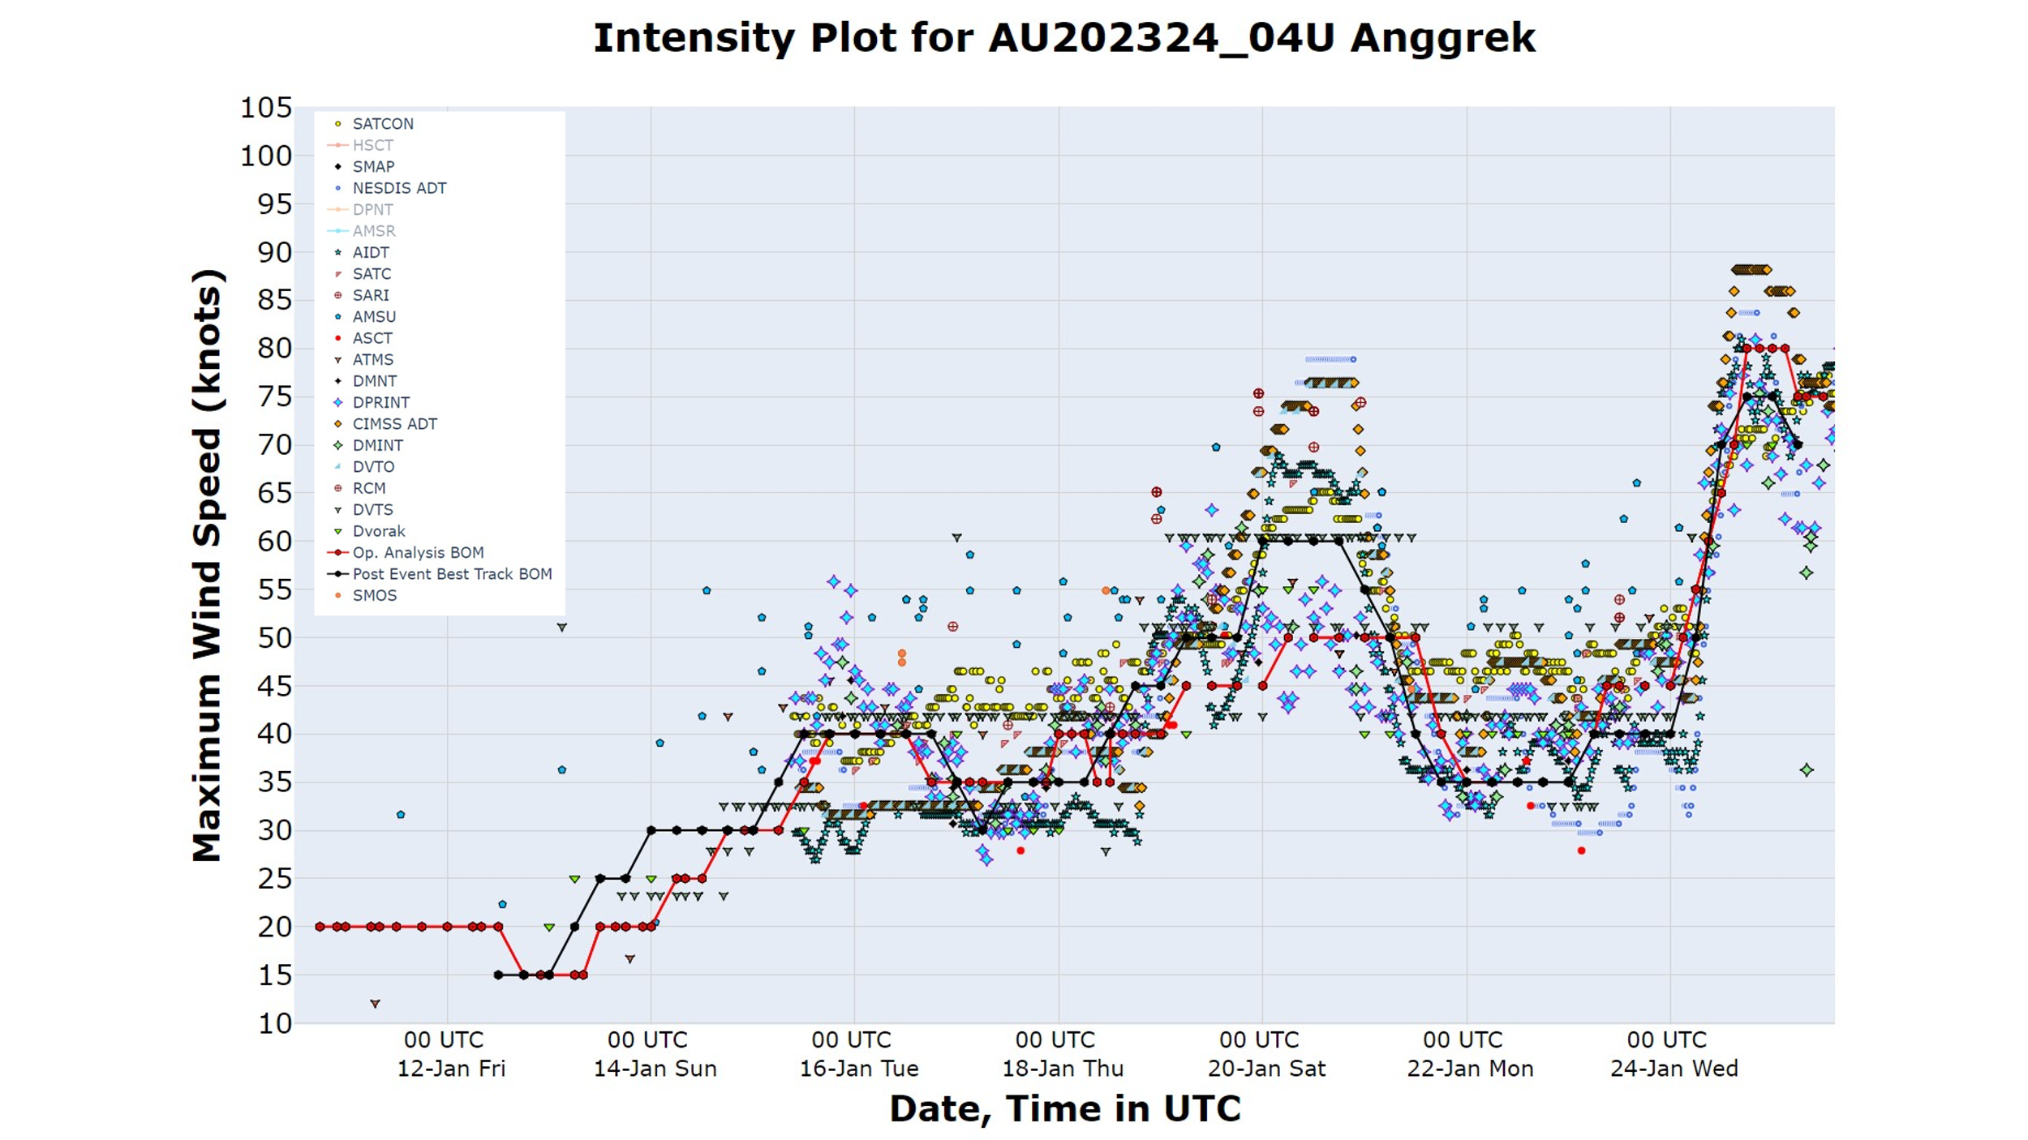
Figure 2 Intensity plot of objective and subjective guidance. SATCON, AiDT, NEDIS ADT, AMSU, SATC, CIMSS ADT, D-MINT, D-PRINT, Objective Dvorak have been adjusted from 1-minute to 10-minute maximum mean winds.
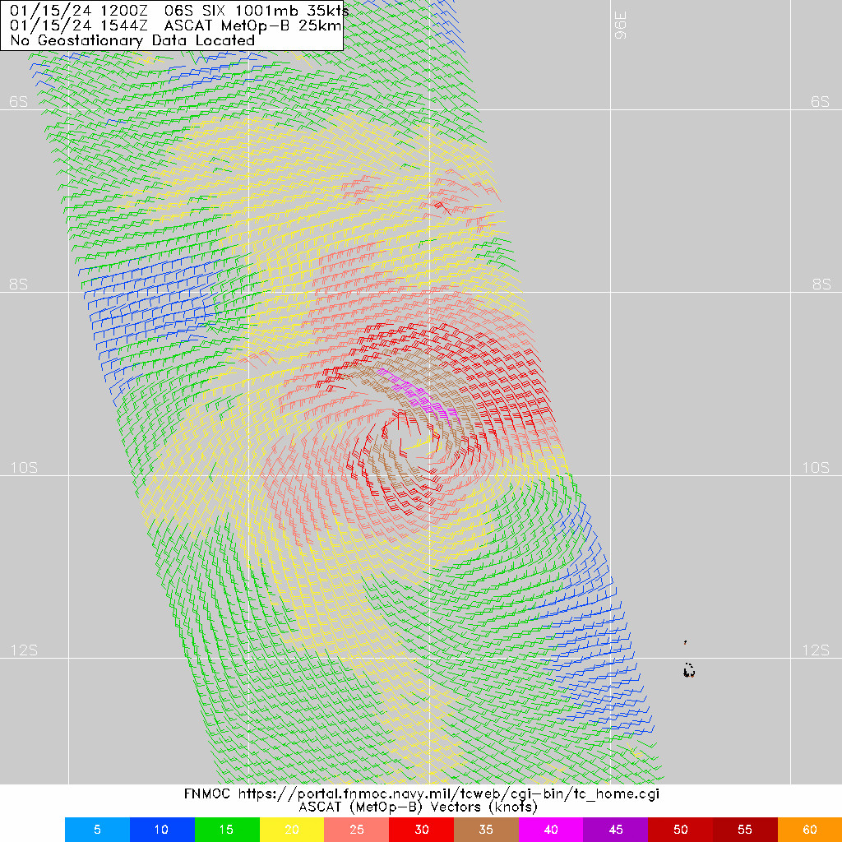
Figure 3 ASCAT-B scatterometer pass at 1544 UTC 15 January shortly after reaching tropical cyclone intensity. Image courtesy NRL: https://www.nrlmry.navy.mil/TC.html.

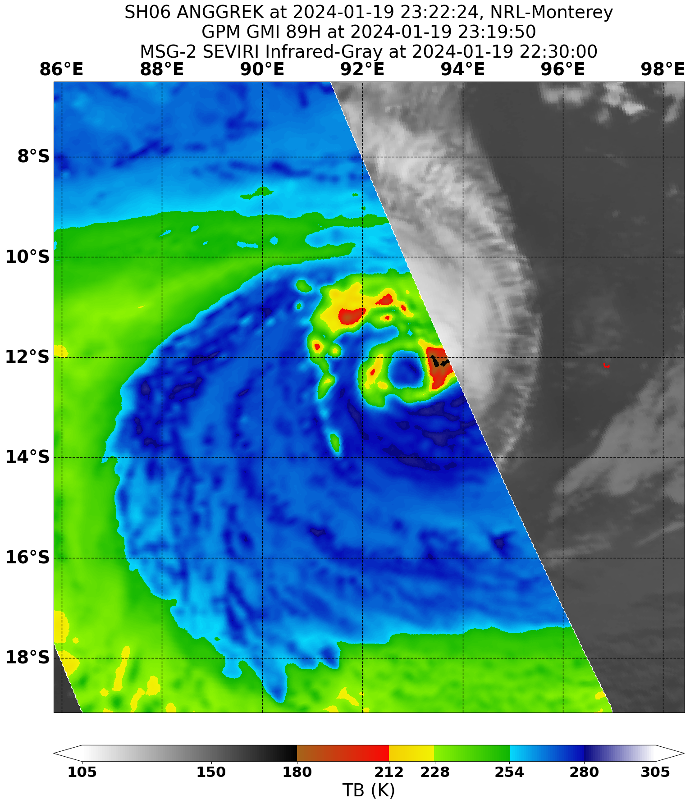
Figure 4 89GHz GPM microwave pass at 2319 UTC 19 January showing an eye pattern in the deep convection. Image courtesy NRL: https://www.nrlmry.navy.mil/TC.html

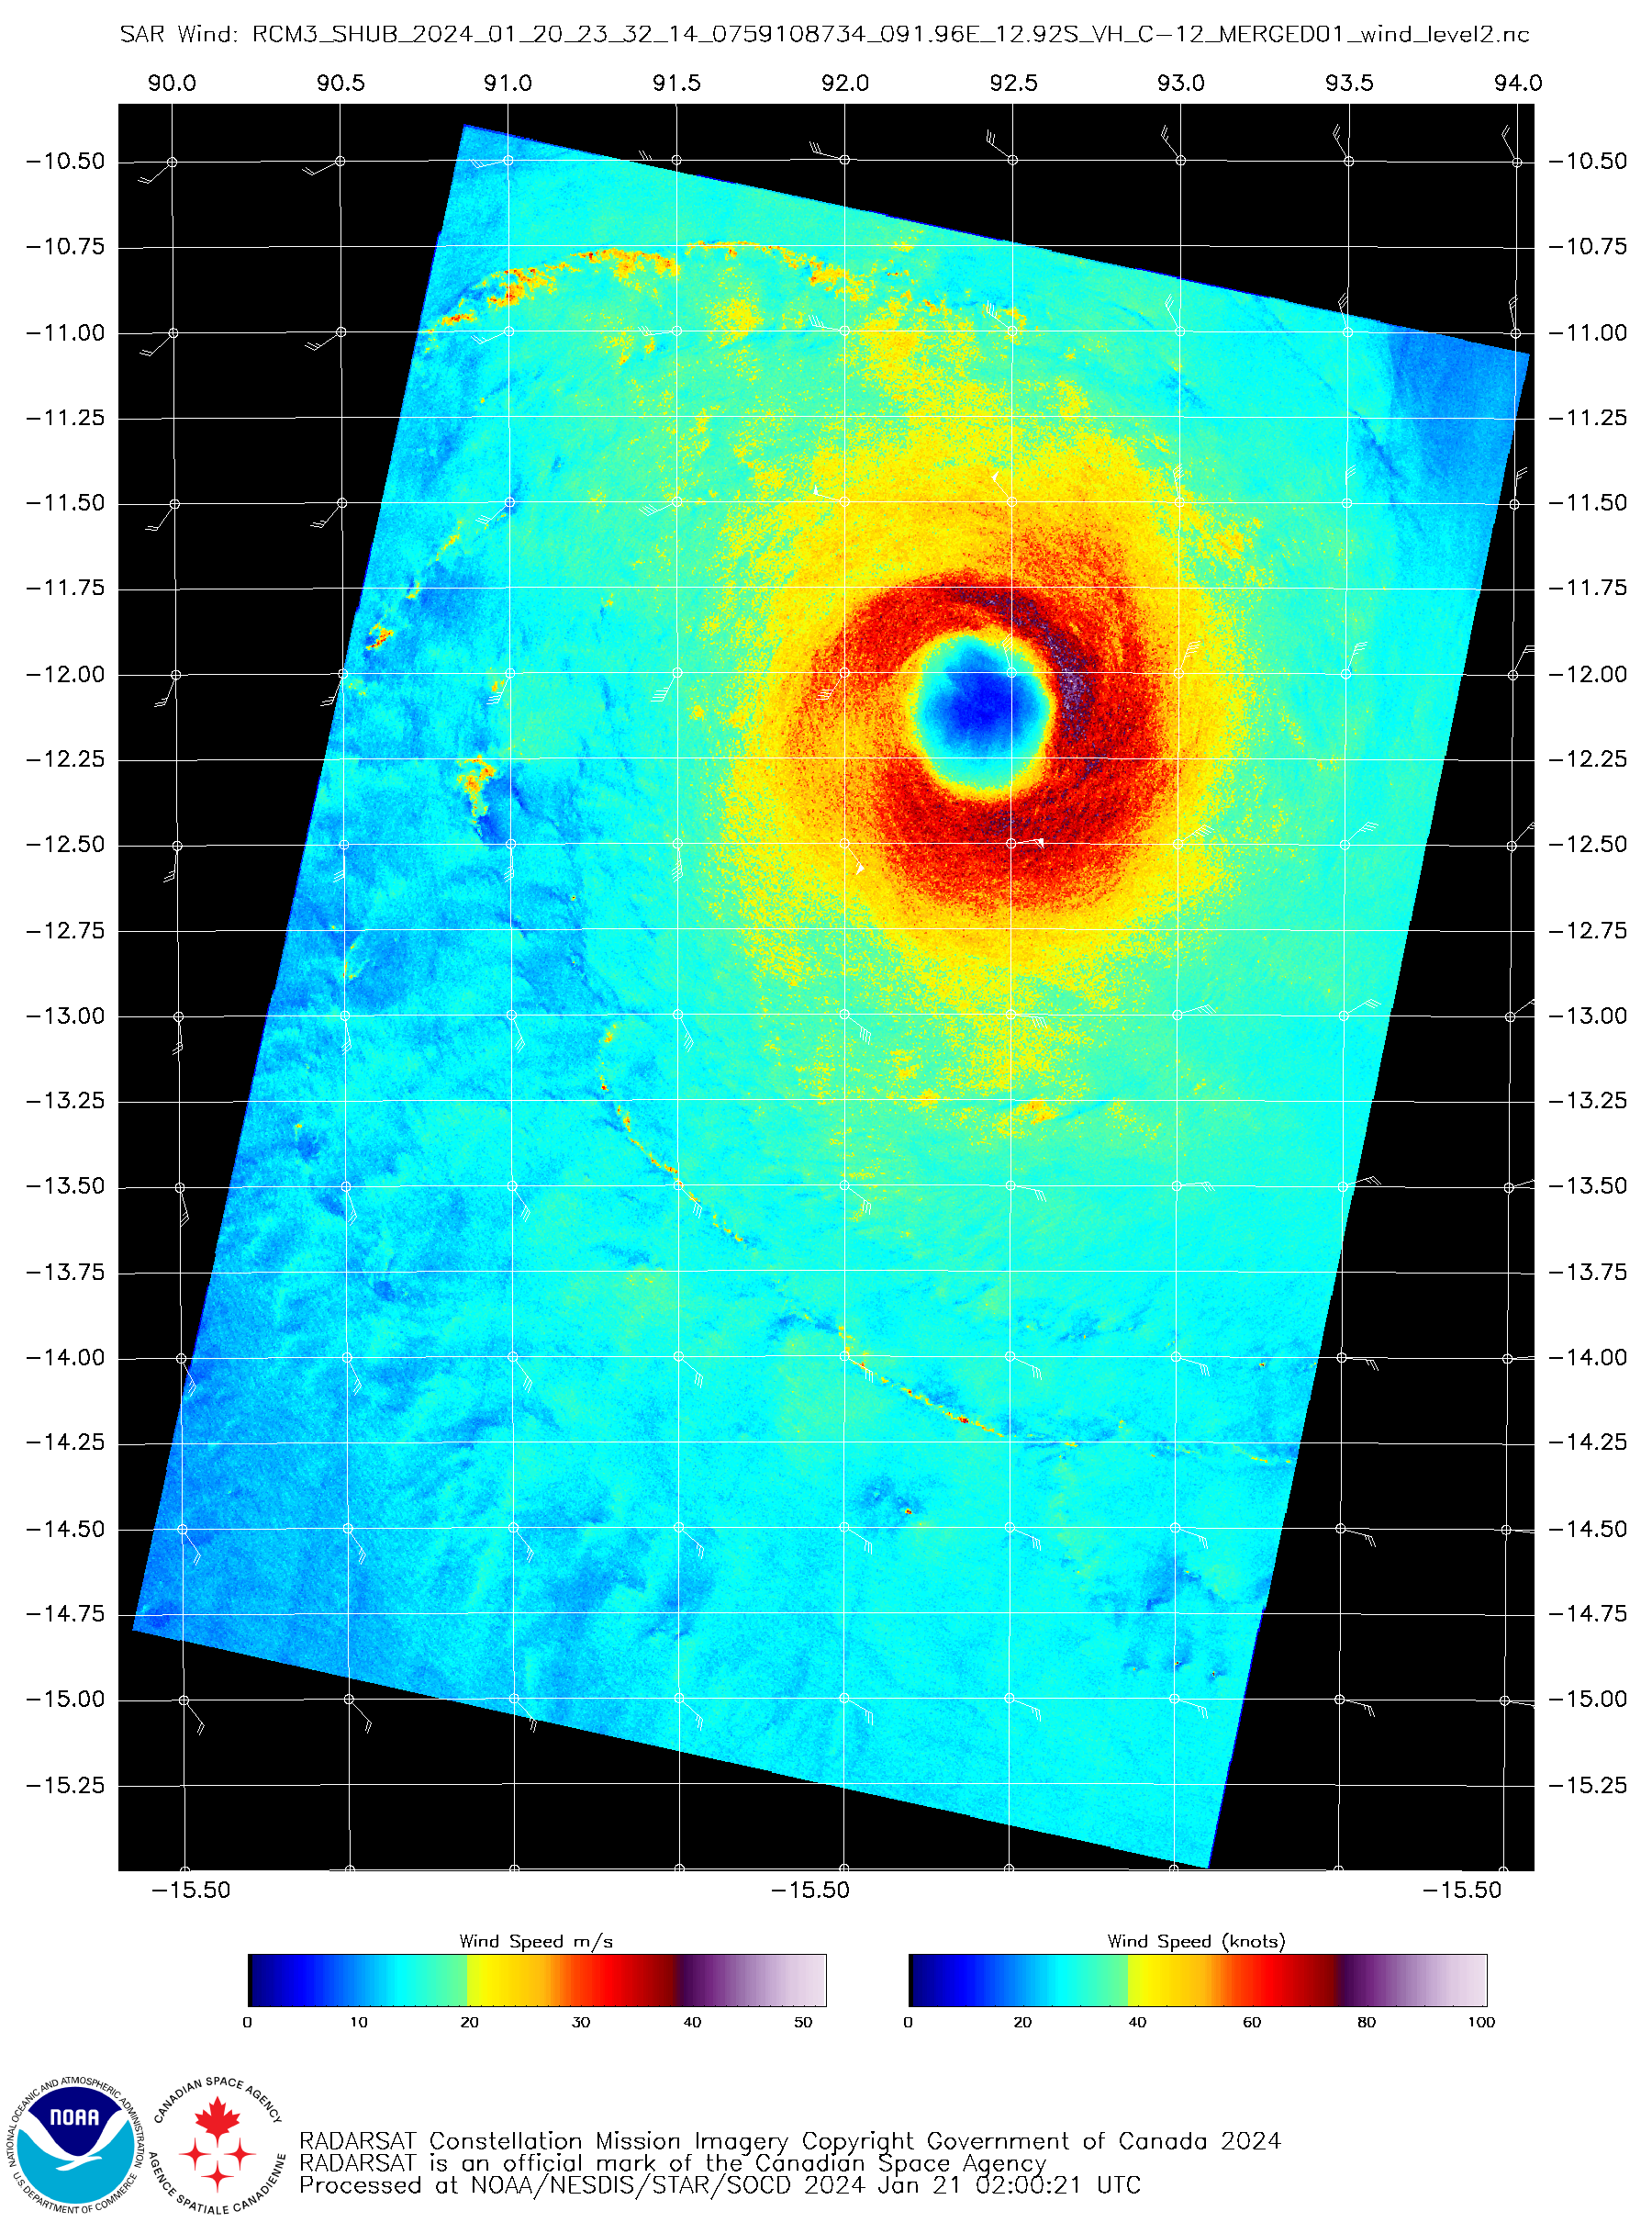
Figure 5 SAR imagery from RCM pass at 2332 UTC 20 January showing a classic eye pattern with maximum winds at 80 knots. Image courtesy NOAA STAR: https://www.star.nesdis.noaa.gov/socd/mecb/sar/sarwinds_tropical.php.

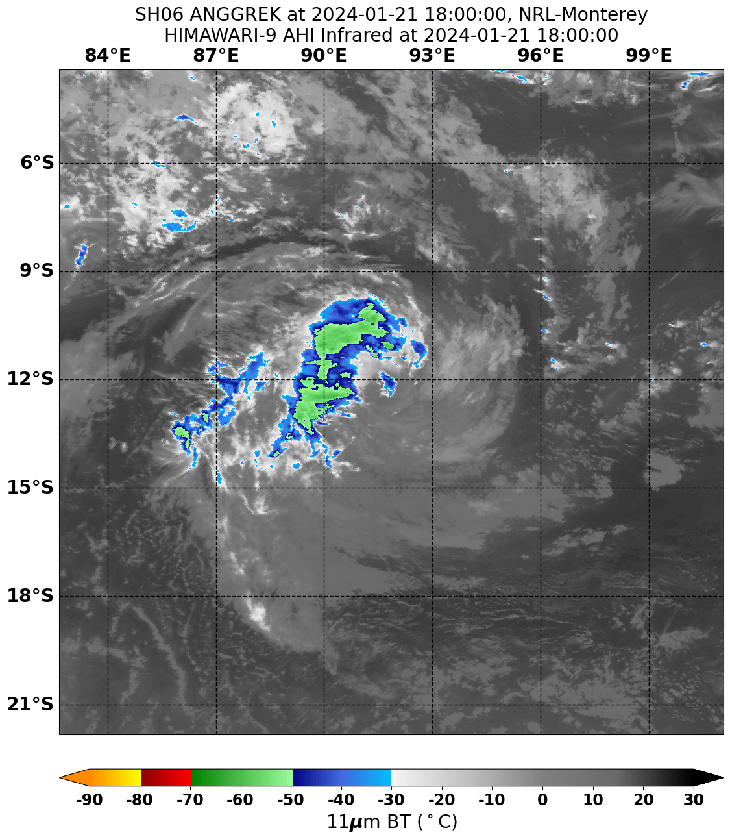
Figure 6 Himawari-9 colour enhanced infrared satellite imagery from 1800 UTC 21 January showing only a small region of cold cloud tops. Image courtesy NRL: https://www.nrlmry.navy.mil/TC.html

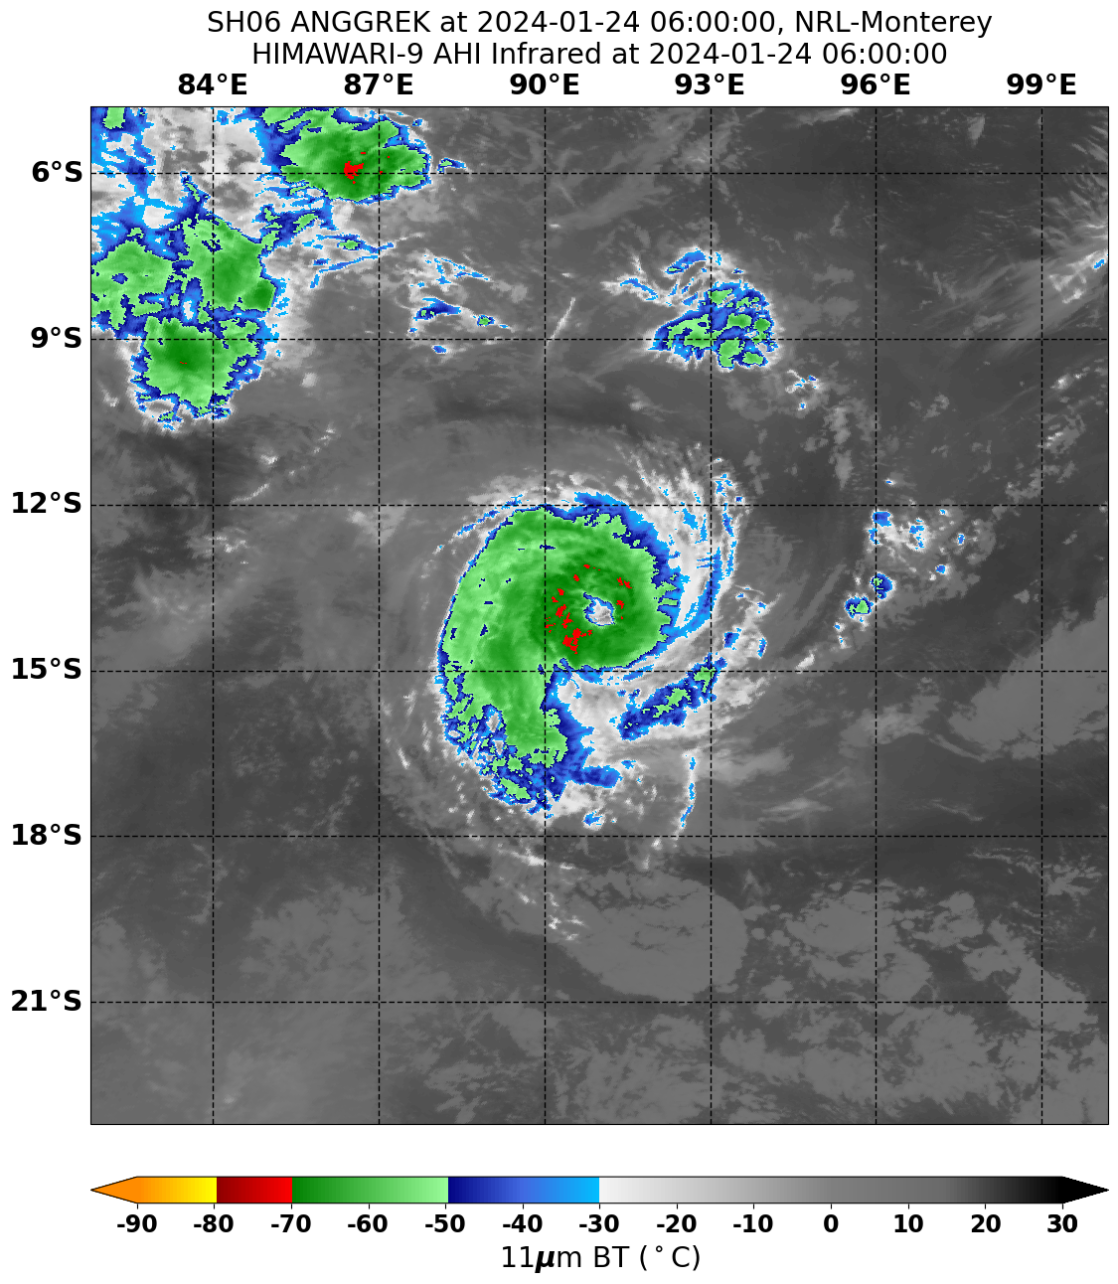
Figure 7 Himawari-9 colour enhanced infrared satellite imagery from 0600 UTC 24 January showing an eye pattern. Image courtesy NRL: https://www.nrlmry.navy.mil/TC.html

  - Structure
Anggrek was a smaller than average sized system for the Western Australian region. Gales initially developed on the northern side to a radius of about 70 nm (130 km) before extending to the southern side where they were as little as 30 nm (65 km). After the initial development into a tropical cyclone and subsequent weakening, gales then redeveloped to the north and east of the centre with a radius to gales of 40 nm. They later extended as far as 80 nm (150 km) from the centre and into the south-west quadrant. Following the second peak in intensity, gales almost became absent from the northwest quadrant on 23 January. At the third time of strengthening, gales were initially only present to the east of the system to a radius of 50 nm (95 km) but quickly extended through the western side and once again the radius to gales increased to as much as 80 nm (150 km). The radii were observed in the scatterometry and SAR passes such as Figure 3 and Figure 5.
The radius to maximum winds (RMW) varied to be as large as 35 nm (15 km) when Anggrek was a weak system reducing to 15 nm, close to the climatological average, at peak intensity. An eye was visible on satellite imagery for around 24 hours prior to Anggrek moving out of the region. As it was ragged in presentation at times the eye diameter varied between 10 nm and 15 nm (18 km and 28 km).
  - Motion
During its early development Anggrek was a shallow tropical low steered towards the southeast by low-level north-westerly winds. As it became more established, mid-level southeasterly winds began to counter the low-level north-westerly winds and it was pushed back to the north before it eventually became very slow-moving between 15 and 16 January. A trough approaching from the west then lead to Anggrek moving south during 17 and 18 January. Following the passage of the trough, a new ridge established to the south and steered the system towards the west, however this was offset by mid-level westerly winds to the north, so motion was slow.
The slow westward motion continued until 22 January when the westerly winds to the north of Anggrek weakened. This coincided with the ridge also weakening to the southeast of Anggrek with net result being movement to the south once again. During 24 January, the ridge to the southeast re-established and Anggrek accelerated towards the southwest and out of the region.
- Impact
There was no impact to any island or coastal communities.

- Observations
No significant observations were recorded.

- Forecast Performance
A Tropical Cyclone Advice was first issued at 0648 UTC on Monday 15 January as a Watch for the Cocos (Keeling) Islands. Although Anggrek was outside the Australian Area of Responsibility at this time the Bureau also commenced Ocean Wind Warnings at this time to support TCWC Jakarta. The Watch continued for three days until being cancelled at 0053 UTC Thursday 18 January as it became clear that Anggrek would remain to the west of the Cocos (Keeling) Islands. No Warning was ever issued and a total of 12 Tropical Cyclone Advices were issued.
Ocean Wind Warnings continued to be issued until 0658 UTC 25 January when responsibility for Anggrek was transferred to RSMC La Reunion and Mauritius Meteorological Service.
The accuracy figures (Mean Absolute Error) for Severe Tropical Cyclone Anggrek are below in Table 2.
The slow motion observed during Anggrek's lifetime contributed to forecast track positions being better than the five-year average at all lead times (refer to Figure 8).
The intensity forecast was slightly worse than, but comparable to, the five-year average for the first 36 hours of the forecast (refer to Figure 9). A contributing factor for this is the lower operationally analysed intensity, and therefore short-term forecast intensity, around 20 January as discussed in section 2.1. It was better than the five-year average from forecast hours 48 to 72 but poorer from forecast hours 96-120.
Table 2 Verification statistics for Severe Tropical Cyclone Anggrek
 | 0 | 6 | 12 | 18 | 24 | 36 | 48 | 72 | 96 | 120
Position Absolute error (km) | 17 | 23 | 30 | 38 | 47 | 64 | 87 | 119 | 148 | 205
Intensity Absolute error (kn) | 4.0 | 6.0 | 8.0 | 9.1 | 10.0 | 11.1 | 10.0 | 7.2 | 14.4 | 18.3
Sample Size | 41 | 40 | 39 | 38 | 37 | 35 | 33 | 29 | 25 | 21

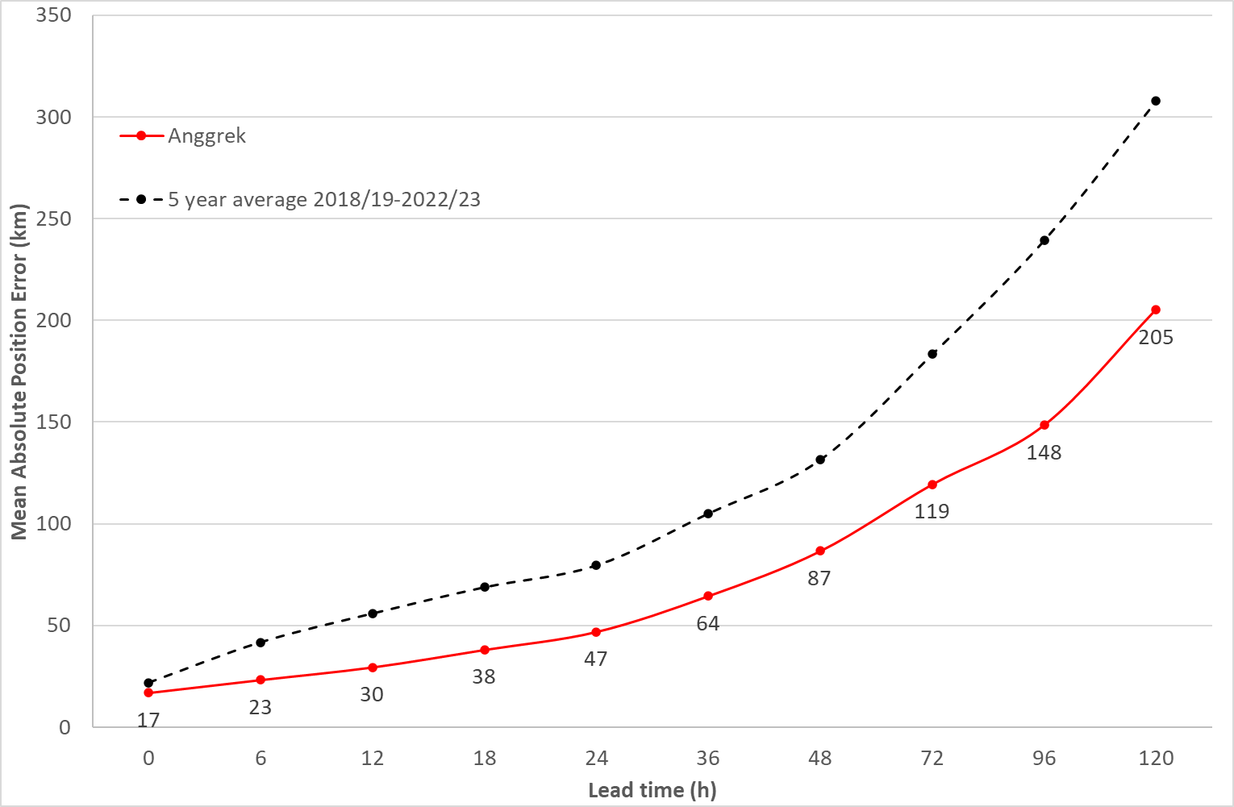
Figure 8 Position accuracy figures for Severe Tropical Cyclone Anggrek.

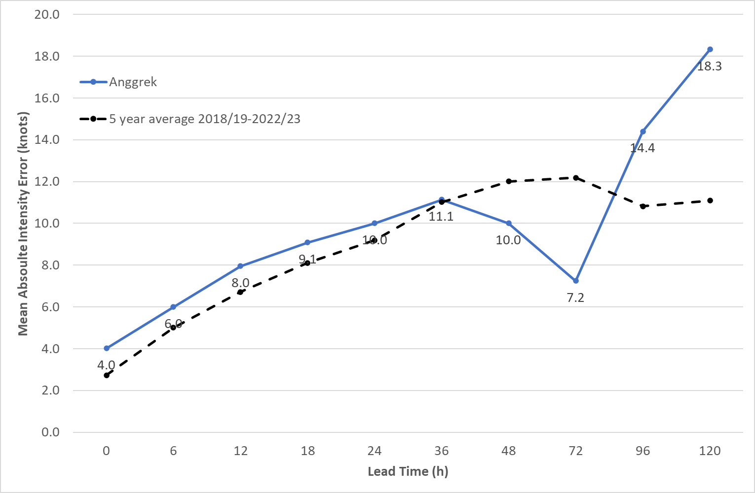
Figure 9 Intensity accuracy figures for Severe Tropical Cyclone Anggrek.

- Appendix: List of abbreviations
Abbreviation | Term
ADT | Advanced Dvorak Technique
ACST | Australian Central Standard Time
AEST | Australian Eastern Standard Time
AiDT | AI-enhanced Dvorak Technique
AMSR2 | Advanced Microwave Scanning Radiometer
AMSU | Advanced Microwave Sounding Unit
ASCAT | Advanced Scatterometer
ATMS | Advanced Technology Microwave Sounder
AWS | automatic weather station
AWST | Australian Western Standard Time
°C | Celsius
CI | Current intensity
CIMSS | Cooperative Institute for Meteorological Satellite Studies (USA)
CIRA | Cooperative Institute for Research in the Atmosphere (USA)
D-MINT | Deep learning - Multispectral Intensity of TCs (formerly known as DMN)
D-PRINT | Deep learning - IR Intensity of TCs (formerly known as OPEN-AIIR)
EIR | Enhanced InfraRed
ERC | eyewall replacement cycle
FNMOC | Fleet Numerical Meteorology and Oceanography Centre (USA)
FT | Final T-number
GCOM | Global Change Observation Mission
GHz | Gigahertz
GMI | Global Precipitation Measurement Microwave Imager
h | hour
hPa | hectopascal
HSCAT | Hai Yang 2 Scatterometer (HY-2B, HY-2C)
km | kilometres
km/h | kilometres per hour
kn | knot
LLCC | LLCC
MET | Model Expected T-number
METOP | Meteorological Operational Satellite
MJO | Madden-Julian Oscillation
mm | millimetres
MSLP | mean sea level pressure
NESDIS | National Environmental Satellite, Data, and Information Service
nm | nautical mile
NOAA | National Oceanic and Atmospheric Administration
NRL | Navy Research Lab (USA)
OPEN-AiiR | Ordered Pattern Encoding AI Infrared
PAT | Pattern T-number
RCM | RadarSat Constellation Mission – Synthetic Aperture Radar
RH | relative humidity
RMW | radius of maximum winds
RSMC | Regional Specialised Meteorological Centre
SAR | Synthetic Aperture Radar
SATC | CIMSS Advanced Dvorak Technique
SATCON | Satellite Consensus
SEN1 | Sentinel-1A – Synthetic Aperture Radar
SMAP | Soil Moisture Active Passive
SMOS | Soil Moisture and Ocean Salinity
SSMIS | Special Sensor Microwave Imager/Sounder
TC | Tropical Cyclone
TCWC | Tropical Cyclone Warning Centre
UTC | Universal Time Co-ordinated

