Tropical Cyclone Anthony

## 22 – 31 January 2011

## Joe Courtney, Tropical Cyclone Environmental Prediction Services

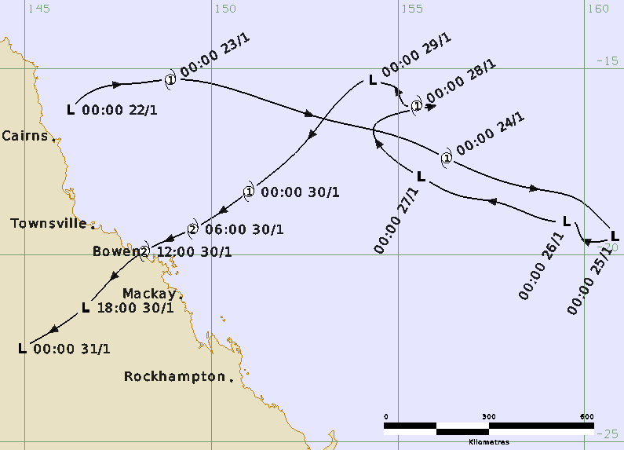

### Revision history

|  |  |  |  |
| --- | --- | --- | --- |
| Date | Version | Authors | Description |
| 17/10/2024 | 1.0 | Joe Courtney | Final draft ready |

### Review status

|  |  |  |  |
| --- | --- | --- | --- |
| Date | Version | Reviewer | Description |
| 18/10/2024 | 1.0 | Linda Paterson | Completed |

### Release history

|  |  |  |  |
| --- | --- | --- | --- |
| Date | Version | Status | Approval |
| 18/10/2024 | 1.0 | Approved for release | Craig Earl-Spurr |



Contact details:

Tropical Cyclone Team Lead

Severe Weather Environmental Prediction Services

Bureau of Meteorology

PO Box 1370, West Perth WA 6872

Email: tcwc@bom.gov.au

This work is copyright. Apart from any use as permitted under the Copyright Act 1968, no part may be reproduced without prior written permission from the Bureau of Meteorology. Refer to www.bom.gov.au/other/copyright.shtml for further information. Unless otherwise noted, all images in this document are licensed under the Creative Commons Attribution Australia Licence.

© Commonwealth of Australia 2024

Published by The Bureau of Meteorology

Cover image: Track of Tropical Cyclone Anthony 22 – 31 January 2011. Times in UTC (AEST-10.0h).

Table of Contents

1. Summary 5

2. Meteorological description 8

2.1. Intensity Analysis 8

2.2. Structure 8

2.3. Motion 9

3. Impact 12

4. Observations 12

4.1. Wind 12

4.2. Rainfall 12

4.3. Storm Surge 12

5. Appendix: List of Abbreviations 13

**List of Figures**

Figure 1. Best track of Tropical Cyclone Anthony 22 - 31 January 2011. 5

Figure 2. Detailed best track of Tropical Cyclone Anthony as it approached and crossed the Queensland coast 30-31 January 2011. 6

Figure 3. Series of visible images taken at 0030 UTC from 23 to 30 January 10

Figure 4. TMI microwave composite image at 0900UTC 23 January and Willis Island radar image at 0620 UTC 23 January 10

Figure 5. ASCAT scatterometry at 1058 UTC 23 January and right at 1035 UTC 24 January. 11

Figure 6.Visible image at 0730 UTC 30 January, and Bowen radar image at 0920 UTC 30 Jan. 11

**List of Tables**

Table 1. Best track summary for Tropical Cyclone Anthony, 22-31 January 2011. 7

1. Summary

Tropical Cyclone Anthony was a Coral Sea event that crossed the Queensland coast near Bowen at category 2 intensity late on 30 January. The track is shown in Figure 1 while Figure 2 shows more detailed track close to landfall and data fields are shown in Table 1.

A tropical low was initially analysed in the northwest Coral Sea, northeast of Cairns on 22 January. The low quickly developed reaching tropical cyclone intensity on 23 January and then accelerated to the southeast away from the Queensland coast. Increased vertical wind shear weakened the system below cyclone intensity on 25 January. The low then made an abrupt turn to the northwest and re-intensified into a category 1 tropical cyclone for 12 hours on 28 January. Anthony then weakened once more and began to adopt a southwesterly track on 29 January towards the central Queensland coast which continued through to landfall.

Anthony re-intensified into a category 1 cyclone on the morning of 30 January, further intensifying into a category 2 system prior to making landfall near Bowen just before 1200 UTC (2200 AEST) on 30 January.

Impacts were considered relatively minor. From Bowen to Mackay power outages occurred and there were numerous reports of damage to vegetation, but only minor damage to buildings. Townsville and Mackay were pre-emptively declared disaster areas to aid recovery response and the ports at Townsville, Mackay, Hay Point and Abbott Point were closed.

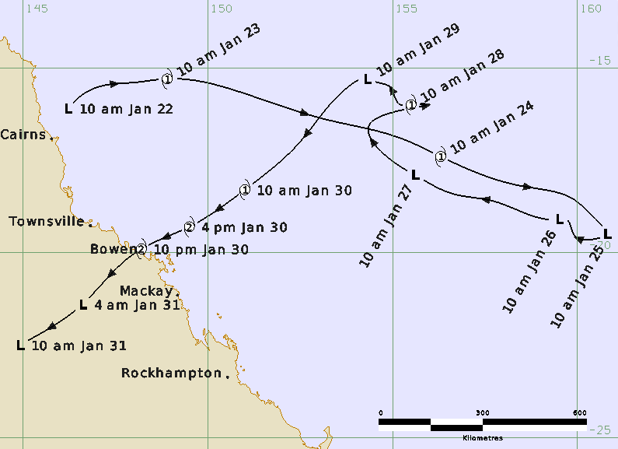

Figure 1. Best track of Tropical Cyclone Anthony 22 - 31 January 2011 (times in AEST, UTC +10).

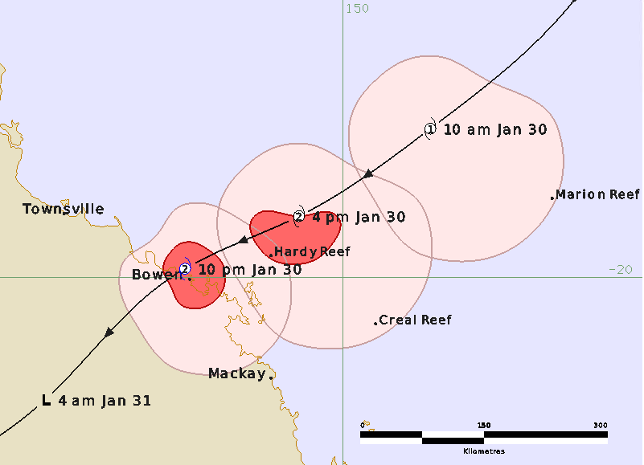

Figure 2. Detailed best track of Tropical Cyclone Anthony as it approached and crossed the Queensland coast 30-31 January 2011 (times in AEST, UTC +10). The pink areas show the extent of gales and the red area the extent of storm-force winds.

|  |  |  |  |  |  |  |  |  |  |  |  |  |
| --- | --- | --- | --- | --- | --- | --- | --- | --- | --- | --- | --- | --- |
| Year | Month | Day | Hour UTC | Pos. Lat S | Pos. Long. E | Pos. Acc. nm | Max. wind kn | Max. gust kn | Cent. Press hPa | Rad of gales (NE/SE/SW/NW) nm | Rad of storm (NE/SE/SW/NW) nm | RMW nm |
| 2011 | 1 | 22 | 0000 | 16.1 | 146.2 | 30 | 20 | 45 | 1002 | 0/0/0/0 | 0/0/0/0 | - |
| 2011 | 1 | 22 | 0600 | 15.7 | 146.6 | 30 | 20 | 45 | 1002 | 0/0/0/0 | 0/0/0/0 | - |
| 2011 | 1 | 22 | 1200 | 15.5 | 147.1 | 25 | 30 | 45 | 999 | 0/0/0/0 | 0/0/0/0 | - |
| 2011 | 1 | 22 | 1800 | 15.4 | 148.0 | 25 | 30 | 45 | 999 | 0/0/0/0 | 0/0/0/0 | - |
| 2011 | 1 | 23 | 0000 | 15.3 | 148.9 | 25 | 35 | 50 | 997 | 40/60/30/50 | 0/0/0/0 | 20 |
| 2011 | 1 | 23 | 0600 | 15.7 | 151.0 | 20 | 40 | 55 | 996 | 40/60/40/60 | 0/0/0/0 | 20 |
| 2011 | 1 | 23 | 1200 | 16.4 | 153.2 | 30 | 45 | 65 | 994 | 40/60/50/60 | 0/0/0/0 | 20 |
| 2011 | 1 | 23 | 1800 | 16.9 | 155.2 | 30 | 40 | 55 | 996 | 40/60/60/60 | 0/0/0/0 | 25 |
| 2011 | 1 | 24 | 0000 | 17.4 | 156.3 | 30 | 35 | 50 | 997 | 50/60/70/60 | 0/0/0/0 | 35 |
| 2011 | 1 | 24 | 0600 | 18.2 | 158.5 | 40 | 40 | 55 | 996 | 50/70/70/60 | 0/0/0/0 | 35 |
| 2011 | 1 | 24 | 1200 | 18.5 | 159.8 | 30 | 45 | 65 | 991 | 60/70/80/60 | 0/0/0/0 | 40 |
| 2011 | 1 | 24 | 1800 | 19.2 | 160.6 | 30 | 35* | 50 | 997 | 0/0/0/0 | 0/0/0/0 | 40 |
| 2011 | 1 | 25 | 0000 | 19.5 | 160.8 | 20 | 30 | 45 | 998 | 0/0/0/0 | 0/0/0/0 | - |
| 2011 | 1 | 25 | 0600 | 19.6 | 160.6 | 20 | 30 | 45 | 1000 | 0/0/0/0 | 0/0/0/0 | - |
| 2011 | 1 | 25 | 1200 | 19.5 | 159.9 | 30 | 25 | 45 | 1000 | 0/0/0/0 | 0/0/0/0 | - |
| 2011 | 1 | 25 | 1800 | 19.1 | 159.7 | 30 | 30 | 45 | 997 | 0/0/0/0 | 0/0/0/0 | - |
| 2011 | 1 | 26 | 0000 | 19.1 | 159.5 | 30 | 30 | 45 | 996 | 0/0/0/0 | 0/0/0/0 | - |
| 2011 | 1 | 26 | 0600 | 18.9 | 158.5 | 30 | 35* | 45 | 1000 | 0/80/80/0 | 0/0/0/0 | - |
| 2011 | 1 | 26 | 1200 | 18.6 | 157.7 | 25 | 40* | 55 | 1002 | 0/90/90/0 | 0/0/0/0 | - |
| 2011 | 1 | 26 | 1800 | 18.4 | 156.6 | 30 | 30 | 45 | 1003 | 0/0/0/0 | 0/0/0/0 | - |
| 2011 | 1 | 27 | 0000 | 17.9 | 155.6 | 20 | 30 | 45 | 1000 | 0/0/0/0 | 0/0/0/0 | - |
| 2011 | 1 | 27 | 0600 | 17.6 | 155.1 | 20 | 25 | 45 | 1002 | 0/0/0/0 | 0/0/0/0 | - |
| 2011 | 1 | 27 | 1200 | 16.5 | 154.4 | 30 | 30 | 45 | 999 | 0/0/0/0 | 0/0/0/0 | - |
| 2011 | 1 | 27 | 1800 | 16.0 | 155.9 | 30 | 35 | 50 | 992 | 40/80/80/40 | 0/0/0/0 | 25 |
| 2011 | 1 | 28 | 0000 | 16.0 | 155.5 | 30 | 40 | 55 | 993 | 40/80/80/40 | 0/0/0/0 | 25 |
| 2011 | 1 | 28 | 0600 | 16.0 | 155.2 | 30 | 35 | 50 | 995 | 40/80/80/40 | 0/0/0/0 | 30 |
| 2011 | 1 | 28 | 1200 | 15.5 | 154.9 | 30 | 30 | 45 | 1001 | 0/0/0/0 | 0/0/0/0 | - |
| 2011 | 1 | 28 | 1800 | 15.4 | 154.6 | 40 | 25 | 45 | 1000 | 0/0/0/0 | 0/0/0/0 | - |
| 2011 | 1 | 29 | 0000 | 15.3 | 154.3 | 30 | 25 | 45 | 1000 | 0/0/0/0 | 0/0/0/0 | - |
| 2011 | 1 | 29 | 0600 | 15.6 | 153.7 | 30 | 30 | 45 | 999 | 0/0/0/0 | 0/0/0/0 | - |
| 2011 | 1 | 29 | 1200 | 16.0 | 153.3 | 30 | 30 | 45 | 999 | 0/0/0/0 | 0/0/0/0 | - |
| 2011 | 1 | 29 | 1800 | 17.0 | 152.5 | 30 | 35* | 50 | 998 | 0/100/60/0 | 0/0/0/0 | - |
| 2011 | 1 | 30 | 0000 | 18.3 | 151.0 | 25 | 40 | 55 | 996 | 50/100/60/50 | 0/0/0/0 | 30 |
| 2011 | 1 | 30 | 0600 | 19.3 | 149.5 | 15 | 50 | 70 | 988 | 50/100/60/50 | 0/30/35/0 | 20 |
| 2011 | 1 | 30 | 1200 | 19.9 | 148.2 | 15 | 50 | 70 | 989 | 50/80/50/30 | 20/30/15/15 | 15 |
| 2011 | 1 | 30 | 1300 | 20.1 | 147.9 | 20 | 50 | 70 | 991 | 50/50/25/30 | 20/0/0/0 | 15 |
| 2011 | 1 | 30 | 1800 | 21.4 | 146.6 | 30 | 25 | 45 | 998 | 0/0/0/0 | 0/0/0/0 | - |
| 2011 | 1 | 31 | 0000 | 22.5 | 144.9 | 25 | 20 | 45 | 1004 | 0/0/0/0 | 0/0/0/0 | - |

Table 1. Best track summary for Tropical Cyclone Anthony, 22-31 January 2011.

UTC=AEST-10. * Not at tropical cyclone intensity as gales less than halfway around centre.

1. Meteorological description
   1. Intensity Analysis

A low-level circulation formed off the Queensland North Tropical Coast northeast of Cairns on 22 January. Deep convection became more organised overnight in a low vertical wind shear environment and Dvorak estimates showed the system had developed into a tropical cyclone on 23 January. Supporting evidence of the intensification include: the morning visible image (Figure 3); microwave imagery (TRMM at 0900 UTC in Figure 4), Willis Is radar at 0620 UTC (Figure 4) showing a partial eyewall; and then satellite winds from ASCAT at 1056 UTC in Figure 5a indicating gales are present around the centre. During this period a well-defined circulation appeared on radar and microwave imagery.

Overnight from 23 to 24 January, increased vertical wind shear weakened deep convection but tropical cyclone intensity is estimated to have persisted on the basis of gales being present around the centre on the ASCAT-A 1035 UTC 24 January (Figure 5b). The strong monsoon inflow supported the winds higher than the conventional Dvorak estimates indicated. However, deep convection then reduced considerably and winds are estimated to have weakened below gale force on 25 January.

The system remained as a tropical low for the next few days as it moved across the Coral Sea as a low-level circulation centre with little or no associated convection. ASCAT on 26 January showed gales re-emerging in southern quadrants co-incident with an area of deep convection. Anthony re-intensified into a category 1 system early on 28 January (Figure 3d) as a result of a brief change in movement to the east-northeast, thus reducing the effect of northwesterly vertical wind shear located over the area. Dvorak estimates reached CI=3.0 based on DT=3.0. Late on 28 January, Anthony turned back to the west north-west and became sheared, again weakening into a tropical low (Figure 3e).

The circulation then accelerated to the southwest and again re-intensified into a category 1 system by 0000 UTC (1000 AEST) 30 January (Figure 3f). Dvorak estimates again reached CI=3.0 based on a DT=3.0 using a curved band pattern. Gales were also observed south of the centre at Marion Reef then Creal and Hardy Reef. Deep convection continued over the centre under reduced wind shear as Anthony approached the coast. Category 2 intensity estimates are supported by Dvorak estimates reaching CI=3.5 (Visible image in Figure 6, and observations at Hardy Reef and Hamilton Island. Bowen radar (Figure 6) also showed a tight circulation. Following landfall, Anthony rapidly weakened into a tropical low over land.

* 1. Structure

Development on 22-23 January was supported by strong monsoon flow as shown in Figure 5a. Although deep convection weakened on 24 January the ASCAT in Figure 5b showed gales reasonably symmetric about the centre and highest on the northern side, likely assisted by translation speed of the system. The strongest winds of 30-35kn then shifted to the southern side over following days, as the system slowed then changed direction to the northwest. For example, ASCAT late on 26 January (not shown) showed gales south of the centre.

The system remained as a sheared tropical low until late on 29 January when convection began to increase as a result of weakening upper atmospheric vertical wind shear. As the system moved to the southwest, gales are estimated initially on the southern side early on 30 January and then extending around the centre. Observed gales at Marion Reef and Creal Reef confirmed gale extent to about 90 nm (165 km) southeast of the centre, although by landfall, the extent of gales is estimated to have contracted somewhat as shown in Figure 2. Gales were strongly attenuated over land.

The Radius of Maximum Winds (RMW) varied throughout the lifetime of Anthony and was estimated at 20-40 nm (35-75 km) on 23-24 January; 25-30 nm (45-55 km) on 27-28 January; and then on 30 January reducing from 30 nm (55 km) to 15 nm (30 km) at landfall.

* 1. Motion

The initial motion to the east-southeast track was influenced by the monsoon flow and by an upper trough over the northern Coral Sea (Figure 1). This trough remained the main steering influence until 25 January, taking the system east of 160°E when a new lower-level ridge began to build to the south of the circulation and move the system back to the west-northwest.

The low adopted an east-northeasterly track late on 27 January, most likely as a result of the Fujiwara Effect as a secondary circulation developed on its eastern side and rotated to its south. As this secondary circulation moved to the northwest of Anthony, early on 28 January, its movement rapidly returned to the west north-west. During this period Anthony may have also been influenced by the Fujiwara Effect from Severe Tropical Cyclone Wilma, located east of New Caledonia and moving south towards New Zealand.

The system then accelerated to the southwest on 29 and 30 January towards the central Queensland coast as an upper high strengthened over central Australia and extended a ridge into the southern Coral Sea. This movement persisted into 30 January when the system made landfall on the Queensland east coast near Bowen.

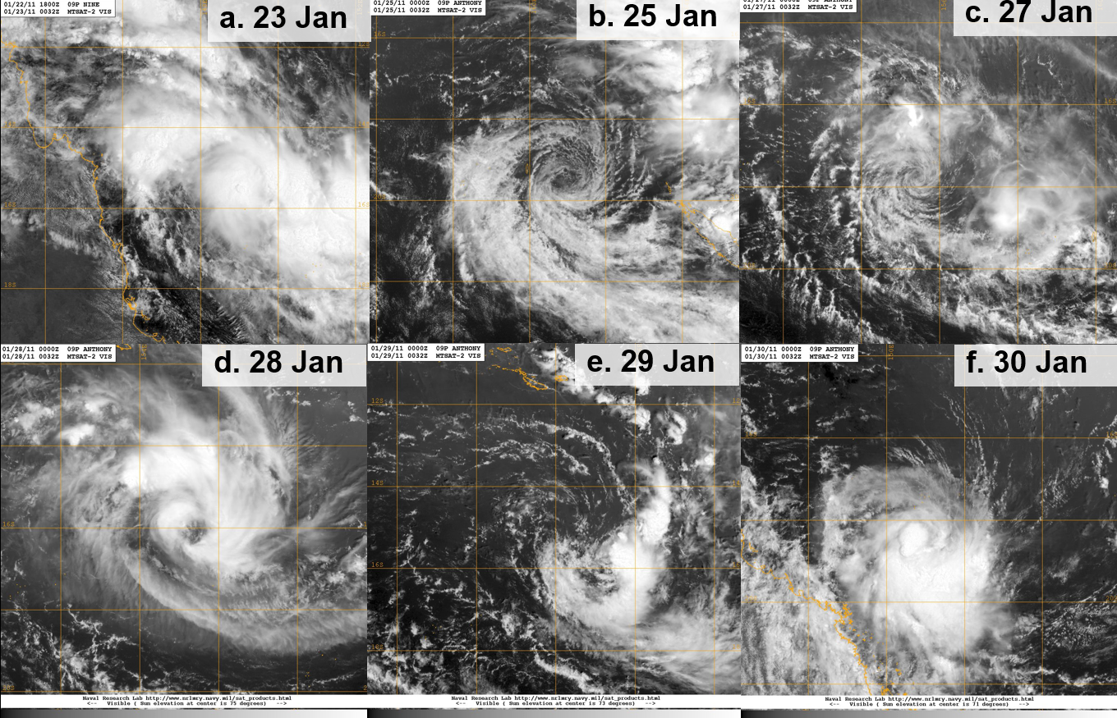

Figure 3. Series of visible images taken at 0030 UTC from 23 to 30 January: a. 23 January; b. 25 January; c. 27 January; d. 28 January, e. 29 January and f. 30 January. Images courtesy of NRL: <https://www.nrlmry.navy.mil/TC.html>

|  |  |
| --- | --- |
| TMI microwave composite image at 0900UTC 23 January | Willis Island radar image at 0620 UTC 23 January showing a partial eyewall |

Figure 4. Left TMI microwave composite image at 0900UTC 23 January; and right Willis Island radar image at 0620 UTC 23 January showing a partial eyewall. Microwave image courtesy NRL <https://www.nrlmry.navy.mil/TC.html>

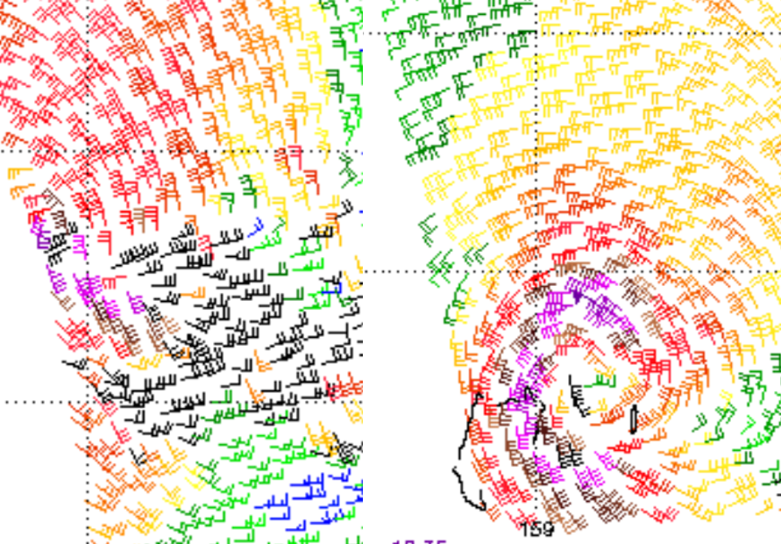

Figure 5. ASCAT scatterometry: left at 1058 UTC 23 January; and right at 1035 UTC 24 January. Images courtesy NOAA: <https://manati.star.nesdis.noaa.gov/datasets/ASCATData.php>

|  |  |
| --- | --- |
| Visible image at 0730 UTC 30 January showing deep convection over the centre. | *Bowen radar reflectivity image at 0920UTC 30 January prior to landfall. This shows strong reflectivity around between the radar and the centre but  the lack of reflectivity on the eastern side is primarily due to attenuation of the radar signal.* |

Figure 6. Left: visible image at 0730 UTC 30 January, and right: Bowen radar reflectivity image at 0920 UTC 30 January prior to landfall. Note that the lack of reflectivity on the eastern side is primarily due to attenuation of the radar signal. Visible image courtesy NRL <https://www.nrlmry.navy.mil/TC.html>

1. Impact

Impacts were considered relatively minor. A total of 11,415 homes were reported to have lost power in Bowen, Airlie Beach, Mackay, Collinsville and Sarina. Around Bowen, the Whitsundays and as far south as Mackay there were numerous reports of damage to vegetation, but only minor damage to buildings. A boat sunk outside Bowen marina and six boats broke their moorings at Airlie Beach marina. Townsville and Mackay were pre-emptively declared disaster areas to aid recovery response and the ports at Townsville, Mackay, Hay Point and Abbott Point were closed.

1. Observations
   1. Wind

Hamilton Island AWS recorded a maximum 10-minute wind speed of 54 kn (100 km/h) at 0955 UTC (1955 AEST) 30 January and maximum wind gust of 67 kn (124 km/h) at 0801 UTC (1801 AEST) 30 January. Marion Reef AWS recorded a 10-minute mean wind of 36 kn (67 km/h) at 2200 29 January (0800 AEST 30 Jan.), while Creal Reef AWS recorded a mean wind of 43 knots (80 km/h) at 0720 UTC (1720 AEST 30 Jan).

Hardy Reef, part of the Australian Institude of Marine Science (AIMS) network recorded a wind speed of 71 kn (131 km/h) at 0930 UTC (1930 AEST) 30 January and a minimum pressure of 993.9 hPa at 0910UTC (1910 AEST) 30 January. The Bureau of Meteorology cannot guarantee the quality of this data which was a factor in not increasing the intensity of the system around this time.

* 1. Rainfall

Rainfall totals of up to 200mm were recorded on 31 January in the area between Bowen and Mackay. There were no reports of serious flash flooding in the region and only isolated major flooding was observed in the upper reaches of the Pioneer River and in Denison Creek in the Fitzroy River Basin.

* 1. Storm Surge

No significant storm surge anomalies were recorded for tropical cyclone Anthony, and no tide heights exceeded Highest Astronomical Tide (HAT).

1. Appendix: List of Abbreviations

|  |  |
| --- | --- |
| Abbreviation | Term |
| ADT | Advanced Dvorak Technique |
| ACST | Australian Central Standard Time |
| AEST | Australian Eastern Standard Time |
| AiDT | AI-enhanced Dvorak Technique |
| AMSR2 | Advanced Microwave Scanning Radiometer |
| AMSU | Advanced Microwave Sounding Unit |
| ASCAT | Advanced Scatterometer |
| ATMS | Advanced Technology Microwave Sounder |
| AWS | automatic weather station |
| AWST | Australian Western Standard Time |
| °C | Celsius |
| CI | Current intensity |
| CIMSS | Cooperative Institute for Meteorological Satellite Studies (USA) |
| CIRA | Cooperative Institute for Research in the Atmosphere (USA) |
| D-MINT | Deep learning - Multispectral Intensity of TCs (formerly known as DMN) |
| D-PRINT | Deep learning - IR Intensity of TCs (formerly known as OPEN-AIIR) |
| EIR | Enhanced InfraRed |
| ERC | eyewall replacement cycle |
| FNMOC | Fleet Numerical Meteorology and Oceanography Centre (USA) |
| FT | Final T-number |
| GCOM | Global Change Observation Mission |
| GHz | Gigahertz |
| GMI | Global Precipitation Measurement Microwave Imager |
| h | hour |
| hPa | hectopascal |
| HSCAT | Hai Yang 2 Scatterometer (HY-2B, HY-2C) |
| km | kilometres |
| km/h | kilometres per hour |
| kn | knot |
| LLCC | LLCC |
| MET | Model Expected T-number |
| METOP | Meteorological Operational Satellite |
| MJO | Madden-Julian Oscillation |
| mm | millimetres |
| MSLP | mean sea level pressure |
| NESDIS | National Environmental Satellite, Data, and Information Service |
| nm | nautical mile |
| NOAA | National Oceanic and Atmospheric Administration |
| NRL | Navy Research Lab (USA) |
| OSCAT | Scatterometer aboard the OceanSat satellite |
| PAT | Pattern T-number |
| RCM | RadarSat Constellation Mission – Synthetic Aperture Radar |
| RH | relative humidity |
| RMW | radius of maximum winds |
| RSMC | Regional Specialised Meteorological Centre |
| SAR | Synthetic Aperture Radar |
| SATC | CIMSS Advanced Dvorak Technique |
| SATCON | Satellite Consensus |
| SEN1 | Sentinel-1A – Synthetic Aperture Radar |
| SMAP | Soil Moisture Active Passive |
| SMOS | Soil Moisture and Ocean Salinity |
| SSMIS | Special Sensor Microwave Imager/Sounder |
| TC | Tropical Cyclone |
| TCWC | Tropical Cyclone Warning Centre |
| UTC | Universal Time Co-ordinated |