Severe Tropical Cyclone Bianca

## 19-27 February 2025

## Matthew Boterhoven and Alessandro Paduano

## Tropical Cyclone Environmental Prediction Services

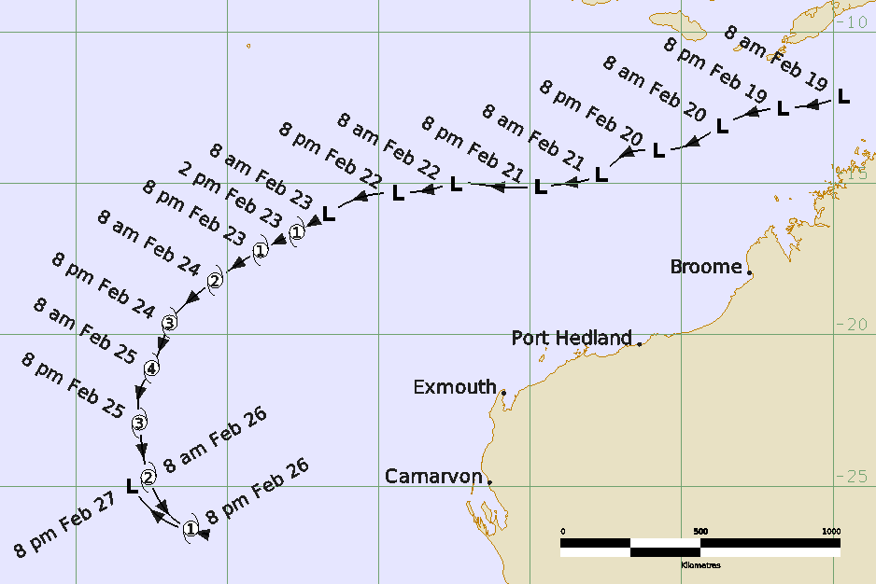

### Revision history

|  |  |  |  |
| --- | --- | --- | --- |
| Date | Version | Author | Description |
| 23/04/2025 | 1.0 | Matthew Boterhoven  Alessandro Paduano | Final draft |

### Review status

|  |  |  |  |
| --- | --- | --- | --- |
| Date | Version | Reviewer | Description |
| 24/4/2025 | 1.0 | Linda Paterson | Completed |

### Release history

|  |  |  |  |
| --- | --- | --- | --- |
| Date | Version | Status | Approval |
| 16/05/2025 | 1.0 | Approved for release | Andrew Burton |



Contact details:

Tropical Cyclone Team Lead

Severe Weather Environmental Prediction Services

Bureau of Meteorology

PO Box 1370, West Perth WA 6872

Email: tcwc@bom.gov.au

This work is copyright. Apart from any use as permitted under the Copyright Act 1968, no part may be reproduced without prior written permission from the Bureau of Meteorology. Refer to www.bom.gov.au/other/copyright.shtml for further information. Unless otherwise noted, all images in this document are licensed under the Creative Commons Attribution Australia Licence.

© Commonwealth of Australia 2025

Published by The Bureau of Meteorology

Cover image: Track of Severe Tropical Cyclone Bianca 19-27 February 2025. Times in AWST (UTC+8).

Table of contents

1. Summary 5

2. Meteorological description 7

2.1. Intensity Analysis 7

2.2. Structure 13

2.3. Motion 13

3. Impact 13

4. Observations 13

5. Forecast Performance 13

6. Appendix: List of Abbreviations 16

List of Figures

Figure 1: Best track of Bianca from 19-27 February 2025. Times are in AWST (UTC+8 hours). 5

Figure 2: Hovmoller diagram of tropical waves over the latitude range of 5S to 15S. The formation of Bianca (the system annotated B) occurred with a weak Equatorial Rossby (ER) wave. The image is courtesy of the North Carolina Institute for Climate Studies: https://ncics.org/pub/mjo/archive/2025/2025-02-27/v2/ 9

Figure 3: Satellite wind speeds from ASCAT-C at 0243 UTC 23 February (left) and AMSR2 at 0652 UTC 23 February (right). The ASCAT imagery indicates that gales are present in the western quadrants of the system, with the later AMSR2 imagery showing that gales have now wrapped into the northeastern quadrant, indicating that Bianca had reached tropical cyclone intensity at this time. Images courtesy NRL: https://www.nrlmry.navy.mil/TC.html 10

Figure 4: Colour composite microwave imagery from SSMIS at 2320 UTC 24 February (left) and GMI at 0243 UTC 25 February (right). Both images show Bianca as a compact system at peak intensity, with deep convection around a distinct microwave eye. Images courtesy NRL: https://www.nrlmry.navy.mil/TC.html 10

Figure 5: Satellite wind speeds from SAR at 1134 UTC 25 February around the time of peak intensity. Hurricane force winds are seen wrapping around most of the system, with peak wind speeds of 106 kn present in the southwestern quadrant. Image courtesy of NOAA https://www.star.nesdis.noaa.gov/socd/mecb/sar/sarwinds_tropical.php 11

Figure 6: Colour composite microwave imagery from SSMIS at 1138 UTC 26 February (left) and IR imagery from Himawari-9 at 1140 UTC 26 February (right). Both images show that deep convection is displaced to the southeast of the system centre (shown by the circle in both images) with the low-level circulation exposed, indicating that the system is under strong northwesterly shear and weakening rapidly. SSMIS image courtesy of NRL: https://www.nrlmry.navy.mil/TC.html 12

Figure 7: Satellite wind speeds from SAR at 2223 UTC 26 February (left) and from SMOS at 2312 UTC 26 February (right). Gales are confined to the southwestern quadrant, indicating that Bianca has dropped below tropical cyclone intensity. SAR image courtesy of NOAA https://www.star.nesdis.noaa.gov/socd/mecb/sar/sarwinds_tropical.php and SMOS image courtesy of NRL: https://www.nrlmry.navy.mil/TC.html 12

Figure 8: Position accuracy figures for Severe Tropical Cyclone Bianca compared against the 5-year average. 15

Figure 9: Intensity accuracy figures for Severe Tropical Cyclone Bianca compared against the 5-year average. 15

Figure 10: Intensity plot of objective and subjective guidance. SATCON, AiDT, AMSU, SAR, ASCAT, CIMSS ADT, DMINT, DPRINT, Dvorak subjective estimate, operational analysis (red) and post event best track analysis (black). 18

List of Tables

Table 1: Best track summary for Severe Tropical Cyclone Bianca, 19-27 February 2025. 6

Table 2: Verification statistics for Severe Tropical Cyclone Bianca. * Note, verification is performed using the Official Forecast Tracks at the standard times of 00, 06,12 and 18 UTC. 14

1. Summary

Severe Tropical Cyclone Bianca developed in the Timor Sea and moved southwest over the Indian Ocean. It did not affect mainland Australia or any offshore island territories.

A tropical low (21U) developed in the Timor Sea, northwest of the Kimberley coast on 19 February. Between the 19 and 23 February the system tracked generally west southwest, well offshore of the coast of Western Australia. Bianca developed into a tropical cyclone at 0600 UTC 23 February. Conditions were moderately favourable and Bianca intensified over the coming days. The system reached a peak 10-minute mean intensity of 95 kn (175 km/h) at 0000 UTC 25 February while located well to the west of Exmouth. As the system took a more southerly track, conditions became less favourable with increased vertical wind shear and cooler sea surface temperatures and Bianca began to weaken. Bianca weakened to below tropical cyclone strength at 1800 UTC 26 February, and the weak low-level centre was steered westwards into the Indian Ocean.

There were no impacts to the Australian mainland or Island communities from this system.

Figure 1 shows the best track of Bianca, and Table 1 is a summary of the best track data.



Figure 1: Best track of Bianca from 19-27 February 2025. Times are in AWST (UTC+8 hours).

Table 1: Best track summary for Severe Tropical Cyclone Bianca, 19-27 February 2025.

|  |  |  |  |  |  |  |  |  |  |  |  |  |
| --- | --- | --- | --- | --- | --- | --- | --- | --- | --- | --- | --- | --- |
| Year | Month | Day | Hour UTC | Pos. Lat S | Pos. Long. E | Pos. Acc. Nm | Max Wind 10 min kn | Max Wind gust kn | Cent. Press hPa | Rad of gales (NE/SE/SW/NW) nm | Rad of storm (NE/SE/SW/NW) nm | RMW nm |
| 2025 | 2 | 19 | 0000 | 12.1 | 125.3 | 40 | 20 | 45 | 1006 | 0/0/0/0 | 0/0/0/0 | - |
| 2025 | 2 | 19 | 0600 | 12.4 | 124.4 | 40 | 20 | 45 | 1005 | 0/0/0/0 | 0/0/0/0 | - |
| 2025 | 2 | 19 | 1200 | 12.5 | 123.3 | 40 | 20 | 45 | 1005 | 0/0/0/0 | 0/0/0/0 | - |
| 2025 | 2 | 19 | 1800 | 12.7 | 122.2 | 60 | 25 | 45 | 1005 | 0/0/0/0 | 0/0/0/0 | - |
| 2025 | 2 | 20 | 0000 | 13.1 | 121.3 | 60 | 25 | 45 | 1005 | 0/0/0/0 | 0/0/0/0 | - |
| 2025 | 2 | 20 | 0600 | 13.8 | 120.0 | 30 | 20 | 45 | 1005 | 0/0/0/0 | 0/0/0/0 | - |
| 2025 | 2 | 20 | 1200 | 13.9 | 119.2 | 30 | 25 | 45 | 1005 | 0/0/0/0 | 0/0/0/0 | - |
| 2025 | 2 | 20 | 1800 | 14.0 | 118.2 | 30 | 25 | 45 | 1004 | 0/0/0/0 | 0/0/0/0 | - |
| 2025 | 2 | 21 | 0000 | 14.7 | 117.3 | 25 | 25 | 45 | 1006 | 0/0/0/0 | 0/0/0/0 | - |
| 2025 | 2 | 21 | 0600 | 15.0 | 116.2 | 30 | 25 | 45 | 1004 | 0/0/0/0 | 0/0/0/0 | - |
| 2025 | 2 | 21 | 1200 | 15.1 | 115.3 | 25 | 20 | 45 | 1007 | 0/0/0/0 | 0/0/0/0 | - |
| 2025 | 2 | 21 | 1800 | 15.1 | 113.9 | 35 | 20 | 45 | 1006 | 0/0/0/0 | 0/0/0/0 | - |
| 2025 | 2 | 22 | 0000 | 15.0 | 112.5 | 30 | 25 | 45 | 1005 | 0/0/0/0 | 0/0/0/0 | - |
| 2025 | 2 | 22 | 0600 | 15.2 | 111.7 | 25 | 25 | 45 | 1005 | 0/0/0/0 | 0/0/0/0 | - |
| 2025 | 2 | 22 | 1200 | 15.3 | 110.6 | 25 | 25 | 45 | 1005 | 0/0/0/0 | 0/0/0/0 | - |
| 2025 | 2 | 22 | 1800 | 15.4 | 109.6 | 30 | 25 | 45 | 1002 | 0/0/0/0 | 0/0/0/0 | - |
| 2025 | 2 | 23 | 0000 | 16.0 | 108.3 | 35 | 30 | 45 | 1000 | 0/0/0/0 | 0/0/0/0 | - |
| 2025 | 2 | 23 | 0600 | 16.6 | 107.3 | 20 | 35 | 50 | 997 | 40/0/50/50 | 0/0/0/0 | 20 |
| 2025 | 2 | 23 | 1200 | 17.2 | 106.1 | 15 | 40 | 55 | 995 | 50/50/60/60 | 0/0/0/0 | 20 |
| 2025 | 2 | 23 | 1800 | 17.7 | 105.3 | 20 | 45 | 65 | 993 | 60/60/50/50 | 0/0/0/0 | 20 |
| 2025 | 2 | 24 | 0000 | 18.2 | 104.6 | 15 | 50 | 70 | 991 | 60/60/50/50 | 30/30/30/30 | 18 |
| 2025 | 2 | 24 | 0600 | 19.0 | 103.6 | 10 | 60 | 85 | 989 | 60/60/50/50 | 30/30/30/30 | 18 |
| 2025 | 2 | 24 | 1200 | 19.6 | 103.1 | 10 | 65 | 90 | 980 | 50/50/50/50 | 25/30/25/25 | 18 |
| 2025 | 2 | 24 | 1800 | 20.1 | 102.9 | 10 | 80 | 110 | 975 | 50/50/50/50 | 25/30/25/25 | 12 |
| 2025 | 2 | 25 | 0000 | 21.1 | 102.5 | 10 | 95 | 135 | 954 | 60/60/60/50 | 30/30/30/25 | 10 |
| 2025 | 2 | 25 | 0600 | 21.9 | 102.1 | 10 | 90 | 125 | 967 | 60/60/60/50 | 25/25/25/25 | 10 |
| 2025 | 2 | 25 | 1200 | 22.9 | 102.1 | 10 | 85 | 120 | 967 | 60/70/70/50 | 40/40/30/30 | 10 |
| 2025 | 2 | 25 | 1800 | 23.8 | 102.2 | 20 | 65 | 90 | 972 | 70/70/75/60 | 50/50/40/40 | 15 |
| 2025 | 2 | 26 | 0000 | 24.7 | 102.4 | 25 | 55 | 75 | 991 | 70/70/75/60 | 50/50/40/40 | 20 |
| 2025 | 2 | 26 | 0600 | 25.7 | 102.9 | 25 | 50 | 70 | 993 | 70/80/75/50 | 40/40/30/0 | 20 |
| 2025 | 2 | 26 | 1200 | 26.4 | 103.8 | 20 | 40 | 55 | 1000 | 40/80/80/50 | 0/0/0/0 | 30 |
| 2025 | 2 | 26 | 1800 | 26.6 | 104.4 | 20 | 35* | 50 | 1002 | 0/40/60/0 | 0/0/0/0 | - |
| 2025 | 2 | 27 | 0000 | 26.5 | 103.9 | 20 | 35* | 50 | 1002 | 0/0/60/0 | 0/0/0/0 | - |
| 2025 | 2 | 27 | 0600 | 25.8 | 102.5 | 10 | 30 | 45 | 1008 | 0/0/0/0 | 0/0/0/0 | - |
| 2025 | 2 | 27 | 1200 | 25.0 | 101.8 | 20 | 25 | 45 | 1012 | 0/0/0/0 | 0/0/0/0 | - |

1. Meteorological description
   1. Intensity Analysis

A comparison of the subjective and objective intensity estimates is shown in Figure 10.

A trough formed over the Timor Sea and adjacent waters in response to an Equatorial Rossby wave and a weak cross equatorial surge (refer to Figure 2). A weak low formed in this trough on 18 February. The environment was generally conducive for further development: sea surface temperatures were in the range of 29-30°C, there was low to moderate vertical wind shear, good upper-level divergence and poleward outflow to the south, and abundant moisture through depth.

The system took several days to consolidate, with several scatterometry passes from ASCAT and Oceansat between 18 to 21 February showing an elongated, trough-like structure at the surface. The system's development during this time was most likely hampered by moderate to strong easterly vertical wind shear disrupting its vertical structure. Dvorak T1.0 was assigned at 1200 UTC on 19 February, with persistent deep convection observed near and to the southwest of the system centre as the weak surface low began to slowly consolidate. This continued throughout 20 and 21 February as the system moved west, remaining well to the north of the Western Australian coastline. Scatterometry passes during this time still indicated an elongated, trough-like structure to the low-level circulation. Dvorak estimates remained around DT/CI=1.5 with very little curvature observed in the cloud patterns, and the intensity of the system ranged between 20-25 kn (35-45 km/h).

The system began to show signs of improvement during 22 February. ASCAT scatterometry passes at 1355 UTC indicated that while there was still some elongation in the low-level circulation, it had become much more consolidated with winds of 25-30 kn (45-55 km/h) in the southwest quadrant. Curvature became more apparent in the cloud signatures with Dvorak estimates increasing to a DT between 1.5 and 2.0 and CI=2.0. The system improved further on 23 February. An ASCAT pass at 0243 UTC indicated that gales were present in the western quadrants, an Oceansat pass at 0453 UTC indicated a tight, well consolidated low-level circulation, and a later AMSR2 pass at 0602 indicating gales had wrapped around into the northeastern quadrant. The ASCAT and AMSR2 passes are shown in Figure 3. Dvorak estimates increased to DT/CI=3.0 with convection beginning to wrap more tightly around the system and at 0600 UTC on 23 February, the system reached tropical cyclone intensity with an intensity of 35 kn (65 km/h). This was further confirmed with a later SAR pass at 1119 UTC indicating gales in all quadrants.

Bianca maintained a track to the southwest on 24 February and due to continued favourable environmental conditions Bianca began to intensify faster than the standard rate. A SAR pass at 2229 UTC on 23 February indicated storm force winds in all quadrants and Bianca was upgraded to a Category 2 tropical cyclone with an intensity of 50 kn (90 km/h) at 0000 UTC on 24 February. An eye began to develop in visible satellite imagery over the following hours, with scatterometry passes indicating the circulation was tightening with convective bands wrapping around the system and the gale radii decreasing. An ASCAT pass at 1358 UTC indicated hurricane force winds and Bianca was upgraded to a Category 3 severe tropical cyclone at 1200 UTC with an intensity of 65 kn (120 km/h). The satellite pattern continued to improve, with the eye becoming more defined, and good outflow channels and cirrus banding visible.

Bianca reached peak intensity at 0000 UTC 25 February as a Category 4 system with an intensity of 95 kn (175 km/h). Dvorak estimates at this time were DT=5.5 (3-hr average) and CI=5.5, with the CI having increased by 2.0 in the 24 hours prior. Microwave imagery from this time is shown in Figure 4, showing Bianca as a compact system with a well-established eye. A SAR pass at 1134 UTC, shown in Figure 5, indicated hurricane force winds wrapping around the system and an intensity of 106 kn (196 km/h).

At the time of peak intensity, objective aids (all adjusted to 10-min means and shown in Figure 10) showed a small spread in intensities. Some aids indicated higher intensities, with ADT=100-105 kn (185-195 km/h) and AiDT=95-100 kn (175-185 km/h), while SATCON=90-95kn (165-175 km/h more closely matched the peak intensity of the system. Conversely, DMINT and DPRINT had slightly weaker intensities at 85 kn (155 km/h) and 85-95 kn (155-175 km/h) respectively. Notably, DPRINT displayed a delayed peak intensity, peaking at 94 kn (174 km/h) some 12 hours after the analysed peak intensity of the system.

After reaching peak intensity, Bianca began to take a more southerly track through the Indian Ocean and from 1200 UTC 25 February started to weaken rapidly as high shear began to impact the system. Environmental conditions deteriorated as the system moved further south of 20S, with dry air entrained into the system and vertical wind shear increasing as the system approached the northern edge of the subtropical jet. Satellite imagery throughout 26 February (Figure 6) indicated that the low-level centre became more exposed with the deep convection offset to the southeast under strong northwesterly shear. By 1800 UTC 26 February, Bianca weakened below tropical cyclone intensity, with gales confined to the southern quadrants only[1] as indicated by an ASCAT pass at 1456 UTC, SAR pass at 2223 UTC, and SMOS pass at 2312, shown in Figure 7. By 1200 UTC 27 February, the discrete circulation had dissipated as it was absorbed into the broader southeasterly flow driven by a high pressure system in the southern Indian Ocean.

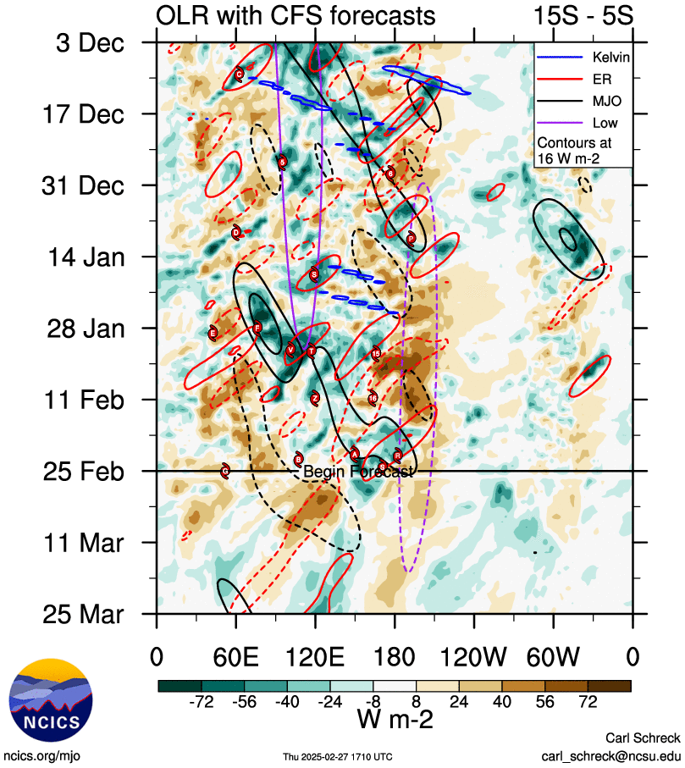

Figure 2: Hovmoller diagram of tropical waves over the latitude range of 5S to 15S. The formation of Bianca (the system annotated B) occurred with a weak Equatorial Rossby (ER) wave. The image is courtesy of the North Carolina Institute for Climate Studies: https://ncics.org/pub/mjo/archive/2025/2025-02-27/v2/

|  |  |
| --- | --- |
|  |  |

Figure 3: Satellite wind speeds from ASCAT-C at 0243 UTC 23 February (left) and AMSR2 at 0652 UTC 23 February (right). The ASCAT imagery indicates that gales are present in the western quadrants of the system, with the later AMSR2 imagery showing that gales have now wrapped into the northeastern quadrant, indicating that Bianca had reached tropical cyclone intensity at this time. Images courtesy NRL: https://www.nrlmry.navy.mil/TC.html

|  |  |
| --- | --- |
|  |  |

Figure 4: Colour composite microwave imagery from SSMIS at 2320 UTC 24 February (left) and GMI at 0243 UTC 25 February (right). Both images show Bianca as a compact system at peak intensity, with deep convection around a distinct microwave eye. Images courtesy NRL: https://www.nrlmry.navy.mil/TC.html

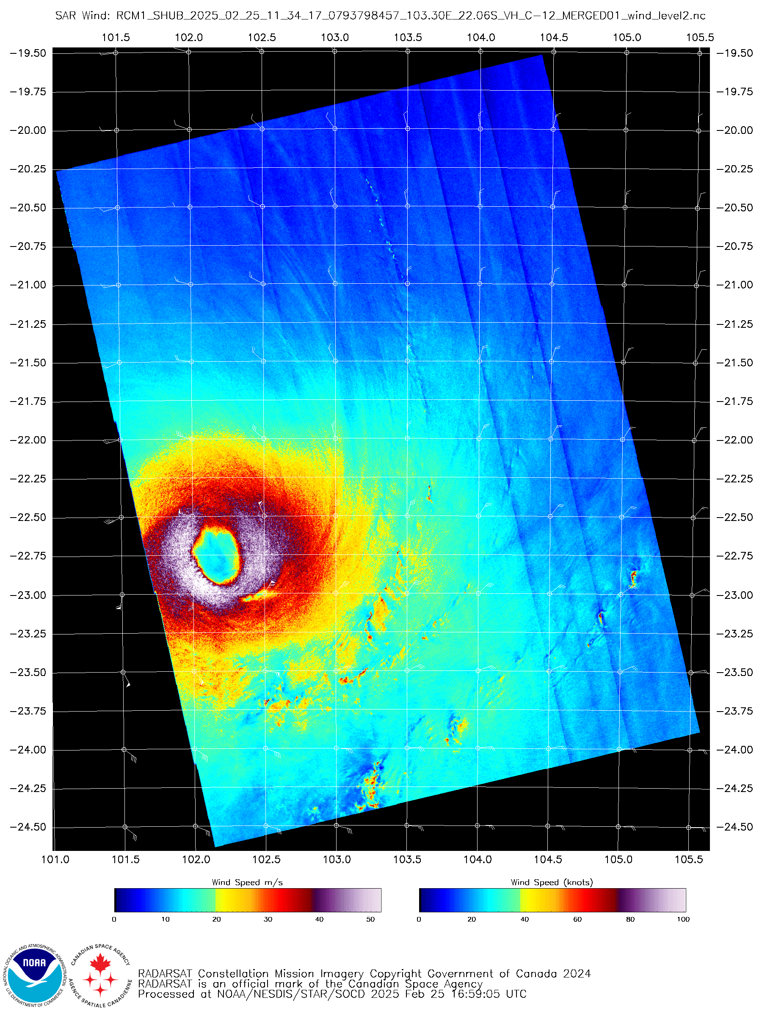

Figure 5: Satellite wind speeds from SAR at 1134 UTC 25 February around the time of peak intensity. Hurricane force winds wrap around most of the system, with peak wind speeds of 106 kn (196 km/h) present in the southwestern quadrant. Image courtesy of NOAA https://www.star.nesdis.noaa.gov/socd/mecb/sar/sarwinds_tropical.php

|  |  |
| --- | --- |
|  |  |

Figure 6: Colour composite microwave imagery from SSMIS at 1138 UTC 26 February (left) and IR imagery from Himawari-9 at 1140 UTC 26 February (right). Both images show that deep convection is displaced to the southeast of the system centre (shown by the circle in both images) with the low-level circulation exposed, indicating that the system is under strong northwesterly shear and weakening rapidly. SSMIS image courtesy of NRL: https://www.nrlmry.navy.mil/TC.html

|  |  |
| --- | --- |
|  |  |

Figure 7: Satellite wind speeds from SAR at 2223 UTC 26 February (left) and from SMOS at 2312 UTC 26 February (right). Gales are confined to the southwestern quadrant, indicating that Bianca has dropped below tropical cyclone intensity. SAR image courtesy of NOAA https://www.star.nesdis.noaa.gov/socd/mecb/sar/sarwinds_tropical.php and SMOS image courtesy of NRL: https://www.nrlmry.navy.mil/TC.html

* 1. Structure

Bianca was a compact system for most of its lifetime. Gale radii were between 50-60 nm (90-110 km) for most of its intensification period. Storm force winds were first observed at 0000 UTC on 24 February, with small storm force wind radii between 25-30 nm (45-55 km) observed. Hurricane force winds were observed 12 hours later, with the hurricane wind radius also remaining compact at 15-25 nm (30-45 km). At peak intensity, Bianca remained a small, compact system with gale radii of 60 nm (110 km), storm radii of 30 nm (55 km) and hurricane radii of 15 nm (30 km). The radius of maximum winds ranged between 20 nm (35 km) during intensification and 10 nm (20 km) at peak intensity.

As Bianca weakened under increasing northwesterly shear, the wind radii expanded in the southern and eastern quadrants. The radius of maximum winds also increased to 30 nm (55 km) prior to weakening below tropical cyclone intensity. Gale radii extended to 70-80 nm (130-150 km) south and east of the centre, and storm radii reached 50 nm (95 km) to the east. Meanwhile, wind radii in the northwest quadrant contracted as the system became more sheared.

After weakening below tropical cyclone intensity on 26-27 February, the gale radius in the southwestern quadrant grew to 60-80 nm (110-150 km), aided by a southeasterly surge from a high pressure system in the southern Indian Ocean. By 0600 UTC 27 February, gales were no longer present in the system.

* 1. Motion

The steering influences for Bianca were primarily dominated by a mid-level ridge to the south for much of its lifetime. This resulted in the steady westward motion of the system during its formation and initial intensification stages. Bianca began moving southwest late on 23 February and into 24 February, around the edge of the mid-level ridge. On 25 February, the system moved more to the south as the ridge shifted east. A mid-level trough approached from the southwest on 26 February, steering Bianca southeast and increasing wind shear. As Bianca weakened below tropical cyclone intensity and into 27 February, the system became shallower, and the dominant steering mechanism became a surface high pressure system in the southern Indian Ocean. This steered the remnant low briefly towards the west on 27 February before the circulation dissipated.

1. Impact

There were no impacts to any island or coastal communities.

1. Observations

No significant observations were recorded.

1. Forecast Performance

The accuracy statistics for Severe Tropical Cyclone Bianca are below in Table 2 and shown in Figure 8 and Figure 9.

Forecast track position accuracy was better than the 5-year average, particularly beyond the 48-hour forecast range, shown in Figure 8. This strong performance can be attributed to the well-defined steering influences during Bianca’s lifecycle. The system was primarily steered by a mid-level ridge to its south, resulting in a steady westward motion during its formation and early intensification stages. From late on 23 February into 24 February, Bianca began to move southwest as it rounded the edge of the ridge — a movement that was well captured by NWP guidance.

Intensity forecasts within the first 72 hours were generally slightly poorer than the 5-year average, shown in Figure 9. However, accuracy improved at the day 4 and 5 forecast ranges. Forecasts struggled to capture the system’s intensification on 24 February and its peak intensity on 25 February, with a general under bias evident during this period.

Forecast Track Maps were issued from 1200 UTC on 20 February to 1200 UTC on 26 February. Ocean Wind Warnings were issued from 1200 UTC on 20 February to 1800 UTC on 26 February. Technical Bulletins were issued from 1800 UTC on 20 February to 1800 UTC on 26 February.

Table 2: Verification statistics for Severe Tropical Cyclone Bianca. * Note, verification is performed using the Official Forecast Tracks at the standard times of 00, 06,12 and 18 UTC.

|  |  |  |  |  |  |  |  |  |  |  |
| --- | --- | --- | --- | --- | --- | --- | --- | --- | --- | --- |
| Time | 00 | 06 | 12 | 18 | 24 | 36 | 48 | 72 | 96 | 120 |
| Position accuracy (km) | 28 | 41 | 52 | 57 | 63 | 81 | 88 | 66 | 77 | 187 |
| Intensity accuracy (knots) | 2.4 | 5.4 | 6.8 | 8.4 | 10.0 | 12.4 | 14.3 | 15.3 | 10.4 | 6.7 |
| Sample size | 25 | 25 | 25 | 25 | 25 | 23 | 21 | 17 | 13 | 9 |

Figure 8: Position accuracy figures for Severe Tropical Cyclone Bianca compared against the 5-year average.

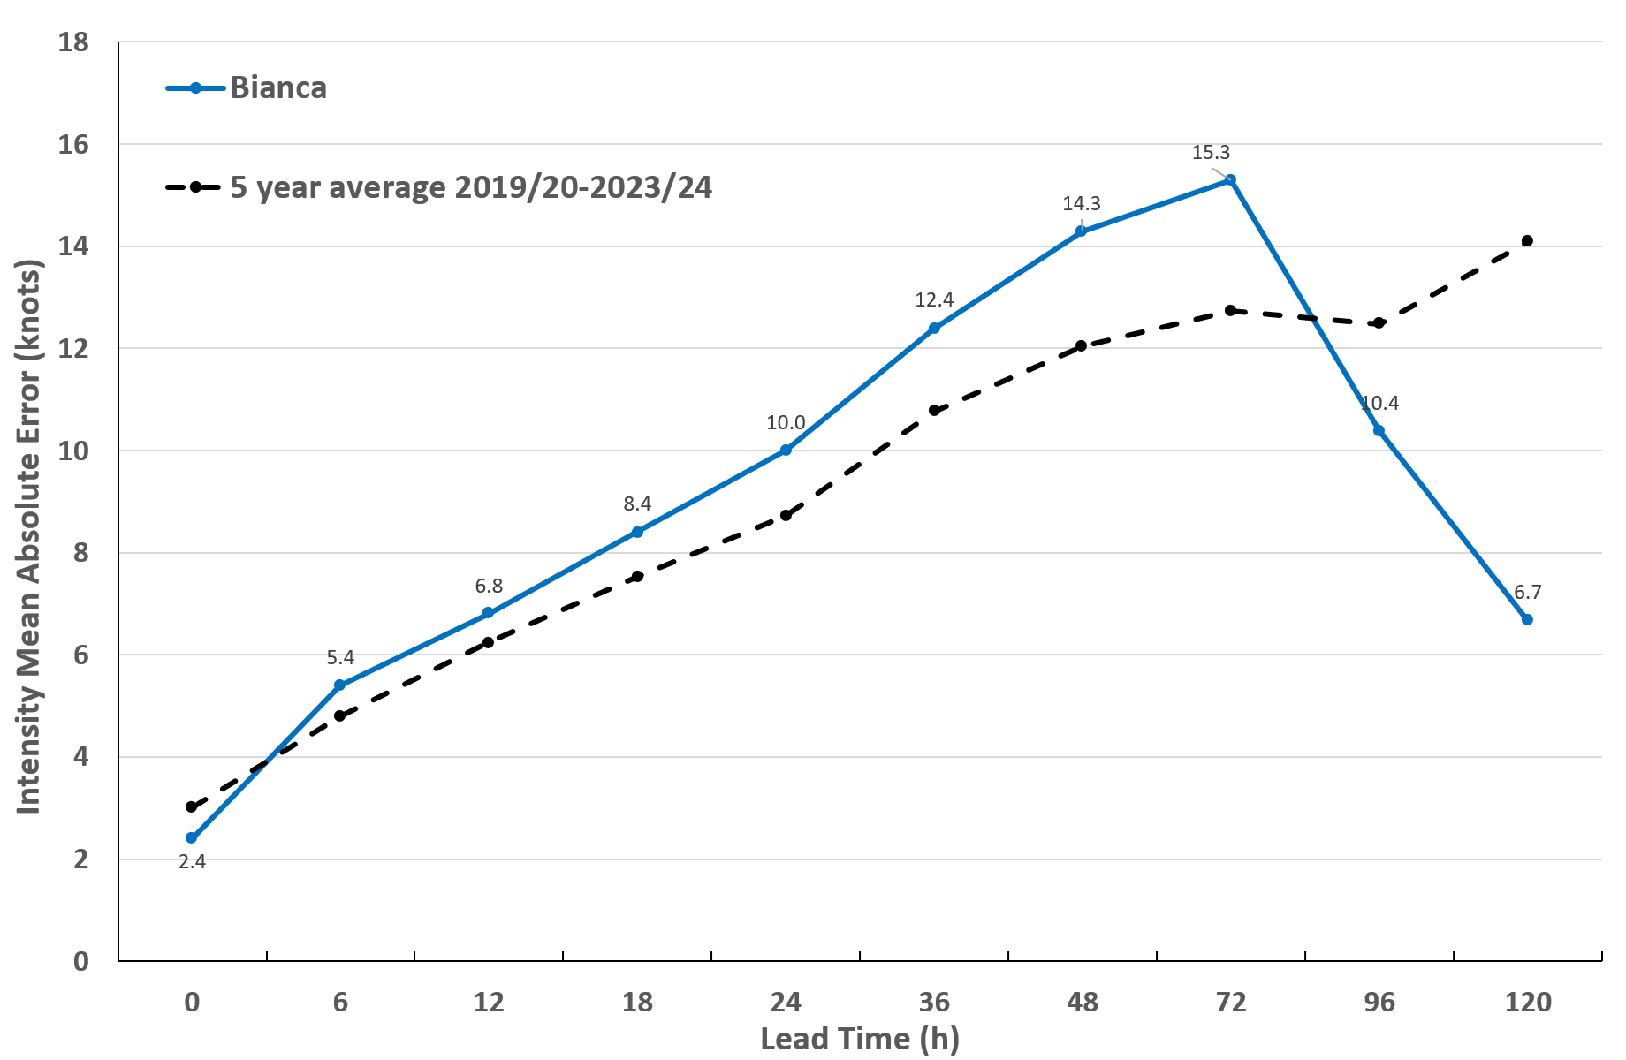

Figure 9: Intensity accuracy figures for Severe Tropical Cyclone Bianca compared against the 5-year average.

1. Appendix: List of Abbreviations

|  |  |
| --- | --- |
| Abbreviation | Term |
| ADT | Advanced Dvorak Technique |
| ACST | Australian Central Standard Time |
| AEST | Australian Eastern Standard Time |
| AiDT | AI-enhanced Dvorak Technique |
| AMSR2 | Advanced Microwave Scanning Radiometer |
| AMSU | Advanced Microwave Sounding Unit |
| ASCAT | Advanced Scatterometer |
| ATMS | Advanced Technology Microwave Sounder |
| AWS | automatic weather station |
| AWST | Australian Western Standard Time (UTC+8h) |
| °C | Celsius |
| CI | Current intensity |
| CIMSS | Cooperative Institute for Meteorological Satellite Studies (USA) |
| CIRA | Cooperative Institute for Research in the Atmosphere (USA) |
| D-MINT | Deep learning - Multispectral Intensity of TCs (formerly known as DMN) |
| D-PRINT | Deep learning - IR Intensity of TCs (formerly known as OPEN-AIIR) |
| EIR | Enhanced InfraRed |
| ERC | eyewall replacement cycle |
| FNMOC | Fleet Numerical Meteorology and Oceanography Centre (USA) |
| FT | Final T-number |
| GCOM | Global Change Observation Mission |
| GHz | Gigahertz |
| GMI | Global Precipitation Measurement Microwave Imager |
| h | hour |
| hPa | hectopascal |
| HSCAT | Hai Yang 2 Scatterometer (HY-2B, HY-2C) |
| km | kilometres |
| km/h | kilometres per hour |
| kn | knot |
| LLCC | Low Level Cloud Centre |
| MET | Model Expected T-number |
| METOP | Meteorological Operational Satellite |
| MJO | Madden-Julian Oscillation |
| mm | millimetres |
| MSLP | mean sea level pressure |
| NESDIS | National Environmental Satellite, Data, and Information Service |
| nm | nautical mile |
| NOAA | National Oceanic and Atmospheric Administration |
| NRL | Navy Research Lab (USA) |
| OPEN-AiiR | Ordered Pattern Encoding AI Infrared |
| PAT | Pattern T-number |
| RCM | RadarSat Constellation Mission – Synthetic Aperture Radar |
| RH | relative humidity |
| RMW | radius of maximum winds |
| RSMC | Regional Specialised Meteorological Centre |
| SAR | Synthetic Aperture Radar |
| SATC | CIMSS Advanced Dvorak Technique |
| SATCON | Satellite Consensus |
| SEN1 | Sentinel-1A – Synthetic Aperture Radar |
| SMAP | Soil Moisture Active Passive |
| SMOS | Soil Moisture and Ocean Salinity |
| SSMIS | Special Sensor Microwave Imager/Sounder |
| TC | Tropical Cyclone |
| TCWC | Tropical Cyclone Warning Centre |
| UTC | Universal Time Co-ordinated |

Figure 10: Intensity plot of objective and subjective guidance. SATCON, AiDT, AMSU, SAR, ASCAT, CIMSS ADT, DMINT, DPRINT, Dvorak subjective estimate, operational analysis (red) and post event best track analysis (black).

1. Under the Australian definition of a tropical cyclone, a system must exhibit gale force winds in at least three quadrants to be classified as a tropical cyclone.