**Severe Tropical Cyclone Courtney**

22 – 29 March 2025

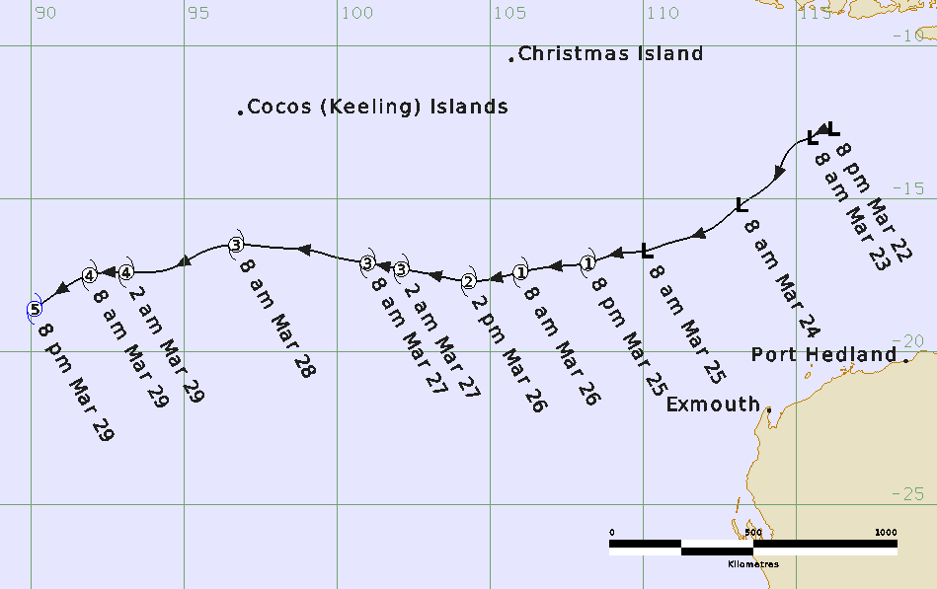

## Summary

Severe Tropical Cyclone Courtney developed to the north of Western Australia and moved westwards, leaving the Australian area of responsibility on 29 March. Courtney remained well away from the Australian mainland and island communities throughout its life and caused no direct impacts.

An active phase of the Madden-Julian Oscillation affected Western Australian longitudes during the second half of March. Tropical Low 27U gradually coalesced out of the monsoon trough well north of the Pilbara coastline and was first trackable on 22 March. Development was slow initially as the broad circulation remained close to or under a region of strong easterly deep layer wind shear. 27U moved generally to the west-southwest steered by a mid-level ridge to the south, which remained the dominant steering influence for the next week.

By 25 March, atmospheric conditions had improved, and the system consolidated and strengthened. 27U was named Courtney on the evening of 25 March. For the next several days it was steered steadily west through open waters of the Indian Ocean while continuing to develop. On the morning of 28 March, it passed approximately 480 kilometres to the south of the Cocos (Keeling) Islands at category 3 strength, which was its closest approach to any inhabited community as a tropical cyclone. On the evening of 29 March, Courtney reached category 5 strength only an hour or two before moving out of the Australian area of responsibility.

Severe Tropical Cyclone Courtney was the ninth tropical cyclone in the Australian region for the 2024/25 season.

**All information relating to intensity and track is preliminary information based on operational estimates and subject to change following post analysis.**