Severe Tropical Cyclone Debbie

## 16 - 23 December 2003

## Joe Courtney, Tropical Cyclone Environmental Prediction Services

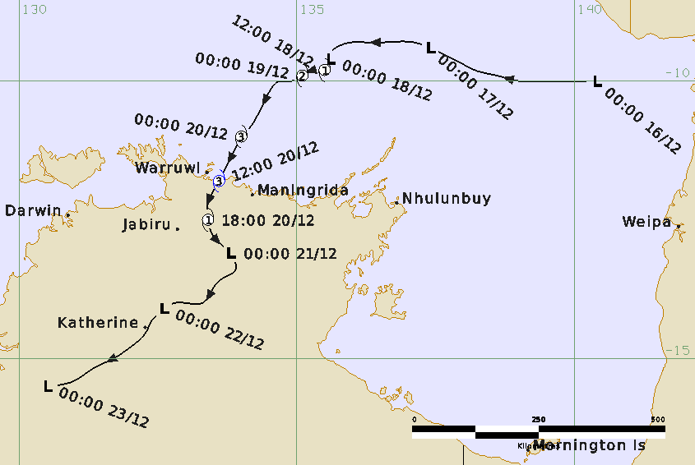

### Revision history

|  |  |  |  |
| --- | --- | --- | --- |
| Date | Version | Authors | Description |
| 7/11/2024 | 1.0 | Joe Courtney | Final draft ready |

### Review status

|  |  |  |  |
| --- | --- | --- | --- |
| Date | Version | Reviewer | Description |
| 7/11/2024 | 1.0 | Ian Shepherd | Completed |

### Release history

|  |  |  |  |
| --- | --- | --- | --- |
| Date | Version | Status | Approval |
| 8/11/2024 | 1.0 | Approved for release | Andrew Burton |



Contact details:

Tropical Cyclone Team Lead

Severe Weather Environmental Prediction Services

Bureau of Meteorology

PO Box 1370, West Perth WA 6872

Email: tcwc@bom.gov.au

This work is copyright. Apart from any use as permitted under the Copyright Act 1968, no part may be reproduced without prior written permission from the Bureau of Meteorology. Refer to www.bom.gov.au/other/copyright.shtml for further information. Unless otherwise noted, all images in this document are licensed under the Creative Commons Attribution Australia Licence.

© Commonwealth of Australia 2024

Published by The Bureau of Meteorology

Cover image: Track of Severe Tropical Cyclone Debbie 16 – 23 December 2003. Times in UTC (ACST-9.5h).

Table of Contents

1. Summary 5

2. Meteorological description 9

2.1. Intensity Analysis 9

2.2. Structure 9

2.3. Motion 9

3. Impact 10

4. Observations 10

4.1. Wind 10

4.2. Rainfall 10

4.3. Storm Surge and Waves 10

5. Appendix: List of Abbreviations 12

**List of Figures**

Figure 1. Best track of Severe Tropical Cyclone Debbie 16-23 December 2003. 5

Figure 2. Detailed best track of Severe Tropical Cyclone Debbie as it approached and crossed the Northern Territory coast 18-21 December 2003. 6

Figure 3. Rainfall analysis for week ending 25 December 2003. 11

**List of Tables**

Table 1. Best track summary for Severe Tropical Cyclone Debbie 16-23 December 2003. 8

1. Summary

Severe Tropical Cyclone Debbie reached category three intensity before crossing the Northern Territory coast between Goulburn Island and Maningrida late on 20 December. The track is shown in Figure 1 while Figure 2 shows more detailed track close to landfall. Track data are in Table 1.

A tropical low formed in the Arafura Sea on 16 December and tracked to the west reaching tropical cyclone intensity overnight from 18-19 December. Debbie then moved to the southwest and peaked at category 3 intensity on 20 December as it approached the Northern Territory coast.

Debbie crossed the Northern Territory coast late in the evening between Goulburn Is and Maningrida. Debbie then moved south over land, decaying into a rain depression on the morning of 21 December and tracking to the southwest over land for the next few days.

As Debbie crossed a sparsely populated section of the coast, no significant structural damage occurred to townships. The communities of Warruwi (on Goulburn Island) and Maningrida suffered some minor structural damage such as lifted sheets of roofing iron. Warruwi sustained tree damage to power lines, with interruptions to both power and water supplies following Debbie 's landfall. The region exposed to Debbie 's core sustained severe vegetation damage, with 30-40 per cent of trees felled in the area. As the rain depression tracked southwest over the Northern Territory Top End and finally into the Kimberley region of Western Australia, heavy rainfall caused significant rises in river levels with localised flooding in many areas. Charles Point, near Darwin, received 197 mm on 22 December, while Tindal, near Katherine, received 284 mm on 23 December. Roads were cut at the Cullen and Waterhouse rivers due to flooding.

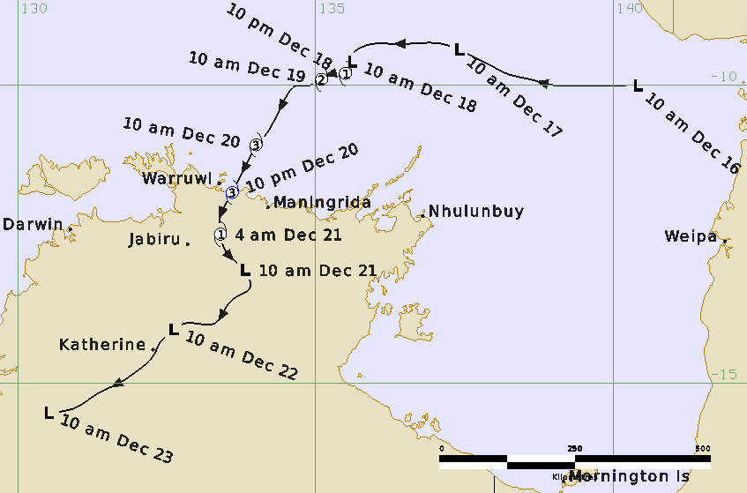

Figure 1. Best track of Severe Tropical Cyclone Debbie 16-23 December 2003 (times in ACST, UTC +9.5).

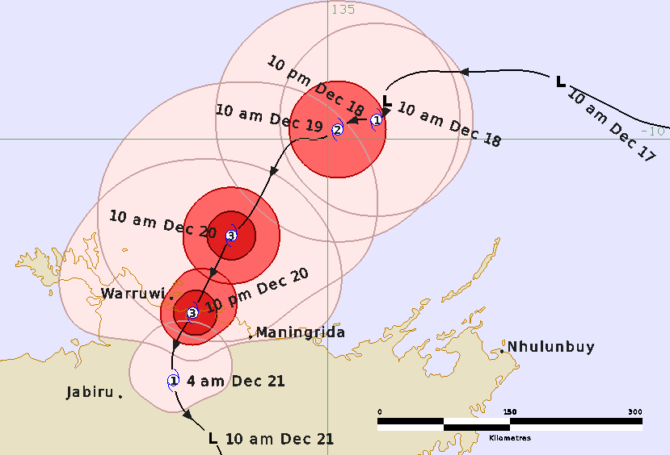

Figure 2. Detailed best track of Severe Tropical Cyclone Debbie as it approached and crossed the Northern Territory coast 18-21 December 2003 (times in ACST, UTC +9.5). The pink areas show the extent of gales, the red area the extent of storm-force winds and the dark red colour is the extent of hurricane-force winds.

|  |  |  |  |  |  |  |  |  |  |  |  |  |
| --- | --- | --- | --- | --- | --- | --- | --- | --- | --- | --- | --- | --- |
| Year | Month | Day | Hour UTC | Pos. Lat S | Pos. Long. E | Pos. Acc. nm | Max. wind kn | Max. gust kn | Cent. Press hPa | Rad of gales (NE/SE/SW/NW) nm | Rad of storm (NE/SE/SW/NW) nm | RMW nm |
| 2003 | 12 | 16 | 0000 | 10.0 | 140.4 | 60 | 20 | 45 | 1005 | 0/0/0/0 | 0/0/0/0 | - |
| 2003 | 12 | 16 | 0300 | 10.0 | 139.8 | 60 | 20 | 45 | 1004 | 0/0/0/0 | 0/0/0/0 | - |
| 2003 | 12 | 16 | 0600 | 10.0 | 139.4 | 60 | 20 | 45 | 1003 | 0/0/0/0 | 0/0/0/0 | - |
| 2003 | 12 | 16 | 0900 | 10.0 | 139.0 | 60 | 20 | 45 | 1003 | 0/0/0/0 | 0/0/0/0 | - |
| 2003 | 12 | 16 | 1200 | 9.9 | 138.6 | 60 | 20 | 45 | 1004 | 0/0/0/0 | 0/0/0/0 | - |
| 2003 | 12 | 16 | 1500 | 9.8 | 138.2 | 60 | 20 | 45 | 1004 | 0/0/0/0 | 0/0/0/0 | - |
| 2003 | 12 | 16 | 1800 | 9.7 | 138.0 | 60 | 20 | 45 | 1003 | 0/0/0/0 | 0/0/0/0 | - |
| 2003 | 12 | 16 | 2100 | 9.6 | 137.8 | 50 | 20 | 45 | 1003 | 0/0/0/0 | 0/0/0/0 | - |
| 2003 | 12 | 17 | 0000 | 9.4 | 137.4 | 50 | 25 | 45 | 1002 | 0/0/0/0 | 0/0/0/0 | - |
| 2003 | 12 | 17 | 0300 | 9.3 | 137.1 | 40 | 25 | 45 | 1001 | 0/0/0/0 | 0/0/0/0 | - |
| 2003 | 12 | 17 | 0600 | 9.3 | 136.6 | 40 | 25 | 45 | 1000 | 0/0/0/0 | 0/0/0/0 | - |
| 2003 | 12 | 17 | 0900 | 9.3 | 136.2 | 40 | 30 | 45 | 998 | 0/0/0/0 | 0/0/0/0 | - |
| 2003 | 12 | 17 | 1200 | 9.3 | 136.0 | 40 | 30 | 45 | 998 | 0/0/0/0 | 0/0/0/0 | - |
| 2003 | 12 | 17 | 1500 | 9.4 | 135.7 | 40 | 30 | 45 | 998 | 0/0/0/0 | 0/0/0/0 | - |
| 2003 | 12 | 17 | 1800 | 9.5 | 135.6 | 40 | 30 | 45 | 998 | 0/0/0/0 | 0/0/0/0 | - |
| 2003 | 12 | 17 | 2100 | 9.6 | 135.6 | 40 | 30 | 45 | 998 | 0/0/0/0 | 0/0/0/0 | - |
| 2003 | 12 | 18 | 0000 | 9.6 | 135.6 | 30 | 30 | 45 | 995 | 0/0/0/0 | 0/0/0/0 | - |
| 2003 | 12 | 18 | 0300 | 9.7 | 135.6 | 30 | 30 | 45 | 995 | 0/0/0/0 | 0/0/0/0 | - |
| 2003 | 12 | 18 | 0600 | 9.7 | 135.6 | 30 | 30 | 45 | 995 | 0/0/0/0 | 0/0/0/0 | - |
| 2003 | 12 | 18 | 0900 | 9.8 | 135.5 | 30 | 30 | 45 | 995 | 0/0/0/0 | 0/0/0/0 | - |
| 2003 | 12 | 18 | 1200 | 9.8 | 135.5 | 30 | 30 | 45 | 995 | 0/0/0/0 | 0/0/0/0 | - |
| 2003 | 12 | 18 | 1500 | 9.8 | 135.5 | 30 | 35 | 50 | 992 | 60/60/60/60 | 0/0/0/0 | 12 |
| 2003 | 12 | 18 | 1800 | 9.8 | 135.4 | 20 | 40 | 55 | 990 | 60/60/60/60 | 0/0/0/0 | 12 |
| 2003 | 12 | 18 | 2100 | 9.8 | 135.3 | 20 | 50 | 70 | 988 | 70/70/70/70 | 30/30/30/30 | 12 |
| 2003 | 12 | 19 | 0000 | 9.9 | 135.1 | 20 | 50 | 70 | 988 | 70/70/70/70 | 30/30/30/30 | 12 |
| 2003 | 12 | 19 | 0300 | 10.0 | 134.9 | 20 | 55 | 80 | 985 | 70/70/70/70 | 30/30/30/30 | 12 |
| 2003 | 12 | 19 | 0600 | 10.0 | 134.8 | 20 | 55 | 80 | 982 | 70/70/70/70 | 30/30/30/30 | 12 |
| 2003 | 12 | 19 | 0900 | 10.0 | 134.7 | 20 | 55 | 80 | 980 | 70/70/70/70 | 30/30/30/30 | 12 |
| 2003 | 12 | 19 | 1200 | 10.2 | 134.5 | 20 | 60 | 85 | 975 | 70/70/70/70 | 30/30/30/30 | 12 |
| 2003 | 12 | 19 | 1500 | 10.4 | 134.4 | 20 | 65 | 90 | 970 | 80/80/80/80 | 30/30/30/30 | 12 |
| 2003 | 12 | 19 | 1800 | 10.6 | 134.3 | 20 | 65 | 90 | 970 | 80/80/80/80 | 30/30/30/30 | 12 |
| 2003 | 12 | 19 | 2100 | 10.9 | 134.1 | 20 | 65 | 90 | 970 | 80/80/80/80 | 30/30/30/30 | 12 |
| 2003 | 12 | 20 | 0000 | 11.0 | 134.0 | 15 | 65 | 90 | 970 | 80/80/80/80 | 30/30/30/30 | 12 |
| 2003 | 12 | 20 | 0300 | 11.2 | 133.9 | 15 | 65 | 90 | 970 | 70/70/70/70 | 30/30/30/30 | 12 |
| 2003 | 12 | 20 | 0600 | 11.4 | 133.8 | 15 | 65 | 90 | 970 | 70/70/70/70 | 30/20/20/30 | 12 |
| 2003 | 12 | 20 | 0900 | 11.6 | 133.7 | 15 | 60 | 70 | 975 | 70/70/70/70 | 30/20/20/30 | 12 |
| 2003 | 12 | 20 | 1200 | 11.8 | 133.6 | 15 | 60 | 85 | 975 | 50/50/50/50 | 40/20/20/30 | 12 |
| 2003 | 12 | 20 | 1500 | 12.2 | 133.4 | 15 | 50 | 70 | 980 | 40/40/40/40 | 40/0/0/30 | 12 |
| 2003 | 12 | 20 | 1800 | 12.5 | 133.4 | 15 | 40 | 55 | 985 | 30/30/30/30 | 0/0/0/0 | 12 |
| 2003 | 12 | 20 | 2100 | 12.8 | 133.5 | 15 | 35 | 50 | 990 | 20/20/20/20 | 0/0/0/0 | 12 |
| 2003 | 12 | 21 | 0000 | 13.1 | 133.8 | 15 | 30 | 45 | 993 | 0/0/0/0 | 0/0/0/0 | - |
| 2003 | 12 | 21 | 0300 | 13.4 | 133.9 | 20 | 20 | 45 | 995 | 0/0/0/0 | 0/0/0/0 | - |
| 2003 | 12 | 21 | 0600 | 13.6 | 133.6 | 20 | 20 | 45 | 995 | 0/0/0/0 | 0/0/0/0 | - |
| 2003 | 12 | 21 | 0900 | 14.0 | 133.3 | 20 | 20 | 45 | 993 | 0/0/0/0 | 0/0/0/0 | - |
| 2003 | 12 | 21 | 1200 | 14.0 | 133.0 | 20 | 20 | 45 | 995 | 0/0/0/0 | 0/0/0/0 | - |
| 2003 | 12 | 21 | 1500 | 14.0 | 132.8 | 20 | 20 | 45 | 995 | 0/0/0/0 | 0/0/0/0 | - |
| 2003 | 12 | 21 | 1800 | 14.0 | 132.8 | 20 | 20 | 45 | 992 | 0/0/0/0 | 0/0/0/0 | - |
| 2003 | 12 | 21 | 2100 | 14.0 | 132.8 | 20 | 15 | 45 | 993 | 0/0/0/0 | 0/0/0/0 | - |
| 2003 | 12 | 22 | 0000 | 14.1 | 132.6 | 20 | 15 | 45 | 994 | 0/0/0/0 | 0/0/0/0 | - |
| 2003 | 12 | 22 | 0300 | 14.2 | 132.5 | 20 | 15 | 45 | 993 | 0/0/0/0 | 0/0/0/0 | - |
| 2003 | 12 | 22 | 0600 | 14.3 | 132.4 | 20 | 15 | 45 | 992 | 0/0/0/0 | 0/0/0/0 | - |
| 2003 | 12 | 22 | 0900 | 14.5 | 132.3 | 20 | 15 | 45 | 991 | 0/0/0/0 | 0/0/0/0 | - |
| 2003 | 12 | 22 | 1200 | 14.8 | 132.0 | 20 | 15 | 45 | 993 | 0/0/0/0 | 0/0/0/0 | - |
| 2003 | 12 | 22 | 1500 | 15.0 | 131.7 | 20 | 15 | 45 | 993 | 0/0/0/0 | 0/0/0/0 | - |
| 2003 | 12 | 22 | 1800 | 15.2 | 131.3 | 20 | 15 | 45 | 992 | 0/0/0/0 | 0/0/0/0 | - |
| 2003 | 12 | 22 | 2100 | 15.4 | 131.0 | 20 | 15 | 45 | 993 | 0/0/0/0 | 0/0/0/0 | - |
| 2003 | 12 | 23 | 0000 | 15.5 | 130.5 | 20 | 15 | 45 | 993 | 0/0/0/0 | 0/0/0/0 | - |

Table 1. Best track summary for Severe Tropical Cyclone Debbie 16-23 December 2003. UTC=ACST-9.5. * Not at tropical cyclone intensity as gales less than halfway around centre.

1. Meteorological description
   1. Intensity Analysis

A tropical low was identified in the eastern Arafura Sea within the monsoon trough on 16 December, as an MJO pulse propagated into the region. A deep easterly surge, combined with decreasing upper-level shear, created favourable conditions for the low to slowly develop while continuing westward. Debbie reached cyclone intensity overnight from 18-19 December and continued to develop.

Debbie reached peak intensity early on 20 December with a maximum 10-minute wind of 65 kn (120 km/h) which continued through until landfall late that day on the northern Australian coast. Debbie weakened to a rain depression early on 21 December.

* 1. Structure

Debbie was a reasonably symmetric system having gales extend to 70-80 nm (130-150 km). Gales increased in the northeast quadrant to 140 nm (260 km) with an increase in the monsoon flow on 19-20 December. Gales were then affected by land as the system came onto the coast. Storm-force winds were estimated to extend to 30 nm (55 km) while hurricane force winds extended to 15 nm (28 km). The radius of maximum winds (RMW) was estimated initially at 12 nm (20 km).

* 1. Motion

The initial movement to the west from 16-18 December was driven by the influence of a low to mid-level easterly airstream (refer Figure 1). On 18 December the low slowed and began moving to the southwest, as it came under the increasing influence of the monsoonal westerlies.

1. Impact

As Debbie crossed a sparsely populated section of the coast, no significant structural damage occurred to townships. The communities of Warruwi (on Goulburn Island) and Maningrida suffered some minor structural damage such as lifted sheets of roofing iron. Warruwi sustained tree damage to power lines, with interruptions to both power and water supplies following Debbie 's landfall. The region exposed to Debbie 's core sustained severe vegetation damage, with 30-40 per cent of trees felled in the area.

As the rain depression tracked southwest over the Northern Territory Top End and finally into the Kimberley region of Western Australia, heavy rainfall caused significant rises in river levels with localised flooding in many areas. The Stuart Highway was cut at the Cullen River for a short period and the Central Arnhem Road was cut at the Waterhouse River from 22 to 24 December.

1. Observations
   1. Wind

Warruwi AWS recorded about 7 hours of gales and one hour of near storm-force winds as Debbie passed within 30 km to the east. The maximum wind gust was 66 kn (122 km/h) at 1130 UTC (2100 ACST) on 20 December.

Maningrida recorded a period of gales around 2130 ACST on 20 December.

McCluer Island recorded gales for 8 hours with a maximum wind gust of 51 kn (94 km/h) at 0618 UTC (1548 ACST) 20 December.

* 1. Rainfall

Figure 3 shows the weekly rainfall distribution for the week ending 25 December Significant 24-hour rainfall totals to 9 am ACST (over 130 mm) include:

21 Dec.: McCluer Is 148 mm, Geriatric Park 134 mm,

22 Dec.: Charles Point (near Darwin) 197 mm, Elcho Island 130 mm;

23 Dec.: Tindal (near Katherine) 284 mm, Katherine Council 228 mm, Darwin Hospital 160 mm, Old Delamere 140 mm;

24 Dec.: Wave Hill Police 156 mm.

* 1. Storm Surge and Waves

Debbie crossed close to low tide. Nevertheless at Maningrida a 2-metre swell combined with a storm surge to cause minor coastal flooding, and the sea level rose about 0.5 m above the barge landing.

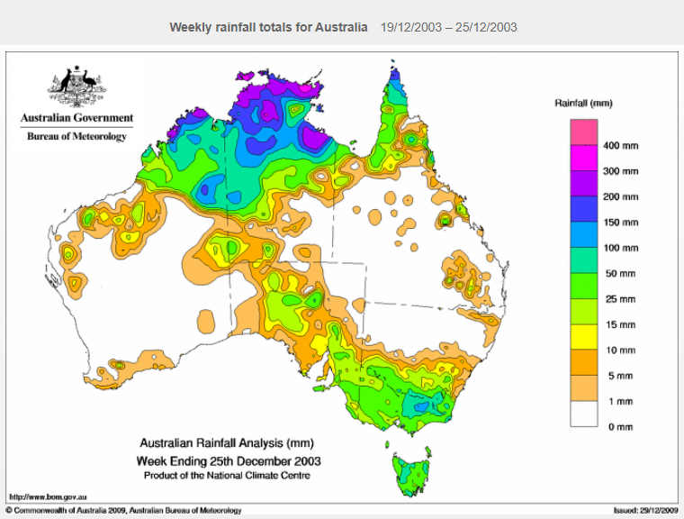

Figure 3. Rainfall analysis for week ending 25 December 2003.

1. Appendix: List of Abbreviations

|  |  |
| --- | --- |
| Abbreviation | Term |
| ADT | Advanced Dvorak Technique |
| ACST | Australian Central Standard Time |
| AEST | Australian Eastern Standard Time |
| AiDT | AI-enhanced Dvorak Technique |
| AMSR2 | Advanced Microwave Scanning Radiometer |
| AMSU | Advanced Microwave Sounding Unit |
| ASCAT | Advanced Scatterometer |
| ATMS | Advanced Technology Microwave Sounder |
| AWS | automatic weather station |
| AWST | Australian Western Standard Time |
| °C | Celsius |
| CI | Current intensity |
| CIMSS | Cooperative Institute for Meteorological Satellite Studies (USA) |
| CIRA | Cooperative Institute for Research in the Atmosphere (USA) |
| D-MINT | Deep learning - Multispectral Intensity of TCs (formerly known as DMN) |
| D-PRINT | Deep learning - IR Intensity of TCs (formerly known as OPEN-AIIR) |
| EIR | Enhanced InfraRed |
| ERC | eyewall replacement cycle |
| FNMOC | Fleet Numerical Meteorology and Oceanography Centre (USA) |
| FT | Final T-number |
| GCOM | Global Change Observation Mission |
| GHz | Gigahertz |
| GMI | Global Precipitation Measurement Microwave Imager |
| h | hour |
| hPa | hectopascal |
| HSCAT | Hai Yang 2 Scatterometer (HY-2B, HY-2C) |
| km | kilometres |
| km/h | kilometres per hour |
| kn | knot |
| LLCC | LLCC |
| MET | Model Expected T-number |
| METOP | Meteorological Operational Satellite |
| MJO | Madden-Julian Oscillation |
| mm | millimetres |
| MSLP | mean sea level pressure |
| NESDIS | National Environmental Satellite, Data, and Information Service |
| nm | nautical mile |
| NOAA | National Oceanic and Atmospheric Administration |
| NRL | Navy Research Lab (USA) |
| OSCAT | Scatterometer aboard the OceanSat satellite |
| PAT | Pattern T-number |
| RCM | RadarSat Constellation Mission – Synthetic Aperture Radar |
| RH | relative humidity |
| RMW | radius of maximum winds |
| RSMC | Regional Specialised Meteorological Centre |
| SAR | Synthetic Aperture Radar |
| SATC | CIMSS Advanced Dvorak Technique |
| SATCON | Satellite Consensus |
| SEN1 | Sentinel-1A – Synthetic Aperture Radar |
| SMAP | Soil Moisture Active Passive |
| SMOS | Soil Moisture and Ocean Salinity |
| SSMIS | Special Sensor Microwave Imager/Sounder |
| TC | Tropical Cyclone |
| TCWC | Tropical Cyclone Warning Centre |
| UTC | Universal Time Co-ordinated |