Tropical Cyclone Dianne (28U)

# 27-30 March 2025

## Craig Earl-Spurr, Tropical Cyclone Environmental Prediction Services

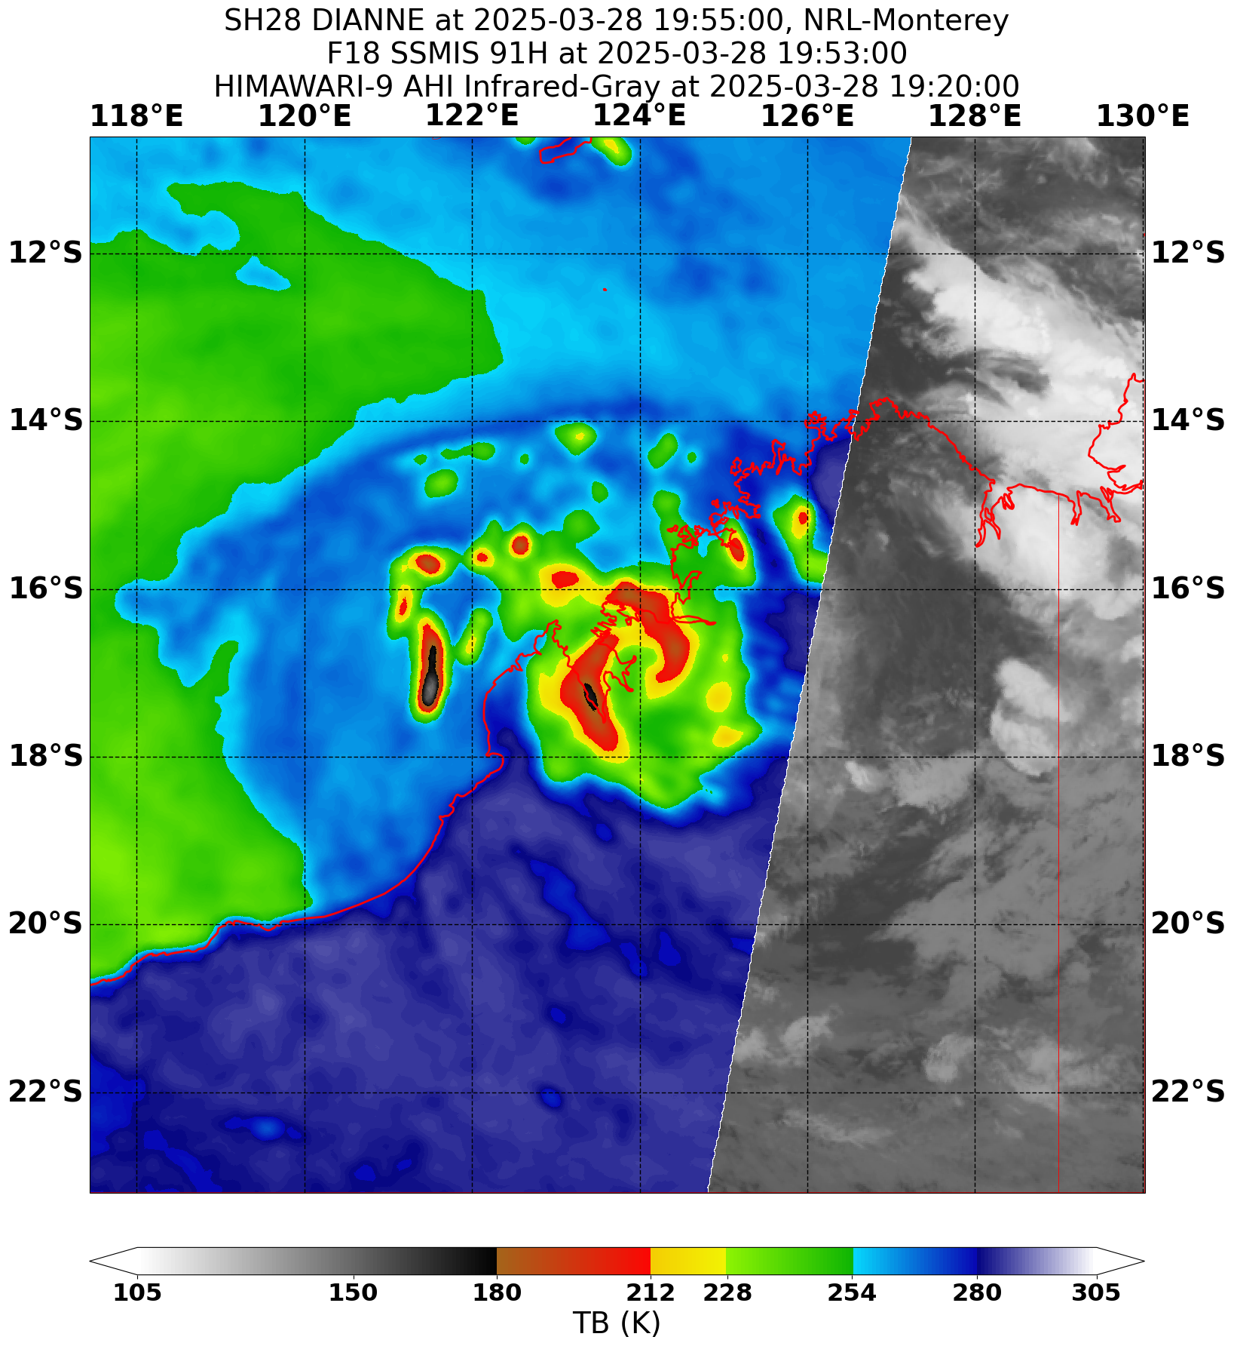

**Revision history**

|  |  |  |  |
| --- | --- | --- | --- |
| Date | Version | Author | Description |
| 10/04/2025 | 1.0 | Craig Earl-Spurr | Final draft |

**Review status**

|  |  |  |  |
| --- | --- | --- | --- |
| Date | Version | Reviewer | Description |
| 24/04/2025 | 1.0 | Joe Courtney | Completed |

**Release history**

|  |  |  |  |
| --- | --- | --- | --- |
| Date | Version | Status | Approval |
| 28/04/2025 | 1.0 | Approved for release | David Grant |

Contact details:

Tropical Cyclone Team Lead

Severe Weather Environmental Prediction Services

Bureau of Meteorology

PO Box 1370, West Perth WA 6872

Email: [tcwc@bom.gov.au](mailto:tcwc@bom.gov.au)



This work is copyright. Apart from any use as permitted under the Copyright Act 1968, no part may be reproduced without prior written permission from the Bureau of Meteorology. Refer to www.bom.gov.au/other/copyright.shtml for further information. Unless otherwise noted, all images in this document are licensed under the Creative Commons Attribution Australia Licence.

© Commonwealth of Australia 2025

Published by the Bureau of Meteorology

Cover image: SSMIS 91 GHz satellite image of Tropical Cyclone Dianne at 1953 UTC 28 March 2025 (3:53am AWST 29 March 2025), shortly after crossing the Kimberley coast. Image courtesy NRL. https://www.nrlmry.navy.mil/TC.html

Contents

1. Summary 5

2. Meteorological description 7

2.1. Intensity analysis 7

2.2. Structure 12

2.3. Motion 12

3. Impact 12

4. Observations 12

4.1. Wind 12

4.2. Precipitation 13

4.3. Storm Surge 14

5. Forecast Performance 15

Appendix: List of abbreviations 18

**List of Figures**

Figure 1 Best track of Dianne 27 - 30 March 2025. Times in AWST (UTC+8 hours) 5

Figure 2 Hovmoller diagram of tropical waves showing the formation of Dianne occurred during an active phase of the MJO (black) coinciding with an Equatorial Rossby (ER) wave (red). The image is courtesy of the North Carolina Institute for Climate Studies. https://ncics.org/pub/mjo/archive/2025/2025-03-29/v2/ 8

Figure 3 ASCAT pass at 0025 UTC 28 March 2025 showing gales in yellow initially confined to the northern side of the developing tropical low that later became Dianne. Image courtesy NRL. https://www.nrlmry.navy.mil/TC.html 9

Figure 4 Comparison of objectivity intensity analysis aids and the Post Event Best Track for Tropical Cyclone Dianne. 10

Figure 5 Synthetic Aperture Radar (SAR) pass at 1023 UTC 28 March 2025 prior to peak intensity at 1800 UTC. Image courtesy NOAA. https://www.star.nesdis.noaa.gov/socd/mecb/sar/sarwinds_tropical.php 11

Figure 6 Rainfall analysis for the 24 days till 9am on 29 March 2025 showing heavy falls because of Dianne mostly confined to near the point of coastal crossing. Analysis does not include Koolan Island total. 14

Figure 7 Position accuracy figures for Tropical Cyclone Dianne. 16

Figure 8 Intensity accuracy figures for Tropical Cyclone Dianne. 17

**List of Tables**

Table 1 Best track summary for Tropical Cyclone Dianne, 27-30 March 2025. 6

Table 2. Verification statistics for Tropical Cyclone Dianne. * Note, verification is performed using the Official Forecast Tracks at the standard times of 00, 06,12 and 18 UTC. 15

1. Summary

A monsoon trough developed to the north of Western Australia in late March associated with an active phase of the Madden-Julian Oscillation. Aided by the passage of an Equatorial Rossby Wave, a tropical low (28U) formed within the monsoon trough to the northwest of the Kimberley in the early hours of 27 March.

The tropical low moved east towards the Kimberley coast during 27 March. Gales developed initially on the northern side overnight into 28 March and it continued to strengthen quickly as a small system, becoming Tropical Cyclone Dianne that afternoon. As it strengthened it turned south, crossing the coast near Koolan Island as a category 2 tropical cyclone early in the morning of 29 March. Near storm force winds were recorded at Koolan Island as Dianne crossed with a maximum gust of 62 knots (115 km/h) recorded at 1823 UTC 28 March (02:23 AWST 29 March).

Heavy rainfall was also observed through parts of the western Kimberley with Derby Airport recording 153 mm in the 24 hours to 9am on 29 March, including 133 mm in the six hours between 3am and 9am 29 March.

As it moved inland, Dianne quickly weakened again but continued to bring rainfall to inland parts of the Kimberley and North Interior.

Figure 1 shows the best track of Dianne while Table 1 is a summary of the best track data.

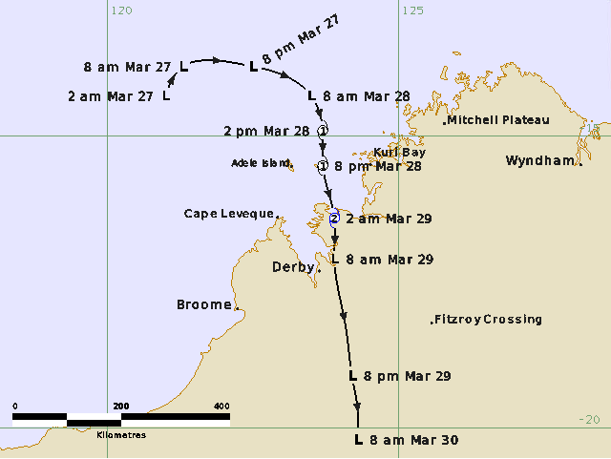

Figure 1 Best track of Dianne 27 - 30 March 2025. Times in AWST (UTC+8 hours)

|  |  |  |  |  |  |  |  |  |  |  |  |  |
| --- | --- | --- | --- | --- | --- | --- | --- | --- | --- | --- | --- | --- |
| Year | Month | Day | Hour (UTC) | Pos. Lat. (S) | Pos. Long. (E) | Pos. Acc. (nm) | Max. Wind (kn) | Wind Gust (kn) | Cent. Press (hPa) | Radius of Gales NE/SE/SW/NW (nm) | Radius of Storm NE/SE/SW/NW (nm) | RMW (nm) |
| 2025 | 3 | 26 | 1800 | 14.3 | 121.0 | 30 | 25 | 45 | 999 | -/-/-/- | -/-/-/- |  |
| 2025 | 3 | 27 | 0000 | 13.8 | 121.3 | 20 | 30 | 45 | 998 | -/-/-/- | -/-/-/- |  |
| 2025 | 3 | 27 | 0600 | 13.7 | 121.9 | 20 | 30 | 45 | 997 | -/-/-/- | -/-/-/- |  |
| 2025 | 3 | 27 | 1200 | 13.8 | 122.5 | 30 | 30 | 45 | 997 | -/-/-/- | -/-/-/- |  |
| 2025 | 3 | 27 | 1800 | 13.9 | 122.9 | 30 | 35* | 50 | 994 | -/-/-/60 | -/-/-/- |  |
| 2025 | 3 | 28 | 0000 | 14.3 | 123.5 | 20 | 35* | 50 | 992 | 50/-/-/60 | -/-/-/- |  |
| 2025 | 3 | 28 | 0600 | 14.9 | 123.7 | 20 | 40 | 55 | 989 | 50/-/40/60 | -/-/-/- | 15 |
| 2025 | 3 | 28 | 1200 | 15.5 | 123.7 | 15 | 45 | 65 | 986 | 40/40/40/50 | -/-/-/- | 12 |
| 2025 | 3 | 28 | 1800 | 16.4 | 123.9 | 20 | 50 | 70 | 984 | 40/15/20/40 | -/-/-/20 | 10 |
| 2025 | 3 | 29 | 0000 | 17.1 | 123.9 | 20 | 35 | 50 | 992 | -/-/20/35 | -/-/-/- |  |
| 2025 | 3 | 29 | 0600 | 18.3 | 124.1 | 20 | 30 | 45 | 997 | -/-/-/- | -/-/-/- |  |
| 2025 | 3 | 29 | 1200 | 19.1 | 124.2 | 15 | 25 | 45 | 999 | -/-/-/- | -/-/-/- |  |
| 2025 | 3 | 29 | 1800 | 19.7 | 124.3 | 45 | 25 | 45 | 1000 | -/-/-/- | -/-/-/- |  |
| 2025 | 3 | 30 | 0000 | 20.2 | 124.3 | 30 | 25 | 45 | 1000 | -/-/-/- | -/-/-/- |  |
| 2025 | 3 | 30 | 0600 | 20.2 | 124.3 | 10 | 25 | 45 | 997 | -/-/-/- | -/-/-/- |  |

Table 1 Best track summary for Tropical Cyclone Dianne, 27-30 March 2025.

UTC=AWST+8h. * Not a tropical cyclone as gales less than halfway around centre.

1. Meteorological description
   1. Intensity analysis

Aided by the passage of an Equatorial Rossby Wave (Figure 2), a tropical low was first analysed within the monsoon trough to the northwest of the Kimberley at 1800 UTC 26 March. Scatterometry showed 25 knot winds when the tropical low initially formed which increased marginally to 30 knots as the low consolidated during 27 March.

Despite some initial vertical wind shear, the environment was otherwise favourable for further development with sea surface temperatures higher than 30°C and high atmospheric moisture. As the vertical wind shear decreased, gales first developed at 1800 UTC 27 March on the northern side (Figure 3) and Dianne developed into a tropical cyclone at 0600 UTC 28 March. Dianne continued to strengthen through the afternoon and into the evening right up until coastal crossing. Sustained winds at Adele Island reached 41 knots shortly before 0800 UTC and then 47 knots at Koolan Island just after 1800 UTC, around the time of coastal crossing.

Dianne's peak intensity was 50 knots at 1800 UTC 28 March at roughly the same time it was crossing the coast. This was based on the observations from Koolan Island, though is in general agreement with available objective aids (Figure 4). Dvorak intensity estimates were consistently lower than radiometry and scatterometry data which themselves varied in intensity and were affected by land contamination in Dianne's stronger stages. However, all had at least gale force winds in the lead up to coastal crossing with the strongest SAR pass at 1032 UTC 28 March (Figure 5) depicting maximum winds of 59 knots (1-min mean).

After crossing the coast Dianne weakened quickly with the intensity dropping to 30 knots by 0600 UTC 29 March.

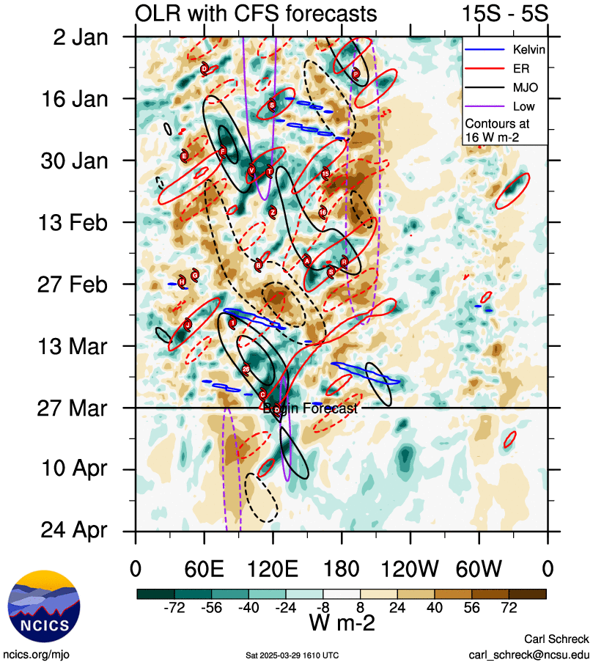

Figure 2 Hovmoller diagram of tropical waves showing the formation of Dianne occurred during an active phase of the MJO (black) coinciding with an Equatorial Rossby (ER) wave (red). The image is courtesy of the North Carolina Institute for Climate Studies. https://ncics.org/pub/mjo/archive/2025/2025-03-29/v2/

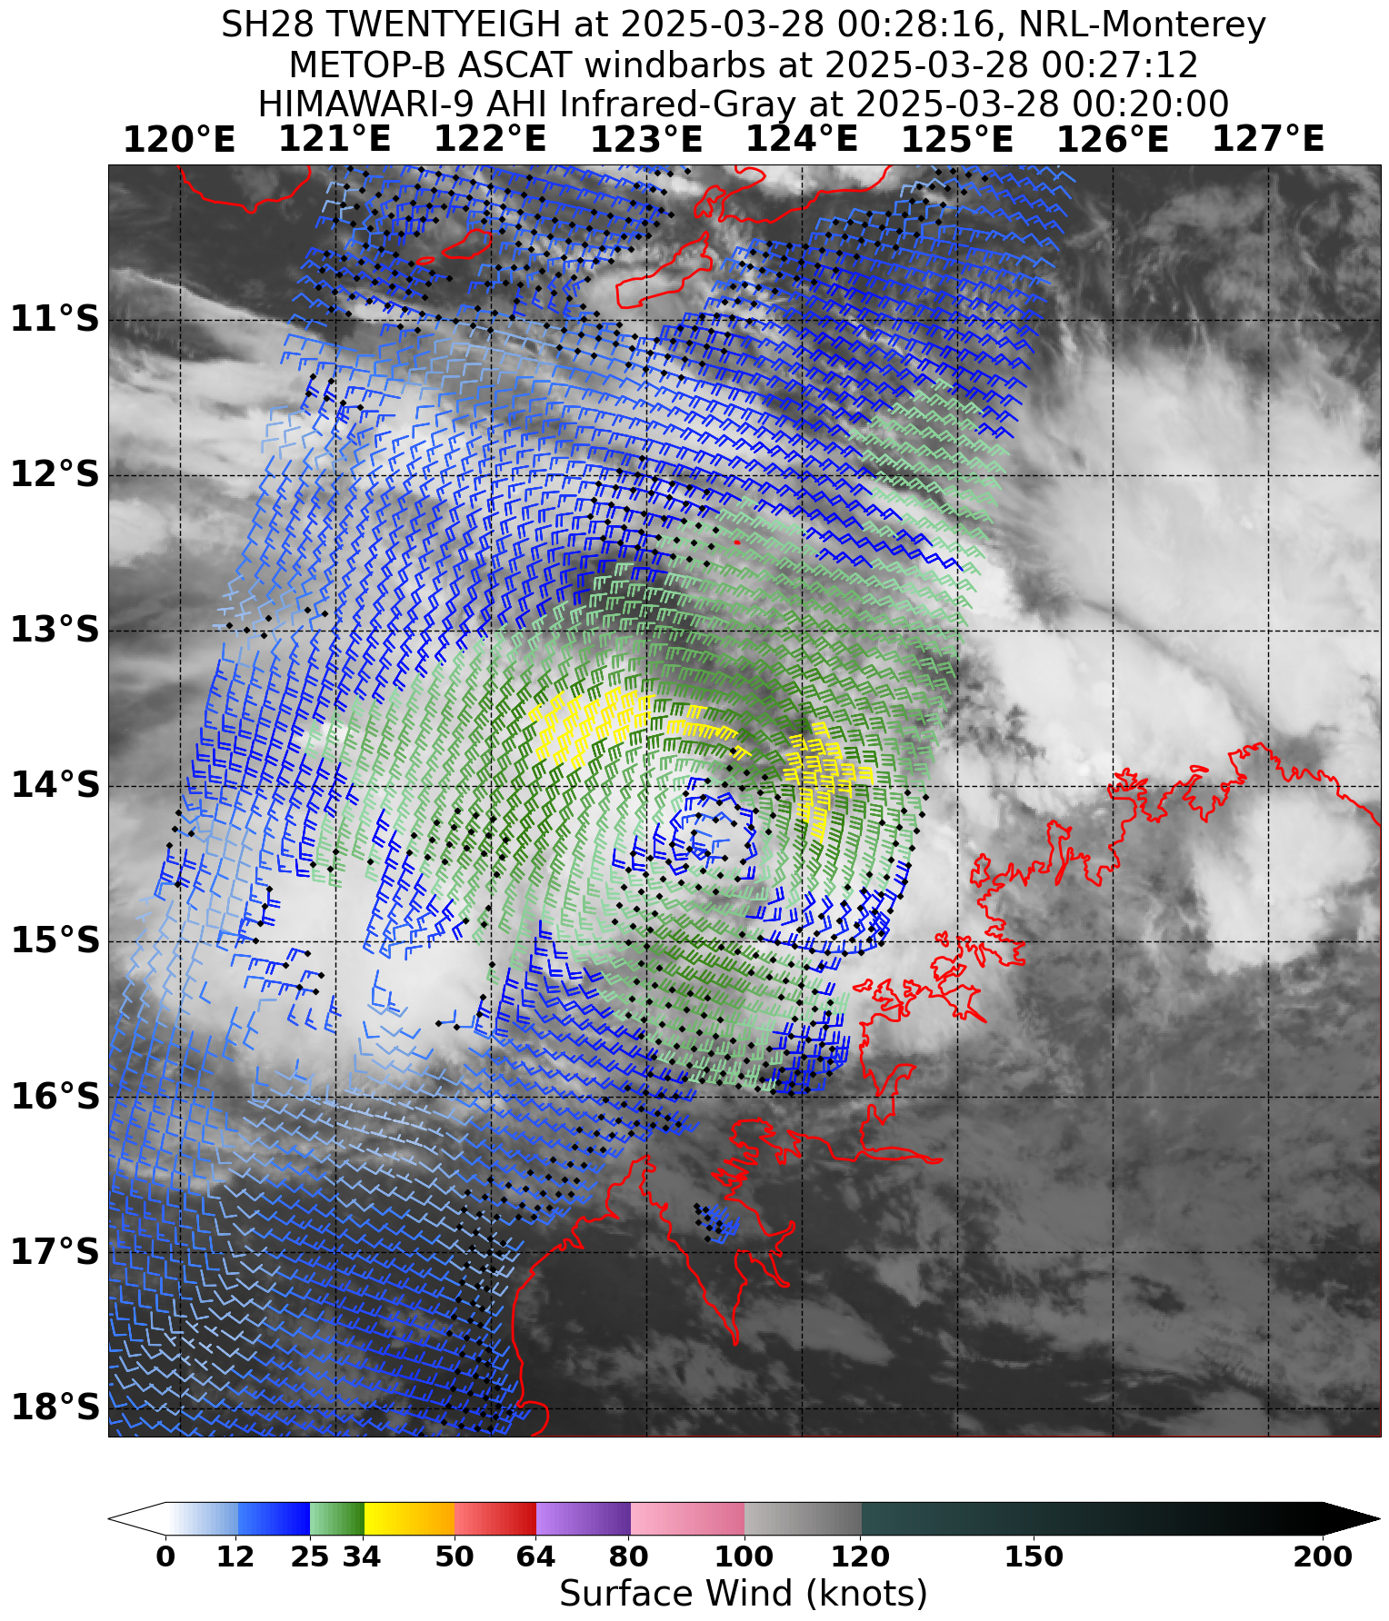

Figure 3 ASCAT pass at 0025 UTC 28 March 2025 showing gales in yellow initially confined to the northern side of the developing tropical low that later became Dianne. Image courtesy NRL. https://www.nrlmry.navy.mil/TC.html

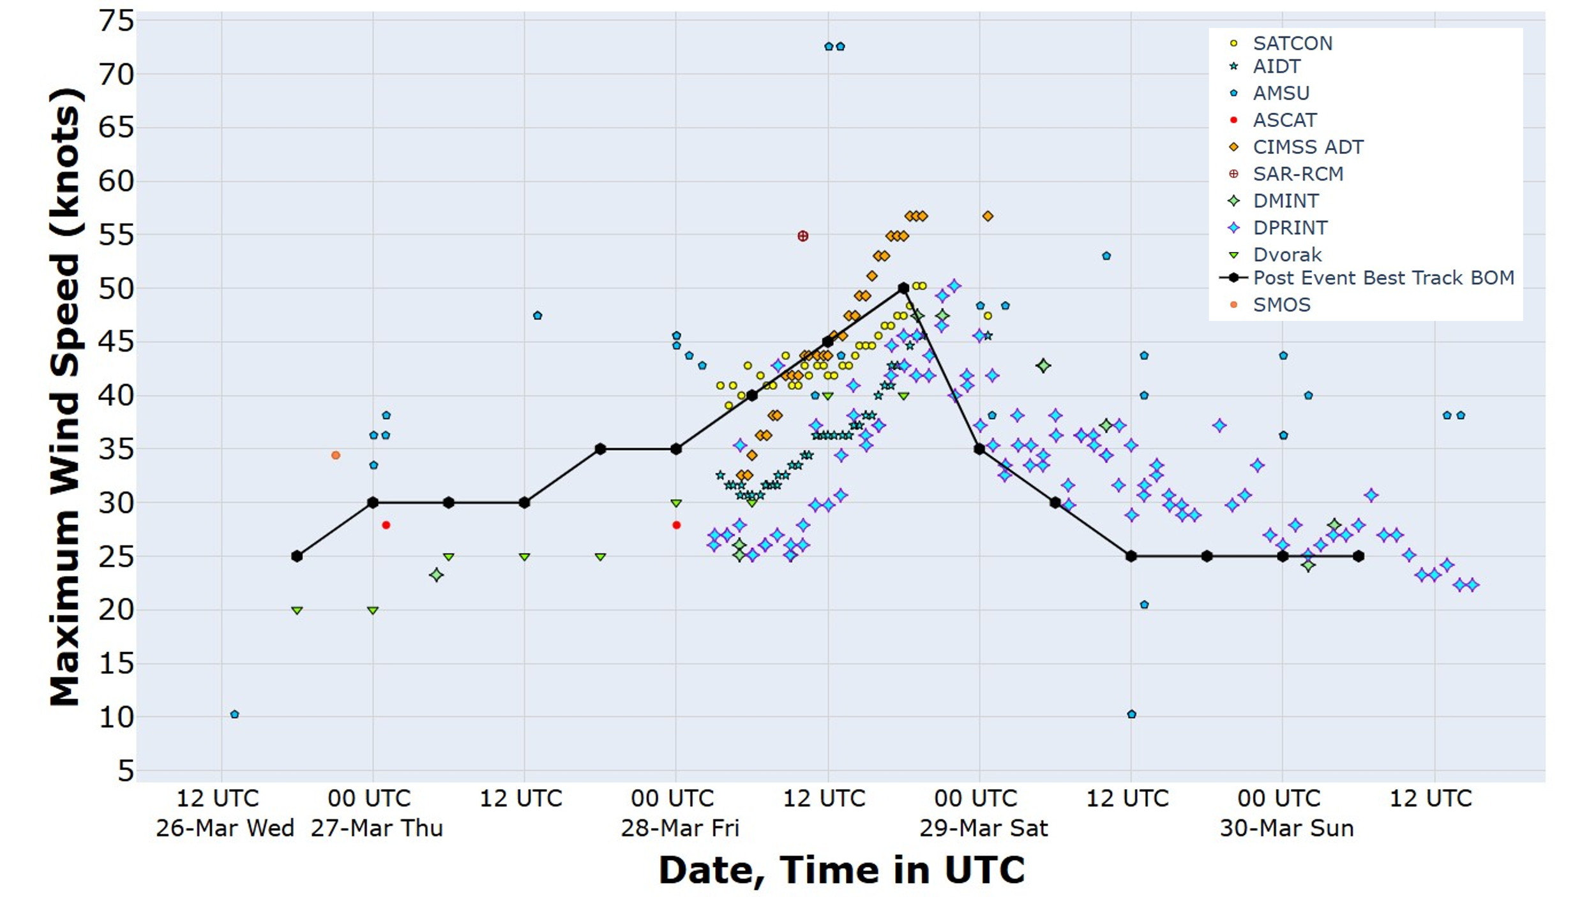

Figure 4 Comparison of objectivity intensity analysis aids and the Post Event Best Track for Tropical Cyclone Dianne.

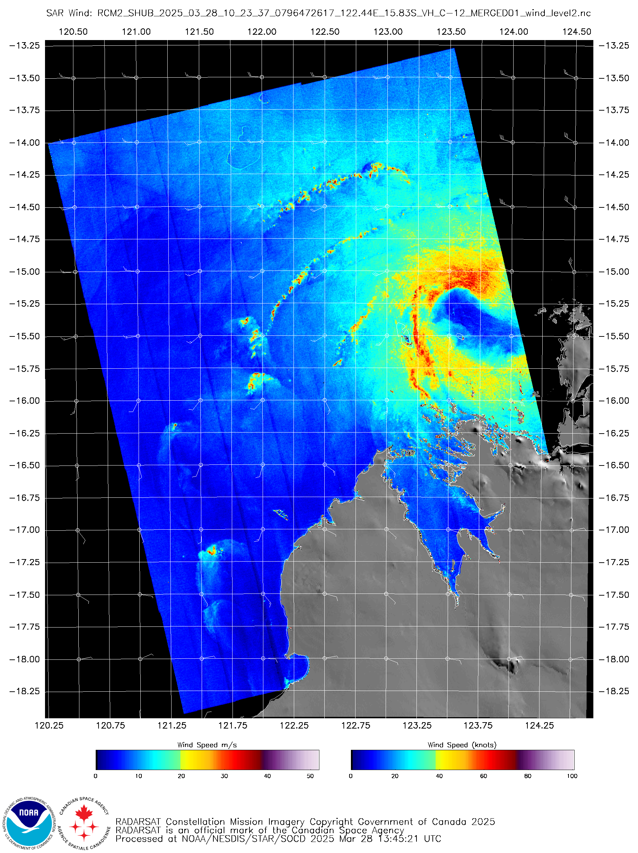

Figure 5 Synthetic Aperture Radar (SAR) pass at 1023 UTC 28 March 2025 prior to peak intensity at 1800 UTC. Image courtesy NOAA. https://www.star.nesdis.noaa.gov/socd/mecb/sar/sarwinds_tropical.php

* 1. Structure

Dianne was a small tropical cyclone throughout its brief lifetime. Assisted by the monsoon flow, gales first developed to the north of the system centre to a radius of approximately 60 nm (110 km) between 1200 UTC and 1800 UTC 27 March (Figure 3). Gales then extended into the southwestern quadrant from 0600 UTC 28 March and the southeast quadrant by 1200 UTC 28 March.

As Dianne both continued to intensify and approached the coast, the radius of gales decreased to 40 nm (75 km). The brief period of storm force winds was confined to the northwest quadrant and within 20 nm (35 km) of the centre. After coastal crossing the coast gales continued in King Sound, to the west of the centre, till shortly after 0000 UTC 29 March.

The RMW was initially 15 nm (30 km) decreasing as Dianne intensified to 10 nm (20 km) at peak intensity as it crossed the Kimberley coast.

* 1. Motion

The tropical low that became Dianne moved initially to the northeast under the influence of a mid-level trough to the southeast. The trough then retrogressed to the west, slipping to the south of the tropical low. The low made its way around the northern periphery of the trough, moving further east before turning to the south. This movement to the south then persisted through to coastal crossing and beyond, steered by the northerly flow along the eastern side of the mid-level trough.

1. Impact

Heavy rainfall caused minor impacts to road networks around Derby on the morning of 29 March, otherwise no other impacts to buildings or residents were reported.

1. Observations
   1. Wind

Damaging wind gusts were recorded at Adele Island and Koolan Island with the strongest wind gust during Tropical Cyclone Dianne being 62 kn (115 km/h) at Koolan Island, reported at 1823 UTC 28 March (02:23 AWST 29 March).

The strongest 10-minute sustained winds were also recorded at Koolan Island peaking marginally below the threshold for storm force winds, reaching 47 kn (87 km/h) at 1813 UTC 28 March (02:13 AWST 29 March).

No locations on the mainland reported damaging wind gusts with the strongest being 80 km/h at both Derby Airport and Curtin RAAF Base, occurring at 0041 UTC (08:41 AWST) 29 March and 0043 UTC (08:43 AWST) 29 March respectively. Derby Airport was also the mainland location which reported the strongest 10-minute sustained winds, peaking marginally below gale force at 33 kn (62 km/h) at 0043 UTC (08:43 AWST) 29 March.

A summary of stations that reported damaging wind gusts or stronger is included below.

**Koolan Island** recorded gale force winds intermittently from 1451 to 2057 UTC 28 March (22:51 AWST 28 March to 04:57 AWST 29 March) including an extended period of continuous gale force winds or stronger between 1741 and 2037 UTC 28 March (01:41 to 04:37 AWST 29 March). The maximum 10-minute mean wind recorded was 47 kn (87 km/h) at 1813 UTC 28 March (02:13 AWST 29 March) and the maximum wind gust recorded was 62 kn (115 km/h) at 1823 UTC 28 March (02:23 AWST 29 March).

**Adele Island** recorded gale force winds intermittently from 0743 to 0924 UTC 28 March (15:43 to 17:24 AWST 28 March). The maximum 10-minute mean wind recorded was 41 kn (75 km/h) at 0757 UTC 28 March (15:57 AWST 28 March) and the maximum wind gust recorded was 51 kn (94 km/h) at 0751 UTC 28 March (15:51 AWST 28 March).

* 1. Precipitation

Heavy rain associated with Dianne was recorded at Derby Airport on the morning of 29 March. 99.2 mm was recorded between 2235 UTC 28 March and 0135 UTC 29 March, exceeding the 3-hourly 10% Annual Exceedance Probability (AEP). This largely overlapped with a 6-hourly total of 133.4 mm between 1859 UTC 28 March and 0059 UTC 29 March, exceeding the 5% (AEP).

Other notable totals were Curtin RAAF Base recording 127.2 mm in a 12-hour period between 1500 UTC 28 March and 0300 UTC 29 March and Koolan Island recording 126.6 mm in a 12-hour period between 0844 UTC and 2043 UTC 28 March.

A map of daily totals is in Figure 6.

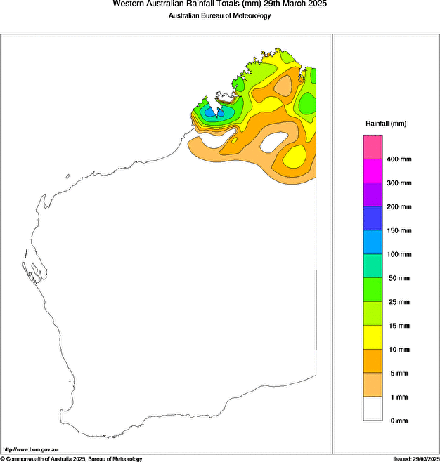

Figure 6 Rainfall analysis for the 24 days till 9am on 29 March 2025 showing heavy falls because of Dianne mostly confined to near the point of coastal crossing. Analysis does not include Koolan Island total.

* 1. Storm Surge

No significant storm surge was recorded during Tropical Cyclone Dianne.

1. Forecast Performance

The accuracy statistics for Tropical Cyclone Dianne are below in Table 2 and shown in Figure 7 and Figure 8. The statistics generally suffer from a small sample size, particularly beyond 36 hours and being such a short-lived event there is no data for 96 hours and beyond.

Although the sample sizes are very small, for both forecast intensity and position, accuracy was similar at analysis time (+00 hour) to the 5-year average and then considerably better beyond that.

The seven-day forecast for 28U commenced on 24 March. The probability of Dianne developing into a tropical cyclone was initially Low but increased to Moderate on 25 March and High (>50%) on 27 March. The peak likelihood of Dianne being a tropical cyclone was consistently the evening of 28 March. A Forecast Track Map was first issued at 0000 UTC 27 March, along with an Ocean Wind Warning, and continued until 0000 UTC 29 March. The first Tropical Cyclone Advice was issued at 0600 UTC 27 March.

|  |  |  |  |  |  |  |  |  |
| --- | --- | --- | --- | --- | --- | --- | --- | --- |
| Time | 00 | 12 | 24 | 36 | 48 | 72 | 96 | 120 |
| Position accuracy (km) | 19 | 41 | 46 | 52 | 74 | 52 | - | - |
| Intensity accuracy (knots) | 3.3 | 2.8 | 3.9 | 3.8 | 0 | 3.8 | - | - |
| Sample size | 9 | 9 | 9 | 8 | 6 | 2 | 0 | 0 |

Table 2. Verification statistics for Tropical Cyclone Dianne. * Note, verification is performed using the Official Forecast Tracks at the standard times of 00, 06,12 and 18 UTC.

Figure 7 Position accuracy figures for Tropical Cyclone Dianne.

Figure 8 Intensity accuracy figures for Tropical Cyclone Dianne.

Appendix: List of abbreviations

|  |  |
| --- | --- |
| Abbreviation | Term |
| ADT | Advanced Dvorak Technique |
| ACST | Australian Central Standard Time |
| AEST | Australian Eastern Standard Time |
| AiDT | AI-enhanced Dvorak Technique |
| AMSR2 | Advanced Microwave Scanning Radiometer |
| AMSU | Advanced Microwave Sounding Unit |
| ASCAT | Advanced Scatterometer |
| ATMS | Advanced Technology Microwave Sounder |
| AWS | automatic weather station |
| AWST | Australian Western Standard Time |
| °C | Celsius |
| CI | Current intensity |
| CIMSS | Cooperative Institute for Meteorological Satellite Studies (USA) |
| CIRA | Cooperative Institute for Research in the Atmosphere (USA) |
| D-MINT | Deep learning - Multispectral Intensity of TCs (formerly known as DMN) |
| D-PRINT | Deep learning - IR Intensity of TCs (formerly known as OPEN-AIIR) |
| EIR | Enhanced InfraRed |
| ERC | eyewall replacement cycle |
| FNMOC | Fleet Numerical Meteorology and Oceanography Centre (USA) |
| FT | Final T-number |
| GCOM | Global Change Observation Mission |
| GHz | Gigahertz |
| GMI | Global Precipitation Measurement Microwave Imager |
| h | hour |
| hPa | hectopascal |
| HSCAT | Hai Yang 2 Scatterometer (HY-2B, HY-2C) |
| km | kilometres |
| km/h | kilometres per hour |
| kn | knot |
| LLCC | LLCC |
| MET | Model Expected T-number |
| METOP | Meteorological Operational Satellite |
| MJO | Madden-Julian Oscillation |
| mm | millimetres |
| MSLP | mean sea level pressure |
| NESDIS | National Environmental Satellite, Data, and Information Service |
| nm | nautical mile |
| NOAA | National Oceanic and Atmospheric Administration |
| NRL | Navy Research Lab (USA) |
| OPEN-AiiR | Ordered Pattern Encoding AI Infrared |
| PAT | Pattern T-number |
| RCM | RadarSat Constellation Mission – Synthetic Aperture Radar |
| RH | relative humidity |
| RMW | radius of maximum winds |
| RSMC | Regional Specialised Meteorological Centre |
| SAR | Synthetic Aperture Radar |
| SATC | CIMSS Advanced Dvorak Technique |
| SATCON | Satellite Consensus |
| SEN1 | Sentinel-1A – Synthetic Aperture Radar |
| SMAP | Soil Moisture Active Passive |
| SMOS | Soil Moisture and Ocean Salinity |
| SSMIS | Special Sensor Microwave Imager/Sounder |
| TC | Tropical Cyclone |
| TCWC | Tropical Cyclone Warning Centre |
| UTC | Universal Time Co-ordinated |