Tropical Cyclone Ellie (09U)

# 30 January – 3 February 2009

## Joe Courtney, Tropical Cyclone Environmental Prediction Services

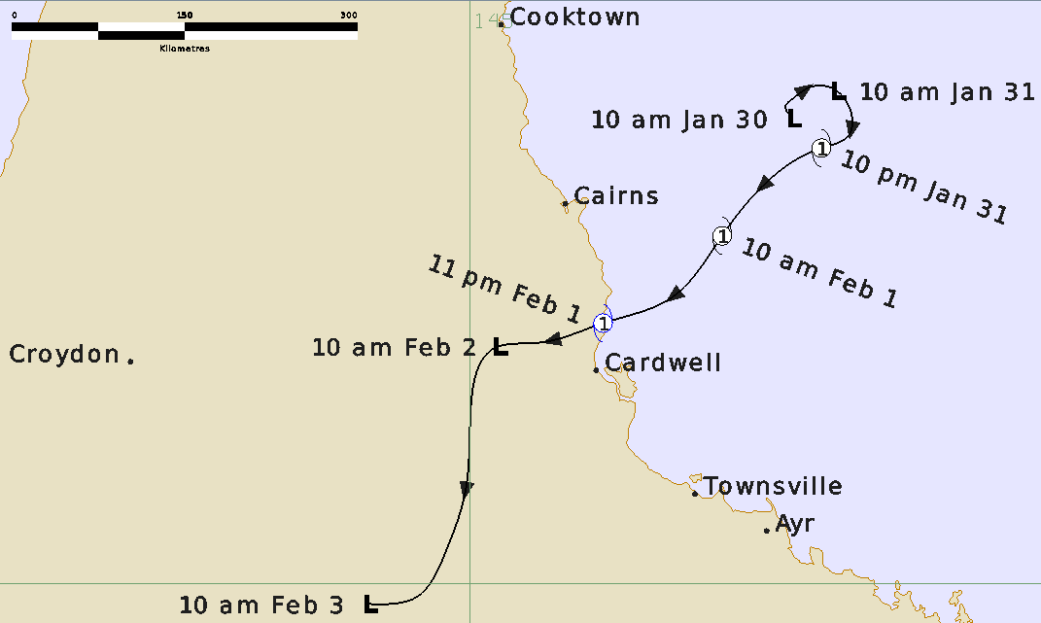

**Revision history**

|  |  |  |  |
| --- | --- | --- | --- |
| Date | Version | Author | Description |
| 29/04/2025 | 1.0 | Joe Courtney | Final draft based on unpublished information from 2009. |

**Review status**

|  |  |  |  |
| --- | --- | --- | --- |
| Date | Version | Reviewer | Description |
| 30/04/2025 | 1.0 | Linda Paterson | Completed |

**Release history**

|  |  |  |  |
| --- | --- | --- | --- |
| Date | Version | Status | Approval |
| 01/05/2025 | 1.0 | Approved for release | David Grant |

Contact details:

Tropical Cyclone Team Lead

Severe Weather Environmental Prediction Services

Bureau of Meteorology

PO Box 1370, West Perth WA 6872

Email: [tcwc@bom.gov.au](mailto:tcwc@bom.gov.au)



This work is copyright. Apart from any use as permitted under the Copyright Act 1968, no part may be reproduced without prior written permission from the Bureau of Meteorology. Refer to www.bom.gov.au/other/copyright.shtml for further information. Unless otherwise noted, all images in this document are licensed under the Creative Commons Attribution Australia Licence.

© Commonwealth of Australia 2025

Published by the Bureau of Meteorology

Cover image: Track of Tropical Cyclone Ellie 2009. Times in AEST (UTC+10h)

Contents

1. Summary 5

2. Meteorological description 6

2.1. Intensity analysis 6

2.2. Structure 6

2.3. Motion 6

3. Impact 9

4. Observations 9

4.1. Wind 9

4.2. Rainfall 9

4.3. Pressure 9

4.4. Storm surge 9

Appendix: List of abbreviations 11

**List of Figures**

Figure 1 Best track of Ellie 30 January- 3 February 2009. 5

Figure 2, SSMIS 85GHz image from 2117 UTC 31 January 2009. 7

Figure 3 Clump Point barograph showing a minimum pressure of 991 hPa.. 8

Figure 4. Weekly rainfall totals, 29 January to 4 February 2009. 10

**List of Tables**

Table 1 Best track summary for Tropical Cyclone Ellie, 31 January-2 February 2009.. 6

1. Summary

Tropical cyclone Ellie was a short-lived event that crossed the north Queensland coast as a category 1 system at Clump Point, near Mission Beach south of Cairns, late on 1 February 2009. The main impact from cyclone Ellie was due to heavy rain as the system weakened into a rain depression. Flooding occurred mainly in the Herbert River catchment. This event was part of a broader period of flooding across northern Queensland in January and February 2009.

Figure 1 shows the best track of Ellie while Table 1 is a summary of the best track data.



Figure 1 Best track of Ellie 30 January- 3 February 2009. Times in AEST (UTC+10 hours)

|  |  |  |  |  |  |  |  |  |  |  |  |  |
| --- | --- | --- | --- | --- | --- | --- | --- | --- | --- | --- | --- | --- |
| Year | Mon | Day | Hour UTC | Pos.  Lat. S | Pos. Long.E. | Pos Acc. nm | Max Wind10minkn | Max Gust kn | Cent.PresshPa | Rad. of gales NE/SE/SW/NW | Rad. of storm | RMW  nm |
| 2009 | 01 | 31 | 00 | 16.0 | 148.0 | 30 | 25 | 45 | 998 |  |  |  |
| 2009 | 01 | 31 | 06 | 16.4 | 148.1 | 25 | 25 | 45 | 995 |  |  |  |
| 2009 | 01 | 31 | 12 | 16.5 | 147.8 | 35 | 35 | 50 | 991 | -/50/30/40 |  | 20 |
| 2009 | 01 | 31 | 18 | 16.6 | 147.6 | 40 | 40 | 55 | 988 | 30/50/50/50 |  | 18 |
| 2009 | 02 | 01 | 00 | 17.2 | 147.0 | 40 | 40 | 55 | 991 | 40/50/50/50 |  | 18 |
| 2009 | 02 | 01 | 06 | 17.7 | 146.6 | 40 | 40 | 55 | 990 | 40/50/50/40 |  | 18 |
| 2009 | 02 | 01 | 12 | 17.9 | 146.2 | 35 | 35 | 50 | 991 | 40/50/30/30 |  | 18 |
| 2009 | 02 | 01 | 18 | 18.1 | 145.6 | 30 | 30 | 40 | 995 |  |  |  |
| 2009 | 02 | 02 | 00 | 18.1 | 145,2 | 30 | 25 | 40 | 997 |  |  |  |

Table 1 Best track summary for Tropical Cyclone Ellie, 31 January-2 February 2009. UTC=AEST-10h.

1. Meteorological description
   1. Intensity analysis

A tropical low developed late in January in the Coral Sea off the far north Queensland coast. Initially the system was affected by easterly wind shear. The system intensified on 31 January as the centre moved closer to the deep convection and became more organised as the wind shear reduced. Tropical cyclone intensity was attained at 1200 UTC 31 January as Dvorak DT estimates reached 3.0. The SSMI 91 GHz microwave on 2117 UTC, 31 January indicated vigorous deep convection near and west of the centre (refer Figure 2).

Ellie remained at category 1 intensity for just over 24 hours through until landfall late on 1 February having a peak intensity of 40 kn (75 km/h) prior to making landfall. A significant increase in convection was observed as the system made landfall. Observations from reef platforms in the area indicated mean winds of at least 40 knots (75 km/h) occurred with this system. Ellie made landfall near Clump Point where a minimum pressure of 991 hPa was recorded (refer Figure 3).

* 1. Structure

Initially gale radii were around 50 nm (95 km) in western and southern quadrants. Ellie became a little more symmetric as it approached the coast until land reduced the extent of gales west of the centre. The radius to maximum winds (RMW) was around 18-20 nm (35 km) during the time at cyclone intensity.

* 1. Motion

Ellie generally moved towards the southwest at between 5-8 kn (10 and 15 km/h) under the influence of a mid-level ridge to the southeast.

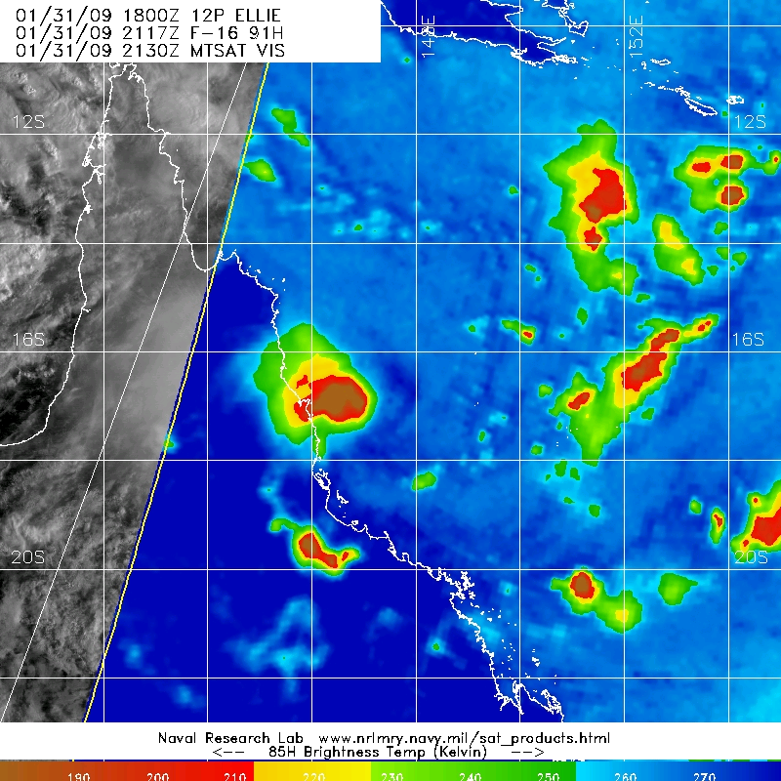

Figure 2, SSMIS 85GHz image from 2117 UTC 31 January 2009. Image courtesy of US NRL: http://www.nrlmry.navy.mil/

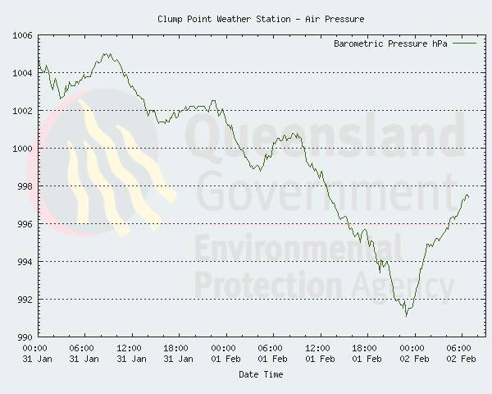

Figure 3 Clump Point barograph showing a minimum pressure of 991 hPa. Time in AEST (UTC+10h). Data courtesy of Queensland Environmental Protection Agency.

1. Impact

No significant wind impacts were observed with cyclone Ellie.

However, flooding did occur as a result of heavy rainfall after landfall, chiefly in the Herbert River catchment. This event was part of a broader period of flooding across northern Queensland in January and February 2009.

1. Observations
   1. Wind

Observations from the reef platforms in the area indicated mean winds of at least 40 kn (75 km/h) occurred with cyclone Ellie.

* 1. Rainfall

Heavy rainfall developed about the coast and ranges between Cardwell and Bowen including after landfall. This heavy rainfall was focused mainly on the Herbert River catchment. The weekly rainfall to 4 February is shown in Figure 4. Heavy rainfall continued in the days following Ellie's landfall and some of these are also listed below. Over the three days to 4 February Hawkins Creek recorded 920 mm and Ingham Pump Station recorded 798 mm.

Notable daily rainfall totals associated around the time of landfall of Ellie included:

31 January: Dunk Island 322 mm; El Arish PO 306.8 mm; Bingil Bay 232.5 mm; Japoonvale 232 mm; Tully Sugar Mill 209 mm;

2 February: 304 mm Yourka Alert; 293 Ingham Pump Stn; 286 mm Running Ck; Ingham 282 mm; Victoria Sugar Mill 251 mm.

3 February: Ingham Pump Stn 202 mm.

4 February: Hawkins Creek 497 mm; Cardwell Range 467 mm; Bemerside 400 mm; Gairloch 373 mm; Ingham Pump Stn 303 mm.

* 1. Pressure

As Ellie crossed the coast, a Queensland Environmental Protection Authority barometer at Clump Point, near Mission Beach, indicated a minimum pressure of 991 hPa as shown in Figure 3.

* 1. Storm surge

No significant storm surge was recorded with tropical cyclone Ellie.

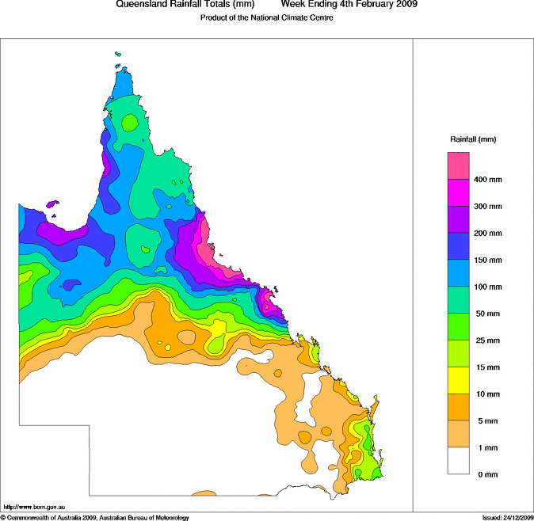

Figure 4. Weekly rainfall totals, 29 January to 4 February 2009.

Appendix: List of abbreviations

|  |  |
| --- | --- |
| Abbreviation | Term |
| ADT | Advanced Dvorak Technique |
| ACST | Australian Central Standard Time |
| AEST | Australian Eastern Standard Time |
| AiDT | AI-enhanced Dvorak Technique |
| AMSR2 | Advanced Microwave Scanning Radiometer |
| AMSU | Advanced Microwave Sounding Unit |
| ASCAT | Advanced Scatterometer |
| ATMS | Advanced Technology Microwave Sounder |
| AWS | automatic weather station |
| AWST | Australian Western Standard Time |
| °C | Celsius |
| CI | Current intensity |
| CIMSS | Cooperative Institute for Meteorological Satellite Studies (USA) |
| CIRA | Cooperative Institute for Research in the Atmosphere (USA) |
| D-MINT | Deep learning - Multispectral Intensity of TCs (formerly known as DMN) |
| D-PRINT | Deep learning - IR Intensity of TCs (formerly known as OPEN-AIIR) |
| DT | Dvorak Data T number |
| EIR | Enhanced InfraRed |
| ERC | eyewall replacement cycle |
| FNMOC | Fleet Numerical Meteorology and Oceanography Centre (USA) |
| FT | Final T-number |
| GCOM | Global Change Observation Mission |
| GHz | Gigahertz |
| GMI | Global Precipitation Measurement Microwave Imager |
| h | hour |
| hPa | hectopascal |
| HSCAT | Hai Yang 2 Scatterometer (HY-2B, HY-2C) |
| km | kilometres |
| km/h | kilometres per hour |
| kn | knot |
| LLCC | LLCC |
| MET | Model Expected T-number |
| METOP | Meteorological Operational Satellite |
| MJO | Madden-Julian Oscillation |
| mm | millimetres |
| MSLP | mean sea level pressure |
| NESDIS | National Environmental Satellite, Data, and Information Service |
| nm | nautical mile |
| NOAA | National Oceanic and Atmospheric Administration |
| NRL | Navy Research Lab (USA) |
| OPEN-AiiR | Ordered Pattern Encoding AI Infrared |
| PAT | Pattern T-number |
| RCM | RadarSat Constellation Mission – Synthetic Aperture Radar |
| RH | relative humidity |
| RMW | radius of maximum winds |
| RSMC | Regional Specialised Meteorological Centre |
| SAR | Synthetic Aperture Radar |
| SATC | CIMSS Advanced Dvorak Technique |
| SATCON | Satellite Consensus |
| SEN1 | Sentinel-1A – Synthetic Aperture Radar |
| SMAP | Soil Moisture Active Passive |
| SMOS | Soil Moisture and Ocean Salinity |
| SSMIS | Special Sensor Microwave Imager/Sounder |
| TC | Tropical Cyclone |
| TCWC | Tropical Cyclone Warning Centre |
| UTC | Universal Time Co-ordinated |