Severe Tropical Cyclone Errol (29U)

**9 – 18 April 2025**

**Matthew Boterhoven and Alessandro Paduano**

**Tropical Cyclone Environmental Prediction Services**

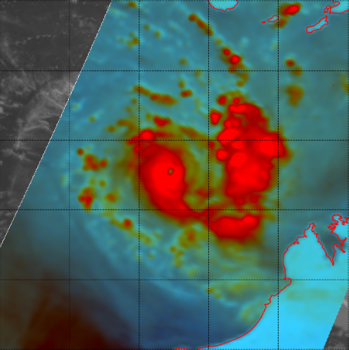

**Revision history**

|  |  |  |  |
| --- | --- | --- | --- |
| Date | Version | Author | Description |
| 28/05/2025 | 1.0 | Matthew Boterhoven  Alessandro Paduano | Final draft |

**Review status**

|  |  |  |  |
| --- | --- | --- | --- |
| Date | Version | Reviewer | Description |
| 30/05/2025 | 1.0 | Steph Bond | Completed |

**Release history**

|  |  |  |  |
| --- | --- | --- | --- |
| Date | Version | Status | Approval |
| 3/07/2025 | 1.0 | Approved for release | Andrew Burton |

Contact details:

Tropical Cyclone Team Lead

Severe Weather Environmental Prediction Services

Bureau of Meteorology

PO Box 1370, West Perth WA 6872

Email: [tcwc@bom.gov.au](mailto:tcwc@bom.gov.au)



This work is copyright. Apart from any use as permitted under the Copyright Act 1968, no part may be reproduced without prior written permission from the Bureau of Meteorology. Refer to www.bom.gov.au/other/copyright.shtml for further information. Unless otherwise noted, all images in this document are licensed under the Creative Commons Attribution Australia Licence.

© Commonwealth of Australia 2025

Published by the Bureau of Meteorology

Cover image: GMI 91 GHz composite satellite image of Severe Tropical Cyclone Errol at 2131 UTC 16 April (0531 AWST 17 April), just after the system reached peak intensity. Image courtesy of NRL. https://www.nrlmry.navy.mil/TC.html

Table of Contents

1. Summary 5

2. Meteorological description 8

2.1. Intensity analysis 8

2.2. Structure 15

2.3. Motion 15

3. Impact 15

4. Observations 16

4.1. Wind 16

4.2. Precipitation 16

4.3. Pressure 16

4.4. Storm Surge 16

5. Forecast Performance 18

Appendix: List of abbreviations 20

**List of Figures**

Figure 1: Best track of Severe Tropical Cyclone Errol from 9-18 April 2025. Times are in AWST (UTC+8 hours). 6

Figure 2: Hovmoller diagram of tropical waves over the latitude range of 5-15S. The formation of Errol (the system annotated E) occurred in the absence of any major tropical waves, with only a background low-frequency wave analysed (denoted by the purple contour). The image is courtesy of the North Carolina Institute for Climate Studies: https://ncics.org/pub/mjo/archive/2025/2025-04-19/v2/ 10

Figure 3: *Left*: 13 April 0000Z ECMWF (left) model run for the 0600 UTC timestep on 13 April. Relative vorticity contours for 850 hPa (red), 700 hPa (yellow), 500 hPa (green), and 300 hPa (blue) displayed, in addition to 850-300 hPa averaged winds in knots (wind barbs) and 500 hPa geopotential height contours (black contours). The guidance indicates that the 500 hPa vorticity (green) has become displaced to the southeast of the low-level circulation at this time. *Right*: Satellite derived deep-layer vertical wind shear contours overlaid on Himawari-9 satellite imagery at 0600 UTC 13 April. The system lies off the north Kimberley coast in an area of low deep-layer vertical wind shear. Image courtesy of CIMMS: https://cimss.ssec.wisc.edu/ 11

Figure 4: Satellite scatterometry from OCEANSAT-3 at 0359 UTC 15 April (left) and satellite wind speeds from SMOS at 0946 UTC 15 April (right). The earlier OCEANSAT-3 scatterometry shows gales in the southern quadrants, with the later SMOS pass indicating that gales have expanded to all four quadrants and that Errol reached tropical cyclone intensity between these two satellite passes. Images courtesy NRL: https://www.nrlmry.navy.mil/TC.html 11

Figure 5: Satellite wind speeds from SAR at 1032 UTC 16 April just prior to the time of peak intensity. Hurricane force winds wrap around the system centre, with peak winds of 125 kn (230 km/h) present in the northeastern quadrant, and peak winds exceeding 100 kn (185 km/h) present in the remaining quadrants. The system is very compact, with a radius of maximum winds of 4 nm (7.4 km). Image courtesy of NOAA https://www.star.nesdis.noaa.gov/socd/mecb/sar/sarwinds_tropical.php 12

Figure 6: Infrared satellite imagery from Himawari-9 at 1300 UTC 16 April (left) and colour composite microwave imagery from GMI at 2134 UTC 16 April (right). Both images show Errol as a compact system at and in the hours after reaching peak intensity. Deep convection is present wrapped around a distinct infrared and microwave eye. Images courtesy NRL: https://www.nrlmry.navy.mil/TC.html 13

Figure 7: Colour composite microwave satellite imagery from GMI at 2049 UTC 17 April (left) and from AMSR2 at 0525 UTC 18 April (right). The GMI imagery shows Errol at category 2 intensity and weakening, with deep curved convection limited to the eastern side of the system. The AMSR2 imagery shows Errol just prior to weakening to a tropical low, with deep convection only persisting over land to the east of the system centre, and very little to no curvature present in the cloud signatures. Images courtesy of NRL: https://www.nrlmry.navy.mil/TC.html 13

Figure 8: Satellite derived wind speeds from ASCAT-C at 0045 UTC 18 April that indicates that areas of gales have contracted to the southern quadrants only with the maximum wind speed decreasing. Image courtesy of NRL: https://www.nrlmry.navy.mil/TC.html 14

Figure 9: Rainfall analysis for the 24 hours to 9am on 19 April 2025. The rainfall in the Kimberley is the result of the remnants of Errol crossing the Kimberley coast and moving further inland. 17

Figure 10: Position accuracy figures for Severe Tropical Cyclone Errol compared against the 5-year average. 19

Figure 11: Intensity accuracy figures for Severe Tropical Cyclone Errol compared against the 5-year average. 19

Figure 12: Intensity plot of objective and subjective guidance. SATCON, AiDT, NESDIS ADT, SAR-SEN1, AMSU, SAR-RCM, ASCAT, CIMMS ADT, DMINT, DPRINT, Dvorak subjective estimate, operational analysis (red) and post event best track analysis (black). 22

**List of Tables**

Table 1: Best track summary for Severe Tropical Cyclone Errol, 9-18 April 2025. UTC=AWST+8h. * Not a tropical cyclone as gales less than halfway around centre. 7

Table 2: Verification statistics for Severe Tropical Cyclone Errol. Note: Verification is performed using the Official Forecast Tracks at the standard times of 00, 06, 12 and 18 UTC. 18

1. Summary

Severe Tropical Cyclone Errol was a compact but intense system that underwent a period of rapid intensification, reaching category 5 strength off the Western Australian coast, before weakening and making landfall to the south of Kuri Bay as a tropical low.

A tropical low, 29U, formed on 9 April in the northern Arafura Sea. It initially tracked westward and then to the southwest, fluctuating in intensity over several days, passing within 250 km of the north Kimberley coast for the first time on 13 April. After a period of steady development, Errol reached tropical cyclone intensity at 0600 UTC 15 April (1400 AWST 15 April, AWST = UTC+8 hours). Extremely rapid intensification occurred on 15-16 April, with Errol strengthening from a 35 kn (65km/h) category 1 system to a 110 kn (205 km/h) category 5 system in 30 hours. Errol peaked around 1200 UTC 16 April (2000 AWST 16 April) with 10-minute sustained winds of 110 kn (205 km/h) and wind gusts of 155 kn (285 km/h).

On 17 April, Errol turned sharply to the southeast and weakened rapidly over the next day as it tracked eastwards towards the north Kimberley coast. Errol weakened below tropical cyclone intensity prior to crossing the coast to the south of Kuri Bay around 0900 UTC 18 April (1700 AWST 18 April). The remnants of the system continued to weaken and dissipate over the north Kimberley.

Impacts were limited due to the cyclone’s small size and remote landfall location. Heavy rainfall occurred through parts of the coastal north Kimberley as Errol approached the coast, with Koolan Island recording 68.8 mm in the 24 hours to 0900 AWST on 18 April. This heavy rainfall spread into the inland north Kimberley as the remnants of the system moved inland the following day. Kalumburu recorded 160.8 mm of rainfall in the 24 hours to 0900 AWST 19 April, which was the highest daily rainfall record for April for this station. No locations on the mainland recorded damaging wind gusts. Errol crossed over Adele Island in the hours prior to crossing the coast, with the weather station recording a peak wind gust of 55kn (102 km/h) and a lowest atmospheric pressure of 994.2 hPa.

Figure 1 shows the best track of Errol while Table 1 is a summary of the best track data.

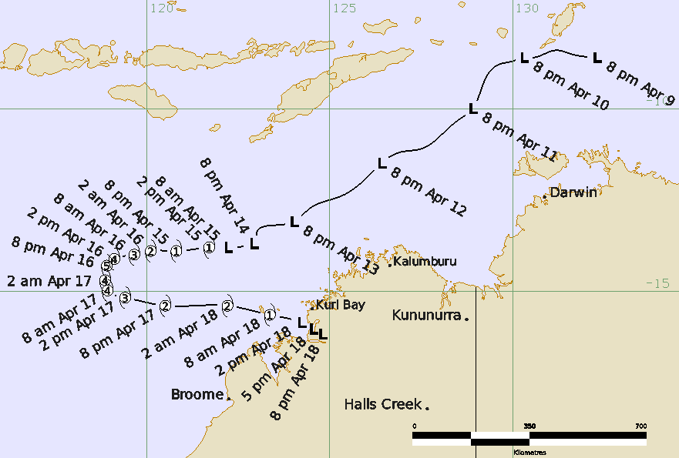

Figure 1: Best track of Severe Tropical Cyclone Errol from 9-18 April 2025. Times are in AWST (UTC+8 hours).

|  |  |  |  |  |  |  |  |  |  |  |  |  |
| --- | --- | --- | --- | --- | --- | --- | --- | --- | --- | --- | --- | --- |
| Year | Month | Day | Hour | Pos. | Pos. | Pos. | Max Wind | Max | Cent. | Rad. of gales | Rad. of storm | RMW |
|  |  |  | UTC | Lat. | Long. | Acc. | 10min | gust | Press. | (NE/SE/ | (NE/SE/ | nm |
|  |  |  |  | S | E | nm | kn | kn | hPa | SW/NW) | SW/NW) |  |
| 2025 | 4 | 9 | 1200 | 8.6 | 132.3 | 20 | 15 | 45 | 1007 | 0/0/0/0 | 0/0/0/0 | - |
| 2025 | 4 | 9 | 1800 | 8.5 | 131.6 | 25 | 15 | 45 | 1005 | 0/0/0/0 | 0/0/0/0 | - |
| 2025 | 4 | 10 | 0000 | 8.4 | 131.2 | 20 | 15 | 45 | 1006 | 0/0/0/0 | 0/0/0/0 | - |
| 2025 | 4 | 10 | 0600 | 8.6 | 130.6 | 20 | 20 | 45 | 1002 | 0/0/0/0 | 0/0/0/0 | - |
| 2025 | 4 | 10 | 1200 | 8.6 | 130.3 | 25 | 25 | 45 | 1003 | 0/0/0/0 | 0/0/0/0 | - |
| 2025 | 4 | 10 | 1800 | 8.7 | 130.0 | 25 | 30 | 45 | 1000 | 0/0/0/0 | 0/0/0/0 | - |
| 2025 | 4 | 11 | 0000 | 8.8 | 129.6 | 20 | 30 | 45 | 1001 | 0/0/0/0 | 0/0/0/0 | - |
| 2025 | 4 | 11 | 0600 | 9.1 | 129.3 | 20 | 30 | 45 | 1000 | 0/0/0/0 | 0/0/0/0 | - |
| 2025 | 4 | 11 | 1200 | 10.0 | 128.9 | 25 | 30 | 45 | 1002 | 0/0/0/0 | 0/0/0/0 | - |
| 2025 | 4 | 11 | 1800 | 10.4 | 128.4 | 25 | 35* | 50 | 999 | 0/50/50/0 | 0/0/0/0 | - |
| 2025 | 4 | 12 | 0000 | 11.1 | 127.5 | 20 | 35* | 50 | 1001 | 0/50/50/0 | 0/0/0/0 | - |
| 2025 | 4 | 12 | 0600 | 11.2 | 126.9 | 20 | 35* | 50 | 1001 | 0/50/0/0 | 0/0/0/0 | - |
| 2025 | 4 | 12 | 1200 | 11.5 | 126.4 | 25 | 30 | 45 | 1004 | 0/0/0/0 | 0/0/0/0 | - |
| 2025 | 4 | 12 | 1800 | 11.8 | 126.1 | 25 | 30 | 45 | 1003 | 0/0/0/0 | 0/0/0/0 | - |
| 2025 | 4 | 13 | 0000 | 12.4 | 125.3 | 25 | 30 | 45 | 1006 | 0/0/0/0 | 0/0/0/0 | - |
| 2025 | 4 | 13 | 0600 | 12.7 | 124.5 | 20 | 25 | 45 | 1005 | 0/0/0/0 | 0/0/0/0 | - |
| 2025 | 4 | 13 | 1200 | 13.1 | 124.0 | 20 | 30 | 45 | 1003 | 0/0/0/0 | 0/0/0/0 | - |
| 2025 | 4 | 13 | 1800 | 13.2 | 123.4 | 20 | 30 | 45 | 1002 | 0/0/0/0 | 0/0/0/0 | - |
| 2025 | 4 | 14 | 0000 | 13.4 | 123.0 | 20 | 30 | 45 | 1003 | 0/0/0/0 | 0/0/0/0 | - |
| 2025 | 4 | 14 | 0600 | 13.7 | 123.0 | 20 | 30 | 45 | 1001 | 0/0/0/0 | 0/0/0/0 | - |
| 2025 | 4 | 14 | 1200 | 13.7 | 122.9 | 20 | 35* | 50 | 1000 | 0/50/0/0 | 0/0/0/0 | - |
| 2025 | 4 | 14 | 1800 | 13.8 | 122.5 | 20 | 35* | 50 | 999 | 0/50/50/0 | 0/0/0/0 | - |
| 2025 | 4 | 15 | 0000 | 13.8 | 122.2 | 20 | 35* | 50 | 999 | 0/40/50/0 | 0/0/0/0 | - |
| 2025 | 4 | 15 | 0600 | 13.8 | 121.7 | 20 | 35 | 50 | 998 | 0/40/50/20 | 0/0/0/0 | 20 |
| 2025 | 4 | 15 | 1200 | 13.9 | 120.8 | 20 | 45 | 65 | 999 | 0/40/50/20 | 0/0/0/0 | 19 |
| 2025 | 4 | 15 | 1800 | 13.9 | 120.1 | 15 | 55 | 75 | 987 | 40/60/50/40 | 0/20/20/0 | 18 |
| 2025 | 4 | 16 | 0000 | 14.0 | 119.7 | 10 | 65 | 90 | 980 | 50/60/60/40 | 25/25/25/25 | 16 |
| 2025 | 4 | 16 | 0600 | 14.1 | 119.1 | 10 | 90 | 125 | 956 | 40/60/60/40 | 30/30/30/30 | 12 |
| 2025 | 4 | 16 | 1200 | 14.3 | 118.9 | 10 | 110 | 155 | 936 | 40/70/60/35 | 25/25/35/25 | 6 |
| 2025 | 4 | 16 | 1800 | 14.7 | 118.9 | 10 | 105 | 145 | 940 | 40/60/50/35 | 25/25/25/25 | 6 |
| 2025 | 4 | 17 | 0000 | 15.0 | 118.9 | 15 | 100 | 140 | 947 | 40/60/40/30 | 20/20/20/20 | 7 |
| 2025 | 4 | 17 | 0600 | 15.2 | 119.4 | 15 | 80 | 110 | 965 | 35/60/40/25 | 20/20/25/20 | 8 |
| 2025 | 4 | 17 | 1200 | 15.4 | 120.5 | 15 | 60 | 85 | 984 | 30/60/40/20 | 15/20/25/15 | 11 |
| 2025 | 4 | 17 | 1800 | 15.4 | 122.2 | 20 | 50 | 70 | 991 | 30/50/20/20 | 0/30/0/0 | 20 |
| 2025 | 4 | 18 | 0000 | 15.7 | 123.4 | 15 | 40 | 55 | 996 | 20/25/20/20 | 0/0/0/0 | 20 |
| 2025 | 4 | 18 | 0600 | 15.9 | 124.2 | 20 | 35* | 50 | 997 | 0/15/15/0 | 0/0/0/0 | - |
| 2025 | 4 | 18 | 0900 | 16.0 | 124.5 | 30 | 30 | 45 | 1000 | 0/0/0/0 | 0/0/0/0 | - |
| 2025 | 4 | 18 | 1200 | 16.2 | 124.8 | 45 | 25 | 45 | 1002 | 0/0/0/0 | 0/0/0/0 | - |

Table 1: Best track summary for Severe Tropical Cyclone Errol, 9-18 April 2025. UTC=AWST+8h. * Not a tropical cyclone as gales less than halfway around centre.

1. Meteorological description
   1. Intensity analysis

A comparison of the subjective and objective intensity estimates is shown in Figure 12.

A trough developed in the Arafura Sea during an active phase of the tropics accompanied by a weak southeasterly surge, and a weak low formed in the trough on April 8-9. Aside from a background low-frequency wave, no other tropical waves were analysed (see Figure 2). The environment was generally conducive for further development, with sea surface temperatures 30-31°C, sufficient moisture through depth, low to moderate vertical wind shear, and good upper divergence with improving meridional outflow to the north.

The circulation was initially weak, and scatterometry passes on 8 April and early on 9 April showed a broad, elongated circulation that was more trough-like in nature. Deep convection improved around the centre of the circulation during the diurnally favourable period on 9 April. The mean wind of the system was around 15 kn (28 km/h) with stronger winds displaced to the south of the circulation and located in a southeasterly surge. Dvorak T1.0 was assigned at 0000 UTC 10 April, with observed persistent deep convection and rotation in the system. The system improved in structure and increased in intensity during 10 April. Scatterometry passes showed a consolidating low-level circulation with synoptic-scale gales displaced well southwest of the centre, and deep convection consolidating around the system centre on 11-12 April. Gales developed between 1800 UTC 11 April and 0600 12 April, but were confined to the southern quadrants as confirmed by scatterometry passes (SAR 2114 UTC 11 April and ASCAT-B 0016 UTC 12 April). The intensity during these times was 35 kn (65 km/h), and Dvorak estimates indicated a FT/CI of 3.0.

The development of the system stalled between 12-13 April, as the system was moving to the southwest. During 12 April, the direction of the mid-level vertical wind shear shifted from easterly to north-northwesterly, which increased the relative shear acting on the system. This disrupted the vertical structure of the vortex and caused the system to weaken despite otherwise favourable environmental factors (e.g. low deep-layer vertical wind shear, refer to Figure 3). Model guidance from 13 April, also shown in Figure 3, indicated that the mid and upper-level circulations had become misaligned with the low-level circulation, having been exposed to persistent strong relative mid-level vertical wind shear for the previous day and a half. By 0600 UTC 13 April the intensity of the system had decreased to 25 kn (45 km/h), with visible satellite imagery showing cirrus over the system centre and no deep convection.

The system began to show improvements in structure and intensity from late on 13 April onwards as the mid-level vertical wind shear decreased and the vortex vertically realigned. Deep convection restarted near the low-level circulation and the system intensity increased to 30 kn (55 km/h). An ASCAT-C pass at 1259 UTC 14 April and a later AMSR2 pass at 1641 UTC showed gales were present in the southern quadrants. The system continued to improve during the diurnally favourable period into 15 April. Dvorak estimates increased to a DT/CI of 3.0 with evidence of rotation observed in the deep convection. At 0600 UTC 15 April, the system reached tropical cyclone intensity with an intensity of 35 kn (65 km/h). This was confirmed by a SMOS pass at 0946 UTC indicating gales in all quadrants (refer to Figure 4).

After reaching tropical cyclone intensity, Errol underwent a period of extremely rapid intensification in a very favourable environment as it tracked west into the Indian Ocean. An AMSR2 pass at 1724 UTC 15 April indicated storm force winds in the southern quadrants, and Errol was upgraded to a category 2 tropical cyclone with an intensity of 55 kn (100 km/h) at 1800 UTC. An eye began to develop in visible satellite imagery early on 16 April, and scatterometry passes indicated a tightening circulation. Dvorak estimates at 0000 UTC 16 April indicated a DT of 5.0 and a FT/CI of 4.5, and Errol was upgraded to a category 3 severe tropical cyclone with an intensity of 65 kn (120 km/h). An AMSR2 pass at 0538 UTC confirmed hurricane force winds were present in the system.

Further rapid intensification continued during 16 April as Errol began to turn towards the south, with intensity estimates being biased towards objective aids and subjective Dvorak estimates during this period. At 0600 UTC, Errol was upgraded to a category 4 system with an intensity of 90 kn (165 km/h). This was consistent with objective aids such as SATCON and DMINT, while Dvorak estimates indicated a 3-hour average DT of 6.5 with FT/CI constrained to 5.5. A SAR pass at 1032 UTC (shown in Figure 5), showed Errol as an extremely compact system, with hurricane force winds in all quadrants and an estimated maximum intensity of 125 kn (230 km/h).

Errol reached its peak intensity as a 110 kn (205 km/h) category 5 system at 1200 UTC 16 April, with intensity estimates biased towards objective aids. At this point Errol had rapidly intensified over 30 hours from a 35 kn (65km/h) category 1 system to a 110 kn (205 km/h) category 5 system, with infrared and microwave satellite imagery (refer to Figure 6) showing Errol as a compact system with a well-established eye. Dvorak estimates at peak intensity indicated an instantaneous DT of 7.5 and a FT/CI constrained to 6.0. Objective aids (all adjusted to 10-min means and shown in Figure 12) at Errol's peak intensity of 110 kn (205 km/h) showed similar or slightly lower intensities: CIMMS ADT=109 kn (202 km/h), AiDT=108 kn (200 km/h), SATCON=104 kn (193 km/h), DPRINT=104 kn (193 km/h) and SAR=116 kn (215 km/h). The peak of most objective aids occurred a few hours later around 110-115 kn (205-215 km/h), while DPRINT reached 115-125 kn (215-230 km/h).

After peaking in intensity, Errol tracked to the south and then east towards the north Kimberley coast. The environment became less favourable as deep-layer vertical wind shear increased ahead of an approaching upper trough, and dry air in the mid to upper levels began to intrude into the circulation. Satellite imagery throughout 17 April indicated the system was rapidly weakening with the visible eye disappearing, and microwave imagery showed that curvature in the deep convection was limited to the eastern side of the circulation only (see Figure 7). Scatterometry and radiometry data (SAR at 1023 UTC, AMSR2 at 1712 UTC) confirmed weakening with strongest winds contracting south-eastward. Rapid changes in the cloud structure made subjective and objective Dvorak estimates difficult and less reliable.

Errol passed to the south of Adele Island just prior to 0000 UTC 18 April as a category 1 system with an intensity of 40 kn (75 km/h) and gales in all quadrants. Errol continued to track to the east-southeast towards the Kimberley coast while weakening and by 0600 UTC 18 April, Errol had weakened below tropical cyclone intensity while still over water. Gales became confined to the southern quadrants as indicated by an earlier ASCAT C pass at 0045 UTC (see Figure 8). The remnant tropical low tracked southeast and crossed the Kimberley coast between 0900 UTC and 1200 UTC 18 April, roughly 35 nm (65 km) south of Kuri Bay.

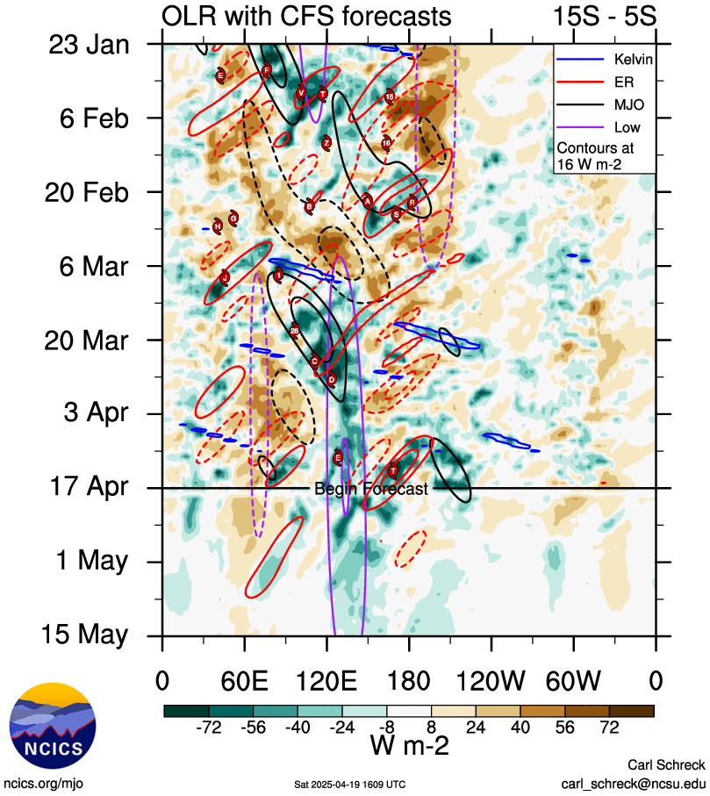

Figure 2: Hovmoller diagram of tropical waves over the latitude range of 5-15S. The formation of Errol (the system annotated E) occurred in the absence of any major tropical waves, with only a background low-frequency wave analysed (denoted by the purple contour). The image is courtesy of the North Carolina Institute for Climate Studies: https://ncics.org/pub/mjo/archive/2025/2025-04-19/v2/

|  |  |
| --- | --- |
| A map of the northern Kimberley. Overlaid are contours showing the relative vorticity at different levels in the atmosphere, wind barbs showing the 850-300 hPa averaged wind, and the 500 hPa geopotential height contours. The green contour for 500 hPa is displaced from the centre of the tropical cyclone. | A satellite image of northwestern Australia. Overlaid are contours depicting deep-layer vertical wind shear. |

Figure 3: *Left*: 13 April 0000Z ECMWF (left) model run for the 0600 UTC timestep on 13 April. Relative vorticity contours for 850 hPa (red), 700 hPa (yellow), 500 hPa (green), and 300 hPa (blue) displayed, in addition to 850-300 hPa averaged winds in knots (wind barbs) and 500 hPa geopotential height contours (black contours). The guidance indicates that the 500 hPa vorticity (green) has become displaced to the southeast of the low-level circulation at this time. *Right*: Satellite derived deep-layer vertical wind shear contours overlaid on Himawari-9 satellite imagery at 0600 UTC 13 April. The system lies off the north Kimberley coast in an area of low deep-layer vertical wind shear. Image courtesy of CIMMS: https://cimss.ssec.wisc.edu/

|  |  |
| --- | --- |
| An infrared satellite image of Errol off the north Kimberley coast. Overlaid are scatterometry wind bards of different colours indicating wind speed and direction at the sea surface. Yellow wind barbs show that gales are present near the system centre. | An infrared satellite image of Errol off the north Kimberley coast. Overlaid are contours of different contours showing the wind speed of the system at the sea surface. The yellow contouring is near the centre of the system indicating gale force winds are present. |

Figure 4: Satellite scatterometry from OCEANSAT-3 at 0359 UTC 15 April (left) and satellite wind speeds from SMOS at 0946 UTC 15 April (right). The earlier OCEANSAT-3 scatterometry shows gales in the southern quadrants, with the later SMOS pass indicating that gales have expanded to all four quadrants and that Errol reached tropical cyclone intensity between these two satellite passes. Images courtesy NRL: https://www.nrlmry.navy.mil/TC.html

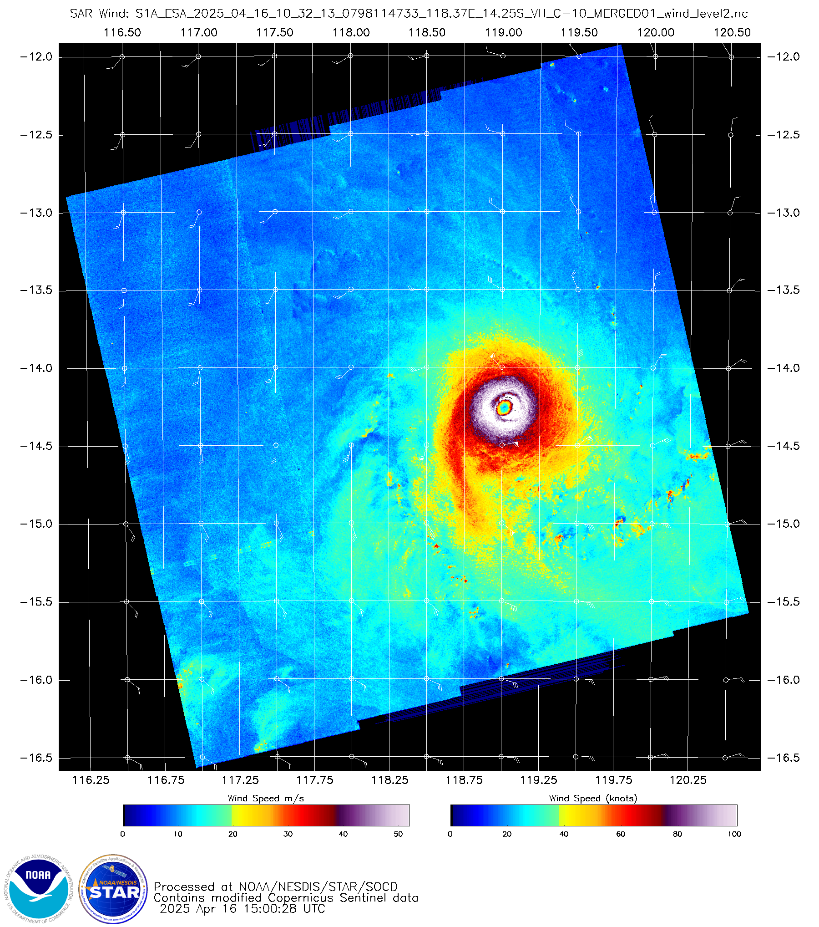

Figure 5: Satellite wind speeds from SAR at 1032 UTC 16 April just prior to the time of peak intensity. Hurricane force winds wrap around the system centre, with peak winds of 125 kn (230 km/h) present in the northeastern quadrant, and peak winds exceeding 100 kn (185 km/h) present in the remaining quadrants. The system is very compact, with a radius of maximum winds of 4 nm (7.4 km). Image courtesy of NOAA https://www.star.nesdis.noaa.gov/socd/mecb/sar/sarwinds_tropical.php

|  |  |
| --- | --- |
| Coloured infrared satellite imagery of Errol. It shows the system has an eyer, with the clouds near the centre coloured in red and yellow, indicating these are deep convective clouds with very cold cloud top temperatures (colder than minus 70 degrees). | A coloured microwave satellite image of Severe Tropical Cyclone Errol off the Western Australian coastline. Deep thunderstorm clouds are shown in bright red around the cyclone, with a distinct eye present at the system centre. |

Figure 6: Infrared satellite imagery from Himawari-9 at 1300 UTC 16 April (left) and colour composite microwave imagery from GMI at 2134 UTC 16 April (right). Both images show Errol as a compact system at and in the hours after reaching peak intensity. Deep convection is present wrapped around a distinct infrared and microwave eye. Images courtesy NRL: https://www.nrlmry.navy.mil/TC.html

|  |  |
| --- | --- |
| A coloured microwave satellite image of Errol as it nears the north Kimberley coast. Deep convective clouds shown in bright red are only present on the northern and eastern side of the system centre, indicating that the system is weakening. | A coloured microwave satellite image of Errol as it nears the north Kimberley coast. Isolated deep convective clouds shown in bright red are only present on the  eastern side of the system. This shows that the system has weakened. |

Figure 7: Colour composite microwave satellite imagery from GMI at 2049 UTC 17 April (left) and from AMSR2 at 0525 UTC 18 April (right). The GMI imagery shows Errol at category 2 intensity and weakening, with deep curved convection limited to the eastern side of the system. The AMSR2 imagery shows Errol just prior to weakening to a tropical low, with deep convection only persisting over land to the east of the system centre, and very little to no curvature present in the cloud signatures. Images courtesy of NRL: https://www.nrlmry.navy.mil/TC.html

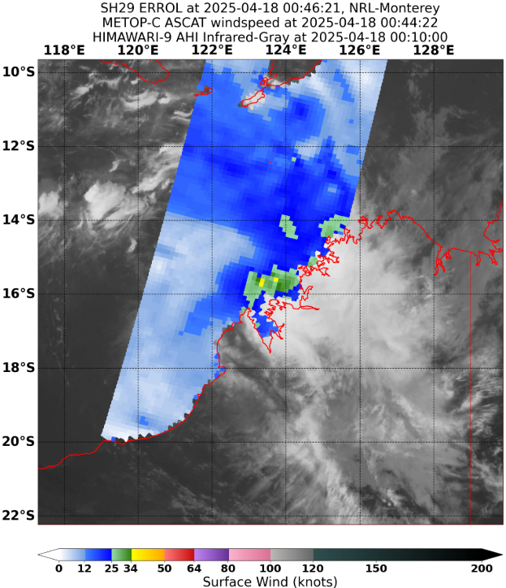

Figure 8: Satellite derived wind speeds from ASCAT-C at 0045 UTC 18 April that indicates that areas of gales have contracted to the southern quadrants only with the maximum wind speed decreasing. Image courtesy of NRL: https://www.nrlmry.navy.mil/TC.html

* 1. Structure

Errol was a very compact system for most of its lifetime, including at its peak intensity and weakening. During the first emergence of gales on 11-12 April, the gale radii was 50 nm (95 km) in the southern quadrants. For most of the rapid intensification period on 15-16 April, gale radii were between 50-70 nm (95-130 km) in the southern quadrants and 35-50 nm (65-95 km) in the northern quadrants. Storm force winds were first observed at 1800 UTC 15 April, with radii between 20-35 nm (35-65 km). Hurricane force winds, with radii of 15-20 nm (30-35 km), were observed at 0000 UTC 16 April.

At peak intensity, gale radii measured 60-70 nm (110-130 km) in the southern quadrants and 35-40 nm (65-75 km) in the northern quadrants, storm force wind radii of 25-35 nm (45-65 km), and a hurricane wind radius of 15 nm (30 km). The radius of maximum winds ranged from 20 nm (35 km) at the start of Errol's rapid intensification to 6 nm (11 km) at peak intensity. A SAR pass at 1032 UTC 16 April just prior to peak intensity suggested that the radius of maximum winds was even smaller at just 4 nm (7.4 km) (see Figure 5).

During Errol's weakening phase, gale radii became more asymmetric. Northern quadrants decreased to 20-30 nm (35-55 km) and the southern quadrants decreased to 20 nm (35 km) just prior to Errol weakening below tropical cyclone intensity. Storm force wind radii decreased to 15 nm (30 km) and 20 nm (35 km) in the northern and southern quadrants respectively, and hurricane force winds contracted to the southern quadrants. The radius of maximum winds began to increase, reaching 20 nm (35 km) prior to weakening to a tropical low. Upon weakening to a tropical low, gales became confined to the southern quadrants only with a radius of 15 nm (30 km).

* 1. Motion

The steering influences for Errol were primarily dominated by a mid-level ridge to the south of the system situated over central Australia. This resulted in motion to the southwest during the development of the system, and then westward motion during initial intensification. On 16 April, the influence of the mid-level ridge weakened, and the system became slow-moving as it moved southwards. An upper trough amplified over southwest Western Australia on 17 April and this caused Errol to move to the east southeast towards the Kimberley coastline. This motion continued as Errol made landfall on 18 April.

1. Impact

Errol crossed the north Kimberley coast in a sparsely populated area, with no known major wind or rainfall impacts to island or coastal communities. The Department of Fire and Emergency Services recorded no requests for assistance, and tourism operators in the region welcomed the extra rainfall ahead of the tourist season. Source: ABC news <https://www.abc.net.au/news/2025-04-19/ex-cyclone-errol-kimberley-tropical-low-impact-severe-weather/105192150>

1. Observations
   1. Wind

No locations on the mainland recorded damaging wind gusts or sustained gale force winds.

**Adele Island** recorded damaging wind gusts and periods of sustained gale force winds as Errol approached the Kimberley coast on 17 April. The strongest wind gust recorded was 55 kn (102 km/h) at 2216 UTC 17 April (0616 AWST 18 April). The maximum 10-minute sustained wind was 41 kn (76 km/h) also at 2216 UTC 17 April (0616 AWST 18 April). Sustained gale force winds were recorded intermittently at the observation site between 2130 UTC 17 April and 0000 UTC 18 April.

**Bayu Undan** first recorded a maximum wind gust of 41 kn (76 km/h) between 1722-1730 UTC 11 April. The maximum 10-minute sustained wind was 32 kn (59 km/h) recorded at 1730 UTC 11 April. These wind speeds were recorded when Errol first developed gale force winds while located over the Timor Sea on 11 April.

* 1. Precipitation

Figure 9 shows the rainfall distribution in Western Australia for the 24 hours to 0900 AWST 19 April. The heaviest rainfall occurred over the inland Kimberley as the remnants of Errol moved further inland, with totals of 15-40 mm recorded at several inland stations. Notable totals for the 24 hours to 9am 19 April include:

* Kalumburu: 160.8 mm, which was the highest daily rainfall record for April at this location.
* Digger's Rest: 71.0 mm
* Doongan: 62.0 mm
* Kununurra Airport: 54.0 mm

Koolan Island also received 68.8 mm, and Cygnet Bay 29.0 mm in the 24 hours to 0900 AWST 18 April as Errol approached the Kimberley coast.

* 1. Pressure

Adele Island recorded a minimum pressure of 994.2 hPa at 2224 UTC 17 April (0624 AWST 18 April) as Errol passed over the island. At this time, the weather station was located close to the low-pressure centre.

* 1. Storm Surge

No significant storm surge was recorded during this event.

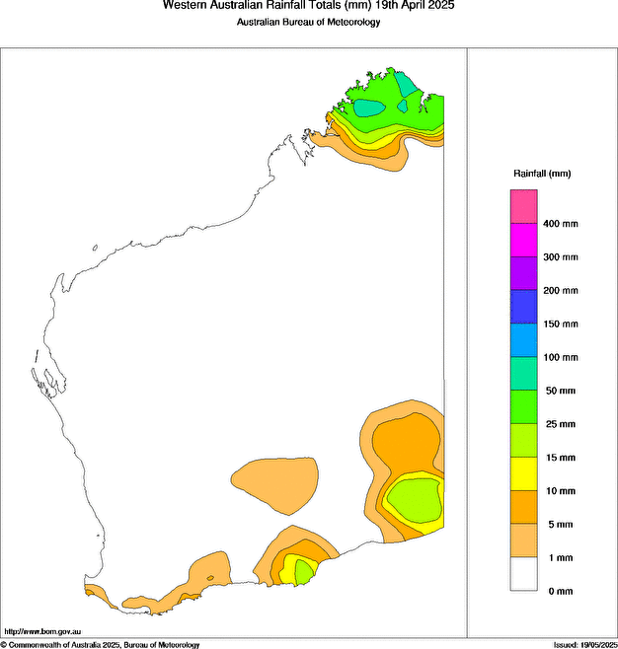

Figure 9: Rainfall analysis for the 24 hours to 9am on 19 April 2025. The rainfall in the Kimberley is the result of the remnants of Errol crossing the Kimberley coast and moving further inland.

1. Forecast Performance

The accuracy statistics for Severe Tropical Cyclone Errol are below in Table 2 and shown in Figure 10 and Figure 11.

Forecast track position accuracy was slightly poorer than the five-year average over the first 24 hours, but beyond 48 hours it exceeded the five-year average (see Figure 10). This represents a very good performance given the sharp turn back towards the coast undertaken by Errol on 17 April.

Intensity forecasts were generally poorer than the 5-year average, shown in Figure 11. However, accuracy improved at the day 5 forecast range. Early forecasts struggled as vertical shear inhibited Errol’s development. Between 15-16 April 2025, Errol underwent rapid intensification, during which the forecasts exhibited a consistent underbias. Deterministic guidance struggled to capture the rapid intensification, and intensity estimates during this period were biased towards objective aids and subjective Dvorak estimates.

Forecast Track Maps were issued from 1800 UTC on 10 April to 0600 UTC on 18 April. Ocean Wind Warnings were issued from 1800 UTC on 10 April to 1200 UTC on 18 April. Technical Bulletins were issued from 1800 UTC on 10 April to 0600 UTC on 18 April.

|  |  |  |  |  |  |  |  |  |  |  |
| --- | --- | --- | --- | --- | --- | --- | --- | --- | --- | --- |
| Time | 00 | 06 | 12 | 18 | 24 | 36 | 48 | 72 | 96 | 120 |
| Position accuracy (km) | 28 | 47 | 65 | 77 | 86 | 100 | 124 | 166 | 223 | 259 |
| Intensity accuracy (knots) | 2.7 | 5.3 | 8.8 | 11.7 | 13.9 | 18.3 | 21.3 | 24.5 | 21.3 | 15.4 |
| Sample Size | 31 | 31 | 30 | 29 | 28 | 26 | 24 | 20 | 16 | 12 |

Table 2: Verification statistics for Severe Tropical Cyclone Errol. Note: Verification is performed using the Official Forecast Tracks at the standard times of 00, 06, 12 and 18 UTC.

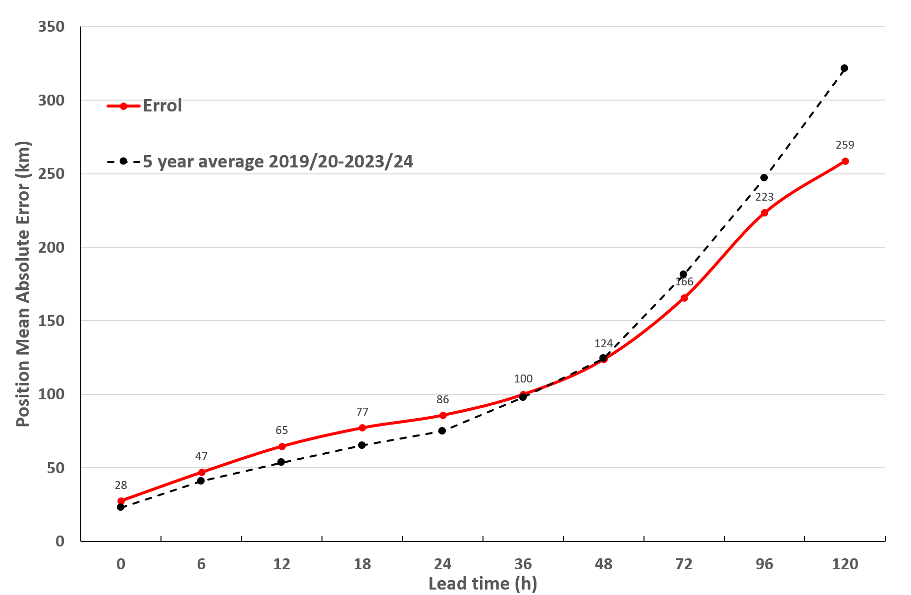

Figure 10: Position accuracy figures for Severe Tropical Cyclone Errol compared against the 5-year average.

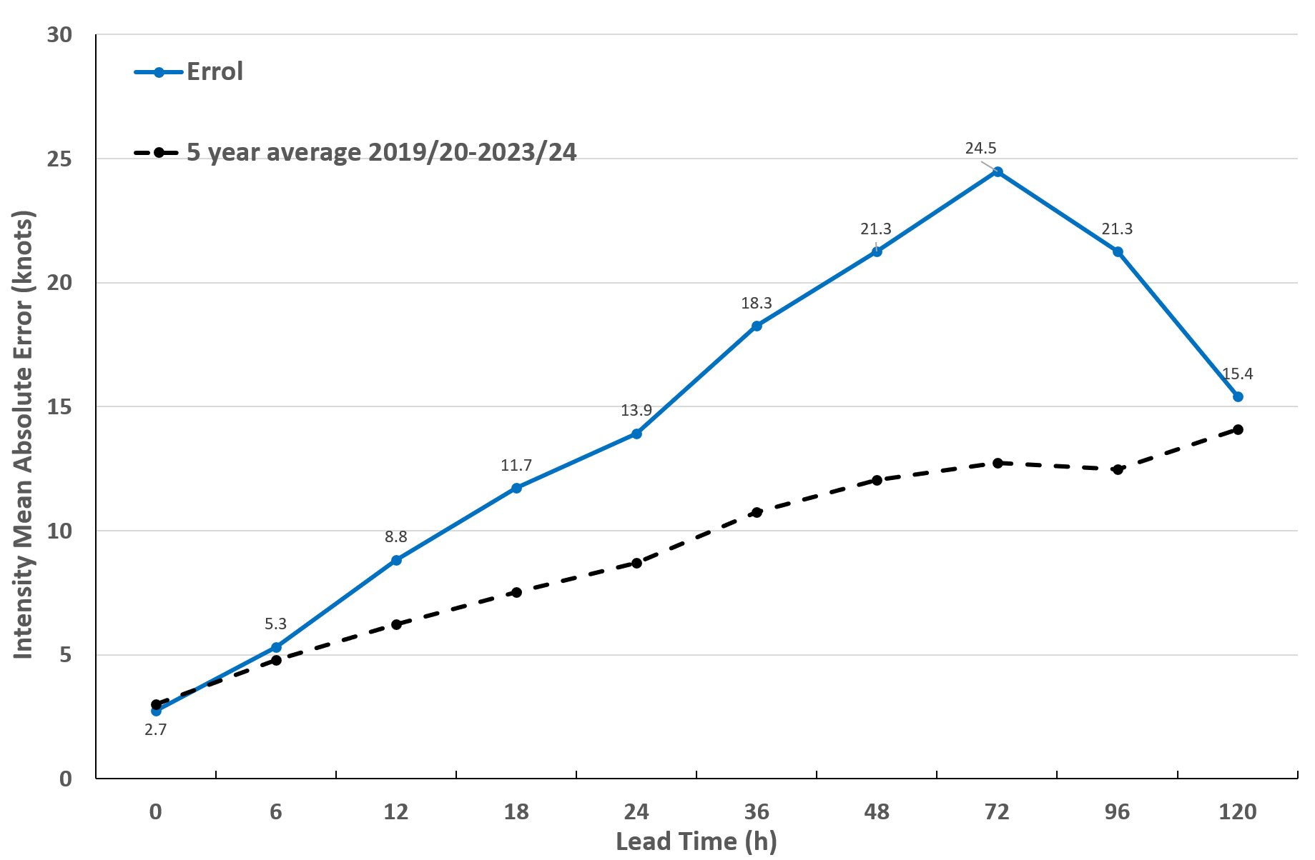

Figure 11: Intensity accuracy figures for Severe Tropical Cyclone Errol compared against the 5-year average.

Appendix: List of abbreviations

|  |  |
| --- | --- |
| Abbreviation | Term |
| ADT | Advanced Dvorak Technique |
| ACST | Australian Central Standard Time |
| AEST | Australian Eastern Standard Time |
| AiDT | AI-enhanced Dvorak Technique |
| AMSR2 | Advanced Microwave Scanning Radiometer |
| AMSU | Advanced Microwave Sounding Unit |
| ASCAT | Advanced Scatterometer |
| ATMS | Advanced Technology Microwave Sounder |
| AWS | automatic weather station |
| AWST | Australian Western Standard Time |
| °C | Celsius |
| CI | Current intensity |
| CIMSS | Cooperative Institute for Meteorological Satellite Studies (USA) |
| CIRA | Cooperative Institute for Research in the Atmosphere (USA) |
| D-MINT | Deep learning - Multispectral Intensity of TCs (formerly known as DMN) |
| D-PRINT | Deep learning - IR Intensity of TCs (formerly known as OPEN-AIIR) |
| DT | Data T-number |
| EIR | Enhanced InfraRed |
| ERC | eyewall replacement cycle |
| FNMOC | Fleet Numerical Meteorology and Oceanography Centre (USA) |
| FT | Final T-number |
| GCOM | Global Change Observation Mission |
| GHz | Gigahertz |
| GMI | Global Precipitation Measurement Microwave Imager |
| h | hour |
| hPa | hectopascal |
| HSCAT | Hai Yang 2 Scatterometer (HY-2B, HY-2C) |
| km | kilometres |
| km/h | kilometres per hour |
| kn | knot |
| LLCC | LLCC |
| MET | Model Expected T-number |
| METOP | Meteorological Operational Satellite |
| MJO | Madden-Julian Oscillation |
| mm | millimetres |
| MSLP | mean sea level pressure |
| NESDIS | National Environmental Satellite, Data, and Information Service |
| nm | nautical mile |
| NOAA | National Oceanic and Atmospheric Administration |
| NRL | Navy Research Lab (USA) |
| OPEN-AiiR | Ordered Pattern Encoding AI Infrared |
| OSCAT | Ocean Scatteromoter |
| PAT | Pattern T-number |
| RCM | RadarSat Constellation Mission – Synthetic Aperture Radar |
| RH | relative humidity |
| RMW | radius of maximum winds |
| RSMC | Regional Specialised Meteorological Centre |
| SAR | Synthetic Aperture Radar |
| SATC | CIMSS Advanced Dvorak Technique |
| SATCON | Satellite Consensus |
| SEN1 | Sentinel-1A – Synthetic Aperture Radar |
| SMAP | Soil Moisture Active Passive |
| SMOS | Soil Moisture and Ocean Salinity |
| SSMIS | Special Sensor Microwave Imager/Sounder |
| TC | Tropical Cyclone |
| TCWC | Tropical Cyclone Warning Centre |
| UTC | Universal Time Co-ordinated |

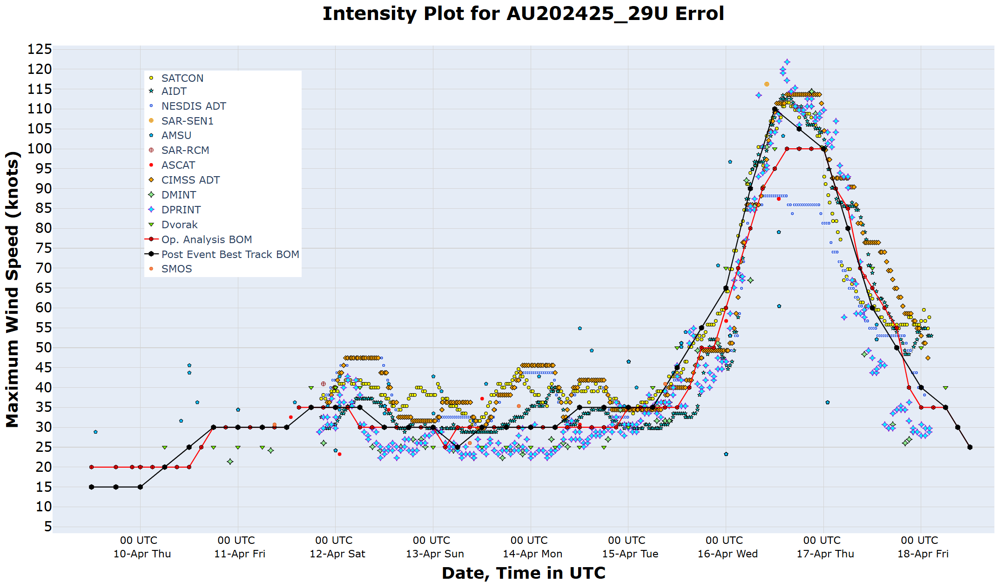

Figure 12: Intensity plot of objective and subjective guidance. SATCON, AiDT, NESDIS ADT, SAR-SEN1, AMSU, SAR-RCM, ASCAT, CIMMS ADT, DMINT, DPRINT, Dvorak subjective estimate, operational analysis (red) and post event best track analysis (black).