Severe Tropical Cyclone Gabrielle

**7-12 February 2023**

**Tony Wedd, Linda Paterson and Joe Courtney  
Tropical Cyclone Environmental Prediction Services**

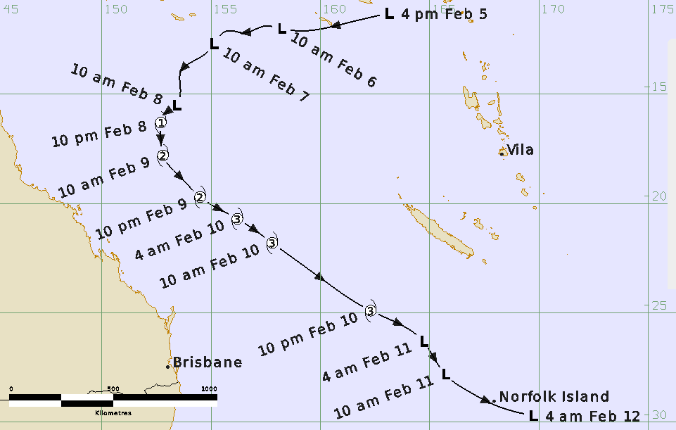

**Revision history**

|  |  |  |  |
| --- | --- | --- | --- |
| Date | Version | Author | Description |
| 13/05/2023 | 1.0 | Joe Courtney | Initial draft |
| 13/07/2023 | 1.1 | Linda Paterson | Summary text update |

**Review status**

|  |  |  |  |
| --- | --- | --- | --- |
| Date | Version | Reviewer | Description |
| 06/02/2024 | 1.2 | Joe Courtney | Minor edits. |

**Release history**

|  |  |  |  |
| --- | --- | --- | --- |
| Date | Version | Approver | Status |
| 25/03/2024 | 1.2 | Andrew Burton | Approved. |

Contact details:

Tropical Cyclone Team Lead

Severe Weather Environmental Prediction Services

Bureau of Meteorology

PO Box 1370, West Perth WA 6872

Email: tcwc@bom.gov.au



This work is copyright. Apart from any use as permitted under the Copyright Act 1968, no part may be reproduced without prior written permission from the Bureau of Meteorology. Refer to www.bom.gov.au/other/copyright.shtml for further information. Unless otherwise noted, all images in this document are licensed under the Creative Commons Attribution Australia Licence.

© Commonwealth of Australia 2024

Published by the Bureau of Meteorology

Cover image: Best track of Gabrielle

Contents

1. Summary 5

2. Meteorological description 8

2.1. Intensity analysis 8

2.2. Structure 18

2.3. Motion 18

3. Impact 18

4. Observations 18

4.1. Wind 18

4.2. Pressure 19

5. Forecast Performance 19

6. Appendix: List of abbreviations 22

# List of figures

Figure 1 Best track of Severe Tropical Cyclone Gabrielle (times in AEST, UTC +10). 5

Figure 2 SSMIS microwave image of Gabrielle 1705 UTC on 8 February 2023 just after it reached tropical cyclone intensity. 10

Figure 3 EIR image of Gabrielle at 0830 UTC 9 February while it had a weak eye pattern. 11

Figure 4 Microwave imager from AMSR2 1521 UTC 9 February which shows the erosion of the convection on the western side of the system. 12

Figure 5 SMAP pass over Gabrielle at 1912 UTC 9 February showing a large area of hurricane strength winds. 13

Figure 6 AMSR2 pass at 331 UTC 10 February showing Gabrielle had regained a curved band structure. 14

Figure 7 SMAP pass at 0719 UTC 10 February showing Gabrielle near peak intensity. 15

Figure 8 AMSR2 pass at 1427 UTC 10 February as Gabrielle underwent extra-tropical transition. 16

Figure 9 A 1333 UTC 11 February AMSR2 wind pass showing an expanded wind field more consistent with a system that had transitioned to sub-tropical. 17

Figure 11 Position accuracy figures for Gabrielle. 20

Figure 12 Intensity accuracy figures for Gabrielle. 21

Figure 10 Comparison of objective and subjective intensity estimates for Gabrielle. 24

# List of tables

Table 1 Best track summary for Severe Tropical Cyclone Gabrielle 7-12 February 2023 6

Table 2 Lowest mean sea level pressure recorded from selected observing sites. 20

Table 3 Mean Absolute Error verification statistics for Gabrielle. * Note, verification is performed using the Official Forecast Tracks at the standard times of 00UTC, 06UTC,12UTC and 18UTC. 20

1. Summary

Severe Tropical Gabrielle was a large Coral Sea tropical cyclone that passed close to Norfolk Island after it had transitioned into an intense sub-tropical system.

A low formed near the Solomon Islands on 5 February and moved southwest. The low formed into a tropical cyclone at 1200 UTC 8 February and continued to intensify as it turned to the south and then the southeast. Gabrielle reached a peak 10-minute mean wind intensity of 80 kn (150 km/h) at 0600 UTC 10 February. As Gabrielle accelerated to the southeast, it transitioned into a sub-tropical system before passing directly over Norfolk Island during the overnight period from 11 to 12 February. Gabrielle continued to move in a south easterly direction and impacted the north island of New Zealand (refer to Figure 1).

Although Tropical Cyclone Advices were issued for Norfolk Island indicating the potential for destructive winds, the island escaped with relatively minor wind impacts such as trees and power lines down. The cyclone had a very large gale radius, particularly as it transitioned to a sub-tropical low. This resulted in high waves that caused large boulders to be flung onto the Cascade Pier which damaged railings and the pier surface. The Norfolk Island Airport recorded a minimum pressure of 958.1 hPa, its lowest pressure on record.



Figure 1 Best track of Severe Tropical Cyclone Gabrielle (times in AEST, UTC +10).

Table 1 Best track summary for Severe Tropical Cyclone Gabrielle 7-12 February 2023

|  |  |  |  |  |  |  |  |  |  |  |  |  |
| --- | --- | --- | --- | --- | --- | --- | --- | --- | --- | --- | --- | --- |
| **Year** | **Month** | **Day** | **Hour UTC** | **Pos. Lat.** | **Pos. Lon.** | **Pos. Acc. nm** | **Max Wind 10 min kn** | **Max gust kn** | **Cent. Press. hPa** | **Rad. of gales  (NE/SE/SW/NW) nm** | **Rad. of storm (NE/SE/ SW/NW) nm** | **RMW nm** |
| 2023 | 02 | 5 | 0600 | 11.3 | 163.1 | 40 | 15 | 45 | 1004 |  |  |  |
| 2023 | 02 | 5 | 1200 | 11.8 | 161.0 | 40 | 15 | 45 | 1004 |  |  |  |
| 2023 | 02 | 5 | 1800 | 12.1 | 159.4 | 40 | 20 | 45 | 1002 |  |  |  |
| 2023 | 02 | 6 | 0000 | 12.0 | 158.2 | 50 | 20 | 45 | 1002 |  |  |  |
| 2023 | 02 | 6 | 0600 | 11.9 | 157.4 | 30 | 25 | 45 | 1000 |  |  |  |
| 2023 | 02 | 6 | 1200 | 12.2 | 156.5 | 30 | 25 | 45 | 1002 |  |  |  |
| 2023 | 02 | 6 | 1800 | 12.1 | 155.8 | 25 | 30 | 45 | 999 |  |  |  |
| 2023 | 02 | 7 | 0000 | 12.7 | 155.1 | 25 | 30 | 45 | 999 |  |  |  |
| 2023 | 02 | 7 | 0600 | 13.1 | 154.8 | 30 | 30 | 45 | 995 |  |  |  |
| 2023 | 02 | 7 | 1200 | 14.0 | 153.6 | 30 | 30 | 45 | 997 |  |  |  |
| 2023 | 02 | 7 | 1800 | 14.8 | 153.6 | 35 | 35* | 50 | 994 | 150/150/0/0 |  |  |
| 2023 | 02 | 8 | 0000 | 15.5 | 153.4 | 20 | 35* | 50 | 994 | 150/120/0/0 |  |  |
| 2023 | 02 | 8 | 0600 | 16.0 | 152.8 | 15 | 35* | 55 | 990 | 180/150/0/0 |  |  |
| 2023 | 02 | 8 | 1200 | 16.3 | 152.7 | 25 | 40 | 55 | 987 | 180/90/ 90/120 |  | 30 |
| 2023 | 02 | 8 | 1800 | 17.0 | 152.7 | 20 | 45 | 65 | 984 | 180/120/110/100 |  | 25 |
| 2023 | 02 | 9 | 0000 | 17.8 | 152.8 | 20 | 50 | 70 | 986 | 200/130/130/100 | 80/80//0 | 25 |
| 2023 | 02 | 9 | 0600 | 18.8 | 153.6 | 20 | 50 | 70 | 981 | 200/150/130/100 | 80/80/80/80 | 25 |
| 2023 | 02 | 9 | 1200 | 19.7 | 154.5 | 20 | 60 | 85 | 972 | 200/150/150/130 | 90/90/ 90/90 | 40 |
| 2023 | 02 | 9 | 1800 | 20.7 | 156.2 | 20 | 65 | 90 | 969 | 200/150/150/130 | 120/120/90/70 | 40 |
| 2023 | 02 | 10 | 0000 | 21.8 | 157.8 | 20 | 70 | 100 | 969 | 200/150/150/130 | 120/120/80/70 | 40 |
| 2023 | 02 | 10 | 0600 | 23.4 | 160.0 | 20 | 80 | 110 | 959 | 200/150/150/130 | 120/120/80/70 | 40 |
| 2023 | 02 | 10 | 1200 | 24.9 | 162.3 | 30 | 75 | 105 | 962 | 200/180/180/130 | 100/100/100/90 | 35 |
| 2023 | 02 | 10 | 1800 | 26.3 | 164.7 | 20 | 60** | 85 | 964 | 200/240/180/130 | 100/150/120/50 | 45 |
| 2023 | 02 | 11 | 0000 | 27.8 | 165.7 | 20 | 60** | 85 | 964 | 200/210/180/130 | 100/120/120/70 | 45 |
| 2023 | 02 | 11 | 0600 | 28.6 | 166.8 | 20 | 60** | 85 | 960 | 200/230/210/160 | 100/140/150/110 | 70 |
| 2023 | 02 | 11 | 1200 | 29.3 | 168.2 | 20 | 60** | 85 | 958 | 240/240/210/210 | 150/0/150/140 | 80 |
| 2023 | 02 | 11 | 1800 | 29.7 | 169.7 | 20 | 55** | 75 | 958 | 300/400/120/100 | 130/60/60/60 | 80 |

Times in UTC (UTC=AEST-10h)

* Not at tropical cyclone intensity as gales less than halfway around centre. ** Sub-tropical status.

Gabrielle moved outside the Australian region after 0600 UTC 10 February but additional fixes are provided because of the impact to Norfolk Island.

1. Meteorological description
   1. Intensity analysis

A monsoon trough strengthened in the southwest Pacific in response to the combined influences of the MJO and an equatorial Rossby wave. This assisted the development of an elongated low on the southern side of the Solomon Islands on 6 December. Ongoing deep convection allowed a Dvorak DT number of 1.0 to be assigned at 1200 UTC 6 February. Satellite imagery on 7 February showed an asymmetrical cloud pattern with all the convection located in the northern quadrants. ASCAT passes around 1200 UTC showed wind speeds of 30 kn (55 km/h) in the western quadrants. By 1800 UTC SMAP and SMOS passes indicated gales were present in the northeast and southeast quadrants and intensity was estimated at 35 kn (65 km/h). During 8 February convection became more symmetrical and a 0745 UTC SMAP pass showed gales beginning to extend further around the centre. The tropical low intensified into a tropical cyclone by 1200 UTC (Figure 2). Gabrielle passed 75 kilometres (km) to the east of Lihou Reef late on 8 February, the observation site located on the reef recorded a period of gales and a minimum pressure of 988 hPa.

Conditions were favourable for development with moderate vertical wind shear and high upper divergence in the area. Deep convection increased and by early on 9 February the cloud pattern showed a tightly wrapped system with symmetric spiral banding in all quadrants. The available EIR imagery through 9 February showed a system with cold cloud around a fluctuating weak eye and the DT slowly increased to 4.0 by 1200 UTC (Figure 3). From about 1500 UTC microwave imagery showed a loss of cold convection on the western side of the tropical cyclone (Figure 4). Despite some fluctuations in the cloud signature a SMAP pass at 1912 UTC 9 February indicated that Gabrielle had reached hurricane intensity by 1800 UTC 9 February (Figure 5). Cold cloud redeveloped on the western side of the tropical cyclone early on 10 February and an AMSR2 pass at 0331 UTC 10 February showed Gabrielle had regained a curved band structure (Figure 6). A SMAP pass at 0719 UTC 10 February (Figure 7) indicated Gabrielle had wind speeds around the centre in the 80-100 kn range. Gabrielle was deemed to have reached a peak intensity of 80 kn (150 km/h) at 0600 10 February. Refer to Figure 10 for a comparison of objective and subjective intensity estimates for Gabrielle. There was mostly reasonable agreement between the best track estimates and the objective guidance however SATCON reached a higher peak estimate early on 10 February.

From 0600 UTC 10 February, Gabrielle moved out of the Australian AOR and the Bureau of Meteorology is not the agency responsible for post- analysis after this time. However, the Bureau continued to issue forecasts for the Australian community of Norfolk Island which was directly in the path of the system. The remainder of the intensity analysis is done for completeness but does not necessarily correlate with other agencies post-analyses.

As Gabrielle moved southeast it transitioned into a sub-tropical system, the cloud top temperatures warmed and the cold cloud that remained became very asymmetric in appearance, confined to the southern quadrants. A 1427 UTC 10 February AMSR2 pass showed an exposed low-level centre with deep convection well removed to the south (Figure 8). By 1200 UTC the intensity had weakened to 75 kn and then 60 kn by 1800 UTC 10 February. It is likely that Gabrielle could be classified as sub-tropical by 1800 UTC 10 February. During 11 February Gabrielle continued to accelerate to the southeast and the wind field greatly expanded as captured in the 1333 UTC 11 February AMSR2 pass (Figure 9). This change in the structure of the wind field is likely why, despite Gabrielle passing very close to Norfolk Island, the observation site only recorded a maximum wind gust of 55 kn (102 km/h) at 0336 UTC 11 February. The remaining circulation of Ex-Tropical Cyclone Gabrielle intensified into a severe mid-latitude cyclone which moved across the North Island of New Zealand where large areas experienced heavy rainfall, flooding and damaging wind gusts.

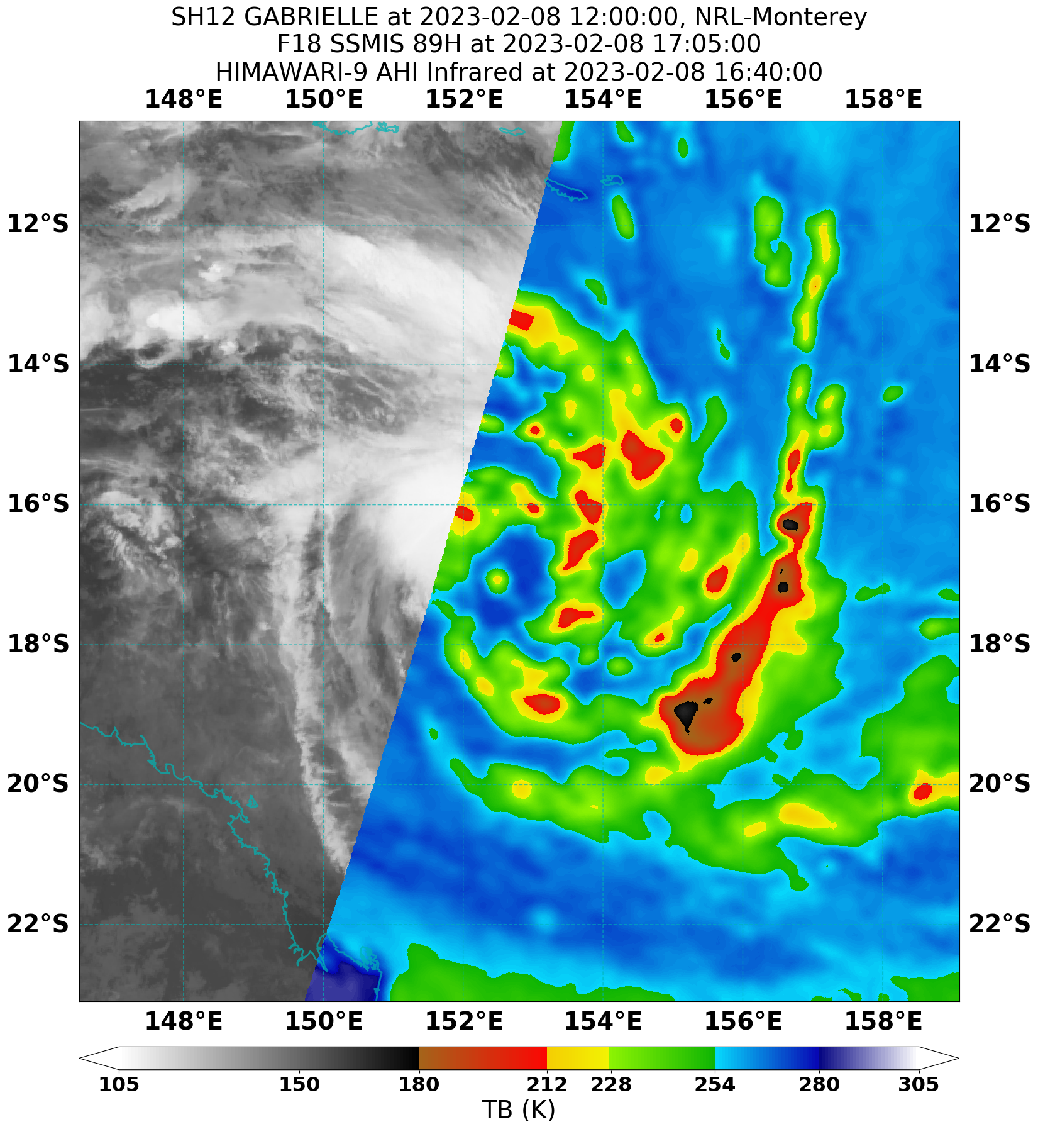

Figure 2 SSMIS microwave image of Gabrielle 1705 UTC on 8 February 2023 just after it reached tropical cyclone intensity.

Image courtesy of NRL: <https://www.nrlmry.navy.mil/TC.html>

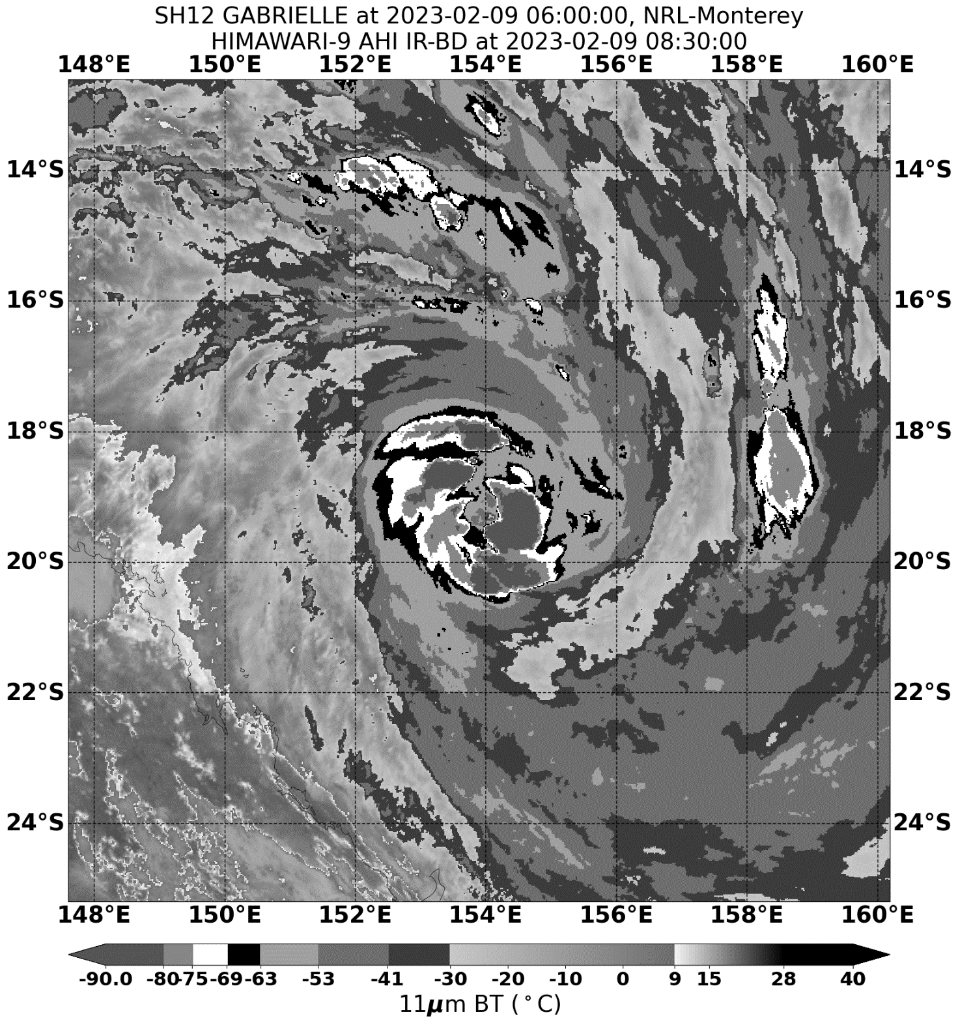

Figure 3 EIR image of Gabrielle at 0830 UTC 9 February while it had a weak eye pattern.

Image courtesy of NRL: <https://www.nrlmry.navy.mil/TC.html>

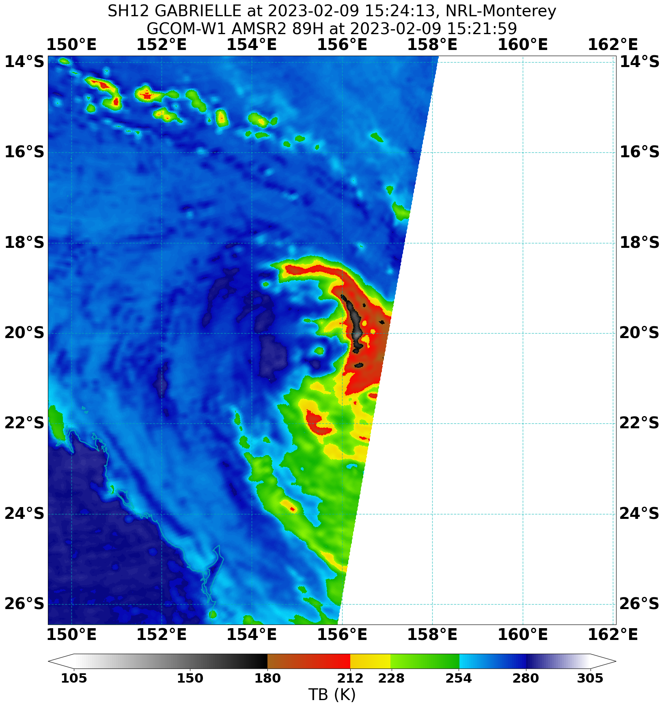

Figure 4 Microwave imager from AMSR2 1521 UTC 9 February which shows the erosion of the convection on the western side of the system.

Image courtesy of NRL: <https://www.nrlmry.navy.mil/TC.html>

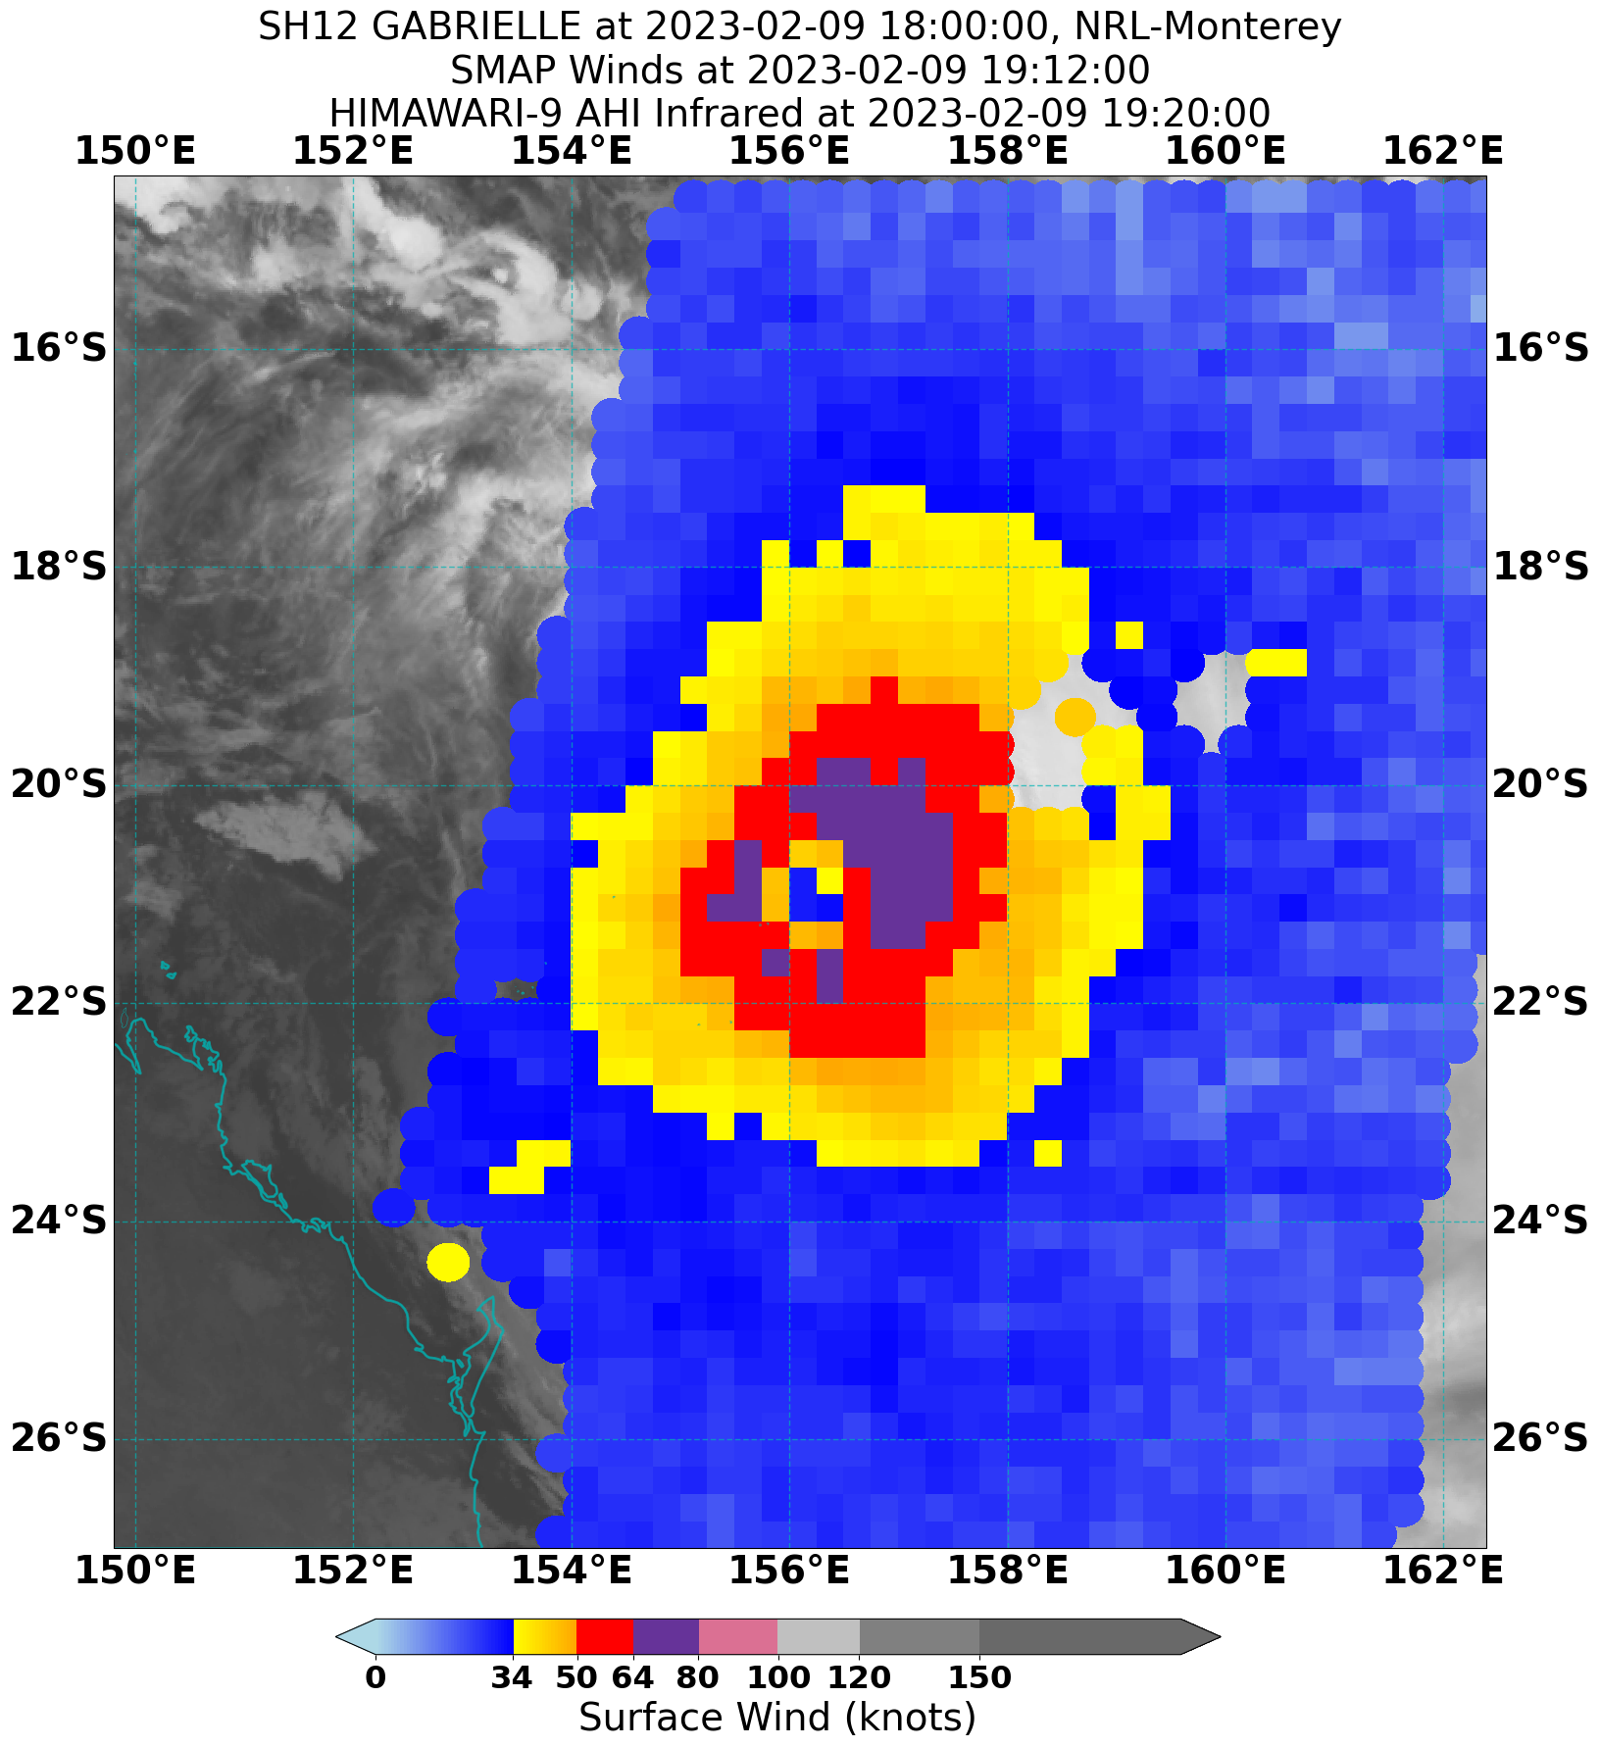

Figure 5 SMAP pass over Gabrielle at 1912 UTC 9 February showing a large area of hurricane strength winds.

Image courtesy of NRL: <https://www.nrlmry.navy.mil/TC.html>

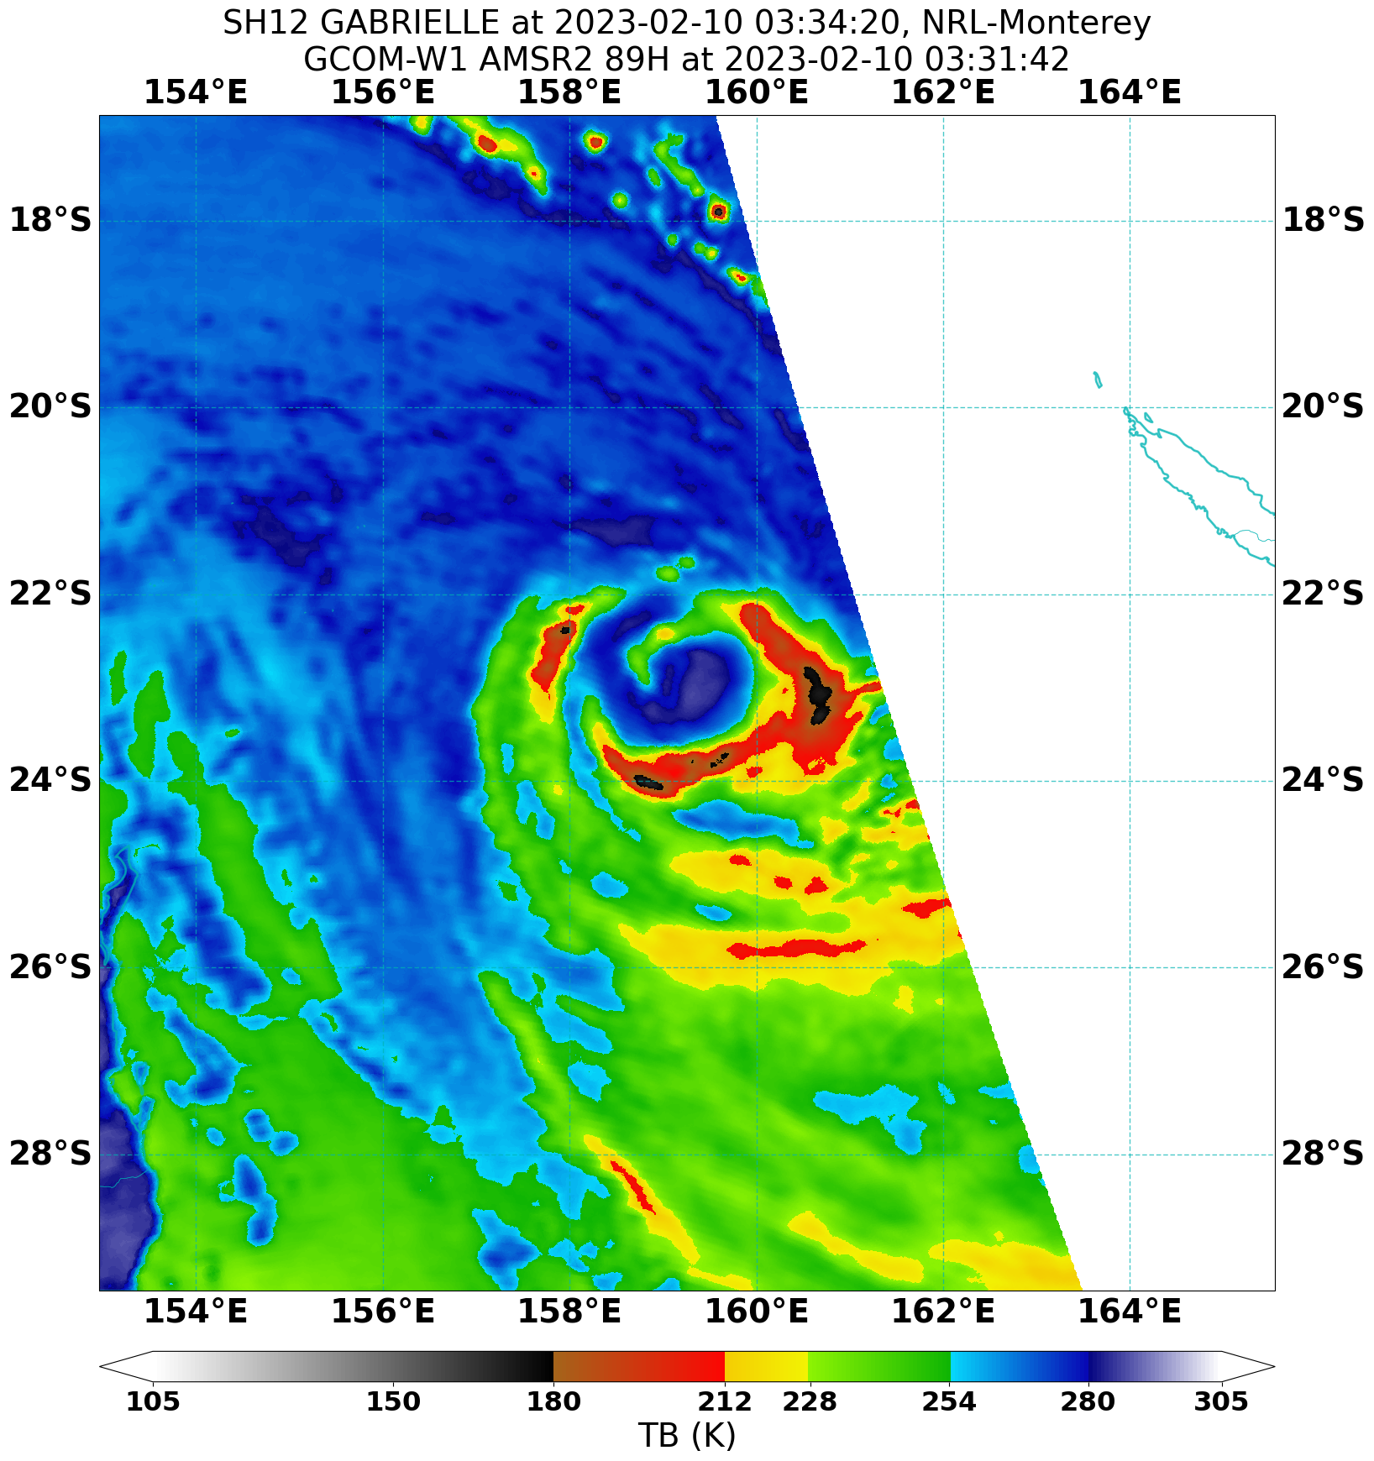

Figure 6 AMSR2 pass at 331 UTC 10 February showing Gabrielle had regained a curved band structure.

Image courtesy of NRL: <https://www.nrlmry.navy.mil/TC.html>

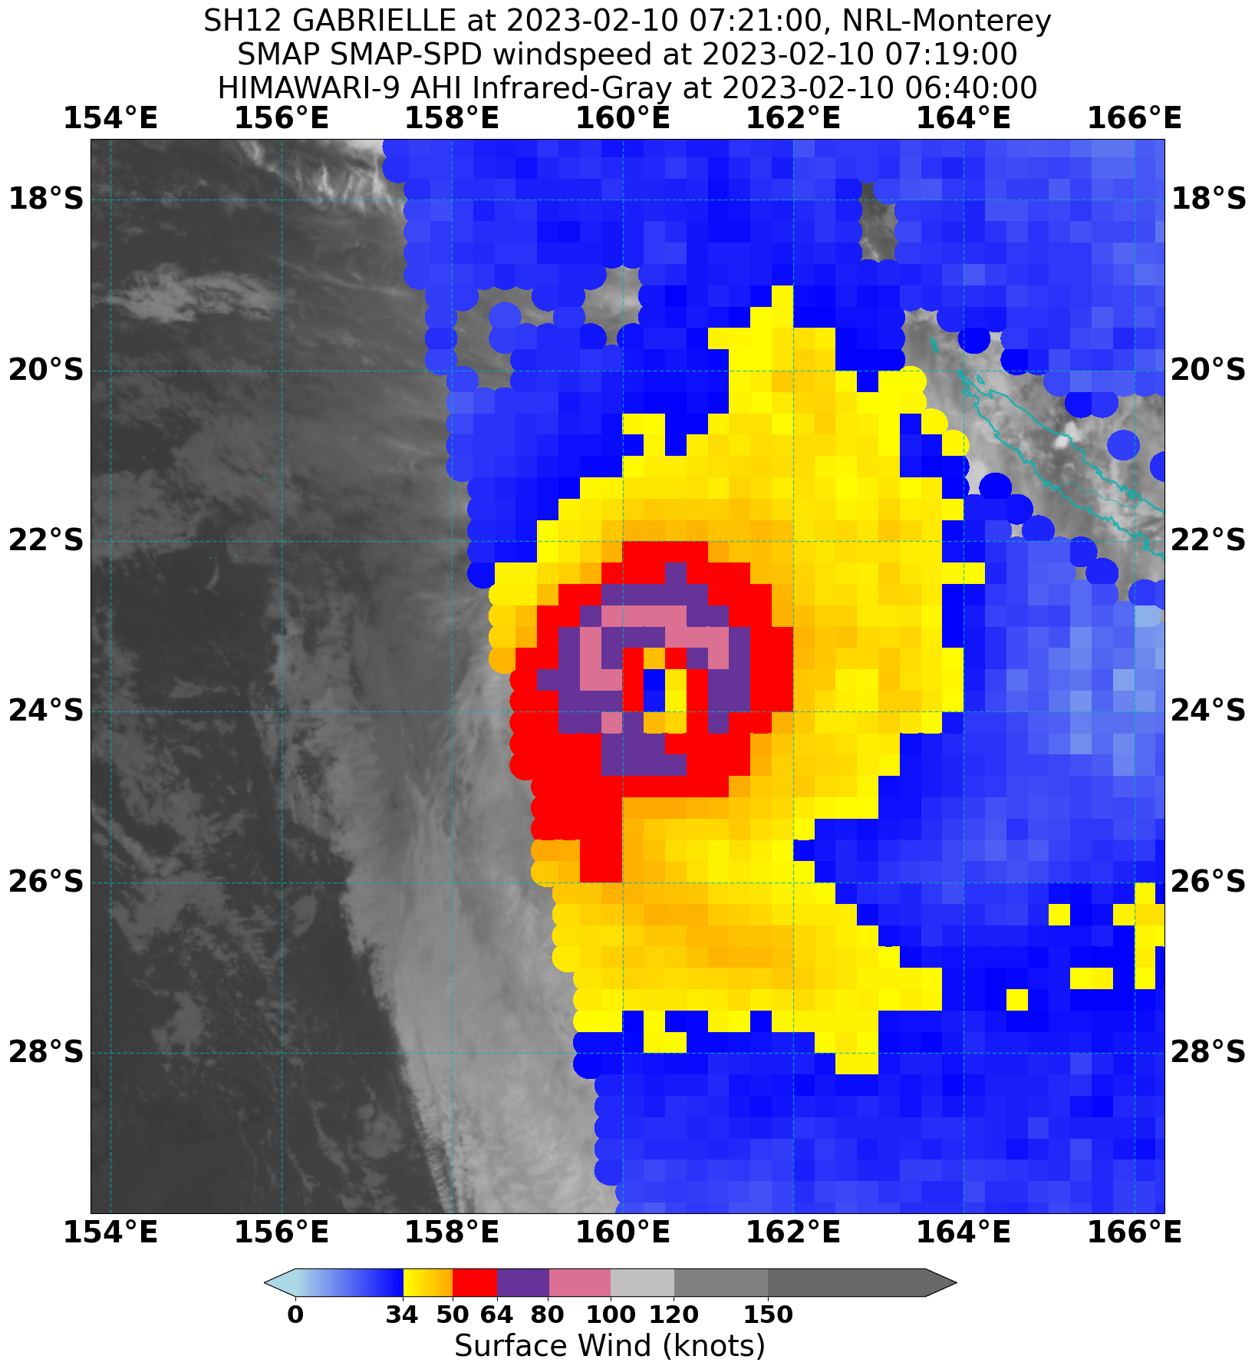

Figure 7 SMAP pass at 0719 UTC 10 February showing Gabrielle near peak intensity.

Image courtesy of NRL: <https://www.nrlmry.navy.mil/TC.html>

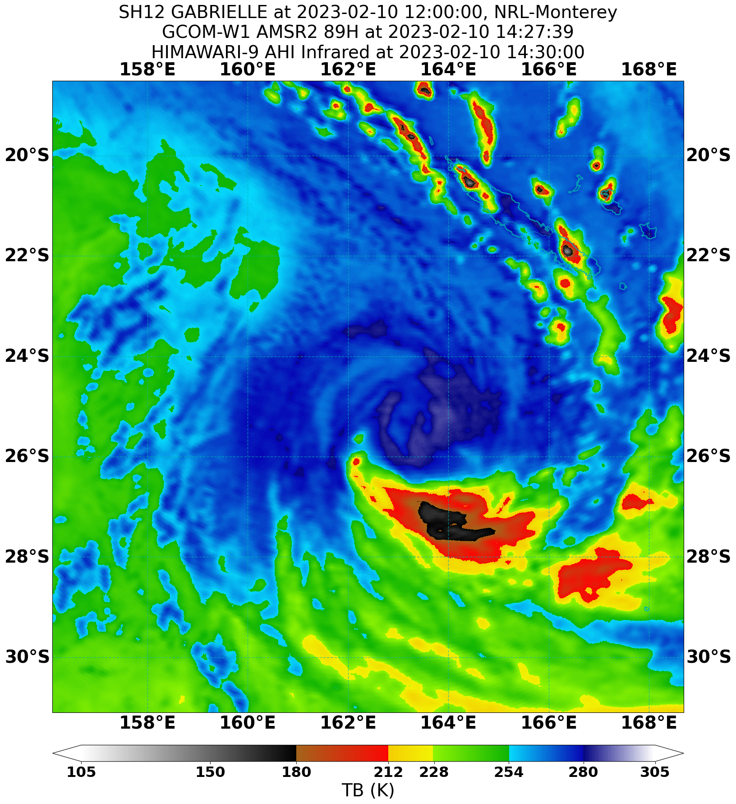

Figure 8 AMSR2 pass at 1427 UTC 10 February as Gabrielle underwent extra-tropical transition.

Image courtesy of NRL: <https://www.nrlmry.navy.mil/TC.html>

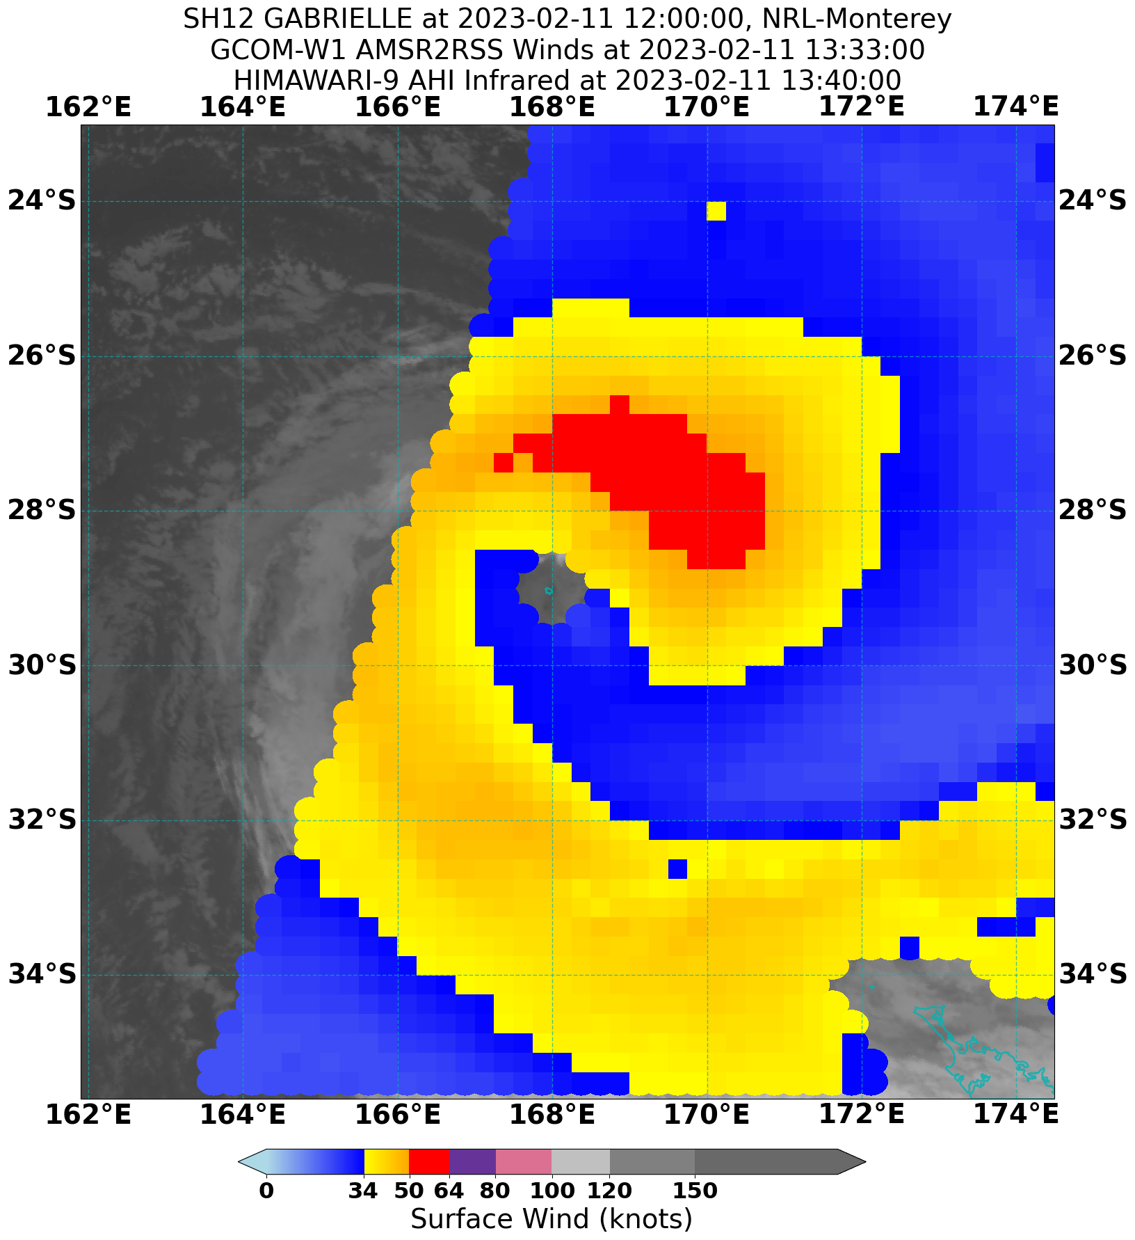

Figure 9 A 1333 UTC 11 February AMSR2 wind pass showing an expanded wind field more consistent with a system that had transitioned to sub-tropical.

Image courtesy of NRL: <https://www.nrlmry.navy.mil/TC.html>

* 1. Structure

Initially Gabrielle had large gale radii of 150 nm (280 km) in the eastern quadrants. As the system reached tropical cyclone intensity the southern gale radii decreased to 90 nm (167 km) while the northern radii remained large at 120-180 nm (220 – 335 km). The gale radii were large throughout the life of Gabrielle but became increasingly asymmetric as Gabrielle transitioned into a sub-tropical system, Figure 9. The southeast quadrant increased to 400 nm (740 km) by 1800 UTC 11 February, however the western radii remained much smaller at 100-120 nm (185 – 220 km), this is typical in a tropical cyclone undergoing extra-tropical transition.

The radius to maximum wind (RMW) was estimated at 30 nm (55 km) initially and decreased to 25 nm (45 km) as Gabrielle intensified. As Gabrielle reached peak intensity the RMW expanded to 40 nm (75 km) and then 80 nm (150 km) as it passed by Norfolk Island.

* 1. Motion

Initially Gabrielle was steered in a westerly direction by the mid-level ridge to the east of the system. As the steering ridge weakened Gabrielle moved south during 8 February. By 9 February a mid-level trough located to the west of Gabrielle became the dominant steering influence and Gabrielle moved southeast, gradually accelerating until it crossed 160oE and moved out of the Australian region.

1. Impact

Although tropical cyclone advices were issued for Norfolk Island which warned of the potential for destructive winds on the island as Gabrielle passed close by, the island escaped with relatively minor wind impacts such as trees and power lines down. The cyclone had a very large gale radius, particularly as it transitioned to a sub-tropical low. This resulted in high waves that caused large boulders to be flung onto the Cascade Pier which damaged railings and the pier surface.

Source: <https://www.abc.net.au/news/2023-02-11/tropical-cyclone-gabrielle-norfolk-island-pictures/101961792>

1. Observations
   1. Wind

**Lihou Reef AWS** recorded gale force winds between 1010-1013, 1023-1038, 1052-1116, 1136-1143, 1203-1242 and 1253-1311 UTC 8 February. A peak 10-minute mean wind of 38 kn (70 km/h) was recorded at 1220, 1221, 1223-1227 UTC 8 February and peak 3-second gust of 48 kn (89 km/h) at 1218 UTC 8 February.

**Marion Reef AWS** recorded gale force winds between 1547-1558, 1633-1641, 1652-1658, 1708-1820, 1831-1841 UTC 8 February and 1844 UTC 8 February to 1216 UTC 9 February. A peak 10-minute mean wind of 52 kn (96 km/h) was recorded at 0630 and 6031 UTC 9 February and peak 3-second gust of 63 kn (117 km/h) at 0616, 0623 and 0624 UTC 9 February.

**Frederick AWS** recorded gale force winds between 0200-0203, 0237-0243 and 0302-2028 UTC 9 February. A peak 10-minute mean wind of 62 kn (115 km/h) was recorded at 1430 UTC 9 February and peak 3-second gust of 75 kn (139 km/h) at 1423 UTC 9 February.

**Norfolk Island AWS** recorded a peak 10-minute mean wind of 32 kn (59 km/h) at 0258 and 0259 UTC 11 February and peak 3-second gust of 55 kn (102 km/h) at 0336 UTC 11 February.

* 1. Pressure

The minimum mean sea level pressure (MSLP) was recorded at the following sites.

Table 2 Lowest mean sea level pressure recorded from selected observing sites.

|  |  |  |
| --- | --- | --- |
| Location | Pressure | Time UTC |
| Lihou Reef | 988.8 hPa | 1317 UTC 8 February |
| Marion Reef | 985.4 hPa | 0502, 0503, 0507, 0518, 0534, 0535 UTC 9 February |
| Frederick Reef | 980.7 hPa | 1532 UTC 9 February |
| Norfolk Island | 958.1 hPa | 1100 UTC 11 February |

1. Forecast Performance

Forecast tracks were issued for Gabrielle from 1200 UTC 6 February to 1200 UTC 11 February. Verification is performed using the Official Forecast Tracks for the standard times of 0000, 0600, 1200 and 1800 UTC. The accuracy figures (Mean Absolute Error, MAE) for Severe Tropical Cyclone Gabrielle are below in Table 3 and are also shown in Figure 11 and Figure 12

The position accuracy for Gabrielle performed better than the 5-year average at all time steps. The intensity accuracy was poorer than the 5-year average up to 36 hours and then decreased to perform better than the long-term average.

Table 3 Mean Absolute Error verification statistics for Gabrielle. * Note, verification is performed using the Official Forecast Tracks at the standard times of 00UTC, 06UTC,12UTC and 18UTC.

|  |  |  |  |  |  |  |  |  |  |
| --- | --- | --- | --- | --- | --- | --- | --- | --- | --- |
| Time | 00 | 06 | 12 | 18 | 24 | 36 | 48 | 72 | 120 |
| Position accuracy (km) | 13 | 40 | 48 | 54 | 53 | 64 | 85 | 123 | 291 |
| Intensity accuracy (knots) | 0.2 | 4.1 | 5.4 | 6.7 | 7.1 | 7.8 | 6.6 | 3.5 | 5.0 |
| Sample size | 21 | 21 | 20 | 19 | 18 | 16 | 14 | 10 | 2 |

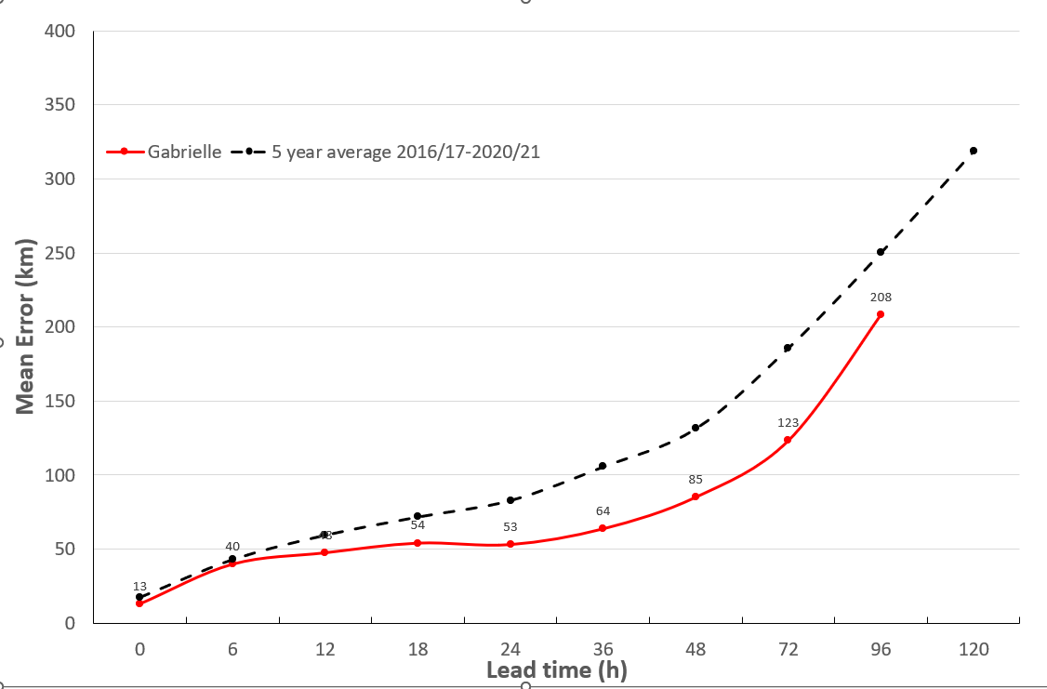

Figure 11 Position accuracy figures for Gabrielle.

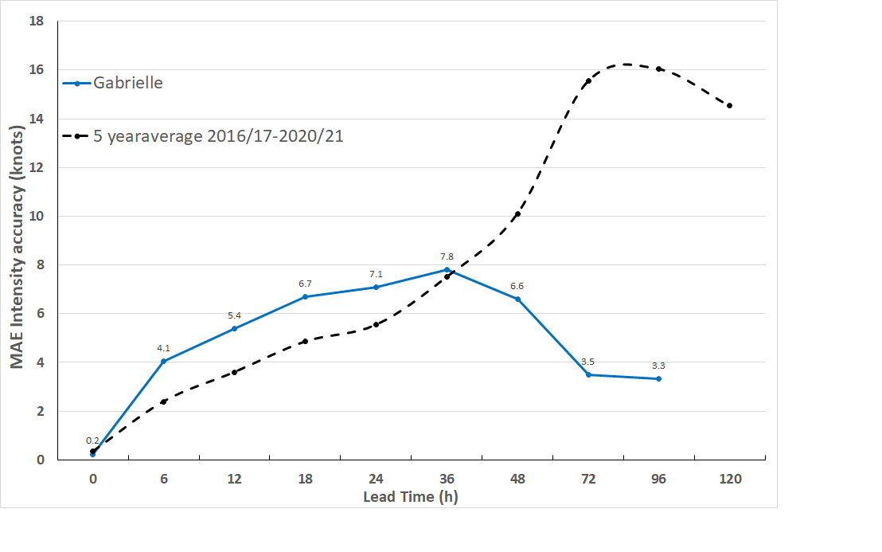

Figure 12 Intensity accuracy figures for Gabrielle.

1. Appendix: List of abbreviations

|  |  |
| --- | --- |
| Abbreviation | Term |
| ADT | Advanced Dvorak Technique |
| ACST | Australian Central Standard Time |
| AEST | Australian Eastern Standard Time |
| AMSR2 | Advanced Microwave Scanning Radiometer |
| ASCAT | Advanced Scatterometer |
| ATMS | Advanced Technology Microwave Sounder |
| AWS | automatic weather station |
| AWST | Australian Western Standard Time |
| °C | Celsius |
| CI | Current intensity |
| CIMSS | Cooperative Institute for Meteorological Satellite Studies (USA) |
| CIRA | Cooperative Institute for Research in the Atmosphere (USA) |
| D-MINT | Deep learning - Multispectral Intensity of TCs (formerly known as DMN) |
| D-PRINT | Deep learning - IR Intensity of TCs (formerly known as OPEN-AIIR) |
| EIR | Enhanced InfraRed |
| ERC | eyewall replacement cycle |
| FNMOC | Fleet Numerical Meteorology and Oceanography Centre (USA) |
| FT | Final T-number |
| GCOM | Global Change Observation Mission |
| GHz | Gigahertz |
| GMI | Global Precipitation Measurement Microwave Imager |
| h | hour |
| hPa | hectopascal |
| HSCAT | Hai Yang 2 Scatterometer (HY-2B, HY-2C) |
| km | kilometres |
| km/h | kilometres per hour |
| kn | knot |
| LLCC | LLCC |
| MET | Model Expected T-number |
| METOP | Meteorological Operational Satellite |
| MJO | Madden-Julian Oscillation |
| mm | millimetres |
| MSLP | mean sea level pressure |
| nm | nautical mile |
| NOAA | National Oceanic and Atmospheric Administration |
| NRL | Navy Research Lab (USA) |
| OPEN-AiiR | Ordered Pattern Encoding AI Infrared |
| PAT | Pattern T-number |
| RCM | RadarSat Constellation Mission – Synthetic Aperture Radar |
| RH | relative humidity |
| RMW | radius of maximum winds |
| RSMC | Regional Specialised Meteorological Centre |
| SAR | Synthetic Aperture Radar |
| SATC | CIMSS Advanced Dvorak Technique |
| SATCON | Satellite Consensus |
| SEN1 | Sentinel-1A – Synthetic Aperture Radar |
| SMAP | Soil Moisture Active Passive |
| SMOS | Soil Moisture and Ocean Salinity |
| SSMIS | Special Sensor Microwave Imager/Sounder |
| TC | Tropical Cyclone |
| TCWC | Tropical Cyclone Warning Centre |
| UTC | Universal Time Co-ordinated |

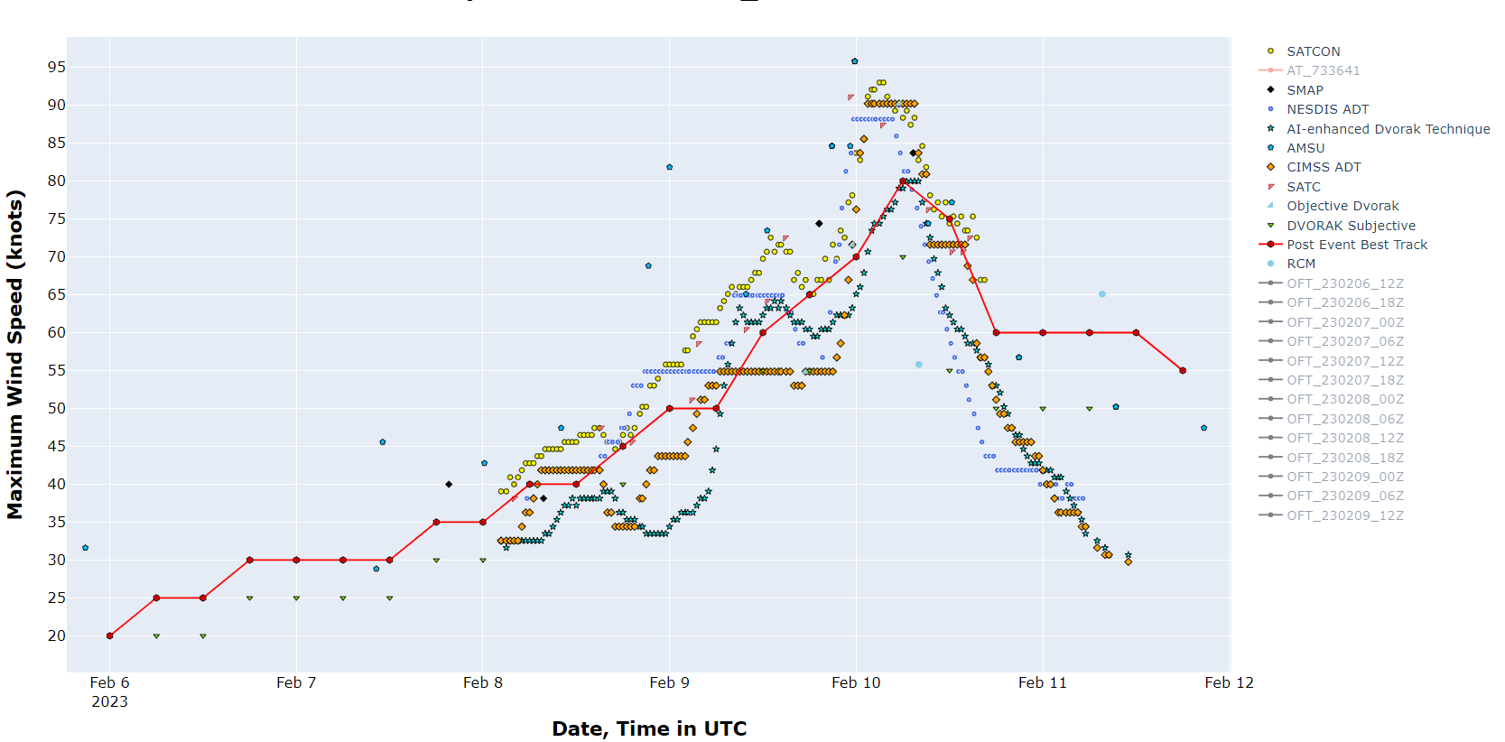

Figure 10 Comparison of objective and subjective intensity estimates for Gabrielle.