Tropical Cyclone Iris

**23 March – 9 April 2018**

Joe Courtney, Tropical Cyclone Environmental Prediction Services,

12 March 2024

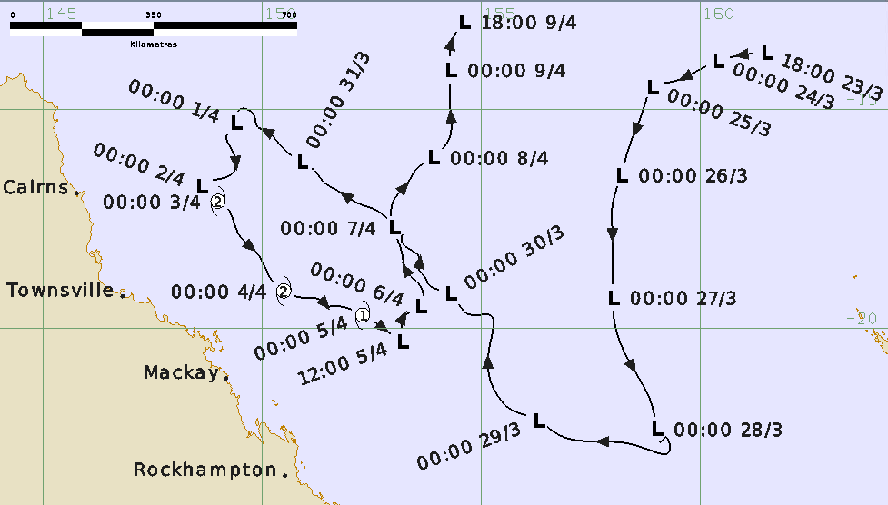

**Revision history**

|  |  |  |  |
| --- | --- | --- | --- |
| Date | Version | Authors | Description |
| 12/03/2024 | 1.0 | Joe Courtney | Final draft |

**Review status**

|  |  |  |  |
| --- | --- | --- | --- |
| Date | Version | Reviewer | Description |
| 13/03/2024 | 1.0 | Linda Paterson | Completed |

**Release history**

|  |  |  |  |
| --- | --- | --- | --- |
| Date | Version | Status | Approval |
| 26/03/2024 | 1.0 | Approved for release | Andrew Burton |

Contact details:

Tropical Cyclone Team Lead

Weather Environmental Prediction Services

Bureau of Meteorology

PO Box 1370, West Perth WA 6872

Email: tcwc@bom.gov.au



This work is copyright. Apart from any use as permitted under the Copyright Act 1968, no part may be reproduced without prior written permission from the Bureau of Meteorology. Refer to www.bom.gov.au/other/copyright.shtml for further information. Unless otherwise noted, all images in this document are licensed under the Creative Commons Attribution Australia Licence.

© Commonwealth of Australia 2024

Published by the Bureau of Meteorology

Cover image: Track of Tropical Cyclone Iris (times in UTC, AEST-10h).

Table of contents

1. Summary 5

2. Meteorological description 9

2.1 Intensity analysis 9

2.2 Structure 10

2.3 Motion 10

3. Impact 16

4. Observations 17

4.1 Winds 17

5. Forecast performance 18

6. Appendix: List of abbreviations 21

**List of Figures**

Figure 1. Best Track of Tropical Cyclone Iris, 24 March to 10 April 2018.. 6

Figure 2. Detailed best track of Tropical Cyclone Iris in the Coral Sea 1-5 April.. 6

Figure 3. Series of visible images at 0000 UTC at a. 2 April; b. 3 April; c. 4 April; and d. 5 April. 11

Figure 4. Advanced Scatterometer (ASCAT-B) wind distribution at 1118 UTC 2 April. 12

Figure 5. Special Sensor Microwave Image/Sounder (SSMIS) composite image at 1437 UTC 2 April 13

Figure 6. Special Sensor Microwave Image/Sounder (SSMIS) 91GHz H image at 1807 UTC 3 April near peak intensity. 14

Figure 7. Advanced Scatterometer (ASCAT-B) wind distribution at 2324 UTC 4 April 15

Figure 8. Forecast track map issued 1153 pm AEST 2 April when a TC Watch was first issued. 19

Figure 9. Position accuracy figures for Tropical Cyclone Iris. 20

Figure 10. Intensity accuracy figures for Tropical Cyclone Iris. 20

**List of Tables**

Table 1. Best track summary for Tropical Cyclone Iris, 23 March – 9 April 2018. 6

# Summary

Tropical Cyclone Iris was a long-lived tropical disturbance that performed a looping traversal of the Coral Sea during late March and early April 2018 as shown in Figure 1 and Figure 2. Iris was at tropical cyclone intensity from 2-5 April off the Queensland coast and produced gales over the Whitsunday Islands and hazardous surf conditions along the central and southern Queensland coast.

A tropical low was first identified over the eastern Solomon Islands on 20 March, On 23 March, the system consolidated northwest of Vanuatu and began to intensify as it moved westward. It was named Iris by the Fiji Meteorological Service early on 24 March, however it was not estimated to have been a tropical cyclone as it crossed 160°E into the Australian region.

Over the following five days the system tracked to the southwest then south over the eastern Coral Sea. On 28 March the low took a turn to the west northwest in response to a strong ridge to the south. Despite minimal deep convection, a small region of gales were observed on 29 March but well away from the circulation south of the centre. The strong southeasterly winds generated large waves and hazardous surf on the Queensland coast that closed beaches from K'gari (Fraser Island) to the Gold Coast for the Easter long weekend (30 March-2 April).

The low moved rapidly northwest for a few days. On 1 April the system slowed and deep convection increased signalling intensification. Flinders Reef commenced recording gales early on 2 April and continued for 43 hours. The system was reanalysed to be at tropical cyclone intensity overnight from 2 to 3 April quickly attaining category 2 intensity on the evidence of observed winds at Flinders Reef.

Iris moved southeast roughly parallel to the Queensland coast while maintaining category 2 intensity for the next 2 days. It made its closest approach to the coast, 210 km northeast of Hamilton Island in the Whitsundays, on the morning of 4 April. Hamilton Island recorded a period of gales and maximum wind gusts to 106 km/h.

Iris began to weaken during 4 April, being estimated below tropical cyclone intensity late on 5 April. The low then turned towards the north and eventually dissipated south of Papua New Guinea on 9 April.

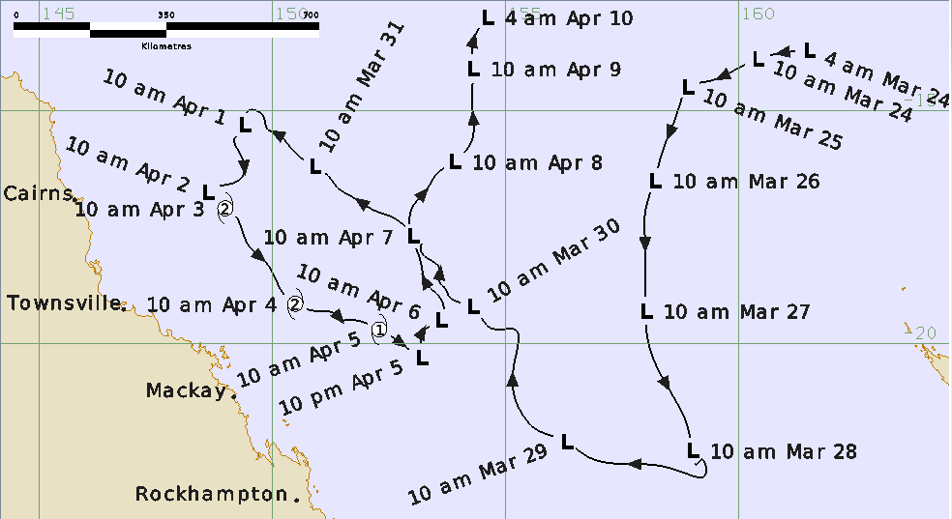

Figure . Best Track of Tropical Cyclone Iris, 24 March to 10 April 2018 (times in AEST, UTC +10).

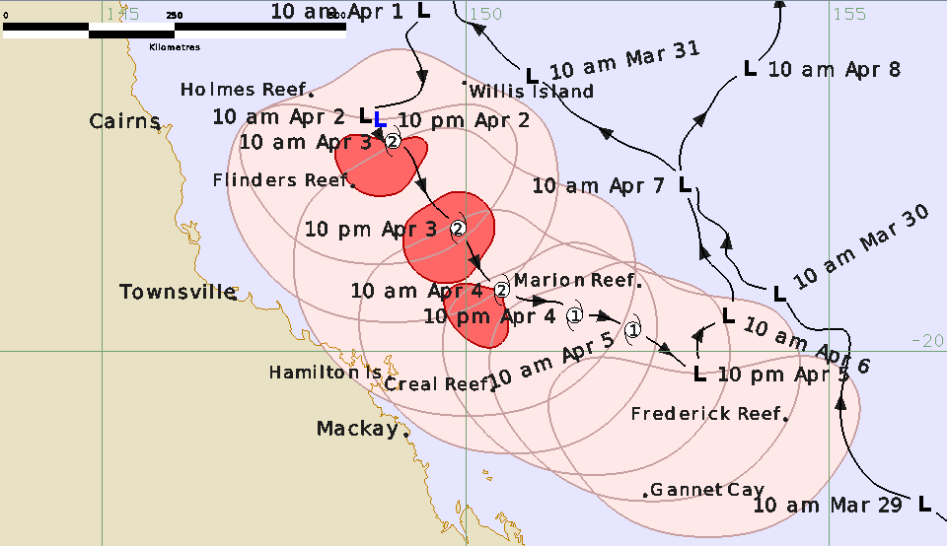

Figure . Detailed best track of Tropical Cyclone Iris in the Coral Sea 1-5 April, showing wind radii (gale - pink, storm - red and hurricane force – dark red) (times in AEST, UTC +10).

Table . Best track summary for Tropical Cyclone Iris, 23 March – 9 April 2018.

Refer to the Australian Tropical Cyclone database for complete listing of parameters. UTC=AEST-10h. * Not at tropical cyclone intensity as gales less than halfway around centre.

|  |  |  |  |  |  |  |  |  |  |  |  |  |
| --- | --- | --- | --- | --- | --- | --- | --- | --- | --- | --- | --- | --- |
| Year | Mon | Day | Hour | Pos | Pos. | Pos | Max Wind | Max | Cent. | Rad. of gales | Rad. of storm | RMW |
|  |  |  | UTC | Lat. | Long. | Acc. | 10min | gust | Press. | (NE/SE/ | (NE/SE/ | nm |
|  |  |  |  | S | E | nm | kn | kn | hPa | SW/NW) | SW/NW) |  |
| 2018 | 3 | 23 | 1800 | 13.7 | 161.5 | 50 | 30 | 45 | 998 | 0/0/0/0 | 0/0/0/0 | - |
| 2018 | 3 | 24 | 0000 | 13.9 | 160.4 | 30 | 30 | 45 | 998 | 0/0/0/0 | 0/0/0/0 | - |
| 2018 | 3 | 24 | 0600 | 14.2 | 159.8 | 30 | 30 | 45 | 998 | 0/0/0/0 | 0/0/0/0 | - |
| 2018 | 3 | 24 | 1200 | 14.3 | 159.6 | 30 | 30 | 45 | 998 | 0/0/0/0 | 0/0/0/0 | - |
| 2018 | 3 | 24 | 1800 | 14.4 | 159.2 | 30 | 30 | 50 | 998 | 0/0/0/0 | 0/0/0/0 | - |
| 2018 | 3 | 25 | 0000 | 14.5 | 158.9 | 30 | 30 | 45 | 1000 | 0/0/0/0 | 0/0/0/0 | - |
| 2018 | 3 | 25 | 0600 | 14.7 | 158.8 | 25 | 25 | 45 | 1000 | 0/0/0/0 | 0/0/0/0 | - |
| 2018 | 3 | 25 | 1200 | 15.3 | 158.6 | 30 | 25 | 45 | 1002 | 0/0/0/0 | 0/0/0/0 | - |
| 2018 | 3 | 25 | 1800 | 15.8 | 158.4 | 35 | 25 | 45 | 1002 | 0/0/0/0 | 0/0/0/0 | - |
| 2018 | 3 | 26 | 0000 | 16.5 | 158.2 | 35 | 25 | 45 | 1002 | 0/0/0/0 | 0/0/0/0 | - |
| 2018 | 3 | 26 | 0600 | 17.2 | 158.0 | 30 | 25 | 45 | 1000 | 0/0/0/0 | 0/0/0/0 | - |
| 2018 | 3 | 26 | 1200 | 17.8 | 158.0 | 30 | 25 | 45 | 1001 | 0/0/0/0 | 0/0/0/0 | - |
| 2018 | 3 | 26 | 1800 | 18.5 | 158.0 | 30 | 25 | 45 | 1000 | 0/0/0/0 | 0/0/0/0 | - |
| 2018 | 3 | 27 | 0000 | 19.3 | 158.0 | 30 | 25 | 45 | 1002 | 0/0/0/0 | 0/0/0/0 | - |
| 2018 | 3 | 27 | 0600 | 20.1 | 158.1 | 25 | 25 | 45 | 1000 | 0/0/0/0 | 0/0/0/0 | - |
| 2018 | 3 | 27 | 1200 | 20.6 | 158.3 | 35 | 25 | 45 | 1002 | 0/0/0/0 | 0/0/0/0 | - |
| 2018 | 3 | 27 | 1800 | 21.5 | 158.8 | 35 | 25 | 45 | 1002 | 0/0/0/0 | 0/0/0/0 | - |
| 2018 | 3 | 28 | 0000 | 22.3 | 159.0 | 30 | 25 | 45 | 1002 | 0/0/0/0 | 0/0/0/0 | - |
| 2018 | 3 | 28 | 0600 | 22.6 | 159.1 | 25 | 25 | 45 | 1000 | 0/0/0/0 | 0/0/0/0 | - |
| 2018 | 3 | 28 | 1200 | 22.5 | 159.2 | 25 | 25 | 45 | 1000 | 0/0/0/0 | 0/0/0/0 | - |
| 2018 | 3 | 28 | 1800 | 22.8 | 158.9 | 25 | 25 | 45 | 1000 | 0/0/0/0 | 0/0/0/0 | - |
| 2018 | 3 | 29 | 0000 | 22.1 | 156.3 | 20 | 30 | 45 | 998 | 0/0/0/0 | 0/0/0/0 | - |
| 2018 | 3 | 29 | 0600 | 21.4 | 155.3 | 25 | 30 | 45 | 1000 | 0/0/0/0 | 0/0/0/0 | - |
| 2018 | 3 | 29 | 1200 | 20.4 | 155.2 | 20 | 30 | 45 | 1000 | 0/0/0/0 | 0/0/0/0 | - |
| 2018 | 3 | 29 | 1800 | 19.7 | 154.9 | 25 | 30 | 45 | 998 | 0/0/0/0 | 0/0/0/0 | - |
| 2018 | 3 | 30 | 0000 | 19.2 | 154.3 | 20 | 30 | 45 | 998 | 0/0/0/0 | 0/0/0/0 | - |
| 2018 | 3 | 30 | 0600 | 18.4 | 153.6 | 15 | 30 | 45 | 996 | 0/0/0/0 | 0/0/0/0 | - |
| 2018 | 3 | 30 | 1200 | 17.6 | 153.0 | 15 | 30 | 45 | 994 | 0/0/0/0 | 0/0/0/0 | - |
| 2018 | 3 | 30 | 1800 | 16.9 | 151.8 | 15 | 30 | 45 | 993 | 0/0/0/0 | 0/0/0/0 | - |
| 2018 | 3 | 31 | 0000 | 16.2 | 150.9 | 15 | 25 | 45 | 993 | 0/0/0/0 | 0/0/0/0 | - |
| 2018 | 3 | 31 | 0600 | 15.5 | 150.1 | 15 | 25 | 45 | 993 | 0/0/0/0 | 0/0/0/0 | - |
| 2018 | 3 | 31 | 1200 | 15.1 | 149.8 | 15 | 25 | 45 | 993 | 0/0/0/0 | 0/0/0/0 | - |
| 2018 | 3 | 31 | 1800 | 15.0 | 149.5 | 20 | 30 | 45 | 993 | 0/0/0/0 | 0/0/0/0 | - |
| 2018 | 4 | 1 | 0000 | 15.3 | 149.4 | 20 | 30 | 45 | 993 | 0/0/0/0 | 0/0/0/0 | - |
| 2018 | 4 | 1 | 0600 | 15.6 | 149.2 | 20 | 30 | 45 | 993 | 0/0/0/0 | 0/0/0/0 | - |
| 2018 | 4 | 1 | 1200 | 15.9 | 149.3 | 25 | 30 | 45 | 992 | 0/0/0/0 | 0/0/0/0 | - |
| 2018 | 4 | 1 | 1800 | 16.5 | 149.3 | 25 | 35* | 50 | 990 | 0/0/80/0 | 0/0/0/0 | - |
| 2018 | 4 | 2 | 0000 | 16.8 | 148.6 | 25 | 40* | 55 | 988 | 0/120/120/0 | 0/0/0/0 | 30 |
| 2018 | 4 | 2 | 0600 | 16.8 | 148.7 | 20 | 40* | 50 | 986 | 0/120/120/0 | 0/0/0/0 | 30 |
| 2018 | 4 | 2 | 1200 | 16.8 | 148.8 | 20 | 45* | 65 | 986 | 0/120/120/0 | 0/0/0/0 | 50 |
| 2018 | 4 | 2 | 1800 | 17.0 | 148.8 | 20 | 55 | 75 | 982 | 70/140/140/70 | 0/30/55/0 | 25 |
| 2018 | 4 | 3 | 0000 | 17.1 | 149.0 | 20 | 55 | 70 | 982 | 80/150/150/70 | 0/30/50/0 | 20 |
| 2018 | 4 | 3 | 0600 | 17.9 | 149.5 | 20 | 50 | 70 | 984 | 80/180/150/60 | 0/30/50/0 | 20 |
| 2018 | 4 | 3 | 1200 | 18.3 | 149.9 | 20 | 50 | 70 | 986 | 70/160/150/90 | 30/30/50/30 | 25 |
| 2018 | 4 | 3 | 1800 | 19.0 | 150.3 | 20 | 50 | 70 | 987 | 60/140/130/80 | 0/30/50/0 | 25 |
| 2018 | 4 | 4 | 0000 | 19.2 | 150.5 | 20 | 50 | 70 | 987 | 60/140/130/70 | 0/0/50/0 | 30 |
| 2018 | 4 | 4 | 0600 | 19.3 | 150.9 | 20 | 45 | 65 | 989 | 70/140/120/75 | 0/0/0/0 | 30 |
| 2018 | 4 | 4 | 1200 | 19.5 | 151.5 | 20 | 40 | 55 | 990 | 60/140/120/60 | 0/0/0/0 | 30 |
| 2018 | 4 | 4 | 1800 | 19.5 | 151.6 | 20 | 40 | 55 | 988 | 50/150/120/60 | 0/0/0/0 | 30 |
| 2018 | 4 | 5 | 0000 | 19.7 | 152.3 | 20 | 40 | 55 | 990 | 50/150/130/60 | 0/0/0/0 | 25 |
| 2018 | 4 | 5 | 0600 | 20.1 | 152.9 | 20 | 40 | 55 | 991 | 30/140/130/30 | 0/0/0/0 | 25 |
| 2018 | 4 | 5 | 1200 | 20.3 | 153.2 | 25 | 40* | 55 | 992 | 0/140/130/0 | 0/0/0/0 | - |
| 2018 | 4 | 5 | 1800 | 19.8 | 153.2 | 20 | 30 | 45 | 995 | 0/0/0/0 | 0/0/0/0 | - |
| 2018 | 4 | 6 | 0000 | 19.5 | 153.6 | 20 | 30 | 40 | 998 | 0/0/0/0 | 0/0/0/0 | - |
| 2018 | 4 | 6 | 0600 | 19.1 | 153.6 | 20 | 25 | 40 | 998 | 0/0/0/0 | 0/0/0/0 | - |
| 2018 | 4 | 6 | 1200 | 18.7 | 153.3 | 25 | 25 | 40 | 1000 | 0/0/0/0 | 0/0/0/0 | - |
| 2018 | 4 | 6 | 1800 | 18.3 | 153.2 | 25 | 25 | 40 | 1000 | 0/0/0/0 | 0/0/0/0 | - |
| 2018 | 4 | 7 | 0000 | 17.7 | 153.0 | 25 | 25 | 40 | 1003 | 0/0/0/0 | 0/0/0/0 | - |
| 2018 | 4 | 7 | 0600 | 17.1 | 153.0 | 20 | 25 | 40 | 1002 | 0/0/0/0 | 0/0/0/0 | - |
| 2018 | 4 | 7 | 1200 | 16.7 | 153.3 | 20 | 25 | 45 | 1004 | 0/0/0/0 | 0/0/0/0 | - |
| 2018 | 4 | 7 | 1800 | 16.4 | 153.5 | 20 | 25 | 35 | 1004 | 0/0/0/0 | 0/0/0/0 | - |
| 2018 | 4 | 8 | 0000 | 16.1 | 153.9 | 20 | 25 | 35 | 1006 | 0/0/0/0 | 0/0/0/0 | - |
| 2018 | 4 | 8 | 0600 | 15.6 | 154.3 | 20 | 25 | 35 | 1005 | 0/0/0/0 | 0/0/0/0 | - |
| 2018 | 4 | 8 | 1200 | 15.0 | 154.3 | 20 | 25 | 45 | 1007 | 0/0/0/0 | 0/0/0/0 | - |
| 2018 | 4 | 8 | 1800 | 14.5 | 154.3 | 20 | 20 | 40 | 1007 | 0/0/0/0 | 0/0/0/0 | - |
| 2018 | 4 | 9 | 0000 | 14.1 | 154.3 | 20 | 20 | 35 | 1007 | 0/0/0/0 | 0/0/0/0 | - |
| 2018 | 4 | 9 | 0600 | 13.6 | 154.3 | 30 | 20 | 40 | 1007 | 0/0/0/0 | 0/0/0/0 | - |
| 2018 | 4 | 9 | 1200 | 13.3 | 154.4 | 30 | 20 | 40 | 1007 | 0/0/0/0 | 0/0/0/0 | - |
| 2018 | 4 | 9 | 1800 | 13.0 | 154.6 | 30 | 20 | 40 | 1007 | 0/0/0/0 | 0/0/0/0 | - |

# Meteorological description

## 2.1 Intensity analysis

Tropical Cyclone Iris was named by Fiji Meteorological Services on 24 March prior to crossing west of 160°E into the Australian region. At this time it was estimated to be below tropical cyclone intensity and the circulation remained below tropical cyclone intensity over the following days. Despite minimal deep convection from 29 to 31 March the low interacted with strong southeasterly broadscale low to the south. The ASCAT A and B passes around 0000 UTC 29 March showed a small region of gales removed from the circulation south of the centre.

Deep convection increased overnight from 1 to 2 April and Flinders Reef to the south commenced recording gales that continued until 1400 UTC 3 April. Figure 3 shows the series of visible images at 0000 UTC from 2 to 5 April. A broad convective band well to the north and east assisted in the development but weakened during 2 April. A SMAP pass at 2002 UTC 1 April did show marginal gales in this band well to the east but not on the subsequent SMAP pass at 0811 UTC 2 April.

Operationally the system was described as at tropical cyclone intensity from 0000 UTC 2 April however upon reanalysis this was delayed until 1500 UTC 2 April on the basis of gales being confined south of the centre. This was indicated by scatterometer passes - ASCAT-B at 1118 UTC shown in Figure 4 and ASCAT-A at 1200 UTC.

However, Holmes Reef, located northwest of the centre, commenced gales at 1400 UTC which confirmed that gales then extended more than half-way around the centre, this indicated tropical cyclone intensity had been reached. At this time Flinders Reef was reporting storm-force winds in excess of 48 kn to indicate Iris was indeed at category 2 intensity. The AMSR2 microwave composite at 1437 UTC 2 April in Figure 5 shows the centre removed north of the deepest convection. The broadscale southeasterly flow south of the centre was enhancing the flow. The maximum 10-minute mean wind intensity was estimated at 55 kn from 1800 UTC 2 April to 0000 UTC 3 April based on the Flinders Reef observations. This was the peak intensity during the lifetime of Iris even though the satellite signature was not at its strongest. Subjective Dvorak estimates were at CI=3.0, equivalent to 35-45 kn, and objective estimates were also less than 50 kn.

The intensity of 50 kn was estimated to continue through to 0000 UTC 4 April. Deep convection persisted and extended near the centre during 3 April and Iris had its strongest satellite signature in the overnight period from 3 to 4 April as demonstrated on the SSMIS 91GHz microwave image at 1807 UTC 3 April in Figure 6. Subjective Dvorak estimates peaked at 3.5 consistent with 50 kn wind intensity, this was also similar to SATCON objective aid that peaked around 48 kn (converted to 10-minute average) at a similar time.

While Iris had experienced low vertical wind shear and upper-level outflow south of the circulation during 2-4 April, its development was hampered by upper-level outflow being restricted to the north. There was also dry air in that region and sea surface temperatures only of the order of 26-27°C.

During 4 April deep convection reduced and became displaced further south of the centre under increased northerly vertical wind shear. Creal Reef, Marion Reef, Frederick Reef and Gannet Cay (refer Figure 2) all recorded periods of gales during 4-5 April. ASCAT-B at 2324 UTC 4 April in Figure 7 indicated gales primarily southwest of the centre with a small area to the east.

Iris is estimated to be below tropical cyclone intensity at 1200 UTC 5 April when gales were confined to be south of the centre as indicated on ASCAT-B at 1056 UTC.

## 2.2 Structure

The estimation of the extent of gales was assisted by the plethora of observing sites in the Coral Sea as shown in Figure 2 and described in the observations section. Gales are first estimated in the southwest quadrant at 1800 UTC ahead of observed gales at Flinders Reef. Gale radii were estimated 120 nm (222 km) south of the centre on 2 April and extending to 70 nm (130 km) in northern quadrants at 1800 UTC 2 April. At this time Flinders Reef was observing storm-force winds southwest of the centre and Iris is estimated at peak intensity. Observed gales at Willis Is (northeast of the centre), Holmes Reef (northwest of the centre) and then Creal Reef and Hamilton Island (south of the centre) helped to quantify gale radii. The enhanced southeasterly flow between the centre and the Queensland coast enlarged the gale extent to 180 nm (333 km) but it should be noted that gales extended further from the centre but were assessed as being in the broadscale flow and not directly from the circulation as indicated in the ASCAT images in Figure 4 (1118 UTC 2 April) and Figure 7 (2324 UTC 4 April) and also in the observed gales at Frederick on 3-4 April well to the southeast of the centre.

The increasing northeasterly vertical wind shear weakened convection near the centre on 5 April and gales weakened north of the centre. An ASCAT-B pass at 1155 UTC 5 April showed gales restricted to the south where Gannet Cay was observing gales.

The radius to maximum winds (RMW) was estimated at 20-30 nm (37-55 km).

## 2.3 Motion

As shown in Figure 1, Iris had a highly erratic track across the Coral Sea. Initially Iris was moving to the west southwest as it entered the Australian region on 24 March. Iris took a southerly track over following days influenced by a mid-level ridge to the east and a broad mid to upper-level trough over Australia. By 29 March a strengthening low to mid-level ridge over Australia turned Iris towards the northwest. The ridge weakened south of the system on 1 April slowing Iris and then a mid to upper-level trough over southeast Australia combined with the ridge to the east to turn Iris to the south and then southeast by 3 April. The deep northwesterly flow increased the vertical wind shear and weakened the circulation by 5 April. The shallow circulation was then steered to the north to north northeast through to its demise over the northern Coral Sea.

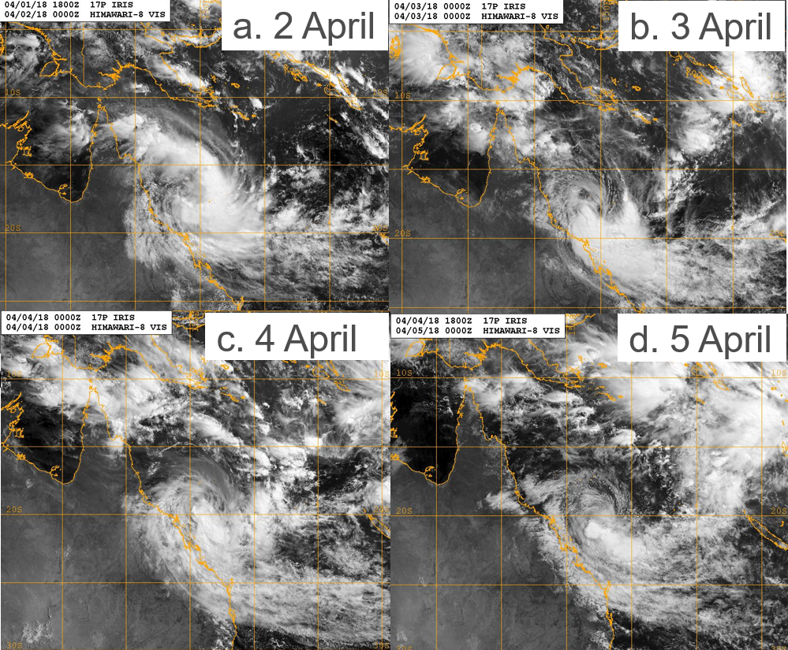

Figure . Series of visible images at 0000 UTC at a. 2 April; b. 3 April; c. 4 April; and d. 5 April. Images courtesy of courtesy NRL: <https://www.nrlmry.navy.mil/TC.html>

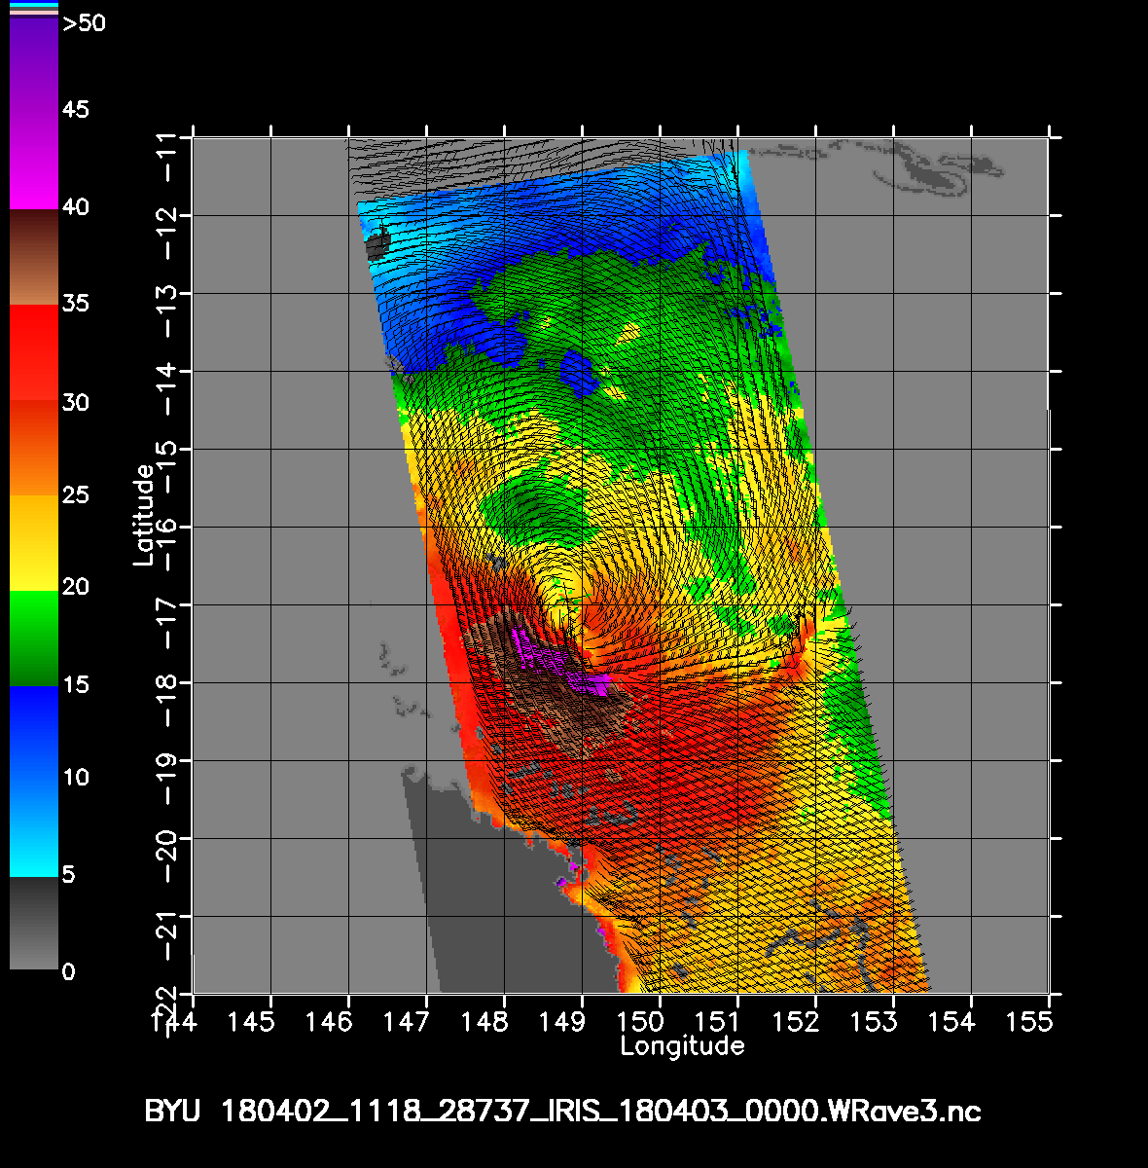

Figure . Advanced Scatterometer (ASCAT-B) wind distribution at 1118 UTC 2 April indicating gales south of the centre. Image courtesy NOAA: <https://manati.star.nesdis.noaa.gov/datasets/ASCATData.php>

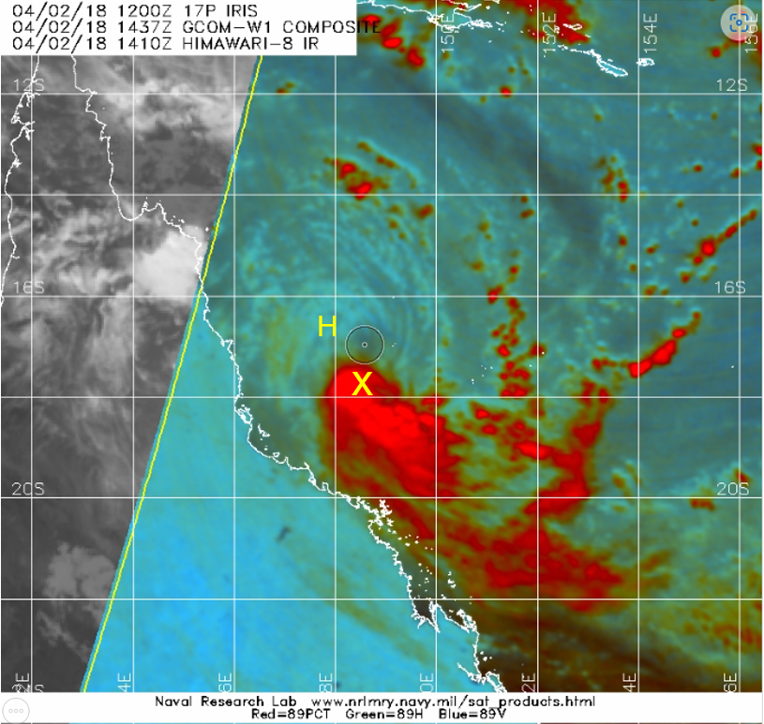

Figure 5. Special Sensor Microwave Image/Sounder (SSMIS) composite image at 1437 UTC 2 April as Tropical Cyclone Iris was at tropical cyclone intensity having gales extending more than halfway around the centre. Flinders Reef (marked X) was recording 10-min. wind of 52 kn and Holmes Reef (marked H) 34 kn. Image courtesy NRL: <https://www.nrlmry.navy.mil/TC.html>

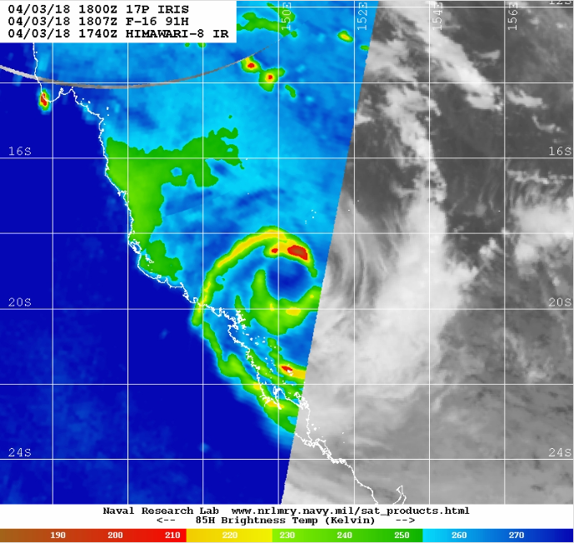

Figure 6. Special Sensor Microwave Image/Sounder (SSMIS) 91GHz H image at 1807 UTC 3 April near peak intensity. Image courtesy NRL: <https://www.nrlmry.navy.mil/TC.html>

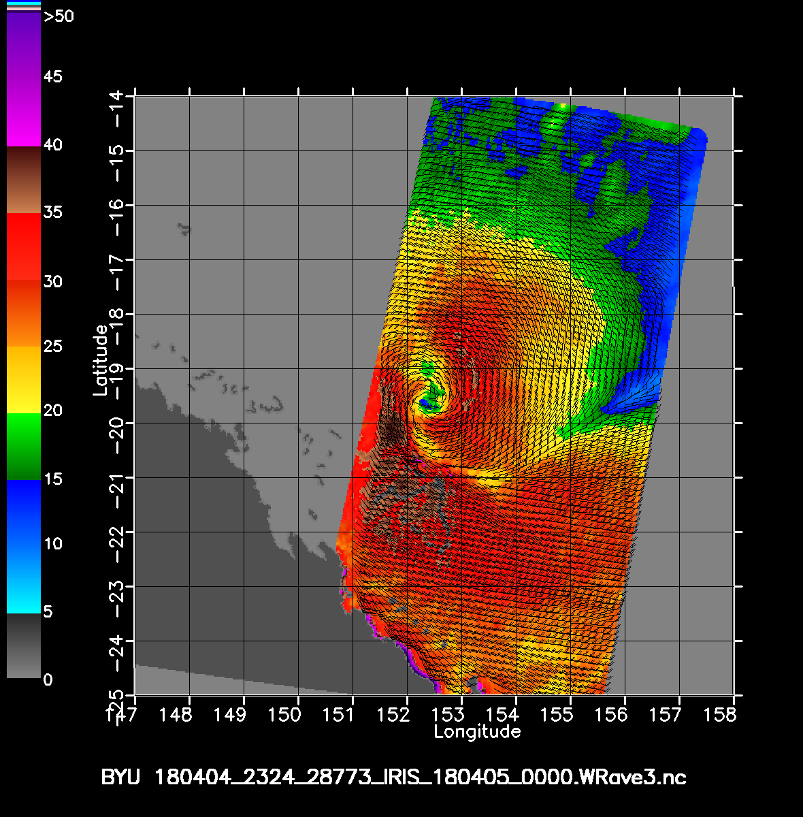

Figure 7. Advanced Scatterometer (ASCAT-B) wind distribution at 2324 UTC 4 April indicating gales primarily southwest of the centre. Image courtesy NOAA: <https://manati.star.nesdis.noaa.gov/datasets/ASCATData.php>

.

# Impact

Iris remained well off the Queensland coast but gales did occur on the Whitsunday Islands for a prolonged period on 3-4 April and disrupted tourism.

Hazardous surf closed beaches from central Queensland south to the New South Wales coast over the Easter holidays.

.

# Observations

## 4.1 Winds

Flinders Reef recorded gale-force winds between 19 UTC 1 April – 14 UTC 3 April; storm-force winds between 12 – 15 UTC, 18 -19 UTC 2 April; peak 10-minute wind of 54 kn (101 km/h) at 1725 UTC 2 April and peak 3-second wind gust of 68 kn (126 km/h) at 1720 UTC 2 April.

Holmes Reef recorded gale-force winds between 14 UTC 2 April – 02 UTC 3 April; peak 10min. winds of 43 kn (80 km/h) at 1839 UTC 2 April; peak gusts of 53 kn (98 km/h) at 1823 UC 2 April.

Willis Island recorded gales between 23 UTC 2 April – 02 UTC 3 April then briefly around 07UTC 3 April; peak 10min. winds of 37 kn (68 km/h) and peak wind gust of 45 kn (83 km/h).

Hamilton Island recorded gale-force winds for periods between 15 UTC 2 April to 07 UTC 4 April; peak 10 min. winds of 48 kn (89 km/h) at 0004 UTC 4 April; peak gusts of 57 kn (106 km/h) at 1941 UTC 3 April. Note that observed winds are enhanced as the site is elevated.

Frederick Reef recorded gale-force winds between 09 UTC 3 April – 07 UTC 4 April; peak 10min. winds of 43 kn (80 km/h) at 1352 UTC 3 April; peak gusts of 50 kn (93 km/h) at 1247 UC 3 April.

Marion Reef recorded gale-force winds between 13 – 15 UTC 3 April and 06 – 07, 10 – 14, 18 – 21 UTC 4 April; peak 10 min. winds of 38 kn (70 km/h) at 1958 UTC 4 April; peak gusts of 47 kn (87 km/h) at 1953 UTC 4 April.

Creal Reef recorded gale-force winds between 00-01 UTC, 05-07 UTC 2 April, 19 UTC 2 April – 00 UTC 3 April, 02 UTC 3 April – 20 UTC 4 April, 10-11 UTC 5 April; storm-force winds between 12 -18 UTC 3 April; peak 10min. winds of 49 kn (91 km/h) at 1300 and 1811 UTC 3 April; peak gust of 62 kn (115 km/h) at 0334 UTC 4 April.

Cato Island recorded gale-force winds between 22 UTC 28 March and 02 UTC 29 March; peak 10min. winds of 39 kn (72 km/h) at 2344 UTC 28 March; peak gust of 49 kn (91 km/h) at 0016, 0047 UTC 29 March.

Gannet Cay recorded gale-force winds between 13 UTC 3 April and 13 UTC 5 April; peak 10 min. winds of 41 kn (76 km/h) at 1415 and 1537 UTC 4 April; peak gusts of 51 kn (94 km/h) at 1324 UTC 4 April.

# Forecast performance

Tropical Cyclone products were issued from 07-13 UTC 24 March and then from 01 UTC 2 April to 19 UTC 5 April. Tropical Cyclone Watch was initiated at 13 UTC 2 April between Ayr and St Lawrence including Mackay. Advices extended south to Yeppoon at 07 UTC 3 April and finally cancelled at 10 UTC 4 April as Iris moved away from the coast and was weakening. Advices warned of gales for the Whitsunday Islands and adjacent coastline.

Figure 8 shows the Forecast Track Map when the first TC Watch was declared late on 2 April. This forecast accurately identified the southeast motion and development to a category 2 on 3 April then weakening to category 1 by 5 April. When Iris reached category 2 intensity on 3 April, forecasts indicated further development to category 3 intensity but this failed to occur.

The overall accuracy figures for Tropical Cyclone Iris are below and also shown in Figure 8. These show that the forecast position was considerably less accurate than the five-year average, especially at longer lead times. If limiting the verification to when the system was at gale-force intensity, then the accuracy figures improve significantly indicating that much of the errors are a result of the differences when the system was weak. For example, at T+48h the track error for all intensities is 229 km (Table 1) compared to 138 km if limiting to 35 kn as shown in Figure 9. The erratic nature of the track as shown in Figure 1 is an indication of the variation in steering influences at different stages and it should not be surprising to have large errors at long lead times.

In contrast, the intensity forecasts had much lower errors to the five-year average at all time steps as seen in Figure 10.

Table 2. Verification statistics for Tropical Cyclone Iris.

|  |  |  |  |  |  |  |  |  |  |  |
| --- | --- | --- | --- | --- | --- | --- | --- | --- | --- | --- |
| **Time** | **0** | **6** | **12** | **18** | **24** | **36** | **48** | **72** | **96** | **120** |
| **Position Absolute error (km)** | 23 | 56 | 75 | 97 | 122 | 171 | 229 | 369 | 516 | 596 |
| **Intensity Absolute error (kn)** | 1.3 | 3.4 | 5.1 | 7.5 | 8.5 | 7.7 | 5.3 | 4.2 | 4.4 | 3.6 |
| **Sample Size** | 18 | 18 | 18 | 18 | 18 | 18 | 18 | 18 | 17 | 11 |

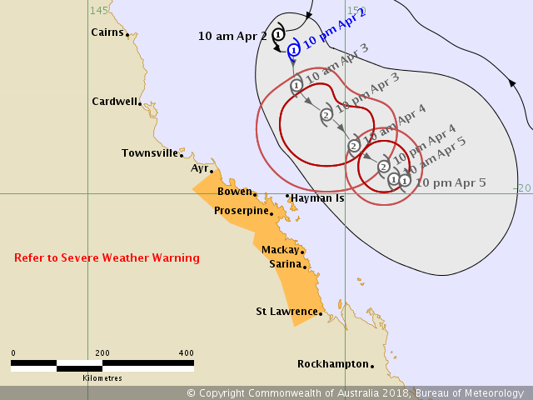

Figure . Forecast track map issued 1153 pm AEST 2 April when a TC Watch was first issued.

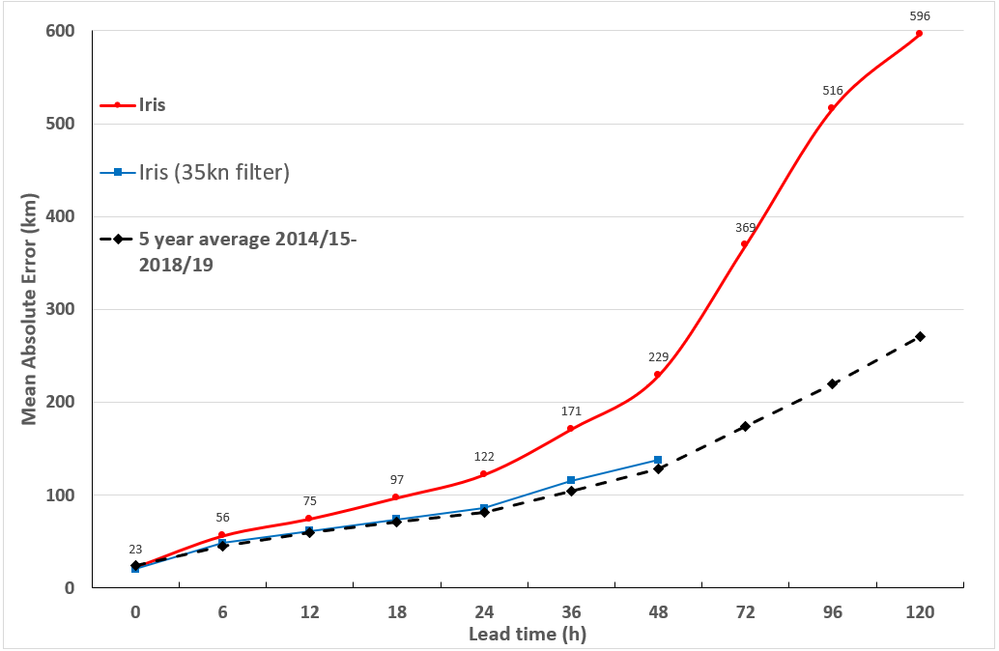

Figure 9. Position accuracy figures for Tropical Cyclone Iris.

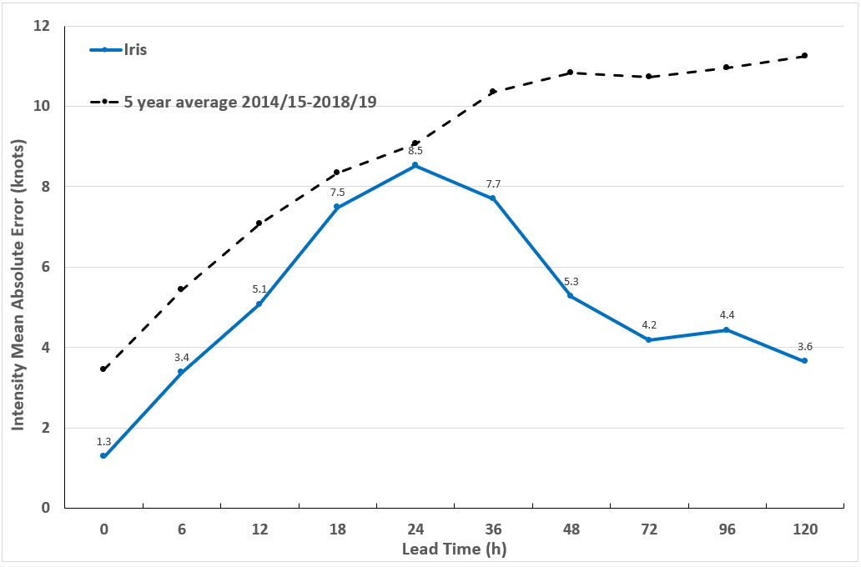

Figure 10. Intensity accuracy figures for Tropical Cyclone Iris.

# Appendix: List of abbreviations

|  |  |
| --- | --- |
| Abbreviation | Term |
| ADT | Advanced Dvorak Technique |
| ACST | Australian Central Standard Time |
| AEST | Australian Eastern Standard Time |
| AMSR2 | Advanced Microwave Scanning Radiometer |
| ASCAT | Advanced Scatterometer |
| ATMS | Advanced Technology Microwave Sounder |
| AWS | automatic weather station |
| AWST | Australian Western Standard Time |
| °C | Celsius |
| CI | Current intensity |
| CIMSS | Cooperative Institute for Meteorological Satellite Studies (USA) |
| CIRA | Cooperative Institute for Research in the Atmosphere (USA) |
| EIR | Enhanced InfraRed |
| ERC | eyewall replacement cycle |
| FNMOC | Fleet Numerical Meteorology and Oceanography Centre (USA) |
| FT | Final T-number |
| GCOM | Global Change Observation Mission |
| GHz | Gigahertz |
| GMI | Global Precipitation Measurement Microwave Imager |
| h | hour |
| hPa | hectopascal |
| HSCAT | Hai Yang 2 Scatterometer (HY-2B, HY-2C) |
| km | kilometres |
| km/h | kilometres per hour |
| kn | knot |
| LLCC | LLCC |
| MET | Model Expected T-number |
| METOP | Meteorological Operational Satellite |
| MJO | Madden-Julian Oscillation |
| mm | millimetres |
| MSLP | mean sea level pressure |
| nm | nautical mile |
| NOAA | National Oceanic and Atmospheric Administration |
| NRL | Navy Research Lab (USA) |
| PAT | Pattern T-number |
| RH | relative humidity |
| RMW | radius of maximum winds |
| RSMC | Regional Specialised Meteorological Centre |
| SAR | Synthetic Aperture Radar |
| SATCON | satellite Consensus |
| SMAP | Soil Moisture Active Passive |
| SMOS | Soil Moisture and Ocean Salinity |
| SSMIS | Special Sensor Microwave Imager/Sounder |
| TC | Tropical Cyclone |
| TCWC | Tropical Cyclone Warning Centre |
| UTC | Universal Time Co-ordinated |