Severe Tropical Cyclone Kirrily

## 17 January – 5 February 2024

## Tony Wedd, Lauren Pattie, and David Grant

## Tropical Cyclone Environmental Prediction Services

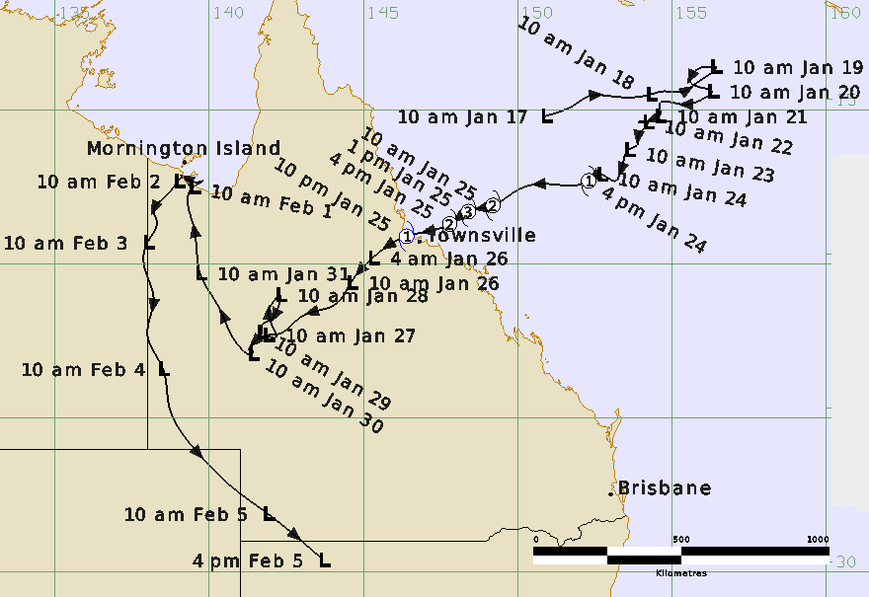

### Revision history

|  |  |  |  |
| --- | --- | --- | --- |
| Date | Version | Authors | Description |
| 20/08/2024 | 1.0 | Tony Wedd | Final draft ready |
| 13/09/2024 | 1.1 | Tony Wedd | Review comments incorporated |

### Review status

|  |  |  |  |
| --- | --- | --- | --- |
| Date | Version | Reviewer | Description |
| 29/08/2024 | 1.0 | Linda Paterson | Completed |
| 07/10/2024 | 1.1 | Joe Courtney | Completed |

### Release history

|  |  |  |  |
| --- | --- | --- | --- |
| Date | Version | Status | Approval |
| 07/10/2024 | 1.1 | Approved for release | Craig Earl-Spurr |



Contact details:

Tropical Cyclone Team Lead

Severe Weather Environmental Prediction Services

Bureau of Meteorology

PO Box 1370, West Perth WA 6872

Email: tcwc@bom.gov.au

This work is copyright. Apart from any use as permitted under the Copyright Act 1968, no part may be reproduced without prior written permission from the Bureau of Meteorology. Refer to www.bom.gov.au/other/copyright.shtml for further information. Unless otherwise noted, all images in this document are licensed under the Creative Commons Attribution Australia Licence.

© Commonwealth of Australia 2024

Published by The Bureau of Meteorology

Cover image: Track of Severe Tropical Cyclone Kirrily 17 January – 5 February 2024. Times in AEST, UTC +10.0h.

Table of Contents

1. Summary 5

2. Meteorological description 10

2.1. Intensity Analysis 10

2.2. Structure 19

2.3. Motion 20

3. Impact 21

4. Observations 21

4.1. Wind 21

4.2. Rainfall 22

4.3. Pressure 24

4.4. Storm Surge 24

5. Forecast Performance 25

6. Appendix: List of Abbreviations 29

**List of Figures**

Figure 1. Best track of Severe Tropical Cyclone Kirrily 17 January - 5 February 2024. 6

Figure 2. Detailed best track of Severe Tropical Cyclone Kirrily as it approached and crossed the Queensland coast 25-26 January 2024 7

Figure 3. Hovmoller diagram of tropical waves showing the formation of Kirrily on 21-24 January occurred at the end of a strong pulse of the MJO with associated Equatorial Rossby (ER) and Kelvin wave influences 13

Figure 4. Satellite winds 22 January: Left: SMOS 2005 UTC; Right: HSCAT HY-2C 2100 UTC. 14

Figure 5. ASCAT scatterometry at 2238 UTC 22 January (left) and 1111 UTC 23 January (right). 14

Figure 6. Satellite winds: SMAP at 0809 UTC 24 January 15

Figure 7. Satellite winds on 24 January (UTC): SMOS at 2026 UTC (left) and ASCAT-B at 2342 UTC (right), showing 45-50 knot wind speeds in the northern quadrants of Kirrily. 16

Figure 8. Himawari-9 visible image at 0230 UTC 25 January showing Kirrily near peak intensity of 65 knots.. 16

Figure 9. SAR image showing the wind structure of Kirrily at 0846 UTC 25 January. 17

Figure 10. ASCAT-C scatterometry data of Kirrily near landfall at 1124 UTC 25 January 18

Figure 11. HSCAT scatterometer data (left) and enhanced infra-red Himawari-9 imagery (right) of ex-Tropical Cyclone Kirrily near the Gulf of Carpentaria coast at 0924 UTC 1 February 19

Figure 12. Radar reflectivity image of Kirrily close to landfall at 1109 UTC 25 January from the Townsville (Hervey Range) weather radar. 20

Figure 13. Weekly Australian rainfall for the week ending 29 January 2024. 23

Figure 14. Weekly Australian rainfall for the week ending 5 February 2024. 24

Figure 15. Position accuracy figures for Severe Tropical Cyclone Kirrily. 26

Figure 16. Intensity accuracy figures for Severe Tropical Cyclone Kirrily. 27

Figure 17. Forecast Track Map issued at 5pm AEST Monday 22 January, approximately 3 days prior to landfall. 28

Figure 18. Intensity plot (10-minute mean) of objective and subjective guidance. 31

**List of Tables**

Table 1. Best track summary for Severe Tropical Cyclone Kirrily 10

Table 2. Verification statistics for Severe Tropical Cyclone Kirrily. 26

1. Summary

Severe Tropical Cyclone Kirrily peaked as a category 3 system in the Coral Sea shortly before crossing the north Queensland coast in the vicinity of Balgal Beach, Rollingstone, about 50 km northwest of Townsville, as a Category 1 tropical cyclone.

The system was first identified as a tropical low (05U), which formed along the monsoon trough in the Coral Sea, approximately 150 km NE of Willis Island, during 17 January. Strong monsoon winds initially steered the system east, but during the 19-20 January, 05U slowed and turned towards the southwest. The system then developed slowly over the next four days and was named Tropical Cyclone Kirrily at 0600 UTC (4pm AEST) 24 January (AEST=UTC+10), about 50 km southeast of Lihou reef.

Kirrily then turned west-southwest, towards the Queensland coast, and began to develop more rapidly. The system reached a peak intensity of category 3 strength (65 kn, 120 km/h mean winds) at 0300 UTC (1pm AEST) 25 January. On its final approach towards the coast, however, Kirrily began to weaken quite rapidly. It crossed the north Queensland coast, in the vicinity of Balgal Beach, Rollingstone, at 1200 UTC (10pm AEST) 25 January as a category 1 cyclone. It then weakened quickly as it moved inland, decreasing to below tropical cyclone intensity by 1800 UTC 25 January (4am AEST 26 January).

Ex-Tropical Cyclone Kirrily then moved west and north across central and western Qld. During 1 February, the system strengthened as it moved just offshore over the southern Gulf of Carpentaria. Gales developed on the northern side of Kirrily, but it did not redevelop into a tropical cyclone. Intermittent gales occurred at Mornington Island Airport for nearly 24 hours, which recorded its equal highest wind gust of 55 kn (102 km/h) at 1137 UTC (9:37pm AEST) February 1. Early on 2 February, Kirrily moved back over land and the northern gales eased.

During the following days Kirrily moved to the south near the Queensland Northern Territory Border. On 5 February Kirrily interacted with an upper trough which resulted in another episode of strengthening and caused a brief period of gales on the eastern side of the system, recorded at Ballera in southwest Queensland for several hours from 2000 UTC 4 February (6am AEST 5 February). Later that day, ex-Tropical Cyclone Kirrily merged into an existing trough over southeastern Australia.

As Kirrily moved over the tropical coast and then inland across Queensland it led to heavy rainfall, as well as widespread flooding for western Queensland.



Figure 1. Best track of Severe Tropical Cyclone Kirrily 17 January - 5 February 2024 (times in AEST, UTC +10).

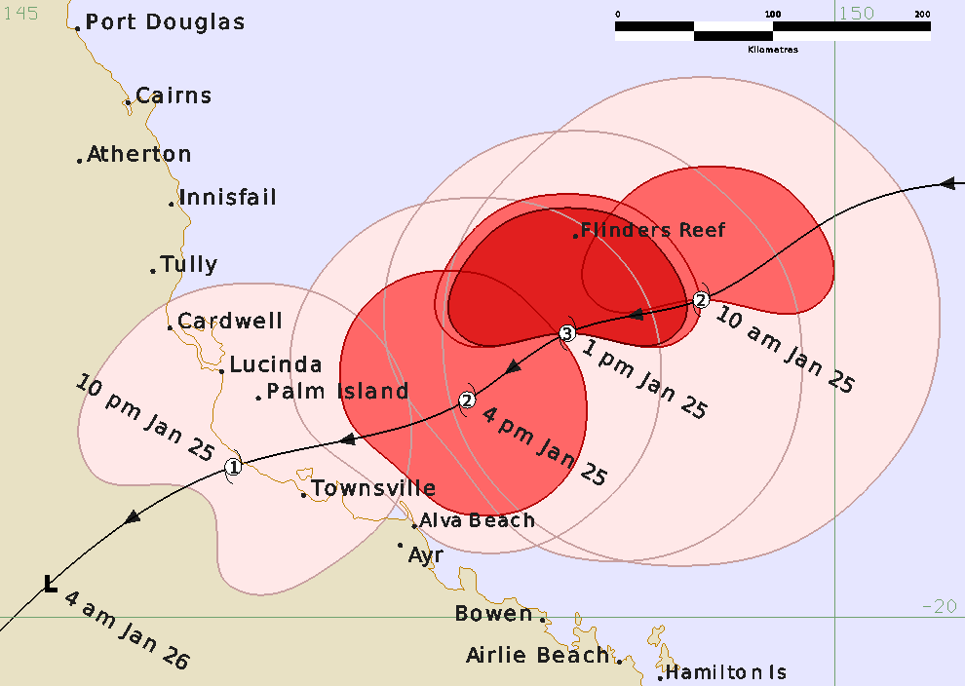

Figure 2. Detailed best track of Severe Tropical Cyclone Kirrily as it approached and crossed the Queensland coast 25-26 January 2024 (times in AEST, UTC +10).

|  |  |  |  |  |  |  |  |  |  |  |  |  |
| --- | --- | --- | --- | --- | --- | --- | --- | --- | --- | --- | --- | --- |
| Year | Month | Day | Hour UTC | Pos. Lat S | Pos. Long. E | Pos. Acc. nm | Max. wind kn | Max. gust kn | Cent. Press hPa | Rad of gales (NE/SE/SW/NW) nm | Rad of storm (NE/SE/SW/NW) nm | RMW nm |
| 2024 | 1 | 17 | 0000 | 15.2 | 150.9 | 40 | 15 | 45 | 1000 | 0/0/0/0 | 0/0/0/0 | - |
| 2024 | 1 | 17 | 0600 | 14.8 | 151.9 | 70 | 15 | 45 | 1000 | 0/0/0/0 | 0/0/0/0 | - |
| 2024 | 1 | 17 | 1200 | 14.6 | 152.2 | 50 | 15 | 45 | 1001 | 0/0/0/0 | 0/0/0/0 | - |
| 2024 | 1 | 17 | 1800 | 14.6 | 153.2 | 60 | 15 | 45 | 1001 | 0/0/0/0 | 0/0/0/0 | - |
| 2024 | 1 | 18 | 0000 | 14.5 | 154.3 | 10 | 20 | 45 | 1001 | 0/0/0/0 | 0/0/0/0 | - |
| 2024 | 1 | 18 | 0600 | 14.4 | 154.7 | 25 | 20 | 45 | 1000 | 0/0/0/0 | 0/0/0/0 | - |
| 2024 | 1 | 18 | 1200 | 14.4 | 155.4 | 40 | 20 | 45 | 999 | 0/0/0/0 | 0/0/0/0 | - |
| 2024 | 1 | 18 | 1800 | 14.2 | 155.7 | 40 | 20 | 45 | 999 | 0/0/0/0 | 0/0/0/0 | - |
| 2024 | 1 | 19 | 0000 | 13.6 | 156.4 | 30 | 20 | 45 | 999 | 0/0/0/0 | 0/0/0/0 | - |
| 2024 | 1 | 19 | 0600 | 13.6 | 156.2 | 35 | 25 | 45 | 997 | 0/0/0/0 | 0/0/0/0 | - |
| 2024 | 1 | 19 | 1200 | 13.7 | 155.8 | 20 | 25 | 45 | 997 | 0/0/0/0 | 0/0/0/0 | - |
| 2024 | 1 | 19 | 1800 | 14.1 | 155.6 | 30 | 25 | 45 | 996 | 0/0/0/0 | 0/0/0/0 | - |
| 2024 | 1 | 20 | 0000 | 14.4 | 156.3 | 15 | 25 | 45 | 996 | 0/0/0/0 | 0/0/0/0 | - |
| 2024 | 1 | 20 | 0600 | 14.7 | 155.9 | 20 | 25 | 45 | 996 | 0/0/0/0 | 0/0/0/0 | - |
| 2024 | 1 | 20 | 1200 | 14.8 | 155.2 | 30 | 25 | 45 | 998 | 0/0/0/0 | 0/0/0/0 | - |
| 2024 | 1 | 20 | 1800 | 14.8 | 154.6 | 20 | 25 | 45 | 999 | 0/0/0/0 | 0/0/0/0 | - |
| 2024 | 1 | 21 | 0000 | 15.2 | 154.6 | 30 | 30 | 45 | 998 | 0/0/0/0 | 0/0/0/0 | - |
| 2024 | 1 | 21 | 0600 | 15.3 | 154.4 | 20 | 30 | 45 | 996 | 0/0/0/0 | 0/0/0/0 | - |
| 2024 | 1 | 21 | 1200 | 15.4 | 154.1 | 12 | 30 | 45 | 999 | 0/0/0/0 | 0/0/0/0 | - |
| 2024 | 1 | 21 | 1800 | 15.4 | 153.9 | 30 | 30 | 45 | 998 | 0/0/0/0 | 0/0/0/0 | - |
| 2024 | 1 | 22 | 0000 | 15.4 | 154.2 | 35 | 30 | 45 | 998 | 0/0/0/0 | 0/0/0/0 | - |
| 2024 | 1 | 22 | 0600 | 15.7 | 154.0 | 30 | 30 | 45 | 996 | 0/0/0/0 | 0/0/0/0 | - |
| 2024 | 1 | 22 | 1200 | 15.9 | 153.9 | 40 | 30 | 45 | 998 | 0/0/0/0 | 0/0/0/0 | - |
| 2024 | 1 | 22 | 1800 | 16.1 | 153.9 | 35 | 30 | 45 | 996 | 0/0/0/0 | 0/0/0/0 | - |
| 2024 | 1 | 23 | 0000 | 16.3 | 153.6 | 20 | 35* | 50 | 997 | 0/120/90/0 | 0/0/0/0 | - |
| 2024 | 1 | 23 | 0600 | 16.8 | 153.4 | 20 | 35* | 50 | 993 | 0/130/120/0 | 0/0/0/0 | - |
| 2024 | 1 | 23 | 1200 | 17.1 | 153.3 | 30 | 35* | 50 | 994 | 0/130/130/0 | 0/0/0/0 | - |
| 2024 | 1 | 23 | 1800 | 17.3 | 153.2 | 40 | 40* | 50 | 991 | 0/130/140/0 | 0/0/0/0 | - |
| 2024 | 1 | 24 | 0000 | 17.1 | 152.7 | 30 | 40* | 55 | 995 | 0/0/130/100 | 0/0/0/0 | - |
| 2024 | 1 | 24 | 0600 | 17.3 | 152.3 | 20 | 40 | 55 | 992 | 0/150/160/110 | 0/0/0/0 | 50 |
| 2024 | 1 | 24 | 1200 | 17.4 | 150.9 | 20 | 40 | 55 | 990 | 0/140/140/90 | 0/0/0/0 | 35 |
| 2024 | 1 | 24 | 1800 | 17.6 | 150.0 | 30 | 45 | 55 | 990 | 80/100/130/80 | 0/0/0/0 | 40 |
| 2024 | 1 | 25 | 0000 | 18.1 | 149.2 | 15 | 50 | 70 | 987 | 80/90/100/80 | 50/0/0/45 | 40 |
| 2024 | 1 | 25 | 0300 | 18.3 | 148.4 | 15 | 65 | 90 | 973 | 75/90/60/70 | 50/0/0/50 | 40 |
| 2024 | 1 | 25 | 0600 | 18.7 | 147.8 | 10 | 55 | 90 | 974 | 75/60/45/70 | 40/45/35/50 | 25 |
| 2024 | 1 | 25 | 1200 | 19.1 | 146.4 | 12 | 45 | 65 | 989 | 70/50/15/60 | 0/0/0/0 | 14 |
| 2024 | 1 | 25 | 1800 | 19.8 | 145.3 | 20 | 30 | 45 | 993 | 0/0/0/0 | 0/0/0/0 | - |
| 2024 | 1 | 26 | 0000 | 20.6 | 144.6 | 30 | 25 | 45 | 998 | 0/0/0/0 | 0/0/0/0 | - |
| 2024 | 1 | 26 | 0600 | 21.3 | 144.1 | 30 | 25 | 45 | 997 | 0/0/0/0 | 0/0/0/0 | - |
| 2024 | 1 | 26 | 1200 | 21.7 | 143.0 | 30 | 25 | 45 | 999 | 0/0/0/0 | 0/0/0/0 | - |
| 2024 | 1 | 26 | 1800 | 22.3 | 142.0 | 30 | 25 | 45 | 998 | 0/0/0/0 | 0/0/0/0 | - |
| 2024 | 1 | 27 | 0000 | 22.3 | 141.9 | 25 | 25 | 45 | 998 | 0/0/0/0 | 0/0/0/0 | - |
| 2024 | 1 | 27 | 0600 | 22.4 | 142.1 | 15 | 25 | 45 | 996 | 0/0/0/0 | 0/0/0/0 | - |
| 2024 | 1 | 27 | 1200 | 21.9 | 142.0 | 15 | 20 | 40 | 999 | 0/0/0/0 | 0/0/0/0 | - |
| 2024 | 1 | 27 | 1800 | 21.2 | 142.1 | 20 | 20 | 40 | 998 | 0/0/0/0 | 0/0/0/0 | - |
| 2024 | 1 | 28 | 0000 | 21.0 | 142.3 | 10 | 20 | 40 | 999 | 0/0/0/0 | 0/0/0/0 | - |
| 2024 | 1 | 28 | 0600 | 21.5 | 142.2 | 15 | 20 | 40 | 998 | 0/0/0/0 | 0/0/0/0 | - |
| 2024 | 1 | 28 | 1200 | 21.8 | 142.0 | 20 | 20 | 40 | 1000 | 0/0/0/0 | 0/0/0/0 | - |
| 2024 | 1 | 28 | 1800 | 22.0 | 141.7 | 25 | 20 | 40 | 1000 | 0/0/0/0 | 0/0/0/0 | - |
| 2024 | 1 | 29 | 0000 | 22.2 | 141.7 | 20 | 20 | 40 | 1002 | 0/0/0/0 | 0/0/0/0 | - |
| 2024 | 1 | 29 | 0600 | 22.6 | 141.4 | 20 | 20 | 40 | 999 | 0/0/0/0 | 0/0/0/0 | - |
| 2024 | 1 | 29 | 1200 | 22.8 | 141.3 | 20 | 20 | 40 | 1002 | 0/0/0/0 | 0/0/0/0 | - |
| 2024 | 1 | 29 | 1800 | 22.8 | 141.4 | 20 | 20 | 40 | 1001 | 0/0/0/0 | 0/0/0/0 | - |
| 2024 | 1 | 30 | 0000 | 22.9 | 141.4 | 15 | 20 | 40 | 1004 | 0/0/0/0 | 0/0/0/0 | - |
| 2024 | 1 | 30 | 0600 | 22.7 | 141.0 | 15 | 20 | 40 | 1001 | 0/0/0/0 | 0/0/0/0 | - |
| 2024 | 1 | 30 | 1200 | 21.8 | 140.5 | 20 | 20 | 40 | 1001 | 0/0/0/0 | 0/0/0/0 | - |
| 2024 | 1 | 30 | 1800 | 21.2 | 140.2 | 10 | 20 | 40 | 1001 | 0/0/0/0 | 0/0/0/0 | - |
| 2024 | 1 | 31 | 0000 | 20.3 | 139.7 | 10 | 20 | 40 | 1003 | 0/0/0/0 | 0/0/0/0 | - |
| 2024 | 1 | 31 | 0600 | 19.6 | 139.6 | 15 | 20 | 40 | 999 | 0/0/0/0 | 0/0/0/0 | - |
| 2024 | 1 | 31 | 1200 | 18.8 | 139.5 | 20 | 20 | 40 | 999 | 0/0/0/0 | 0/0/0/0 | - |
| 2024 | 1 | 31 | 1800 | 18.0 | 139.3 | 25 | 20 | 40 | 996 | 0/0/0/0 | 0/0/0/0 | - |
| 2024 | 2 | 1 | 0000 | 17.5 | 139.5 | 15 | 30 | 45 | 995 | 0/0/0/0 | 0/0/0/0 | - |
| 2024 | 2 | 1 | 0600 | 17.3 | 139.8 | 15 | 35* | 50 | 994 | 60/0/0/60 | 0/0/0/0 | - |
| 2024 | 2 | 1 | 1200 | 17.35 | 139.6 | 20 | 40* | 55 | 993 | 60/0/0/60 | 0/0/0/0 | - |
| 2024 | 2 | 1 | 1800 | 17.2 | 139.1 | 20 | 35* | 50 | 992 | 50/0/0/50 | 0/0/0/0 | - |
| 2024 | 2 | 2 | 0000 | 17.3 | 139.0 | 15 | 35* | 50 | 991 | 50/0/0/0 | 0/0/0/0 | - |
| 2024 | 2 | 2 | 0600 | 17.8 | 138.6 | 15 | 30 | 45 | 991 | 0/0/0/0 | 0/0/0/0 | - |
| 2024 | 2 | 2 | 1200 | 18.3 | 138.2 | 20 | 30 | 45 | 993 | 0/0/0/0 | 0/0/0/0 | - |
| 2024 | 2 | 2 | 1800 | 18.6 | 138.3 | 25 | 25 | 45 | 993 | 0/0/0/0 | 0/0/0/0 | - |
| 2024 | 2 | 3 | 0000 | 19.3 | 138.0 | 25 | 25 | 45 | 995 | 0/0/0/0 | 0/0/0/0 | - |
| 2024 | 2 | 3 | 0600 | 20.1 | 137.9 | 25 | 25 | 45 | 993 | 0/0/0/0 | 0/0/0/0 | - |
| 2024 | 2 | 3 | 1200 | 21.1 | 138.2 | 20 | 25 | 45 | 996 | 0/0/0/0 | 0/0/0/0 | - |
| 2024 | 2 | 3 | 1800 | 22.3 | 138.0 | 25 | 25 | 45 | 993 | 0/0/0/0 | 0/0/0/0 | - |
| 2024 | 2 | 4 | 0000 | 23.4 | 138.5 | 15 | 25 | 45 | 996 | 0/0/0/0 | 0/0/0/0 | - |
| 2024 | 2 | 4 | 0600 | 24.6 | 138.7 | 10 | 25 | 45 | 994 | 0/0/0/0 | 0/0/0/0 | - |
| 2024 | 2 | 4 | 1200 | 26.2 | 139.7 | 15 | 30 | 45 | 993 | 0/0/0/0 | 0/0/0/0 | - |
| 2024 | 2 | 4 | 1800 | 27.2 | 140.7 | 20 | 35* | 50 | 991 | 40/40/0/0 | 0/0/0/0 | - |
| 2024 | 2 | 5 | 0000 | 28.1 | 141.9 | 10 | 35* | 50 | 995 | 40/40/0/0 | 0/0/0/0 | - |
| 2024 | 2 | 5 | 0600 | 29.6 | 143.7 | 20 | 25 | 45 | 996 | 0/0/0/0 | 0/0/0/0 | - |

Table 1. Best track summary for Severe Tropical Cyclone Kirrily, 17 January - 5 February 2024.

UTC=AEST-10. * Not at tropical cyclone intensity as gales less than halfway around centre.

1. Meteorological description
   1. Intensity Analysis

A comparison of subjective and objective intensity estimates is shown in Figure 18.

Tropical Low 05U was first analysed along the monsoon trough in the Coral Sea on 17 January, about 150 km northeast of Willis Island. At the time, an active phase of the MJO was moving into the Coral Sea region, supported by Equatorial Rossby and Kelvin waves as shown in Figure 3.

During the next two days, the tropical low moved steadily eastwards. The surface circulation remained elongated and disorganised, located on the southern side of a persistent cloud cluster. Scatterometry (ASCAT-B 2240 UTC 17 January, HSCAT HY-2B 0740 UTC 18 January, HSCAT HY-2C 1027 UTC 18 January, HSCAT HY-2B 1908 UTC 18 January, HSCAT HY-2C 2135 UTC 18 January, ASCAT-B 2221 UTC 18 January, ASCAT-B 1057 UTC 19 January, not shown) showed a broad wind maximum of 20-25 kn (35-45 km/h) on the northern side of the circulation, with lighter winds to the south.

On 19 January, 05U changed direction and assumed an erratic generally southwest track. Development continued to be very slow as the broad monsoonal circulation struggled to consolidate. Scatterometry on 21 January (ASCAT-B 2237 UTC 20 January, not shown) suggested that, while the low-level centre remained elongated, stronger winds had moved closer to the centre and overall intensity had increased to 30 kn (55 km/h). There was little further change in intensity until 23 January, when radiometer and scatterometry (SMOS 2005 UTC 22 January, HSCAT HY-2C 2100 UTC 22 January, Figure 4, and ASCAT-B 2238 UTC 22 January, ASCAT-B 1111 UTC 23 January, Figure 5) showed that gales had developed in the southern quadrants of the circulation. A swathe of gales displaced well to the north was also evident at this time, which was outside the circulation of 05U and part of the broader monsoon flow. The cloud signature of 05U remained only loosely organised, with Dvorak T-numbers in the 1.5 to 2.0 range during this period (Figure 5).

Overnight on 23-24 January, 05U continued to become more organised as the zone of gale force winds followed the deep convection wrapping around the western periphery of the system. The Automatic Weather Station (AWS) at Lihou Reef (west of the system centre) recorded intermittent southerly gale force winds between 1126 UTC (2126 AEST) 23 January and 2100 UTC 23 January (0700 AEST 24 January). Over the course of 24 January, various scatterometry passes suggested there was sufficient evidence that gales were occurring more than half-way around the system in the southern and northwestern quadrants. The system was classified as a tropical cyclone at 06 UTC (4pm AEST) 24 January and named Kirrily. This was supported in post-analysis by the 0809 UTC 24 January SMAP pass (Figure 6). The subjective Dvorak T number remained at 2.5, lower than tropical cyclone intensity (overall, the Dvorak technique mostly underestimated the intensity of Kirrily throughout its lifetime as a tropical cyclone). The AWS at Lihou Reef recorded a minimum sea level pressure of 991.8 hPa as the centre of Kirrily passed within 35 km of the station.

On 25 January, the broad scale environment became more favourable for development and Kirrily continued to consolidate and intensify as it moved steadily west-southwest. The cloud signature improved, and at 1800 UTC 24 January (0400 AEST 25 January), the Dvorak T number had increased to 3.0, briefly matching the analysed intensity of 45 kn (85 km/h). A SMOS pass at 2026 UTC 24 January (0626 AEST 25 January, Figure 7) suggested that winds were approaching 50 kn (95 km/h) in the northern quadrants. ASCAT-B at 2342 UTC 24 January (0942 AEST 25 January, Figure 7) supported this, depicting 45-50 kn (85-95 km/h) chiefly in the northeastern quadrant. At 0000 UTC (1000 AEST) 25 January, Flinders Reef AWS, then approximately 95 km northwest of Kirrily's centre, recorded mean winds of 44 kn (85 km/h), which increased to storm force (48 kn (89 km/h)) an hour later. Kirrily was therefore upgraded to category 2 (50 kn (95 km/h) mean winds) at 0000 UTC based on this information. Note that the Bureau AWS at Hamilton Island, then approximately 220 km south of the centre of Kirrily, recorded 10-minute mean wind speeds up to 48 kn (89 km/h) (see Section 4.1). This was likely due to a belt of synoptically enhanced winds outside the circulation of Kirrily. Furthermore, it was likely an overestimate of the surface winds as the Hamilton Island AWS is situated on an exposed hill well above sea level.

Over the next few hours, the winds at Flinders Reef AWS continued to increase as Kirrily approached and passed just over 55 km to the south. The 10-minute mean wind recorded by Flinders Reef AWS peaked at 63 kn (117 km/h), just below hurricane force, at 0229 UTC (1229 AEST) 25 January. At this time, the AWS was located in the northern (partial) eye wall of Kirrily, near the estimated radius of maximum winds (Figure 8). This was close to the peak intensity of Kirrily, which was estimated at 65 kn (120 km/h) (category 3) at 0300 UTC (1300 AEST) 25 January. The Dvorak T number remained lower than this intensity at 3.0 (category 1), as did the objective aids: SATCON peaked at 59 kn (109 km/h) at 11 UTC (2100 AEST) 25 January, while other objective aids (CIMSS ADT, NESDIS ADT, DMINT, and DPRINT) generally peaked in the 50-55 kn (95-100 km/h) range during 25 January (Figure 18).

Kirrily continued to approach the Queensland coast on a steady west-southwest track. The cloud signature improved, and the Dvorak T number peaked at 3.5 (category 2) at 0600 UTC (1600 AEST) 25 January. Shortly afterward, a Synthetic Aperture Radar retrieval (SAR RCM-3 0846 UTC (1846 AEST), Figure 9) depicted a belt of winds exceeding hurricane force (64 kn (120 km/h)) persisting in the northeastern quadrant of the circulation. This was consistent with the earlier observations from Flinders Reef. However, there is some conjecture that in extreme rainfall intensities that SAR and ASCAT (at C-band wavelengths) result in too high wind retrieval speeds. Land and marine anemometers at this time were reading lower than the co-located SAR retrieval wind estimate. Objective aids were also lower than the SAR estimate (Figure 18): SATCON 55 kn (100 km/h), DPRINT and AiDT 50-55 kn (95-100 km/h). Therefore, it is estimated that Kirrily had weakened to category 2 (55 kn (100 km/h)) by 0600 UTC (1600 AEST) 25 January, consistent with the subjective Dvorak and objective aids.

Kirrily crossed the coast about 45 km to the northwest of Townsville in Queensland at around 1200 UTC (2200 AEST) 25 January. Wind measurements from scatterometry and anemometers indicated that the system had weakened considerably prior to crossing. Scatterometry close to the time of crossing (ASCAT-C 1124 UTC 25 January, Figure 10) indicated maximum winds in the 40-45 kn (75-85 km/h) range. Land-based Bureau AWS at Cape Ferguson (30 km east of Townsville), Alva Beach (80 km east-southeast of Townsville), and Lucinda Point (90 km northwest of Townsville) supported this, each recorded maximum 10-minute mean winds likewise in the 40-45 kn (75-85 km/h) range leading up to landfall (see Section 4.1 Wind). A series of anemometers deployed by James Cook University on Surface Weather Relay and Logging Network (SWIRLnet) towers (at a height of approximately 3.2m) around Townsville recorded a maximum 10-minute wind speed of 44.1 kn (81.7 km/h) during the event (see Section 4.1 Wind). Kirrily was therefore determined to be a category 1 cyclone at landfall, with a maximum 10-minute mean wind of 45 kn (85 km/h). The Dvorak T number remained slightly higher than this intensity at 3.5 (category 2). Objective estimates were also generally slightly higher (Figure 18), with DMINT and DPRINT in the 45-55 kn (85-100 km/h) range, and SATCON in the 55-60 kn (100-110 km/h) range. The CIMSS ADT and AiDT estimates at landfall agreed with the post-analysis intensity of 45 kn (85 km/h).

After making landfall, Kirrily weakened rapidly and was downgraded to a tropical low six hours later at 1800 UTC 25 January (0400 AEST 26 January), with gale force winds no longer evident. The remnant low persisted over inland Queensland for several days and eventually turned north (see section 2.3 Motion). As ex-Kirrily approached the southern Gulf of Carpentaria coast early on 1 February, it strengthened. Westerly winds increased over Mornington Island and became gale force from 0351 UTC (1351 AEST) 1 February. The system centre moved over water in the far southern Gulf of Carpentaria for several hours on 1 February, but by early on 2 February it had moved back over land and soon turned to the southwest, moving back inland. Gales with a maximum speed of 40 kn (75 km/h) persisted at Mornington Island for nearly 24 hours between 0351 UTC (1351 AEST) 1 February, and 0105 UTC (1105 AEST) 2 February. However, no gales were recorded on the mainland during this period, nor was there any evidence from scatterometry that the gales extended to the southern quadrants of the circulation (see e.g. HSCAT HY-2B 0924 UTC (1924 AEST) 1 February, Figure 11). Kirrily therefore remained a tropical low over the far southern Gulf of Carpentaria and did not redevelop into a tropical cyclone.

Ex-Kirrily moved south close to the Northern Territory / Queensland border for the following few days, then turned southeast. Overnight on 4-5 February, the system interacted with an approaching upper trough and once again strengthened, this time while over land. Land gales developed in the eastern quadrants (enhanced by the rapid southeasterly movement of the system) and were recorded at the Bureau AWS at Ballera Gas Field in southwest Queensland between 2000 UTC 4 February (0600 AEST 5 February) and 2330 UTC 4 February (0930 AEST 5 February).

Later on 5 February, the low merged into an existing trough over southeastern Australia and ceased to be trackable.

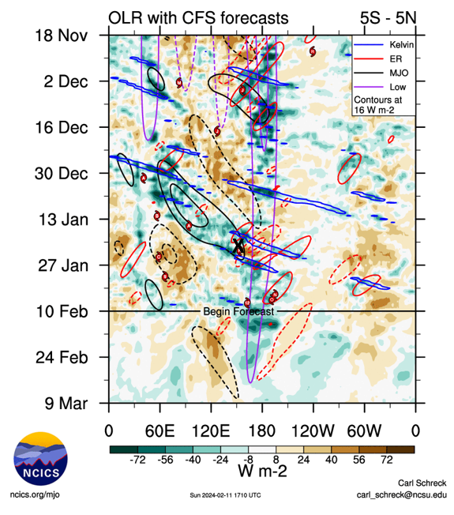

Figure 3. Hovmoller diagram of tropical waves showing the formation of Kirrily on 21-24 January (indicated by "X") occurred at the end of a strong pulse of the MJO (black), with associated Equatorial Rossby (ER) (red) and Kelvin wave (blue) influences. Image courtesy of North Carolina Institute for Climate Studies (ncics.org).

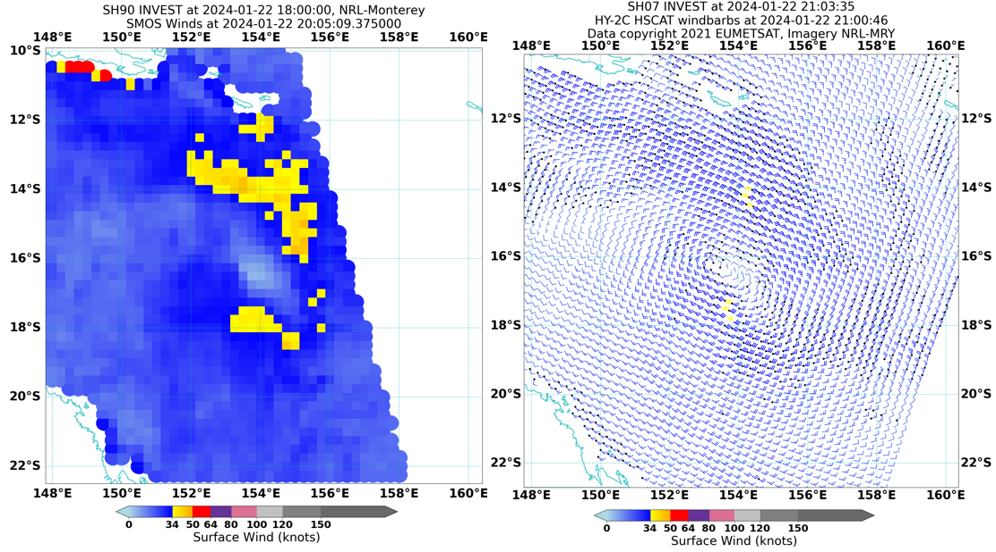

Figure 4. Radiometer and Scatterometry on the morning of 23 January (AEST), showing gales developing in the southern quadrants of 05U, with a swathe of monsoonal gales evident to the north. Left: SMOS 2005 UTC 22 January. Right: HSCAT HY-2C 2100 UTC 22 January. Images courtesy NRL: <https://www.nrlmry.navy.mil/TC.html>

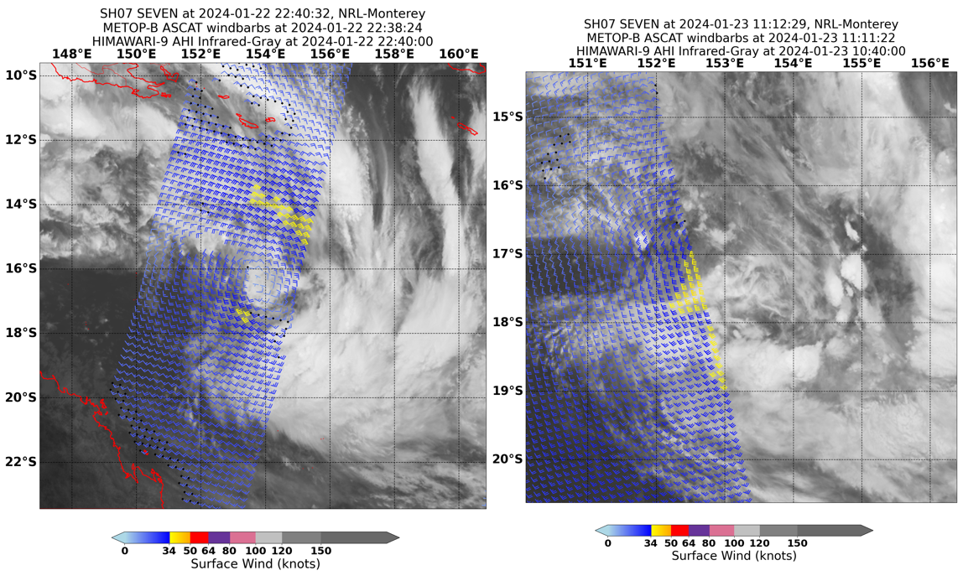

Figure 5. ASCAT-B scatterometry at 2238 UTC 22 January (left) and 1111 UTC 23 January (right) overlain on Himawari-9 infrared imagery. Gales are seen becoming more predominant in the southern quadrants during the day, while the cloud signature remains only loosely organised. Images courtesy NRL: <https://www.nrlmry.navy.mil/TC.html>

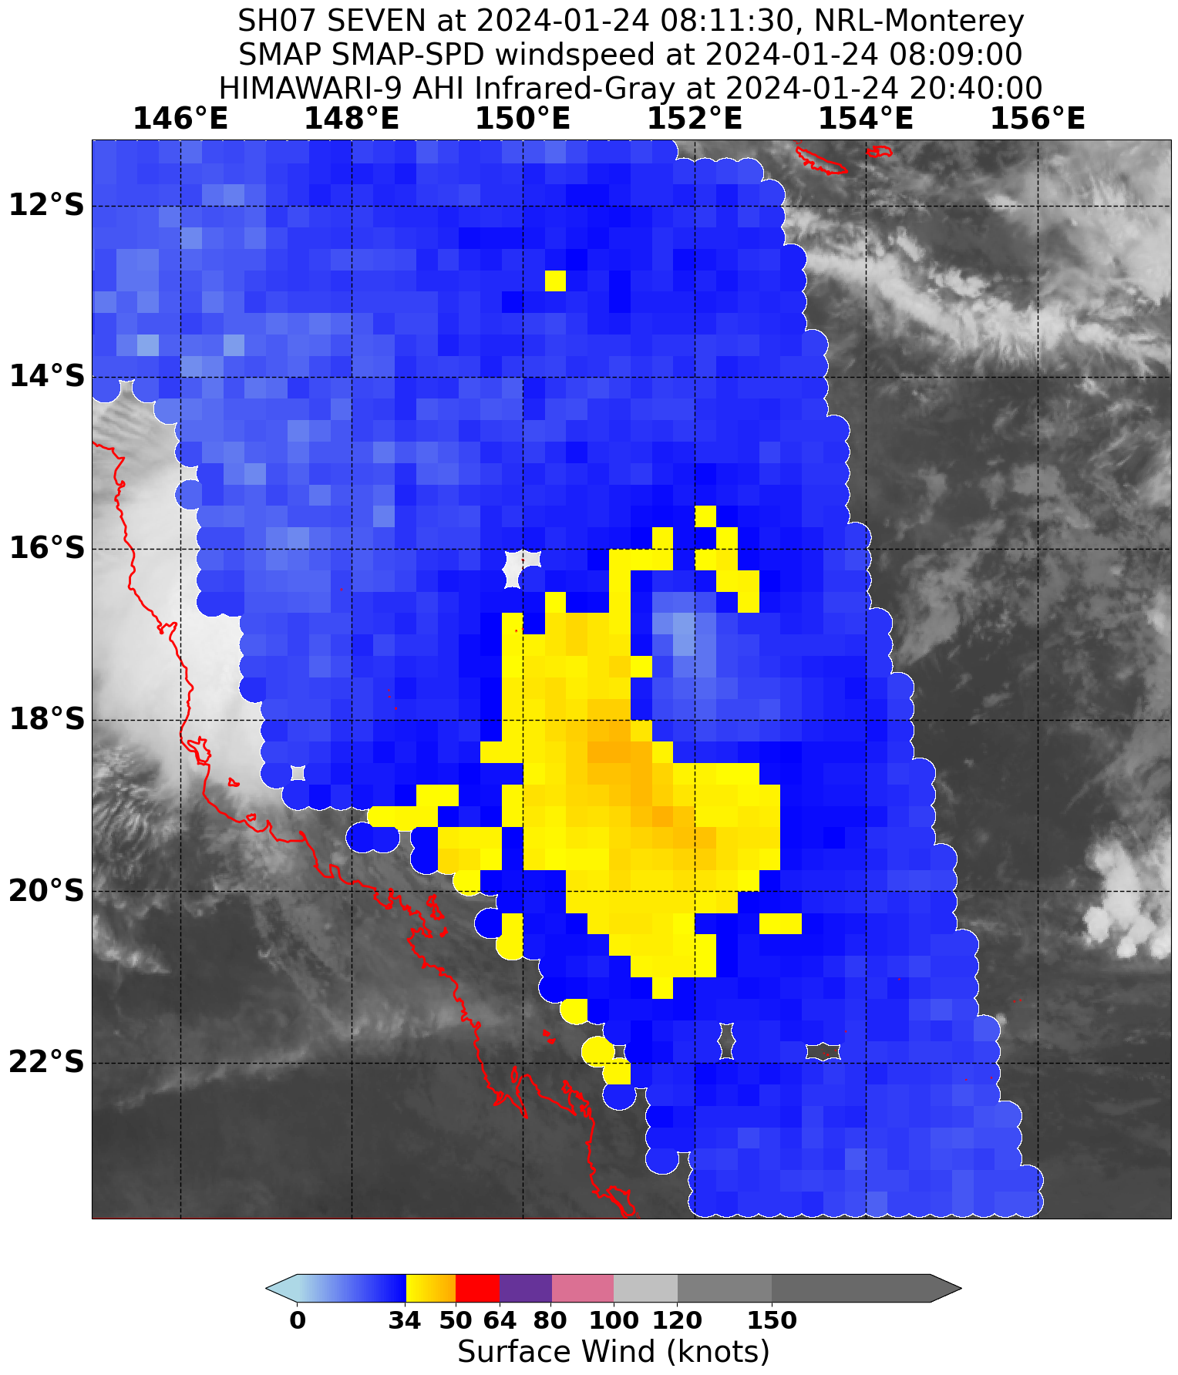

Figure 6. SMAP radiometer pass at 0809 UTC 24 January, showing evidence of gales in all four quadrants of Kirrily. Image courtesy NRL: <https://www.nrlmry.navy.mil/TC.html>

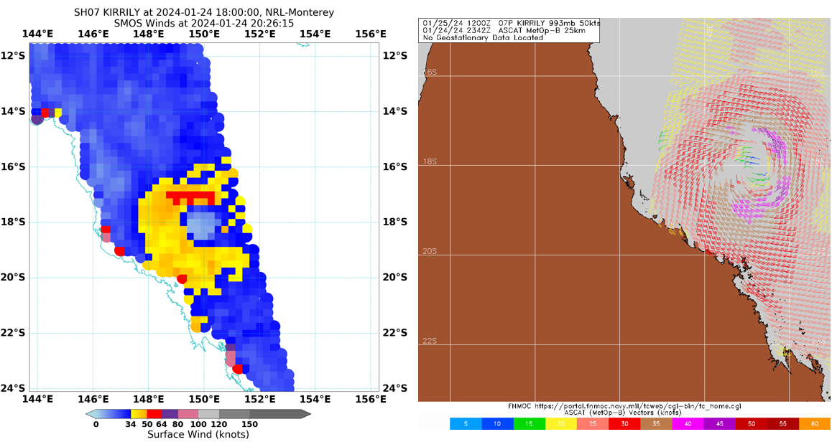

Figure 7. Radiometer and scatterometry passes on 24 January (UTC): SMOS at 2026 UTC (left) and ASCAT-B at 2342 UTC (right), showing 45-50 knot wind speeds in the northern quadrants of Kirrily. Images courtesy NRL: <https://www.nrlmry.navy.mil/TC.html>

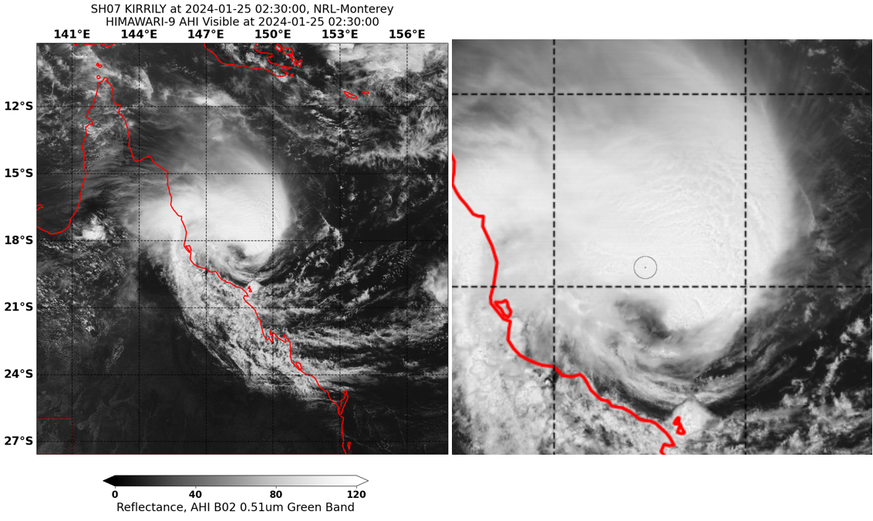

Figure 8. Himawari-9 visible image at 0230 UTC 25 January (left) showing Kirrily near peak intensity of 65 knots. Right: same image zoomed in. The location of Flinders Reef (63 knots) is indicated by a circle. Images courtesy NRL: <https://www.nrlmry.navy.mil/TC.html>

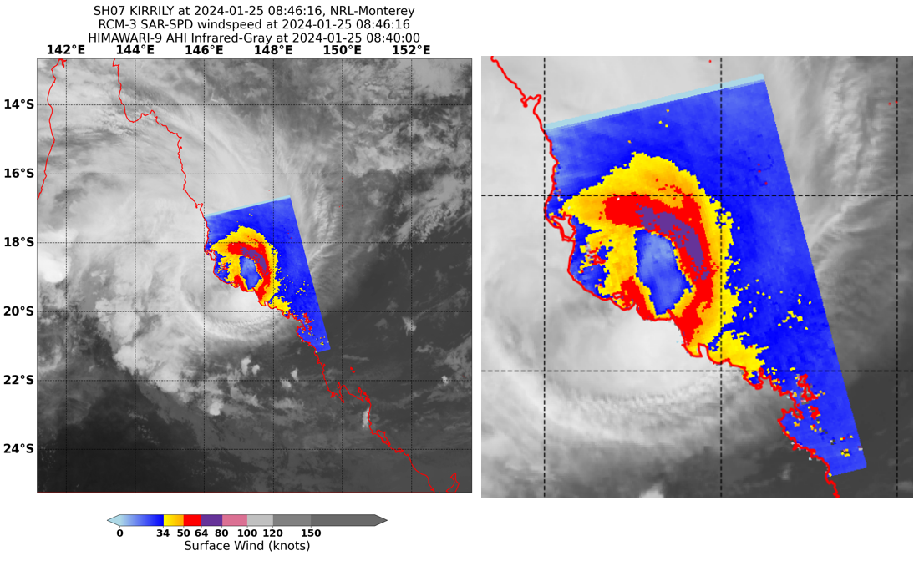

Figure 9. SAR image showing the wind structure of Kirrily at 0846 UTC 25 January (approximately 3 hours prior to landfall), suggesting winds in the northeast quadrant still exceeding hurricane force (64 knots). Images courtesy NRL: <https://www.nrlmry.navy.mil/TC.html>

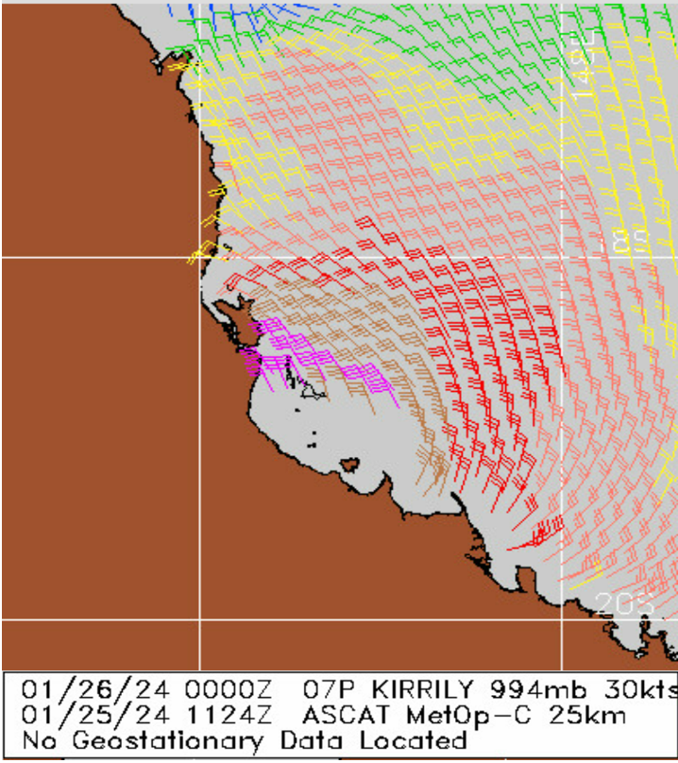

Figure 10. ASCAT-C scatterometry data of Kirrily near landfall at 1124 UTC 25 January showing maximum winds in the 40-45 knot range. Images courtesy NRL: <https://www.nrlmry.navy.mil/TC.html>

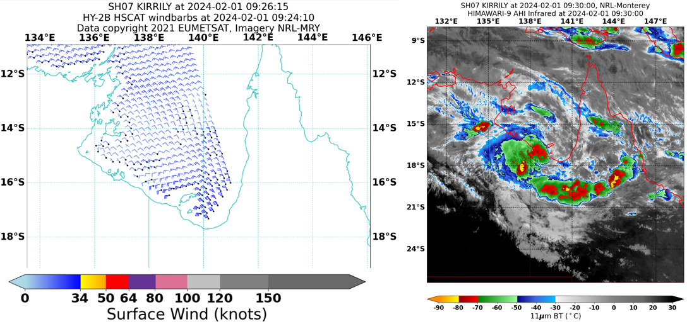

Figure 11. HSCAT scatterometer data (left) and enhanced infra-red Himawari-9 imagery (right) of ex-Tropical Cyclone Kirrily near the Gulf of Carpentaria coast at 0924 UTC 1 February. Images courtesy NRL: <https://www.nrlmry.navy.mil/TC.html>

* 1. Structure

05U began as a broad circulation in the monsoon trough with an elongated east-west centre and took several days to consolidate and strengthen. Gales initially developed in the southern quadrants of the system at 0000 UTC (1000 AEST) 23 January. Scatterometry near that time indicated that the southern quadrant gales extended out to a maximum radius of 120 nm (222 km) (Figure 5).

During 24 January, the belt of gale force winds wrapped through the western quadrants and eventually completely around the system, extending up to 160 nm (296 km) during this process (Figure 6). Once the system had formed into a tropical cyclone, the radius of gale force winds began to contract as Kirrily intensified. At peak intensity on 25 January, gale force winds extended up to 90 nm (167 km) from the centre, and storm force winds extended up to 50 nm (93 km) from the centre. Unusually for a Coral Sea cyclone, the strongest winds (hurricane force) were found in the northern quadrants of the system.

As a broad circulation developing in the monsoon trough, the strongest winds associated with 05U were located well away from the centre during the early stages (Figure 5). These winds only gradually contracted towards the centre over a period of days. Upon achieving tropical cyclone intensity, the radius of maximum winds of Kirrily was estimated at 50 nm (93 km), which is larger than average for a category 1 tropical cyclone. The radius of maximum winds remained relatively steady at around 40 nm (74 km) for approximately the next 18 hours, then began to shrink steadily as Kirrily approached the coast. By the time Kirrily crossed the coast, the radius of maximum winds was estimated at 14 nm (26 km) (Figure 12), which is below average for the estimated category 1 intensity at landfall.

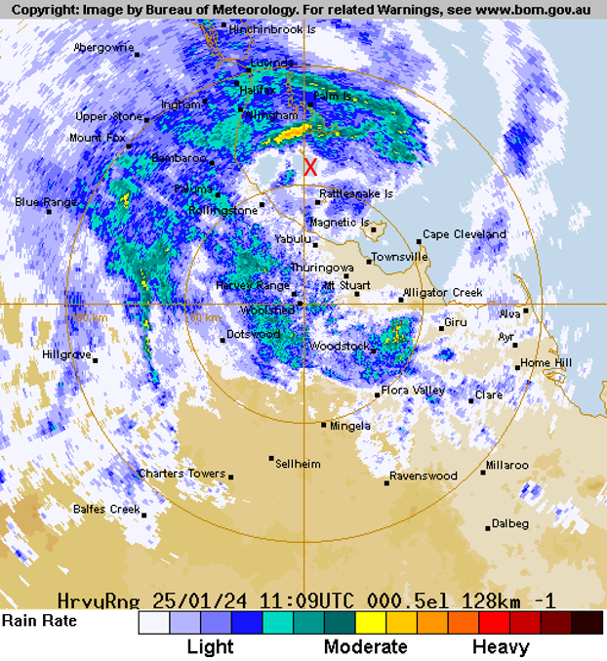

Figure 12. Radar reflectivity image of Kirrily close to landfall at 1109 UTC (2109 AEST) 25 January from the Townsville (Hervey Range) weather radar. Centre indicated by an X. Image from the Bureau of Meteorology: bom.gov.au/Australia/radar

* 1. Motion

In its early stages (17-19 January), 05U was a shallow monsoonal system and was steered towards the east-northeast by the predominating westerly monsoon airstream. Once deep convection became established closer to the centre from 19 January, the deeper vortex was influenced by mid-atmospheric steering flows and became slow moving for a period, as the low-level monsoon steering competed with a developing mid-level ridge to the southeast.

This mid-level ridge gradually dominated and steered the system slowly to the southwest during the next few days, with an average speed of only 3 kn (6 km/h). From 24 January, the mid-level ridge extended south of and cradled Tropical Cyclone Kirrily, causing it to be steered more rapidly west-southwest, with an average speed of 12 kn (22 km/h). This motion persisted up until landfall at 1200 UTC (2200 AEST) 25 January and for another 36 hours afterward.

The shallow ex-tropical cyclone then stalled in a broad area of surface troughing over central Queensland for several days. From 30 January, 05U was pushed northward as surface ridging extended across southern Australia. This motion continued until 1200 UTC (2200 AEST) 1 February, at which time the centre of 05U was close to the Gulf of Carpentaria coast and the circulation strengthened once again.

From 2 February, a trough system approaching from the west captured ex-Tropical Cyclone Kirrily and dragged it rapidly southward along the Northern Territory – Queensland border, and then south-eastward into far northern New South Wales, where it became indiscernible during 5 February.

1. Impact

As Kirrily crossed the north Queensland coast, power outages impacted thousands of people around the greater Townsville area. Townsville Airport and schools in the area were also closed prior to landfall.

In the following days after landfall, the remnants of Kirrily brought down trees and cut power to many residents of Mornington Island. Heavy rain then developed across northwest and western Queensland, which caused widespread flooding and extended community isolation for many across the area. Some towns and homesteads were evacuated prior to the rainfall given many catchments in the area were wet and were likely to respond quickly to any further heavy rain.

1. Observations
   1. Wind

Lihou Reef

Gales recorded between 1126 and 2100 UTC 23 January.

Maximum 10-minute mean wind of 38 knots (70.4 km/h) at 1200 UTC 23 January.

Maximum 3-second wind gust of 53 knots (98.2 km/h) at 1519 UTC 23 January.

Creal Reef

Gales recorded between 0600 and 2113 UTC 24 January.

Maximum 10-minute mean wind of 42 knots (77.8 km/h) at 1645 UTC 24 January.

Maximum 3-second wind gust of 51 knots (94.6 km/h) at 1643UTC 24 January.

Hamilton Island Airport

Gales recorded between 0930 UTC 24 January and 0730 UTC 25 January.

Maximum 10-minute mean wind of 48 knots (89 km/h) at 2331 UTC 24 January.

Maximum 3-second wind gust of 62 knots (114.9 km/h) at 2329 UTC 24 January.

Flinders Reef

Gales recorded between 1800 UTC 24 January and 0830 UTC 25 January.

Storm-force winds recorded between 0100 and 0500 UTC 25 January.

Maximum 10-minute mean wind of 63 knots (116.7 km/h) at 0229 UTC 25 January.

Maximum 3-second wind gust of 77 knots (142.8 km/h) at 0223 UTC 25 January.

Alva Beach

Gales recorded between 0730 and 1100 UTC 25 January.

Maximum 10-minute mean wind of 43 knots (79.6 km/h) at 0930 UTC 25 January.

Maximum 3-second wind gust of 58 knots (107.5 km/h) at 0900UTC 25 January.

Cape Ferguson NTC

Gales recorded between 0730 and 1130 UTC 25 January.

Maximum 10-minute mean wind of 40.7 knots (75.5 km/h) at 0933 UTC 25 January.

Maximum 3-second wind gust of 54 knots (100.0 km/h) at 0930UTC 25 January.

Lucinda Point

Gales recorded between 0900 and 1430 UTC 25 January.

Maximum 10-minute mean wind of 44 knots (81.5 km/h) between 1030 and 1100 UTC 25 January.

Maximum 3-second wind gust of 54 knots (100.0 km/h) at 1055UTC 25 January.

Townsville Aero

Gales briefly recorded around 0900 UTC 25 January.

Maximum 10-minute mean wind of 34 knots (63 km/h) at 0900 UTC 25 January.

Maximum 3-second wind gust of 50 knots (92.6 km/h) at 0942 UTC 25 January.

James Cook University deployed Surface Weather Relay and Logging Network (SWIRLnet) towers (at a height of approximately 3.2m) around Townsville during the event, which measured maximum, standardised 10-minute mean winds of 44.1 knots (81.7 km/h).

[Mason_Matthew-AWES-2024.pdf (jcu.edu.au)](https://www.jcu.edu.au/__data/assets/pdf_file/0009/2174517/Mason_Matthew-AWES-2024.pdf)

Mornington Island Airport

Gales recorded between 0351 UTC 1 February and 0105 UTC 2 February.

Maximum 10-minute mean wind of 40 knots (74.1 km/h) at 2200 UTC 1 February.

Maximum 3-second wind gust of 55 knots (101.9 km/h) at 2200 UTC 1 February.

Ballera Gas Field

Gales recorded between 2000 UTC and 2330 UTC 4 February.

Maximum 10-minute mean wind of 37 knots (68.5 km/h) at 2230 UTC 4 February.

Maximum 3-second wind gust of 47 knots (87.0 km/h) at 2230 4 February.

* 1. Rainfall

Rainfall was above average to very much above average over central and western parts of the state during February due to the passage of Kirrily and highest on record for parts of the Gulf Country. Sites that observed their highest February daily rainfall on record during the event included:

|  |  |  |
| --- | --- | --- |
| Location | New record (mm) | Years of record |
| Herbert Vale (near Lawn Hill) | 155 | 69 |
| Westmoreland Station | 332 | 60 |
| Sweers Island | 227 | 28 |
| Burketown Airport | 154.6 | 23 |

Weekly rainfall totals for the weeks ending on 29 January and 5 February are shown in Figures 13 and 14.

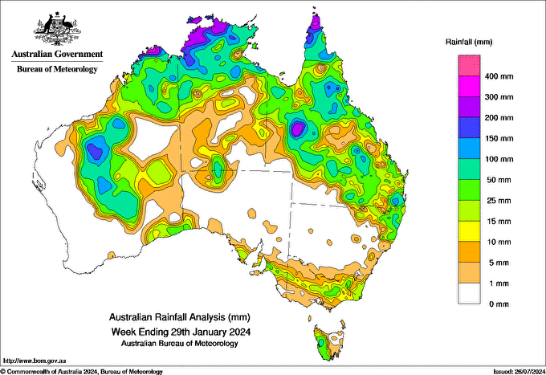

Figure 13. Weekly Australian rainfall for the week ending 29 January 2024.

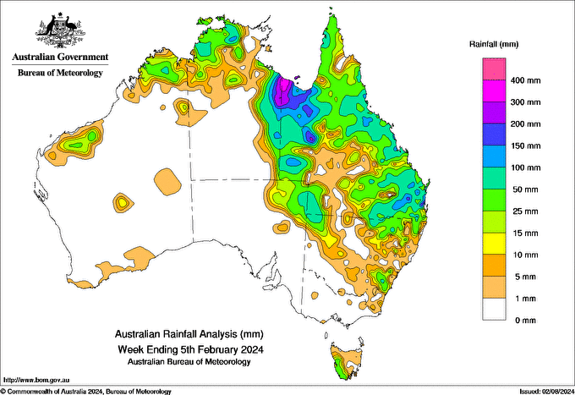

Figure 14. Weekly Australian rainfall for the week ending 5 February 2024.

* 1. Pressure

|  |  |  |
| --- | --- | --- |
| Location | Pressure (hPa) | Time |
| Townsville Aero | 989.0 | 1156 UTC 25 January |
| Alva Beach | 990.5 | 0826 UTC 25 January |
| Cape Ferguson NTC | 991.1 | 1121 UTC 25 January |
| Flinders Reef | 991.4 | 0127 UTC 25 January |
| Mornington Island Airport | 994.2 | 1900 UTC 1 February |

* 1. Storm Surge

Tide gauges along the coast between Lucinda and Mackay recorded surge values between 0.4-0.7m, with a higher surge of around 1.1m recorded at Cape Ferguson.

1. Forecast Performance

The accuracy statistics for Severe Tropical Cyclone Kirrily are shown below in Table 2 and in Figure 15 and Figure 16.

The first Forecast Track Map was issued at 11am AEST (0100 UTC) on Sunday 21 January, forecasting Tropical Low 05U to ultimately develop into a category 3 tropical cyclone and suggesting a coastal crossing between Cairns and Mackay. Tropical Cyclone Advices commenced from 8am AEST on Monday 22 January (2200 UTC 21 January), initially for the area between Ayr and St Lawrence (which, due to the shape of the coastline, was likely to be the first mainland area to experience gale force winds). At 5pm AEST (0700 UTC), the Tropical Cyclone Watch was extended northward to cover the area between Cairns and St Lawrence, including the Townsville area (Figure 17), and depicted a category 3 landfall near Townsville. This was approximately 72 hours before land areas experienced gales due to the cyclone.

Tropical Cyclone Warnings commenced for the Townsville area at 2pm AEST (0400 UTC) on Wednesday 24 January, approximately 27 hours before gale force winds commenced in the area (see Section 4.1). Hourly Tropical Cyclone Advices and Forecast Track Maps were issued between 10am AEST (0000 UTC) Thursday 25 January and 1am AEST Friday 26 January (1500 UTC Thursday 25 January). In total, 37 Tropical Cyclone Advices were issued for Severe Tropical Cyclone Kirrily.

As seen from Figure 15, the forecast track accuracy was better than the five-year average at all lead times up to and including 96 hours, and worse than the five-year average at 120 hours lead time. Figure 16 shows that the intensity forecast accuracy was an improvement over the five-year average at all lead times other than 72 hours, at which lead time it was equal to the five-year average.

|  |  |  |  |  |  |  |  |  |  |
| --- | --- | --- | --- | --- | --- | --- | --- | --- | --- |
| Time | 00 | 06 | 12 | 18 | 24 | 36 | 48 | 72 | 120 |
| Position accuracy (km) | 19 | 33 | 39 | 43 | 41 | 51 | 77 | 130 | 401 |
| Intensity accuracy (knots) | 2.4 | 3.2 | 2.9 | 3.2 | 4.5 | 6.3 | 9.5 | 12.1 | 4.7 |
| Sample size | 19 | 19 | 19 | 19 | 19 | 19 | 19 | 19 | 19 |

Table 2. Verification statistics for Severe Tropical Cyclone Kirrily. * Note, verification is performed using the Official Forecast Tracks at the standard times of 00, 06,12 and 18 UTC.

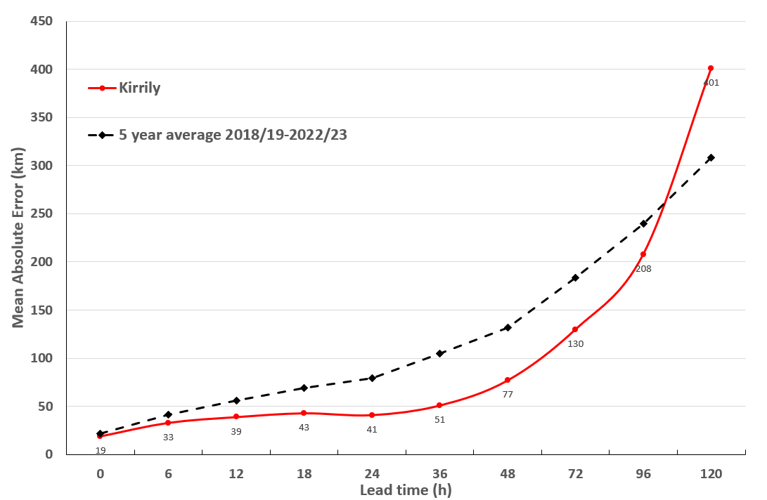

Figure 15. Position accuracy figures for Severe Tropical Cyclone Kirrily.

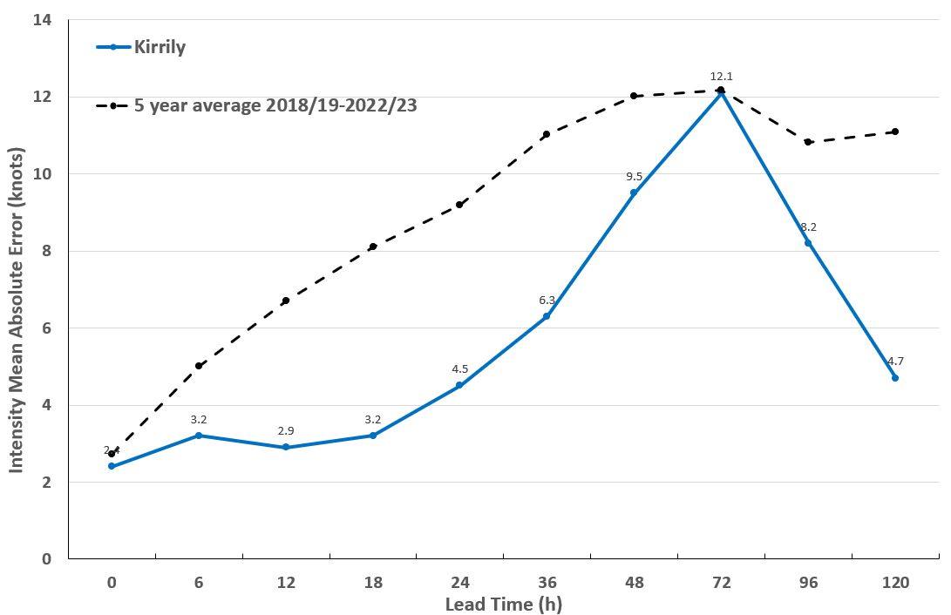

Figure 16. Intensity accuracy figures for Severe Tropical Cyclone Kirrily.

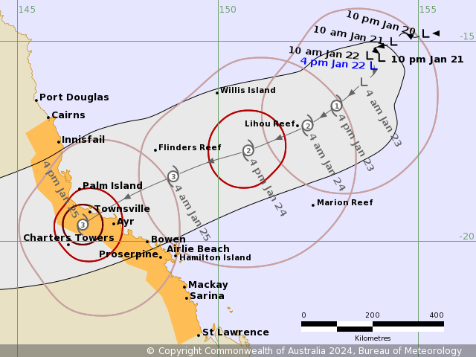

Figure 17. Forecast Track Map issued at 5pm AEST Monday 22 January, approximately 3 days prior to landfall. The forecast landfall was within 70km of the observed landfall location, and 9 hours earlier than the actual landfall time. The forecast landfall intensity (category 3) was higher than what eventually occurred due to Kirrily weakening on its final approach to the coast.

1. Appendix: List of Abbreviations

|  |  |
| --- | --- |
| Abbreviation | Term |
| ADT | Advanced Dvorak Technique |
| ACST | Australian Central Standard Time |
| AEST | Australian Eastern Standard Time |
| AiDT | AI-enhanced Dvorak Technique |
| AMSR2 | Advanced Microwave Scanning Radiometer |
| AMSU | Advanced Microwave Sounding Unit |
| ASCAT | Advanced Scatterometer |
| ATMS | Advanced Technology Microwave Sounder |
| AWS | automatic weather station |
| AWST | Australian Western Standard Time |
| °C | Celsius |
| CI | Current intensity |
| CIMSS | Cooperative Institute for Meteorological Satellite Studies (USA) |
| CIRA | Cooperative Institute for Research in the Atmosphere (USA) |
| D-MINT | Deep learning - Multispectral Intensity of TCs (formerly known as DMN) |
| D-PRINT | Deep learning - IR Intensity of TCs (formerly known as OPEN-AIIR) |
| EIR | Enhanced InfraRed |
| ERC | eyewall replacement cycle |
| FNMOC | Fleet Numerical Meteorology and Oceanography Centre (USA) |
| FT | Final T-number |
| GCOM | Global Change Observation Mission |
| GHz | Gigahertz |
| GMI | Global Precipitation Measurement Microwave Imager |
| h | hour |
| hPa | hectopascal |
| HSCAT | Hai Yang 2 Scatterometer (HY-2B, HY-2C) |
| km | kilometres |
| km/h | kilometres per hour |
| kn | knot |
| LLCC | LLCC |
| MET | Model Expected T-number |
| METOP | Meteorological Operational Satellite |
| MJO | Madden-Julian Oscillation |
| mm | millimetres |
| MSLP | mean sea level pressure |
| NESDIS | National Environmental Satellite, Data, and Information Service |
| nm | nautical mile |
| NOAA | National Oceanic and Atmospheric Administration |
| NRL | Navy Research Lab (USA) |
| OPEN-AiiR | Ordered Pattern Encoding AI Infrared |
| PAT | Pattern T-number |
| RCM | RadarSat Constellation Mission – Synthetic Aperture Radar |
| RH | relative humidity |
| RMW | radius of maximum winds |
| RSMC | Regional Specialised Meteorological Centre |
| SAR | Synthetic Aperture Radar |
| SATC | CIMSS Advanced Dvorak Technique |
| SATCON | Satellite Consensus |
| SEN1 | Sentinel-1A – Synthetic Aperture Radar |
| SMAP | Soil Moisture Active Passive |
| SMOS | Soil Moisture and Ocean Salinity |
| SSMIS | Special Sensor Microwave Imager/Sounder |
| TC | Tropical Cyclone |
| TCWC | Tropical Cyclone Warning Centre |
| UTC | Universal Time Co-ordinated |

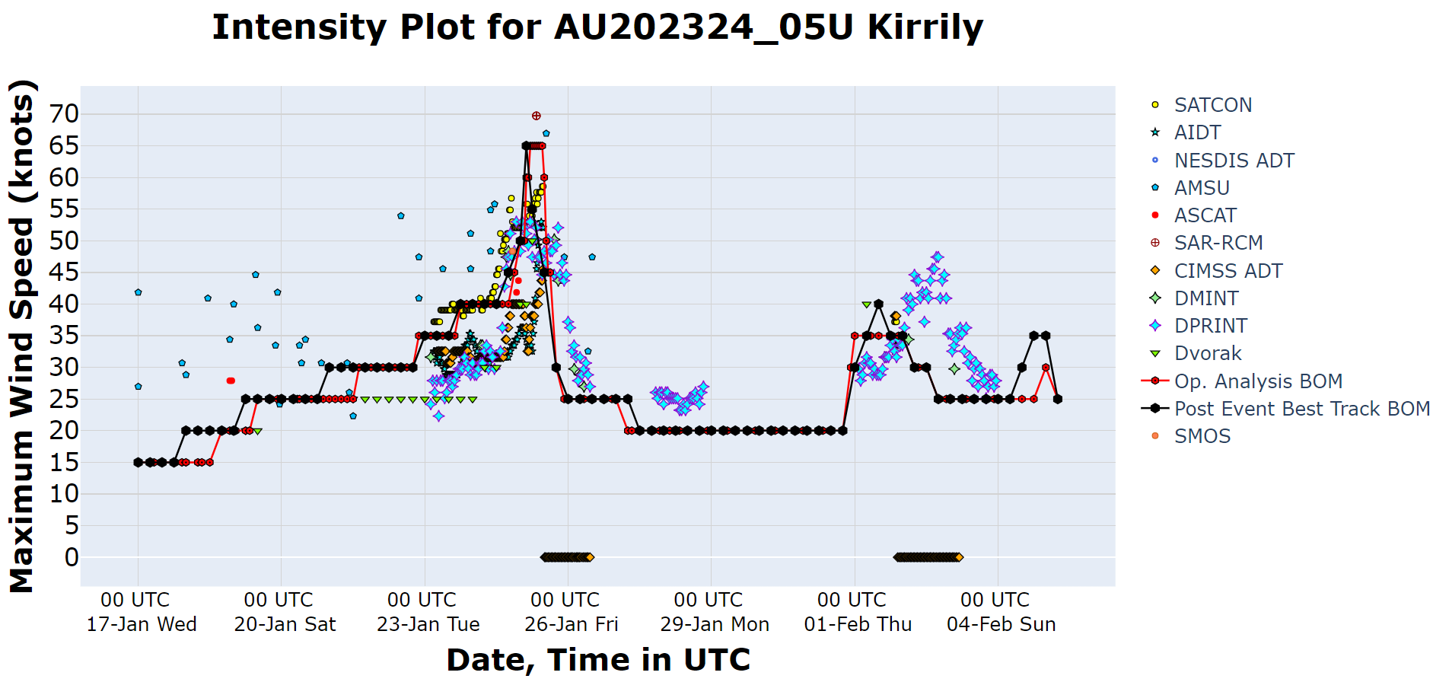

Figure 18. Intensity plot (10-minute mean) of objective and subjective guidance. SATCON, AiDT, NESDIS ADT, AMSU, ASCAT, SAR-RCM, CIMSS ADT, DMINT, DPRINT, Dvorak (subjective estimate), operational analysis (red), post event best track analysis (black), and SMOS.