Severe Tropical Cyclone Marian (15U)

**22 February – 9 March 2021**

**Nadine Birch and Joe Courtney, Tropical Cyclone Environmental Prediction Services**

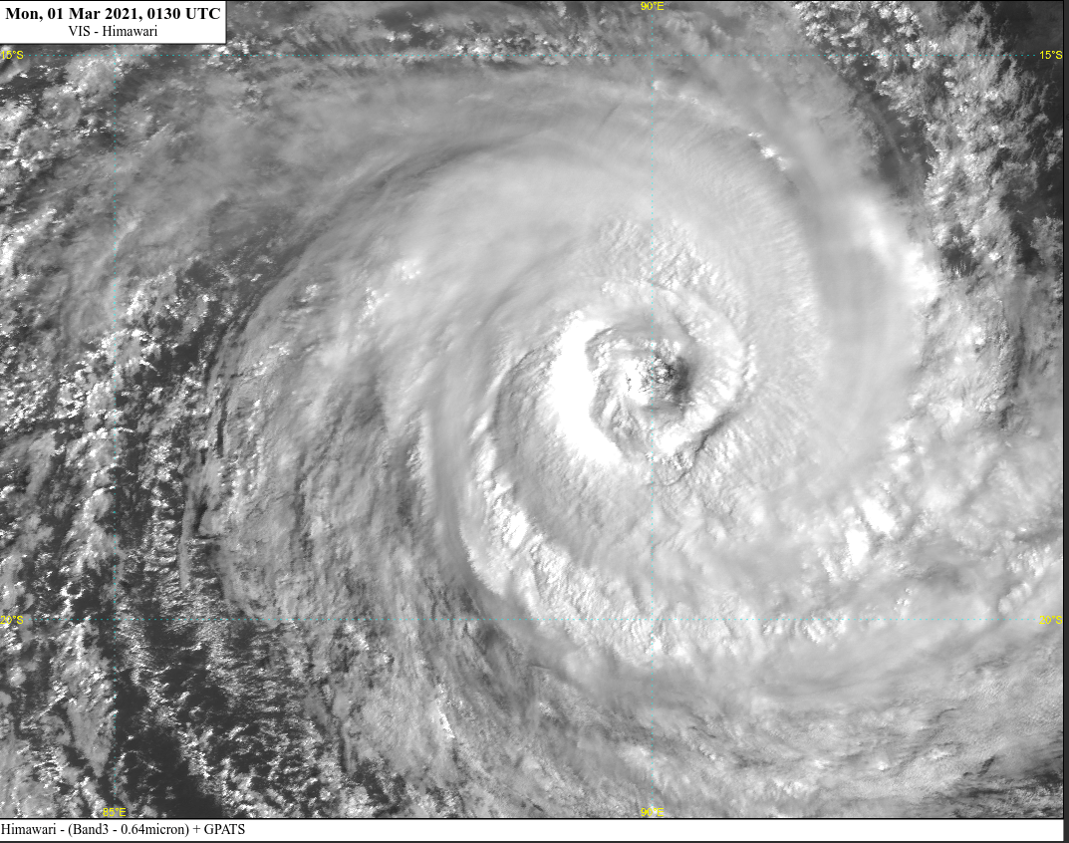

**Revision history**

|  |  |  |  |
| --- | --- | --- | --- |
| Date | Version | Author | Description |
| 20/09/2024 | 1.0 | Nadine Birch | Final draft ready |

**Review status**

|  |  |  |  |
| --- | --- | --- | --- |
| Date | Version | Reviewer | Description |
| 1/10/2024 | 1.0 | Joe Courtney | Completed |

**Release history**

|  |  |  |  |
| --- | --- | --- | --- |
| Date | Version | Status | Approval |
| 4/10/2024 | 1.0 | Approved for release | Andrew Burton |

Contact details:

Tropical Cyclone Team Lead

Severe Weather Environmental Prediction Services

Bureau of Meteorology

PO Box 1370, West Perth WA 6872

Email: [tcwc@bom.gov.au](mailto:tcwc@bom.gov.au)



This work is copyright. Apart from any use as permitted under the Copyright Act 1968, no part may be reproduced without prior written permission from the Bureau of Meteorology. Refer to www.bom.gov.au/other/copyright.shtml for further information. Unless otherwise noted, all images in this document are licensed under the Creative Commons Attribution Australia Licence.

© Commonwealth of Australia 2024

Published by the Bureau of Meteorology

Cover image: Visible image of Severe Tropical Cyclone Marian at 0130 UTC 1 March. Image courtesy of Japan Meteorological Agency [ww.jma.go.jp/jma/indexe.html](https://www.jma.go.jp/jma/indexe.html)

Contents

1. Summary 5

2. Meteorological description 9

2.1 Intensity analysis 9

2.1 Structure 17

2.2 Motion 18

3. Impact 18

4. Observations 18

5. Forecast Performance 18

Appendix: List of abbreviations 22

**List of Figures**

Figure 1. Best track of Severe Tropical Cyclone Marian 22 February - 9 March 2021. 5

Figure 2. Detailed best track of Severe Tropical Cyclone Marian 26 February – 5 March 2021 6

Figure 3. SSMI 91 GHz microwave pass at 2336 UTC 25 February when Marian reached tropical cyclone intensity. 12

Figure 4. SSMIS 89 GHz microwave pass at 1209 UTC 26 February. 13

Figure 5. Series of visible images at 0600 UTC from 26 February to 3 March. 14

Figure 6. Visible and enhanced IR images near peak intensity, 28 February 14

Figure 7. SSMIS colour composite microwave pass at 2210 UTC 28 February. 15

Figure 8. Series of radiometer passes, 1 - 2 March. 16

Figure 9. Series of ASCAT Images, 26 February to 3 March. 17

Figure 10. RCM-2 SAR wind pass at 2319 UTC 2 March 18

Figure 11. Position accuracy figures for Severe Tropical Cyclone Marian. 20

Figure 12. Intensity accuracy figures for Severe Tropical Cyclone Marian. 21

Figure 13. Intensity plot of objective and subjective guidance.. 24

**List of Tables**

Table 1. Best track summary for Severe Tropical Cyclone Marian, 22 Feb.- 9 March 2021. 8

Table 2. Verification statistics for Severe Tropical Cyclone Marian. 19

1. Summary

Severe Tropical Cyclone Marian was a long-lived Indian Ocean event that started near Darwin and travelled over open waters without causing any impacts to Australian communities as shown in Figure 1.

A weak tropical low was first identified in the Timor Sea near the western coast of the Top End of the Northern Territory on 22 February. It quickly moved west, well to the north of Western Australia while slowly developing. It reached tropical cyclone intensity on 26 February and passed to the south of the Cocos (Keeling) Islands. While a Warning was issued for the islands, no direct impact occurred.

On 1 March, Marian started to move slowly south while gradually intensifying. Marian reached peak intensity at 90 knots (165 km/h, category 4) on 28 February near 90°E, the western boundary of the Australian area of responsibility. Marian initially weakened under reduced sea surface temperatures, as a result of its slow motion causing the mixing of cooler sub-surface waters.

Marian then turned to the southeast and gradually weakened.

By 5 March, the system encountered a high shear environment, dry air and cooler sea surface temperatures weakening the system below cyclone strength on 6 March.

There was no impact to any island or coastal communities.

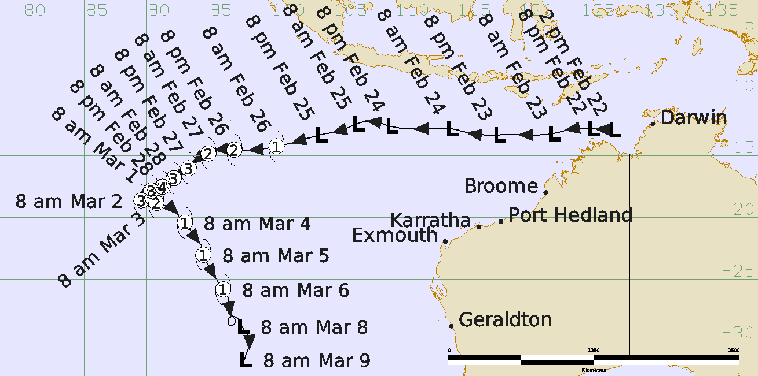

Figure 1. Best track of Severe Tropical Cyclone Marian 22 February - 9 March 2021 (times in AWST, UTC +8).

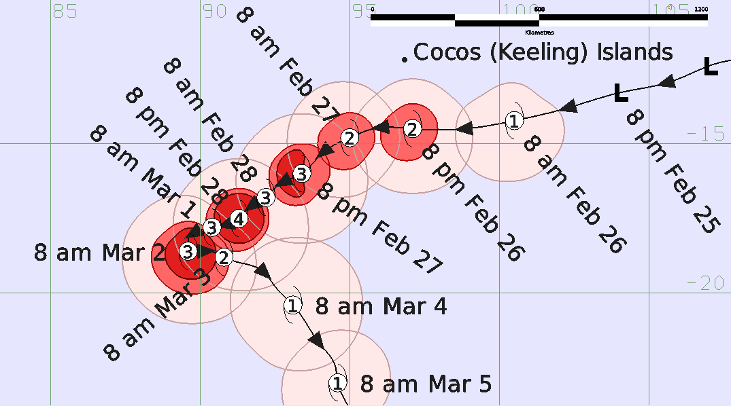

Figure 2. Detailed best track of Severe Tropical Cyclone Marian with wind radii 26 February – 5 March 2021 (times in AWST, UTC +8)

|  |  |  |  |  |  |  |  |  |  |  |  |  |
| --- | --- | --- | --- | --- | --- | --- | --- | --- | --- | --- | --- | --- |
| **Year** | **Month** | **Day** | **Hour UTC** | **Pos. Lat S** | **Pos. Long. E** | **Pos. Acc. Nm** | **Mean wind kn** | **Max. gust kn** | **Cent. Press hPa** | **Rad of gales (NE/SE/SW/NW) nm** | **Rad of storm (NE/SE/SW/NW) nm** | **RMW nm** |
| 2021 | 02 | 22 | 06 | -12.9 | 127.7 | 40 | 15 | 45 | 1002 |  |  |  |
| 2021 | 02 | 22 | 12 | -12.8 | 126.0 | 40 | 15 | 45 | 1002 |  |  |  |
| 2021 | 02 | 22 | 18 | -12.8 | 124.5 | 40 | 15 | 45 | 1002 |  |  |  |
| 2021 | 02 | 23 | 00 | -13.2 | 122.8 | 40 | 15 | 45 | 1003 |  |  |  |
| 2021 | 02 | 23 | 06 | -13.3 | 120.9 | 30 | 15 | 45 | 1003 |  |  |  |
| 2021 | 02 | 23 | 12 | -13.3 | 118.4 | 30 | 15 | 45 | 1003 |  |  |  |
| 2021 | 02 | 23 | 18 | -13.2 | 116.3 | 40 | 15 | 45 | 1003 |  |  |  |
| 2021 | 02 | 24 | 00 | -12.8 | 114.6 | 60 | 15 | 45 | 1003 |  |  |  |
| 2021 | 02 | 24 | 06 | -12.8 | 112.4 | 60 | 20 | 45 | 1001 |  |  |  |
| 2021 | 02 | 24 | 12 | -12.6 | 109.7 | 60 | 25 | 45 | 1000 |  |  |  |
| 2021 | 02 | 24 | 18 | -12.2 | 108.0 | 40 | 30 | 45 | 999 |  |  |  |
| 2021 | 02 | 25 | 00 | -12.4 | 107.0 | 30 | 30 | 45 | 998 |  |  |  |
| 2021 | 02 | 25 | 06 | -12.9 | 105.8 | 25 | 30 | 45 | 998 |  |  |  |
| 2021 | 02 | 25 | 12 | -13.3 | 104.0 | 30 | 30 | 45 | 999 |  |  |  |
| 2021 | 02 | 25 | 18 | -13.8 | 102.3 | 35 | 35 | 50 | 997 | *0/110/130/0 |  |  |
| 2021 | 02 | 26 | 00 | -14.2 | 100.5 | 30 | 40 | 55 | 994 | 70/110/130/80 |  | 35 |
| 2021 | 02 | 26 | 06 | -14.5 | 98.9 | 25 | 45 | 65 | 990 | 70/110/130/80 |  | 35 |
| 2021 | 02 | 26 | 12 | -14.5 | 97.1 | 25 | 50 | 70 | 987 | 100/130/130/100 | 50/50/70/50 | 35 |
| 2021 | 02 | 26 | 18 | -14.5 | 95.8 | 20 | 55 | 75 | 983 | 110/110/130/120 | 50/50/70/50 | 35 |
| 2021 | 02 | 27 | 00 | -14.8 | 95.0 | 20 | 60 | 85 | 979 | 100/100/130/120 | 50/50/70/50 | 30 |
| 2021 | 02 | 27 | 06 | -15.3 | 94.1 | 20 | 65 | 90 | 975 | 120/120/130/120 | 50/50/70/60 | 30 |
| 2021 | 02 | 27 | 12 | -16.0 | 93.4 | 20 | 70 | 100 | 973 | 120/140/140/120 | 60/50/70/60 | 30 |
| 2021 | 02 | 27 | 18 | -16.4 | 92.6 | 20 | 75 | 105 | 968 | 130/150/140/120 | 60/50/70/60 | 30 |
| 2021 | 02 | 28 | 00 | -16.8 | 92.2 | 20 | 80 | 110 | 960 | 140/150/140/130 | 60/60/70/60 | 25 |
| 2021 | 02 | 28 | 06 | -17.1 | 91.7 | 15 | 80 | 110 | 961 | 140/150/140/120 | 60/60/70/60 | 25 |
| 2021 | 02 | 28 | 12 | -17.5 | 91.3 | 15 | 90 | 125 | 951 | 120/150/140/120 | 60/60/70/60 | 30 |
| 2021 | 02 | 28 | 18 | -17.7 | 90.9 | 15 | 85 | 120 | 956 | 120/150/130/120 | 60/60/70/60 | 30 |
| 2021 | 03 | 01 | 00 | -17.8 | 90.4 | 15 | 80 | 110 | 962 | 120/170/130/120 | 60/60/70/60 | 40 |
| 2021 | 03 | 01 | 06 | -17.9 | 90.0 | 15 | 75 | 105 | 968 | 120/170/160/120 | 60/60/80/60 | 40 |
| 2021 | 03 | 01 | 12 | -18.2 | 89.6 | 15 | 80 | 110 | 961 | 100/170/160/120 | 60/90/80/60 | 35 |
| 2021 | 03 | 01 | 18 | -18.4 | 89.6 | 15 | 85 | 120 | 955 | 100/150/150/120 | 60/90/80/60 | 35 |
| 2021 | 03 | 02 | 00 | -18.6 | 89.6 | 15 | 85 | 120 | 955 | 100/150/140/120 | 60/90/80/60 | 35 |
| 2021 | 03 | 02 | 06 | -18.6 | 89.7 | 15 | 80 | 110 | 958 | 110/170/150/120 | 60/90/60/50 | 35 |
| 2021 | 03 | 02 | 12 | -18.6 | 90.0 | 15 | 70 | 100 | 967 | 110/170/140/110 | 90/90/80/50 | 35 |
| 2021 | 03 | 02 | 18 | -18.6 | 90.4 | 15 | 65 | 90 | 971 | 110/170/140/110 | 90/90/80/50 | 40 |
| 2021 | 03 | 03 | 00 | -18.8 | 90.8 | 15 | 55 | 75 | 983 | 110/110/130/110 | 80/80/70/60 | 45 |
| 2021 | 03 | 03 | 06 | -19.0 | 91.4 | 15 | 50 | 70 | 987 | 130/160/130/130 | 70/70/70/70 | 45 |
| 2021 | 03 | 03 | 12 | -19.2 | 92.0 | 20 | 50 | 70 | 983 | 130/160/130/130 | 70/70/70/70 | 40 |
| 2021 | 03 | 03 | 18 | -19.9 | 92.6 | 20 | 50 | 70 | 983 | 130/160/150/130 | 70/70/70/70 | 40 |
| 2021 | 03 | 04 | 00 | -20.4 | 93.1 | 20 | 45 | 65 | 987 | 140/140/120/130 |  | 40 |
| 2021 | 03 | 04 | 06 | -21.1 | 93.6 | 20 | 45 | 65 | 988 | 130/120/110/120 |  | 40 |
| 2021 | 03 | 04 | 12 | -21.7 | 94.0 | 20 | 45 | 65 | 988 | 130/120/120/110 |  | 40 |
| 2021 | 03 | 04 | 18 | -22.4 | 94.5 | 30 | 45 | 65 | 989 | 120/100/120/100 |  | 40 |
| 2021 | 03 | 05 | 00 | -23.0 | 94.6 | 20 | 45 | 65 | 989 | 110/100/120/100 |  | 50 |
| 2021 | 03 | 05 | 06 | -23.7 | 94.9 | 20 | 45 | 65 | 988 | 110/120/150/100 |  | 50 |
| 2021 | 03 | 05 | 12 | -24.4 | 95.3 | 20 | 45 | 65 | 988 | 110/130/150/100 |  | 50 |
| 2021 | 03 | 05 | 18 | -25.1 | 95.7 | 25 | 45 | 65 | 987 | 110/140/150/100 |  | 50 |
| 2021 | 03 | 06 | 00 | -25.8 | 96.2 | 25 | 45 | 65 | 987 | 100/140/150/100 |  | 50 |
| 2021 | 03 | 06 | 06 | -26.5 | 96.6 | 20 | 40 | 55 | 990 | *0/0/140/100 |  |  |
| 2021 | 03 | 06 | 12 | -27.3 | 96.7 | 20 | 40 | 55 | 991 | *0/0/140/0 |  |  |
| 2021 | 03 | 06 | 18 | -27.9 | 96.9 | 20 | 40 | 55 | 990 | *0/0/140/0 |  |  |
| 2021 | 03 | 07 | 00 | -28.5 | 97.2 | 15 | 30 | 45 | 999 |  |  |  |
| 2021 | 03 | 07 | 06 | -28.7 | 96.7 | 15 | 30 | 45 | 998 |  |  |  |
| 2021 | 03 | 07 | 12 | -28.1 | 96.7 | 15 | 25 | 45 | 1004 |  |  |  |
| 2021 | 03 | 07 | 18 | -28.1 | 97.3 | 15 | 20 | 45 | 1007 |  |  |  |
| 2021 | 03 | 08 | 00 | -28.8 | 97.7 | 20 | 15 | 45 | 1009 |  |  |  |
| 2021 | 03 | 08 | 06 | -29.6 | 98.2 | 20 | 15 | 45 | 1009 |  |  |  |
| 2021 | 03 | 08 | 12 | -30.3 | 98.3 | 20 | 15 | 45 | 1009 |  |  |  |
| 2021 | 03 | 08 | 18 | -30.9 | 98.1 | 20 | 15 | 45 | 1009 |  |  |  |
| 2021 | 03 | 09 | 00 | -31.5 | 97.9 | 20 | 15 | 45 | 1009 |  |  |  |

Table 1. Best track summary for Severe Tropical Cyclone Marian, 22 Feb.- 9 March 2021. UTC=AWST-8.

* Not at tropical cyclone intensity as gales less than halfway around centre.

1. Meteorological description

2.1 Intensity analysis

A comparison of the subjective and objective intensity estimates is shown in Figure 13.

A low developed in the Timor Sea north of the Kimberley coastline in an area of active thunderstorm activity on 22 February. Ongoing easterly wind shear constrained development in the days to follow as the system tracked to the west over open waters. An initial Dvorak Data T-number (DT) of 1.0 was assigned at 0000 UTC 24 February. A SCATSAT scatterometry pass at 1246 UTC 24 February showed a broad circulation having 30 kn winds both north and south of the centre, indicating support from both the monsoon flow to the north and sub-tropical east southeasterly flow to the south.

Deep convection became more organised on 25 February and extended around the northern side of the circulation later in the day against the easterly wind shear. These convective bursts northeast of the centre induced a split flow in the upper level flow that shielded the inner core from surrounding high wind shear. This assisted to reduce vortex tilt which permitted intensification. Gales are estimated at 1800 UTC 25 February in southern quadrants extending around the centre to denote tropical cyclone intensity at 0000 UTC 26 February. This was based on a range of supporting evidence. Dvorak estimates reached 3.0 based on an improving curved band signature, evident on the 91 GHz SSMIS microwave image at 2336 UTC 25 February in Figure 3. Gales around the centre were evident from many satellite sensors around this time: SMAP at 2304 UTC, SMOS at 2336 UTC, HY-2B at 2330 UTC all on 25 February, and then on 26 February partial coverage from ASCAT-A at 0142 UTC, ASCAT-C at 0209 UTC and ASCAT-B at 0259 UTC.

Intensification continued throughout 26 February. An SSMIS 89 GHz microwave pass in Figure 4 showed indications of an eye developing. By 1800 UTC an eye briefly appeared in enhanced IR imagery overnight, indicative of a reduction in the wind shear.

Figure 5 shows the series of visible images each day at 0600 UTC from 26 February to 3 March. Marian was estimated to have reached category 3 intensity (65 kn) at 0600 UTC 27 February as an eye became apparent in both visible and infrared imagery. Indeed, an eye pattern fluctuated from 27 February to 2 March. Intensity estimates varied between 75 and 90 kn from 28 February to 2 March.

Peak intensity (Figure 6) was estimated at 90 kn, category 4, at 1200 UTC 28 February coincident with Dvorak (eye pattern) FT/CI of 5.5. Objective guidance was slightly higher (SATCON ~95kn). However, this coincided with the onset of an eye wall replacement cycle (ERC) which resulted in weakening despite the general environment remaining conducive for further development. Microwave imagery from AMSR2 at 0742 UTC 28 February to the SSMIS at 0039 UTC 1 March showed the inner eye wall weakening and being replaced by a broader eye wall (Figure 7). Hence the intensity reduced to 75 kn by 0600 UTC 1 March.

The eye pattern slightly improved later on 1 March continuing into 2 March as ongoing low wind shear offset the movement over sea surface temperatures (SSTs) below 27°C. A series of SMAP and SMOS radiometer passes (SMOS at 1148 UTC 1 March; SMAP at 2354 UTC 1 March and SMOS 0950 UTC 2 March) shown in Figure 8 indicated maximum winds 65-80 kn.

On 1 and 2 March, Marian slowed to below 8 km/h. The extended period of strong winds mixed sub-surface waters that resulted in cooling of SSTs to below 25°C by 3 March. This contributed to weakening along with dry air wrapping around the west and north of the centre and a general disconnection with tropical moisture inflow despite ongoing low wind shear. A SAR (RCM-2) pass at 2319 UTC 2 March showed maximum winds to 55 kn southwest of the centre, shown in Figure 10. ASCAT passes (ASCAT-A 0142UTC, ASCAT-B at 0257 UTC) also showed winds of 50-55 kn. The visible image at 0600 UTC 3 March showed weakening (Figure 5) and Dvorak estimates reduced to 3.5, consistent with objective guidance (Figure 13).

However, during 4 March Marian accelerated into warmer waters and this combined with ongoing low wind shear caused weakening to be arrested. Visible and IR imagery showed deep convection rotating around the centre which maintained Dvorak CI estimates at 3.0. SMOS (1133 UTC) and SMAP (1138 UTC) passes indicated small patches of 50 kn winds east and west of the centre but intensity was estimated at 45 kn in line with ASCAT (e.g. ASCAT-A at 0327 UTC and 1347 UTC) and on the high end of the Dvorak CI=3.0 scale.

Increasing northwesterly wind shear late on 4 March combined with dry air resulted in convection being restricted southeast of the centre. Dvorak CI estimates reduced to 2.5 at 0600 UTC 5 March but gales continued around the centre as shown from scatterometry (partial ASCAT-C at 0306 UTC and ASCAT-C 1533 UTC 5 March) and radiometry (SMAP 2351 UTC 4 March and 2307 UTC 5 March).

Gales are estimated to have reduced to less than halfway around the centre at 0600 UTC 6 March and hence be below tropical cyclone intensity. ASCAT indicated ongoing gales southwest of the centre around 14-16 UTC 6 March. Gales ceased altogether by 0000 UTC 7 March as confirmed by subsequent ASCAT passes such as ASCAT-A 0159 UTC.

2.2 Structure

Marian formed as a broad circulation in a monsoon flow with a subtropical ridge to the south. Winds from radiometry (SMAP and SMOS) shown for example in Figure 8, and scatterometry such as the series in Figure 9 strongly informed the wind structure. During the early stages of development, Marian experienced easterly vertical wind shear. With the ridge to the south gales were present initially in southern quadrants at 1800 UTC 25 February. On 26 February a burst in convection to the northeast split the flow in vertical wind shear and gales were able to wrap around the system in northern quadrants. Gale radii remained large in southern quadrants, extending to 130 nm (240 km) in the southwest.

Marian remained a large cyclone throughout its lifetime and development was gradual. On 27 February hurricane force winds western quadrants extended to 50 nm (95 km). As Severe TC Marian approached peak intensity, the wind structure became more symmetric. Hurricane-force wind radii being 50 nm (95 km) and gale radii 120 nm (220 km) in northern quadrants, extending to 150 nm (280 km) in the southeast.

On 28 February at 1200 UTC an eye wall replacement cycle commenced, resulting in a slight weakening over the next 18 hours, until the cycle completed. During this time the radius of maximum winds (RMW) expanded to 40 nm (75 km). Otherwise, the RMW was generally 30-35 nm (55-65 km) increasing to 50 nm (95 km) during the weakening stages.

A SAR pass at 2319 UTC 2 March continued to portray a broad circulation. Gale radii increased to the south, reaching 170 nm (315 km) in the southeast quadrant. As Marian weakened, gale radii remained substantial to the southwest 150 nm (280 km) aided by a strong pressure gradient and a cold front to the south. At 0700 UTC 6 March AMSR2 winds showed gales less than halfway around the centre, and the subsequent ASCAT showed maximum winds of 30 kn.

2.3 Motion

Marian moved on a steady westerly track from its origins near Darwin from 22 to 27 February being steered by a mid-level ridge to the south. Marian tracked to the southwest on 27-28 February before slowing on 1 March. On 2 March Marian turned to the southeast and accelerated on 3 March as an upper-level trough approached. On 7 March movement slowed and Ex-TC Marian traversed in a loop, and then continued moving southwards on 8 March.

1. Impact

There were no known impacts from Marian. TC Advices were issued on the morning of 25 February for a potential impact at Cocos Island but were cancelled on 26 February when there was increased confidence that Marian would pass sufficiently far to the south not to cause gales over the islands.

1. Observations

Severe Tropical Cyclone Marian remained over a maritime environment so there are no surface observations available. All track data has been estimated using Tropical Cyclone analysis techniques.

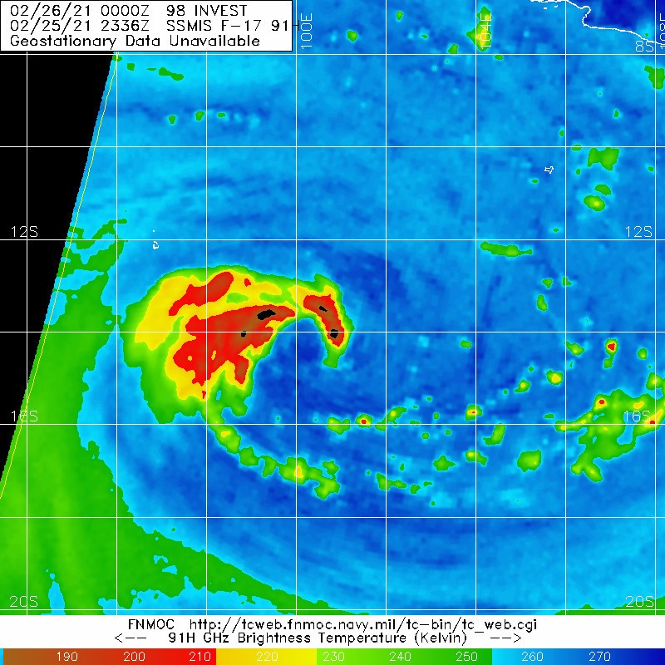

Figure 3. SSMI 91 GHz microwave pass at 2336 UTC 25 February when Marian reached tropical cyclone intensity.

Image courtesy NRL <https://www.nrlmry.navy.mil/TC.html>

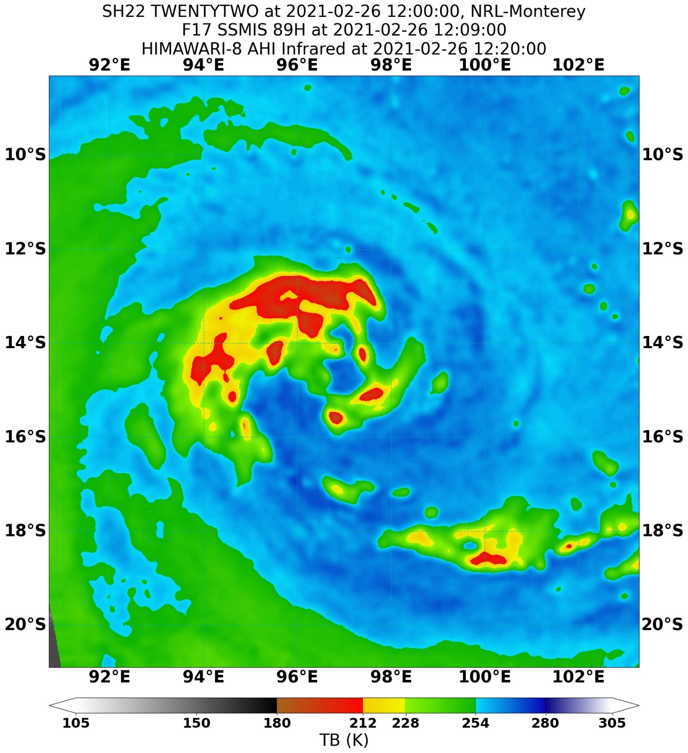

Figure 4. SSMIS 89 GHz microwave pass at 1209 UTC 26 February showing the ongoing development of Marian's intensification with an eye developing.

Image courtesy NRL <https://www.nrlmry.navy.mil/TC.html>

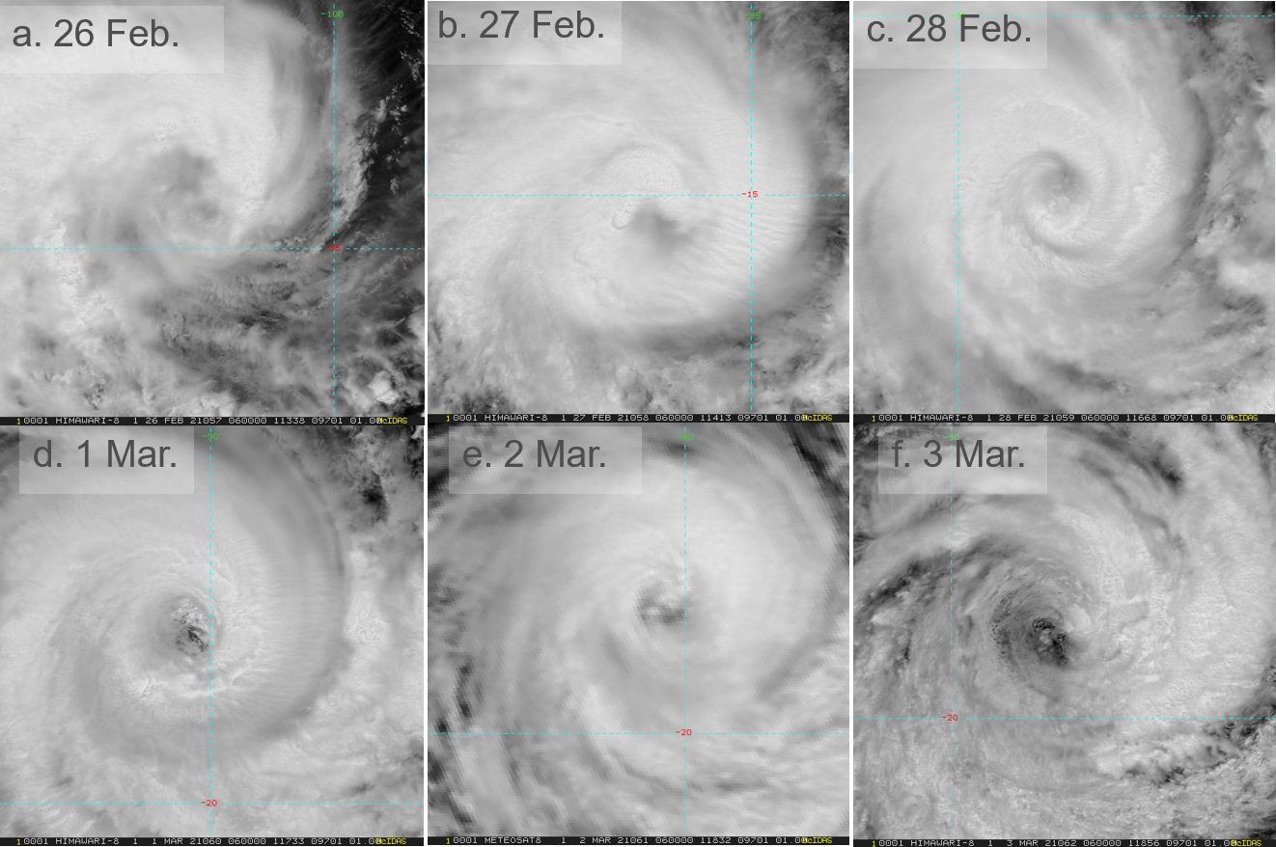

Figure 5. Series of visible images at 0600 UTC showing the development and weakening of Marian, from a. 26 February; b. 27 February; c. 28 February; d. 1 March; e. 2 March; and f. 3 March. Images courtesy of CIRA.

|  |  |
| --- | --- |
| Satellite images near peak intensity - visible satellite image at 0800 UTC 28 February showing an eye pattern. | Enhanced IR satellite image near peak intensity at 1040 UTC 28 February showing an eye pattern. |

Figure 6. Marian near peak intensity, left Vis image at 0800 UTC 28 February, and right enhanced IR image at 1040 UTC. Images courtesy of CIRA.

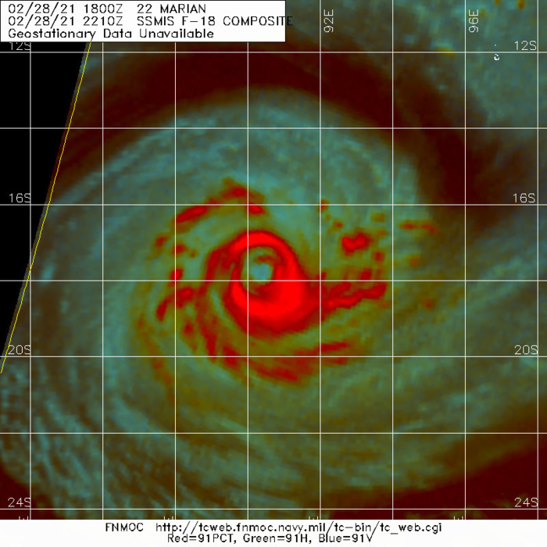

Figure 7. SSMIS colour composite microwave pass at 2210 UTC 28 February showing an outer eye wall encircling the last remnants of an inner eye wall.

Image courtesy NRL: <https://www.nrlmry.navy.mil/TC.html>

**a b c**

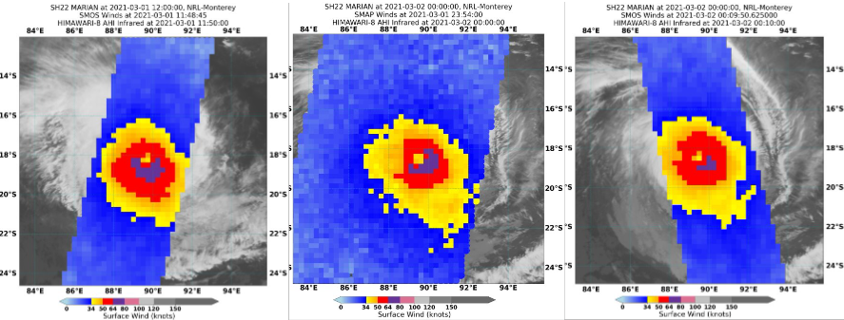

Figure 8. Series of radiometer passes; a. SMOS at 1148 UTC 1 March; b. SMAP 2354 UTC 1 March; c. SMOS 0950 UTC 2 March.

Image courtesy NRL: <https://www.nrlmry.navy.mil/TC.html>

|  |  |
| --- | --- |
| **a**ASCAT Images; ASCAT-A 1415 UTC 26 February showing partial coverage northeastern half showing storm-force winds near the centre. | **b**ASCAT Images ASCAT-C 0331 UTC 27 February, showing the extent of gales and storm-force winds near the centre. |
| **c**ASCAT Image ASCAT-C 1521 UTC 1 March, showing the extent of gales and very strong winds near the centre. | **d**ASCAT Image ASCAT-B 0255 UTC 3 March showing gales around the centre and peak storm- force winds northeast of the centre. |

Figure 9. Series of ASCAT Images; a. ASCAT-A 1415 UTC 26 February, b. ASCAT-C 0331 UTC 27 February, c. ASCAT-C 1521 UTC 1 March, d. ASCAT-B 0255 UTC 3 March.

Image courtesy NOAA/STAR https://manati.star.nesdis.noaa.gov/datasets/ASCATData.php

|  |  |
| --- | --- |
| RCM-2 SAR wind pass at 2319 UTC 2 March showing a broad circulation and maximum winds of approximately 55kn southwest of the centre, left wind distribution and right winds by quadrant. | RCM-2 SAR wind pass at 2319 UTC 2 March showing winds by quadrant - a broad circulation and maximum winds of approximately 55kn southwest of the centre. |

Figure 10. RCM-2 SAR wind pass at 2319 UTC 2 March showing a broad circulation and maximum winds of approximately 55 kn southwest of the centre, left wind distribution and right winds by quadrant.

Image courtesy: <https://www.star.nesdis.noaa.gov/socd/mecb/sar/sarwinds_tropical.php?year=2021&storm=SH222021_MARIAN>

1. Forecast Performance

The accuracy statistics for Severe Tropical Cyclone Marian are below in Table 2 and shown in Figure 11 and Figure 12.

Tropical Cyclone Forecast Track Maps began at 0000 UTC 25 February and continued through until 0000 UTC 6 March 2021.

As shown in Figure 11 the forecast positions were significantly more accurate than the five-year average. The intensity accuracy was near the five-year average for the first 12 hours, and significantly better than average thereafter (Figure 12). The Tropical Cyclone Outlook sent on 20 February indicated the formation of a low in the coming days with the risk of development increasing later in the week. The ratings were well forecast with a "High" rating forecast for Friday 26 February three days prior to Marian forming. Initially model performance was good with agreeance of a threat to the Cocos (Keeling) Islands. Forecast Advices were issued from 0100 UTC 25 February indicating the threat of gale force winds and heavy rainfall, but Marian passed far enough to the south that the Islands did not observe any hazardous weather, and Advices ceased on 26 February.

Most models did not account for the cooling sea surface temperatures due to upwelling on 3 March, however HWRF managed to resolve this. As a result, the EC, GFS, ACCESS-G and JMA all maintained a strong cyclone three days out on 5-6 March, instead of the weakening category 1 system that was analysed.

|  |  |  |  |  |  |  |  |  |  |  |
| --- | --- | --- | --- | --- | --- | --- | --- | --- | --- | --- |
| Time | 00 | 06 | 12 | 18 | 24 | 36 | 48 | 72 | 96 | 120 |
| Position accuracy (km) | 12 | 28 | 36 | 43 | 48 | 61 | 73 | 108 | 132 | 166 |
| Intensity accuracy (knots) | 3.9 | 5.5 | 6.3 | 6.7 | 6.5 | 7.4 | 9.3 | 8.9 | 7.6 | 7.7 |
| Sample size | 37 | 37 | 37 | 37 | 37 | 37 | 37 | 37 | 33 | 29 |

Table 2. Verification statistics for Severe Tropical Cyclone Marian.  
Note, verification is performed using the Official Forecast Tracks at the standard times of 00, 06, 12 and 18 UTC.

Figure 11. Position accuracy figures for Severe Tropical Cyclone Marian.

Figure 12. Intensity accuracy figures for Severe Tropical Cyclone Marian.

Appendix: List of abbreviations

|  |  |
| --- | --- |
| Abbreviation | Term |
| ADT | Advanced Dvorak Technique |
| ACST | Australian Central Standard Time |
| AEST | Australian Eastern Standard Time |
| AiDT | AI-enhanced Dvorak Technique |
| AMSR2 | Advanced Microwave Scanning Radiometer |
| AMSU | Advanced Microwave Sounding Unit |
| ASCAT | Advanced Scatterometer |
| ATMS | Advanced Technology Microwave Sounder |
| AWS | automatic weather station |
| AWST | Australian Western Standard Time |
| °C | Celsius |
| CI | Current intensity |
| CIMSS | Cooperative Institute for Meteorological Satellite Studies (USA) |
| CIRA | Cooperative Institute for Research in the Atmosphere (USA) |
| D-MINT | Deep learning - Multispectral Intensity of TCs (formerly known as DMN) |
| D-PRINT | Deep learning - IR Intensity of TCs (formerly known as OPEN-AIIR) |
| EIR | Enhanced InfraRed |
| ERC | eyewall replacement cycle |
| FNMOC | Fleet Numerical Meteorology and Oceanography Centre (USA) |
| FT | Final T-number |
| GCOM | Global Change Observation Mission |
| GHz | Gigahertz |
| GMI | Global Precipitation Measurement Microwave Imager |
| h | hour |
| hPa | hectopascal |
| HSCAT | Hai Yang 2 Scatterometer (HY-2B, HY-2C) |
| km | kilometres |
| km/h | kilometres per hour |
| kn | knot |
| LLCC | LLCC |
| MET | Model Expected T-number |
| METOP | Meteorological Operational Satellite |
| MJO | Madden-Julian Oscillation |
| mm | millimetres |
| MSLP | mean sea level pressure |
| NESDIS | National Environmental Satellite, Data, and Information Service |
| nm | nautical mile |
| NOAA | National Oceanic and Atmospheric Administration |
| NRL | Navy Research Lab (USA) |
| OPEN-AiiR | Ordered Pattern Encoding AI Infrared |
| PAT | Pattern T-number |
| RCM | RadarSat Constellation Mission – Synthetic Aperture Radar |
| RH | relative humidity |
| RMW | radius of maximum winds |
| RSMC | Regional Specialised Meteorological Centre |
| SAR | Synthetic Aperture Radar |
| SATC | CIMSS Advanced Dvorak Technique |
| SATCON | Satellite Consensus |
| SEN1 | Sentinel-1A – Synthetic Aperture Radar |
| SMAP | Soil Moisture Active Passive |
| SMOS | Soil Moisture and Ocean Salinity |
| SSMIS | Special Sensor Microwave Imager/Sounder |
| TC | Tropical Cyclone |
| TCWC | Tropical Cyclone Warning Centre |
| UTC | Universal Time Co-ordinated |

Intensity plot of objective and subjective guidance.
SATCON, AMSU, SMAP, NESDIS ADT, ASCAT, CIMSS ADT, RS2, Dvorak (subjective estimate), operational analysis (red) and post event best track analysis (black). All winds are 10-minute estimates. Official peak intensity of 90 kn is reached on 28 February.


Figure 13. Intensity plot of objective and subjective guidance.  
SATCON, AMSU, SMAP, NESDIS ADT, ASCAT, CIMSS ADT, RS2, Dvorak (subjective estimate), operational analysis (red) and post event best track analysis (black). All winds are 10-minute estimates.