Severe Tropical Cyclone Megan (09U)

# 13 – 21 March 2024

## Joe Courtney, Tropical Cyclone Environmental Prediction Services

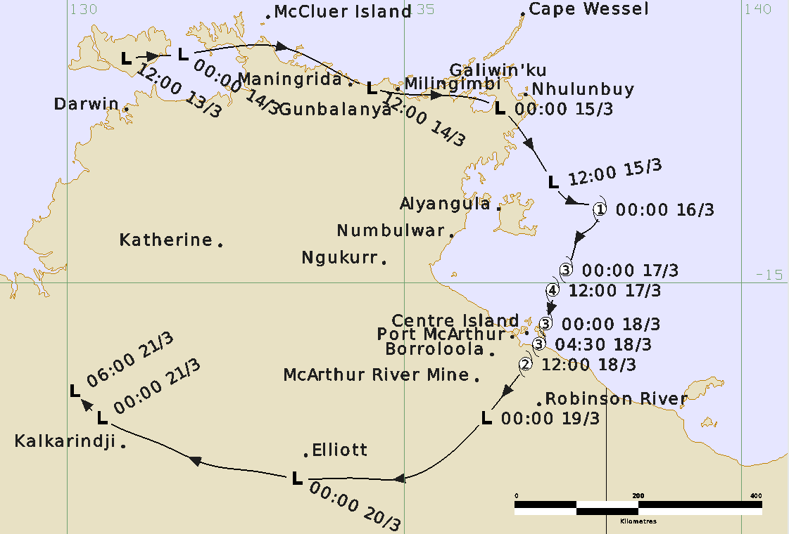

**Revision history**

|  |  |  |  |
| --- | --- | --- | --- |
| Date | Version | Author | Description |
| 04/04/2024  13/05/2024 | 1.0  1.1 | Joe Courtney  Joe Courtney | First draft ready  Final draft |

**Review status**

|  |  |  |  |
| --- | --- | --- | --- |
| Date | Version | Reviewer | Description |
| 14/05/2024 | 1.1 | Linda Paterson | Completed |

**Release history**

|  |  |  |  |
| --- | --- | --- | --- |
| Date | Version | Status | Approval |
| 14/05/2024 | 1.1 | Approved for release | Andrew Burton |

Contact details:

Tropical Cyclone Team Lead

Severe Weather Environmental Prediction Services

Bureau of Meteorology

PO Box 1370, West Perth WA 6872

Email: [tcwc@bom.gov.au](mailto:tcwc@bom.gov.au)



This work is copyright. Apart from any use as permitted under the Copyright Act 1968, no part may be reproduced without prior written permission from the Bureau of Meteorology. Refer to www.bom.gov.au/other/copyright.shtml for further information. Unless otherwise noted, all images in this document are licensed under the Creative Commons Attribution Australia Licence.

© Commonwealth of Australia 2024

Published by the Bureau of Meteorology

Cover image: Track of Severe Tropical Cyclone Megan 13-21 March 2024. Times in UTC (ACST-9.5h)

Contents

1. Summary 5

2. Meteorological description 10

2.1 Intensity analysis 10

2.1 Structure 17

2.2 Motion 17

3. Impact 17

4. Observations 20

4.1. Winds 20

4.2. Rainfall 20

4.3. Pressure 21

5. Forecast Performance 22

6. Appendix: List of abbreviations 25

**List of Figures**

Figure 1. Best track of Severe Tropical Cyclone Megan 13-21 March 2024.. 6

Figure 2. Detailed Best track of Severe Tropical Cyclone Megan over the Gulf of Carpentaria 15-19 March 2024. 7

Figure 3. Intensity plot of objective and subjective guidance. 27

Figure 4. Hovmoller diagram of tropical waves showing the formation of Megan on 13-15 March. 12

Figure 5 Satellite winds from ASCAT from 15 to 17 March.. 13

Figure 6. 89 GHz microwave imagery from 16-19 March. 14

Figure 7. Synthetic Aperture Radar (SAR) at 0919 UTC 17 March: 15

Figure 8. Synthetic Aperture Radar (SAR) wind distribution: at 2025 UTC 17 March; 2027 UTC 17 March; and 0927 UTC 18 March. 15

Figure 9. Winds on 17 March: AMSR2 (0417 UTC); SMOS (0841 UTC) ASCAT-B (1238 UTC).. 16

Figure 10. Satellite winds from ASCAT-C 2345 UTC 17 March, ASCAT-B 0037 UTC 18 March. 16

Figure 11. The MV Anikitos adjacent to the damaged wharf at Groote Eylandt. 18

Figure 12. Floodwaters around Borroloola 19 March.. 19

Figure 13. Weekly rainfall distribution ending 21 March. 21

Figure 14. Position accuracy figures for Tropical Cyclone Megan. 23

Figure 15. Intensity accuracy figures for Tropical Cyclone Megan. 23

Figure 16. First forecast track map issued around 0100 UTC 15 February showing the watch region between Port Roper and Burketown.. 24

**List of Tables**

Table 1. Best track summary for Severe Tropical Cyclone Megan, 14-21 March 2024. 9

Table 2. Verification statistics for Severe Tropical Cyclone Megan.. 22

1. Summary

Severe Tropical Cyclone Megan crossed the southwestern Gulf of Carpentaria coast of the Northern Territory (NT) on 18 March.

A tropical low (designated AU202324_09U) formed near the Tiwi Islands, north of Darwin, late on 13 March associated with a burst in the monsoonal flow to the north. Gale-force winds were observed north of the centre as the low moved eastwards close to the Top End coast. Heavy rainfall and flooding affected some Top End communities during this period. The low emerged into the Gulf of Carpentaria on 15 March.

The low became slow moving to the east of Groote Eylandt on 16 March and reached tropical cyclone intensity (Figure 1 and Table 1). At Groote Eylandt gale-force winds late on 16 March caused significant damage to vegetation and the wharf was badly damaged as the Manganese bulk carrier MV Anikitos was pushed against it.

Megan quickly reached category 2 intensity on 16 March and then category 3 intensity on 17 March as it moved slowly to the south southwest, peaking at category 4 overnight from 17 to 18 March. Megan crossed the southwestern Gulf of Carpentaria coast, about 45 km southeast of Port McArthur, as a category 3 cyclone on the afternoon of 18 March having weakened slightly ahead of landfall. Megan quickly weakened as it moved inland and was downgraded to a tropical low overnight from 18 to 19 March (Figure 2).

The slow movement of the cyclone resulted in very intense rainfall and flooding being recorded at Groote Eylandt, and in catchments along the southern Gulf of Carpentaria coast during this event. Groote Eylandt Airport recorded a two-day total of 680.4 mm and Borroloola recorded a two-day total of 370.6 mm. A record Major flood level was recorded in the McArthur River on 22 March. Flooding forced the evacuation of many Borroloola residents.

Fortunately, Megan crossed an unpopulated part of the coast hence there was minimal wind impacts along the southwest Gulf coast. An aerial survey by the NT Department of Environment, Parks and Water Security of the coastline around landfall area found no stranded marine megafauna and no evidence of any storm surge damage. There was little evidence of vegetation damage aside from some foliage wind burn in open woodland vegetation on Vanderlin Island, east of Centre Island in the Sir Edward Pellew Group.

Flooding associated with ex-Tropical Cyclone Megan damaged major highways and several secondary roads along its path across the Northern Territory during late March.

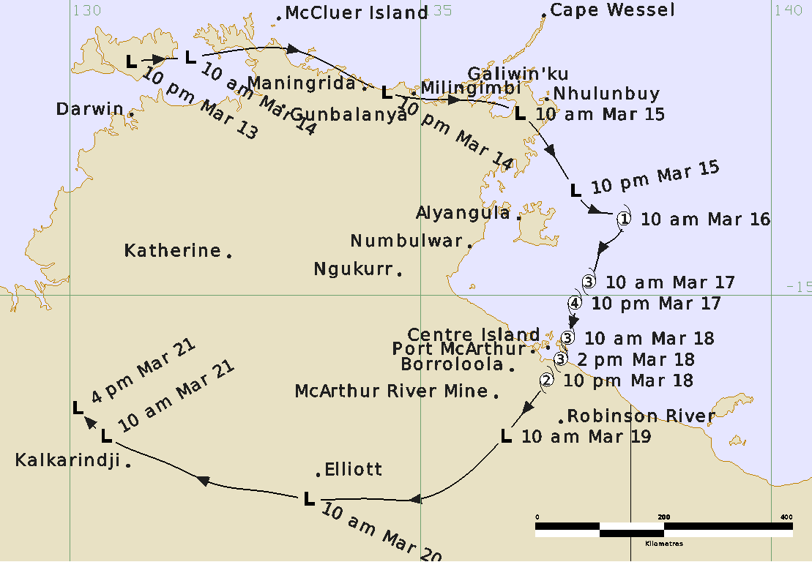Figure 1. Best track of Severe Tropical Cyclone Megan 13-21 March 2024 (times in ACST, UTC +9.5).

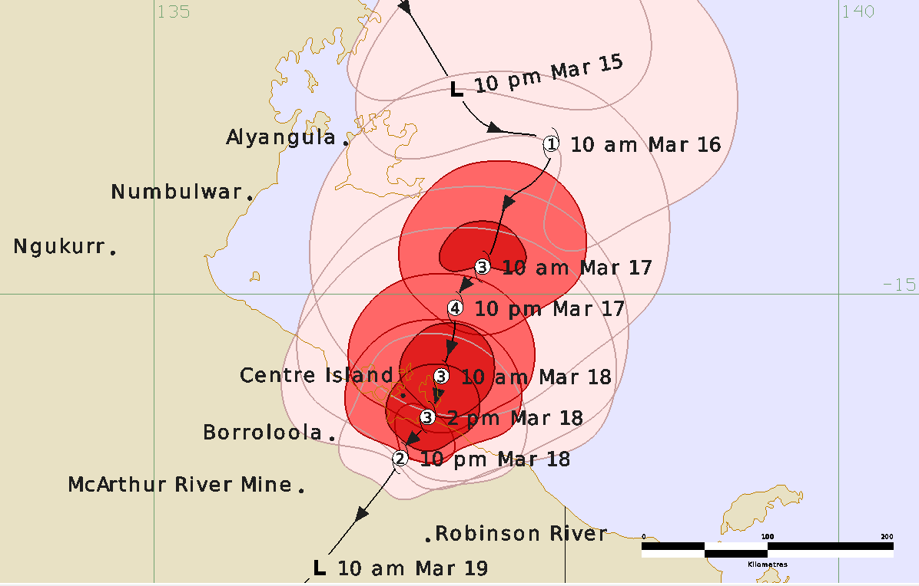

Figure 2. Detailed Best track of Severe Tropical Cyclone Megan over the Gulf of Carpentaria 15-19 March 2024 (times in ACST, UTC +9.5).

|  |  |  |  |  |  |  |  |  |  |  |  |  |
| --- | --- | --- | --- | --- | --- | --- | --- | --- | --- | --- | --- | --- |
| Year | Month | Day | Hour  UTC | Pos.  Lat. S | Pos.  Long.  E. | Pos.  Acc.  nm | Max Wind  10min  kn | Max  gust  kn | Cent.  Press  hPa | Rad. of gales  NE/SE/SW/NW | Rad. of storm  NE/SE/SW/NW | RMW  nm |
| 2024 | 3 | 13 | 1200 | 11.7 | 130.9 | 30 | 15 | 40 | 1002 | 0/0/0/0 | 0/0/0/0 | - |
| 2024 | 3 | 13 | 1800 | 11.6 | 131.3 | 30 | 15 | 40 | 1002 | 0/0/0/0 | 0/0/0/0 | - |
| 2024 | 3 | 14 | 0000 | 11.6 | 131.7 | 25 | 20 | 45 | 1000 | 0/0/0/0 | 0/0/0/0 | - |
| 2024 | 3 | 14 | 0600 | 11.5 | 133.2 | 25 | 30 | 45 | 998 | 0/0/0/0 | 0/0/0/0 | - |
| 2024 | 3 | 14 | 1200 | 12.1 | 134.5 | 20 | 30 | 45 | 998 | 0/0/0/0 | 0/0/0/0 | - |
| 2024 | 3 | 14 | 1800 | 12.2 | 135.1 | 20 | 35* | 50 | 995 | 0/0/0/80 | 0/0/0/0 | - |
| 2024 | 3 | 15 | 0000 | 12.4 | 136.4 | 20 | 40* | 55 | 995 | 100/0/0/100 | 0/0/0/0 | - |
| 2024 | 3 | 15 | 0600 | 13.0 | 136.9 | 15 | 40* | 55 | 995 | 100/0/0/20 | 0/0/0/0 | - |
| 2024 | 3 | 15 | 1200 | 13.5 | 137.2 | 15 | 40* | 55 | 993 | 90/0/0/50 | 0/0/0/0 | - |
| 2024 | 3 | 15 | 1800 | 13.8 | 137.5 | 15 | 40* | 55 | 993 | 90/0/0/60 | 0/0/0/0 | - |
| 2024 | 3 | 16 | 0000 | 13.9 | 137.9 | 15 | 45 | 65 | 990 | 90/50/0/90 | 0/0/0/0 | 45 |
| 2024 | 3 | 16 | 0600 | 14.2 | 137.8 | 15 | 50 | 70 | 986 | 90/50/50/90 | 40/0/0/0 | 35 |
| 2024 | 3 | 16 | 1200 | 14.3 | 137.6 | 15 | 55 | 75 | 980 | 90/60/60/90 | 50/0/0/50 | 35 |
| 2024 | 3 | 16 | 1800 | 14.4 | 137.6 | 15 | 60 | 85 | 976 | 90/60/60/90 | 50/30/30/50 | 20 |
| 2024 | 3 | 17 | 0000 | 14.8 | 137.4 | 15 | 65 | 90 | 974 | 90/60/70/90 | 50/30/30/50 | 20 |
| 2024 | 3 | 17 | 0600 | 14.9 | 137.3 | 15 | 75 | 105 | 964 | 90/60/65/90 | 50/40/40/50 | 15 |
| 2024 | 3 | 17 | 1200 | 15.1 | 137.2 | 15 | 90 | 125 | 951 | 90/60/60/95 | 50/40/40/50 | 13 |
| 2024 | 3 | 17 | 1800 | 15.2 | 137.2 | 15 | 90 | 125 | 950 | 90/70/60/90 | 50/40/40/50 | 13 |
| 2024 | 3 | 18 | 0000 | 15.6 | 137.1 | 15 | 80 | 110 | 963 | 90/50/40/70 | 45/25/25/45 | 13 |
| 2024 | 3 | 18 | 0300 | 15.8 | 137.1 | 15 | 80 | 110 | 961 | 90/40/30/70 | 45/25/20/40 | 13 |
| 2024 | 3 | 18 | 0450 | 15.9 | 137.0 | 15 | 75 | 105 | 968 | 90/35/25/70 | 45/20/20/40 | 13 |
| 2024 | 3 | 18 | 0600 | 16.0 | 137.0 | 15 | 75 | 105 | 968 | 90/30/25/70 | 45/20/15/35 | 13 |
| 2024 | 3 | 18 | 0900 | 16.1 | 136.9 | 20 | 60 | 85 | 975 | 70/50/15/60 | 30/15/0/25 | 15 |
| 2024 | 3 | 18 | 1200 | 16.2 | 136.8 | 20 | 50 | 75 | 981 | 60/20/15/30 | 25/0/0/0 | 15 |
| 2024 | 3 | 18 | 1800 | 16.5 | 136.6 | 20 | 40* | 55 | 985 | 50/0/0/20 | 0/0/0/0 | - |
| 2024 | 3 | 19 | 0000 | 17.0 | 136.2 | 20 | 30 | 40 | 988 | 0/0/0/0 | 0/0/0/0 | - |
| 2024 | 3 | 19 | 0600 | 17.6 | 135.6 | 20 | 25 | 40 | 992 | 0/0/0/0 | 0/0/0/0 | - |
| 2024 | 3 | 19 | 1200 | 17.9 | 135.0 | 25 | 25 | 40 | 995 | 0/0/0/0 | 0/0/0/0 | - |
| 2024 | 3 | 19 | 1800 | 17.9 | 134.3 | 25 | 25 | 40 | 996 | 0/0/0/0 | 0/0/0/0 | - |
| 2024 | 3 | 20 | 0000 | 17.9 | 133.4 | 20 | 25 | 40 | 999 | 0/0/0/0 | 0/0/0/0 | - |
| 2024 | 3 | 20 | 0600 | 17.8 | 132.8 | 15 | 25 | 35 | 999 | 0/0/0/0 | 0/0/0/0 | - |
| 2024 | 3 | 20 | 1200 | 17.7 | 132.1 | 20 | 25 | 35 | 1002 | 0/0/0/0 | 0/0/0/0 | - |
| 2024 | 3 | 20 | 1800 | 17.4 | 131.4 | 20 | 25 | 35 | 1002 | 0/0/0/0 | 0/0/0/0 | - |
| 2024 | 3 | 21 | 0000 | 17.0 | 130.5 | 20 | 25 | 35 | 1004 | 0/0/0/0 | 0/0/0/0 | - |
| 2024 | 3 | 21 | 0600 | 16.6 | 130.1 | 20 | 20 | 35 | 1004 | 0/0/0/0 | 0/0/0/0 | - |

Table 1. Best track summary for Severe Tropical Cyclone Megan, 14-21 March 2024.

UTC=ACST-9.5. * Not at tropical cyclone intensity as gales less than halfway around centre.

1. Meteorological description

2.1 Intensity analysis

A comparison of the subjective and objective intensity estimates is shown in Figure 3.

A low emerged within a trough over the Tiwi Islands, north of Darwin late on 13 March. A strong monsoon flow extended north of the circulation stimulated by a strong MJO and supported by Equatorial Rossby and Kelvin waves as shown in Figure 4. The low moved quickly eastwards close to the northern NT coast passing by observation sites at Warruwi, McCluer Island, Maningrida and Milingimbi on 14 March. Scatterometry (ASCAT-B 1223 UTC 13 March; ASCAT-C 0020 UTC 14 March, not shown) showed 30 kn winds in the monsoonal westerly flow to the north. Gales developed north of the centre early on 15 March as the centre moved over the northeastern Arnhem land region, as indicated on ASCAT-C 2359 UTC 14 March and by surface observations at Ngayawili (Elcho Island) and Cape Wessel. The satellite signature developed despite the system being overland, and microwave imagery indicated strong deep convection having increased curvature west and north of the centre.

During 15 March the low emerged into the Gulf of Carpentaria where sea surface temperatures were around 30°C. While most influences favoured development, moderate vertical wind shear prevented rapid development at this point. Scatterometry (HSCAT 1026 UTC and 2115 UTC) showed continued development but gales only north of the centre.

The system developed quickly during 16 March. During operations the system was named Megan at 0600 UTC but upon reanalysis tropical cyclone intensity was estimated earlier at 0000 UTC. ASCAT-C 2339 UTC 15 March, ASCAT-B 0027 UTC 16 March (in Figure 5a) showed gales mostly north of the centre but also a region of 30-35 kn to the south, sufficient to have gales extending more than half-way around the centre to confirm tropical cyclone intensity was attained.

The SSMIS 89 GHz microwave image at 0648 UTC in Figure 6 showed tight curvature in the deep convection while animated visible imagery also showed the convection wrapping around into southern sectors. Indeed, the strong microwave signal and the earlier ASCAT 45 kn winds suggested the intensity was 50 kn (category 2) at 0600 UTC, slightly higher than subjective Dvorak (CI=3.0) estimates. ASCAT-C 1211 UTC and ASCAT-B 1256 UTC in Figure 5b showed an extensive region of gales around the circulation while high resolution analyses showed 50 kn winds to the north. These also showed gales along the west and southern coast of Groote Eylandt around the time of the damage to the wharf at Alyungula (see 3 Impact). The earlier SMAP wind analysis at 0901 UTC and subsequent AMSR2 at 1603 UTC showed a region of winds in excess of 50 kn.

The enhanced IR imagery sequence showed an ongoing very cold cloud over the central circulation, the moderate shear resulting in high cirrus obscuring the eye, a pattern that continued through to landfall. This provided challenges for the Dvorak and objective aids. Microwave, scatterometer, radiometer information and closer to land, observations from Centre Island all provided more detail on underlying surface wind distribution.

Microwave imagery, such as the SSMIS 89 GHz at 1955 UTC 16 March in Figure 6, continued to show an improved signature in the circulation core and combined with Dvorak trends and objective aids (SATCON/ADT/AiDT ~ 70 kn) suggested category 3 intensity was reached at 0000 UTC 17 March. The 89 GHz microwave images, SSMIS at 1955 UTC 16 March and AMSR2 at 0417 UTC 17 March, indicated an almost complete eye.

Peak intensity of 90 kn is estimated from 1200 to 1800 UTC 17 March. This is higher than subjective Dvorak and objective aids: subjective Dvorak 75-85 kn based on CI of 5.0; SATCON 72 kn, ADT 74 kn; AiDT and DPRINT 70 kn (all adjusted to 10-min. averages).

The peak intensity is influenced by the series of Synthetic Aperture Radar (SAR) images at 0919 UTC 17 March (RCM-3) in Figure 7, near concurrent passes from Sentinel-1A at 2025 UTC and RCM-2 at 2027 UTC 17 March and then RCM-3 just following landfall at 0927 UTC 18 March, as shown in Figure 8. The 0919 UTC 17 March SAR indicated maximum winds north of the centre of 100 kn or more, while the 2025/2027 UTC peaks are on the order of 90-95 kn. Additionally, AMSR2 at 0417 UTC, SMOS at 0841 UTC and Ultra High Resolution (UHR) ASCAT-B at 1238 UTC in Figure 9 all show extensive areas above 65 kn and in the case of AMSR2 and ASCAT-B winds over 80 kn. Possibly winds on the northern side were enhanced because of the frictional effects of winds over Groote Eylandt deflecting the flow towards the circulation.

The peak estimate is slightly lower than SAR peaks as there is some conjecture that in extreme rainfall intensities that SAR and ASCAT (at C-band wavelengths) result in too high wind retrieval speeds.

By 0000 UTC the circulation was nearing land and likely some weakening commenced which was also reflected in objective SATCON and ADT estimates. The UHR ASCAT images (ASCAT-C 2345 UTC 17 March and ASCAT-B 0037 UTC 18 March) in Figure 10 suggested some weakening as it neared land. Megan made landfall at 0430 UTC on the southwestern Gulf of Carpentaria coast southeast of Port McArthur with an estimated intensity of 75 kn. Centre Island recorded maximum 10-minute winds of 71 kn (131 km/h) at 0528 UTC with gusts to 92 kn when Megan lay approximately 15 nm (28 km) to the southeast.

Megan quickly weakened as it moved further inland and although it passed within about 30 nm (56 km) of both Borroloola and McArthur River Mine, neither site recorded gales, even though they recorded pressures below 990 hPa. Over the following days the circulation moved west over the Northern Territory eventually dissipating on 21 March.

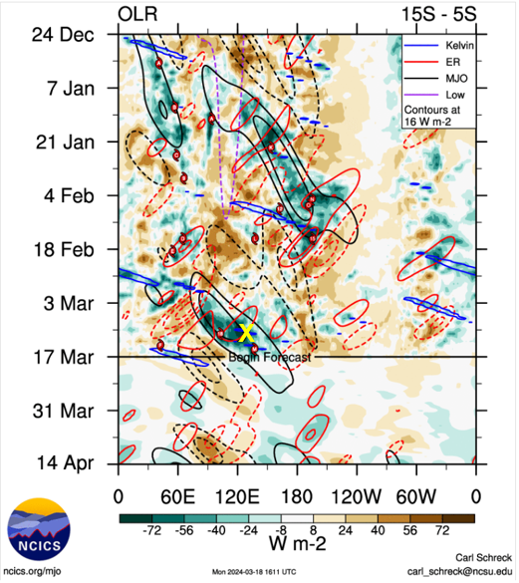

Figure 4. Hovmoller diagram of tropical waves showing the formation of Megan on 13-15 March (indicated by X) occurred with a strong pulse of the MJO (black), and Equatorial Rossby (ER) wave (red), and some Kelvin wave (blue). Image courtesy of North Carolina Institute for Climate Studies (ncics.org).

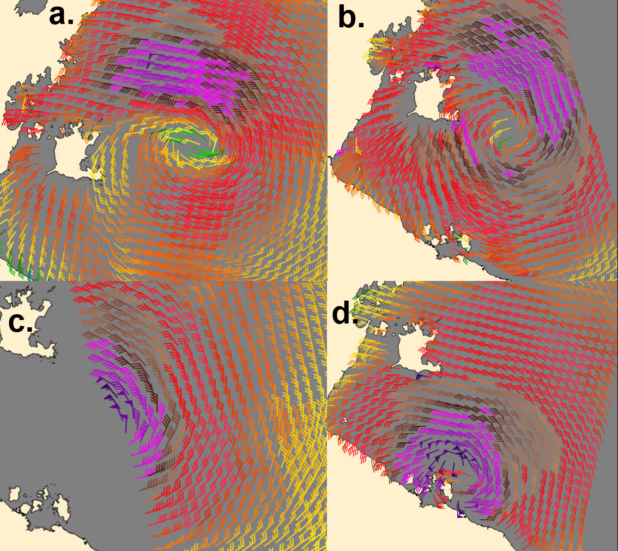

Figure 5 Satellite winds from ASCAT: a. composite of ASCAT-C 2336 UTC 15 March and ASCAT-B 0027 UTC 16 March; b. composite ASCAT-C 1208 UTC ASCAT-B 1256 UTC 16 March; c. ASCAT-B 1236 UTC 17 March; and d. ASCAT-B 2345 UTC 17 March.

|  |  |
| --- | --- |
| 89 GHz microwave imagery SSMIS at 0648 UTC 16 March | 89 GHz microwave imagery SSMIS 1955 UTC 16 March showing developing curvature in deep convection around the centre |
| 89 GHz microwave imagery  AMSR2 89 GHz microwave image at 0417 UTC 17 March | 89 GHz microwave imagery 0500 UTC 18 March near landfall. |

Figure 6. 89 GHz microwave imagery (top left) SSMIS at 0648 UTC 16 March; (top right) SSMIS 1955 UTC 16 March showing developing curvature in deep convection around the centre; (lower left) AMSR2 89 GHz microwave images at 0417 UTC 17 March, and (lower right) 0500 UTC 18 March near landfall. Images courtesy NRL: <https://www.nrlmry.navy.mil/TC.html>

|  |  |
| --- | --- |
| Synthetic Aperture Radar (SAR) at 0919 UTC 17 March wind speed distribution gridlines at 0.25 degree | Synthetic Aperture Radar (SAR) at 0919 UTC 17 March wind profile by quadrant |

Figure 7. Synthetic Aperture Radar (SAR) at 0919 UTC 17 March: (left) wind speed distribution with gridlines at 0.25 degree; and (right) wind profile by quadrant. Image courtesy NOAA STAR [https://www.star.nesdis.noaa.gov/socd/mecb/sar/sarwinds_tropical.php?year=2024&storm=SH192024_MEGAN](https://aus01.safelinks.protection.outlook.com/?url=https%3A%2F%2Fwww.star.nesdis.noaa.gov%2Fsocd%2Fmecb%2Fsar%2Fsarwinds_tropical.php%3Fyear%3D2024%26storm%3DSH192024_MEGAN&data=05%7C02%7Cjoe.courtney%40bom.gov.au%7C65d991a3b0bc420d23bb08dc475a75c7%7Cd1ad7db597dd4f2b816e50d663b7bb94%7C0%7C0%7C638463701105668989%7CUnknown%7CTWFpbGZsb3d8eyJWIjoiMC4wLjAwMDAiLCJQIjoiV2luMzIiLCJBTiI6Ik1haWwiLCJXVCI6Mn0%3D%7C0%7C%7C%7C&sdata=5Tqp%2BO20KYUEaiFd5gvpQxQqGBqkLKQj4%2F48lpoh174%3D&reserved=0)

|  |  |  |
| --- | --- | --- |
| Synthetic Aperture Radar (SAR) wind distribution: Sentinel-1A at 2025 UTC 17 March | Synthetic Aperture Radar (SAR) wind distribution:  RCM-2 at 2027 UTC 17 March; | Synthetic Aperture Radar (SAR) wind distribution: RCM-3 at 0927 UTC 18 March |

Figure 8. Synthetic Aperture Radar (SAR) wind distribution: (left) Sentinel-1A at 2025 UTC 17 March; (middle) RCM-2 at 2027 UTC 17 March; and (right) RCM-3 at 0927 UTC 18 March. Images courtesy NOAA STAR [https://www.star.nesdis.noaa.gov/socd/mecb/sar/sarwinds_tropical.php?year=2024&storm=SH192024_MEGAN](https://aus01.safelinks.protection.outlook.com/?url=https%3A%2F%2Fwww.star.nesdis.noaa.gov%2Fsocd%2Fmecb%2Fsar%2Fsarwinds_tropical.php%3Fyear%3D2024%26storm%3DSH192024_MEGAN&data=05%7C02%7Cjoe.courtney%40bom.gov.au%7C65d991a3b0bc420d23bb08dc475a75c7%7Cd1ad7db597dd4f2b816e50d663b7bb94%7C0%7C0%7C638463701105668989%7CUnknown%7CTWFpbGZsb3d8eyJWIjoiMC4wLjAwMDAiLCJQIjoiV2luMzIiLCJBTiI6Ik1haWwiLCJXVCI6Mn0%3D%7C0%7C%7C%7C&sdata=5Tqp%2BO20KYUEaiFd5gvpQxQqGBqkLKQj4%2F48lpoh174%3D&reserved=0)

|  |  |  |
| --- | --- | --- |
| Wind distribution on 17 March from  AMSR2 at 0417 UTC showing winds above 100 kn near the centre | Wind distribution on 17 March from SMOS at 0841 UTC showing winds between 64-80kn near the centre | Wind distribution on 17 March from Ultra High Resolution (UHR) ASCAT-B at 1238 UTC showing a small area above 80kn north and south of the centre. |

Figure 9. Wind distribution on 17 March from (left) AMSR2 at 0417 UTC; (middle) SMOS at 0841 UTC and (right) Ultra High Resolution (UHR) ASCAT-B at 1238 UTC. Images courtesy NRL.

|  |  |  |
| --- | --- | --- |
| Satellite winds from ASCAT-C 2345 UTC 17 March showing strong winds near the southwestern Gulf coast prior to landfall. | Satellite winds from ASCAT-B 0037 UTC 18 March showing strong winds near the southwestern Gulf coast prior to landfall. |  |

Figure 10. Satellite winds from (left) ASCAT-C 2345 UTC 17 March, and (right) ASCAT-B 0037 UTC 18 March. Images courtesy NRL: <https://www.nrlmry.navy.mil/TC.html>

## 2.1 Structure

The strong monsoon flow resulted in gales extending a long way north of the system in the initial stages. Technically gales were first attributed to be associated with the circulation at 1800 UTC 14 March and scatterometry (ASCAT-C 2359 UTC 14 March) supported by observations from Cape Wessel and Elcho Island indicated that gales extended to about 100 nm to the north.

Once the system moved into the Gulf of Carpentaria and developed into a tropical cyclone, gales were estimated to 90 nm to the north and 60 nm to the south (Figure 5). As the system intensified the radius of maximum winds reduced from the initial 35 nm to 13 nm as measured by SAR shown in Figures 7 and 8. The highest winds were consistently evident to the north of the system throughout the event. Land affected the extent of gales as the system approached the coast as shown in Figures 5 and 10. The extent of gales overland is difficult to estimate, although Borroloola only recorded near gales (maximum 33 kn) and McArthur River Mine well below gales suggesting that wind speeds were much reduced compared to over water.

2.2 Motion

As shown in the track in Figure 1, during the formation stages the system was steered rapidly to the east near the northern coast of the NT by the dominant monsoonal flow to the north. The circulation took a more southeast track as it entered the Gulf of Carpentaria on 15 March, then slowed almost to a halt on 16 March as the easing monsoon flow was balanced by the mid-level ridge to the south. Megan moved slowly southwards to the coast on 16-18 March. After weakening over land, the circulation took a more westward track over the Northern Territory from 19-21 March under the influence of the mid-level ridge to the south and southwest.

1. Impact

Monsoonal strong winds and heavy rain affected coastal communities along the Arnhem land coast on 14-15 March. Galiwinku had many fallen trees around the community including onto power lines resulting in power and water being turned off in the community. Gunbulunya residents were relocated to higher ground and 15 dwellings were inundated by floodwaters. There was also the threat of estuarine crocodiles in flood waters.

Strong winds early on 16 March at Groote Eylandt brought trees and power lines down around Alyangula. Roads were closed due to flooding. Late on 16 March the Alyungula wharf was badly damaged as the Manganese bulk carrier MV Anikitos was pushed against it as shown in Figure 11.

The slow movement of the cyclone resulted in very intense rainfall being recorded near the path of Megan. Widespread flooding occurred on Groote Eylandt and in catchments along the southern Gulf of Carpentaria coast during this event. A record Major flood level was recorded in the McArthur River on 22 March. Flooding forced the evacuation of many Borroloola residents to Darwin after the cyclone impacted the community (see photo in Figure 12).

Sea level anomalies measured by the Groote Eylandt tide gauge on the Alyangula wharf reached close to 2 metres above the normal tide level before the gauge was destroyed during the evening of 16 March. The gauge indicated a sea level around 1 metre above the Highest Astronomical Tide level at Alyangula when data ceased to be transmitted.

An aerial survey by the NT Department of Environment, Parks and Water Security of the coastline around landfall area found no stranded marine megafauna (turtles or dugongs) and no evidence of any storm surge damage. There was little evidence of vegetation damage aside from some foliage wind burn in open woodland vegetation on Vanderlin Island, east of Centre Island in the Sir Edward Pellew Group.

Major highways and secondary roads were damaged by floodwaters associated with ex-Tropical Cyclone Megan as it traversed central parts of the Northern Territory during the third week of March. The Stuart Highway was cut north of Tennant Creek and the Tanami, Plenty and Barkly Highways were also impacted for extended periods. Heavy rainfall in Central Australia associated with a cloud band that extended southeast from the ex-cyclone caused a significant flow in the Todd River through Alice Springs.

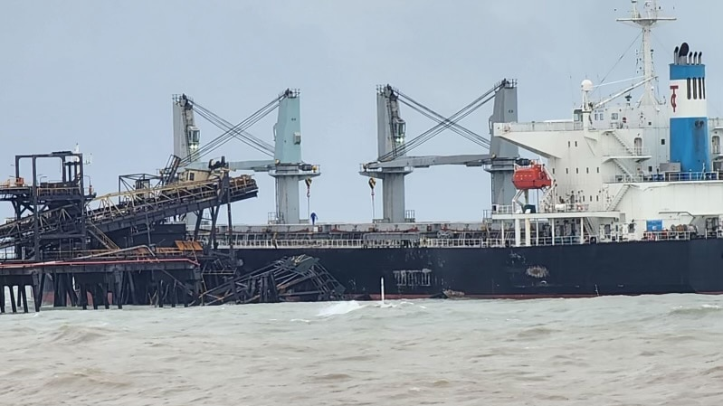

Figure 11. The MV Anikitos adjacent to the damaged wharf at Groote Eylandt. Photo supplied to ABC. <https://www.abc.net.au/news/2024-03-19/bulk-carrier-crashes-into-south32-manganese-wharf-groote-eylandt/103604700>

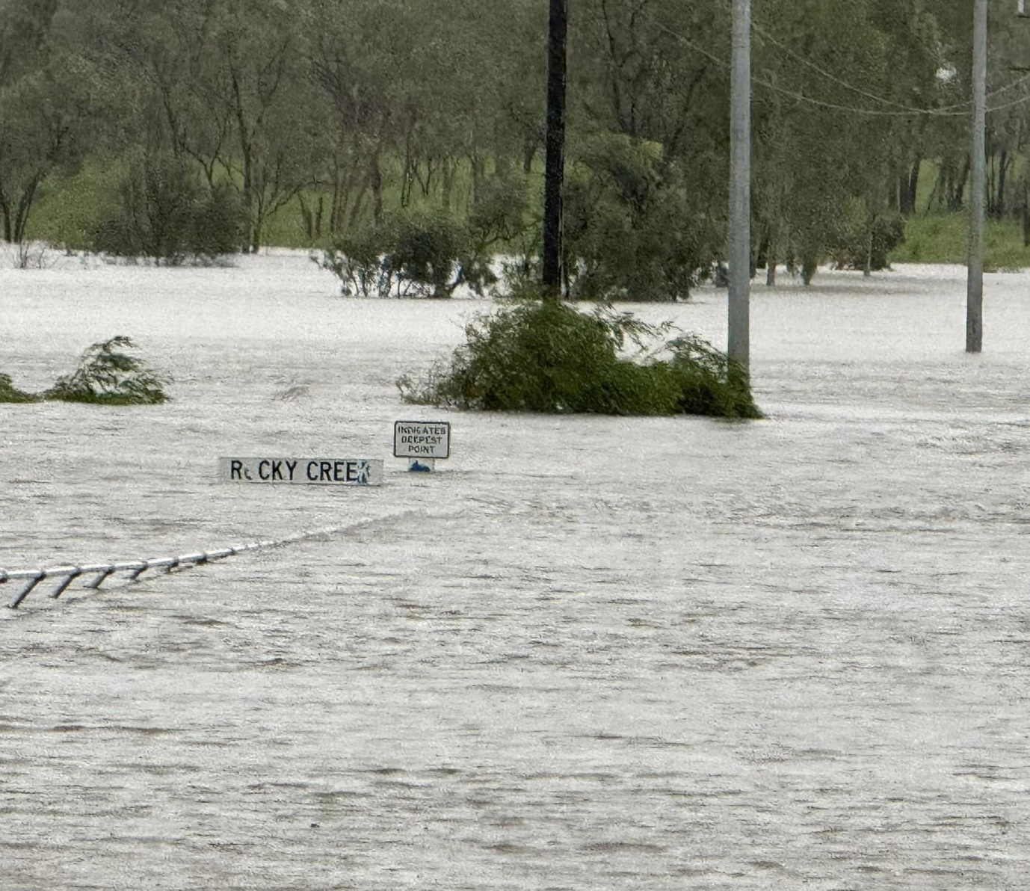

Figure 12. Floodwaters around Borroloola 19 March. Photo courtesy Steve Edgington.

1. Observations
   1. Winds

Ngayawili (on Elcho Island near Galiwin'ku) recorded non-continuous gales between 2131 UTC 14 March to 0736 UTC 15 March (0706 to 1706 ACST 15 March); maximum 10-minute winds of 45 kn (82 km/h) at 2245 UTC 14 March (0815 ACST 15 March) and maximum gust 56 kn (104 km/h) at 2142 and 2148 UTC 14 March (0712 and 0718 ACST 15 March.

Cape Wessel recorded non-continuous gales between 2136 UTC 14 March to 1348 UTC 15 March (0706 to 2318 ACST 15 March); maximum 10-minute winds of 41 kn 75 km/h at 0304 UTC (1234 ACST) 15 March and maximum gust 50 kn (93 km/h) at 0206 UTC (1136 ACST) 15 March.

Centre Island recorded non-continuous gales between 2245 UTC 16 March to 1407 UTC 18 March (0815 17 March to 2337 ACST 18 March); storm-force (48 kn and greater) between 1944 UTC 17 March to 0802 UTC 18 March (0514 to 1732 ACST 18 March); hurricane-force (64 kn and greater) between 0521 to 0536 UTC (1451-1506 ACST) 18 March; maximum 10-minute winds of 71 kn (131 km/h) at 0528 UTC (1458 ACST) 18 March and maximum gust 92 kn (170 km/h) at 0527 UTC (1457 ACST) 18 March.

Borroloola recorded maximum10-minute winds of 33 kn (61 km/h) at 0708 UTC (1638 ACST) 18 March.

* 1. Rainfall

The slow movement of the cyclone resulted in very intense rainfall being recorded at Groote Eylandt, Centre Island and Borroloola and surrounding areas. The weekly rainfall distribution to 21 March is shown in Figure 13.

Notable 24 hour falls to 9 am local time included:

14 March: Point Fawcett 146.8 mm;

15 March: Milingimbi Airport 166.8 mm; Oenpelli Airport 159.6 mm; Maningrida Airport 142.6 mm; Murganella Airstrip 126.4mm; Ngayawili 122.0 mm; Warruwi Airport 109.0 mm;

16 March: Groote Eylandt Airport 249.4 mm;

17 March: Groote Eylandt Airport 431.0 mm (highest ever daily rainfall record);

18 March: Centre Island 223.8 mm; McArthur River Borroloola 124.5; Borroloola Airport 114.0 mm

19 March: Centre Island 289.0 mm, McArthur River Mine 274.4 mm; Baileys Grave 257.0 mm; Borroloola Airport 256.6 mm; Anthony Lagoon 249.0 mm; McArthur River Borroloola 235.0 mm; King Ash Bay 220.0 mm; Favenc Range 126.0 mm;

20 March: Helen Springs 161.0 mm; Tennant Creek 103.0 mm;

22 March: Rabbit Flat: 128.0 mm; The Granites 106.2 mm.

* 1. Pressure

|  |  |  |
| --- | --- | --- |
| Location | Pressure hPa | Time UTC (ACST) |
| Ngayawili (Elcho Island) | 994.7 | 1937 14 March (0507 15 March) |
| Centre Island | 976.1 | 0529 (1459) 18 March |
| Borroloola | 989.8 | 0713 UTC (1643 ACST) 18 March |
| McArthur River Mine | 989.6 | Between 1858 and 1944 UTC 18 March (0428-0514 ACST 19 March) |

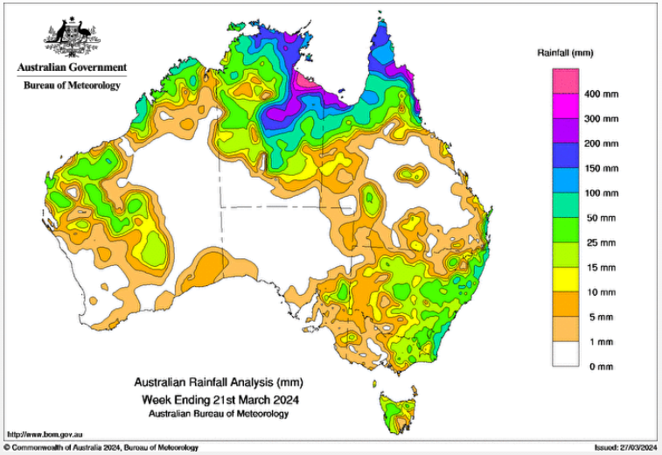

Figure 13. Weekly rainfall distribution ending 21 March.

1. Forecast Performance

The accuracy statistics for Severe Tropical Cyclone Megan are below in Table 2 and shown in Figures 14 and 15.

Tropical Cyclone Advices and Forecast Track Maps began at 0100 UTC 15 March for areas between Alyangula (Groote Eylandt) to the NT/Qld border and concluded at 0000 UTC 19 March once Megan had weakened over land. A total of 34 Tropical Cyclone Advices were issued.

The initial warnings accurately forecast the crossing location and timing (compare Figure 16 and Figure 2). By late afternoon 15 March the area under Watch was upgraded to a Warning while the Watch area extended to Mornington Island (Queensland) and to adjacent inland areas of the southwest Gulf. The early Advices indicated a Category 2 intensity by landfall and this was upgraded to Category 3 on the forecast issued on the morning of 16 March.

As shown in Figures 14 and 15, the forecast track positions and intensity were better than the five-year average, aside from the analysed intensity that reflected the higher peak intensity upon reanalysis.

The seven-day forecast first mentioned 09U on 4 March for a low rating (5-20% chance of a TC) on 10-11 March. The forecast rating was upgraded to Moderate (20-50%) for 16-18 March on 12 March and to High (>50%) for 17 March on 14 March.

In the early stages of development on 14 March, Severe Weather Warnings were issued for the Top End coast for monsoonal weather conditions. Severe Weather Warnings were again issued following Megan's weakening on 19 March until 21 March for heavy rain as the system tracked over the NT. Flood Advices also continued for many days.

|  |  |  |  |  |  |  |  |  |  |  |
| --- | --- | --- | --- | --- | --- | --- | --- | --- | --- | --- |
| Time | 00 | 06 | 12 | 18 | 24 | 36 | 48 | 72 | 96 | 120 |
| Position accuracy (km) | 5 | 19 | 28 | 32 | 41 | 59 | 70 | 105 | 159 | 169 |
| Intensity accuracy (knots) | 5.3 | 5.9 | 7.2 | 7.5 | 10.0 | 10.8 | 11.2 | 5.2 | 3.0 | 4.2 |
| Sample size | 17 | 17 | 17 | 17 | 17 | 17 | 17 | 14 | 10 | 6 |

Table 2. Verification statistics for Severe Tropical Cyclone Megan. * Note, verification is performed using the Official Forecast Tracks at the standard times of 00, 06,12 and 18 UTC.

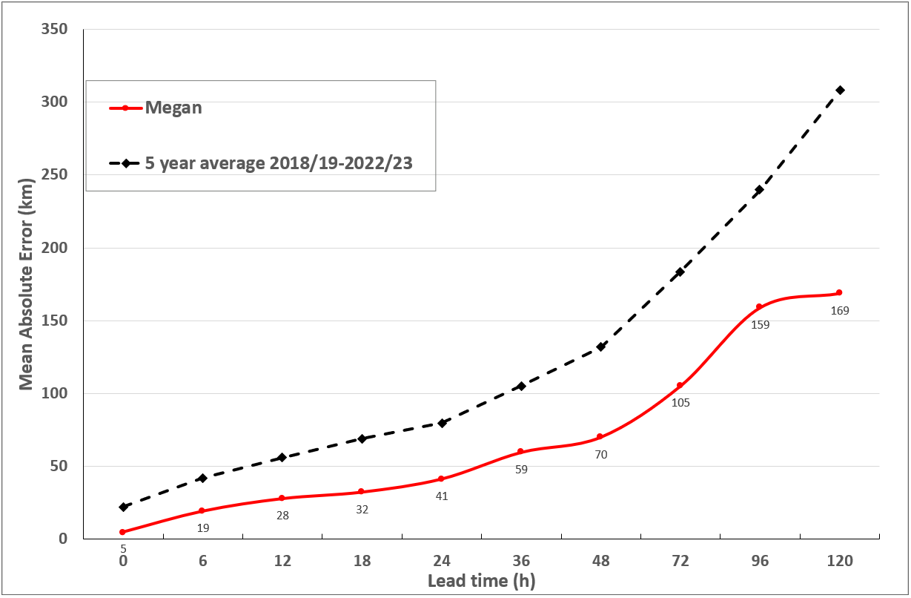

Figure 14. Position accuracy figures for Tropical Cyclone Megan.

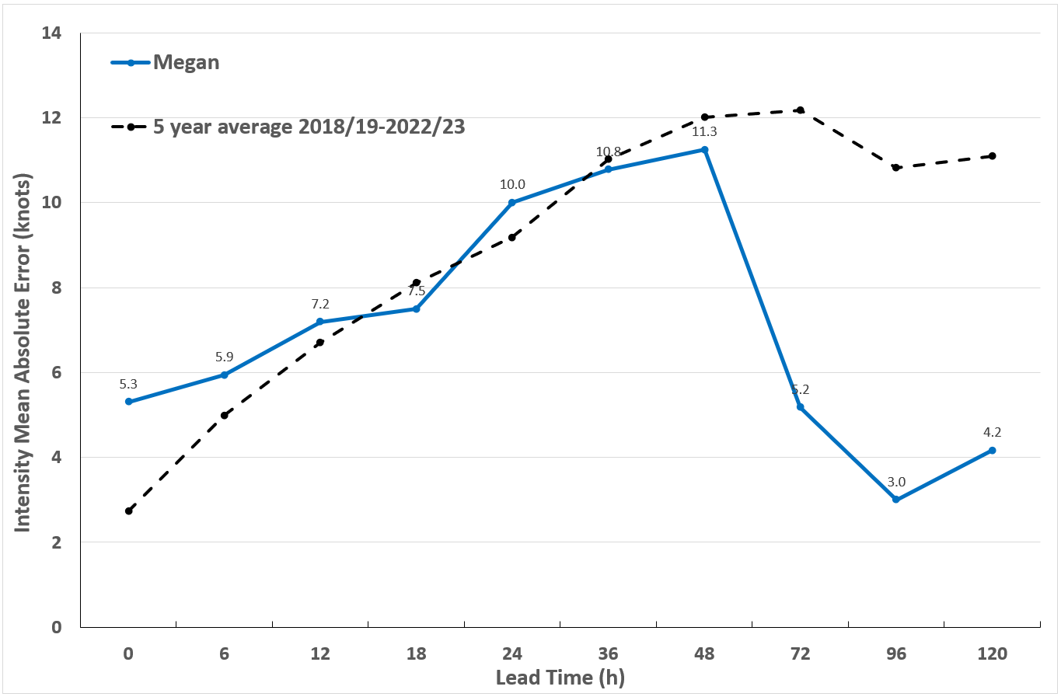

Figure 15. Intensity accuracy figures for Tropical Cyclone Megan.

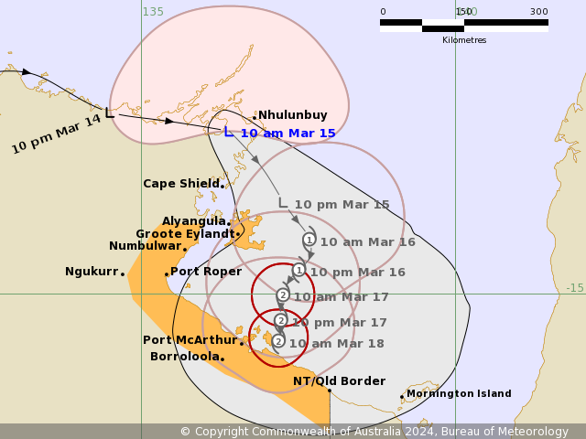

Figure 16. First forecast track map issued around 0100 UTC 15 March showing the watch region between Port Roper and Burketown. The coastal crossing time and location were exceptionally accurate while the near landfall intensity forecast was less than the actual category 3 intensity (refer Figure 2 for the actual track).

Appendix: List of abbreviations

|  |  |
| --- | --- |
| Abbreviation | Term |
| ADT | Advanced Dvorak Technique |
| ACST | Australian Central Standard Time |
| AEST | Australian Eastern Standard Time |
| AiDT | AI-enhanced Dvorak Technique |
| AMSR2 | Advanced Microwave Scanning Radiometer |
| AMSU | Advanced Microwave Sounding Unit |
| ASCAT | Advanced Scatterometer |
| ATMS | Advanced Technology Microwave Sounder |
| AWS | automatic weather station |
| AWST | Australian Western Standard Time |
| °C | Celsius |
| CI | Current intensity |
| CIMSS | Cooperative Institute for Meteorological Satellite Studies (USA) |
| CIRA | Cooperative Institute for Research in the Atmosphere (USA) |
| D-MINT | Deep learning - Multispectral Intensity of TCs (formerly known as DMN) |
| D-PRINT | Deep learning - IR Intensity of TCs (formerly known as OPEN-AIIR) |
| EIR | Enhanced InfraRed |
| ERC | eyewall replacement cycle |
| FNMOC | Fleet Numerical Meteorology and Oceanography Centre (USA) |
| FT | Final T-number |
| GCOM | Global Change Observation Mission |
| GHz | Gigahertz |
| GMI | Global Precipitation Measurement Microwave Imager |
| h | hour |
| hPa | hectopascal |
| HSCAT | Hai Yang 2 Scatterometer (HY-2B, HY-2C) |
| km | kilometres |
| km/h | kilometres per hour |
| kn | knot |
| LLCC | LLCC |
| MET | Model Expected T-number |
| METOP | Meteorological Operational Satellite |
| MJO | Madden-Julian Oscillation |
| mm | millimetres |
| MSLP | mean sea level pressure |
| NESDIS | National Environmental Satellite, Data, and Information Service |
| nm | nautical mile |
| NOAA | National Oceanic and Atmospheric Administration |
| NRL | Navy Research Lab (USA) |
| OPEN-AiiR | Ordered Pattern Encoding AI Infrared |
| PAT | Pattern T-number |
| RCM | RadarSat Constellation Mission – Synthetic Aperture Radar |
| RH | relative humidity |
| RMW | radius of maximum winds |
| RSMC | Regional Specialised Meteorological Centre |
| SAR | Synthetic Aperture Radar |
| SATC | CIMSS Advanced Dvorak Technique |
| SATCON | Satellite Consensus |
| SEN1 | Sentinel-1A – Synthetic Aperture Radar |
| SMAP | Soil Moisture Active Passive |
| SMOS | Soil Moisture and Ocean Salinity |
| SSMIS | Special Sensor Microwave Imager/Sounder |
| TC | Tropical Cyclone |
| TCWC | Tropical Cyclone Warning Centre |
| UTC | Universal Time Co-ordinated |

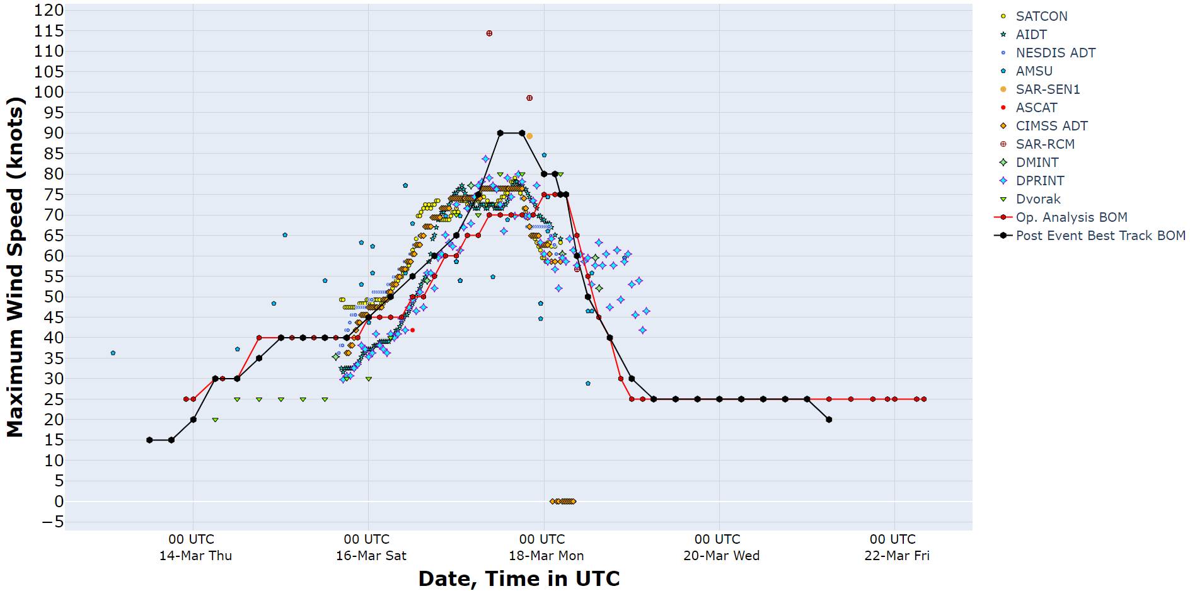

Figure 3. Intensity plot of objective and subjective guidance. SATCON, AiDT, NESDIS ADT, AMSU, SAR-RCM, ASCAT, CIMSS ADT, DMINT, DPRINT, Dvorak (subjective estimate), operational analysis (red) and post event best track analysis (black). Objective Dvorak have been adjusted from 1-minute to 10-minute maximum mean winds.