Severe Tropical Cyclone Monica

16 - 27 April 2006

Joe Courtney, Tropical Cyclone Environmental Prediction Services

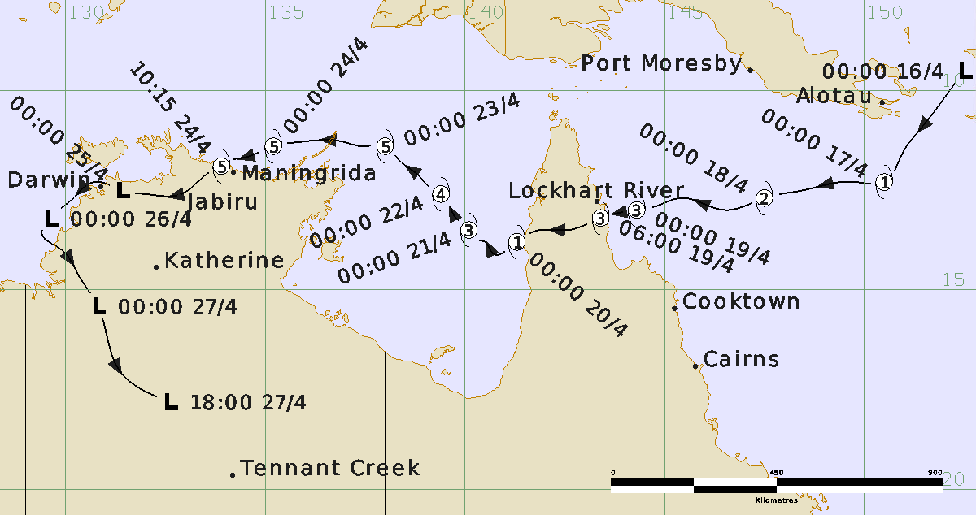

Revision history
Date | Version | Authors | Description
13/11/2024 | 1.0 | Joe Courtney | Final draft ready. Based on information primarily collated during 2006.

Review status
Date | Version | Reviewer | Description
15/11/2024 | 1.0 | Ian Shepherd | Completed

Release history
Date | Version | Status | Approval
22/11/2024 | 1.0 | Approved for release | Andrew Burton

Contact details:
Tropical Cyclone Team Lead
Severe Weather Environmental Prediction Services
Bureau of Meteorology
PO Box 1370, West Perth WA 6872
Email: tcwc@bom.gov.au
This work is copyright. Apart from any use as permitted under the Copyright Act 1968, no part may be reproduced without prior written permission from the Bureau of Meteorology. Refer to www.bom.gov.au/other/copyright.shtml for further information. Unless otherwise noted, all images in this document are licensed under the Creative Commons Attribution Australia Licence.
© Commonwealth of Australia 2024
Published by The Bureau of Meteorology
Cover image: Track of Severe Tropical Cyclone Monica 16 – 27 April 2006. Times in UTC (ACST-9.5h or AEST-10h).

Table of Contents

1. Summary 5

2. Meteorological description 10

2.1. Intensity Analysis 10

2.2. Structure 11

2.3. Motion 11

3. Impact 18

4. Observations 18

4.1. Wind 18

4.2. Pressure 19

4.3. Rainfall 19

4.4. Storm Surge 19

5. Appendix: List of Abbreviations 26

List of Figures
Figure 1. Track of Severe Tropical Cyclone Monica 16 – 27 April 2006. 6
Figure 2. Detailed best of Severe Tropical Cyclone Monica as it approached and crossed the north Queensland coast 17-20 April 2006. 6
Figure 3. Detailed best of Severe Tropical Cyclone Monica as it approached and crossed the Northern Territory coast 22-24 April 2006. 7
Figure 4. Visible images at 0003 UTC whilst Monica was in the Coral Sea: left 18 April and right 19 April. 12
Figure 5. AMSRE 89 GHz microwave images at a. 1552 UTC 18 April and b. 0406 UTC 19 April whilst Monica was in the Coral Sea. 12
Figure 6. Radar images: from left Weipa at 0600 UTC 19 April; and right Gove at 1150 UTC 23 April 2006. 13
Figure 7. Visible images at 0003 UTC whilst Monica was in the Gulf of Carpentaria: a. 20 April, b. 21 April, c. 22 April, d. 23 April. 14
Figure 8. Series of microwave images from 20 to 23 April showing the development of Monica across the Gulf of Carpentaria: a. TMI 85 GHz 0309 UTC 20 April; b. TMI 85 GHz 0213 UTC 21 April; c. AMSRE 89 GHz 0437 UTC 22 April; and d. TMI 85 GHz 0200 UTC 23 April. 15
Figure 9. AMSRE microwave images at 0426 UTC 24 April just prior to Monica crossing the Northern Territory coast: left 36 GHz composite image; and right 89 GHz (horizontally polarised). 16
Figure 10. MODIS visible image at 0430 UTC 24 April. 17
Figure 11. Rainfall analysis for Queensland for week ending 23 April 2006. 20
Figure 12. Rainfall analysis for Northern Territory for week ending 23 April 2006. 21
Figure 13. Defoliation at Junction Bay, 35 km west of Maningrida, after Tropical Cyclone Monica. 22
Figure 14. Damage to the Cape Wessel Automatic Weather Station.. 23
Figure 15. Damage to Maningrida after Tropical Cyclone Monica narrowly missed a direct hit on the township.. 24
Figure 16. Erosion at the coastal crossing point of Junction Bay, 35 km west of Maningrida. 25

List of Tables
Table 1. Best track summary for Severe Tropical Cyclone Monica 16-27 April 2006.. 9

- Summary
Severe Tropical Cyclone Monica made two significant landfalls, firstly as a category three system on the far north Queensland coast north of Cooktown on 19 April and then on the north coast of the Northern Territory near Maningrida at category 5 intensity on 24 April. Monica was the most intense tropical cyclone in the Australian region and the strongest to ever make landfall in Australia. Monica is also one of only three category 5 tropical cyclones to affect the Northern Territory coast, the others being Kathy (1984) and Ingrid (2005).
The track is shown in Figure 1 while Figure 2 shows more detailed track as Monica approached and crossed the Queensland coast and Figure 3 shows the more detailed track as Monica approached and crossed the Northern Territory coast. Track data are in Table 1.
A tropical low was analysed in the far northern Coral Sea on 16 April. The low moved towards the southwest under the influence of a weakening ridge to the south. There it reached cyclone intensity on 17 April and began a more westward track toward Cape York Peninsula. The system intensified to hurricane-force strength before making landfall 40 km south of Lockhart River on the afternoon of 19 April. The system weakened over land, before entering the Gulf of Carpentaria as a weak cyclone early the following day.
Monica began to intensify rapidly as it tracked to the northwest over the Gulf of Carpentaria reaching category 5 intensity at 0600 UTC 22 April then attaining maximum intensity of 135 kn (250 km/h) 24 hours later about 110 km to the northeast of Nhulunbuy. This is the highest intensity of any cyclone in the Australian region. At this time, Monica had an eye diameter of around 30 km but the effects of the very destructive core were very much confined near to the eye wall. The Cape Wessel AWS recorded a mean wind of 70 kn (130 km/h) at 1030 UTC (2000 ACST) 23 April prior to failing as Monica 's maximum winds approached to within an estimated 15 km of the station. The convective structure of Monica maintained its intense nature until it made landfall at 1015 UTC (1945 ACST) 24 April at Junction Bay, 35 km west of Maningrida.
Monica quickly weakened after landfall, passing over northern parts of Kakadu National Park near Jabiru at category 2 intensity and then weakening below tropical cyclone intensity just 12 hours after landfall. The system passed to the north of Darwin as a tropical low during the afternoon of 25 April and then turned to the southwest then to the southeast weakening over land on 27 April.
Fortunately, Monica crossed Cape York Peninsula at a remote location, avoiding the local townships of Lockhart River and Coen. However, there was widespread tree damage and moderate damage to infrastructure along the Arnhem Land coast, extending as far west as the township of Jabiru. Maningrida community received substantial damage as the cyclone passed just to the north of the township, with several houses damaged by fallen trees and debris. The uninhabited coastal crossing point suffered severe vegetation damage, with 60-80 per cent of all trees uprooted or snapped, as well as evidence of a 5-6 m storm surge in Junction Bay.
Heavy rainfall caused flooding in the Adelaide, Victoria, Daly and Katherine River catchments.

Figure 1. Track of Severe Tropical Cyclone Monica 16 – 27 April 2006. Times in UTC (AEST-10h, ACST-9.5h).
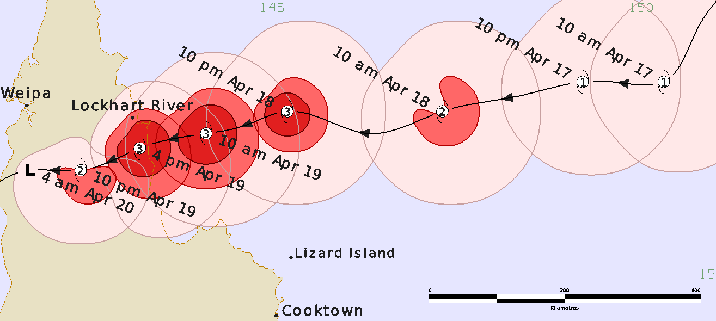
Figure 2. Detailed best of Severe Tropical Cyclone Monica as it approached and crossed the north Queensland coast 17-20 April 2006 (times in AEST, UTC +10). The pink areas show the extent of gales, the red area the extent of storm-force winds and the dark red colour is the extent of hurricane-force winds.
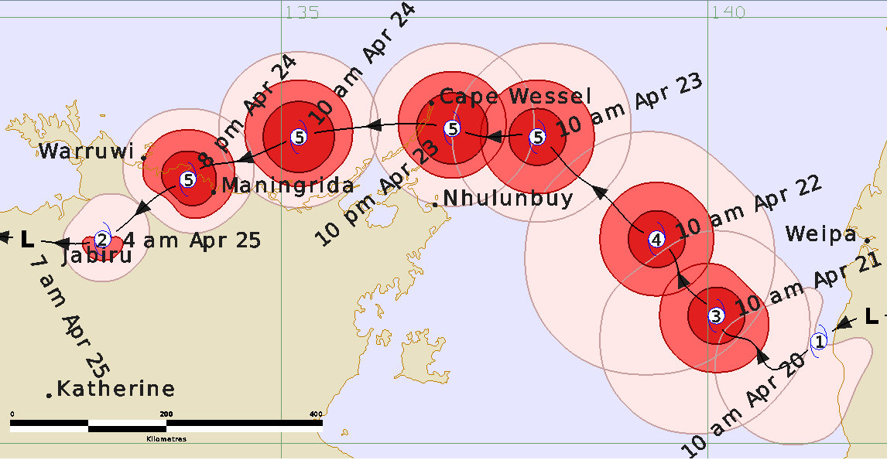
Figure 3. Detailed best of Severe Tropical Cyclone Monica as it approached and crossed the Northern Territory coast 22-24 April 2006 (times in ACST, UTC +9.5). The pink areas show the extent of gales, the red area the extent of storm-force winds and the dark red colour is the extent of hurricane-force winds.

Year | Month | Day | Hour UTC | Pos. Lat. S | Pos. Long. E | Pos. Acc. nm | Max. wind kn | Max. gust kn | Cent. Press hPa | Rad of gales NE/SE/SW/NW nm | Rad of storm NE/SE/SW/NW nm | RMW nm
2006 | 4 | 16 | 0000 | 9.5 | 152.5 | 30 | 25 | 45 | 1003 | 0/0/0/0 | 0/0/0/0 | -
2006 | 4 | 16 | 0600 | 11.1 | 151.3 | 30 | 25 | 45 | 1003 | 0/0/0/0 | 0/0/0/0 | -
2006 | 4 | 16 | 1200 | 11.5 | 151.0 | 30 | 25 | 45 | 1003 | 0/0/0/0 | 0/0/0/0 | -
2006 | 4 | 16 | 1800 | 11.5 | 151.0 | 30 | 35* | 45 | 1000 | 50/50/0/0 | 0/0/0/0 | -
2006 | 4 | 17 | 0000 | 12.3 | 150.5 | 30 | 40 | 55 | 994 | 80/80/60/60 | 0/0/0/0 | 20
2006 | 4 | 17 | 0600 | 12.3 | 149.8 | 25 | 40 | 55 | 994 | 80/80/60/60 | 0/0/0/0 | 25
2006 | 4 | 17 | 1200 | 12.3 | 149.4 | 25 | 45 | 65 | 990 | 80/80/70/60 | 0/0/0/0 | 20
2006 | 4 | 17 | 1800 | 12.5 | 148.5 | 25 | 50 | 70 | 985 | 80/80/70/60 | 0/30/0/0 | 20
2006 | 4 | 18 | 0000 | 12.7 | 147.5 | 20 | 60 | 85 | 980 | 80/80/70/60 | 30/30/25/0 | 20
2006 | 4 | 18 | 0600 | 13.0 | 146.5 | 20 | 65 | 90 | 975 | 80/80/70/60 | 30/35/30/20 | 15
2006 | 4 | 18 | 1200 | 12.7 | 145.4 | 20 | 70 | 100 | 970 | 80/80/70/60 | 30/35/30/20 | 10
2006 | 4 | 18 | 1800 | 12.9 | 144.8 | 15 | 75 | 105 | 965 | 70/80/70/60 | 40/40/40/30 | 20
2006 | 4 | 19 | 0000 | 13.0 | 144.3 | 15 | 75 | 105 | 965 | 70/80/70/60 | 40/45/45/30 | 20
2006 | 4 | 19 | 0600 | 13.2 | 143.4 | 15 | 75 | 105 | 965 | 60/80/40/40 | 35/45/30/25 | 20
2006 | 4 | 19 | 1200 | 13.5 | 142.6 | 15 | 60 | 85 | 970 | 20/60/60/30 | 0/30/20/0 | 20
2006 | 4 | 19 | 1800 | 13.5 | 141.9 | 15 | 40* | 65 | 985 | 0/50/50/0 | 0/0/0/0 | 20
2006 | 4 | 20 | 0000 | 13.8 | 141.3 | 15 | 40 | 55 | 990 | 0/40/80/40 | 0/0/0/0 | 20
2006 | 4 | 20 | 0600 | 14.1 | 140.7 | 15 | 40 | 55 | 987 | 40/60/90/50 | 0/0/0/0 | 20
2006 | 4 | 20 | 1200 | 13.8 | 140.5 | 15 | 50 | 70 | 984 | 50/60/90/50 | 0/30/40/20 | 20
2006 | 4 | 20 | 1800 | 13.7 | 140.2 | 10 | 55 | 80 | 976 | 60/70/90/60 | 0/30/40/30 | 20
2006 | 4 | 21 | 0000 | 13.5 | 140.1 | 10 | 65 | 95 | 971 | 60/70/90/60 | 30/40/40/40 | 20
2006 | 4 | 21 | 0600 | 13.3 | 139.9 | 10 | 80 | 110 | 959 | 60/80/90/60 | 40/40/40/40 | 15
2006 | 4 | 21 | 1200 | 13.1 | 139.7 | 10 | 90 | 125 | 954 | 70/80/90/70 | 40/40/40/40 | 15
2006 | 4 | 21 | 1800 | 12.8 | 139.6 | 10 | 90 | 125 | 953 | 70/90/100/80 | 40/40/40/40 | 12
2006 | 4 | 22 | 0000 | 12.6 | 139.4 | 15 | 100 | 140 | 947 | 70/90/100/80 | 40/40/40/40 | 10
2006 | 4 | 22 | 0600 | 12.5 | 139.2 | 15 | 110 | 155 | 935 | 80/80/90/80 | 40/40/40/40 | 10
2006 | 4 | 22 | 1200 | 12.1 | 138.8 | 10 | 125 | 175 | 928 | 70/70/70/70 | 40/40/40/40 | 15
2006 | 4 | 22 | 1800 | 11.8 | 138.4 | 10 | 125 | 175 | 928 | 70/60/70/60 | 40/40/40/40 | 15
2006 | 4 | 23 | 0000 | 11.4 | 138.0 | 10 | 125 | 175 | 929 | 70/60/60/60 | 40/40/40/40 | 12
2006 | 4 | 23 | 0600 | 11.4 | 137.4 | 10 | 135 | 195 | 916 | 60/55/55/60 | 40/35/35/40 | 10
2006 | 4 | 23 | 1200 | 11.3 | 137.0 | 10 | 135 | 195 | 919 | 60/55/55/60 | 40/35/35/40 | 10
2006 | 4 | 23 | 1800 | 11.3 | 135.8 | 10 | 135 | 195 | 917 | 60/50/50/60 | 40/35/35/40 | 10
2006 | 4 | 24 | 0000 | 11.4 | 135.2 | 10 | 135 | 195 | 919 | 60/50/50/60 | 40/35/35/40 | 12
2006 | 4 | 24 | 0600 | 11.7 | 134.4 | 10 | 135 | 195 | 917 | 50/50/45/50 | 35/35/35/35 | 15
2006 | 4 | 24 | 0900 | 11.8 | 134.0 | 10 | 135 | 195 | 917 | 50/45/40/50 | 35/30/25/35 | 15
2006 | 4 | 24 | 1025 | 11.9 | 133.9 | 10 | 135 | 70 | 917 | 50/40/35/50 | 35/30/20/35 | 15
2006 | 4 | 24 | 1200 | 12.0 | 133.7 | 20 | 90 | 125 | 954 | 50/35/35/45 | 35/20/20/35 | 15
2006 | 4 | 24 | 1800 | 12.6 | 132.9 | 30 | 50 | 70 | 983 | 35/30/30/25 | 0/15/15/0 | 15
2006 | 4 | 24 | 2100 | 12.6 | 132.0 | 15 | 30 | 45 | 994 | 0/0/0/0 | 0/0/0/0 | -
2006 | 4 | 25 | 0000 | 12.5 | 131.4 | 15 | 25 | 35 | 998 | 0/0/0/0 | 0/0/0/0 | -
2006 | 4 | 25 | 0600 | 12.3 | 130.7 | 15 | 25 | 35 | 998 | 0/0/0/0 | 0/0/0/0 | -
2006 | 4 | 25 | 1200 | 12.4 | 130.5 | 15 | 30 | 45 | 998 | 0/0/0/0 | 0/0/0/0 | -
2006 | 4 | 25 | 1800 | 12.7 | 130.2 | 15 | 30 | 45 | 995 | 0/0/0/0 | 0/0/0/0 | -
2006 | 4 | 26 | 0000 | 13.2 | 129.6 | 25 | 30 | 45 | 996 | 0/0/0/0 | 0/0/0/0 | -
2006 | 4 | 26 | 0600 | 13.6 | 129.4 | 30 | 30 | 45 | 995 | 0/0/0/0 | 0/0/0/0 | -
2006 | 4 | 26 | 1200 | 14.0 | 129.9 | 30 | 20 | 30 | 1000 | 0/0/0/0 | 0/0/0/0 | -
2006 | 4 | 26 | 1800 | 14.6 | 130.3 | 30 | 20 | 30 | 1002 | 0/0/0/0 | 0/0/0/0 | -
2006 | 4 | 27 | 0000 | 15.4 | 130.8 | 30 | 20 | 30 | 1004 | 0/0/0/0 | 0/0/0/0 | -
2006 | 4 | 27 | 0600 | 17.1 | 131.4 | 30 | 20 | 30 | 1003 | 0/0/0/0 | 0/0/0/0 | -
2006 | 4 | 27 | 1200 | 17.5 | 131.9 | 65 | 20 | 30 | 1005 | 0/0/0/0 | 0/0/0/0 | -
2006 | 4 | 27 | 1800 | 17.8 | 132.6 | 65 | 20 | 30 | 1005 | 0/0/0/0 | 0/0/0/0 | -
Table 1. Best track summary for Severe Tropical Cyclone Monica 16-27 April 2006. UTC=ACST-9.5, AEST-10h. * Not at tropical cyclone intensity as gales less than halfway around centre.

- Meteorological description
  - Intensity Analysis
An active monsoon associated with the MJO was sustained over Papua New Guinea and the Solomon Islands in early to mid-April. A tropical low was analysed in the far northern Coral Sea on 16 April. The general environment of the low was conducive for development being in low vertical wind shear near the axis of the upper ridge and high SSTs of about 29-30°C. The low moved towards the southwest under the influence of a weakening ridge to the south. There it reached cyclone intensity on 17 April. The system intensified to category 3 intensity with maximum 10-minute winds to 75 kn (140 km/h) before making landfall 40 km south of Lockhart River on the afternoon of 19 April. The visible images in Figure 4 and microwave images in Figure 5 show the development of an eye, albeit not well defined just prior to landfall on 19 April. The Weipa radar in Figure 6 also shows a strong circulation at landfall. The system weakened over land, before entering the Gulf of Carpentaria as a weak cyclone early the following day.
Despite weakening overland, Monica retained a deep circulation and once over the warm waters of the Gulf of Carpentaria on 20 April, rapidly intensified reaching category three intensity on the morning of 21 April and then to category 5 intensity on 22 April. The series of visible images in Figure 7 and microwave images in Figure 8 identify the formation of a well-defined eye that continued on the 24 April as shown on the AMSRE microwave images at 0426 UTC in Figure 9, and in the MODIS visible image at 0430 UTC in Figure 10. The system was in an environment of weak vertical wind shear and a weak upper-level trough passed to the south that enhanced influence on Monica's deep convection providing strong outflow from the system to the southeast.
Monica then reached a peak intensity on 23 April having maximum 10-minute winds of 135 kn (250 km/h) which persisted to landfall late on 24 April. This is the highest intensity of any cyclone in the Australian region. At this time, Monica had an eye diameter of around 30 km but the effects of the very destructive core were very much confined near to the eye wall. The Cape Wessel AWS recorded a mean wind of 70 kn (130 km/h) at 1030 UTC (2000 ACST) prior to failing as Monica's maximum winds approached to within an estimated 15 km of the station. Figure 6 also shows the Gove radar at 1150 UTC clearly showing the eyewall as it passes over Wessel Islands after the failure of the AWS.
The convective structure of Monica maintained its intense nature until it made landfall at 1015 UTC 24 April at Junction Bay, 35 km west northwest of Maningrida. Subjective Dvorak DT estimates were consistently 7.0-7.5 from 1200 UTC 23 April through to landfall. Objective ADT estimates even reached CI=8.0 for a period on 23-24 April and SATCON peaked at about 165 kn (1-minute means). These objective estimates are the highest of any tropical cyclone in the Australian region. Maningrida AWS recorded gales from 0620-1150 UTC (1550-2120 ACST) 24 April but fortunately was outside the zone of the highest winds.
From the time of landfall, Monica was beginning to move south of the upper ridge and felt the influence of increasing westerly shear. This combined with entrainment of mid-level dry air and the terrain of northwestern Arnhem Land to contribute to rapid weakening. Gales were observed at Jabiru Airport for and recorded maximum mean winds of 40 kn (75 km/h) and peak gusts of 64 kn (118 km/h).
Just 12 hours after landfall the system had weakened to below cyclone intensity and passed to the north of Darwin as a tropical low during the afternoon of 25 April. As it moved offshore, the system stalled just to the northwest of Charles Point, and being back out over warm waters again, began to re-intensify. The system never redeveloped into a tropical cyclone, but peripheral squall lines produced 33 kn (61 km/h) mean winds at Charles Point (12 km west of Darwin), with wind gusts to 49 kn (91 km/h) and very heavy rainfall to the western Top End and Victoria River District. The low then moved to the south and moved over land until its demise early on 28 April.
  - Structure
During its first phase as a tropical cyclone in the Coral Sea, Monica's extent of gales was around 60-70 nm (110-130 km) west of the centre increasing to around 80 nm (150 km) east of the centre. The radius of maximum winds (RMW) was initially 20-25 nm (35-45 km) reducing to 10 nm (18 km) as the cyclone reached category 3 intensity before being 20 nm (35 km) at landfall on the far north Queensland coast.
In the second phase as a tropical cyclone in the Gulf of Carpentaria and off Northern Territory, Monica became a compact system. Initially on 21 and 22 April gales extended to 60-80 nm (110-135 km) to a peak of 90-100 nm (165-185 km) in the southwest quadrant which reflected an enhancement in the southeasterly flow across the Gulf of Carpentaria. During the peak phase as a category 5 cyclone from 23 April to landfall on 24 April, the extent of gales reduced to 50-60 nm (95-110 km). The RMW during the peak phase was 10-15 nm (18-28 km).
  - Motion
The initial movement to the southwest on 16 April was driven under the influence of a weakening ridge to the south (refer Figure 1). It then was steered on a general westerly track through to landfall on the far north Queensland coast on 19 December. Following its traverse over Cape York, Monica slowed as the ridge weakened as a mid-latitude trough passed to the south. The ridge to the southwest over Western Australia then turned Monica to the northwest from 20 to 23 April accompanying the period of intensification. As the ridge extended eastwards, Monica then tracked to the west on 23 and 24 through to landfall along the north coast of the Northern Territory. Monica deviated to the southwest briefly following landfall then again to the west to pass near Darwin on 25 April as a tropical low. The low then turned southwest and then eventually to the southeast over the Northern Territory from 26 April to its demise early on 28 April.

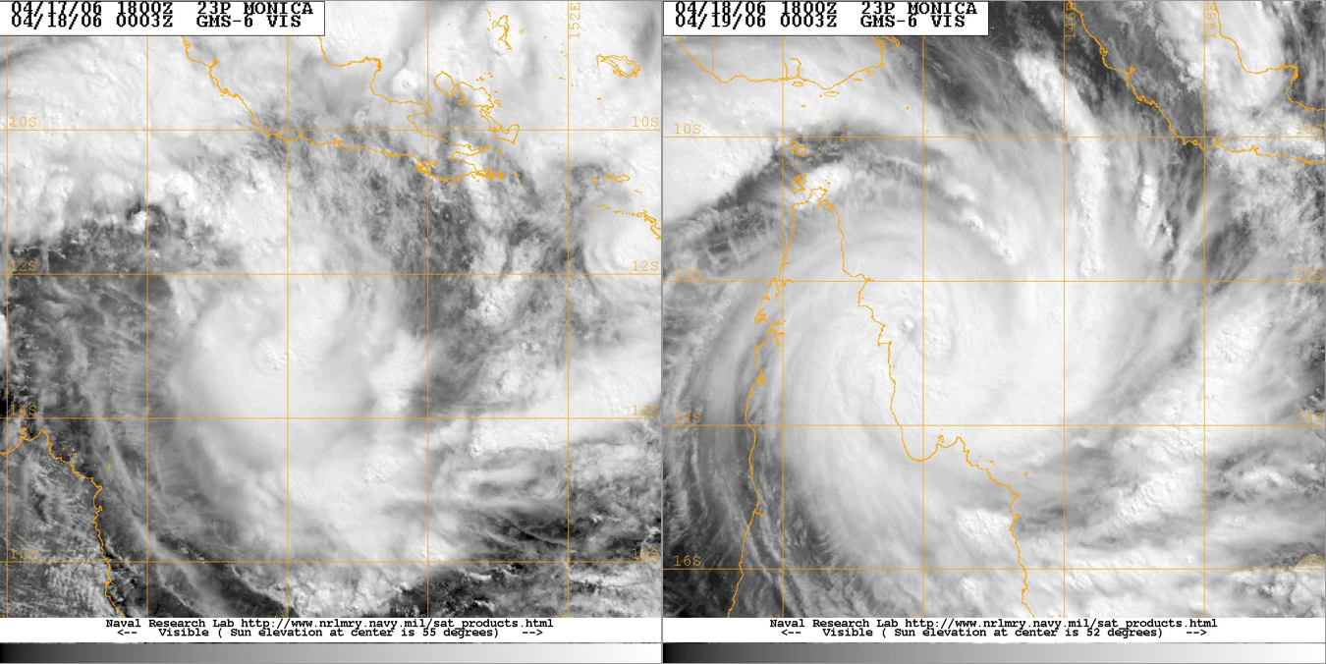
Figure 4. Visible images at 0003 UTC whilst Monica was in the Coral Sea: left 18 April and right 19 April. Images courtesy of NRL https://www.nrlmry.navy.mil/TC.html
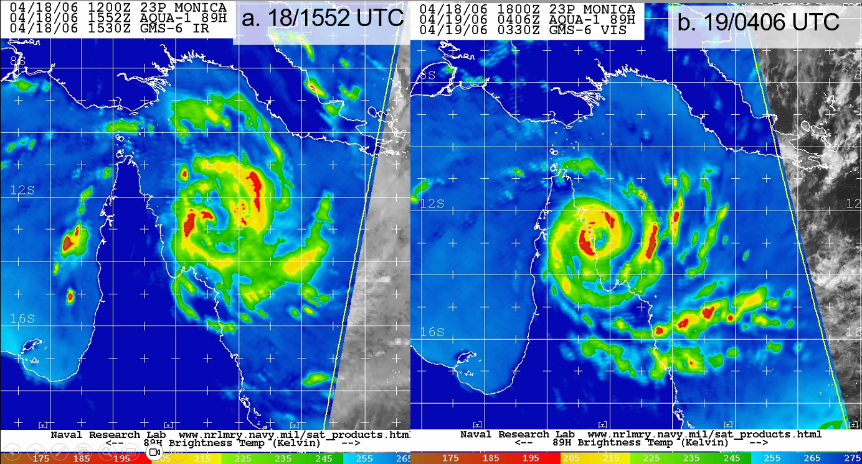
Figure 5. AMSRE 89 GHz microwave images at a. 1552 UTC 18 April and b. 0406 UTC 19 April whilst Monica was in the Coral Sea. Images courtesy of NRL https://www.nrlmry.navy.mil/TC.html

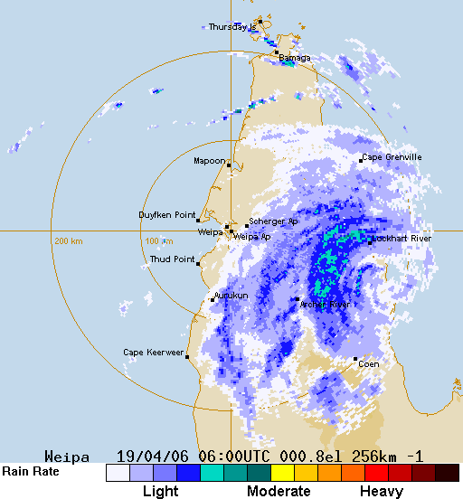 | 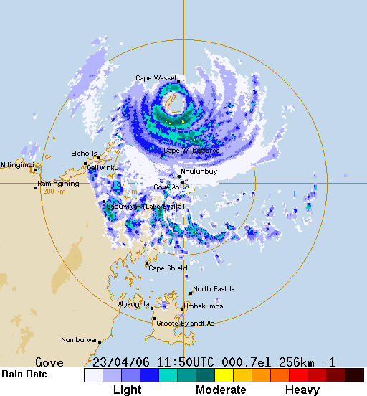
Figure 6. Radar images: from left Weipa at 0600 UTC 19 April; and right Gove at 1150 UTC 23 April 2006.

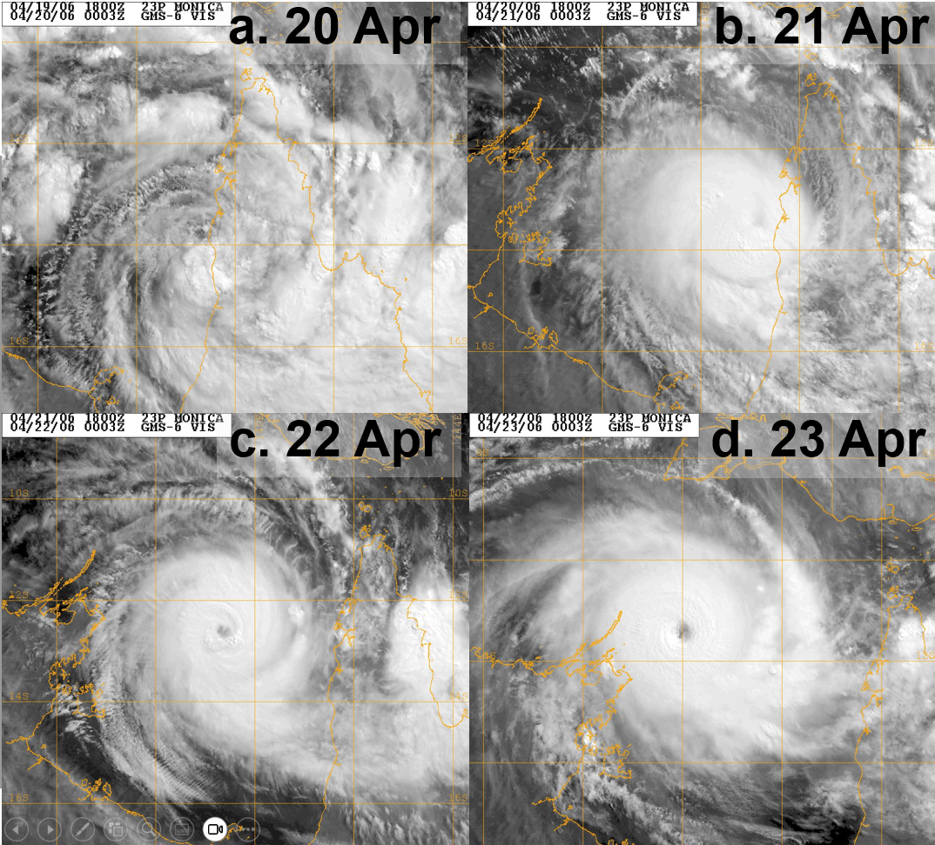
Figure 7. Visible images at 0003 UTC whilst Monica was in the Gulf of Carpentaria: a. 20 April, b. 21 April, c. 22 April, d. 23 April. Images courtesy of NRL https://www.nrlmry.navy.mil/TC.html

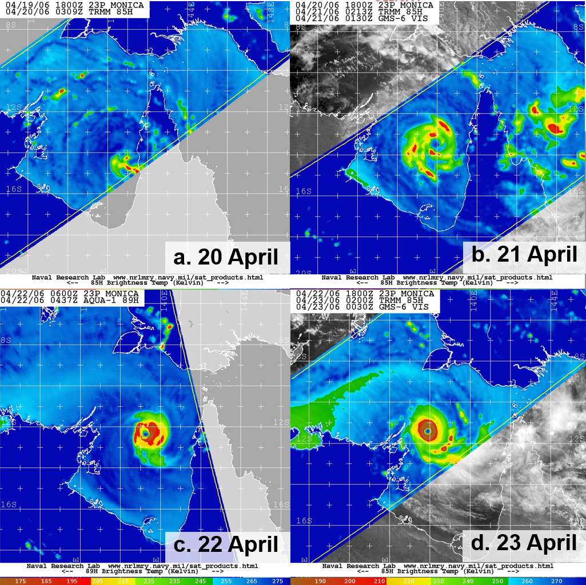
Figure 8. Series of microwave images from 20 to 23 April showing the development of Monica across the Gulf of Carpentaria: a. TMI 85 GHz 0309 UTC 20 April; b. TMI 85 GHz 0213 UTC 21 April; c. AMSRE 89 GHz 0437 UTC 22 April; and d. TMI 85 GHz 0200 UTC 23 April. Images courtesy NRL https://www.nrlmry.navy.mil/TC.html
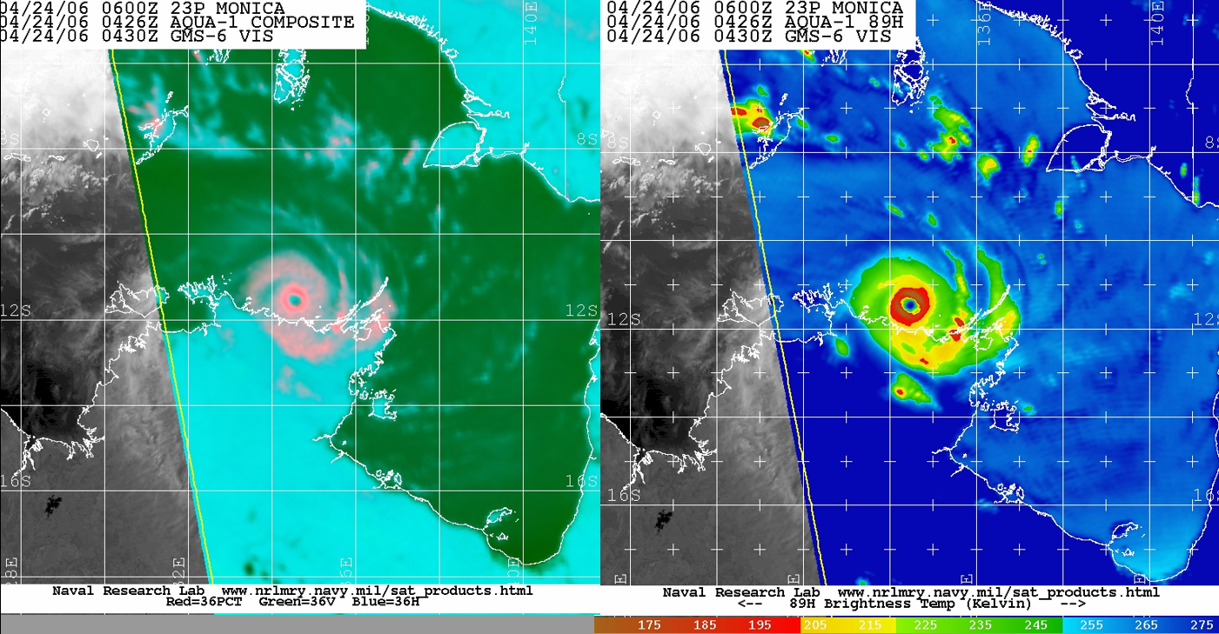

Figure 9. AMSRE microwave images at 0426 UTC 24 April just prior to Monica crossing the Northern Territory coast: left 36 GHz composite image; and right 89 GHz (horizontally polarised). Images courtesy NRL https://www.nrlmry.navy.mil/TC.html

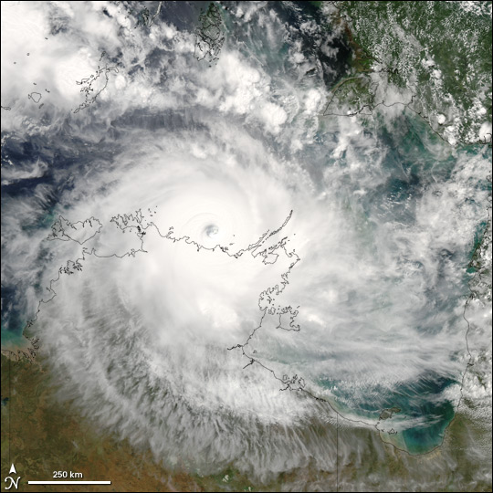
Figure 10. MODIS visible image at 0430 UTC 24 April. Image courtesy of NASA: https://earthobservatory.nasa.gov/images/6496/tropical-cyclone-monica

- Impact
Fortunately, populated centres were spared the worst of the core of Severe Tropical Cyclone Monica as it crossed Queensland's Cape York Peninsula at a remote location, avoiding the local townships of Lockhart River and Coen. Communities along the north coast of the Northern Territory were not so lucky although the core of cyclone passed just to the north and west of Maningrida. Figure 13 shows the defoliation and destruction of trees near the crossing point at Junction Bay, 35 km west of Maningrida. The core also had passed over Wessel Islands where the unoccupied Martjanba Outstation was destroyed and the Cape Wessel AWS was badly damaged as shown in Figure 14.
Nevertheless, there was widespread tree damage and moderate damage to infrastructure along the Arnhem Land coast, extending as far west as the township of Jabiru. Maningrida community received substantial damage, with several houses damaged by fallen trees, mainly large unstable African Mahogany trees, while many eucalypt trees were snapped (see Figure 15). One house was totally destroyed by the impact of flying debris. Power and communications were cut and were not restored until 3-4 days later.
The uninhabited coastal crossing point suffered severe vegetation damage, with 60-80 per cent of all trees uprooted or snapped and over 80 per cent completely defoliated.
At Jabiru many of the large African Mahogany trees fell during the event, with some causing minor damage to housing, and bringing down power lines. On the northern side of town, where the eye of Monica passed, some eucalypt trees were snapped or fallen as well.
A post event survey estimated the peak storm surge to be 5-6 m above the normal tide level in the storm surge zone in Junction Bay (Figure 16). This was about 3.5-4 m above the highest astronomical tide (HAT) at the time of coastal crossing.
Both the Adelaide River and Victoria River flooded on 26 and 27 April respectively, with widespread heavy rainfall in the catchments. Moderate flooding also occurred in the Daly and Katherine River catchments.
- Observations
  - Wind
Lockhart River recorded a maximum wind gust of 59 kn (109 km/h) at 0500 UTC (1500 AEST) 19 April.
Cape Wessel recorded a maximum 10-minute wind of 70 kn (130 km/h) at 1030 UTC (2000 ACST) 23 April prior to observations ceasing.
Maningrida recorded gales from 0620-1150 UTC (1550-2120 ACST) 24 April and storm-force winds from 0830 to 0950 UTC (1800-1920 ACST) 24 April; maximum mean wind of 53 kn (98 km/h) at 0840 UTC (1810 ACST) and maximum gust of 80 kn (148 km/h) at 0910 UTC (1840 ACST) 24 April
Milingimbi recorded gales from 0150-0340 UTC (1120-1310 ACST) 24 April.
Jabiru Airport recorded gales from 1650-1800 UTC (0220-0330 ACST) 25 April and a maximum mean wind of 40 kn (74 km/h) and maximum gust of 64 kn (118 km/h).
  - Pressure
Lockhart River record a minimum pressure of 986 hPa.
Cape Wessel recorded a minimum pressure of 970.2 hPa at 1030 UTC (2000 ACST) 23 April prior to observations ceasing.
Maningrida recorded 986.2 hPa at 0920 UTC (1850 ACST) 24 April.
Jabiru recorded a minimum pressure of 989.8 hPa at 1700 UTC 24 April (0230 ACST 25 April).
  - Rainfall
The weekly rainfall distributions are shown in Figure 11 for the week ending 23 April over Queensland, and in Figure 12 for the week ending 29 April over Northern Territory. Significant 24-hour rainfall totals to 9 am ACST include:
Queensland
20 April: 239 mm at Violet Vale; 212 mm Lakefield N.P.; 200 mm at Strathway; 188 mm at Wolverton; 175 mm at Lilyvale; 164 mm at Coen P.O.
21 April: 282 mm at Musgrave.
22 April: 215 mm at Lockhart River.

Northern Territory
25 April: 190 mm at Nhayawilli;
26 April: 340 mm at Majestic Orchids (near Darwin River Dam);
27 April 261 mm at Kidman Springs, 230 mm at Victoria River Roadhouse; 216.2 mm at Coolibah.
  - Storm Surge
A post event survey showed evidence of a 5-6 m storm surge in Junction Bay which was about 3.5-4 m above HAT at the time of coastal crossing. The coastal erosion at Junction Bay is shown in the photo in Figure 16.

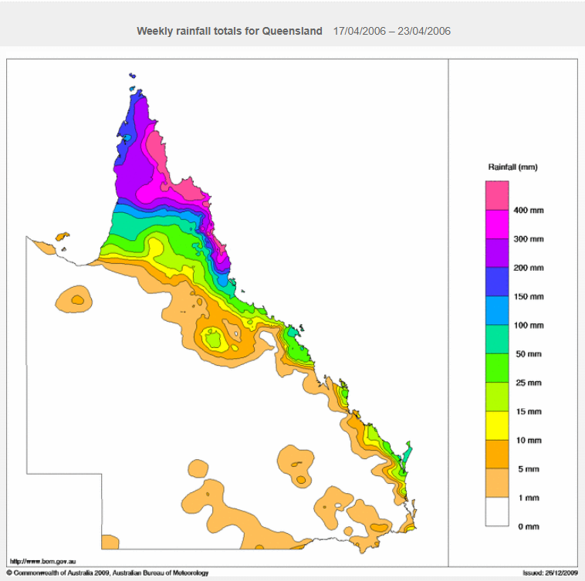

Figure 11. Rainfall analysis for Queensland for week ending 23 April 2006.
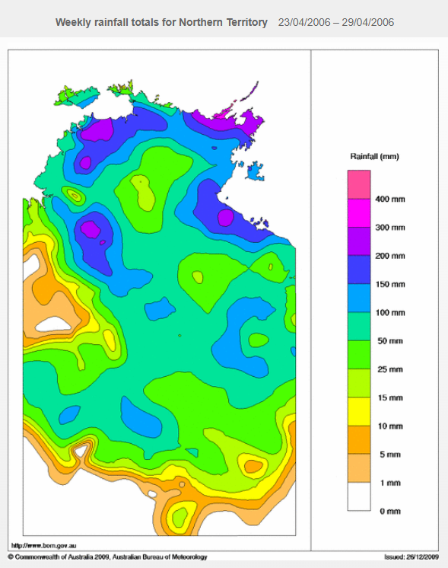
Figure 12. Rainfall analysis for Northern Territory for week ending 23 April 2006.
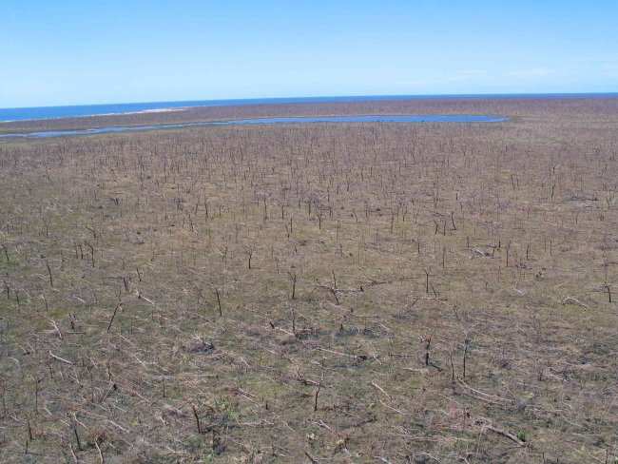
Figure 13. Defoliation at Junction Bay, 35 km west of Maningrida, after Tropical Cyclone Monica. Trees were totally defoliated, and most were snapped or uprooted. Credit: Bill Milne.

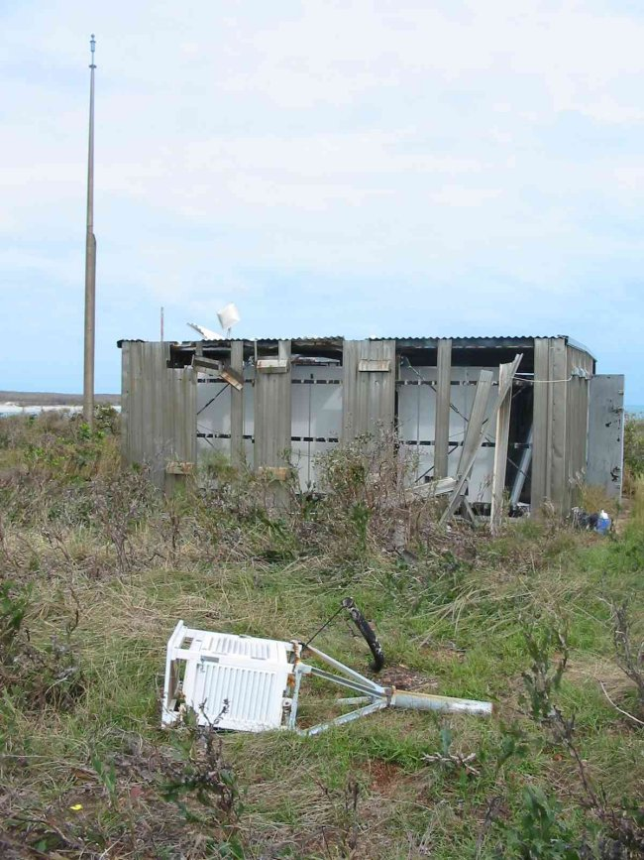
Figure 14. Damage to the Cape Wessel Automatic Weather Station after Tropical Cyclone Monica. Credit: Dale Ingarfield.

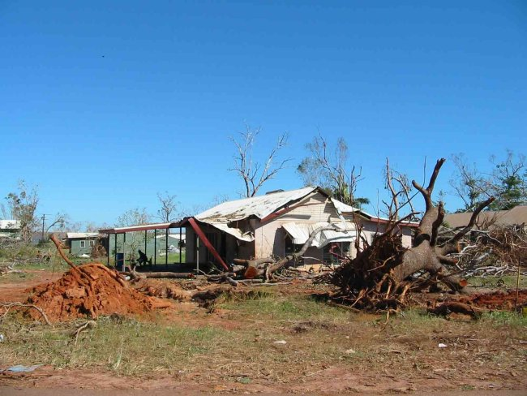
Figure 15. Damage to Maningrida after Tropical Cyclone Monica narrowly missed a direct hit on the township. Credit: Lori Chappel.

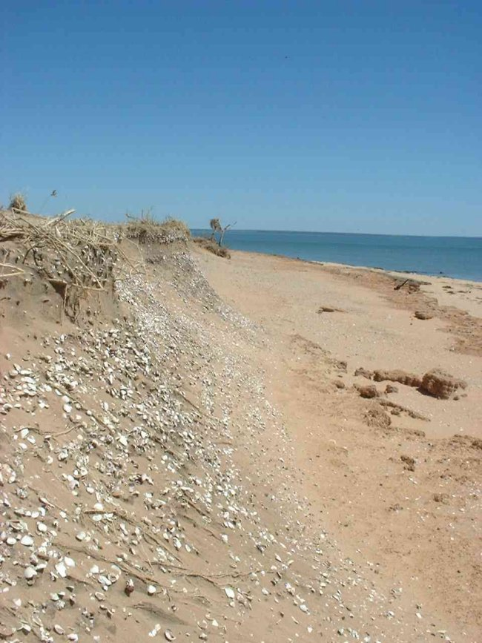
Figure 16. Erosion at the coastal crossing point of Junction Bay, 35 km west of Maningrida. Credit: Ian Shepherd.

- Appendix: List of Abbreviations
Abbreviation | Term
ADT | Advanced Dvorak Technique
ACST | Australian Central Standard Time
AEST | Australian Eastern Standard Time
AiDT | AI-enhanced Dvorak Technique
AMSR2 | Advanced Microwave Scanning Radiometer
AMSU | Advanced Microwave Sounding Unit
ASCAT | Advanced Scatterometer
ATMS | Advanced Technology Microwave Sounder
AWS | automatic weather station
AWST | Australian Western Standard Time
°C | Celsius
CI | Current intensity
CIMSS | Cooperative Institute for Meteorological Satellite Studies (USA)
CIRA | Cooperative Institute for Research in the Atmosphere (USA)
D-MINT | Deep learning - Multispectral Intensity of TCs (formerly known as DMN)
D-PRINT | Deep learning - IR Intensity of TCs (formerly known as OPEN-AIIR)
EIR | Enhanced InfraRed
ERC | eyewall replacement cycle
FNMOC | Fleet Numerical Meteorology and Oceanography Centre (USA)
FT | Final T-number
GCOM | Global Change Observation Mission
GHz | Gigahertz
GMI | Global Precipitation Measurement Microwave Imager
h | hour
hPa | hectopascal
HSCAT | Hai Yang 2 Scatterometer (HY-2B, HY-2C)
km | kilometres
km/h | kilometres per hour
kn | knot
LLCC | LLCC
MET | Model Expected T-number
METOP | Meteorological Operational Satellite
MJO | Madden-Julian Oscillation
mm | millimetres
MSLP | mean sea level pressure
NESDIS | National Environmental Satellite, Data, and Information Service
nm | nautical mile
NOAA | National Oceanic and Atmospheric Administration
NRL | Navy Research Lab (USA)
OSCAT | Scatterometer aboard the OceanSat satellite
PAT | Pattern T-number
RCM | RadarSat Constellation Mission – Synthetic Aperture Radar
RH | relative humidity
RMW | radius of maximum winds
RSMC | Regional Specialised Meteorological Centre
SAR | Synthetic Aperture Radar
SATC | CIMSS Advanced Dvorak Technique
SATCON | Satellite Consensus
SEN1 | Sentinel-1A – Synthetic Aperture Radar
SMAP | Soil Moisture Active Passive
SMOS | Soil Moisture and Ocean Salinity
SSMIS | Special Sensor Microwave Imager/Sounder
TC | Tropical Cyclone
TCWC | Tropical Cyclone Warning Centre
UTC | Universal Time Co-ordinated

