Tropical Cyclone Nelson (05U)

# 31 January – 7 February 2007

## Joe Courtney, Tropical Cyclone Environmental Prediction Services

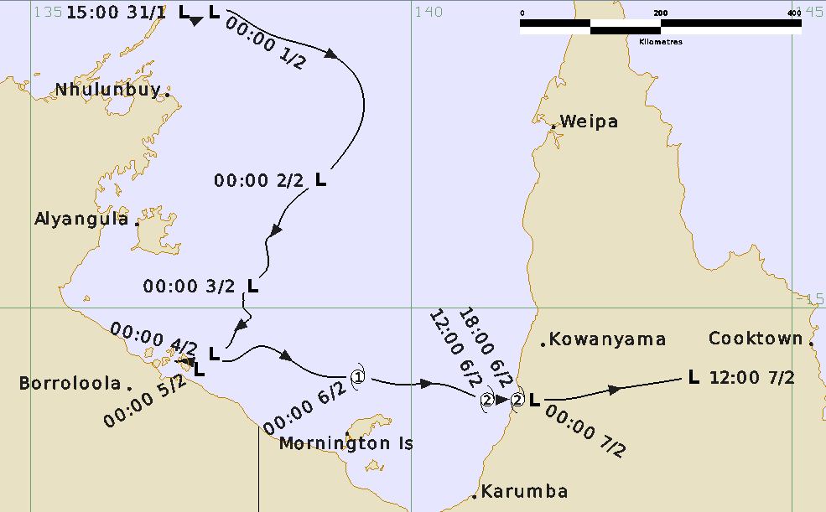

**Revision history**

|  |  |  |  |
| --- | --- | --- | --- |
| Date | Version | Author | Description |
| 5/05/2025 | 1.0 | Joe Courtney | Final draft based on information primarily assembled from 2007. |

**Review status**

|  |  |  |  |
| --- | --- | --- | --- |
| Date | Version | Reviewer | Description |
| 06/05/2025 | 1.0 | Linda Paterson | Completed |

**Release history**

|  |  |  |  |
| --- | --- | --- | --- |
| Date | Version | Status | Approval |
| 06/05/2025 | 1.0 | Approved for release | David Grant |

Contact details:

Tropical Cyclone Team Lead

Severe Weather Environmental Prediction Services

Bureau of Meteorology

PO Box 1370, West Perth WA 6872

Email: [tcwc@bom.gov.au](mailto:tcwc@bom.gov.au)



This work is copyright. Apart from any use as permitted under the Copyright Act 1968, no part may be reproduced without prior written permission from the Bureau of Meteorology. Refer to www.bom.gov.au/other/copyright.shtml for further information. Unless otherwise noted, all images in this document are licensed under the Creative Commons Attribution Australia Licence.

© Commonwealth of Australia 2025

Published by the Bureau of Meteorology

Cover image: Track of Tropical Cyclone Nelson 2007. Times in UTC (AEST=UTC-10h)

Contents

1. Summary 5

2. Meteorological description 7

2.1 Intensity analysis 7

2.2 Structure 11

2.3 Motion 11

3. Impact 11

4. Observations 12

4.1 Winds 12

4.2 Rainfall 12

4.3 Wave height 13

4.4 Storm Tide 13

Appendix: List of abbreviations 16

**List of Figures**

Figure 1 Best track of Tropical Cyclone Nelson, 1 - 7 February 2007. 5

Figure 2 Detailed best track of Tropical Cyclone Nelson, 6 - 7 February 2007. 7

Figure 3 MODIS visible image at 0425 UTC 6 February 2007 showing Tropical Cyclone Nelson near the Queensland coast.. 8

Figure 4 Enhanced Infra-Red image at 1730 UTC 6 February 2007 9

Figure 5 QSCAT scatterometry image at 2020 UTC 6 February 2025 10

Figure 6. Weekly rainfall totals for Queensland to 9 am 8 February 2007. 12

Figure 7 Weipa wave height and period, 1-8 February 2007. 13

Figure 8 Weipa tide height for 1-8 February 2007. 14

Figure 9 Karumba tide height for 1-8 February 2007. 14

Figure 10 Mornington Island tide height for 1-8 February 2007. 15

**List of Tables**

Table 1 Best track summary for Tropical Cyclone Nelson, 31 January-7 February 2007. 6

1. Summary

Tropical Cyclone Nelson (14U) crossed the Queensland Gulf of Carpentaria coast in a sparsely populated area between Karumba and Kowanyama at category 2 intensity.

Tropical low 05U formed just off the northeast Arnhem land coast late on 31 January. It initially moved to the southeast then turned to the south southwest, moving close to the southern Gulf of Carpentaria NT coast on 5 February. The system then turned to the east and developed, reaching tropical cyclone intensity early on 6 February before it peaked at category 2 intensity (10-minute mean wind peak intensity of 75 kn (140 km/h)), prior to crossing the sparsely populated region of the Queensland coast near Gilbert River Mouth between Kowanyama and Kurumba early on 7 February. Nelson weakened quickly as it tracked over the Cape York Peninsula on 7 February.

Large waves and high tides were recorded along the Queensland coast. Rough seas caused the mineral barge MV Wunma, a 113m vessel, to be disabled around 45 km north of Karumba and all 10 people on board were winched to safety via helicopter. A couple were winched to safety by rescue helicopter from Dina station, 150 km north of Karumba after a tree fell on their homestead and floodwaters forced them to higher ground.

Figure 1 shows the best track of Nelson and Figure 2 is a more detailed track showing the extent of gale and storm-force winds, while Table 1 is a summary of the best track data.

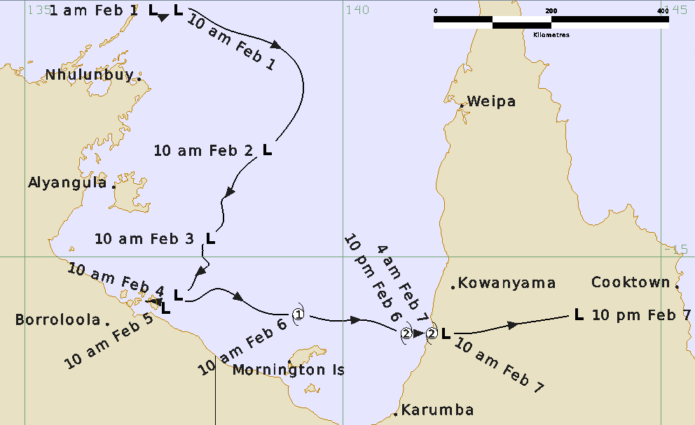

Figure 1 Best track of Tropical Cyclone Nelson, 1 - 7 February 2007. Times in AEST (UTC+10 hours)

|  |  |  |  |  |  |  |  |  |  |  |  |  |
| --- | --- | --- | --- | --- | --- | --- | --- | --- | --- | --- | --- | --- |
| Year | Mon | Day | Hour UTC | Pos.  Lat. S | Pos. Long.E. | Pos Acc. nm | Max Wind10minkn | Max Gust kn | Cent.PresshPa | Rad. of gales nm  NE/SE/ SW/NW | Rad. of storm nm  NE/SE/ SW/NW | RMW  nm |
| 2007 | 1 | 31 | 1800 | 11.1 | 137.1 | 25 | 20 | 30 | 1001 | 0/0/0/0 | 0/0/0/0 | - |
| 2007 | 2 | 1 | 0000 | 11.1 | 137.4 | 20 | 25 | 35 | 1000 | 0/0/0/0 | 0/0/0/0 | - |
| 2007 | 2 | 1 | 0600 | 11.4 | 138.2 | 25 | 30 | 45 | 998 | 0/0/0/0 | 0/0/0/0 | - |
| 2007 | 2 | 1 | 1200 | 11.7 | 139.1 | 60 | 30 | 45 | 998 | 0/0/0/0 | 0/0/0/0 | - |
| 2007 | 2 | 1 | 1800 | 12.5 | 139.4 | 60 | 25 | 45 | 998 | 0/0/0/0 | 0/0/0/0 | - |
| 2007 | 2 | 2 | 0000 | 13.3 | 138.8 | 30 | 30 | 45 | 997 | 0/0/0/0 | 0/0/0/0 | - |
| 2007 | 2 | 2 | 0600 | 13.8 | 138.3 | 60 | 25 | 45 | 998 | 0/0/0/0 | 0/0/0/0 | - |
| 2007 | 2 | 2 | 1200 | 14.1 | 138.1 | 60 | 25 | 45 | 998 | 0/0/0/0 | 0/0/0/0 | - |
| 2007 | 2 | 2 | 1800 | 14.5 | 138.1 | 60 | 25 | 45 | 998 | 0/0/0/0 | 0/0/0/0 | - |
| 2007 | 2 | 3 | 0000 | 14.7 | 137.9 | 25 | 25 | 45 | 999 | 0/0/0/0 | 0/0/0/0 | - |
| 2007 | 2 | 3 | 0600 | 14.9 | 137.8 | 20 | 25 | 45 | 998 | 0/0/0/0 | 0/0/0/0 | - |
| 2007 | 2 | 3 | 1200 | 15.1 | 137.9 | 40 | 25 | 45 | 998 | 0/0/0/0 | 0/0/0/0 | - |
| 2007 | 2 | 3 | 1800 | 15.3 | 137.7 | 30 | 25 | 45 | 998 | 0/0/0/0 | 0/0/0/0 | - |
| 2007 | 2 | 4 | 0000 | 15.6 | 137.4 | 30 | 25 | 45 | 1000 | 0/0/0/0 | 0/0/0/0 | - |
| 2007 | 2 | 4 | 0600 | 15.9 | 137.2 | 25 | 25 | 45 | 999 | 0/0/0/0 | 0/0/0/0 | - |
| 2007 | 2 | 4 | 1200 | 15.7 | 137.1 | 30 | 25 | 45 | 999 | 0/0/0/0 | 0/0/0/0 | - |
| 2007 | 2 | 4 | 1800 | 15.7 | 136.9 | 30 | 25 | 45 | 998 | 0/0/0/0 | 0/0/0/0 | - |
| 2007 | 2 | 5 | 0000 | 15.8 | 137.2 | 25 | 25 | 45 | 998 | 0/0/0/0 | 0/0/0/0 | - |
| 2007 | 2 | 5 | 0600 | 15.7 | 137.3 | 25 | 25 | 45 | 996 | 0/0/0/0 | 0/0/0/0 | - |
| 2007 | 2 | 5 | 1200 | 15.5 | 138.0 | 25 | 25 | 35 | 997 | 0/0/0/0 | 0/0/0/0 | - |
| 2007 | 2 | 5 | 1800 | 15.8 | 138.6 | 25 | 35* | 50 | 995 | 0/40/0/0 | 0/0/0/0 | - |
| 2007 | 2 | 6 | 0000 | 15.9 | 139.3 | 25 | 35 | 50 | 992 | 60/40/40/30 | 0/0/0/0 | 25 |
| 2007 | 2 | 6 | 0600 | 16.0 | 140.4 | 25 | 45 | 60 | 988 | 60/50/50/40 | 0/0/0/0 | 15 |
| 2007 | 2 | 6 | 1200 | 16.2 | 141.0 | 25 | 50 | 70 | 985 | 60/50/50/40 | 25/25/25/20 | 15 |
| 2007 | 2 | 6 | 1800 | 16.2 | 141.4 | 20 | 50 | 70 | 985 | 60/30/60/50 | 15/0/25/25 | 15 |
| 2007 | 2 | 7 | 0000 | 16.2 | 141.6 | 20 | 35* | 50 | 990 | 0/0/60/50 | 0/0/0/0 | - |
| 2007 | 2 | 7 | 0600 | 16.1 | 142.5 | 20 | 30 | 40 | 992 | 0/0/0/0 | 0/0/0/0 | - |
| 2007 | 2 | 7 | 1200 | 15.9 | 143.7 | 20 | 15 | 20 | 996 | 0/0/0/0 | 0/0/0/0 | - |

Table 1 Best track summary for Tropical Cyclone Nelson, 31 January-7 February 2007.

UTC=AEST-10h. * Not at tropical cyclone intensity as gales less than halfway around centre.

1. Meteorological description

2.1 Intensity analysis

A weak tropical low began formation off the Northern Territory coast late in January 2007 associated with an increase in the monsoonal flow. A defined circulation was identified later on 31 January off the northeast Arnhem coast. Deep convection increased during 1 February but then weakened later that day due to ongoing easterly vertical wind shear. The degree of organisation of deep convection continued to vary over following days as the circulation moved south and became disconnected from the monsoon flow.

The circulation became more organised later on 5 February as the system moved east over the southern Gulf of Carpentaria under decreasing wind shear and improving upper-level outflow conditions. A Quickscat pass at 2045 UTC 5 February showed gales southeast of the centre and near gales to the north. This coincided with an increase in Dvorak DT estimates to 3.0 and the system is estimated to have reached tropical cyclone intensity by 0000 UTC 6 February. The MODIS visible image at 0425 UTC 6 February in Figure 3 showed extensive deep convection near the centre. Dvorak estimates later peaked at 3.5 as Nelson moved to the east over the southern Gulf of Carpentaria. The enhanced infra-red image at 1730 UTC 6 February in Figure 4 showed a region of very cold cloud as Nelson made landfall on the Queensland coast.

A Quickscat pass at 2020 UTC shows strongest winds occurred in the southwesterly flow off the coast even though the centre had moved inland in Figure 5.

Nelson is estimated to have weakened quickly as it tracked overland.

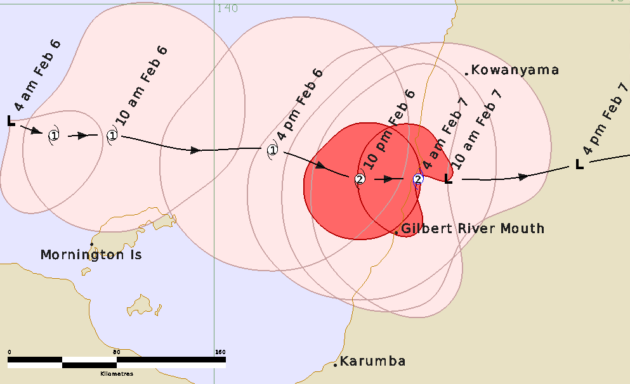

Figure 2 Detailed best track of Tropical Cyclone Nelson, 6 - 7 February 2007 showing wind radii - gale and storm-force in pink and red respectively. Times in AEST (UTC+10 hours).

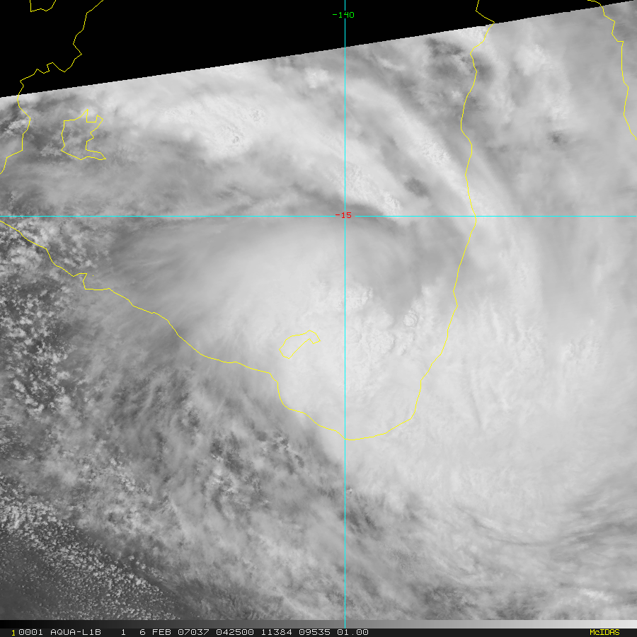

Figure 3 MODIS visible image at 0425 UTC 6 February 2007 showing Tropical Cyclone Nelson near the Queensland coast..Image courtesy CIRA. <https://rammb-data.cira.colostate.edu/tc_realtime/index.asp>

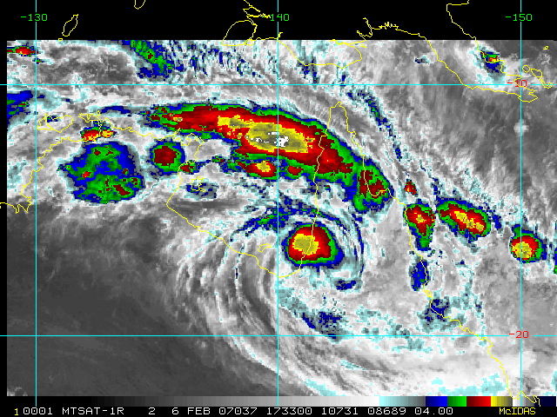

Figure 4 Enhanced Infra-Red image at 1730 UTC 6 February 2007 as Tropical Cyclone Nelson was making landfall. Image courtesy CIRA. <https://rammb-data.cira.colostate.edu/tc_realtime/index.asp>

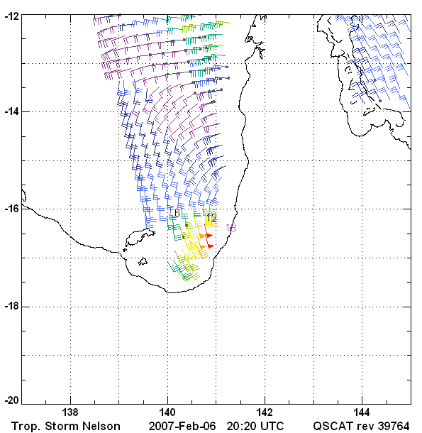

Figure 5 QSCAT scatterometry image at 2020 UTC 6 February 2025 storm-force winds off the Queensland Gulf of Carpentaria coast. Image courtesy REMSS. <https://www.remss.com/tropical-cyclones/tc-winds/>

2.2 Structure

Nelson had a small extent of gales. The radius to gales reached 60 nm (110 km) in the northeast quadrant but only 30-50 nm (55-95km) elsewhere. The radius to maximum winds (RMW) was initially 25 nm (45 km), this decreased to 15 nm (28 km) as Nelson approached peak intensity on 6 February.

2.3 Motion

Tropical low 05U was initially steered to the east southeast by the monsoonal flow to the north but then turned to the south southwest on 1 February due to the increasing influence of a mid-level ridge located to the east. The low slowed on 4 February as the ridge weakened. The developing low on 5 February deepened in vertical extent and was steered to the east. Nelson continued on an easterly track through to landfall at 1800 UTC 6 February and during its weakening overland.

1. Impact

The mineral barge MV Wunma, a 113m vessel, became disabled in rough seas around 45 km north of Karumba and all 10 people on board were winched to safety via helicopter.

A couple were winched to safety by rescue helicopter from Dina station, 150 km north of Karumba after a tree fell on their homestead and floodwaters forced them to higher ground.

1. Observations

4.1 Winds

No surface wind observations were recorded during Nelson.

4.2 Rainfall

Heavy rainfall accompanied the landfall of Nelson on the Queensland Gulf coast. The weekly rainfall analysis to 8 February in Figure 6 shows rainfall exceeded 200 mm near the track. Some notable daily rainfall totals to 9am 7 February include: 195.6 mm Stirling Station; 193.0 mm Vanrook Station; 178.0 mm Lotus Vale; 166.6 mm Miranda Downs Station; and 156.0 mm Gamboola Station.

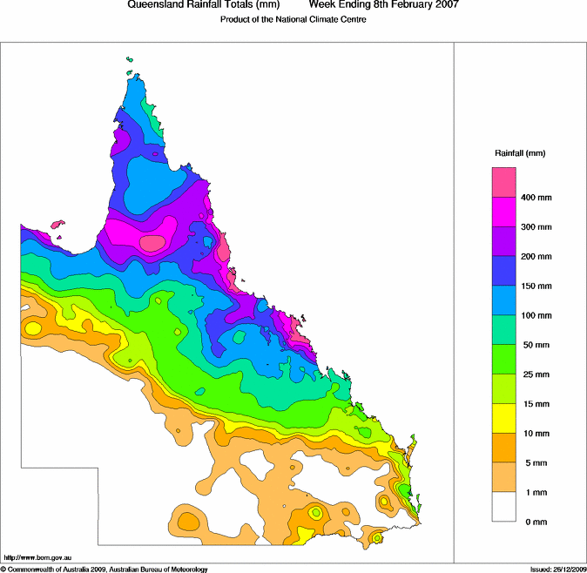

Figure 6. Weekly rainfall totals for Queensland to 9 am 8 February 2007.

4.3 Wave height

Weipa recorded a peak significant wave height of 3.1 m at 0700 AEST 7 February and a peak maximum individual wave height of 5.6m (refer Figure 7). This was the third largest recorded by the EPA at this site since recordings commenced there in December 1978.

4.4 Storm Tide

Tide observations were available from Weipa (Figure 8), Karumba (Figure 9) and Normanton (Figure 10) gauges courtesy of the Queensland EPA.

Weipa recorded a peak surge of 1.1m at 0310 AEST 7 February, Kurumba 0.8m at 1210 AEST 5 February and Mornington Is 0.7m at 1900 AEST 4 February. Fortunately, the maximum surge at Weipa was near the time of low tide. The peak storm tide is likely to have occurred near the Gilbert and Staaten Rivers, about 120 km north of Karumba.

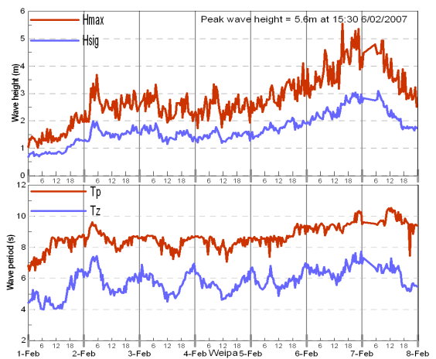

Figure 7 Weipa wave height and period, for 1-8 February 2007. Image courtesy Queensland EPA <https://www.publications.qld.gov.au/dataset/19c20822-f29e-494c-880a-113ccd13a04b/resource/654bee4b-4c66-45ce-ab6c-c686b268ab0d/download/tc-nelson.pdf>

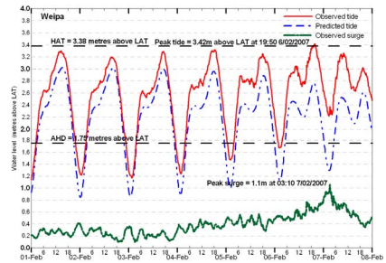

Figure 8 Weipa tide height for 1-8 February 2007. Image courtesy Queensland EPA <https://www.publications.qld.gov.au/dataset/19c20822-f29e-494c-880a-113ccd13a04b/resource/654bee4b-4c66-45ce-ab6c-c686b268ab0d/download/tc-nelson.pdf>

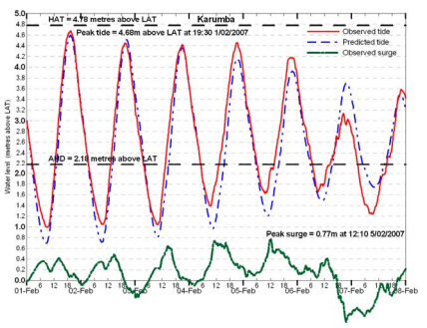

Figure 9 Karumba tide height for 1-8 February 2007. Image courtesy Queensland EPA <https://www.publications.qld.gov.au/dataset/19c20822-f29e-494c-880a-113ccd13a04b/resource/654bee4b-4c66-45ce-ab6c-c686b268ab0d/download/tc-nelson.pdf>

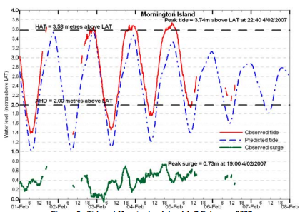

Figure 10 Mornington Island tide height for 1-8 February 2007. Image courtesy Queensland EPA <https://www.publications.qld.gov.au/dataset/19c20822-f29e-494c-880a-113ccd13a04b/resource/654bee4b-4c66-45ce-ab6c-c686b268ab0d/download/tc-nelson.pdf>

Appendix: List of abbreviations

|  |  |
| --- | --- |
| Abbreviation | Term |
| ADT | Advanced Dvorak Technique |
| ACST | Australian Central Standard Time |
| AEST | Australian Eastern Standard Time |
| AiDT | AI-enhanced Dvorak Technique |
| AMSR2 | Advanced Microwave Scanning Radiometer |
| AMSU | Advanced Microwave Sounding Unit |
| ASCAT | Advanced Scatterometer |
| ATMS | Advanced Technology Microwave Sounder |
| AWS | automatic weather station |
| AWST | Australian Western Standard Time |
| °C | Celsius |
| CI | Current intensity |
| CIMSS | Cooperative Institute for Meteorological Satellite Studies (USA) |
| CIRA | Cooperative Institute for Research in the Atmosphere (USA) |
| D-MINT | Deep learning - Multispectral Intensity of TCs (formerly known as DMN) |
| D-PRINT | Deep learning - IR Intensity of TCs (formerly known as OPEN-AIIR) |
| DT | Dvorak Data T number |
| EIR | Enhanced InfraRed |
| ERC | eyewall replacement cycle |
| FNMOC | Fleet Numerical Meteorology and Oceanography Centre (USA) |
| FT | Final T-number |
| GCOM | Global Change Observation Mission |
| GHz | Gigahertz |
| GMI | Global Precipitation Measurement Microwave Imager |
| h | hour |
| hPa | hectopascal |
| HSCAT | Hai Yang 2 Scatterometer (HY-2B, HY-2C) |
| km | kilometres |
| km/h | kilometres per hour |
| kn | knot |
| LLCC | LLCC |
| MET | Model Expected T-number |
| METOP | Meteorological Operational Satellite |
| MJO | Madden-Julian Oscillation |
| mm | millimetres |
| MSLP | mean sea level pressure |
| NESDIS | National Environmental Satellite, Data, and Information Service |
| nm | nautical mile |
| NOAA | National Oceanic and Atmospheric Administration |
| NRL | Navy Research Lab (USA) |
| OPEN-AiiR | Ordered Pattern Encoding AI Infrared |
| PAT | Pattern T-number |
| RCM | RadarSat Constellation Mission – Synthetic Aperture Radar |
| RH | relative humidity |
| RMW | radius of maximum winds |
| RSMC | Regional Specialised Meteorological Centre |
| SAR | Synthetic Aperture Radar |
| SATC | CIMSS Advanced Dvorak Technique |
| SATCON | Satellite Consensus |
| SEN1 | Sentinel-1A – Synthetic Aperture Radar |
| SMAP | Soil Moisture Active Passive |
| SMOS | Soil Moisture and Ocean Salinity |
| SSMIS | Special Sensor Microwave Imager/Sounder |
| TC | Tropical Cyclone |
| TCWC | Tropical Cyclone Warning Centre |
| UTC | Universal Time Co-ordinated |