Severe Tropical Cyclone Neville (08U)

**7 – 25 March 2024**

**Adam Conroy, Tropical Cyclone Environmental Prediction Services**

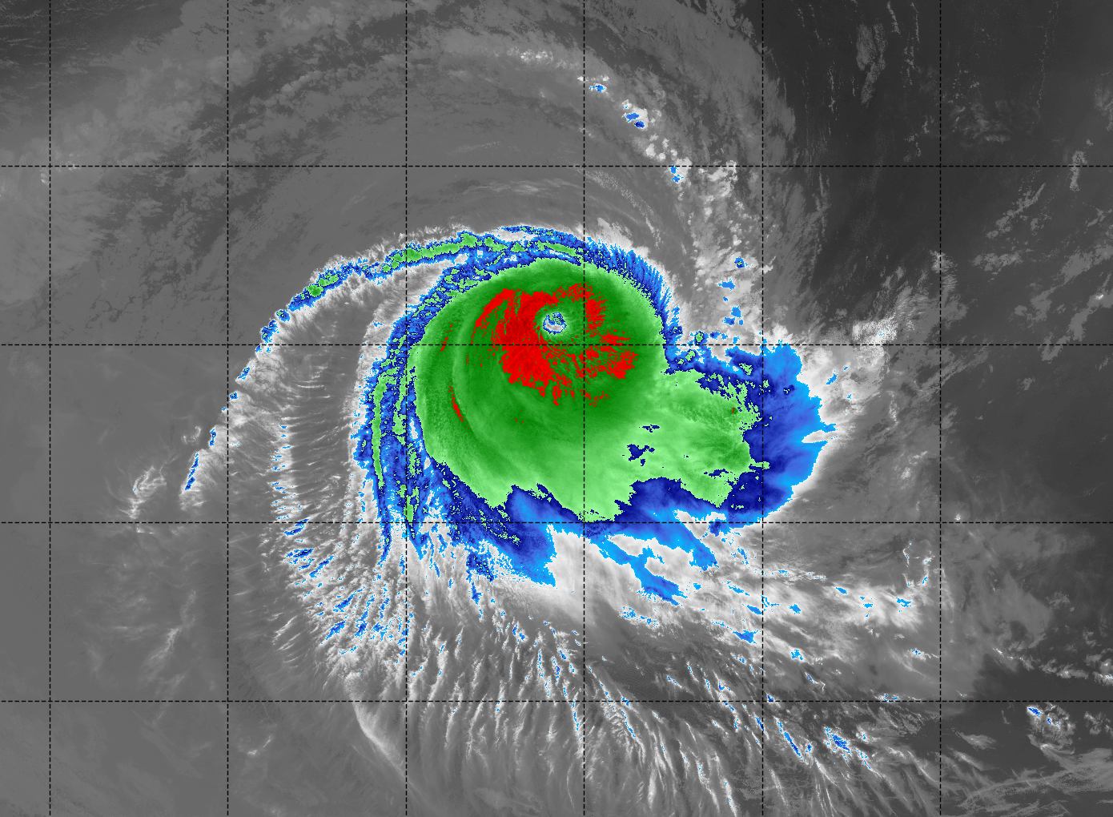

**Revision history**

|  |  |  |  |
| --- | --- | --- | --- |
| Date | Version | Author | Description |
| 17/06/2024 | 1.0 | Adam Conroy | Final draft ready |

**Review status**

|  |  |  |  |
| --- | --- | --- | --- |
| Date | Version | Reviewer | Description |
| 18/06/2024 | 1.0 | Vikash Prasad | Completed |

**Release history**

|  |  |  |  |
| --- | --- | --- | --- |
| Date | Version | Status | Approval |
| 26/06/2024 | 1.0 | Approved for release | Andrew Burton |

Contact details:

Tropical Cyclone Team Lead

Weather Environmental Prediction Services

Bureau of Meteorology

PO Box 1370, West Perth WA 6872

Email: [tcwc@bom.gov.au](mailto:tcwc@bom.gov.au)



This work is copyright. Apart from any use as permitted under the Copyright Act 1968, no part may be reproduced without prior written permission from the Bureau of Meteorology. Refer to www.bom.gov.au/other/copyright.shtml for further information. Unless otherwise noted, all images in this document are licensed under the Creative Commons Attribution Australia Licence.

© Commonwealth of Australia 2024

Published by the Bureau of Meteorology

Cover image: Enhance infrared satellite image of Severe Tropical Cyclone Neville at 1809 UTC March 21, 2024. Image courtesy of NRL: https://www.nrlmry.navy.mil/TC.html

Contents

1. Summary 5

2. Meteorological description 10

2.1 Intensity analysis 10

2.1 Structure 11

2.2 Motion 11

3. Impact 13

4. Observations 13

5. Forecast Performance 23

Appendix: List of abbreviations 26

**List of Figures**

Figure 1. Best track of Severe Tropical Cyclone Neville 7-25 March 2024 6

Figure 2. Detailed best track of 08U 8-12 March as it tracks past Cocos (Keeling) Islands and Christmas Island, prior to reaching tropical cyclone intensity 6

Figure 3. Detailed best track of Severe Tropical Cyclone Neville 20-24 March, during the time it was at tropical cyclone intensity 7

Figure 4. Visible satellite image at 0230 UTC 10 March, showing the centre of the tropical low (marked by a red cross) just south of the Cocos (Keeling) Islands 14

Figure 5. A HY-2C HSCAT pass at 1243 UTC 11 March, showing a large band of gale force winds to the west of Christmas Island 15

Figure 6. An ASCAT-B pass at 0110 UTC 14 March, showing a well-defined low level circulation with gales in the northern semcircle 16

Figure 7. An AMSR2 37 GHz microwave and windspeed passes at 1732 UTC 18 March, showing the low level structure and gales in the southwest quadrant 17

Figure 8. Himiwari-9 visible satellite image at 0600 UTC 20 March, at the time Neville first reached tropical cyclone intensity 18

Figure 9. A SAR windspeed pass at 1127 UTC 21 March, showing that Severe Tropical Cyclone Neville was a small but very intense system 19

Figure 10. Himiwari-9 infrared satellite imagery at 0000 UTC 22 March, when Severe Tropical Cyclone Neville was estimated to be at peak intensity 20

Figure 11. An ASCAT-C pass at 0339 UTC 24 March, showing that gales were almost confined to the southern semi-circle 21

Figure 12. Himiwari-9 visible satellite image at 0600 UTC 24 March, at the time Neville weakened to below tropical cyclone intensity 22

Figure 13. Position accuracy figures for Severe Tropical Cyclone Neville. 24

Figure 14. Intensity accuracy figures for Severe Tropical Cyclone Neville. 25

Figure 15. Intensity plot of objective and subjective guidance 28

**List of Tables**

Table 1. Best track summary for Severe Tropical Cyclone Neville. 9

Table 2. Verification statistics for Severe Tropical Cyclone Neville 23

1. Summary

Severe Tropical Cyclone Neville spent two weeks traversing the eastern Indian Ocean as a tropical low before finally developing into a tropical cyclone as it moved west and away from the Western Australian (WA) mainland. Although no land impacts were experienced while this system was at tropical cyclone intensity, heavy monsoonal conditions affected both the Cocos (Keeling) Islands and Christmas Island as it moved past.

A tropical low (08U) formed in the Indian Ocean on 7 March, about 800 km WNW of the Cocos (Keeling) Islands. It initially moved towards the east to southeast under the influence of a strong monsoonal flow to the north.

The system struggled to develop significantly in these early stages due to the effects of strong vertical wind shear in the atmosphere. However, an increasing monsoonal flow saw gale force winds develop on the northwest quadrant of the system during 9 March, which then extended to the northeast quadrant later on 10 March.

While still a low, Neville passed close to the Cocos (Keeling) Islands during 10 March, with gale force winds being recorded at Cocos Island Airport in the early hours of 11 March. The peak wind gust recorded was 46 kn (85 km/h) at 1844 and 1906 UTC 10 March (1:14am and 1:36am 11 March Cocos Islands time), and some structural damage occurred at the Island's resort.

The monsoonal flow strengthened further after this, which accelerated the low faster towards the east southeast from 11 March. Although it passed more than 250 km to the south of Christmas Island on 12 March, large waves cause inundation and damage along the Island's northern coast.

By 15 March the low was located northwest of the WA coast, and at this stage the monsoonal flow weakened, and gale force winds around the system eased. It remained slow moving over the next few days as a mid-level trough to the south resulted in light steering winds.

The low began moving towards the west from 19 March due to the influence of a mid-level ridge to the south. At the same time, it encountered an area of favourable environmental conditions which led to development, and the system was named Tropical Cyclone Neville at 0600 UTC 20 March (2pm AWST).

Neville continued to rapidly develop into a severe tropical cyclone and reached a peak 10-minute mean wind intensity of 100 kn (185 km/h) at 0000 UTC 22 March (8am AWST).

From later on 22 March, Neville began to weaken under the influence of dry air and increasing vertical wind shear. It dropped below tropical cyclone intensity at 2pm AWST 24 March (0600 UTC), and it then moved into the La Reunion RSMC Area of Responsibility. It continued to weaken before dissipating late on 25 March.

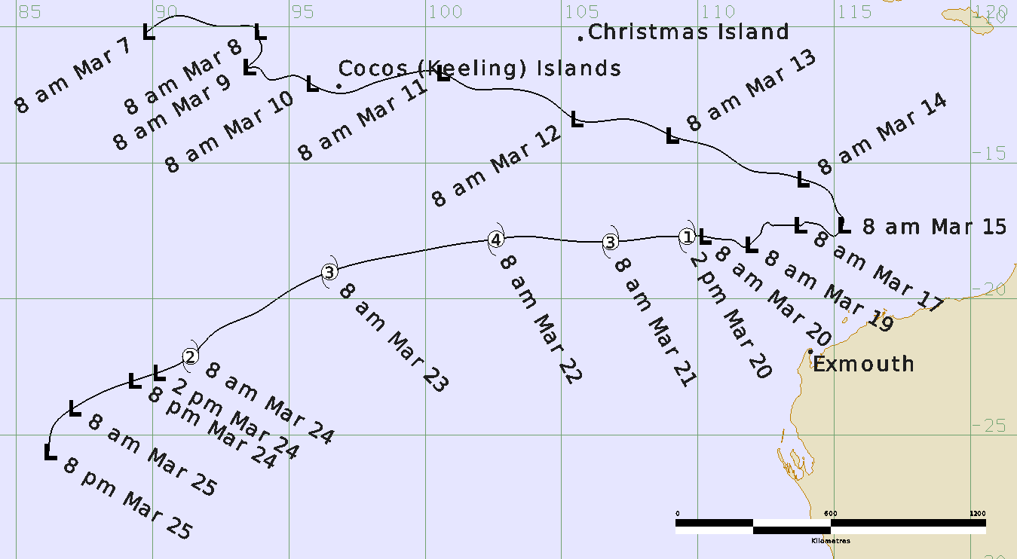

Figure 1. Best track of Severe Tropical Cyclone Neville 7-25 March 2024 (times in AWST, UTC +8h).

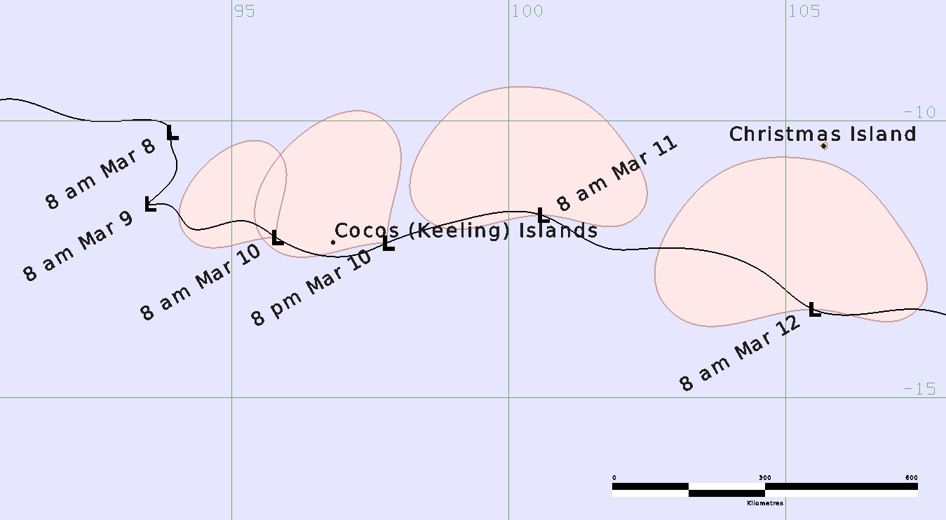

Figure 2. Detailed best track of 08U 8-12 March as it tracks past Cocos (Keeling) Islands and Christmas Island, prior to reaching tropical cyclone intensity (times in AWST, UTC +8h).

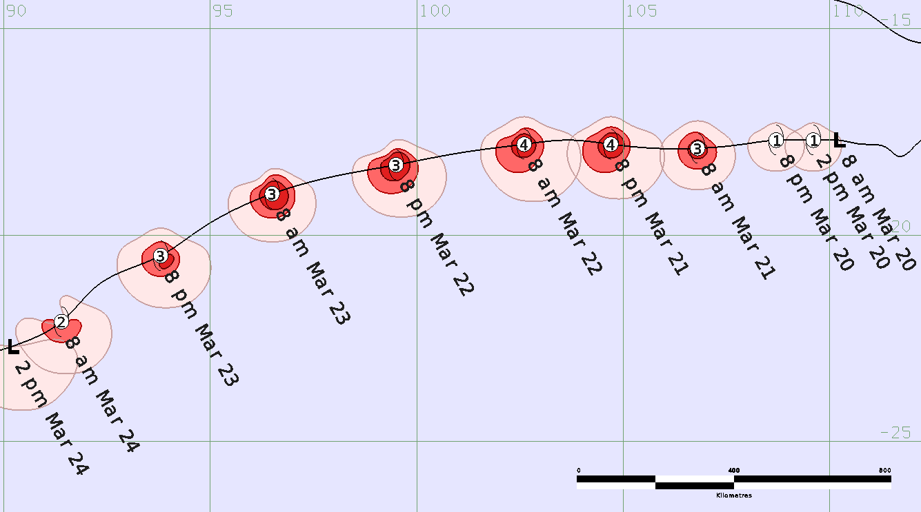

Figure 3. Detailed best track of Severe Tropical Cyclone Neville 20-24 March, during the time it was at tropical cyclone intensity (times in AWST, UTC +8h).

|  |  |  |  |  |  |  |  |  |  |  |  |  |
| --- | --- | --- | --- | --- | --- | --- | --- | --- | --- | --- | --- | --- |
| **Year** | **Month** | **Day** | **Hour UTC** | **Pos. Lat S** | **Pos. Long. E** | **Pos. Acc. Nm** | **Mean wind kn** | **Max. gust kn** | **Cent. Press hPa** | **Rad of gales (NE/SE/SW/NW) nm** | **Rad of storm (NE/SE/SW/NW) nm** | **RMW nm** |
| 2024 | 3 | 7 | 0000 | 10.2 | 89.8 | 45 | 20 | 40 | 1006 | 0/0/0/0 | 0/0/0/0 | - |
| 2024 | 3 | 7 | 0600 | 9.6 | 91.0 | 30 | 20 | 40 | 1006 | 0/0/0/0 | 0/0/0/0 | - |
| 2024 | 3 | 7 | 1200 | 9.9 | 92.0 | 45 | 20 | 40 | 1006 | 0/0/0/0 | 0/0/0/0 | - |
| 2024 | 3 | 7 | 1800 | 10.0 | 92.9 | 45 | 20 | 40 | 1006 | 0/0/0/0 | 0/0/0/0 | - |
| 2024 | 3 | 8 | 0000 | 10.2 | 93.9 | 45 | 20 | 40 | 1005 | 0/0/0/0 | 0/0/0/0 | - |
| 2024 | 3 | 8 | 0600 | 10.4 | 93.9 | 60 | 20 | 40 | 1004 | 0/0/0/0 | 0/0/0/0 | - |
| 2024 | 3 | 8 | 1200 | 10.7 | 94.0 | 60 | 25 | 40 | 1004 | 0/0/0/0 | 0/0/0/0 | - |
| 2024 | 3 | 8 | 1800 | 11.3 | 93.7 | 60 | 25 | 45 | 1002 | 0/0/0/0 | 0/0/0/0 | - |
| 2024 | 3 | 9 | 0000 | 11.5 | 93.5 | 45 | 30 | 45 | 1002 | 0/0/0/0 | 0/0/0/0 | - |
| 2024 | 3 | 9 | 0600 | 11.5 | 93.8 | 45 | 35* | 45 | 1001 | 0/0/0/110 | 0/0/0/0 | - |
| 2024 | 3 | 9 | 1200 | 11.9 | 94.2 | 45 | 35* | 50 | 1000 | 0/0/0/110 | 0/0/0/0 | - |
| 2024 | 3 | 9 | 1800 | 11.8 | 95.2 | 30 | 35* | 50 | 1000 | 0/0/0/110 | 0/0/0/0 | - |
| 2024 | 3 | 10 | 0000 | 12.1 | 95.8 | 20 | 35* | 45 | 1000 | 0/0/0/110 | 0/0/0/0 | - |
| 2024 | 3 | 10 | 0600 | 12.4 | 97.3 | 10 | 35* | 45 | 1000 | 0/0/0/150 | 0/0/0/0 | - |
| 2024 | 3 | 10 | 1200 | 12.2 | 97.8 | 20 | 35* | 45 | 999 | 0/0/0/150 | 0/0/0/0 | - |
| 2024 | 3 | 10 | 1800 | 11.8 | 99.1 | 30 | 40* | 55 | 999 | 90/0/0/140 | 0/0/0/0 | - |
| 2024 | 3 | 11 | 0000 | 11.7 | 100.6 | 25 | 40* | 55 | 996 | 120/0/0/150 | 0/0/0/0 | - |
| 2024 | 3 | 11 | 0600 | 12.3 | 101.8 | 15 | 40* | 55 | 995 | 140/0/0/150 | 0/0/0/0 | - |
| 2024 | 3 | 11 | 1200 | 12.3 | 102.5 | 20 | 45* | 65 | 993 | 180/0/0/160 | 0/0/0/0 | - |
| 2024 | 3 | 11 | 1800 | 12.8 | 104.7 | 30 | 45* | 65 | 993 | 140/0/0/160 | 0/0/0/0 | - |
| 2024 | 3 | 12 | 0000 | 13.4 | 105.5 | 15 | 40* | 55 | 996 | 130/0/0/180 | 0/0/0/0 | - |
| 2024 | 3 | 12 | 0600 | 13.5 | 106.2 | 20 | 40* | 55 | 998 | 110/0/0/180 | 0/0/0/0 | - |
| 2024 | 3 | 12 | 1200 | 13.4 | 107.4 | 30 | 35* | 50 | 996 | 110/0/0/140 | 0/0/0/0 | - |
| 2024 | 3 | 12 | 1800 | 13.9 | 108.8 | 25 | 35* | 50 | 998 | 90/0/0/0 | 0/0/0/0 | - |
| 2024 | 3 | 13 | 0000 | 14.0 | 109.0 | 25 | 30 | 45 | 998 | 0/0/0/0 | 0/0/0/0 | - |
| 2024 | 3 | 13 | 0600 | 14.5 | 110.7 | 30 | 30 | 45 | 998 | 0/0/0/0 | 0/0/0/0 | - |
| 2024 | 3 | 13 | 1200 | 15.3 | 112.0 | 30 | 35* | 50 | 996 | 0/0/0/100 | 0/0/0/0 | - |
| 2024 | 3 | 13 | 1800 | 15.4 | 113.0 | 30 | 35* | 50 | 996 | 0/0/0/80 | 0/0/0/0 | - |
| 2024 | 3 | 14 | 0000 | 15.6 | 113.8 | 10 | 35* | 50 | 994 | 70/0/0/80 | 0/0/0/0 | - |
| 2024 | 3 | 14 | 0600 | 16.2 | 114.9 | 10 | 35* | 50 | 996 | 70/0/0/80 | 0/0/0/0 | - |
| 2024 | 3 | 14 | 1200 | 16.9 | 115.2 | 20 | 35* | 50 | 994 | 70/0/0/90 | 0/0/0/0 | - |
| 2024 | 3 | 14 | 1800 | 17.0 | 115.3 | 25 | 35* | 50 | 993 | 0/0/0/90 | 0/0/0/0 | - |
| 2024 | 3 | 15 | 0000 | 17.3 | 115.3 | 30 | 35* | 50 | 993 | 0/0/0/70 | 0/0/0/0 | - |
| 2024 | 3 | 15 | 0600 | 17.5 | 115.2 | 30 | 30 | 45 | 996 | 0/0/0/0 | 0/0/0/0 | - |
| 2024 | 3 | 15 | 1200 | 17.7 | 115.0 | 30 | 30 | 45 | 996 | 0/0/0/0 | 0/0/0/0 | - |
| 2024 | 3 | 15 | 1800 | 17.6 | 114.8 | 25 | 30 | 45 | 996 | 0/0/0/0 | 0/0/0/0 | - |
| 2024 | 3 | 16 | 0000 | 17.3 | 114.5 | 25 | 30 | 45 | 998 | 0/0/0/0 | 0/0/0/0 | - |
| 2024 | 3 | 16 | 0600 | 17.2 | 114.1 | 25 | 30 | 45 | 998 | 0/0/0/0 | 0/0/0/0 | - |
| 2024 | 3 | 16 | 1200 | 17.2 | 113.9 | 25 | 25 | 45 | 998 | 0/0/0/0 | 0/0/0/0 | - |
| 2024 | 3 | 16 | 1800 | 17.3 | 113.8 | 25 | 25 | 45 | 998 | 0/0/0/0 | 0/0/0/0 | - |
| **Year** | **Month** | **Day** | **Hour UTC** | **Pos. Lat S** | **Pos. Long. E** | **Pos. Acc. Nm** | **Mean wind kn** | **Max. gust kn** | **Cent. Press hPa** | **Rad of gales (NE/SE/SW/NW) nm** | **Rad of storm (NE/SE/SW/NW) nm** | **RMW nm** |
| 2024 | 3 | 17 | 0000 | 17.3 | 113.7 | 20 | 25 | 45 | 1000 | 0/0/0/0 | 0/0/0/0 | - |
| 2024 | 3 | 17 | 0600 | 17.3 | 112.9 | 15 | 25 | 45 | 999 | 0/0/0/0 | 0/0/0/0 | - |
| 2024 | 3 | 17 | 1200 | 17.3 | 112.8 | 25 | 25 | 45 | 999 | 0/0/0/0 | 0/0/0/0 | - |
| 2024 | 3 | 17 | 1800 | 17.3 | 112.7 | 25 | 25 | 45 | 998 | 0/0/0/0 | 0/0/0/0 | - |
| 2024 | 3 | 18 | 0000 | 17.2 | 112.6 | 25 | 30 | 45 | 998 | 0/0/0/0 | 0/0/0/0 | - |
| 2024 | 3 | 18 | 0600 | 17.3 | 112.4 | 30 | 30 | 45 | 998 | 0/0/0/0 | 0/0/0/0 | - |
| 2024 | 3 | 18 | 1200 | 17.6 | 112.3 | 25 | 35* | 50 | 996 | 0/90/0/0 | 0/0/0/0 | - |
| 2024 | 3 | 18 | 1800 | 17.8 | 112.1 | 20 | 35* | 50 | 996 | 0/0/80/0 | 0/0/0/0 | - |
| 2024 | 3 | 19 | 0000 | 18.0 | 111.9 | 20 | 35* | 50 | 996 | 0/0/80/0 | 0/0/0/0 | - |
| 2024 | 3 | 19 | 0600 | 18.1 | 111.7 | 20 | 35* | 50 | 996 | 0/0/80/0 | 0/0/0/0 | - |
| 2024 | 3 | 19 | 1200 | 17.9 | 111.4 | 20 | 35* | 50 | 996 | 0/0/80/0 | 0/0/0/0 | - |
| 2024 | 3 | 19 | 1800 | 17.8 | 110.8 | 10 | 30 | 45 | 998 | 0/0/0/0 | 0/0/0/0 | - |
| 2024 | 3 | 20 | 0000 | 17.7 | 110.2 | 15 | 30 | 45 | 999 | 0/0/0/0 | 0/0/0/0 | - |
| 2024 | 3 | 20 | 0600 | 17.7 | 109.6 | 15 | 35 | 50 | 998 | 25/45/45/25 | 0/0/0/0 | 15 |
| 2024 | 3 | 20 | 1200 | 17.7 | 108.7 | 15 | 45 | 65 | 992 | 25/45/45/25 | 0/0/0/0 | 15 |
| 2024 | 3 | 20 | 1800 | 17.8 | 107.9 | 15 | 55 | 75 | 986 | 30/50/50/30 | 20/25/25/20 | 13 |
| 2024 | 3 | 21 | 0000 | 17.9 | 106.8 | 15 | 70 | 100 | 978 | 40/60/60/40 | 20/30/30/25 | 12 |
| 2024 | 3 | 21 | 0600 | 17.9 | 105.8 | 15 | 80 | 110 | 967 | 40/70/70/40 | 25/30/40/25 | 10 |
| 2024 | 3 | 21 | 1200 | 17.8 | 104.7 | 10 | 95 | 135 | 953 | 40/85/70/40 | 25/30/45/25 | 9 |
| 2024 | 3 | 21 | 1800 | 17.7 | 103.7 | 10 | 95 | 135 | 953 | 40/90/70/35 | 25/30/45/25 | 8 |
| 2024 | 3 | 22 | 0000 | 17.8 | 102.6 | 10 | 100 | 140 | 948 | 40/90/70/40 | 25/30/45/20 | 7 |
| 2024 | 3 | 22 | 0600 | 18.0 | 101.1 | 10 | 95 | 135 | 952 | 40/80/70/30 | 25/30/45/20 | 8 |
| 2024 | 3 | 22 | 1200 | 18.3 | 99.5 | 10 | 85 | 120 | 960 | 40/80/70/30 | 25/35/45/20 | 10 |
| 2024 | 3 | 22 | 1800 | 18.6 | 97.9 | 10 | 85 | 120 | 961 | 40/80/70/30 | 25/40/45/20 | 13 |
| 2024 | 3 | 23 | 0000 | 19.0 | 96.5 | 15 | 80 | 110 | 966 | 40/70/70/30 | 30/35/35/20 | 15 |
| 2024 | 3 | 23 | 0600 | 19.9 | 94.7 | 20 | 75 | 105 | 972 | 40/80/70/40 | 25/35/35/20 | 15 |
| 2024 | 3 | 23 | 1200 | 20.5 | 93.8 | 20 | 65 | 90 | 979 | 40/80/70/40 | 20/30/30/20 | 18 |
| 2024 | 3 | 23 | 1800 | 21.2 | 92.3 | 20 | 55 | 75 | 986 | 40/80/70/40 | 0/30/30/0 | 20 |
| 2024 | 3 | 24 | 0000 | 22.1 | 91.4 | 15 | 50 | 70 | 994 | 40/80/70/0 | 0/30/30/0 | 25 |
| 2024 | 3 | 24 | 0600 | 22.7 | 90.2 | 15 | 45* | 65 | 997 | 0/100/80/0 | 0/0/0/0 | - |
| 2024 | 3 | 24 | 1200 | 23.0 | 89.3 | 15 | 40* | 55 | 999 | 0/90/60/0 | 0/0/0/0 | - |
| 2024 | 3 | 24 | 1800 | 23.4 | 88.2 | 15 | 35* | 50 | 1002 | 0/60/60/0 | 0/0/0/0 | - |
| 2024 | 3 | 25 | 0000 | 24.0 | 87.1 | 15 | 30 | 45 | 1002 | 0/0/0/0 | 0/0/0/0 | - |
| 2024 | 3 | 25 | 0600 | 24.6 | 86.4 | 15 | 25 | 45 | 1004 | 0/0/0/0 | 0/0/0/0 | - |
| 2024 | 3 | 25 | 1200 | 25.6 | 86.2 | 15 | 20 | 40 | 1005 | 0/0/0/0 | 0/0/0/0 | - |

Table 1. Best track summary for Severe Tropical Cyclone Neville.

UTC=AWST-8. * Not at tropical cyclone intensity as gales less than halfway around centre.

1. Meteorological description

2.1 Intensity analysis

Table 1 shows the summary data at the standard six-hourly times from 7 to 25 March. A comparison of the subjective and objective intensity estimates is shown in Figure 15.

A persistent, closed low-level circulation was first analysed at 0000 UTC 7 March, with winds up to 20 kn (37 km/h) around the centre based on scatterometry data. The low was slow to develop, with strong vertical wind shear inhibiting the system from forming a deep, vertically stacked structure. A surge in the monsoon flow to the north of the system resulted in gales developing in the northwest quadrant from 0600 UTC 9 March.

The system passed just south of the Cocos (Keeling) Islands at around 0300 UTC 10 March (Figure 4), however the gales were further northwest of the centre, and so were not recorded by the AWS at Cocos Island Airport until the early hours of 11 March (local time).

The monsoon flow to the north of the low strengthened further during 11 March (Figure 5), with winds reaching up to 45 kn (83 km/h) at 1200 UTC and 1800 UTC 11 March. This was the peak intensity for this stage of the system's life. The monsoon flow subsequently weakened a little, and for a short period on 13 March the intensity dropped to 30 kn (56 km/h).

Gales again redeveloped north of the centre at 1200 UTC 13 March (Figure 6), and intensity was maintained at 35 kn (65 km/h) through until 0000 UTC 15 March. After this time, the monsoon flow become separated from the low, and winds eased to below gale force again.

The low remained weak for the next few days as moderate vertical wind shear inhibited development. Environmental conditions improved a little during 18 March, and enhanced convection on the southern side allowed gales to redevelop (Figure 7). Development stalled again a little after this, as dry air was ingested into the centre, and winds eased to 30 kn (56 km/h) by 1800 UTC 19 March.

Environmental conditions once again became favourable for development on 20 March, with low vertical wind shear and upper divergence. Convection developed close to the centre, which overcame the influence of dry air, and the system rapidly improved. At 0600 UTC 20 March, gales developed around the centre of the system, and it was named Tropical Cyclone Neville (Figure 8).

Neville continued to develop rapidly in response to environmental support, and at 0000 UTC 21 March it became a severe (category 3) system, with an intensity of 70 kn (130 km/h). A clear eye was evident on satellite imagery. Further intensification continued during the day, and a SAR windspeed pass at 1127 UTC 21 March (Figure 9) showed that Neville had reached category 4 intensity.

Severe Tropical Cyclone Neville was estimated to have reached a maximum intensity of 100 kn (185 km/h) at 0000 UTC 22 March (Figure 10), based on Dvorak analysis and consistent with a SAR pass from 2237 UTC 21 March.

From this point, Neville started to weaken under the influence of increasing northerly wind shear, due to an approaching upper trough from the west. Initially the weakening was slow, as the increase in wind shear was balanced somewhat by increased upper poleward outflow. Once dry air intruded into the centre, the weakening accelerated. An ASCAT-C pass at 0339 UTC 24 March (Figure 11) showed that gale force winds had almost completely eased in the northern semicircle, and a little later at 0600 UTC 24 March, Neville was no longer classified as a tropical cyclone (Figure 12).

Ex-Tropical Cyclone Neville continued to weaken as it moved west and into the La Reunion RSMC's Area of Responsibility. Gales in the southern semicircle eased after 1800 UTC 24 March, and the remnants of Neville dissipated soon after 1200 UTC March 25.

## 2.1 Structure

After formation, the tropical low that would eventually develop into Neville was initially an elongated and poorly defined circulation (Figure 5). A strong monsoon flow enhanced winds to the north of the centre, but due to high vertical wind shear this was unable to translate into improvement of the low-level centre. Gales in the northern semicircle extended a long way from the centre, up to 180 nautical miles (nm, 333 km) during 11-12 March.

On 13 March, a second circulation was evident in the trough to the east of the existing circulation; during the day these circulations interacted with one another, and eventually merged. The best track follows the existing circulation until the time that it merges.

From 14 March, the surface circulation became more circular as it gradually became disconnected from the monsoon flow to the north (Figure 6). Deep convection was mostly displaced to the west of the centre under the influence of easterly vertical wind shear. On 17 and 18 March, this shear eased, and the structure of the system improved with convection becoming more focussed around the centre. The presence of dry air near the centre inhibited significant development initially, however once this was overcome on March 20, the system rapidly developed into Tropical Cyclone Neville.

Once at tropical cyclone intensity, Neville remained a small system. Gales in the northern semicircle only extended to around 40 nm (75km) from the centre (although gales did extend as far as 90 nm (167 km) in the southern semicircle due to enhancement from westerly motion and a synoptic squeeze from a ridge to the south). The RMW were estimated at 15 nm (28 km) when Neville first formed, decreasing to as low as 7 nm (13 km) at the time of maximum intensity. Analysis of the structure was aided by two SAR passes at 1127 UTC (Figure 9) and 2237 on 12 March.

An eye was visible on satellite imagery from around 0000 UTC 21 March until 0000 UTC 23 March. After this, Neville weakened, and the cloud features became less distinct. As increasing northerly vertical wind shear and dry air affected the system, winds eased in the northern semicircle (Figure 11), and by 0600 UTC 24 March gales were no longer occurring more the halfway around the centre. At this stage, the system could no longer be classified as a tropical cyclone.

2.2 Motion

The initial motion of the system was in a general east-southeast direction, driven by a strong monsoonal flow to the north. From 11 March, this flow strengthened, and as a result motion accelerated faster to the east southwest. After 14 March, the monsoon became separated to the north of the system, and steering become somewhat balanced between the remains of the monsoon flow and a mid-level ridge to the southeast. This resulted in a slow drift towards the west from 15 March until 19 March.

A new mid-level ridge developed to the south of Neville on 20 March, which caused steady westwards motion over the following days, tending more west southwesterly from 23 March as the ridge moved to the southeast. This motion persisted until Neville weakened.

1. Impact

The strongest winds to affect the Cocos (Keeling) Islands occurred in the early hours of 11 March, when winds briefly reached gale force at Cocos Island Airport. Some wind damage was report to the Island's resort. In addition to wind impacts, higher than normal swells caused the Island's ferry service to shut down for a period.

At Christmas Island, large swells impacted the coastline as 08U passed to the south. Waves were reported to have reached 4-5 metres, with water inundation causing some damage to the skate park and entertainment area. Although gale force winds were not recorded, there were also reports of some minor wind-related damage to vegetation within the rainforest.

1. Observations

Wind gusts of 46 kn (85 km/h) were recorded at Cocos Island Airport at 1844 and 1906 UTC 10 March (1:14am and 1:36am 11 March Cocos Islands time)

The peak 10-minute mean wind recorded at Cocos Island Airport was 34 kn (63 km/h) at 1910 UTC 10 March (1:40am 11 March Cocos Islands time)

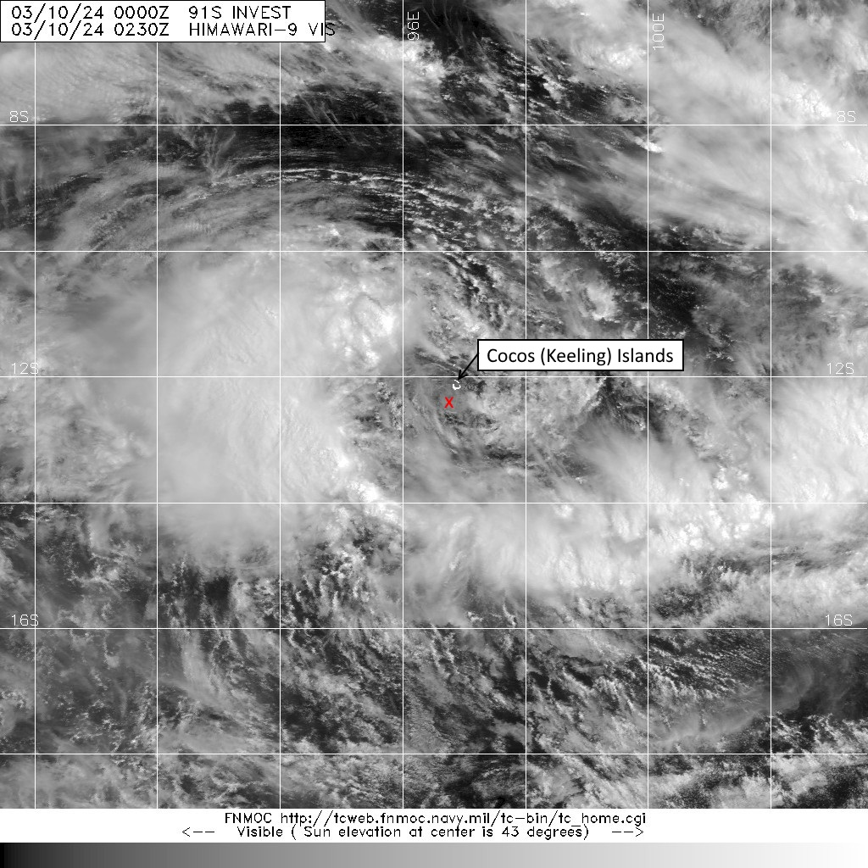

Figure 4. Visible satellite image at 0230 UTC 10 March, showing the centre of the tropical low (marked by a red cross) just south of the Cocos (Keeling) Islands. Image from Himiwari-9 satellite, courtesy of NRL: <https://www.nrlmry.navy.mil/TC.html>

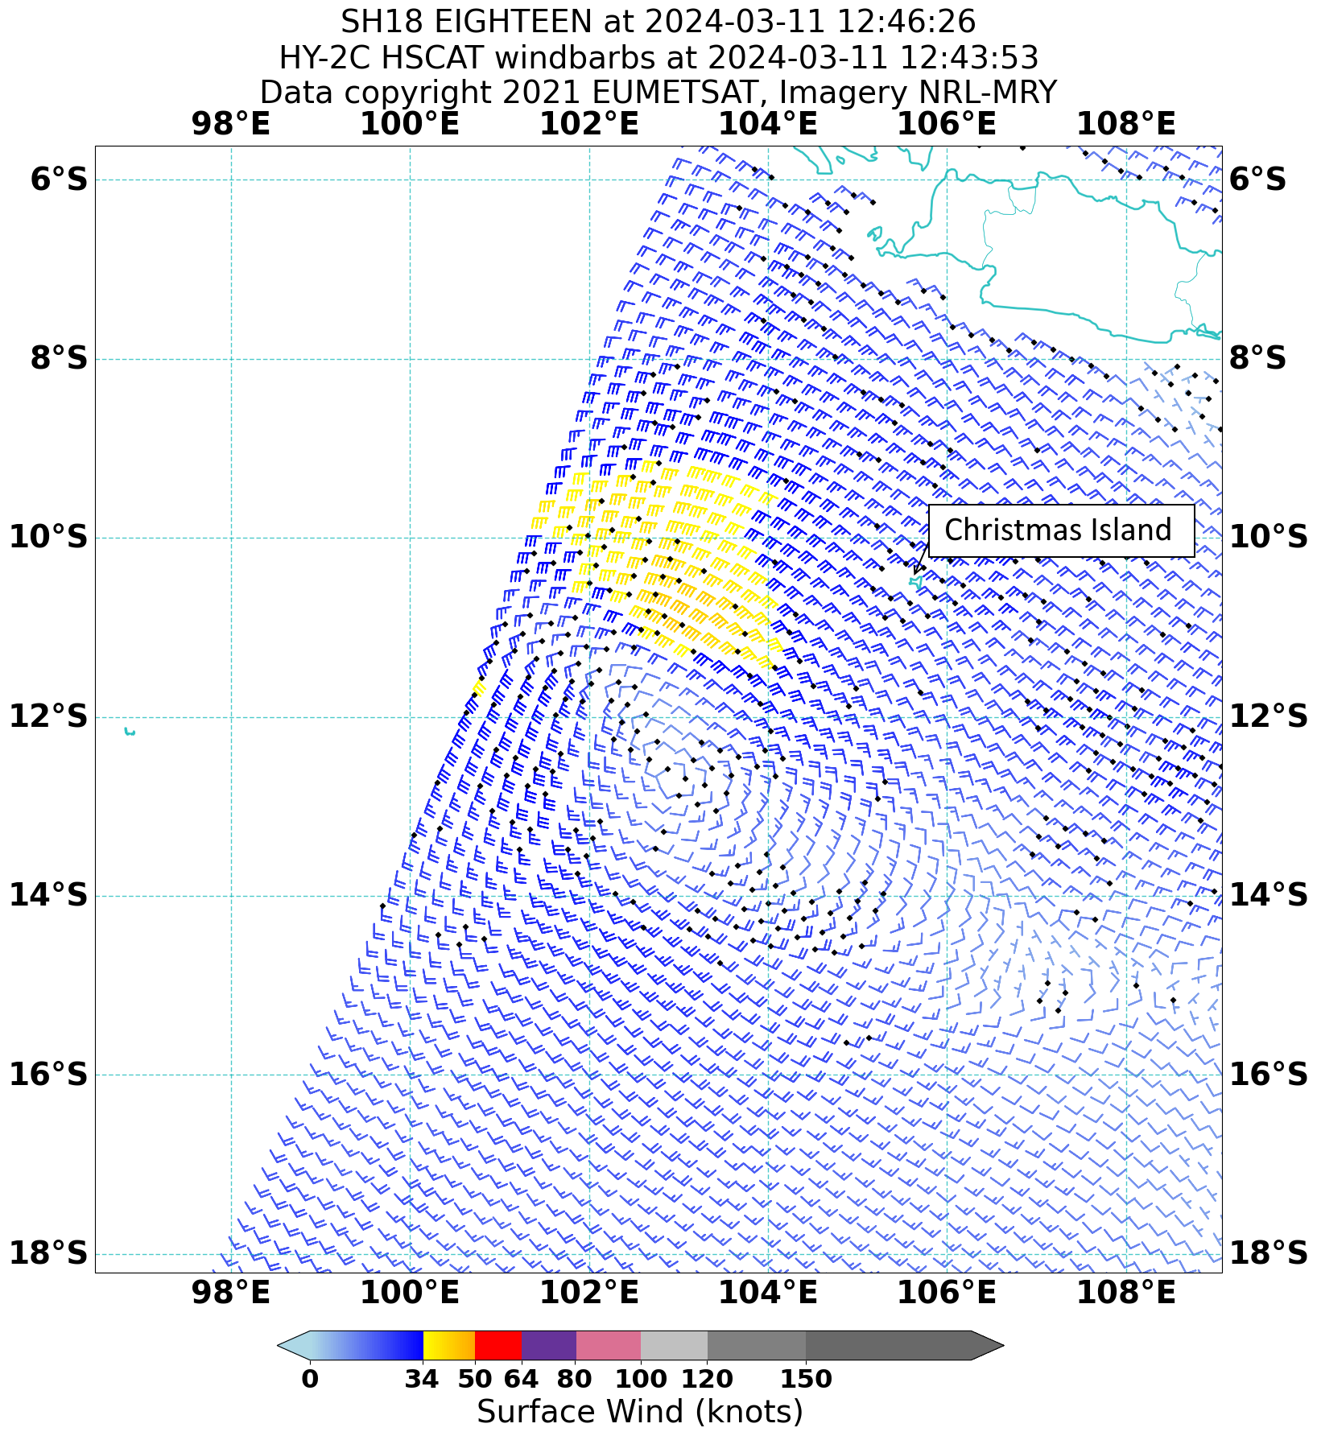

Figure 5. A HY-2C HSCAT pass at 1243 UTC 11 March, showing a large band of gale force winds to the west of Christmas Island. Image courtesy of NRL: <https://www.nrlmry.navy.mil/TC.html>

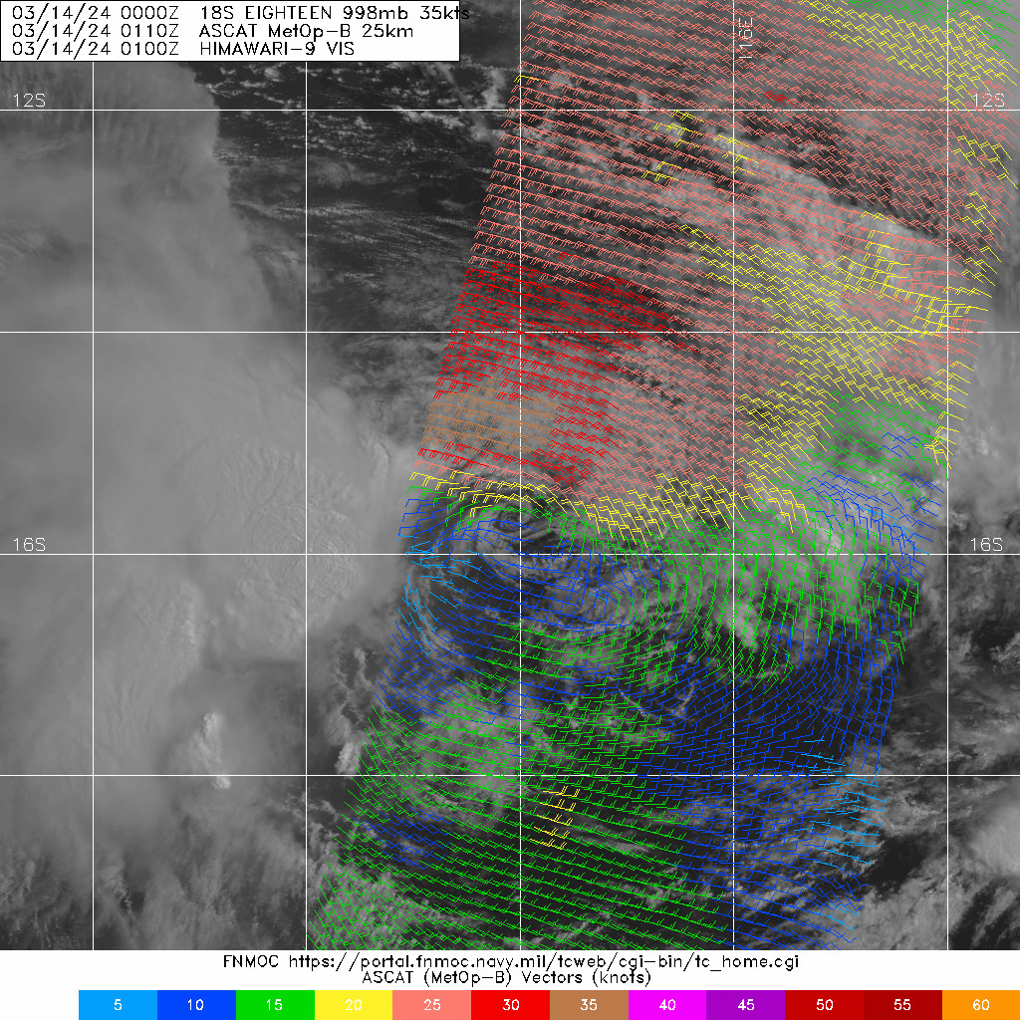

Figure 6. An ASCAT-B pass at 0110 UTC 14 March, showing a well-defined low level circulation with gales in the northern semcircle. Image courtesy of NRL: <https://www.nrlmry.navy.mil/TC.html>

|  |  |
| --- | --- |
|  |  |

Figure 7. An AMSR2 37 GHz microwave and windspeed passes at 1732 UTC 18 March, showing the low level structure and gales in the southwest quadrant. Images courtesy of NRL: <https://www.nrlmry.navy.mil/TC.html>

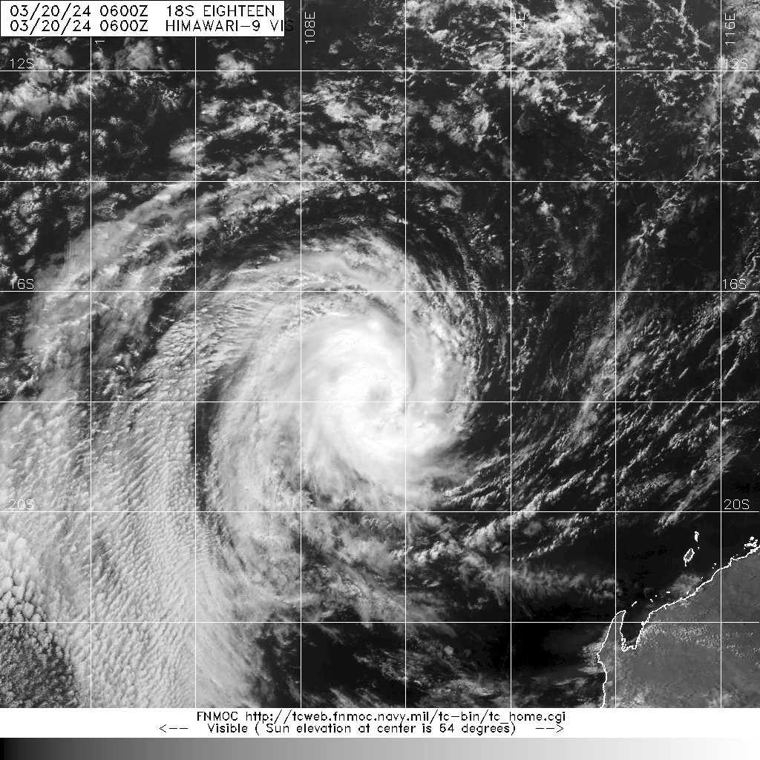

Figure 8. Himiwari-9 visible satellite image at 0600 UTC 20 March, at the time Neville first reached tropical cyclone intensity. Image courtesy of NRL: <https://www.nrlmry.navy.mil/TC.html>

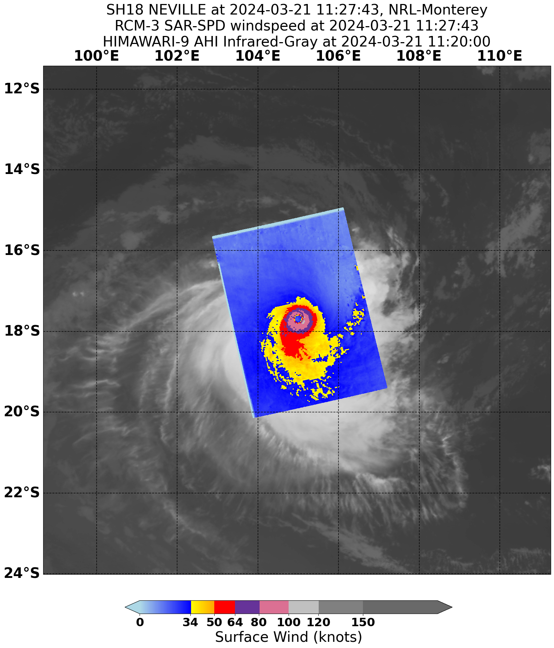

Figure 9. A SAR windspeed pass at 1127 UTC 21 March, showing that Severe Tropical Cyclone Neville was a small but very intense system. Image courtesy of NRL: <https://www.nrlmry.navy.mil/TC.html>

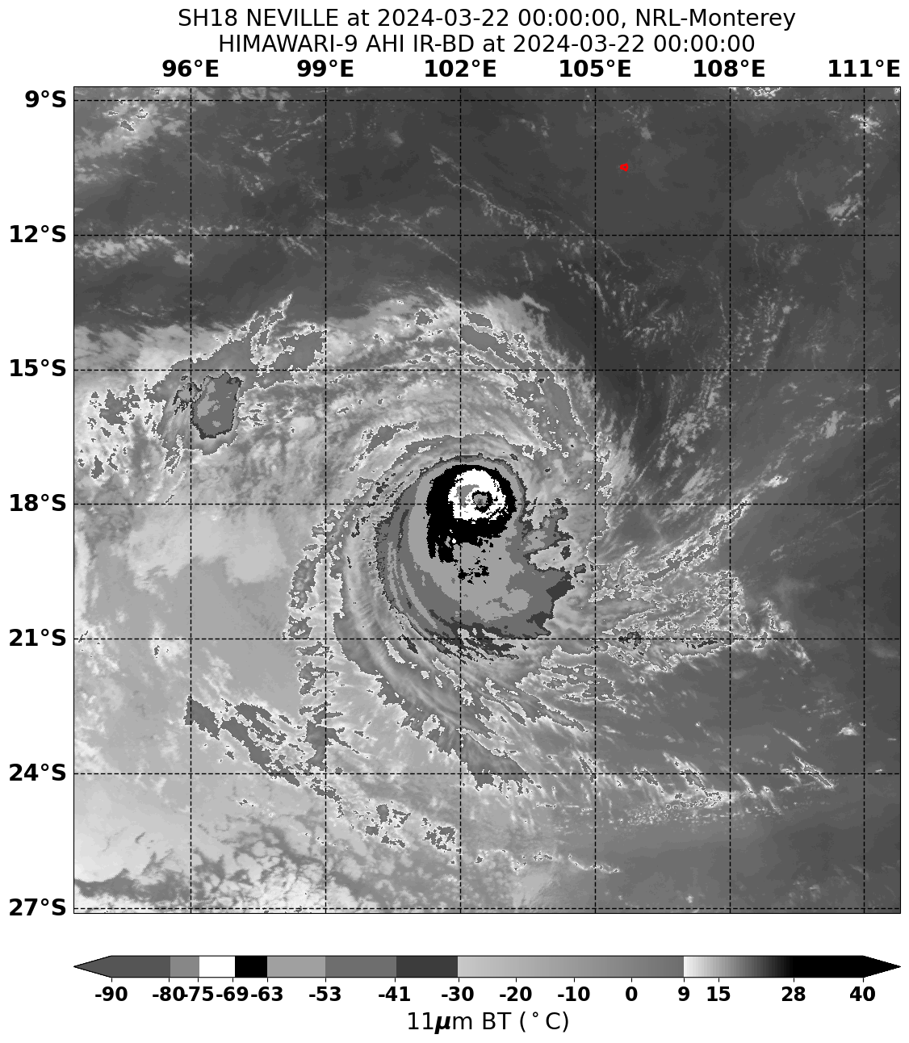

Figure 10. Himiwari-9 infrared satellite imagery at 0000 UTC 22 March, when Severe Tropical Cyclone Neville was estimated to be at peak intensity. Image courtesy of NRL: <https://www.nrlmry.navy.mil/TC.html>

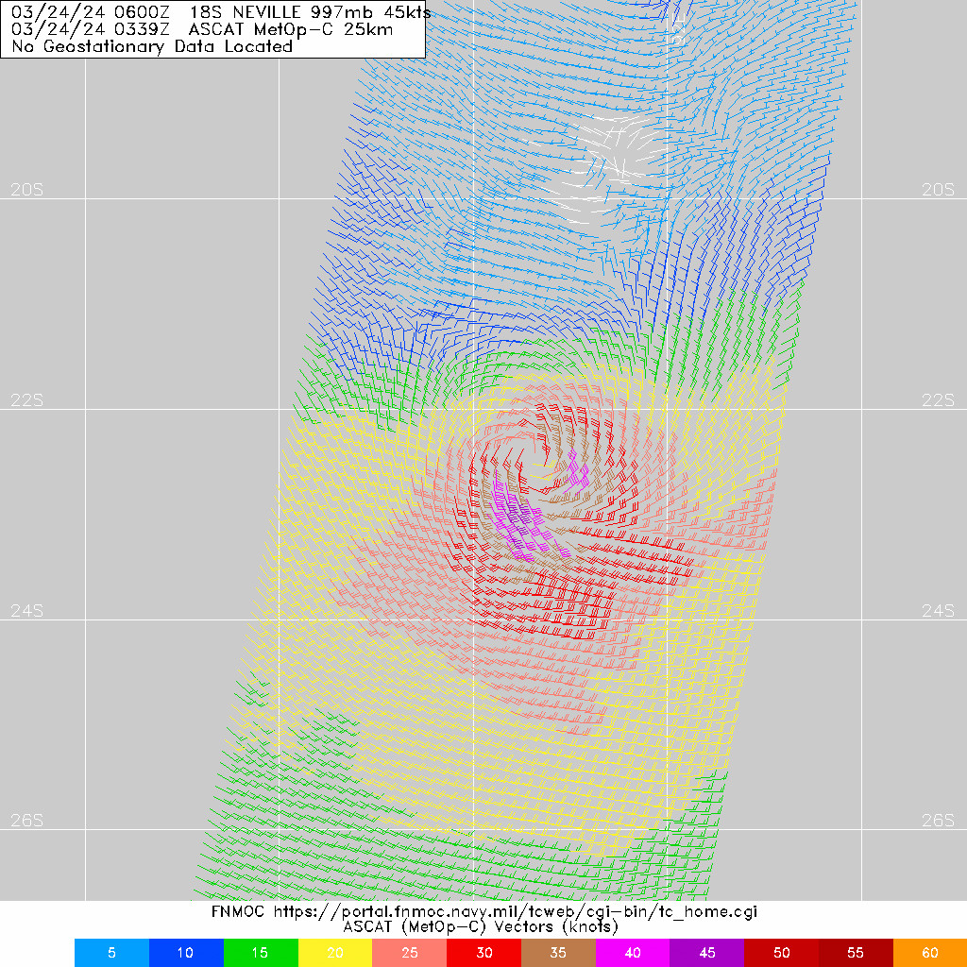

Figure 11. An ASCAT-C pass at 0339 UTC 24 March, showing that gales were almost confined to the southern semi-circle. Image courtesy of NRL: <https://www.nrlmry.navy.mil/TC.html>

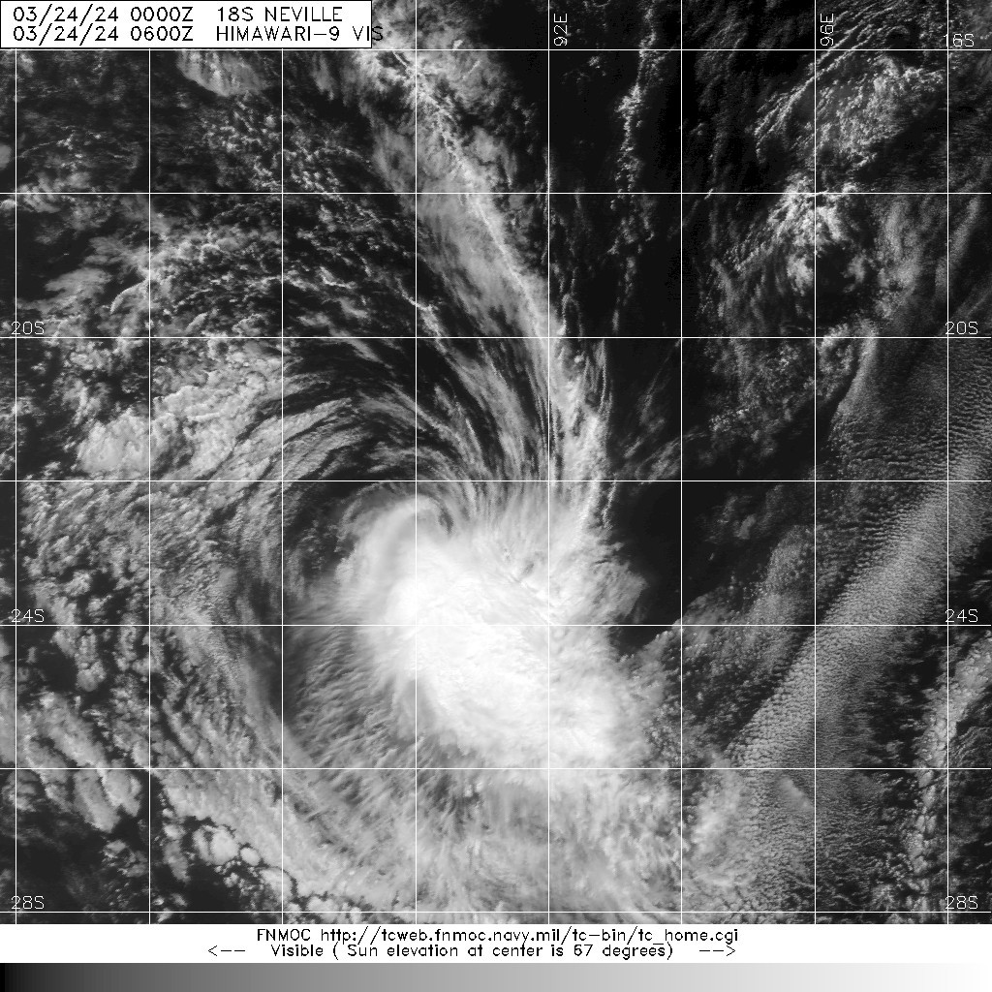

Figure 12. Himiwari-9 visible satellite image at 0600 UTC 24 March, at the time Neville weakened to below tropical cyclone intensity. Image courtesy of NRL: <https://www.nrlmry.navy.mil/TC.html>

1. Forecast Performance

The accuracy statistics for Severe Tropical Cyclone Neville are below in Table 2.

Tropical Cyclone Information Bulletins, Forecast Track Maps and Ocean Wind Warnings were issued six-hourly from 0700 UTC 9 March to 0700 UTC 24 March.

As shown in Figure 13, the forecast track position accuracy was poorer than the five-year average for the analysis and 6-hour forecast, then generally slightly better than the five-year average for the longer lead time forecasts. The initial errors were related to the extended period for which the system was weak and difficult to analyse. Despite these initial errors, NWP guidance generally performed well across the life of the system. Environmental steering conditions well-modelled, which lead to lower-than-normal errors across longer forecast lead-times.

Figure 14 shows the intensity error for various forecast lead-times. The errors for forecast times up to 48 hours were significantly better than the five-year average, which can be attributed to the times where the intensity was remaining steady and forecast to continue doing so in the short term. The larger errors at longer lead-times were due to two factors – there was a period of time prior to 20 March when the system was forecast to intensify but failed to do so, and then once it did reach tropical cyclone intensity it proceeded to reach a higher intensity than was forecast.

The first 7 Day Forecast for 08U was issued at 0100 UTC 29 February, with a forecast for the low to form on 6 March. The probability of the system developing into a tropical cyclone was rated 'Low' (5-20%) or 'Very Low' (less than 5%) on all 7 Day Forecasts issued up until 6 March. On the forecast issued at 0100 UTC 7 March, the probability of the system developing into a tropical cyclone was increased to 'Moderate' (20-50%) from 0000 UTC 12 March, and on the forecast issued at 0100 UTC 11 March it was increased to 'High' (greater than 50%) from 0000 UTC 15 March. Initially the period rated the greatest risk of development was from 15 to 19 March, but on forecasts from 17 March this was delay until 20 March. The 7 Day Forecasts were consistent with forecasting the system to weaken and dissipate on 25-26 March.

|  |  |  |  |  |  |  |  |  |  |  |
| --- | --- | --- | --- | --- | --- | --- | --- | --- | --- | --- |
| Time | 00 | 06 | 12 | 18 | 24 | 36 | 48 | 72 | 96 | 120 |
| Position accuracy (km) | 32 | 47 | 55 | 64 | 70 | 88 | 108 | 164 | 233 | 306 |
| Intensity accuracy (kn) | 1.8 | 2.6 | 3.6 | 4.8 | 5.4 | 7.5 | 8.9 | 14.6 | 20.1 | 20.7 |
| Sample size | 60 | 60 | 60 | 60 | 60 | 59 | 57 | 53 | 49 | 45 |

Table 2. Verification statistics for Severe Tropical Cyclone Neville. * Note, verification was performed using the Official Forecast Tracks at the standard times of 00, 06, 12 and 18 UTC.

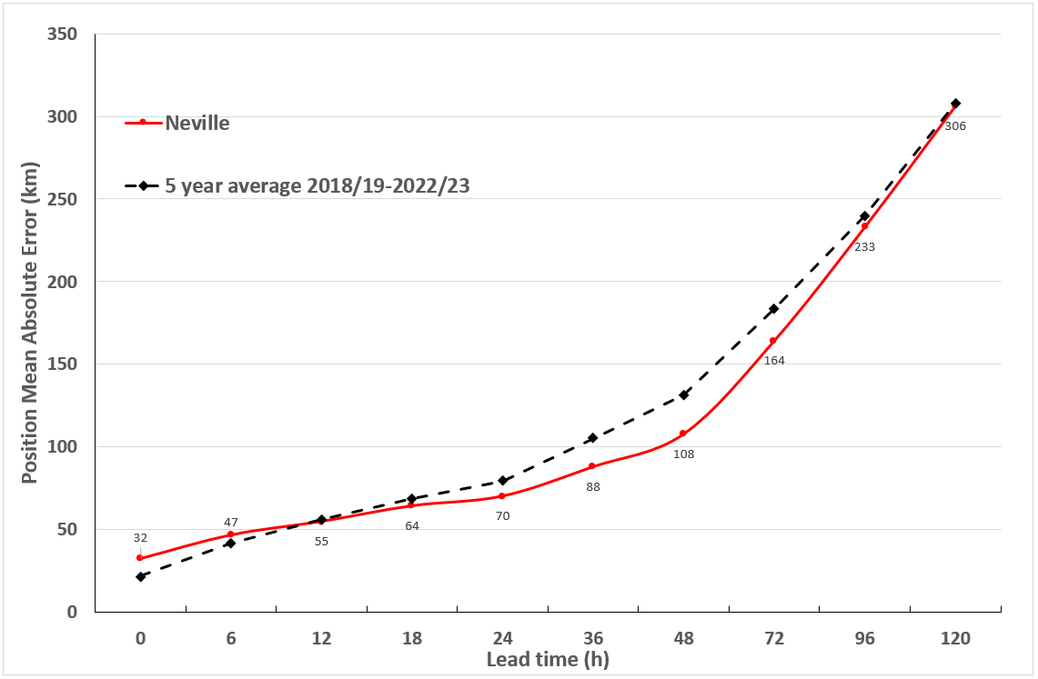

Figure 13. Position accuracy figures for Severe Tropical Cyclone Neville.

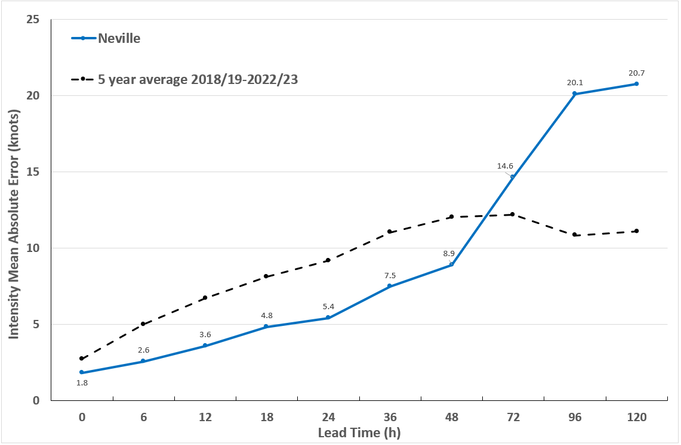

Figure 14. Intensity accuracy figures for Severe Tropical Cyclone Neville.

Appendix: List of abbreviations

|  |  |
| --- | --- |
| Abbreviation | Term |
| ADT | Advanced Dvorak Technique |
| AEST | Australian Central Standard Time |
| AEST | Australian Eastern Standard Time |
| AiDT | AI-enhanced Dvorak Technique |
| AMSR2 | Advanced Microwave Scanning Radiometer |
| AMSU | Advanced Microwave Sounding Unit |
| ASCAT | Advanced Scatterometer |
| ATMS | Advanced Technology Microwave Sounder |
| AWS | automatic weather station |
| AWST | Australian Western Standard Time |
| °C | Celsius |
| CI | Current intensity |
| CIMSS | Cooperative Institute for Meteorological Satellite Studies (USA) |
| CIRA | Cooperative Institute for Research in the Atmosphere (USA) |
| D-MINT | Deep learning - Multispectral Intensity of TCs (formerly known as DMN) |
| D-PRINT | Deep learning - IR Intensity of TCs (formerly known as OPEN-AIIR) |
| EIR | Enhanced InfraRed |
| ERC | eyewall replacement cycle |
| FNMOC | Fleet Numerical Meteorology and Oceanography Centre (USA) |
| FT | Final T-number |
| GCOM | Global Change Observation Mission |
| GHz | Gigahertz |
| GMI | Global Precipitation Measurement Microwave Imager |
| h | hour |
| hPa | hectopascal |
| HSCAT | Hai Yang 2 Scatterometer (HY-2B, HY-2C) |
| km | kilometres |
| km/h | kilometres per hour |
| kn | knots |
| LLCC | LLCC |
| MET | Model Expected T-number |
| METOP | Meteorological Operational Satellite |
| MJO | Madden-Julian Oscillation |
| mm | millimetres |
| MSLP | mean sea level pressure |
| NESDIS | National Environmental Satellite, Data, and Information Service |
| nm | nautical mile |
| NOAA | National Oceanic and Atmospheric Administration |
| NRL | Navy Research Lab (USA) |
| OPEN-AiiR | Ordered Pattern Encoding AI Infrared |
| PAT | Pattern T-number |
| RCM | RadarSat Constellation Mission – Synthetic Aperture Radar |
| RH | relative humidity |
| RMW | radius of maximum winds |
| RSMC | Regional Specialised Meteorological Centre |
| SAR | Synthetic Aperture Radar |
| SATC | CIMSS Advanced Dvorak Technique |
| SATCON | Satellite Consensus |
| SEN1 | Sentinel-1A – Synthetic Aperture Radar |
| SMAP | Soil Moisture Active Passive |
| SMOS | Soil Moisture and Ocean Salinity |
| SSMIS | Special Sensor Microwave Imager/Sounder |
| TC | Tropical Cyclone |
| TCWC | Tropical Cyclone Warning Centre |
| UTC | Universal Time Co-ordinated |

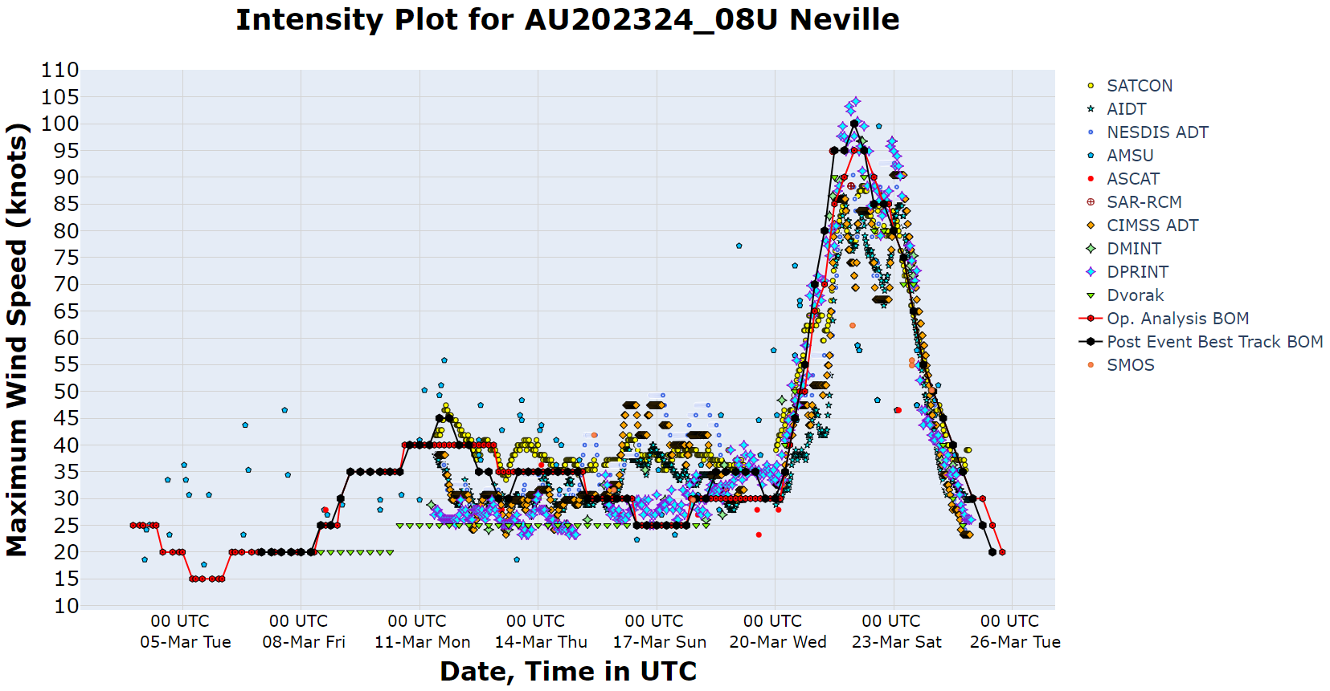

Figure 15. Intensity plot of objective and subjective guidance. SATCON, AiDT, NESDIS ADT, AMSU, ASCAT, SAR-RCM, ASCAT, CIMSS ADT, DMINT, DPRINT, Dvorak (subjective estimate), operational analysis (red) and post event best track analysis (black). Objective Dvorak and SAR-RCM have been adjusted from 1-minute to 10-minute maximum mean winds.