Severe Tropical Cyclone Olga (11U)

# 4 – 11 April 2024

## Linda Paterson, Tropical Cyclone Environmental Prediction Services

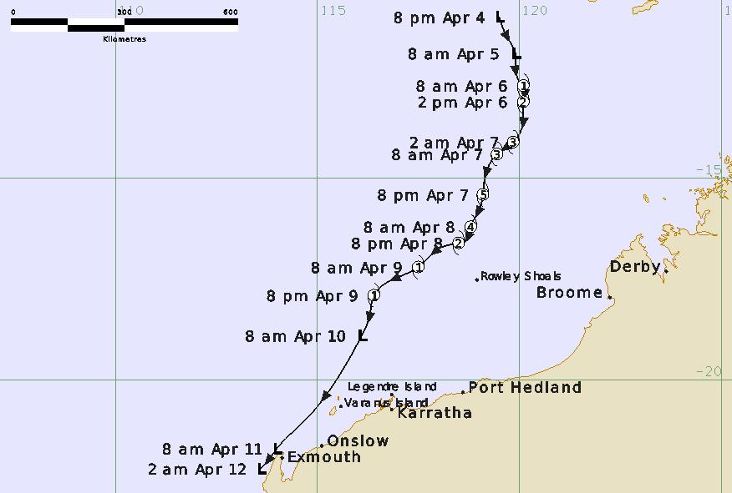

**Revision history**

|  |  |  |  |
| --- | --- | --- | --- |
| Date | Version | Author | Description |
| 17/04/2024 | 1.0 | Linda Paterson | Final draft ready |

**Review status**

|  |  |  |  |
| --- | --- | --- | --- |
| Date | Version | Reviewer | Description |
| 17/04/2024 | 1.0 | Joe Courtney | Completed |

**Release history**

|  |  |  |  |
| --- | --- | --- | --- |
| Date | Version | Status | Approval |
| 24/04/2024 | 1.0 | Approved for release | Andrew Burton |

Contact details:

Tropical Cyclone Team Lead

Severe Weather Environmental Prediction Services

Bureau of Meteorology

PO Box 1370, West Perth WA 6872

Email: [tcwc@bom.gov.au](mailto:tcwc@bom.gov.au)



This work is copyright. Apart from any use as permitted under the Copyright Act 1968, no part may be reproduced without prior written permission from the Bureau of Meteorology. Refer to www.bom.gov.au/other/copyright.shtml for further information. Unless otherwise noted, all images in this document are licensed under the Creative Commons Attribution Australia Licence.

© Commonwealth of Australia 2024

Published by the Bureau of Meteorology

Cover image: Track of Severe Tropical Cyclone Olga 4-12 April 2024. Times in UTC (ACST-9.5h)

Contents

1. Summary 5

2. Meteorological description 8

2.1 Intensity analysis 8

2.1 Structure 16

2.2 Motion 16

3. Impact 16

4. Observations 17

4.1 Winds 17

4.2 Pressure 17

5. Forecast Performance 18

Appendix: List of abbreviations 21

**List of Figures**

Figure 1 Best track of Severe Tropical Cyclone Olga 4-11 April 2024 (times in AWST, UTC +8). 5

Figure 2 Detailed Best track of Severe Tropical Cyclone Olga near west Pilbara 9-11 April 2024 (times in AWST, UTC +8) 6

Figure 3 Hovmoller diagram of tropical waves showing the formation of Olga on 4-6 April (indicated by cyclone symbol) occurred with a strong pulse of the MJO (black), and Equatorial Rossby (ER) wave (red), and some Kelvin wave (blue). Image courtesy of North Carolina Institute for Climate Studies (ncics.org). 9

Figure 4 An AMSR2 microwave pass at 1717 UTC 5 April showing improved curved banding around the centre. 10

Figure 5 An ASCAT metop-b pass at 0131 UTC 6 April indicated gales were present in all quadrants. 11

Figure 6 An ASCAT metop-b pass at 1403 UTC 6 April indicating hurricane force winds present in eastern quadrants. 12

Figure 7 A GMI microwave pass at 1003 UTC 7 April near peak intensity. 13

Figure 8 A SAR wind pass at 1032 UTC 7 April near peak intensity. 14

Figure 9 A GMI microwave pass at 0922 UTC 8 April showing the loss of deep convection from the northern side with a completely exposed low level centre. 15

Figure 10 Position accuracy figures for Tropical Cyclone Olga. 19

Figure 11 Intensity accuracy figures for Tropical Cyclone Olga. 20

Figure 12 Intensity plot of objective and subjective guidance. SATCON, AiDT, NESDIS ADT, AMSU, SAR-RCM, ASCAT, CIMSS ADT, DMINT, DPRINT, Dvorak (subjective estimate), operational analysis (red) and post event best track analysis (black). All winds are 10-minute estimates. 23

**List of Tables**

Table 1 Best track summary for Severe Tropical Cyclone Olga, 4-11 April 2024. UTC=AWST-8. 7

Table 2 Verification statistics for Severe Tropical Cyclone Olga 18

1. Summary

Severe Tropical Cyclone Olga developed rapidly into a category 5 system north of the West Australian coast and weakened to below cyclone strength before passing close to the west Pilbara coast.

A low developed south of the island of Sumba on 4 April and moved south. The environment was very favourable for development and Olga reached tropical cyclone strength by 0000 UTC 6 April. The system intensified rapidly and peaked at a category 5 system with a maximum 10-minute mean wind of 110 kn (205 km/h) between 1200 and 1800 UTC 7 April.

From 1800 UTC 7 April increased vertical wind shear combined with the entrainment of dry air into the core of the cyclone caused Olga to weaken. The low-level centre became completely exposed and Olga weakened to below tropical cyclone strength by 1800 UTC 9 April. The remnant low moved southwest parallel to the west Pilbara coast and caused a period of gale force winds and heavy rainfall to coastal communities.



Figure 1 Best track of Severe Tropical Cyclone Olga 4-11 April 2024 (times in AWST, UTC +8).

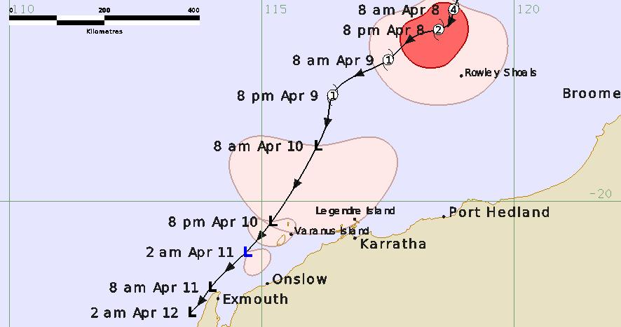

Figure 2 Detailed best track of Severe Tropical Cyclone Olga near the west Pilbara coast 8-12 April 2024 (times in AWST, UTC +8)

|  |  |  |  |  |  |  |  |  |  |  |  |  |
| --- | --- | --- | --- | --- | --- | --- | --- | --- | --- | --- | --- | --- |
| **Year** | **Month** | **Day** | **Hour UTC** | **Pos. Lat S** | **Pos. Long. E** | **Pos. Acc. Nm** | **Mean wind kn** | **Max. gust kn** | **Cent. Press hPa** | **Rad of gales (NE/SE/SW/NW) nm** | **Rad of storm (NE/SE/SW/NW) nm** | **RMW nm** |
| 2024 | 04 | 4 | 12 | 11.0 | 119.5 | 30 | 10 | 45 | 1005 |  |  |  |
| 2024 | 04 | 4 | 18 | 11.5 | 119.7 | 30 | 20 | 45 | 1005 |  |  |  |
| 2024 | 04 | 5 | 00 | 11.9 | 119.9 | 20 | 20 | 45 | 1005 |  |  |  |
| 2024 | 04 | 5 | 06 | 12.2 | 119.9 | 20 | 25 | 45 | 1003 |  |  |  |
| 2024 | 04 | 5 | 12 | 12.5 | 119.9 | 30 | 30 | 45 | 1000 |  |  |  |
| 2024 | 04 | 5 | 18 | 12.6 | 120.0 | 20 | 35* | 50 | 999 | 0/60/60/0 |  |  |
| 2024 | 04 | 6 | 00 | 12.7 | 120.1 | 20 | 40 | 55 | 996 | 50/50/40/40 |  | 25 |
| 2024 | 04 | 6 | 06 | 13.1 | 120.1 | 10 | 50 | 70 | 988 | 50/60/50/40 | 30/30/0/0 | 20 |
| 2024 | 04 | 6 | 12 | 13.6 | 120.1 | 15 | 55 | 75 | 985 | 50/70/60/50 | 30/30/0/0 | 15 |
| 2024 | 04 | 6 | 18 | 14.1 | 119.8 | 15 | 65 | 90 | 978 | 50/70/60/40 | 25/40/30/25 | 15 |
| 2024 | 04 | 7 | 00 | 14.4 | 119.4 | 15 | 75 | 105 | 970 | 50/70/60/40 | 25/40/40/25 | 15 |
| 2024 | 04 | 7 | 06 | 14.8 | 119.2 | 15 | 95 | 135 | 949 | 50/70/70/40 | 25/40/45/25 | 12 |
| 2024 | 04 | 7 | 12 | 15.4 | 119.1 | 10 | 110 | 155 | 934 | 70/80/80/50 | 40/50/50/35 | 8 |
| 2024 | 04 | 7 | 18 | 15.8 | 119.0 | 10 | 110 | 155 | 933 | 60/80/80/50 | 35/50/50/35 | 8 |
| 2024 | 04 | 8 | 00 | 16.2 | 118.8 | 15 | 95 | 135 | 953 | 60/80/80/50 | 35/50/50/30 | 10 |
| 2024 | 04 | 8 | 06 | 16.5 | 118.7 | 15 | 75 | 105 | 969 | 40/80/60/40 | 25/30/30/25 | 15 |
| 2024 | 04 | 8 | 12 | 16.6 | 118.5 | 20 | 60 | 85 | 981 | 40/90/90/40 | 35/35/50/25 | 20 |
| 2024 | 04 | 8 | 18 | 16.7 | 118.1 | 15 | 50 | 70 | 991 | 40/120/100/55 | 0/40/50/35 | 25 |
| 2024 | 04 | 9 | 00 | 17.2 | 117.5 | 10 | 45 | 65 | 993 | 35/120/100/50 |  | 25 |
| 2024 | 04 | 9 | 06 | 17.6 | 116.7 | 15 | 45 | 55 | 993 | 30/100/80/40 |  | 25 |
| 2024 | 04 | 9 | 12 | 17.9 | 116.4 | 15 | 45 | 55 | 993 | 30/90/80/0 |  | 20 |
| 2024 | 04 | 9 | 18 | 18.4 | 116.3 | 15 | 45* | 55 | 993 | 0/90/120/0 |  |  |
| 2024 | 04 | 10 | 00 | 18.9 | 116.1 | 15 | 45* | 65 | 993 | 0/100/110/0 |  |  |
| 2024 | 04 | 10 | 06 | 19.8 | 115.6 | 15 | 40* | 55 | 997 | 0/80/50/0 |  |  |
| 2024 | 04 | 10 | 12 | 20.4 | 115.2 | 15 | 35* | 50 | 1003 | 0/30/30/0 |  |  |
| 2024 | 04 | 10 | 18 | 21.0 | 114.7 | 15 | 35* | 50 | 1004 | 0/30/0/0 |  |  |
| 2024 | 04 | 11 | 00 | 21.7 | 114.0 | 15 | 25 | 45 | 1006 |  |  |  |
| 2024 | 04 | 11 | 06 | 22.1 | 113.7 | 15 | 25 | 45 | 1007 |  |  |  |
| 2024 | 04 | 11 | 12 | 22.2 | 113.6 | 15 | 25 | 45 | 1008 |  |  |  |
| 2024 | 04 | 11 | 18 | 22.2 | 113.6 | 15 | 25 | 45 | 1009 |  |  |  |

Table 1 Best track summary for Severe Tropical Cyclone Olga, 4-11 April 2024.  
UTC=AWST-8. * Not at tropical cyclone intensity as gales less than halfway around centre.

1. Meteorological description

2.1 Intensity analysis

A comparison of the subjective and objective intensity estimates is shown in Figure 12.

An active monsoon burst developed over waters to the north of Australia in early April associated with a weak MJO signal. A westward moving Equatorial Rossby wave assisted in the development of a low just to the south of Sumba on 4 April, refer Figure 3. An initial Data T (DT) number of 1.5 was assigned at 1800 UTC 4 April. The low moved southwards and developed with improved curved banding around the centre on imagery. By 1800 UTC 5 April an AMSR2 microwave pass indicated strong curved banding, refer Figure 4, and also gales in the southern quadrants. Subjective Dvorak estimates reached 3.0 at 0000 UTC 6 April. An 0130 UTC 6 April ASCAT pass indicated gales were present in all quadrants so tropical cyclone intensity was assigned from 0000 UTC 6 April, refer Figure 5.

With high sea surface temperatures, low vertical wind shear and abundant moisture, Olga was in a favourable environment for development. During 6 April an amplifying mid-level trough to the southwest of Olga increased poleward outflow and these factors all combined to assist in the rapid intensification of the tropical cyclone. Through the overnight period of 6 April EIR imagery showed deep convection in a spiral band pattern with very cold tops. There was a lack of microwave imagery through this period but ASCAT passes showed the mean wind speed had increased significantly with hurricane force winds present in eastern quadrants by 1400 UTC 6 April, refer Figure 6. From around 1700 UTC 6 April EIR imagery indicated an eye beginning to emerge and a 2002 UTC SSMIS pass showed a microwave eye present. An eye was maintained in EIR imagery through 7 April with a peak subjective Dvorak DT of 6.5 reached at 1200 UTC 7 April, refer Figure 7 and Figure 8. This combined with objective intensity estimates and a SAR pass indicate Olga reached a peak intensity of around 110 kn (205 km/h) at this time, refer Figure 12. The mid-level trough to the southwest of Olga increased the vertical wind shear and Olga began to suffer the effects of this. From 1500 UTC 7 April the eye disappeared from satellite imagery. There was dry air located to the northwest of Olga and the trough assisted to entrain this dry air into the core of Olga. The cyclone weakened rapidly from this point onwards.

By about 0600 UTC 8 April Olga had lost the deep convection from the northern side and a low-level centre became completely exposed, refer Figure 9. Subjective and objective intensity estimates decreased steadily (refer Figure 12), and Olga weakened below tropical cyclone strength at 1800 UTC 9 April. The remnant low continued to move to the southwest, parallel to the Pilbara coast and gales were present in the southern quadrants until 1800 UTC 10 April. By 0000 UTC 11 April a weak low was located north of Exmouth which drifted southwest and dissipated some 24 hours later.

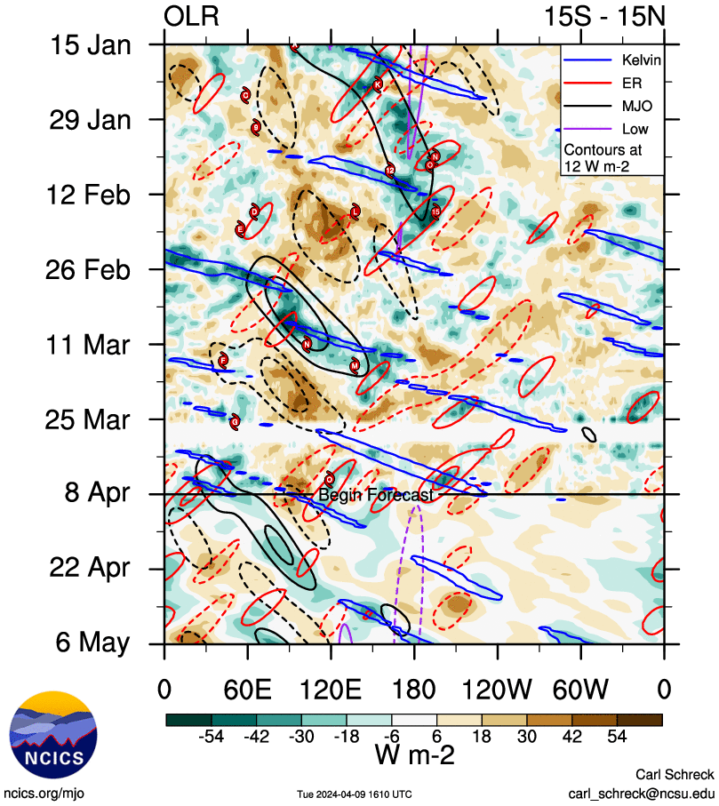

Figure 3 Hovmoller diagram of tropical waves showing the formation of Olga on 4-6 April (indicated by cyclone symbol) occurred with a strong pulse of the MJO (black), and Equatorial Rossby (ER) wave (red), and some Kelvin wave (blue). Image courtesy of North Carolina Institute for Climate Studies (ncics.org).

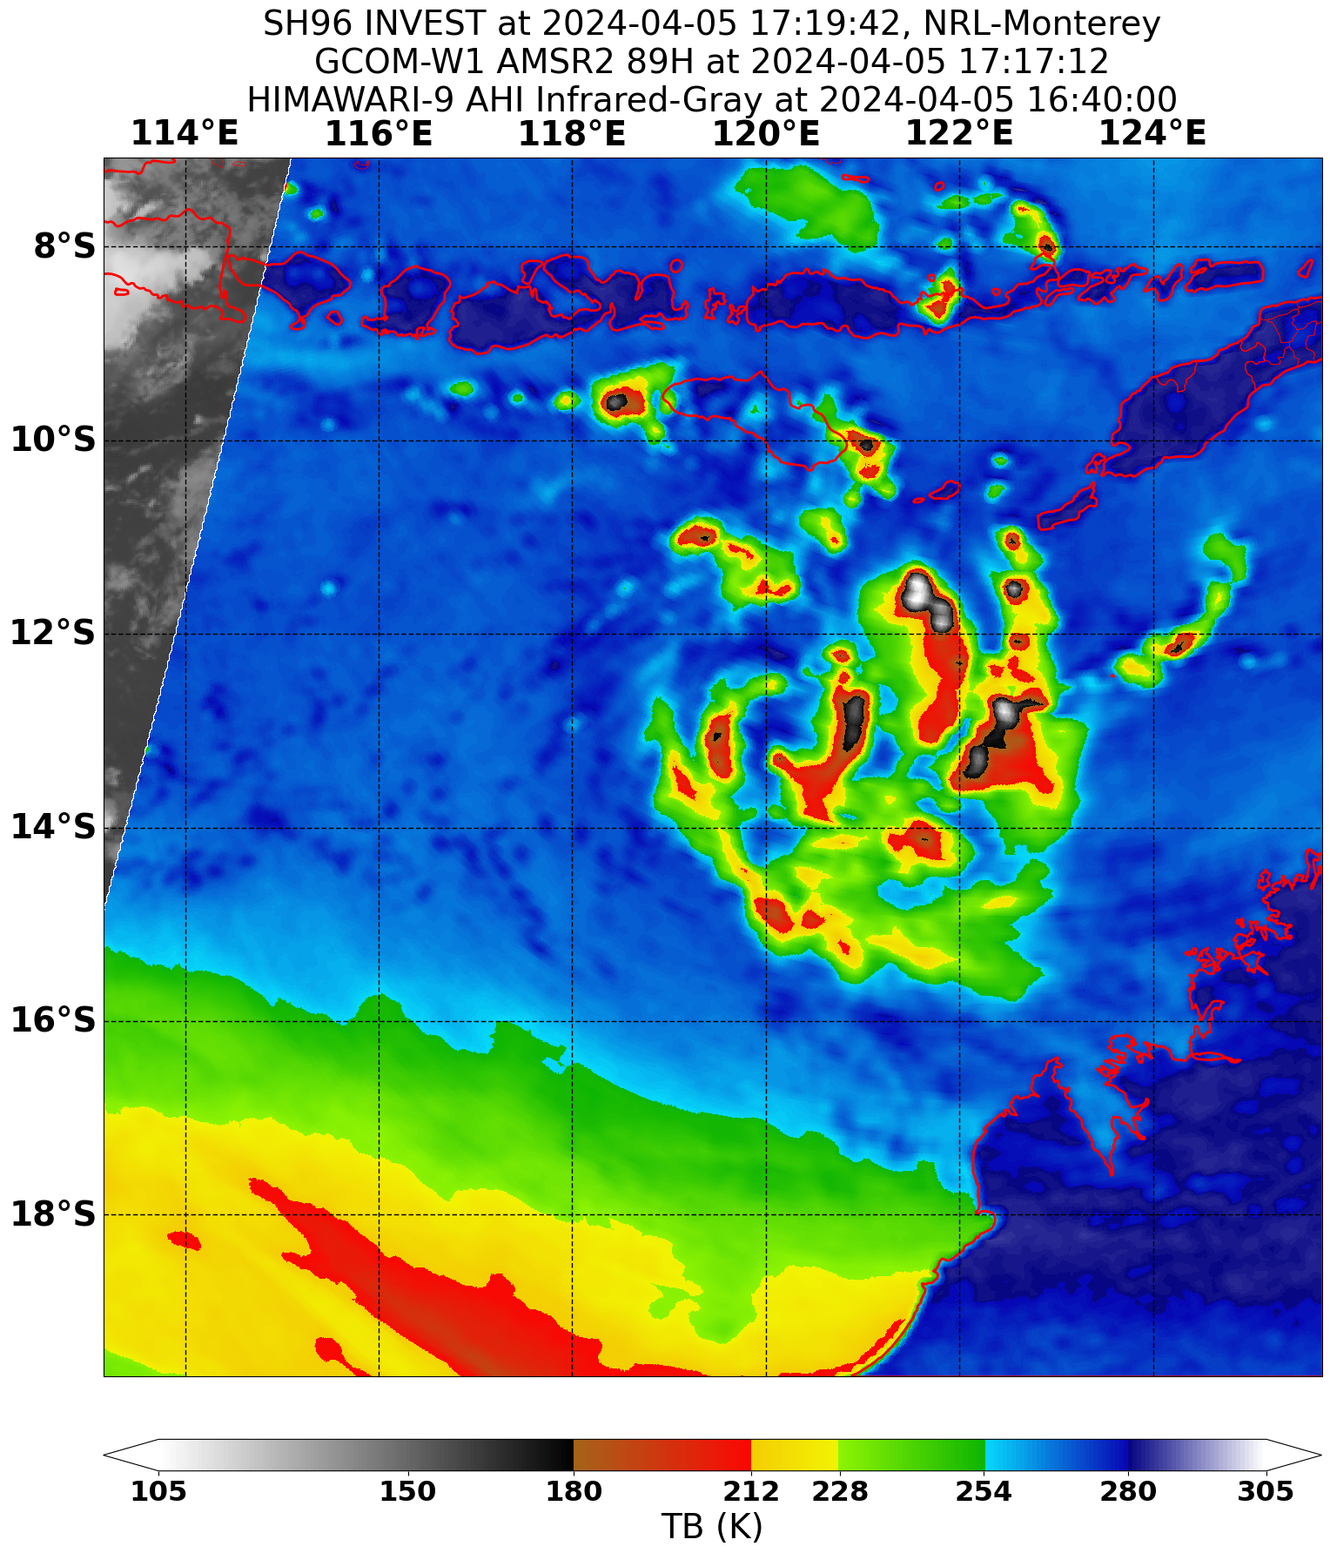

Figure 4 An AMSR2 microwave pass at 1717 UTC 5 April showing improved curved banding around the centre.

Image courtesy NRL: <https://www.nrlmry.navy.mil/TC.html>

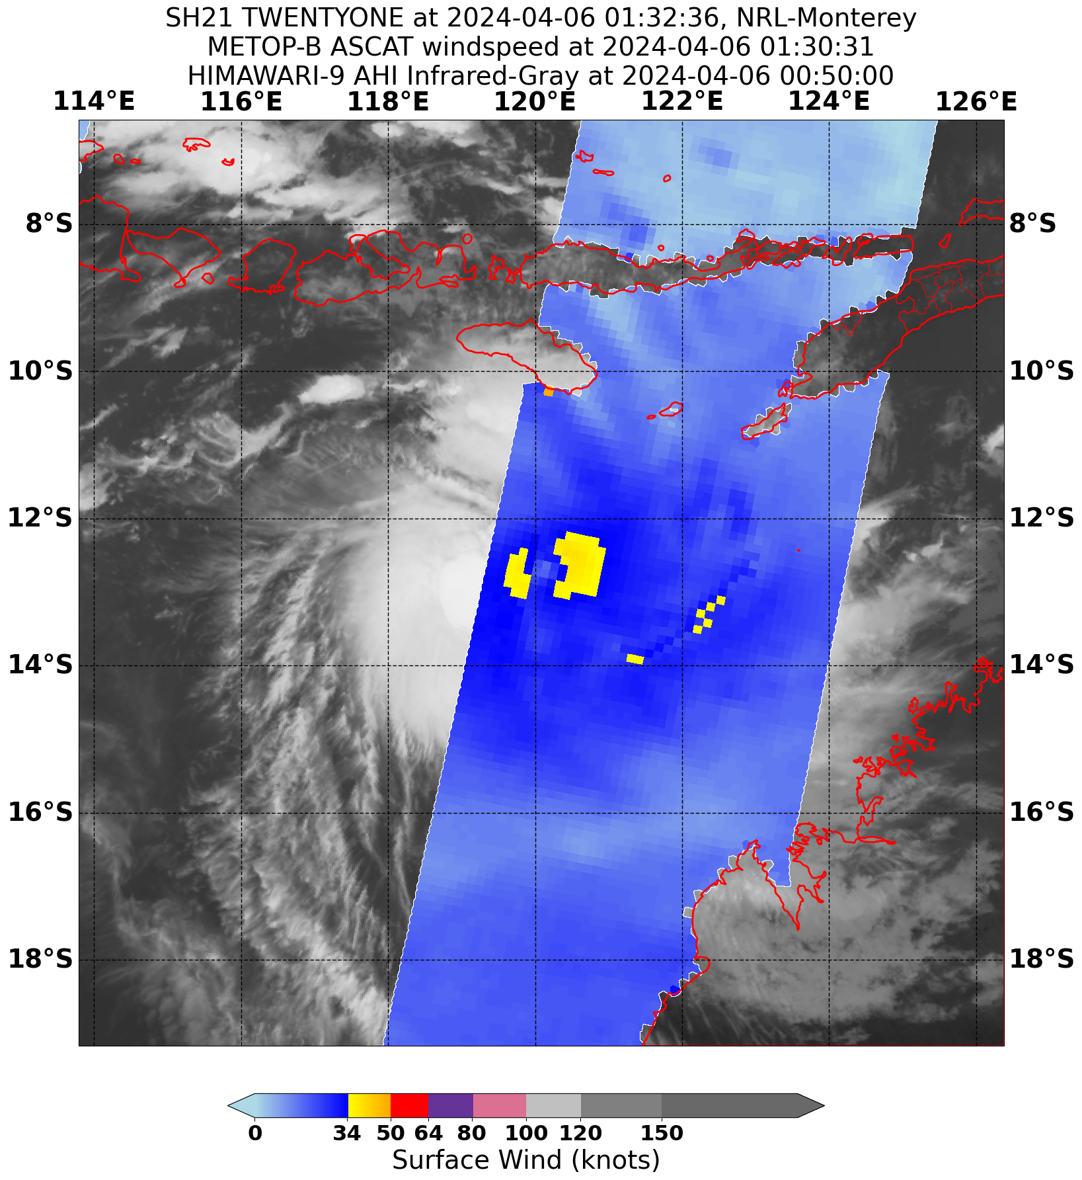

Figure 5 An ASCAT B pass at 0131 UTC 6 April indicated gales were present in all quadrants.

Image courtesy NRL: <https://www.nrlmry.navy.mil/TC.html>

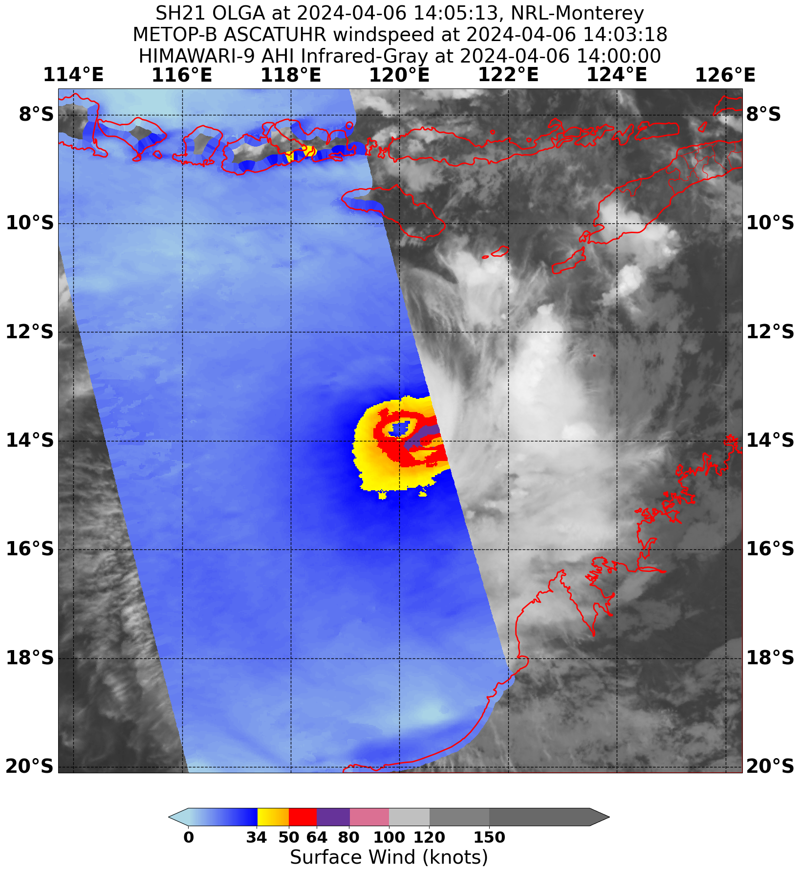

Figure 6 An ASCAT- B pass at 1403 UTC 6 April indicating hurricane force winds present in eastern quadrants.

Image courtesy NRL: <https://www.nrlmry.navy.mil/TC.html>

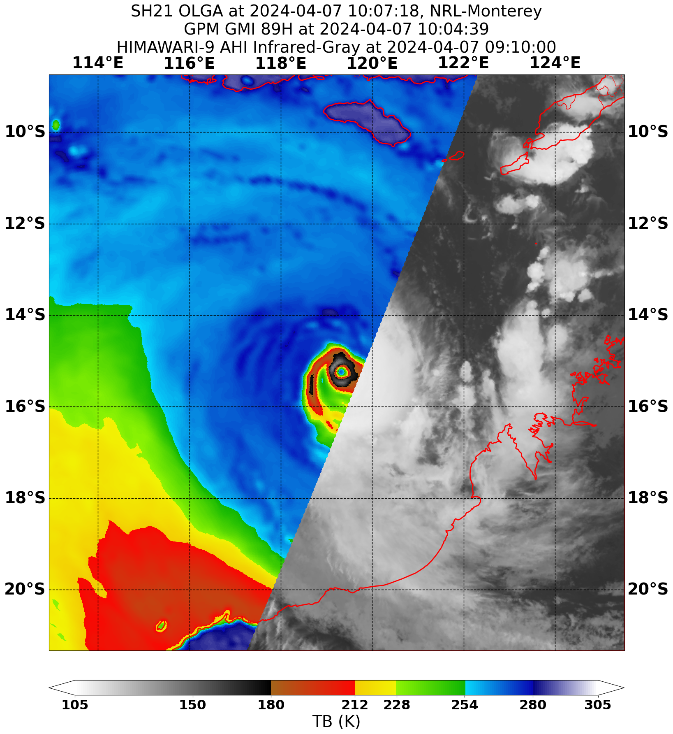

Figure 7 A GMI microwave pass at 1003 UTC 7 April near peak intensity.

Image courtesy NRL: <https://www.nrlmry.navy.mil/TC.html>

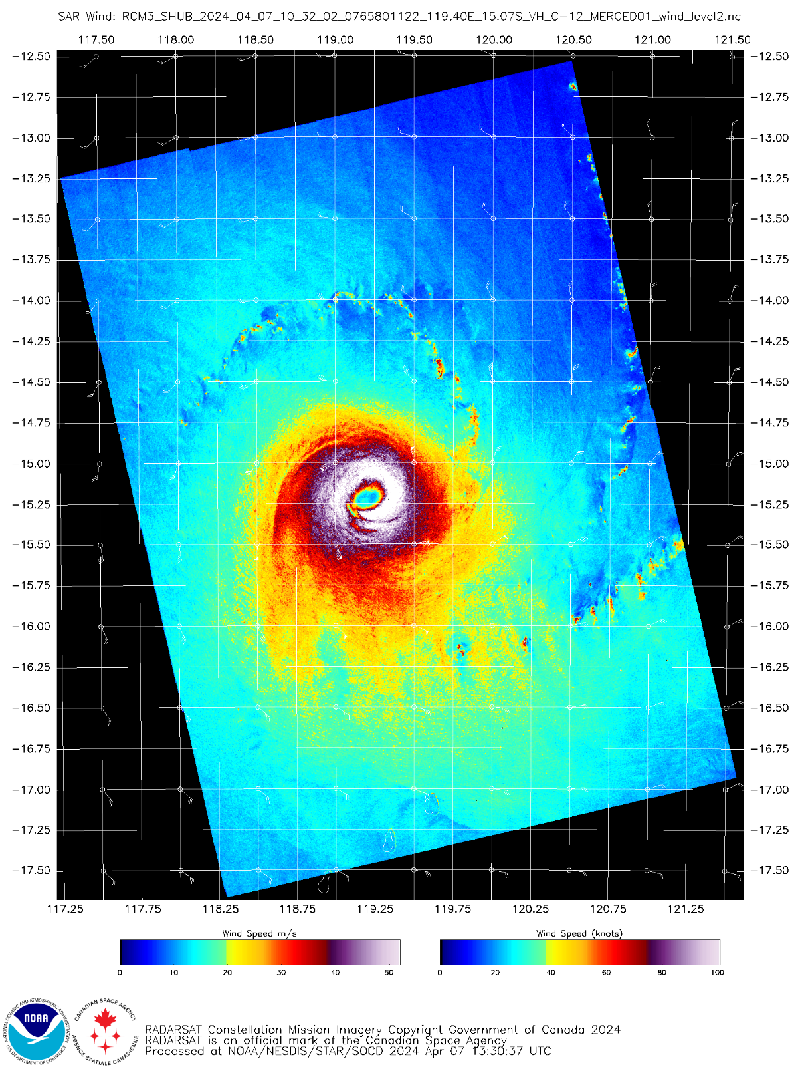

Figure 8 A SAR wind pass at 1032 UTC 7 April near peak intensity.

Image courtesy https://www.star.nesdis.noaa.gov/socd/mecb/sar/sarwinds_tropical.php?year=2024&storm=SH212024_OLGA

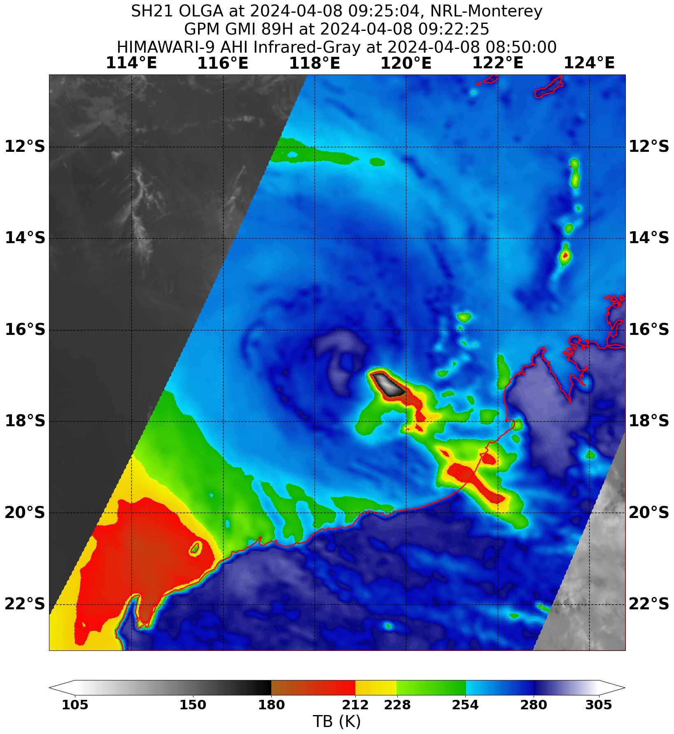

Figure 9 A GMI microwave pass at 0922 UTC 8 April showing the loss of deep convection from the northern side with a completely exposed low level centre.

Image courtesy NRL: <https://www.nrlmry.navy.mil/TC.html>

2.1 Structure

Olga initially had gales in the southern quadrants with a radius of 60 nm before extending to northern quadrants. For most of the cyclone's life the southern gale and storm force wind extent was larger than the northern, and this wa also reflected in hurricane the extent of hurricane force winds, refer Figure 8. As Olga weakened the northern gale and storm radii remained small but the southern radii extended to 120 nm. This was due to the convection becoming located at a distance from the centre in southern quadrants, the result of strong northwest vertical wind shear.

The radius of maximum winds decreased from 25 nm to 8 nm at its most intense before expanding to 25 nm again as it weakened.

2.2 Motion

Olga was located in the upper ridge which resulted in slow movement to the south during 4-7 April. By 8 April the mid-level trough to the southwest of Olga increased the vertical wind shear, this resulted in Olga losing the upper part of its circulation and weakened the cyclone, steering was then dominated by the lower-level ridge and Olga moved in a more west-southwest direction until the low dissipated on 12 April.

1. Impact

Olga disrupted offshore oil and gas activities over the Northwest Shelf region. Island locations such as Rowley Shoals, Legendre Island and Varanus Island recorded periods of gales but there was no recorded damage. There were no gales recorded from any locations on mainland Australia.

1. Observations
   1. Winds

**Rowley Shoal AWS** recorded non-continuous gales between 0042-2324 UTC 8 April (0842 8 April to 0724 AWST 9 April); maximum 10-minute wind of 44.5 kn (82 km/h) at 0707 UTC 8 April (1507 AWST 8 April) and maximum gust of 55 kn (102 km/h) at 1017 UTC 8 April (1817 AWST 8 April).

**Legendre Island AWS** recorded non-continuous gales between 1046 UTC 9 April (1846 9 April AWST) to 0744 UTC 10 April (1544 10 April AWST); maximum 10-minute wind of 46 kn (85 km/h) at 2127-2128 UTC 9 April (0527-0528 AWST 10 April) and maximum gust of 55 kn (102 km/h) at 2125 UTC 9 April (0525 AWST 10 April).

**Varanus Island AWS** recorded non-continuous gales between 1040 UTC 9 April (1840 9 April AWST) to 1129 UTC 10 April (1929 10 April AWST); maximum 10-minute wind of 43 kn (80 km/h) at 0000-0003 UTC 10 April (0800-0803 10 April AWST) and maximum gust of 50 kn (95 km/h) at 2353 and 2359 UTC 9 April (0753 and 0759 10 April AWST).

* 1. Pressure

|  |  |  |
| --- | --- | --- |
| Location | Pressure hPa | Time |
| Rowley Shoals AWS | 998.8 hPa | 0733 UTC (1533 AWST) 8 April |

1. Forecast Performance

The accuracy statistics for Severe Tropical Cyclone Olga are below in Table 2 and shown in Figure 10 and Figure 11.

Tropical Cyclone Forecast Track Maps began at 0000 UTC 5 April and continued through until 1800 UTC 10 April.

As shown in Figure 10 and Figure 11, the forecast track position accuracy was comparable to the five-year average until 36 hours when it became significantly poorer. The intensity accuracy was poorer than the five-year average at all forecast times up to 120 hours. The model guidance for location and intensity did not perform well during Olga. Model guidance indicated tracks that turned to the west much earlier than occurred which caused large errors in forecast positions at longer lead times. The intensity forecasts from model guidance were variable with some model runs indicating intensification and others indicating only a modest system. There was only a limited period when conditions were favourable for development and models struggled to resolve this. Some indicated an upper trough to the southwest would shear the system and limit the development earlier than occurred. This caused large errors in intensity forecasts and hence poor accuracy figures, especially between 24- and 96-hour lead times.

The seven-day forecast first mentioned the possibility of a tropical cyclone on 30 March with a Low (10%) probability of development over waters north of the Pilbara for 6 April. On 2 April the risk was increased to Moderate (25%) from 00 UTC 7 April. This was further increased at 00 UTC 3 April to High (55-60%) from 00 UTC 7 April. This was gradually brought forward to 6 April which is when formation occurred.

|  |  |  |  |  |  |  |  |  |  |  |
| --- | --- | --- | --- | --- | --- | --- | --- | --- | --- | --- |
| Time | 00 | 06 | 12 | 18 | 24 | 36 | 48 | 72 | 96 | 120 |
| Position accuracy (km) | 18 | 38 | 54 | 66 | 75 | 91 | 134 | 243 | 396 | 549 |
| Intensity accuracy (knots) | 4.8 | 5.9 | 7.0 | 9.1 | 12.5 | 15.5 | 17.1 | 9.6 | 8.6 | 6.4 |
| Sample size | 23 | 23 | 23 | 23 | 22 | 21 | 19 | 13 | 11 | 7* |

Table 2 Verification statistics for Severe Tropical Cyclone Olga.  
*sample size less than 10 is not considered reliable  
 Note, verification is performed using the Official Forecast Tracks at the standard times of 00, 06,12 and 18 UTC.

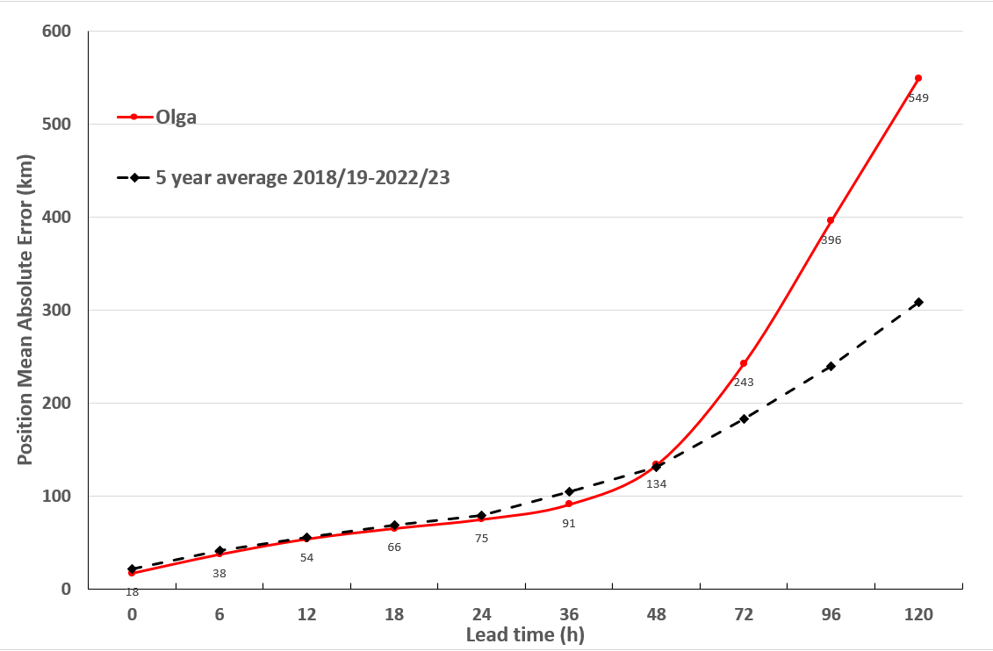

Figure 10 Position accuracy figures for Severe Tropical Cyclone Olga.

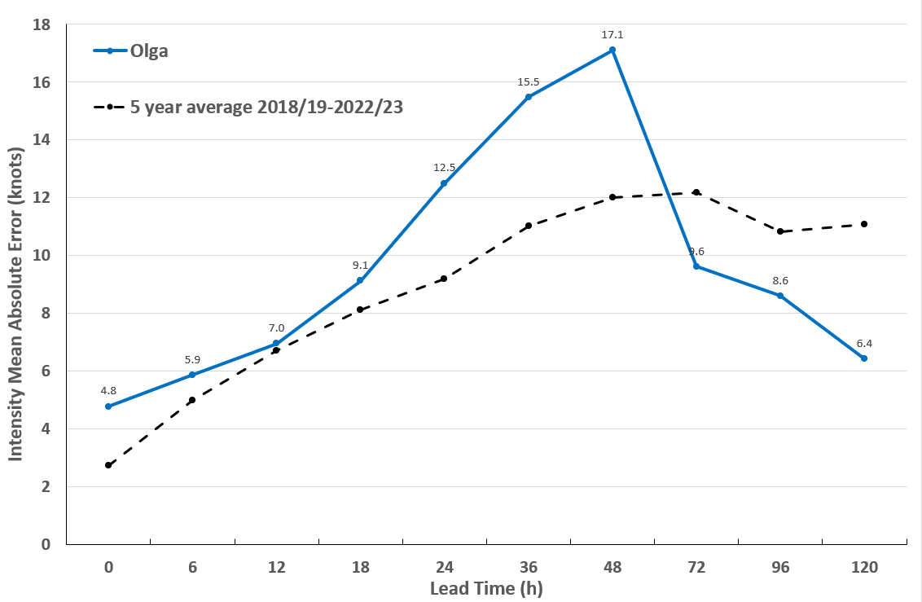

Figure 11 Intensity accuracy figures for Severe Tropical Cyclone Olga.

Appendix: List of abbreviations

|  |  |
| --- | --- |
| Abbreviation | Term |
| ADT | Advanced Dvorak Technique |
| ACST | Australian Central Standard Time |
| AEST | Australian Eastern Standard Time |
| AiDT | AI-enhanced Dvorak Technique |
| AMSR2 | Advanced Microwave Scanning Radiometer |
| AMSU | Advanced Microwave Sounding Unit |
| ASCAT | Advanced Scatterometer |
| ATMS | Advanced Technology Microwave Sounder |
| AWS | automatic weather station |
| AWST | Australian Western Standard Time |
| °C | Celsius |
| CI | Current intensity |
| CIMSS | Cooperative Institute for Meteorological Satellite Studies (USA) |
| CIRA | Cooperative Institute for Research in the Atmosphere (USA) |
| D-MINT | Deep learning - Multispectral Intensity of TCs (formerly known as DMN) |
| D-PRINT | Deep learning - IR Intensity of TCs (formerly known as OPEN-AIIR) |
| EIR | Enhanced InfraRed |
| ERC | eyewall replacement cycle |
| FNMOC | Fleet Numerical Meteorology and Oceanography Centre (USA) |
| FT | Final T-number |
| GCOM | Global Change Observation Mission |
| GHz | Gigahertz |
| GMI | Global Precipitation Measurement Microwave Imager |
| h | hour |
| hPa | hectopascal |
| HSCAT | Hai Yang 2 Scatterometer (HY-2B, HY-2C) |
| km | kilometres |
| km/h | kilometres per hour |
| kn | knot |
| LLCC | LLCC |
| MET | Model Expected T-number |
| METOP | Meteorological Operational Satellite |
| MJO | Madden-Julian Oscillation |
| mm | millimetres |
| MSLP | mean sea level pressure |
| NESDIS | National Environmental Satellite, Data, and Information Service |
| nm | nautical mile |
| NOAA | National Oceanic and Atmospheric Administration |
| NRL | Navy Research Lab (USA) |
| OPEN-AiiR | Ordered Pattern Encoding AI Infrared |
| PAT | Pattern T-number |
| RCM | RadarSat Constellation Mission – Synthetic Aperture Radar |
| RH | relative humidity |
| RMW | radius of maximum winds |
| RSMC | Regional Specialised Meteorological Centre |
| SAR | Synthetic Aperture Radar |
| SATC | CIMSS Advanced Dvorak Technique |
| SATCON | Satellite Consensus |
| SEN1 | Sentinel-1A – Synthetic Aperture Radar |
| SMAP | Soil Moisture Active Passive |
| SMOS | Soil Moisture and Ocean Salinity |
| SSMIS | Special Sensor Microwave Imager/Sounder |
| TC | Tropical Cyclone |
| TCWC | Tropical Cyclone Warning Centre |
| UTC | Universal Time Co-ordinated |

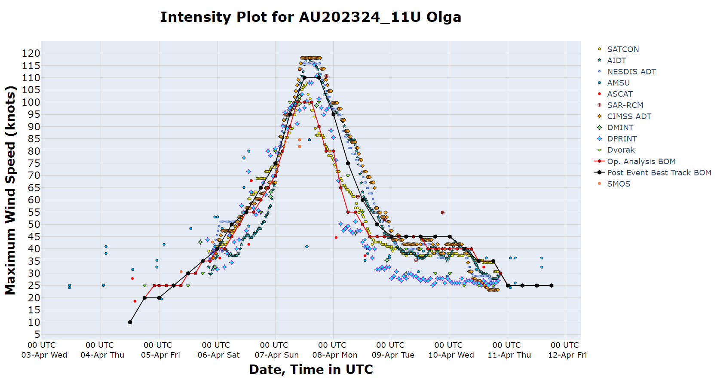

Figure 12 Intensity plot of objective and subjective guidance.  
SATCON, AiDT, NESDIS ADT, AMSU, SAR-RCM, ASCAT, CIMSS ADT, DMINT, DPRINT, Dvorak (subjective estimate), operational analysis (red) and post event best track analysis (black). All winds are 10-minute estimates.