Tropical Cyclone Paul (13U)

# 9 – 12 April 2024

## Joe Courtney, Tropical Cyclone Environmental Prediction Services

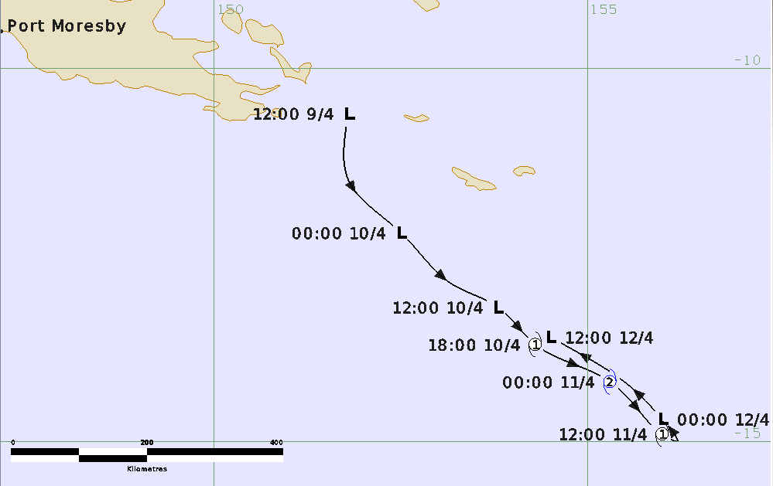

**Revision history**

|  |  |  |  |
| --- | --- | --- | --- |
| Date | Version | Author | Description |
| 16/04/2024 | 1.0 | Joe Courtney | Final draft ready |

**Review status**

|  |  |  |  |
| --- | --- | --- | --- |
| Date | Version | Reviewer | Description |
| 17/04/2024 | 1.0 | Linda Paterson | Completed |

**Release history**

|  |  |  |  |
| --- | --- | --- | --- |
| Date | Version | Status | Approval |
| 19/04/2024 | 1.0 | Approved for release | Andrew Burton |

Contact details:

Tropical Cyclone Team Lead

Weather Environmental Prediction Services

Bureau of Meteorology

PO Box 1370, West Perth WA 6872

Email: [tcwc@bom.gov.au](mailto:tcwc@bom.gov.au)



This work is copyright. Apart from any use as permitted under the Copyright Act 1968, no part may be reproduced without prior written permission from the Bureau of Meteorology. Refer to www.bom.gov.au/other/copyright.shtml for further information. Unless otherwise noted, all images in this document are licensed under the Creative Commons Attribution Australia Licence.

© Commonwealth of Australia 2024

Published by the Bureau of Meteorology

Cover image: Track of Tropical Cyclone Paul 9-12 April 2024. Times in UTC (AEST-10h)

Contents

1. Summary 5

2. Meteorological description 7

2.1 Intensity analysis 7

2.1 Structure 8

2.2 Motion 8

3. Impact 8

4. Observations 8

5. Forecast Performance 12

Appendix: List of abbreviations 14

**List of Figures**

Figure 1. Best track of Tropical Cyclone Paul 9-13 April 2024. 5

Figure 2. Detailed best track of Tropical Cyclone Paul 10-12 April 2024. 6

Figure 3. Panel of visible images at 0000 UTC from 9-12 April. 9

Figure 4. AMSR2 microwave images at 0328 UTC 10 April (37 and 89 GHz) 10

Figure 5. ASCAT images from ASCAT-C 1153 UTC 10 April and ASCAT-B 1040 UTC 11 April. 11

Figure 6. Comparison of model surface winds and MSLP for the run on 0000 UTC 10 April valid for 1800 UTC 10 April. 13

Figure 7. Intensity plot of objective and subjective guidance.. 16

**List of Tables**

Table 1. Best track summary for Tropical Cyclone Paul, 9-12 April 2024. 6

Table 2. Verification statistics for Tropical Cyclone Paul. 12

1. Summary

Tropical Cyclone Paul was a small short-lived tropical cyclone in the eastern Coral Sea that caused no known impacts.

A tropical low (designated AU202324_13U) formed over the Louisiade Archipelago of the Milne Bay province of Papua New Guinea late on 9 April. The low moved south into the northeast Coral Sea and developed in favourable environmental conditions. Deep convection was sustained near the centre during 10 April and tropical cyclone intensity was estimated at 1800 UTC 10 April. Satellite winds from scatterometry indicated that Tropical Cyclone Paul was a very small system with gales only extending 30-40 nm (55-75 km) from the centre.

Paul reached category 2 intensity during 11 April as it continued to move to the southeast. Late in the day the combination of increasing northwesterly vertical wind shear and the entrainment of dry air into the circulation rapidly weakened the circulation. By 0000 UTC 12 April Paul was estimated to be below tropical cyclone intensity and then dissipated later that day as the shallow circulation was steered to the northwest.

The track in Figure 1 shows the southeast motion from 9-11 April followed by an abrupt reversal in motion to the northwest on 12 April, while a more detailed track show in Figure 2 shows the extent of gale and storm-force winds at higher resolution.

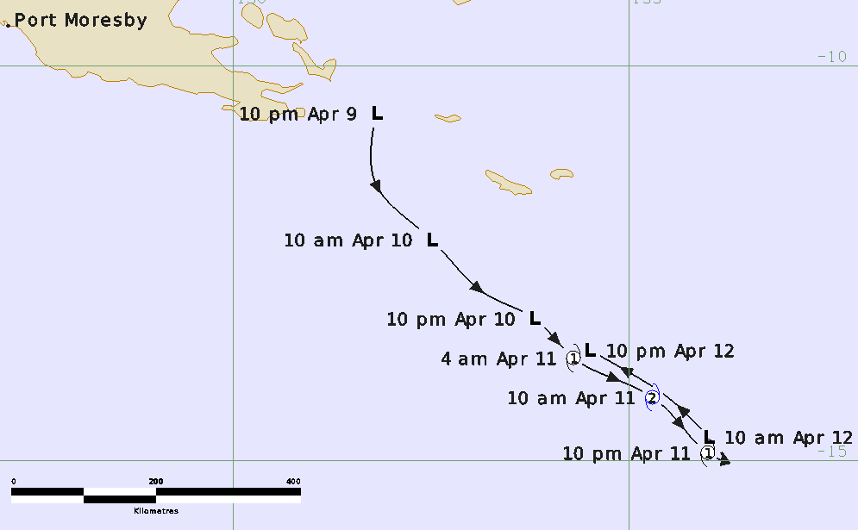

Figure 1. Best track of Tropical Cyclone Paul 9-13 April 2024 (times in AEST, UTC +10h).

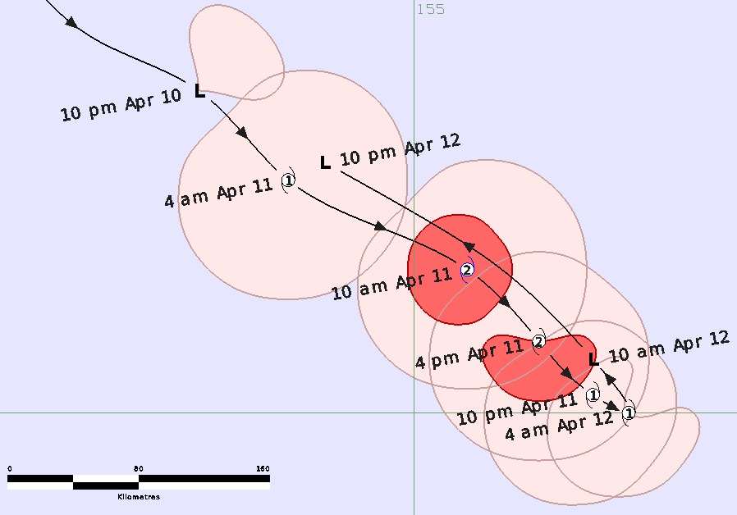

Figure 2. Detailed best track of Tropical Cyclone Paul 10-12 April 2024 (times in AEST, UTC +10h).

|  |  |  |  |  |  |  |  |  |  |  |  |  |
| --- | --- | --- | --- | --- | --- | --- | --- | --- | --- | --- | --- | --- |
| **Year** | **Month** | **Day** | **Hour UTC** | **Pos. Lat S** | **Pos. Long. E** | **Pos. Acc. Nm** | **Mean wind kn** | **Max. gust kn** | **Cent. Press hPa** | **Rad of gales (NE/SE/SW/NW) nm** | **Rad of storm (NE/SE/SW/NW) nm** | **RMW nm** |
| 2024 | 04 | 9 | 12 | 10.6 | 151.8 | 40 | 15 | 45 | 1004 |  |  |  |
| 2024 | 04 | 9 | 18 | 11.5 | 151.8 | 35 | 20 | 45 | 1004 |  |  |  |
| 2024 | 04 | 10 | 00 | 12.2 | 152.5 | 25 | 25 | 45 | 1004 |  |  |  |
| 2024 | 04 | 10 | 06 | 12.9 | 153.2 | 20 | 30 | 45 | 1002 |  |  |  |
| 2024 | 04 | 10 | 12 | 13.2 | 153.8 | 20 | 35* | 50 | 1000 | 30/0/0/0 |  |  |
| 2024 | 04 | 10 | 18 | 13.7 | 154.3 | 20 | 45 | 65 | 998 | 40/40/40/30 |  | 15 |
| 2024 | 04 | 11 | 00 | 14.2 | 155.3 | 20 | 50 | 70 | 994 | 40/40/40/30 | 15/15/20/20 | 15 |
| 2024 | 04 | 11 | 06 | 14.6 | 155.7 | 20 | 50 | 70 | 994 | 30/40/40/30 | 0/20/20/0 | 15 |
| 2024 | 04 | 11 | 12 | 14.9 | 156.0 | 20 | 45 | 65 | 996 | 25/30/40/25 |  | 15 |
| 2024 | 04 | 11 | 18 | 15.0 | 156.2 | 25 | 40 | 55 | 998 | 0/25/30/20 |  | 15 |
| 2024 | 04 | 12 | 00 | 14.7 | 156.0 | 25 | 25 | 45 | 1002 |  |  |  |
| 2024 | 04 | 12 | 06 | 14.0 | 155.2 | 15 | 20 | 35 | 1004 |  |  |  |
| 2024 | 04 | 12 | 12 | 13.6 | 154.5 | 20 | 15 | 25 | 1005 |  |  |  |

Table 1. Best track summary for Tropical Cyclone Paul, 9-12 April 2024.

UTC=AEST-10. * Not at tropical cyclone intensity as gales less than halfway around centre.

1. Meteorological description

2.1 Intensity analysis

Table 1 shows the summary data at the standard six-hourly times from 9 to 12 April. A comparison of the subjective and objective intensity estimates is shown in Figure 7. Figure 3 shows the sequence of visible images at 0000 UTC each day from 9 to 12 April showing the intensification and weakening of Paul.

Deep convection developed on 9 April over the Louisiade Archipelago of the Milne Bay province of Papua New Guinea supported by a weak Rossby wave. A tropical low (designated AU202324_13U) formed that night and moved south into the northeast Coral Sea. The initial T1 Dvorak classification was estimated at 1800 UTC 9 April given ongoing deep convection near the centre.

Development was assisted by warm ocean temperatures of 29.5-30°C, strong upper-level divergent flow south of the centre associated with a mid-latitude trough to the south, low vertical wind shear and moist low to mid-level flow from tropical origins.

The AMSR2 microwave pass at 0328 UTC 10 April in Figure 4 showed a developed low-level circulation (37 GHz) and curved bands developing both north and south (89 GHz). A small region of gales was evident northeast of the centre on ASCAT passes (ASCAT-B 1101 UTC and the ASCAT-C 1153 UTC shown in Figure 5). Deep convection became further organised in the overnight period and tropical cyclone intensity was estimated at 1800 UTC 10 April when the system was named Tropical Cyclone Paul based on subjective Dvorak CI estimates reaching 3.0.

Peak intensity occurred at 0000 UTC 11 April when 10-minute maximum winds were estimated at 50 kn based on subjective Dvorak FT/CI estimates of 3.5. The visible image in Figure 3 shows deep convection near the centre. Objective guidance was less, for example SATCON 44 kn and ADT 41 kn (one-minute average) as shown in Figure 7 but this was not surprising given the small size of the circulation.

An increase in southeasterly winds associated with a ridge to the south assisted with inflow during the course of 11 April. However, visible imagery and enhanced infra-red showed a reduction in the extent and curvature of deep convection and warming cloud tops to indicate weakening. The system had moved to the southeast into a region of increasing upper-level west northwesterly winds which led to increasing vertical wind shear and entrainment of dry air on the western flank of the circulation. Nevertheless ASCAT-B at 1040 UTC 11 April showed gales extending in all quadrants. Weakening continued in the overnight period. Satellite winds from SMAP at 1922 UTC and SMOS 1951 UTC both showed a small region of gales only southwest of the centre, then ASCAT-C at 2240 UTC showed maximum winds to 30 kn in the unidirectional southeasterly flow indicating that the circulation had weakened below tropical cyclone intensity. The circulation then dissipated late on 12 April.

## 2.1 Structure

Tropical Cyclone Paul was a very small sized cyclone. The extent of gales, as indicated by scatterometry (Figure 5) only extended to 30-40 nm from the centre. Initially gales formed in the northeast quadrant at 1200 UTC 10 April then extended around the centre during 11 April before being most predominant in the southwest quadrant in the weakening stages as a result of a ridge well to the south. The extent of storm-force winds was only 20 nm (37 km) while the radius of maximum winds (RMW) was estimated at 15 nm (28 km) during its time as a tropical cyclone.

2.2 Motion

As shown in the track in Figure 1, during the formation stages the system was steered steadily to the southeast. The dominant steering influences were a mid-level ridge to the east and mid-level trough to the south.

As Paul weakened later on 11 April, the motion slowed and the influence of the low to mid-level ridge to the southwest began to dominate turning the system to the northwest.

1. Impact

There were no known impacts from Tropical Cyclone Paul.

1. Observations

Nil.

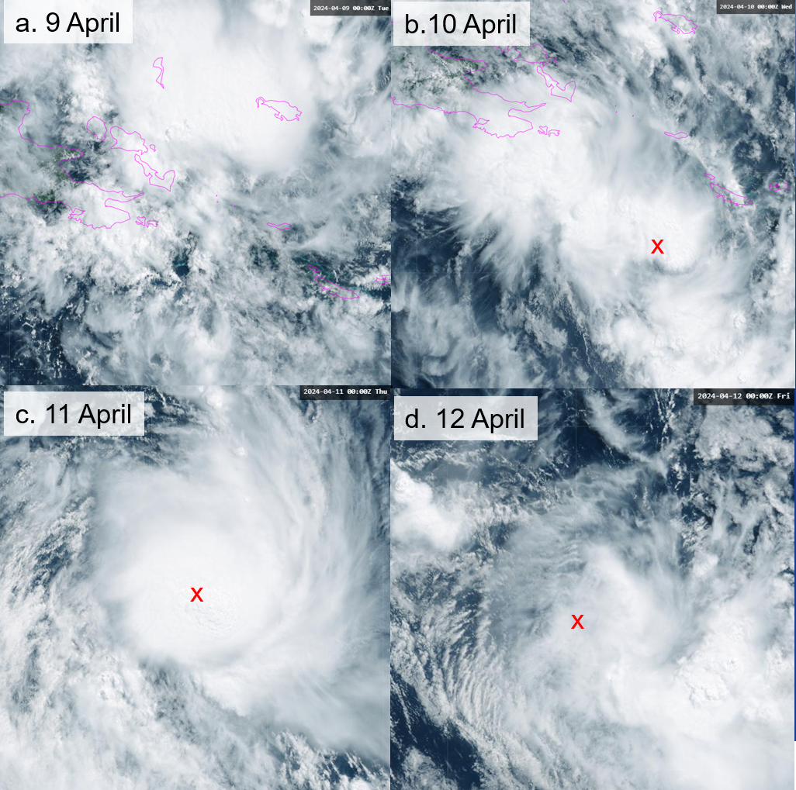

Figure 3. Panel of visible images at 0000 UTC from a. 9 April, b. 10 April, c. 11 April and d. 12 April. The red x marks the centre location.

|  |  |
| --- | --- |
| AMSR2 microwave image at 0328 UTC 10 April at 37 GHz showing a small but well defined circulation. | AMSR2 microwave images at 0328 UTC 10 April at 89 GHz showing deep convective bands north and south of the centre. |

Figure 4. AMSR2 microwave images at 0328 UTC 10 April of left 37 GHz (and right 89 GHz. Images courtesy of NRL: <https://www.nrlmry.navy.mil/TC.html>

|  |  |
| --- | --- |
| ASCAT images from ASCAT-C 1153 UTC 10 April showing gales in the northeast quadrant. | ASCAT images from left ASCAT-C 1153 UTC 10 April showing a small region of gales northeast of the centre and right ASCAT-B 1040 UTC 11 April showing gales around the centre. |

Figure 5. ASCAT images from left ASCAT-C 1153 UTC 10 April and right ASCAT-B 1040 UTC 11 April. Images courtesy of NRL: <https://www.nrlmry.navy.mil/TC.html>

1. Forecast Performance

The accuracy statistics for Tropical Cyclone Paul are below in Table 2. Given the short duration of the event, the low number of sample points reduces the significance of the standard metrics.

Tropical Cyclone Information Bulletins and Forecast Track Maps were issued six-hourly from 1900 UTC 10 April to 0100 UTC 12 April. Ocean wind warnings were issued from 1545 UTC 10 April to 0609 UTC 12 April.

In general NWP guidance did not indicate that a tropical cyclone would form with the exception of some runs of the US (GFS) model Even the model runs on the same day as the tropical cyclone formed did not suggest a tropical cyclone. Figure 6 is a model comparison of the European (EC), US (GFS), Australian (ACCESS-G) and UK models for the model run on 0000 UTC 10 April valid for 1800 UTC 10 April, when Paul was at tropical cyclone strength. All models depicted a weak tropical low. As a result the seven-day forecast underestimated the formation of the cyclone. The seven-day forecast first mentioned 13U on 8 April for a low rating (5-20% chance of a TC) on 11-13 April. The forecast rating was only upgraded (to High) within six hours of the declaration of Tropical Cyclone Paul early on 11 April.

|  |  |  |  |  |  |  |  |  |  |  |
| --- | --- | --- | --- | --- | --- | --- | --- | --- | --- | --- |
| Time | 00 | 06 | 12 | 18 | 24 | 36 | 48 | 72 | 96 | 120 |
| Position accuracy (km) | 8 | 51 | 76 | 83 | 124 | 173 | - | - | - | - |
| Intensity accuracy (knots) | 4.2 | 8.3 | 12.5 | 16.0 | 21.3 | 25.0 | - | - | - | - |
| Sample size | 6 | 6 | 6 | 5 | 4 | 2 | 0 | 0 | 0 | 0 |

Table 2. Verification statistics for Tropical Cyclone Paul. * Note, verification was performed using the Official Forecast Tracks at the standard times of 00, 06, 12 and 18 UTC.

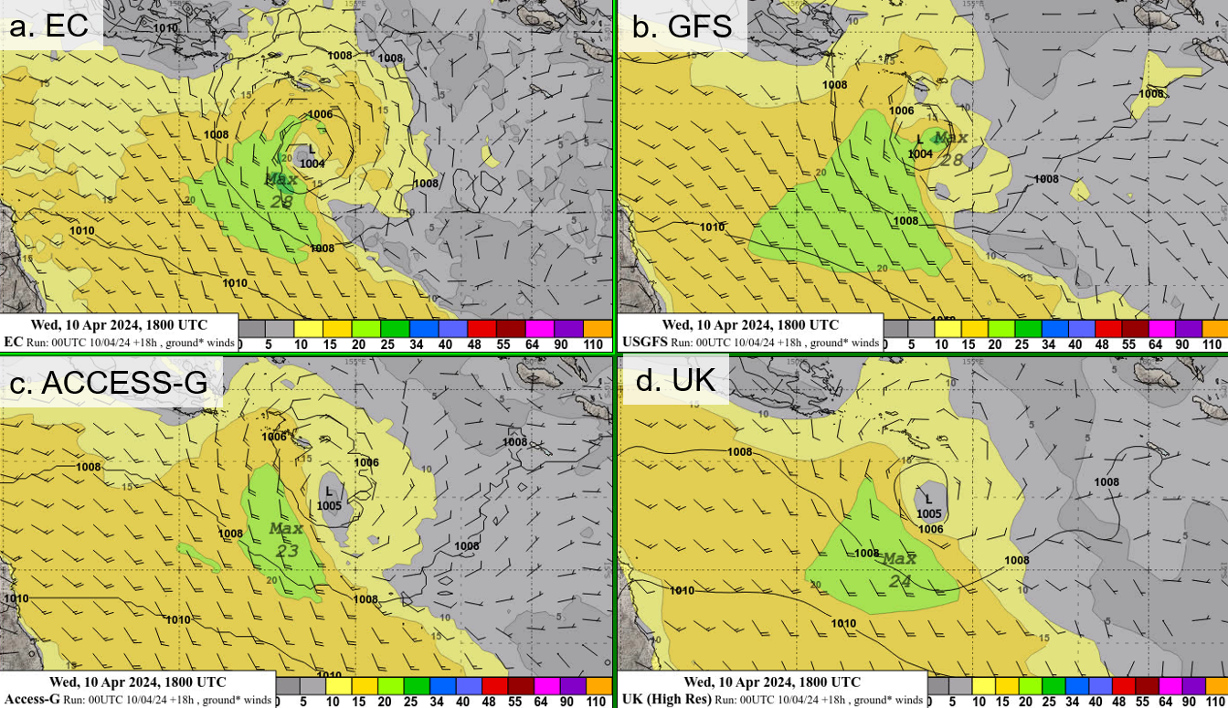

Figure 6. Comparison of model surface winds and MSLP for the run on 0000 UTC 10 April valid for 1800 UTC 10 April, when Paul was at tropical cyclone: a.(top left) European (EC), b. (top right) US (GFS), c. (lower left) Australian (ACCESS-G) and d. (lower right) UK models.

Appendix: List of abbreviations

|  |  |
| --- | --- |
| Abbreviation | Term |
| ADT | Advanced Dvorak Technique |
| AEST | Australian Central Standard Time |
| AEST | Australian Eastern Standard Time |
| AiDT | AI-enhanced Dvorak Technique |
| AMSR2 | Advanced Microwave Scanning Radiometer |
| AMSU | Advanced Microwave Sounding Unit |
| ASCAT | Advanced Scatterometer |
| ATMS | Advanced Technology Microwave Sounder |
| AWS | automatic weather station |
| AWST | Australian Western Standard Time |
| °C | Celsius |
| CI | Current intensity |
| CIMSS | Cooperative Institute for Meteorological Satellite Studies (USA) |
| CIRA | Cooperative Institute for Research in the Atmosphere (USA) |
| D-MINT | Deep learning - Multispectral Intensity of TCs (formerly known as DMN) |
| D-PRINT | Deep learning - IR Intensity of TCs (formerly known as OPEN-AIIR) |
| EIR | Enhanced InfraRed |
| ERC | eyewall replacement cycle |
| FNMOC | Fleet Numerical Meteorology and Oceanography Centre (USA) |
| FT | Final T-number |
| GCOM | Global Change Observation Mission |
| GHz | Gigahertz |
| GMI | Global Precipitation Measurement Microwave Imager |
| h | hour |
| hPa | hectopascal |
| HSCAT | Hai Yang 2 Scatterometer (HY-2B, HY-2C) |
| km | kilometres |
| km/h | kilometres per hour |
| kn | knot |
| LLCC | LLCC |
| MET | Model Expected T-number |
| METOP | Meteorological Operational Satellite |
| MJO | Madden-Julian Oscillation |
| mm | millimetres |
| MSLP | mean sea level pressure |
| NESDIS | National Environmental Satellite, Data, and Information Service |
| nm | nautical mile |
| NOAA | National Oceanic and Atmospheric Administration |
| NRL | Navy Research Lab (USA) |
| OPEN-AiiR | Ordered Pattern Encoding AI Infrared |
| PAT | Pattern T-number |
| RCM | RadarSat Constellation Mission – Synthetic Aperture Radar |
| RH | relative humidity |
| RMW | radius of maximum winds |
| RSMC | Regional Specialised Meteorological Centre |
| SAR | Synthetic Aperture Radar |
| SATC | CIMSS Advanced Dvorak Technique |
| SATCON | Satellite Consensus |
| SEN1 | Sentinel-1A – Synthetic Aperture Radar |
| SMAP | Soil Moisture Active Passive |
| SMOS | Soil Moisture and Ocean Salinity |
| SSMIS | Special Sensor Microwave Imager/Sounder |
| TC | Tropical Cyclone |
| TCWC | Tropical Cyclone Warning Centre |
| UTC | Universal Time Co-ordinated |

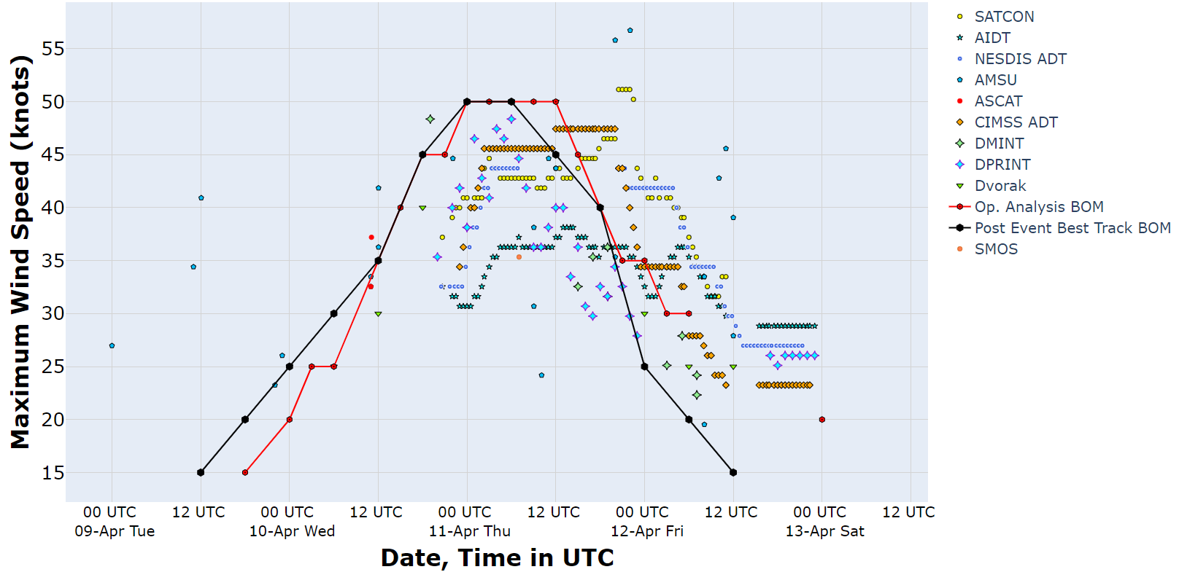

Figure 7. Intensity plot of objective and subjective guidance. SATCON, AiDT, NESDIS ADT, AMSU, SAR-RCM, ASCAT, CIMSS ADT, DMINT, DPRINT, Dvorak (subjective estimate), operational analysis (red) and post event best track analysis (black). Objective Dvorak have been adjusted from 1-minute to 10-minute maximum mean winds.