Tropical Cyclone Penny (07U)

## 28 December 2018 – 9 January 2019

## Joe Courtney and Chris Matthews, Tropical Cyclone Environmental Prediction Services

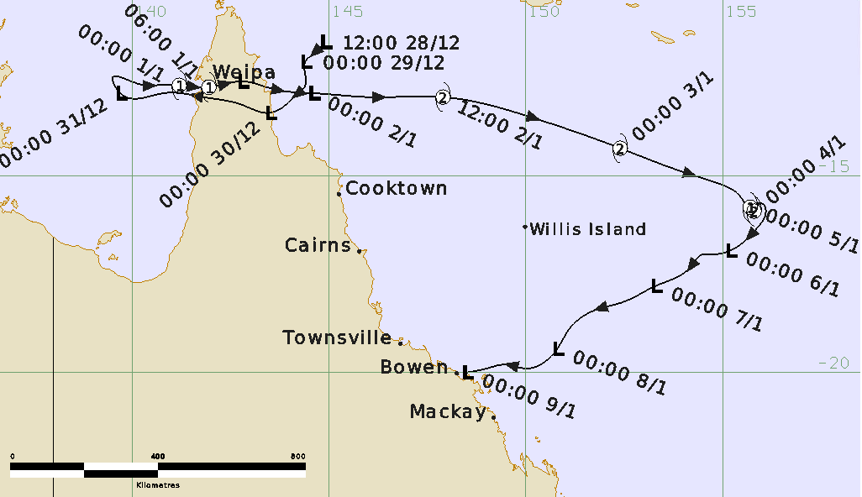

**Revision history**

|  |  |  |  |
| --- | --- | --- | --- |
| Date | Version | Author | Description |
| 01/10/2024 | 1.0 | Joe Courtney | Final draft ready |

**Review status**

|  |  |  |  |
| --- | --- | --- | --- |
| Date | Version | Reviewer | Description |
| 01/01/2024 | 1.0 | Linda Paterson | Completed |

**Release history**

|  |  |  |  |
| --- | --- | --- | --- |
| Date | Version | Status | Approval |
| 01/10/2024 | 1.0 | Approved for release | Andrew Burton |

Contact details:

Tropical Cyclone Team Lead

Weather Environmental Prediction Services

Bureau of Meteorology

PO Box 1370, West Perth WA 6872

Email: [tcwc@bom.gov.au](mailto:tcwc@bom.gov.au)



This work is copyright. Apart from any use as permitted under the Copyright Act 1968, no part may be reproduced without prior written permission from the Bureau of Meteorology. Refer to www.bom.gov.au/other/copyright.shtml for further information. Unless otherwise noted, all images in this document are licensed under the Creative Commons Attribution Australia Licence.

© Commonwealth of Australia 2024

Published by the Bureau of Meteorology

Cover image: Track of Tropical Cyclone Penny. Times in UTC (AEST-10h)

Contents

1. Summary 5

2. Meteorological description 9

2.1 Intensity analysis 9

2.2 Structure 11

2.3 Motion 11

3. Impact 11

4. Observations 12

4.1. Wind 12

4.2. Rainfall 12

4.3. Pressure 12

5. Forecast Performance 18

Appendix: List of abbreviations 21

**List of Figures**

Figure 1. Best track of Tropical Cyclone Penny, 28 December 2018 to 9 January 2019. 6

Figure 2. Detailed best track of Tropical Cyclone Penny, 30 December 2018 to 1 January 2019 in the vicinity of Cape York Peninsula. 6

Figure 3. Detailed best track of Tropical Cyclone Penny 1 – 9 January 2019 in the Coral Sea. 7

Figure 4. Hovmoller analysis of Outgoing Longwave Radiation (OLR) 10

Figure 5. ASCAT images 1 - 2 January. 13

Figure 6. SSMIS composite microwave images 1 – 4 January 14

Figure 7. Visible and Enhanced InfraRed images at 0600 UTC 3 January near peak intensity. 15

Figure 8. SSMIS 37 and 91 GHz microwave images at 0737 UTC 3 January near peak intensity: 15

Figure 9. ASCAT images 4 and 6 January 16

Figure 10. Weekly rainfall distribution over Queensland 28 December 2018 to 3 January 2019. 17

Figure 11. Position accuracy figures for Tropical Cyclone Penny. 19

Figure 12. Intensity accuracy figures for Tropical Cyclone Penny. 19

Figure 13. Forecast Track Map 4pm AEST 30 December 2018. 20

Figure 14. Intensity plot of objective and subjective guidance. 23

**List of Tables**

Table 1. Best track summary for Tropical Cyclone Penny.. 8

Table 2. Verification statistics for Tropical Cyclone Penny. 18

1. Summary

Tropical cyclone Penny had two phases at tropical cyclone intensity: briefly as a category one tropical cyclone making landfall near Weipa on the west coast of Cape York Peninsula late on New Year's Day 2018; and then over open waters in the Coral Sea where it peaked at category 2 intensity on 3 January (Figure 1, Figure 2 and Figure 3). The most significant impacts during this event were not directly associated with Penny, but more so with the monsoon that was active across the Maritime Continent at the time. There were reports of multiple fatalities in Papua New Guinea and the Solomon Islands due to the impacts of monsoonal rain and winds during late December and early January.

The tropical low that became Penny was first identified and tracked on 28 December in the northwest Coral Sea. In the days leading up to New Year's Eve, the low drifted slowly west across Cape York Peninsula and towards the northern Gulf of Carpentaria. The low quickly developed over the Gulf waters then made an abrupt turn back towards the east late on New Years Eve under the influence of the monsoonal flow to the north. The system reached tropical cyclone intensity on New Year's Day, approximately 100 km west of Weipa ahead of making landfall later that day.

A 0.8 metre storm surge was recorded by the Weipa storm tide gauge on 1 January, which lead to a marginal exceedance of the Highest Astronomical Tide level. Large waves were also observed for a brief period at the Weipa wave monitoring gauge.

Following landfall, Penny continued to track in an eastwards direction across Cape York Peninsula and emerged over the northwest Coral Sea on 2 January. Aided by the ongoing strong monsoon flow to the north Penny was able to reform into a tropical cyclone on 2 January and quickly reached category 2 intensity. Penny tracked further across the Coral Sea and peaked on 3 January as a category 2 strength system having 10-minute maximum winds to 55 kn (100 km/h).

Penny commenced weakening during 4 January as it became removed from the monsoonal flow to the north of the system and as drier mid-level air began to entrain into the circulation. The system fell below tropical cyclone intensity late on 5 January but gales continued south of the centre until 8 January as the system tracked southwest towards the Queensland coast.

The low was tracked until 9 January near Bowen. Heavy rainfall then occurred in areas of central and northern Queensland. Strathbogie (south of Ayr and west of Bowen) received 432 mm in the 24 hours to 9 am on 10 January.

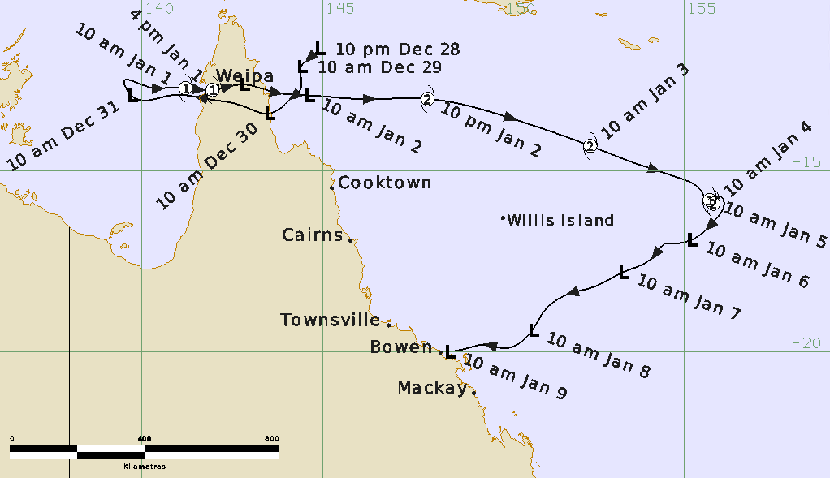

Figure 1. Best track of Tropical Cyclone Penny, 28 December 2018 to 9 January 2019 (times in AEST, UTC +10h).

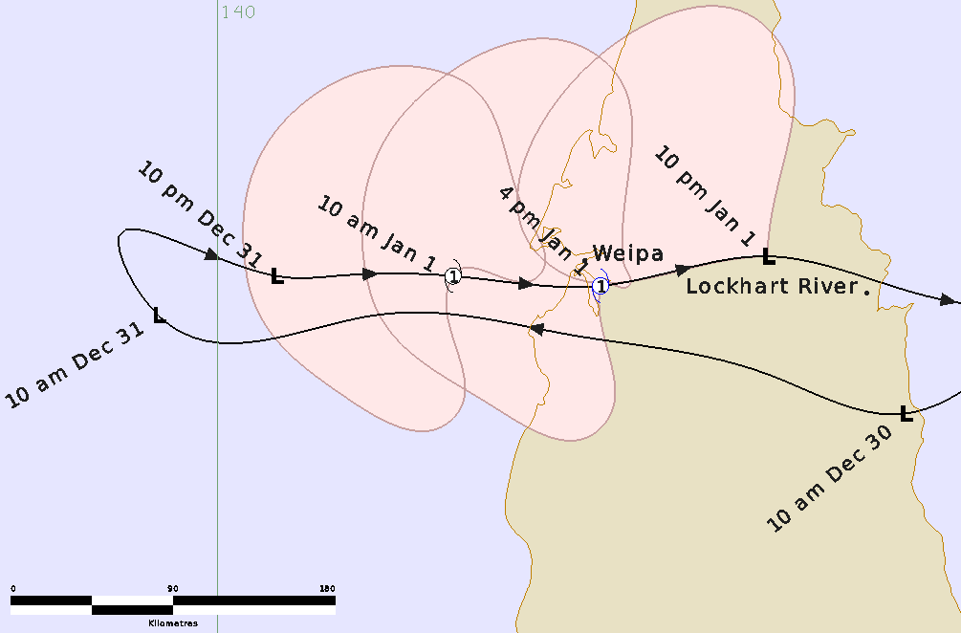

Figure 2. Detailed best track of Tropical Cyclone Penny, 30 December 2018 to 1 January 2019 in the vicinity of Cape York Peninsula showing the extent of gales (times in AEST, UTC +10h).

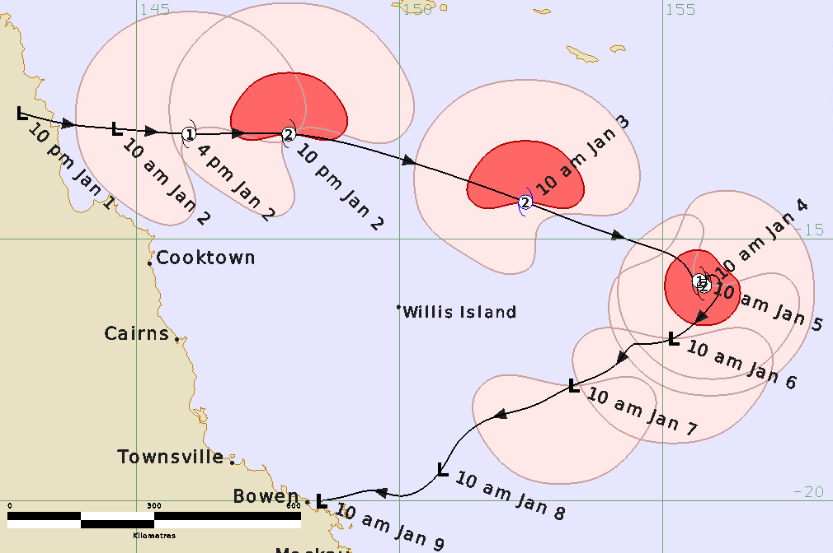

Figure 3. Detailed best track of Tropical Cyclone Penny 1 – 9 January 2019 in the Coral Sea showing the extent of gale (in pink) and storm-force (in red) winds (times in AEST, UTC +10h).

|  |  |  |  |  |  |  |  |  |  |  |  |  |
| --- | --- | --- | --- | --- | --- | --- | --- | --- | --- | --- | --- | --- |
| **Year** | **Month** | **Day** | **Hour UTC** | **Pos. Lat S** | **Pos. Long. E** | **Pos. Acc. Nm** | **Mean wind kn** | **Max. gust kn** | **Cent. Press hPa** | **Rad of gales (NE/SE/SW/NW) nm** | **Rad of storm (NE/SE/SW/NW) nm** | **RMW nm** |
| 2018 | 12 | 28 | 1200 | 11.6 | 144.9 | 30 | 15 | 45 | 1002 | 0/0/0/0 | 0/0/0/0 | - |
| 2018 | 12 | 28 | 0600 | 12.4 | 150.9 | 90 | 15 | 45 | 1002 | 0/0/0/0 | 0/0/0/0 | - |
| 2018 | 12 | 29 | 1200 | 12.5 | 150.4 | 45 | 20 | 45 | 1004 | 0/0/0/0 | 0/0/0/0 | - |
| 2018 | 12 | 29 | 2100 | 12.5 | 149.8 | 60 | 20 | 45 | 1001 | 0/0/0/0 | 0/0/0/0 | - |
| 2018 | 12 | 29 | 0000 | 12.5 | 149.6 | 60 | 20 | 45 | 1004 | 0/0/0/0 | 0/0/0/0 | - |
| 2018 | 12 | 29 | 0300 | 12.8 | 149.3 | 60 | 20 | 45 | 1001 | 0/0/0/0 | 0/0/0/0 | - |
| 2018 | 12 | 30 | 0600 | 13.1 | 149.0 | 60 | 20 | 45 | 1003 | 0/0/0/0 | 0/0/0/0 | - |
| 2018 | 12 | 30 | 1200 | 13.1 | 148.3 | 60 | 15 | 45 | 1000 | 0/0/0/0 | 0/0/0/0 | - |
| 2018 | 12 | 30 | 1800 | 13.5 | 147.5 | 20 | 20 | 45 | 1001 | 0/0/0/0 | 0/0/0/0 | - |
| 2018 | 12 | 30 | 2100 | 13.6 | 147.3 | 40 | 25 | 45 | 1000 | 0/0/0/0 | 0/0/0/0 | - |
| 2018 | 12 | 31 | 0000 | 13.8 | 146.8 | 40 | 25 | 45 | 999 | 0/0/0/0 | 0/0/0/0 | - |
| 2018 | 12 | 31 | 0300 | 13.8 | 146.5 | 40 | 30 | 45 | 998 | 0/0/0/0 | 0/0/0/0 | - |
| 2018 | 12 | 31 | 0600 | 13.8 | 146.4 | 35 | 30 | 45 | 997 | 0/0/0/0 | 0/0/0/0 | - |
| 2018 | 12 | 31 | 0900 | 13.9 | 146.2 | 35 | 30 | 45 | 996 | 0/0/0/0 | 0/0/0/0 | - |
| 2019 | 1 | 1 | 1200 | 13.9 | 146.0 | 30 | 40 | 55 | 991 | 30/0/50/70 | 0/0/0/0 | 30 |
| 2019 | 1 | 1 | 1500 | 13.9 | 145.9 | 40 | 40 | 55 | 990 | 10/0/50/80 | 0/0/0/0 | 15 |
| 2019 | 1 | 1 | 1800 | 13.8 | 145.8 | 25 | 35* | 50 | 994 | 0/0/0/80 | 0/0/0/0 | - |
| 2019 | 1 | 1 | 2100 | 13.9 | 145.6 | 25 | 35* | 50 | 995 | 0/0/0/60 | 0/0/0/0 | - |
| 2019 | 1 | 2 | 0000 | 13.9 | 145.4 | 25 | 30 | 45 | 997 | 0/0/0/0 | 0/0/0/0 | - |
| 2019 | 1 | 2 | 0300 | 13.9 | 145.1 | 20 | 40 | 55 | 995 | 140/0/110/140 | 0/0/0/0 | 60 |
| 2019 | 1 | 2 | 0600 | 13.9 | 145.1 | 30 | 50 | 70 | 991 | 150/0/100/150 | 70/0/0/70 | 60 |
| 2019 | 1 | 2 | 0900 | 13.9 | 145.2 | 25 | 50 | 70 | 989 | 150/0/90/150 | 70/0/0/70 | 50 |
| 2019 | 1 | 3 | 1200 | 13.8 | 145.0 | 25 | 50 | 70 | 991 | 140/30/90/140 | 70/0/0/70 | 40 |
| 2019 | 1 | 3 | 1500 | 13.7 | 144.9 | 25 | 55 | 75 | 985 | 130/100/100/130 | 60/30/40/60 | 40 |
| 2019 | 1 | 3 | 1800 | 13.5 | 145.0 | 25 | 55 | 75 | 987 | 130/120/120/120 | 30/30/30/30 | 30 |
| 2019 | 1 | 3 | 2100 | 13.4 | 145.0 | 25 | 50 | 70 | 988 | 130/130/120/60 | 30/40/50/40 | 30 |
| 2019 | 1 | 4 | 0000 | 13.4 | 145.0 | 30 | 50 | 70 | 988 | 120/130/120/60 | 30/45/45/45 | 25 |
| 2019 | 1 | 4 | 0300 | 13.4 | 145.1 | 15 | 50 | 70 | 988 | 80/120/130/80 | 0/40/40/40 | 25 |
| 2019 | 1 | 4 | 0600 | 13.4 | 145.1 | 15 | 45 | 65 | 990 | 0/130/130/80 | 0/0/0/0 | 30 |
| 2019 | 1 | 4 | 0900 | 13.3 | 145.0 | 30 | 45 | 65 | 990 | 0/130/120/80 | 0/0/0/0 | 30 |
| 2019 | 1 | 5 | 1200 | 13.2 | 145.0 | 25 | 40 | 55 | 993 | 0/120/100/80 | 0/0/0/0 | 50 |
| 2019 | 1 | 5 | 1500 | 13.1 | 145.0 | 25 | 40 | 55 | 993 | 0/90/120/60 | 0/0/0/0 | 50 |
| 2019 | 1 | 5 | 1800 | 13.1 | 145.0 | 40 | 35* | 50 | 994 | 0/120/120/0 | 0/0/0/0 | - |
| 2019 | 1 | 5 | 2100 | 13.2 | 145.2 | 25 | 35* | 50 | 994 | 0/120/120/0 | 0/0/0/0 | - |
| 2019 | 1 | 6 | 0000 | 13.3 | 145.5 | 20 | 40* | 50 | 995 | 0/120/120/0 | 0/0/0/0 | - |
| 2019 | 1 | 6 | 0300 | 13.2 | 145.6 | 15 | 35* | 50 | 995 | 0/120/120/0 | 0/0/0/0 | - |
| 2019 | 1 | 6 | 0600 | 13.1 | 145.8 | 25 | 30 | 45 | 997 | 0/0/0/0 | 0/0/0/0 | - |
| 2019 | 1 | 6 | 0900 | 13.1 | 146.5 | 20 | 35* | 50 | 995 | 0/0/120/0 | 0/0/0/0 | - |
| 2019 | 1 | 7 | 1200 | 13.3 | 146.9 | 25 | 35* | 50 | 996 | 0/100/120/0 | 0/0/0/0 | - |
| 2019 | 1 | 7 | 1500 | 13.3 | 147.1 | 30 | 35* | 50 | 996 | 0/80/120/0 | 0/0/0/0 | - |
| 2019 | 1 | 7 | 1800 | 13.4 | 147.5 | 30 | 35* | 50 | 997 | 0/0/120/0 | 0/0/0/0 | - |
| 2019 | 1 | 7 | 2100 | 13.1 | 147.9 | 30 | 35* | 50 | 997 | 0/0/100/0 | 0/0/0/0 | - |
| 2019 | 1 | 8 | 0000 | 13.2 | 148.5 | 30 | 30 | 45 | 999 | 0/0/0/0 | 0/0/0/0 | - |
| 2019 | 1 | 8 | 0600 | 13.7 | 148.8 | 30 | 30 | 45 | 999 | 0/0/0/0 | 0/0/0/0 | - |
| 2019 | 1 | 8 | 1200 | 13.7 | 149.0 | 50 | 30 | 45 | 1000 | 0/0/0/0 | 0/0/0/0 | - |
| 2019 | 1 | 8 | 1800 | 13.8 | 149.7 | 40 | 30 | 45 | 999 | 0/0/0/0 | 0/0/0/0 | - |
| 2019 | 1 | 9 | 0000 | 13.9 | 149.7 | 40 | 25 | 40 | 1001 | 0/0/0/0 | 0/0/0/0 | - |

Table 1. Best track summary for Tropical Cyclone Penny, 28 December 2018 to 9 January 2019.

UTC=AEST-10. * Not at tropical cyclone intensity as gales less than halfway around centre.

1. Meteorological description

## 2.1 Intensity analysis

Table 1 shows the summary data at the standard six-hourly times from 28 December 2018 to 9 January 2019. A comparison of the subjective and objective intensity estimates is shown in Figure 14.

A weak circulation formed in the Coral Sea off the far north Queensland coast on 28 December. Formation was assisted by the passage of a strong Madden Julian Oscillation coinciding with an Equatorial Rossby wave as indicated by the Hovmoller analysis of outgoing longwave radiation (OLR) in Figure 4. The low drifted to the southwest but strong easterly wind shear hindered development prior to crossing the far north Queensland coast south of Cooktown on 30 December.

The weak low moved west across the Cape York Peninsula into the Gulf of Carpentaria early on New Year's Eve. The initial T1.5 Dvorak classification was estimated at 1800 UTC 30 December as deep convection increased mainly west of the centre under ongoing easterly wind shear. Development was assisted by warm ocean temperatures exceeding 30°C. Deep convection increased further on 1 January from an increase in the low-level monsoon flow offsetting ongoing easterly wind shear. Tropical cyclone intensity was estimated by 0000 UTC 1 January based on subjective Dvorak CI estimates reaching 3.0 prior to making landfall near Weipa at 0600 UTC. Weipa recorded a minimum pressure of 991.1 hPa at 0530 UTC, and the Weipa doppler radar indicated wind gusts in excess of 50 kn along the coast. ASCAT imagery near 12 UTC showed a vigorous westerly monsoonal flow north of the centre (see Figure 5).

The circulation moved offshore near Lockhart River into the Coral Sea once more early on 2 January. Figure 6 shows the sequence of SSMIS microwave images each day showing the intensification over the Coral Sea from 1 to 3 January then weakening on 4 January. Development recommenced on 2 January and Penny regained tropical cyclone intensity by 0600 UTC. Although ASCAT-B at 2315 UTC 1 January showed no gales, the subsequent ASCAT-B at 1127 UTC shown in Figure 5 showed a much stronger circulation having an area of 50 kn north of the centre. The easterly wind shear eased somewhat but the low level centre remained exposed from the deep convection so Dvorak estimates underestimated the intensity.

On 3 January deep convection extended around to the eastern side as shown on visible and enhanced IR images at 0600 UTC in Figure 7; and the SSMIS 37 GHz and 91 GHz at 0737 UTC in Figure 8. Peak intensity occurred from 0600 to 1200 UTC 3 January when 10-minute maximum winds were estimated at 55 kn (100 km/h). This is consistent with SATCON guidance but Dvorak estimates remained slightly lower peaking at 3.5 (Figure 14).

Increasing northerly wind shear allowed dry air to reduce deep convection near the centre from late on 3 January exposing the low-level centre. Over following days deep convection pulsed diurnally southwest of the centre. Scatterometry (for example ASCAT on 4 and 6 January in Figure 9) helped inform intensity estimates. Gales were observed at Marion Reef and Creal Reef on 6 to 7 January south of the centre. Maximum winds are estimated less than gale-force on 8 January with weakening of the low-level circulation and deep convection. An ASCAT pass (2245 UTC 8 January) Hayman Island observations confirmed the absence of gales.

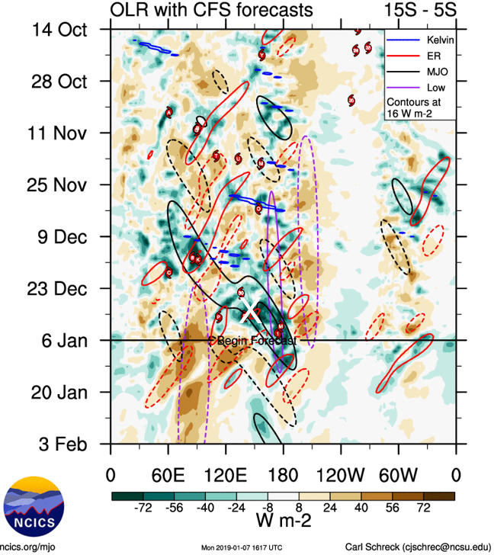

Figure 4. Hovmoller analysis of Outgoing Longwave Radiation (OLR) showing tropical waves including the MJO and ER intersecting at the time of formation stages of Tropical Cyclone Penny in the vicinity of 140-145°E during 28-31 December 2018 (shown as a white X). Image courtesy of <https://ncics.org/portfolio/monitor/mjo/>

## 2.2 Structure

Scatterometry (for example ASCAT in Figure 5 and Figure 9) and surface observations largely informed the wind structure. The extent of gales during the initial stages was strongly influenced by the monsoon flow and by proximity to Cape York Peninsula as shown in Figure 2 and Figure 3.

Once over the Coral Sea on 2-3 January gales extended 150 nm (280 km) northwards and storm-force winds 70 nm (130 km) as indicated by scatterometry in Figure 5. As both the monsoon and easterly wind shear influence eased later on 3 January, winds became more symmetric, gales extending to 120-130 nm (220-240 km) and storm-force winds to 40-50 nm (75-95 km).

Gales ceased in the northeast quadrant later on 4 January and then became confined to southern quadrants later on 5 January. Scatterometry (Figure 9) indicated that gales briefly ceased late on 6 January but quickly resumed with a resurgence in deep convection southwest of the centre. Gales were confined southwest of the centre late on 7 January and ceased completely on 8 January as the system weakened further off the Queensland coast.

The radius of maximum winds (RMW) was estimated initially at 30 nm (55 km) in the Gulf of Carpentaria, then increased to 60 nm (110 km) in the Coral Sea on 2 January before reducing to 25-30 nm (45-55 km) for a period on 4-5 January.

## 2.3 Motion

As shown in the track in Figure 1, during the early stages the weak system was steered to the west by the sub-tropical ridge to the south. As the low deepened in the Gulf of Carpentaria during 31 December the developing deeper monsoon flow became the dominant steering influence, and the low made an abrupt turn to the east. Penny crossed the north Queensland coast on 1 January and continued eastwards into the Coral Sea in following days. Penny accelerated to move at 22 kn (40 km/h) to the southeast on 3 January before slowing as the monsoon flow eased. Penny became slow moving on 4 and 5 January in the eastern Coral Sea. The weakening circulation then turned to the southwest towards the Queensland coast under the steering influence of a ridge to the south.

1. Impact

The most significant impacts during this event were not directly associated with Penny, but more so with the monsoon that was active across the Maritime Continent at the time. There were reports of multiple fatalities in Papua New Guinea and the Solomon Islands due to the impacts of monsoonal rain and winds during late December and early January.

1. Observations
   1. Wind

Marion Reef recorded periods of gales between 2025 UTC 6 January (0625 AEST 7 Jan.) to 1043 UTC (2043 AEST) 7 January.

Creal Reef recorded periods of gales between 1330 UTC (2330 AEST) 7 January and 1716 UTC 7 January (0316 AEST 8 January).

* 1. Rainfall

Cumulative rainfall totals exceeded 200 mm over large parts of far north Cape York Peninsula as the system affected the region in late December and early January as shown on the weekly rainfall distribution to 3 January 2019 in Figure 10.

Some significant daily totals to 9 am AEST:

29 December: Lockhart River 129.4 mm;

1 January: Stewart River 106 mm; Piccaninny Plains 102 mm.

2 January: Telegraph Crossing 144 mm; Moreton Telegraph 133 mm; Picaninny Plains 128 mm; Scherger RAAF 121.8 mm;

10 January: Strathbogie (west of Bowen) 432 mm; Eton Vale Alert 224 mm; Groper Creek Alert 184 mm.

* 1. Pressure

Weipa recorded a minimum pressure 991.1 hPa at 0530 UTC (1530 AEST) 1 January.

|  |  |
| --- | --- |
| ASCAT-B image at 1148 UTC 1 January showing gales near the far northwest of the Cape York Peninsula. | ASCAT-B image at 1127 UTC 2 January showing gales around the centre of Penny except for the southeast quadrant and peak winds of 50 knots north of the centre. |

Figure 5. ASCAT-B images from left 1148 UTC 1 January and right 1127 UTC 2 January.   
Images courtesy of NOAA https://manati.star.nesdis.noaa.gov/

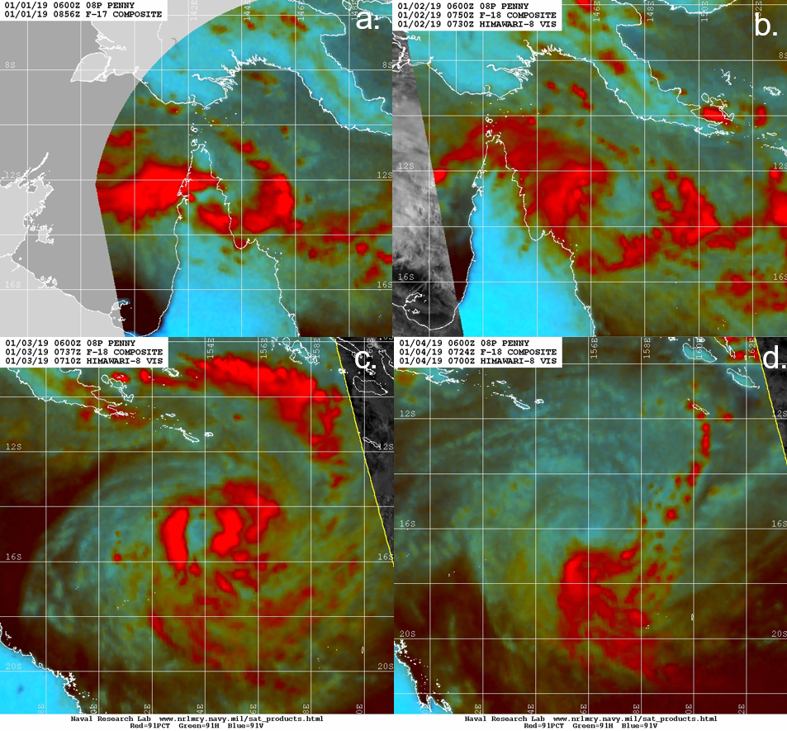

Figure 6. SSMIS composite microwave images at a. 0856 UTC 1 January b. 0750 UTC 2 January, c. 0737 UTC 3 January, and d. 0724 UTC 4 January showing the development and weakening over the Coral Sea. Images courtesy of NRL: <https://www.nrlmry.navy.mil/TC.html>

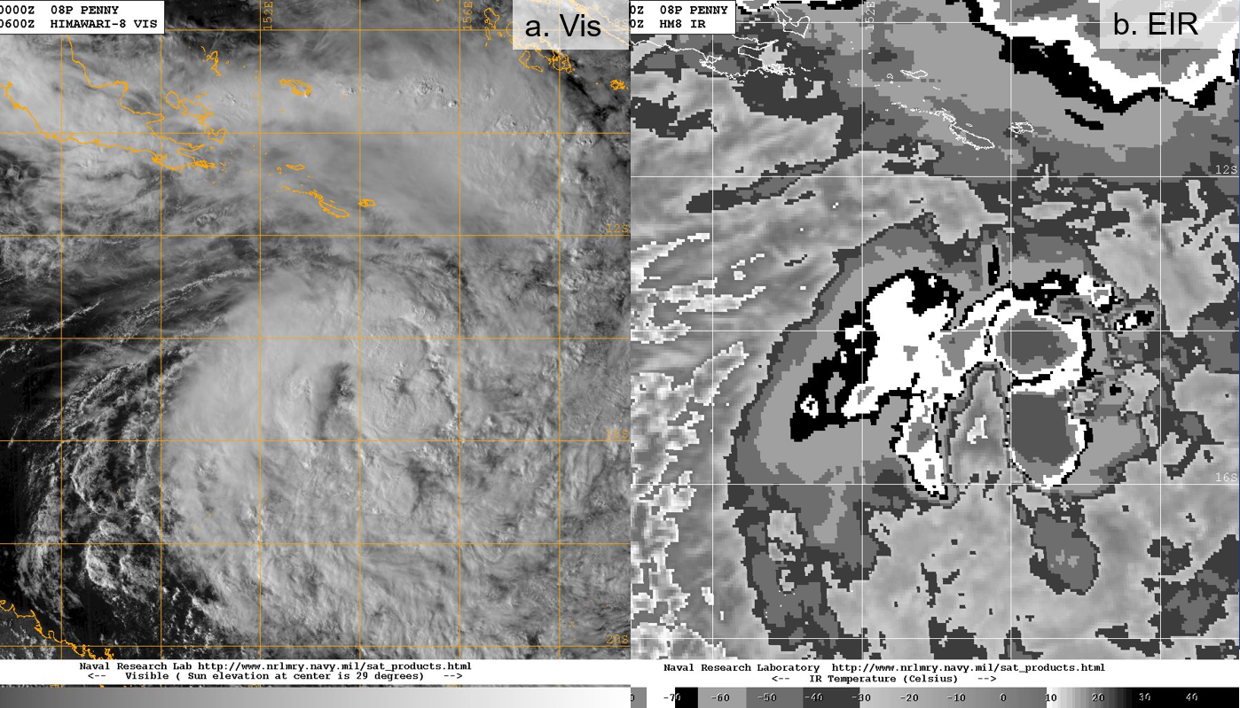

Figure 7. a. Visible image and b. Enhanced InfraRed (EIR) image at 0600 UTC 3 January near peak intensity. Himawari-8 images courtesy of JMA via NRL: <https://www.nrlmry.navy.mil/TC.html>

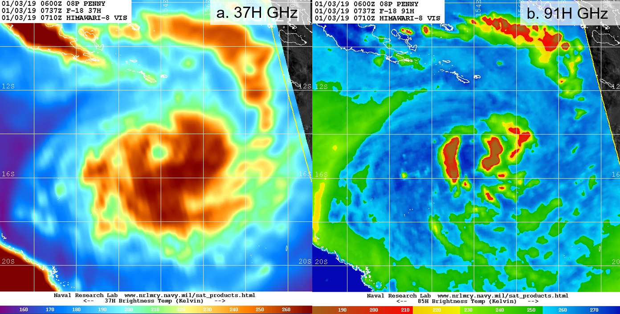

Figure 8. SSMIS microwave (horizontally polarised) images at 0737 UTC 3 January near peak intensity: a. 37H GHz and b. 91H GHz. Images courtesy of NRL: <https://www.nrlmry.navy.mil/TC.html>

|  |  |
| --- | --- |
| ASCAT-A image at 1118 UTC 4 January showing gales around the centre of Penny except to the northeast and peak winds of 40-45 knots south of the centre. | ASCAT-B image at 1155 UTC 6 January showing gales southwest of the centre (partial coverage). |

Figure 9. ASCAT images from left ASCAT-A 1118 UTC 4 January, and right ASCAT-B 1155 UTC 6 January. Images courtesy of NOAA https://manati.star.nesdis.noaa.gov/

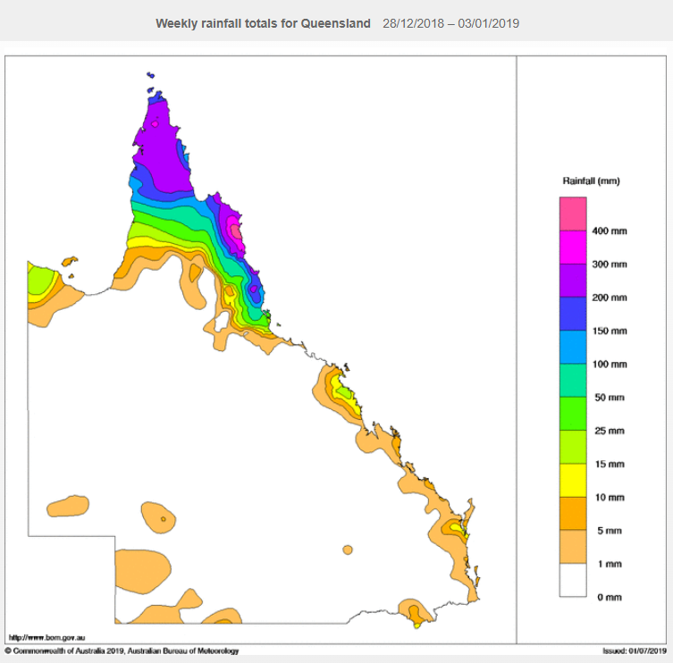

Figure 10. Weekly rainfall distribution over Queensland 28 December 2018 to 3 January 2019. Totals exceeded 200 mm over far north Queensland.

1. Forecast Performance

The accuracy statistics for Tropical Cyclone Penny are below in Table 2 while graphs of position and intensity accuracy against the five-year averages are shown in Figure 11 and Figure 12.

Tropical Cyclone Advices were initiated at 0700 UTC 30 January for the Queensland coast from Kowanyama north to Torres Strait Islands as shown on the forecast track map in Figure 13. Advices continued until Penny weakened overland by 0900 UTC 1 January. Further track maps and other products continued until 0100 UTC 9 January.

The position accuracy was similar to the five-year average to +48h then slightly worse for +72 to +120h. In general forecasts correctly predicted the turns in the Gulf of Carpentaria and in the Coral Sea but periods of fast motion and abrupt turns presented track forecast challenges. Intensity forecasts were close to the five-year average for forecast times to +18h then were superior to +120h. Forecasts correctly estimated Penny to peak as a category 2 system in the Coral Sea then weaken as it turned towards the Queensland coast.

|  |  |  |  |  |  |  |  |  |  |  |
| --- | --- | --- | --- | --- | --- | --- | --- | --- | --- | --- |
| Time | 00 | 06 | 12 | 18 | 24 | 36 | 48 | 72 | 96 | 120 |
| Position accuracy (km) | 22 | 44 | 61 | 70 | 78 | 111 | 156 | 239 | 299 | 340 |
| Intensity accuracy (knots) | 1.8 | 2.9 | 3.6 | 4.1 | 4.3 | 6.0 | 6.8 | 6.4 | 6.1 | 8.3 |
| Sample size | 39 | 39 | 38 | 37 | 36 | 34 | 32 | 28 | 24 | 20 |

Table 2. Verification statistics for Tropical Cyclone Penny.

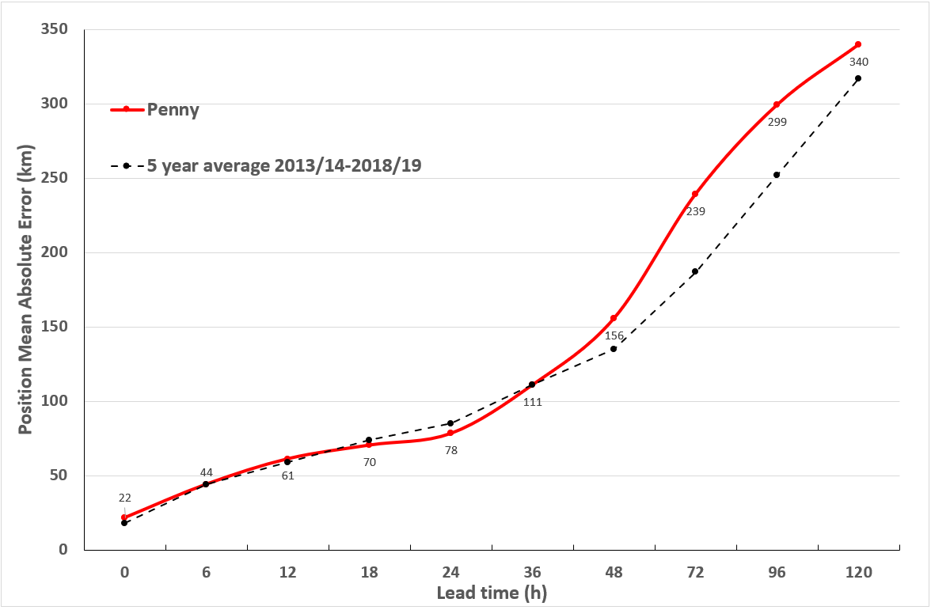

Figure 11. Position accuracy figures for Tropical Cyclone Penny.

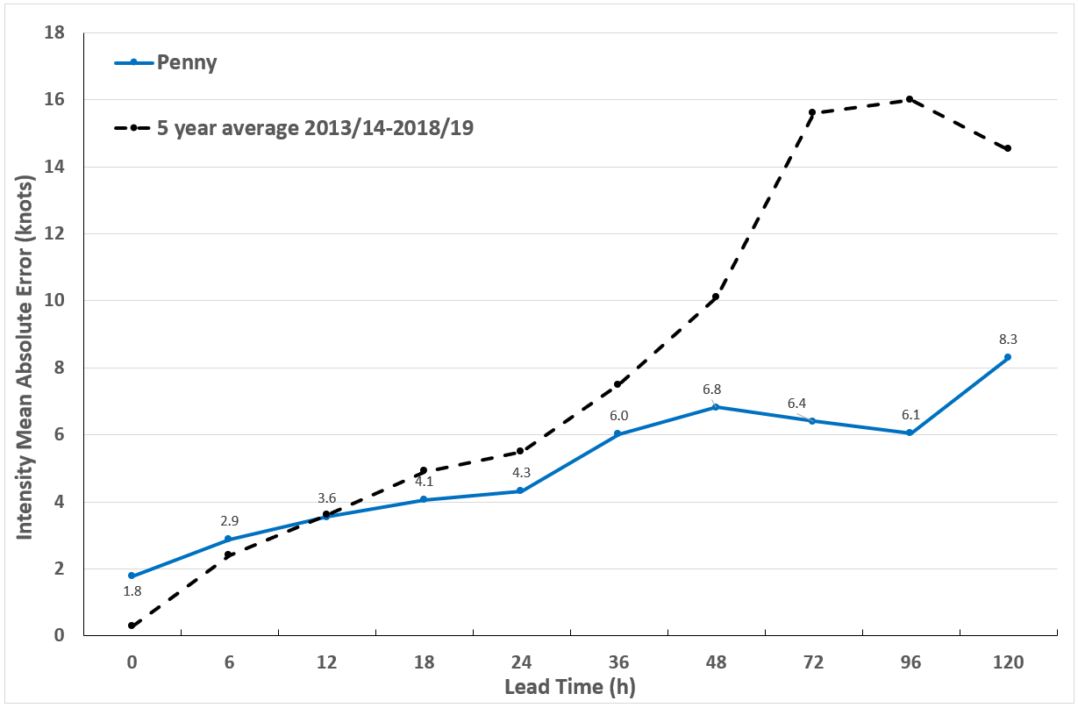

Figure 12. Intensity accuracy figures for Tropical Cyclone Penny.

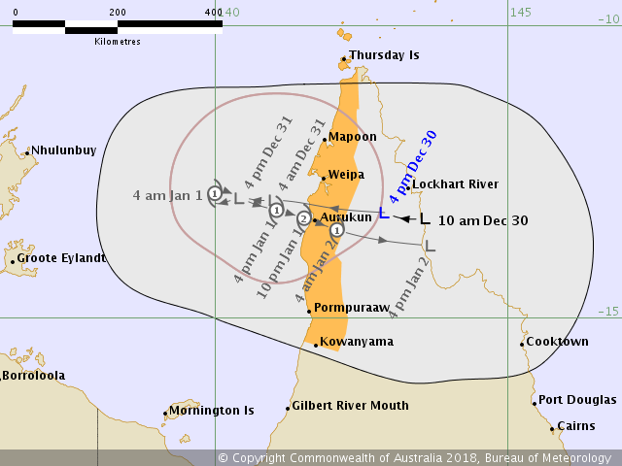

Figure 13. Forecast Track Map issued at 4pm AEST 30 December 2018 associated with the first Tropical Cyclone Watch.

Appendix: List of abbreviations

|  |  |
| --- | --- |
| Abbreviation | Term |
| ADT | Advanced Dvorak Technique |
| AEST | Australian Central Standard Time |
| AEST | Australian Eastern Standard Time |
| AiDT | AI-enhanced Dvorak Technique |
| AMSR2 | Advanced Microwave Scanning Radiometer |
| AMSU | Advanced Microwave Sounding Unit |
| ASCAT | Advanced Scatterometer |
| ATMS | Advanced Technology Microwave Sounder |
| AWS | automatic weather station |
| AWST | Australian Western Standard Time |
| °C | Celsius |
| CI | Current intensity |
| CIMSS | Cooperative Institute for Meteorological Satellite Studies (USA) |
| CIRA | Cooperative Institute for Research in the Atmosphere (USA) |
| D-MINT | Deep learning - Multispectral Intensity of TCs (formerly known as DMN) |
| D-PRINT | Deep learning - IR Intensity of TCs (formerly known as OPEN-AIIR) |
| EIR | Enhanced InfraRed |
| ERC | eyewall replacement cycle |
| FNMOC | Fleet Numerical Meteorology and Oceanography Centre (USA) |
| FT | Final T-number |
| GCOM | Global Change Observation Mission |
| GHz | Gigahertz |
| GMI | Global Precipitation Measurement Microwave Imager |
| h | hour |
| hPa | hectopascal |
| HSCAT | Hai Yang 2 Scatterometer (HY-2B, HY-2C) |
| km | kilometres |
| km/h | kilometres per hour |
| kn | knot |
| LLCC | LLCC |
| MET | Model Expected T-number |
| METOP | Meteorological Operational Satellite |
| MJO | Madden-Julian Oscillation |
| mm | millimetres |
| MSLP | mean sea level pressure |
| NESDIS | National Environmental Satellite, Data, and Information Service |
| nm | nautical mile |
| NOAA | National Oceanic and Atmospheric Administration |
| NRL | Navy Research Lab (USA) |
| OPEN-AiiR | Ordered Pattern Encoding AI Infrared |
| PAT | Pattern T-number |
| RCM | RadarSat Constellation Mission – Synthetic Aperture Radar |
| RH | relative humidity |
| RMW | radius of maximum winds |
| RSMC | Regional Specialised Meteorological Centre |
| SAR | Synthetic Aperture Radar |
| SATC | CIMSS Advanced Dvorak Technique |
| SATCON | Satellite Consensus |
| SEN1 | Sentinel-1A – Synthetic Aperture Radar |
| SMAP | Soil Moisture Active Passive |
| SMOS | Soil Moisture and Ocean Salinity |
| SSMIS | Special Sensor Microwave Imager/Sounder |
| TC | Tropical Cyclone |
| TCWC | Tropical Cyclone Warning Centre |
| UTC | Universal Time Co-ordinated |

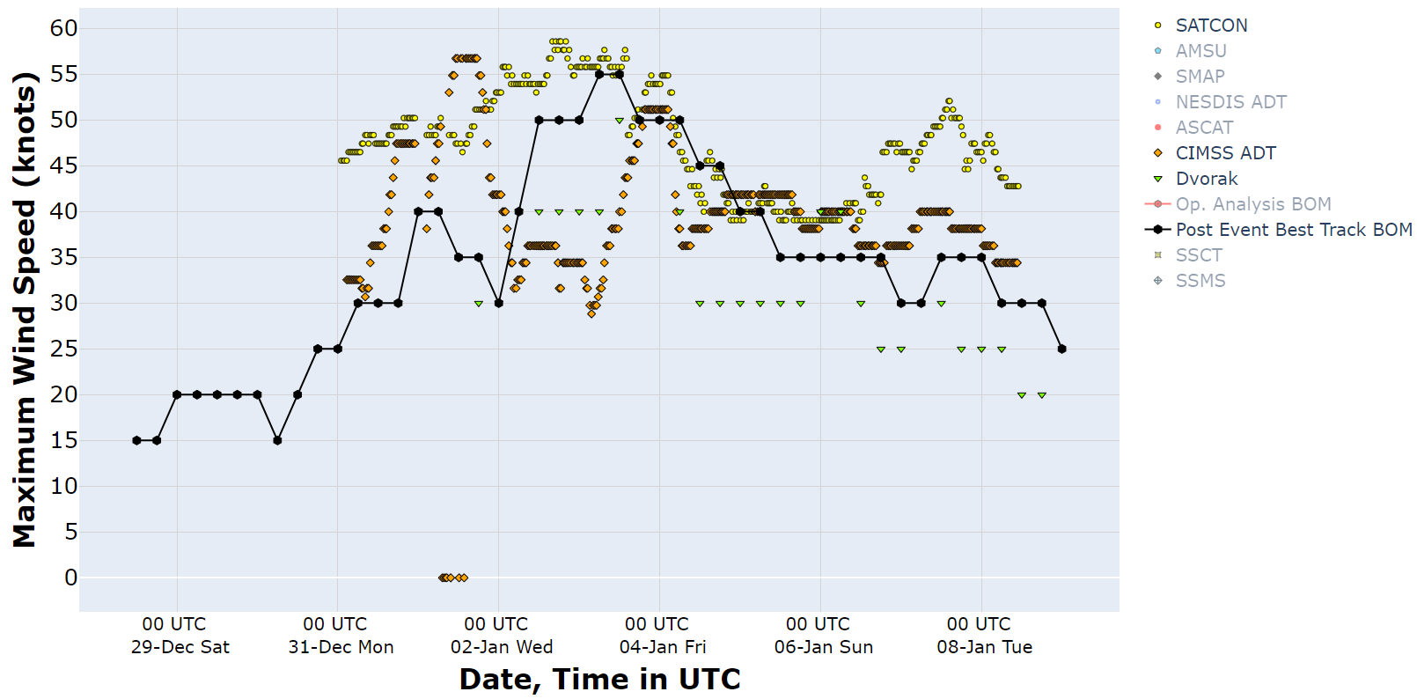

Figure 14. Intensity plot of objective and subjective guidance. SATCON, CIMSS ADT, Dvorak (subjective estimate) and post event best track analysis (black). CIMSS ADT and SATCON have been adjusted from 1-minute to 10-minute maximum mean winds.