Tropical Cyclone Robyn (01U)

# 23 November – 1 December 2024

## Linda Paterson, Tropical Cyclone Environmental Prediction Services

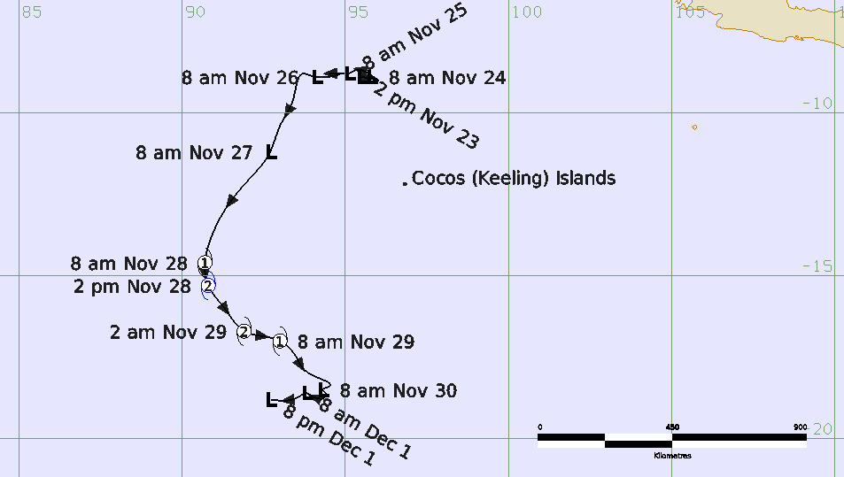

**Revision history**

|  |  |  |  |
| --- | --- | --- | --- |
| Date | Version | Author | Description |
| 22/01/2025 | 1.0 | Linda Paterson | Final draft |

**Review status**

|  |  |  |  |
| --- | --- | --- | --- |
| Date | Version | Reviewer | Description |
| 23/01/2025 | 1.0 | Joe Courtney | Completed |

**Release history**

|  |  |  |  |
| --- | --- | --- | --- |
| Date | Version | Status | Approval |
| 23/01/2025 | 1.0 | Approved for release | Andrew Burton |

Contact details:

Tropical Cyclone Team Lead

Severe Weather Environmental Prediction Services

Bureau of Meteorology

PO Box 1370, West Perth WA 6872

Email: [tcwc@bom.gov.au](mailto:tcwc@bom.gov.au)



This work is copyright. Apart from any use as permitted under the Copyright Act 1968, no part may be reproduced without prior written permission from the Bureau of Meteorology. Refer to www.bom.gov.au/other/copyright.shtml for further information. Unless otherwise noted, all images in this document are licensed under the Creative Commons Attribution Australia Licence.

© Commonwealth of Australia 2025

Published by the Bureau of Meteorology

Cover image: Track of Tropical Cyclone Robyn 23 November-1 December 2024. Times in AWST(UTC+8h)

Contents

1. Summary 5

2. Meteorological description 8

2.1 Intensity analysis 8

2.1 Structure 15

2.2 Motion 16

3. Impact 16

4. Observations 16

5. Forecast Performance 17

Appendix: List of abbreviations 19

**List of Figures**

Figure 1 Best track of Robyn 23 November - 1 December 2024. 5

Figure 2 Hovmoller diagram of tropical waves showing the formation of Robyn occurred with a strong pulse of the MJO and an Equatorial Rossby (ER) wave. 9

Figure 3 OSCAT pass at 0537 UTC 23 November 2024. 10

Figure 4 SMOS image at 1136 UTC 27 November 2024 with gales depicted in southern quadrants. 11

Figure 5 Ultra high resolution (UHR) ASCATB pass at 0327 UTC 28 November 2024 when Robyn attained tropical cyclone intensity. 12

Figure 6 UHR ASCAT-C pass at 1514 UTC 28 November 2024 when Robyn was near peak intensity. 13

Figure 7 Enhanced infrared image of Robyn at 1200 UTC 28 November 2024 as Robyn was near peak intensity 14

Figure 8 UHR ASCAT-B image at 1534 UTC 29 November 2024 as Robyn weakened. 15

Figure 9 Position accuracy figures for Tropical Cyclone Robyn. 18

Figure 10 Intensity accuracy figures for Tropical Cyclone Robyn. 18

**List of Tables**

Table 1 Best track summary for Tropical Cyclone Robyn, 23 November - 1 December 2024. 7

Table 2. Verification statistics for Tropical Cyclone Robyn.. 17

1. Summary

Tropical Cyclone Robyn was an early season, short lived cyclone in the Indian Ocean.

A tropical low (designated AU202425_01U) formed southwest of Sumatra associated with MJO and Kelvin wave activity. The development of a broad low was very gradual as it was constrained by northeasterly vertical wind shear.

The low moved southwest into the Australian region of responsibility (south of 10°S) on 27 November. The wind shear decreased, and Robyn reached tropical cyclone intensity early on 28 November, peaked briefly at category 2 intensity late on 28 November before weakening rapidly on 29 November. The remnant circulation then turned to the west and passed west of 90°E out of the Australian region during early December.

The system passed initially to the north then west of Cocos Islands and had no direct impact on the islands.

Figure 1 shows the best track of Robyn while Table 1 is a summary of the best track data.



Figure 1 Best track of Robyn 23 November - 1 December 2024. Times in WST (UTC+8 hours)

|  |  |  |  |  |  |  |  |  |  |  |  |  |
| --- | --- | --- | --- | --- | --- | --- | --- | --- | --- | --- | --- | --- |
| Year | Month | Day | Hour UTC | Pos Lat. S | Pos Long.E. | Pos Acc. nm | Max Wind10minkn | Max Gust kn | Cent.PresshPa | Rad. of gales  NE/SE/ SW/NW | Rad. of storm  NE/SE/ SW/NW | RMW  nm |
| 2024 | 11 | 23 | 0600 | 8.9 | 95.5 | 30 | 15 | 45 | 1004 |  |  |  |
| 2024 | 11 | 23 | 1200 | 9.0 | 96.0 | 40 | 15 | 45 | 1004 |  |  |  |
| 2024 | 11 | 23 | 1800 | 8.9 | 95.7 | 40 | 15 | 45 | 1004 |  |  |  |
| 2024 | 11 | 24 | 0000 | 8.9 | 95.8 | 50 | 15 | 45 | 1004 |  |  |  |
| 2024 | 11 | 24 | 0600 | 9.0 | 96.0 | 50 | 15 | 45 | 1004 |  |  |  |
| 2024 | 11 | 24 | 1200 | 8.7 | 95.5 | 50 | 15 | 45 | 1002 |  |  |  |
| 2024 | 11 | 24 | 1800 | 8.7 | 95.3 | 50 | 20 | 45 | 1002 |  |  |  |
| 2024 | 11 | 25 | 0000 | 8.8 | 95.1 | 50 | 20 | 45 | 1002 |  |  |  |
| 2024 | 11 | 25 | 0600 | 8.8 | 94.9 | 50 | 25 | 45 | 1002 |  |  |  |
| 2024 | 11 | 25 | 1200 | 8.8 | 94.5 | 50 | 25 | 45 | 1002 |  |  |  |
| 2024 | 11 | 25 | 1800 | 8.8 | 94.8 | 50 | 25 | 45 | 1002 |  |  |  |
| 2024 | 11 | 26 | 0000 | 8.9 | 94.1 | 45 | 25 | 45 | 1000 |  |  |  |
| 2024 | 11 | 26 | 0600 | 8.8 | 93.7 | 40 | 30 | 45 | 998 |  |  |  |
| 2024 | 11 | 26 | 1200 | 9.6 | 93.4 | 25 | 30 | 45 | 998 |  |  |  |
| 2024 | 11 | 26 | 1800 | 10.4 | 93.0 | 30 | 30 | 45 | 998 |  |  |  |
| 2024 | 11 | 27 | 0000 | 11.2 | 92.7 | 25 | 30 | 45 | 999 |  |  |  |
| 2024 | 11 | 27 | 0600 | 12.1 | 92.0 | 25 | 30 | 45 | 997 |  |  |  |
| 2024 | 11 | 27 | 1200 | 13.0 | 91.3 | 25 | 35 | 50 | 996 | 0/120/120/0* |  |  |
| 2024 | 11 | 27 | 1800 | 13.8 | 90.9 | 30 | 40 | 55 | 993 | 0/120/120/0* |  |  |
| 2024 | 11 | 28 | 0000 | 14.6 | 90.7 | 25 | 45 | 65 | 993 | 40/120/120/50 |  | 25 |
| 2024 | 11 | 28 | 0600 | 15.3 | 90.8 | 25 | 50 | 70 | 994 | 50/120/120/70 | 0/0/70/0 | 25 |
| 2024 | 11 | 28 | 1200 | 16.0 | 91.3 | 15 | 55 | 75 | 988 | 50/120/120/70 | 0/50/40/0 | 25 |
| 2024 | 11 | 28 | 1800 | 16.7 | 91.9 | 25 | 55 | 75 | 985 | 70/120/110/60 | 0/50/40/0 | 25 |
| 2024 | 11 | 29 | 0000 | 17.0 | 93.0 | 20 | 45 | 65 | 991 | 50/120/150/70 |  | 25 |
| 2024 | 11 | 29 | 0600 | 17.5 | 93.5 | 20 | 35 | 50 | 997 | 0/120/120/0* |  |  |
| 2024 | 11 | 29 | 1200 | 18.0 | 93.9 | 25 | 35 | 50 | 998 | 0/110/90/0* |  |  |
| 2024 | 11 | 29 | 1800 | 18.4 | 94.5 | 25 | 30 | 45 | 1000 |  |  |  |
| 2024 | 11 | 30 | 0000 | 18.5 | 94.3 | 15 | 30 | 45 | 1000 |  |  |  |
| 2024 | 11 | 30 | 0600 | 18.6 | 94.4 | 10 | 30 | 45 | 1000 |  |  |  |
| 2024 | 11 | 30 | 1200 | 18.7 | 94.4 | 10 | 25 | 45 | 1000 |  |  |  |
| 2024 | 11 | 30 | 1800 | 18.7 | 94.0 | 15 | 25 | 45 | 1002 |  |  |  |
| 2024 | 12 | 1 | 0000 | 18.6 | 93.8 | 15 | 25 | 45 | 1002 |  |  |  |
| 2024 | 12 | 1 | 0600 | 18.7 | 93.6 | 15 | 25 | 45 | 1004 |  |  |  |

Table 1 Best track summary for Tropical Cyclone Robyn, 23 November - 1 December 2024.

UTC=AWST-8h. * Not at tropical cyclone intensity as gales less than halfway around centre.

1. Meteorological description

2.1 Intensity analysis

An active phase of the MJO moved into the central Indian Ocean and aligned with an Equatorial Rossby wave (refer Figure 2) to aid the formation of a low during 23 November (refer Figure 3). The low remained weak with convection well removed from the centre until 26 November when a DT of 1.0 could be assigned. The low developed and a SMAP pass at 1140 UTC 26 November showed gales present in the southwest quadrant. A SMOS pass on 27 November showed gales had extended to the southeast quadrant (refer Figure 4). The area of gales increased and by 0000 UTC 28 November the gales had extended around the system centre and the circulation attained tropical cyclone intensity, refer Figure 5.

Robyn reached a 10-minute mean wind peak intensity of 55 kn (102 km/h) at 1200 and 1800 UTC 28 November. Enhanced infrared satellite imagery showed a cold comma cloud with the centre located well under the cold cloud, refer Figure 7. Subjective Dvorak reached a maximum DT of 3.5 at 1500 UTC 28 November and scatterometry and SAR passes confirmed the presence of at least 50 kn (93 km/h) winds through the period 0600 to 1800 UTC 28 November (refer Figure 6). Though Robyn still exhibited signs of being affected by shear, the centre of the system was located well under the cold cloud.

Due to a combination of increased vertical wind shear and ingestion of dry air Robyn weakened quickly from 1800 UTC 28 November and had decreased to below tropical cyclone intensity by 0600 UTC 29 November, refer Figure 8. A low persisted through until 1 December before it dissipated altogether.

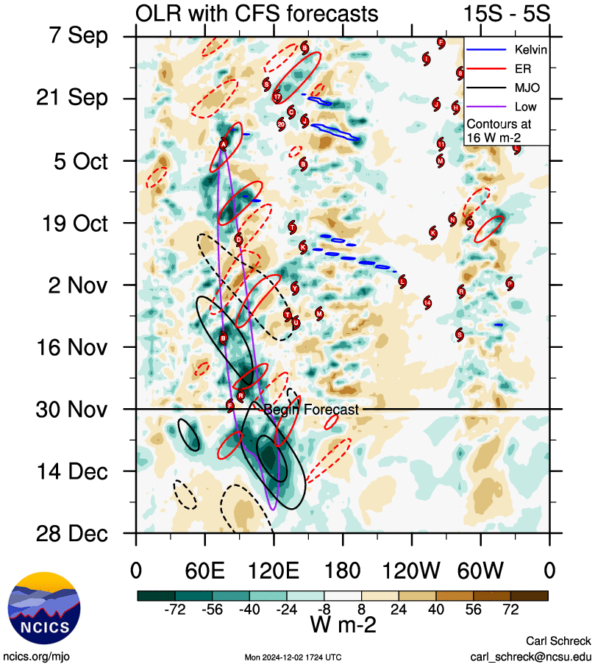

Figure 2 Hovmoller diagram of tropical waves showing the formation of Robyn occurred with a strong pulse of the MJO (black) and an Equatorial Rossby (ER) wave (red). The image is courtesy of the North Carolina Institute for Climate Studies. https://ncics.org/pub/mjo/archive/2024/2024-12-02/v2/

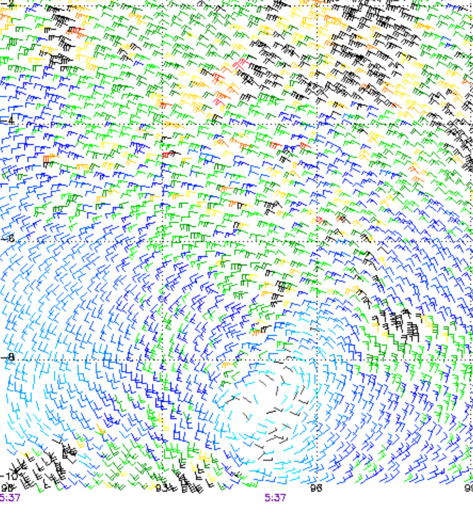

Figure 3 OSCAT pass at 0537 UTC 23 November 2024. Image courtesy NOAA STAR https://manati.star.nesdis.noaa.gov/datasets/ASCATBData.php

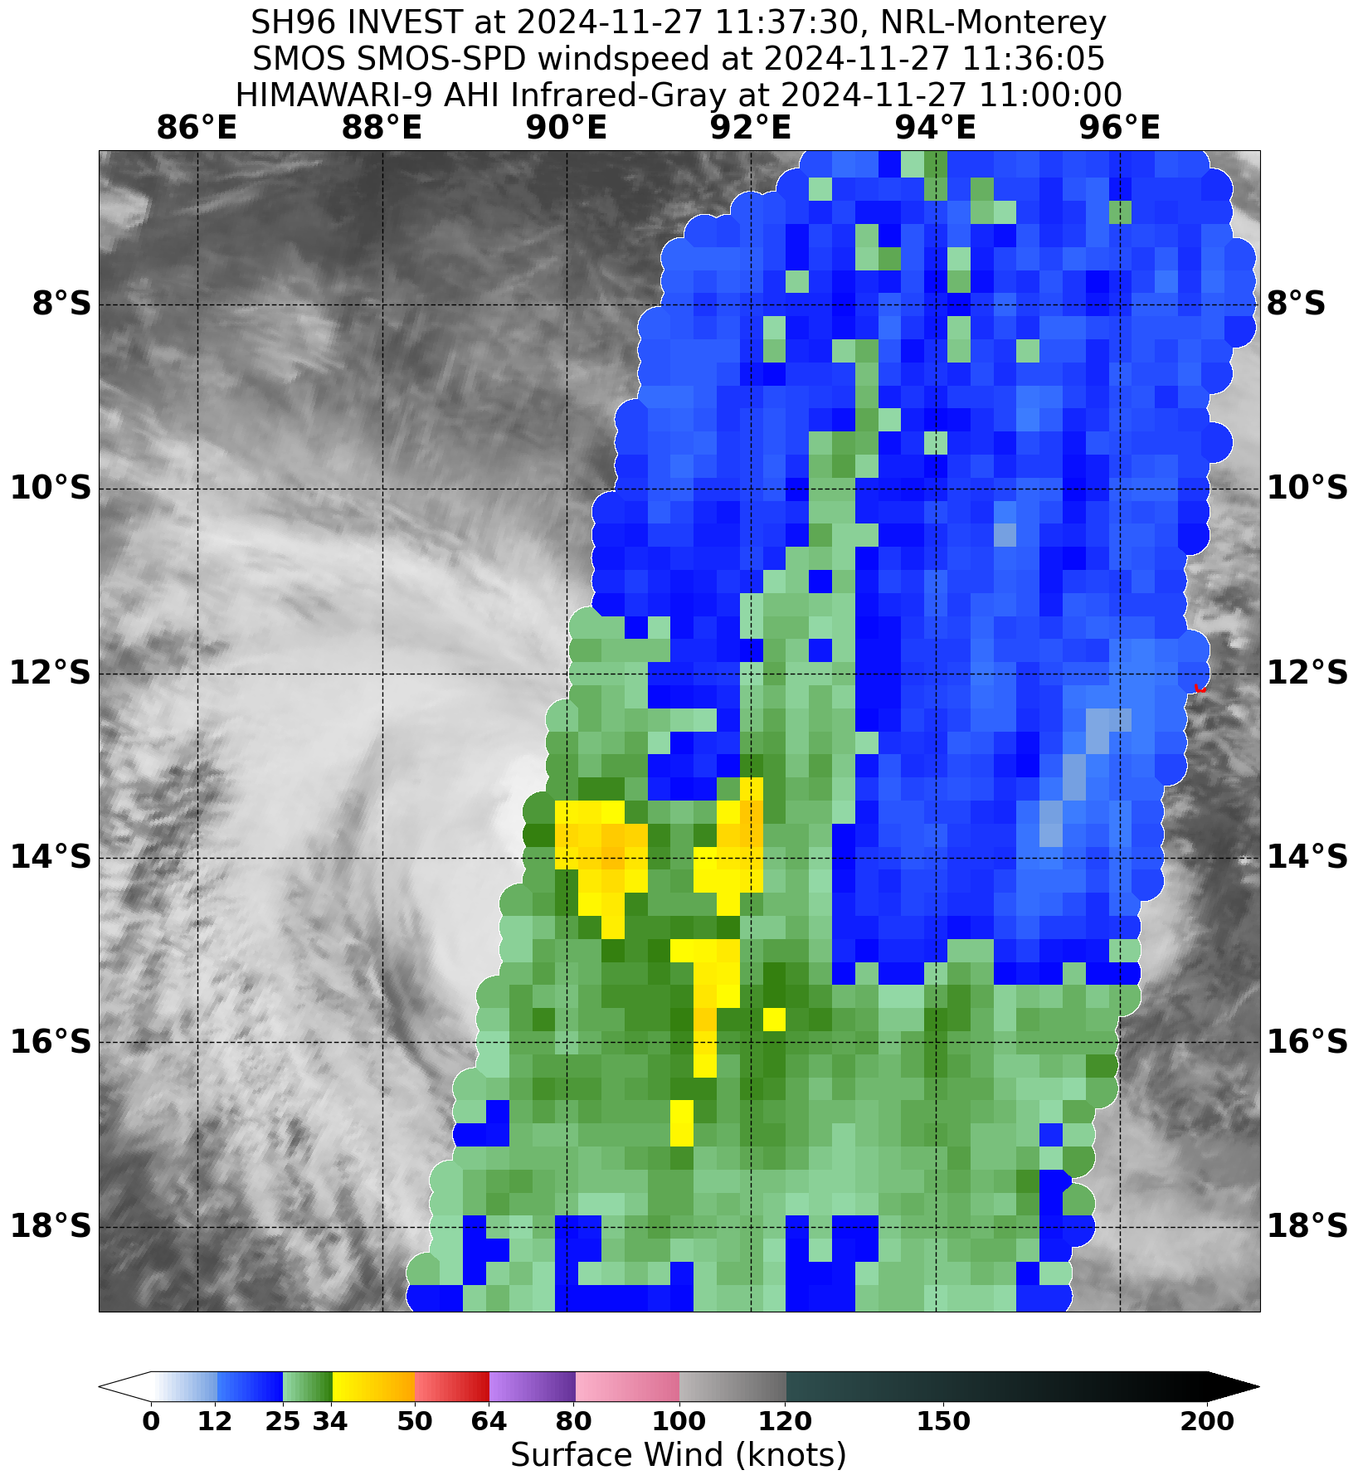

Figure 4 SMOS image at 1136 UTC 27 November 2024 with gales depicted in southern quadrants.

Image courtesy NRL. <https://www.nrlmry.navy.mil/TC.html>

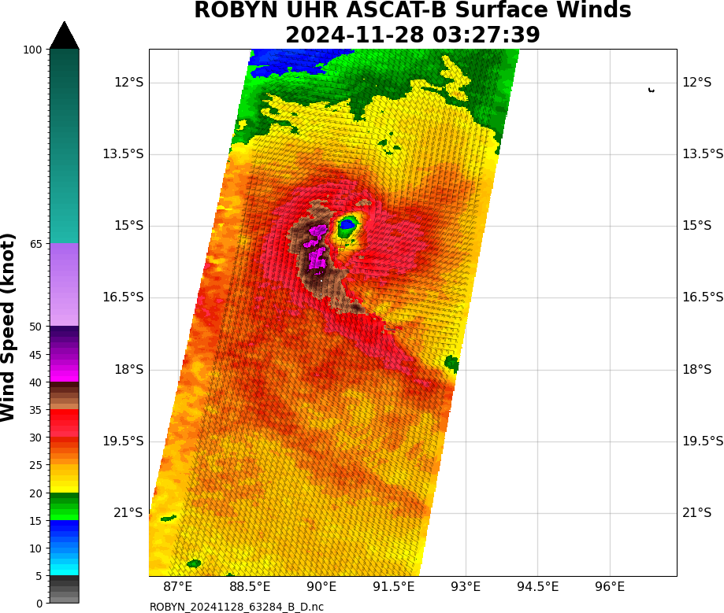

Figure 5 Ultra high resolution (UHR) ASCATB pass at 0327 UTC 28 November 2024 when Robyn attained tropical cyclone intensity. Image courtesy NRL. <https://www.nrlmry.navy.mil/TC.html>

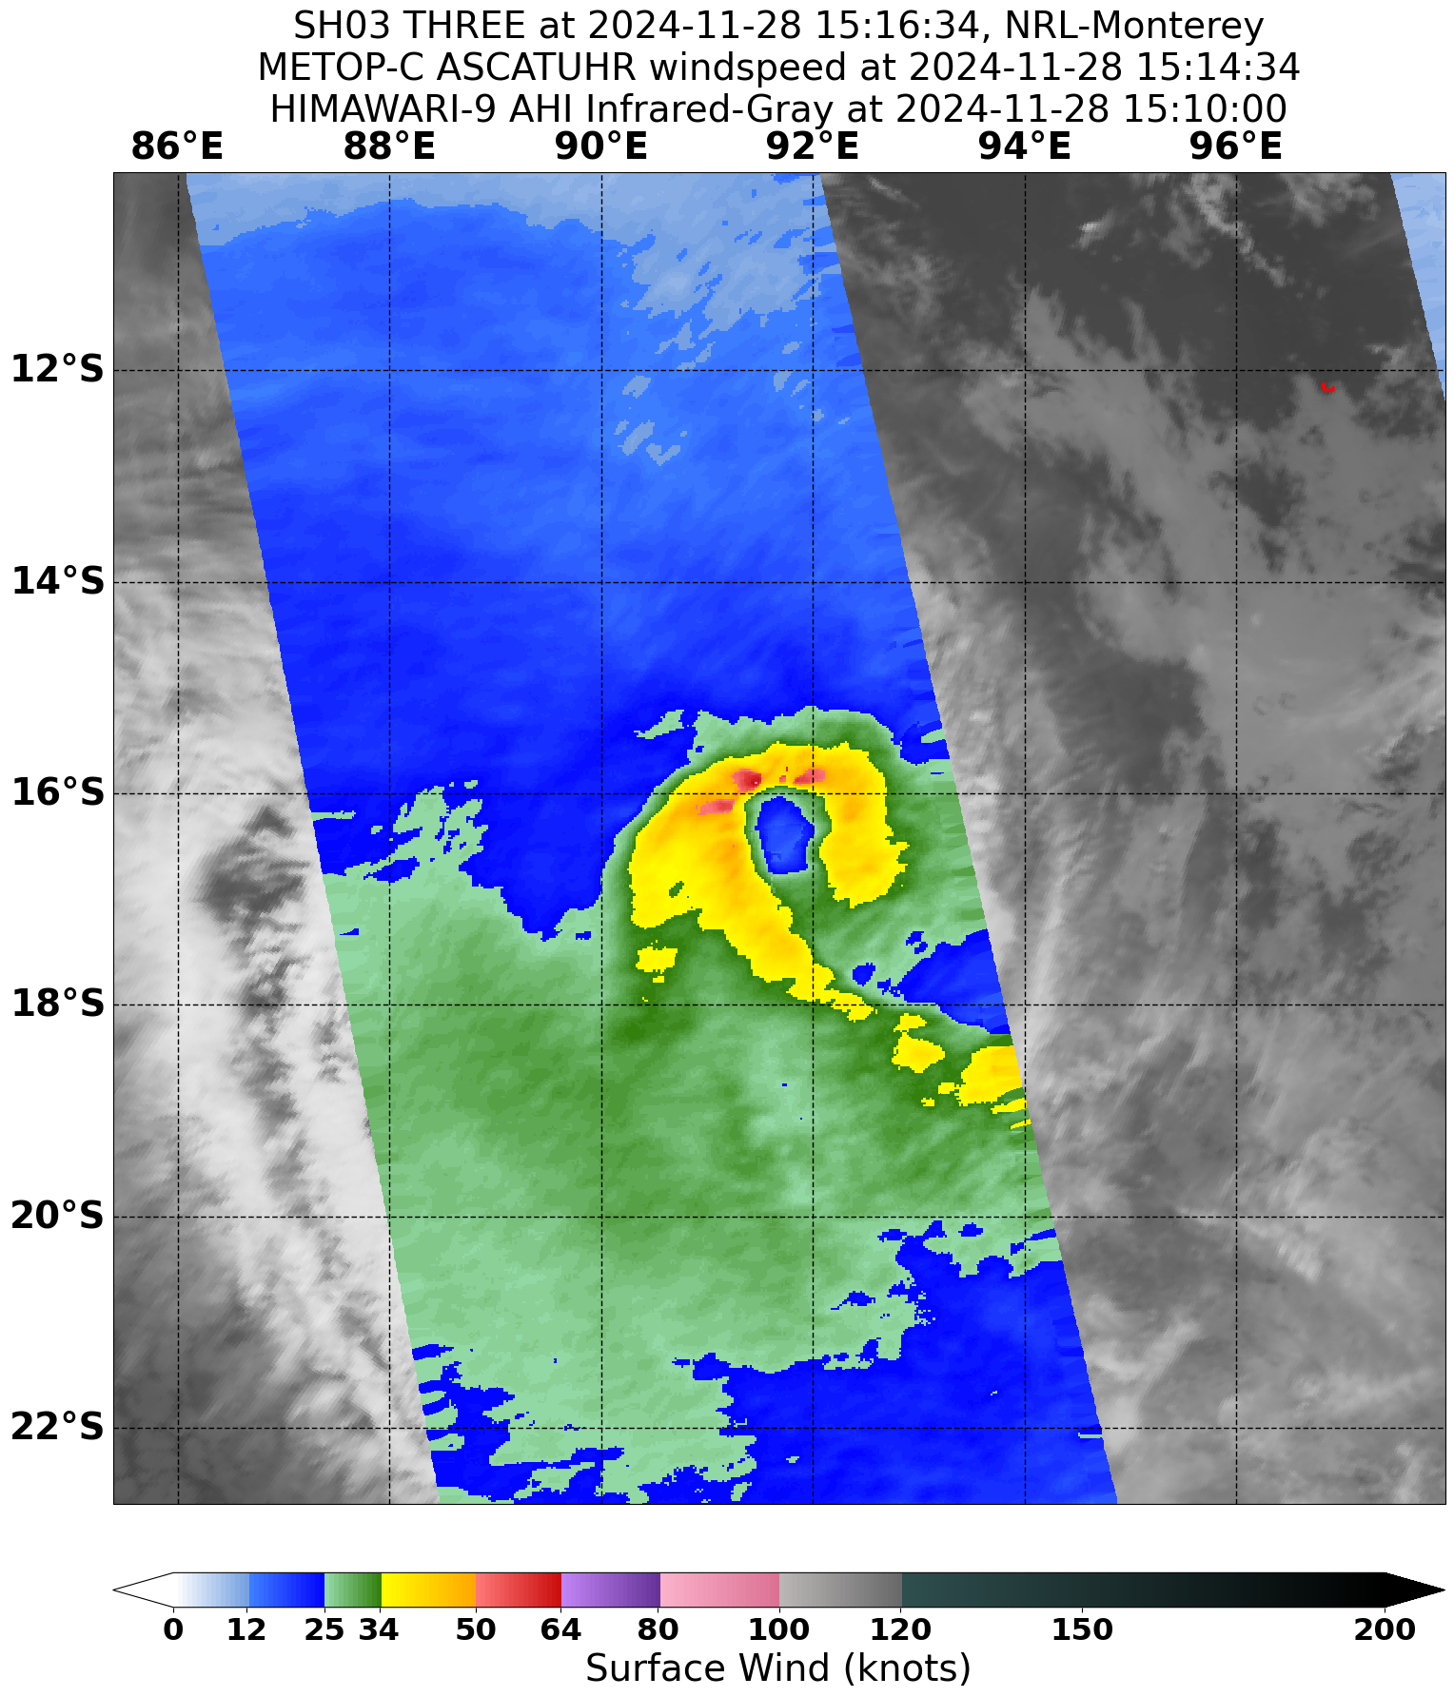

Figure 6 UHR ASCAT-C pass at 1514 UTC 28 November 2024 when Robyn was near peak intensity. Image courtesy NRL. <https://www.nrlmry.navy.mil/TC.html>

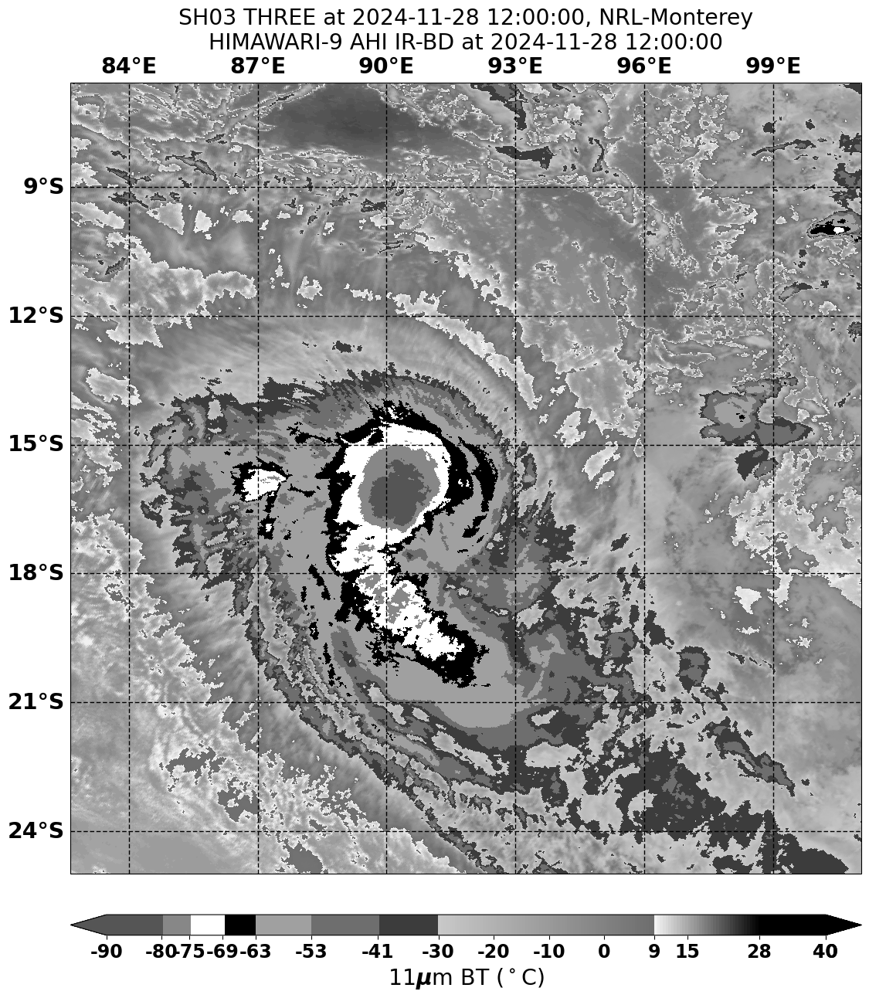

Figure 7 Enhanced infrared image of Robyn at 1200 UTC 28 November 2024 as Robyn was near peak intensity. Image courtesy NRL. <https://www.nrlmry.navy.mil/TC.html>

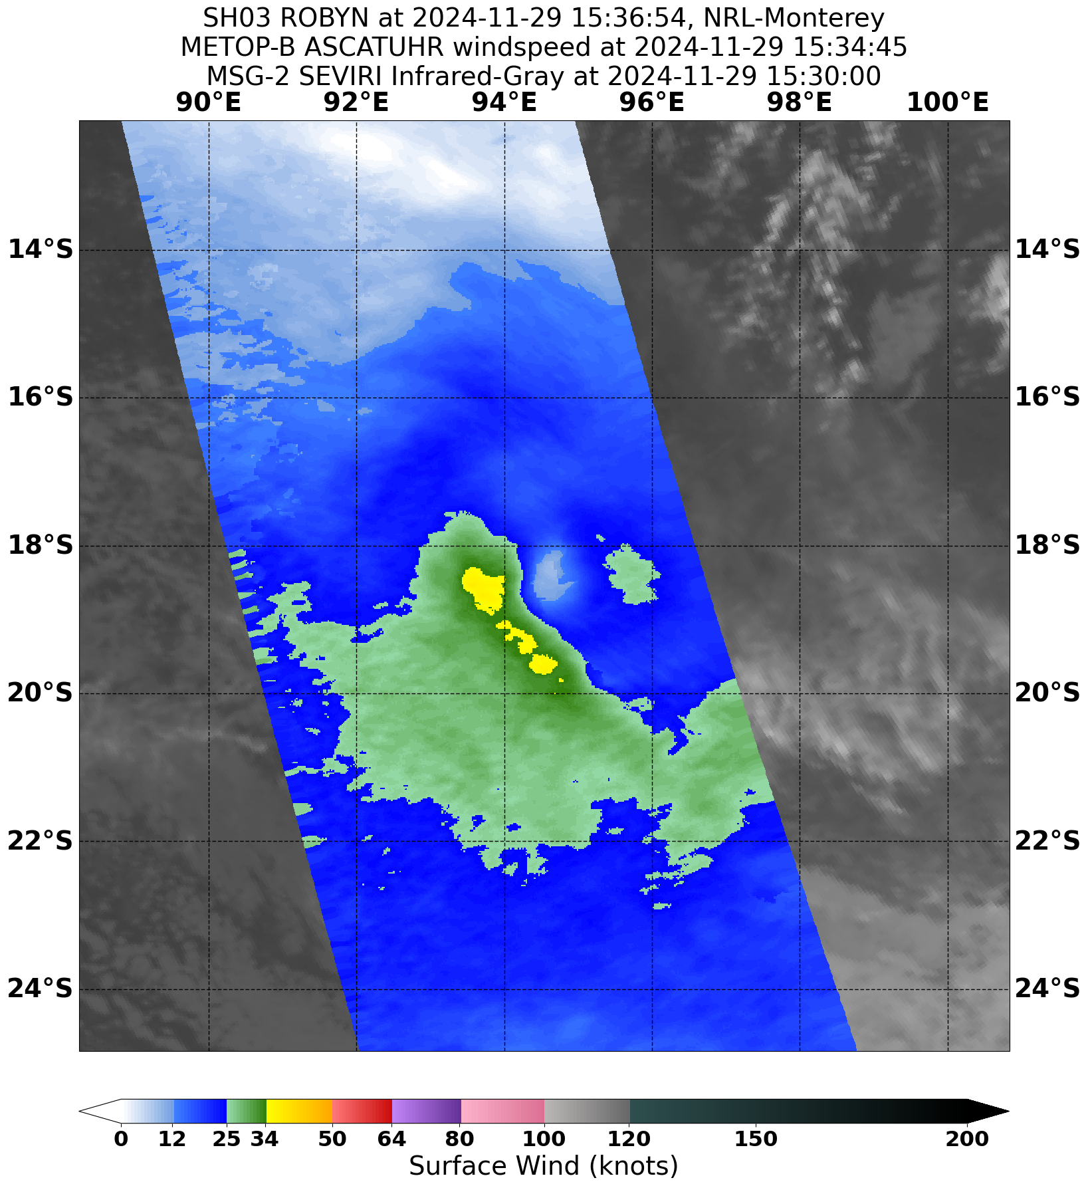

Figure 8 UHR ASCAT-B image at 1534 UTC 29 November 2024 as Robyn weakened. Image courtesy NRL. <https://www.nrlmry.navy.mil/TC.html>

## 2.1 Structure

Robyn was influenced by moderate vertical wind shear for most of its life cycle and exhibited an asymmetric cloud structure with cold cloud predominantly located on the western side of the system. Initially the radius to gales was 120 nm (220 km) in the southern quadrants (refer Figure 3). As Robyn intensified gales developed on the northern side with radius to gales of 40-50 nm (75-95 km). As Robyn weakened the gales contracted to the southern quadrants once again with a radius of 120 nm (220 km). Radius to maximum winds was 25 nm (45 km) through its time as a cyclone.

2.2 Motion

As shown in the track in Figure 1, during the early stages Robyn was steered west and then southwest by the upper ridge to the east of the system. During 27 November Robyn was captured by the upper trough passing to the south and the movement became southerly and then southeasterly on 28 November. The mid and upper-level circulation became separated from the low-level circulation during 29 November and by 30 November the remaining low-level centre was steered back to the west by low level easterlies.

1. Impact

There were no impacts from Tropical Cyclone Robyn on Cocos (Keeling) Islands.

1. Observations

Nil.

1. Forecast Performance

The accuracy statistics for Tropical Cyclone Robyn are below in Table 2 and shown in Figure 9 and Figure 10.

The forecast track position accuracy was considerably poorer than the 5-year average and intensity were better than the five-year average.

The poorer forecast performance can be attributed to an error in timing of the rapid shift in the direction of motion that Robyn experienced as it weakened. Official forecasts indicated the abrupt turn to the west would occur on 29 November but Robyn actually continued to the southeast to make the turn on 30 November. From the 27 November ensemble guidance became more consistent in indicating a westwards turn of the system during 29 November.

The intensity accuracy was comparable to and better than the 5-year average over the lifetime of Robyn.

The seven-day forecast for 01U commenced on 15 November. The probability of Robyn developing into a tropical cyclone was kept at moderate (25-45%) through until 28 November when it was increased to High (95%) as Robyn formed. Forecast track maps were issued between 0000 UTC 27 November and 1200 UTC 29 November with corresponding Information Bulletins and Technical Bulletins. Ocean Wind Warnings were issued between 1800 UTC 26 November and 1200 UTC 29 November.

|  |  |  |  |  |  |  |  |  |  |
| --- | --- | --- | --- | --- | --- | --- | --- | --- | --- |
| Time | 00 | 06 | 12 | 18 | 24 | 36 | 48 | 72 | 96 |
| Position accuracy (km) | 29 | 56 | 93 | 144 | 188 | 278 | 363 | 462 | 509 |
| Intensity accuracy (knots) | 2.9 | 5.4 | 5.4 | 5.8 | 6.7 | 5.8 | 4.2 | 1.9 | 2.5 |
| Sample size | 12 | 12 | 12 | 12 | 12 | 12 | 12 | 8 | 4 |

Table 2. Verification statistics for Tropical Cyclone Robyn. * Note, verification is performed using the Official Forecast Tracks at the standard times of 00, 06,12 and 18 UTC.

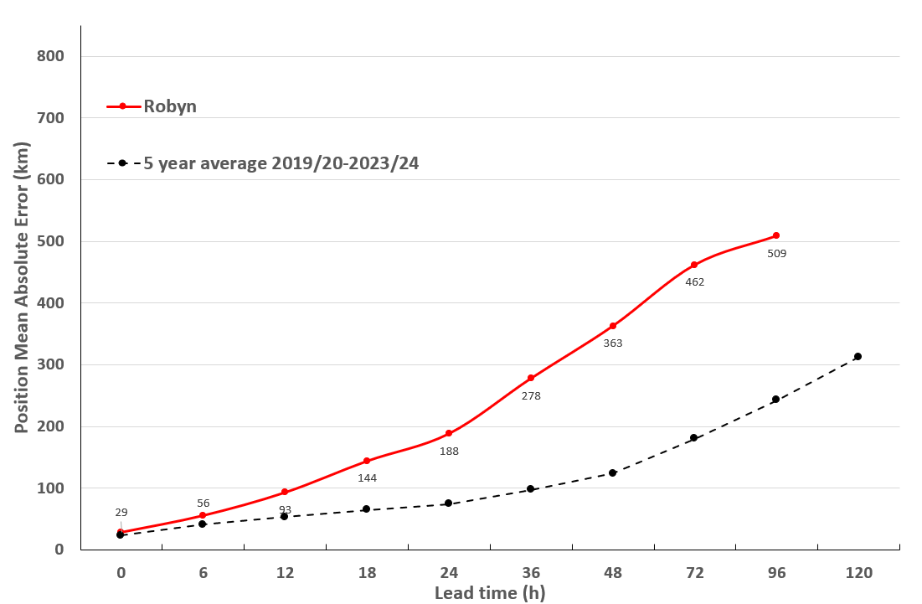

Figure 9 Position accuracy figures for Tropical Cyclone Robyn.

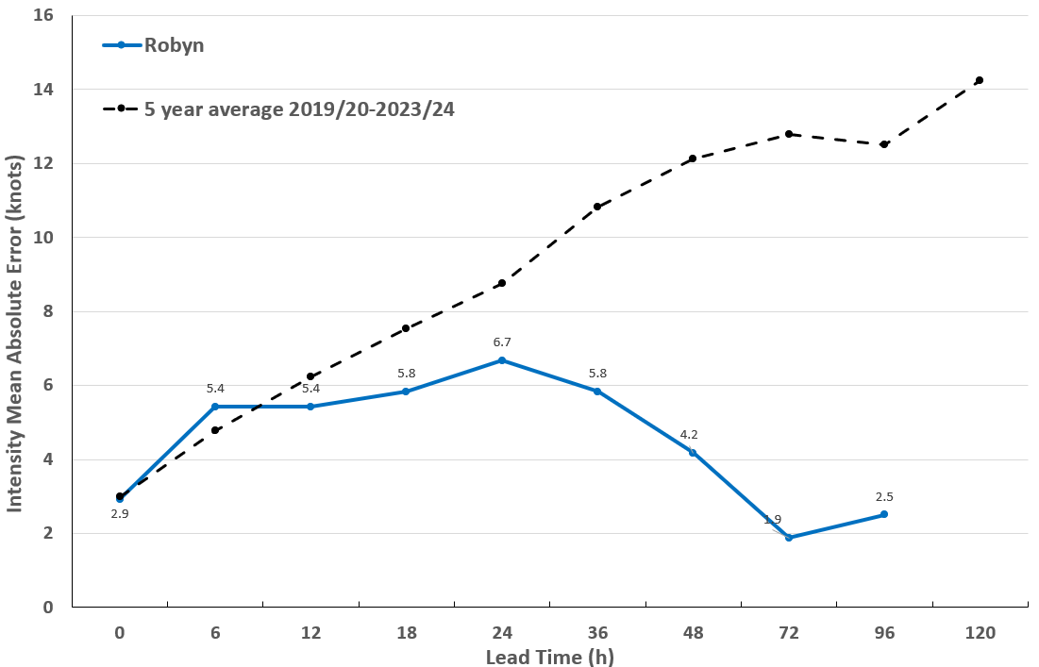

Figure 10 Intensity accuracy figures for Tropical Cyclone Robyn.

Appendix: List of abbreviations

|  |  |
| --- | --- |
| Abbreviation | Term |
| ADT | Advanced Dvorak Technique |
| ACST | Australian Central Standard Time |
| AEST | Australian Eastern Standard Time |
| AiDT | AI-enhanced Dvorak Technique |
| AMSR2 | Advanced Microwave Scanning Radiometer |
| AMSU | Advanced Microwave Sounding Unit |
| ASCAT | Advanced Scatterometer |
| ATMS | Advanced Technology Microwave Sounder |
| AWS | automatic weather station |
| AWST | Australian Western Standard Time |
| °C | Celsius |
| CI | Current intensity |
| CIMSS | Cooperative Institute for Meteorological Satellite Studies (USA) |
| CIRA | Cooperative Institute for Research in the Atmosphere (USA) |
| D-MINT | Deep learning - Multispectral Intensity of TCs (formerly known as DMN) |
| D-PRINT | Deep learning - IR Intensity of TCs (formerly known as OPEN-AIIR) |
| EIR | Enhanced InfraRed |
| ERC | eyewall replacement cycle |
| FNMOC | Fleet Numerical Meteorology and Oceanography Centre (USA) |
| FT | Final T-number |
| GCOM | Global Change Observation Mission |
| GHz | Gigahertz |
| GMI | Global Precipitation Measurement Microwave Imager |
| h | hour |
| hPa | hectopascal |
| HSCAT | Hai Yang 2 Scatterometer (HY-2B, HY-2C) |
| km | kilometres |
| km/h | kilometres per hour |
| kn | knot |
| LLCC | LLCC |
| MET | Model Expected T-number |
| METOP | Meteorological Operational Satellite |
| MJO | Madden-Julian Oscillation |
| mm | millimetres |
| MSLP | mean sea level pressure |
| NESDIS | National Environmental Satellite, Data, and Information Service |
| nm | nautical mile |
| NOAA | National Oceanic and Atmospheric Administration |
| NRL | Navy Research Lab (USA) |
| OPEN-AiiR | Ordered Pattern Encoding AI Infrared |
| PAT | Pattern T-number |
| RCM | RadarSat Constellation Mission – Synthetic Aperture Radar |
| RH | relative humidity |
| RMW | radius of maximum winds |
| RSMC | Regional Specialised Meteorological Centre |
| SAR | Synthetic Aperture Radar |
| SATC | CIMSS Advanced Dvorak Technique |
| SATCON | Satellite Consensus |
| SEN1 | Sentinel-1A – Synthetic Aperture Radar |
| SMAP | Soil Moisture Active Passive |
| SMOS | Soil Moisture and Ocean Salinity |
| SSMIS | Special Sensor Microwave Imager/Sounder |
| TC | Tropical Cyclone |
| TCWC | Tropical Cyclone Warning Centre |
| UTC | Universal Time Co-ordinated |