Severe Tropical Cyclone Sean (11U)

17-23 January 2025

Craig Earl-Spurr, Tropical Cyclone Environmental Prediction Services
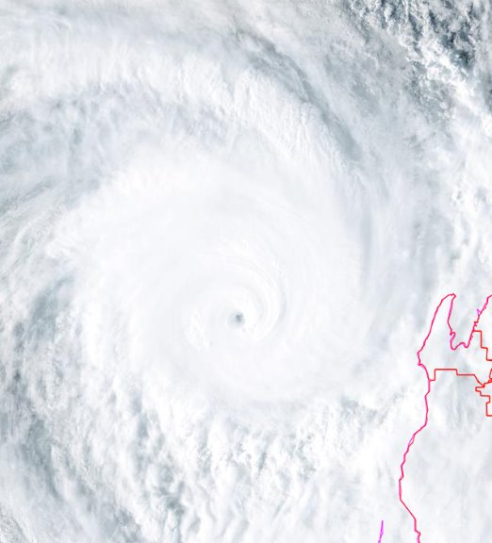

Revision history
Date | Version | Author | Description
13/03/2025 | 1.0 | Craig Earl-Spurr | Final draft

Review status
Date | Version | Reviewer | Description
9/04/2025 | 1.0 | Linda Paterson | Completed

Release history
Date | Version | Status | Approval
28/04/2025 | 1.0 | Approved for release | David Grant

Contact details:
Tropical Cyclone Team Lead
Severe Weather Environmental Prediction Services
Bureau of Meteorology
PO Box 1370, West Perth WA 6872
Email: tcwc@bom.gov.au

This work is copyright. Apart from any use as permitted under the Copyright Act 1968, no part may be reproduced without prior written permission from the Bureau of Meteorology. Refer to www.bom.gov.au/other/copyright.shtml for further information. Unless otherwise noted, all images in this document are licensed under the Creative Commons Attribution Australia Licence.
© Commonwealth of Australia 2025
Published by the Bureau of Meteorology
Cover image: Himawari-9 visible satellite image of Severe Tropical Cyclone Sean at time of peak intensity, 0900 UTC (5pm AWST) 20 January 2025

Contents

1. Summary 5

2. Meteorological description 8

2.1. Intensity analysis 8

2.2. Structure 13

2.3. Motion 15

3. Impact 16

4. Observations 16

4.1. Wind 16

4.2. Precipitation 17

4.3. Storm Surge 19

5. Forecast Performance 21

Appendix: List of abbreviations 24

List of Figures
Figure 1 Best track of Sean 17 - 23 January 2025. Times in WST (UTC+8 hours) 6
Figure 2 Hovmoller diagram of tropical waves showing the formation of Sean (indicated by the red cyclone symbol annotated with a 'S' near 120E around 18 Jan) occurred during an absence of the MJO in the region (black) but was associated with an Equatorial Rossby (ER) wave (red). The image is courtesy of the North Carolina Institute for Climate Studies. https://ncics.org/pub/mjo/archive/2025/2025-02-06/v2/ 9
Figure 3 Sea Surface Temperature (SST) analysis showing very warm waters off the northern coast of Western Australia. 10
Figure 4 AMSR2 89GHz image at 1804 UTC 19 January 2025 showing very clear eye structure in the deep convection. Image courtesy NRL. https://www.nrlmry.navy.mil/TC.html 11
Figure 5 Synthetic Aperture Radar (SAR) pass at 1108 UTC 20 January 2025 near the time of peak intensity. Image courtesy NOAA. https://www.star.nesdis.noaa.gov/socd/mecb/sar/sarwinds_tropical.php 12
Figure 6 Comparison of objective intensity aids for Severe Tropical Cyclone Sean. All values converted to 10-minute averages. 13
Figure 7 ASCAT pass at 0148 UTC 18 January 2025 showing much stronger winds on the southern side of the developing tropical low that later became Sean. Image courtesy NRL. https://www.nrlmry.navy.mil/TC.html 14
Figure 8 ASCAT pass at 0152 UTC 20 January 2025 showing large extent of gale force winds on the eastern side of Sean. Image courtesy NRL. https://www.nrlmry.navy.mil/TC.html 15
Figure 9 Rainfall analysis for the 7 days till 9am on 23 January 2025 showing heavy falls as a result of Sean mostly confined to the coastal fringe of the Pilbara. 19
Figure 10 The storm surge residual and total water level recorded at Exmouth compared with the predicted tide and Highest Astronomical Tide (HAT) for the period 19-22 January 2025. Data courtesy Department of Transport. 20
Figure 11 Position accuracy figures for Severe Tropical Cyclone Sean. 22
Figure 12 Intensity accuracy figures for Severe Tropical Cyclone Sean. 23

List of Tables
Table 1 Best track summary for Severe Tropical Cyclone Sean, 17-23 January 2025. 7
Table 2 Daily and 4-day rainfall totals at various Pilbara and Kimberley locations. Values recorded in the 24 hours to 9am of the respective dates. 18
Table 3. Verification statistics for Severe Tropical Cyclone Sean. * Note, verification is performed using the Official Forecast Tracks at the standard times of 00, 06,12 and 18 UTC. 21

- Summary
A tropical low (11U) formed west of the Kimberley coast on 17 January where near record sea surface temperatures contributed to a very favourable environment for tropical cyclone development. Another tropical low (10U) nearby initially hampered the development of 11U, but 10U steadily dissipated, allowing 11U to strengthen. As 11U developed it was steered to the west-southwest, parallel to the Pilbara coast. It reached tropical cyclone intensity and was named Tropical Cyclone Sean at 0000 UTC (8:00am AWST) 19 January while to the north of Karratha. Sean continued to intensify quickly, reaching category 3 strength by 1200 UTC 19 January.
Sean turned southwest and reached a peak intensity of 95 knots (175 km/h) at 1200 UTC 20 January while it was located about 350 km to the west of Exmouth. From 1800 UTC 20 January Sean began to weaken as it moved over cooler sea surface temperatures. Sean stayed well to the west of the Western Australian coast as it continued to weaken and had lost its tropical characteristics by 0600 UTC 22 January.
Gales were observed along the Pilbara coast between Roebourne and Exmouth during 19 and 20 January with a maximum wind gust of 56 knots (104 km/h) recorded at Karratha at 0829 UTC 19 January. Karratha also exceeded its highest annual daily rainfall record when 274 mm of rain fell in the 24 hours to 9 am 20 January, including an intense rainband that moved across the town during the late afternoon and early evening of 19 January. Residents reported water ingress and flooding, as well as trees down on properties and cars.
A combination of a shelf wave and storm surge generated tides of about 0.6 to 1.2 m above normal along the Pilbara and west coasts.
Figure 1 shows the best track of Sean while Table 1 is a summary of the best track data.
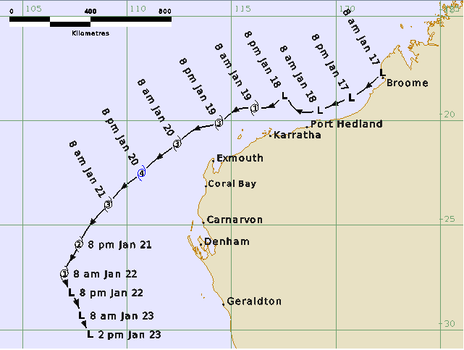
Figure 1 Best track of Sean 17 - 23 January 2025. Times in AWST (UTC+8 hours)

Year | Month | Day | Hour (UTC) | Pos Lat (S) | Pos Long (E) | Poss Acc (nm) | Max Wind (kn) | Wind Gust (kn) | Cent Press (hPa) | Radius of Gales NE/SE/SW/NW | Radius of Storm NE/SE/SW/NW | RMW (nm)
2025 | 1 | 17 | 0000 | 17.7 | 122.2 | 30 | 20 | 45 | 1000 | -/-/-/- | -/-/-/-
2025 | 1 | 17 | 0600 | 18.2 | 121.7 | 20 | 25 | 45 | 1000 | -/-/-/- | -/-/-/-
2025 | 1 | 17 | 1200 | 18.9 | 120.7 | 30 | 25 | 45 | 998 | -/-/-/- | -/-/-/-
2025 | 1 | 17 | 1800 | 19.1 | 120.2 | 40 | 30 | 45 | 998 | -/-/-/- | -/-/-/-
2025 | 1 | 18 | 0000 | 19.5 | 119.2 | 30 | 30 | 45 | 998 | -/-/-/- | -/-/-/-
2025 | 1 | 18 | 0600 | 19.3 | 117.9 | 20 | 30 | 45 | 996 | -/-/-/- | -/-/-/-
2025 | 1 | 18 | 1200 | 18.8 | 117.5 | 30 | 35 | 50 | 996 | -/60/-/-* | -/-/-/-
2025 | 1 | 18 | 1800 | 19.1 | 117.2 | 20 | 40 | 55 | 993 | -/80/80/-* | -/-/-/-
2025 | 1 | 19 | 0000 | 19.4 | 116.1 | 15 | 45 | 65 | 989 | 70/100/90/50 | -/-/-/- | 25
2025 | 1 | 19 | 0600 | 19.5 | 115.2 | 15 | 55 | 75 | 986 | 70/150/110/70 | -/70/60/- | 20
2025 | 1 | 19 | 1200 | 20.1 | 114.4 | 15 | 65 | 90 | 974 | 90/150/110/80 | 40/70/60/20 | 15
2025 | 1 | 19 | 1800 | 20.4 | 113.3 | 15 | 75 | 105 | 965 | 150/150/130/80 | 40/70/60/40 | 10
2025 | 1 | 20 | 0000 | 21.1 | 112.4 | 15 | 85 | 120 | 959 | 180/170/140/100 | 40/70/60/40 | 8
2025 | 1 | 20 | 0600 | 21.7 | 111.6 | 15 | 90 | 125 | 948 | 200/180/120/100 | 60/80/60/40 | 7
2025 | 1 | 20 | 1200 | 22.5 | 110.7 | 15 | 95 | 135 | 945 | 160/160/110/110 | 70/80/60/50 | 6
2025 | 1 | 20 | 1800 | 23.2 | 109.8 | 20 | 85 | 120 | 952 | 130/130/110/110 | 70/80/60/60 | 8
2025 | 1 | 21 | 0000 | 24.0 | 109.1 | 20 | 80 | 110 | 954 | 130/130/110/100 | 60/60/70/60 | 10
2025 | 1 | 21 | 0600 | 24.9 | 108.3 | 30 | 65 | 90 | 968 | 120/130/110/100 | 60/70/70/30 | 15
2025 | 1 | 21 | 1200 | 25.9 | 107.7 | 20 | 60 | 85 | 972 | 120/120/110/90 | 50/70/60/- | 18
2025 | 1 | 21 | 1800 | 26.5 | 107.4 | 20 | 50 | 70 | 978 | 100/110/110/40 | 50/70/-/- | 22
2025 | 1 | 22 | 0000 | 27.3 | 107 | 10 | 45 | 65 | 987 | 80/90/120/- | -/-/-/- | 30
2025 | 1 | 22 | 0600 | 27.8 | 107.1 | 10 | 40 | 55 | 988 | -/90/120/-* | -/-/-/-
2025 | 1 | 22 | 1200 | 28.2 | 107.3 | 15 | 40 | 55 | 988 | -/90/120/-* | -/-/-/-
2025 | 1 | 22 | 1800 | 28.5 | 107.5 | 15 | 40 | 55 | 992 | -/90/120/-* | -/-/-/-
2025 | 1 | 23 | 0000 | 29.3 | 107.8 | 10 | 35 | 50 | 990 | -/-/120/-* | -/-/-/-
2025 | 1 | 23 | 0600 | 30.2 | 108.2 | 10 | 25 | 45 | 998 | -/-/-/- | -/-/-/-
Table 1 Best track summary for Tropical Cyclone Sean, 17-23 January 2025.
UTC=AWST-8h. * Not a tropical cyclone as gales less than halfway around centre.
- Meteorological description
  - Intensity analysis
Despite the absence of an active Madden Julian Oscillation, an Equatorial Rossby Wave passing to the north of Western Australia (Figure 2) aided the formation of a low on 17 January. The low was initially evident on the Broome and then Port Hedland radars. Scatterometer and radiometer passes showed strong winds on the periphery of the low steadily consolidate nearer the centre over the course of the day. Similarly, convection that was initially active over a broad region off the Kimberley coast became focussed near the circulation and a DT of 1.0 was assigned at 1800 UTC 17 January.
Fuelled by record sea surface temperatures (Figure 3), the tropical low continued to strengthen during 18 January. Gale force winds developed from 1200 UTC, and it became Tropical Cyclone Sean at 0000 UTC 19 January by which time it already had an intensity of 45 knots. Sean then underwent a period of rapid intensification, developing an eye (Figure 4) as it strengthened into a severe tropical cyclone, reaching 85 knots by 0000 UTC 20 January, an increase of 40 knots over 24 hours. It reached a peak intensity of 95 knots between 0900 UTC and 1200 UTC on 20 January with a SAR pass at 1102 UTC (Figure 5) depicting maximum winds near the centre reaching 110 knots (1-min mean).
Sean then began to move over much cooler seas and weakened almost as quickly as it strengthened, its intensity decreasing to 60 knots by 1200 UTC 21 January. Sean then continued weakening as it started to become a shallow and cold cored low. It was no longer a tropical cyclone from 0600 UTC 22 January, though gale force winds persisted until 0000 UTC 23 January before it quickly dissipated. A comparison of objective intensity aids is included in Figure 6.
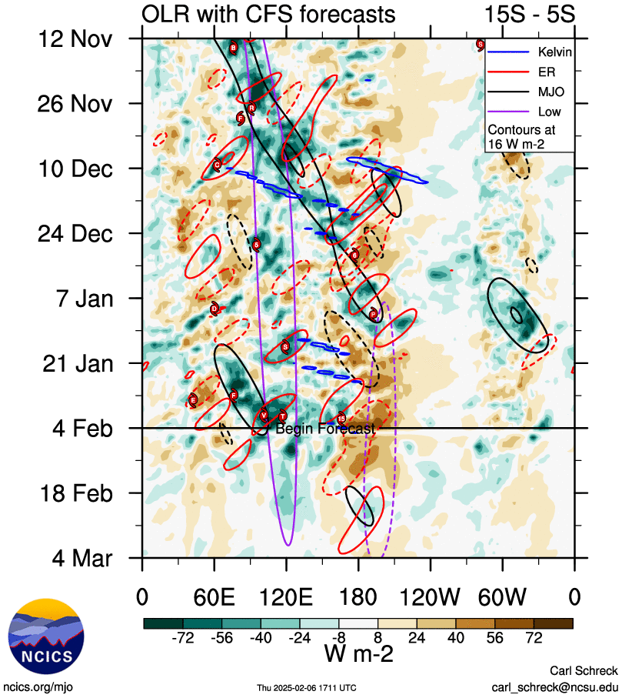
Figure 2 Hovmoller diagram of tropical waves showing the formation of Sean (indicated by the red cyclone symbol annotated with a 'S' near 120E around 18 Jan) occurred during an absence of the MJO in the region (black) but was associated with an Equatorial Rossby (ER) wave (red). The image is courtesy of the North Carolina Institute for Climate Studies. https://ncics.org/pub/mjo/archive/2025/2025-02-06/v2/

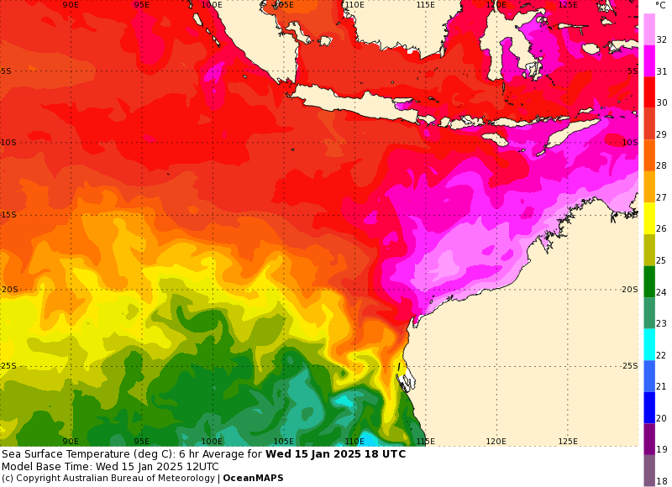
Figure 3 Sea Surface Temperature (SST) analysis showing very warm waters off the northern coast of Western Australia.
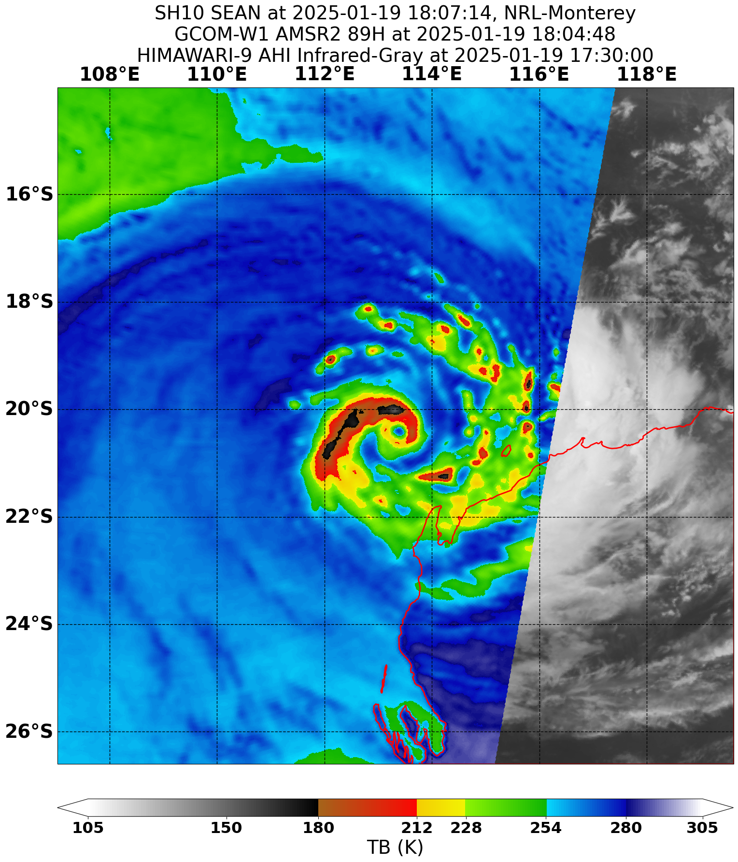
Figure 4 AMSR2 89GHz image at 1804 UTC 19 January 2025 showing very clear eye structure in the deep convection. Image courtesy NRL. https://www.nrlmry.navy.mil/TC.html

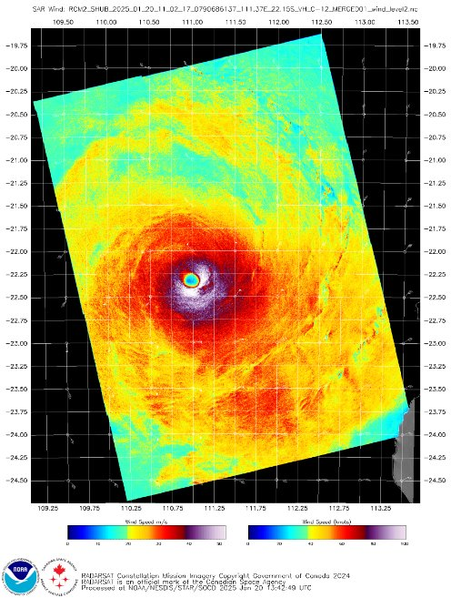
Figure 5 Synthetic Aperture Radar (SAR) pass at 1108 UTC 20 January 2025 near the time of peak intensity. Image courtesy NOAA. https://www.star.nesdis.noaa.gov/socd/mecb/sar/sarwinds_tropical.php
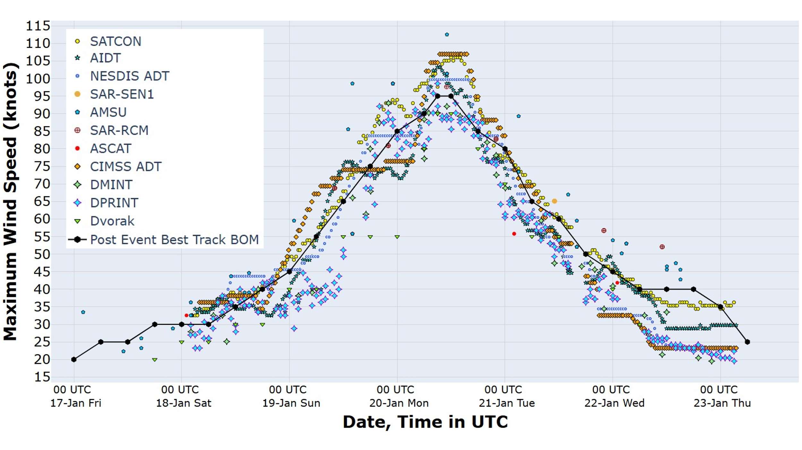
Figure 6 Comparison of objective intensity aids for Severe Tropical Cyclone Sean. All values converted to 10-minute averages.
  - Structure
In the early stages of Sean's development, the strongest winds were confined to its southern side (Figure 7) and this is where gales first developed to a radius of approximately 80 nm (150 km) between 1200 UTC and 1800 UTC 18 January. Gales then extended around the northern side of Sean from 0000 UTC 19 January. As Sean intensified further the gale radius increased over the next 24 hours, eventually extending to at least 110 nm (205 km) in all quadrants. During 19 and 20 January the gale radius on the eastern side extended substantially further with a vigorous convective band feature in the northeast quadrant pushing the gales out to 200 nm (375 km) from the centre (Figure 8).
As Sean interacted more with the mid-latitudes and weakened, the gale structure became more asymmetric with gales once more becoming confined to the south of the system, largely due to the influence of the subtropical ridge to its south.
Like the area of gales, both the storm and hurricane radii generally extended further in the southeast quadrant, albeit less pronounced. Storm radii were generally around 60 nm (110 km), extending to 80 nm (150 km) in the southeast and hurricane radii were around 30 nm (55 km), extending to 50 nm (95 km) in the southeast.
The RMW was initially 25 nm (45 km) decreasing as Sean intensified to a mere 6 nm (11 km) at peak intensity. At the time of peak intensity, a small eye with a radius of 5 nm (9 km) was clear on satellite imagery. The RMW then increased again as Sean weakened, reaching 30 nm (55 km) prior to Sean losing tropical cyclone status.
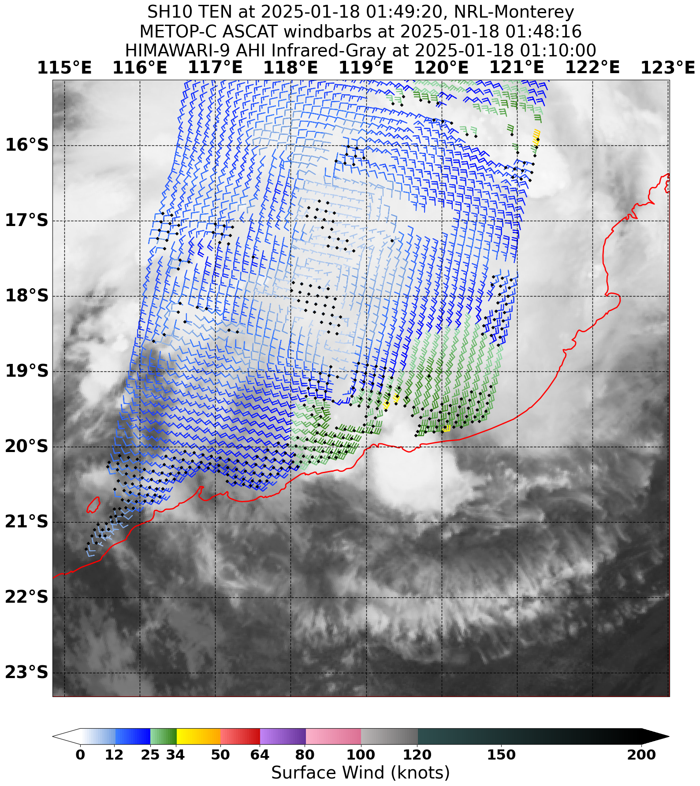
Figure 7 ASCAT pass at 0148 UTC 18 January 2025 showing much stronger winds on the southern side of the developing tropical low that later became Sean. Image courtesy NRL. https://www.nrlmry.navy.mil/TC.html

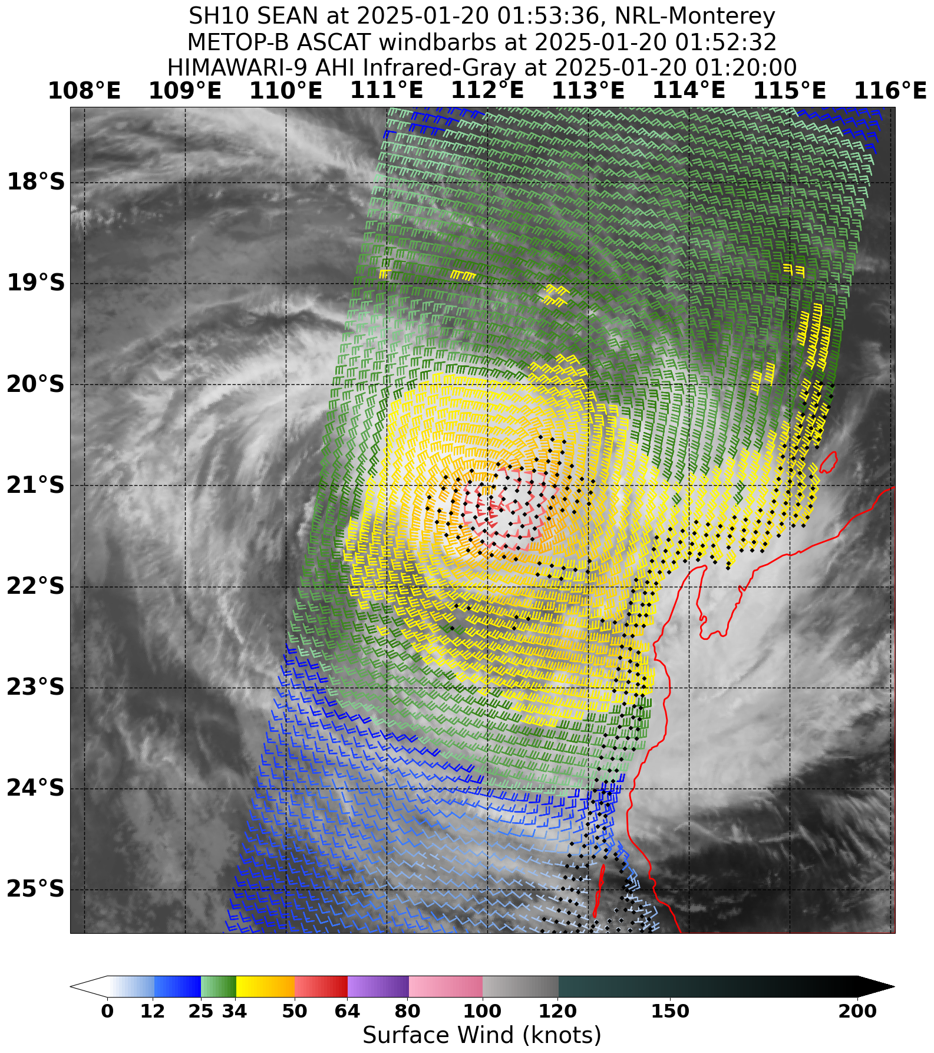
Figure 8 ASCAT pass at 0152 UTC 20 January 2025 showing large extent of gale force winds on the eastern side of Sean. Image courtesy NRL. https://www.nrlmry.navy.mil/TC.html
  - Motion
Prior to strengthening into a tropical cyclone, the low that became Sean moved generally west though had a slightly erratic track likely due to the influence of the remnants of 10U. As Sean subsequently strengthened it was steered west and then southwest by the upper ridge to the east of the system. During 22 January, the weakening Sean was captured by a mid-level trough passing to the south and turned sharply towards the southeast before its eventual dissipation shortly thereafter.
- Impact
The most notable impacts from Severe Tropical Cyclone Sean were reported from Karratha during the late afternoon and early evening on 19 January when an intense rain band moved across the town. Flooding was reported in the town of Karratha and the North West Coastal Highway had to be temporarily closed, effectively cutting off road access to the towns of Karratha and Dampier from the remainder of the state.
A total of 48 Requests for Assistance were made to SES units across the Pilbara, including 32 in Karratha. Most requests involved water ingress or flooding with a handful reporting trees down on properties or cars.
- Observations
  - Wind
Damaging wind gusts were recorded at several sites with the strongest wind gust during Severe Tropical Cyclone being 64 kn (119 km/h) at Legendre Island, reported at 1626 UTC 19 January (00:26 AWST on 20 January).
The strongest 10-minute sustained winds were recorded at Varanus Island reached the threshold for storm force winds at a few brief periods during the afternoon of 19 January. The 10-minute mean wind peaked at 0546 UTC (13:46 AWST), reaching 48 kn (90 km/h).
Of the locations which reported damaging wind gusts on the mainland, the strongest was 56 knots (104 km/h) at Karratha Airport at 0829 UTC (16:29 AWST) on 19 January. This was also the mainland location which reported the strongest 10-minute sustained winds, peaking at 45 knots (84km/h) at 0835 UTC (16:35 AWST).
A summary of stations that reported damaging wind gusts or stronger is included below.
Varanus Island recorded gale force winds intermittently from 2313 UTC 18 January to 0158 UTC 20 January including an extended period of continuous gale force winds or stronger between 0049 UTC 19 January and 1710 UTC 19 January and intermittent storm force winds between 0543 UTC 19 January and 1007 UTC 19 January. The maximum 10-minute mean wind recorded was 48 kn (90 km/h) at 1000 UTC 19 January and the maximum wind gust recorded was 61 kn (113 km/h) at 0540 UTC 19 January.
Legendre Island recorded gale force winds intermittently from 0537 UTC 18 January to 0241 UTC 20 January including an extended period of continuous gale force winds or stronger between 2001 UTC 18 January and 0527 UTC 19 January and briefly storm force winds from 1632 to 1633 UTC 19 January. The maximum 10-minute mean wind recorded was 48 kn (90 km/h) at 1633 UTC 19 January and the maximum wind gust recorded was 64 kn (119 km/h) at 1626 UTC 19 January.
Barrow Island recorded gale force winds intermittently from 0006 UTC 19 January to 0235 UTC 20 January including an extended period of continuous gale force winds between 0340 UTC 19 January and 1805 UTC 19 January. The maximum 10-minute mean wind recorded was 46 kn (85 km/h) at 1026 UTC 19 January and the maximum wind gust recorded was 61 kn (113 km/h) at 1021 UTC 19 January.
Thevenard Island recorded gale force winds intermittently from 0418 UTC 19 January to 1007 UTC 20 January including extended periods of continuous gale force winds between 1020 UTC and 1452 UTC 19 January and again between 0049 UTC and 0534 UTC 20 January. The maximum 10-minute mean wind recorded was 43 kn (80 km/h) at 0347 UTC 20 January and the maximum wind gust recorded was 59 kn (109 km/h) at 1229 UTC 19 January.
Karratha recorded gale force winds intermittently from 0019 UTC 19 January to 1701 UTC 19 January. The maximum 10-minute mean wind recorded was 45 kn (84 km/h) at 0835 UTC 19 January and the maximum wind gust recorded was 56 kn (104 km/h) at 0829 UTC 19 January.
Learmonth recorded gale force winds intermittently from 1315 UTC 19 January to 1113 UTC 20 January including an extended period of continuous gale force winds between 0447 UTC and 0955 UTC 20 January. The maximum 10-minute mean wind recorded was 42 kn (78 km/h) at 0655 UTC 20 January and the maximum wind gust recorded was 55 kn (102 km/h) at 0306 UTC 20 January.
Roebourne recorded gale force winds intermittently from 0441 UTC to 1002 UTC 19 January. The maximum 10-minute mean wind recorded was 42 kn (78 km/h) at 0940 UTC 19 January and the maximum wind gust recorded was 55 kn (102 km/h) at 0931 UTC 19 January.
Onslow recorded gale force winds intermittently from 0417 UTC 19 January to 0420 UTC 20 January. The maximum 10-minute mean wind recorded was 42 kn (77 km/h) at 0154 UTC 20 January and the maximum wind gust recorded was 54 kn (100 km/h) at 0148 UTC 20 January.
  - Precipitation
Heavy rain associated with Sean was confined mostly to the coastal fringe. Heavy falls were recorded in the 24 hours to 9am on 18 and 19 of January along the West Kimberley coast as Sean was first forming. These falls then moved further west with Sean, the highest totals recorded on 20 and 21 January being along the Pilbara coast.
The most notable rainfall occurred in Karratha in the late afternoon and early evening of 19 January in a convergent band on the periphery of Sean. 97.8mm was recorded at Karratha Airport in the 1 hour between 1044 and 1144 UTC (18:44 and 19:44 AWST), significantly exceeding the 1% Annual Exceedance Probability (AEP) of 64.9mm. This also contributed to a new daily rainfall record for Karratha Airport with 274.4mm recorded in the 24 hours to 9am on Monday.
A summary of notable rainfall totals is included in Table 2 and a map of weekly total in Figure 9.

Station | Saturday 18 January | Sunday 19 January | Monday 20 January | Tuesday 21 January | 4-Day Total
Karratha | 0 | 2.6 | 274.4 | 2.6 | 279.6
Koolan Island | 111.4 | 97.6 | 2.4 | 0 | 211.4
De Grey | 8.0 | 160.0 | 18.0 | 0 | 186.0
Barrow Island | 4.4 | 17.6 | 146.0 | 16.6 | 184.6
Country Downs | 138.8 | 40.4 | 0 | 0 | 182.2
Bilanoo Pool | 3.0 | 9.0 | 139.6 | 2.2 | 153.8
Varanus Island | 8.4 | 45.6 | 88.8 | 4.2 | 147.0
Pardoo Station | 17.2 | 122.5 | 0 | 0 | 139.7
Broome | 117.2 | 18.6 | 0 | 0 | 135.8
Onslow | 0 | 35.2 | 78.0 | 19.4 | 132.6
Mardie | 11.8 | 7.6 | 110.8 | 0 | 132.2
Thevenard Island | 0 | 24.8 | 82.6 | 24.4 | 131.8
Roebourne | 0 | 3.2 | 112.6 | 4.4 | 120.2
Learmonth | 0 | 26.2 | 33.8 | 56.2 | 116.2
Port Hedland | 2.6 | 81.2 | 29.8 | 0.2 | 113.8
Exmouth Town | 0 | 9.4 | 46.2 | 38.4 | 94.0
Table 2 Daily and 4-day rainfall totals at various Pilbara and Kimberley locations. Values recorded in the 24 hours to 9am of the respective dates.
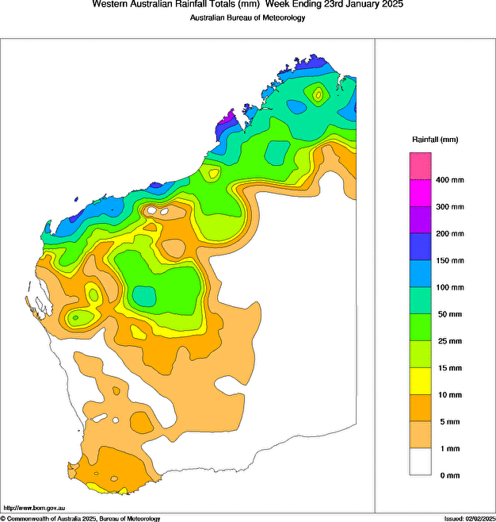
Figure 9 Rainfall analysis for the 7 days till 9am on 23 January 2025 showing heavy falls as a result of Sean mostly confined to the coastal fringe of the Pilbara.
  - Storm Surge
Despite not crossing the coast at any stage Severe Tropical Cyclone Sean still generated a notable increase in water levels along the Pilbara coast. Record high sea surface temperatures (SST) along the coast off northwestern Australia contributed to a persistent sea level anomaly approximately 20-30 centimetres above the astronomical tide. The easterly winds generated on the southern side of Sean and blowing roughly parallel to the Pilbara coast produced a coastally trapped Rossby wave, or shelf wave, which propagated along the Pilbara coast and then down the west coast of Western Australia.
Department of Transport data showed the maximum recorded surge was 1.21m at Exmouth during the morning of 20 January (Figure 10) when Sean was approximately 200 km north-northwest of the town. Though due to the slow-moving nature of the shelf wave, the highest total water level was not recorded until the afternoon high tide reaching 3.30m above Lowest Astronomical Tide (LAT), nearly 40cm above the Highest Astronomical Tide (HAT). Total Water Levels also peaked above HAT at Onslow and Carnarvon.

Figure 10 The storm surge residual and total water level recorded at Exmouth compared with the predicted tide and Highest Astronomical Tide (HAT) for the period 19-22 January 2025. Data courtesy Department of Transport.

- Forecast Performance
The accuracy statistics for Severe Tropical Cyclone Sean are below in Table 3 and shown in Figure 11 and Figure 12.
The forecast track position accuracy was considerably better than the 5-year average for the first 72 hours of the forecast but quickly deteriorated beyond that. Although the sample size quickly decreases beyond 72 hours, the larger errors in this period can largely be attributed to Severe Tropical Cyclone Sean turning towards the south much earlier than early forecasts had anticipated.
Intensity accuracy was very similar to the five-year average over the first 12 hours of the forecast but then considerably better beyond that.
The seven-day forecast for 11U commenced on 13 January. The probability of Sean developing into a tropical cyclone was kept at Low (15%) through until 16 January when it was increased to High (>50%) for the expectation of Sean developing on 19 January. Forecast track maps were issued between 0600 UTC 17 January and 0600 UTC 22 January. Corresponding Tropical Cyclone Advices were issued until 1500 UTC 20 January when Severe Tropical Cyclone Sean had moved far enough away from the Western Australian coast to no longer pose a direct threat. Ocean Wind Warnings were issued between 1800 UTC 17 January and 0600 UTC 22 January.

Time | 00 | 06 | 12 | 18 | 24 | 36 | 48 | 72 | 96
Position accuracy (km) | 21 | 31 | 31 | 40 | 51 | 60 | 85 | 165 | 303
Intensity accuracy (knots) | 2.9 | 4.8 | 6.4 | 6.4 | 6.2 | 7.4 | 10 | 8.9 | 3.3
Sample size | 21 | 21 | 21 | 21 | 21 | 19 | 17 | 13 | 9
Table 3. Verification statistics for Severe Tropical Cyclone Sean. * Note, verification is performed using the Official Forecast Tracks at the standard times of 00, 06,12 and 18 UTC.

Figure 11 Position accuracy figures for Severe Tropical Cyclone Sean.

Figure 12 Intensity accuracy figures for Severe Tropical Cyclone Sean.

Appendix: List of abbreviations
Abbreviation | Term
ADT | Advanced Dvorak Technique
ACST | Australian Central Standard Time
AEST | Australian Eastern Standard Time
AiDT | AI-enhanced Dvorak Technique
AMSR2 | Advanced Microwave Scanning Radiometer
AMSU | Advanced Microwave Sounding Unit
ASCAT | Advanced Scatterometer
ATMS | Advanced Technology Microwave Sounder
AWS | automatic weather station
AWST | Australian Western Standard Time
°C | Celsius
CI | Current intensity
CIMSS | Cooperative Institute for Meteorological Satellite Studies (USA)
CIRA | Cooperative Institute for Research in the Atmosphere (USA)
D-MINT | Deep learning - Multispectral Intensity of TCs (formerly known as DMN)
D-PRINT | Deep learning - IR Intensity of TCs (formerly known as OPEN-AIIR)
EIR | Enhanced InfraRed
ERC | eyewall replacement cycle
FNMOC | Fleet Numerical Meteorology and Oceanography Centre (USA)
FT | Final T-number
GCOM | Global Change Observation Mission
GHz | Gigahertz
GMI | Global Precipitation Measurement Microwave Imager
h | hour
hPa | hectopascal
HSCAT | Hai Yang 2 Scatterometer (HY-2B, HY-2C)
km | kilometres
km/h | kilometres per hour
kn | knot
LLCC | LLCC
MET | Model Expected T-number
METOP | Meteorological Operational Satellite
MJO | Madden-Julian Oscillation
mm | millimetres
MSLP | mean sea level pressure
NESDIS | National Environmental Satellite, Data, and Information Service
nm | nautical mile
NOAA | National Oceanic and Atmospheric Administration
NRL | Navy Research Lab (USA)
OPEN-AiiR | Ordered Pattern Encoding AI Infrared
PAT | Pattern T-number
RCM | RadarSat Constellation Mission – Synthetic Aperture Radar
RH | relative humidity
RMW | radius of maximum winds
RSMC | Regional Specialised Meteorological Centre
SAR | Synthetic Aperture Radar
SATC | CIMSS Advanced Dvorak Technique
SATCON | Satellite Consensus
SEN1 | Sentinel-1A – Synthetic Aperture Radar
SMAP | Soil Moisture Active Passive
SMOS | Soil Moisture and Ocean Salinity
SSMIS | Special Sensor Microwave Imager/Sounder
TC | Tropical Cyclone
TCWC | Tropical Cyclone Warning Centre
UTC | Universal Time Co-ordinated

