Severe Tropical Cyclone Taliah (14U)

# 31 January – 12 February 2025

## Linda Paterson and Joe Courtney, Tropical Cyclone Environmental Prediction Services

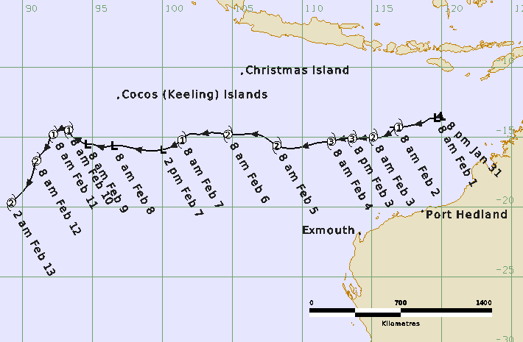

**Revision history**

|  |  |  |  |
| --- | --- | --- | --- |
| Date | Version | Author | Description |
| 15/04/2025 | 1.0 | Linda Paterson | Final draft |
| 20/05/2025 | 1.1 | Linda Paterson | Change to intensity at border made after discussion with La Reunion |

**Review status**

|  |  |  |  |
| --- | --- | --- | --- |
| Date | Version | Reviewer | Description |
| 22/04/2025 | 1.0 | Joe Courtney | Completed |

**Release history**

|  |  |  |  |
| --- | --- | --- | --- |
| Date | Version | Status | Approval |
| 23/04/2025 | 1.0 | Approved for release | Andrew Burton |
| 11/06/2025 | 1.1 | Approved for release | Andrew Burton |

Contact details:

Tropical Cyclone Team Lead

Severe Weather Environmental Prediction Services

Bureau of Meteorology

PO Box 1370, West Perth WA 6872

Email: [tcwc@bom.gov.au](mailto:tcwc@bom.gov.au)



This work is copyright. Apart from any use as permitted under the Copyright Act 1968, no part may be reproduced without prior written permission from the Bureau of Meteorology. Refer to www.bom.gov.au/other/copyright.shtml for further information. Unless otherwise noted, all images in this document are licensed under the Creative Commons Attribution Australia Licence.

© Commonwealth of Australia 2025

Published by the Bureau of Meteorology

Cover image: Track of Severe Tropical Cyclone Taliah 2025. Times in AWST (UTC+8h)

Contents

1. Summary 5

2. Meteorological description 8

2.1. Intensity analysis 8

2.2. Structure 16

2.3. Motion 18

3. Impact 18

4. Observations 18

5. Forecast Performance 19

Appendix: List of abbreviations 20

**List of Figures**

Figure 1 Best track of Taliah 31 January- 12 February 2025. Times in WST (UTC+8 hours) 5

Figure 2 Hovmoller diagram of tropical waves showing the formation of Taliah (TC symbol with a T) occurred on the tail end of a strong pulse of the MJO (black) and an Equatorial Rossby (ER) wave (red). 9

Figure 3 ASCAT pass at 0041 UTC 2 February 2025 around the time Taliah reached tropical cyclone intensity that shows gales in at least three quadrants. 10

Figure 4 SSMIS image at 2226 UTC 3 February 2025 showing Taliah as it neared peak intensity 11

Figure 5 AMSR2 pass at 1803 UTC 4 February 2025 showed deep convection located to the west of the low-level centre. 12

Figure 6 SSMIS pass at 1124 UTC 5 February 2025 as Taliah continued to weaken 13

Figure 7 ASCAT pass showing no gales present around the remaining circulation of Taliah at 0233 UTC 9 February 2025. 14

Figure 8 GPM image at 0702 UTC 12 February 2025 as Taliah approached the border of the Australian region. 15

Figure 9 ASCAT pass at 0118 UTC 3 February 2025 showing the asymmetric gale structure with radii significantly larger in the northern quadrants than the southern quadrants. 17

Figure 10 Position accuracy figures for Severe Tropical Cyclone Taliah. 19

Figure 11 Intensity accuracy figures for Severe Tropical Cyclone Taliah. 20

Figure 12 Intensity plot for Taliah in knots showing all available objective guidance with the post event best track plotted in the thick black line. 23

**List of Tables**

Table 1 Best track summary for Severe Tropical Cyclone Taliah, 31 January-12 February 2025. 7

Table 2. Verification statistics for Severe Tropical Cyclone Taliah. 19

1. Summary

Severe Tropical Cyclone Taliah (14U) was a long-lived event that tracked west across the eastern Indian Ocean experiencing multiple peaks in intensity throughout its lifetime.

Tropical low 14U formed northwest of the Kimberley coast late on 31 January and developed steadily over following days as it tracked to the west southwest. 14U reached tropical cyclone intensity at 0000 UTC 2 February (0800 WST 2 February, WST=UTC+8 hours) well north of the Pilbara coast. Taliah continued its west to west-southwest track and reached a 10-minute mean wind peak intensity of 75 kn (140 km/h) between 0000 – 0600 UTC 4 February.

From late on 4 February the combined influences of increased vertical wind shear and dry air being entrained into the circulation weakened Taliah. During 7 February Taliah weakened below tropical cyclone intensity, however gales persisted north of the centre, assisted by the monsoon flow, until 8 February. Between 1200 UTC 8 February and 1800 UTC 9 February there were no gales present around Taliah. Conditions then became more favourable with a decrease in vertical wind shear and Taliah re-intensified into a tropical cyclone at 0000 UTC 10 February. Taliah continued to intensify and crossed 90°E late on 12 February at an intensity of 60 kn (110 km/h), moving out of the Australian area of responsibility. Taliah then weakened very gradually over following days as it moved southwest over the central Indian Ocean.

Taliah did not impact the Australian mainland or island communities.

Figure 1 shows the best track of Taliah while Table 1 is a summary of the best track data.



Figure 1 Best track of Taliah 31 January- 12 February 2025. Times in WST (UTC+8 hours)

|  |  |  |  |  |  |  |  |  |  |  |  |  |
| --- | --- | --- | --- | --- | --- | --- | --- | --- | --- | --- | --- | --- |
| Year | Mon | Day | Hour UTC | Pos.  Lat. S | Pos. Long.E. | Pos Acc. nm | Max Wind10minkn | Max Gust kn | Cent.PresshPa | Rad. of gales  NE/SE/ SW/NW | Rad. of storm  NE/SE/ SW/NW | RMW  nm |
| 2025 | 1 | 31 | 1200 | 13.5 | 120.0 | 25 | 25 | 45 | 1001 | 0/0/0/0 | 0/0/0/0 | - |
| 2025 | 1 | 31 | 1800 | 13.5 | 119.8 | 25 | 30 | 45 | 1001 | 0/0/0/0 | 0/0/0/0 | - |
| 2025 | 2 | 1 | 0000 | 13.6 | 119.6 | 25 | 30 | 45 | 999 | 0/0/0/0 | 0/0/0/0 | - |
| 2025 | 2 | 1 | 0600 | 13.7 | 119.1 | 25 | 30 | 45 | 998 | 0/0/0/0 | 0/0/0/0 | - |
| 2025 | 2 | 1 | 1200 | 13.9 | 118.8 | 30 | 35* | 50 | 996 | 0/0/0/60 | 0/0/0/0 | - |
| 2025 | 2 | 1 | 1800 | 14.1 | 118.1 | 30 | 35* | 50 | 995 | 0/0/60/60 | 0/0/0/0 | - |
| 2025 | 2 | 2 | 0000 | 14.3 | 116.9 | 20 | 40 | 55 | 993 | 70/70/60/60 | 0/0/0/0 | 25 |
| 2025 | 2 | 2 | 0600 | 14.3 | 116.3 | 15 | 45 | 65 | 986 | 70/60/60/60 | 0/0/0/0 | 25 |
| 2025 | 2 | 2 | 1200 | 14.3 | 116.5 | 20 | 50 | 70 | 982 | 70/60/60/70 | 40/0/0/0 | 25 |
| 2025 | 2 | 2 | 1800 | 15.0 | 115.7 | 15 | 50 | 70 | 982 | 80/60/70/70 | 40/0/40/40 | 20 |
| 2025 | 2 | 3 | 0000 | 15.0 | 115.1 | 20 | 55 | 75 | 980 | 80/60/70/80 | 40/30/40/40 | 20 |
| 2025 | 2 | 3 | 0600 | 15.1 | 114.2 | 20 | 60 | 85 | 979 | 80/60/90/90 | 40/40/40/40 | 20 |
| 2025 | 2 | 3 | 1200 | 15.1 | 113.6 | 20 | 65 | 90 | 972 | 100/80/100/110 | 50/40/40/50 | 15 |
| 2025 | 2 | 3 | 1800 | 15.1 | 113.1 | 20 | 70 | 100 | 967 | 100/90/100/130 | 50/40/50/50 | 15 |
| 2025 | 2 | 4 | 0000 | 15.3 | 112.1 | 20 | 75 | 105 | 964 | 100/100/100/150 | 50/40/50/50 | 15 |
| 2025 | 2 | 4 | 0600 | 15.4 | 111.2 | 20 | 75 | 105 | 964 | 100/100/100/150 | 70/50/60/60 | 15 |
| 2025 | 2 | 4 | 1200 | 15.6 | 110.6 | 20 | 70 | 100 | 967 | 100/100/100/150 | 80/60/70/80 | 15 |
| 2025 | 2 | 4 | 1800 | 15.8 | 109.4 | 15 | 65 | 90 | 970 | 100/110/100/140 | 70/50/60/80 | 20 |
| 2025 | 2 | 5 | 0000 | 15.6 | 108.2 | 15 | 55 | 75 | 973 | 120/100/120/140 | 70/50/60/70 | 20 |
| 2025 | 2 | 5 | 0600 | 15.0 | 107.3 | 15 | 50 | 70 | 980 | 120/70/120/160 | 70/0/60/70 | 25 |
| 2025 | 2 | 5 | 1200 | 14.8 | 106.7 | 20 | 50 | 70 | 980 | 120/70/120/140 | 60/0/0/70 | 30 |
| 2025 | 2 | 5 | 1800 | 14.8 | 105.8 | 30 | 50 | 70 | 982 | 120/70/120/140 | 60/0/0/70 | 35 |
| 2025 | 2 | 6 | 0000 | 14.8 | 104.7 | 30 | 50 | 70 | 982 | 120/80/120/160 | 60/0/0/100 | 35 |
| 2025 | 2 | 6 | 0600 | 14.7 | 103.3 | 30 | 45 | 65 | 987 | 120/60/120/160 | 0/0/0/0 | 35 |
| 2025 | 2 | 6 | 1200 | 14.8 | 102.6 | 30 | 45 | 65 | 987 | 120/60/100/150 | 0/0/0/0 | 35 |
| 2025 | 2 | 6 | 1800 | 14.8 | 101.9 | 30 | 45 | 65 | 989 | 100/60/100/150 | 0/0/0/0 | 35 |
| 2025 | 2 | 7 | 0000 | 15.2 | 101.4 | 30 | 45 | 65 | 989 | 100/40/60/150 | 0/0/0/0 | 35 |
| 2025 | 2 | 7 | 0600 | 15.9 | 100.0 | 30 | 40 | 55 | 992 | 100/0/0/150 | 0/0/0/0 | - |
| 2025 | 2 | 7 | 1200 | 15.9 | 98.4 | 30 | 40* | 55 | 993 | 100/0/0/130 | 0/0/0/0 | - |
| 2025 | 2 | 7 | 1800 | 15.7 | 97.5 | 30 | 40* | 55 | 993 | 50/0/0/130 | 0/0/0/0 | - |
| 2025 | 2 | 8 | 0000 | 15.6 | 96.5 | 30 | 40* | 55 | 993 | 90/0/0/90 | 0/0/0/0 | - |
| 2025 | 2 | 8 | 0600 | 15.7 | 95.6 | 30 | 40* | 55 | 993 | 90/0/0/90 | 0/0/0/0 | - |
| 2025 | 2 | 8 | 1200 | 15.6 | 95.3 | 30 | 30 | 45 | 993 | 0/0/0/0 | 0/0/0/0 | - |
| 2025 | 2 | 8 | 1800 | 15.5 | 94.9 | 30 | 30 | 45 | 992 | 0/0/0/0 | 0/0/0/0 | - |
| 2025 | 2 | 9 | 0000 | 15.5 | 94.6 | 30 | 30 | 45 | 992 | 0/0/0/0 | 0/0/0/0 | - |
| 2025 | 2 | 9 | 0600 | 15.1 | 93.8 | 30 | 30 | 45 | 998 | 0/0/0/0 | 0/0/0/0 | - |
| 2025 | 2 | 9 | 1200 | 15.0 | 93.6 | 30 | 30 | 45 | 996 | 0/0/0/0 | 0/0/0/0 | - |
| 2025 | 2 | 9 | 1800 | 14.7 | 93.4 | 30 | 30 | 45 | 998 | 0/0/0/0 | 0/0/0/0 | - |
| 2025 | 2 | 10 | 0000 | 14.5 | 93.3 | 30 | 35 | 50 | 995 | 60/0/60/50 | 0/0/0/0 | 30 |
| 2025 | 2 | 10 | 0600 | 14.3 | 93.3 | 30 | 40 | 55 | 993 | 60/0/60/60 | 0/0/0/0 | 30 |
| 2025 | 2 | 10 | 1200 | 14.3 | 93.1 | 30 | 40 | 55 | 992 | 60/60/60/60 | 0/0/0/0 | 30 |
| 2025 | 2 | 10 | 1800 | 14.5 | 92.6 | 25 | 40 | 55 | 992 | 80/80/80/70 | 0/0/0/0 | 30 |
| 2025 | 2 | 11 | 0000 | 14.8 | 92.2 | 30 | 45 | 65 | 991 | 100/90/100/80 | 0/0/0/0 | 30 |
| 2025 | 2 | 11 | 0600 | 15.0 | 92.0 | 20 | 50 | 70 | 991 | 120/110/100/80 | 60/0/0/0 | 40 |
| 2025 | 2 | 11 | 1200 | 15.6 | 91.8 | 25 | 50 | 70 | 988 | 120/130/120/80 | 60/60/0/0 | 40 |
| 2025 | 2 | 11 | 1800 | 15.9 | 91.6 | 25 | 55 | 75 | 984 | 120/140/130/80 | 60/100/60/0 | 40 |
| 2025 | 2 | 12 | 0000 | 16.7 | 91.0 | 30 | 55 | 75 | 980 | 150/200/180/100 | 70/120/100/70 | 40 |
| 2025 | 2 | 12 | 0600 | 17.7 | 90.7 | 30 | 55 | 75 | 980 | 180/200/180/100 | 70/120/100/70 | 30 |
| 2025 | 2 | 12 | 1200 | 18.8 | 90.1 | 20 | 60 | 85 | 976 | 140/220/200/100 | 70/120/120/60 | 30 |

Table 1 Best track summary for Severe Tropical Cyclone Taliah, 31 January-12 February 2025.

UTC=AWST-8h. * Not at tropical cyclone intensity as gales less than halfway around centre.

1. Meteorological description
   1. Intensity analysis

The tail end of a strong MJO pulse in the region combined with an eastward moving Equatorial Rossby wave (refer Figure 2) aided the formation of a low to the north of Western Australia on 31 January. Deep convection persisted near the centre and a Dvorak DT of 1.0 was assigned at 1800 UTC 31 January. The low was in a favourable environment with warm sea surface temperatures (SSTs) over 30°C, low vertical wind shear, good upper outflow and ample available moisture. This ensured deep convection continued to develop around the centre and Taliah reached tropical cyclone intensity by 0000 UTC 2 February. This was confirmed by a partial ASCAT pass at 0041 UTC 2 February (refer Figure 3) which showed gales in at least three quadrants.

Despite an increase in vertical wind shear to greater than 20 kn during 3 February deep curved banding improved rapidly around the centre of Taliah and the DT reached 4.0 at 1800 UTC 3 February. Figure 12 (located at the end of the document) is a plot of all available objective intensity estimates for the duration of the event. Using all these inputs it is estimated Taliah reached a 10-minute mean wind peak intensity of 75 kn (140 km/h) between 0000 -0600 UTC 4 February (refer Figure 4) which is higher than the subjective Dvorak would indicate. A continued increase in vertical wind shear to around 30 kn from 0600 UTC 4 February combined with dry air entrainment into the core of Taliah led to weakening and the intensity began to decrease from 1200 UTC 4 February. During 4 February satellite imagery showed a fluctuating very weak eye pattern, however this was not sustained and by 1500 UTC 4 February the eye pattern had disappeared. Late on 4 February microwave imagery showed a sheared system with the low-level centre partially exposed, refer Figure 5. Subsequently the centre was located under a deep cold convective blow up and the application of an embedded centre pattern held the DT at 4.0 until 1200 UTC 5 February. The vertical tilt of the system increased and by 1200 UTC 5 February the low-level centre was completely exposed in microwave imagery, refer Figure 6.

Taliah weakened below tropical cyclone strength at 0000 UTC 7 February though scatterometry passes showed gales persisted in northern quadrants until 0600 UTC 8 February. The remaining circulation had 30 kn (55 km/h) winds around it (refer Figure 7) for several days. As vertical wind shear decreased, and the surrounding environment became more favourable Taliah re-intensified into a tropical cyclone at 0000 UTC 10 February. Deep convection around the centre slowly increased and Taliah reached a 10-minute mean wind of 60 kn (110 km/h) at 1200 UTC 12 February before exiting the region. Satellite images showed a large, broad circulation with a centre of about a degree in diameter, refer Figure 8.

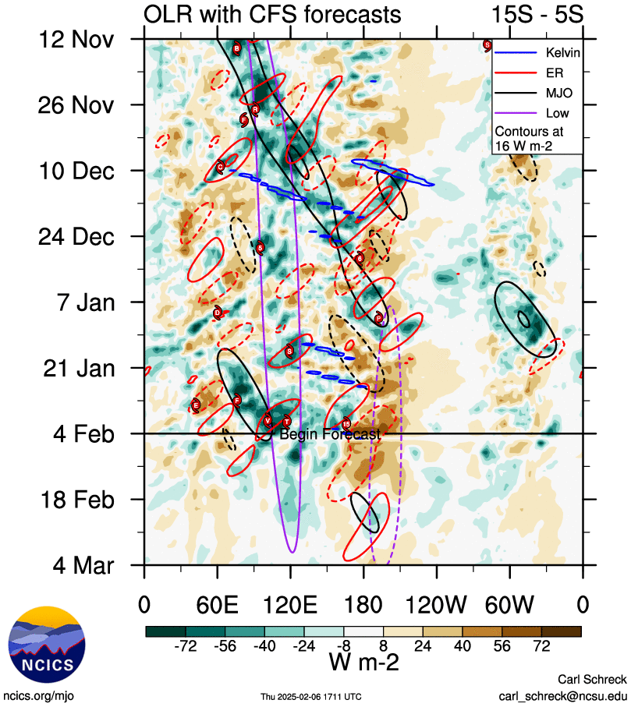

Figure 2 Hovmoller diagram of tropical waves showing the formation of Taliah (TC symbol with a T) occurred on the tail end of a strong pulse of the MJO (black) and an Equatorial Rossby (ER) wave (red). The image is courtesy of the North Carolina Institute for Climate Studies. https://ncics.org/pub/mjo/archive/2024/2024-12-02/v2/

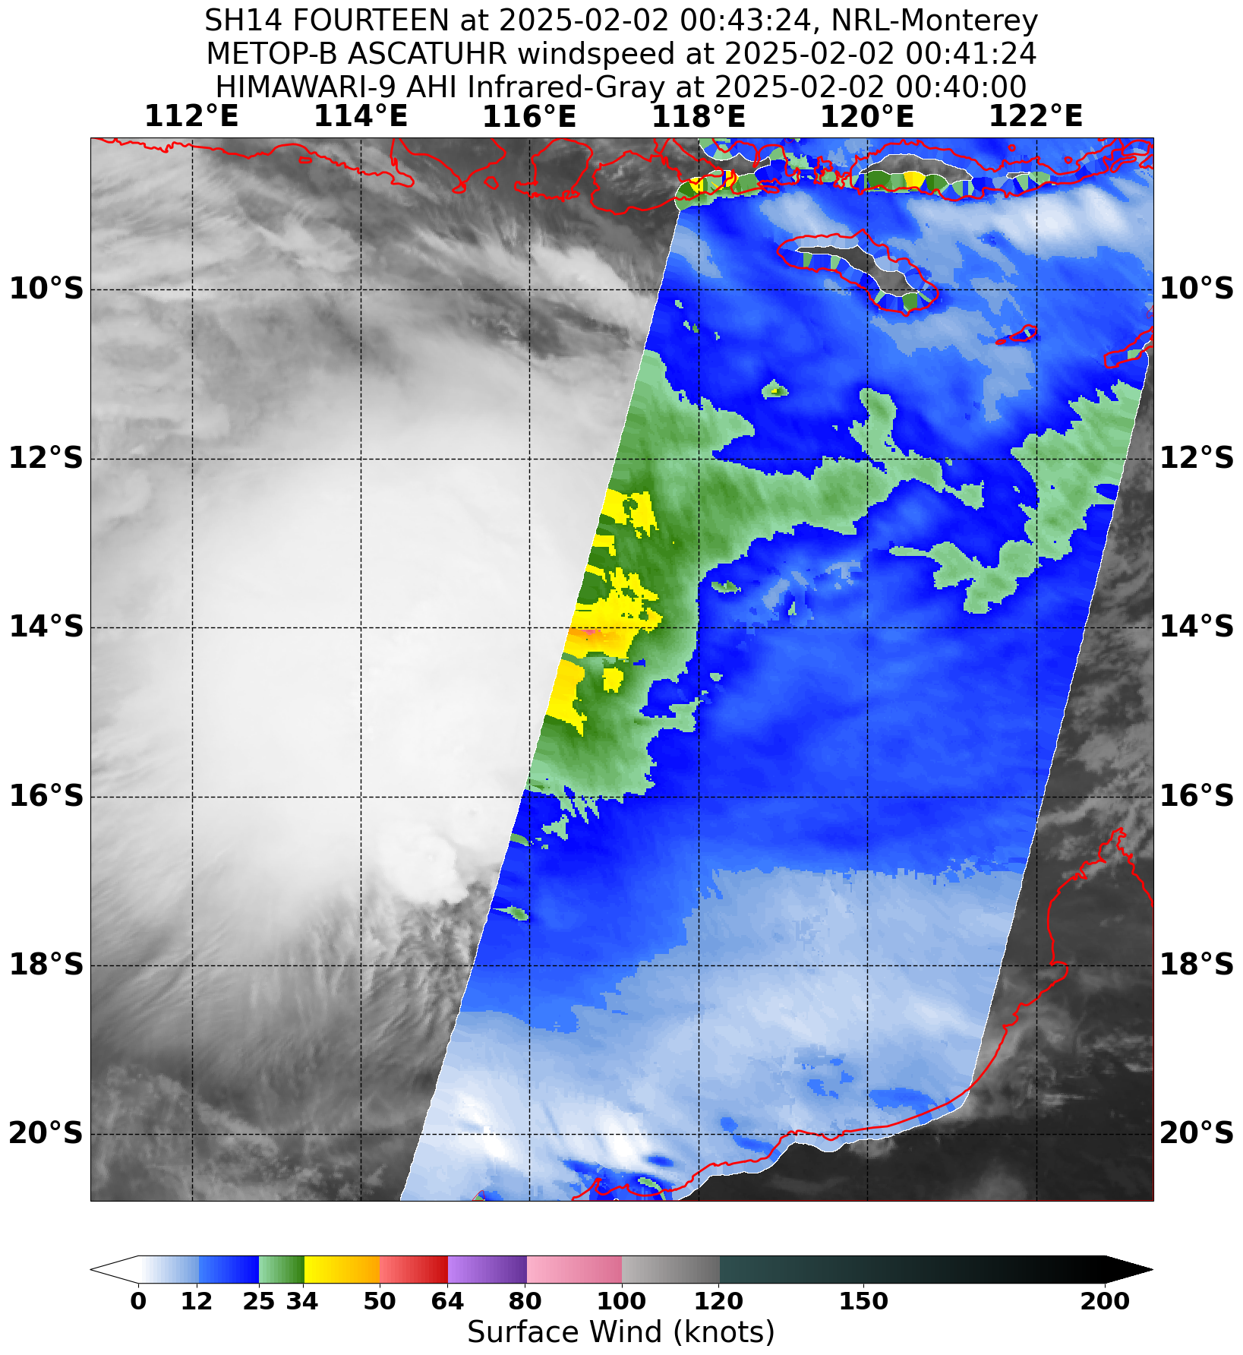

Figure 3 ASCAT pass at 0041 UTC 2 February 2025 around the time Taliah reached tropical cyclone intensity that shows gales in at least three quadrants. Image courtesy NOAA STAR <https://manati.star.nesdis.noaa.gov/datasets/ASCATBData.php>

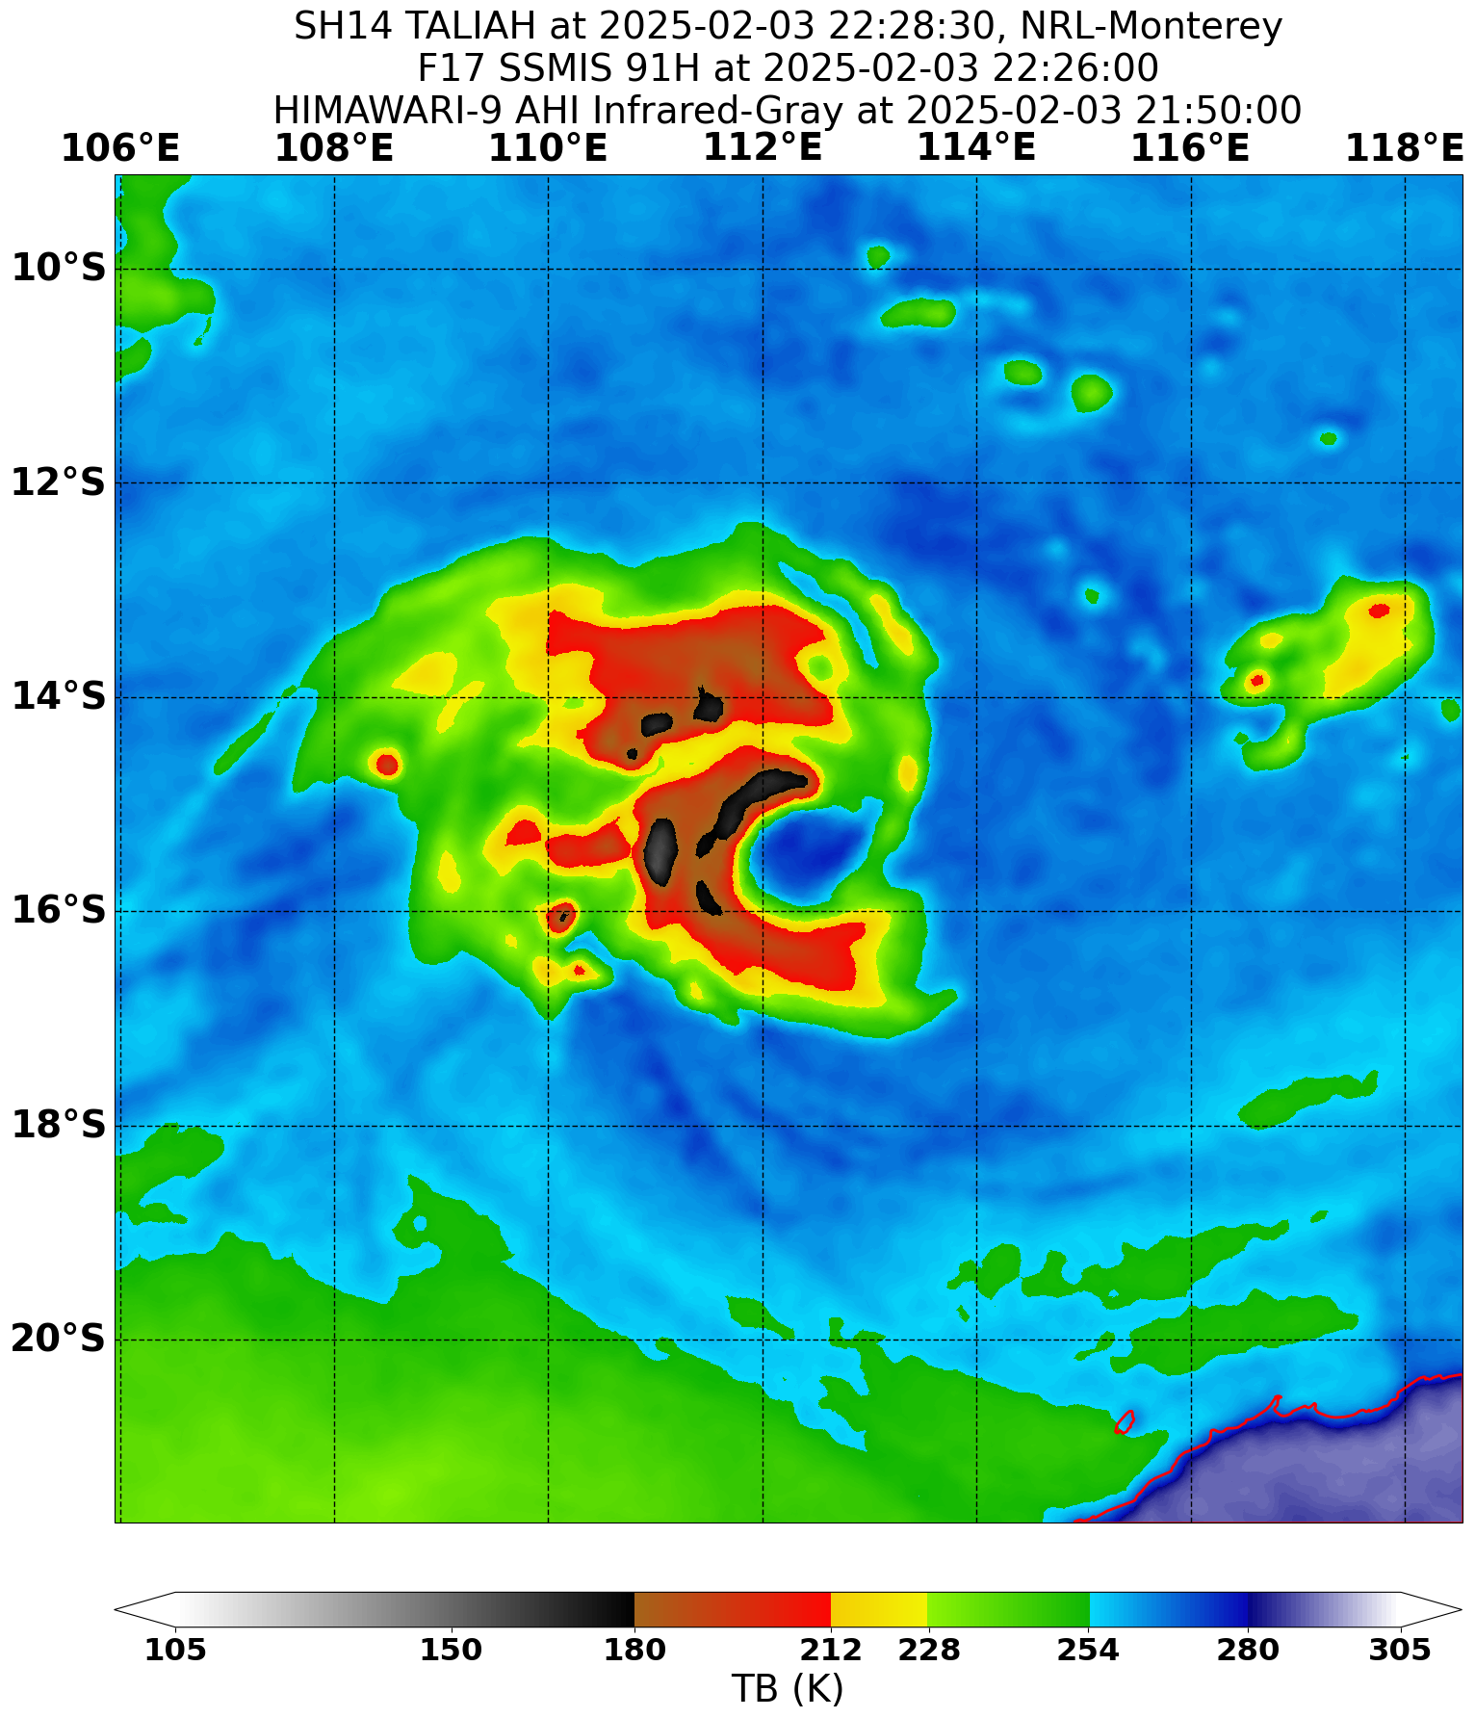

Figure 4 SSMIS image at 2226 UTC 3 February 2025 showing Taliah as it neared peak intensity.

Image courtesy NRL. <https://www.nrlmry.navy.mil/TC.html>

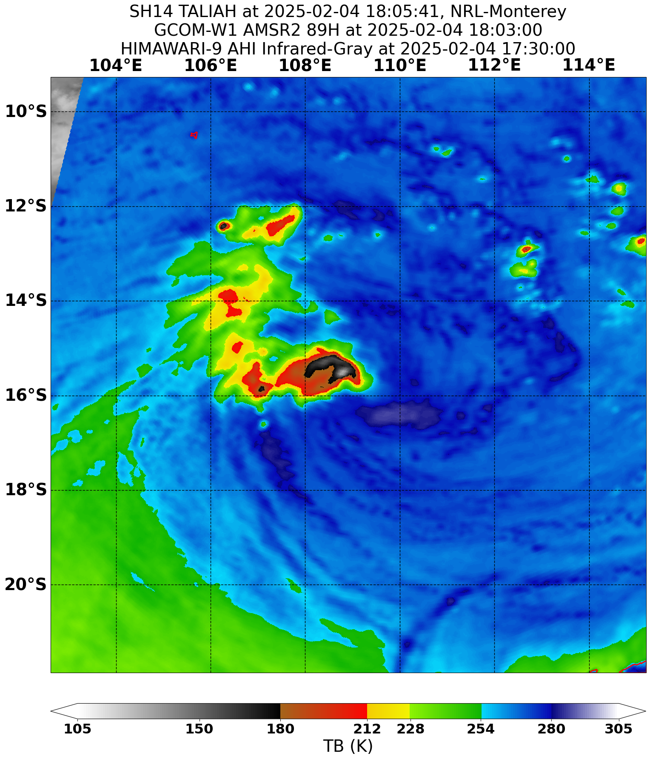

Figure 5 AMSR2 pass at 1803 UTC 4 February 2025 showed deep convection located to the west of the low-level centre. Image courtesy NRL. <https://www.nrlmry.navy.mil/TC.html>

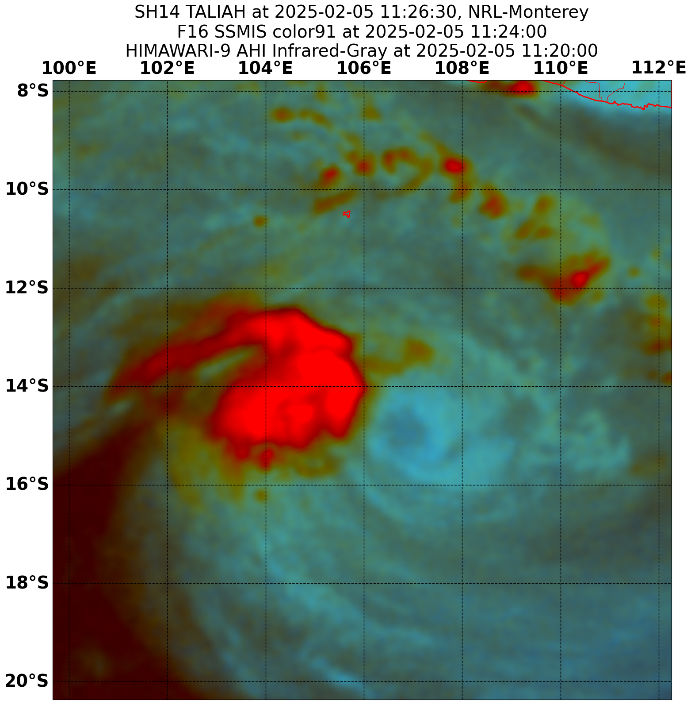

Figure 6 SSMIS pass at 1124 UTC 5 February 2025 as Taliah continued to weaken. Image courtesy NRL. <https://www.nrlmry.navy.mil/TC.html>

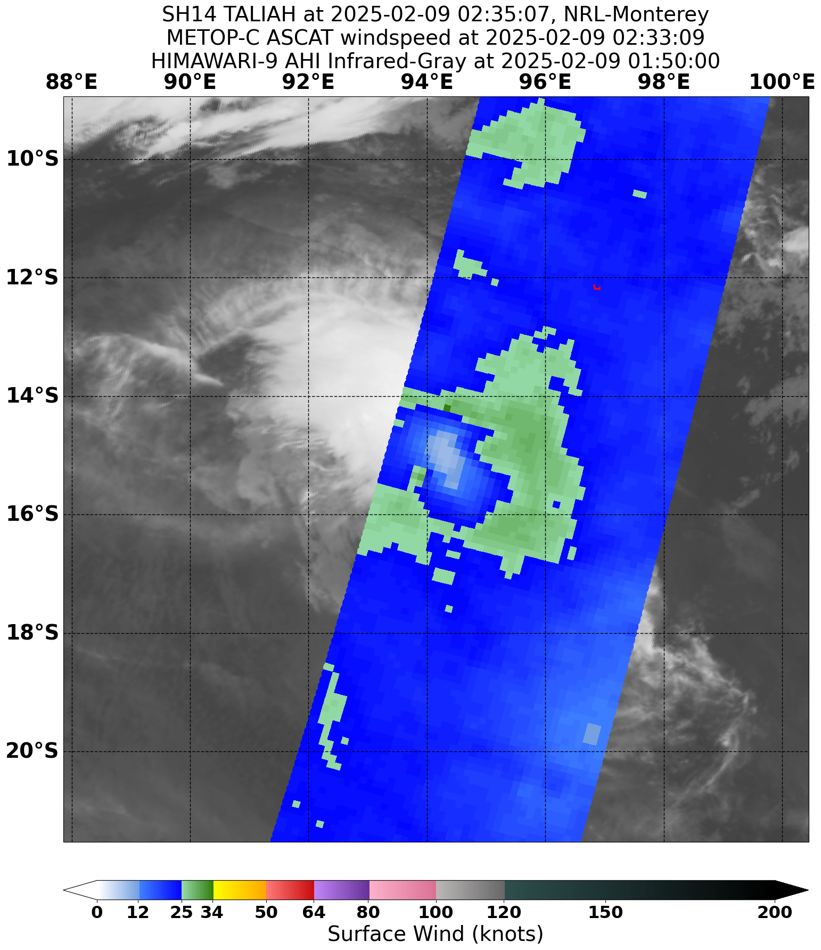

Figure 7 ASCAT pass showing no gales present around the remaining circulation of Taliah at 0233 UTC 9 February 2025. Image courtesy NRL. <https://www.nrlmry.navy.mil/TC.html>

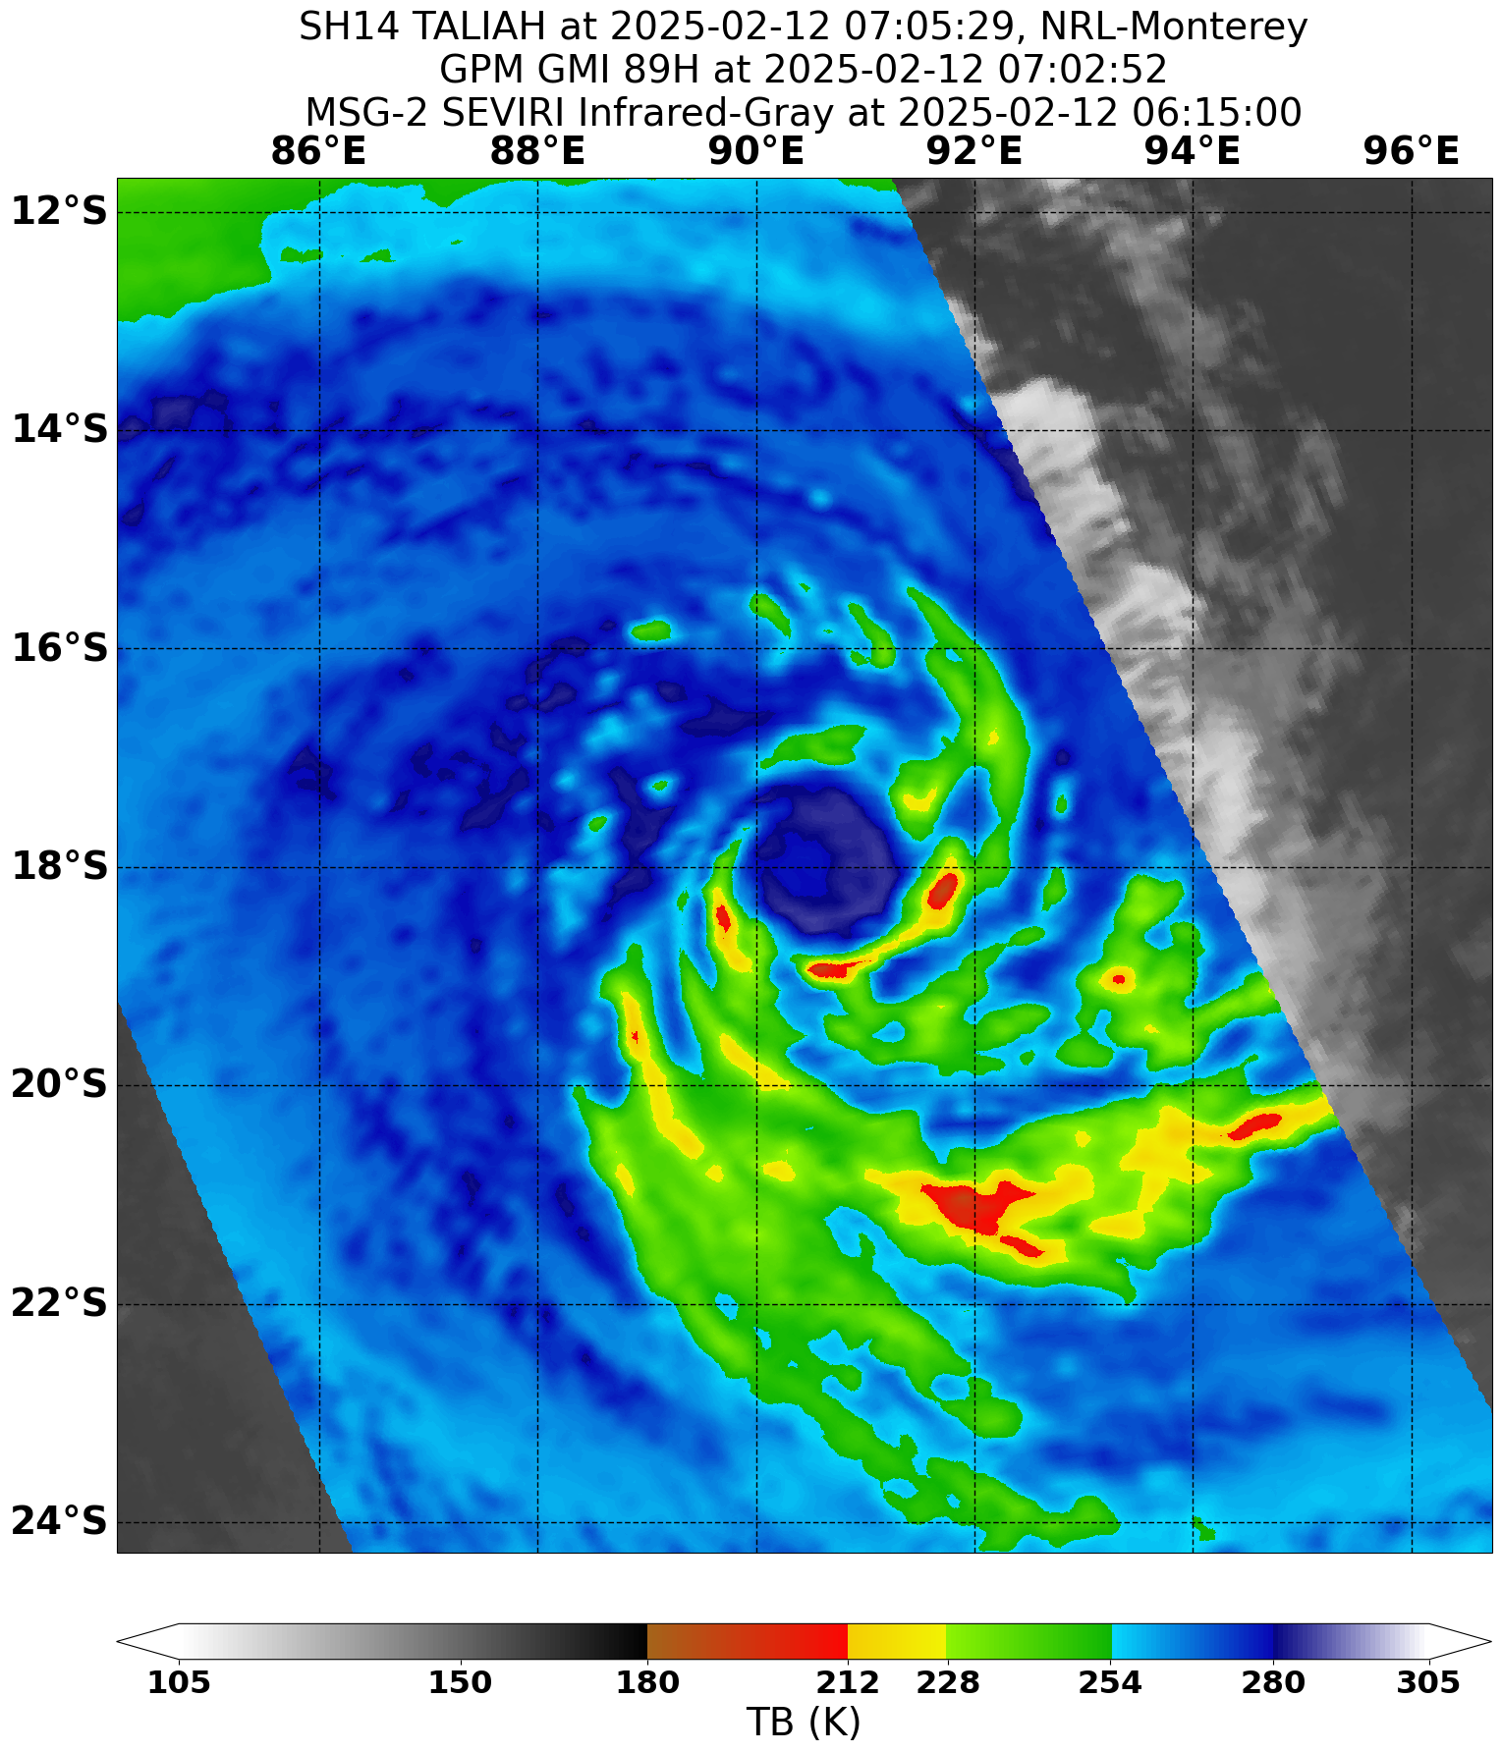

Figure 8 GPM image at 0702 UTC 12 February 2025 as Taliah approached the border of the Australian region. Image courtesy NRL. <https://www.nrlmry.navy.mil/TC.html>

* 1. Structure

Taliah formed in an active monsoon trough and gale radii were generally largest in the northern quadrants. Initially gale radii were around 60 - 70 nm. These increased to 100 to 120 nm in southern quadrants and up to 160 nm in northern quadrants at their largest, refer Figure 9. Taliah remained large as it redeveloped into a tropical cyclone from 10 February however it was southern gale radii which were the largest. Initially radii were 60 - 80 nm in all quadrants on 10 February however southern radii increased to around 200 – 220 nm by 12 February.

The radius to maximum winds (RMW) was initially 25 nm, this decreased to 15 nm at peak intensity on 3 and 4 February. As Taliah weakened the RMW expanded to as large as 35 nm. During the second period of intensification RMW was initially 30 nm. Unusually, even though Taliah was increasing in intensity the RMW grew larger to 40 nm with a large open circulation indicated on imagery. From 12 February the RMW decreased again to 30 nm.

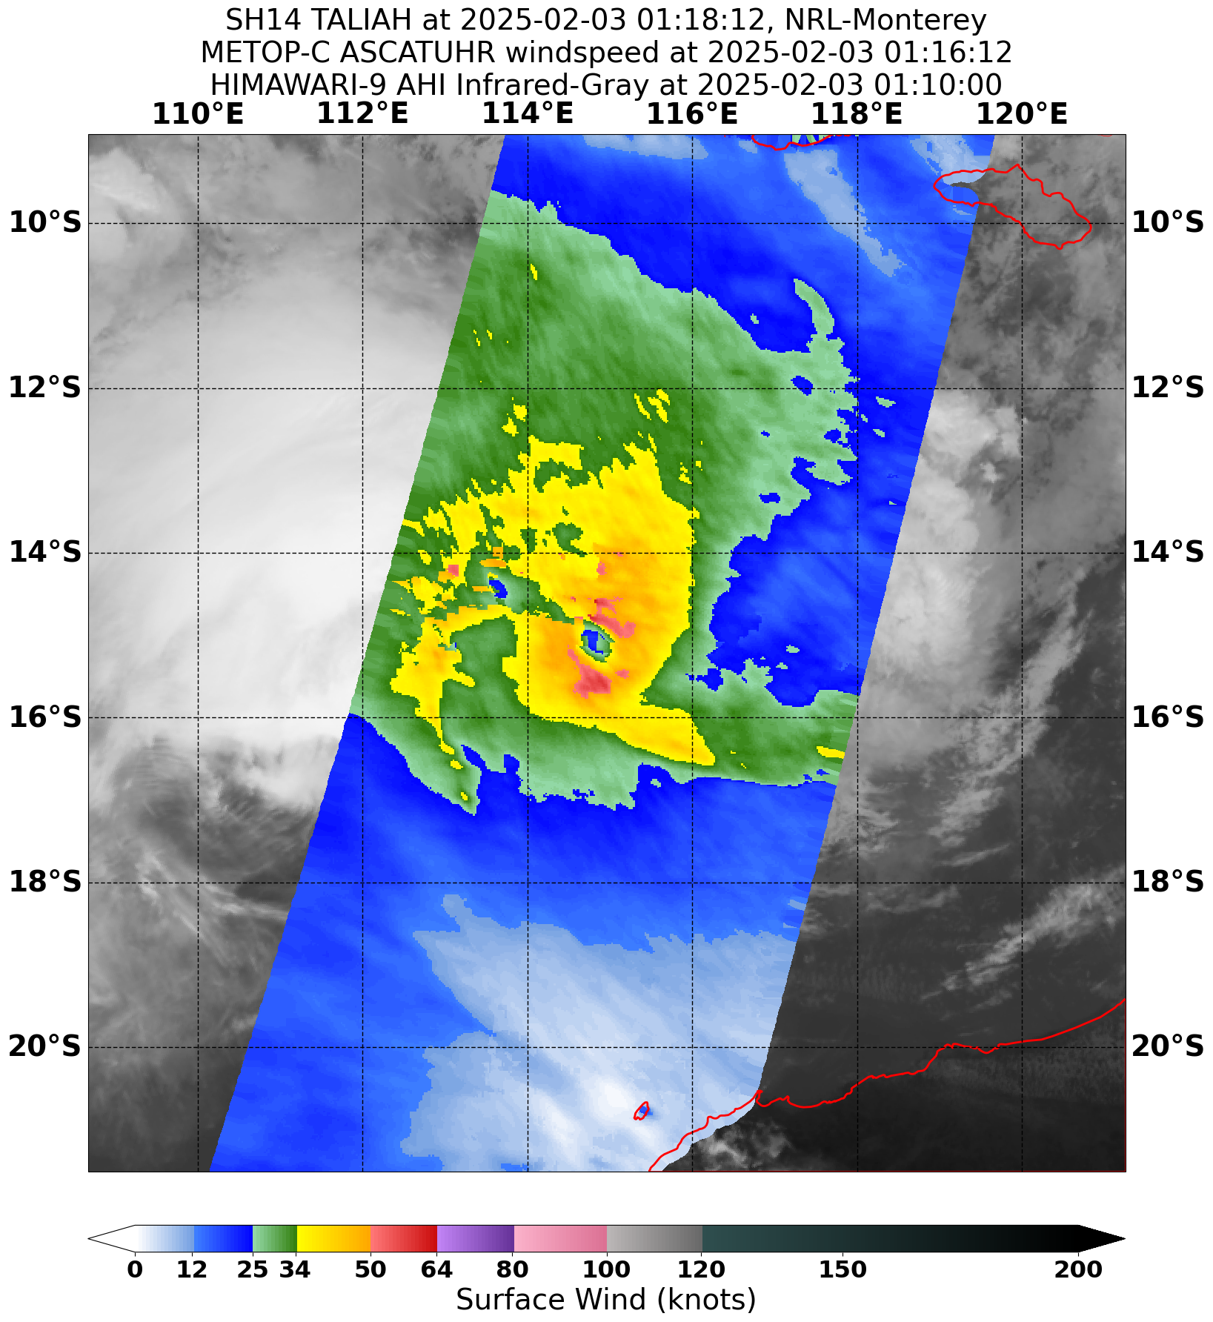

Figure 9 ASCAT pass at 0118 UTC 3 February 2025 showing the asymmetric gale structure with radii significantly larger in the northern quadrants than the southern quadrants. Image courtesy NRL. <https://www.nrlmry.navy.mil/TC.html>

* 1. Motion

Taliah was steered westwards by the mid-level ridge located to the south of the system. There was a slowing in the speed of movement during 8 and 9 February as the eastern anti-cyclone retreated and a new anti-cyclone to the southwest of the system became the dominant steering influence. This also resulted in a period of northwest motion during 9 February. From 1200 UTC 10 February Taliah resumed its southwest motion which persisted as it crossed the border of the region.

1. Impact

There were no impacts from Severe Tropical Cyclone Taliah on the Australian mainland or the island territories of Christmas or the Cocos (Keeling) Islands.

1. Observations

No observations were recorded during Taliah.

1. Forecast Performance

The accuracy statistics for Severe Tropical Cyclone Taliah are below in Table 2 and shown in Figure 10 and Figure 11.

The forecast track position accuracy was close to or better than the five-year average, and this can be attributed to the consistent westward movement of Taliah. There was very little spread of the forecast tracks in the model guidance resulting in accurate track forecasts.

The intensity accuracy was close to the five-year average up to 24 hours and then considerably poorer in the longer term. The initial intensification of Taliah was well forecast however model guidance performed poorly with respect to the subsequent weakening and then re-intensification of the system resulting in larger errors in the forecast intensity at the longer lead times.

The seven-day forecast for 14U commenced on 25 January with low (5-15%) ratings. From 31 January the probability of Taliah developing into a tropical cyclone was increased to high (> 50%) from 3 February.

Forecast track maps were issued between 0600 UTC 1 February and 0600 UTC 12 February with corresponding Information Bulletins and Technical Bulletins. Ocean Wind Warnings were issued between 0600 UTC 1 February and 0600 UTC 12 February.

|  |  |  |  |  |  |  |  |  |  |  |
| --- | --- | --- | --- | --- | --- | --- | --- | --- | --- | --- |
| Time | 00 | 06 | 12 | 18 | 24 | 36 | 48 | 72 | 96 | 120 |
| Position accuracy (km) | 37 | 51 | 60 | 66 | 72 | 90 | 109 | 158 | 210 | 269 |
| Intensity accuracy (knots) | 3.8 | 5.0 | 6.9 | 8.7 | 11.1 | 15.7 | 20.9 | 26.4 | 27.0 | 25.6 |
| Sample size | 45 | 45 | 45 | 45 | 45 | 45 | 45 | 45 | 45 | 43 |

Table 2. Verification statistics for Severe Tropical Cyclone Taliah. * Note, verification is performed using the Official Forecast Tracks at the standard times of 00, 06,12 and 18 UTC.

Figure 10 Position accuracy figures for Severe Tropical Cyclone Taliah.

Figure 11 Intensity accuracy figures for Severe Tropical Cyclone Taliah.

Appendix: List of abbreviations

|  |  |
| --- | --- |
| Abbreviation | Term |
| ADT | Advanced Dvorak Technique |
| ACST | Australian Central Standard Time |
| AEST | Australian Eastern Standard Time |
| AiDT | AI-enhanced Dvorak Technique |
| AMSR2 | Advanced Microwave Scanning Radiometer |
| AMSU | Advanced Microwave Sounding Unit |
| ASCAT | Advanced Scatterometer |
| ATMS | Advanced Technology Microwave Sounder |
| AWS | automatic weather station |
| AWST | Australian Western Standard Time |
| °C | Celsius |
| CI | Current intensity |
| CIMSS | Cooperative Institute for Meteorological Satellite Studies (USA) |
| CIRA | Cooperative Institute for Research in the Atmosphere (USA) |
| D-MINT | Deep learning - Multispectral Intensity of TCs (formerly known as DMN) |
| D-PRINT | Deep learning - IR Intensity of TCs (formerly known as OPEN-AIIR) |
| DT | Dvorak Data T number |
| EIR | Enhanced InfraRed |
| ERC | eyewall replacement cycle |
| FNMOC | Fleet Numerical Meteorology and Oceanography Centre (USA) |
| FT | Final T-number |
| GCOM | Global Change Observation Mission |
| GHz | Gigahertz |
| GMI | Global Precipitation Measurement Microwave Imager |
| h | hour |
| hPa | hectopascal |
| HSCAT | Hai Yang 2 Scatterometer (HY-2B, HY-2C) |
| km | kilometres |
| km/h | kilometres per hour |
| kn | knot |
| LLCC | LLCC |
| MET | Model Expected T-number |
| METOP | Meteorological Operational Satellite |
| MJO | Madden-Julian Oscillation |
| mm | millimetres |
| MSLP | mean sea level pressure |
| NESDIS | National Environmental Satellite, Data, and Information Service |
| nm | nautical mile |
| NOAA | National Oceanic and Atmospheric Administration |
| NRL | Navy Research Lab (USA) |
| OPEN-AiiR | Ordered Pattern Encoding AI Infrared |
| PAT | Pattern T-number |
| RCM | RadarSat Constellation Mission – Synthetic Aperture Radar |
| RH | relative humidity |
| RMW | radius of maximum winds |
| RSMC | Regional Specialised Meteorological Centre |
| SAR | Synthetic Aperture Radar |
| SATC | CIMSS Advanced Dvorak Technique |
| SATCON | Satellite Consensus |
| SEN1 | Sentinel-1A – Synthetic Aperture Radar |
| SMAP | Soil Moisture Active Passive |
| SMOS | Soil Moisture and Ocean Salinity |
| SSMIS | Special Sensor Microwave Imager/Sounder |
| TC | Tropical Cyclone |
| TCWC | Tropical Cyclone Warning Centre |
| UTC | Universal Time Co-ordinated |

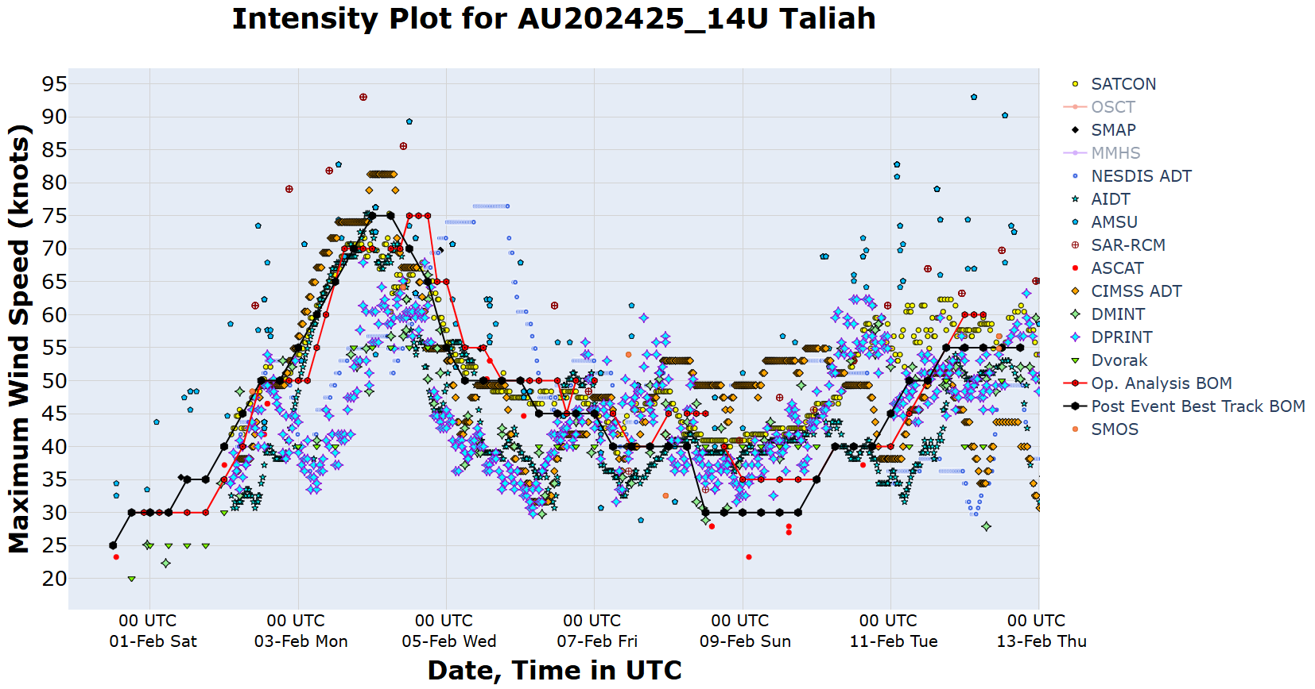

Figure 12 Intensity plot for Taliah in knots showing all available objective guidance with the post event best track plotted in the thick black line.