Severe Tropical Cyclone Trevor

**17 – 28 March 2019**

David Grant, Tropical Cyclone Environmental Prediction Services

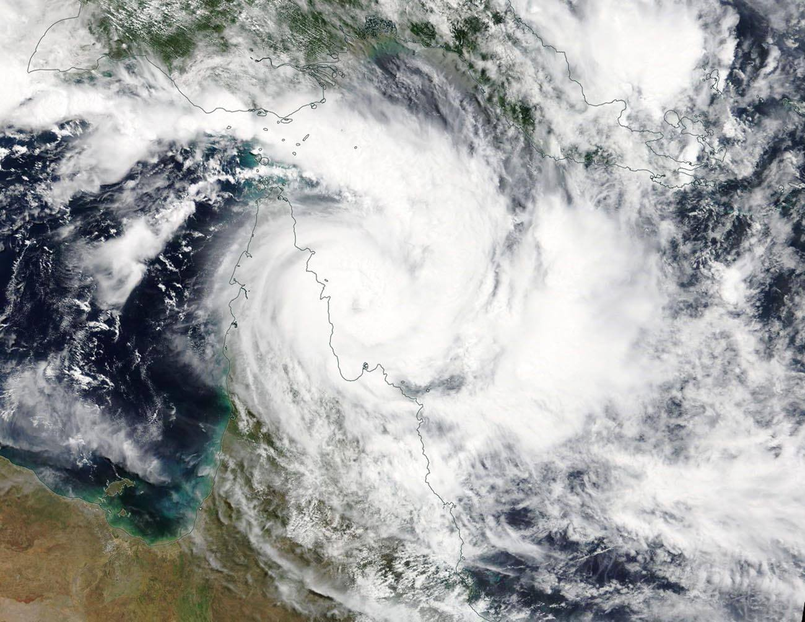

**Revision history**

|  |  |  |  |
| --- | --- | --- | --- |
| Date | Version | Author | Description |
| 18/6/2024 | 1.0 | David Grant | Final draft ready |

**Review status**

|  |  |  |  |
| --- | --- | --- | --- |
| Date | Version | Reviewer | Description |
| 21/6/2024 | 1.0 | Tony Wedd | Completed review |

**Release history**

|  |  |  |  |
| --- | --- | --- | --- |
| Date | Version | Status | Approval |
| 24/6/2024 | 1.0 | Approved for release | Andrew Burton |

Contact details:

Tropical Cyclone Team Lead

Severe Weather Environmental Prediction Services

Bureau of Meteorology

PO Box 1370, West Perth WA 6872

Email: tcwc@bom.gov.au



This work is copyright. Apart from any use as permitted under the Copyright Act 1968, no part may be reproduced without prior written permission from the Bureau of Meteorology. Refer to www.bom.gov.au/other/copyright.shtml for further information. Unless otherwise noted, all images in this document are licensed under the Creative Commons Attribution Australia Licence.

© Commonwealth of Australia 2023

Published by the Bureau of Meteorology

Cover image: Terra/MODIS satellite image of Severe Tropical Cyclone Trevor (source: NASA Worldview)

Table of contents

1. Summary 4

2. Meteorological description 7

3. Impact 14

4. Observations 15

5. Forecast performance 16

## 1. Summary

Trevor initially formed in the northwest Coral Sea on 17 March before rapidly intensifying into a severe tropical cyclone and reaching category 4 intensity prior to crossing the far north Queensland coast, south of Lockhart River, at around 6pm AEST on 19 March (see Figure 1 and Figure 2).

As the cyclone crossed the coast, the community of Lockhart River was subjected to approximately four hours of destructive (i.e. category 2) winds with peak gusts of up to 137 km/h recorded at the airport. These winds caused damage to buildings and uprooted trees around Lockhart River with heavy rain leading to flooding and road closures across Cape York

Trevor remained a category 1 system as it moved westwards across Cape York before it emerged over Gulf of Carpentaria waters, near Weipa, on 21 March. Trevor turned towards the southwest and quickly re-intensified as it moved across the Gulf and towards the Northern Territory coast over the next couple of days. The cyclone reached category 4 intensity with estimated wind gusts of 260 km/h before it crossed the Northern Territory coast, between Port McArthur and the Queensland border around 11am ACST on 23 March. The strongest wind gust recorded in the Northern Territory was 139 km/h early on 23 March at Centre Island, near Port McArthur (equivalent to category 2 intensity). Gales were reported for several hours at Borroloola as the cyclone passed on 23 March.

The cyclone moved inland across the Carpentaria and Barkly districts before weakening into a tropical low early on 24 March near Creswell Downs. The low continued south through the eastern Northern Territory before moving across northwest Queensland from 26 March.

In the Northern Territory, the cyclone passed between Borroloola and Robinson River with little damage in those communities apart from felled trees. A fishing camp south of Borroloola sustained damage to several houses and out-buildings. A storm surge affected the southern Gulf of Carpentaria coast but caused little damage in a mostly unpopulated area. The tide gauge at Burketown, 300km east of landfall, recorded a surge of 1.8m, while Mornington Island recorded a 1.7m surge. More than 2000 people were evacuated to Darwin and Katherine from Alyangula, Borroloola, Numbulwar and Ngukurr in advance of Trevor making landfall in the Northern Territory.

The most widespread impact from the system was the heavy rainfall in drought-ravaged areas in eastern parts of the Northern Territory and northern and central Queensland. Some sites had their highest March daily rainfall on record or their highest total March rainfall in several decades. Localised flooding cut many roads in these districts, including the Tablelands, Sandover and Plenty Highways, and Tobermorey Station near the NT/Queensland border was inundated by floodwaters from the Sandover River.

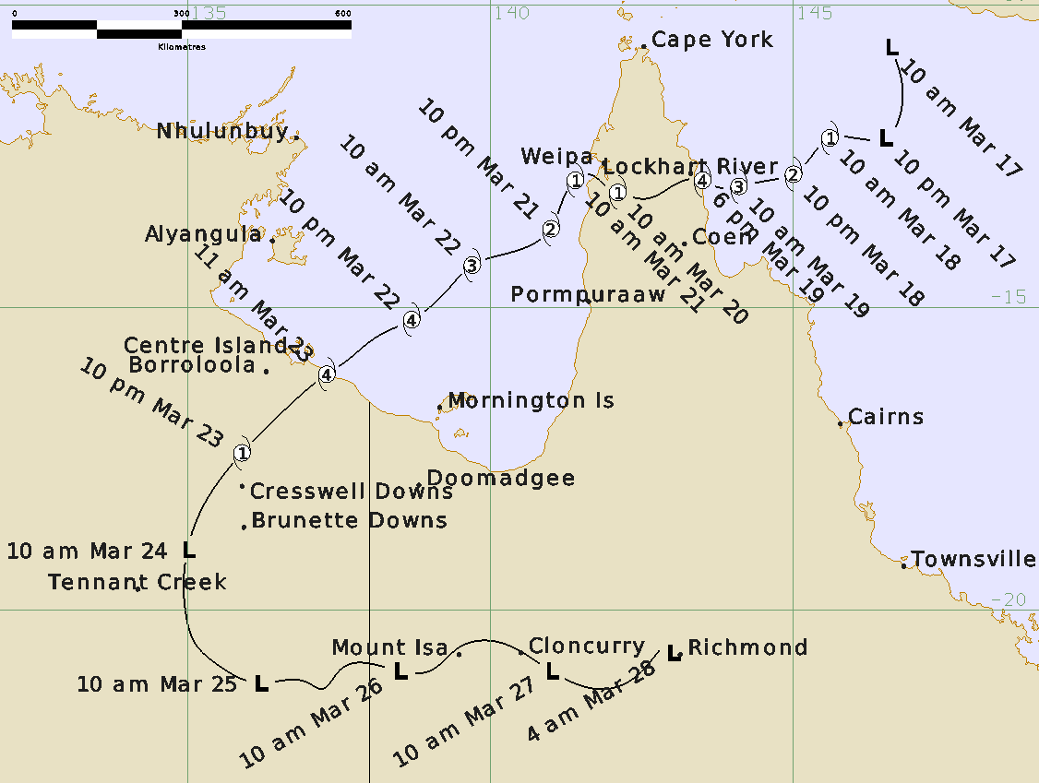

Figure 1: Best track of Severe Tropical Cyclone Trevor (times in AEST, UTC +10).

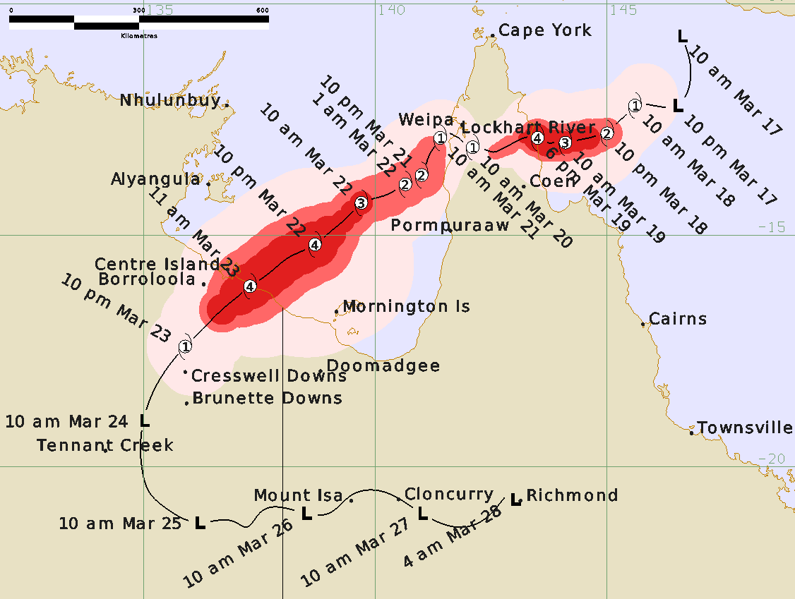

Figure 2: Detailed best track of Severe Tropical Cyclone Trevor showing wind radii (category 1 winds - pink, category 2 winds - red and category 3 winds – dark red) (times in AEST, UTC +10).

|  |  |  |  |  |  |  |  |  |  |  |  |  |  |
| --- | --- | --- | --- | --- | --- | --- | --- | --- | --- | --- | --- | --- | --- |
| **Year** | **Month** | **Day** | **Hour UTC** | **Pos. Lat S** | **Pos. Long. E** | **Pos. Acc. Nm** | **Mean wind**  **kn** | **Max. gust kn** | **Cent. Press hPa** | **Rad of gales (NE/SE/SW/NW) nm** | **Rad of storm nm** | **Rad of hurricane nm** | **RMW nm** |
| 2019 | 3 | 17 | 00 | 10.7 | 146.6 | 45 | 25 | 45 | 1000 |  |  |  |  |
| 2019 | 3 | 17 | 06 | 11.4 | 146.8 | 45 | 25 | 45 | 1000 |  |  |  |  |
| 2019 | 3 | 17 | 12 | 12.2 | 146.5 | 45 | 30 | 45 | 1001 |  |  |  |  |
| 2019 | 3 | 17 | 18 | 12.2 | 146.0 | 30 | 30 | 45 | 1001 |  |  |  |  |
| 2019 | 3 | 18 | 00 | 12.2 | 145.6 | 15 | 35 | 50 | 1000 | 60/50/50/40 |  |  | 25 |
| 2019 | 3 | 18 | 06 | 12.5 | 145.3 | 15 | 45 | 65 | 994 | 60/50/50/40 |  |  | 15 |
| 2019 | 3 | 18 | 12 | 12.8 | 145.0 | 10 | 55 | 75 | 983 | 60/50/50/50 | 20 |  | 15 |
| 2019 | 3 | 18 | 18 | 12.9 | 144.6 | 8 | 80 | 110 | 963 | 70/70/60/50 | 25 | 15 | 10 |
| 2019 | 3 | 19 | 00 | 13.0 | 144.1 | 8 | 85 | 120 | 959 | 70/70/60/50 | 25 | 15 | 12 |
| 2019 | 3 | 19 | 06 | 13.0 | 143.7 | 8 | 90 | 125 | 950 | 70/70/50/40 | 25 | 18 | 10 |
| 2019 | 3 | 19 | 08 | 12.9 | 143.5 | 8 | 90 | 125 | 950 | 70/70/50/40 | 25 | 18 | 8 |
| 2019 | 3 | 19 | 12 | 12.9 | 143.2 | 5 | 70 | 100 | 970 | 60/40/40/40 | 15 | 7 | 3 |
| 2019 | 3 | 19 | 18 | 13.2 | 142.6 | 5 | 50 | 70 | 988 | 30/20/20/30 | 10 |  | 3 |
| 2019 | 3 | 20 | 00 | 13.1 | 142.1 | 5 | 35 | 50 | 990 | 30/15/20/30 | 35/50/50/35 |  | 6 |
| 2019 | 3 | 20 | 06 | 13.0 | 141.9 | 5 | 35 | 50 | 990 | 20/0/20/20 | 35/50/50/30 |  | 6 |
| 2019 | 3 | 20 | 12 | 12.9 | 141.8 | 7 | 35 | 50 | 990 | 20/0/30/30 | 25/30/30/25 |  | 8 |
| 2019 | 3 | 20 | 18 | 12.8 | 141.6 | 15 | 35 | 50 | 990 | 20/0/30/30 | 35/35/50/25 |  | 15 |
| 2019 | 3 | 21 | 00 | 12.9 | 141.4 | 15 | 40 | 55 | 991 | 50/50/90/50 | 0/40/50/35 |  | 15 |
| 2019 | 3 | 21 | 06 | 13.2 | 141.2 | 15 | 50 | 70 | 988 | 50/50/90/50 | 20 |  | 15 |
| 2019 | 3 | 21 | 12 | 13.7 | 141.0 | 12 | 50 | 70 | 987 | 50/50/90/50 | 30 |  | 20 |
| 2019 | 3 | 21 | 18 | 14.1 | 140.3 | 15 | 60 | 85 | 981 | 50/50/90/50 | 30 |  | 18 |
| 2019 | 3 | 22 | 00 | 14.3 | 139.7 | 15 | 70 | 100 | 972 | 50/50/90/50 | 30 | 15 | 18 |
| 2019 | 3 | 22 | 06 | 14.7 | 139.3 | 12 | 75 | 105 | 968 | 70/90/90/70 | 30 | 15 | 15 |
| 2019 | 3 | 22 | 12 | 15.2 | 138.7 | 8 | 95 | 135 | 949 | 100/140/100/100 | 50 | 30 | 9 |
| 2019 | 3 | 22 | 18 | 15.5 | 138.1 | 5 | 100 | 140 | 944 | 100/140/100/100 | 50 | 30 | 6 |
| 2019 | 3 | 23 | 00 | 15.9 | 137.6 | 5 | 100 | 140 | 945 | 100/100/80/100 | 50 | 30 | 6 |
| 2019 | 3 | 23 | 01 | 16.1 | 137.3 | 5 | 100 | 140 | 945 | 100/100/80/100 | 50 | 30 | 6 |
| 2019 | 3 | 23 | 06 | 16.6 | 136.7 | 25 | 65 | 90 | 976 | 70/50/50/70 | 30 | 20 | 20 |
| 2019 | 3 | 23 | 12 | 17.4 | 135.9 | 25 | 45 | 65 | 990 | 50/70/50/50 |  |  | 20 |
| 2019 | 3 | 23 | 18 | 18.4 | 135.2 | 20 | 30 | 45 | 998 |  |  |  |  |
| 2019 | 3 | 24 | 00 | 19.0 | 135.0 | 20 | 30 | 45 | 999 |  |  |  |  |

Table 1 Best track summary for Severe Tropical Cyclone Trevor, 17-24 March 2019 (times in AEST, UTC +10).

## 2. Meteorological description

2.1 Intensity analysis

The tropical low that became Trevor was first identified and tracked in the northwest Coral Sea, near Papua New Guinea, on 17 March. An initial Dvorak T-no. of 1.0 was assigned at 0000 UTC on 17 March following evidence of convective cloud persisting around a centre that was identified on an Advanced Scatterometer ASCAT-A pass at 2254 UTC on 16 March (see Figure 3).

The system rapidly intensified into a severe tropical cyclone by 19 March before it went through an eyewall replacement cycle that day, which briefly steadied its rate of intensification (see Figure 4 for a sequence of microwave images showing the development of the system). The eyewall replacement cycle finished just a few hours before Trevor crossed the far north Queensland coast (as shown in Figure 5), but in this time, the system was able to intensify further to category 4 intensity. The Dvorak estimate at landfall was based on an eye-pattern with a Light Grey surround (with 24nm narrowest width consideration) and an adjustment due to a White surround (no minimum width consideration) and an Off-White eye, which gave a Dvorak T-no. of 5.5. This was generally the average T-number in the last few hours before landfall with objective intensity guidance also largely supporting a 90-knot system as it crossed the far north Queensland coast, south of Lockhart River. As a result, the initial landfall intensity of Trevor was increased to a category 4 following a review of all available evidence in post-event analysis.

Trevor is likely to have remained at category 1 intensity as it moved westwards across the Cape with an Advanced Scatterometer ASCAT-A pass at 2312 UTC on 20 March indicating that gales extended more than halfway around the system as it moved back over Gulf of Carpentaria waters on 21 March (see Figure 6).

Trevor turned towards the southwest and quickly re-intensified as it moved across the Gulf and towards the Northern Territory coast over the next couple of days. The system once again went through an eye wall replacement cycle, which was evident in microwave and radar imagery (see Figure 8), as it approached the Northern Territory coast on 23 March. The cyclone managed to reach category 4 intensity though the eyewall replacement cycle arrested any further intensification in the last few hours before it crossed the Northern Territory coast, between Port McArthur and the Queensland Border around 11am ACST on 23 March.

A comparison of the intensity estimates is shown in Figure 7.

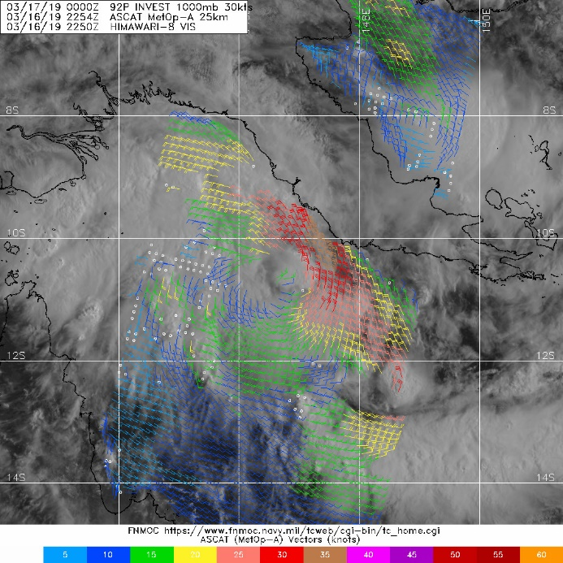

Figure 3: Advanced Scatterometer ASCAT-A pass at 2254UTC on 16th March 2019.

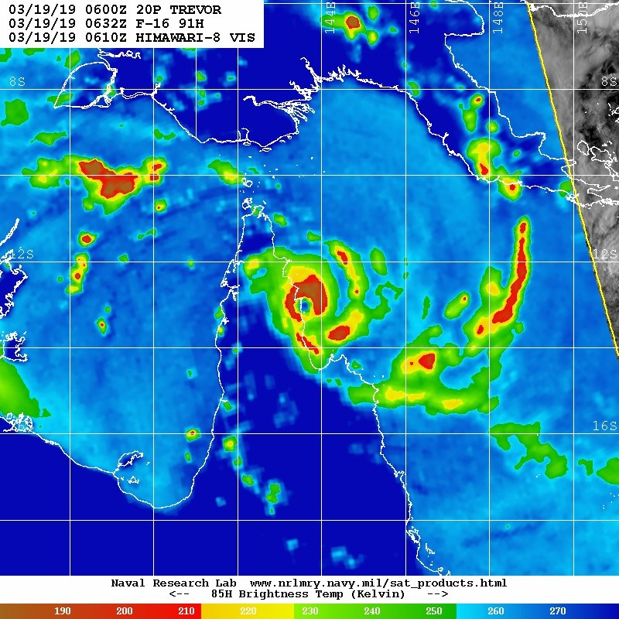

Figure 4: Sequence of 85-91GHz microwave images of Severe Tropical Cyclone Trevor between 17-19th March 2019.

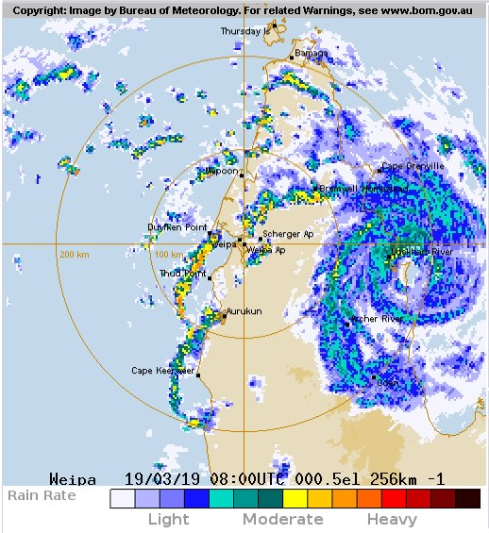

Figure 5: Radar image of Severe Tropical Cyclone Trevor as it crossed the far north Queensland coast, south of Lockhart River, on 19 March 2019.

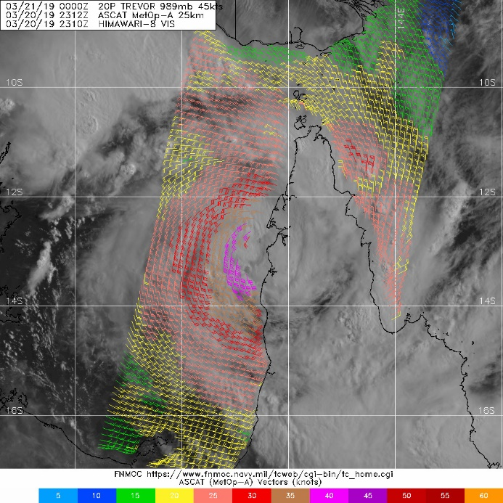

Figure 6: Advanced Scatterometer ASCAT-A pass at 2312UTC on 20 March 2019.

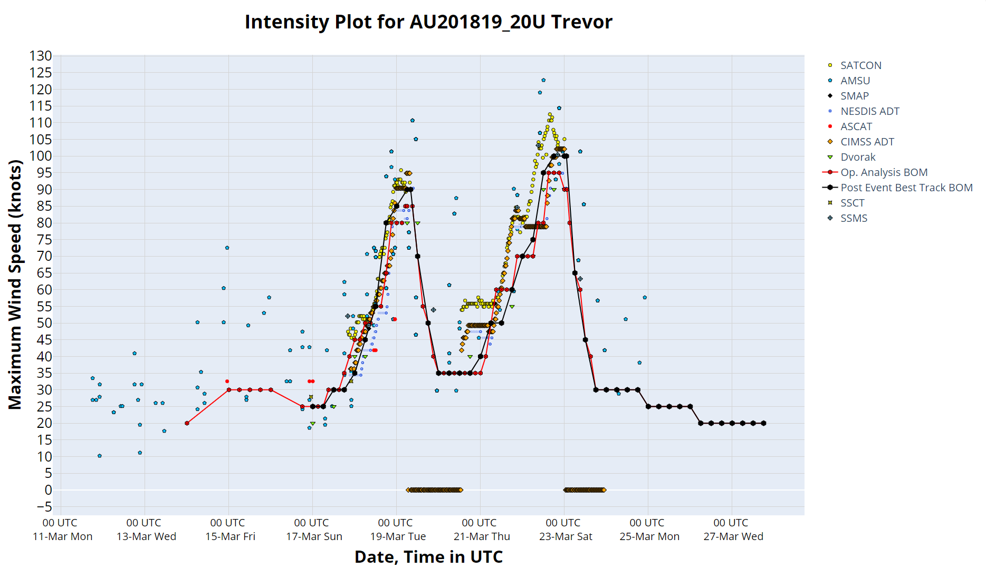

Figure 7: Intensity plot of objective and subjective guidance. SATCON, AMSU, SMAP, NESDIS ADT, ASCAT, CIMSS ADT, Dvorak subjective estimate, operational analysis (red), post event best track analysis (black), SSCT and SSMS. Objective Dvorak have been adjusted from 1-minute to 10-minute maximum mean winds.

2.1 Structure

Gales were initially evident in the northeast quadrant on 17 March (see Figure 3) before they developed up to 70 nautical miles around the system as it intensified on approach to the far north Queensland coast. Storm and hurricane force winds developed up to 25 and 18 nautical miles from the centre of the system respectively during the initial phase of Trevor.

As Trevor moved into the Gulf of Carpentaria the area of gale force winds extended up to 140 nautical miles from the centre of the system. Storm and hurricane force winds developed more broadly out to 50 and 30 nautical miles from the centre of the system as it went through its second eyewall replacement cycle in its life cycle (as shown in Figure 9).

The radius of maximum winds (RMW) generally ranged from 3-25 nm (5-45 km) throughout the event, depending on the intensity and with variations occurring during each of the eye wall replacement cycles (see Figure 8).

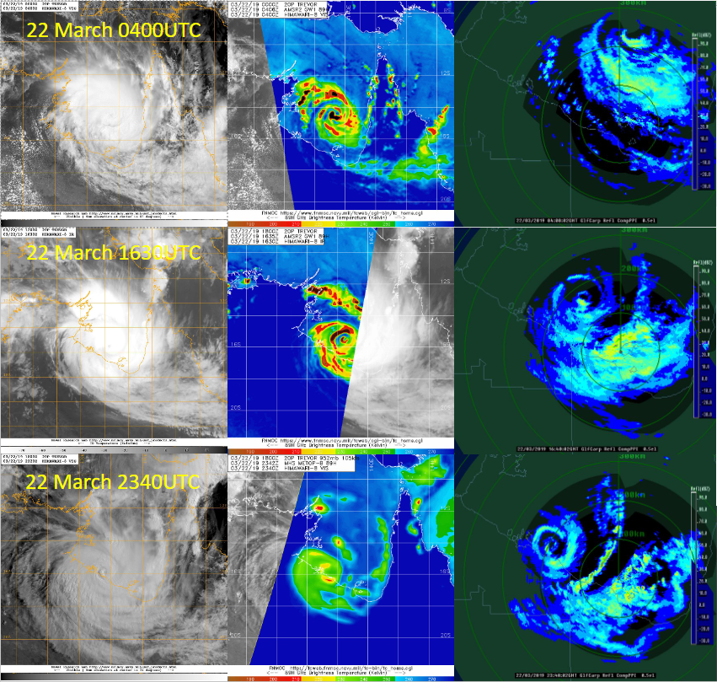

Figure 8: Sequence of satellite, microwave and radar imagery of Severe Tropical Cyclone Trevor as it underwent an eyewall replacement cycle over the Gulf of Carpentaria between 22-23 March 2019.

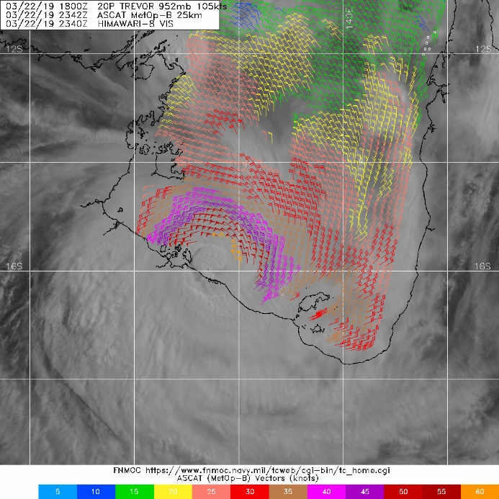

Figure 9: Advanced Scatterometer ASCAT-A pass at 2342UTC on 22 March 2019.

2.2 Motion

A mid-level ridge south of the system was the dominant steering mechanism throughout most of the initial period of Trevor's life cycle. As the ridge slowly moved eastwards during the event it allowed Trevor to adopt a track towards the southwest as the system moved over Gulf of Carpentaria waters.

## 3. Impact

In the Northern Territory, the cyclone passed between Borroloola and Robinson River with little damage in those communities apart from felled trees. A fishing camp south of Borroloola sustained damage to several houses and out-buildings. More than 2000 people were evacuated to Darwin and Katherine from Alyangula, Borroloola, Numbulwar and Ngukurr in advance of Trevor making landfall in the Northern Territory.

The most widespread impact from the system was the heavy rainfall in drought-ravaged areas in eastern parts of the Northern Territory and northern and central Queensland. Some sites had their highest March daily rainfall on record or their highest total March rainfall in several decades. Localised flooding cut many roads in these districts, including the Tablelands, Sandover and Plenty Highways, and Tobermorey Station near the NT/Queensland border was inundated by floodwaters from the Sandover River.

A storm surge affected the southern Gulf of Carpentaria coast but caused little damage in a mostly unpopulated area.

## 4. Observations

4.1 Winds

Lockhart River Airport

Gales recorded between 0655 and 1330 UTC 19 March.

Storm-force winds recorded at times between 0715 and 1130 UTC 19 March.

Maximum 10-minute mean wind of 49 knots (90.7 km/h) at 0715, 1028 and 1130 UTC 19 March.

Maximum 3-second wind gust of 74 knots (137 km/h) at 1106 UTC 19 March.

Mornington Island Airport

Gales recorded between 1919 and 2000 UTC 22 March.

Maximum 10-minute mean wind of 37.9 knots (70.2 km/h) at 2000 UTC 22 March.

Maximum 3-second wind gust of 55 knots (101.9 km/h) at 1958 UTC 22 March.

Centre Island

Gales recorded around 1140UTC 22 March and between 1930 22 March and 0600 UTC 23 March.

Storm-force winds recorded between 2330 UTC 22 March and 0130 UTC 23 March.

Maximum 10-minute mean wind of 58.9 knots (109.1 km/h) at 0030 UTC 23 March.

Maximum 3-second wind gust of 75 knots (139 km/h) at 0017 UTC 23 March.

Borroloola Airport

Gales recorded between 0330 and 0500 UTC 23 March.

Maximum 10-minute mean wind of 47 knots (87.1 km/h) at 0422 UTC 23 March.

Maximum 3-second wind gust of 57 knots (105.6 km/h) at 0450 UTC 23 March.

McArthur River Mine Airport

Maximum 3-second wind gust of 55 knots (101.9 km/h) at 0654 UTC 23 March.

4.2 Pressure

Lockhart River Airport

Lowest mean-sea level pressure: 972.9 hPa at 1036 UTC 19 March.

Centre Island

Lowest mean-sea level pressure: 983.6 hPa at 0132 UTC 23 March.

4.3 Storm surge

The tide gauge at Burketown, 300km east of landfall, recorded a surge of 1.8m, while Mornington Island recorded a 1.7m surge.

## 5. Forecast performance

Tropical Cyclone Advices were issued from 01 UTC 17 March until 19 UTC 23 March.

Tropical Cyclone Advices were issued initially for the north Queensland coast north of Cape Flattery (north of Cooktown). The forecast track was consistent in highlighting the main coastal impact region was expected to be in the Lockhart River region with the first Tropical Cyclone Warning issued at around 11pm AEST on 17 March. Initial forecasts were for a probable category 2 crossing and this was upgraded to a category 3 during 18 March, more than 24 hours before landfall.

Advices extended to the western parts of Cape York Peninsula prior to Trevor making landfall on 19 March.

A Tropical Cyclone Advice was initiated for the Northern Territory coast from Nhulunbuy to the Queensland border on the morning of 20 March. The first Tropical Cyclone Warning was issued for the Northern Territory on 21 March. Trevor was consistently forecast to rapidly re-intensify into a severe tropical cyclone and cross the southwest Gulf of Carpentaria coast as a category 4 system.

The accuracy figures for Severe Tropical Cyclone Trevor are below and also shown in Figures 10 a and 10 b. These show that the forecast position was slightly better than the five-year average at all time steps. The intensity forecasts were better than the five-year average beyond 48 hours but slightly worse before then.

|  |  |  |  |  |  |  |  |  |  |  |
| --- | --- | --- | --- | --- | --- | --- | --- | --- | --- | --- |
| Time | 00 | 06 | 12 | 18 | 24 | 36 | 48 | 72 | 96 | 120 |
| Position accuracy (km) | 12.4 | 29.1 | 37.5 | 41.0 | 45.4 | 60.7 | 72.5 | 124.0 | 205.7 | 253.0 |
| Intensity accuracy (knots) | 3.4 | 6.9 | 8.8 | 10.7 | 12.2 | 12.6 | 11.1 | 5.9 | 7.2 | 9.4 |
| Sample size | 28 | 28 | 28 | 28 | 28 | 28 | 28 | 28 | 28 | 24 |

Table 1: Verification statistics for Severe Tropical Cyclone Trevor.

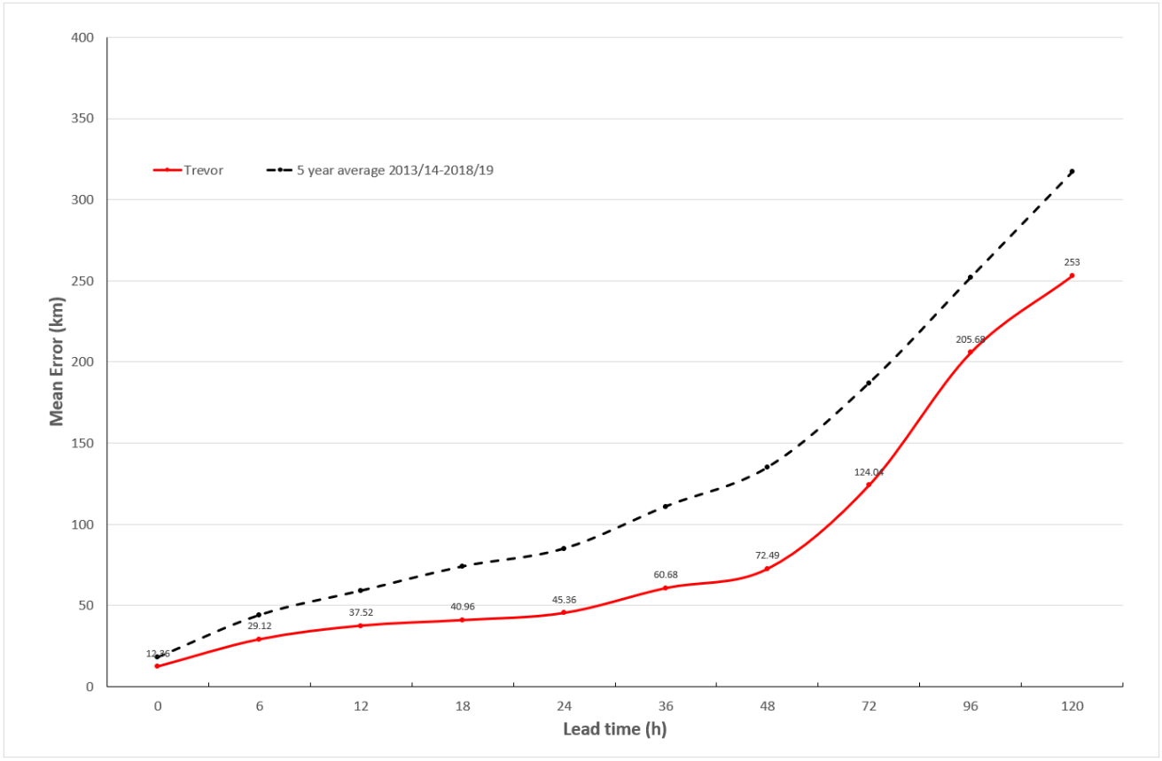

Figure 9 a. Position accuracy figures for Severe Tropical Cyclone Trevor.

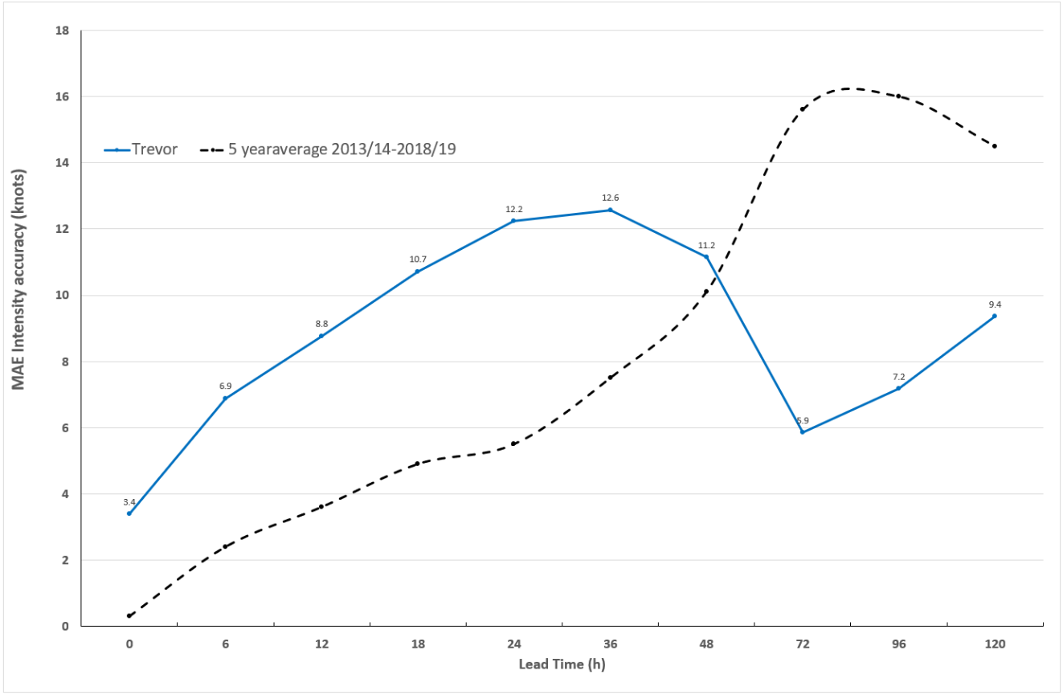

Figure 9 b. Intensity accuracy figures for Severe Tropical Cyclone Trevor.

1. Appendix: List of abbreviations

|  |  |
| --- | --- |
| Abbreviation | Term |
| ADT | Advanced Dvorak Technique |
| ACST | Australian Central Standard Time |
| AEST | Australian Eastern Standard Time |
| AMSR2 | Advanced Microwave Scanning Radiometer |
| ASCAT | Advanced Scatterometer |
| ATMS | Advanced Technology Microwave Sounder |
| AWS | automatic weather station |
| AWST | Australian Western Standard Time |
| °C | Celsius |
| CI | Dvorak Current Intensity number |
| CIMSS | Cooperative Institute for Meteorological Satellite Studies (USA) |
| CIRA | Cooperative Institute for Research in the Atmosphere (USA) |
| EIR | Enhanced InfraRed |
| ERC | eyewall replacement cycle |
| FNMOC | Fleet Numerical Meteorology and Oceanography Centre (USA) |
| FT | Dvorak Final T-number |
| GCOM | Global Change Observation Mission |
| GHz | Gigahertz |
| GMI | Global Precipitation Measurement Microwave Imager |
| h | hour |
| hPa | hectopascal |
| HSCAT | Hai Yang 2 Scatterometer (HY-2B, HY-2C) |
| km | kilometres |
| km/h | kilometres per hour |
| kn | knot |
| LLCC | LLCC |
| MET | Model Expected T-number |
| METOP | Meteorological Operational Satellite |
| MJO | Madden-Julian Oscillation |
| mm | millimetres |
| MSLP | mean sea level pressure |
| nm | nautical mile |
| NOAA | National Oceanic and Atmospheric Administration |
| NRL | Navy Research Lab (USA) |
| PAT | Pattern T-number |
| RH | relative humidity |
| RMW | radius of maximum winds |
| RSMC | Regional Specialised Meteorological Centre |
| SAR | Synthetic Aperture Radar |
| SATCON | satellite Consensus |
| SMAP | Soil Moisture Active Passive |
| SMOS | Soil Moisture and Ocean Salinity |
| SSMIS | Special Sensor Microwave Imager/Sounder |
| TC | Tropical Cyclone |
| TCWC | Tropical Cyclone Warning Centre |
| UTC | Universal Time Co-ordinated |