Severe Tropical Cyclone Ului (09U)

# 14 – 21 March 2010

## Joe Courtney, Tropical Cyclone Environmental Prediction Services

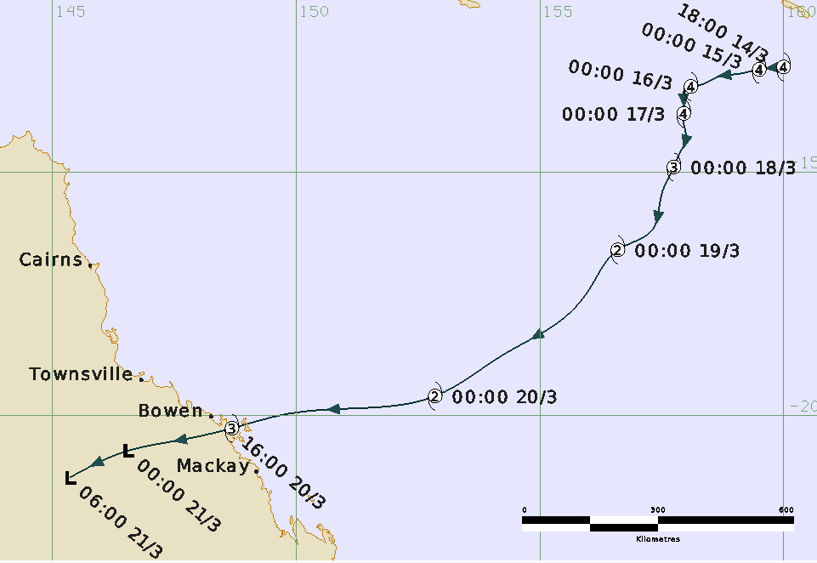

**Revision history**

|  |  |  |  |
| --- | --- | --- | --- |
| Date | Version | Author | Description |
| 8/05/2025 | 1.0 | Joe Courtney | Final draft based on information primarily assembled from 2010. |

**Review status**

|  |  |  |  |
| --- | --- | --- | --- |
| Date | Version | Reviewer | Description |
| 12/05/2025 | 1.0 | Linda Paterson | Completed |

**Release history**

|  |  |  |  |
| --- | --- | --- | --- |
| Date | Version | Status | Approval |
| 12/05/2025 | 1.0 | Approved for release | Andrew Burton |

Contact details:

Tropical Cyclone Team Lead

Severe Weather Environmental Prediction Services

Bureau of Meteorology

PO Box 1370, West Perth WA 6872

Email: [tcwc@bom.gov.au](mailto:tcwc@bom.gov.au)



This work is copyright. Apart from any use as permitted under the Copyright Act 1968, no part may be reproduced without prior written permission from the Bureau of Meteorology. Refer to www.bom.gov.au/other/copyright.shtml for further information. Unless otherwise noted, all images in this document are licensed under the Creative Commons Attribution Australia Licence.

© Commonwealth of Australia 2025

Published by the Bureau of Meteorology

Cover image: Track of Severe Tropical Cyclone Ului 14-21 March 2010. Times in UTC (AEST=UTC-10h)

Contents

1. Summary 5

2. Meteorological description 8

2.1 Intensity analysis 8

2.2 Structure 16

2.3 Motion 16

3. Impact 17

4. Observations 18

4.1 Winds 18

4.2 Pressure 18

4.3 Rainfall 18

4.4 Wave height 19

4.5 Storm Tide 19

Appendix: List of abbreviations 21

**List of Figures**

Figure 1 Best track of Severe Tropical Cyclone Ului, 12 – 21 March 2010. 6

Figure 2. Detailed best track of Severe Tropical Cyclone Ului, 20 – 21 March 2010 6

Figure 3. MODIS visible image around 03 UTC 15 March 2010 9

Figure 4 MODIS visible image at 0250 UTC 18 March 2010 10

Figure 5 MODIS visible image at 0330 UTC 19 March 2010 11

Figure 6 ASCAT-A scatterometry image at 2320 UTC 16 March and 1131 UTC 18 March. 12

Figure 7. AMSR microwave 89 GHz at 1509 UTC 20 March 13

Figure 8 Mackay radar at 1600 UTC 20 March as Ului made landfall. 14

Figure 9. Visible image at 2130 UTC 20 March as Ului was moving inland. 15

Figure 10. Daily rainfall totals for Queensland to 9 am 21 March 2010 and 22 March 2010 . 19

Figure 11 Laguna Quays showing tide levels exceeding HAT early on 21 March. 20

**List of Tables**

Table 1 Best track summary for Severe Tropical Cyclone Ului, 14-21 March 2010. 7

1. Summary

Severe Tropical Cyclone Ului crossed the north Queensland coast at category 3 intensity causing significant wind damage between Airlie Beach and Mackay including on the Whitsunday Islands.

A tropical low formed in the Pacific Ocean to the north of Vanuatu on 8 March. The low then traversed the northern islands of Vanuatu before developing into a tropical cyclone late on 12 March, it was named Ului by Fiji Meteorological Service. Ului then rapidly intensified over the next couple of days into a severe tropical cyclone as it moved in a westerly direction to the south of the Solomon Islands.

Ului moved into the Australian region early on 15 March and became a slow-moving system and adopted a south to southwesterly track. Ului underwent a weakening phase as the system moved across the Coral Sea due to a combination of increased wind shear from an upper trough crossing the Tasman Sea and cool sea surface temperatures.

On 18 March Ului accelerated to the southwest towards the Queensland east coast under the influence of an upper ridge, and re-intensified into a severe tropical cyclone. Ului made landfall near Airlie Beach on the Whitsunday Coast at category 3 intensity early on 21 March. The system weakened below cyclone intensity as it moved overland on 21 March.

Significant wind damage was reported around the Central Coast and Whitsundays district, mainly between Airlie Beach and Mackay. Reports of damage include widespread tree damage, large areas of sugarcane destroyed and localised structural damage, particularly to roofs. About 50,000 homes lost power. Many boats were also damaged or destroyed due to large seas and swell created by Ului, particularly around Shute Harbour near Airlie Beach.

Figure 1 shows the best track of Ului and Figure 2 is a more detailed track showing the extent of gale and storm-force winds, while Table 1 is a summary of the best track data.

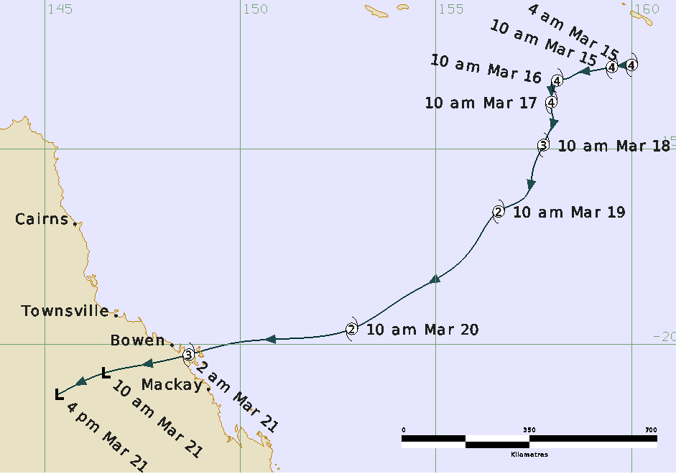

Figure 1 Best track of Severe Tropical Cyclone Ului, 15 – 21 March 2010. Times in AEST (UTC+10 hours)

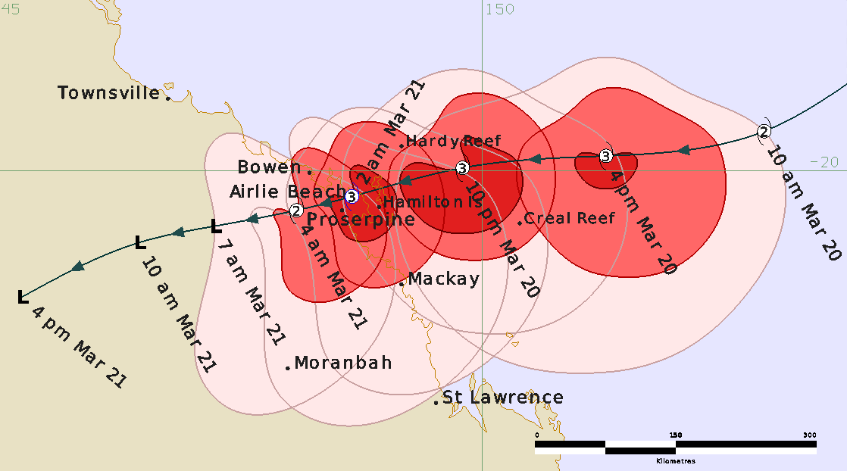

Figure 2. Detailed best track of Severe Tropical Cyclone Ului, 20 – 21 March 2010 showing the extent of gale, storm-force and hurricane-force winds in pink, red and dark red respectively. Times in AEST (UTC+10 hours).

|  |  |  |  |  |  |  |  |  |  |  |  |  |
| --- | --- | --- | --- | --- | --- | --- | --- | --- | --- | --- | --- | --- |
| Year | Mon | Day | Hour UTC | Pos.  Lat. S | Pos. Long.E | Pos Acc. nm | Max Wind 10min kn | Max Gust kn | Cent. Press hPa | Rad. of gales nm  NE/SE/SW/NW | Rad. of storm nm  NE/SE/SW/NW | RMW  nm |
| 2010 | 3 | 14 | 1800 | 12.9 | 160.0 | 15 | 105 | 145 | 939 | 80/100/90/70 | 55/55/60/55 | 18 |
| 2010 | 3 | 15 | 0000 | 12.9 | 159.5 | 10 | 105 | 145 | 939 | 80/100/90/70 | 55/55/60/55 | 12 |
| 2010 | 3 | 15 | 0600 | 13.0 | 159.0 | 10 | 105 | 145 | 939 | 80/100/90/70 | 55/55/55/45 | 12 |
| 2010 | 3 | 15 | 1200 | 13.1 | 158.7 | 10 | 100 | 140 | 945 | 80/100/80/70 | 55/55/55/45 | 17 |
| 2010 | 3 | 15 | 1800 | 13.2 | 158.4 | 10 | 95 | 135 | 948 | 90/100/80/70 | 55/50/55/45 | 17 |
| 2010 | 3 | 16 | 0000 | 13.3 | 158.1 | 15 | 100 | 140 | 943 | 100/100/80/70 | 55/50/55/45 | 17 |
| 2010 | 3 | 16 | 0600 | 13.4 | 158.0 | 15 | 105 | 145 | 937 | 110/110/80/80 | 55/45/55/45 | 17 |
| 2010 | 3 | 16 | 1200 | 13.5 | 158.0 | 15 | 100 | 140 | 943 | 120/110/90/80 | 50/40/55/40 | 17 |
| 2010 | 3 | 16 | 1800 | 13.7 | 158.0 | 15 | 100 | 140 | 941 | 110/110/90/80 | 50/45/55/35 | 20 |
| 2010 | 3 | 17 | 0000 | 13.8 | 158.0 | 10 | 100 | 140 | 944 | 100/110/100/90 | 50/50/60/30 | 20 |
| 2010 | 3 | 17 | 0600 | 14.0 | 158.0 | 10 | 95 | 135 | 950 | 100/100/110/90 | 50/50/60/35 | 15 |
| 2010 | 3 | 17 | 1200 | 14.3 | 158.0 | 10 | 85 | 120 | 960 | 100/100/120/80 | 50/50/65/40 | 12 |
| 2010 | 3 | 17 | 1800 | 14.7 | 157.9 | 15 | 85 | 120 | 958 | 90/100/130/70 | 50/50/70/40 | 18 |
| 2010 | 3 | 18 | 0000 | 14.9 | 157.8 | 15 | 80 | 110 | 962 | 90/100/140/70 | 50/55/70/40 | 20 |
| 2010 | 3 | 18 | 0600 | 15.1 | 157.7 | 15 | 75 | 105 | 967 | 90/100/150/70 | 55/60/75/40 | 15 |
| 2010 | 3 | 18 | 1200 | 15.5 | 157.5 | 15 | 65 | 90 | 976 | 90/100/160/70 | 60/60/80/40 | 20 |
| 2010 | 3 | 18 | 1800 | 16.2 | 157.3 | 20 | 55 | 75 | 982 | 80/100/150/70 | 50/60/65/40 | 25 |
| 2010 | 3 | 19 | 0000 | 16.6 | 156.6 | 20 | 55 | 75 | 986 | 70/100/140/70 | 40/70/50/40 | 25 |
| 2010 | 3 | 19 | 0600 | 17.4 | 156.1 | 20 | 55 | 75 | 983 | 70/100/130/70 | 40/80/60/40 | 20 |
| 2010 | 3 | 19 | 1200 | 18.0 | 155.6 | 20 | 55 | 75 | 986 | 70/120/120/60 | 40/100/70/40 | 22 |
| 2010 | 3 | 19 | 1800 | 18.8 | 154.3 | 20 | 55 | 75 | 985 | 70/130/130/60 | 40/120/80/40 | 18 |
| 2010 | 3 | 20 | 0000 | 19.6 | 152.9 | 20 | 55 | 75 | 983 | 70/145/170/60 | 40/110/90/40 | 15 |
| 2010 | 3 | 20 | 0600 | 19.9 | 151.3 | 15 | 65 | 90 | 978 | 60/120/140/60 | 45/80/60/35 | 15 |
| 2010 | 3 | 20 | 1200 | 20.0 | 149.8 | 15 | 80 | 110 | 967 | 60/110/80/60 | 50/60/50/30 | 18 |
| 2010 | 3 | 20 | 1600 | 20.3 | 148.7 | 15 | 80 | 110 | 967 | 60/130/40/40 | 50/60/20/25 | 15 |
| 2010 | 3 | 20 | 1800 | 20.4 | 148.1 | 15 | 60 | 85 | 982 | 60/140/30/0 | 40/60/15/0 | 15 |
| 2010 | 3 | 20 | 2100 | 20.6 | 147.3 | 20 | 35* | 55 | 994 | 60/120/0/0 | 0/0/0/0 | - |
| 2010 | 3 | 21 | 0000 | 20.7 | 146.5 | 20 | 30 | 45 | 998 | 0/0/0/0 | 0/0/0/0 | - |
| 2010 | 3 | 21 | 0600 | 13.4 | 145.1 | 20 | 55 | 75 | 979 | 0/0/0/0 | 0/0/0/0 | - |

Table 1 Best track summary for Severe Tropical Cyclone Ului, 14-21 March 2010. UTC=AEST-10h.

* Not at tropical cyclone intensity as gales less than halfway around centre.

1. Meteorological description

2.1 Intensity analysis

A tropical low formed in the Pacific Ocean to the north of Vanuatu on 8 March. The low then traversed the northern islands of Vanuatu before developing into a tropical cyclone late on 12 March, and was named Ului by Fiji Meteorological Service. Ului then rapidly intensified over the next couple of days into a severe tropical cyclone as it moved in a westerly direction to the south of the Solomon Islands.

Ului moved into the Australian region early on 15 March exhibiting a well-defined eye as shown on the MODIS visible image at around 0300 UTC 15 March in Figure 3. The peak intensity of Ului within the Australian region was estimated at 105 kn (195 km/h) at this time. Ului then weakened from later on 16 March due to cooler sea surface temperatures. The decrease in SSTs was a consequence of its slow motion which caused a prolonged period of strong winds that brought cooler sub-surface waters to the surface. The inner eye weakened and cloud tops warmed. The MODIS visible image at on 0250 UTC 18 March in Figure 4 showed a broad eye pattern. Further weakening occurred with increased wind shear from an upper trough to the south and this is evident on the MODIS visible image at 0330 UTC 19 March in Figure 5. By this time the intensity had weakened to category 2 (55 kn).

On 19 March Ului accelerated to the southwest over warmer waters and gradually re-intensified into a severe tropical cyclone on 20 March as confirmed by surface observations. Ului passed to the south of Hardy Reef where a minimum pressure of 971.2 hPa was recorded at 1400 UTC 20 March.

Ului made landfall near Airlie Beach on the Whitsunday Coast at category 3 intensity early on 21 March. The system weakened below cyclone intensity as it moved overland on 21 March. The visible image at 2130 UTC 20 March in Figure 9 showed ongoing extensive deep convection near the centre but this weakened rapidly in the following 6-12 hours.

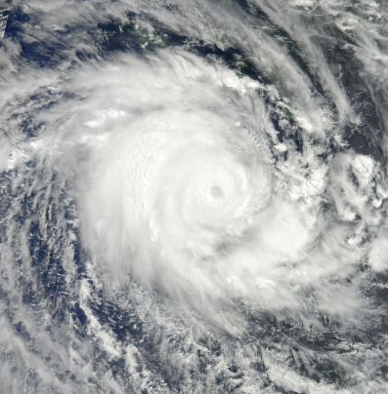

Figure 3. MODIS visible image around 0300 UTC 15 March 2010 as Severe Tropical Cyclone Ului moved over the northeastern Coral Sea. Image courtesy NASA <https://earthobservatory.nasa.gov/images/43154/tropical-cyclones-tomas-and-ului>

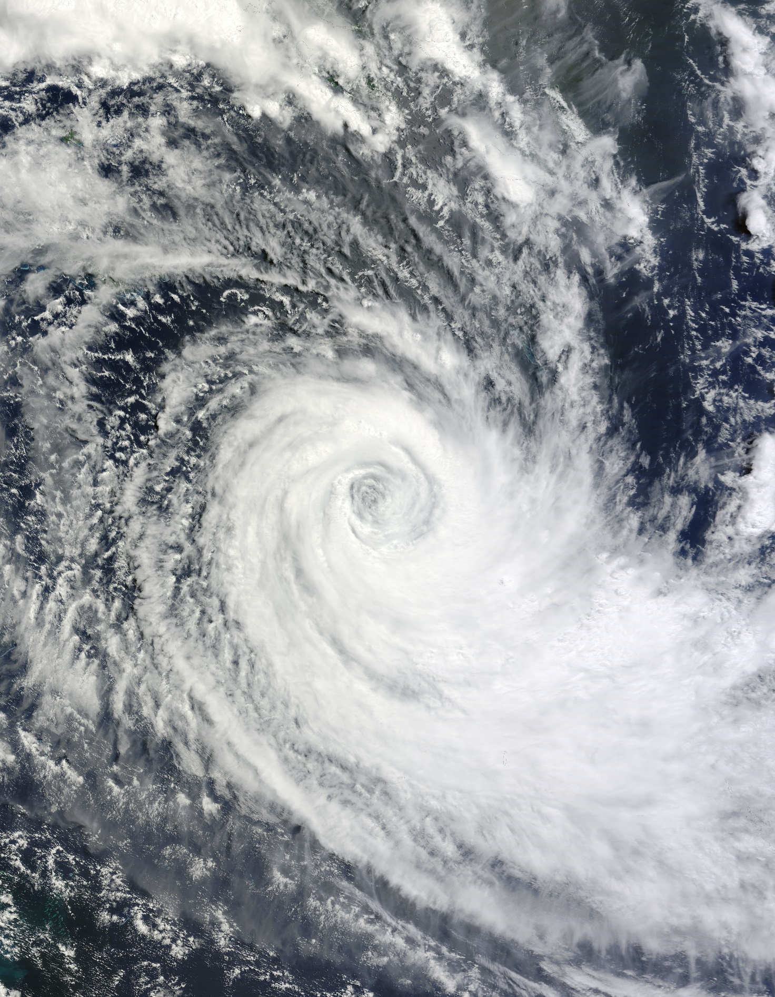

Figure 4 MODIS visible image at 0250 UTC 18 March 2010 showing Tropical Cyclone Ului in the Coral Sea. Image courtesy NASA <https://earthobservatory.nasa.gov/images/43180/tropical-cyclone-ului>

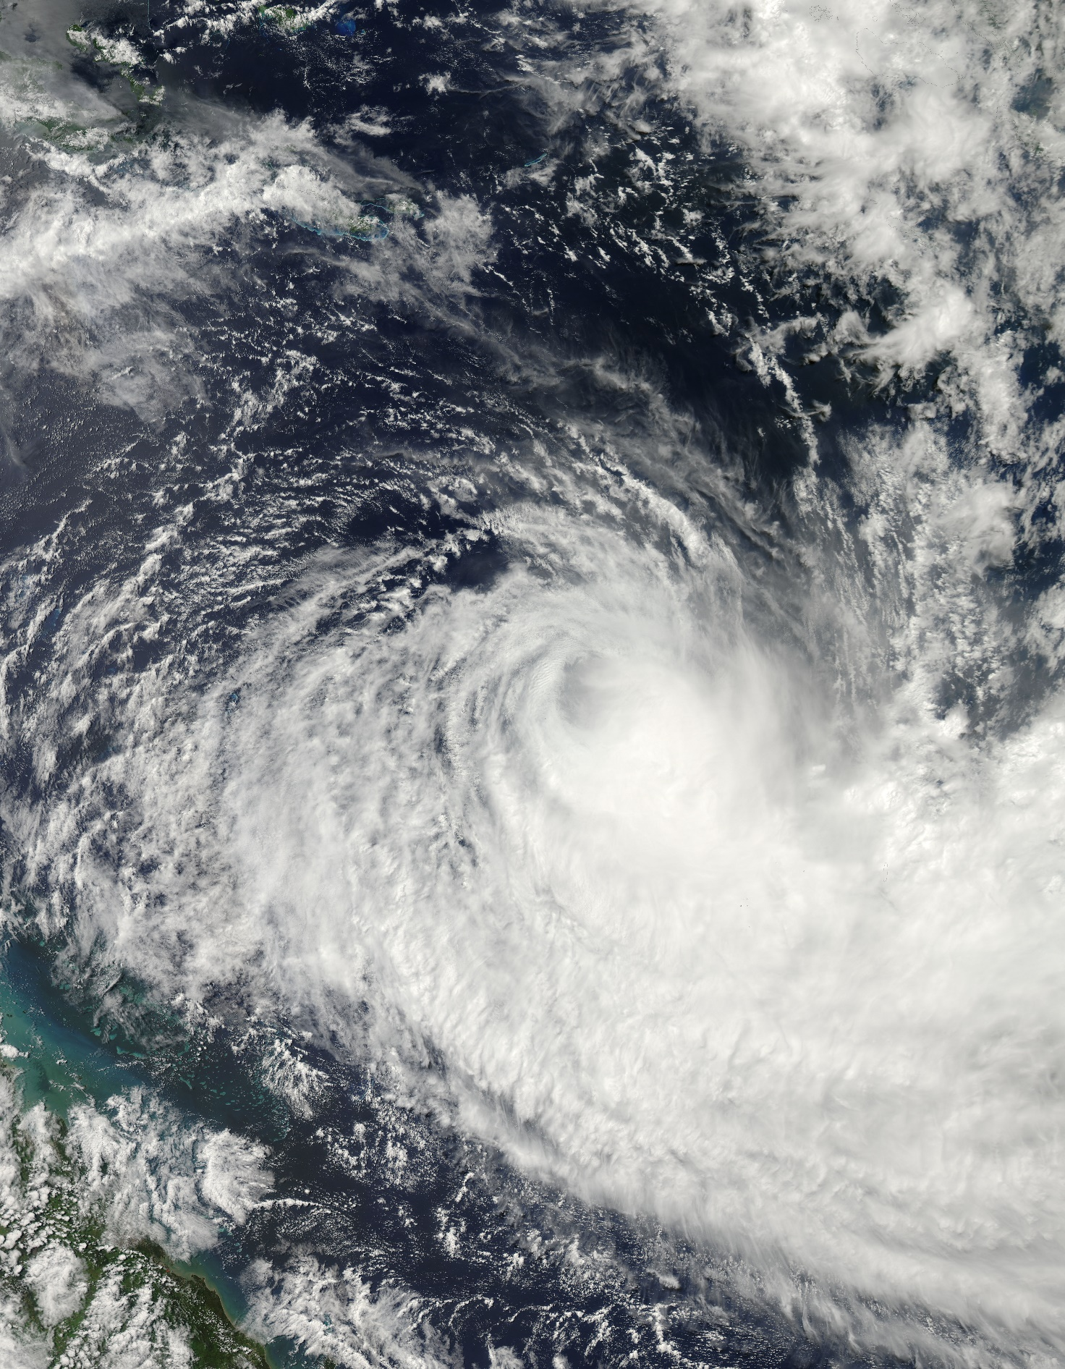

Figure 5 MODIS visible image at 0330 UTC 19 March 2010 showing Tropical Cyclone Ului temporarily weaker in the Coral Sea. Image courtesy NASA <https://earthobservatory.nasa.gov/images/43188/tropical-cyclone-ului>

|  |  |
| --- | --- |
| ASCAT-A scatterometry image at 2320 UTC 16 March | ASCAT-A scatterometry image at 1131 UTC 18 March |

Figure 6 ASCAT-A scatterometry image at: left 2320 UTC 16 March; and right 1131 UTC 18 March. Images courtesy NOAA: <https://manati.star.nesdis.noaa.gov/datasets/ASCATData.php>

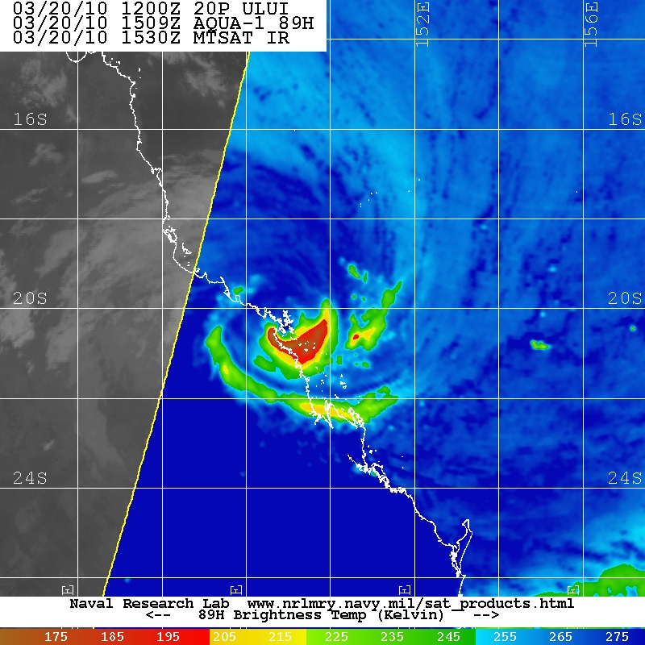

Figure 7. AMSR microwave 89 GHz at 1509 UTC 20 March as Ului made landfall. Image courtesy NRL: https://www.nrlmry.navy.mil/TC.html

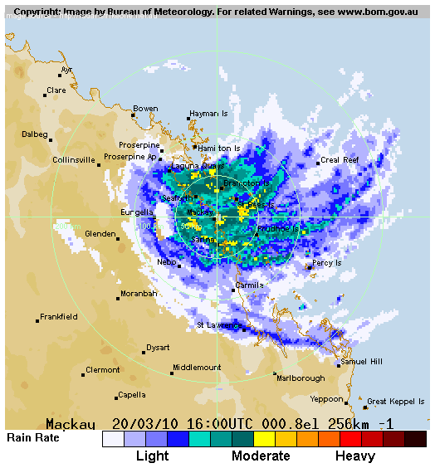

Figure 8 Mackay radar at 1600 UTC 20 March as Ului made landfall.

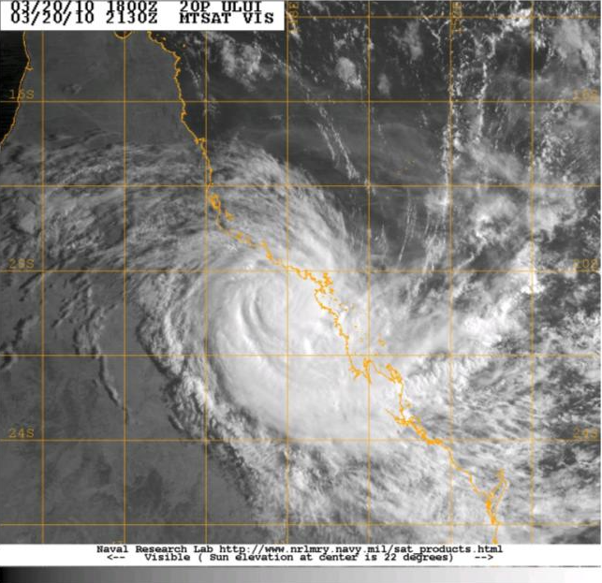

Figure 9. Visible image at 2130 UTC 20 March as Ului was moving inland. Image courtesy NRL: https://www.nrlmry.navy.mil/TC.html:

2.2 Structure

The extent of gales was asymmetric throughout Ului's track in the Australian region and was greatest south of the centre. This was due to synoptic forcing of the ridge to the south of the system centre. Refer to Table 1 for details.

When Ului entered the Australian region the radius to gales ranged from 70-80 nm (130-150 km) north of the centre to 90-100 nm (165-185 km) in southern quadrants. Scatterometry, for example ASCAT-A at 2320 UTC 16 March and 1131 UTC 18 March, shown in Figure 6 provided confidence in the extent of gale and storm-force winds. Gales extended to beyond 150 nm (280 km) at times southwest of the centre. This resulted in gales commencing on the coast while Ului was still well offshore between Bowen and Mackay after 0000 UTC 20 March.

As Ului tracked towards the coast on 19-21 March, the convective pattern became highly asymmetric, being strongest south of the centre as shown on microwave imagery, example AMSR 89 GHz at 1509 UTC 20 March in Figure 7; and on radar imagery, example Mackay radar at 1600 UTC 20 March in Figure 8.

The radius to maximum winds (RMW) was initially small at 12-15 nm (20-28 km), increasing to 25 nm (45 km) for a period on 19 March when Ului weakened to category 2 intensity, then being 15 nm (28 km) at landfall.

As Ului approached land it was in an intensifying phase with a large eye developing before landfall. As a result of this large eye the term “winds may remain light for up to an hour” was included in Tropical Cyclone Advices to alert the public to the risk of leaving shelter while in the eye.

2.3 Motion

Severe Tropical Cyclone Ului initially was tracking to the west when it entered the Australian area of responsibility (160oE). From 15 to 17 March, Ului became slow moving. Severe Tropical Cyclones Tomas, near Fiji, may have contributed to this slow southerly movement.

As Ului fell under the influence of an upper ridge on 18 March the system accelerated towards the Queensland east coast. At landfall Ului was moving to the west southwest at 15 kn (30 km/h).

1. Impact

Ului caused significant damage to the southern Solomon Islands including Rennel Islands and the Bellona Province.

In Australia widespread wind damage was reported around the Central Coast and Whitsundays district, mainly between Airlie Beach and Mackay. Reports of damage included widespread tree damage, large areas of sugarcane destroyed and localised structural damage, particularly to roofs. About 50,000 homes lost power following the passage of the system.

Many boats were also damaged or destroyed due to large seas and swell created by Ului, particularly around Shute Harbour near Airlie Beach. This included about a dozen that were washed onto rocks. Along the Queensland central coast there were reports of beach erosion and damage to coastal infrastructure.

Evacuations occurred from the offshore islands of Heron and Lady Elliot Islands as Ului approached and many ports were close due to large waves.

Flooding from heavy rainfall was principally in the Pioneer River. Major flood levels were recorded in the top of the Pioneer River in the Mirani area, with minor to moderate flooding in Cattle Creek. Downstream at Mackay, river levels remained below minor flood level. During Monday 22 March heavy rainfall associated with Tropical Cyclone Ului was recorded in the Townsville area, producing minor flooding in the Bohle River and in Major Creek in the Haughton River catchment.

Large waves extended a south along the Queensland coast. A 19-year-old competitor in the Australian Surf Live Saving Championships at Kurrawa Beach on the Gold Coast died in rough surf conditions prompting the cancellation of the championships.

1. Observations

4.1 Winds

Hardy Reef, Creal Reef, Hamilton Is, Proserpine and Mackay all recorded winds of at least gale-force intensity as summarised in the table below. Hamilton Island recorded maximum 10-minute mean winds of 93 kn (172 km/h) but the observation site is located on elevated terrain and as such is considered to have overestimated wind readings for the island. Creal Reef also recorded hurricane-force winds (>63 kn) from 0840 to 1050 UTC 20 March (1840 to 2050 AEST 20 March).

|  |  |  |  |  |
| --- | --- | --- | --- | --- |
| Site | Max. 10-min mean wind kn (km/h) Time UTC* | Max. 3-sec. gust kn (km/h) Time UTC* | Period of gales  in UTC* | Period of storm-force winds (>48kn) in UTC* |
| Hardy Reef | 55 (102) at 1500 20 Mar. |  | 0530-1700 20 Mar. | 1300-1630 20 Mar. |
| Creal Reef | 71 (131) at 0900 20 Mar. 1900 20 Mar. | 90 (167) at 0910 20 Mar. | 2240 19 Mar. –1910 20 Mar. | 0630-1410 20 Mar. |
| Hamilton Is.** | 93kn (172) at 1440 20 Mar. |  |  |  |
| Proserpine | 51 (94) at 1610 20 Mar. | 79 (146) 1530 20 Mar. | 1510-1640 20 Mar. | 1610-1630 20 Mar. |
| Mackay Apt | 46 (85) at 1420 20 Mar. | 64 (118) at 1410 20 Mar. | 1210-1820 20 Mar. |  |

* UTC=AEST-10h

** Note site is located on elevated terrain and considered to overestimate winds for the island

4.2 Pressure

Hardy Reef recorded a min. pressure of 971.2 hPa at 1400 UTC 20 March (0000 AEST 21 Mar.).

Creal Reef recorded a min. pressure of 989.2 hPa at 0850 UTC 20 March (1850 AEST 20 March) outside the eye.

Hamilton Island recorded a min. pressure of 975.4 hPa from within the eye at 1457 UTC 20 March (0057 AEST 21 March).

Proserpine recorded a min. pressure of 981.0 hPa at 1700 UTC 20 March (0300 AEST 21 March).

4.3 Rainfall

Heavy rainfall accompanied the landfall of Ului on the Queensland east coast. Figure 10 is the daily rainfall distribution to 9am AEST 21 March and 22 March and shows rainfall exceeding 200 mm near the track. Some notable daily rainfall totals to 9am 21 March include:452.0 mm Clarke Range Alert; 332.0 Finch Hatton Alert; 261.0 mm Rowallan Park Alert; 258.5 mm Mt Jukes; 236.0 Hannaville Alert 227.0 Mt Charlton.

|  |  |
| --- | --- |
| Daily rainfall totals for Queensland to 9 am 21 March 2010  showing falls over 150mm on the southern side where Ului crossed the coast. | Daily rainfall totals for Queensland to 9 am 22 March 2010  showing falls over 100mm associated with the track of Ului. |

Figure 10. Daily rainfall totals for Queensland to 9 am 21 March 2010 left and 22 March 2010 right.

4.4 Wave height

Mackay wave buoy (courtesy of DERM) recorded a peak wave height of 9.4 m at midnight AEST 21 March, before Ului made landfall. This was a new record for the site which had been recording since 1975. Swell direction was generally out of the east-southeast to east-northeast.

4.5 Storm Tide

Laguna Quays storm tide gauge (courtesy of DERM) observed a surge height of 2.45 m near a high neap tide. As a result water levels there exceeded HAT by 0.4 m as shown in Figure 11.

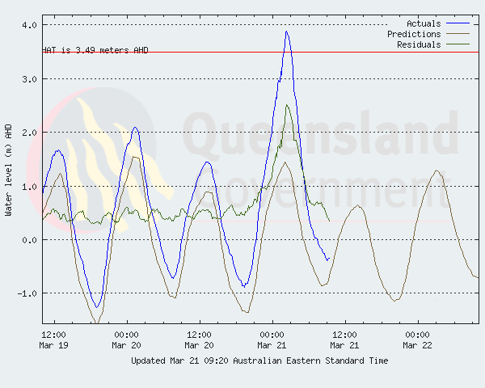

Figure 11 Laguna Quays showing tide levels exceeding HAT early on 21 March. Image courtesy Queensland DERM <https://www.publications.qld.gov.au/dataset/tropical-cyclone-wave-and-storm-tide-reports/resource/e4eb734c-4e3b-47cd-ab9b-2db5994c2356>

Appendix: List of abbreviations

|  |  |
| --- | --- |
| Abbreviation | Term |
| ADT | Advanced Dvorak Technique |
| ACST | Australian Central Standard Time |
| AEST | Australian Eastern Standard Time |
| AiDT | AI-enhanced Dvorak Technique |
| AMSR2 | Advanced Microwave Scanning Radiometer |
| AMSU | Advanced Microwave Sounding Unit |
| ASCAT | Advanced Scatterometer |
| ATMS | Advanced Technology Microwave Sounder |
| AWS | automatic weather station |
| AWST | Australian Western Standard Time |
| °C | Celsius |
| CI | Current intensity |
| CIMSS | Cooperative Institute for Meteorological Satellite Studies (USA) |
| CIRA | Cooperative Institute for Research in the Atmosphere (USA) |
| D-MINT | Deep learning - Multispectral Intensity of TCs (formerly known as DMN) |
| D-PRINT | Deep learning - IR Intensity of TCs (formerly known as OPEN-AIIR) |
| DT | Dvorak Data T number |
| EIR | Enhanced InfraRed |
| ERC | eyewall replacement cycle |
| FNMOC | Fleet Numerical Meteorology and Oceanography Centre (USA) |
| FT | Final T-number |
| GCOM | Global Change Observation Mission |
| GHz | Gigahertz |
| GMI | Global Precipitation Measurement Microwave Imager |
| h | hour |
| hPa | hectopascal |
| HSCAT | Hai Yang 2 Scatterometer (HY-2B, HY-2C) |
| km | kilometres |
| km/h | kilometres per hour |
| kn | knot |
| LLCC | LLCC |
| MET | Model Expected T-number |
| METOP | Meteorological Operational Satellite |
| MJO | Madden-Julian Oscillation |
| mm | millimetres |
| MSLP | mean sea level pressure |
| NESDIS | National Environmental Satellite, Data, and Information Service |
| nm | nautical mile |
| NOAA | National Oceanic and Atmospheric Administration |
| NRL | Navy Research Lab (USA) |
| OPEN-AiiR | Ordered Pattern Encoding AI Infrared |
| PAT | Pattern T-number |
| RCM | RadarSat Constellation Mission – Synthetic Aperture Radar |
| RH | relative humidity |
| RMW | radius of maximum winds |
| RSMC | Regional Specialised Meteorological Centre |
| SAR | Synthetic Aperture Radar |
| SATC | CIMSS Advanced Dvorak Technique |
| SATCON | Satellite Consensus |
| SEN1 | Sentinel-1A – Synthetic Aperture Radar |
| SMAP | Soil Moisture Active Passive |
| SMOS | Soil Moisture and Ocean Salinity |
| SSMIS | Special Sensor Microwave Imager/Sounder |
| TC | Tropical Cyclone |
| TCWC | Tropical Cyclone Warning Centre |
| UTC | Universal Time Co-ordinated |