Tropical Cyclone Unnamed 09U

## 08 – 13 January 2025

## Nadine Birch

## Tropical Cyclone Environmental Prediction Services

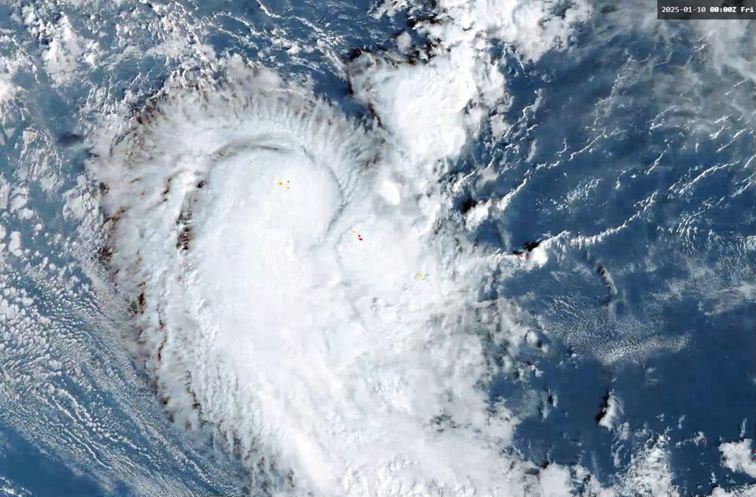

### Revision history

|  |  |  |  |
| --- | --- | --- | --- |
| Date | Version | Author | Description |
| 2 May 2025 | 1.0 | Nadine Birch | Final Draft |

### Review status

|  |  |  |  |
| --- | --- | --- | --- |
| Date | Version | Reviewer | Description |
| 2 May 2025 | 1.0 | Joe Courtney | Complete |

### Release history

|  |  |  |  |
| --- | --- | --- | --- |
| Date | Version | Status | Approval |
| 7 May 2025 | 1.0 | Approved | David Grant |



Contact details:

Tropical Cyclone Team Lead

Severe Weather Environmental Prediction Services

Bureau of Meteorology, PO Box 1370, West Perth WA 6872

Email: tcwc@bom.gov.au

This work is copyright. Apart from any use as permitted under the Copyright Act 1968, no part may be reproduced without prior written permission from the Bureau of Meteorology. Refer to www.bom.gov.au/other/copyright.shtml for further information. Unless otherwise noted, all images in this document are licensed under the Creative Commons Attribution Australia Licence.

© Commonwealth of Australia 2025

Published by The Bureau of Meteorology

Cover image: Visible Satellite image of 09U at Category 1 intensity, 0000 UTC 10 January 2025. Image courtesy of Japan Meteorological Agency.

Table of contents

1. Summary 5

2. Meteorological description 7

2.1. Intensity Analysis 7

2.2. Structure 8

2.3. Motion 9

3. Impact 9

4. Observations 9

5. Forecast Performance 9

Appendix 1: List of Abbreviations 10

Table of Figures

Figure 1: Best track of 09U, 8 - 13 January 2025.. 4

Figure 2: Zoomed in best track of 09U 9-12 January 2025, during its maximum intensity showing the extent of gale force winds.. 6

Figure 3: Ultra High resolution (UHR) scatterometer winds from ASCAT-C showing gales extending more than halfway around the system centre, 0255 UTC 10 January 2025. 7

Figure 4. Intensity plot of objective and subjective guidance. 12

Table of Tables

Table 1: Best track summary of 09U. * gales in 2 or less quadrants does not meet the Australian definition of a tropical cyclone. 5

Table 2: Forecast accuracy of the Official Forecast Tracks compared to the best track for position (km) and intensity (kn), noting the small sample size. 8

1. Summary

The unnamed tropical cyclone 09U was deemed to have briefly reached tropical cyclone intensity upon reanalysis, over open waters of the Indian Ocean on 10 January.

A tropical low formed to the south of Christmas Island on 8 January 2025. In the days preceding the formation of a closed circulation there was a trough lying through Indonesia, and 09U likely eventuated from this elongated area of rotation. There were no climate drivers aiding formation and the Madden-Julian Oscillation (MJO) was in a supressed phase.

Tropical low 09U initially moved in a general westward direction, then made a turn towards the south on 9 January 2025. On 10 January 09U intensified. During operations gales were analysed in southern quadrants, but on post event review gale force winds are analysed to extend into all quadrants for a period of 6-12 hours, classifying 09U as a category 1 tropical cyclone from 0000 UTC on 10 January. By 1200 UTC 10 January 09U gales contracted to the southern quadrants, and by 0000 UTC on 11 January winds were estimated below gale force.

There were no impacts to island or coastal communities associated with 09U.

The post-event best track of 09U is shown in Figure 1 below and a summary is given in Table 1.

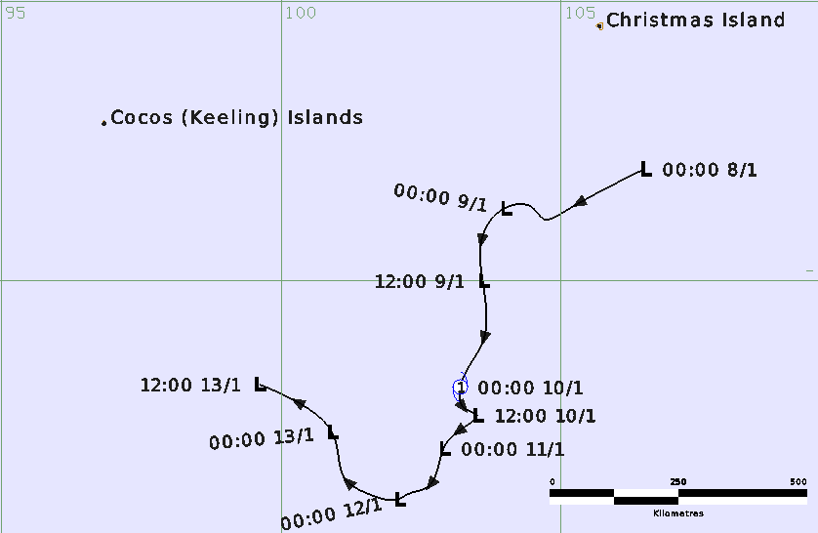

Figure 1: Best track of 09U, 8 - 13 January 2025. Times in UTC (AWST-8h).

|  |  |  |  |  |  |  |  |  |  |  |  |  |
| --- | --- | --- | --- | --- | --- | --- | --- | --- | --- | --- | --- | --- |
| Year | Month | Day | Hour UTC | Pos. Lat. S | Pos. Long. E | Pos. Acc. nm | MaxWind (10m) kn | Max. gust kn | Cent. Press hPa | Rad of gales NE/SE/SW/NW nm | Rad of storm NE/SE/SW/NW nm | RMW nm |
| 2025 | 1 | 8 | 0000 | 13.0 | 106.5 | 60 | 15 | 45 | 1007 |  |  |  |
| 2025 | 1 | 8 | 0600 | 13.8 | 105.0 | 50 | 20 | 45 | 1006 |  |  |  |
| 2025 | 1 | 8 | 1200 | 13.9 | 104.7 | 50 | 20 | 45 | 1006 |  |  |  |
| 2025 | 1 | 8 | 1800 | 13.7 | 104.5 | 50 | 25 | 45 | 1005 |  |  |  |
| 2025 | 1 | 9 | 0000 | 13.7 | 104.0 | 30 | 25 | 45 | 1006 |  |  |  |
| 2025 | 1 | 9 | 0600 | 14.2 | 103.6 | 30 | 25 | 45 | 1006 |  |  |  |
| 2025 | 1 | 9 | 1200 | 15.0 | 103.6 | 45 | 25 | 45 | 1004 |  |  |  |
| 2025 | 1 | 9 | 1800 | 16.1 | 103.6 | 30 | 35* | 50 | 1003 | 0/0/60/0 |  |  |
| 2025 | 1 | 10 | 0000 | 16.9 | 103.2 | 30 | 40 | 55 | 1003 | 40/90/70/40 |  | 20 |
| 2025 | 1 | 10 | 0600 | 17.3 | 103.3 | 25 | 40 | 55 | 1000 | 40/90/70/40 |  | 20 |
| 2025 | 1 | 10 | 1200 | 17.4 | 103.5 | 20 | 35* | 50 | 1002 | 0/120/110/0 |  |  |
| 2025 | 1 | 10 | 1800 | 17.6 | 103.3 | 20 | 35* | 50 | 1002 | 0/0/80/0 |  |  |
| 2025 | 1 | 11 | 0000 | 18.0 | 102.9 | 20 | 30 | 45 | 1003 |  |  |  |
| 2025 | 1 | 11 | 0600 | 18.7 | 102.6 | 15 | 30 | 45 | 1004 |  |  |  |
| 2025 | 1 | 11 | 1200 | 18.8 | 102.3 | 15 | 25 | 45 | 1006 |  |  |  |
| 2025 | 1 | 11 | 1800 | 18.85 | 102.2 | 15 | 25 | 45 | 1005 |  |  |  |
| 2025 | 1 | 12 | 0000 | 18.9 | 102.1 | 10 | 25 | 45 | 1006 |  |  |  |
| 2025 | 1 | 12 | 0600 | 18.84 | 101.63 | 10 | 20 | 45 | 1009 |  |  |  |
| 2025 | 1 | 12 | 1200 | 18.51 | 101.12 | 15 | 20 | 45 | 1006 |  |  |  |
| 2025 | 1 | 12 | 1800 | 18.0 | 101.0 | 15 | 20 | 45 | 1006 |  |  |  |
| 2025 | 1 | 13 | 0000 | 17.7 | 100.9 | 10 | 20 | 45 | 1006 |  |  |  |
| 2025 | 1 | 13 | 0600 | 17.3 | 100.5 | 10 | 20 | 45 | 1006 |  |  |  |
| 2025 | 1 | 13 | 1200 | 16.85 | 99.6 | 15 | 20 | 45 | 1006 |  |  |  |

Table 1: Best track summary of 09U. * gales in 2 or less quadrants does not meet the Australian definition of a tropical cyclone.

1. Meteorological description
   1. Intensity Analysis

Tropical low 09U formed on 8 January 2025 over warm ocean temperatures (30 – 31 degrees Celsius) to the south of Indonesia. Moderate easterly shear over the system and a lack of deep convective drivers resulted in a short window of development. On 10 January poleward outflow improved as an upper-level trough approached from the southwest, and the upper divergence gave 09U support to intensify. Peak intensity was analysed at 40 knots (10-minute mean). A zoomed image of the best track can be viewed in Figure 2. Gales were estimated to occur first in the southwest quadrant from 1800 UTC on 9 January, then extending around the centre at 0000 UTC 10 January. Scatterometry high resolution winds from ASCAT-C at 0255 UTC showed evidence of gales wrapping more than halfway around the centre (Figure 3).

Tropical cyclone status was short lived as the shear increased from the upper trough. 09U lost deep convection within 12 hours of being classified a tropical cyclone. Gales were estimated in the southern quadrants from 1200 UTC on 10 January until 0000 UTC 11 January, when intensity was dropped below gale force. A plot of intensity is included at the end of this document in Figure 4. Unnamed 09U did not meet the triggers for various objective satellite estimates to be used during the event.

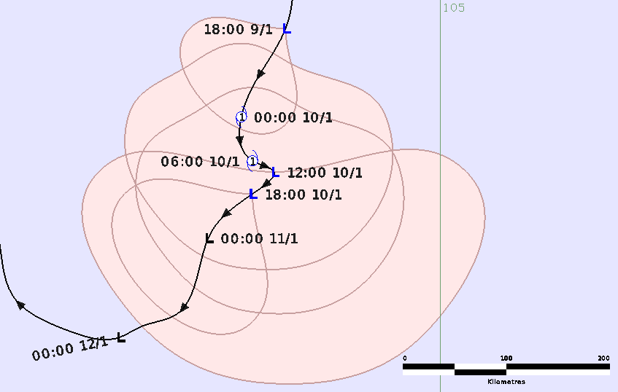

Figure 2: Zoomed in best track of 09U 9-12 January 2025, during its maximum intensity showing the extent of gale force winds. Times in UTC (AWST-8h).

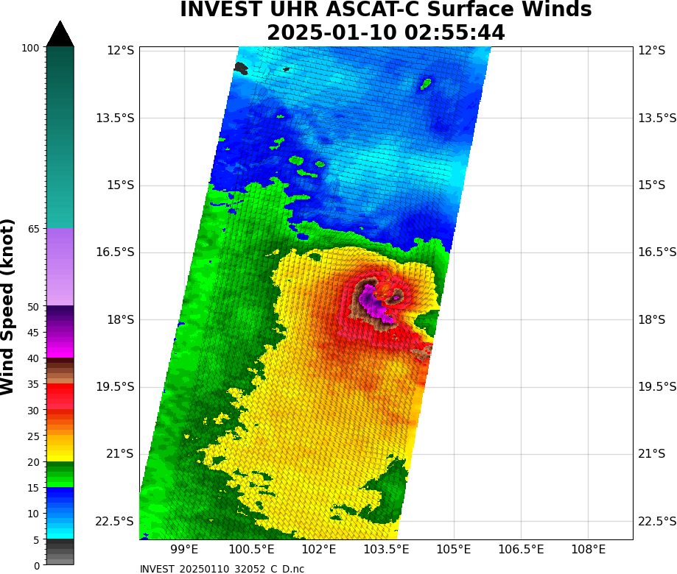

Figure 3: Ultra High resolution (UHR) scatterometer winds from ASCAT-C showing gales extending more than halfway around the system centre, 0255 UTC 10 January 2025. Image courtesy NOAA <https://manati.star.nesdis.noaa.gov/datasets/ASCATCStorm.php>

* 1. Structure

The influence of moderate to high shear resulted in 09U having an asymmetrical structure. The initial gale radius was small, just 60 nm (110 km) in the southwest quadrant only. On 10 January, the day that 09U attained tropical cyclone classification, gales only extended to 40 nm (75 km) in the northern quadrants and extended to 90 nm (165 km) in the southeast and 70 nm (130 km) in the southwest. As the shear increased at 1200 UTC on 10 January and the deep convection was transported southwards, gales ceased to the north and expanded to 120 nm (220 km) in the southeast and 110 nm (205 km) in the southwest. The extent of the gale radii is given in Table 1.

The radius of maximum winds (RMW) was estimated at 20 nm (35 km).

* 1. Motion

As shown by the track in Figure 1, unnamed 09U was steered to the west-southwest by a mid-level ridge to its south in its initial stages. On 9 to 11 January 09U was steered southwards at a moderate pace, under the influence of a mid to upper-level trough to the west. The trough passed to the southeast and 09U was captured by a mid-level high pressure system, which steered 09U slowly towards the northwest.

1. Impact

There were no impacts from Tropical Cyclone 09U on any island communities.

1. Observations

There were no nearby significant surface observations associated with 09U.

1. Forecast Performance

Official Forecast tracks were first issued on 9 January 1800 UTC and ceased after 10 January 1800 UTC. The forecast tracks contained gale force winds in the southern quadrants, not extending more than halfway around the centre, to meet the Australian criteria of being named a tropical cyclone. Ocean Wind Warnings were issued by the TCWC from 10 January 0051 UTC and 11 January 0052 UTC for gales in the southern quadrants. There were no Advices issued as 09U remained oceanic and was no threat to island communities.

The forecast performance of the Official Forecast Tracks is given in Table 2. Although the performance was better than the 5-year averages for both track and intensity, no meaningful conclusions can be made given the small sample size.

|  |  |  |  |  |  |  |  |  |
| --- | --- | --- | --- | --- | --- | --- | --- | --- |
| Time | 00 | 06 | 12 | 18 | 24 | 36 | 48 | 72 |
| Position accuracy (km) | 21 | 61 | 85 | 86 | 72 | 88 | 91 | 119 |
| Intensity accuracy (knots) | 2 | 4 | 3 | 3 | 3 | 5 | 8 | 5 |
| Sample size | 5 | 5 | 5 | 5 | 5 | 5 | 5 | 4 |

Table 2: Forecast accuracy of the Official Forecast Tracks compared to the best track for position (km) and intensity (kn), noting the small sample size.

# Appendix 1: List of Abbreviations

|  |  |
| --- | --- |
| Abbreviation | Term |
| ADT | Advanced Dvorak Technique |
| ACST | Australian Central Standard Time |
| AEST | Australian Eastern Standard Time |
| AiDT | AI-enhanced Dvorak Technique |
| AMSR2 | Advanced Microwave Scanning Radiometer |
| AMSU | Advanced Microwave Sounding Unit |
| ASCAT | Advanced Scatterometer |
| ATMS | Advanced Technology Microwave Sounder |
| AWS | automatic weather station |
| AWST | Australian Western Standard Time |
| °C | Celsius |
| CI | Current intensity |
| CIMSS | Cooperative Institute for Meteorological Satellite Studies (USA) |
| CIRA | Cooperative Institute for Research in the Atmosphere (USA) |
| D-MINT | Deep learning - Multispectral Intensity of TCs (formerly known as DMN) |
| D-PRINT | Deep learning - IR Intensity of TCs (formerly known as OPEN-AIIR) |
| EIR | Enhanced InfraRed |
| ERC | eyewall replacement cycle |
| FNMOC | Fleet Numerical Meteorology and Oceanography Centre (USA) |
| FT | Final T-number |
| GCOM | Global Change Observation Mission |
| GHz | Gigahertz |
| GMI | Global Precipitation Measurement Microwave Imager |
| h | hour |
| hPa | hectopascal |
| HSCAT | Hai Yang 2 Scatterometer (HY-2B, HY-2C) |
| km | kilometres |
| km/h | kilometres per hour |
| kn | knot |
| LLCC | LLCC |
| MET | Model Expected T-number |
| METOP | Meteorological Operational Satellite |
| MJO | Madden-Julian Oscillation |
| mm | millimetres |
| MSLP | mean sea level pressure |
| NESDIS | National Environmental Satellite, Data, and Information Service |
| nm | nautical mile |
| NOAA | National Oceanic and Atmospheric Administration |
| NRL | Navy Research Lab (USA) |
| OPEN-AiiR | Ordered Pattern Encoding AI Infrared |
| PAT | Pattern T-number |
| RCM | RadarSat Constellation Mission – Synthetic Aperture Radar |
| RH | relative humidity |
| RMW | radius of maximum winds |
| RSMC | Regional Specialised Meteorological Centre |
| SAR | Synthetic Aperture Radar |
| SATC | CIMSS Advanced Dvorak Technique |
| SATCON | Satellite Consensus |
| SEN1 | Sentinel-1A – Synthetic Aperture Radar |
| SMAP | Soil Moisture Active Passive |
| SMOS | Soil Moisture and Ocean Salinity |
| SSMIS | Special Sensor Microwave Imager/Sounder |
| TC | Tropical Cyclone |
| TCWC | Tropical Cyclone Warning Centre |
| UTC | Universal Time Co-ordinated |

Figure 4. Intensity plot of objective and subjective guidance. ASCAT, Dvorak subjective estimate, operational analysis (red) and post event best track analysis (black). No objective aids were available during this event.