Severe Tropical Cyclone Vince (15U)

# 31 January – 4 February 2025

## Adam Conroy, Tropical Cyclone Environmental Prediction Services

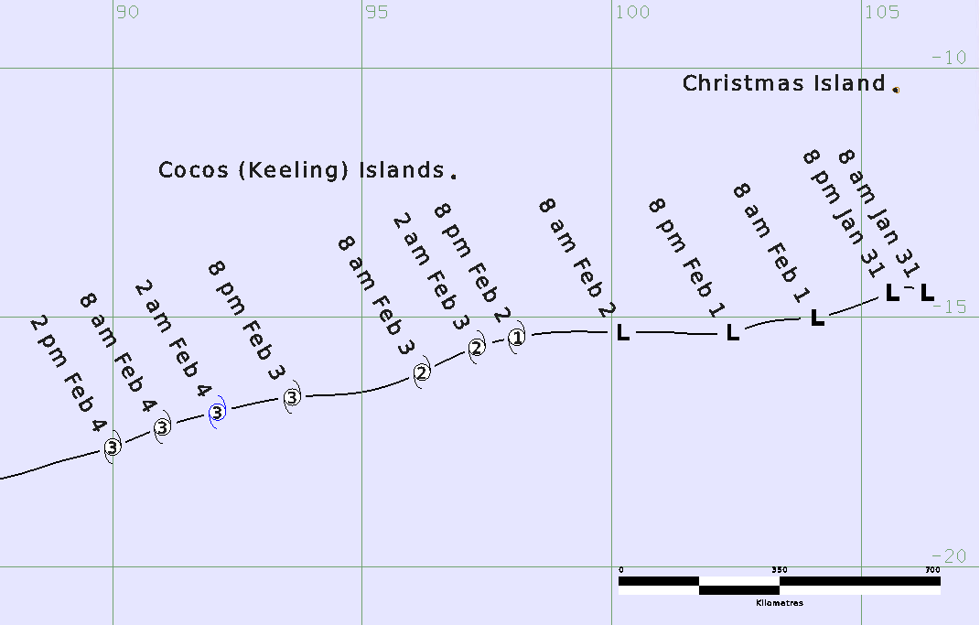

**Revision history**

|  |  |  |  |
| --- | --- | --- | --- |
| Date | Version | Author | Description |
| 02/04/2025 | 1.0 | Adam Conroy | Final draft |

**Review status**

|  |  |  |  |
| --- | --- | --- | --- |
| Date | Version | Reviewer | Description |
| 04/04/2025 | 1.0 | Linda Paterson | Completed |

**Release history**

|  |  |  |  |
| --- | --- | --- | --- |
| Date | Version | Status | Approval |
| 04/04/2025 | 1.0 | Approved for release | Andrew Burton |

Contact details:

Tropical Cyclone Team Lead

Severe Weather Environmental Prediction Services

Bureau of Meteorology

PO Box 1370, West Perth WA 6872

Email: [tcwc@bom.gov.au](mailto:tcwc@bom.gov.au)



This work is copyright. Apart from any use as permitted under the Copyright Act 1968, no part may be reproduced without prior written permission from the Bureau of Meteorology. Refer to www.bom.gov.au/other/copyright.shtml for further information. Unless otherwise noted, all images in this document are licensed under the Creative Commons Attribution Australia Licence.

© Commonwealth of Australia 2025

Published by the Bureau of Meteorology

Cover image: Track of Severe Tropical Cyclone Vince 2025. Times in AWST (UTC +8h)

Contents

1. Summary 5

2. Meteorological description 7

2.1. Intensity analysis 7

2.2. Structure 7

2.3. Motion 8

3. Impact 17

4. Observations 17

5. Forecast Performance 18

Appendix: List of abbreviations 20

**List of Figures**

Figure 1 Best track of Vince 31 January- 4 February 2025. Times in WST (UTC+8 hours) 5

Figure 2 Hovmoller diagram of tropical waves showing the formation of Vince (the cyclone symbol labelled 'V') occurred after a pulse of the MJO (black) moved through the region. 9

Figure 3 ASCAT-B pass at 0125 UTC 31 January 2025, near the time that tropical low 15U first formed (centre mark by a red cross). Image courtesy NRL. https://www.nrlmry.navy.mil/TC.html 10

Figure 4 OSCAT pass at 1727 UTC 1 February 2025, showing a well-defined circulation with a small area of gales in the southern quadrants. Image courtesy NRL. https://www.nrlmry.navy.mil/TC.html 11

Figure 5 SMOS image at 1130 UTC 2 February 2025, with gales in the southern semicircle, extending into the northwest quadrant. Image courtesy NRL. https://www.nrlmry.navy.mil/TC.html 12

Figure 6 Enhanced Infrared Himiwari-9 satellite imagery at 1200 UTC 2 February 2025, when 15U was estimated to first be at tropical cyclone intensity (centre mark by a cyan cross). Image courtesy NRL. https://www.nrlmry.navy.mil/TC.html 13

Figure 7 RCM-2 SAR pass at 2333 UTC 3 February, when Severe Tropical Cyclone Vince was at its peak intensity within the Australian region. Image courtesy NRL. https://www.nrlmry.navy.mil/TC.html 14

Figure 8 Visible Terra MODIS satellite imagery at 0342 UTC 4 February 2025 with a well-defined eye visible. Image courtesy NRL. https://www.nrlmry.navy.mil/TC.html 15

Figure 9 Intensity plot of objective and subjective guidance. SATCON, AiDT, NESDIS ADT, AMSU, SAR-RCM, ASCAT, CIMSS ADT, DMINT, DPRINT, Dvorak (subjective estimate), SMOS, operational analysis (red) and post event best track analysis (black). Objective Dvorak (ADT) and SAR-RCM have been adjusted from 1-minute to 10-minute maximum mean winds. 16

Figure 10 Position accuracy figures for Tropical Cyclone Vince. 19

Figure 11 Intensity accuracy figures for Tropical Cyclone Vince. 19

**List of Tables**

Table 1 Best track summary for Severe Tropical Cyclone Vince, 31 January-4 February 2025. 6

Table 2. Verification statistics for Tropical Cyclone Vince. 18

1. Summary

Severe Tropical Cyclone Vince (15U) was a long-lived event that tracked west-southwest across the Indian Ocean.

Tropical low 15U formed in the eastern Indian Ocean, northwest of the Western Australian coast and south of Christmas Island on 31 January. It gradually developed over following days as it steadily tracked over open waters to the west-southwest. Gales developed south of the centre late on 1 February and then extended around the remainder of centre at 1200 UTC 2 February (2000 WST 2 February, WST=UTC+8 hours). The system was named Tropical Cyclone Vince at 0000 UTC 3 February. Vince continued on its west-southwest track reaching category 3 intensity later on 3 February. Vince then crossed 90°E moving beyond the Australian region of responsibility. Vince continued to intensify over following days to become a very intense tropical cyclone on 6-8 February before turning to the south-southeast and gradually weakening over the central Indian Ocean.

Vince did not impact the Australian mainland or island communities.

Figure 1 shows the best track of Vince while Table 1 is a summary of the best track data.



Figure 1 Best track of Vince 31 January- 4 February 2025. Times in WST (UTC+8 hours)

|  |  |  |  |  |  |  |  |  |  |  |  |  |
| --- | --- | --- | --- | --- | --- | --- | --- | --- | --- | --- | --- | --- |
| Year | Month | Day | Hour UTC | Pos.  Lat. S | Pos. Long.E. | Pos. Acc. nm | Max Wind 10min kn | Max Gust kn | Cent. Press hPa | Rad. of gales  NE/SE/ SW/NW | Rad. of storm  NE/SE/ SW/NW | RMW  nm |
| 2025 | 1 | 31 | 0000 | 14.5 | 106.3 | 30 | 20 | 45 | 1000 | 0/0/0/0 | 0/0/0/0 | - |
| 2025 | 1 | 31 | 0600 | 14.4 | 105.9 | 25 | 20 | 45 | 1000 | 0/0/0/0 | 0/0/0/0 | - |
| 2025 | 1 | 31 | 1200 | 14.5 | 105.6 | 25 | 25 | 45 | 1000 | 0/0/0/0 | 0/0/0/0 | - |
| 2025 | 1 | 31 | 1800 | 14.7 | 105.1 | 20 | 25 | 45 | 1000 | 0/0/0/0 | 0/0/0/0 | - |
| 2025 | 2 | 1 | 0000 | 15.0 | 104.1 | 20 | 30 | 45 | 998 | 0/0/0/0 | 0/0/0/0 | - |
| 2025 | 2 | 1 | 0600 | 15.1 | 103.1 | 15 | 30 | 45 | 998 | 0/0/0/0 | 0/0/0/0 | - |
| 2025 | 2 | 1 | 1200 | 15.3 | 102.4 | 20 | 30 | 45 | 996 | 0/0/0/0 | 0/0/0/0 | - |
| 2025 | 2 | 1 | 1800 | 15.3 | 101.1 | 20 | 35* | 50 | 997 | 0/50/60/0 | 0/0/0/0 | - |
| 2025 | 2 | 2 | 0000 | 15.3 | 100.2 | 20 | 40* | 55 | 994 | 0/50/60/0 | 0/0/0/0 | - |
| 2025 | 2 | 2 | 0600 | 15.3 | 98.9 | 20 | 45* | 65 | 992 | 0/80/80/0 | 0/0/0/0 | - |
| 2025 | 2 | 2 | 1200 | 15.4 | 98.1 | 15 | 45 | 65 | 989 | 30/60/80/40 | 0/0/0/0 | 20 |
| 2025 | 2 | 2 | 1800 | 15.6 | 97.3 | 20 | 50 | 70 | 988 | 40/80/90/50 | 0/30/30/0 | 20 |
| 2025 | 2 | 3 | 0000 | 16.1 | 96.2 | 20 | 50 | 70 | 987 | 40/90/90/60 | 0/30/30/0 | 20 |
| 2025 | 2 | 3 | 0600 | 16.5 | 95.0 | 20 | 60 | 85 | 982 | 50/100/100/60 | 0/30/30/0 | 20 |
| 2025 | 2 | 3 | 1200 | 16.6 | 93.6 | 15 | 65 | 90 | 978 | 50/120/110/60 | 15/45/40/15 | 15 |
| 2025 | 2 | 3 | 1800 | 16.9 | 92.1 | 15 | 75 | 105 | 970 | 50/120/110/60 | 20/50/50/25 | 12 |
| 2025 | 2 | 4 | 0000 | 17.2 | 91.0 | 20 | 75 | 105 | 970 | 50/110/110/60 | 40/60/60/45 | 10 |
| 2025 | 2 | 4 | 0600 | 17.6 | 90.0 | 20 | 75 | 105 | 970 | 50/90/110/60 | 40/60/60/45 | 10 |

Table 1 Best track summary for Severe Tropical Cyclone Vince, 31 January-4 February 2025.

UTC=AWST-8h. * Not at tropical cyclone intensity as gales less than halfway around centre.

1. Meteorological description
   1. Intensity analysis

Tropical Low 15U formed on 31 January 2025, after an active phase of the Madden-Julian Oscillation moved through the eastern Indian Ocean (Figure 2).

Initially, 15U formed as a broad low pressure system, with the strongest winds being 20 kn (35 km/h) on the southern side (Figure 3). The stronger winds in the monsoonal flow to the northeast were separated from the system circulation.

Gales developed on the southern side of 15U at 1800 UTC 1 February. This occurred as deep convection moved over the centre and was aided by the synoptic easterly gradient to the south of 15U (Figure 4). Despite easterly shear inhibiting the development to an extent, the wind strength in the southern quadrants gradually increased, reaching 45 kn (85 km/h) by 0600 UTC 2 February.

By 1200 UTC 2 February, gales extended into the northern quadrants of 15U, and it became a tropical cyclone by the Australian definition (Figure 5 and Figure 6). Operationally, the gales to the north of the centre weren't analysed until 0000 UTC 3 February, which is when 15U was named Tropical Cyclone Vince. By this stage, post analysis has determined that Vince was already a category 2 system, with an intensity of 50 kn (95 km/h)

During 3 February and into the morning of 4 February, Vince intensified rapidly into a severe category 3 system, in response to increased divergence and outflow in the upper levels of the atmosphere. It reached its 10-minute mean wind peak intensity in the Australian region of 75 kn (150 km/h) at 1800 UTC 3 February (Figure 7), and a clear eye was visible on satellite imagery (Figure 8).

Severe Tropical Cyclone Vince moved into the La Reunion Area of Responsibility (west of 90°E) after 0600 UTC 4 February. According to analysis by La Reunion, Vince intensified further, reaching a peak intensity of 120 kn (220 km/h) at 1800 UTC 6 February. By 12 February it was no longer classified as a tropical cyclone, as it transitioned to an extra-tropical system.

Figure 9 shows a plot of various objective intensity aids for the time Vince was in the Australian region, along with the operational analysis track and post-event best track.

* 1. Structure

As Tropical Low 15U formed, the strongest winds were located on the southern side of the system, enhanced by both the easterly motion of the system and the synoptic gradient from a high pressure ridge to the south (Figure 4 and Figure 5). These asymmetries were maintained as the system developed, with larger gale, storm and hurricane radii on the southern side (gale and storm quadrant radii are detailed in Table 1). The inner core did become more symmetrical on 4 February as Vince reached high-end category 3 intensity (Figure 7).

The RMW for Vince decreased as the system intensified, from 20 nm (37 km) when first at tropical cyclone intensity on 2 February, to 10 nm (18 km) on 4 February.

* 1. Motion

From formation through until the time it left the Australian Area of Responsibility, Vince was steered in a steady west southwesterly direction due to a mid-level ridge located to the south of the system.

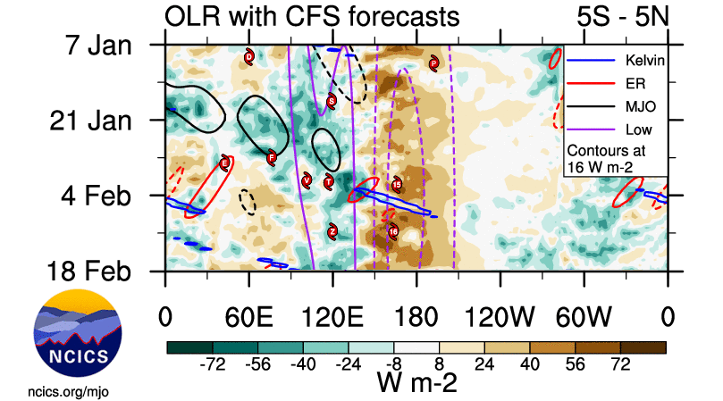

Figure 2 Hovmoller diagram of tropical waves showing the formation of Vince (the cyclone symbol labelled 'V') occurred after a pulse of the MJO (black) moved through the region.

The image is adapted from the original at <https://ncics.org/pub/mjo/archive/2025/2025-04-03/v2/> - courtesy of the North Carolina Institute for Climate

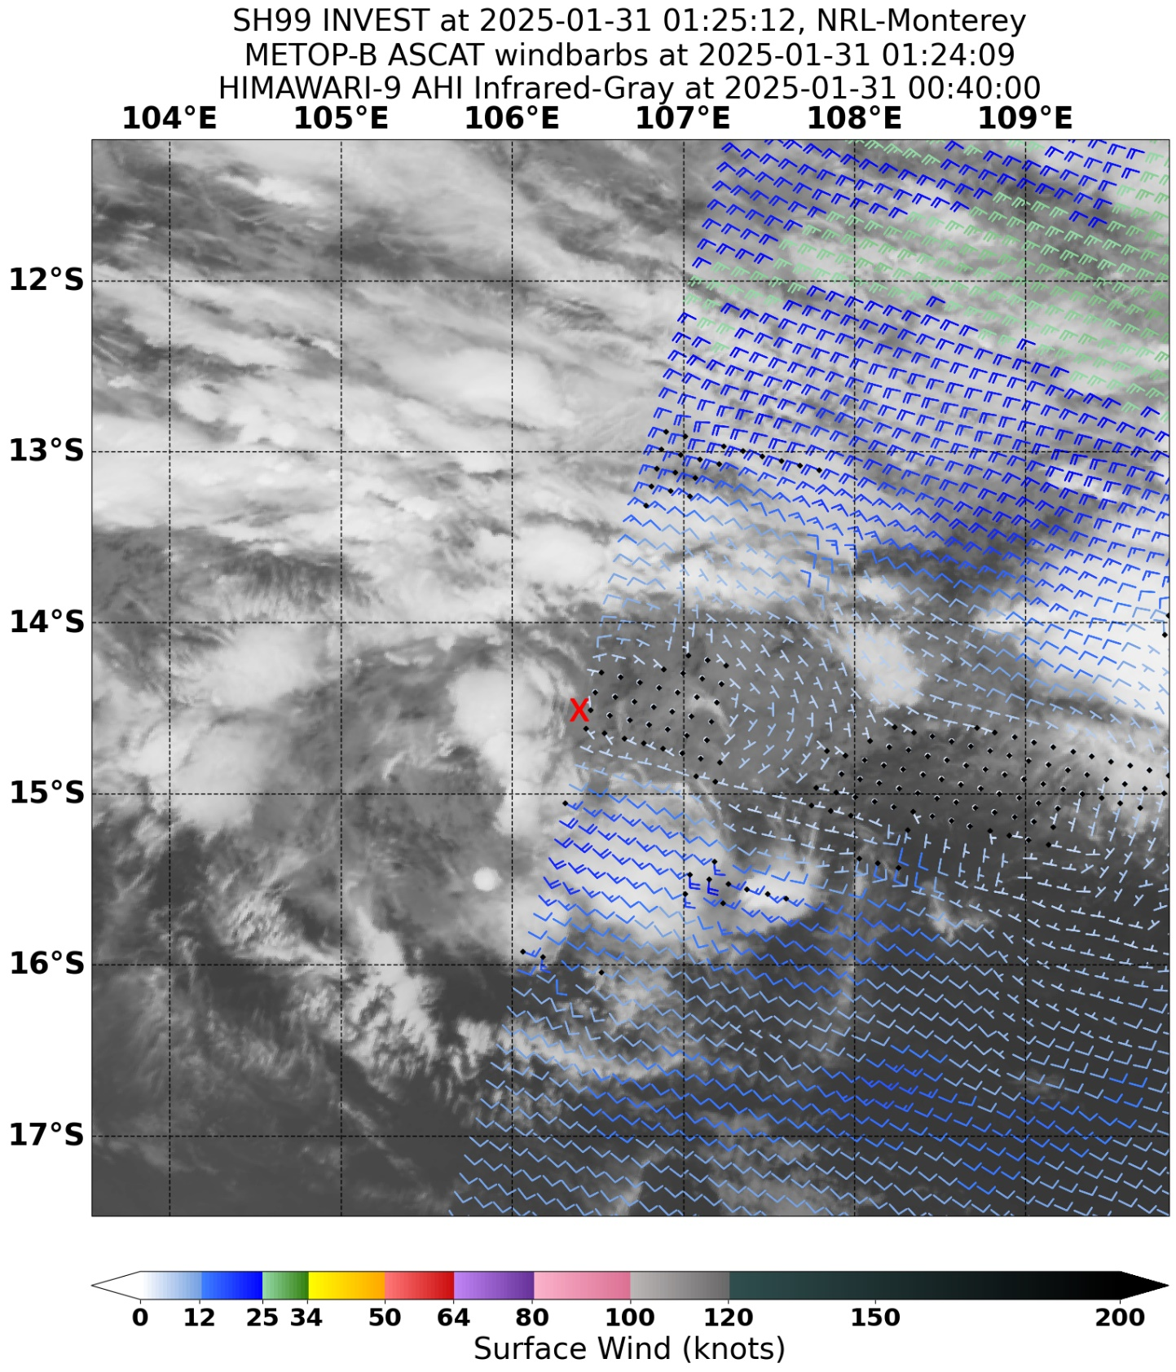

Figure 3 ASCAT-B pass at 0125 UTC 31 January 2025, near the time that tropical low 15U first formed (centre mark by a red cross). Image courtesy NRL. <https://www.nrlmry.navy.mil/TC.html>

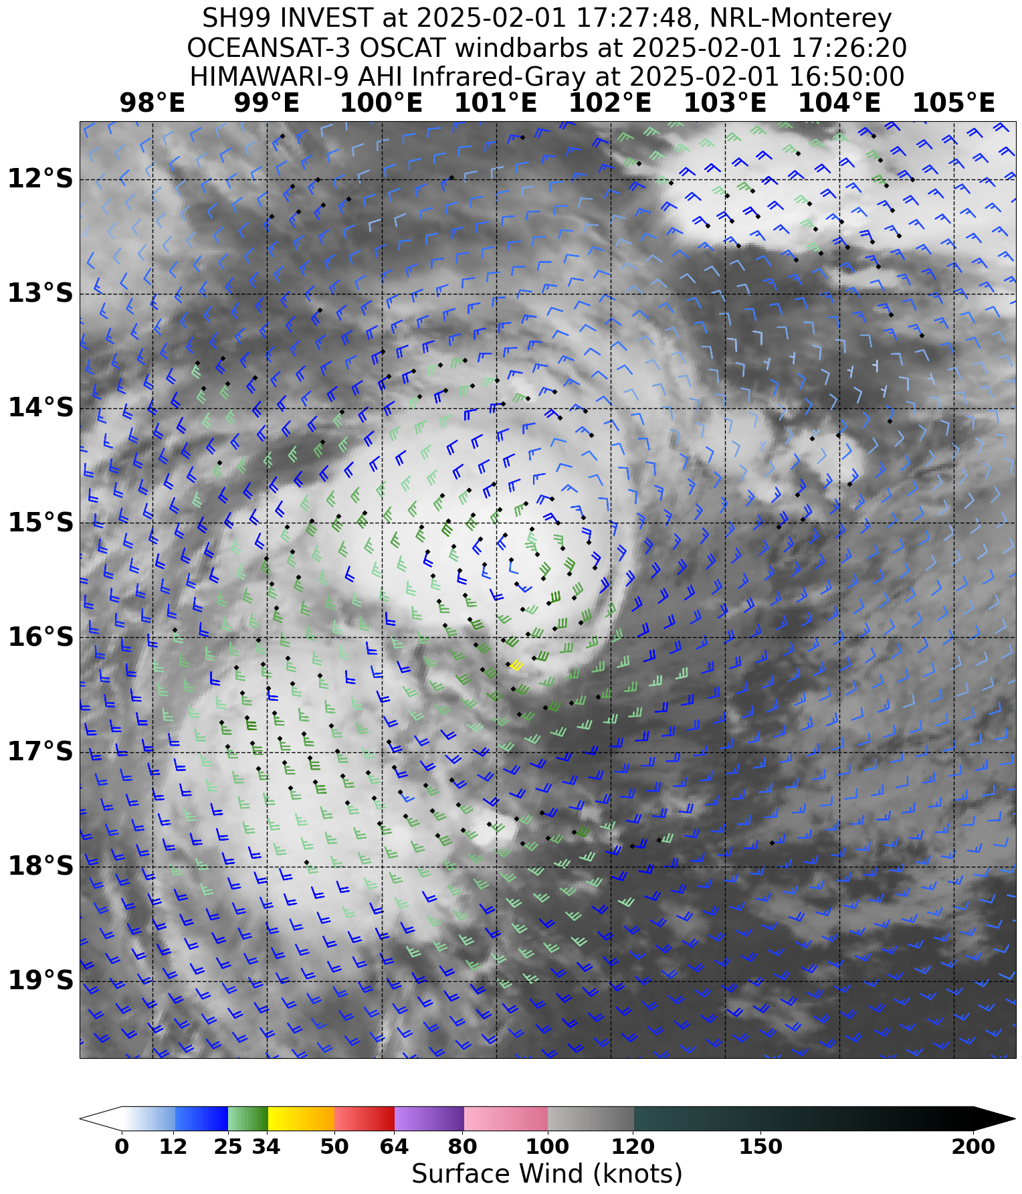

Figure 4 OSCAT pass at 1727 UTC 1 February 2025, showing a well-defined circulation with a small area of gales in the southern quadrants. Image courtesy NRL. <https://www.nrlmry.navy.mil/TC.html>

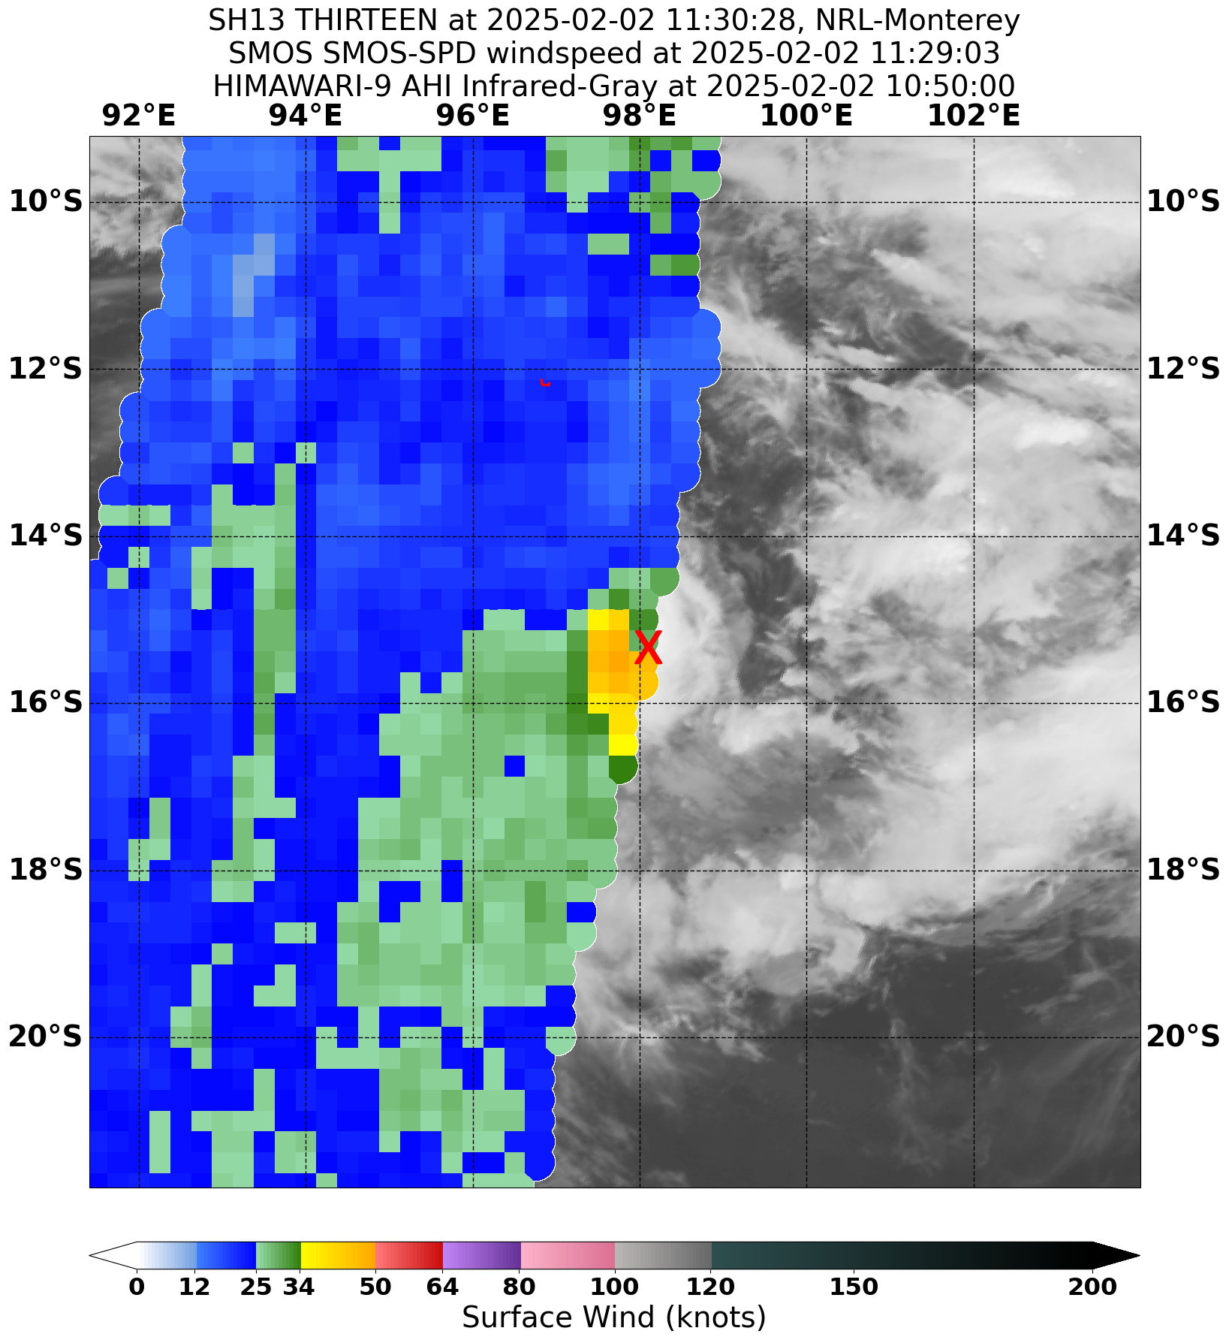

Figure 5 SMOS image at 1130 UTC 2 February 2025, with gales in the southern semicircle, extending into the northwest quadrant. Image courtesy NRL. <https://www.nrlmry.navy.mil/TC.html>

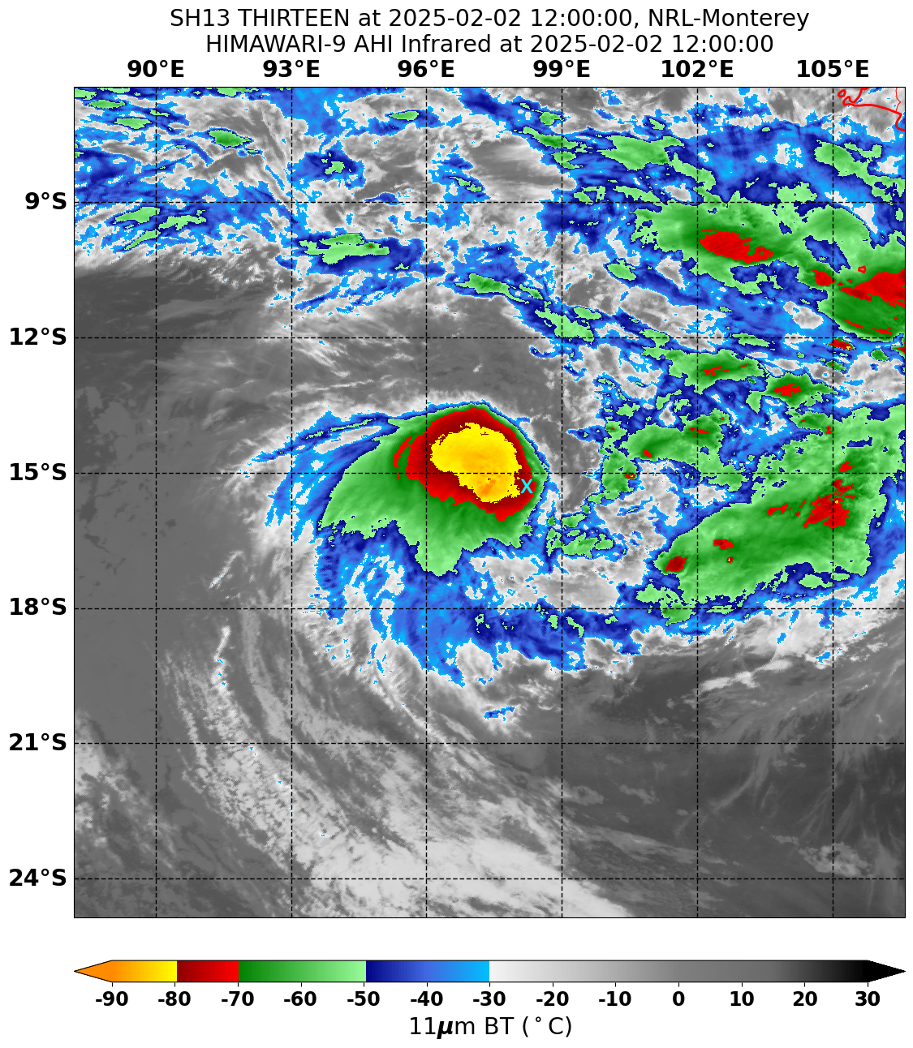

Figure 6 Enhanced Infrared Himiwari-9 satellite imagery at 1200 UTC 2 February 2025, when 15U was estimated to first be at tropical cyclone intensity (centre mark by a cyan cross). Image courtesy NRL. <https://www.nrlmry.navy.mil/TC.html>

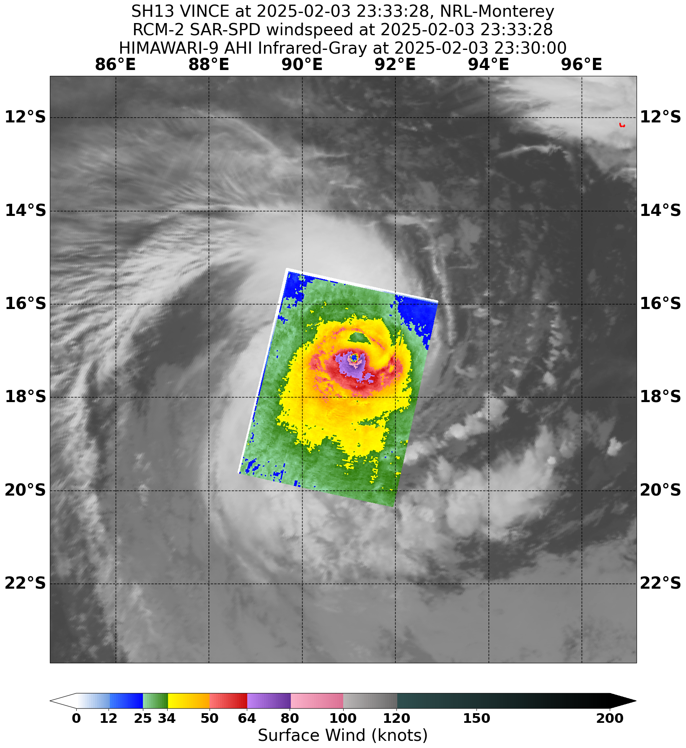

Figure 7 RCM-2 SAR pass at 2333 UTC 3 February, when Severe Tropical Cyclone Vince was at its peak intensity within the Australian region. Image courtesy NRL. <https://www.nrlmry.navy.mil/TC.html>

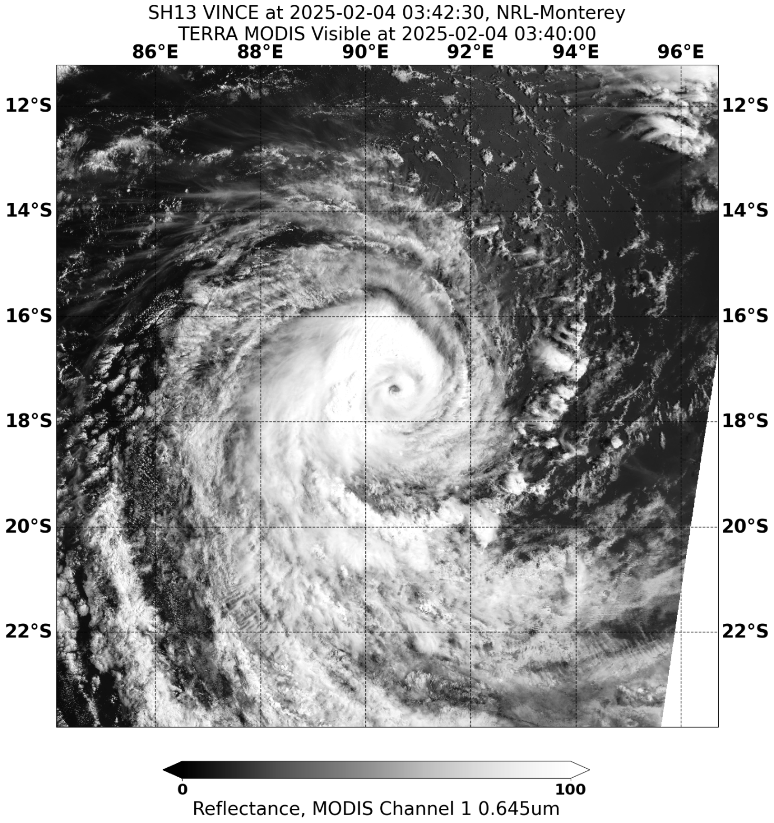

Figure 8 Visible Terra MODIS satellite imagery at 0342 UTC 4 February 2025 with a well-defined eye visible. Image courtesy NRL. <https://www.nrlmry.navy.mil/TC.html>

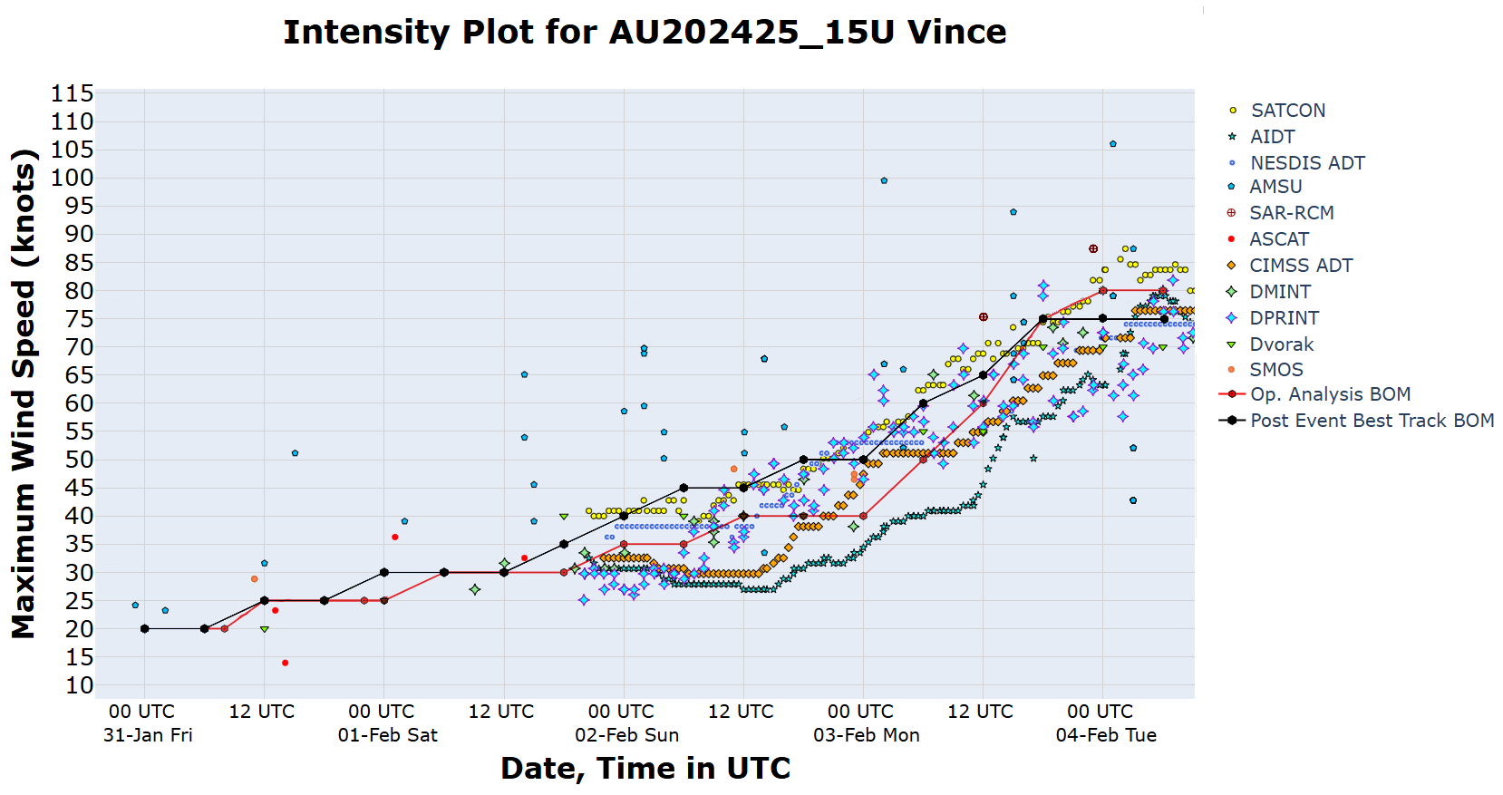

Figure 9 Intensity plot of objective and subjective guidance. SATCON, AiDT, NESDIS ADT, AMSU, SAR-RCM, ASCAT, CIMSS ADT, DMINT, DPRINT, Dvorak (subjective estimate), SMOS, operational analysis (red) and post event best track analysis (black). Objective Dvorak (ADT) and SAR-RCM have been adjusted from 1-minute to 10-minute maximum mean winds.

1. Impact

There were no impacts from Tropical Cyclone Vince on the Australian mainland or the Indian Ocean island territories.

1. Observations

Nil.

1. Forecast Performance

The accuracy statistics for Tropical Cyclone Vince are below in Table 2 and shown in Figure 10 and Figure 11.

The forecast track position accuracy was close to the 5-year average for all forecast lead times up to 72 hours. There were no forecast positions for the 96-hour and 120-hour lead times.

With little variation in the steering flow direction while Vince was in the Australian region, good performance in position forecasting would be expected. The main source of error was from the forecast positions generally being a little faster and further to the south than the observed track.

The intensity accuracy was poor compared to the 5-year average at the analysis time and at all forecast lead times.

Vince intensified much quicker than forecast at all time steps due to it developing rapidly in a favourable environment. Model guidance was both poor at analysing the current intensity as well as forecasting intensification. Additionally, the analysis intensity was generally lower than post event analysis revealed, due to objective guidance and Dvorak analysis giving lower values than were later analysed.

The first 7 Day Tropical Cyclone Forecast for 15U was issued on the morning of 27 January, with the system rated a Low (10%) chance of developing into a tropical cyclone from 0000 UTC 1 February, increasing to a Moderate (25%) chance from 0000 UTC 3 February. The development risk was increased on the afternoon issue of 30 January, with the system rated a Moderate (25%) chance from 0000 UTC 1 February, increasing to a High (55%) chance from 1200 UTC 2 February.

Ocean Wind Warnings were issued from 0700 UTC 1 February, Forecast Track Maps were issued from 1900 UTC 2 February, and the first Tropical Cyclone Information Bulletin was issued at 0100 UTC 2 February. The final issue of these products was at 0700 UTC 4 February, as Vince moved into La Reunion's Area of Responsibility.

|  |  |  |  |  |  |  |  |  |
| --- | --- | --- | --- | --- | --- | --- | --- | --- |
| Time | 00 | 06 | 12 | 18 | 24 | 36 | 48 | 72 |
| Position accuracy (km) | 23 | 42 | 59 | 68 | 78 | 105 | 124 | 180 |
| Intensity accuracy (knots) | 6.8 | 8.2 | 10.9 | 11.4 | 11.4 | 13.0 | 17.5 | 17.5 |
| Sample size | 11 | 11 | 11 | 11 | 11 | 10 | 8 | 4 |

Table 2. Verification statistics for Tropical Cyclone Vince.

* Note, verification is performed using the Official Forecast Tracks at the standard times of 00, 06,12 and 18 UTC.

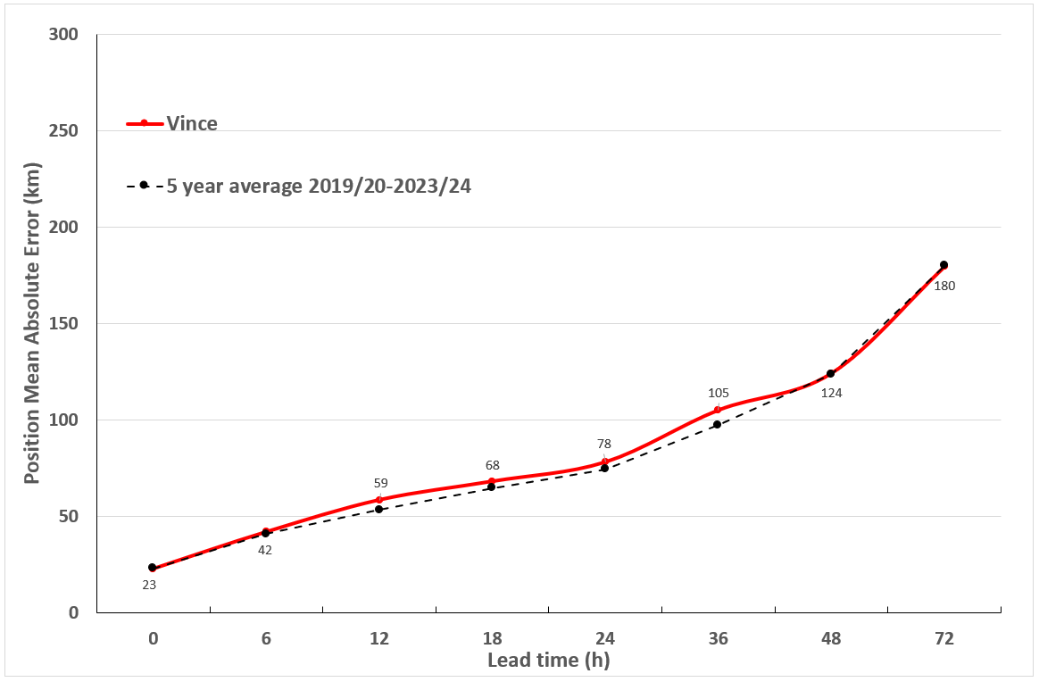

Figure 10 Position accuracy figures for Tropical Cyclone Vince.

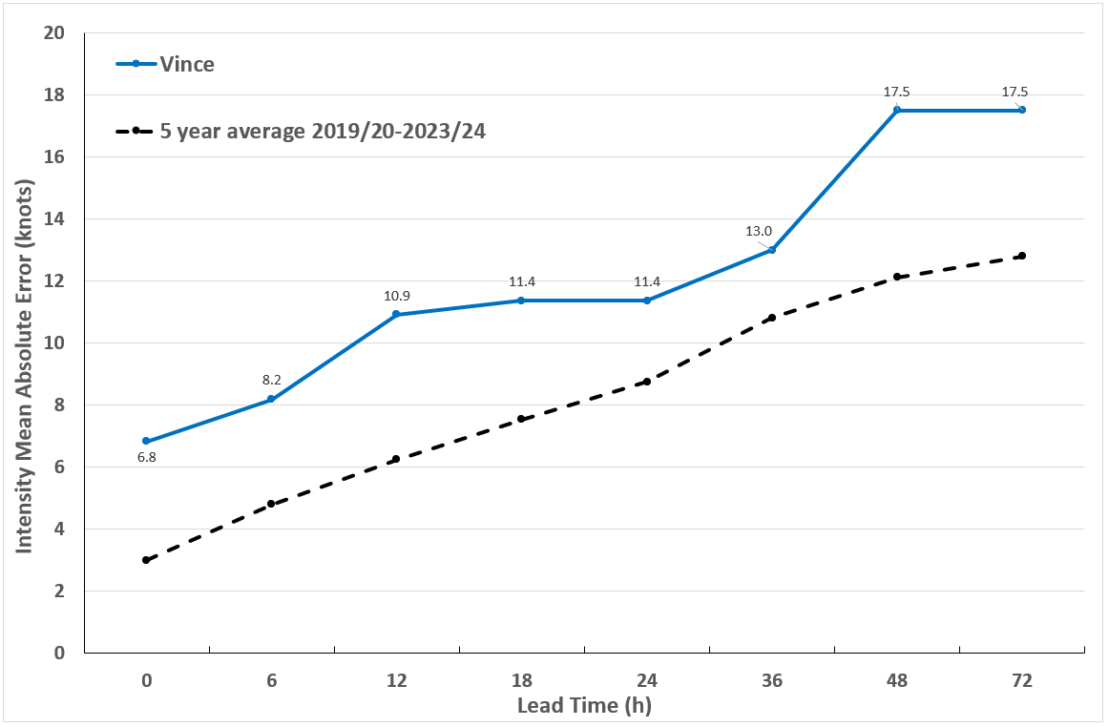

Figure 11 Intensity accuracy figures for Tropical Cyclone Vince.

Appendix: List of abbreviations

|  |  |
| --- | --- |
| Abbreviation | Term |
| ADT | Advanced Dvorak Technique |
| ACST | Australian Central Standard Time |
| AEST | Australian Eastern Standard Time |
| AiDT | AI-enhanced Dvorak Technique |
| AMSR2 | Advanced Microwave Scanning Radiometer |
| AMSU | Advanced Microwave Sounding Unit |
| ASCAT | Advanced Scatterometer |
| ATMS | Advanced Technology Microwave Sounder |
| AWS | automatic weather station |
| AWST | Australian Western Standard Time |
| °C | Celsius |
| CI | Current intensity |
| CIMSS | Cooperative Institute for Meteorological Satellite Studies (USA) |
| CIRA | Cooperative Institute for Research in the Atmosphere (USA) |
| D-MINT | Deep learning - Multispectral Intensity of TCs (formerly known as DMN) |
| D-PRINT | Deep learning - IR Intensity of TCs (formerly known as OPEN-AIIR) |
| EIR | Enhanced InfraRed |
| ERC | eyewall replacement cycle |
| FNMOC | Fleet Numerical Meteorology and Oceanography Centre (USA) |
| FT | Final T-number |
| GCOM | Global Change Observation Mission |
| GHz | Gigahertz |
| GMI | Global Precipitation Measurement Microwave Imager |
| h | hour |
| hPa | hectopascal |
| HSCAT | Hai Yang 2 Scatterometer (HY-2B, HY-2C) |
| km | kilometres |
| km/h | kilometres per hour |
| kn | knot |
| LLCC | LLCC |
| MET | Model Expected T-number |
| METOP | Meteorological Operational Satellite |
| MJO | Madden-Julian Oscillation |
| mm | millimetres |
| MSLP | mean sea level pressure |
| NESDIS | National Environmental Satellite, Data, and Information Service |
| nm | nautical mile |
| NOAA | National Oceanic and Atmospheric Administration |
| NRL | Navy Research Lab (USA) |
| OPEN-AiiR | Ordered Pattern Encoding AI Infrared |
| PAT | Pattern T-number |
| RCM | RadarSat Constellation Mission – Synthetic Aperture Radar |
| RH | relative humidity |
| RMW | radius of maximum winds |
| RSMC | Regional Specialised Meteorological Centre |
| SAR | Synthetic Aperture Radar |
| SATC | CIMSS Advanced Dvorak Technique |
| SATCON | Satellite Consensus |
| SEN1 | Sentinel-1A – Synthetic Aperture Radar |
| SMAP | Soil Moisture Active Passive |
| SMOS | Soil Moisture and Ocean Salinity |
| SSMIS | Special Sensor Microwave Imager/Sounder |
| TC | Tropical Cyclone |
| TCWC | Tropical Cyclone Warning Centre |
| UTC | Universal Time Co-ordinated |