Tropical Cyclone Wanda

21 – 25 January 1974

Queensland Regional Office
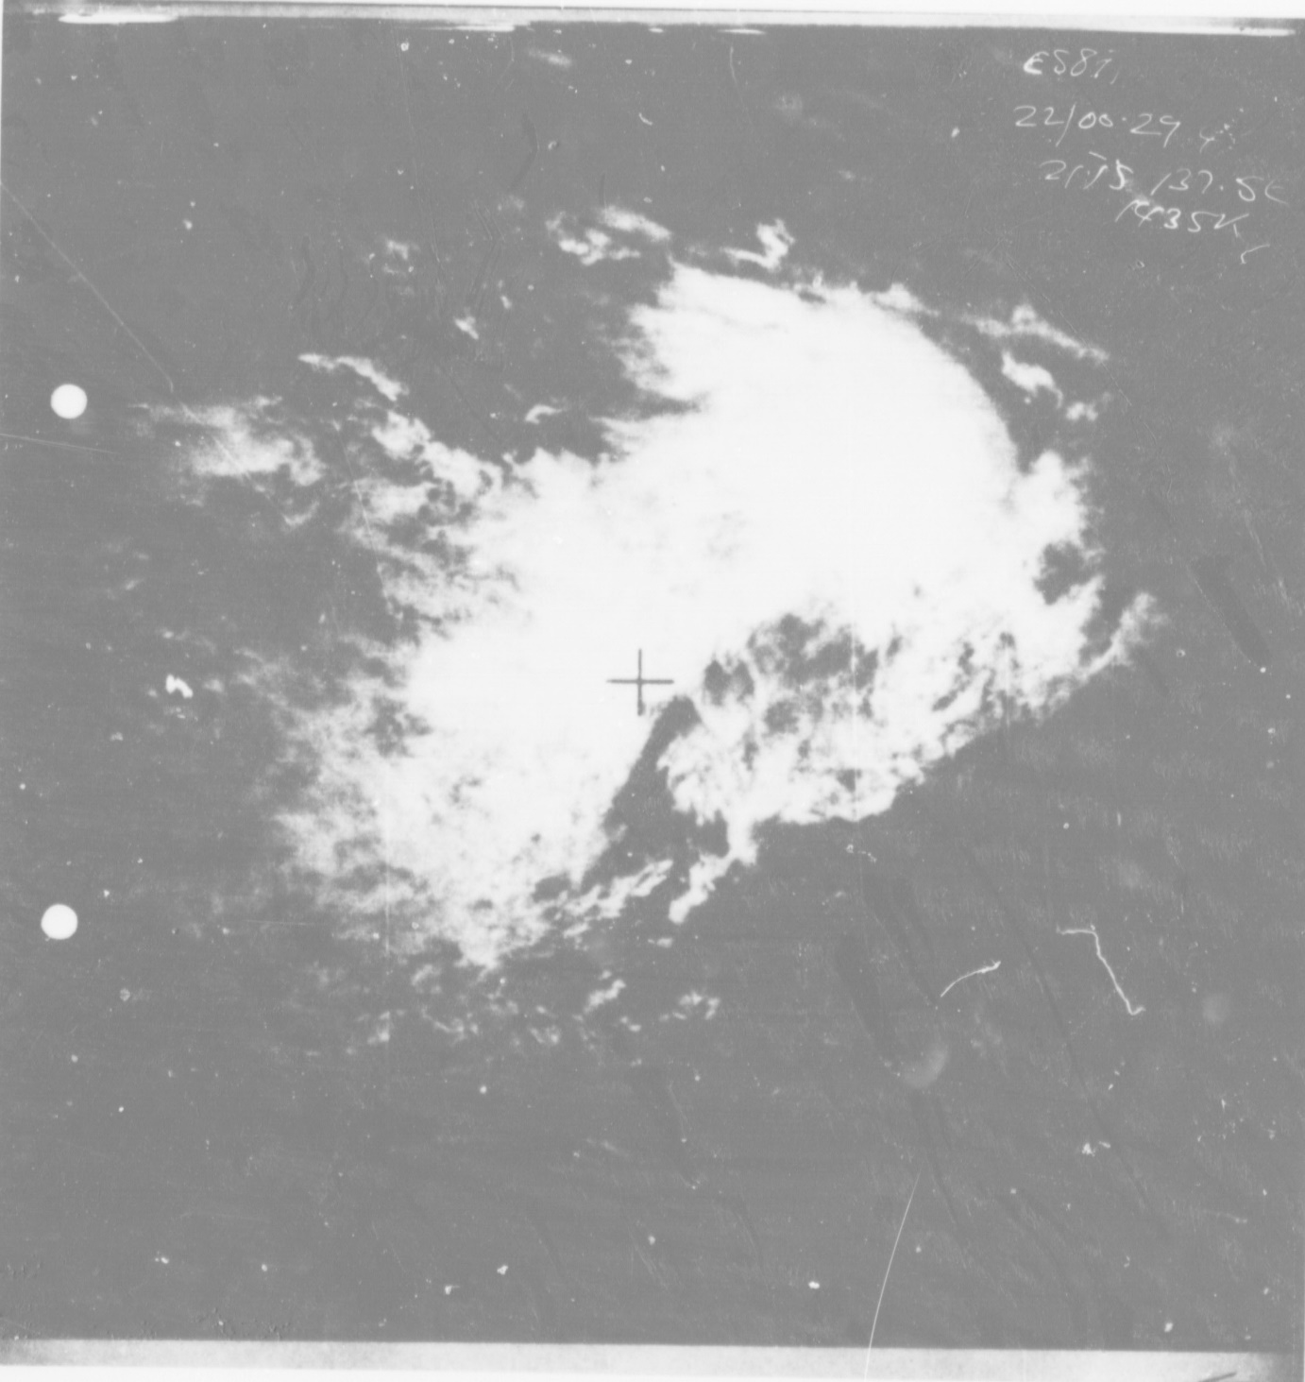

Revision history
Date | Version | Author | Description
9/5/2025 | 1.0 | Chris Mathews / Tony Wedd | Converted original document to word format

Review status
Date | Version | Reviewer | Description
15/5/2025 | 1.0 | Linda Paterson

Release history
Date | Version | Status | Approval
15/5/2025 | 1.0 | Approved for release | Andrew Burton

Contact details:
Tropical Cyclone Team Lead
Severe Weather Environmental Prediction Services
Bureau of Meteorology
PO Box 1370, West Perth WA 6872
Email: tcwc@bom.gov.au

This work is copyright. Apart from any use as permitted under the Copyright Act 1968, no part may be reproduced without prior written permission from the Bureau of Meteorology. Refer to www.bom.gov.au/other/copyright.shtml for further information. Unless otherwise noted, all images in this document are licensed under the Creative Commons Attribution Australia Licence.
© Commonwealth of Australia 2025
Published by the Bureau of Meteorology
Cover image: An old satellite image of Tropical Cyclone Wanda.
Note to readers
This report is a digitisation of the original report on Tropical Cyclone Wanda, published by the Bureau of Meteorology soon after the cyclone in 1974. The text and figures have been reproduced as they appeared in the original report. As a result, readers may note differences in the language, style, format, and units used in this report compared to more recent tropical cyclone reports.

Contents

1. Introduction 5

2. Development 7

2.1. Surface Considerations 7

2.2. Satellite Considerations 16

2.3. Microseisms 18

2.4. Sferics 18

2.5. Upper Air Considerations 18

3. Features of the Track 32

3.1. Surface 32

3.2. Upper Air 32

3.3. Radar 33

4. Observations 37

4.1. Rainfall 37

4.2. Flooding and Flood Damage 38

4.3. Wind and Wind Damage 39

4.4. Storm Surge 39

4.5. Seas and Swell 39

5. Appendix: List of abbreviations 42

- Introduction
Tropical Cyclone “Wanda” formed initially as a wave low on the ITCZ to the southwest of Willis Island on 20th January 1974 in the wake of tropical cyclone “Vera” which had moved steadily away from the region during the previous few days. This wave low gradually developed while moving on an east-southeast track away from the Queensland coast. On January 23rd it veered onto a south-southwest track while slowly deepening, and eventually crossed the coast just north of Double Island Point between 240600 GMT and 241100 GMT. Its central pressure at that time was 997 mb and at no stage did the central eye mechanism fully develop to the mature cyclone category.
After crossing the coast, “Wanda” weakened rapidly to a rain depression, and at 250200 GMT, was centred just north of Dalby. The flood rains which followed were to prove the most disastrous the Moreton region had experienced this century.
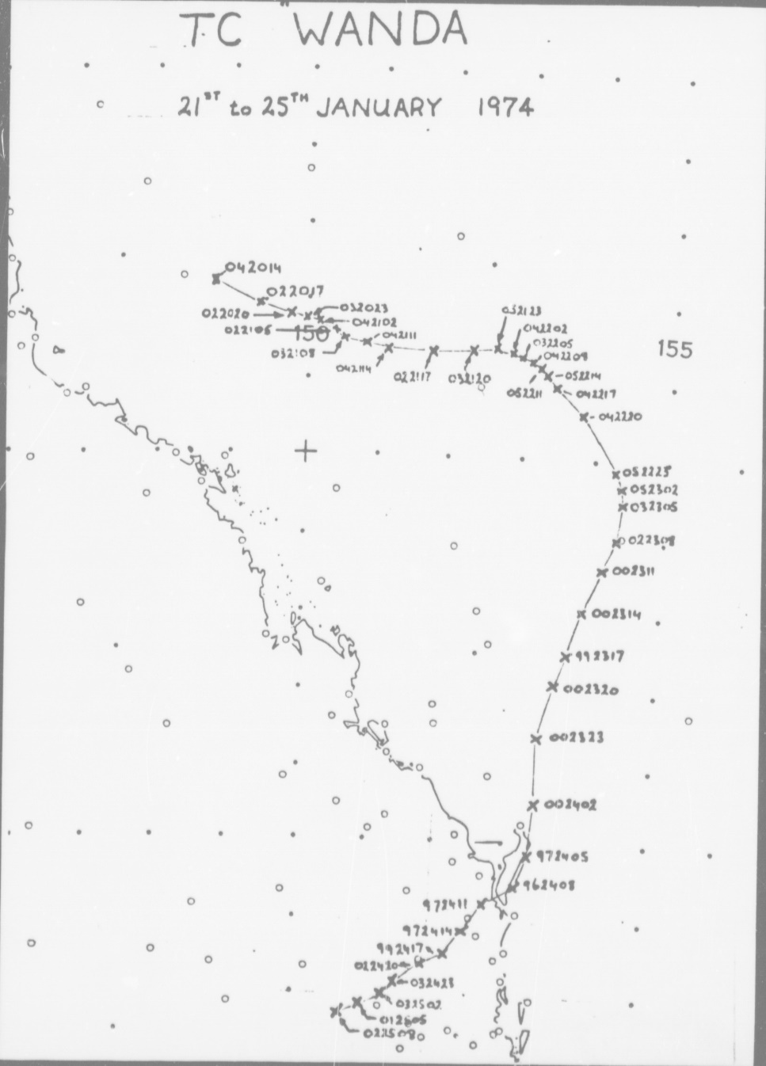
Figure 1. Track of Tropical Cyclone "Wanda". Code indicates central pressure, date, and GMT time (two digits each). For example, the first point 040214 should be read as 1004 hPa on 20 January at 14 GMT.
.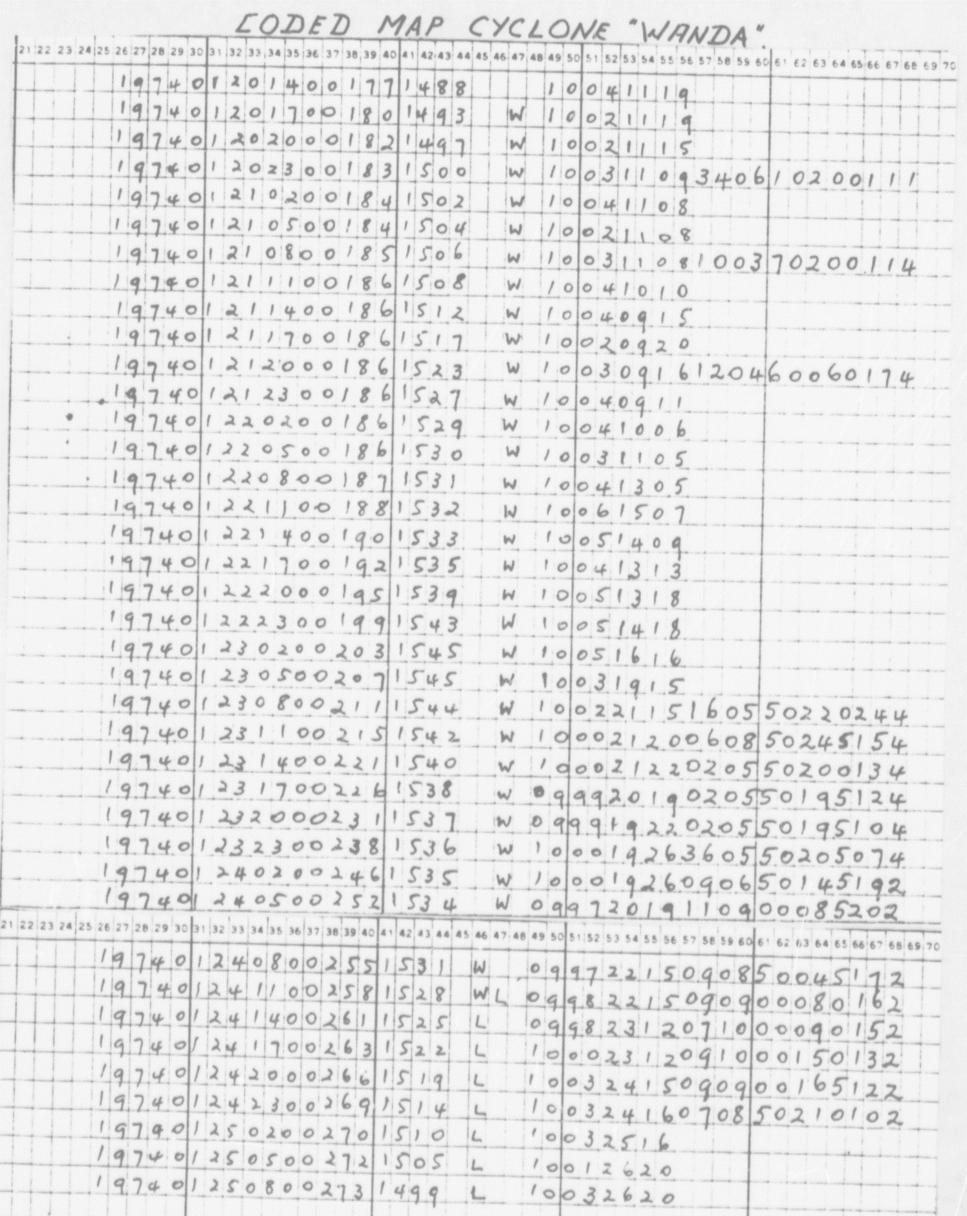
Figure 2. Track summary for Tropical Cyclone "Wanda", 21st - 25th January 1974. This data is reproduced as it appeared in the original report, for a complete listing of data in a more accessible format see the Bureau's tropical cyclone database http://www.bom.gov.au/cyclone/tropical-cyclone-knowledge-centre/databases/
- Development
  - Surface Considerations

The first indications of a low on the ITCZ appeared in the vicinity of Flinders Reef on the midnight chart of January 20th (Figure 3). At this time tropical cyclone “Vera” was centred some 1300 km to the southeast and moving on a southeast track. By 202300 GMT, a 1003 mb centre was clearly defined on the ITCZ just over 200 km to the south of Willis Island (Figure 4). The ship ‘SANJURU PIONEER” reported a northwest wind of 65 km/h approximately 200 km east of the centre at 210000 GMT. To the west of the low the ITCZ crossed the Queensland coast just north of Innisfail and marked the northern limit of the coastal ridge extending from a 1013 mb high located southwest of Lord Howe Island.

By 212300 GMT, the low had drifted east-southeastward with little change in intensity, while “Vera” was crossing waters to the south of New Caledonia (Figure 5). The ridge had persisted along the Queensland coast with the high maintaining a constant central pressure.

By 222300 GMT, the low, with a central pressure of 1005 mb, had become organised while still moving east-southeastward (Figure 6). The ITCZ had now drifted to the south of Innisfail. During the afternoon of the 23rd, pressures along the Queensland coast began to fall and the low changed its direction of movement from east-southeastward to southward. At 231100 GMT, the low veered south-southwestward with the central pressure falling to 1000 mb (Figure 7). Strong easterly winds had developed along the coast between Gladstone and Cape Moreton and a high, which had strengthened to the west of Tasmania, had by this time moved into the southwest Tasman Sea.

During the following 12 hours, “Wanda” continued on a south-southwest track and, at 232300 GMT, was centred 220 km east of Gladstone with central pressure 1000 mb (Figure 8). The high in the Tasman Sea had progressed further east and a strong easterly stream was affecting coastal areas between Sandy Cape and Byron Bay. A gale of 69 km/h was reported from Double Island Point. The pressure gradient between “Wanda” and the Tasman Sea high increased during the afternoon, causing easterly winds to 75 km/h from Double Island Point to Byron Bay.

Shortly after 240800 GMT “Wanda”, with a central pressure below 998 mb, moved inland just north of Double Island Point (Figure 9). The wind at Double Island Point at 240800 GMT was easterly 83 km/h and mean sea level pressure 998.3 mb. During the night, as “Wanda” drifted on a more southwest track, winds along the coast reached their strongest between Tewantin and Byron Bay. 93 km/h easterly winds were reported from both Tewantin and Caloundra at 241100 GMT; a 104 km/h easterly was recorded at Cape Moreton at 241700 GMT.

By 242300 GMT, “Wanda” had weakened and, with a central pressure of 1003 mb, was centred just north of Dalby (Figure 10). It had ceased to be a tropical cyclone. However, gales were to continue between Caloundra and Byron Bay until 262000 GMT.

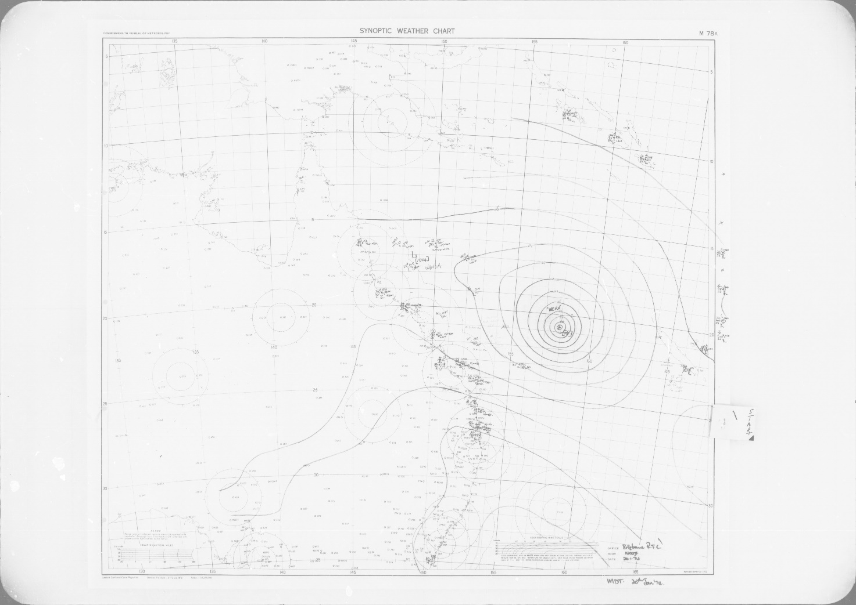
Figure 3. Surface chart at 14 GMT January 20, 1974 (12am AEST January 21, 1974), showing Tropical Cyclone Vera off the Queensland coast, with the precursor low to Tropical Cyclone Wanda to its northwest.

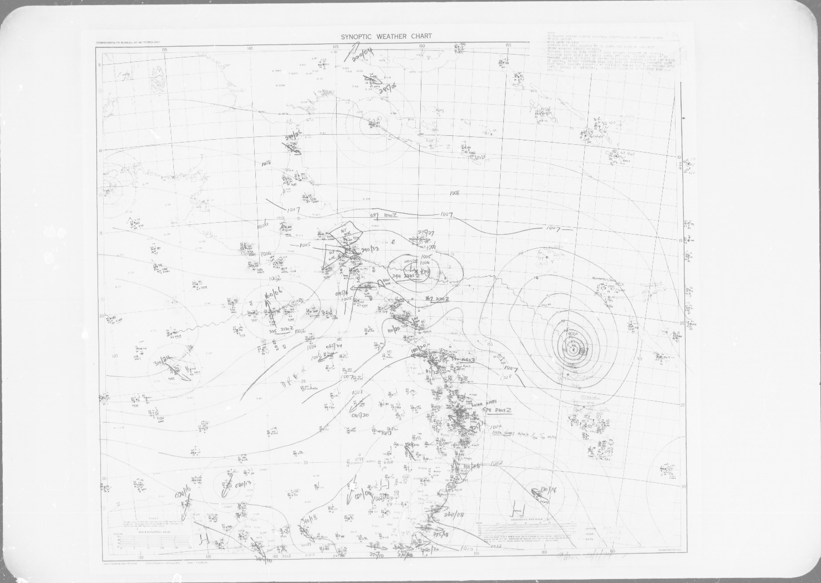
Figure 4. As Figure 3, but surface chart at 23 GMT January 20, 1974 (9am AEST January 21, 1974).

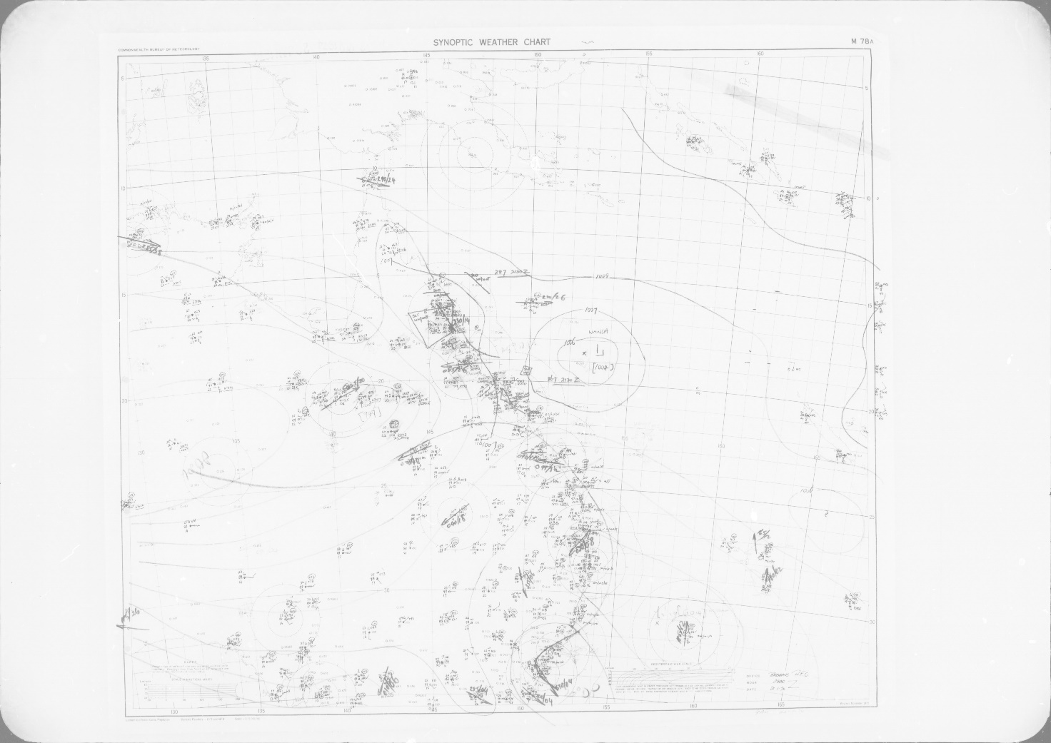
Figure 5. Surface chart at 23 GMT January 21, 1974 (9am AEST January 22, 1974).

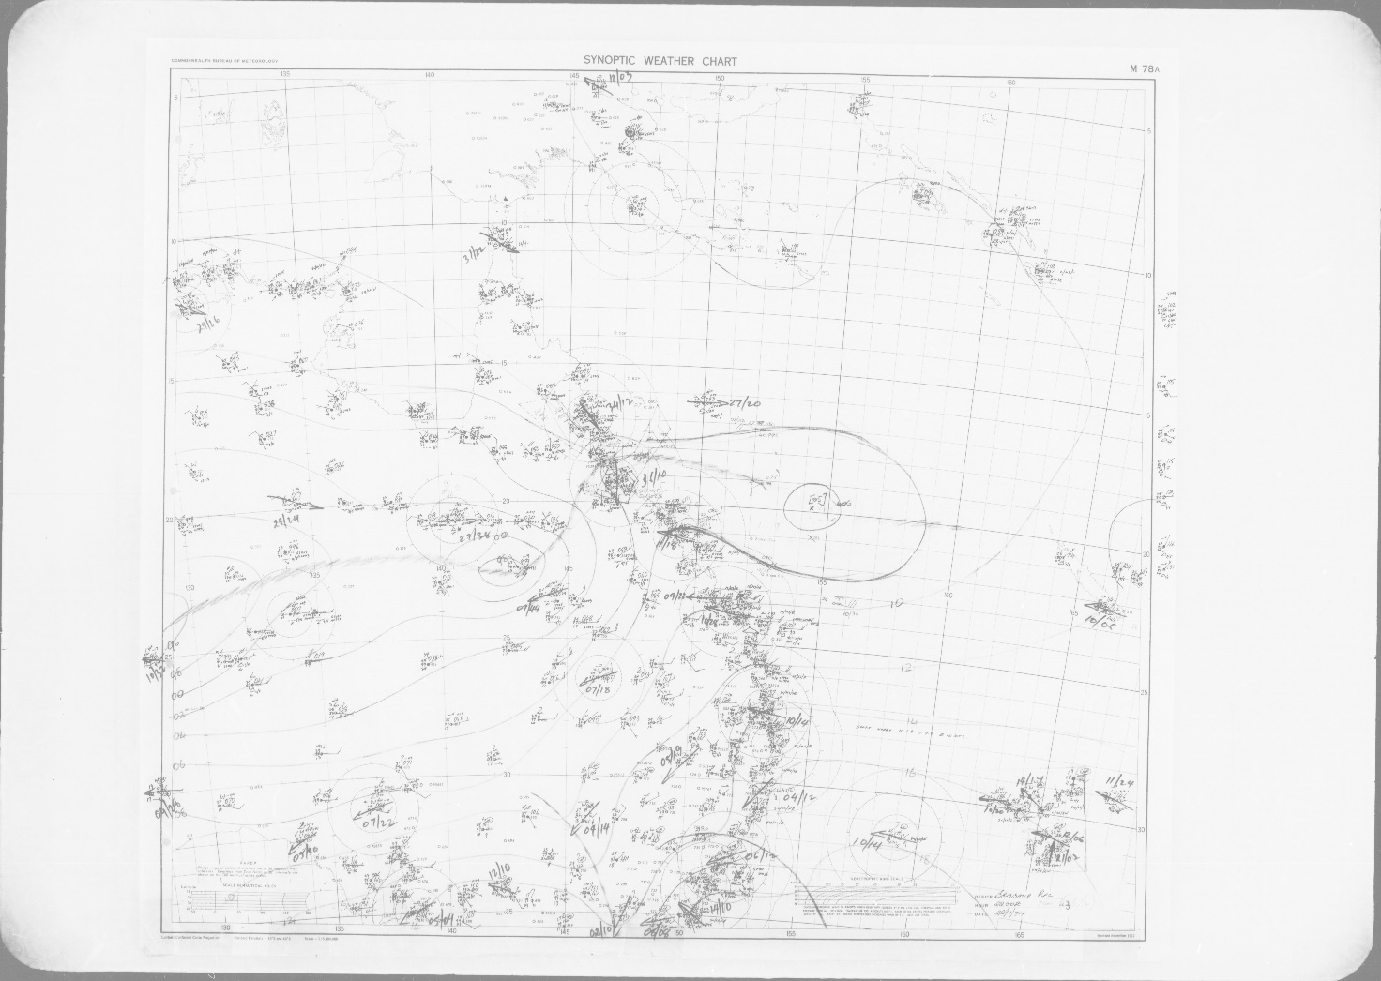
Figure 6. Surface chart at 23 GMT January 22, 1974 (9am AEST January 23, 1974).

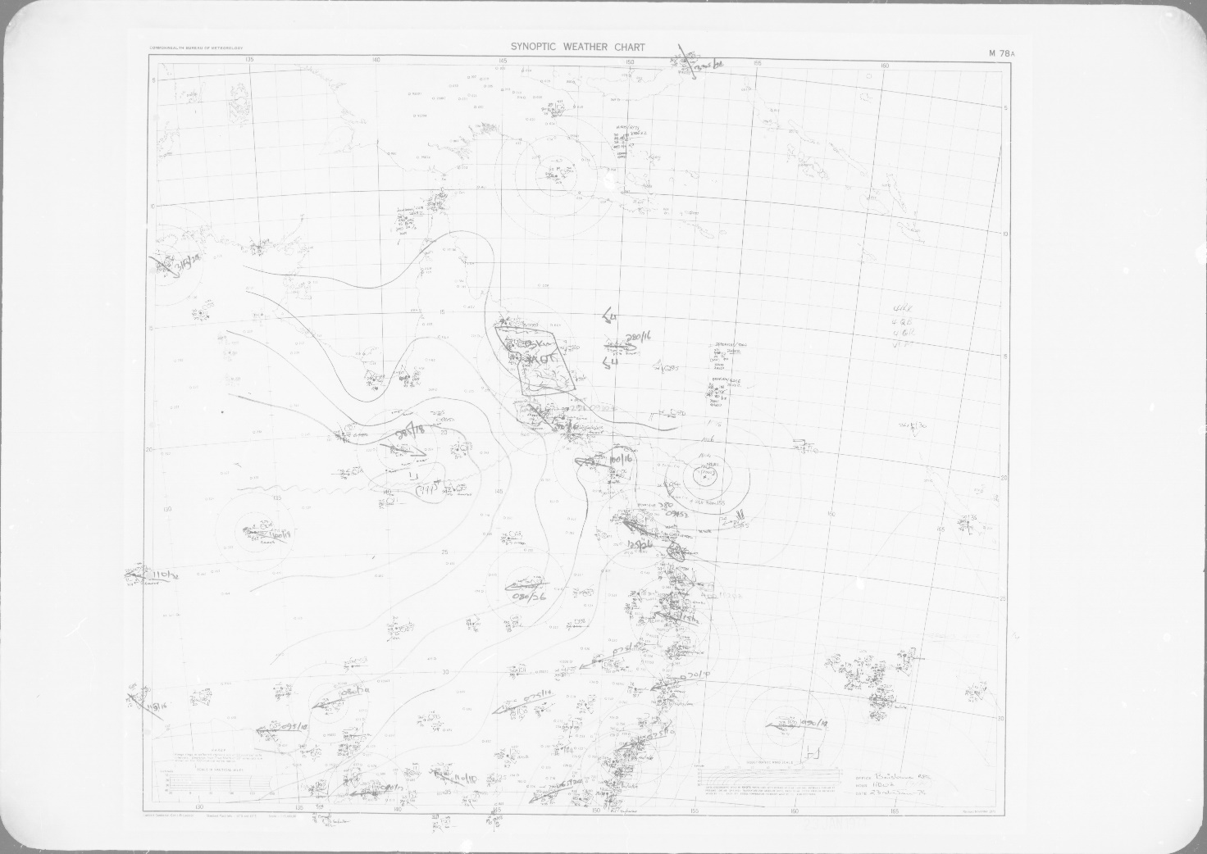
Figure 7. Surface chart at 11 GMT (9pm AEST) January 23, 1974.

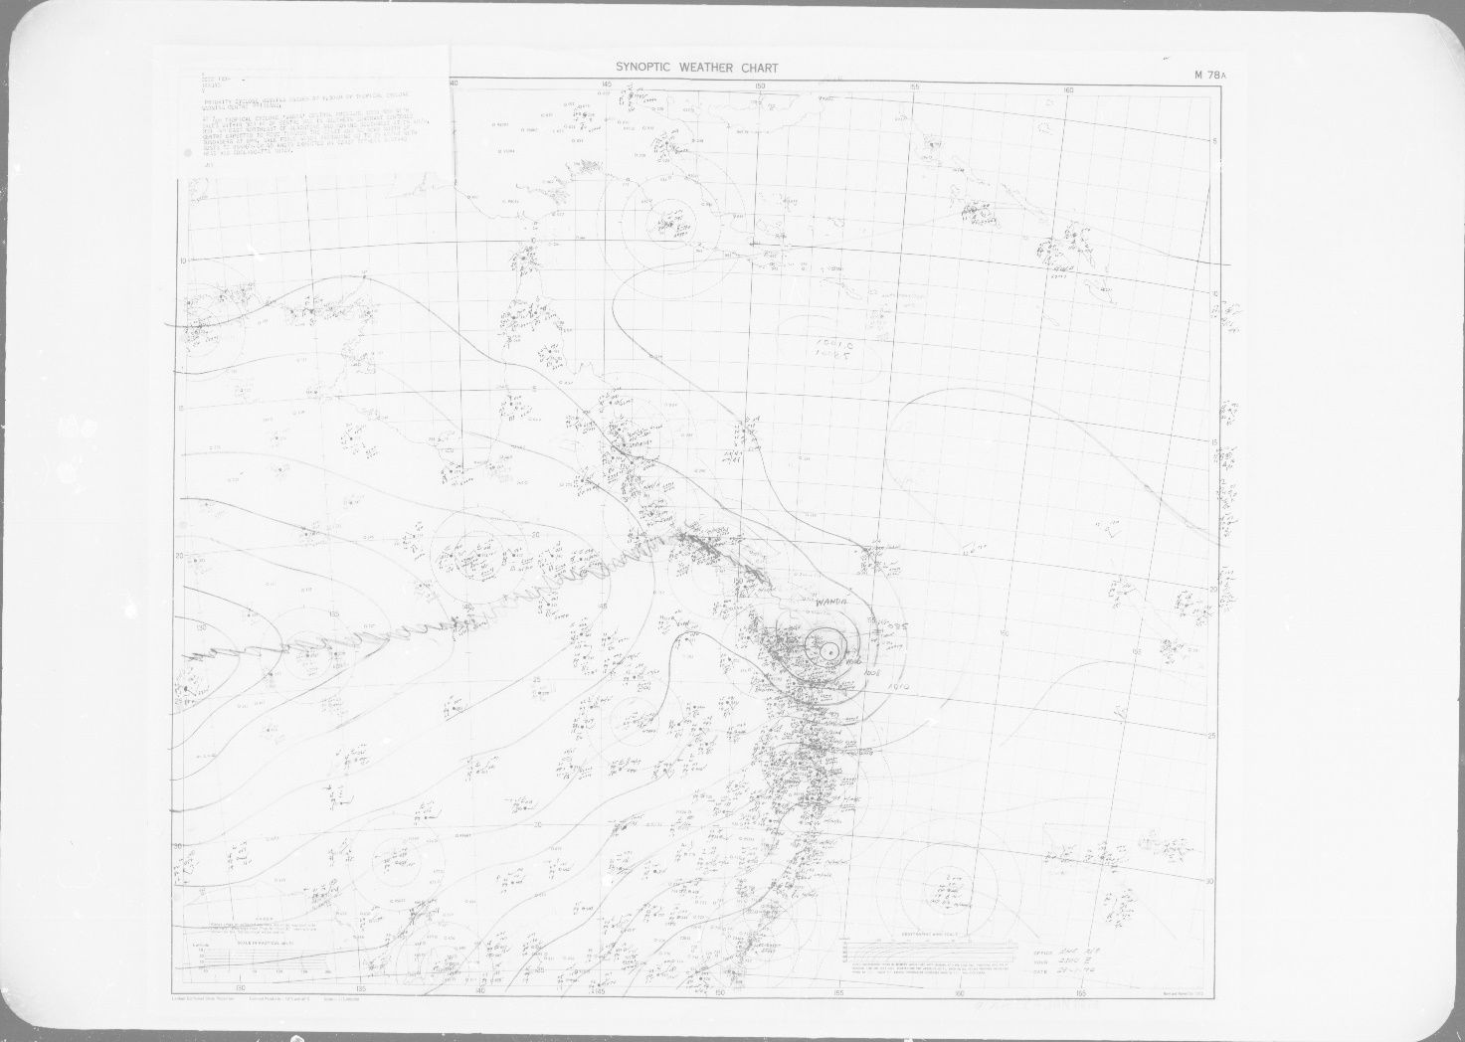
Figure 8. Surface chart at 23 GMT January 23, 1974 (9am AEST January 24, 1974).

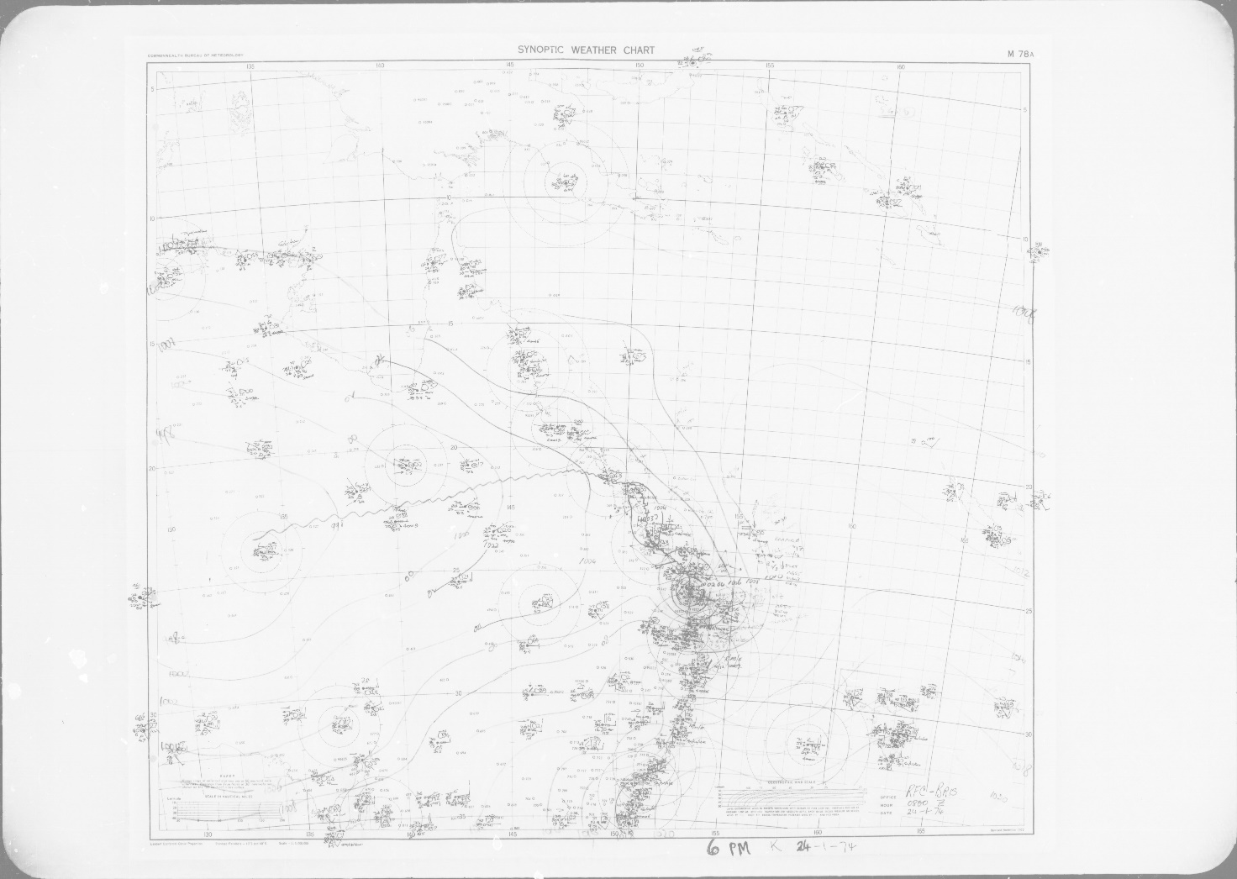
Figure 9. Surface chart at 8 GMT (6pm AEST) January 24, 1974, showing Tropical Cyclone Wanda making landfall just north of Double Island Point.

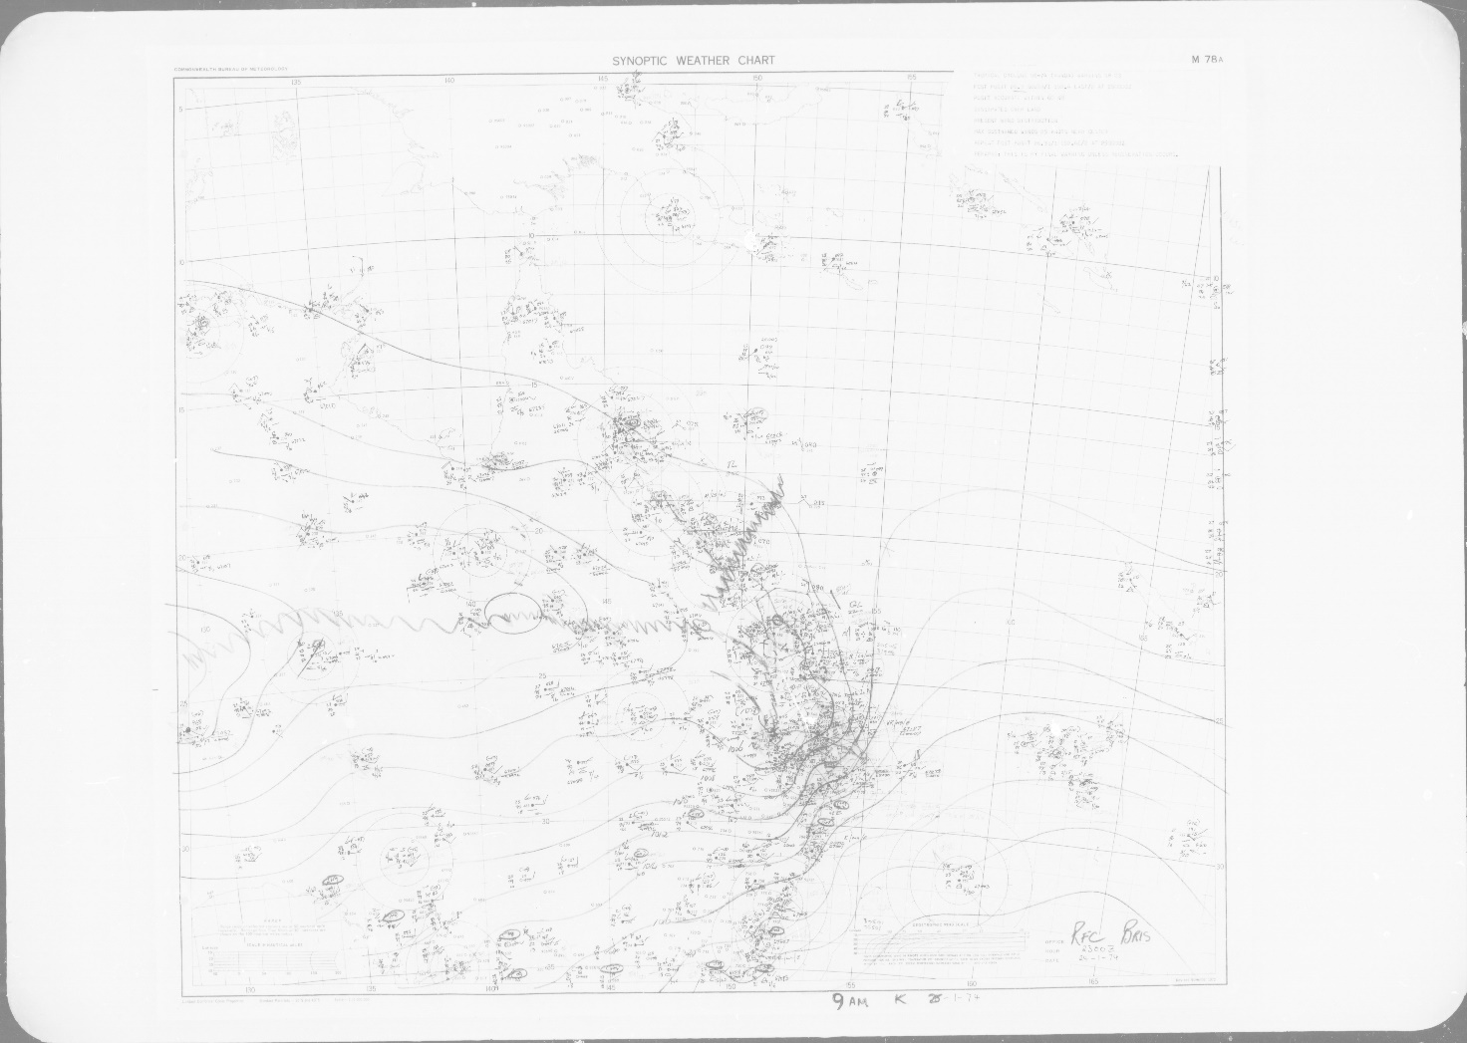
Figure 10. Surface chart at 23 GMT January 24, 1974 (9am AEST January 25, 1974). Wanda had weakened to a tropical low north of Dalby.

  - Satellite Considerations

ESSA 8, orbit 23366, 192247 GMT; NOAA 2, orbit 5775, 192300 GMT:

Poor organisation over area with no clearly-defined “focal point”. Overcast cirrus circular band running from north through east to south to southwest of central cloud feature. The criteria did not meet Dvorak’s seedling development rating of T2. The rating given was T1.5. Position of “focal point” 17.6S 154.0E.

NOAA 2, orbit 5781, 201105 GMT:

Very poor organisation.

ESSA 8, orbit 23379, 202339 GMT, NOAA 2, orbit 5787, 202154 GMT:

System centre was still very poorly organised and difficult to position. The overcast cirrus band of the previous day was no longer evident. There was a weak, cyclonically-curved, convective cloud band running from northwest through east to south of a ragged, oblong-shaped overcast cloud mass with a slight hook shape on the southwest corner. No cirrus outflow was evident. The system centre was estimated at 17.2 S 149.0 E, with a Dvorak rating of T 1.5. To the south of 20S, a marked wedge of dry air had been injected by “Vera” which was centred well to the southeast.

NOAA 2, orbit 5793, 21108 GMT:

Dense cumulus clusters but no banding evident. Very difficult to determine the system centre.

ESSA 8, orbit 23392, 220030 GMT, NOAA 2, orbit 5800, 212249 GMT:

Unfortunately the area under consideration was close to the picture edge on this and the preceding orbit. The system as a whole had become detached from the main cloud band stretching from the southeast tip of Papua New Guinea to New Zealand. A ragged, irregular, north-south oriented overcast was centred near 18.5 S 152.0 E. This was displaced about 2.5 degrees west of a broken band running north through east to southeast of the overcast. A “focal point” of the band could be placed at 17.5 S 155 E. As a whole, the system was still poorly organised. The Dvorak rating was T 1.5.

NOAA 2, orbit 5806, 221103 GMT:

Thin circular banding indicating a “focal point” near 18 S 154 E, which was just east of a north-south orientated dense cloud mass.

ESSA 8, orbit 23404, 222326 GMT:

Development had taken place. Increasing banding features were apparent through the east, south and west of a “focal point” at 20 S 155.2 E where the radius of curvature was about one-half latitude degree giving the appearance of a large “eye”. This “eye” was located one degree south of the edge of a ragged, central dense overcast (“CDO”) of two degrees diameter. The “CDO” was attached to a broken to overcast band extending towards the northwest. The ITCZ was clearly defined, extending southwestwards from the “CDO” to near St. Lawrence on the Queensland Central coast. The Dvorak rating was T 2.

NOAA 2, orbit 5818, 231003 GMT:

The system had taken on a more organised appearance, although the system centre was difficult to locate due to the lumpy texture of the dense overcast. Banding, although not merging with the dense overcast, ran from north to east. The synoptic centre was placed to the northwest of the cloud centre.

ESSA 8, orbit 23416, 232200 GMT:

The area of interest was on the picture edge of this, and the following, ESSA orbit. The “CDO” of the previous day was still clear, although the system centre was outside the dense overcast. A narrow cumulus band lying north-south was displaced about three degrees east of the main overcast cloud mass.

A small tongue appeared to extend southwestward from the “CDO” towards a U-shaped feature located about two degrees to the south. The system overall was still poorly organised and no “focal point” was evident from low-level feeder bands. The NOAA 2 picture did not clarify the situation. The existence of a bright “CDO” of 1.5 degrees diameter was the only outstanding feature. The “CDO” centre, taken from ESSA, was 23.8 S 154.7 E.

ESSA 8, orbit 2317, 240017 GMT:

A thin cloud band stretching from the Shoalwater Bay region extends directly into the north-northwest face of the “CDO”. The banding “focal point” of the previous day was no longer apparent.

A Dvorak rating of T 1.5 was assigned, with the centroid of the “CDO” positioned closer to the synoptic centre. The decrease in banding features since the previous day indicated a weakening of the system.

NOAA 2, orbit 5831, 241055 GMT:

“Wanda” had crossed the coast and the cloud had dispersed into a series of large cumulus clusters.

ESSA 8, orbit 23429, 242313 GMT:

“Wanda” had further decayed to a disorganised cloud mass.
  - Microseisms

Telegraphic reports from Cairns of Type C groups of 5-second periods were received between 201930 GMT and 211945 GMT. The initial amplitude was 14 mm with peaks to 32 mm, subsequently decreasing to 11 mm with peaks of 16 mm. During this period, "Vera" was moving southwestward away from the mainland. From the limited available data, it appears that the microseisms were generated by "Vera".
  - Sferics

During the life-time of "Wanda", very little sferic activity resulted. Early on January 21st, scattered sferics were reported in the southeast Gulf of Carpentaria and about the ITCZ which crossed the Queensland coast near Cardwell. During the afternoon and night, reports were isolated; all being associated with the northwesterly flow to the north of the ITCZ.
On the morning of January 22nd, a group of first class fixes was observed about 750 km northeast of the developing centre. A small group of first class fixes was also observed at 220200 GMT; on this occasion, approximately 400 km northeast of the centre. Sferics were detected on the base of Care York Peninsula at the same time.
Very little activity then occurred until 240200 GMT when "Wanda" was just northeast of Sandy Cape. This renewed activity was more than 1000 km to the northeast; an area which remained relatively active until 241700 GMT.
  - Upper Air Considerations
At 192300 GMT, a marked trough at 850 mb extended west-east through Cardwell to a closed cyclonic circulation about 450 km southeast of Willis Island. This closed circulation was evident to 600 mb with a southwesterly flow above. The west-east trough had a southward tilt to 500 mb and lay just south of Mackay at that level. At this time, Tropical Cyclone “Vera” was centred approximately 450 km southeast of New Caledonia. A large anticyclone blanketed most of the Tasman Sea with the 850 mb centre between Sydney and Lord Howe Island.
At 202300 GMT (Figures 11 and 12), the 850 mb trough over the Coral Sea passed between Cairns and Townsville, where winds were 290°/81 km/h and 090°/37 km/h respectively. The high at this stage appeared to have retrogressed to the west of Newcastle. Above 500 mb a small outflow spanned the Willis Island – Townsville area. A firm ridge lay across southeastern Australia and the southwest Tasman Sea.
At 212300 GMT (Figures 13 and 14), the trough at 850 mb had drifted southward to Townsville, although at this stage no closed cyclonic circulation was evident. The ridge over southeast Australia had weakened due to the movement of a front across Tasmania into the southwest Tasman Sea. Above 500 mb the flow was diffluent over "Wanda" ahead of a trough lying from Rockhampton to the southeast Tasman.
At 222300 GMT (Figures 15 and 16), a small closed cyclonic circulation had become established over “Wanda” from 850 mb to 600 mb. The marked west-east trough crossed the coast near Bowen and was now vertical to 500 mb. The 850 mb high had drifted off the central coast of New South Wales and a general westerly flow to 500 mb covered the southern Tasman Sea. Above 500 mb the flow over “Wanda” was weakly anticyclonic with the 200 mb outflow centre in the Alice Springs region. The trough through the Rockhampton area had weakened markedly in the previous 24 hours.
The depth of the indraft had increased to 500 mb by 232300 GMT (Figures 17 and 18) whilst becoming detached from the main trough which crossed the coast near Mackay and extended west-southwestward to Alice Springs. A weak ridge was now apparent over Queensland’s southeast quarter at 600 and 500 mb, and the 850 mb high had strengthened and encompassed the whole Tasman Sea region. The flow above 500 mb was still weakly diffluent between Gladstone and Brisbane.
At 240500 GMT (Figures 19 and 20), a small closed circulation existed up to 500 mb over Fraser Island, whilst the 850 mb outflow centre was located to the south of Lord Howe Island with a ridge extending northwards to New Caledonia. This placed the small circulation of “Wanda” in a general east-northeast stream up to 600 mb. Above the 500 mb level a light diffluent wind field existed with a small outflow region located over Emerald, though the main outflow centre was located to the north of Alice Springs.
By 242300 GMT (Figures 21 and 22), the closed low-level circulation had decayed into a marked west-east orientated trough which at this time lay just to the north of Brisbane. This feature was apparent up to 500 mb; above this level there was a light west-southwest flow.

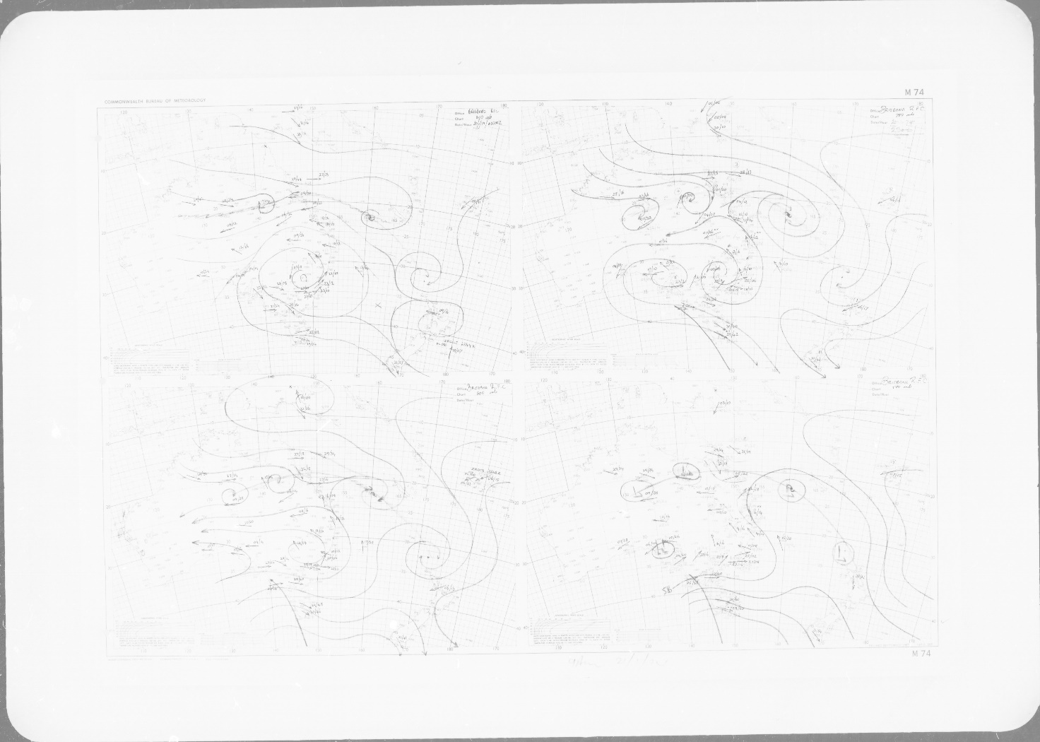
Figure 11. Upper air streamline charts at 22 GMT January 20, 1974 (8am AEST January 21, 1974). Top left: 850 mb. Top right: 700 mb. Bottom left: 600 mb. Bottom right: 500 mb.
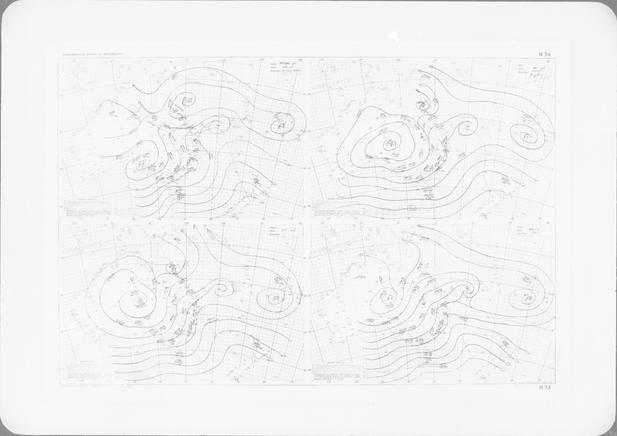
Figure 12. Upper air streamline charts at 22 GMT January 20, 1974 (8am AEST January 21, 1974). Top left: 400 mb. Top right: 300 mb. Bottom left: 250 mb. Bottom right: 200 mb.

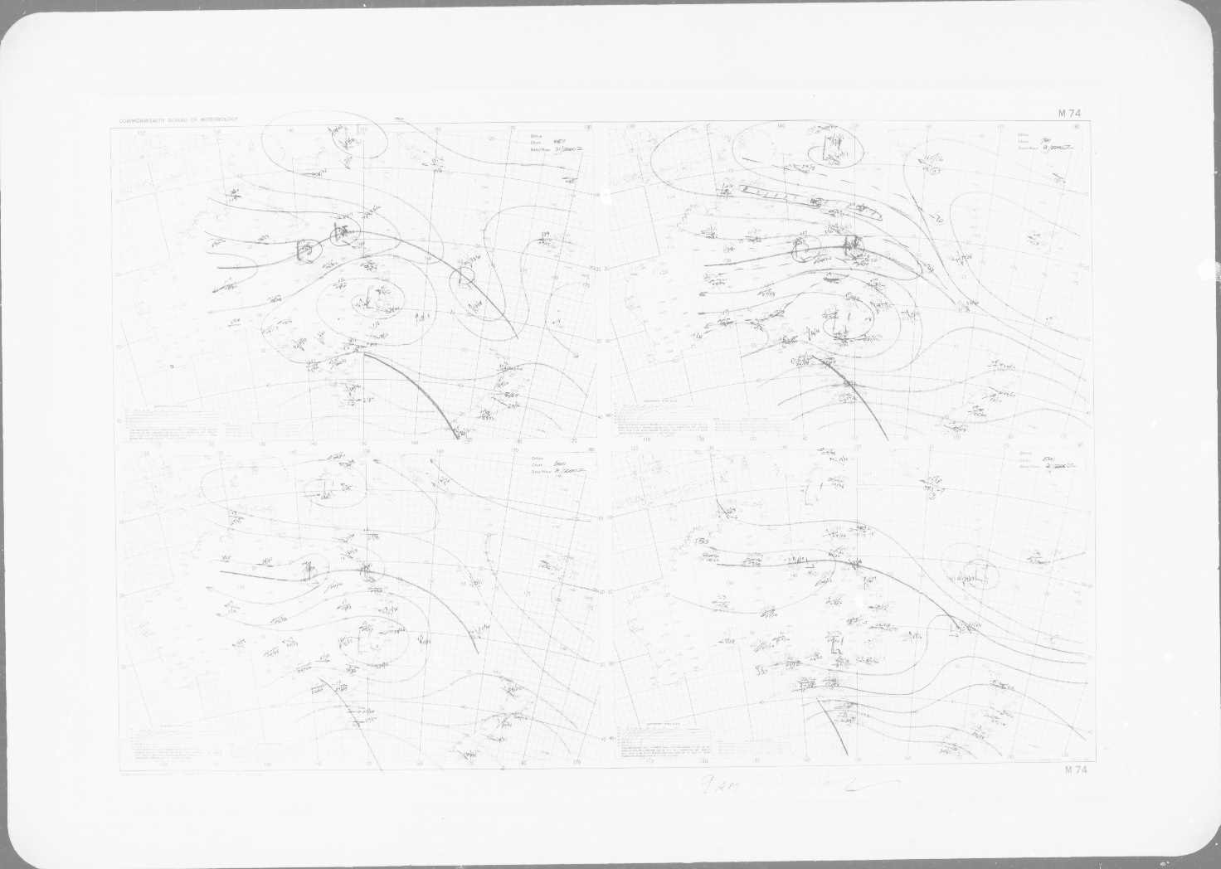
Figure 13. Upper air streamline charts at 22 GMT January 21, 1974 (8am AEST January 22, 1974). Top left: 850 mb. Top right: 700 mb. Bottom left: 600 mb. Bottom right: 500 mb.
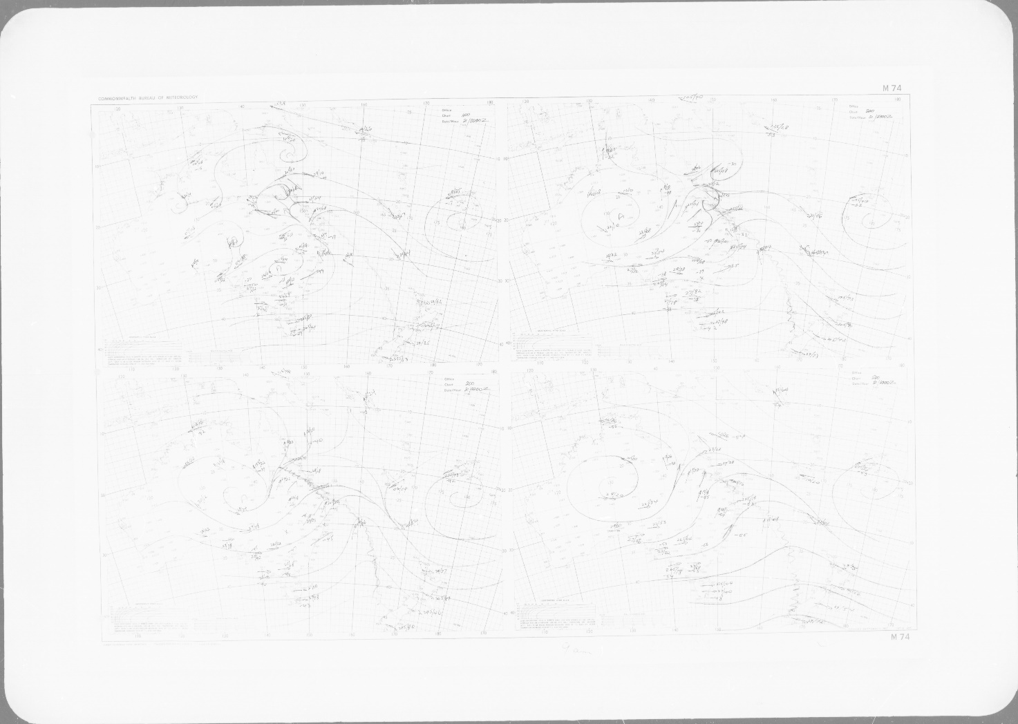
Figure 14. Upper air streamline charts at 22 GMT January 21, 1974 (8am AEST January 22, 1974). Top left: 400 mb. Top right: 300 mb. Bottom left: 250 mb. Bottom right: 200 mb.

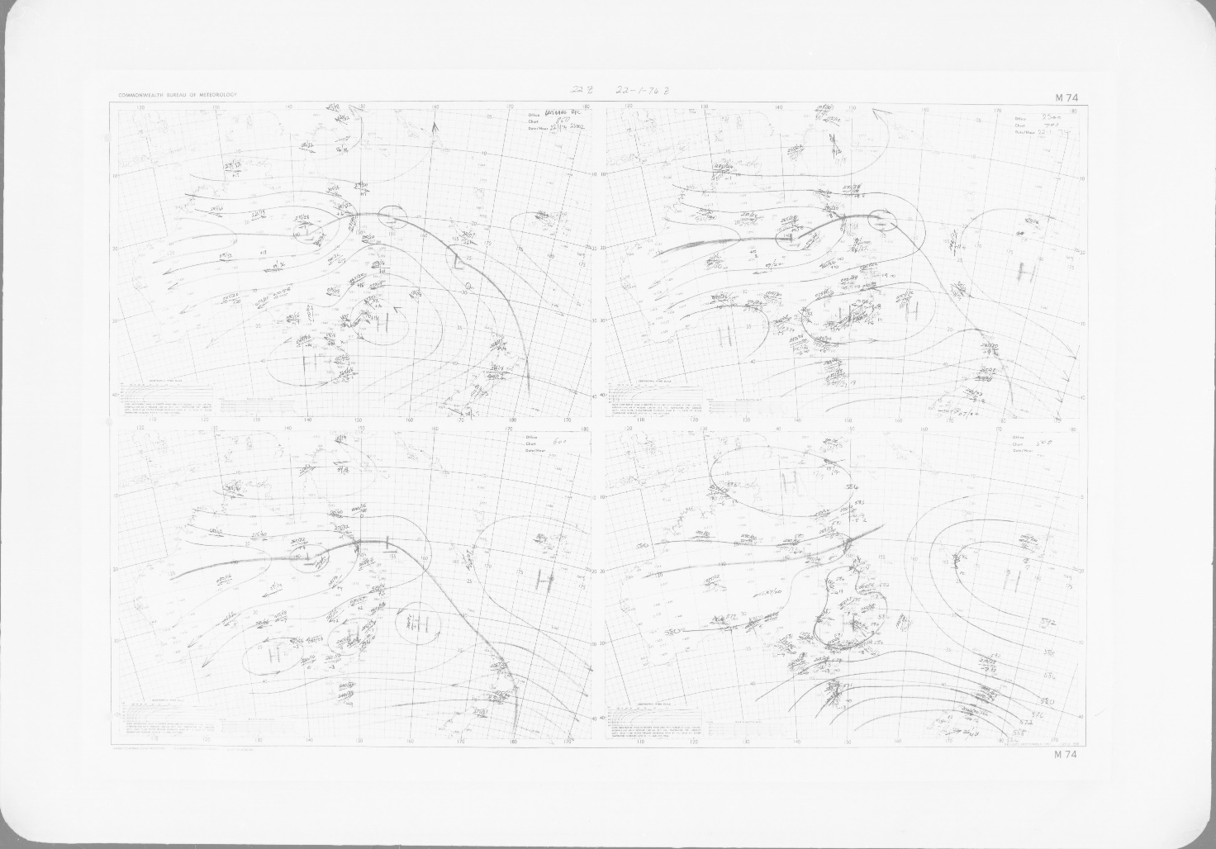
Figure 15. Upper air streamline charts at 22 GMT January 22, 1974 (8am AEST January 23, 1974). Top left: 850 mb. Top right: 700 mb. Bottom left: 600 mb. Bottom right: 500 mb.
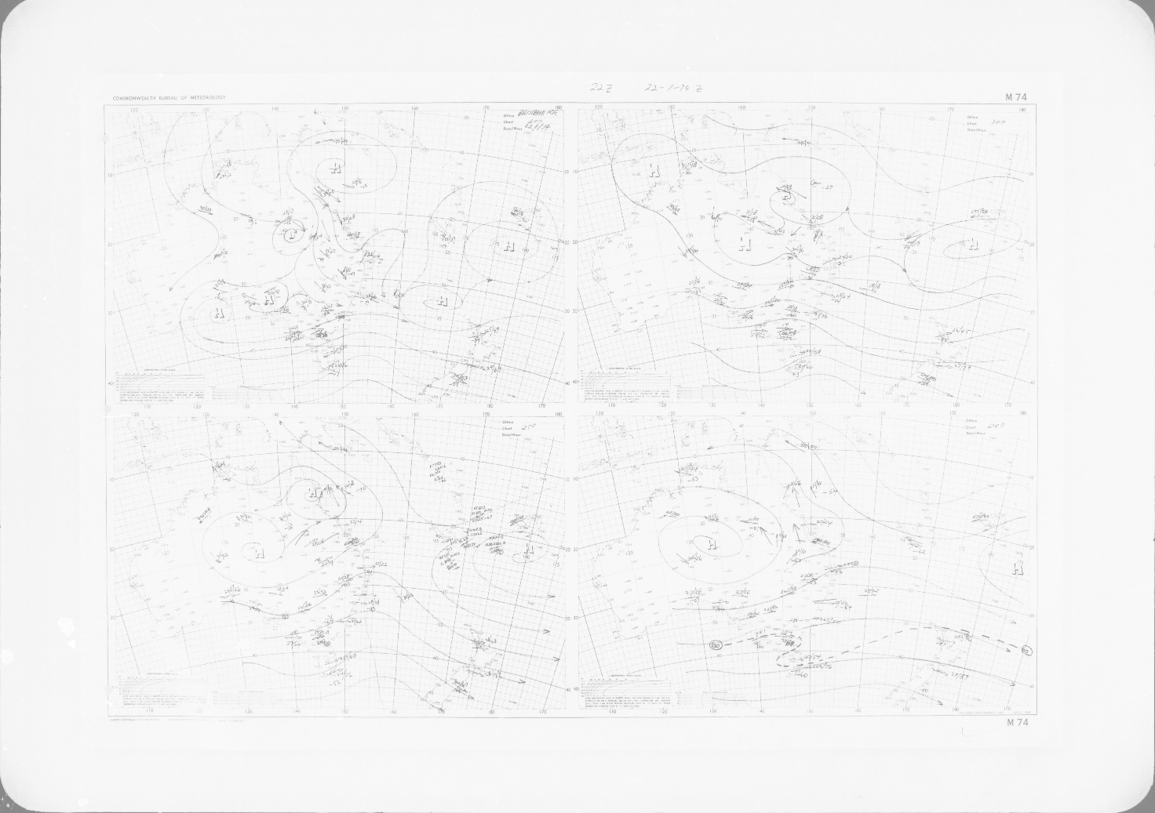
Figure 16. Upper air streamline charts at 22 GMT January 22, 1974 (8am AEST January 23, 1974). Top left: 400 mb. Top right: 300 mb. Bottom left: 250 mb. Bottom right: 200 mb.

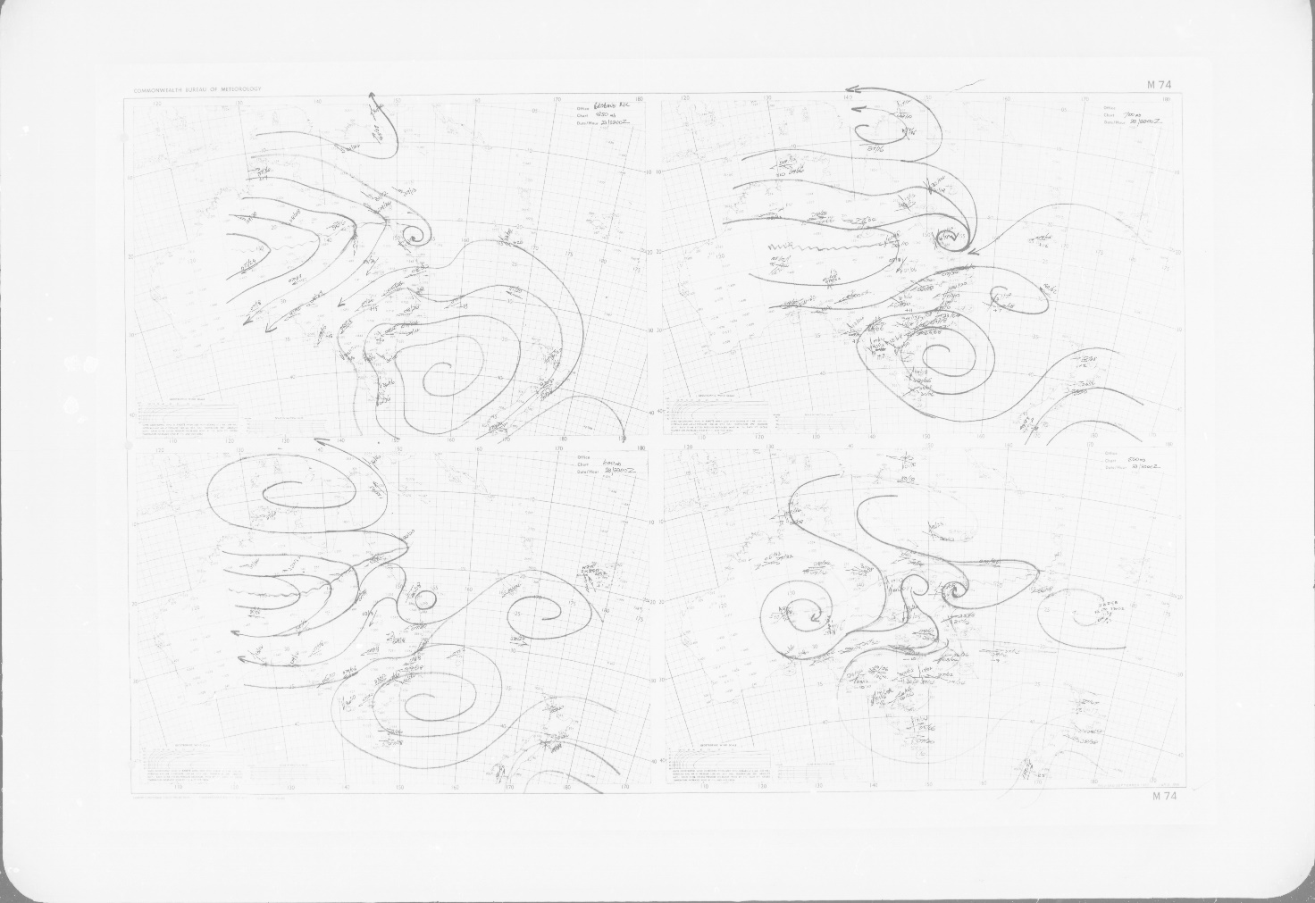
Figure 17. Upper air streamline charts at 22 GMT January 23, 1974 (8am AEST January 24, 1974). Top left: 850 mb. Top right: 700 mb. Bottom left: 600 mb. Bottom right: 500 mb.
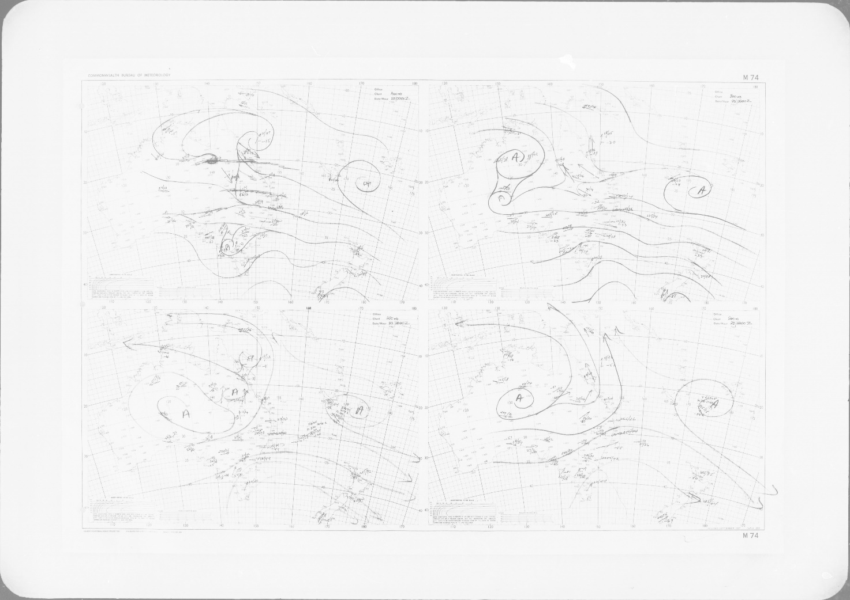
Figure 18. Upper air streamline charts at 22 GMT January 23, 1974 (8am AEST January 24, 1974). Top left: 400 mb. Top right: 300 mb. Bottom left: 250 mb. Bottom right: 200 mb.

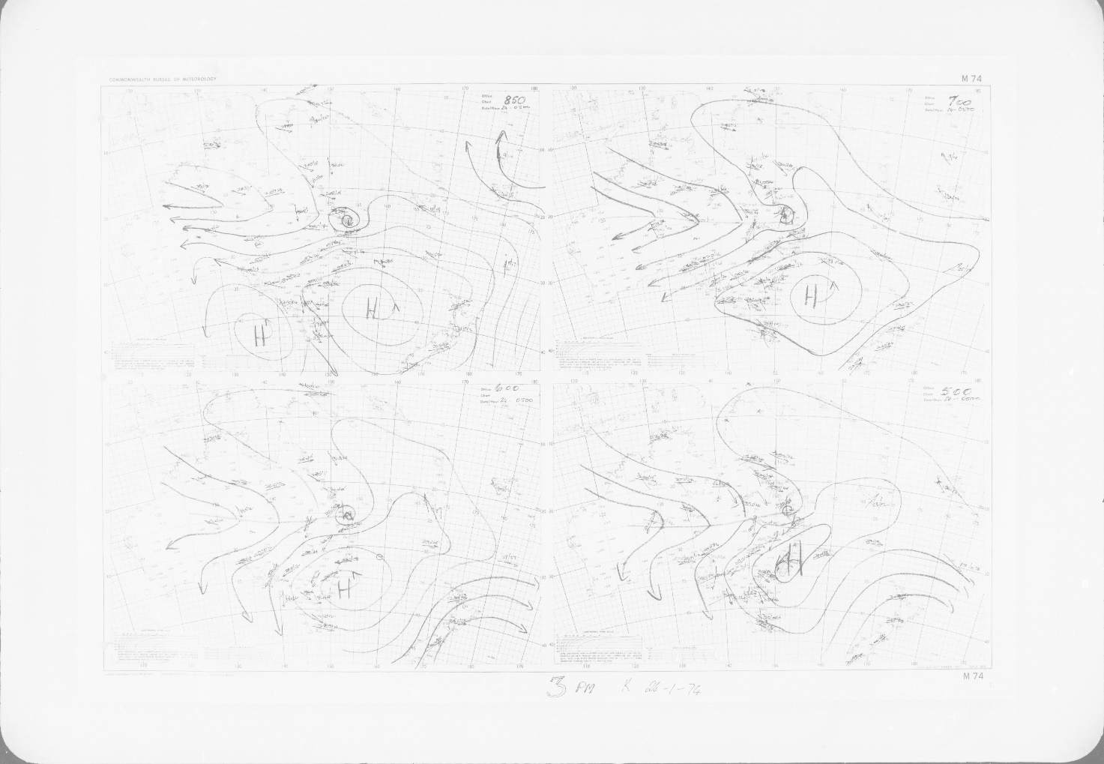
Figure 19. Upper air streamline charts at 5 GMT (3pm AEST) January 24, 1974. Top left: 850 mb. Top right: 700 mb. Bottom left: 600 mb. Bottom right: 500 mb.
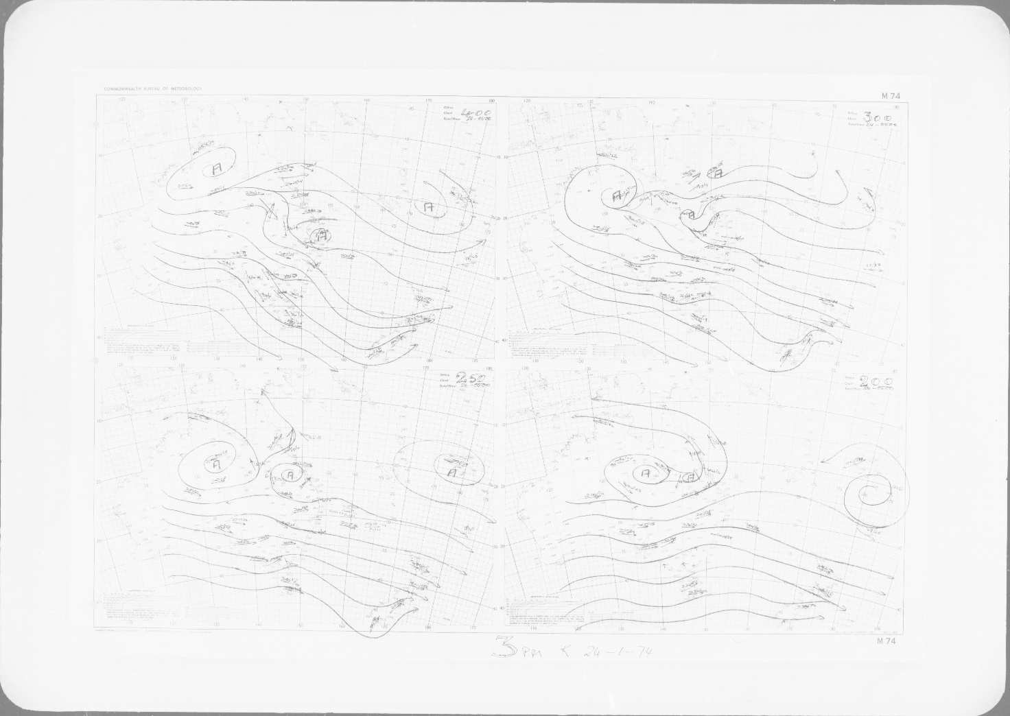
Figure 20. Upper air streamline charts at 5 GMT (3pm AEST) January 24, 1974. Top left: 400 mb. Top right: 300 mb. Bottom left: 250 mb. Bottom right: 200 mb.

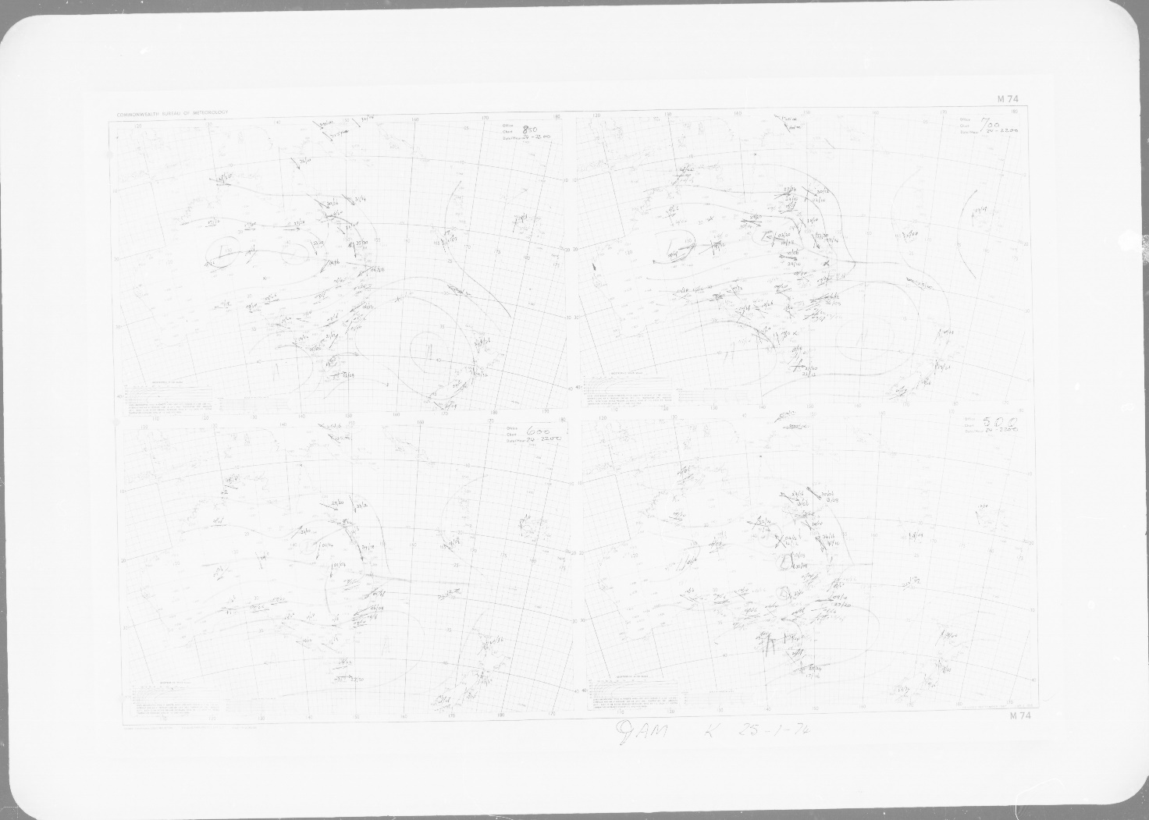
Figure 21. Upper air streamline charts at 22 GMT January 24, 1974 (8am AEST January 25, 1974). Top left: 850 mb. Top right: 700 mb. Bottom left: 600 mb. Bottom right: 500 mb.
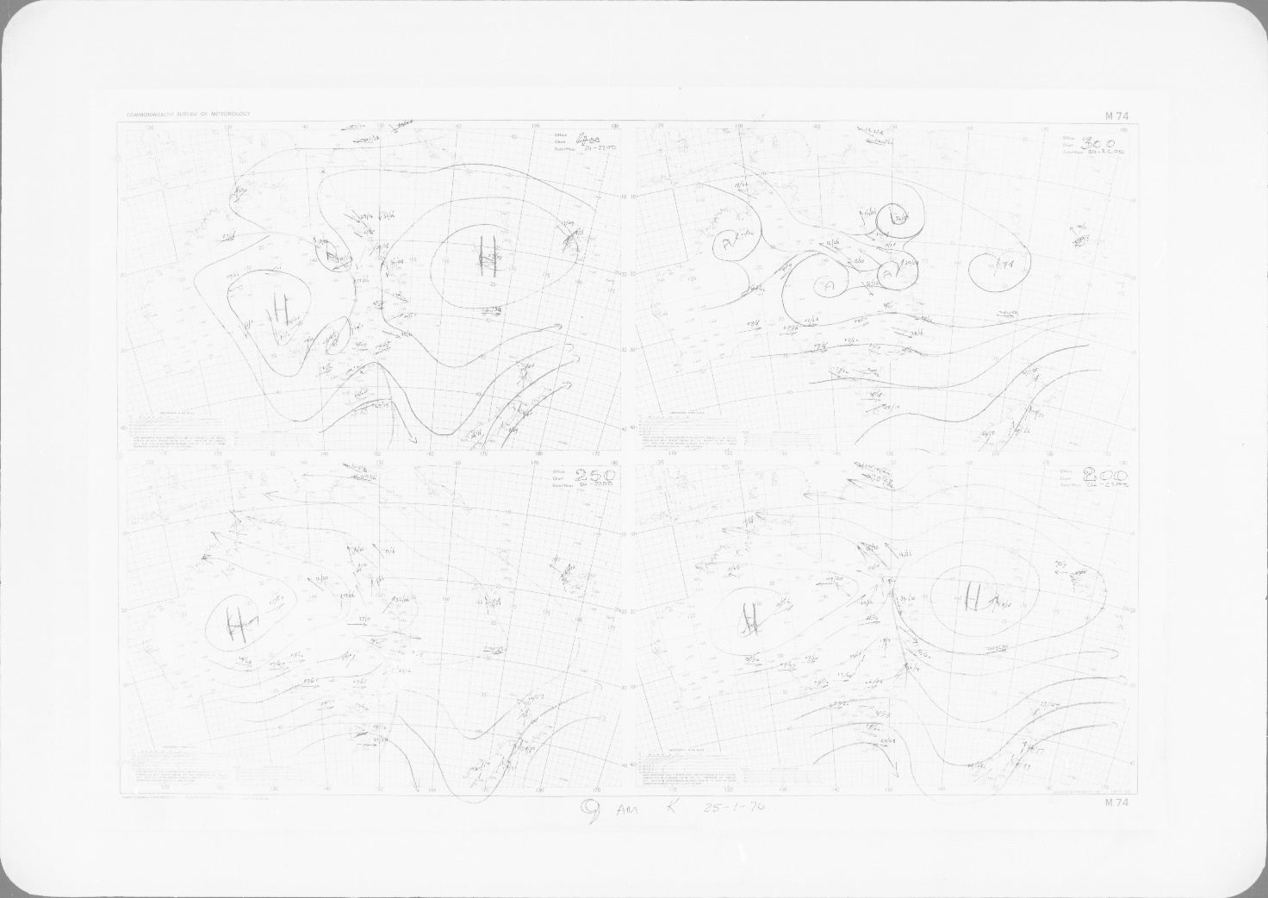
Figure 22. Upper air streamline charts at 22 GMT January 24, 1974 (8am AEST January 25, 1974). Top left: 400 mb. Top right: 300 mb. Bottom left: 250 mb. Bottom right: 200 mb.

- Features of the Track
  - Surface

Early on the 21st of January, the first indication of the incipient “Wanda” was apparent on the surface chart as a low centred about 200 km to the southwest of Willis Island (Figure 1). Up to 212300 GMT, this low moved on an east-southeast track whilst advancing some 400 km. During this period Tropical Cyclone “Vera” moved 1100 km away on a southeast track. From 212300 GMT to 221400 GMT, “Wanda” decelerated whilst recurving onto a southeast track which was then maintained until 222300 GMT. “Wanda" then veered southward and later south-southwestward during the 24-hour period to 232300 GMT, accelerating in the process. Between 232300 GMT and 240800 GMT, “Wanda” moved steadily southward to pass just to the east of Fraser Island, paralleling the island’s coast during the afternoon.

“Wanda” then turned rapidly west-southwestward cutting across the southern tip of Fraser Island to move onto the mainland just north of Double Island Point around 240930 GMT. The remnants of “Wanda” then continued on a general southwest track towards the Dalby region during the next 24 hours.

Another important system that was a feature of the chart during the period of “Wanda” was an intense high which persisted over the Tasman Sea. During the 24th of January, this high moved northeastward from a position west of Tasmania into the south Tasman Sea, and intensified from 1026 mb to 1030 mb. The system then became quasi-stationary and was responsible, at least in part, for the recurvature of “Wanda” to a southwest track, and for the maintenance of a very strong easterly gradient flow to the south of the cyclone centre.

During the 25th of January, the Tasman Sea high moved slightly further east-northeastward and weakened, whilst “Wanda” had moved inland and also weakened.
  - Upper Air

On the 21st of January, the incipient cyclone was embedded in a west-northwest stream on the northern side of a marked involuted low to mid-level trough (Figures 11 and 12), whilst winds near the region above 500 mb were light southwesterlies. This pattern remained essentially unchanged until 212300 GMT and the low followed the expected east-southeast track.

Between 212300 GMT and 222300 GMT (Figures 13, 14, 15, and 16), the low changed to a southeast track though the flow above 500 mb was still chiefly westerly. Below the 500 mb level the marked trough had drifted southward though still lying to the south of the surface feature.

During the 24-hour period to 232300 GMT (Figures 17 and 18), “Wanda” moved onto a south-southeast track and later south-southwest. This change in direction would have been difficult to predict using the 300 to 200 mb winds as they became light south-southwesterlies over the region. However, below 500 mb the trough sheared leaving now a closed circulation to the 600 – 500 mb level embedded in an east-southeast stream on the northern side of a large outflow region centred to the east of Bass Strait.

Up to time of landfall, winds above 500 mb across “Wanda” continued to be southwesterlies having no influence on the course taken by “Wanda”. As “Wanda” never became a well-developed cyclone, its movement was controlled by surface and low to mid-level systems and, in particular, the development of the high over the southwest Tasman Sea.

At 192300 GMT, the 1000 – 500 mb thickness analysis showed a marked involution within the axis of the trough lying from the Mackay region to southern New Zealand. During the 21st and 22nd of January, the involuted trough weakened over the southwest Coral Sea and for most of the time “Wanda” was located beneath a col region. The involuted pattern over the Tasman Sea began to break down as westerlies became established across these latitudes.

By 222300 GMT, the axis of the trough, now in westerlies, lay from the Willis Island region to Lord Howe Island and then southward, and, instead of “Wanda” being under a general col region, it lay to the east of the trough axis. Thickness also decreased slightly in the vicinity of “Wanda” during the 24-hour period.

By 231100 GMT, the trough, whilst progressive south of 30 S, retrogressed marginally north of 30 S to be just off the Queensland coast between Brisbane and Cairns. It was at this stage that “Wanda” changed direction from south-southeastward to south-southwestward. There was a marked change in the pattern over “Wanda” at 232300 GMT. The trough that had been to the west of “Wanda” had relaxed north from 30 S and a small 57 decameter high now became established over “Wanda” which was centred about 200km to the north of Fraser Island.

By 241100 GMT, “Wanda” had crossed the coast and a thickness ridge covered all of Queensland from a high centred near Giles. Apart from the initial stages when the incipient “Wanda” followed the general east-southeast to southeast flow of the thickness pattern, there was no evidence to infer re-curvature of the southerly track prior to landfall.
  - Radar

During the period from the 21st to the 23rd of January, when “Wanda” was well out to sea, the Rareps were all associated with precipitation caused by the ITCZ as it moved gradually southwards. Gladstone first observed a precursor to the rain band in the southeast sector of “Wanda” at 231500 GMT with a line of solid weak echoes when it was some 300 km to the northeast of the station. This line had a history of southeast movement up to 231900 GMT, fluctuating from solid to scattered weak echoes.

Widespread rain set in along the coast between Double Island Point and Coolangatta from 232300 GMT. A continuous radar cyclone watch, except for breaks for upper wind observations, commenced at Eagle Farm at 232100 GMT and continued until 250100 GMT when “Wanda” was well inland.

At 240200 GMT, the first well defined outer rain band appeared at the 155/165 km range. This band moved southward and showed a sharp intense leading edge, however, its curvature was negligible and could not be used to estimate an eye position. By 240600 GMT (Figure 23), the southern edge of the rain echo was lying from Brisbane to 220 km on the 100° radial and had a confused area to the north of it. Attenuation indicated the stronger rain echoes aligned in westward converging lines but with negligible curvature.

Between 240700 GMT and 240830 GMT a false centre was detected 55 km due east of Eagle Farm with semicircular echoes. This was well separated from the recognised synoptic centre and disappeared after 240830 GMT. Another feature during the period 240500 GMT to 240900 GMT was the almost complete absence of rain echoes south of the Brisbane 090° radial. Rain echoes moving into the southeast quadrant rapidly dissipated.

Between 240700 GMT and 240800 GMT, interest was also centred on an echo at 167 km bearing 002°. This echo changed its orientation from west-southwest/east-northeast to west/east and then to northwest to southeast and could have indicated a circulation to the north of the echo. At 240900 GMT, the area at 157 km due north was still the focus of interest with marked rain echo curvature showing a possible centre.

After 241200 GMT, the curvature of the rain echo bands became more pronounced at ranges beyond 74 km. Spiral band overlays were only of marginal assistance. Difficulty was experienced because of spurious rain bands in coastal areas. At 241230 GMT, a small echo at 350°/148 km was showing a slow eastward movement and was closely watched as it changed its orientation from west/east to become a north/south arc of 90° by 241415 GMT. This was taken to indicate the true centre of the circulation at 360°/130 km north of Noosa and south of Double Island Point. There was still some doubt about this position because of the appearance of northwest/southeast banding in echoes to the southeast of this probable centre and in a confused mass of rain echoes.

In the period 241500 GMT to 241600 GMT, rain echoes along the ranges to the west of Brisbane gave a north/south appearance to the banding but this was taken to be orographical and not indicative of a centre to the east of this area. The rain over Moreton Island/Stradbroke Island also gave a similar effect so that a false echo appeared at 76 km east-northeast of Brisbane. Photographs at 241700 GMT and 241800 GMT substantiated the conclusions reached and showed the centre to be to the northwest of Brisbane at about 93 km.

From 241800 GMT onwards, there was little to be watched as cyclonic features were concerned. The radar showed a mass of rain from Brisbane out to almost 150 km. “Wanda” was a difficult cyclone to follow by radar due to:
- The lack of well organised spiral band formation within range
- The mass of the rain area over the Brisbane region
- The orographic induced rain echoes caused by the ranges to the west and offshore islands to the east.

False circulation formations were present. Very close observations of short-lived echoes at maximum range was the best guide in deciding the true region of the cyclone centre. No useful Aireps were received during the life-time of “Wanda”.

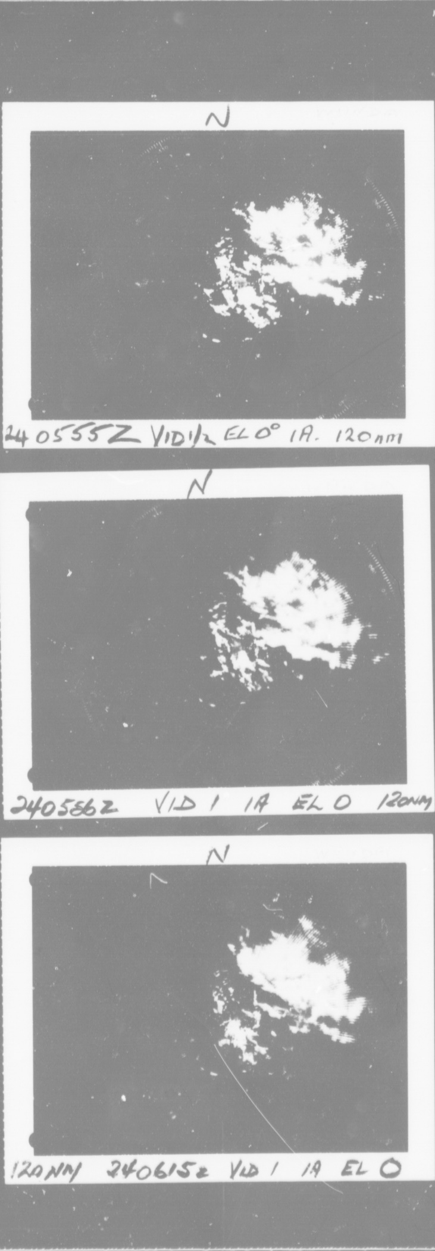
Figure 23. Radar images between 0555 and 0615 GMT (3:55pm and 4:15pm AEST) Janary 24, 1974.

- Observations
  - Rainfall

“Wanda” weakened rapidly after crossing the coast and disappeared as a surface feature during Friday 25th January. Despite its rapid weakening, “Wanda” played a major part in the generation of the flood to follow because, in addition to providing the initial rain that saturated the Brisbane catchment, it forced the monsoonal trough southwards to Brisbane (e.g. Figure 24). Here the trough persisted for several days and small oscillations in its movement and intensity resulted in several periods of very intense rainfall. The trough finally weakened and retreated northwards on Monday 28th January and a drier southern maritime air mass moved in over Brisbane ending the protracted rain period.

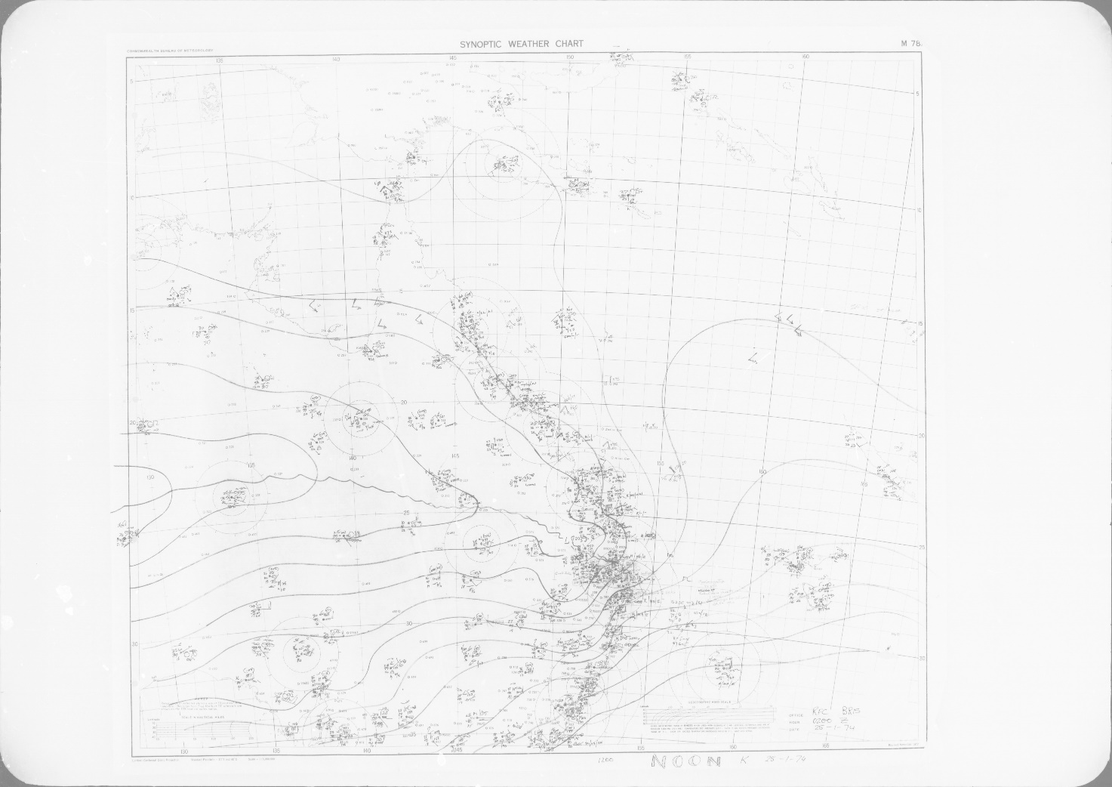
Figure 24. Surface chart at 2 GMT (12pm AEST) January 25, 1974, showing the monsoon trough intersecting the coast near Brisbane.

Total rainfall in the Brisbane metropolitan area for the five-day period ending 282300 GMT ranged from 500 to 900mm and exceeded 300 mm over all but extreme western parts of the Brisbane River Catchment area. Mt. Glorious located on the eastern boundary of the Brisbane River Catchment recorded the highest total with 1318 mm. The Bureau in the city centre recorded 650 mm during the period.

Many places in the Brisbane Valley received record or near record totals during the floods for various durations. For example, New Beith recorded 683 mm in 48 hours to 262399 GMT and included a 6 hour fall of 250 mm. The Brisbane Bureau, in the 24 hours to 252300 GMT, recorded 314 mm and this was only the second occasion on which a 24-hour total in January exceeded the average monthly rainfall.
  - Flooding and Flood Damage

Flooding started in the Stanley River Catchment late on Thursday 24th in association with the decaying “Wanda”. By 242300 GMT, major flooding was occurring on the Upper Stanley River but, although rain had fallen over the other main Brisbane River tributaries, initial losses had not been satisfied. However, by 251100 GMT, significant run-off had commenced in both the Upper Brisbane River and Lockyer Creek.

Major flooding commenced in the Bremer and Upper Brisbane Rivers and in the Lockyer Creek by 252300 GMT. A peak of 19.70 m was recorded at Ipswich on the Bremer River at about 270500 GMT. On the 25th and 26th of January, the flood was still being generated in the Brisbane Valley, but in the Brisbane Metropolitan area, three intense rainfall periods resulted in three separate floods in the metropolitan creeks producing record flood levels.

The Brisbane River continued to rise and the previous highest flood level this century (1931) was exceeded by about 262300 GMT when the level at the Port Office reached 4.5 m. Heavy rain which fell over most of the Brisbane Valley principally between 260500 GMT and 270500 GMT was responsible for the major flooding in Brisbane.

The Brisbane River attained a peak height of 6.60 m at the Port Office (5.5 m Brisbane City Gauge) on the high tide at 282315 GMT and did not fall to below 3.0 m until Thursday 31st January. The Queensland Disaster Welfare Committee reported that there were 6,007 flooded households in Brisbane and Ipswich and 9,980 cases of emotional disturbance, health problems, or material damage. A total of 56 homes in Ipswich and Brisbane were either destroyed or condemned and a Q.D.W.C. survey of 37 of these indicated a total loss of house and contents valued at $850,058, the average per house being $22,974 (Ref. 4).

Insurance Companies met claims totalling $70 million for damage in the Brisbane and Ipswich areas. The bulk of this was aligned with river and suburban creek flooding. Damage on a large reference scale has been estimated at $173 million which included both direct and indirect damage (Ref. 3).

References:
- Report by Director of Meteorology “Brisbane Floods January 1974” issued by Australian Government Publishing Service, Canberra, 1974.
- Proceedings of Symposium “January 1974 Floods, Moreton Region” published by the Institution of Engineers, Australia, Queensland Division, August 1974.
- Brisbane River Flood Investigations – Final Report, prepared by Snowy Mountains Engineering Corporation, November 1975, for Cities Commission.
- Executive Officers Report to the Queensland Disaster Welfare Committee, November 1974.
  - Wind and Wind Damage

“Wanda” crossed the coast between 240800 GMT and 241100 GMT between Maryborough and Double Island Point with a central pressure of 998 mb. Mean surface wind speeds were mostly between 70 and 80 km/h south of the centre with some squalls to 100 km/h. The central eye mechanism did not develop sufficiently to produce a mature cyclone before “Wanda” crossed the coast.

A high moved northeast from a position east of Tasmania on the 24th of January and intensified 4 mb to 1030 mb, and maintained a very strong easterly flow south of the cyclone centre. Between 232300 GMT and 250500 GMT, the winds at Brisbane were mostly in the 80 – 100 km/h range at the 1000 m level.

Winds measured by a synchrotac anemometer at Caloundra Signal station were generally of the order of 70 and 80 km/h from 231100 GMT up to about 242000 GMT. The highest gust recorded was 135 km/h at 241430 GMT at Caloundra and this is consistent with a mean wind of 83 to 93 km/h.

Little wind damage was reported. Damage to trees was generally restricted to broken branches of less than 10 cm diameter. Wind damage to houses along the coastal strip from Double Island Point to Coolangatta was minimal. There were a few houses at Caloundra that lost tiles and iron roofing sheets. Some display signs were blown over in the Maroochydore area.
  - Storm Surge

No significant storm surge was observed due to the relatively high central pressure of “Wanda”.
  - Seas and Swell

The following ship reports were received during the life of “Wanda”:
Ship name | Time received (GMT) | Distance from cyclone centre (km) | Bearing | Sea | Swell
GYYS | 211200 | 30 | 048 | 0.5m/1 sec | 2.5 m/<5 sec/conf
“Vancouver Island”, GOZU | 220000 | 530 | 142 | 2m/2 sec | 2.5 m/10 sec/200°
“Aurufa”, GZSE | 231200 | 420 | 004 | 1 m/1 sec | 1.0 m/5 sec/conf
“Aurufa”, GZSE | 232100 | 350 | 023 | 1.5 m/4 sec | 2.5 m/6 sec/033°
“Aurufa”, GZSE | 240000 | 340 | 021 | 1.5 m/3 sec | 2.0 m/6 sec/010°
“Aurufa”, GZSE | 240900 | 400 | 063 | 1.5 m/3 sec | 2.0 m/6 sec/360°
“Aurufa”, GZSE | 241200 | 420 | 081 | 1.5 m/3 sec | 2.0 m/6 sec/010°
“Aurufa”, GZSE | 250000 | 580 | 119 | 2 m/5 sec | 2.5 m/6 sec/090°
NNXX | 231800 | 620 | 168 | 3 m/6 sec | 3.5 m/7 sec/110°
“Templein”, GPOU | 240000 | 420 | 164 | 1.5 m/3 sec | 2 m/9 sec/080°
“Templein”, GPOU | 241200 | 300 | 098 | 3.0 m/XX | 7 m/11 sec/040°
“Brisbane Trader” | 240600 | 230 | 164 | Rough Seas | Heavy east-southeast swell
“NICHIBOMAHU”, JHDQ | 240900 | 140 | 113 | 2 m/5 sec | 5 m/10 sec/080°
“NICHIBOMAHU”, JHDQ | 241200 | 230 | 074 | 3 m/5 sec | 5 m/9 sec/080°
“NICHIBOMAHU”, JHDQ | 250000 | 550 | 141 | 2.5 m/5 sec | 4 m/9 sec/310°
“Northern Star”, GHZB | 240400 | 100 | 155 | wind 090/44
“Northern Star”, GHZB | 241500 | 510 | 080 | 5 m/3 sec | 5.5 m/6 sec/080°

Up to 230500 GMT, seas were slight to moderate between Pine Islet and Byron Bay as “Wanda” was in the developing stage and located to the north of Frederick Reef. The swell along the southern Queensland coast was mostly a moderate short southeasterly. The seas increased to rough during the night of the 23rd and the swell became a heavy short easterly at Caloundra from 232000 GMT. Elsewhere only a moderate short to average easterly swell was reported.

The seas and swells decreased at North Reef, Cape Capricorn, and Lady Elliot Island as “Wanda” moved southwards past these stations to be centred just to the north of Sandy Cape at 240200 GMT. Whilst the moderation was occurring over waters to the north of “Wanda’s” centre, the seas rose to rough southwards and increased to very rough at Eurong and Fraser Island; and progressively southwards to Double Island Point, Caloundra, and Cape Moreton during the period from 232300 GMT to 242300 GMT. They were associated with a heavy short to average easterly swell.

“Wanda” had crossed the coast by 241100 GMT but a strong east/northeast flow persisted up to 262300 GMT along the coastal strip between Caloundra and Byron Bay and maintained rough seas and a heavy east to northeast swell. Seas and swell then moderated as the stream eased.

- Appendix: List of abbreviations
Abbreviation | Term
AEST | Australian Eastern Standard Time
AWS | automatic weather station
°C | Celsius
CI | Current intensity
FT | Final T-number
GHz | Gigahertz
GMT | Greenwich Mean Time
h | hour
hPa | hectopascal
km | kilometres
km/h | kilometres per hour
kn | knot
MET | Model Expected T-number
mb | millibars
mm | millimetres
MSLP | mean sea level pressure
nm | nautical mile
PAT | Pattern T-number
RH | relative humidity
RMW | radius of maximum winds
RSMC | Regional Specialised Meteorological Centre
TC | Tropical Cyclone
TCWC | Tropical Cyclone Warning Centre
UTC | Universal Time Co-ordinated

