Severe Tropical Cyclone Zelia

## 12 – 18 January 2011

## Joe Courtney, Tropical Cyclone Environmental Prediction Services

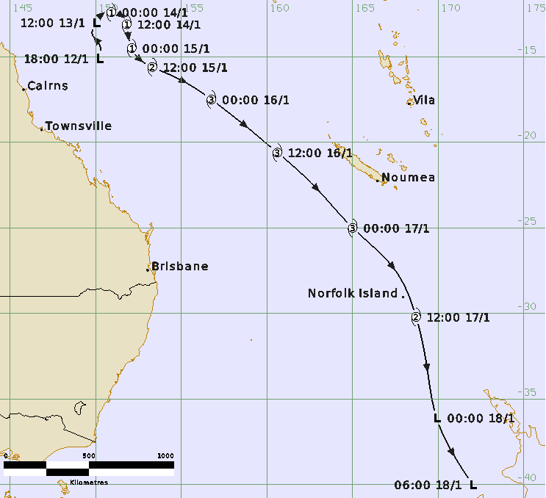

### Revision history

|  |  |  |  |
| --- | --- | --- | --- |
| Date | Version | Authors | Description |
| 21/10/2024 | 1.0 | Joe Courtney | Final draft ready |

### Review status

|  |  |  |  |
| --- | --- | --- | --- |
| Date | Version | Reviewer | Description |
| 23/10/2024 | 1.0 | Linda Paterson | Completed |

### Release history

|  |  |  |  |
| --- | --- | --- | --- |
| Date | Version | Status | Approval |
| 23/10/2024 | 1.0 | Approved for release | Andrew Burton |



Contact details:

Tropical Cyclone Team Lead

Severe Weather Environmental Prediction Services

Bureau of Meteorology

PO Box 1370, West Perth WA 6872

Email: tcwc@bom.gov.au

This work is copyright. Apart from any use as permitted under the Copyright Act 1968, no part may be reproduced without prior written permission from the Bureau of Meteorology. Refer to www.bom.gov.au/other/copyright.shtml for further information. Unless otherwise noted, all images in this document are licensed under the Creative Commons Attribution Australia Licence.

© Commonwealth of Australia 2024

Published by The Bureau of Meteorology

Cover image: Track of Tropical Cyclone Zelia 12 – 18 January 2011. Times in UTC (AEST-10.0h).

Table of Contents

1. Summary 5

2. Meteorological description 7

2.1. Intensity Analysis 7

2.2. Structure 7

2.3. Motion 7

3. Impact 12

4. Observations 12

4.1. Wind/pressure 12

5. Appendix: List of Abbreviations 13

**List of Figures**

Figure 1. Best track of Tropical Cyclone Zelia 12 – 18 January 2011 5

Figure 2. TMI 37 GHz microwave image at 0417 UTC 14 January. 8

Figure 3. AMSRE 89 GHz microwave image at 0248 UTC 16 January. 9

Figure 4. Modis visible image at 0000 UTC 16 January as Zelia was approaching peak intensity. 10

Figure 5. ASCAT scatterometer winds at 2309 UTC 15 January. 11

**List of Tables**

Table 1. Best track summary for Tropical Cyclone Zelia, 12-18 January 2011. 6

1. Summary

Severe Tropical Cyclone Zelia initially developed over the northern Coral Sea approximately 750 kilometres northeast of Cairns on 14th January. Zelia began to move in a southeasterly direction under the influence of a mid-level ridge situated across the western Coral Sea. Zelia rapidly intensified to a category 3 system on 15 January and then further to a category 4 the following day while accelerating to the west of New Caledonia.

Severe Tropical Cyclone Zelia began weakening on 17 January due to a combination of cooler sea surface temperatures and increased vertical wind shear. Zelia passed just east of Norfolk Island as it transitioned into a mid-latitude low whilst still causing gale-force winds on 18 January. Heavy rain and strong winds subsequently affected New Zealand.

The track is shown in Figure 1 and track data are shown in Table 1.

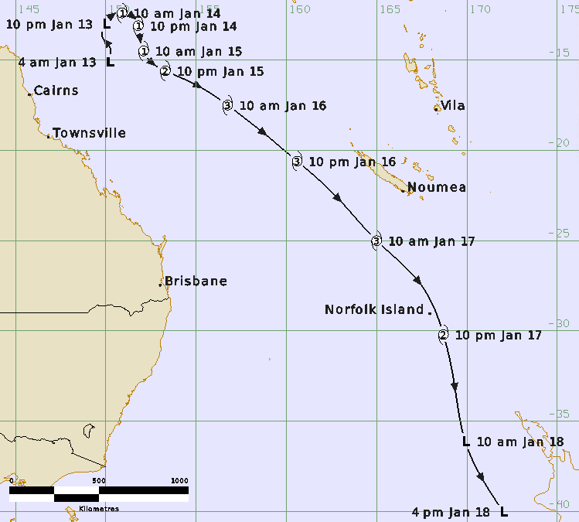

Figure 1. Best track of Tropical Cyclone Zelia 12 – 18 January 2011 (times in AEST, UTC +10).

|  |  |  |  |  |  |  |  |  |  |  |  |  |
| --- | --- | --- | --- | --- | --- | --- | --- | --- | --- | --- | --- | --- |
| Year | Month | Day | Hour UTC | Pos. Lat S | Pos. Long. E | Pos. Acc. nm | Max. wind kn | Max. gust kn | Cent. Press hPa | Rad of gales (NE/SE/SW/NW) nm | Rad of storm (NE/SE/SW/NW) nm | RMW nm |
| 2011 | 1 | 12 | 1800 | 15.1 | 150.2 | 70 | 20 | 40 | 1000 | 0/0/0/0 | 0/0/0/0 | - |
| 2011 | 1 | 13 | 0000 | 14.3 | 150.2 | 60 | 20 | 45 | 1000 | 0/0/0/0 | 0/0/0/0 | - |
| 2011 | 1 | 13 | 0600 | 13.7 | 149.8 | 60 | 25 | 45 | 995 | 0/0/0/0 | 0/0/0/0 | - |
| 2011 | 1 | 13 | 1200 | 13.0 | 150.0 | 45 | 25 | 45 | 994 | 0/0/0/0 | 0/0/0/0 | - |
| 2011 | 1 | 13 | 1800 | 12.5 | 150.4 | 45 | 30 | 45 | 995 | 0/0/0/0 | 0/0/0/0 | - |
| 2011 | 1 | 14 | 0000 | 12.4 | 150.9 | 40 | 35 | 50 | 992 | 90/60/45/90 | 0/0/0/0 | 12 |
| 2011 | 1 | 14 | 0600 | 12.6 | 151.5 | 40 | 35 | 50 | 992 | 90/60/45/90 | 0/0/0/0 | 12 |
| 2011 | 1 | 14 | 1200 | 13.1 | 151.8 | 40 | 35 | 50 | 990 | 90/60/45/90 | 0/0/0/0 | 12 |
| 2011 | 1 | 14 | 1800 | 13.8 | 151.9 | 40 | 40 | 55 | 988 | 90/60/45/90 | 0/0/0/0 | 12 |
| 2011 | 1 | 15 | 0000 | 14.5 | 152.1 | 40 | 45 | 65 | 989 | 100/45/45/100 | 0/0/0/0 | 12 |
| 2011 | 1 | 15 | 0600 | 15.1 | 152.5 | 10 | 50 | 70 | 985 | 100/45/45/100 | 30/0/0/20 | 12 |
| 2011 | 1 | 15 | 1200 | 15.6 | 153.3 | 30 | 60 | 85 | 977 | 100/60/60/100 | 40/20/20/30 | 12 |
| 2011 | 1 | 15 | 1800 | 16.4 | 155.0 | 25 | 65 | 90 | 977 | 100/60/60/100 | 40/30/30/30 | 12 |
| 2011 | 1 | 16 | 0000 | 17.5 | 156.8 | 10 | 80 | 110 | 964 | 100/60/60/100 | 40/30/30/30 | 12 |
| 2011 | 1 | 16 | 0400 | 18.5 | 158.1 | 10 | 100 | 140 | 943 | 100/60/60/100 | 40/30/30/30 | 12 |
| 2011 | 1 | 16 | 0600 | 19.1 | 158.8 | 10 | 100 | 140 | 944 | 100/60/60/100 | 40/30/30/30 | 12 |
| 2011 | 1 | 16 | 1000 | 20.1 | 160.0 | 15 | 100 | 140 | 943 | 100/60/60/100 | 40/30/30/30 | 12 |
| 2011 | 1 | 16 | 1200 | 20.6 | 160.6 | 20 | 85 | 120 | 957 | 0/0/0/0 | 0/0/0/0 | - |
| 2011 | 1 | 16 | 1800 | 22.6 | 162.8 | 40 | 80 | 115 | 970 | 0/0/0/0 | 0/0/0/0 | - |
| 2011 | 1 | 17 | 0000 | 25.0 | 165.0 | 60 | 70 | 100 | 975 | 0/0/0/0 | 0/0/0/0 | - |
| 2011 | 1 | 17 | 0600 | 27.5 | 167.5 |  | 60 |  | 975 | 0/0/0/0 | 0/0/0/0 | - |
| 2011 | 1 | 17 | 1200 | 30.2 | 168.7 |  | 55 |  | 980 | 0/0/0/0 | 0/0/0/0 | - |
| 2011 | 1 | 17 | 1800 | 32.9 | 169.3 |  | 45** |  | 990 | 0/0/0/0 | 0/0/0/0 | - |
| 2011 | 1 | 18 | 0000 | 36.1 | 169.9 |  | 45* |  | 988 | 0/0/0/0 | 0/0/0/0 | - |
| 2011 | 1 | 18 | 0600 | 40.0 | 172.0 |  | 40* |  | 987 | 0/0/0/0 | 0/0/0/0 | - |

Table 1. Best track summary for Tropical Cyclone Zelia, 12-18 January 2012.

UTC=AEST-10. * Not at tropical cyclone intensity as gales less than halfway around centre.

1. Meteorological description
   1. Intensity Analysis

The intensity of the system in the Australian region was primarily based upon Dvorak analysis. The circulation showed curved band patterns during the early to middle stages of development and shifted to eye patterns once the system had become fully organised on 16 January.

Development was initially assisted by strong monsoonal west north-westerly flow to the north of the low.

Curved band pattern intensity estimates using the Dvorak Technique initially started at a 0.2 degree wrap on the log10 spiral on 13 January and reached a maximum wrap of 0.8 on 15 January. Microwave imagery showed the development of a well-defined inner circulation as shown on the TMI 37 GHz image at 0417 UTC 14 January in Figure 2.

An eye became well established by 16 January as shown on AMSRE 89GHz microwave image in Figure 3 and MODIS visible image in Figure 4. Dvorak eye pattern intensity estimates reached a maximum on 16 January with a FT and CI number of 6.0. This equated to an estimated peak maximum 10-minute mean wind of 100 kn (185 km/h) at 0600 UTC 16 January, just prior to Zelia moving outside the Australian region at 90°E. Zelia subsequently weakened.

SATCON intensity estimates compared favourably with the subjective Dvorak intensity estimates while ADT intensity estimates provided higher sustained wind values during the early stages of development compared to that of the subjective Dvorak and the final best track intensity estimates.

* 1. Structure

Zelia was a very small system with a tight low-level centre during the early stages of development. This was identified by mMicrowave imagery (Figure 2 and Figure 3). The radius of maximum winds (RMW) was estimated at 12 nm (22 km).

At the time of peak intensity on 16 January Zelia was non-symmetrical with a gale radius ranging from 110-220 km (60-100nm). The gale radius was larger to the north of the system as shown in the ASCAT at 2309 UTC 15 January in Figure 5.

Zelia transitioned into a mid-latitude low as it moved past Norfolk Island and towards New Zealand.

* 1. Motion

Initially the low was steered in a northerly direction by a mid-level ridge extending across eastern Australia (Figure 1). However, Zelia adopted a south-easterly track soon after developing into a tropical cyclone as a broad mid-level trough extending from Tropical Cyclone Vania developed across the western Coral Sea on 15 January.

Zelia continued to move in a south-easterly direction over the next few days while accelerating in speed as the mid-level trough further developed across the western Coral Sea. Zelia reached a peak translation speed of 48 km/h prior to moving out of the Australian area of responsibility late on 16 January. The southeast track continued as Zelia moved past Norfolk Island and then approached New Zealand.

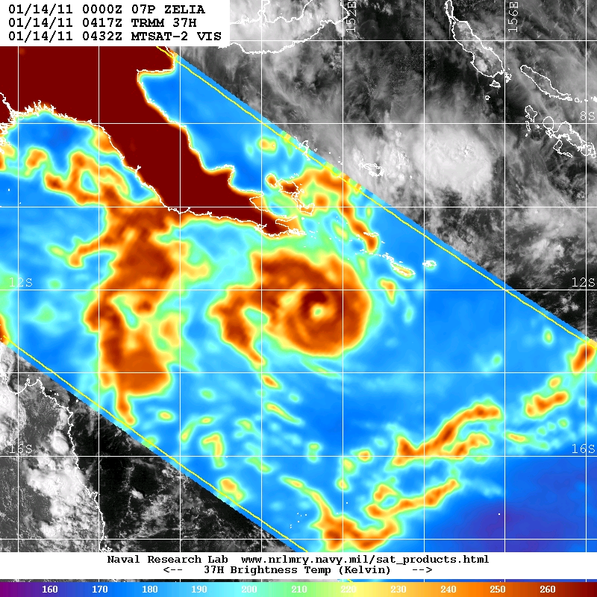

Figure 2. TMI 37 GHz (horizontally polarised view) microwave image at 0417 UTC 14 January.

Images courtesy of NRL: <https://www.nrlmry.navy.mil/TC.html>

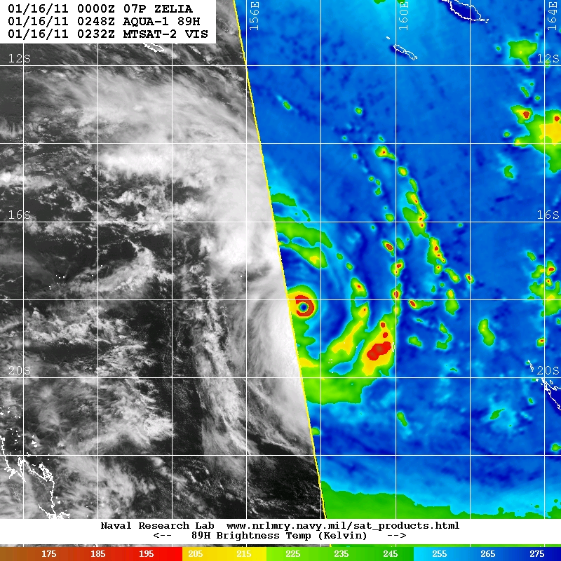

Figure 3. AMSRE 89 GHz (horizontally polarised view) microwave image at 0248 UTC 16 January.

Images courtesy of NRL: <https://www.nrlmry.navy.mil/TC.html>

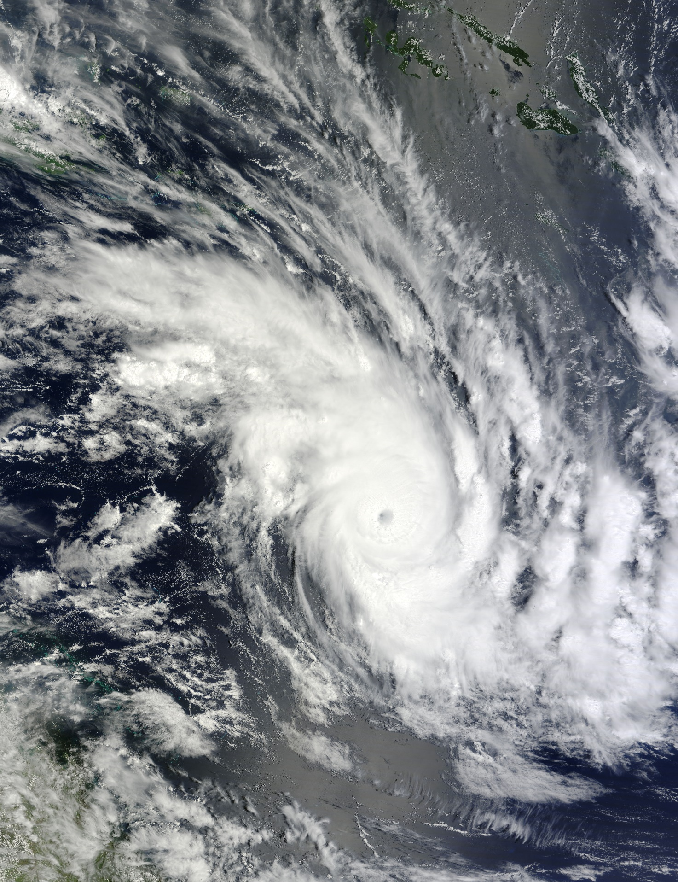

Figure 4. Modis visible image at 0000 UTC 16 January as Zelia was approaching peak intensity. Image courtesy NASA: <https://earthobservatory.nasa.gov/images/48629/cyclone-zelia>

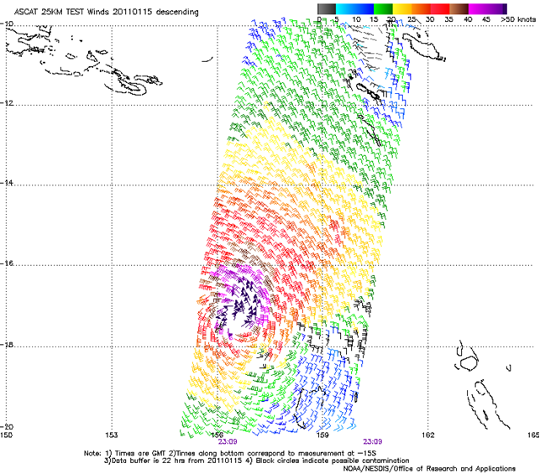

Figure 5. ASCAT scatterometer winds at 2309 UTC 15 January. Image courtesy NOAA: https://manati.star.nesdis.noaa.gov/datasets/ASCATData.php

1. Impact

No significant impacts were reported to Australian territories, but heavy rain and strong winds affected New Zealand.

1. Observations
   1. Wind/pressure

Severe Tropical Cyclone Zelia passed just to the east of Norfolk Island overnight on 17 January. The maximum 10-minute mean wind of 61 km/h (33 kn) with a peak gust of 83 km/h (45 kn) was recorded at Norfolk Island Aero at 2247 NFT (2117 AEST or 1117 UTC). The lowest pressure recorded was 988.4 hPa at Norfolk Island Aero at 2100 NFT (1930 AEST or 0930 UTC) 17 January.

1. Appendix: List of Abbreviations

|  |  |
| --- | --- |
| Abbreviation | Term |
| ADT | Advanced Dvorak Technique |
| ACST | Australian Central Standard Time |
| AEST | Australian Eastern Standard Time |
| AiDT | AI-enhanced Dvorak Technique |
| AMSR2 | Advanced Microwave Scanning Radiometer |
| AMSU | Advanced Microwave Sounding Unit |
| ASCAT | Advanced Scatterometer |
| ATMS | Advanced Technology Microwave Sounder |
| AWS | automatic weather station |
| AWST | Australian Western Standard Time |
| °C | Celsius |
| CI | Current intensity |
| CIMSS | Cooperative Institute for Meteorological Satellite Studies (USA) |
| CIRA | Cooperative Institute for Research in the Atmosphere (USA) |
| D-MINT | Deep learning - Multispectral Intensity of TCs (formerly known as DMN) |
| D-PRINT | Deep learning - IR Intensity of TCs (formerly known as OPEN-AIIR) |
| EIR | Enhanced InfraRed |
| ERC | eyewall replacement cycle |
| FNMOC | Fleet Numerical Meteorology and Oceanography Centre (USA) |
| FT | Final T-number |
| GCOM | Global Change Observation Mission |
| GHz | Gigahertz |
| GMI | Global Precipitation Measurement Microwave Imager |
| h | hour |
| hPa | hectopascal |
| HSCAT | Hai Yang 2 Scatterometer (HY-2B, HY-2C) |
| km | kilometres |
| km/h | kilometres per hour |
| kn | knot |
| LLCC | LLCC |
| MET | Model Expected T-number |
| METOP | Meteorological Operational Satellite |
| MJO | Madden-Julian Oscillation |
| mm | millimetres |
| MSLP | mean sea level pressure |
| NESDIS | National Environmental Satellite, Data, and Information Service |
| nm | nautical mile |
| NOAA | National Oceanic and Atmospheric Administration |
| NRL | Navy Research Lab (USA) |
| OSCAT | Scatterometer aboard the OceanSat satellite |
| PAT | Pattern T-number |
| RCM | RadarSat Constellation Mission – Synthetic Aperture Radar |
| RH | relative humidity |
| RMW | radius of maximum winds |
| RSMC | Regional Specialised Meteorological Centre |
| SAR | Synthetic Aperture Radar |
| SATC | CIMSS Advanced Dvorak Technique |
| SATCON | Satellite Consensus |
| SEN1 | Sentinel-1A – Synthetic Aperture Radar |
| SMAP | Soil Moisture Active Passive |
| SMOS | Soil Moisture and Ocean Salinity |
| SSMIS | Special Sensor Microwave Imager/Sounder |
| TC | Tropical Cyclone |
| TCWC | Tropical Cyclone Warning Centre |
| UTC | Universal Time Co-ordinated |