Severe Tropical Cyclone Zelia (18U)

## 8 – 14 February 2025

## Steph Bond

## Tropical Cyclone Environmental Prediction Services

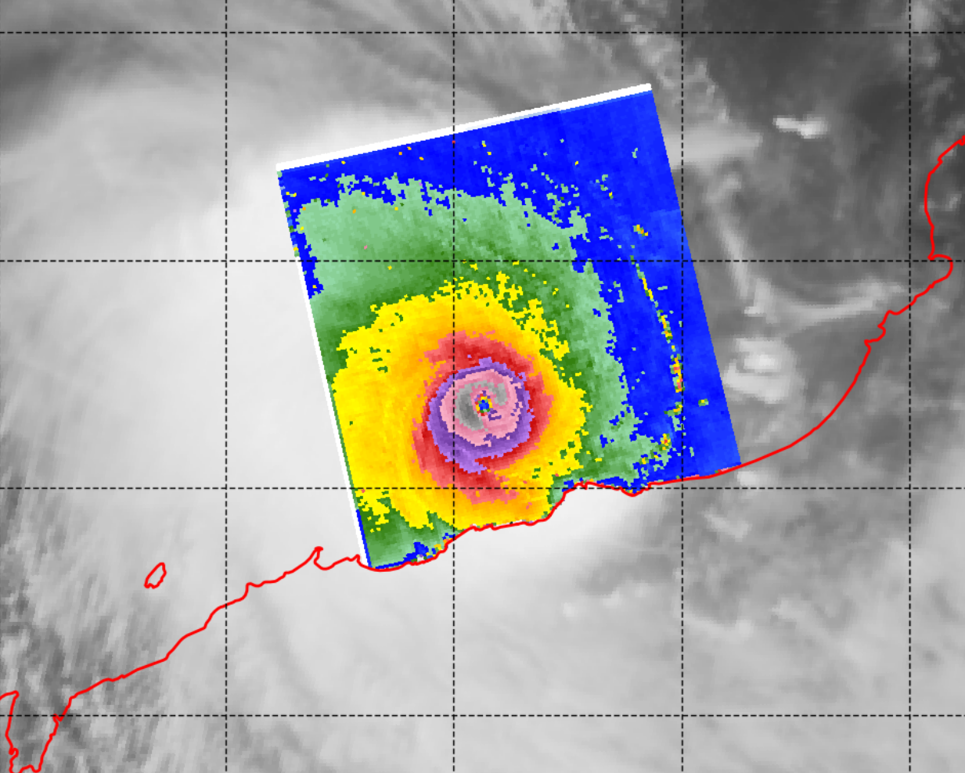

### Revision history

|  |  |  |  |
| --- | --- | --- | --- |
| Date | Version | Author | Description |
| 28/5/25 | 1.0 | Steph Bond | Final draft |

### Review status

|  |  |  |  |
| --- | --- | --- | --- |
| Date | Version | Reviewer | Description |
| 28/5/25 | 1.0 | Linda Paterson | Completed |

### Release history

|  |  |  |  |
| --- | --- | --- | --- |
| Date | Version | Status | Approval |
| 11/6/25 | 1.0 | Approved for release | Andrew Burton |



Contact details:

Tropical Cyclone Team Lead

Severe Weather Environmental Prediction Services

Bureau of Meteorology

PO Box 1370, West Perth WA 6872

Email: tcwc@bom.gov.au

This work is copyright. Apart from any use as permitted under the Copyright Act 1968, no part may be reproduced without prior written permission from the Bureau of Meteorology. Refer to www.bom.gov.au/other/copyright.shtml for further information. Unless otherwise noted, all images in this document are licensed under the Creative Commons Attribution Australia Licence.

© Commonwealth of Australia 2025

Published by The Bureau of Meteorology

Cover image: SAR RCM2 – VH scatterometry image of Severe Tropical Cyclone Zelia at 1031 UTC 13 February 2025 (1831 AWST 13 February 2025), near its peak intensification. Image source from NOAA . https://www.star.nesdis.noaa.gov/socd/mecb/sar/sarwinds_tropical.php?year=2025&storm=SH172025_ZELIA

Table of contents

1. Summary 6

2. Meteorological description 9

2.1. Intensity Analysis 9

2.2. Structure 16

2.3. Motion 16

3. Impact 17

4. Observations 18

4.1. Wind 18

4.2. Rainfall 19

4.3. Storm Surge 20

5. Forecast Performance 20

6. Appendix: List of Abbreviations 25

**List of Figures**

Figure 1 Best track of Zelia 8 - 14 February 2025. Times in AWST (UTC+8 hours) 7

Figure 2 Hovmoller diagram of tropical waves showing the formation of Zelia (denoted by the red dot labelled "Z") occurred during a weakening Equatorial Rossby (ER) Wave (red), and after the MJO (black) had moved into the area east of the Maritime Continent. The image is courtesy of the North Carolina Institute for Climate Studieshttps://ncics.org/pub/mjo/archive/2025/2025-02-20/v2/ 10

Figure 3 Sea Surface anomalies for the week ending 9 February 2025, showing sea surface temperatures 1 to 3 degrees above normal, north of the Pilbara coast where Zelia intensified. The image is courtesy of The Bureau of Meteorology. http://www.bom.gov.au/climate/ocean/sst/#/anom/australia/weekly/20250209 11

Figure 4 Synthetic Aperture Radar (SAR) pass at 2124 UTC 11 February, showing gales around the system, just after Tropical Cyclone Zelia first reached category 1 tropical cyclone strength at 1800 UTC 11 February. Image courtesy NOAA. https://www.star.nesdis.noaa.gov/socd/mecb/sar/sarwinds_tropical.php 12

Figure 5 Himawari-9 Visible Satellite Imagery at 0200 UTC 12 February showing fanning cirrus in the southeast and northwest quadrants. Image courtesy of Japan Meteorological Agency (JMA). 13

Figure 6 Microwave Imagery from SSMIS F17 at 1050 UTC 12 February with the 37 GHz sensor (left) and the 91 GHz sensor (right) showing the eye of Severe Tropical Cyclone Zelia. Images courtesy NRL: https://www.nrlmry.navy.mil/TC.html 14

Figure 7 Synthetic Aperture Radar (SAR) pass at 2133 UTC 12 February, just after going through rapid intensification and showing the larger radii of gale (85 nm (157 km)) and storm force (70 nm (130 km)) winds in the southwest quadrant. Maximum wind speeds of 123 kn (1 min mean) (228 km/h) or around 115 kn (10 min mean) (213 km/h) can be seen in the southwest quadrant. This image is about 12 hours before peak intensity at 1200 UTC 13 February. Image courtesy NOAA. https://www.star.nesdis.noaa.gov/socd/mecb/sar/sarwinds_tropical.php 15

Figure 8 EIR satellite imagery from Himawari-9 at 1200 UTC 13 February (left) and colour composite microwave imagery from SSMIS F17 at 1036 UTC 13 February (right). Both images show Zelia as a compact system at and in the hours before peak intensity at 1200 UTC. Images courtesy NRL: https://www.nrlmry.navy.mil/TC.html 16

Figure 9 CIMMS Analysis of Deep Layer Mean (DLM) Steering (250-850 hPa) at 0000 UTC 12 February, showing Zelia (near Western Australia) in a col between two anti-cyclones and a trough to the south. Image courtesy of CIMMS/University of Wisconsin-Madison. https://tropic.ssec.wisc.edu/archive/ 17

Figure 10 Rainfall analysis for the 7 days to 17 February 2025 showing heaviest falls mainly confined to the coast on and east of Port Hedland, with falls 150-300 mm extending inland towards Marble Bar, as the system moved overland. 19

Figure 11 (left) Track Map issued at 0853 am AWST (0053 UTC) 9 February, which incorporated some of the guidance in Figure 11. 21

Figure 12 (right) The spread of possible forecast locations in the ensemble model guidance for Severe Tropical Cyclone Zelia at timestep 0000 UTC 14 February (just before landfall) (right upper). The time series, bottom right, showing the variation in intensity forecasts from ensemble members. Model run is 1200 UTC 8 February for ECMWF (orange), US GFS (pink), UKMO (brown) and ACCESS-G (purple). The blue shaded area is the 50% and 70% confidence areas for those dots. 21

Figure 13 The spread of possible forecast locations in the ensemble model guidance for Severe Tropical Cyclone Zelia at timestep 0000 UTC 14 February (just before landfall). Images from top left to bottom right (going across and then down) are model runs at 1200 UTC on 10, 11, 12 and 13 February for ECMWF (orange), US GFS (pink), UKMO (brown) and ACCESS-G (purple). The time series below each graphic of dots shows the variation in intensity forecasts from ensemble members. The blue shaded area is the 50% and 70% confidence areas for those dots. 22

Figure 14 Intensity accuracy figures for Severe Tropical Cyclone Zelia. 23

Figure 15 Position accuracy figures for Severe Tropical Cyclone Zelia. 23

Figure 16 Intensity Bias figures for Severe Tropical Cyclone Zelia compared against guidance from ECMWF, US GFS, HWRF, INCW, ECMWF Ensemble Mean and US GFS Ensemble Mean. 24

Figure 17 Comparison of objectivity intensity analysis aids and the Post Event Best Track for Severe Tropical Zelia 27

**List of Tables**

Table 1 Best track summary for Severe Tropical Cyclone Zelia, 8-14 February 2025. 8

Table 2 Verification statistics for Severe Tropical Cyclone Zelia. Note: Verification is performed using the Official Forecast Tracks at the standard times of 00, 06, 12 and 18 UTC. 20

1. Summary

Severe Tropical Cyclone Zelia was a small but very intense cyclone, notable for its rapid development to category 5 off the Pilbara coast of Western Australia. Zelia crossed the coast at category 4 strength near the De Grey River mouth northeast of Port Hedland on 14 February.

A tropical low (18U) was first tracked on 8 February just off the north Kimberley coast. The low remained weak and moved west-southwest for several days, before turning more southwest late on 10 February. On 11 February the environment became more conducive to development, and the winds around 18U strengthened to gale force. It strengthened into Tropical Cyclone Zelia at 1800 UTC (2 am AWST 12 February, AWST=UTC+8) 11 February, about 280 kilometres west of Broome.

On the evening of 12 February, Zelia slowed down and became near stationary about 130 kilometres north-northwest of Port Hedland. The ocean in this area was experiencing a marine heatwave and sea surface temperatures were extremely high (31-32°C). Zelia underwent a period of extremely rapid intensification, strengthening to category 5 at 1500 UTC 12 February. Zelia spent another day moving slowly and erratically at category 5 strength, reaching its peak of 115 kn at 1200 UTC 13 February. Then on the morning of 14 February, it turned southeast and moved towards the coast.

As the cyclone approached land it weakened slightly but still crossed as a high-end category 4 cyclone near the De Grey River mouth at 0400 UTC 14 February. It retained severe tropical cyclone strength through the afternoon as it moved inland, with a discernible eye persisting on radar. During the evening, however, it weakened very rapidly. It was downgraded to a tropical low at 1800 UTC 14 February near Marble Bar.

The very destructive core of the cyclone did not directly impact any towns. Port Hedland experienced damaging winds in the periphery of the cyclone for about seven hours on 14 February as Zelia approached landfall (maximum recorded gust 65 kn (120 km/h)). Marble Bar experienced gusts up to 59 kn (109 km/h) during the evening as the weakening cyclone tracked 15 kilometres to the west of the town centre.

Rainfall and flooding caused significant impacts and the event produced record 3-day rainfall totals at De Grey and Pardoo stations, each receiving over 500mm. Numerous other sites in the Pilbara received over 200mm. Record flooding occurred on the De Grey River. The most notable record was observed at Marble Bar where the river peaked at 10.23 m on the morning of 15 February, around 2 metres above the previous record of 8.3 m from 1998. The Great Northern Highway was cut at Coolenar Pool for an extended period, isolating Pilbara and Kimberley communities. Evacuations from remote communities Warralong and Gooda Binya were conducted during the rising flood.

The closures of ports at Port Hedland (three days), Cape Lambert and Dampier disrupted shipping and combined with disruptions to offshore oil and gas operations resulted in significant economic costs to industry.

Figure 1 shows the best track of Zelia while Table 1 is a summary of the best track data.

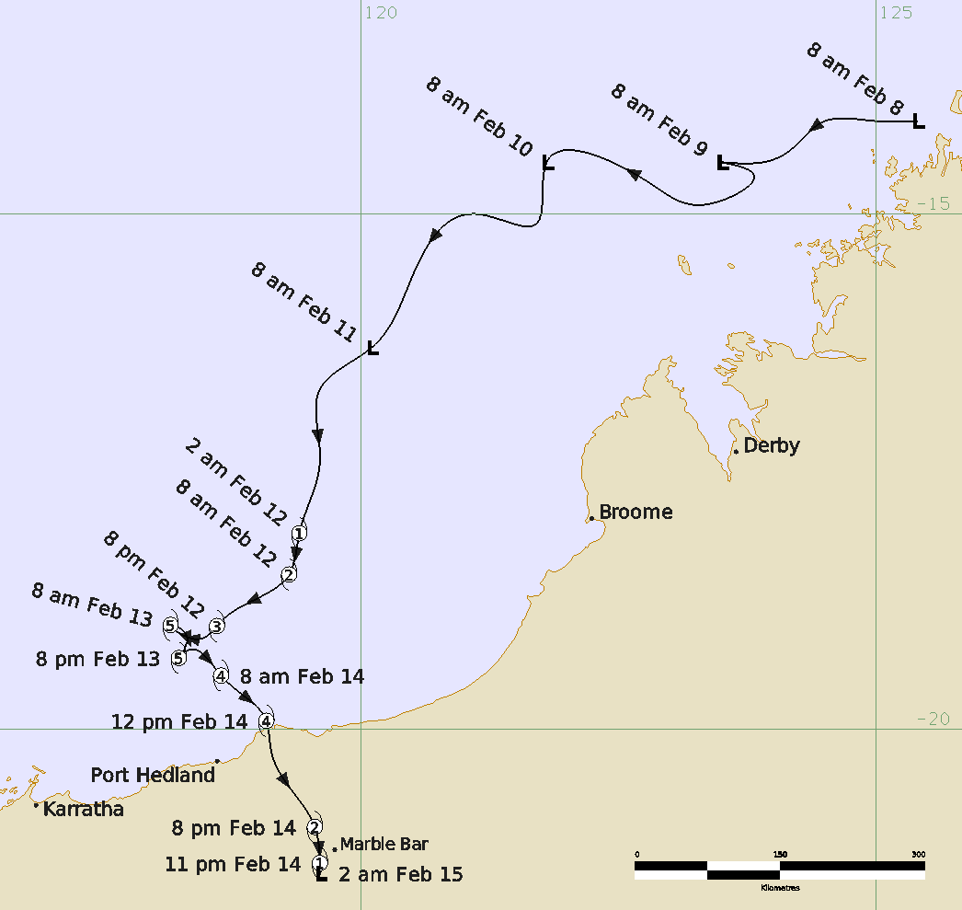

Figure 1 Best track of Zelia 8 - 14 February 2025. Times in AWST (UTC+8 hours)

|  |  |  |  |  |  |  |  |  |  |  |  |  |
| --- | --- | --- | --- | --- | --- | --- | --- | --- | --- | --- | --- | --- |
| **Year** | **Month** | **Day** | **Hour UTC** | **Pos. Lat S** | **Pos. Long. E** | **Pos. Acc. Nm** | **Max. Wind 10min kn** | **Max. gust kn** | **Cent. Press hPa** | **Rad of gales (NE/SE/SW/NW) nm** | **Rad of storm (NE/SE/SW/NW) nm** | **RMW nm** |
| 2025 | 2 | 8 | 0000 | 14.1 | 125.4 | 40 | 15 | 45 | 998 | 0/0/0/0 | 0/0/0/0 | - |
| 2025 | 2 | 8 | 0600 | 14.1 | 125.0 | 30 | 20 | 45 | 996 | 0/0/0/0 | 0/0/0/0 | - |
| 2025 | 2 | 8 | 1200 | 14.1 | 124.5 | 30 | 20 | 45 | 996 | 0/0/0/0 | 0/0/0/0 | - |
| 2025 | 2 | 8 | 1800 | 14.5 | 123.9 | 30 | 20 | 45 | 995 | 0/0/0/0 | 0/0/0/0 | - |
| 2025 | 2 | 9 | 0000 | 14.5 | 123.5 | 40 | 20 | 45 | 998 | 0/0/0/0 | 0/0/0/0 | - |
| 2025 | 2 | 9 | 0600 | 14.6 | 123.8 | 30 | 20 | 45 | 998 | 0/0/0/0 | 0/0/0/0 | - |
| 2025 | 2 | 9 | 1200 | 14.9 | 123.4 | 40 | 20 | 45 | 999 | 0/0/0/0 | 0/0/0/0 | - |
| 2025 | 2 | 9 | 1800 | 14.7 | 122.8 | 30 | 20 | 45 | 997 | 0/0/0/0 | 0/0/0/0 | - |
| 2025 | 2 | 10 | 0000 | 14.5 | 121.8 | 40 | 20 | 45 | 1000 | 0/0/0/0 | 0/0/0/0 | - |
| 2025 | 2 | 10 | 0600 | 15.1 | 121.7 | 50 | 20 | 45 | 999 | 0/0/0/0 | 0/0/0/0 | - |
| 2025 | 2 | 10 | 1200 | 15.0 | 121.1 | 60 | 20 | 45 | 999 | 0/0/0/0 | 0/0/0/0 | - |
| 2025 | 2 | 10 | 1800 | 15.6 | 120.5 | 30 | 25 | 45 | 1001 | 0/0/0/0 | 0/0/0/0 | - |
| 2025 | 2 | 11 | 0000 | 16.3 | 120.1 | 40 | 35* | 50 | 995 | 0/0/80/0 | 0/0/0/0 | - |
| 2025 | 2 | 11 | 0600 | 16.7 | 119.6 | 40 | 40* | 55 | 989 | 0/0/80/0 | 0/0/0/0 | - |
| 2025 | 2 | 11 | 1200 | 17.4 | 119.6 | 40 | 40* | 55 | 990 | 0/0/80/60 | 0/0/0/0 | - |
| 2025 | 2 | 11 | 1800 | 18.1 | 119.4 | 25 | 45 | 65 | 989 | 60/70/80/70 | 0/0/0/0 | 30 |
| 2025 | 2 | 12 | 0000 | 18.5 | 119.3 | 15 | 50 | 70 | 983 | 60/70/100/80 | 0/0/45/50 | 25 |
| 2025 | 2 | 12 | 0600 | 18.9 | 118.7 | 15 | 55 | 75 | 980 | 60/75/85/85 | 30/30/45/50 | 22 |
| 2025 | 2 | 12 | 1200 | 19.0 | 118.6 | 10 | 70 | 90 | 972 | 50/60/80/70 | 30/25/35/35 | 12 |
| 2025 | 2 | 12 | 1800 | 19.1 | 118.4 | 10 | 100 | 140 | 952 | 50/60/85/70 | 30/40/70/40 | 12 |
| 2025 | 2 | 13 | 0000 | 19.0 | 118.2 | 10 | 110 | 155 | 941 | 65/80/90/65 | 35/65/70/35 | 8 |
| 2025 | 2 | 13 | 0600 | 19.1 | 118.3 | 15 | 110 | 155 | 928 | 55/75/80/65 | 40/45/45/45 | 8 |
| 2025 | 2 | 13 | 1200 | 19.3 | 118.2 | 10 | 115 | 160 | 928 | 65/65/75/65 | 35/40/45/40 | 8 |
| 2025 | 2 | 13 | 1800 | 19.3 | 118.3 | 10 | 110 | 155 | 928 | 65/75/70/65 | 40/40/45/40 | 8 |
| 2025 | 2 | 14 | 0000 | 19.5 | 118.6 | 10 | 100 | 140 | 927 | 65/70/70/65 | 35/35/40/35 | 8 |
| 2025 | 2 | 14 | 0400 | 19.9 | 119.1 | 10 | 95 | 135 | 935 | 55/40/55/45 | 25/25/40/35 | 6 |
| 2025 | 2 | 14 | 0600 | 20.2 | 119.1 | 10 | 85 | 120 | 945 | 55/40/45/45 | 25/25/30/35 | 8 |
| 2025 | 2 | 14 | 1200 | 21.0 | 119.6 | 15 | 60 | 85 | 965 | 35/35/45/35 | 25/15/15/20 | 10 |
| 2025 | 2 | 14 | 1500 | 21.3 | 119.6 | 30 | 45* | 65 | 986 | 10/20/30/25 | 0/0/0/0 | 10 |
| 2025 | 2 | 14 | 1800 | 21.4 | 119.6 | 60 | 30 | 45 | 996 | 0/0/0/0 | 0/0/0/0 | - |

Table 1 Best track summary for Severe Tropical Cyclone Zelia, 8-14 February 2025.

UTC=AWST-8h. * Not at tropical cyclone intensity as gales less than halfway around centre.

1. Meteorological description
   1. Intensity Analysis

A tropical low formed within the monsoon trough over the Timor Sea, off the Kimberley coast of Western Australia on the morning of 8 February 2025, likely aided by an Equatorial Rossby (ER) wave moving through the areas. The MJO had started to move into the Western Pacific by 8 February and may also have had an influence on the system forming (Figure 2). It formed over sea surface temperatures (31-32°C) that were well above normal for that time of year, extending down to the waters off the Pilbara coast (Figure 3).

Patchy cold convection persisted to the southwest of a broad low-level centre on 8 February, reaching T1.0 at 1800 UTC 8 February. The system had limited development over 9 and 10 February as its low-level centre remained broad, influenced by moderate to high northeasterly shear and close proximity to the coast of the Kimberley in Western Australia.

Overnight on 10 February, curved banding became more organised and closer to the centre due to a slight drop in shear. By 0000 UTC 11 February, gales developed to the southwest of the system, confirmed by an ASCAT-C scatterometry pass at 0150 UTC 11 February and observations from Rowley Shoals. Standard development continued during 11 February aided by increased divergence to the south, despite persistent moderate northeasterly shear which confined convection to southern and western quadrants. Zelia reached tropical cyclone strength at 1800 UTC 11 February, with gales wrapping around all four quadrants, as shown by a SAR RCM-2 pass at 2124 UTC 11 February (Figure 4).

From early on 12 February, the small system reacted explosively to a very favourable low shear environment and increased upper divergence, with fanning cirrus observed in two outflow channels to the south and northwest (Figure 5). A period of extremely rapid intensification occurred during 12 and 13 February and the system strengthened from 50 kn (95 km/h) to 110 kn (205 km/h) in a 24 hour period between 0000 UTC 12 February and 0000 UTC 13 February.

An eye was first evident on the SSMIS F17 1048 UTC 12 February microwave pass (Figure 6), 6 hours prior to the eye being evident on EIR imagery at 1600 UTC. Objective aids and Dvorak analysis (using embedded centre DT pattern) (Figure 17) confirmed the increase in intensity, with the system reaching 70 kn (130 km/h, category 3) at 1200 UTC 12 February.

The Final T from Dvorak analysis was constrained to 6.0 between 1800 UTC 12 February and 0600 UTC 13 February, despite 3 hourly averaged Data T (DT) numbers reaching a peak of 7.0 (using an EIR eye pattern). A SAR pass at 2133UTC 12 February (Figure 7) indicated an intensity of around 115 kn (10 min mean adjusted and using the mean max wind) (215 km/h). This estimate was higher than the objective guidance at that time though it is consistent with the raw unconstrained DT numbers.

Zelia reached its peak intensity of 115 knots (213 km/h) at 1200UTC 13 February. Figure 8 shows the system at peak intensity in EIR imagery and a SSMIS microwave pass in the hours prior to peak intensity. While there was variation in the timing of the peak on objective guidance and scatterometry passes (varying between 2100UTC 12 February to 1400 UTC 13 February), there is a consensus of a peak intensity between 110 and 120 kn (205-220 km/h), when adjusted to a 10-minute mean (Figure 17). The timing variation was likely due fluctuations in the eye wall structure during this period, which was more visible in radar imagery.

The system started to weaken slightly as it moved towards the Pilbara coast on the morning of the 14 February possibly due to a slight increase in vertical wind shear, a slight decrease in upper divergence as the upper trough to the south moved further east and the fluctuations in the eye wall over the previous 12 hours. Dry air had been present to the west and north of the system over the previous 48 hours, however it did not appear to affect the systems development.

Zelia and crossed the coast as a 95 kn (175 km/h, category 4) system at 0400 UTC 14 February. It retained severe tropical cyclone strength through the afternoon as it moved inland, with a discernible eye persisting on radar. However, being a small system it weakened very rapidly into a tropical low by 1800 UTC 14 February.

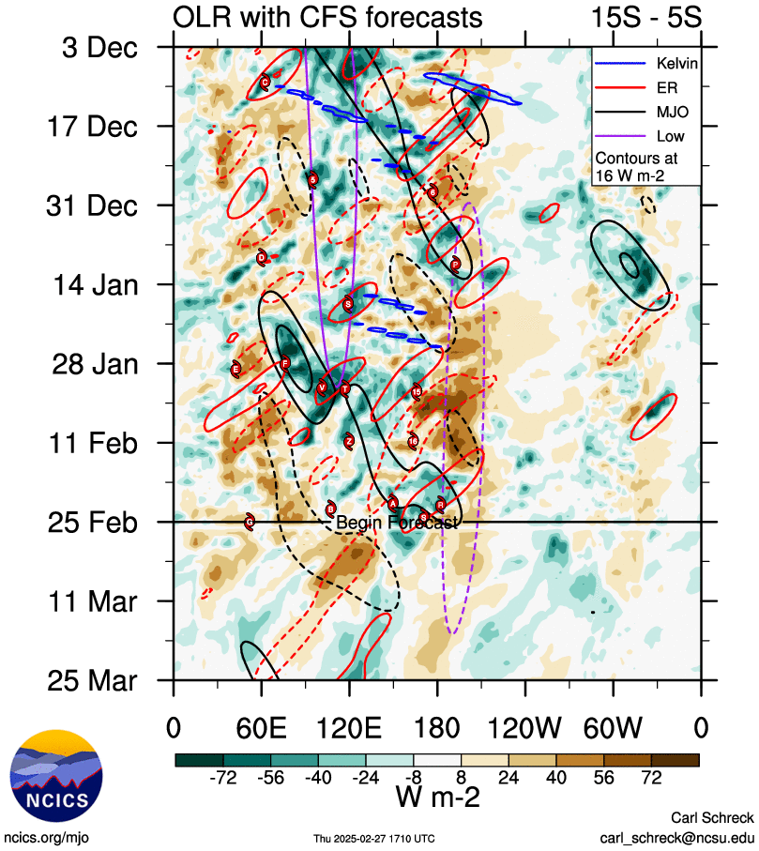

Figure 2 Hovmoller diagram of tropical waves showing the formation of Zelia (denoted by the red dot labelled "Z") occurred during a weakening Equatorial Rossby (ER) Wave (red), and after the MJO (black) had moved into the area east of the Maritime Continent. The image is courtesy of the North Carolina Institute for Climate Studieshttps://ncics.org/pub/mjo/archive/2025/2025-02-20/v2/

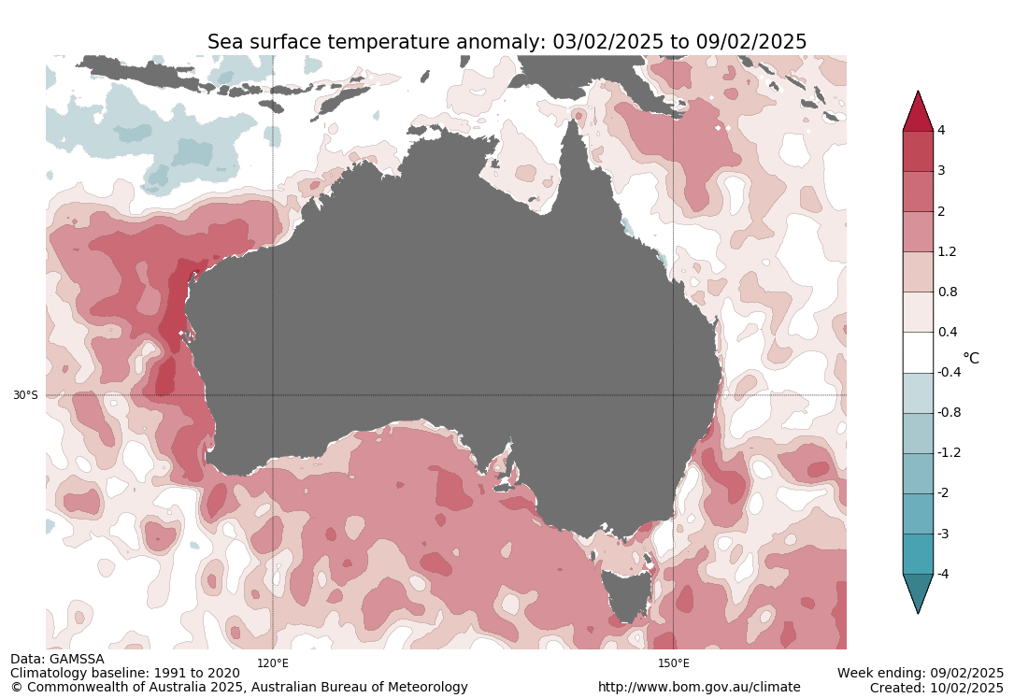

Figure 3 Sea Surface anomalies for the week ending 9 February 2025, showing sea surface temperatures 1 to 3 degrees above normal, north of the Pilbara coast where Zelia intensified. The image is courtesy of The Bureau of Meteorology. http://www.bom.gov.au/climate/ocean/sst/#/anom/australia/weekly/20250209

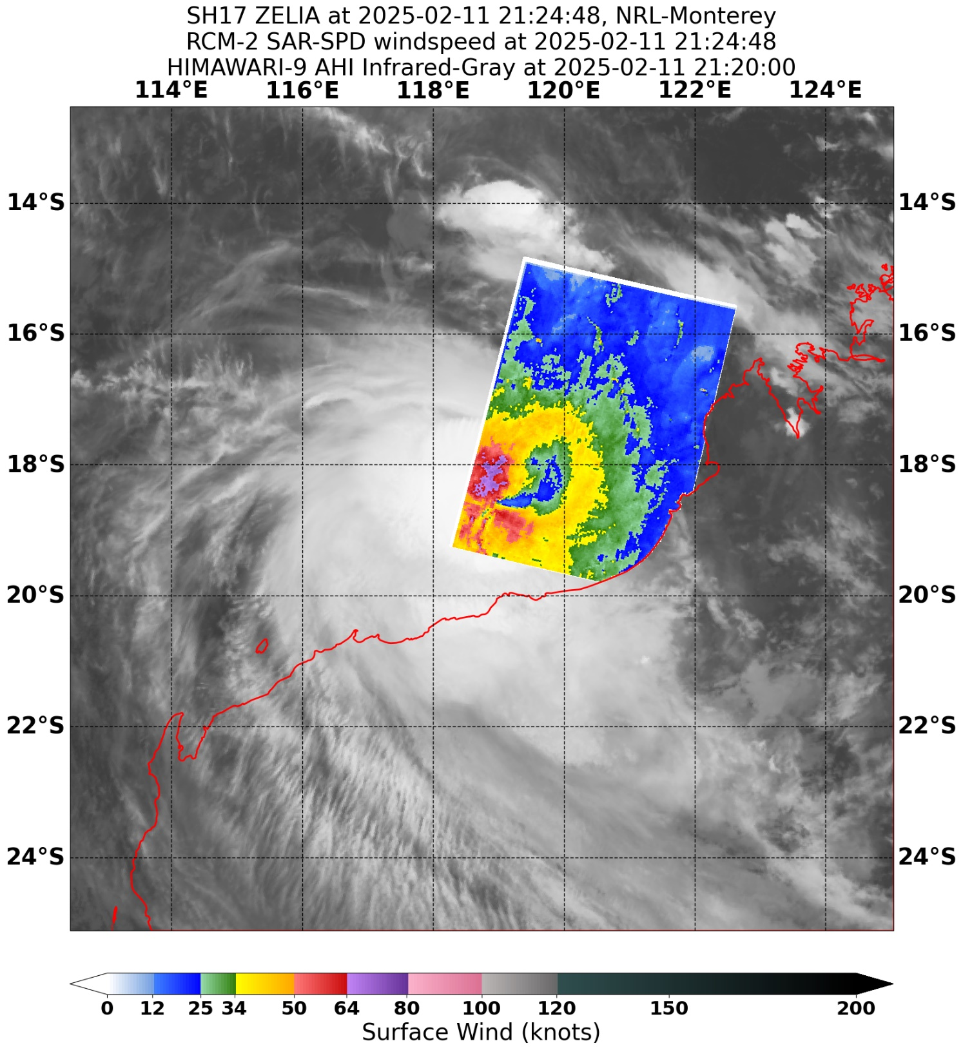

Figure 4 Synthetic Aperture Radar (SAR) pass at 2124 UTC 11 February, showing gales around the system, just after Tropical Cyclone Zelia first reached category 1 tropical cyclone strength at 1800 UTC 11 February. Image courtesy NOAA. https://www.star.nesdis.noaa.gov/socd/mecb/sar/sarwinds_tropical.php

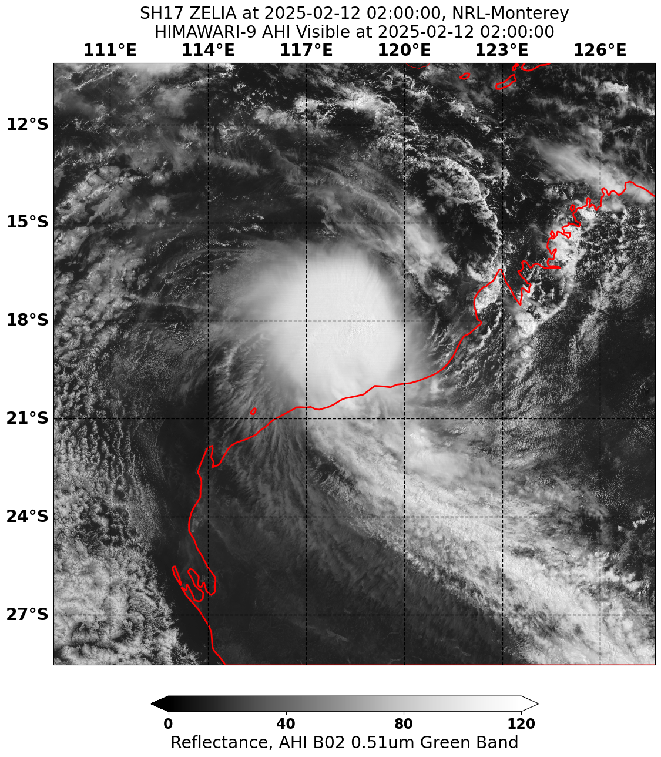

Figure 5 Himawari-9 Visible Satellite Imagery at 0200 UTC 12 February showing fanning cirrus in the southeast and northwest quadrants. Image courtesy of Japan Meteorological Agency (JMA).

|  |  |
| --- | --- |
| Colourful image of a microwave sensor SSMIS F17 at 1050 UTC 12 February. It shows the eye of Severe Tropical Cyclone Zelia | Colourful image of a microwave sensor SSMIS F17 at 1050 UTC 12 February. It shows the eye of Severe Tropical Cyclone Zelia |

Figure 6 Microwave Imagery from SSMIS F17 at 1050 UTC 12 February with the 37 GHz sensor (left) and the 91 GHz sensor (right) showing the eye of Severe Tropical Cyclone Zelia. Images courtesy NRL: https://www.nrlmry.navy.mil/TC.html

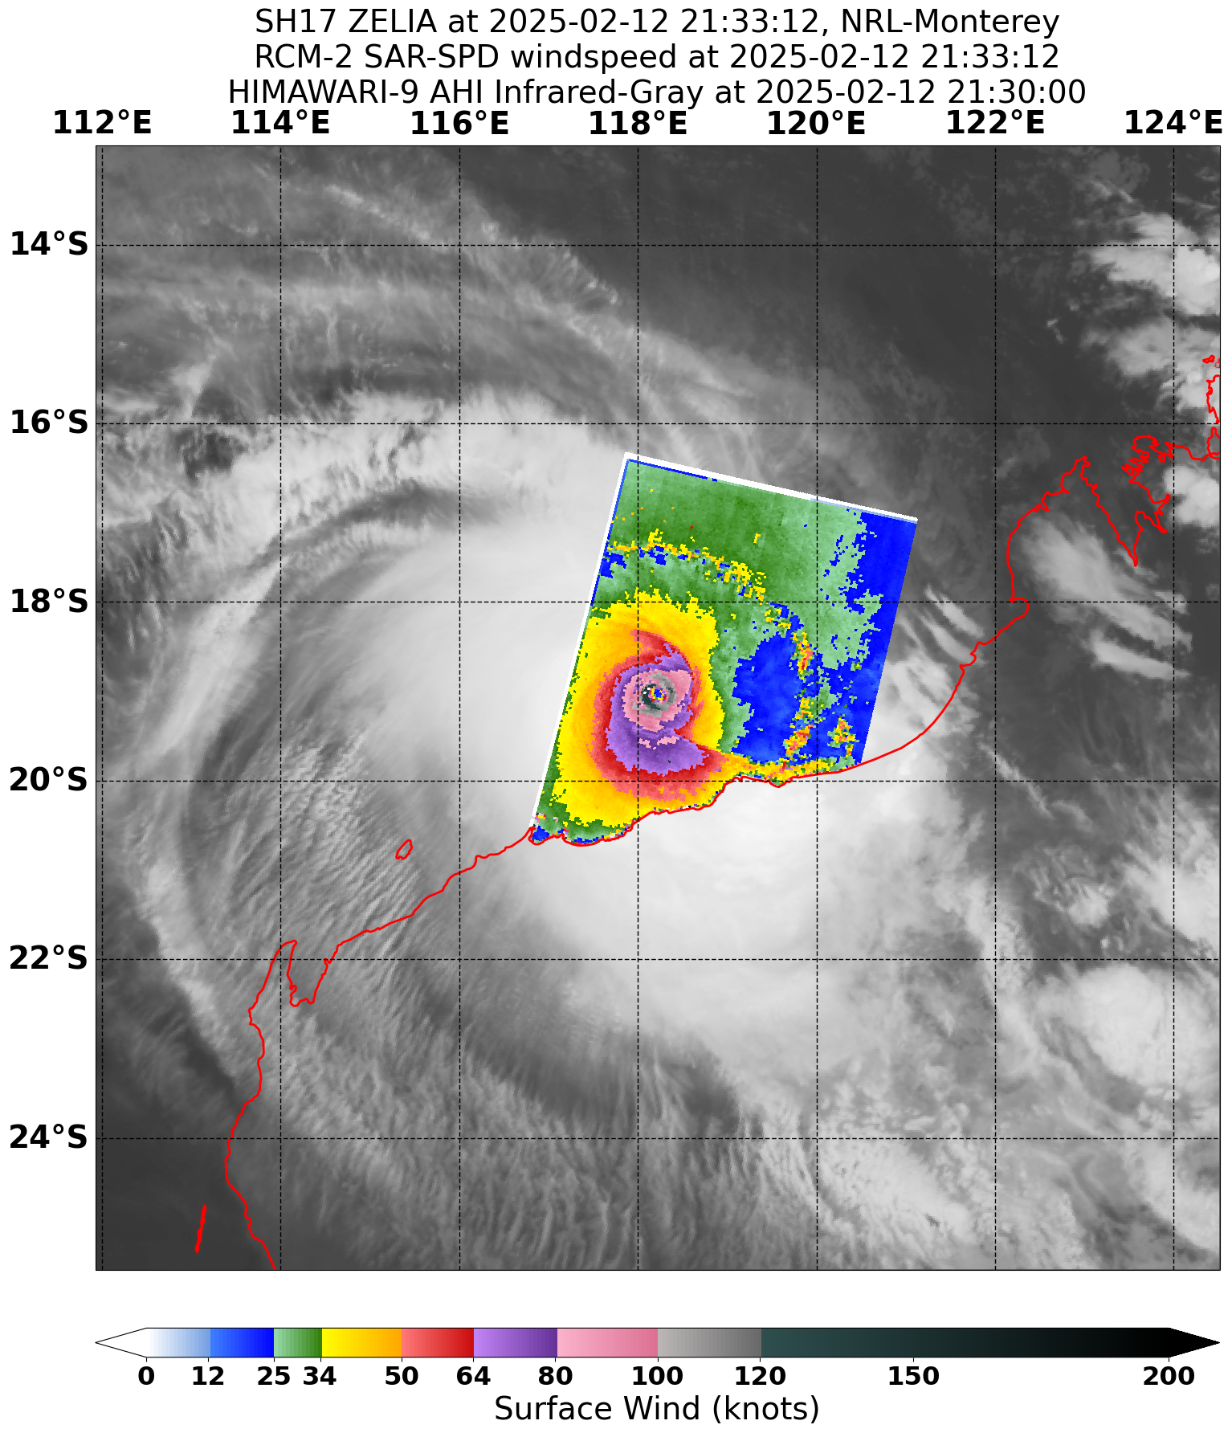

Figure 7 Synthetic Aperture Radar (SAR) pass at 2133 UTC 12 February, just after going through rapid intensification and showing the larger radii of gale (85 nm (157 km)) and storm force (70 nm (130 km)) winds in the southwest quadrant. Maximum wind speeds of 123 kn (1 min mean) (228 km/h) or around 115 kn (10 min mean) (213 km/h) can be seen in the southwest quadrant. This image is about 12 hours before peak intensity at 1200 UTC 13 February. Image courtesy NOAA. https://www.star.nesdis.noaa.gov/socd/mecb/sar/sarwinds_tropical.php

|  |  |
| --- | --- |
| A satellite image with the clouds shaded in colour to represent the depth of the cloud. A bright yellow area of cloud near the centre of Tropical Cyclone Zelia shows the area of most intense convection. | Colour composite microwave imagery from SSMIS at 1036 UTC 13 February showing a compact system with an eye visible. |

Figure 8 EIR satellite imagery from Himawari-9 at 1200 UTC 13 February (left) and colour composite microwave imagery from SSMIS F17 at 1036 UTC 13 February (right). Both images show Zelia as a compact system at and in the hours before peak intensity at 1200 UTC. Images courtesy NRL: <https://www.nrlmry.navy.mil/TC.html>

* 1. Structure

Zelia was a small tropical cyclone throughout its lifetime. Gales initially developed in the southwest quadrant during 11 February, before occurring in all quadrants early on 12 February. Gale radii were largely observed between 60 and 80 nm (110 – 150 km) when it was located north of the coast. The larger gale radii initially occurred in the western quadrants (consistent with the northeasterly vertical wind shear) before being observed in the southern quadrants on the 13 February and becoming mostly symmetrical with a radius of about 70 nm (130 km) from early on the 14 February. Gale radii contracted to 40 nm (75 km) as it moved towards the coast, contracting to about 20 to 30 nm (35 - 55 km/h) as it weakened over land.

Storm force radii were generally 30 to 45 nm (55 - 85 km) over the lifetime of the system, decreasing to 15 to 30 nm (30 - 55 km) as it crossed the coast and moved over land. The radii temporarily extended out to 70 nm (130 km) in the southwest quadrant for 6 hours early on 13 February as the system started to rapidly intensify (observed by SAR FCM-17 2133 UTC 12 February (Figure 7) and AMSR2 1714 UTC 12 February).

The radius to maximum winds (RMW) was initially 30 nm (55 km) before contracting to 8 nm (15 km) on 13 February as it underwent rapid intensification. This was evident on radar imagery.

* 1. Motion

Zelia was initially steered to the west and then southwest tracking around the periphery of the mid-level ridge which was located to the southeast of the system. During 11 February the system started moving to the south as the mid-level ridge to the east started breaking down due to the amplification of the trough to the south. The system became slow moving on the 12 and 13 February while located in a col with mid-level anticyclones to the east and west, and an upper trough passing to the south, providing balanced steering influences (Figure 9). From early 14 February the trough moved into the Great Australian Bight, causing the anti-cyclone over central Australia to become the dominant steering influence, and Zelia moved to the southeast before crossing the coast later that day.

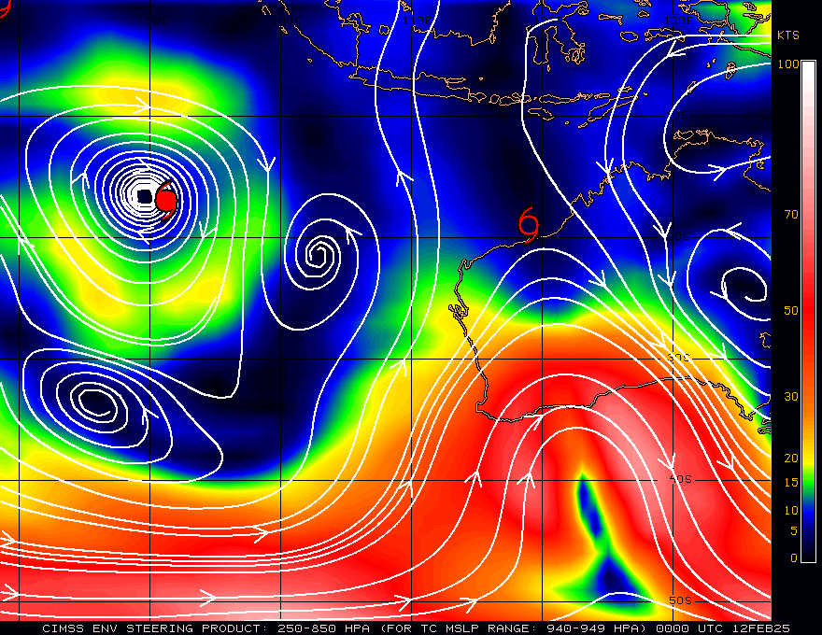

Figure 9 CIMMS Analysis of Deep Layer Mean (DLM) Steering (250-850 hPa) at 0000 UTC 12 February, showing Zelia (near Western Australia) in a col between two anti-cyclones and a trough to the south. Image courtesy of CIMMS/University of Wisconsin-Madison. https://tropic.ssec.wisc.edu/archive/

1. Impact

Rainfall and flooding caused significant impacts. The most notable river height record was observed at Marble Bar where the river peaked at 10.23 m on the morning of 15 February, around 2 metres above the previous record of 8.3 m from 1998. The Great Northern Highway was cut at Coolenar Pool for an extended period of time, isolating Pilbara and Kimberley communities from southern Western Australia. Evacuations from the remote communities of Warralong and Gooda Binya were conducted during the rising flood. Many secondary roads throughout the inland areas of the Pilbara were affected with many communities isolated as a result.

The closures of ports at Port Hedland (three days), Cape Lambert and Dampier disrupted shipping and combined with disruptions to offshore oil and gas operations resulted in significant economic costs to industry. ([ABC News Article 17/2/25](https://www.abc.net.au/news/2025-02-17/tropical-cyclone-zelia-economic-impact-damage-assessment/104943126))

Damage was reported at De Gray and Carlindi Pastoral Stations, closest communities to where the system and destructive core crossed the coast. This included structural damage to the homestead at Carilie and significant damage to outbuildings, solar panels and sheds at both stations ([ABC New Article 15/2/25](https://www.abc.net.au/news/2025-02-15/tropical-cyclone-zelia-update-flood-marble-bar-dfes/104940154) and [Cyclone Testing Station, Technical Report TC Zelia, 2025](https://www.jcu.edu.au/__data/assets/pdf_file/0003/2242443/250307-Draft-TC-Zelia-report-1.pdf)).

The Port Hedland area had damage to trees but little structural damage to buildings due to wind loads alone. Some buildings reported minor water ingress through windows. ([Cyclone Testing Station, Technical Report TC Zelia, 2025](https://www.jcu.edu.au/__data/assets/pdf_file/0003/2242443/250307-Draft-TC-Zelia-report-1.pdf))

1. Observations
   1. Wind

Damaging winds were recorded at Rowley Shoals, Bedout Island and Port Hedland as well as Marble Bar and Ironbridge Airport as the system moved inland. The Bureau of Meteorology had access to non-standard height observations (not 10m) from Pilbara Port Authority within Port Hedland Port and up to 20 nm offshore. Adjusted to an equivalent 10 m mast, most of the locations offshore observed destructive winds on the 14 February as Zelia approached and crossed the coast to the east of Port Hedland.

No observation locations recorded very destructive wind gusts.

The highest wind gust reported on a standard AWS was at Port Hedland with 65 knots (120 km/h) at 0633 UTC 14 February. The strongest 10-minute sustained winds were recorded at Port Hedland with 47 kn (88 km/h) at 0655 UTC 14 February.

A summary of the stations that reported damaging winds or stronger is included below.

**Rowley Shoals** had 24 hours of gales observed from 0133 UTC (0933 AWST) 11 February to 0218 UTC (1018 UTC) 12 February. The AWS did record a 10-minute period of storm force winds between 1718 UTC and 1727 UTC and again from 2008 UTC and 2020 UTC on 11 February. However, because it was so short in duration and a clear pass from SAR RCM-2 2124 UTC 11 February does not indicate storm force in the north or northwest quadrant these were attributed to localised thunderstorm activity within the gale radii. The highest gust reported at Rowley Shoals was 64 kn (118 km/h) at 1722 UTC 11 February (0122 AWST 12 February).

**Bedout Island** reported intermittent gales between 1350 UTC (2150 AWST) 11 February and 2041 UTC 13 February (0441 AWST 14 February). However, Bedout Island often had long periods of observations not being reported and cannot always be taken as a reliable reading.

**Port Hedland** experienced damaging winds in the periphery of the cyclone for about seven hours on 14 February as Zelia approached and made landfall. It first reported gale force winds at 0047 UTC (0833 AWST) until 0740 UTC (1540 AWST). Highest gust and mean wind reported above.

**Marble Bar** experienced gale force winds for about an hour between 1111 UTC (1911 AWST) and 1213 UTC (2013 AWST) 14 February as the weakening cyclone tracked 15 kilometres to the west. The highest gust recorded was 54 kn (109 km/h) at 1203 UTC (2003 AWST) 14 February.

**Ironbridge Airport** recorded gales between 0944 UTC (1744 AWST) to 1040 UTC (1840 AWST) 14 February. It reported a highest wind gust of 51 kn (94 km/h) at 0956 UTC (1756 AWST).

* 1. Rainfall

The event produced record 4-day rainfall totals (between 12 to 15 December) at De Grey and Pardoo stations, each receiving over 678.4 mm and 555.4 mm respectively. They both reported their highest February daily rainfall total with Pardoo recording 228 mm to 9am 13 February and De Grey 261 mm to 9am 14 February.

Other notable sites include Marble Bar TM and Upper North Pole recording daily totals of 202.8 mm and 278.2 mm respectively in the 24 hours to 9am 15 February, as the system moved inland. These sites also had data to show that heavy rainfall occurred in short amounts of time, with 193 mm falling in 6 hours (1450 – 2050 AWST 14 February) at Upper North Pole, exceeding the 6-hourly 1% Annual Exceedance Probability (AEP) and Marble Bar TM recorded 186 m in 12 hours (0910 – 2110 AWST 14 February), exceeding the 12 hourly 1% AEP.

Other sites around the Pilbara recorded event totals of 200 – 350 mm between 11 and 15 February. A map of the event totals is shown in Figure 10.

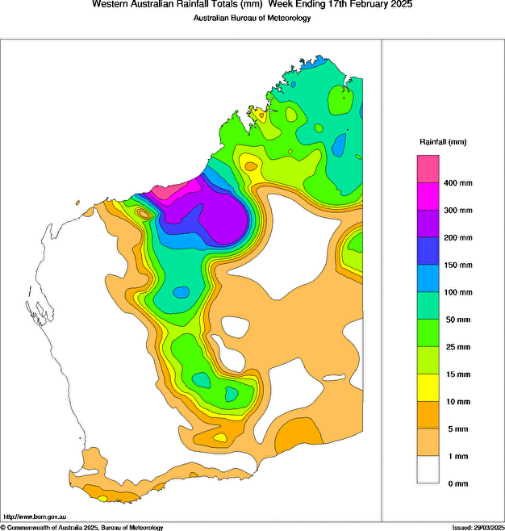

Figure 10 Rainfall analysis for the 7 days to 17 February 2025 showing heaviest falls mainly confined to the coast on and east of Port Hedland, with falls 150-300 mm extending inland towards Marble Bar, as the system moved overland.

* 1. Storm Surge

The system made landfall near the De Gray River Mouth, about 64 km to the east of Port Hedland. While tides above HAT were predicted to the east of the system as it made landfall, there were no reports of storm surge occurring to the east of system, most likely due to the remoteness and lack of permanent human habitation along this coastline. The closest sea tide observation location, at Port Hedland was in an offshore flow and thus had no storm surge impact from this system.

1. Forecast Performance

Zelia was a challenging system to forecast, both for intensity and position with a very large spread in ensemble and deterministic model guidance. This was probably largely due to the light steering pattern Zelia encountered, being a small system and the proximity to land. The accuracy statistics for Severe Tropical Cyclone Zelia are below in Table 2 and shown in Figure 14 and Figure 15.

|  |  |  |  |  |  |  |  |  |  |
| --- | --- | --- | --- | --- | --- | --- | --- | --- | --- |
| Time | 00 | 06 | 12 | 18 | 24 | 36 | 48 | 72 | 120 |
| Position accuracy (km) | 18 | 42 | 67 | 85 | 96 | 115 | 126 | 123 | 227 |
| Intensity accuracy (knots) | 3.5 | 8.7 | 12.3 | 16.2 | 18.5 | 23.4 | 25.8 | 28.8 | 66.9 |
| Sample size | 27 | 27 | 26 | 25 | 24 | 22 | 20 | 16 | 8 |

Table 2 Verification statistics for Severe Tropical Cyclone Zelia. Note: Verification is performed using the Official Forecast Tracks at the standard times of 00, 06, 12 and 18 UTC.

The first seven-day forecast issued was on the morning of 4 February, indicating a Low (5-10%) risk of the system being a tropical cyclone on 10-12 February. As the risk increased, the first public Advice was issued on 8February, showing Zelia possibly developing into a severe tropical cyclone and impacting the Kimberley and Pilbara coast. The spread of the model guidance produced large confidence cones, with a bulge to the west, indicating the system may track to the west and parallel to the Pilbara coast, rather than crossing it. The intensity forecast was similarly divergent, with ECMWF having a large variation in intensity and US GFS continuing with quite weak systems for the first few days of guidance. Figure 11 shows the forecast issued at 0053 UTC (0853 AWST) 9 February and Figure 12 shows the ensemble guidance with corresponding confidence areas and intensity estimates.

The large spread in the ensemble outputs was primarily caused by the finely balanced steering pattern governing Zelia's motion during 12 and 13 February. Slight changes to the strength of the anticyclones to the east and west and the amplifying trough to the south produced forecast scenarios that ranged from an eastward moving system that impacted the Kimberley coast, a system that moved south and impacted the Pilbara coast or a system that moved west and never impacted the coast. The differing direction of motion forecasts had implications for the intensity spread of the ensembles, systems that were steered east and impacted the Kimberley tended to be weaker while those that spent longer over water had time to become very intense tropical cyclones. The larger than usual spread in ensembles persisted through until the time of coastal crossing with Figure 13 showing the ensemble guidance spread at 0000 UTC 14 February (coastal crossing occurred at 0400 UTC) from 1200 UTC ensemble runs on the 10 to 13 February.

Despite this uncertainty, the forecasts issued by the Bureau of Meteorology was comparable to the five year average (2019/20-2023/24) for both intensity (Figure 14) and position (Figure 15) accuracy. The position accuracy was generally as good or better than the five-year average. Intensity forecast was comparable to the five-year average up to 36 hours, and up to 96 hours, always within 1 standard deviation of the five-year average. The 120-hour intensity forecast was much larger than the five-year average but may be explained by having only 3 analysis positions over land after Zelia crossed the coast, reducing sample size available to verify against.

Some of the guidance has similar accuracy to the Bureau's intensity forecast accuracy or had intensity accuracy that was slightly closer to the five-year average for Zelia. However, the forecasts issued by the Bureau of Meteorology has a smaller forecast bias and less variation in that bias, particularly in the 36 to 96 hour forecast period. These results are shown in Figure 16.

Forecast Track Maps were issued from 0924 AWST 8 February to 0258 AWST 15 February (59 total). Ocean Wind Warnings were issued from 0956 AWST 11 February to 2027 AWST 14 February. Technical Bulletins were issued from 1501 AWST 11 February to 0313 AWST 14 February.

|  |  |
| --- | --- |
| Forecast track map issued at 0053 UTC 9 February showing track crossing the coast on 12 February between De Grey and Wallal Downs as a category 3 system. The map also shows the watch region between Cockatoo Island and De Grey. | Colourful dots and lines from model guidance indicating where the position of the tropical cyclone may be at 0000 UTC 14 February. The blue shading shows the confidence areas for 50 percent and 70 percent. A graph with colourful lines showing the intensity of the dots over time. |
|  | |

Figure 11 (left) Track Map issued at 0853 AWST (0053 UTC) 9 February, which incorporated some of the guidance in Figure 11.

Figure 12 (right) The spread of possible forecast locations in the ensemble model guidance for Severe Tropical Cyclone Zelia at timestep 0000 UTC 14 February (just before landfall) (right upper). The time series, bottom right, showing the variation in intensity forecasts from ensemble members. Model run is 1200 UTC 8 February for ECMWF (orange), US GFS (pink), UKMO (brown) and ACCESS-G (purple). The blue shaded area is the 50% and 70% confidence areas for those dots.

|  |  |
| --- | --- |
| Colourful dots and lines from model guidance indicating where the position of the tropical cyclone may be at 0000 UTC 14 February. The blue shading shows the confidence areas for 50 percent and 70 percent. A graph with colourful lines showing the intensity of the dots over time. | Colourful dots and lines from model guidance indicating where the position of the tropical cyclone may be at 0000 UTC 14 February. The blue shading shows the confidence areas for 50 percent and 70 percent. A graph with colourful lines showing the intensity of the dots over time. |
| Colourful dots and lines from model guidance indicating where the position of the tropical cyclone may be at 0000 UTC 14 February. The blue shading shows the confidence areas for 50 percent and 70 percent. A graph with colourful lines showing the intensity of the dots over time. | Colourful dots and lines from model guidance indicating where the position of the tropical cyclone may be at 0000 UTC 14 February. The blue shading shows the confidence areas for 50 percent and 70 percent. A graph with colourful lines showing the intensity of the dots over time. |

Figure 13 The spread of possible forecast locations in the ensemble model guidance for Severe Tropical Cyclone Zelia at timestep 0000 UTC 14 February (just before landfall). Images from top left to bottom right (going across and then down) are model runs at 1200 UTC on 10, 11, 12 and 13 February for ECMWF (orange), US GFS (pink), UKMO (brown) and ACCESS-G (purple). The time series below each graphic of dots shows the variation in intensity forecasts from ensemble members. The blue shaded area is the 50% and 70% confidence areas for those dots.

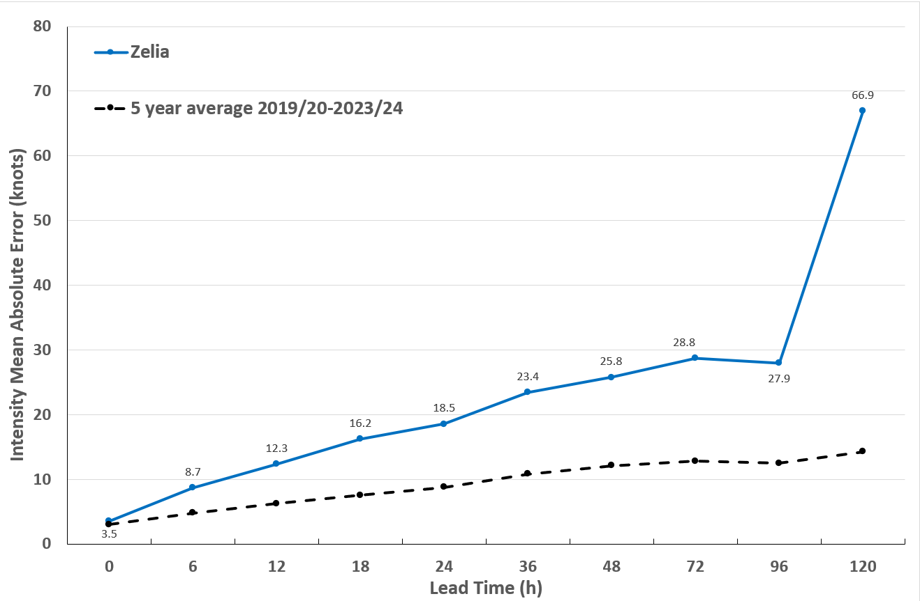

Figure 14 Intensity accuracy figures for Severe Tropical Cyclone Zelia.

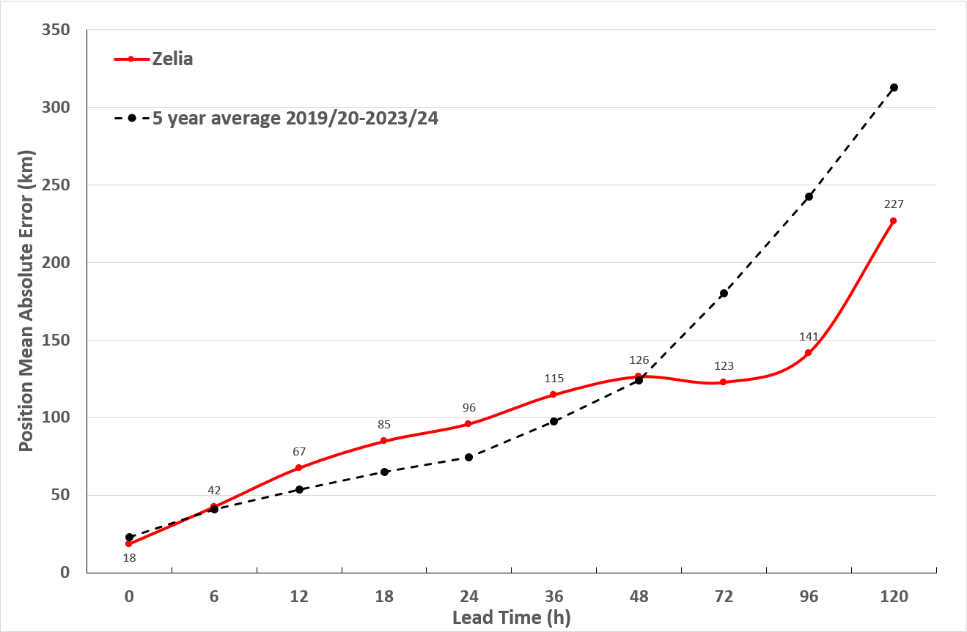

Figure 15 Position accuracy figures for Severe Tropical Cyclone Zelia.

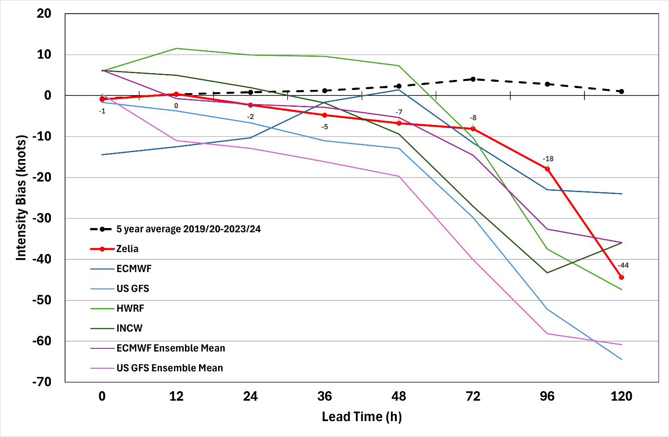

Figure 16 Intensity Bias figures for Severe Tropical Cyclone Zelia compared against guidance from ECMWF, US GFS, HWRF, INCW, ECMWF Ensemble Mean and US GFS Ensemble Mean.

1. Appendix: List of Abbreviations

|  |  |
| --- | --- |
| Abbreviation | Term |
| ADT | Advanced Dvorak Technique |
| ACST | Australian Central Standard Time |
| AEST | Australian Eastern Standard Time |
| AiDT | AI-enhanced Dvorak Technique |
| AMSR2 | Advanced Microwave Scanning Radiometer |
| AMSU | Advanced Microwave Sounding Unit |
| ASCAT | Advanced Scatterometer |
| ATMS | Advanced Technology Microwave Sounder |
| AWS | automatic weather station |
| AWST | Australian Western Standard Time |
| °C | Celsius |
| CI | Current intensity |
| CIMSS | Cooperative Institute for Meteorological Satellite Studies (USA) |
| CIRA | Cooperative Institute for Research in the Atmosphere (USA) |
| D-MINT | Deep learning - Multispectral Intensity of TCs (formerly known as DMN) |
| DT | Data T-number |
| ECMWF | European Centre for Medium Range Weather Forecasts |
| EIR | Enhanced InfraRed |
| ERC | eyewall replacement cycle |
| FNMOC | Fleet Numerical Meteorology and Oceanography Centre (USA) |
| FT | Final T-number |
| GCOM | Global Change Observation Mission |
| GHz | Gigahertz |
| GMI | Global Precipitation Measurement Microwave Imager |
| h | hour |
| hPa | hectopascal |
| HSCAT | Hai Yang 2 Scatterometer (HY-2B, HY-2C) |
| HWRF | Hurricane Weather Research and Forecasting Model |
| INCW | Intensity Consensus W |
| km | kilometres |
| km/h | kilometres per hour |
| kn | knot |
| LLCC | LLCC |
| MET | Model Expected T-number |
| METOP | Meteorological Operational Satellite |
| MJO | Madden-Julian Oscillation |
| mm | millimetres |
| MSLP | mean sea level pressure |
| NESDIS | National Environmental Satellite, Data, and Information Service |
| nm | nautical mile |
| NOAA | National Oceanic and Atmospheric Administration |
| NRL | Navy Research Lab (USA) |
| OPEN-AiiR | Ordered Pattern Encoding AI Infrared |
| PAT | Pattern T-number |
| RCM | RadarSat Constellation Mission – Synthetic Aperture Radar |
| RH | relative humidity |
| RMW | radius of maximum winds |
| RSMC | Regional Specialised Meteorological Centre |
| SAR | Synthetic Aperture Radar |
| SATC | CIMSS Advanced Dvorak Technique |
| SATCON | Satellite Consensus |
| SEN1 | Sentinel-1A – Synthetic Aperture Radar |
| SMAP | Soil Moisture Active Passive |
| SMOS | Soil Moisture and Ocean Salinity |
| SSMIS | Special Sensor Microwave Imager/Sounder |
| TC | Tropical Cyclone |
| TCWC | Tropical Cyclone Warning Centre |
| UKMO | United Kingdom Meteorological Office |
| US GFS | United Staes Global Forecast System |
| UTC | Universal Time Co-ordinated |

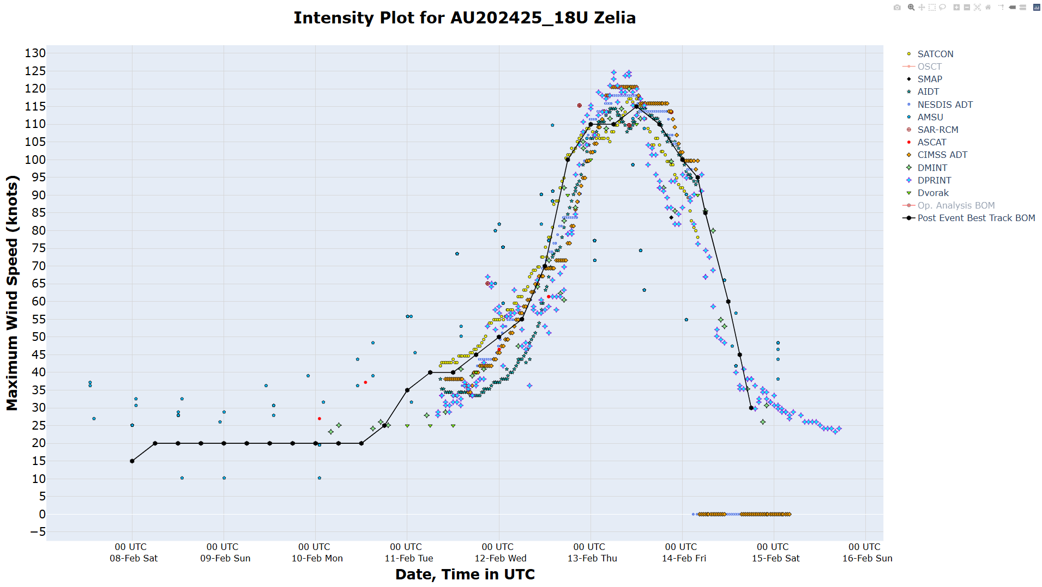

Figure 17 Comparison of objectivity intensity analysis aids and the Post Event Best Track for Severe Tropical Zelia