# Met Office global ensemble prediction developments

## Authors Warren Tennant, Neill Bowler and Helen Titley

*Weather Science, Met Office, Exeter, United Kingdom*

*warren.tennant@metoffice.gov.uk*

**Introduction**

The Met Office Global and Regional Ensemble Prediction System (MOGREPS) has been operational since 2008 (Bowler *et al.*, 2008). The current global model technical details are shown in Table 1. The global ensemble (MOGREPS-G) configuration has generally favoured spending more of the compute resource on resolution than ensemble size, but we boost the latter by lagging the two most recent forecast cycles to form a combined ensemble size of 36 members every six hours. All post-processing is driven this way.

**Initial condition perturbations**

Initial condition perturbations are generated by the Ensemble Transform Kalman Filter (ETKF) scheme (Bishop *et al*, 2001). This uses a 6-hour background forecast from each ensemble member and observations valid during this assimilation window to produce initial perturbations for the next cycle. This is done using a transform matrix and inflation scheme such that the ensemble spread matches the 6-hour forecast error of the ensemble mean in each of 92 equal-sized regions around the globe. A vertically-varying inflation scheme applied over four layers ensures a more realistic vertical distribution of spread.

MOGREPS-G has used the ETKF scheme since it became operational, but this will be replaced by an ensemble of 4D-ensemble-Var (En-4DEnVar) scheme (Bowler *et al.*, 2017) during 2019. The main advantage of En-4DEnVar is that it uses existing code within the deterministic 4D-Var data assimilation system (Clayton *et al.*, 2013), including sophisticated model-based localisation. This also aligns the deterministic data assimilation background error covariances more with the ensemble.

**Table** **1**: Technical details of the Met Office operational global deterministic and ensemble modelling systems in 2018. Red text denotes changes that went operational in OS41 during September 2018.

|  |  |  |
| --- | --- | --- |
|  | **Deterministic** | **Ensemble (MOGREPS-G)** |
| **Resolution**  **(grid points)** | 2560x1920 regular lat/lon  ~10km in mid-latitudes | 1280x960 regular lat/lon  ~20km in mid-latitudes |
| **Vertical levels & Time-step** | 70 levels (model top 80 km)  Time-step = 4min | 70 levels (model top 80 km)  Time-step = 7.5min |
| **Science configuration** | Atmosphere: GA6.1 – Walters *et al* (2017a)  Land: GL8.1 – Walters *et al*. (2017b) | Atmosphere: GA6.1 – Walters *et al* (2017a)  Land: GL8.1 – Walters *et al*. (2017b) |
| **Forecast length & frequency** | 7-days at 00Z and 12Z  2.5-days at 06Z and 18Z | 17 pert + 1 control = 18 members to 7-days every 6 hours. Lag two cycles = 36-mem |
| **Initial conditions** | hybrid-4D-Var | Interpolated from high-resolution deterministic analysis |
| **Initial condition perturbations** | none | Ensemble Transform Kalman Filter (using 44 members) |
| **Stochastic physics** | none | SKEB + Stochastic Perturbation of Tendencies (SPT) (Sanchez *et al*., 2016) |
| **Surface perturbations** | none | SST, soil-moisture and deep soil-temperature (Tennant and Beare, 2014) |

**Stochastic physics perturbations**

MOGREPS-G has utilised a number of stochastic physics schemes to address model uncertainty. The factors that have played a role in choosing these include physical realism or justification (e.g. a missing physical process in the model), ease of implementation and ongoing maintenance, compute resource cost, and effectiveness in controlling ensemble spread.

**Random Parameters (RP2)**

The first scheme used in MOGREPS-G was a form of perturbed parameters, where a selection of physics parametrization scheme parameter settings are perturbed globally within a prescribed range, using a random AR1 process to evolve these values over time. This scheme did a reasonable job at increasing the spread in screen temperature and precipitation, but generally only had a modest impact on increasing large-scale ensemble spread and also involves a large overhead to maintain relevant parameters and sensible perturbation ranges. For these reasons, it was retired in Operational Suite 41 (OS41) that went live in September 2018.

**Stochastic Kinetic Energy Backscatter (SKEB)**

The primary stochastic physics scheme in MOGREPS-G for many years has been the SKEB scheme (Tennant *et al.*, 2011). This uses diagnosed 3D fields of energy loss, from missing physical processes in the forecast model convection scheme and smoothing from the semi-Lagrangian advection scheme, to modulate an evolving random pattern with a prescribed power-spectrum. This produces wind-increments at each forecast time-step. The scheme was upgraded at OS41 to improve the features of the random pattern in high-latitudes and to make the scheme more scale-aware (Sanchez *et al.*, 2016).

**Stochastic Perturbation of Tendencies (SPT)**

SPT, more generally known as Stochastically Perturbed Physics Tendencies (SPPT, Buizza et al., 1999), perturbs the tendencies from selected physics parametrization schemes within a range, centred on zero, as forced by a 3D random pattern with prescribed horizontal length-scales. This pattern also evolves over time using an AR1 process. This scheme is simple and can be calibrated to provide the correct amount of spread in an ensemble. However, it has encountered stability issues in the Unified Model and a fair amount of work has been done to improve its stability and conservation of mass and energy properties, e.g. along sloping vertical coordinates (Sanchez *et al.*, 2016). SPT was implemented in MOGREPS-G at OS41.

**Analysis Increments (AI)**

This scheme uses analysis increments from an archive of the operational 4D-Var data assimilation system, which are reconﬁgured to the ensemble resolution and applied at each model time step over a window of 6 hours for each ensemble member (Piccolo *et al.*, 2018). Every 6 hours a new random set of analysis increments is selected and applied to the forecast model. Preliminary experiments showed that the growth-rate of ensemble spread can be better controlled than before using this scheme (Fig. 1). The optimal impact is seen when using increments from the appropriate season, which could either be from a three-month lagged archive or from the same season from a previous year. While these increments do not represent the flow-dependent structures at the time of the forecast, they do retain the full geographical variation of the systematic errors of the forecast model, which may beneﬁt both the reliability and the resolution of the ensemble.

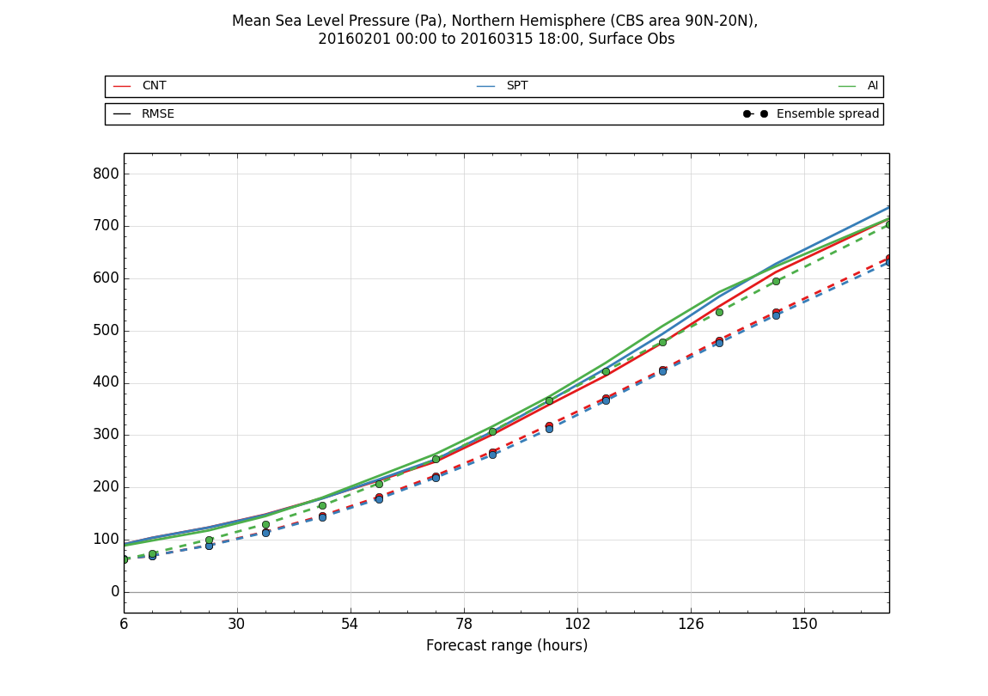

Figure 1: RMSE of the ensemble mean (solid) and ensemble spread (dashed) mean-sea level pressure forecasts by lead-time verified against Northern Hemisphere observations for operational ETKF MOGREPS-G control (red), SPT scheme (blue) and AI scheme (green).

**Tropical cyclone forecasts**

At the Met Office, tropical cyclone tracking is run in real-time on the MOGREPS-G, ECMWF EPS and NCEP GEFS ensembles. The three ensembles are also combined into a 108-member multi-model ensemble. A range of products, including track and intensity forecasts for both named and forming storms, are produced and distributed to several operational tropical cyclone forecasting centres. The probabilistic forecasts from each global ensemble, and the various multi-model combinations, are evaluated using a probabilistic verification framework. Generally, the three systems are comparable, with no single system showing the best score in all ocean basins (Fig. 2). However, a combined multi-model ensemble has the highest score throughout, clearly showing the benefit of data exchange to help improve guidance for high-impact weather events such as these.

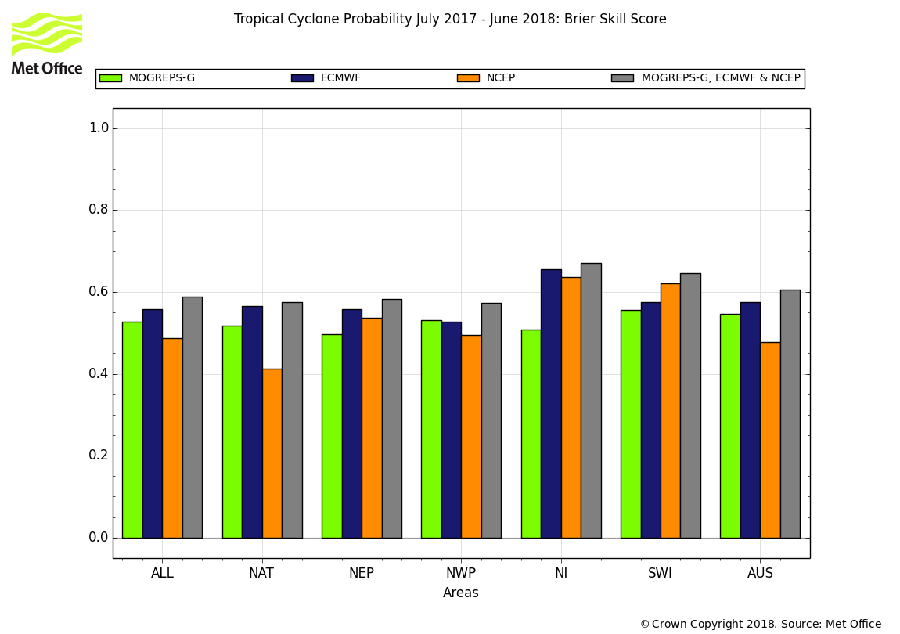

Figure 2: Brier Skill Score of MOGREPS-G (green), ECMWF EPS (blue), NCEP GEFS (orange) and multi-model ensemble forecasts (grey) of strike probability for all named storms in the period July 2017 to June 2018. These are split by tropical cyclone basin – North Atlantic (NAT), northeast Pacific (NEP), north Indian (NI), southwest Indian (SWI) and Oceana (AUS).

**Summary and future work**

MOGREPS-G ranks among the top-performing global ensemble prediction systems. Recent upgrades to the stochastic physics and the upcoming move to En-4DEnVar is expected to make significant improvements to the ensemble skill and reliability. It is acknowledged that MOGREPS-G is somewhat under-dispersive for some forecast fields, something which should be reduced with upcoming upgrades. We are also investigating options to target the spread around tropical cyclones through the use of targeted perturbed observations in those locations.

# References

Bishop, C.H., Etherton, B.J., Majumdar, S.J. 2001: Adaptive sampling with the ensemble transform Kalman filter. Part I: Theoretical aspects. Mon. Wea. Rev. 129, 420-436.

Bowler N.E., Arribas A., Mylne K.R., Robertson K.B., Beare S.E. 2008: The MOGREPS short-range ensemble prediction system. Q. J. R. Meteorol. Soc. 134, 703-722.

Bowler N.E., Clayton A.M., Jardak M., Lee E., Lorenc A.C., Piccolo C., Pring S.R., Wlasak M.A., Barker D.M., Inverarity G.W, Swinbank R. 2017: Inﬂation and localization tests in the development of an ensemble of 4D-ensemble variational assimilations. Q. J. R. Meteorol. Soc., 143: 1280-1302. doi: 10.1002/qj.3004.

Buizza R., Miller M., Palmer T.N.. 1999: Stochastic representation of model uncertainties in the ECMWF ensemble prediction system. Q. J. R. Meteorol. Soc., 125: 2887-2908

Clayton A.M., Lorenc A.C., Barker D.M. 2013: Operational implementation of a hybrid ensemble/4D-Var global data assimilation system at the Met Ofﬁce. Q. J. R. Meteorol. Soc., 139: 1445–1461. doi: 10.1002/qj.2054.

Piccolo, C., Cullen, M., Tennant, W., Semple, A. 2018: Comparison of different representations of model error in ensemble forecasts. Q. J. R. Meteorol. Soc. *(accepted)*. doi:10.1002/qj.3348

Sanchez, C., Williams, K.D., Collins, M. 2016: Improved stochastic physics schemes for global weather and climate models. Q. J. R. Meteorol. Soc., 142, 147–159. doi:10.1002/qj.2640

Tennant, W.J., Shutts, G.J., Arribas, A., Thompson, S.A. 2011: Using a Stochastic Kinetic Energy Backscatter Scheme to Improve MOGREPS Probabilistic Forecast Skill. Mon. Wea. Rev., 139, 1190-1206. doi:10.1175/2010MWR3430.1

Tennant, W., Beare, S. 2014: New schemes to perturb sea-surface temperature and soil moisture content in MOGREPS. Q. J. R. Meteorol. Soc., 140: 1150-1160. doi: 10.1002/qj.2202

Walters, D., and co-authors. 2017a: The Met Office Unified Model Global Atmosphere 6.0/6.1 and JULES Global Land 6.0/6.1 configurations. Geosci. Model Dev., 10, 1487-1520. doi:10.5194/gmd-10-1487-2017

Walters, D., and co-authors. 2017b: The Met Office Unified Model Global Atmosphere 7.0/7.1 and JULES Global Land 7.0 configurations, Geosci. Model Dev. Discuss., doi:10.5194/gmd-2017-291, in review, 2017.