# ACCESS-CE3 – The Bureau's Convective Scale NWP Ensemble

## Shaun Cooper1, Susan Rennie1, Ilia Bermous1, Imtiaz Dharssi1, Gary Dietachmayer1, Martin Dix2, Nathan Eizenberg1, Charmaine Franklin1, Tan Le1, Jin Lee1, Wenming Lu1, Michael Naughton1, Lawrence Rikus1, Peter Steinle1, Chun-Hsu Su1, Asri Sulaiman1, and Yi Xiao3

*1 Science and Innovation Group, Bureau of Meteorology, Melbourne*

*2 CSIRO Oceans and Atmosphere, Melbourne*

*3 National Forecast Services, Bureau of Meteorology, Melbourne*

*shaun.cooper@bom.gov.au*

**Introduction**

The Australian Bureau of Meteorology (Bureau) is currently developing and implementing its first convective scale ensemble forecasting system. Numerical Weather Prediction (NWP) ensembles are designed to sample the possible future state of the atmosphere by acknowledging and attempting to account for sources of uncertainty in weather forecasting. High-resolution NWP ensembles are able to provide information on high impact weather events, and their uncertainties, on the time-scales of a few days.

The Australian Community Climate and Earth-System Simulator (ACCESS) City Ensemble (ACCESS-CE3 or CE3) is currently under active development and has recently begun full scale trials. This system leverages information from the third generation Australian Parallel Suite (APS3) Global Ensemble (ACCESS-GE3 or GE3) and the City deterministic system (ACCESS-C3 or C3) to generate a 0.0198° (~ 2.2 km), 18 member ensemble over six city domains as shown in Figure 1.

**ACCESS-CE3**

ACCESS-CE3 is a convection permitting model (Clarke et al., 2016) based on the Parallel Suite 39 (PS39) Met Office Global and Regional Ensemble Prediction System (MOGREPS) high-resolution ensemble system, MOGREPS-UK (Tennant and Beare, 2014; Tennant 2015; Hagelin et al., 2017). CE3 is a 2.2 km grid-spaced system with 18 members, cycling four times a day over the six city domains, Figure 1. The blue dashed lines represent the location of the (second generation) APS2 city domains while the black lines represent the uniform core of the APS3 city domains (a slight offset has been applied to the APS2 Perth and VicTas domains for visualisation purposes; the APS2 and APS3 domains are exactly the same). All APS2 domains are fully encapsulated by the APS3 domains except the Darwin domain. This domain has been shifted to avoid the variable grid system (discussed below), extending the full Darwin domain (green lines in Figure 1) into the high elevation areas of Papua New Guinea.

The variable resolution grid spacing is 0.036° (~ 4 km) from the boundaries (green lines in Figure 1) to the transition zone (red lines in Figure 1), approximately 40 grid cells into the domain. Grid spacing is reduced in the transition zone from 4 km to 2.2 km over approximately 22 grid cells, forming the inner uniform core of the domain (black lines). The variable resolution grid allows direct nesting of the Local Area Model (LAM) within a coarse grid driving model by reducing the resolution mismatches at the boundaries, eliminating the requirement of intermediate grid length model runs (Tang et al., 2013).

The base initial conditions for CE3 are provided by C3, a 1.5 km resolution system with a 4D-Var Data Assimilation (DA) cycle. Large scale perturbations and lateral boundary conditions are provided by GE3. The large scale perturbations, the residuals from the global ensemble members and control member, are integrated with the base initial conditions to create unique initial conditions for each CE3 ensemble member. The majority of the spread in the ensemble is due to the initial condition perturbations and boundary conditions. The remaining spread is generated by the stochastic physics package known as the Random Parameter (RP) scheme.

The RP scheme aims to incorporate uncertainty in the values of parameters in the model’s physical parameterisation schemes. It varies the values of ten parameters within the model which cover the following physical processes: mixing in the boundary layer, cloud formation, cloud-top diffusion, precipitation and droplet settling near the surface (McCabe et al., 2016). The RP scheme’s contribution to the overall spread of the ensemble is an order of magnitude less than the contribution from the large scale perturbations and boundary conditions, yet it is still important as it helps to address under-dispersiveness in the ensemble.

**Summary and Future Plans**

The Bureau’s first convective permitting, 2.2 km grid-spacing NWP ensemble, ACCESS-CE3, is under active development. Full scale trials of an 18 member ensemble system capable of ingesting 4D-Var initial conditions from C3 have commenced. Early results from these trials will be presented.

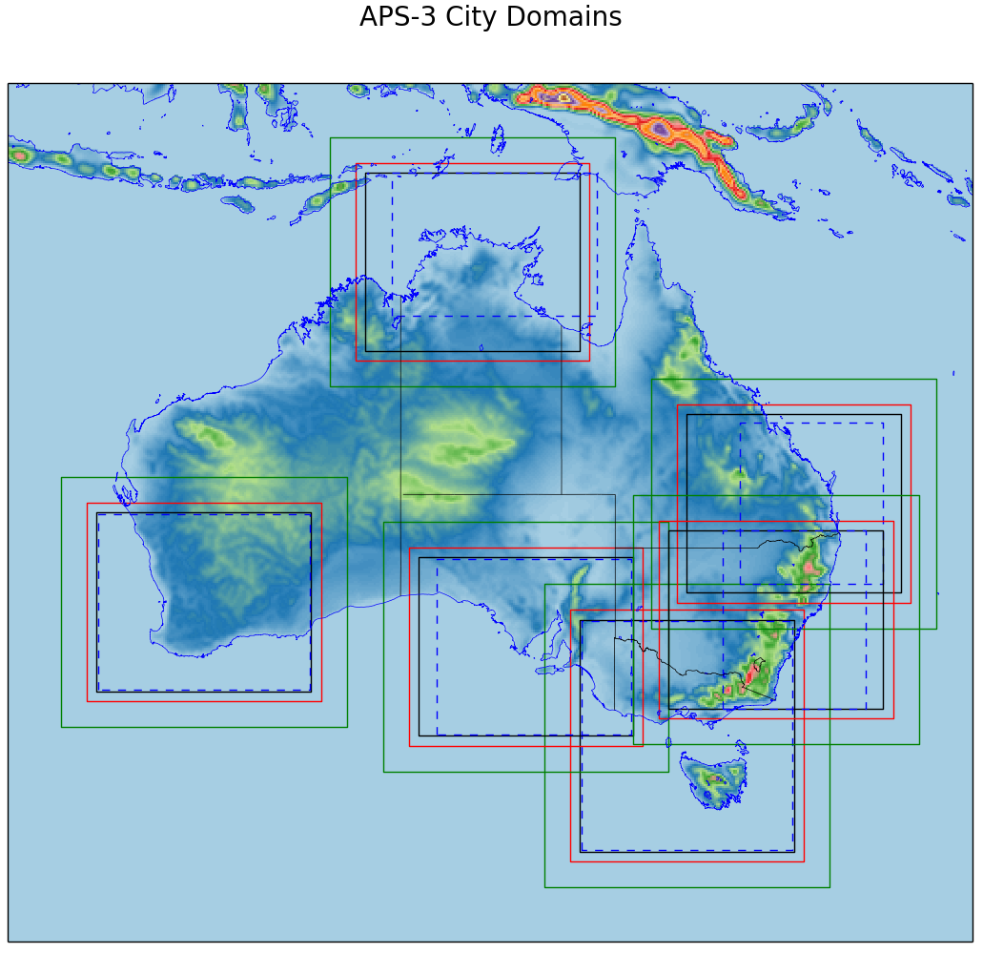

Figure 1: The location of the city domains. The dashed blue lines represent the APS2 domains. The green lines represent the outer boundary, the red lines represent the beginning of the transition zone and the solid black lines represent the uniform section of the APS3 domains.

# References

Clarke, P., Roberts, N., Lean, H., Ballard, S. P., and Charlton-Perez, C. 2016: Convection-permitting models: a step-change in rainfall forecasting, Meteorol. Appl., 23, 165-181.

Hagelin, S., Son, J., Swinbank, R., McCabe, A., Roberts, N., and Tennant, W. 2017: The Met Office convective-scale ensemble, Q. J. R. Meteorol. Soc., DOI:10.1002/qj.3135.

McCabe, A., Swinbank, R., Tennant, W., and Lock, A. 2016: Representing model uncertainty in the Met Office convection-permitting ensemble prediction system and its impact on fog forecasting, Q. J. R. Meteorol. Soc., DOI:10.1002/qj.2876.

Tang, Y., Lean, H. W., and Bornemann, J. 2013: The benefits of the Met Office variable resolution NWP model for forecasting convection, Meteorol. Appl., 20, 417-426.

Tennant, W., 2015: Improving initial condition perturbations for MOGREPS-UK, Q. J. R. Meteorol. Soc., DOI:10.1002/qj.2524.

Tennant, N., and Beare, S., 2014: New schemes to perturb sea-surface temperature and soil moisture content in MOGREPS, Q. J. R. Meteorol. Soc., DOI:10.1002/qj.2202.