# Continental rainfall ensemble derived from multi-source blended analysis

## Luigi J. Renzullo1, Carlos A.Velasco-Forero2, Alan W. Seed2, Beth E. Ebert2, Leon Majewski2, Mark Broomhall2, Albert I.J.M. van Dijk1, Pablo Rozas-Lorraondo1 , and Siyuan Tian1

*1Fenner School of Environment and Society, Australian National University, Canberra*

*2Science to Services, Bureau of Meteorology, Melbourne*

*Luigi.Renzullo@anu.edu.au*

**Introduction**

Frequently-updated (i.e. <10 min latency) high-resolution quantitative rainfall estimates are key inputs to the accurate assessments of heavy rain associated with extreme weather and storms, and potential for flash-flooding. However, for a comprehensive, nation-wide rainfall analysis, there is no single source of rainfall data that possesses the desirable characteristics of coverage, resolution, accuracy and data latency for real-time applications. And while data accuracy and timeliness (i.e. low latency) are characteristics of utmost importance for real-time applications, the ability to reliably capture the spatial and temporal patterns of rainfall across a range of scales may be just as important for accurate catchment streamflow modelling and flood prediction.

The goal of producing high-resolution accurate estimates of rainfall on a national scale, within a few minutes of observation, is only likely to be achieved through the statistical blending of two or more rainfall data sources which may include rain gauges, radar, satellite, and numerical weather prediction model output (Fig.1). A real-time blended analysis is likely to gain wider use if it is accompanied by a spatially explicit representation of estimation accuracy, most usefully as a rainfall ensemble. In addition to providing a quantitative assessment of analysis uncertainty, an ensemble provides a means of computing probabilistic rainfall information, including of exceedance probability.

This presentation describes activities towards developing a national-scale real-time rainfall analysis service. We present our current plans to explore methods for blending multiple sources of (near) real-time rainfall data to generate rainfall analyses, including approaches underpinning MSWEP (Beck et al., 2016), STEPS (Seed et al., 2013) and a scale-dependent blending method (Renzullo et al., 2017). We focus discussion on our approach to ensemble generation based on perturbing rainfall analyses with structured noise following the STEPS method (briefly outlined below).

**Method**

Rainfall exhibits *scaling*, i.e. structure in spatial and temporal patterns across a wide range of scales. For gridded rainfall, scaling is evident in the data power spectral density (*PSD*) which follows a power law distribution,

$PSD\left(λ\right)∝λ^{β}$, (1)

where $λ$ denotes spatial dimension (*wavelength*, in km) and $β$ is known as the spectral exponent, or spectral slope (linear PSD in log-log plot). While most rainfall data exhibit scaling, their representation of rainfall structure can vary across spatial scales (Fig. 2). The spectral slope is indicative of rainfall structure: high $β$ suggest greater organization or smoothness; low $β$ greater spatial irregularity or randomness. It is important that a blended analysis maintains scaling, with $β$ in the range 2.2 – 3.0, to provide realistic patterns of rainfall distribution and structure across the widest range of spatial scales.

Our approach to ensemble generation, based on STEPS, is to perturb the gridded analysis with spatially structured noise. The structure is derived from the blended rainfall analysis, *via* mathematical convolution, thus ensuring that each ensemble member possesses the scaling properties of the blended analysis (Fig. 3). In addition, we will pay close attention to the error variances (or, indirectly, the magnitude) of the perturbations to ensure that the ensemble spread is indeed representative of the actual uncertainty in the blended analysis, and satisfy reliability criteria. Finally, we plan to extend the approach from local to national by concatenating series of spatially contiguous local analyses (Fig. 4), and providing a detailed evaluation of the ensembles through assessing the statistical reliability of the rainfall information products using independent rain gauge measurements.

# References

Beck, H. E., Van Dijk, A. I. J. M., Levizzani, V., Schellekens, J., Miralles, D. G., Martens, B., & de Roo, A. 2016: MSWEP: 3-hourly 0.25° global gridded precipitation (1979–2015) by merging gauge, satellite, and reanalysis data. Hydrol. Earth Sys. Sci. <https://doi.org/10.5194/hess-2016-236>

Renzullo, L.J., Velasco-Forero, C.A., & Seed, A.W. 2017: 'Blending radar, NWP and satellite data for real-time ensemble rainfall analysis: a scale-dependent method', CSIRO Technical Report: <https://doi.org/10.4225/08/594eb78c96025>

Seed, A. W., Pierce, C. E., & Norman, K. 2013: Formulation and evaluation of a scale decomposition-based stochastic precipitation nowcast scheme. Water Resour. Res., 49(10), 6624–6641. <https://doi.org/10.1002/wrcr.20536>

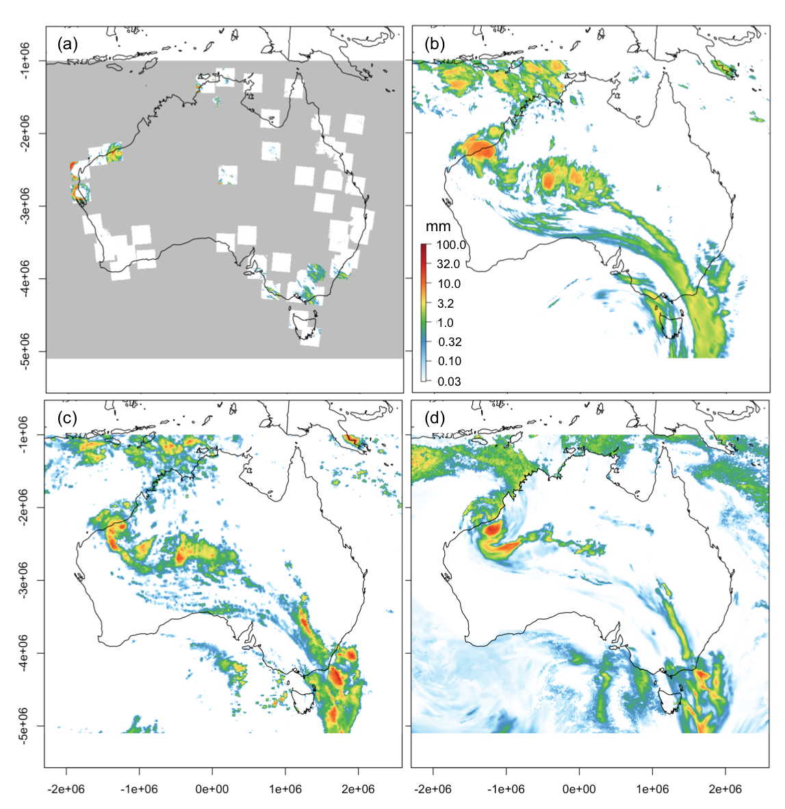

**Figure 1.** Accumulated rainfall (60-min) patterns across Australia for 15:00 hrs UTC on 12 Jan 2018 as captured by: (a) Rainfields v3.0; (b) Himawari-8 Convective Rain Rate Algorithm v1.0; (c) GPM IMERG 3B-HHR_L; and (d) ACCESS-R APS2 06Z forecast. Rainfall the remnants of cyclone Joyce.

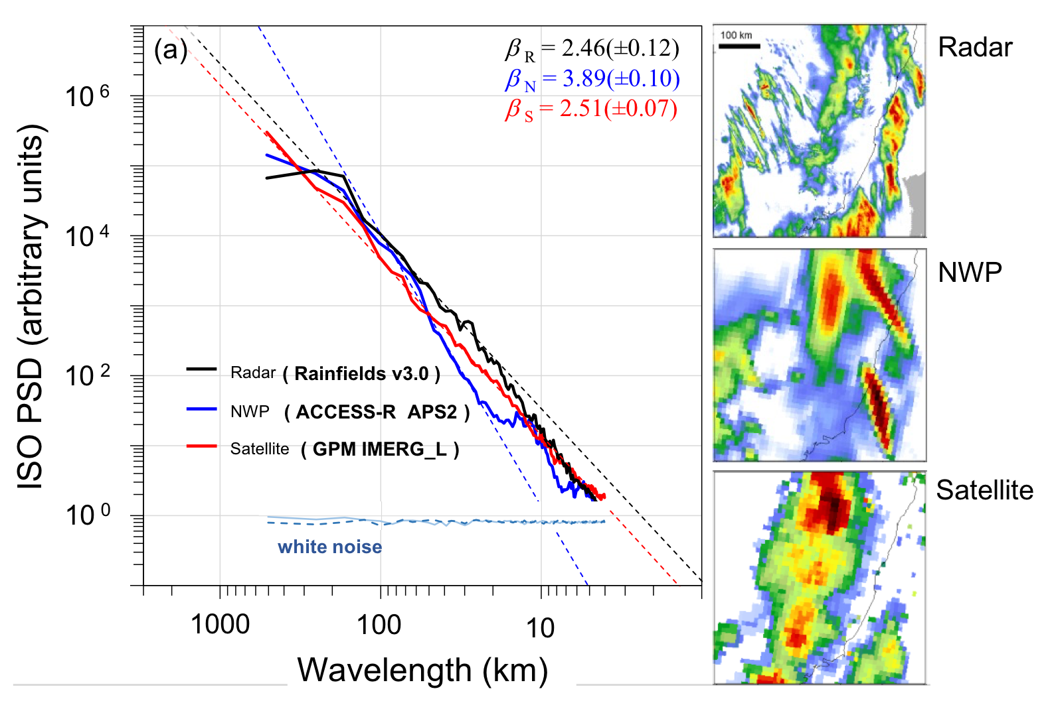

**Figure 2.** Isotropic power spectral density (ISO PSD) of the rainfall patterns in Rainfields (Radar), ACCESS-R (NWP) and GPM (Satellite) data shown on the left for NSW-Qld coast on 14:00 hrs UTC on 2 Sept 2016. The power law spectral slope, , for the various sources, indicating the degree of organization of the data for given spatial scale: higher slopes more organization (smoothness); low slope less structure, PSD of white noise displayed for comparison.

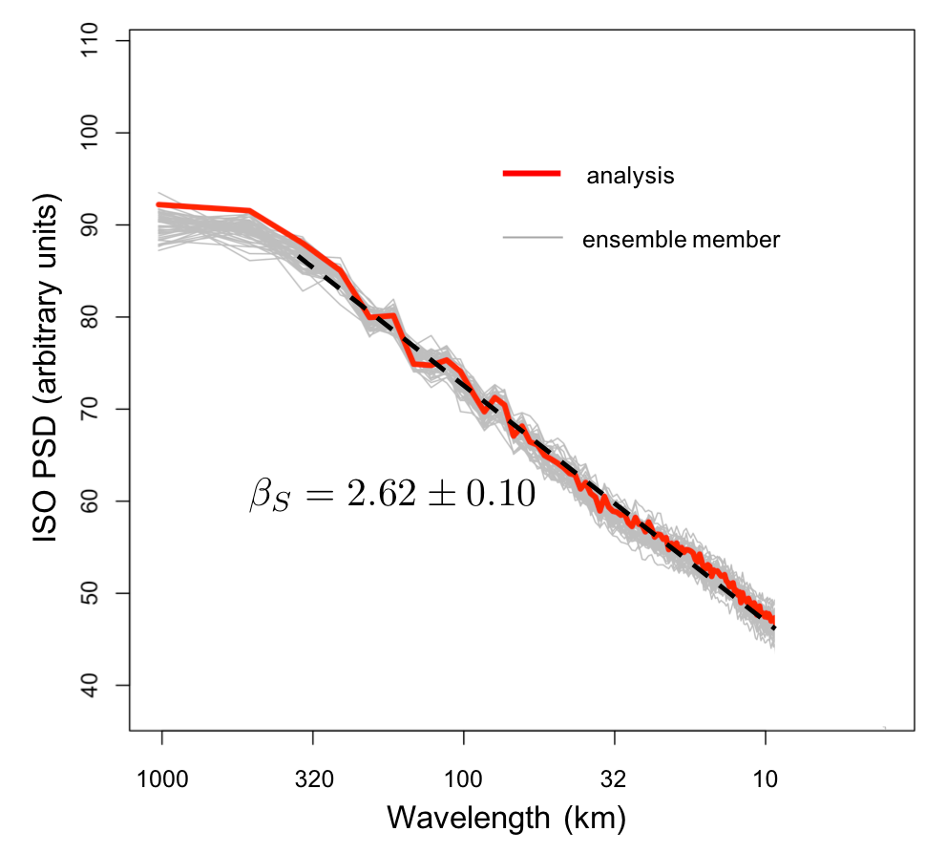

**Figure 3.** ISO PSD for 60-minute accumulated rainfall analysis (GPM in this case) over 1000 km x 1000 km Sydney region (red). Also displayed (in grey) ISO PSD for 50-member ensemble of rainfall derived from perturbing the analysis with structure noise. Average spectral slope for 20 – 100 km spatial scale is 2.62 with a standard deviation of 0.1.

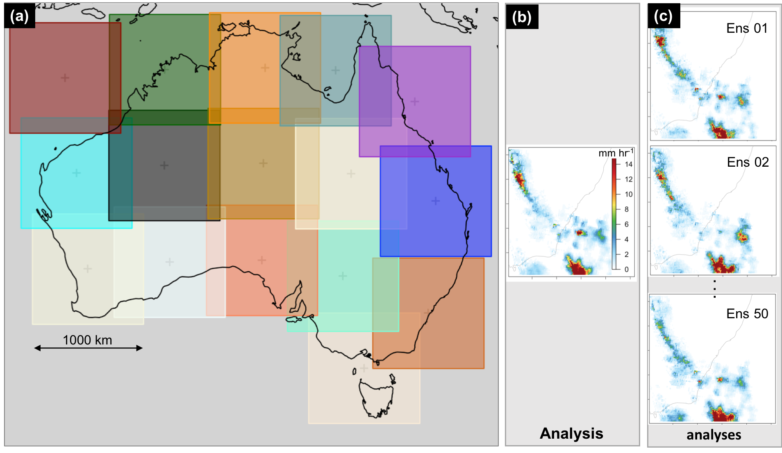

**Figure 4.** National application of the blending method and ensemble generation: (a) 1000 km x 1000 km tiles; (b) blended rainfall analysis for the “Sydney tile”; (c) 50-member ensemble rainfall derived by perturbing the rainfall analysis with noise field possessing the same spatial structure.