**Bureau R&D Workshop 2018**

# Enhanced flood warning services using ensemble forecasting

## Justin Robinson1 Adam Smith1 and Carlos Velasco-Forero 2

*1* *Public Safety Program, Bureau of Meteorology*

*2* *Science to Services Program, Bureau of Meteorology*

*justin.robinson@bom.gov.au*

In the communication of flood risk, it is important to highlight the most likely scenario as well as low probability high impact scenarios. It is no secret that forecasting is an inexact science, but to enable responders to make informed decisions with full knowledge of the probabilities and potential impacts the Bureau needs to effectively communicate the uncertainty in the forecast.

With the introduction of the Bureau's National Hydrological Forecasting System (HyFS), the Bureau's flood warning service has been using ensemble forecasting together with estimates of catchment conditions, historical flood information, and sensitivity analysis to better understand and describe uncertainties in its flood forecasts.

To date, ensemble flood forecasts have focused on the use of multi-model rainfall forecasts from the Bureau's ACCESS models, ECMWF and the enhanced guidance from NexGenFWS (GFE). The multi-model approach is illustrated in Figure 1.

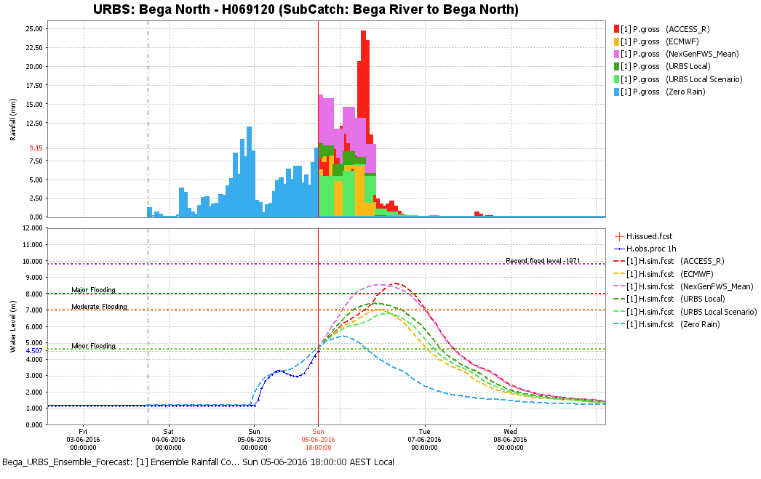

Figure 1: Illustration of multi-model ensemble forecasts currently available in HyFS. The red vertical line shows the current time with the coloured dashed lines showing forecast water levels from the different NWP and NexGenFWS (GFE) rainfall forecasts. The dashed blue line shows the expected water level with no future rainfall.

The multi-model approach has proved to be very successful in supporting the flood watch service, which provides the public and emergency services advice of increased flood risk up to four days in advance of flooding.

This year the Bureau will introduce a flood scenario service to complement the flood watch. Flood scenarios will provide a quantitative estimate of the flood risk for a "most likely" as well as a "credible alternative" scenario. Initially, these scenarios will use the current NexGen and deterministic guidance available in HyFS, but there is good potential to develop the service further to use a full ensemble approach. It is still early days, but one can envisage in the future that the Bureau could provide a full probabilistic flood scenario service using ensemble forecasting.

In developing flood forecasts and warnings, it is often the reality that the observed rainfall differs markedly from the multi-model rainfall forecasts available in HyFS. During high-end extreme rainfall events, the numerical weather prediction models are often poor at capturing the impacts of small-scale topography and embedded thunderstorms which drive extreme rainfall. Defensible flood warnings must supplement rainfall forecasts from NWP with input from meteorological forecasters, observations and nowcasting. To meet the requirement for nowcasting, the flood warning service has been exploring the use of ensemble forecasts from RAINFIELDS. Forecasts from RAINFIELDS are rapidly updated to account for the latest rainfall amounts and automatically merge nowcasts with extended range forecasts. The use of real-time observations and nowcasting is essential in providing credible and defensible flood forecasts.

The Bureau has been piloting the use of RAINFIELDS in the development of an extended lead time flood forecasting service for the Hawkesbury-Nepean Valley (HNV) (Figure 2). The pilot project aims to enable the emergency services to make informed decisions to allow them to commence evacuation at extended lead times. This project has been funded through Infrastructure NSW and developed in collaboration with WaterNSW and the NSW State Emergency Service. It is providing an ensemble based decision-making service that integrates flood intelligence and the Bureau's flood forecasts.

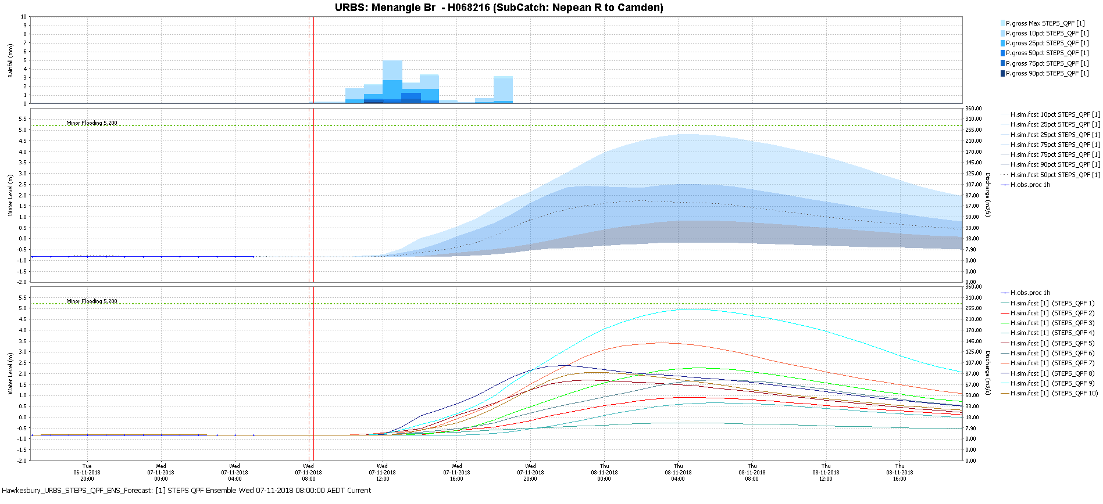

Figure 2: Illustration of RAINFIELDS ensemble forecasts in HyFS. The lower plot shows the time-series of flood forecasts with each coloured line representing an ensemble member. The shaded graphs show 10%, 25%, 75% and 90% probabilities of exceedance. The initial implementation uses a ten-member ensemble which will be extended to more than 30 members later this year.

This paper will explore the Bureau's flood warning service – and its path to providing enhanced flood warning services using ensemble forecasting approaches. In particular, it will highlight work that is underway to help our partner agencies and the community to make informed decisions with a full understanding of impacts and uncertainties