Underpinning Operations, The use of technology in NSW Bush Fire Management

Authors Simon Heemstra1, Laurence McCoy1, Stuart Matthews1 and Erin Heinrich1

*1Planning and Predictive Services Unit, NSW Rural Fire Service, Homebush NSW*

*simon.heemstra@rfs.nsw.gov.au*

**Introduction**

The NSW Rural Fire Service established a formal Predictive Services capacity in 2010 with the commencement of the Fire Behaviour and Smoke Plume Modelling project. The Predictive Services capability has expanded rapidly with successive enhancements to now include a central unit of nine full time staff, four regional staff in addition to a project team of six RFS staff and two BoM staff working to improve the way fire danger ratings are calculated throughout the nation. The unit is equipped with 24 high quality Portable Automatic Weather Stations and 5 military standard Portable Atmospheric Sounding Systems.

Rapid expansion of the unit and significant gaps in modelling capability has driven a healthy appetite for the early adoption of new technology. Increasingly, new technology and research is leading to a shift from deterministic to probabilistic forecasting and the use of ensembles is being considered or already in use for the development of fire behaviour analysis products, seasonal outlook forecasting, bush fire risk management planning and the pilot of a new National Fire Danger Rating System.

**Deterministic Vs. Probabilistic Forecasting**

The use of fire behaviour science has been undergoing a shift in many fire Australian agencies from a system based on experience using hand drawn manual maps to one that increasingly uses simulators (Neale and May, 2018) and includes formal structures and training. A formal predictive services capability within agencies (particularly in NSW) has been a relatively recent feature. The philosophy of the NSW formal capability has been to underpin fire management decisions with the best available science.

A recent evaluation of simulator performance recommended a shift away from deterministic forecasting due to evaluated simulators sensitivity to weather and in particular wind (Faggian et.al., 2017). In NSW, manual forecasting has been used as the primary method for predicting fire behaviour with simulator predictions prepared independently to act as a validation source. The manual prediction method is considered better able to incorporate rapidly changing intelligence and encode uncertainty to provide a best estimate prediction of anticipated fire behaviour.

Despite the ability for a human to consider uncertainty, there still may be decisions required by an analyst that may be better represented using probabilistic forecasting. Experiential learning has lead to the development of ensemble based products using simulators. Figure 1 provides an example of such products. These products provide the ability to vary inputs to account for uncertainty.

**Use of New Technology**

Use of rapid temporal resolution remotely sensed data such as frequent linescans and Himawari-8 satellite imagery has led to increased situational awareness for all levels of the organisation. For Fire Behaviour Analysts, it also provides a unique ability to calibrate models both in operational and research modes.

Situational Awareness is also significantly enhanced by the use of a fleet of Portable Automatic Weather Stations and Portable Atmospheric Sounding Equipment. This equipment providing the ability for Fire Behviour Analysts (and weather forecasters) to detect dangerous fire weather phenomena, leading to improved fire fighter and community safety.

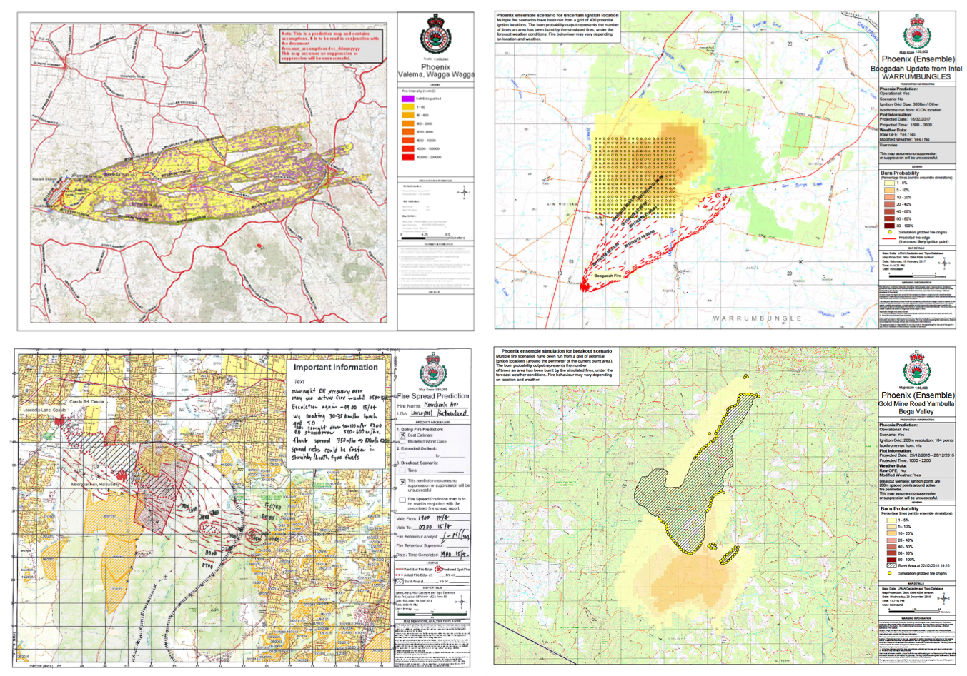

Figure 1 Examples of Fire behaviour prediction products and the use of ensembles in operational use in NSW

**Use of Ensembles**

A program to establish a new National Fire Danger Ratings System has been endorsed by the Australia New Zealand Emergency Management Committee. The system depends on calculations using fuel information and weather forecasts (Figure 2), both of which are uncertain. Ensembles could be used to understand confidence of rating forecasts, for example Category 4 with 10% change of Category 5.

The use of ensembles could also help to mitigate the issues caused by needing to have cut-offs between categories, which are currently handled informally using ‘discretionary range’.

Plans are being implemented for the next generation of Bush Fire Risk Management Planning in NSW to be underpinned by bush fire simulators. These simulator engines are the same as those used for forecasting and suffer from the same issues identified by Faggian et.al. (2017). The use of ensembles will also benefit risk planning by reducing uncertainty associated with the inputs.

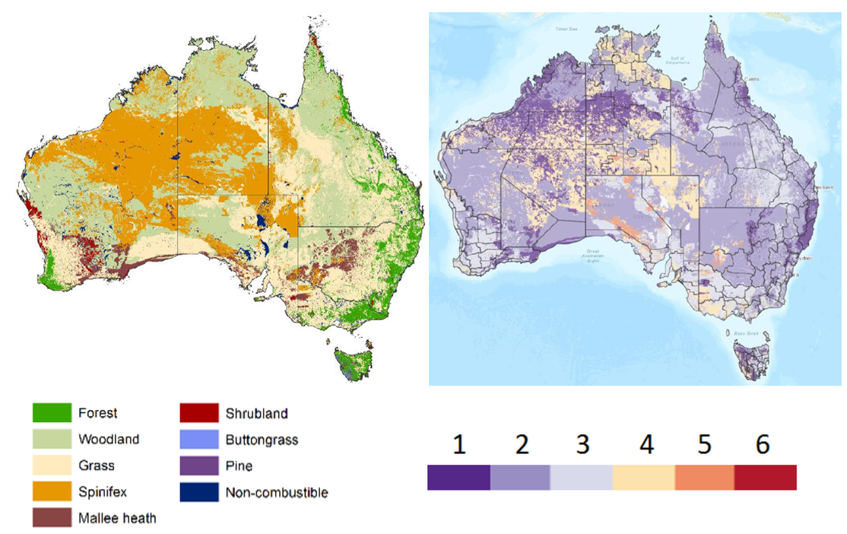

Figure 2 Research Prototype National Fire Danger Rating System. Left) Fuel types, Right) Sample ratings map.

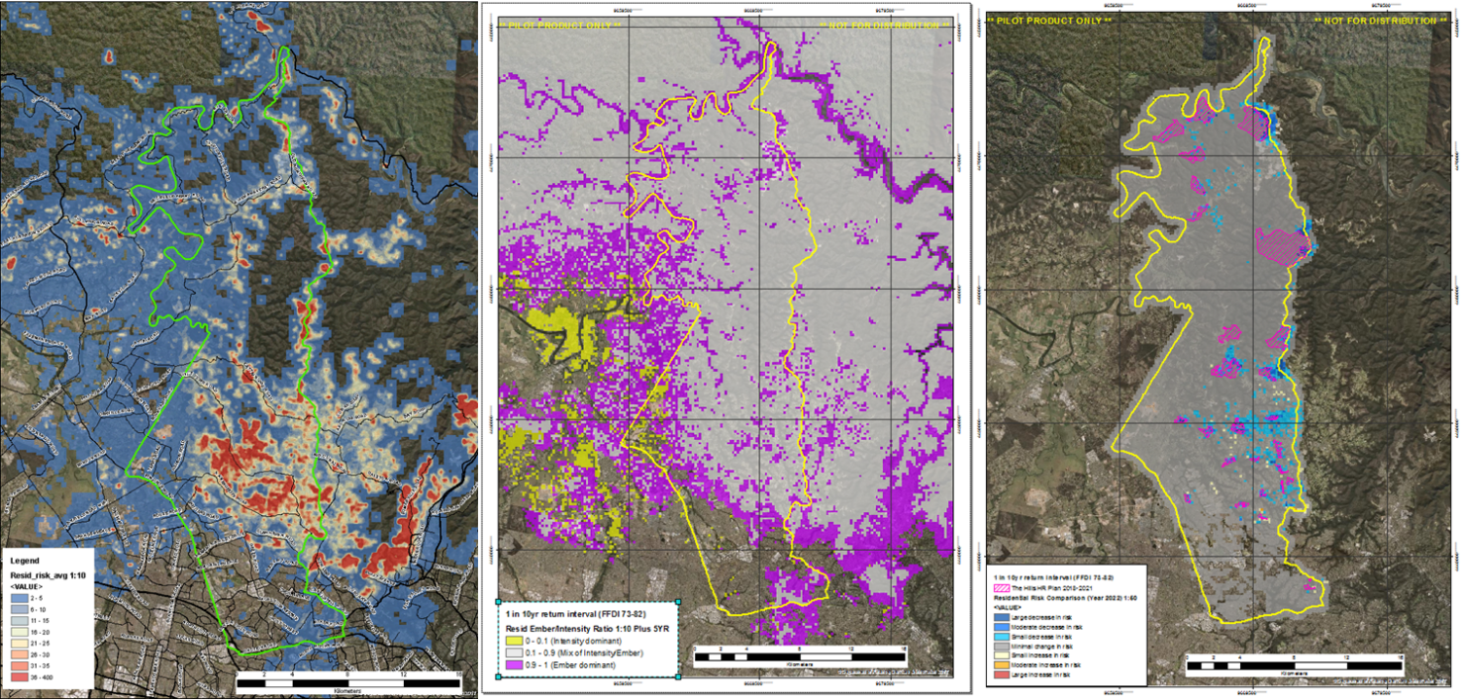

Figure 3 Use of simulators to forecast probabilistic risk

**Conclusion**

There are still many gaps in fire behaviour knowledge and modelling capability. New technologies are emerging which have the ability to overwhelm users of the products with data. Interpretation and utilisation of these outputs for fire behaviour predictions will be a challenge for the NSW RFS Predictive Services Unit. The unit is uniquely positioned to help the NSW RFS navigate the challenges and improve our ability to underpin operations with the best available science to improve safety outcomes for operational personnel and the community as a whole.

**References**

Faggian, N., Bridge, C., Fox-Hughes, P., Jolly, C., Jacobs, H., Ebert, B., and Bally, J. (2017) Bush Fire Predictive Services Final Report: An Evaluation of Fire Spread Simulators Used in Australia. Australian Bureau of Meteorology.

Neale, T., May, D. (2018) Bushfire simulators and analysis in Australia: insights into an emerging sociotechnical practice. Environmental Hazards 17, 200-218.