# Use of Ensembles in Tropical Cyclone Forecasting

## Author Matt. Boterhoven

*State Forecasting Centre, Bureau of Meteorology, Perth*

*Matthew.Boterhoven@bom.gov.au*

Tropical cyclones are a major natural hazard that affects Australian communities, emergency services, and industries. Ensemble guidance is an integral tool that allows Australian Bureau of Meteorology (ABoM) forecasters, whilst under tight time constraints, to provide skillful and reliable track and intensity forecasts for tropical cyclones.

Ensembles are used in a variety of modes in the tropical cyclone forecast process. One of the more valuable uses of ensembles is to characterise the uncertainty in the position of a tropical system on a particular day (Fig. 1).

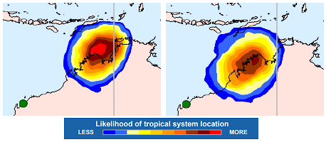

Fig. 1. These images indicate the spread of ensemble tracks from the ECMWF 12UTC 3rd March 2017 model run. For each point on the map, the number of ensemble members are counted that have a system which, at some time in the 24 hour forecast period, is both within 100 nm of that point and of 25 knots or greater intensity. The number of counted ensemble members is then converted to a percentage and that spot on the map is shaded according to the colour scale. The spread of ensemble tracks for the 24 hours of Monday 6th March (left) and Tuesday 7th March (right).

**Future use of ensemble forecasts in operational tropical cyclone forecasting**

Tropical cyclone track forecasting is a manual process that can be time intensive. In the future the ABoM forecasters are interested in automating the track and uncertainty area forecasting processes in the tropical cyclone warning centre. The automation of the track and uncertainty forecast process is likely to be achieved in the future through the uses of ensemble forecasts.