# Use of Ensembles in the Energy and Resource sector forecasts

## Authors: Bradley. Hall1

*1Energy and Resources, Bureau of Meteorology, Perth*

*bradley.hall@bom.gov.au*

**Applying ensemble guidance to offshore weather forecasts**

Ensemble weather models are utilized for their ability to provide a range of probabilistic outcomes. There is a shift from the customers in the resource sector (mainly offshore NW Shelf oil and gas customers) to require more probabilistic forecast products to better align with their planning and risk management assessments. Products such as the P5 (5% probability) forecast and POE (probability of exceedance) forecast are examples of these.

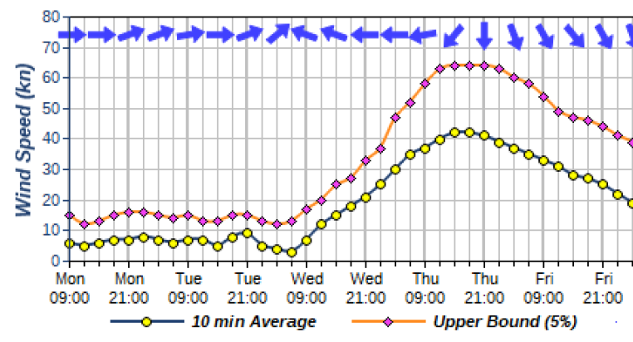

Figure 1: Example graph showing average 10m wind speed and P5 upper bound (5%) for a site