**Bureau R&D Workshop 2018**

# The Use of Probabilistic Forecasting in Antarctica

## Authors: Scott Carpentier

*Manager of Antarctic Meteorology*

*Bureau of Meteorology, Hobart*

*scott.carpentier@bom.gov.au*

**Introduction**

Responsibility for the delivery of Australia's Antarctic program rests with the Australian Antarctic Division (AAD). The program of activities is managed by AAD staff at their headquarters in Kingston, Tasmania and delivered from the Antarctic stations by a mostly transient 'expedition' workforce. This year (2018-19) marks the 72nd Australian Antarctic expedition.

The AAD run four permanent, year-round research stations: Casey, Davis, Mawson and Macquarie Island. Travel between mainland Australia (typically Hobart) and the stations is either by icebreaker, commercial Airbus A319 jet or by Royal Australian Air Force C17. On the icy continent, travel between stations and into remote field camps is by overland tractor convoy, or air transport, with helicopters and fixed wing aircraft such as Basler, Twin Otter or LC130. Due to the long darkness and higher frequency of extreme weather conditions over the winter period, travel is generally restricted to the October-March 'Summer' season. Winter activities are usually restricted to the station, except for the occasional overland traverse to monitor remote penguin colonies, maintain Automatic Weather Stations or recreational purposes at field huts. In contrast to equivalent activities conducted in mainland Australia, the AAD's operational risks are significantly magnified due to the remoteness from help if needed and higher frequency of harsh weather in Antarctica.

With a view to improving operational efficiency and mitigating risks to life and property, the Bureau has embedded 'decision support meteorologists' into the Australian Antarctic program every summer season since the early 1990's. Currently four operational meteorologists are recruited from within the Bureau's State or National Forecast Centers, and a fifth meteorologist from the Royal Australian Navy. The forecasters undertake a 4 week long Antarctic competency training and assessment program prior to deploying into the expedition. The course focuses on the dynamical, physical and climatological aspects of key hazardous weather phenomena, such as severe wind events, blizzards, freezing fog, cold snaps and precipitation (including clear sky precipitation or diamond dust). The pre-departure training also considers the adequacy of in-situ and remotely sensed observational platforms as well as the skill of Numerical Weather Prediction output. Station leaders, pilots, operations coordinators and ships masters are also invited into many training sessions to provide insights into the critical weather thresholds that can affect their activities (see table 1). Armed with these insights, the meteorologists are then embedded into the expedition to support all expeditioners with their weather sensitive decisions. The Bureau's embedded Antarctic service has become increasingly valued by the AAD. Simply put, the service underpins the safe and efficient running of their program.

**Table 1 – Significant Weather Thresholds for General Aviation (guidance only)**

|  |
| --- |
| **Significant Thresholds** |
| * Wind > 15kt (any direction)   + Possible reduced surface contrast due to drifting snow.   + May need ice screws on landing to secure aircraft if surface is slippery. * Wind > 15kt (crosswind component)   + May inhibit takeoff/landing (depending on aircraft type) * Wind > 30kt   + Likely reduced visibility, surface contrast and horizon definition due to blowing snow. * Wind gusts > 48kt   + Need to tie down fixed-wing aircraft. * Mean winds > 50kt or gusts > 60kt   + Tie down/stow helicopter blades (but can only de-blade if wind < 25kt). * VFR restrictions (apply to most Antarctic aviation):   + BKN/OVC cloud with base below 1000ft   + Visibility < 3000m   + Surface or Horizon Definition “Nil” * Helicopter cloud restrictions: * Helicopters operating in Charter Category (most AAP operations) require a minimum altitude of 500ft. Helicopters only need to keep clear of cloud – not maintain a specific vertical separation – so if flying at 500ft the cloud base could legally be at 550ft. |

**The Use of Ensemble Prediction Systems in the Antarctic**

Our Antarctic meteorologists are increasingly making use of Ensemble Prediction System output, specifically from the European Centre for Medium Range Weather Forecasts (ECMWF <https://www.ecmwf.int/> ) and the Antarctic Mesoscale Prediction System (AMPS WRF <http://www2.mmm.ucar.edu/rt/amps/> ), to better frame the likelihood of operational thresholds being breached.

Graphical point time series using non-bias-corrected ECMWF EPS and deterministic global NWP output by ACCESS G, AMPS WRF, NCEP GFS are issued daily to the stations (fig 1).

**Figure 1**

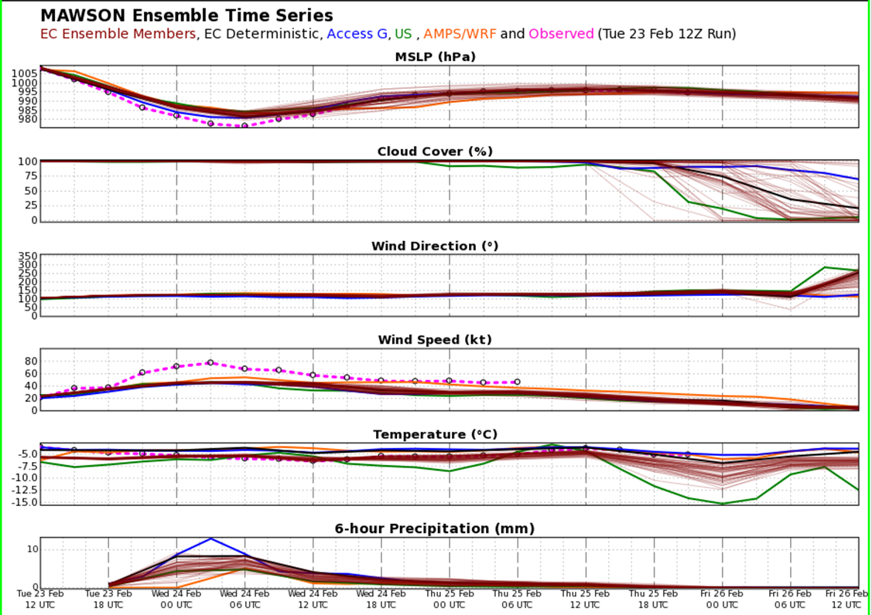

Training in the interpretation of the graphical time series is provided to expeditioners pre-departure and further instruction is possible with the forecasters and observers at the stations. A pamphlet on EPS use is being developed for future expeditions. Wind strength, temperature and precipitation are the key parameters of interest. Gross errors in those parameters are not uncommon as highlighted in the wind speed time series of figure 1, where 1 minute mean winds of 60 to 80 knots were observed (pink dotted line) over an 18 hour period on Wednesday the 24th whilst all NWP guidance ranged between 30-50 knots for the same period. Whilst biases in some parameters (such as pressure) could be corrected, there are dynamical and numerical reasons why wind speed and temperature cannot without great effort. This limits the value of direct model output in servicing high risk activities. The graphic is however not without value, as it is automatically generated (low cost), and conveys weather trends and anticipated forecast confidence through member spread. So it effectively assists routine schedule planning, such as for carpenters wanting to work on a roof 'sometime this week' and other such local area operations. All weather related high-risk activities are however supported by our meteorologists.

**Conveying the 'real' likelihood of operational thresholds being breached**

The Bureau's Antarctic services include three distinct products that highlight the likelihood of an event occurring:

* aviation *TAF* for fog (prob30 and prob40);
* warnings of *Blizzard/Gale risk* in station (public weather) forecasts; and
* in our *Operations Support Briefs* (table 3).

For consistency across our Antarctic products and therefore ease of use, the likelihood of operational thresholds being breached has been set at:

* Low: 0-20% chance of occurrence;
* Moderate: 21-50% chance of occurrence;
* High: 51-100% chance of occurrence.

The setting of likelihood levels was informed by thunderstorm and fog probability levels for aviation Terminal Aerodrome Forecasts (TAF) and through consultation with Antarctic decision makers.

However, because our experience has shown that direct NWP output alone lack sufficient skill to quantify/qualify the likelihood of a weather threshold being crossed, we require the additional consideration by the meteorologist to establish the forecast/warning. A matrix has been developed to standardise the assessment of likelihood between forecasters (table 2).

**Table 2 – Likelihood Matrix**

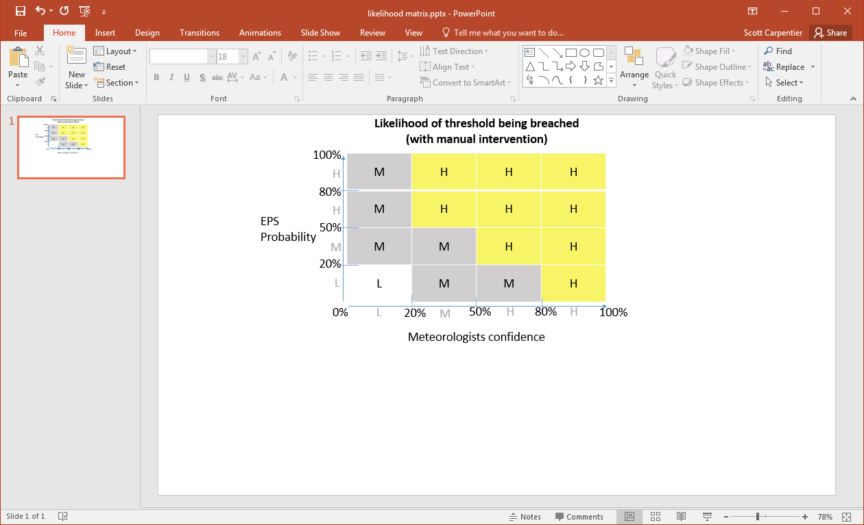

For an example of it's use, consider a meteorologist trying to establish the likelihood of a blizzard impacting Casey Station (a blizzard being definedas: *10 minute mean winds >34 knots; horizontal visibility <100metres; sub-zero Celcius temperatures and duration of at least 1 hour*). The EPS output may have 60% of it's members meeting these criteria whilst the meteorologists confidence may be set at only 30% (via gut feeling, experience and in some cases with support from a decision making tree). The EPS's *high confidence* and Meteorologist's *moderate confidence* combine to result in a *high likelihood (and therefore >50%)* of the event occurring. It is noteworthy that the matrix is skewed to the meteorologists preference, thus allowing one to warn of the high likelihood of an event occurring despite all ensemble members not meeting the threshold.

Table 3 – Operations Support Brief example

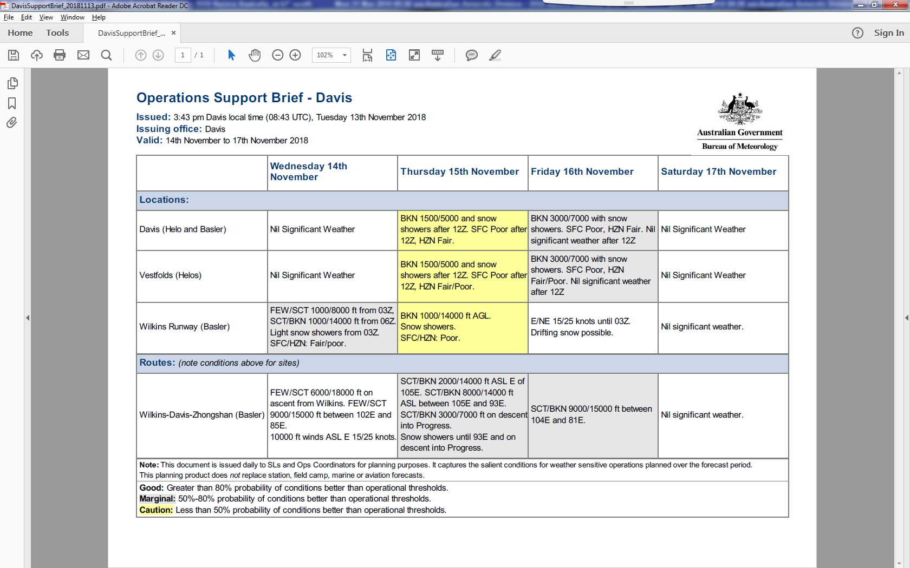

**Conclusions and Comments on the future**

Probabilistic forecasts have become highly valued by Antarctic decision makers, particularly as they assist in the weekly planning of transport activities and help the understanding of exposure to high impact weather. It must be noted that the effective use of probabilistic forecasts has required extensive investment in both user and forecaster education as well as in collaborative design of the products. Not every decision maker was on board and still today some only want to know 'what will happen' rather than a range of possible weather outcomes. Some decision makers also prefer the meteorologist to 'stick to the weather' and not extend *our* advice onto operational impacts as per our Operations Support Brief (table 3). However, on the whole, probabilistic forecasts significantly contribute to the overall success of the Bureau's Antarctic services and are becoming increasingly so as model output, user skill and product 'useability' improve.

A current challenge to 'useability' is integrating multiple EPS's into one viewer or graphic. For example, currently the Bureau acquires two distinct ECMWF EPS datasets (one north and the other south of 60oS) which causes disconnections in maps and warps some statistics when combined. Also, the AMPS WRF EPS is currently only available on a web display which makes it difficult to compare with ECMWF EPS output.

The inability for EPS output to skilfully represent high impact weather also limits its usefulness. The likelihood matrix (table 2) attempts to address this shortcoming by also considering the opinion of the meteorologist before advising on the likelihood of key operational thresholds being breached. The matrix, particularly when used with other decision support systems, also attempts to standardise the calculation of probability across our transient workforce.

Because it was co-designed with Antarctic decision makers, the qualification of likelihood levels at low: 0-20% chance; Moderate: 21-50%; and High: 51-100% is not consistent with Bureau mainland "chance of rain" qualifiers of slight: 15-24%; medium: 35-64%; high: 65-84% and very high: >85%. One could argue for standardisation.