**Bureau R&D Workshop 2018**

# The Copernicus Arctic Marine Forecasting Center

## Øyvind Breivik1,2, Laurent Bertino3 and Kai H. Christensen1,4

*1Norwegian Meteorological Institute*

*2University of Bergen, Norway*

*3Nansen Environmental and Remote Sensing Center, Bergen, Norway*

*4University of Oslo, Norway*

*oyvind.breivik@met.no*

**Introduction**

The Arctic Marine Forecasting Center (ARC MFC) is an ocean, sea-ice, wave, and bio-geochemistry forecasting and reanalysis system covering the Nordic Seas and Arctic Ocean North of 63°N (domain shown in Fig 1). The forecast system serves as the Arctic component of the Copernicus Marine Environmental Monitoring System and is run jointly by The Nansen Environmental and Remote Sensing Center and the Norwegian Meteorological Institute. The TOPAZ ocean and sea-ice model uses an advanced data assimilation (DA) technique (the Ensemble Kalman Filter, Sakov *et al.*, 2012) to constrain the system to six real-time satellite and in situ observational products. In addition to the dissemination of daily forecasts and a reanalysis, a broad range of product quality assessments are performed on weekly and quarterly intervals. The forecast system also includes a wave model which issues fluxes for the estimation of wave effects in the upper ocean as well (see conceptual overview of the forecast system in Fig 2).

Here we present the operational forecast system, its Ensemble Kalman Filter DA and the overall performance of the system. We will also present results from an experimental setup incorporating physical processes related to surface waves, notably parameterizations of Langmuir turbulence (Ali et al, 2018). Wave attenuation in ocean sea ice is also under development, and some preliminary results from different wave damping parameterizations will be presented

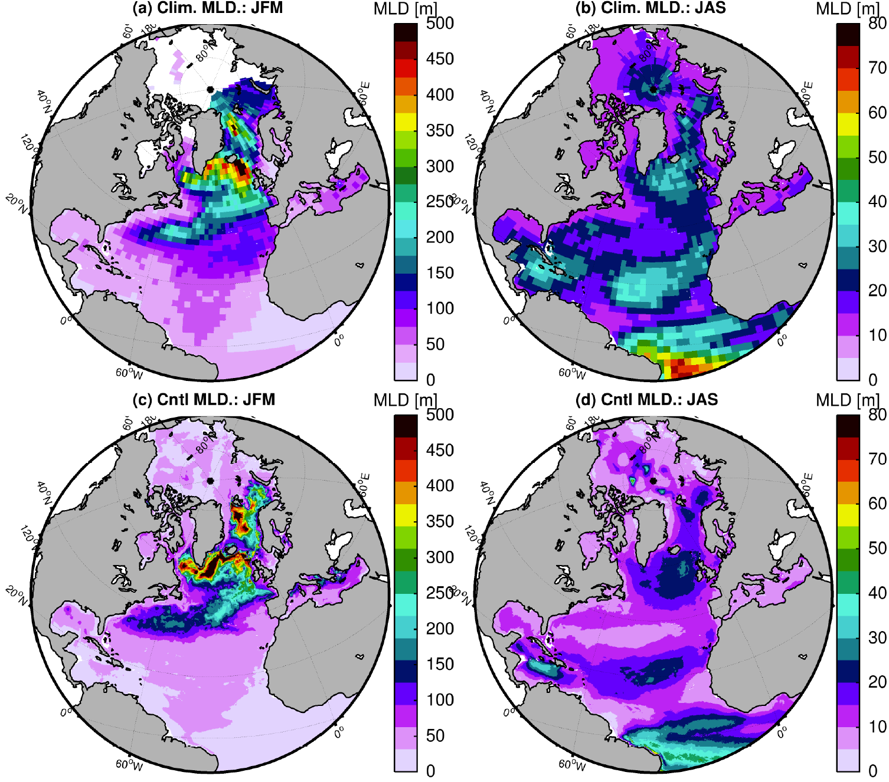

Figure 1. Mixed layer depth January-March (left) and July-September (right). The TOPAZ model domain used for ARC MFC covers the North Atlantic and the Arctic Ocean.

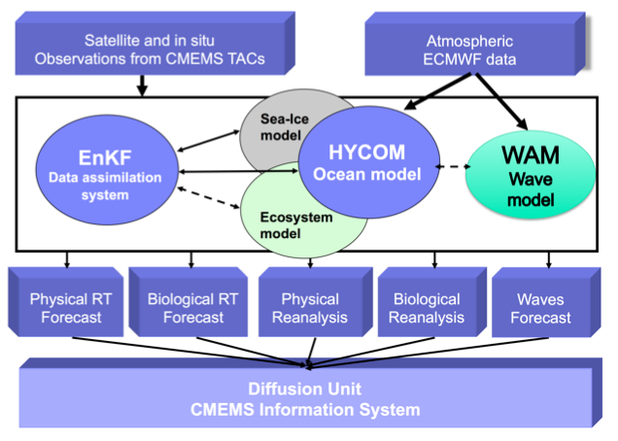

Figure 2. Conceptual overview of the ARC MFC forecast system and its EnKF data assimilation system.

# References

Sakov, P., F. Counillon, L. Bertino, K. A. Lisæter, P. R. Oke, and A. Korablev. 2012. TOPAZ4: An Ocean-Sea Ice Data Assimilation System for the North Atlantic and Arctic., *Ocean Sci*., **8**(4), 633–56. doi:10.5194/os-8-633-2012

Ali, A, K Christensen, Ø Breivik, M Malila, R Raj, L Bertino, E Chassignet and M Bakhoday-Paskyabi (2018). A comparison of Langmuir turbulence parameterizations and key wave effects in a numerical model of the North Atlantic and Arctic Oceans, *Submitted to Ocean Modell*