**Bluelink ocean forecasting developments:**

**OceanMAPS, Maritime Continent and ensemble forecasting**

**Gary B. Brassington1, Peter Oke2, Prasanth Divakaran1, Pavel Sakov1, Mirko Velic1, Xinmei Huang1, Helen Beggs1, Aihong Zhong1, Russell Fiedler2, Matt Chamberlain2, Andy Hogg3 and Andrew Kiss3**

*1Bureau of Meteorology, Melbourne*

*2CSIRO, Hobart*

*3Australian National University, Canberra*

*gary.brassington@bom.gov.au*

The Bureau of Meteorology has delivered operational ocean forecasts since 2007 underpinned by the Ocean Model, Analysis and Prediction System (OceanMAPS) developed through the Bluelink research and sustainment projects. OceanMAPS version 3 is based on a near-global Modular Ocean Model version 4p1 with 1/10 x 1/10 degree resolution and 51 vertical levels which resolves a portion of the mesoscale circulation. An ensemble optimal interpolation method is applied based ENKF-C to assimilate satellite altimetry, satellite SST and in situ profiles on a 3-day cycle. Three time-lagged forecast systems provide an effective multi-cycle to provide guidance on forecast uncertainty. An overview of the current system and recent improvements will be presented including upgrading to MOM5, bulk fluxes, new observing platforms and diagnosis of forecast anomalies and their significance as shown in **Figure 1**.

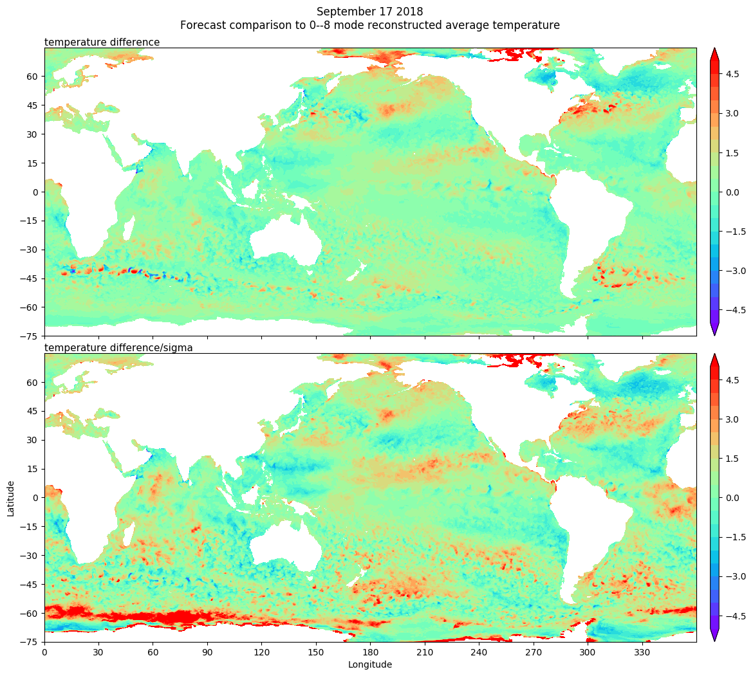

Figure 1 (upper) The OceanMAPS surface temperature anomaly for the 17 September 2018 relative to the seasonal climatology derived from BRAN, (lower) the equivalent anomaly normalied by the expected standard deviation of seasonal anomalies from BRAN.

After over a decade of development of global ocean forecasting several developments are in progress that will extend the systems capability and performance. This includes: a new fully global ocean sea-ice model being developed through an ARC linkage grant based the Modular Ocean Model version 5 with 75 vertical levels optimised for the observed variability; an updated Bluelink ocean reanalysis; and an ensemble Kalman Filter data assimilation system which provides the basis for generating probabilistic ensemble ocean forecasts. **Figure 2** is a comparison of the ensemble spread of temperature at ~60 m depth based on the current OFAM3 model (left) and OFAM3 modified using the new 75 vertical levels of ACCESS-OM2-01 (right). The new vertical levels are optimized for observed ocean variability. In general the two images demonstrate comparable alignment of fronts as observed, however the new system leads to a reduction in amplitude and less diffuse indicating a reduced uncertainty.



Figure 2 (left) ensemble spread of a 3 day hindcast of temperature at model level 65m. This was generated from a 96-member EnKF system based on ENKF-C applied to OFAM3. (right) ensemble spread of 3 day hindcast of temperature at model level 62 m. This was generated using an equivalent EnKF applied to the ACCESS-OM2-01 model which has 75 vertical levels. Colorbar degrees C.

Finally, we will briefly mention a new initiative to forecast the maritime continent region with a 1/50 x 1/50 degree regional downscaled ocean, wave and atmospheric model. A feature of this system is tropical cyclone and tropical lows, Indonesian throughflow, tides and internal tides within a complex archipelago. **Figure 3** provides a snapshot of the tendency of the surface meridional velocity from ROMS forced by ACCESS-R fluxes. The narrow lines of peak positive and negative velocity represent an expression of an internal tidal wave which propagates and radiates from its origin.

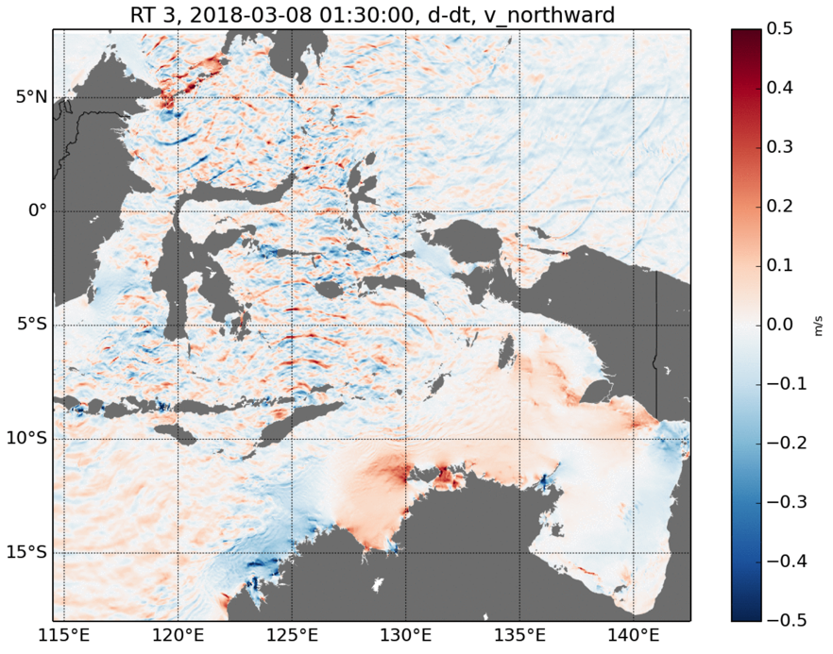

Figure 3 Tendency of meridional surface velocity from a ROMS simulation of the Maritime continent region forced by ACCESS-R atmospheric fluxes and tidal current boundary conditions.