U.S. Navy Forecasting Developments

Patrick Hogan¹, E. Joseph Metzger¹, Clark Rowley¹, Neil Barton²,
Sergey Frolov², Ole Martin Smedstad³,Prasad Thoppil¹

¹Naval Research Laboratory, Oceanography Division, Stennis Space Center, MS
²Naval Research Laboratory, Marine Meteorology Division, Monterrey, CA
³Perspecta, Stennis Space Center, MS 39529

patrick.hogan@nrlssc.navy.mil

Introduction

The Global Ocean Forecast System (GOFS) is the U.S. Navy’s operational global ocean prediction system that runs daily at US Navy production centers. The system depicts the location of mesoscale features such as oceanic eddies and fronts, i.e. the “ocean weather”, and provides accurate 3-dimensional ocean temperature, salinity, and current structure to the Fleet. The first global system was declared operational in February 2006 as GOFS 2.0 and was based on two NRL-developed ocean models, the Navy Layered Ocean Model (NLOM) and Navy Coastal Ocean Model (NCOM). Satellite altimeter data was assimilated into high horizontal resolution NLOM and its sea surface height and observed sea surface temperatures were used to create synthetic temperature and salinity profiles projected downward into the ocean interior of NCOM as part of the assimilation cycle for GOFS (Rhodes et al., 2001).

GOFS 3.0 became operational in March 2013 and represented a next generation forecast system based on the HYbrid Coordinate Ocean Model (HYCOM. GOFS 3.0 had 1/12° horizontal grid resolution, 32 layers in the vertical, an energy-loan ice capability, and used the Navy Coupled Data Assimilation System to ingest observations. HYCOM is unique in that it allows a truly general vertical coordinate, which extends the geographic range of applicability of traditional isopycnic coordinate circulation models toward shallow coastal seas and unstratified parts of the world ocean. It maintains the significant advantages of an isopycnal model in stratified regions while allowing more vertical resolution near the surface and in shallow coastal areas, hence providing a better representation of the upper ocean physics (Metzger et al., 2014).

Present/Planned GOFS Configurations

GOFS 3.1 is the present operational capability, which was declared operational on 07 November 2018 with these three new capabilities: a) increased vertical resolution (41 vs. 32 layers) to better resolve the upper ocean, b) two-way coupling between HYCOM and the Los Alamos-developed Community Ice CodE (CICE), and c) improved synthetic profile projection into the ocean interior (known as Improved Synthetic Ocean Profiles (ISOP). The higher vertical resolution in the upper ocean was designed to better represent mixed layer processes, ISOP to more accurately project surface information into the ocean interior, and CICE to provide improved physics and rheology for better sea ice concentration, thickness and drift forecasts.

The GOFS provides the Navy with a first look of the three dimensional ocean environment “anywhere, anytime” across the global ocean. These environmental fields are used to provide real time predictions of derived acoustic parameters including sound speed and sonic layer depth. In addition, the GOFS provides boundary conditions for higher resolution regional/coastal models. Ocean forecasts are also valuable for tactical planning, optimum track ship routing, asset deployment, search and rescue operations, long-range weather prediction, and the location of high current shear zones. GOFS also provides forecasts of sea ice extent and thickness in the Arctic and Antarctic. The sea ice environment in the Arctic Ocean has become increasingly important for strategic and economic reasons over the past decade given the diminishing trend in year-to-year sea ice extent and thickness and the potential summertime opening of the Northwest Passage and Siberian sea routes. Fractures, leads and polynya forecasts are also valuable to the naval submarine community.

GOFS 3.5, which is scheduled to be transitioned to operations in 2019, is similar to GOFS 3.1 except that the horizontal grid resolution is 1/25° and the system includes tidal forcing. GOFS 3.5 will provide boundary conditions for even higher resolution coastal models, and serve as the backbone of a globally relocatable ocean nowcast/forecast capability that will address the need for littoral or deep water support anywhere in the world and, at 1/25° resolution, without the need for most intermediate regional models. For the presentation, we will provide a technical description of the GOFS systems, including verification and validation as well as derived products.

Earth System Prediction Capability/Navy Earth System Model

Several U.S. agencies are coordinating a national effort to develop the future capability to meet the grand challenge of environmental predictions across a wide spectrum of space and time scales. The primary goal of the effort, known as the Earth System Prediction Capability (ESPC), is to develop and implement a fully coupled global ocean/atmosphere/wave/land/ice prediction system. The US Navy’s configuration is the Navy Earth System Model (NESM). The system will provide daily deterministic high-resolution forecasts (1/25° ocean and sea ice; see Table 1) out to 16-days and lower-resolution (1/12° ocean and sea ice; see Table 1) ensemble predictions at longer lead times (45 to 60 days). Initial operational capability (IOC) is planned for the end of FY18, and Final Operational Capability (FOC) is targeted for 2022. Predictions will provide environmental information to meet Navy and DoD operations and planning needs throughout the globe from undersea to the upper atmosphere and from the tropics to the poles. The system is being implemented on Navy operational computer systems, and the necessary processing infrastructure is being put in place to provide products for Navy fleet user needs.

As the range of prediction is extended, one moves from an initial-value problem toward a boundary-value problem. The extension of the deterministic prediction from short-term 7 day forecast to mid-range time scales (~16 days) demands representing interactive physical processes in momentum, heat and mass between the earth system components that are different from the present separate systems. The exchanges between the systems need to provide representation of feedback mechanisms between components. The stand-alone Navy systems NAVGEM, HYCOM, Wave Watch III (WW3), and CICE are mature prediction systems and have considerable skill. When coupled, these models will function together as one seamless system. As such, the coupling physics and the choice of coupling variables require special attention. In a fully coupled model, model errors propagate through the coupling interface and have nonlinear interactions. NESM has been undergoing the required testing, evaluation, validation, and improvement of the coupling physics are the necessary building blocks to develop a skillful internally consistent system. Those efforts will be summarized in the presentation.

For NESM to meet the emerging Navy/DoD extended range information dominance requirements, an ensemble approach has been implemented. Forecasts greater than ~7 days in the atmosphere and ~14 days in the ocean are limited in usefulness by inherit stochastic processes in the atmosphere and ocean. As forecast length increases, forecasts become inherently more probabilistic. The forecast products change from predicting a particular situation at a particular time, to the likelihood that a particular situation will occur over a particular time window. In addition, as forecast time increases, forecast uncertainty also increases, and a method to estimate forecast reliability becomes more important. Ensemble forecasts are a practical way of dealing with both issues. That is, if the ensembles are well-designed, they can be used to produce probabilistic forecasts (e.g., the fraction of ensemble members with winds above a certain threshold) as well as forecast reliability (e.g., large ensemble spread indicates large forecast uncertainty).

The global coupled ensemble is based on the perturb observation technique in the atmosphere, ocean, and sea ice models. Other centers have found that perturbed observation techniques do not produce adequate ensemble spread and we expect similar results in the Navy ESPC system. To deal with this issue, we will examine stochastic techniques to increases in spread. Specifically for the ocean, we are also planning to implement LETKF-based initial conditions, as well as re-centering with the (1/25°) deterministic forecast.

To date, a coupled ensemble hindcast has been integrated over 2017 with 15 ensemble members. 60-day ensemble forecasts have been performed once per week. Statistical ensemble performance metrics have been calculated and will be presented, as will ensemble means and spreads from the ocean, atmosphere, and sea ice.

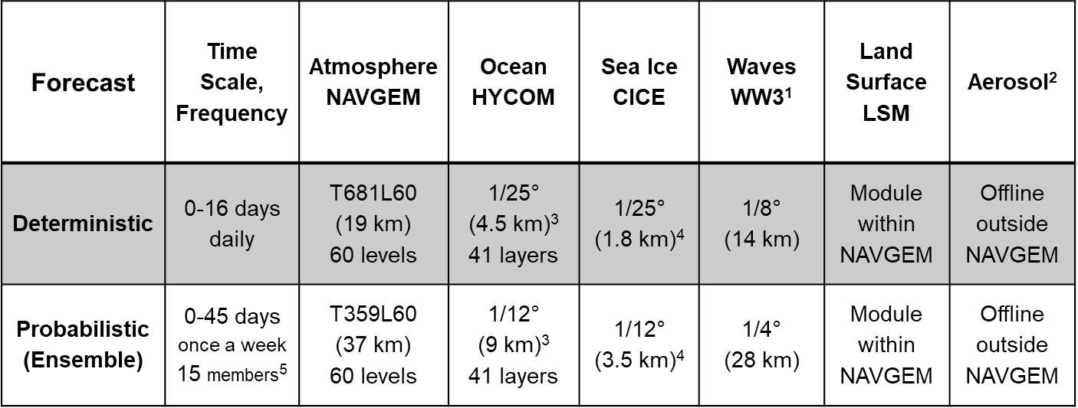

Table 1. Horizontal and vertical resolutions of the individual ESPC components at Initial Operational Capability (IOC). ¹ One-way coupling of atmosphere-ocean-sea ice to WW3. ² One-way coupling of atmosphere to aerosol. ³ Horizontal resolution at the equator. ⁴ Horizontal resolution at the North Pole. ⁵ The exact number of members will be determined by the operational resources available.

