# Ensembles in the ocean: an ECMWF perspective

## Magdalena A. Balmaseda, Hao Zuo

*Research Department, ECMWF, Reading, UK*

*Magdalena.balmaseda@ecmwf.int*

**Introduction**

This presentation reviews different approaches explored for ensemble generation for initialization of seasonal forecast. It then focuses on describing the approach used at ECMWF for creating ocean perturbations in the current ocean reanalysis. It concludes by illustrating the impact of coupled data assimilation in the ensemble spread of surface fluxes.

**The ECMWF scheme for ensemble generation in the ocean**

A new generic perturbation scheme suitable for generation of an ensemble of ocean analysis has been developed at ECMWF (Zuo et al 2017). The scheme consists of two distinct elements: perturbations to the assimilated observations, both profiles and surface observations, and perturbations to the surface forcing fields. The new scheme has been applied to the new Ocean ReAnalysis System-5 (ORAS5, Zuo et al 2018). The surface forcing perturbation has also been used to create oceanic surface forcing for ERA5, and in operational Ensemble Data Assimilation (EDA) from cycle 43R1.

The idea behind the observation perturbation scheme is to account for observation representativeness error. Instead of perturbing the value of the assimilated observations, the scheme perturbs the position of the observations. This is done by applying perturbations to the geographical location of the insitu temperature and salinity profiles, and by random thinning, both in the horizontal for surface observations, and in the vertical for dense profiles. This method exploits the full observation data set and uses more observations (through ensemble approach) than the previous thinning method. The impact of the perturbation scheme in the ocean reanalysis is illustrated together with selected sensitivity experiments. It is shown that the observation perturbations have little impact in global or basin wide climate indices, but they have local effect. The ensemble spread shows large errors in regions with strong mesoscale eddy activities and in areas affected by the Mediterranean Outflow waters. These are regions where departures with respect to observations are also large. It is also shown that ensemble spread in the tropical upper-ocean is under-dispersive with only five ensemble members, but it improves by increasing the ensemble size.

|  |  |
| --- | --- |
| **Regular thinning** | **Random thinning** |

Figure 1: Daily averaged gridded sea-ice concentration data from OSTIA as assimilated in (left) the control member with regular thinning; and in (right) a perturbed member using stratified random sampling method. Here thinning box length-scale is approximately 100 km in the Arctic Ocean.

A revised scheme for generating perturbations to surface forcing has also been developed. It is a generalization of the previous scheme and is still based on sampling past differences between different sources of information. The previous scheme, implemented as part of the seasonal forecasting system 2 (S2), created monthly perturbations for wind stress and Sea Surface Temperature (SST), based on sampled differences between atmospheric re-analysis products. The new scheme is more general in several aspects: i ) it allows for representation of both analysis and structural uncertainty; ii) it permits different temporal de-correlation scales of the perturbations; iii) it encompasses a wider range of variables and iv) it preserves the multivariate relationships among the perturbed variables. The reference data sets for sampling the perturbations have also been updated. The analysis uncertainty is sampled using the ensemble information from ERA-20C. The structural uncertainty in SST is sampled using more up-to-date data sets of high resolution ESA-CCI and HadISSTv2.1. Sea Ice Concentration (SIC) structural uncertainty is sampled using differences between HadISSTv2.0 and v2.1. The scheme is not fully flow dependent yet as it represents only the seasonal variations of uncertainty. However, it has been designed to be compatible with the flow dependent perturbations such as those produced by the real-time EDA; in particular, the climatological analysis uncertainty perturbations can be replaced by those from the EDA when the latter becomes available. The new SST and sea-ice perturbation strategy developed is also used by ERA5 and by the operational EDA (albeit with different parameter choices).

**Impact of coupled data assimilation in flow dependent ensemble spread**

The impact of coupled data assimilation in the flow dependence of the ensemble spread is assessed by comparing the time evolution of the spread in two different systems. The first one is ORA-20C (De Boisseson et al 2017), a 10-member ensemble of uncoupled centenial ocean reanalyses, and the recently developed CERA-20C (Lolayaux et al 2018), a 10-member ensemble of coupled ocean-atmosphere-seaice-wave-land reanalysis covering the XX century. ORA-20C uses the ensemble generation approach described above, which has limitations on the representation of the flow dependent spread. Figure 2 shows the ensemble spread in absorbed solar radiation as prescribed in ORA-20C, and the one resulting from the coupled reanalysis CERA-20C. The figure shows that the coupled reanalyses represents the decadal variations in the uncertainty of the forcing fluxes, with large uncertainty in the early decades of the XX-Century.

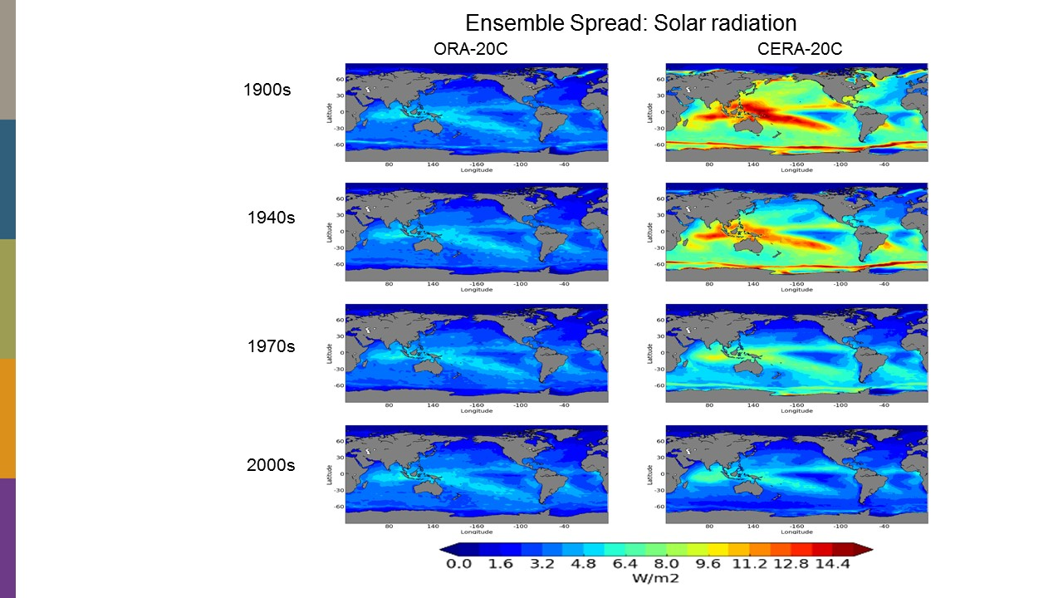

Figure 2: Decadal variations of the spread in solar absorbed solar radiation (left) in the ORA-20C 10-member ensemble of uncoupled reanalyss (De Boisdeson et al 2017) and (right) in the 10-member ensemble of coupled reanalysis (Laloyaux et al 2018). The larger uncertainty in the earlier decades of the XX-century is better captured in the coupled reanalyses.

**REFERENCES**

de Boisseson, E., M.A. Balmaseda, M. A., and M. Mayer,, 2017. Ocean heat content variability in an ensemble of twentieth century ocean reanalyses. *Climate Dynamics*, 50, 3783–3783.

Laloyaux, P., de Boisseson, E., Balmaseda, M., Bidlot, J.‐R., Broennimann, S., Buizza, R., et al. (2018). CERA‐20C: A coupled reanalysis of the twentieth century. *Journal of Advances in Modeling Earth Systems*, 10, 1172–1195. <https://doi.org/10.1029/2018MS001273>

Zuo, H., M.A. Balmaseda, E. de Boisseson, S. Hirahara, M. Churst, P. de Rosnay, 2017: A generic ensemble generation approach for ocean data assimilation and ocean analysis. ECMWF Technical Memorandum 795.

Zuo, H., M.A. Balmaseda, K. Mogensen and S. Tietsche: OCEAN5: the ECMWF Ocean Reanalysis System and its Real-Time analysis component. ECMWF technical Memorandum 823.