# Using climate projections to understand impacts and inform agricultural adaptation

## Richard J. Eckard1 and Brendan R. Cullen1

*1Faculty of Veterinary and Agricultural Sciences, The University of Melbourne, 3010*

*Richard.Eckard@unimelb.edu.au*

**Introduction**

Climate change is already impacting agriculture in Australia, with recent studies quantifying these impacts in wheat production (Hochman et al. 2017; Taylor et al. 2018), wine grapes (Webb et al. 2012) and grazing (Cullen et al. 2009). For agriculture to adapt to climate change, each industry will require regionally specific information about the likely future rainfall patterns and temperature changes, to enable their farm systems models to predict the likely impacts. These impacts can include earlier ripening of grapes (Webb et al. 2012), declining in wheat yields (Hochman et al. 2017), a greater frequency of crop failure (Taylor et al. 2018), or changes in the seasonal growth rate patterns in pastures (Cullen et al. 2009).

A common approach to understanding climate change impacts is to use Global Circulation Model (GCM) data to scale historical climate data to create the regionally specific future daily climate libraries required to drive crop and pasture system models. There are numerous variations on how this can be achieved, from simple arithmetic scaling, through to complex statistical techniques. This paper discusses three case studies by the authors, illustrating how the data then informs adaptation within each industry.

**Climate change effects on pasture systems in south-eastern Australia**

The effects of future climate scenarios on pasture production were modelled at 5 sites in eastern Australia, ranging from a C4-dominant pasture in subtropical south-eastern Queensland to a C3 pasture in the cool temperate environment of north western Tasmania (Cullen et al. 2009). A 30-year climate ‘baseline’ (1971–2000) was used to represent inherent climate variability at each site, based on data from the SILO database (Jeffrey et al. 2001). Future climate scenarios were developed, by adjusting baseline climate data with climate change projections for 2030 and 2070, based on the A1FI and A1B emission scenarios with both medium and high climate sensitivity, to create 30-year realisations of each future climate scenario. Monthly projections for mean temperature (ºC) and rainfall (%) change were obtained from the CSIRO Mark 3 global circulation model, via the OzClim database. These monthly change factors were used to mathematically scale the historical data for each site. The historical data was not detrended as there were no significant linear annual trends over the 30-year record.

The resultant daily climate libraries were then used to drive the SGS and DairyMod pasture models (Johnson et al. 2003; Johnson et al. 2008) to simulate rainfed pasture growth (e.g. Figure 1) for each site, for the baseline period, and then for 30 potential realisations of a 2030 and 2070 year.

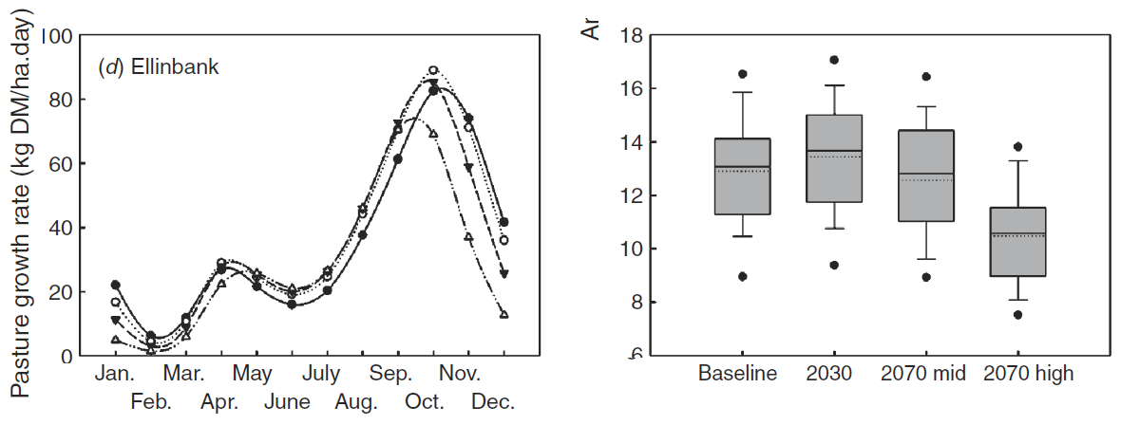

**Figure 1.** Mean monthly predicted pasture growth rate (kg DM/ha.day) for baseline (solid line), 2030 (dotted), 2070 mid (dashed), and 2070 high (mixed) climate scenarios, together with box-plots of predicted annual production (t DM/ha) for the baseline, 2030, 2070 mid, and 2070 high climate scenarios at Ellinbank in West Gippsland, Victoria.

More recently, Harrison et al. (2016) compared the impact of simple monthly scaling (Gradual) with a ‘Variable’ approach which incorporated projections for extreme climate events; for example, with rainfall occurring in fewer, larger events. The ‘Variable’ approach consistently simulated lower pasture production than the ‘Gradual’ approach (Figure 2) even though the monthly average rainfall and temperatures were held constant. These findings highlighted the importance of incorporating projections for increased climatic variability and extreme climate events into future scenarios.

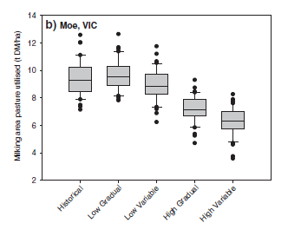

**Figure 2**. Boxplots of annual pasture utilised (t DM/ha) on a case study farm in Moe, Gippsland Victoria, under an historical climate (1975-2013), and Low and High change projections for 2080 using the ‘Gradual’ and ‘Variable’ approaches.

**Potential impacts of climate change on soil organic carbon and productivity in pastures of south eastern Australia**

Meyer et al. (2018) modelled the potential impact of climate change on soil organic carbon under grazed pasture systems at two sites in western Victoria. The methodology for developing the downscaled future climate file built on that of Cullen et al. (2009). Climate change factors were obtained from SimCLIM 2013 AR5 software (version 2.1) (Warrick 2007). All 40 of the GCMs from the coupled model inter-comparison (CMIP 5) available in SimCLIM were included in the ensemble used to generate the climate projections. The GCMs that produced the 10th, 50th and 90th percentile temperature (GCMt) and rainfall (GCMr) projections were used to develop five future climate scenarios, for both the 4.5 and 8.5 Representative Concentration Pathways (RCPs): hot and dry (90th percentile GCMt90 and 10th percentile GCMr10); warm and dry (10th percentile GCMt10 and GCMr10); intermediate (50th percentile GCMt and GCMr); hot and wet (90th percentile GCMt90 and GCMr90), and warm and wet (GCMt10 and GCMr90). Climate libraries from 2017 to 2090 were generated by applying change factors to the historic SILO patch point dataset, detrended for historic climate change effects on temperature. For each climate variable there were different change factors for the 3 selected climate models (10th, 50th and 90th percentile GCM), 2 emissions scenarios (4.5 RCP and 8.5 RCP), 2 seasons (winter growing season and summer) and 2 sites (high rainfall at Hamilton and low rainfall at Birchip).

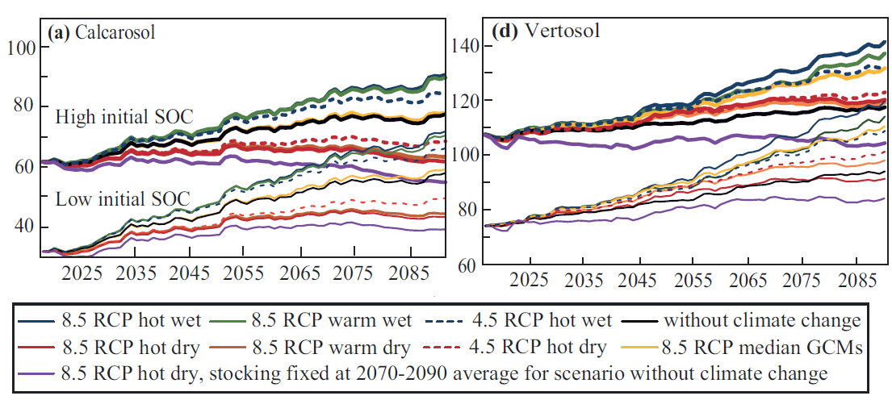

**Figure 3.** Modelled change in SOC from 2017 to 2090, for low and high initial SOC over several climate and 2 soil type scenarios.

The resultant daily climate files were then used to drive the SGS pasture model (Johnson et al. 2003; Johnson et al. 2008), with the SGS model also providing inputs into the Roth C soil carbon model. The models where then run from 2017 through to 2090, for two soil types at each site, each starting with either low or high soil organic matter, to show potential interactions between stocking rate and soil carbon under a changing climate (e.g. Figure 3).

**Trends in wheat yields under representative climate futures: Implications for climate adaptation**

Taylor et al. (2018) modelled the potential impact of climate change on wheat yield across southern Australia. The methodology for developing the downscaled future climate libraries built on the approaches of Cullen et al. (2009) and Meyer et al. (2018). A set of Representative Climate Futures (RCF) (Whetton et al. 2012) was developed, based on RCP4.5 and RCP8.5, to describe plausible future climate scenarios, based on data from Climate Change in Australia. The full suite of available GCMs was used and individual GCMs were organised into: a) the ‘most likely’ case, defined as at least 30% or more of total number of GCMs in agreement, b) the ‘best’ case, defined as the climate future resulting in the highest rainfall and lowest temperature increase, and c) the ‘worst’ case, defined as the lowest rainfall and highest temperature increase (Whetton et al. 2012). The GCMs were ranked using a multivariate ordering technique (Kokic et al. 2002). The GCM closest to the multi-model mean of the ‘most likely’ case was selected, along with the GCMs aligning with the minimum and maximum being selected for the 'best' and 'worst' cases, respectively. The resultant change factors were then applied to the historical SILO data for each site as per Cullen et al. (2009), for a 31-year baseline period from 1980 to 2010, with 1995 as the centred year to predict wheat yields using APSIM (Figure 4).

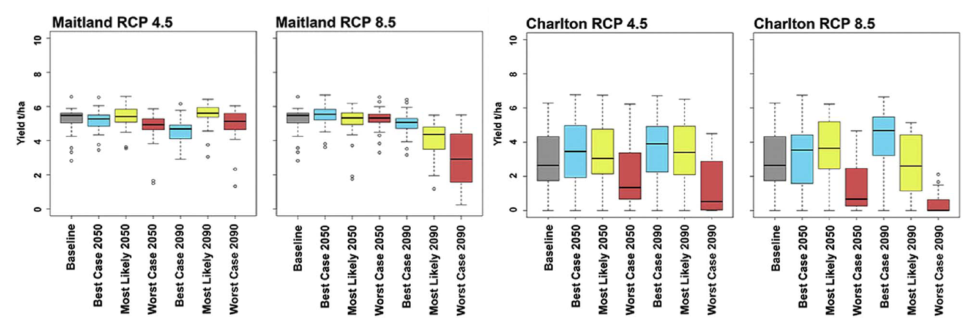

**Figure 4.** Box and whisker plots of projected changes to wheat yield on selected study sites. The grey box represents the baseline climate 1980 to 2010. The blue, yellow and red boxes represent the low (best case), mean (most likely) and high (worst) climate change cases, respectively.

**Informing agricultural adaptation**

The three case studies above have been used to inform both industry and government policy and identify further research on adaptation to the changing climate.

The pasture case study identified changes to seasonal pasture growth patterns, with higher winter and early spring growth rates, but earlier onset of a hotter a drier summer (Figure 1). Adaptation options included a change in management to focus on increasing winter pasture growth to compensate for the loss of late spring growth, plus the selection or breeding for deeper rooted and more heat tolerant pastures in southern regions.

The soil organic carbon (SOC) case study (Figure 3) showed slower SOC accumulation under dry projections (deemed most likely), due to reduced pasture growth and associated decreased average stocking rates, which approached zero by 2090 on the low-rainfall site. The results demonstrated the extent of the uncertainty associated with soil carbon trading for farmers and the need for adaptation options that allow farms to remain sustainable and productive as the climate changes. This modelling has changed government and industry policy, from one of expecting large sequestration benefits from SOC, to a position of aiming to maintain current SOC stocks.

The wheat case study projected yield declines of between 26% and 38%, under a ‘most-likely’ case for RCP 4.5 by 2090, and between 41% and 49%, under a ‘most-likely’ case for RCP 8.5 (Figure 4). Variability also changed from the baseline under all projected RCFs and across all regions, with a standard deviation of up to 2.5 t/ha under the ‘most likely’ case at a site in south-eastern Australia. The study showed that southern drier wheat regions of Australia would be more impacted, requiring more transformational adaptation options. Adaptations in the less impacted regions (e.g. mixed rainfall) may include choice of cultivar and sowing times, whereas the more impacted regions may require a shift to mixed farming systems to spread risk, or even a move away from wheat cropping to other forms of agriculture.

**Conclusions**

Given the uncertainties inherent in the climate change scenarios and GCM predictions, there is the risk of further compounding uncertainty in downscaling to a specific location. However, for the purposes of identifying likely impacts and informing adaptation, the specific downscaling method used appears less important than understanding general trends in rainfall and temperature within a season and region. Improvements to these downscaling methods to develop future climate scenarios should rather focus on including trends in rainfall and temperature variability as well as extreme climate events, as these appear to have a greater impact on agricultural adaptation.

# References

Cullen, B.R., Johnson, I.R., Eckard, R.J., Lodge, G.M., Walker, R.G., Rawnsley, R.P., and McCaskill, M.R., 2009: Climate change effects on pasture systems in south-eastern Australia. Crop and Pasture Science, 60**,** 933-942.

Hochman, Z., Gobbett, D.L., and Horan, H., 2017: Climate trends account for stalled wheat yields in Australia since 1990. Global Change Biology, 23**,** 2071-2081.

Jeffrey, S.J., Carter, J.O., Moodie, K.B., and Beswick, A.R., 2001: Using spatial interpolation to construct a comprehensive archive of Australian climate data. Environmental Modelling & Software, 16**,** 309-330.

Johnson, I.R., Lodge, G.M., and White, R.E., 2003: The Sustainable Grazing Systems Pasture Model: description, philosophy and application to the SGS National Experiment. Australian Journal of Experimental Agriculture, 43**,** 711-728.

Johnson, I.R., Chapman, D.F., Snow, V.O., Eckard, R.J., Parsons, A.J., Lambert, M.G., and Cullen, B.R., 2008: DairyMod and EcoMod: Biophysical pastoral simulation models for Australia and New Zealand. Australian Journal of Experimental Agriculture, 48**,** 621-631.

Kokic, P., Breckling, J., and Lübke, O., 2002: A new definition of multivariate M-quantiles. *Statistical Data Analysis Based on the L1-Norm and Related Methods*, Y. Dodge, Ed., Birkhäuser Verlag,15–24.

Meyer, R.S., Cullen, B.R., Whetton, P.H., Robertson, F.A., and Eckard, R.J., 2018: Potential impacts of climate change on soil organic carbon and productivity in pastures of south eastern Australia. Agricultural Systems, (in press).

Taylor, C., Cullen, B., D'Occhio, M., Rickards, L., and Eckard, R., 2018: Trends in wheat yields under representative climate futures: Implications for climate adaptation. Agricultural Systems, 164**,** 1-10.

Warrick, R., 2007: SimCLIM: Recent Developments of an Integrated Model for Multi-scale, Risk-based Assessments of Climate Change Impacts and Adaptation. *2007 Australia-New Zealand Society for Ecological Economics Conference*, Noosaville, Queensland, Australia-New Zealand Society for Ecological Economics.

Webb, L.B., Whetton, P.H., Bhend, J., Darbyshire, R., Briggs, P.R., and Barlow, E.W.R., 2012: Earlier wine-grape ripening driven by climatic warming and drying and management practices. Nature Clim. Change, 2**,** 259-264.

Whetton, P., Hennessy, K., Clarke, J., McInnes, K., and Kent, D., 2012: Use of Representative Climate Futures in impact and adaptation assessment. Climatic Change, 115**,** 433-442.