**Seasonal Prediction Framework for attribution of extreme events in a changing climate**

## Pandora Hope1, Guomin Wang1, Eun-Pa Lim1, Harry Hendon1, Michael Grose2, Mitchell Black3, Acacia Pepler4, Andrew Dowdy1 and Julie Arblaster5

*1Climate Research, Science to Services, Bureau of Meteorology, Melbourne*

*2Oceans and Atmosphere, CSIRO, Hobart*

*3Community Forecasts, Bureau of Meteorology, Melbourne  
4Climate Research, Science to Services, Bureau of Meteorology, Sydney*

*5School of Earth, Atmosphere and Environment, Monash University, Melbourne*

*pandora.hope@bom.gov.au*

At the Australian Bureau of Meteorology we have developed a system for the attribution of extreme events using our seasonal forecast coupled model, POAMA (Wang et al. 2016). The initial-value nature of the framework allows little time for the growth of model-driven biases, while allowing the full coupled response of the ocean– atmosphere–land system. We can thus analyse the specific event in question, rather than a 'class' of such events. The system provides the potential for analysis of the forecast events before they have occurred.

We have used the system to determine the influence that the last 55 years increase in atmospheric CO2 had on two heat events (Hope et al. 2015, (see Figure 1 below); Hope et al. 2016), a very wet month (Hope et al. 2018) and an extensive frost period (Grose et al. 2018). Results align with those using other methods; for the heat there was an excess temperature anomaly of 1 ºC due to increased CO2, the same magnitude as the temperature trend over the same period. Circulation changes driven by CO2 increases would encourage frost development in south-west Australia, but thermodynamic changes work against this trend. Our method suggests that increasing atmospheric CO2 did not enhance the big wet in south-east Australia in September 2016, however, some questions still remain. We have recently used the method to attempt to attribute the extreme fire weather (FFDI) in February 2017 to CO2 increase, but there is still further development required to allow the attribution of such complex weather phenomena as fire weather.

We can also use the method to assess whether the over-riding signal that led to an extreme event was derived from the ocean, atmosphere or land surface (Arblaster et al. 2014; Hope et al. 2015).

These methods allow better contextualisation of forecast extremes, potentially providing key information to forecasters commentating on the event, or in the post-event analysis.

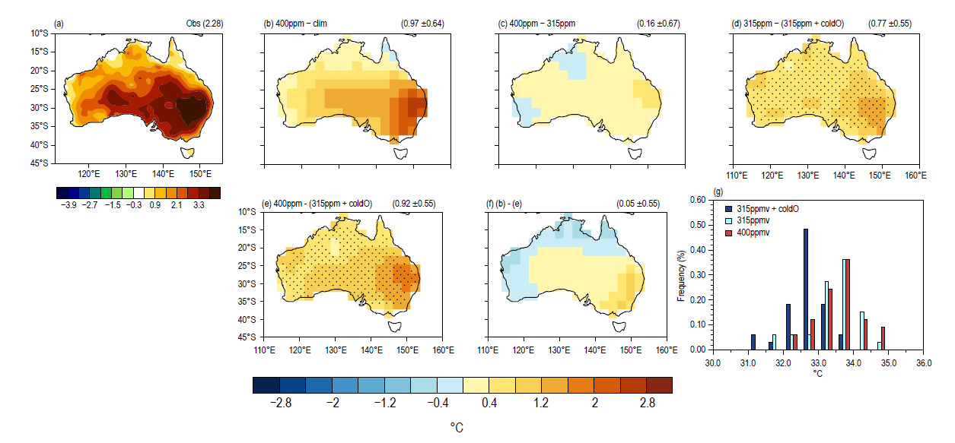

**Figure 1**. The ensemble spread of the forecasts under the current climate (red), the current climate with CO2 set to 315 ppm (light blue), and a 'low-CO2' climate, with a modified ocean initial state as well as CO2 set to 315 ppm (dark blue). (From Hope et al. 2015).

# References

Arblaster, J.M., E.-P. Lim, H.H. Hendon, B.C. Trewin, M.C. Wheeler, G. Liu, G. and K. Braganza, 2014. Understanding Australia’s hottest September on record. In: Explaining extremes of 2013 from a climate perspective”]. Bull. Amer. Met. Soc., 95, S37–S41.

Grose, M.R., M. Black, J. S. Risbey, P. Uhe, P.K. Hope, K. Haustein, and D. Mitchell, 2018. Severe Frosts in Western Australia in September 2016. In: Explaining extreme events of 2016 from a climate perspective, Bull. Amer. Met. Soc., 99, Ch 29. DOI:10.1175/BAMS-D-17-0088.1

Hope, P., E.-P. Lim, H. Hendon, G. Wang, 2018. The effect of increasing CO2 on the extreme September 2016 rainfall across southeastern Australia. In: Explaining extreme events of 2016 from a climate perspective, Bull. Amer. Met. Soc., 99, Ch 26. DOI:10.1175/BAMS-D-17-0094.1

Hope, P., E.-P. Lim, G. Wang, H. H. Hendon, and J. M. Arblaster, 2016: What caused the record-breaking heat across Australia in October 2015? In: Explaining extremes of 2015 from a climate perspective Bull. Amer. Meteor. Soc., 97, 122-126. http://journals.ametsoc.org/doi/pdf/10.1175/BAMS-D-16-0141.1

Hope, P., E.-P. Lim, G. Wang, H. H. Hendon, and J. M. Arblaster, 2015: Contributors to the record high temperatures across Australia in late spring. In: Explaining extremes of 2014 from a climate perspective, Bull. Amer. Meteor. Soc., 96, S149-S153.

Wang, G., P. Hope, E.P. Lim, H.H. Hendon and J.M. Arblaster, 2016. Three methods for the attribution of extreme weather and climate events. Bureau Research Report, 18. Bureau of Meteorology, Australia. http://www.bom.gov.au/research/publications/researchreports/BRR-018.pdf