**Ensemble selection for hydrological projections – preliminary steps**

## Pandora Hope1, Chantal Donnelly2, Louise Wilson3, Justin Peter1, Elisabeth Vogel3, Wendy Sharples3

*1Climate Research, Science to Services, Bureau of Meteorology, Melbourne*

*2Water Resource Modelling Team, Water Program, Bureau of Meteorology, Brisbane*

*3Water Resource Modelling Team, Water Program, Bureau of Meteorology, Melbourne*

*pandora.hope@bom.gov.au*

The Bureau of Meteorology has undertaken to develop a national Hydrological Projections service, and we are in the development stage. A first step in this process is to determine the best way to develop an appropriate ensemble of projections.

There are a number of steps and choices in developing hydrological projections (Figure 1), and these place constraints upon the ensemble that can be used, and at times, pragmatic choices must be made. Earlier efforts (ISI-MIP: Hempel et al. 2013; Victoria: Potter et al. 2018) have used an ensemble of opportunity, based upon the climate model simulations and downscaled data that was available, that also had output of the variables required to run their hydrological models.

In this presentation, we will outline the steps and choices made in the first stages of choosing the ensemble of climate model projections to be used in the Bureau of Meteorology's hydrological projections project.

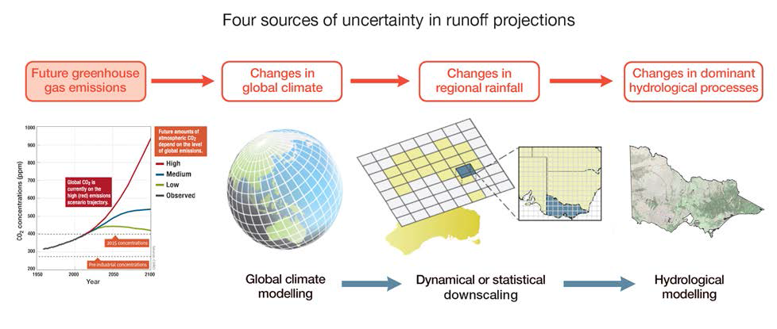

**Figure 1**. From (Hope et al. 2017). Four steps in developing hydrological projections. These four steps are also the points at which choices can be made, and so create an appropriate ensemble to capture the range of uncertainty. Choices can be made about the scenario(s), the GCMs, the downscaling method and the hydrological model.

# References

Hempel, S., K. Frieler, L. Warszawski, J. Schewe, and F. Piontek, 2013: A trend-preserving bias correction &ndash; The ISI-MIP approach. *Earth Syst. Dyn.*, **4**, 219–236, doi:10.5194/esd-4-219-2013.

Hope, P., B. Timbal, H. Hendon, M. Ekström, and N. Potter, 2017: A Synthesis of Findings from the Victorian Climate Initiative. 56. http://www.bom.gov.au/research/projects/vicci/docs/2017/VicCI-SynR-MR.pdf.

Potter, N. J., M. Ekström, F. H. S. Chiew, L. Zhang, and G. Fu, 2018: Change-signal impacts in downscaled data and its influence on hydroclimate projections. *J. Hydrol.*, **564**, 12–25, doi:10.1016/J.JHYDROL.2018.06.018. https://www.sciencedirect.com/science/article/pii/S0022169418304402 (Accessed October 10, 2018).