# Experience from using ensemble methods in climate and water services

## Berit Arheimer1 and the Hydrological Research unit1

*1Swedish Meteorological and Hydrological Institute (SMHI), R&D, 60176 Norrköping, Sweden*

*Berit.Arheimer@smhi.se*

**Introduction**

Currently there is a fast growing development of climate services across the world addressing various geographical domains, scales and societal sectors. The need of readily available high-quality climate data became urgent with the Paris Agreement in 2015, which in addition to mitigation also highlight the necessities of adaptation measures (United Nations, 2015). The numerous existing services differ a lot in design, data content, accessibility, formats, user friendliness and it is often unclear who the target user is. Accordingly, the definition of a climate service varies a lot (c.f. EC, 2015; US NRC, 2001; WMO, 2015). In general, there are two main categories of services provided; (1) the general and web-based, and (2) the tailor made in dialogue with a specific user. The two categories could well be interlinked, when so called ‘Knowledge Purveyors’ use the first service to provide the latter (e.g. Donnelly et al., 2018).

This presentation sums-up recent experiences from working with various climate services; (i) in Sweden by the national weather and water service, (ii) in Europe and globally from proof-of-concepts for the Copernicus Climate Change Services (C3S) operated by ECMWF on behalf of the European Union, and (iii) in several R&D projects, aiming to advance climate services by national and European research councils. It will start with a short Demo of the components suggested to be part of web-based climate services, followed by the importance of ensemble methods in the data production chain, and finally, some lessons learnt from user uptake.

**Suggested components of a web-based climate service**

The climate services discussed here should provide climate data to a user, who needs data and information when working with climate adaptation. The service is the interface between climate science and society, trying to communicate future impacts from climate change. Climate science and tools are often demanding, both in skills and time. In society, there are many potential users of climate data and they have very different needs and capacity. To be useful, the service thus needs to communicate differently to different user groups and convert data into information that can be received by specific user groups. A large part of the service should therefore be dedicated to user guidance, training and showcases, but this is where many climate services fail at present.

Different user communities (e.g policy makers, authorities, managers, consultant engineers or scientists) will use the data in completely different types of applications and therefore need to access it in different forms (Fig. 1). They will face completely different problems in their applications and therefore they also need different user support and means of communication from the data provider (i.e. the scientific community). There is no “one-size-fits-all” for climate services but they must be tailored in each component to reach out to specific user communities. This is probably where there is most potential at present for increasing user-uptake from climate services and accelerating climate adaptation.

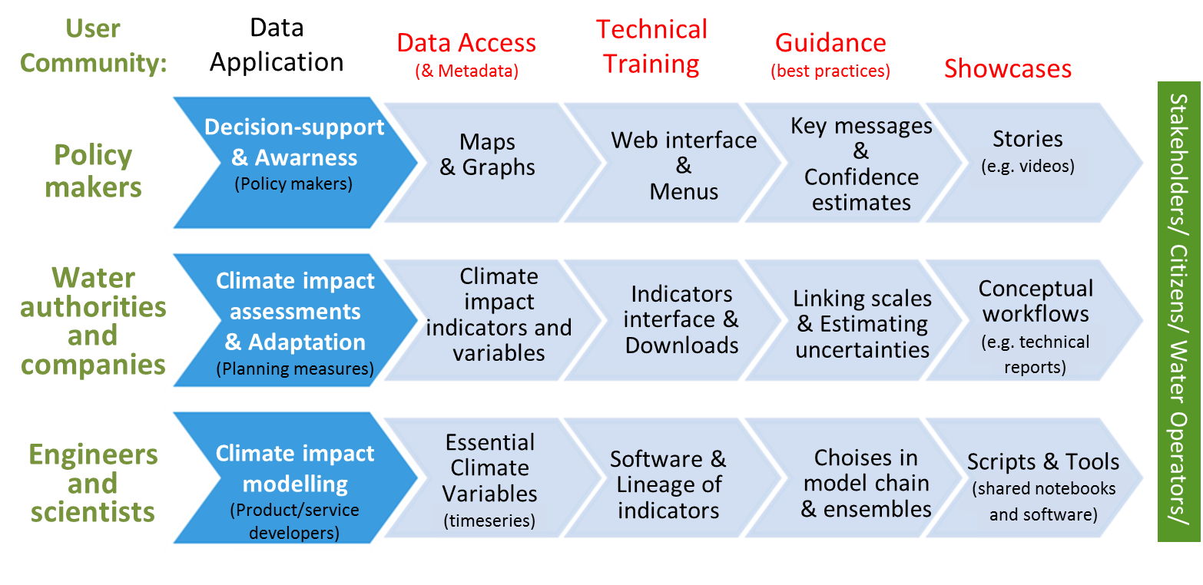

Figure 1. Components (red) in a climate service when tailored (light blue) for different user categories (green) and applications (dark blue).

**Ensemble methods in the data-production chain of climate impacts**

The climate impact indicators provided in a climate service are often the end result of a long chain of model simulations and statistical calculations (Fig 2.). Each step in the production chain includes large uncertainties and therefore an ensemble of projections is normally presented. The ensembles contain a spread of values that reflect the lack of knowledge, for instance about initial conditions, sensitivity of processes, future emissions and natural variability (e.g. Kjellström et al., 2013). Most uncertainty in near-time projections refers to natural variability, which still remains difficult to describe due to low spatial resolution in observation networks and thus unknown initial conditions. On a longer time scale, most uncertainty refers to future concentrations of greenhouse gases in the atmosphere (RCP’s), which depend on societal evolution and implementation of mitigation measures. Additionally, uncertainties refer to future circulation patterns involving atmosphere and ocean dynamics; as the atmospheric system is quite chaotic, it is possible to only make predictions for the nearest days based on known initial conditions - the climate time-scale is not yet possible to predict. Instead, climate modellers explore sensitivities and make assessments about future climate change by using different scenarios for the future, producing projections of climate change in a range of different climate models starting from different initial conditions. The result is an ensemble of climate projections, but ensemble methods are also needed for the production steps that follow in impact assessments, as they may be just as uncertain.

Bias adjustments are normally performed before impact analysis, to make the climate-model results correspond to observations during a reference period. However, the observations at specific points may not be representative, and methods are very sensitive to gauge density (e.g. Olsson et al., 2016). Moreover, various methods may lead to different implications for the final analysis, e.g. inconsistency between corrected variables if this is done separately. The final part of the model chain, the hydrological impact models, may respond differently to climate change due to different interpretation of drivers for flow generation, from model parameter values or assumptions in the model structure (e.g. Krysanova et al., 2018).

Water management is always local, and the local scale is already exposed to large variation in weather patterns. This means that climate impact may not be evident on a year to year basis, but some events may become more frequent, or prolonged, if analysed over a longer time period. Therefore, climate impact assessments often use 30 year averages to explore changes. In practice this may be too short a period for local conditions as they are so variable. If the trend is small and the variability large (often in precipitation and river flow) it may be very difficult to detect changes beyond natural variability.

Most climate services try to give examples on how climate change may be manifested in the future, given some major sources of uncertainty. However, for specific applications, some models and some impact indicators may be more trustworthy than others (e.g. Donnelly et al., 2018). Here the users need guidance for climate adaptation. Traditionally, it has been argued that it is impossible to judge which models perform better under future climate change, and thus, it is the best to a use range of models (an ensemble). Research has shown that an ensemble of models gives a more accurate prediction of future climate impacts than even the best individual model (e.g. Krishnamurti et al., 2000; Tebaldi and Knutti, 2007). For practical reasons, statistical methods on how to choose a sample from the ensemble but still keep the ensemble spread has been suggested (e.g. Pechlivanidis et al., 2018). However, recently, it has also been argued that more qualitative methods should be used, as some members in the model ensemble may be less trustworthy (Krysanova et al., 2018; Donnelly et al., 2018).

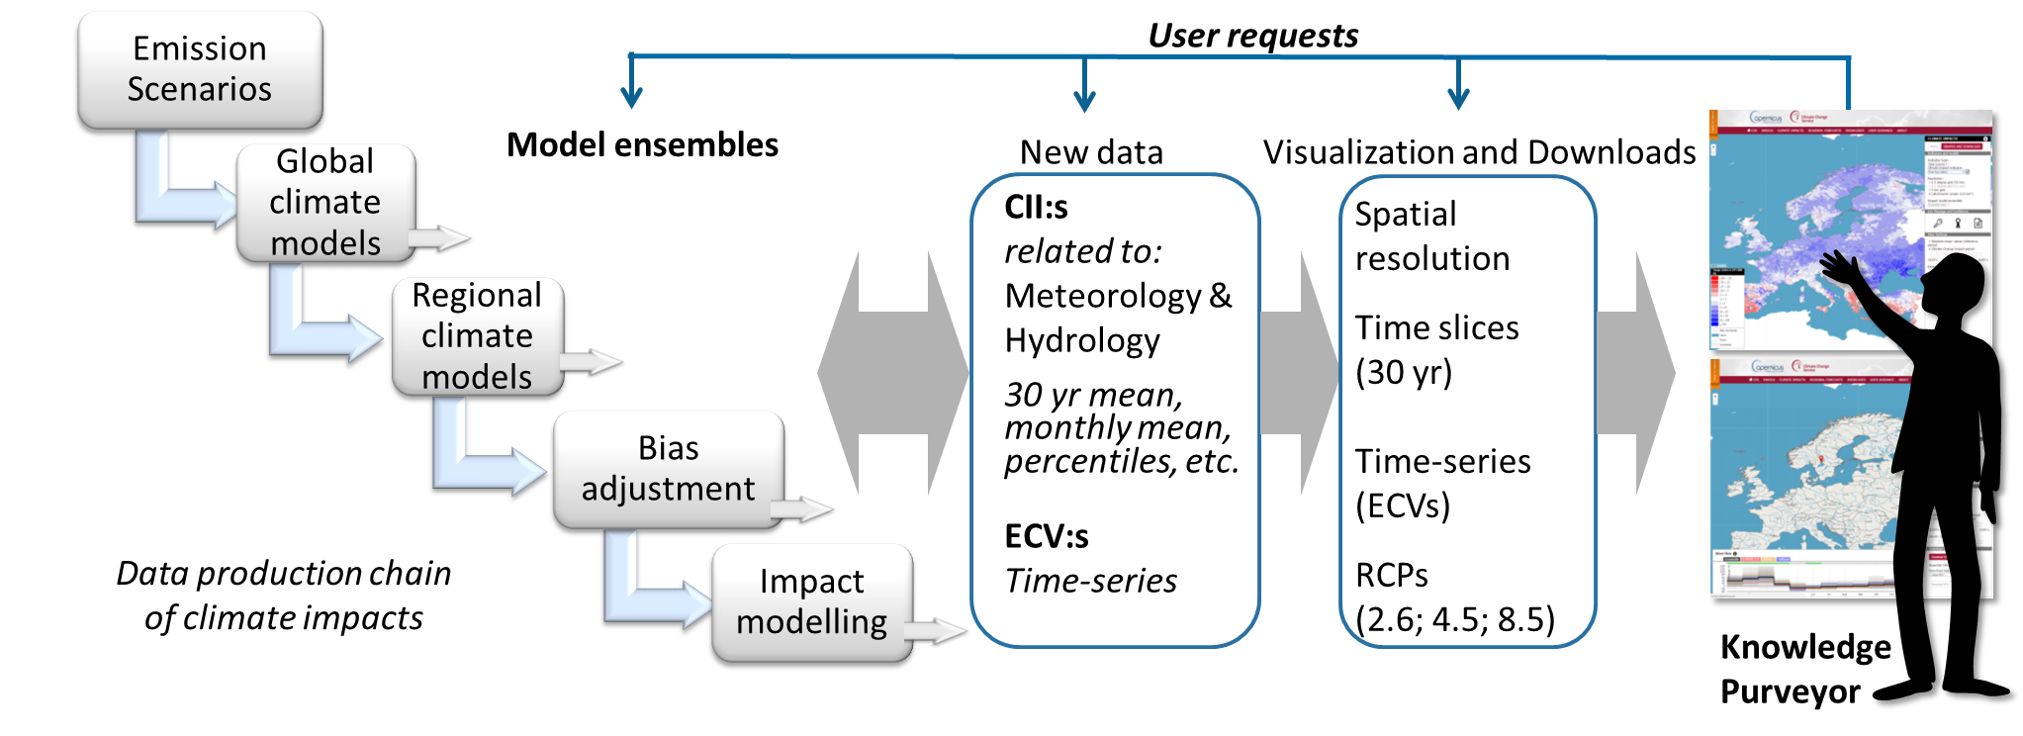

Figure 2. Ensemble methods are included in each step of the production chain of climate impacts to be visualized and downloaded based on user (e.g. a knowledge purveyor) choice in the climate service.

**Lessons learnt from user uptake**

The experiences from working with users of climate and water services, and co-development of services involving different stakeholders across Europe, have resulted in some main lessons learnt:

* Climate science is difficult with large uncertainties (requesting ensemble approaches) and data tailoring for climate adaptation is time-consuming, therefore the concept of ‘Knowledge purveyors”, i.e. consultant engineers, is essential for user uptake of climate services. This intermediate expert group should be in focus when developing climate services for water impact adaptation.
* Know-how in tailoring data is essential for a wide uptake of climate services. The large-scale data need to be further adjusted to observations and merged with local data sources. For this, the Knowledge purveyors need to be educated and web-based services should thus be equipped with online methods, like webinars, video conferences, social-media groups, a Forum, user support and offer various face-to-face meetings, like workshops at dedicated hands-on training.
* Quick and easy access to climate-impact data for download without having to run a full production chain (involving climate and impact modelling) probably is the single most important element of a climate and water service. Climate indicators were in general appreciated as very useful. However, the service need to address specific user communities regarding format, key-messages, meta-data and fact sheets that address their needs and level of competence. Moreover, the users need to be ensured about service sustainability, data consistency, and robustness of results.

# Acknowledgements

Experiences have been gained especially when working with the proof-of-concepts for the Copernicus Climate Change Services (C3S) operated by ECMWF on behalf of the European Union. Among the R&D projects, we would like to mention funding from the project AQUACLEW, which is part of ERA4CS, an ERA-NET initiated by JPI Climate, and funded by FORMAS (SE), DLR (DE), BMWFW (AT), IFD (DK), MINECO (ES), ANR (FR) with co-funding by the European Union (Grant 690462).

# References

Donnelly, C., Ernst, K., Arheimer, B. 2018. A comparison of hydrological climate services at different scales by users and scientists. Climate Services 11:24-35, <https://doi.org/10.1016/j.cliser.2018.06.002>

EC, 2015: European Commission A European Research and Innovation Roadmap for Climate Services (DG Research and Innovation, Luxembourg, 2015).

Kjellström, E., Thejll, P., Rummukainen, M., Christensen, J.H., Boberg, F., Christensen, O.B., Fox Maule, C. 2013: Emerging regional climate change signals for Europe under varying large-scale circulation conditions. Clim Res 56:103-119. <https://doi.org/10.3354/cr01146>

Krishnamurti, T. N., Kishtawal, C. M., Zhang, Z., LaRow, T., Bachiochi, D., Williford, E., Gadgil, S. and Surendran, S.. 2000: Multimodel Ensemble Forecasts for Weather and Seasonal Climate. Journal of Climate. 3:23 pp 4196 – 4216. DOI:http://dx.doi.org/10.1175/1520-0442(2000)013<4196:MEFFWA>2.0.CO;2

Krysanova, V., Donnelly, C., Gelfan, A., Gerten, D., Arheimer, B., Hattermann, F. and Kundzewicz; Z.W., 2018. How the performance of hydrological models relates to credibility of projections under climate change, Hydrological Sciences Journal, DOI: 10.1080/02626667.2018.1446214

Olsson, J., Arheimer, B., Borris, M., Donnelly, C., Foster, K., Nikulin, G., Persson, M., Perttu, A-M., Uvo, C.B., Viklander, M. and Yang, W. 2016: Hydrological Climate Change Impact Assessment at Small and Large Scales: Key Messages from Recent Progress in Sweden. Climate 4(3), 39; doi:10.3390/cli4030039

Pechlivanidis, I.G., Gupta, H., and Bosshard, T. 2018: An information theory approach to identifying a representative subset of hydro‐climatic simulations for impact modeling studies. Water Resources Research, 54, 5422–5435. <https://doi.org/10.1029/2017WR022035>

Tebaldi, C. and Knutti, R. 2007: The use of the multi-model ensemble in probabilistic climate projections. Phil. Trans. Royal Society A: Mathematical, Physical and Engineering Sciences . 365(1857), 2053-2075. DOI: 10.1098/rsta.2007.2076

United Nations 2015: United Nations Framework Convention on Climate Change The Paris Agreement, available at <http://unfccc.int/paris_agreement/items/9485.php>

US NRC, 2001: U.S. National Research Council A Climate Services Vision: First Steps toward the Future (NRC, National Academies Press, Washington, DC, 2001).

WMO 2014: World Meteorological Organization Implementation Plan of the Global Framework for Climate Services (WMO, Geneva, 2014).