**Using the EUROCORDEX ensemble to examine the impacts of 1.5, 2 and 3 °C global warming on European hydrology**

## Chantal Donnelly1&2, Wouter Greuell3, Jafet Andersson2, Dieter Gerten4, Giovanna Pisacane5, Philippe Roudier6 and Fulco Ludwig3

*1Water Program, Bureau of Meteorology, Brisbane,*

*2Research and Development, Swedish Meteorological and Hydrological Institute, Norrkoeping,Sweden*

*3Earth System Sciences Group, Wageningen University and Research Centre (WUR), Wageningen, The Netherlands*

*4**Potsdam Institute for Climate Impact Research, Potsdam, Germany*

*5ENEA, Rome, Italy*

*6Agence Française de Développement, Paris, France*

*Chantal.Donnelly@bom.gov.au*

**Introduction**

Global warming is expected to cause large-scale changes to the terrestrial water cycle affecting water availability for cities, energy production and agriculture, river navigability, flood risks and more. While impacts of climate change on the water cycle in Europe are well studied (e.g. Jiménez Cisneros et al. 2014), it is less well known what the impacts associated with various levels of global warming will be. Prior to the 21st session of the Conference of the Parties (COP21), a goal of +2°C warming globally above preindustrial levels was internationally accepted as the level required to prevent dangerous anthropogenic interference with the system (UNFCCC 2010). Since the 2015 COP21 Paris agreement, a more ambitious mitigation objective to “Hold the increase in the global mean temperature (GMT) to well below 2°C above pre-industrial levels and to pursue efforts to limit the temperature increase to 1.5°C” has been proposed (UNFCCC 2015). At the same time, if the current trajectory of greenhouse emissions continues, we could end up with more than 3 °C GMT rise (Sanford et al. 2014). Hence 1.5, 2 and 3 °C GMT rise are important milestones, not only for mitigation but also to understand the expected impacts of climate change.

This study (Donnelly et al. 2017) outlines a novel methodology to quantify the impact of these warming levels on the terrestrial water cycle in Europe. It uses the EUROCORDEX ensemble of regionally downscaled climate projections and an ensemble of five continental and global-scale hydrological models. An uncertainty in the methodology is tested by repeating the analysis for 2°C of warming using different ensembles, driven by different representative concentration pathways (RCPs). Finally, the impacts of climate change at 1.5, 2 and 3°C global mean temperature rise above pre-industrial levels are presented for a number of indicators of water-related change across Europe.

**Data and Methods**

This study makes use of the latest ensemble of high-resolution climate model outputs from the "Coordinated Regional Climate Downscaling Experiment" (CORDEX, Jacob et al. 2014). The project uses an ensemble of general circulation models (GCMs) from the climate model intercomparison project, phase 5 (CMIP5, Taylor et al. 2012) to force regional climate models (RCMs). A subset of 11 projections was chosen to represent the spread of the full CORDEX ensemble using cluster analysis (Moss et al. 2010). They are based on five unique GCM/RCM combinations (four GCMs and four RCMs) and three concentration pathways, representing a low-, medium- and high-emission scenario (RCP2.6, 4.5 and 8.5),combined in different ensembles for the three warming levels (1.5°C, 2°C and 3°C GMT rise).

The method to define warming thresholds in climate models follows that of Vautard et al. (2014). Scenarios that pass the target warming level are used as snapshots in time representing these levels of warming. This is necessary because the number of climate models stabilising at each of these warming thresholds are not sufficient. The impacts of climate change at 1.5, 2 and 3°C GMT rise are assessed by quantifying the change in hydrological indicators for the 30-year period centred at the year when each GCM reaches the defined increase in GMT relative to preindustrial levels (1881–1910). These temperature thresholds are reached at different times by each GCM. For example, the climate in a 1.5 °C warmed world is calculated using MPI-ESM-LR/CSCRemo/RCP2.6 for the period 2035-2064, in ensemble with EC-EARTH/SMHI-RCA4/RCP2.6 for the period 2028-2057, EC-EARTH/KNMI-RACMO22E/RCP4.5 for the period 2018-2047 and four other ensemble members.

The RCP8.5 runs reach the +1.5°C threshold very early in the twenty-first century when the uncertainty from the initial state of the climate models is still very high, so the ensemble for +1.5°C is made up of the lower emission RCPs: RCP2.6 and RCP4.5. For +3°C, only some of the RCP8.5 simulations reach +3°C by the end of the century. Therefore, the ensemble for the +3°C warming only consists of RCP8.5 (high-emission) runs. To study the sensitivity of the impacts to the choice of concentration pathway, the impacts at 2 °C were calculated twice: (a) for an ensemble of the low-emission pathways (RCP2.6 and 4.5) and (b) for an ensemble of the high-emission pathway (RCP8.5). For details of the methodology, see Donnelly et al. (2017).

The dynamically downscaled projections were each bias-corrected to the E-OBS gridded, interpolated observations data set for Europe. The bias-corrected data was subsequently used to force five hydrological models over Europe (Donnelly et al. 2017). They include model concepts varying from land-surface schemes (VIC, Liang et al. 1994), to process-based hydrological models of varying levels of complexity (LISFLOOD, Burek et al. 2013; WBM, Vörösmarty et al. 2000; and E-HYPE, Donnelly et al. 2016) and a coupled water and carbon cycle model with vegetation dynamics (LPJmL, Schaphoff et al. 2013).

Finally, the changes to a few simple indicators, indicative of the climatic development of aspects of the water cycle relevant for users, were quantified at each warming level. These changes in water-cycle indicators may then be used to infer potential impacts on water-related sectors. The following hydrological indicators were calculated for all of Europe:

1. Evapotranspiration: Mean annual evapotranspiration (indicative of water demand/use)
2. Runoff: Mean annual runoff (indicative of available water resources, e.g. for agriculture, water supply, navigation, etc.)
3. High runoff: Mean annual maximum runoff (indicative of recurring high flows and flooding)
4. Low runoff: Mean annual low runoff (mean of annual 10th percentile runoff, indicative of dry conditions/drought)
5. Snowpack: Mean annual snow water equivalent (SWE) maximum (indicative of snow storage for hydropower production and tourism)

Note that while the warming levels of 1.5, 2 and 3°C are defined relative to preindustrial levels, the impacts of the change are analysed relative to a more recent historical period, 1971-2000.

**Results**

Summarised across Europe, there are quantifiable differences between the impacts at different warming levels for most variables (Fig. 1). This is indicated by the slope of the fitted line of the scatter plots (far left and far right columns). For precipitation and evapotranspiration, the changes are greater at each subsequent warming level, e.g. where precipitation is projected to decrease with increased warming, these decreases become larger. Similarly, projected increases in precipitation become higher. For mean annual runoff, changes at 2°C are greater than at 1.5°C, but differences are less discernible between 2 and 3°C (with the exception of projected large decreases in runoff).

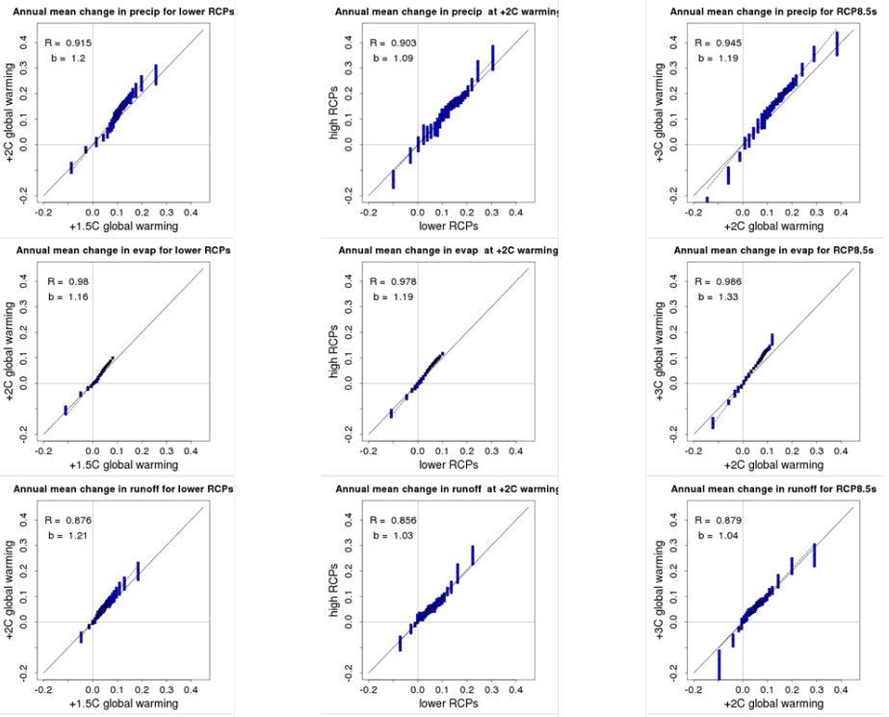

Fig 1. Comparison of ensemble mean changes in hydrological indicators at different levels of global warming (left and right columns) and for different RCPs (middle column) for +2 °C. Changes are relative to the baseline period. (Donnelly et al. 2017).

Some of the uncertainty related to the appropriateness of building the climate model ensembles on different RCPs is assessed by comparing the ensembles using the high and low emission RCPs for the 2°C warming level (Fig 1, central column). Here we see that although there are differences in results between the two methodologies (i.e. deviation from the 1:1 line, central column), these differences are generally smaller than those between the warming levels (left and right columns). For example, changes to precipitation increase more between warming levels than between the ensembles used to define the 2 °C warming level. Exceptions are evapotranspiration, snowpack and for all indicators, those grid cells with the largest changes (see Donnelly et al. 2017). We also compared the sensitivity of the different to warming. For 2 vs 1.5°C, there is less spread in HM response than the magnitude of the projected changes, but for 3 vs 2°C the spread is larger than the ensemble mean changes indicating HM uncertainty in these results. For the 2°C comparison, all models produce similar changes.

Spatially, most of central, western and northern Europe shows robust increases in total annual precipitation for all levels of warming. Changes in precipitation are negligible or uncertain in central western and southern Europe and UK, even at the 3°C warming level (Fig. 3). The decrease in precipitation projected around the Iberian coast becomes larger and more widespread with increasing warming. Changes to runoff generally follow the spatial extent of changes in precipitation but are of a smaller magnitude and less robust. Robust increases in runoff are seen for parts of Scandinavia, northeast Europe, Austria, the northwest Balkans and Hungary and the extent of the robust regions expands from 2 to 3°C. For all levels of warming these runoff changes are strongest in winter.

**Discussion and Conclusions**

At the regional and continental scale, our results support the hypothesis that a higher level of global warming will lead to more severe impacts on precipitation, evapotranspiration, runoff and snow for most of Europe. Impacts increase in severity and spatial extent as warming increases. In particular, our results show a considerable difference between the impacts on mean runoff and low runoff (Donnelly et al. 2017) at 1.5 and 2°C warming indicating the impact that even a small increase in global warming has on European water resources.

One limitation in this study is the transient nature of the climates that are assessed from the climate model simulations at different warming levels for only short (30-year) time periods. The advantage of this approach is that analysing an ensemble of projections for different time periods with a common global temperature change removes some of the uncertainty resulting from the GCM’s climate sensitivity (Vautard et al. 2014). However, the method relies on the assumption that for a given warming, the impacts of climate change are the same, regardless of the time taken to reach it or whether equilibrium has been reached. One argument against this is that systems, such as the ocean, might take longer to adjust to the 2 °C period as might changes in biogeochemical processes including changes to evapotranspiration and growth of vegetation at different CO2 concentrations in the atmosphere. To some extent, this is investigated by quantifying the 2°C changes using two ensembles forced with different RCPs which reach the warming level threshold at different times (mean midpoint of 2040 vs 2061). The results showed that for the different 2°C ensembles tested, the impacts at the same warming level increased with increasing RCP; however, these differences were nearly always smaller than the differences between the different warming levels, supporting the hypothesis that increased warming leads to increased hydrological impacts.

Regarding HM uncertainty, despite the large variations in HM structure, the spread in HM response for runoff was smaller than the projected changes at lower warming levels; however, for higher warming levels (2 to 3°C), the spread in HM response was larger than the projected changes (Donnelly et al. 2017), indicating large uncertainties in hydrological response at higher warming. This is thought to be mainly due to the different formulations and parameterisations of potential evapotranspiration in the different models. Overall, there are large uncertainties resulting from the GCM, RCM and HM choices and representativeness of their spread, the choice of bias-correction methodology as well as the omission of vegetation CO2 response, anthropogenic impacts on the water cycle and landuse use change in the HMs. However, the key message, that impacts on the water cycle increase from 1.5 to 2 to 3 °C warming, is robust.

In conclusion, the impacts of climate change on mean, low and high runoff and mean snowpack (not shown here, see Donnelly et al. 2017 for all results) in Europe increase with increased warming level. Changes to runoff are more intense at 2°C compared to 1.5 °C and become more widespread at 3 °C. The fact that the hydrological impacts of climate change are geographically more widespread for higher levels of warming implies that larger regions and more countries will be impacted by the effects of climate change in sectors where water plays an important role.

# References

Burek P, van der Knijff J, de Roo A (2013) LISFLOOD Distributed Water Balance and Flood Simulation Model. Revised user manual. JRC technical reports EUR 22166 EN/3 EN.

Donnelly C, Andersson JCM, Arheimer B (2016) Using flow signatures and catchment similarities to evaluate the E-HYPE multi-basin model across Europe. Hydrol Sci J. doi:10.1080/02626667.2015.1027710

Donnelly, C., Greuell, W., Andersson, J.C.M, Gerten, D., Pisacane, G., Roudier, P., and Ludwig, F.2017. Impacts of climate change on European hydrology at 1.5, 2 and 3 degrees mean global warming above preindustrial level. Climatic Change, 143(1-2), 13-26.Jacob D et al. (2014) EURO-CORDEX: new high-resolution climate change projections for European impact research. Reg Environ Chang 14:563–578. doi:10.1007/s10113-013-0499-2.

Jiménez Cisneros B. E. et. Al., 2014: Freshwater resources. In: Field CB, et al. (eds.) Climate Change 2014: impacts, adaptation, and vulnerability. Part A: global and sectoral aspects. Contribution of Working Group II to the Fifth Assessment Report of the Intergovernmental Panel on Climate Change. Cambridge University Press, Cambridge, United Kingdom and New York, pp. 229–269.

Moss RH et al (2010) The next generation of scenarios for climate change research and assessment. Nature 463:747–7

Sanford, T., Frumhoff, P.C., Luers, A. and Gulledge, J. 2014. The climate policy narrative for a dangerously warming world. Nature Climate Change 4, 164–166 (2014) doi:10.1038/nclimate2148

Schaphoff S, Heyder U, Ostberg S, Gerten D, Heinke J, Lucht W (2013) Contribution of permafrost soils to the global carbon budget. Environ. Res. Lett. 8: 014026,5. doi:10.1088/1748-9326/8/1/014026.

Taylor KE, Stouffer RJ Meehl GA (2012) An Overview of CMIP5 and the Experiment Design. Bull. Met. Am. Soc, 93:485–498, doi: http://dx.doi.org/10.1175/BAMS-D-11-00094.1.

UNFCCC (2010) Report of the Conference of the Parties on its sixteenth session, held in Cancun from 29 November to 10 December 2010. Available from http://unfccc.int/resource/docs/2010/cop16/eng/07a01.pdf . United

Nations, Geneva

UNFCCC (2015) Adoption of the Paris Agreement. Proposal by the President. Proposal by the President. Available from: http://unfccc.int/resource/d°Cs/2015/cop21/eng/l09r01.pdf. United Nations, Geneva, Switzerland.

Vautard R et al (2014) The European climate under a 2 °C global warming. Environ Res Lett 9:034006

Vörösmarty CJ, Green P, Salisbury J, Lammers RB (2000) Global water resources: vulnerability from climate change and population growth. Science, 289(5477):284-288.