**Using ensemble in deriving baselines for Victorian water assessment**

## Surendra Rauniyar1 and Scott Power1

*1Science to Services, Bureau of Meteorology, Melbourne*

[*Surendra.rauniyar@bom.gov.au*](mailto:Surendra.rauniyar@bom.gov.au)

**Introduction**

The baseline is a period which has been chosen to best represent the current climate of a region and serves two main purposes: 1) it is used as a reference against which recent observations are compared and 2) it can be used as a benchmark to evaluate the looming changes in climate for planning and management processes. Hope et al. (2017) pointed out that baseline selection poses a significant source of uncertainty in defining the exact magnitude of the projected changes in Victoria’s climate.

Key requirements for a baseline are that it should be of sufficient duration to encompass the range of natural climate variability, but, given that the climate is likely to be changing due to anthropogenically-driven climate change, the baseline should also be of short enough duration so as to represent the current state of the climate, and minimize the chance of any climate shifts within the baseline period. The World Meteorological Organization (WMO) recommends using a period of at least 30 years (e.g. 1981–2010) as a baseline to compute the climatological standard normals (WMO 2017), while IPCC has used the 1986–2005 period as a baseline in its fifth assessment report (IPCC 2013) as a reference period in its assessment of climate change.

For rainfall however, a number of studies have found that 30 years or less is not long enough to adequately represent the range of natural variability, especially when it is used as a predictive indicator of the conditions likely to be experienced in a given location. Victoria just experienced its driest cool season (April – October) rainfall for the last 30 years compared to any 30-year period in the historical record from 1900–2016 (Timbal et al. 2016). Research undertaken during the South Eastern Australian Climate Initiative (CSIRO 2012) and the Victorian Climate Initiative (Hope et al. 2017) have shown that the baseline climate is changing as the assumption of a stationary climate has been challenged by the recent persistently dry conditions. Victorian rainfall trends include a known influence from climate change, thus this recent period could be representative of the best baseline to use. However, the projected rainfall reductions for 2030 across the region are smaller than the observed declines over the last decades. Given this discrepancy, do the recent decades represent a true baseline, and a good estimate of the climate going forward, or are they unusually dry? Is any historical period truly representative of the current state of the climate or the expected climatic conditions over the coming decade? These concerns lead to questions about how best to characterize the baseline climate.

Given the concerns above, the current guidelines for "Assessing the Impact of Climate Change on Water Supplies in Victoria" developed by the Department of Environment Land, Water and Planning (DELWP) recommends using a longer period of 1975 to date as a current baseline period for water resources planning and management. Is this the best estimate of the current baseline for Victoria's rainfall?

**Research**

The Bureau of Meteorology recently began research on baselines for the Victorian water sector as part of a new program co-funded by the DELWP and the Bureau. A review of the scientific literature around baselines done under the project has found limited prior research into this question. The research will assess whether a more robust approach to defining the baseline can be developed. We are analyzing baselines over the historical period and for coming years and decades to examine the impact of natural climate variability and anthropogenic forcing on the baselines. We present results on baselines in both the observations and a large number of climate models from around the world.

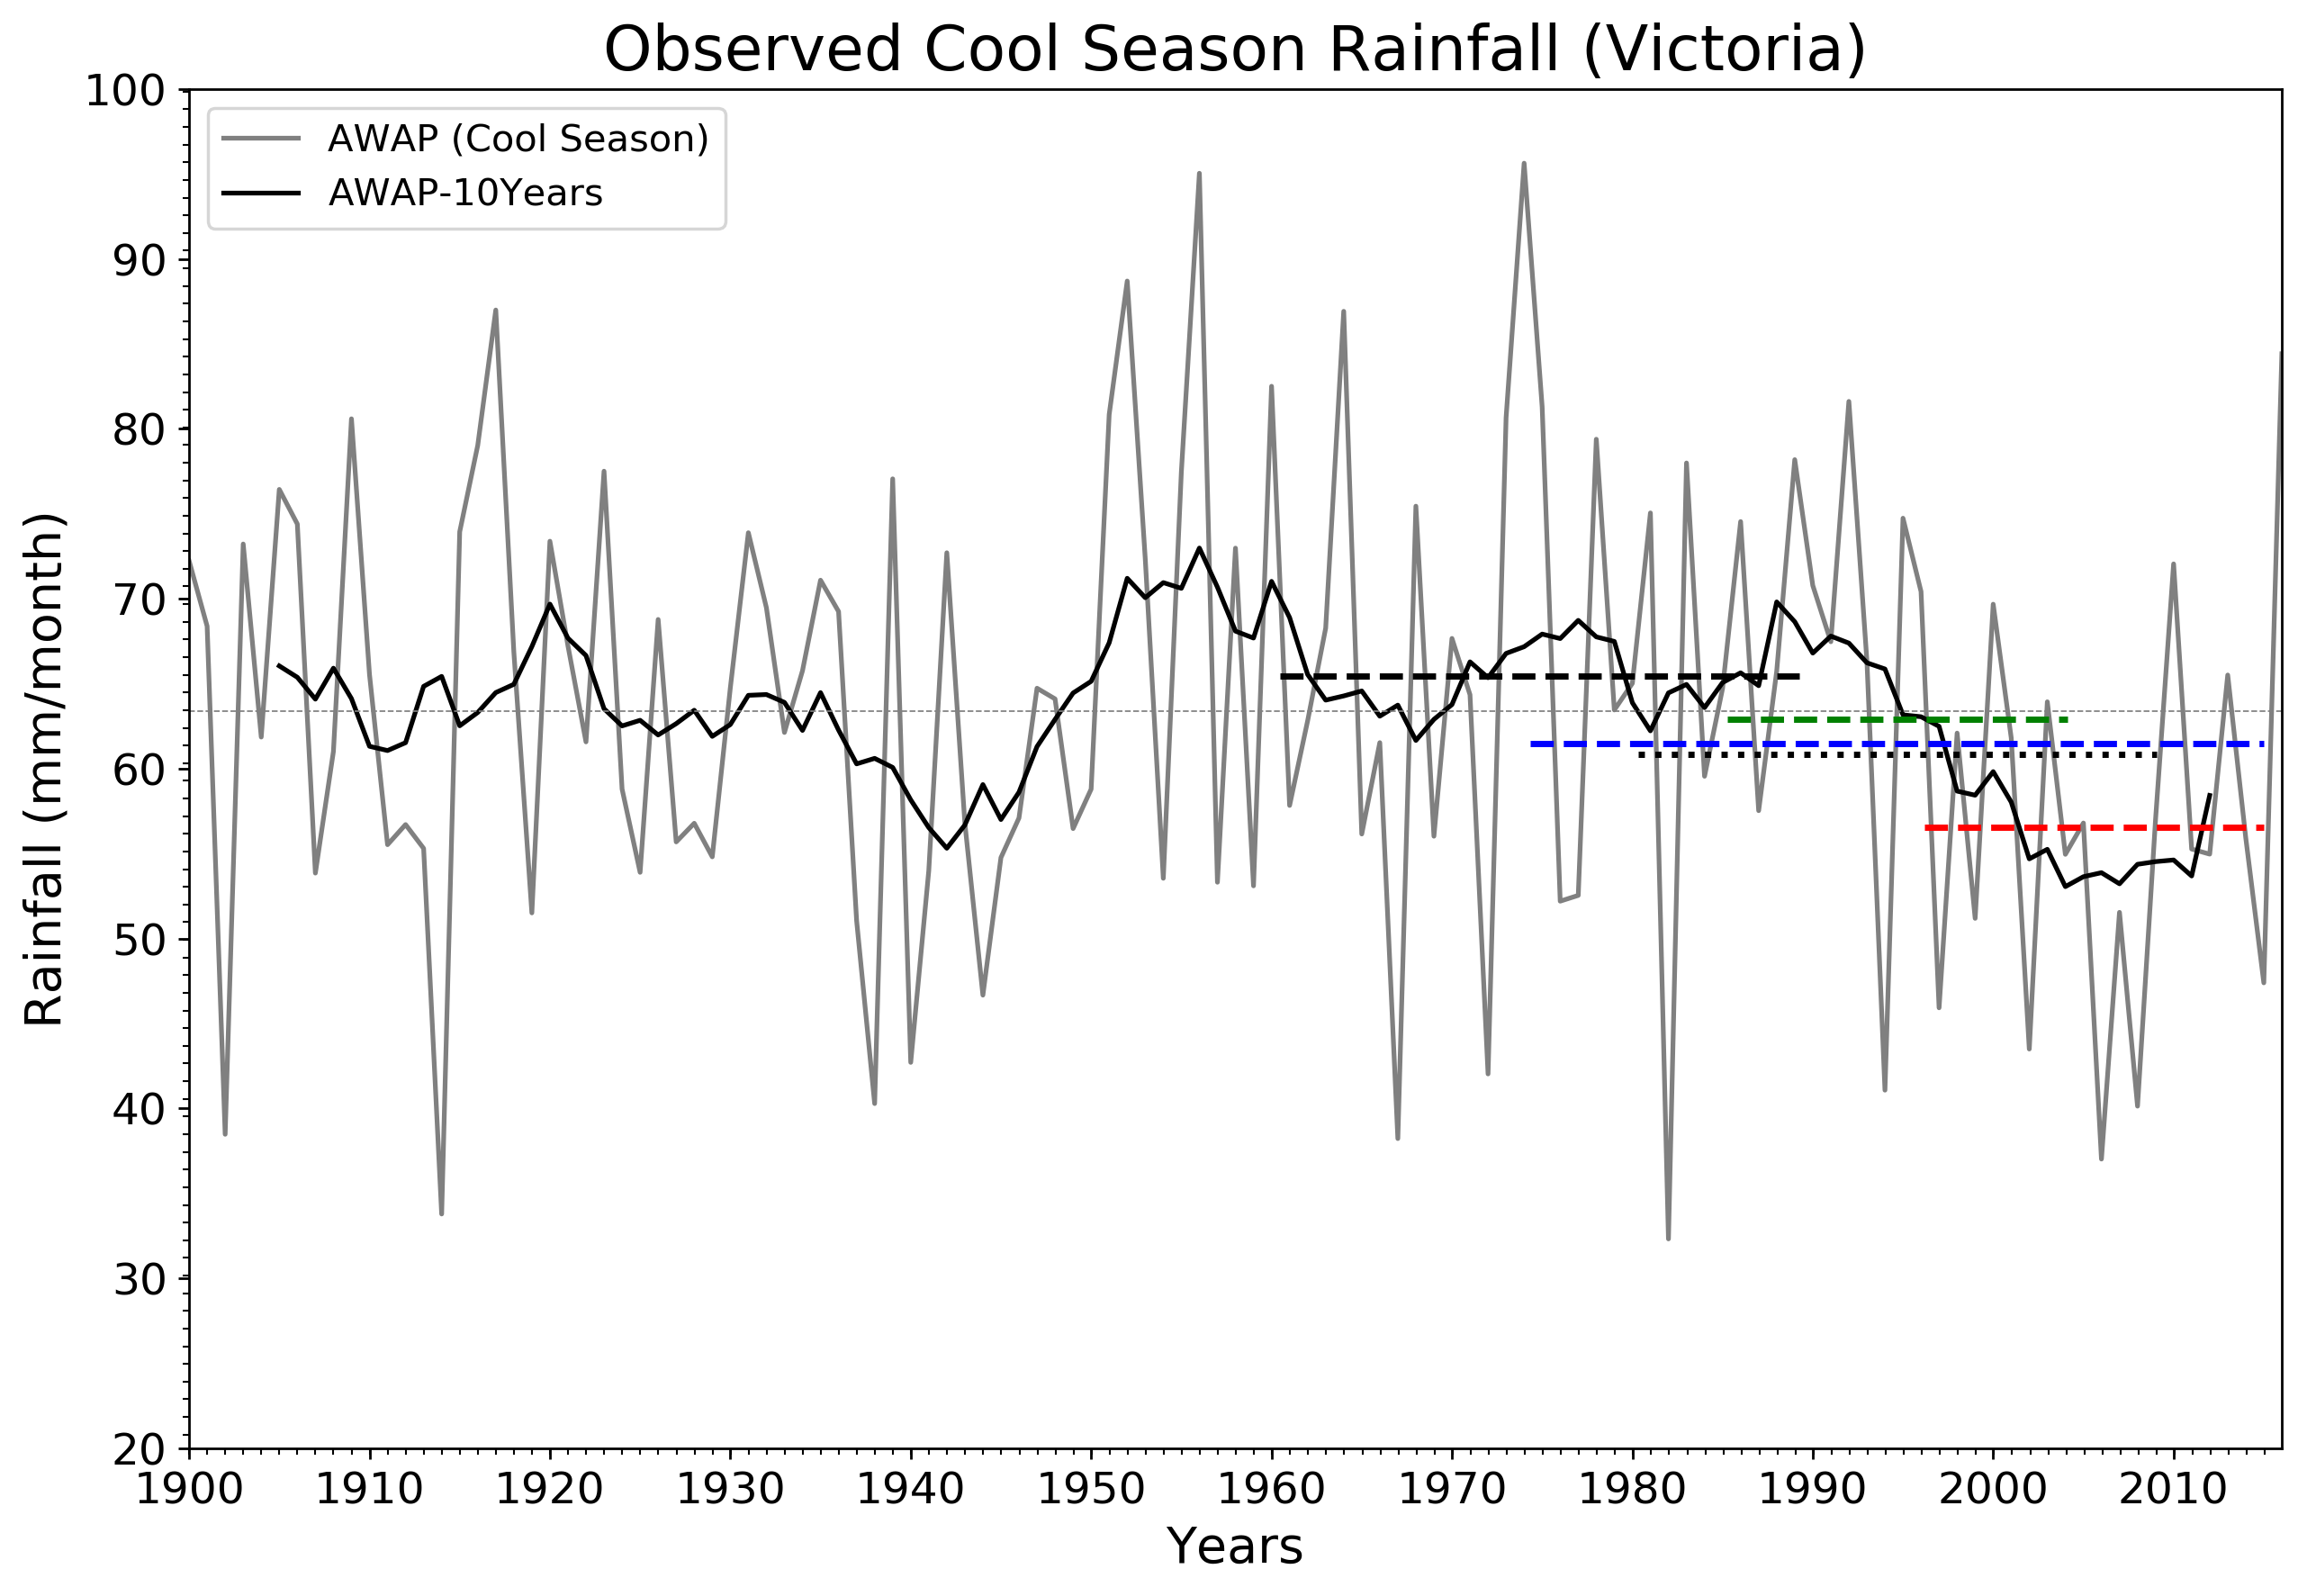

*Time series of the observed mean cool season (April-October) rainfall (grey color) and the 10-year running mean (black color) in mm month-1 over Victoria, Australia. The horizontal dashed and dotted black lines represent the different baselines periods recommended by WMO (i.e. 1961-1990 and 1981-2010). The blue dashed line represents the baseline (1975-current) recommended by DELWP, the green dashed line is the baseline (1986-2005) used in IPCC AR5 reports while the red dashed line represent the baseline from the start of Millennium Drought to current (1997- current).*

# References

CSIRO, 2012. Climate and water availability in south eastern Australia: A synthesis of findings from Phase 2 of the South Eastern Australian Climate Initiative (SEACI). Australia, September 2012, 41 pp.

Hope, P., Timbal, B., Hendon, H., Ekström, M., Potter N., 2017. A synthesis of findings from the Victorian Climate Initiative (VicCI). Bureau of Meteorology, 56 pp, Australia.

IPCC, 2013: Climate Change 2013: The Physical Science Basis. Contribution of Working Group I to the Fifth Assessment Report of the Intergovernmental Panel on Climate Change. Cambridge University Press, Cambridge, United Kingdom and New York, NY, USA, 1535 pp.

Timbal, B., Ekstrom, M., Fiddes, S., Grose, m., Kirono, d., Lim, E.P., Lucas, C. and Wilson, L., 2016. Climate change science and Victoria, Bureau Research Report No. 014. Australian Bureau of Meteorology.

World Meteorological Organization, 2017: Guidelines on the Calculation of Climate Normals (WMO-No. 1203). Geneva.